**Assignment # 3**

**Ali Asif 22i-1019**

**Muhammad Taha 22i-0870**

**Q1**

-- Create all required tables (other than the 2 already shared) in SQL and then insert at least 20 dummy data into each table.

Note : The TEAM & PLAYER tables were created using import as instructed.

-- TEAM

-- Primary Key : TNAME

-- PLAYER

-- Primary Key : PLAYER_ID

-- STADIUM

-- Primary Key : STADIUM_ID

CREATE TABLE STADIUM

(

STADIUM_ID NUMERIC(2) NOT NULL,

STADIUM_NAME VARCHAR(50) NOT NULL,

LOC VARCHAR(20) NOT NULL,

CAPACITY NUMERIC(7) NOT NULL,

PRIMARY KEY (STADIUM_ID)

);

INSERT INTO STADIUM

VALUES

(1, 'National Stadium', 'Karachi', 30000),

(2, 'Gaddafi Stadium', 'Lahore', 27000),

(3, 'Rawalpindi Cricket Stadium', 'Rawalpindi', 25000),

(4, 'Multan Cricket Stadium', 'Multan', 35000),

(5, 'Arbab Niaz Stadium', 'Peshawar', 35000),

(6, 'Bugti Stadium', 'Quetta', 35000);

-- MATCH

-- Primary Key : MATCH_ID

-- Foreign Key : STADIUM_ID, TNAME

CREATE TABLE MATCHES

(

MATCH_ID NUMERIC(2) NOT NULL,

MATCH_DATE DATE NOT NULL,

MATCH_TIME TIME NOT NULL,

STADIUM_ID NUMERIC(2) NOT NULL,

MATCH_TYPE VARCHAR(20) NOT NULL,

TEAM1_NAME NVARCHAR(20) NOT NULL,

TEAM2_NAME NVARCHAR(20) NOT NULL,

PRIMARY KEY (MATCH_ID),

FOREIGN KEY (STADIUM_ID) REFERENCES STADIUM(STADIUM_ID),

FOREIGN KEY (TEAM1_NAME) REFERENCES TEAM(TNAME),

FOREIGN KEY (TEAM2_NAME) REFERENCES TEAM(TNAME),

);

INSERT INTO MATCHES

VALUES

(1, '2024-03-25', '18:00:00', 1, 'Round Robin', 'Karachi Kings', 'Lahore Qalandars'),

(2, '2024-03-26', '18:00:00', 2, 'Round Robin', 'Islamabad United', 'Peshawar Zalmi'),

(3, '2024-03-27', '18:00:00', 3, 'Round Robin', 'Multan Sultans', 'Islamabad United'),

…

(25, '2024-04-10', '18:00:00', 4, 'Final', 'Islamabad United', 'Multan Sultans');

-- PERFORMANCE

-- Primary Key : PERFORMANCE_ID

-- Foreign Key : MATCH_ID, PLAYER_ID

CREATE TABLE PERFORMANCE

(

PERFORMANCE_ID NUMERIC(2) NOT NULL,

MATCH_ID NUMERIC(2) NOT NULL,

PLAYER_ID INT NOT NULL,

RUNS NUMERIC(4) NOT NULL,

WICKETS NUMERIC(2) NOT NULL,

CATCHES NUMERIC(2) NOT NULL,

PRIMARY KEY (PERFORMANCE_ID),

FOREIGN KEY (MATCH_ID) REFERENCES MATCHES(MATCH_ID),

FOREIGN KEY (PLAYER_ID) REFERENCES PLAYER(PLAYER_ID),

)

INSERT INTO PERFORMANCE

VALUES

(1, 1, 1, 129, 1, 4),

(2, 1, 2, 63, 2, 2),

(3, 1, 3, 27, 5, 5),

…

(76, 25, 18, 4, 4, 2);

-- WINNER

-- Foreign Key : TNAME, MATCH_ID

CREATE TABLE WINNER

(

FOREIGN KEY (MATCH_ID) REFERENCES MATCHES(MATCH_ID),

FOREIGN KEY (TNAME) REFERENCES TEAM(TNAME)

)

INSERT INTO WINNER

VALUES

(1, 'Karachi Kings'),

(2, 'Islamabad United'),

(3, 'Multan Sultans'),

…

(25, 'Islamabad United')

-- CALCULATE WINS OF EACH TEAM

-- Concept Used : Nested Query & Aggregate Functions

UPDATE TEAM

SET WINS = (

SELECT COUNT(*)

FROM WINNER

WHERE WINNER.TNAME = TEAM.TNAME

)

-- CALCULATE LOSSES OF EACH TEAM

-- Concept Used : Nested Query & Aggregate Functions

UPDATE TEAM

SET LOSSES = (

SELECT COUNT(*)

FROM MATCHES

WHERE (

(MATCHES.TEAM1_NAME = TEAM.TNAME) OR (MATCHES.TEAM2_NAME = TEAM.TNAME)

) AND MATCHES.MATCH_ID NOT IN (

SELECT WINNER.MATCH_ID

FROM WINNER

WHERE WINNER.TNAME = TEAM.TNAME

)

)

**Q2**

-- Player with the highest number of Catches

-- Concept Used : Nested Query

SELECT NAME AS [HIGHEST CATCHES]

FROM PLAYER

WHERE (

SELECT COUNT(CATCHES)

FROM PERFORMANCE

WHERE PLAYER.PLAYER_ID = PERFORMANCE.PLAYER_ID

) = (

SELECT MAX(TOTAL_CATCHES)

FROM (

SELECT COUNT(CATCHES) AS TOTAL_CATCHES

FROM PERFORMANCE

GROUP BY PLAYER_ID

) AS TOTAL_CATCHES

)



**Q3**

--Team Names along with their Home Stadiums

SELECT TNAME, HOME_STADIUM

FROM TEAM

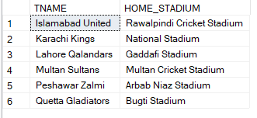

**Q4**

-- Total capacity of a specific Stadium

SELECT STADIUM_NAME, CAPACITY

FROM STADIUM

**Q5**

--Average Runs scored by players in each team

--Concept Used : Join

SELECT T.TNAME, AVG(PR.RUNS) AS Average_Runs_Scored_By_Player

FROM TEAM T

JOIN PLAYER P ON T.TNAME = P.TEAM_NAME

JOIN PERFORMANCE PR ON P.PLAYER_ID = PR.PLAYER_ID

GROUP BY T.TNAME

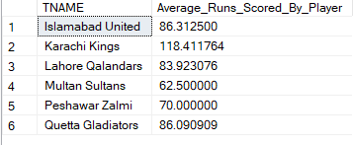

**Q6**

-- Number of Matches played in a specific Stadium

-- Concept Used : Nested Query & Join

SELECT STADIUM_NAME, [MATCHES PLAYED]

FROM STADIUM

JOIN (

SELECT STADIUM_ID AS STD_ID, COUNT(STADIUM_ID) AS [MATCHES PLAYED]

FROM MATCHES

GROUP BY STADIUM_ID

) AS STD_ID

ON STADIUM.STADIUM_ID = STD_ID

**Q7**

--Total Runs Scored by each player

--Concept Used : Join

SELECT P.PLAYER_ID, P.NAME, SUM(PR.RUNS) AS TotalRuns

FROM PLAYER P

JOIN PERFORMANCE PR ON P.PLAYER_ID = PR.PLAYER_ID

GROUP BY P.PLAYER_ID, P.NAME

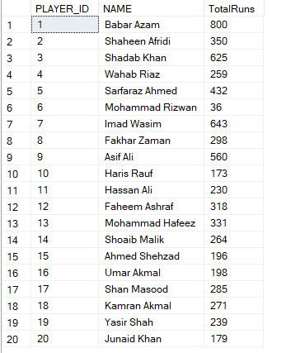

**Q8**

-- Teams with more than 3 Wins

SELECT TNAME, WINS

FROM TEAM

WHERE WINS > 3

**Q9**

--Players that are bowlers

SELECT P.PLAYER_ID, P.NAME

FROM PLAYER P

WHERE P.ROLE = 'Bowler'

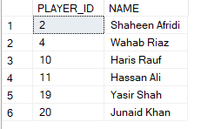

**Q10**

-- List players who scored more than 50 runs and took at least 3 wickets in a single match

-- Concept Used : Nested Query & Join

SELECT NAME, [RUNS], [WICKETS]

FROM (

SELECT NAME, RUNS AS [RUNS], WICKETS AS [WICKETS]

FROM PLAYER

JOIN PERFORMANCE

ON PLAYER.PLAYER_ID = PERFORMANCE.PLAYER_ID

) AS NAME

WHERE [RUNS] > 50 AND [WICKETS] > 3

**Q11**

--The team with the highest runs in the tournament

--Concept Used : Join

SELECT TOP 1 T.TNAME, SUM(PR.RUNS) AS Runs

FROM TEAM T

JOIN PLAYER P ON T.TNAME = P.TEAM_NAME

JOIN PERFORMANCE PR ON P.PLAYER_ID = PR.PLAYER_ID

GROUP BY T.TNAME

ORDER BY RUNS DESC



**Q12**

-- Show matches along with the winning team name

-- Concept Used : Join

SELECT TNAME AS [WINNER], MATCHES.MATCH_ID, MATCH_DATE, MATCH_TIME, STADIUM_ID, MATCH_TYPE

FROM MATCHES

JOIN WINNER

ON WINNER.MATCH_ID = MATCHES.MATCH_ID

**Q13**

--All match types without duplicates

SELECT DISTINCT MATCH_TYPE

FROM MATCHES

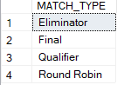

**Q14**

-- List stadiums and the number of matches hosted by each

-- Concept Used : Nested Query & Join

SELECT STADIUM_NAME, [MATCHES HOSTED]

FROM STADIUM

JOIN (

SELECT STADIUM_ID AS STD_ID, COUNT(STADIUM_ID) AS [MATCHES HOSTED]

FROM MATCHES

GROUP BY STADIUM_ID

) AS STD_ID

ON STADIUM.STADIUM_ID = STD_ID

**Q15**

--All Players in a specific team

SELECT PLAYER_ID, NAME

FROM PLAYER

WHERE TEAM_NAME = 'Lahore Qalandars'

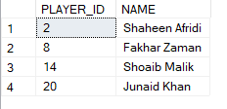

**Q16**

-- List the top 3 players with the most runs scored in final matches

-- Concept Used : Nested Query & Join

SELECT *

FROM PLAYER

JOIN PERFORMANCE

ON PLAYER.PLAYER_ID = PERFORMANCE.PLAYER_ID

WHERE (PERFORMANCE.RUNS IN (

SELECT TOP 3 RUNS

FROM PERFORMANCE

WHERE MATCH_ID = 25

)) AND PLAYER.PLAYER_ID IN (

SELECT PLAYER_ID

FROM PERFORMANCE

WHERE MATCH_ID = 25

) AND (MATCH_ID = 25)

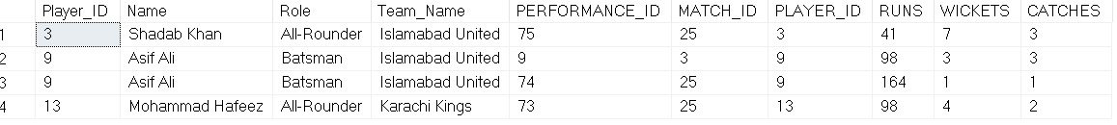

**Q17**

--The players who scored more than 50 runs in winning matches

--Concept Used : Join

SELECT DISTINCT P.PLAYER_ID, P.TEAM_NAME, PR.RUNS

FROM PERFORMANCE PR

JOIN (

SELECT MATCH_ID

FROM WINNER

) AS W ON PR.MATCH_ID = W.MATCH_ID

JOIN Player P ON PR.PLAYER_ID = P.PLAYER_ID

JOIN Winner WIN ON P.TEAM_NAME = WIN.TNAME

WHERE PR.RUNS > 50;

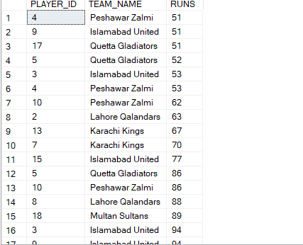

**Q18**

-- Determine the top 3 players with the highest aggregate runs scored in Qualifier, Eliminator, and Final matches

-- Concept Used : Nested Query, Join, Group By & Aggregate Functions

SELECT TOP 3 NAME AS [PLAYER], SUM(RUNS) AS [AGGREGATE RUNS]

FROM (

SELECT NAME, MATCH_ID, RUNS

FROM PERFORMANCE

JOIN PLAYER

ON PLAYER.PLAYER_ID = PERFORMANCE.PLAYER_ID

WHERE MATCH_ID IN (22, 23, 24, 25)

) AS RES

GROUP BY NAME

ORDER BY SUM(RUNS) DESC

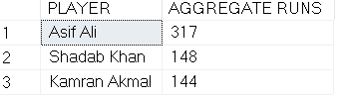

**Q19**

--Average Runs and Wickets scored by each team per stadium

--Concept Used : Join

SELECT P.TEAM_NAME, M.Stadium_ID, AVG(PR.RUNS) AS AverageRuns, AVG(PR.WICKETS) AS AverageWickets

FROM MATCHES M

JOIN PERFORMANCE PR ON M.MATCH_ID = PR.MATCH_ID

JOIN PLAYER P ON PR.PLAYER_ID = P.PLAYER_ID

GROUP BY P.TEAM_NAME, M.Stadium_ID

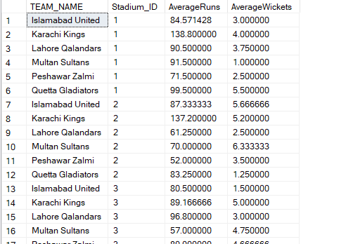

**Q20**

-- Find the number of wins each team has achieved in their home stadium

-- Concept Used : Nested Query, Join, Group By & Aggregate Functions

SELECT [WINNER] AS [TEAM], STADIUM_NAME AS [HOME STADIUM], RES2.[WINS]

FROM (

SELECT STADIUM_NAME, [WINNER], COUNT(*) AS [WINS]

FROM (

SELECT STADIUM_NAME, [WINNER]

FROM STADIUM

JOIN (

SELECT STADIUM_ID AS [STD_ID], TNAME AS [WINNER]

FROM MATCHES

JOIN WINNER

ON MATCHES.MATCH_ID = WINNER.MATCH_ID

) AS STD_ID

ON STADIUM.STADIUM_ID = STD_ID

) AS RES

GROUP BY RES.STADIUM_NAME, RES.WINNER

) AS RES2

JOIN TEAM

ON RES2.STADIUM_NAME = TEAM.HOME_STADIUM

WHERE TEAM.HOME_STADIUM = RES2.STADIUM_NAME AND [WINNER] = TEAM.TNAME

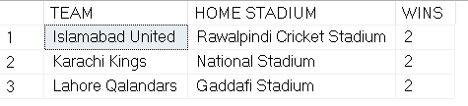

**Q21**

--Current number of wins for each team

SELECT W.TNAME AS Team_Name, COUNT(*) AS Wins

FROM WINNER W

GROUP BY W.TNAME

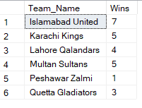

**Q22**

-- Identify players whose performance (runs scored, wickets taken, or catches) was pivotal in securing wins for their team

-- Concept Used : Nested Query & Join

SELECT PLAYER.NAME, MATCHES.MATCH_ID, PERFORMANCE.RUNS, PERFORMANCE.WICKETS, PERFORMANCE.CATCHES, PLAYER.TEAM_NAME

FROM PERFORMANCE

JOIN MATCHES ON MATCHES.MATCH_ID = PERFORMANCE.MATCH_ID

JOIN WINNER ON WINNER.MATCH_ID = PERFORMANCE.MATCH_ID

JOIN PLAYER ON PLAYER.PLAYER_ID = PERFORMANCE.PLAYER_ID

WHERE (MATCHES.TEAM1_NAME = WINNER.TNAME OR MATCHES.TEAM2_NAME = WINNER.TNAME) AND (PLAYER.TEAM_NAME = WINNER.TNAME)

AND ((RUNS > 80) OR (CATCHES > 3) OR (WICKETS > 3))

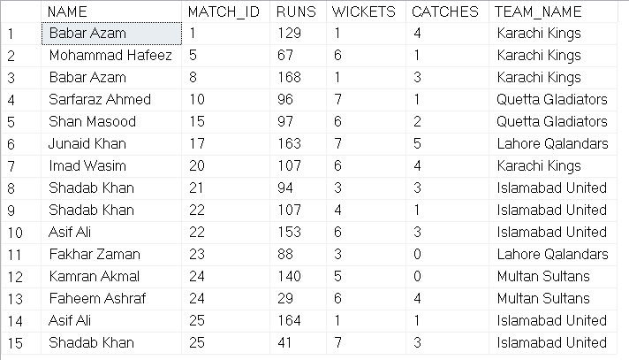

**Q23**

--Correlated Nested Queries

--Nested Query where the inner query uses value from outer query

SELECT RUNS FROM PERFORMANCE

WHERE PLAYER_ID IN ( SELECT PLAYER_ID FROM PLAYER )

--Union

--Combines the values of a column from two different tables without duplicates

SELECT PLAYER_ID FROM PLAYER

UNION

SELECT PLAYER_ID FROM PERFORMANCE

--Group By

--Groups the rows that have the same values

SELECT STADIUM_ID, COUNT(*) AS Matches

FROM MATCHES

GROUP BY STADIUM_ID

--Like

--Finds entries with matching substrings

SELECT NAME FROM PLAYER

WHERE NAME LIKE '%E%'

--Having

--Used instead of WHERE because WHERE cannot be used in aggregate

SELECT STADIUM_ID, COUNT(*) AS Matches

FROM MATCHES

GROUP BY STADIUM_ID

HAVING COUNT(*) > 7

