**LINUX COMMANDS**

**SUBMITTED BY:**

Ali Asjad

**Registration #:**

SP22-BCS-055

**SUBMITTED TO:**

Sir Muhammad Ibrahim

**DATE:**

9th September, 2025

**COMSATS University Islamabad, Wah Campus**

**Department of Computer Science**

**Current path**



**Directory listing**

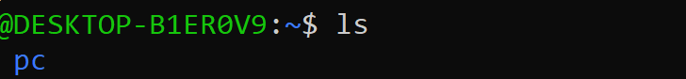

**Folder create**



**Go into particular folder**



**Step back**



**Create new files**

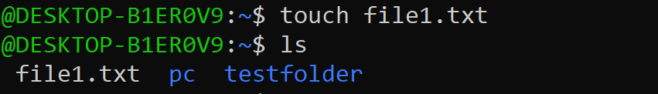

**Rename file**

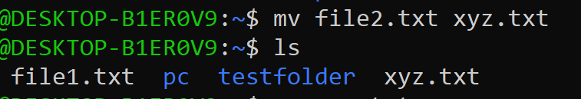

**Remove / delete file**

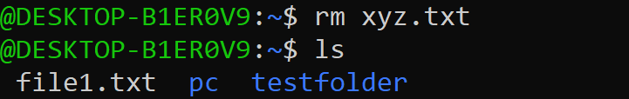

**Remove folder**

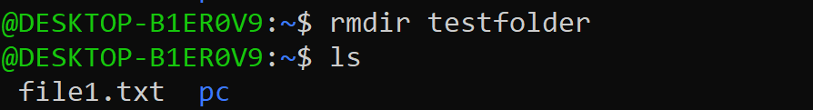

**Inserting text in file**



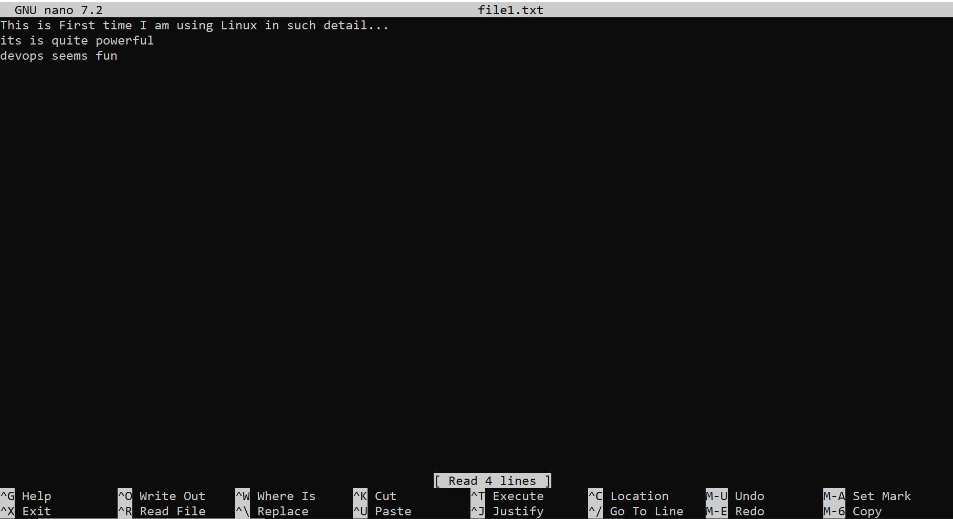

**Show file content**



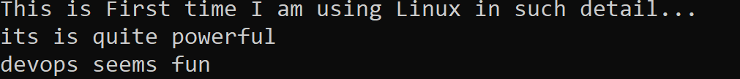

**View file content after opening it**

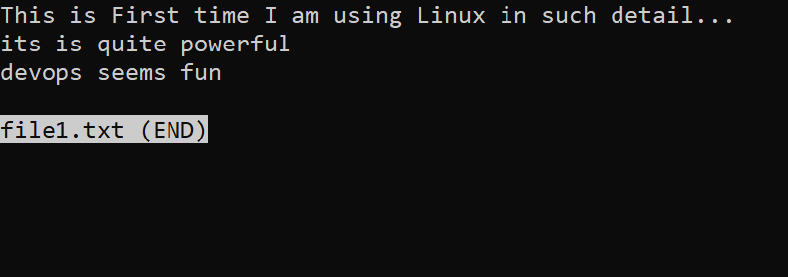

**Finding word in the file’s content**





**Permission check**





**Executable permission**





**Find file**



**Locating files with .txt extension**



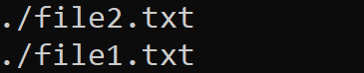

**Show binary paths**





**Locate binary and docs**





**Tar archive**



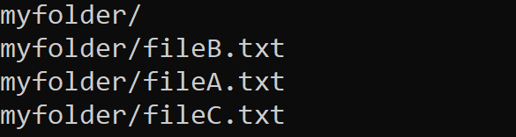

**Extract tar**





**Zip files**



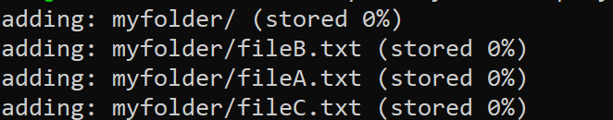

**Unzip files**



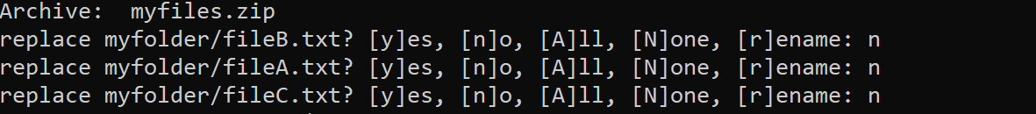

**Sudo apt-get to install packages**



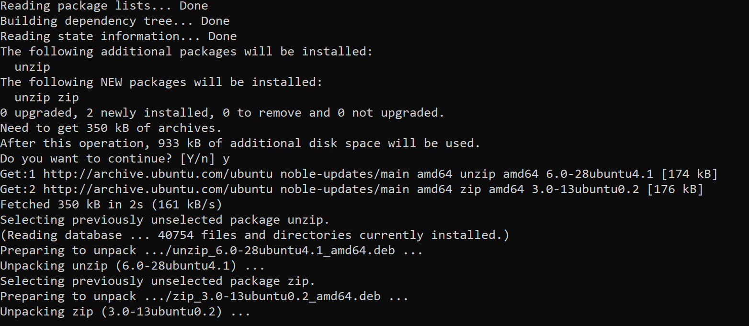

**Show running processes**



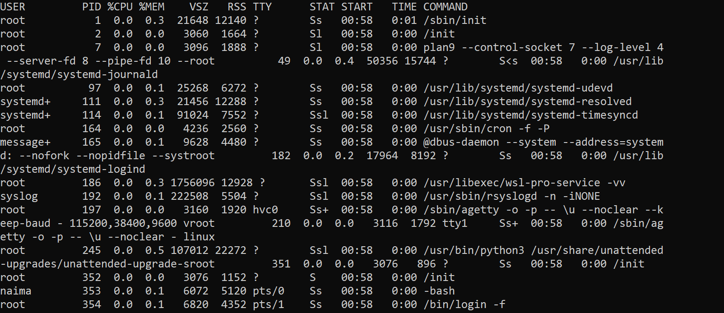

**Basic monitor**



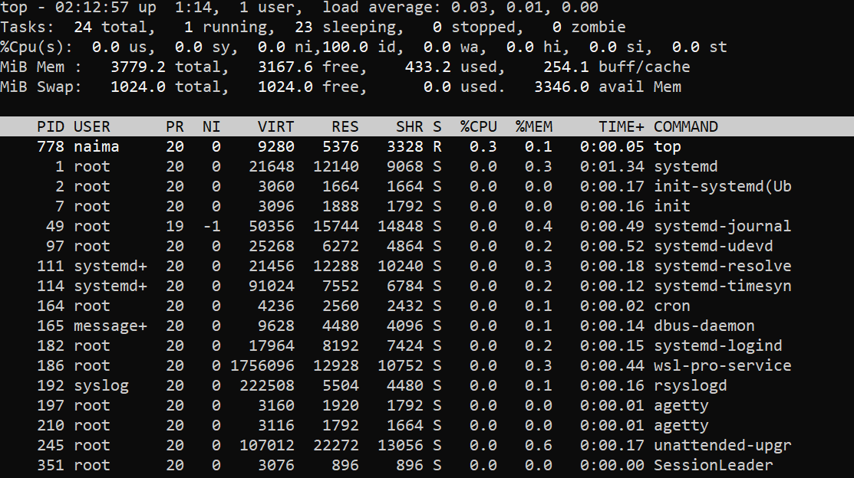

**Advanced monitor**



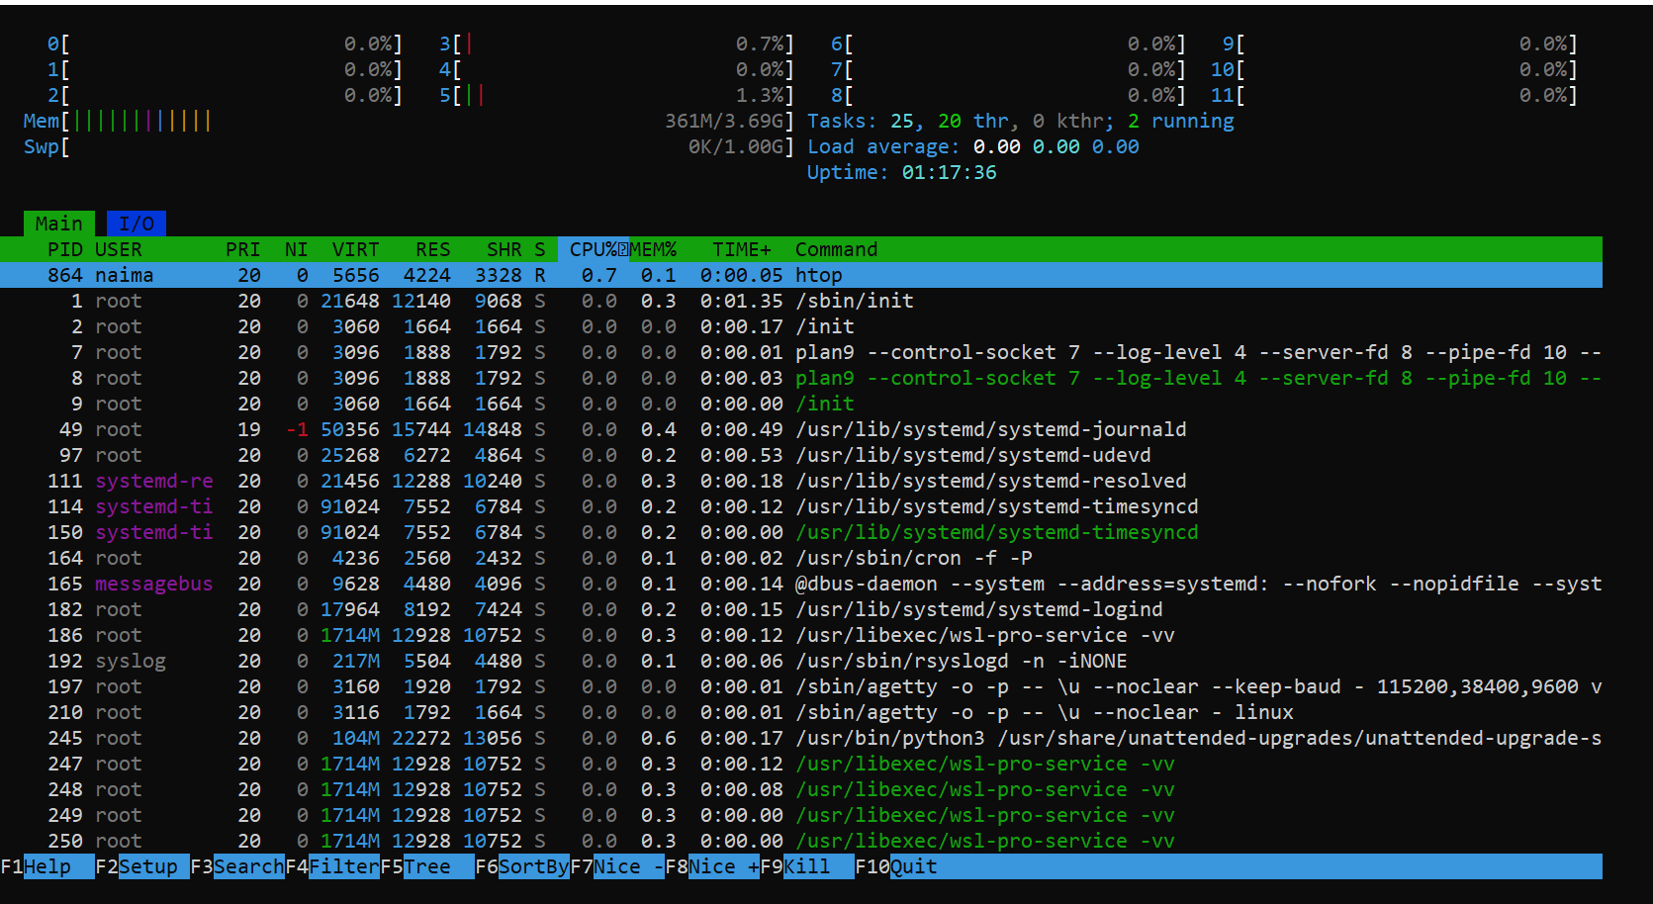

**File content search**





**and killing the process**





**Disk usage**



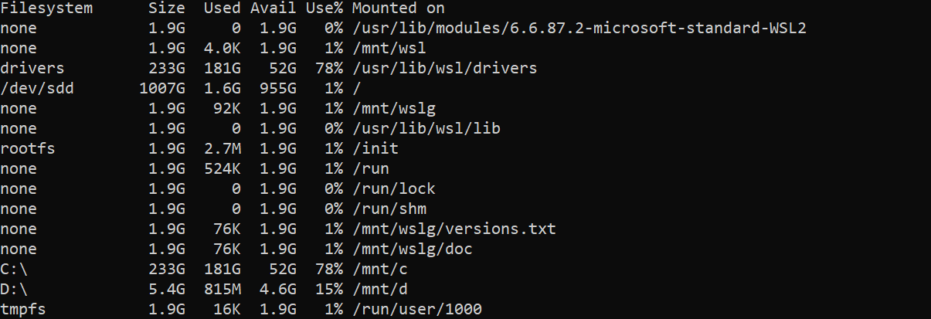

**Folder size**





**Memory**





**Kernel info**





**System load**





**File edit**



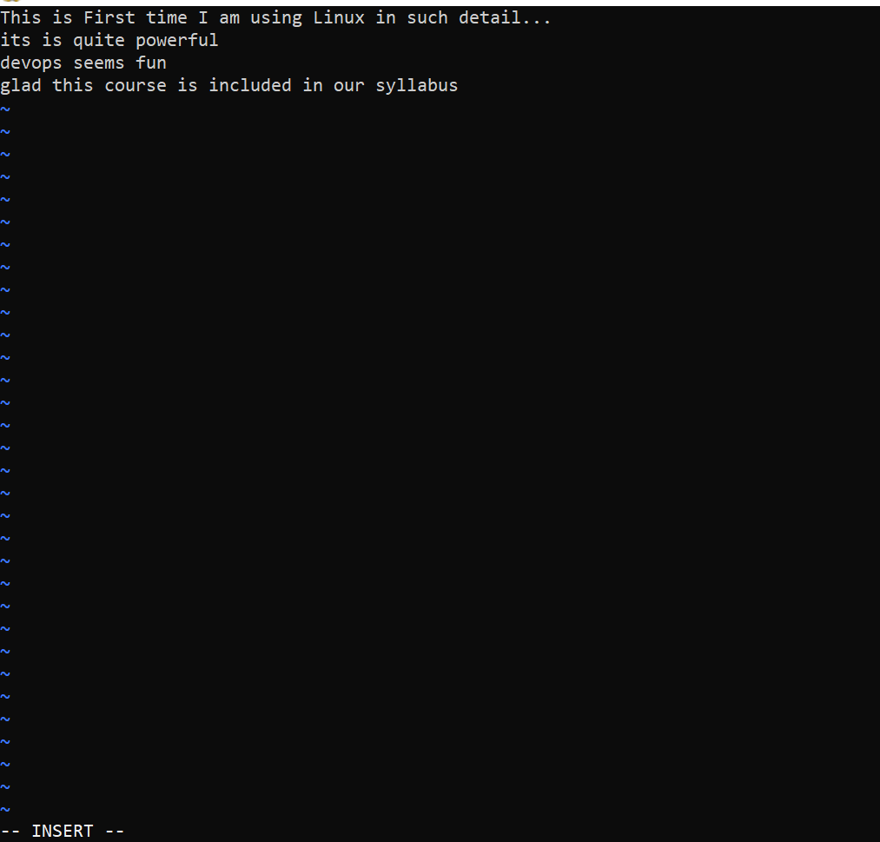

**Append file 2 content in file 1**



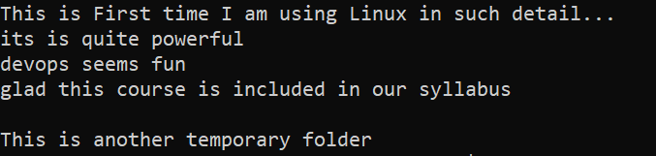

**Remove duplicate**



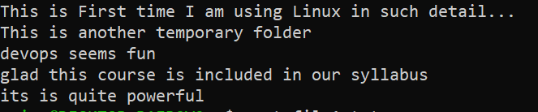

**Sorting**



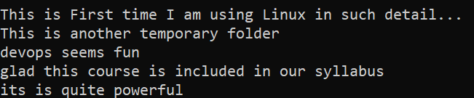

**Open manual**



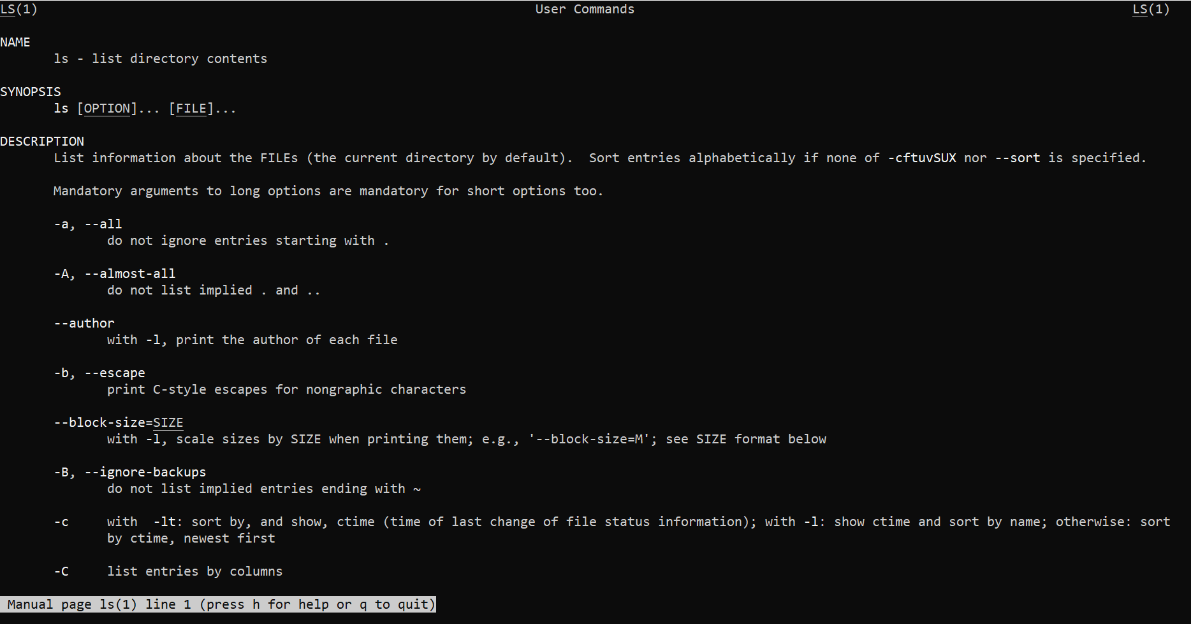

**Help**



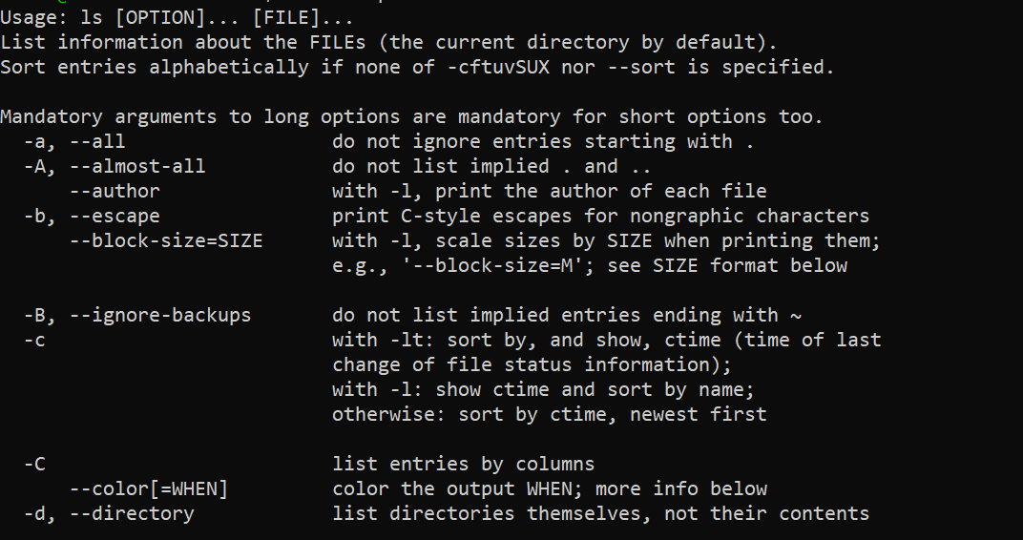

**Ping google**



