RESUME

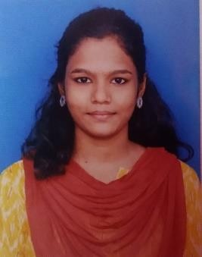

**Name: - S. Swetha**

**Email ID**:- [swethaselvam21.08.03@gmail.com](mailto:swethaselvam21.08.03@gmail.com)

**Mobile**:- 9363233746

**Address**: - 20/8, Ramalingar Street, Vannarpettai, Tirunelveli.

# CAREER OBJECTIVE

Seeking for my future Environment for continuous learning and utilize my skills & abilities for achieving Goal.

# ACADMIC QUALIFICATION

|  |  |  |  |  |  |
| --- | --- | --- | --- | --- | --- |
| **S. No:** | **Class** | **Institution** | **Year** | **Percentage** |  |
| 1. | Bachelor of  Science(Information Technology) | Rose Mary college  of Arts& Science for Womens | 2021-2024 | Pursuing |
| 2. | HIGHER SECONDARY | St. Ignatious Convent  Hr.Sec.Schol | 2021 | 77.5% |
| 3. | SSLC | St. Ignatious  Convent Hr.Sec.School | 2019 | 60% |

**TECHNICAL SKILLS**

* MS – Office
* HTML
* C
* C++
* Java script
* PHP
* Linux
* Java 1.70
* DTP
* Basic .Net

# EXTRA CURICULAR ACTIVITIES

* + Participated and certified in around webinars during the quarantine period.
  + I won the 2rd prize in web design & PPT.
  + I won the 1st prize Debugging.
  + I won the 1st prize in poster presentation.
  + Participated 1 day workshop in python, green foot, Amazon webservice (AWS).

# PERSONAL QUALITIES

* + Self Motivator
  + Dancer, Editor, Modeling
  + Team working
  + Intepersonal skill
  + Ability to handle the pressure

# PERSONAL PROFILE

* + 1. Father’s Name : A. Selvam
    2. Date of Birth : 21-08-2003
    3. Gender : Female
    4. Marital Status : Single / Unmarried
    5. Nationality : Indian
    6. Religion : Hindu
    7. Language known : Tamil , English

# DECLARATION

I , hereby declare that all the details furnished above are true to the best of my knowledge.

# PLACE : TIRUNELVELI SIGNATURE

**DATE : S . SWETHA**