**PROBLEMS**

* **ESP AT ERROR message:**

The esp-01 requires a newline and carriage return at the end of each command

If using Arduino Serial Monitor for testing, use this.

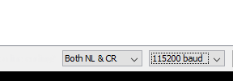

While sending each command in code, do this



* **ADXL345 hangs i2c bus:**

Actually, I didn’t figure this one out. That’s why I used SPI, and shifted to HAL from the base bare-metal code. The problem occurs after reading from it. The provided “works idk why.txt” in code bits folder, was the original code, it can write to as many registers as I want, but after reading a single byte, it hangs the i2c bus. The read data was right though; the problem occurs after that (I used device id to confirm it).

* **Current Sensor calibration:**

The current sensor has a direction. It is biased at half the Vcc, so check the correct direction to ensure the correct working of code.