
CS 2006 : Operating Systems
Spring 2026 : Semester Project

Chrono Rift

Muhammad Ali | 23i-2565
Ahmed Ijaz | 23i-0644

Submission Date: 10 May 2026

1. Project Overview
Chrono Rift is a multi-process, multi-threaded turn-based tactical RPG built in C++17 for Linux, developed as part of the CS 2006 Operating Systems course. The project demonstrates the application of core OS concepts including inter-process communication via shared memory, POSIX threads, semaphores, signals, and deadlock detection in the context of an interactive game.

The game is modelled after classic turn-based RPG combat: one or more human-controlled player characters face off against computer-controlled enemies (NPCs) in a battle where each entity takes turns based on a stamina-driven scheduling system. The battle ends when the players kill 10 enemies, all players die, or the player chooses to quit.

The project is implemented entirely using Linux-specific system calls and POSIX primitives as required. No STL concurrency wrappers such as std::thread or std::mutex were used. All inter-process communication uses POSIX shared memory. All synchronization uses pthreads mutexes and unnamed semaphores with process-shared attributes.

1.1 Group Members
Name | Roll Number
Muhammad Ali | 23i-2565
Ahmed Ijaz | 23i-0644

1.2 Build Environment
The project is developed, compiled, and tested inside a Docker container based on Ubuntu 22.04 as required by the project specification. It uses the SFML library for graphics rendering.
Tool / Library | Purpose
g++ (C++17) | Compilation
POSIX Shared Memory | Inter-process communication
pthreads | Multi-threading
POSIX Semaphores | Turn signalling between processes
POSIX Signals | Stun, Ultimate Ability, process control
SFML 2.x | Graphical user interface and rendering
Docker (Ubuntu 22.04) | Isolated build and run environment

2. System Architecture
The system is divided into three separate processes, each with a distinct role. All three processes communicate exclusively through a single POSIX shared memory segment named /chrono_rift_shm. No pipes, named pipes, or sockets are used.

Process | Executable | Role
Game Arbiter | arbiter_exe | Central authority. Creates and owns shared memory. Runs the scheduler, renderer thread, deadlock monitor thread. Forks HIP and ASP.
Human Interfacing Process (HIP) | hip_exe | Captures player input. One pthread per player. Reads from shared memory input buffer when its turn comes. Does not modify game state directly.
Automated Strategic Process (ASP) | asp_exe | Controls all NPCs. One pthread per NPC. Reads turn semaphore and submits NPC actions to shared memory.

2.1 Process Lifecycle
- Arbiter starts, creates shared memory with shm_open and mmap, initialises all mutexes and semaphores with PTHREAD_PROCESS_SHARED.
- Arbiter spawns the render thread (SFML window). The render thread shows a welcome screen and waits for the player to select a party size (1 to 4).
- Arbiter calls init_entities() to populate all player and NPC data in shared memory.
- Arbiter forks HIP via fork() + execl(). HIP attaches to shared memory, spawns one pthread per player, and waits on the player_turn_sem semaphore.
- Arbiter forks ASP via fork() + execl(). ASP attaches to shared memory, spawns one pthread per NPC, and waits on the npc_turn_sem semaphore.
- Arbiter spawns the deadlock monitor thread and enters run_scheduler().
- On game end, Arbiter sends SIGTERM to HIP and ASP, waits for them with waitpid(), then calls destroy_shared_memory().

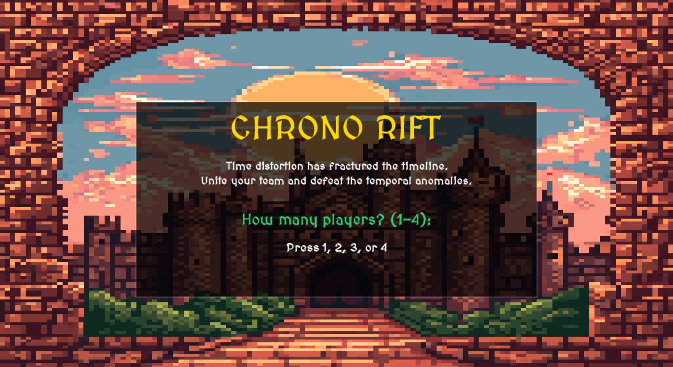

3. Shared Memory and Synchronization
The entire game state lives in a single SharedState struct mapped into all three processes. The struct is created with shm_open and ftruncate, then mapped with mmap using PROT_READ | PROT_WRITE | MAP_SHARED.

3.1 Key Fields in SharedState
Field | Type | Purpose
entities[MAX_ENTITIES] | Entity[] | All players and NPCs, up to 24 total (4 players + 20 NPCs)
action_slot | ActionSlot | The single pending action submitted by HIP or ASP
artifacts | ArtifactTable | Tracks holder and wanted_by for Solar Core, Lunar Blade, Eclipse Relic
player_turn_sem | sem_t | Posted by Arbiter when a player's turn begins; consumed by the correct player thread
npc_turn_sem | sem_t | Posted by Arbiter when an NPC's turn begins; consumed by the correct NPC thread
state_mutex | pthread_mutex_t | Protects general game state reads and writes
action_mutex | pthread_mutex_t | Protects action_slot and current_turn
player_input | PlayerInput | Filled by the renderer thread when the player presses a key
awaiting_drop_response | bool | Set by Arbiter/HIP when a weapon drop prompt is pending
awaiting_eclipse_response | bool | Set by Arbiter when the Eclipse Relic pickup prompt is pending
game_status | GameStatus | GAME_RUNNING, GAME_WIN, GAME_LOSE, or GAME_QUIT

3.2 Synchronization Primitives
All mutexes and semaphores are initialised with PTHREAD_PROCESS_SHARED so they work across process boundaries in the shared memory segment.

- state_mutex: held whenever a thread modifies entities, enemies_killed, spawn counters, or the action log.
- action_mutex: held when reading or writing action_slot or current_turn.
- artifacts.table_mutex: held when reading or writing the ArtifactTable. Never held while also holding state_mutex to avoid nested lock ordering issues.
- player_input.mutex: held when the renderer writes input and when HIP reads it.
- player_turn_sem / npc_turn_sem: posted by the Arbiter scheduler to signal whose turn it is. Consumed by the thread for that entity.

4. Temporal Scheduling and Stamina Logic
The scheduler runs inside the Arbiter process in the main thread after fork. It implements an Active Time Battle (ATB) system where each entity accumulates stamina over time based on its speed stat. Only when stamina reaches max_stamina is the entity eligible to act.

4.1 Scheduling Algorithm
- Every tick (100ms sleep), tick_stamina() is called. It locks state_mutex and adds each entity's speed to its current stamina, capped at max_stamina.
- Stunned entities and dead entities are skipped and receive no stamina.
- find_next_actor() collects all entities with stamina >= max_stamina. If only one qualifies, that entity acts. If multiple qualify simultaneously, a round-robin tie-breaker uses last_actor_index to ensure fair rotation.
- Once an actor is selected, the Arbiter sets current_turn and posts the appropriate semaphore (player_turn_sem or npc_turn_sem). Only the thread for that entity will proceed; all others re-post the semaphore and loop back.
- The Arbiter then waits in wait_for_action(). For player turns, it waits indefinitely. For NPC turns, it times out after 3 seconds and auto-submits a Skip.
- After the action is received, apply_action() is called under state_mutex, then check_game_status() checks win/lose conditions.

4.2 Entity Stats (Seeded from Roll Numbers)
Stats are initialised in init_entities() using the roll numbers as the basis for all random values, seeded with srand(ALI_ROLL).

Stat | Player Formula | NPC Formula
HP | 2565 + random(100 to 1000) | 65 + random(50 to 200)
Damage | 5 + 10 = 15 (last digit of 2565) | 6 + 10 = 16 (second-last digit of 2565)
Speed | 100 / player_count | random(10 to 30)
Max Stamina | 100 | 150

4.3 NPC Count
The number of concurrent enemies at game start is decided randomly each run: npc_count = 2 + (rand() % 8), which produces a value between 2 and 9 inclusive as specified. When an NPC dies and the total kill count is below 10, a reinforcement is spawned (up to a cap of 20 total NPCs over the course of the game).
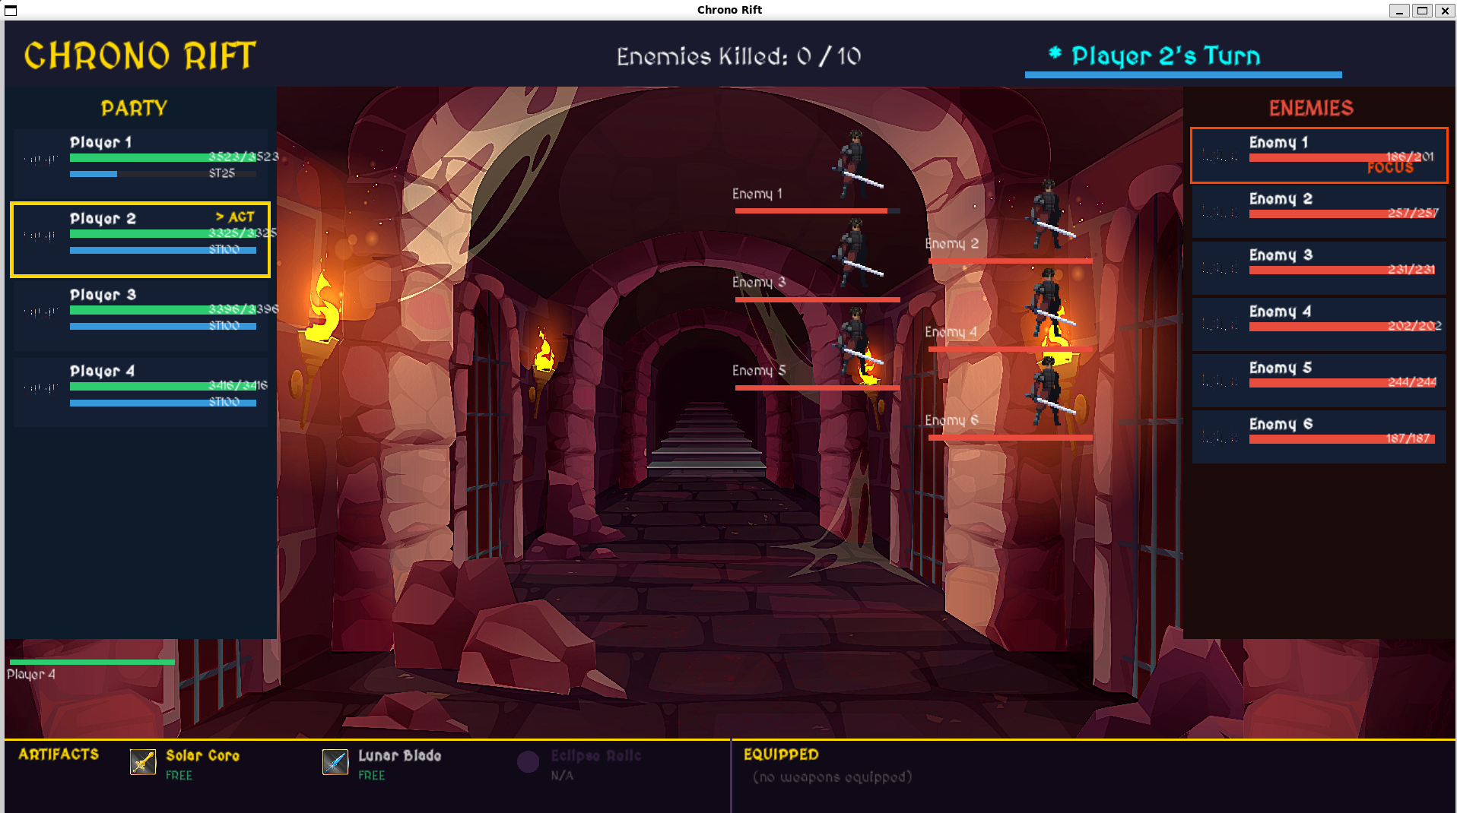
5. Player and NPC Actions

5.1 Player Actions
Choice | Action | Effect on Stamina | Effect
1 | Strike | Reset to 0 | Deals player's damage stat as HP damage to target enemy
2 | Exhaust | Reset to 0 | Reduces target enemy's stamina by player's damage stat x 2
3 | Heal | Reset to 0 | Restores 10% of the player's max HP
4 | Skip | Reset to 50% | Loses the turn, stamina set to half
5 | Use Weapon | Reset to 0 | Deals the selected weapon's damage to a target enemy
6 | Swap In | Reset to 0 | Moves a weapon from Long Term Storage to primary inventory
7 | Stun | Reset to 0 | Sends SIGUSR1 to the target's process; halts that entity for 3 seconds
8 | Ultimate | Reset to 0 | Freezes the entire ASP process for 10 seconds (requires Solar Core + Lunar Blade)
9 | Quit | N/A | Sends SIGTERM to the Arbiter, ending the game

5.2 NPC Actions
Each NPC thread selects from two actions: Strike (attacks a random alive player) or Skip (if no alive players exist). The decision is made inside the npc_thread function in asp.cpp.

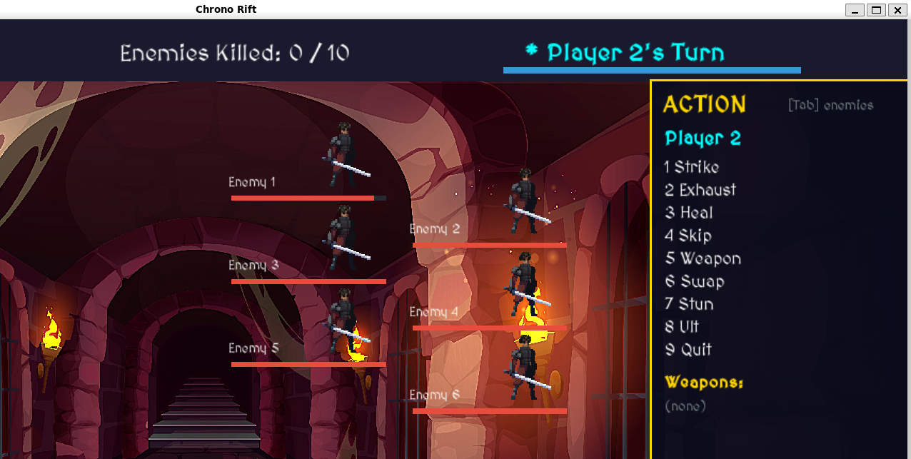
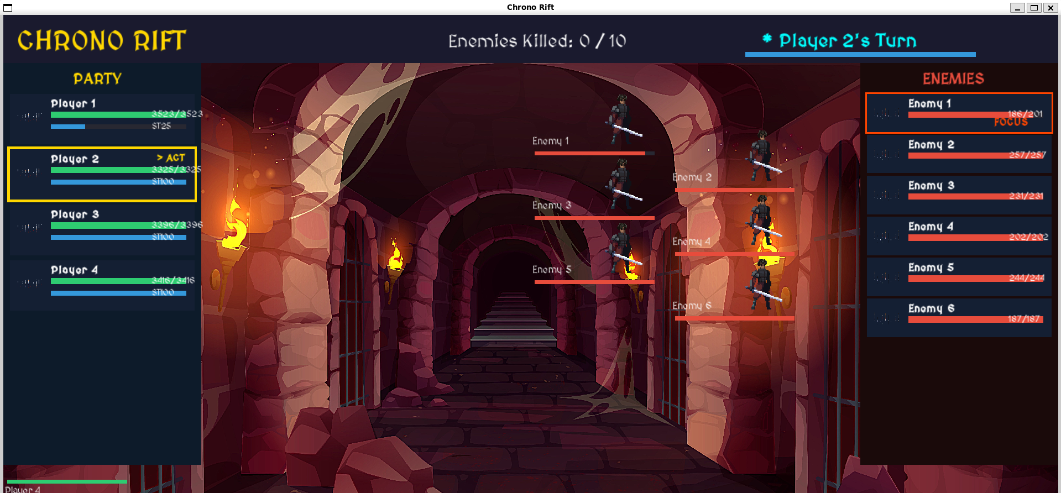

6. Human Interfacing Process (HIP)
HIP is a separate process that attaches to shared memory and spawns one pthread per player character. It is responsible for reading player input and forwarding it to the Arbiter via the shared action_slot.

6.1 Thread Flow
- Each player thread waits on sem_wait(&player_turn_sem).
- When the semaphore is posted by the Arbiter, the thread checks current_turn. If it does not match its own player index, it re-posts the semaphore and loops.
- Before checking current_turn, the thread checks state->entities[my_index].is_stunned. If stunned, it sleeps 3 seconds in thread context, clears the flag, submits a skip, and continues without sem_post.
- If it is this thread's turn and not stunned, get_player_action() is called. This sets awaiting_player_input and waits for the renderer thread (in the Arbiter process) to fill the player_input struct via keyboard events.
- Once input is ready, the thread builds an ActionSlot and writes it to state->action_slot under action_mutex, then clears awaiting_player_input.

6.2 Weapon Drop Handling
When an NPC dies and a weapon drop is triggered, the Arbiter sets pending_drop_weapon_id. HIP detects this at the start of get_player_action() and sets awaiting_drop_response. The renderer shows a Y/N prompt. If the player accepts, allocate_weapon() places it in the primary inventory. If Solar Core or Lunar Blade is accepted, acquire_artifact() is also called to register the player as the holder in the ArtifactTable.

6.3 Signal Handling in HIP
HIP registers handle_sigusr1_hip for SIGUSR1. The handler is intentionally empty. Its only purpose is to interrupt sem_wait() with EINTR so the thread wakes up and checks its own is_stunned flag. This avoids calling unsafe functions in signal handler context.

7. Automated Strategic Process (ASP)
ASP attaches to shared memory and manages all NPC entities. Each NPC runs in its own dedicated pthread, making decisions independently and concurrently. A separate spawn loop thread watches for spawn_pending_count and creates new NPC threads dynamically as reinforcements.

7.1 NPC Thread Flow
- Each NPC thread waits on sem_wait(&npc_turn_sem).
- On wakeup, the thread checks if it is still alive and if game_status is GAME_RUNNING.
- It then checks state->entities[my_index].is_stunned. If true, it sleeps 3 seconds, clears is_stunned, and submits a skip.
- If not stunned, it checks current_turn. If it does not match, it re-posts the semaphore and loops.
- If it is this NPC's turn, it picks a random alive player target and submits an ACTION_ATTACK_STRIKE, or ACTION_SKIP if no targets exist.
- The thread waits for the Arbiter to reset action_slot.ready before looping again.

7.2 NPC Weapon Pickup
When a player declines a weapon drop, the Arbiter sets npc_should_pickup and npc_weapon_id. The active NPC thread picks it up, adding the weapon's damage to the shared npc_weapon_damage_bonus pool. All subsequent NPC Strike actions include this cumulative bonus. If the weapon is Solar Core or Lunar Blade, acquire_artifact() is called to register the NPC in the ArtifactTable.

7.3 Signal Handling in ASP
Like HIP, ASP registers an empty SIGUSR1 handler. The signal interrupts sem_wait via EINTR. The stunned NPC's thread wakes, checks its own is_stunned flag, and handles the stun in thread context using sleep(3). This is the correct POSIX-compliant approach: sleep() and memory accesses are unsafe in signal handlers.

8. Asynchronous Stun Mechanic
The Stun mechanic is implemented entirely through POSIX signals as required. The key constraint is that the signal must interrupt the target process asynchronously, without the target polling a flag or a pipe.

8.1 Stun Flow
- Arbiter's apply_action() receives an ACTION_STUN. It sets target->is_stunned = true under state_mutex, then calls kill(target_pid, SIGUSR1) where target_pid is either hip_pid or asp_pid.
- The signal is delivered to the target process asynchronously. The empty signal handler fires, interrupting sem_wait with EINTR.
- The thread wakes from sem_wait and checks state->entities[my_index].is_stunned. This check is per-entity, so even if the wrong thread catches the signal, the correct thread will see its own flag set to true when it next wakes.
- The stunned thread sleeps for exactly 3 seconds in its normal execution context, then clears is_stunned, submits a skip action, and returns to its main loop.
- The Arbiter's scheduler skips stunned entities in find_next_actor(), so the entity receives no turns during the stun window. Its stamina is also frozen (tick_stamina skips stunned entities).
- After the stun clears, the entity resumes stamina accumulation from wherever it was before.

8.2 Why Per-Entity Flags Instead of a Global Flag
The previous implementation used a single global volatile flag g_player_stunned. With multiple player threads, any thread could consume the flag, meaning the wrong player might be treated as stunned. The correct implementation checks state->entities[my_index].is_stunned, which is set by the Arbiter specifically for the target entity. Regardless of which thread catches the SIGUSR1 signal, each thread only acts on its own entity's flag.

9. Weapon Inventory Management
Each player entity has a primary inventory of 20 contiguous integer slots (inventory[20]) and a long-term storage (LTS) of up to 10 weapons. The inventory allocator in shared/inventory.h manages placement and eviction.

9.1 Weapon Table
ID | Weapon Name | Slots | Damage
0 | Solar Core | 10 | 95
1 | Lunar Blade | 10 | 90
2 | Iron Halberd | 7 | 55
3 | Venom Dagger | 4 | 30
4 | Thunderstaff | 6 | 50
5 | Obsidian Axe | 5 | 45
6 | Frostbow | 6 | 48
7 | Splinter Stick | 2 | 12

9.2 Allocation Logic (shared/inventory.h)
- allocate_weapon(): calls find_free_run() to locate the first contiguous block of free slots large enough for the weapon. If found, fill_slots() writes the weapon ID into those slots.
- evict_and_place(): called when no free contiguous run exists. Collects all distinct weapons currently in the inventory and iterates all subsets using a bitmask (from smallest to largest). For each subset, a simulated layout is checked. The first subset that frees enough contiguous space is committed: those weapons are pushed to LTS with push_to_lts() and removed from the primary inventory. The new weapon is then placed in the freed space.
- swap_in(): removes a weapon from LTS by shifting entries, then calls allocate_weapon() on it. If placement fails, the weapon is re-inserted at the end of LTS.
- Hard constraint: Solar Core and Lunar Blade each occupy 10 slots. If both are in the primary inventory, all 20 slots are occupied. No further weapon can be placed in the primary inventory, and eviction is impossible. The allocator returns false in this case.

9.3 Weapon Drops
- On first NPC kill: a weapon always drops. On subsequent kills: 65% chance.
- If the player accepts the drop: allocate_weapon() is called. If the player declines: the weapon is added to the NPC damage bonus pool.
- If the weapon is Solar Core or Lunar Blade and the player successfully places it: acquire_artifact() registers the player as the holder.
- An eviction consistency check runs after every weapon allocation: if Solar Core or Lunar Blade was pushed to LTS during the allocation, release_artifact() is called to free the artifact table entry.

10. Artifact System and Deadlock Detection
The game includes three special artifacts tracked in the shared ArtifactTable. Each artifact has three associated fields: a free flag, a holder index, and a wanted_by index. Access to the table is always protected by artifacts.table_mutex.

10.1 Artifacts
Artifact | When Available | Special Rule
Solar Core | From game start (as a droppable weapon) | Required for Ultimate Ability (with Lunar Blade)
Lunar Blade | From game start (as a droppable weapon) | Required for Ultimate Ability (with Solar Core)
Eclipse Relic | Spawns when 5 enemies are killed | Can be picked up by players or NPCs; follows same exclusivity rules

10.2 Artifact Locking (shared/artifacts.h)
- acquire_artifact(state, entity_idx, artifact_id): locks table_mutex, checks the free flag. If free, sets free=false and holder=entity_idx. If not free, sets wanted_by=entity_idx and returns false.
- release_artifact(state, entity_idx, artifact_id): locks table_mutex, sets free=true, clears holder and wanted_by.
- release_all_artifacts(): called on entity death. Releases any artifact that entity was holding. Protected by table_mutex.
- All three functions print a log line to stdout for traceability.

10.3 Deadlock Detection (deadlock_monitor thread)
A background pthread is spawned in the Arbiter. Every 2 seconds it wakes and checks for circular waits across all pairs of artifacts.

The detection logic: for every pair of artifacts X and Y, if entity A holds X and wants Y (wanted_by[X] == A, holder[Y] == A is wrong : let me state it precisely): if holder[X] == A and wanted_by[X] == B and holder[Y] == B and wanted_by[Y] == A, then A and B are in a circular wait.

Resolution: the monitor prefers to evict an NPC over a player. If both are the same type, the entity with the higher index is forced to release. release_artifact() is called on the chosen victim.

10.4 Eclipse Relic Pickup
After each entity's turn, offer_eclipse_relic() is called in the Arbiter scheduler. If the Eclipse Relic exists and is free, it is offered to the current actor.
- If the actor is a player: awaiting_eclipse_response is set. The renderer shows a Y/N prompt. The scheduler busy-waits for the renderer to clear the flag. If the player accepts, acquire_artifact() is called.
- If the actor is an NPC: acquire_artifact() is called immediately (NPCs always pick it up).
- The Eclipse Relic follows the same locking and deadlock rules as Solar Core and Lunar Blade once acquired.

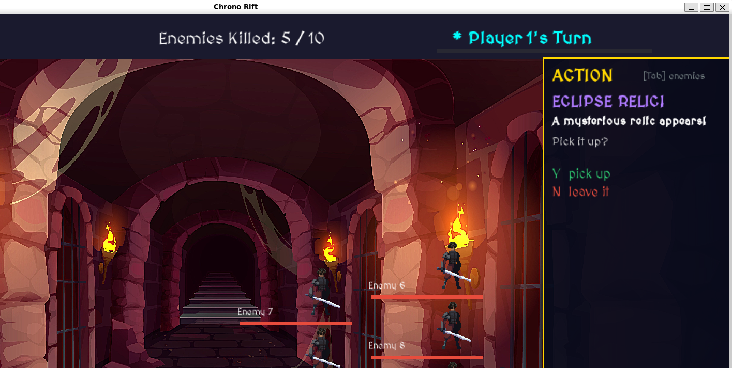

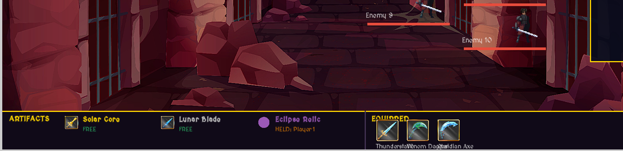

11. Ultimate Ability
The Ultimate Ability is a high-impact player action that freezes all NPC activity for 10 seconds. It requires the player to hold both Solar Core and Lunar Blade in their primary inventory simultaneously.

11.1 Implementation
- When ACTION_ULTIMATE is received, check_ultimate_eligibility() scans the player's primary inventory for both weapon IDs.
- If eligible: kill(asp_pid, SIGSTOP) is called. SIGSTOP cannot be caught or ignored; it immediately suspends the entire ASP process, freezing all NPC threads.
- alarm(10) is set. After 10 seconds, SIGALRM is delivered to the Arbiter. The handle_sigalrm handler calls kill(asp_pid, SIGCONT), resuming ASP.
- If not eligible: the action is rejected with a log message and the player's stamina is set to 50% (treated as a failed skip).
- The suspension and resumption use only signals (SIGSTOP, SIGCONT, SIGALRM). No flags, pipes, or shared memory fields are involved in coordinating this pause.

11.2 NPC Turn Timeout During Ultimate
If the Arbiter's scheduler posts npc_turn_sem during the 10-second window (which can happen if tick_stamina ran before SIGSTOP took effect), wait_for_action() will time out after 3 seconds and auto-submit a skip for that NPC. This prevents the Arbiter from blocking indefinitely.

12. Graphical Interface (SFML Renderer)
The renderer runs in a dedicated pthread inside the Arbiter process. It reads game state directly from shared memory every frame and updates the display independently of the scheduling loop. No locks are held for the duration of a render frame; the renderer reads values atomically where possible and accepts the risk of a torn read on non-critical display fields.

12.1 UI Elements
- Welcome screen: displays game title, prompts the player to choose party size (1 to 4), and waits for a keypress.
- Battle background: tiled sprite covering the full window.
- Entity panels: one panel per entity showing name, HP bar, stamina bar, and a stunned indicator.
- Action menu: presented on the player's turn. Shows all 9 choices with keyboard shortcuts.
- Target selection: after choosing an attack or stun, the player selects a target enemy.
- Weapon selection: for Use Weapon and Swap In actions, a list of available weapons is shown.
- Drop prompt: when a weapon drops, a Y/N overlay asks if the player wants to pick it up.
- Eclipse Relic prompt: a Y/N overlay when the Eclipse Relic is available for pickup.
- Action log: a scrolling panel showing the last 8 events in the game.
- Artifact panel: shows which entity holds each artifact (Solar Core, Lunar Blade, Eclipse Relic).
- Win / Lose / Quit screen: displayed at game end.

12.2 Input Handling
Keyboard input is handled inside the render thread. When a key is pressed, the renderer identifies the current input state (INPUT_SHOW_MENU, INPUT_SHOW_TARGETS, INPUT_DROP_PROMPT, INPUT_ECLIPSE_PROMPT, etc.) and writes the result into state->player_input under player_input.mutex. It then sets player_input.pending = true, signalling the HIP player thread to read it.

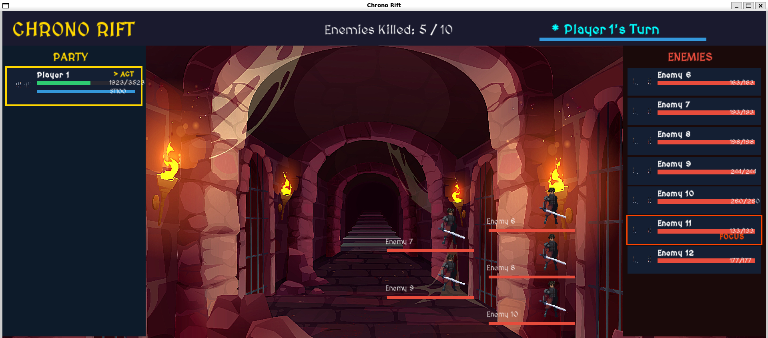

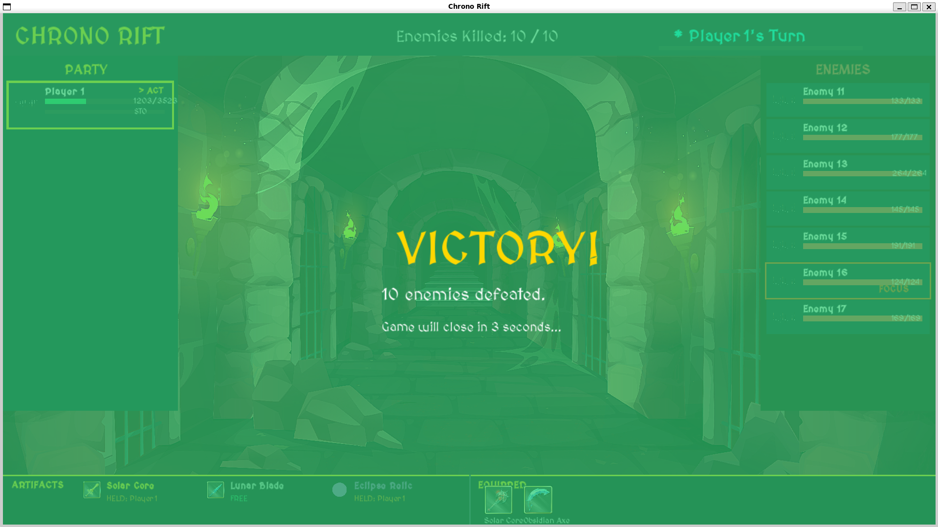

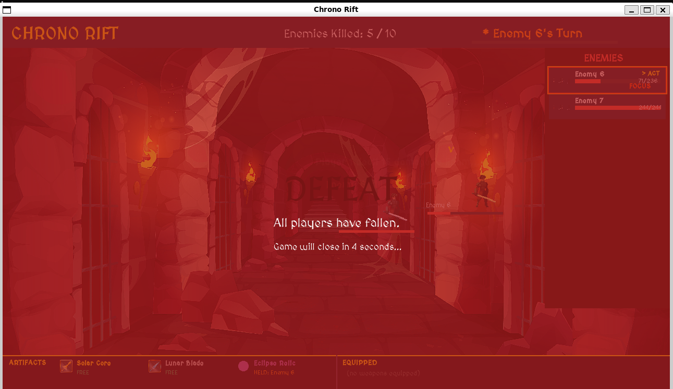

13. Complete Game Flow
Step | Description
1 | Arbiter starts. Shared memory is created and initialised.
2 | Render thread starts. Welcome screen shown. Player selects party size.
3 | init_entities() populates players and NPCs in shared memory. NPC count is random between 2 and 9.
4 | Arbiter forks HIP and ASP. Both processes attach to shared memory.
5 | HIP spawns one thread per player. ASP spawns one thread per NPC.
6 | Deadlock monitor thread starts in Arbiter.
7 | run_scheduler() begins. Stamina ticks every 100ms.
8 | When an entity's stamina reaches max, the Arbiter posts the appropriate semaphore.
9 | The correct thread wakes, checks for stun, checks current_turn, then acts.
10 | Action is submitted to action_slot. Arbiter reads it and calls apply_action().
11 | On NPC death: weapon drop check, artifact release, reinforcement spawn check.
12 | At 5 kills: Eclipse Relic spawns and is offered to entities after each turn.
13 | Game ends when 10 kills reached (win), all players dead (lose), or SIGTERM received (quit).
14 | Arbiter sends SIGTERM to HIP and ASP. Both exit. Shared memory is destroyed.

14. Win, Lose, and Quit Conditions
Condition | Trigger | Mechanism
Win | Players kill 10 enemies total | enemies_killed >= 10 in check_game_status(); game_status = GAME_WIN
Lose | All player characters die | No alive players found in check_game_status(); game_status = GAME_LOSE
Quit | Player selects action 9 | HIP sends SIGTERM to arbiter_pid; handle_sigterm sets game_status = GAME_QUIT

15. OS Concepts Applied
OS Concept | Where Applied | Implementation
POSIX Shared Memory | All IPC | shm_open, ftruncate, mmap with MAP_SHARED across all three processes
Process Creation | HIP and ASP launch | fork() + execl() from Arbiter
Multi-threading | HIP, ASP, Arbiter | pthread_create for player threads, NPC threads, render thread, deadlock monitor
Mutexes | State protection | pthread_mutex_t with PTHREAD_PROCESS_SHARED in shared memory
Semaphores | Turn signalling | Unnamed sem_t with pshared=1 in shared memory
Signals | Stun, Ultimate, Quit | SIGUSR1 (stun), SIGSTOP/SIGCONT/SIGALRM (Ultimate), SIGTERM (quit)
Signal Safety | Stun handler | Handlers are empty; stun logic runs in thread context using per-entity is_stunned flag
Deadlock Detection | Artifact contention | Background monitor thread checks circular waits every 2 seconds and forces release
Process Synchronization | Turn order | Semaphores ensure serial action execution while stamina accumulates concurrently
Dynamic Process Management | NPC reinforcements | New NPC threads spawned at runtime; spawn_pending_count signals ASP to create threads

16. File Structure
File | Purpose
arbiter/arbiter.cpp | Main entry point. Creates shared memory, forks HIP and ASP, starts scheduler and threads.
arbiter/init.h | Entity initialisation. Populates players and NPCs in shared memory using roll number seed.
arbiter/scheduler.h | ATB scheduler, action dispatcher, stamina tick, win/lose checks, Eclipse Relic offer logic.
arbiter/renderer.h | SFML render thread. Draws all UI elements, handles keyboard input, manages input state machine.
hip/hip.cpp | HIP process entry. Spawns player threads. Handles SIGUSR1 (stun) and SIGTERM.
hip/input.h | Player action collection. Waits for renderer input, builds ActionSlot, calls acquire_artifact.
asp/asp.cpp | ASP process entry. Spawns NPC threads and spawn loop. Handles SIGUSR1 and SIGTERM.
shared/shared_state.h | All shared data types: Entity, ActionSlot, ArtifactTable, SharedState, weapon constants.
shared/shared_memory.h | create_shared_memory, attach_shared_memory, destroy_shared_memory.
shared/inventory.h | Weapon inventory allocator: find_free_run, evict_and_place, swap_in.
shared/artifacts.h | Artifact acquire/release, deadlock_monitor thread, spawn_eclipse_relic.
Makefile | Builds arbiter_exe, hip_exe, asp_exe with SFML flags.
Dockerfile | Ubuntu 22.04 container with build-essential, libsfml-dev.

17. Turnaround Time Analysis
In the context of this scheduler, turnaround time for an entity is the time from when its stamina first reached max_stamina to when its action has been fully applied.

The arrival time for an entity's turn is determined by: time_to_full_stamina = max_stamina / speed. For a player with speed 100 (single player) and max_stamina 100, the first turn arrives at 1 tick (100ms). For an NPC with speed 20 and max_stamina 150, the first turn arrives at 7.5 ticks (750ms).

Turnaround time = wait time (time in ready queue) + service time (time to submit and apply action). For player actions, service time depends on human input speed. For NPC actions, service time is bounded by the 3-second timeout.

Entity Type | Max Stamina | Speed (example) | Ticks to First Turn | Time to First Turn
Player (1 player) | 100 | 100 | 1 | ~100ms
Player (4 players) | 100 | 25 | 4 | ~400ms
NPC (slow) | 150 | 10 | 15 | ~1500ms
NPC (fast) | 150 | 30 | 5 | ~500ms

When multiple entities reach max stamina simultaneously, the round-robin tie-breaker ensures fairness: the entity with the lowest index greater than last_actor_index is chosen. This prevents starvation of any single entity in a tied scenario.

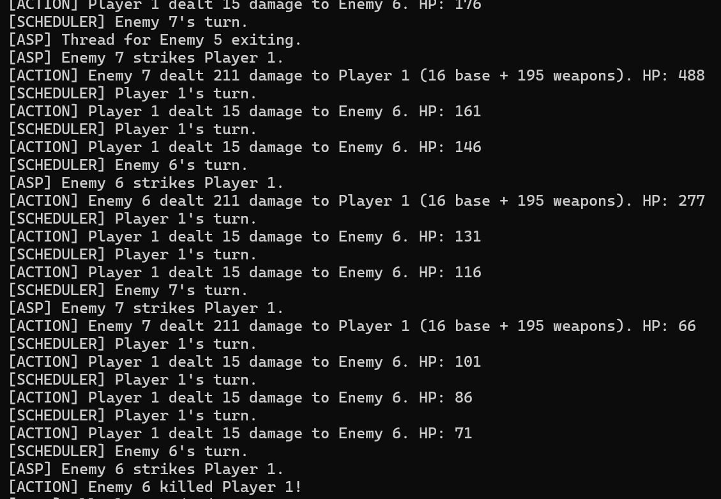

18. Conclusion
Chrono Rift successfully implements a complete multi-process tactical game that applies every core OS concept covered in CS 2006. The three-process architecture with POSIX shared memory IPC, multi-threaded players and NPCs, semaphore-based turn signalling, signal-driven stun and Ultimate mechanics, a minimum-eviction inventory allocator, and a circular-wait deadlock monitor all function together to produce a stable and playable game.

Key design decisions included using per-entity is_stunned flags instead of a global flag to ensure correct stun targeting across multiple threads, using empty SIGUSR1 handlers so that sleep() is called only in safe thread context, and wiring acquire_artifact() into the weapon pickup flow so that the ArtifactTable accurately reflects the game state and the deadlock monitor has real circular waits to detect and resolve.

Muhammad Ali (23i-2565) and Ahmed Ijaz (23i-0644)

