**MIDDLE EAST TECHNICAL UNIVERSITY**

**ELECTRICAL AND ELECTRONICS ENGINEERING DEPARTMENT**



**EE463 STATIC POWER CONVERSION-I**

**PROJECT #2 REPORT**

**Due Date: 16.12.2018**

**Team Members**

**Ali AYDIN 2093326**

**Furkan TOKGOZ 2031458**

**INTRODUCTION**

In this project, we make some simulation about controlled and uncontrolled rectifiers. Firstly, we examine single phase controlled rectifiers which are fully controlled and half controlled rectifier. Fully controlled rectifier consists of 4 thyristor and half controlled rectifier consists of 2 thyristor and two diodes. Secondly, by using three phase full bridge diode rectifier, we simulate a dc motor and we find some parameters about DC motor like armature current, speed etc. Then, we calculate its efficiency. Finally, we describe 12 pulse rectifier`s operation and application areas. Then, we compare that rectifier with full bridge rectifier.

**Question 1-)**

**Part a-)**

1. Fully Controlled Rectifier

To calculate firing angle, we need a formula and we know that formula from courses.

(1)

Where Vs = 230 VRMS, w = 2f, f = 50, Hz, Ls = 0.5 mH and Id = 40 A.

We know above values but we do not know Vd and α. To find Vd, we can write voltage equation and that is

(2)

(3)

We know that average voltage of inductor in a period is zero. Then, Vd is equal to VR and Vd is 40*4 = 160 V.

When we use equation 1, we find α as 41 degree. For that angle, average current is 38.25 A.

1. Half-Controlled Rectifier

Calculation of the output average voltage is straight forward.

(4)

The only unknown in this equation is Vd which we have calculated as 160 V in the first part. So, α is equal to 57 degrees while Vs is equal to 230 V. We have found the average current 39.52 A for a firing angle of 57 degrees.

**Part b-)**

1. Fully Controlled Rectifier

We found the THD is %43.65.

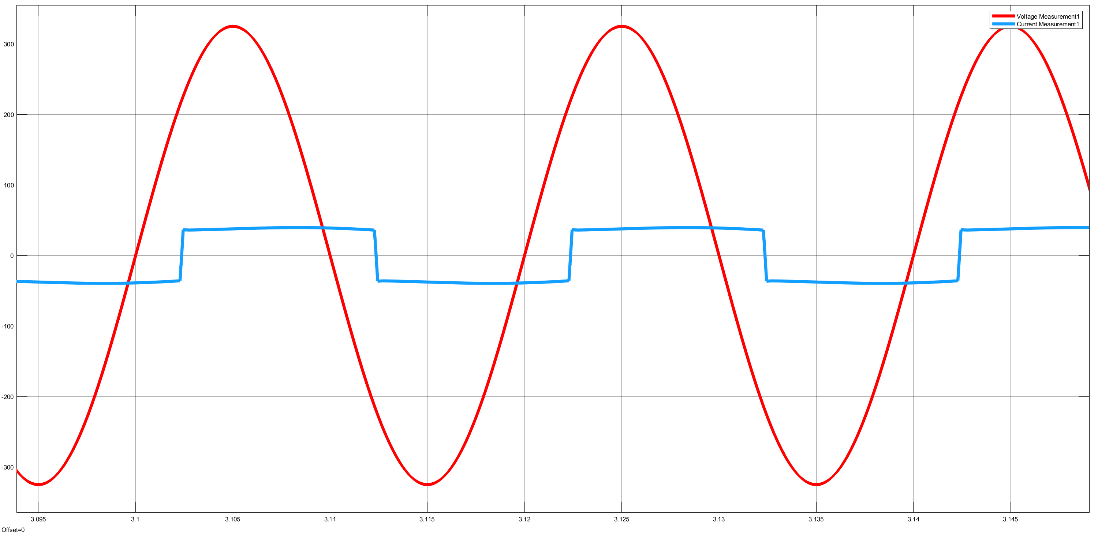

Figure 1: Waveforms of input voltage(red) and input current(blue)

1. Half-Controlled Rectifier

For half-controlled topology, THD is found as %25.85.

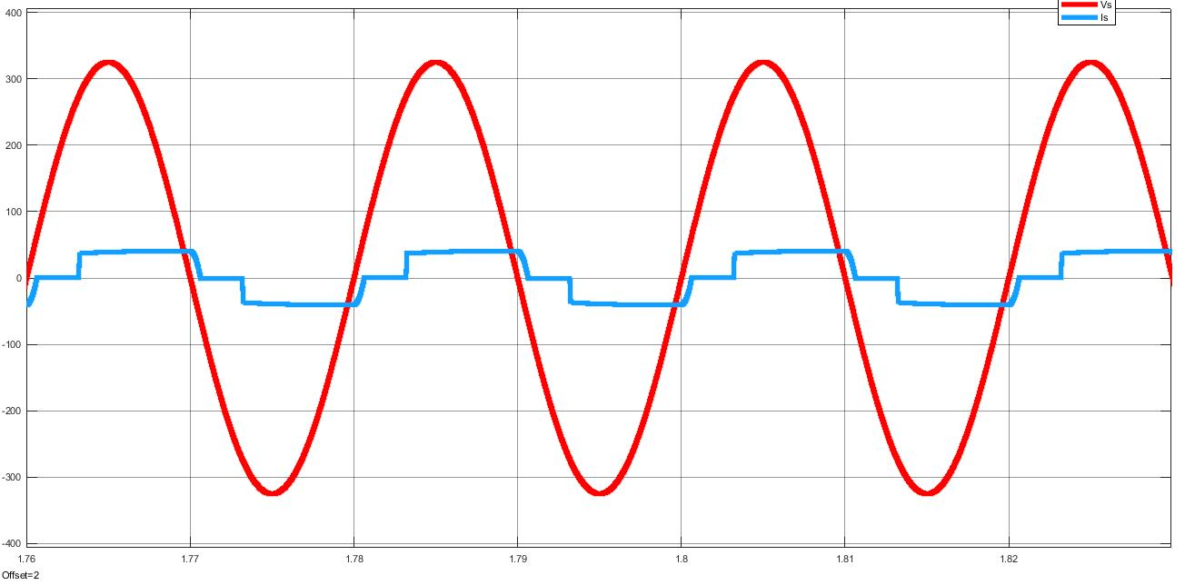

Figure 2: Waveforms of input voltage(red) and input current(blue)

c)

Both topologies have some advantages and disadvantages. Fully-controlled rectifiers can be operated in both quadrants whereas half controlled rectifiers cannot since diode is a single quadrant element. However, fully- controlled rectifiers can be expensive because, one should use 4 thyristors and their controllers. Also, this configuration can be hard to implement. Half- controlled rectifiers, on the other hand, uses 2 thyristors. This means it is cheaper than using fully-controlled rectifiers. However, if we set up the half-controlled rectifier as in the figure, we may end up with burnt diodes as a result. As, conducting diodes has a very small resistance, connecting them in series without a resistor may result in overcurrent in that branch.

**Question 2-)**

**Part a-)**

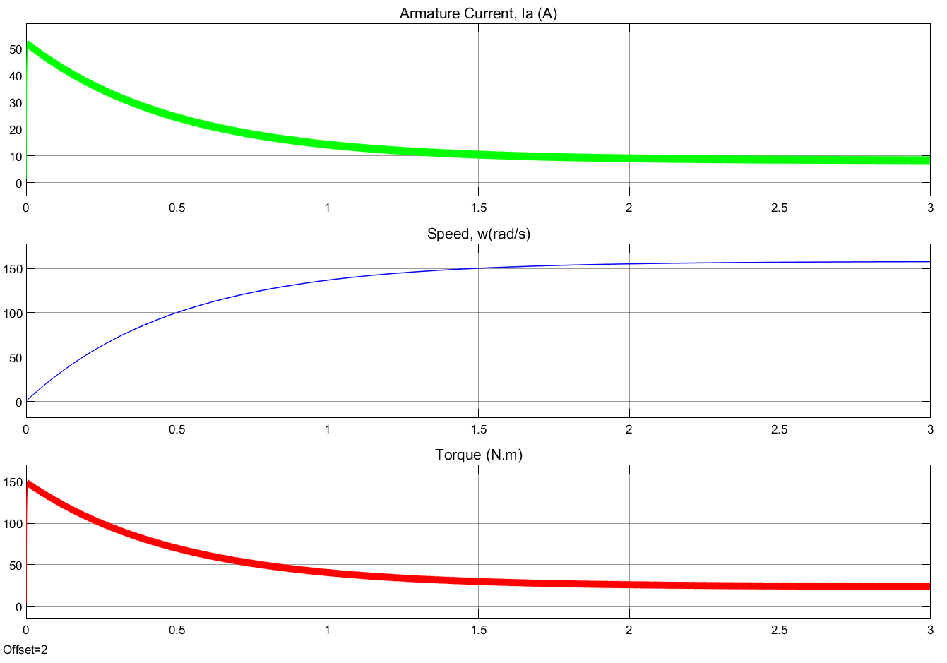

Figure 3: Characteristics of armature current, speed and torque of DC motor

**Part b-)**

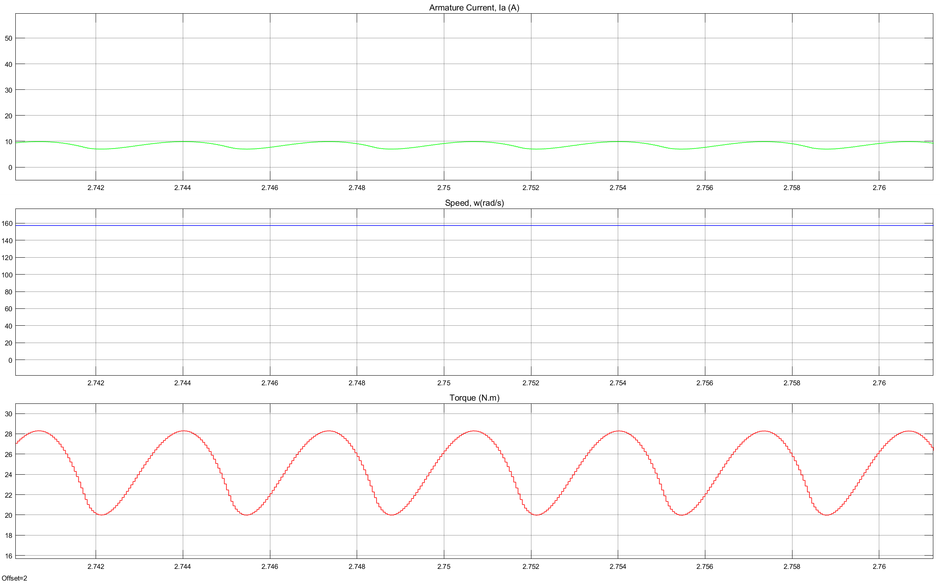

Figure 4: Torque characteristic of DC motor

Torque ripple is variations in torque production during revolution of shaft and this is undesirable effect since it prevents smooth motor rotation. It occurs when constant current is applied to rotate motor. Therefore, we have seen in the figure 4, torque is sinusoidal and its frequency is 300 Hz. Also, its magnitude is 28 N.m and its peak to peak value is 8 N.m.

Line current THD is found as %31.58 at steady state.

**Part c-)**

The first solution we came up with is connecting an inductor to the output of the rectifier. Since torque directly proportional to the armature current, in order to decrease torque ripple we should decrease current ripple. We have connected 50 mH inductor and the resultant torque graph can be seen in Fig. 5.

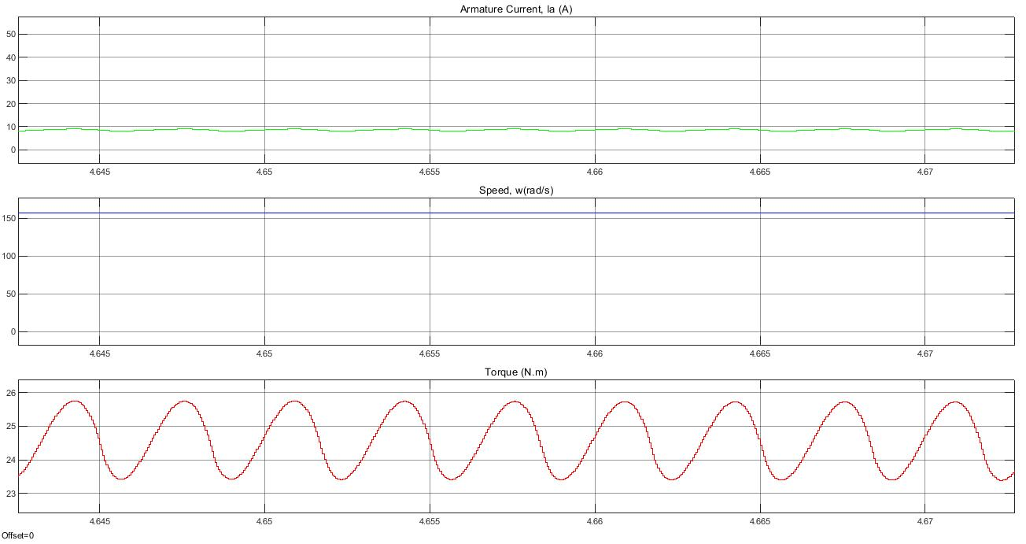

Figure 5: Torque characteristic of DC motor with series inductor

The second solution was connecting a shunt capacitor to the output of the rectifier circuit. We have connected 1 mF capacitor and the resultant torque waveform can be seen in figure 6. Both of the solutions requires big capacitor and inductor values which may be physically big and expensive for this power rating. One other solution might be using combining both inductor and capacitor to form a LC filter at the output of the rectifier circuit. This may results in smaller capacitor and inductor value which means smaller and less expensive solution to torque ripple problem.

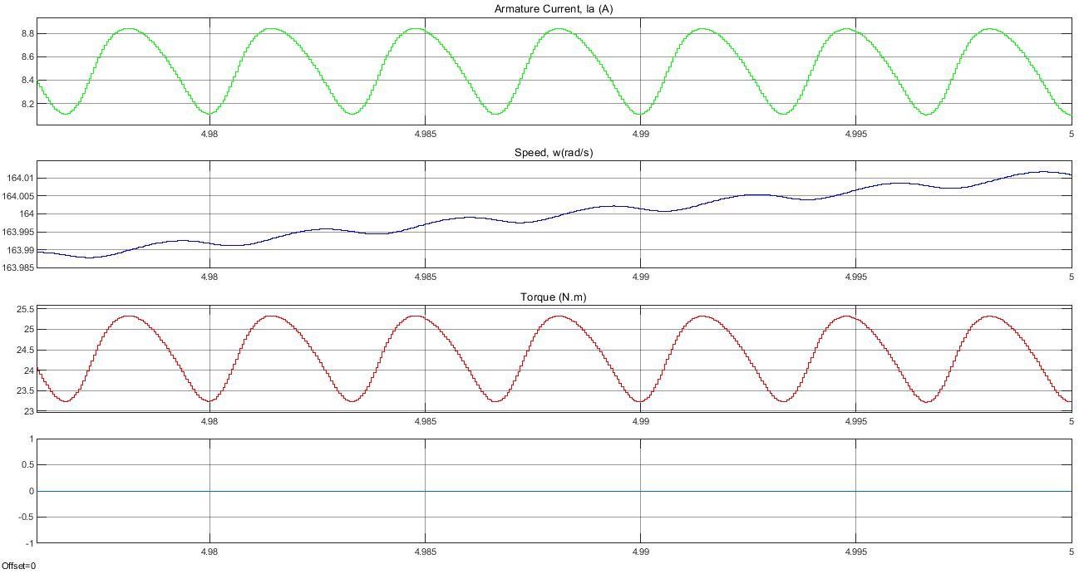

Figure 6. Torque characteristic of DC motor with shunt capacitor

**Part d-)**

To find overall drive efficiency, we need to find two parameters which are mechanical power output and electric power input. We can find mechanical power output by two formulas which are Ea*Ia and Te*w. Te is electrical torque and sum of load torque and friction torque. In our case, there is no friction torque and we can say that mechanical output power is Te*w where w is speed of shaft. We do not know Ea but we can find it by using back-emf constant. We multiply this constant with speed which is unit of rpm. And we multiply with armature current Ia. Then, mechanical output power is found 1927 W. Moreover, to calculate electric power input, there is one formula which is Vt*Ia where Vt is terminal voltage. When we calculate, electric power input is found 2318 W. Finally, drive efficiency is found %83.1.

Power loss arise from armature resistance and inertia. Armature resistance loss is ra*Ia and its value is 364 W. Inertia loss is 27 W.

Figure . Loss chart of the DC motor

**Question 3-)**

**Part a-)**

The name of the topology is 12 pulse rectifier. There is a transformer with two separate secondary windings. This enables us to acquire 3 more voltages with 30 degrees phase shift with respect to original voltage values. After getting 6 voltages with different phases, the next step is to rectify them via diodes or thyristors. In the output voltage, we will have a rectified voltage with smaller ripple voltage compared to 3 phase rectifiers. If we keep increasing number of phases to 12, 24 or 48, we will end up with smaller ripple voltages at output side. These kinds of pulse rectifiers are used in HVDC transmission systems. These systems need to convert high voltage AC to DC. Since using DC link capacitors to filtering ripple at output voltage at these high voltages is not feasible, increasing the number of pulses is a more efficient solution to this problem.

**Part b-)**

We have constructed full bridge and 12 pulse rectifier circuit at same simulation so that we can easily compare two topologies. Output voltage of a full bridge rectifier is as follows:

(5)

In our case Vs is equal to 400 V. The average value of output voltage is equal to 540 V. In order to get an average output voltage of 540 V in 12 pulse rectifier circuit, we have decreased the input voltage from 400 to 200 Vl-l. The result of the simulation is in Fig.8.

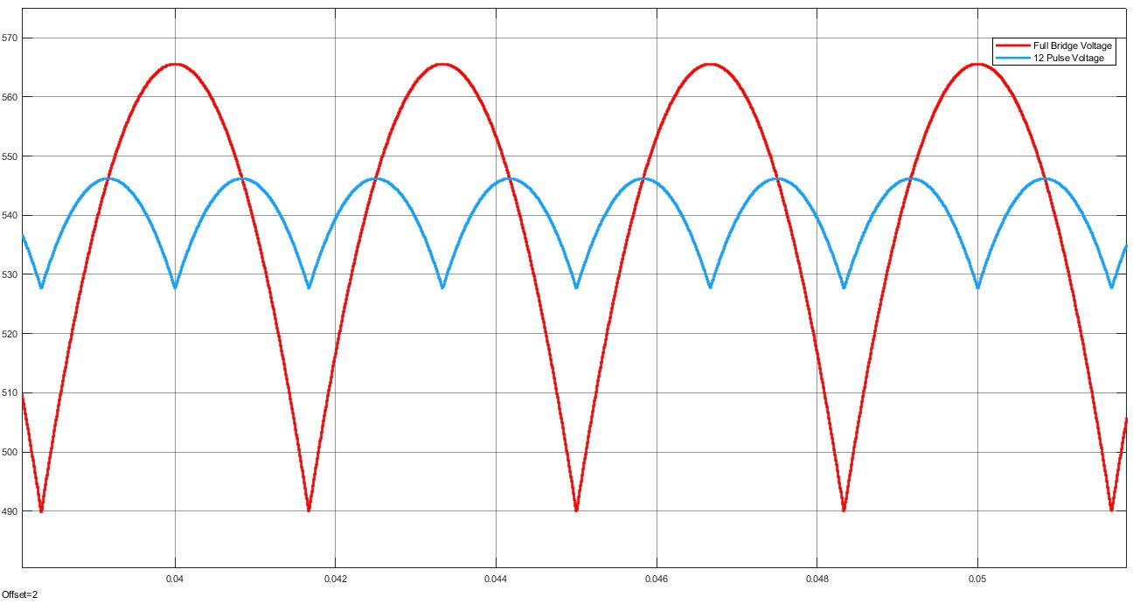

Figure 8: Output waveforms of full bridge rectifier(red) and 12 pulse rectifier(blue)

The average of output current then becomes 54 A in both cases as can be seen in Fig.9.

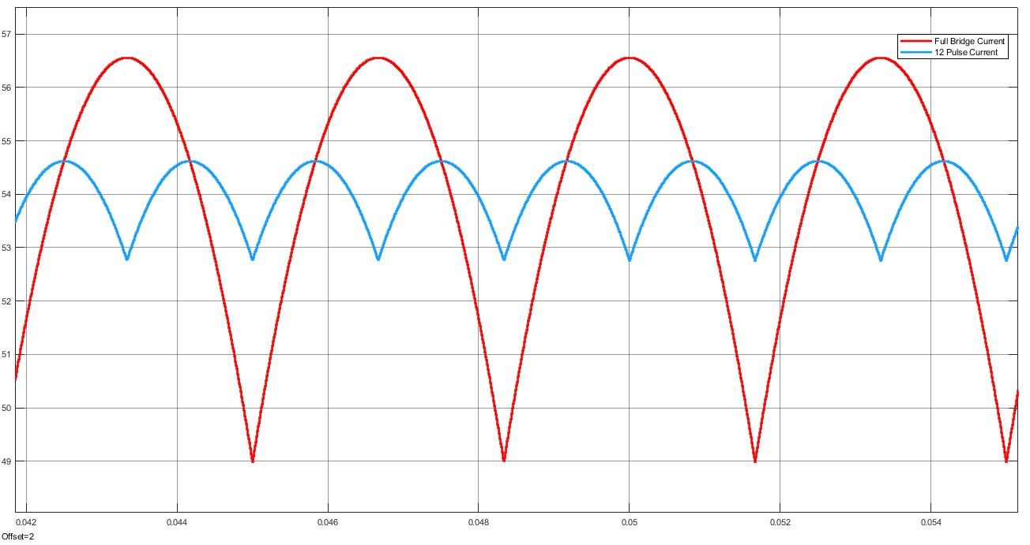

Figure 9: Output current waveforms of full bridge diode rectifier(red) and 12 pulse rectifier(blue)

We have acquired same average output voltage for half of the input voltage in 12 pulse rectifier topology. Also, the output voltage ripple in 12 pulse rectifier is smaller compared to full bridge rectifier circuit. That means if we want to use DC link capacitor to eliminate the ripples in output voltages, we can use smaller capacitors in 12 pulse rectifier topology which is a major advantage in high power applications. However, creating voltages with 30 degrees phase shift is a problem we need to consider for 12 pulse rectifier topology. It may increase the cost of transformer.

**Conclusion**

After learning controlled rectifiers in courses, we have simulated some rectifiers with different topologies in this project. At first, we have simulated fully-controlled rectifiers and half-controlled rectifiers. We have observed that fully-controlled rectifiers can operate in two-quadrant whereas half-controlled rectifiers cannot. Also, in half-controlled topology, line current THD was lower compared to fully-controlled topology. After that, we have created a motor driver circuit in question 2 and solved the problem about torque ripple with two different methods. At last, we have constructed 12 pulse rectifier topology and compared it with full-bridge rectifier circuit. We have observed that we can get same output voltage for half of the input voltage with 12 pulse rectifier circuit. Also, output voltage ripple is lower in 12 pulse rectifier topology.

Overall, this project taught us different circuit topologies, their advantages and disadvantages. Also, we have looked into Simulink program more deeply and simulated a DC machine.