**MIDDLE EAST TECHNICAL UNIVERSITY**

**ELECTRICAL AND ELECTRONICS ENGINEERING DEPARTMENT**



**EE463 STATIC POWER CONVERSION-I**

**PROJECT #3 REPORT**

**Due Date: 05.01.2019**

**Team Members**

**Ali AYDIN 2093326**

**Akın Şavklı 2095115**

**INTRODUCTION**

In this project, we examine some converter topologies which are three phase rectifier, buck and boost converter. Firstly, we fed a dc machine with three phase controlled rectifier by using simulink and we added the speed controller to motor. We controlled the speed with pi controller. Therefore, we observed overshoot in speed graph and motor reached to steady state. In the second part of the project, we designed a buck converter for specified input and output voltage in the Simulink. Thus, we chose the components of this converter with respect to component`s datasheet and made cost analysis. In third part of the project, we designed a boost converter in WEBENCH.

**Question 1-)**

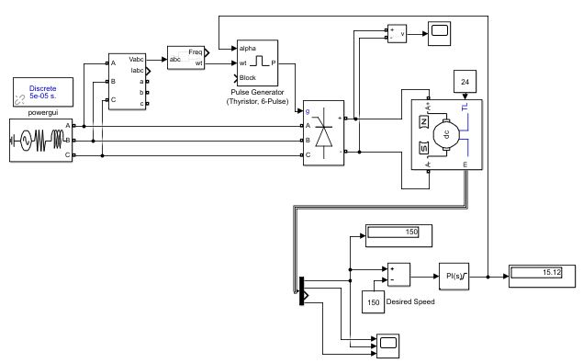

Figure 1: Setup for question 1

As seen in the figure 1, we feed a dc machine with three phase thyristor rectifier. In this question, we design a speed controller with pi controller block. Firstly, to examine the pi controller, we tried with two different desired speed which are 150 and 75 rad/sec in the figure 2 and 3, respectively. Those graphs consist of three different output which are armature current, speed and electrical torque. In the beginning of the graphs, armature current is too high since we give 522 Vdc and motor tries to accelerate suddenly. Due to that, motor takes high current. Explanation for the electrical torque is the same with current response. For speed of motor, motor tries to reach steady state and it accelerate suddenly but it cannot reach steady state since we arrange some pi constant and when motor accelerates, some error occur and pi constant tries to decrease this error but it takes time. When the desired speed is 75 rad/sec, there are huge overshoot since we used small integral constant.

|  |  |
| --- | --- |
| Figure 2: Speed regulation with 150 rad/sec desired speed | Figure 3: Speed regulation with 75 rad/sec desired speed |

Also, we applied performance test to motor and result is seen in the figure 4.

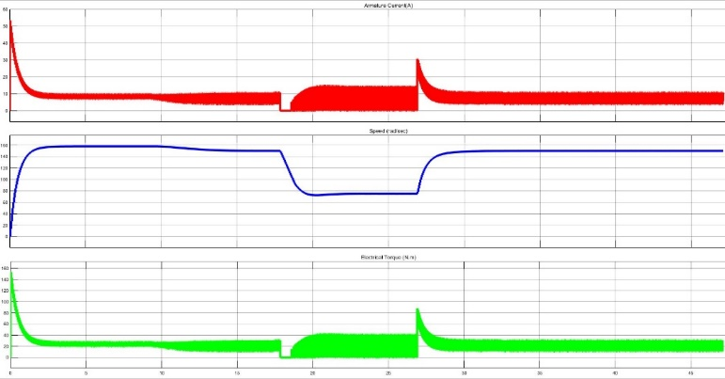

Figure 4: Result for performance test

In performance test, firstly, we arranged the desired speed to 150 rad/sec and we waited to reach motor to steady state. After it reached to steady state, we changed the desired speed to 75 rad/sec. In shorth amount of time, motor reached to steady state since small error occurred from 150 to 75. When it reached to steady state, we changed the desired speed. In shorth amount of time, because of the small error, it reached to steady state.

**Question 2-)**

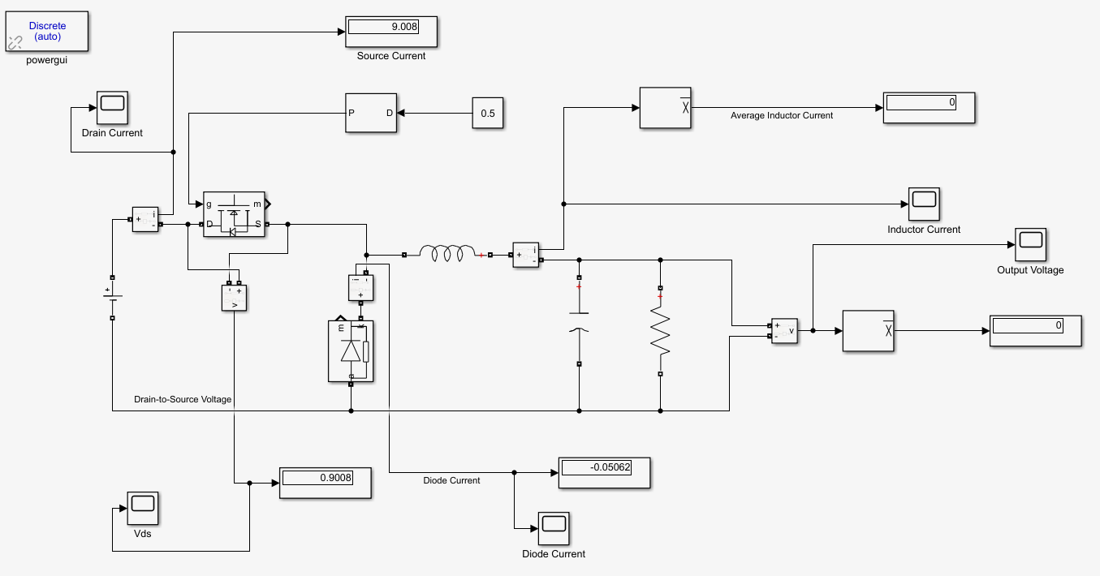

Figure - Setup for question 2 (ideal)

As shown in figure 5, our aim in this question is to obtain 28 V at the output in return to an input voltage of 56 V by utilizing a buck-converter topology with a fixed duty cycle value which is 0.5. For this purpose, we have prefered an open-loop approach and chosen the switching frequency as 20 KHz which is reasonable and is going to be elaborated afterwards in the last part of this question (see “switching frequency decision”).

In order to obtain better (low-ripple) voltage characteristics at the output, we firstly need to choose the components i.e. power MOSFET, diode, capacitor and inductor from the market by checking out their data-sheets according to some criteria which are evaluated below with the tests:

**Tests for MOSFET:**

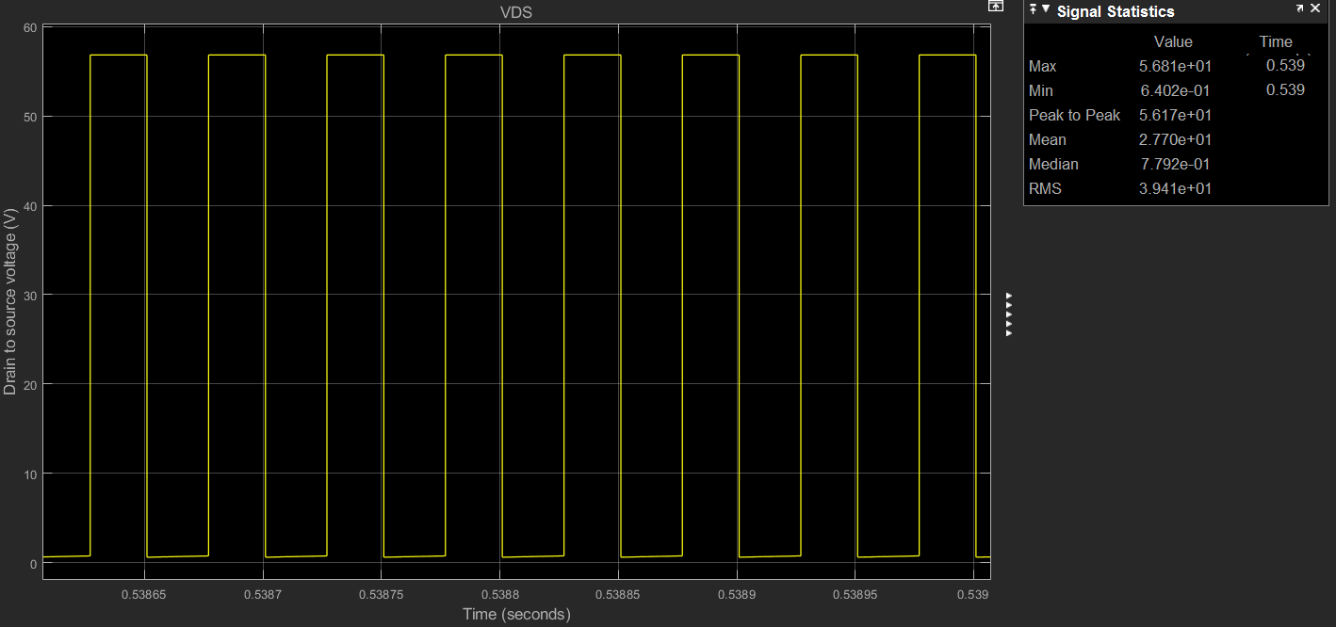

Figure - VDS characteristics of the ideal MOSFET

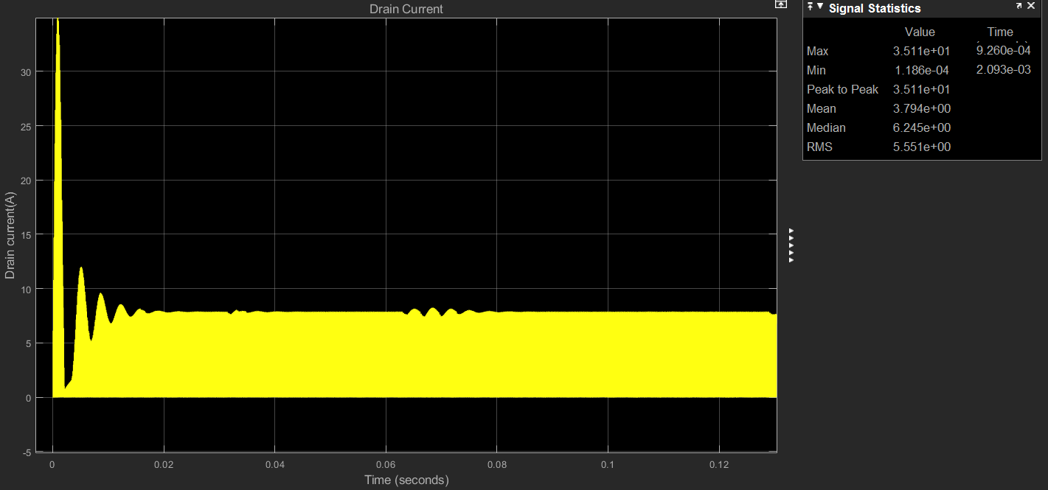

Figure - ID characteristics of ideal MOSFET

As can be seen from figures 6, 7 and 8 the chosen MOSFET should bear to at least 35.1 A pulsed drain current voltage and have the continuous drain current rating more than 7.857 A. Moreover, it should have at least 56.81 V drain-to-source voltage rating. By considering these facts and a bunch of some other criteria given below, we decided to choose “ON-Semiconductor’s 60 V, 26.5 m, 20 A, Single N−Channel MOSFET (NVTFS5C680NL) having the price of 0.77 $/piece**”**

***Datasheet:*** https://www.onsemi.com/pub/Collateral/NVTFS5C680NL-D.PDF

* Important parameters and features of the chosen MOSFET:
* Low RDS to minimize conduction losses

(RDS(on) MAX= 26.5 mΩ @ 10 V and 42.5 mΩ @ 4.5 V)

* Low capacitance to minimize driver losses

(Ciss= 327 pF, Coss= 161 pF when VGS = 0 V, f = 1.0 MHz, VDS = 25 V)

* Low reverse recovery time

(tRR= 17 ns when VGS = 0 V, dlS/dt = 100 A/s, IS = 10 A)

* Low charge & discharge time

(ta= 8 ns, tb= 9 ns when VGS = 0 V, dlS/dt = 100 A/s, IS = 10 A)

* Low rise & fall time

(tr= 25 ns, tf=23 ns when VGS = 4.5 V, VDS = 48 V, ID = 10 A, RG = 1.0 Ω )

* Low turn-on & turn-off delay time

( td(on)= 6.5 ns, td(off)= 13 ns when VGS = 4.5 V, VDS = 48 V, ID = 10 A, RG = 1.0 Ω )

* Sufficiently high drain-to-source breakdown voltage

(V(BR)DSS= 60 V)

* Wide range of operating junction and storage temperature

(-55 to +175 °C)

* Sufficiently high pulsed drain current value

(IDM= 80 A @Tc= 20°C, tp= 10us )

* Sufficiently high continuous drain-to-source voltage

(VDS= 60 V)

* Sufficiently high continuous drain current

(ID= 20 A @Tc= 20°C)

* Low power dissipation at steady state

(PD= 3 W @Tc= 20°C)

***Datasheet:*** <https://www.onsemi.com/pub/Collateral/NVTFS5C680NL-D.P>

**Tests for Diode:**

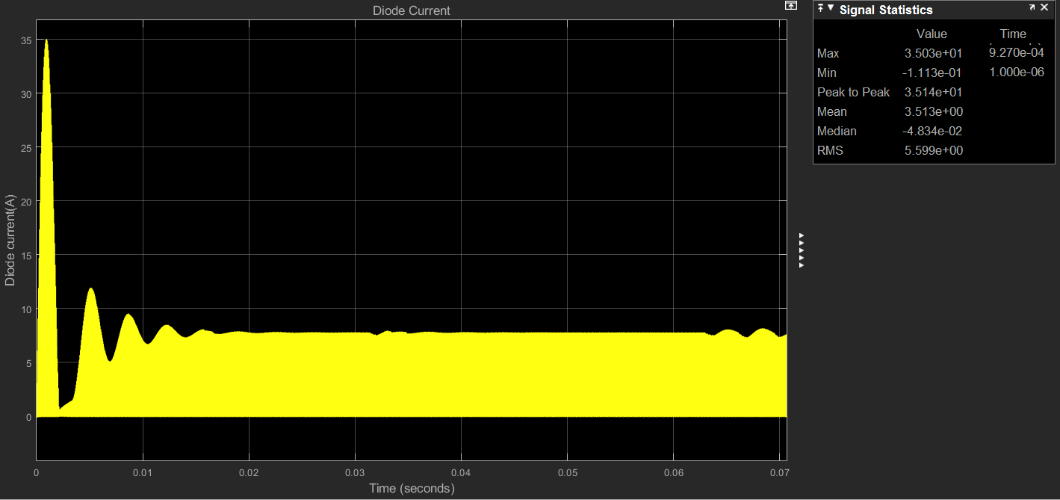

Figure - Surge current characteristics of the ideal diode

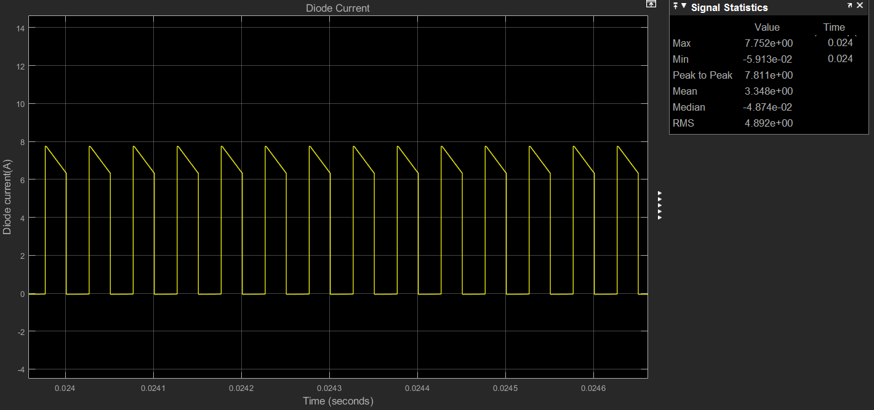

Figure - Steady state current characteristics of the ideal diode

As can be seen in figure 8 and 9 we should pick a diode which can handle the surge current of 35 A and have the continuous current rating more than 3.34 A. By considering these fact we have chosen *“ ON-Semiconductor’s schottky barrier fast-recovery diode of 8 A and 60 V (MBR860MFST1G) having the price of 0.80 $/piece”*

***Datasheet:*** <https://www.onsemi.com/pub/Collateral/MBR860MFS-D.PDF>

Important parameters and features of the chosen Diode:

* Sufficiently high average rectified forward current

( IF(AV)= 8.0 A )

* Sufficiently high non−repetitive peak surge current

(IFSM= 150 A when Surge Applied at Rated Load Conditions Halfwave, Single Phase, 60 Hz)

* Wide range of operating junction temperature

( TJ= −55 to +175 °C )

**Tests for Inductor:**

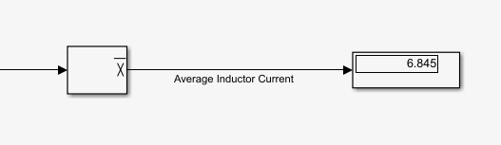

Figure - Average ideal inductor current

As shown in figure 10, we should pick an inductor having the average current rating of at least 6.845 A. Moreover; if we choose an inductor that has a low DC-resistance, we are going to have a lower loss and hence a higher efficiency. For these purposes and also by taking into account that a bigger inductance value would decrease our ripples in the output voltage, we have chosen *“ Abracon LLC’s ATCA series 470µH Unshielded Toroidal Inductor (ATCA-08-471M-V) having the price of 9.2 $/piece”*

***Datasheet:*** https://abracon.com//Magnetics/high-power-toroids/ATCASeries.pdf

Important parameters and features of the chosen Inductor:

* Low EMI/RFI toroid topology
* High saturation current limit

(ISL= 10A)

* High efficiency due to iron powdered core
* Wide operating temperature range

( -40°C to 105°C)

* Vertical and horizontal orientations optimize EMI/RFI
* Low DCresistance value

(DCR=0.064 Ω)

* Sufficiently high DC current limit

(IDC(max)= 7 A)

**Tests for Capacitor:**

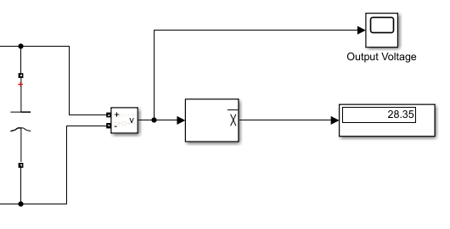

Figure - Average ideal capacitor voltage

As can be seen from figure 11, the average voltage value of the chosen capacitor should be higher than 28.35 V. In addition, if we choose a capacitor that has a low ESR value then we are going to have a lower loss and hence a higher efficiency. For these purposes and also by taking into account the requirements of fc= << fs, we have chosen *“ Panasonic’s aluminium 680 uF 20% 35 V capacitor (EEE-FT1V681UP) having the price of 1.3 $/piece”*

***Datasheet:*** https://industrial.panasonic.com/cdbs/www-data/pdf/RDE0000/ABA0000C1240.pdf

Important parameters and features of the chosen Capacitor:

* Wide operating temperature range

( -55°C to 105°C)

* High rated operating voltage

( 6.3 VDC to 50 VDC )

* Low leakage current

(I < 0.01 CV (μA) After 2 minutes )

* High Endurance

(Capacitance change Within ±30 % of the initial value)

* Low ESR value in order to decrease losses

(ESR= 0.06 Ω @ 100 KHz, 20 °C)

* Low ripple current

(Iripple(rms)= 1190 mA @ 100 KHz, 105 °C)

**Overall cost:** Without resistor taken into account our total cost for four main components is 12.07 $

**Steady-State Performance Analysis:**

Note that there is no need to show input voltage since it is constant DC of 56 Volts. But the other steady state characteristics i.e. input current, output current and output voltage characteristics (taken from the ideal topology) are all shown in the figures below.

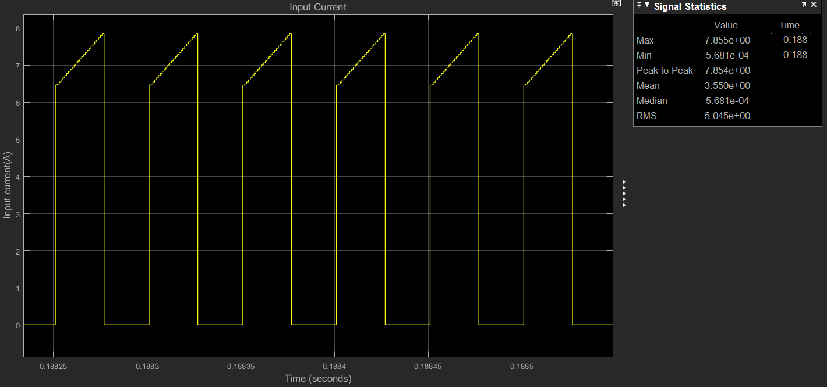

Figure - Input current (Iinput(avg)= 3.55 A)

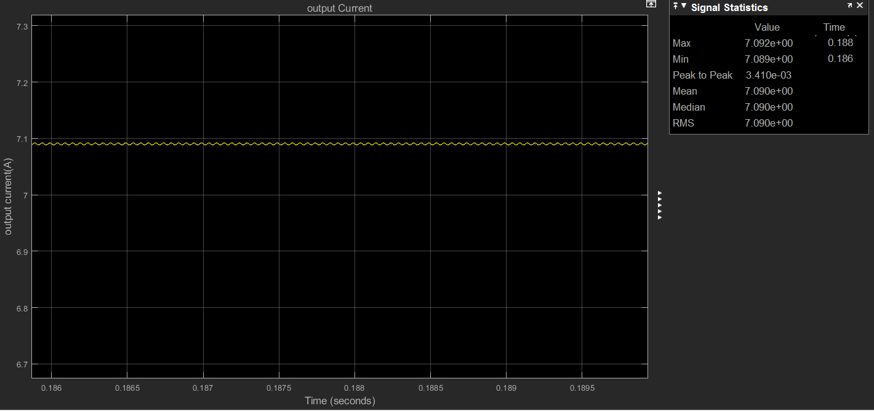

Figure -Output current (Ioutput(avg)= 7.09 A)

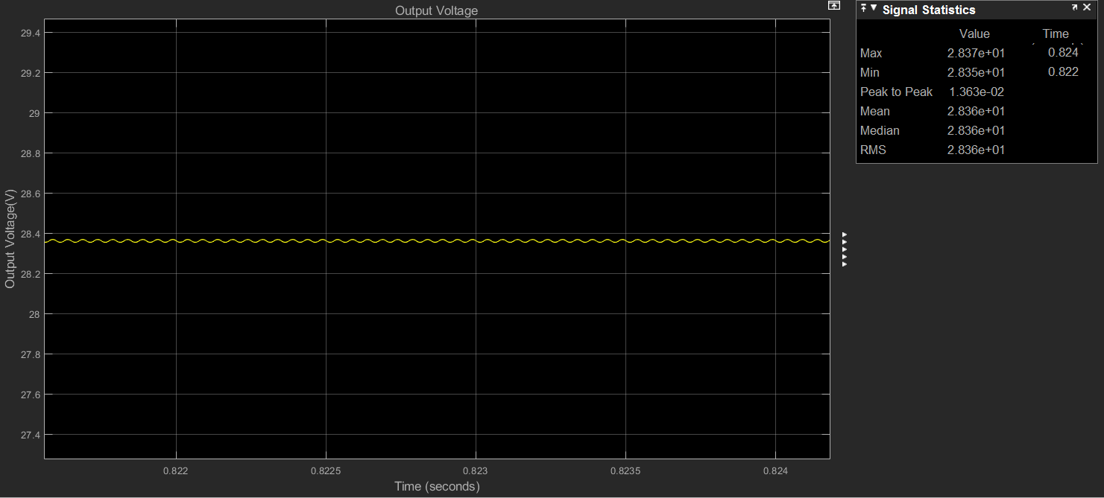

Figure -Output voltage(Voutput(avg)= 28.36 V)

As can be seen from figures 12, 13 and 14;

Vin x D = Vout and Iin x 1/D = Iout requirements are both satisfied in our design

**Ripple Analysis: ΔVout & ΔIL**



Figure - Output voltage ripple (ΔVout =0.01363 V)

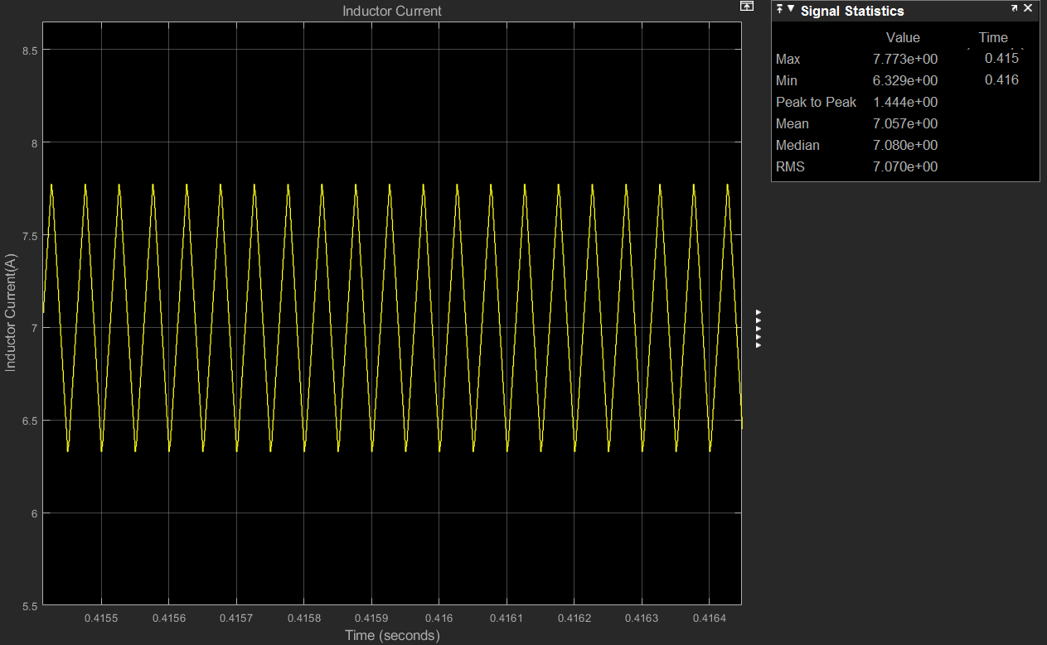

Figure - Inductor current ripple (ΔIL =1.44 A)

As shown in figures 15 and 16 we have reached a very low output voltage ripple i.e. 0.01363 V and a reasonable ripple value of inductor current i.e. 1.44 A. Since the utilized inductance value is chosen according to our system’s steady state requirements i.e. it is not very large, ΔIL is not as small as ΔVout which is expected and normal.

**Overall Efficiency & Comments**

Before computing the efficiency and making comments about it, it is better to give which non-idealities that we took into account in this part of the question:

* ESRcapacitor= 0.06 Ω
* DCRinductor= 0.064 Ω
* RON-MOSFET= 0.022 Ω, Vf-MOSFET= 0.9 V

Note that other parameters of MOSFET are kept the same.

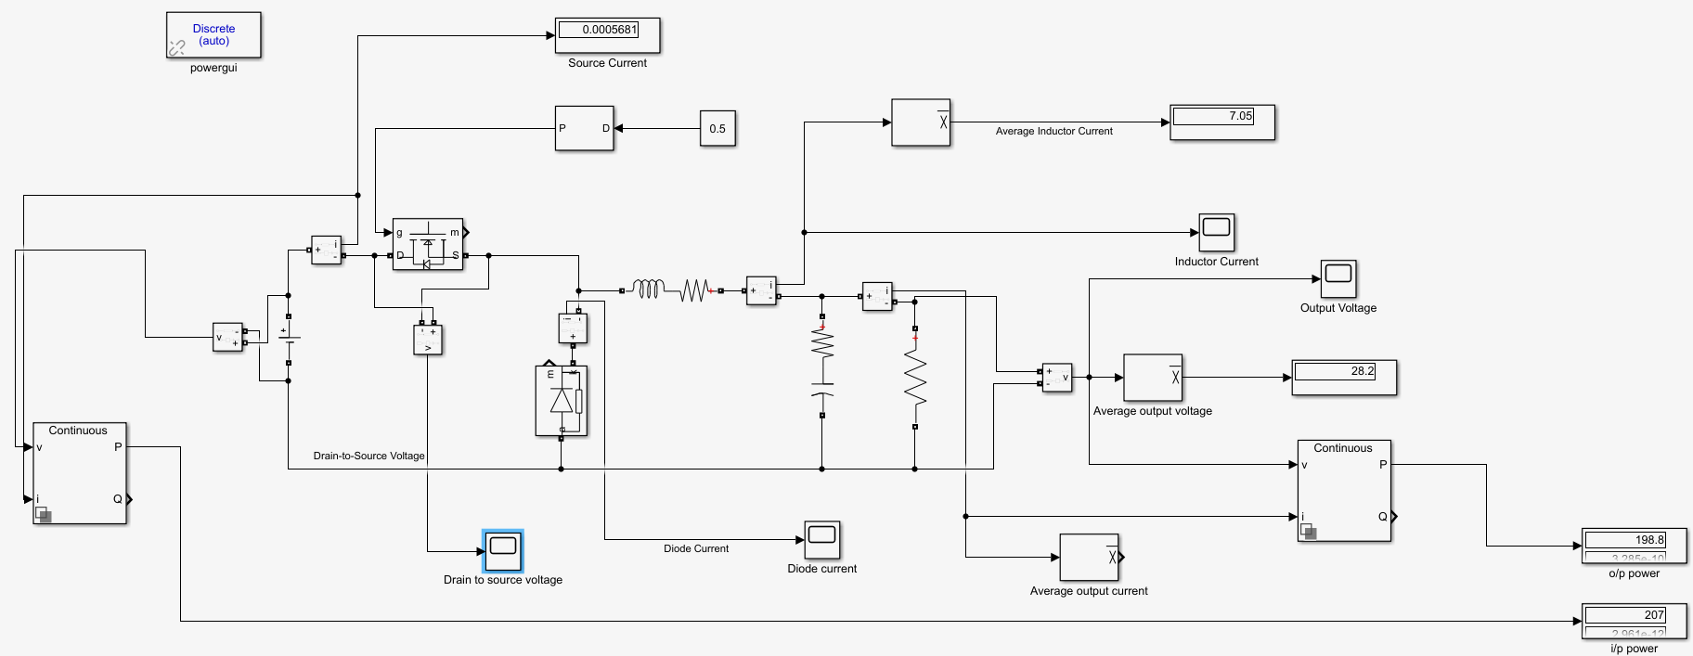

Figure - Overall schematic (non-ideal design)

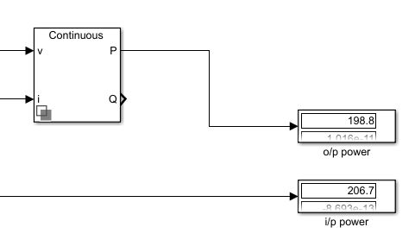

Figure - Output power and input power (non-ideal design)

When we take the added non-idealities into account;

µ(efficiency)= (Pout/Pin)*100= (198.8/206.7)*100= 96.28 % which is satisfying thanks to choosing the components by considering efficiency concerns as mentioned beforehand but still are summarized below:

* Choosing the capacitor with low ESR
* Choosing the inductor with Low DCR Low conduction losses
* Choosing the MOSFET Low RDS and Ciss
* Low tcharging and tdischarging
* Low trise and tfall  of MOSFET Low switching losses
* Low tturn-ON and tturn-OFF

**Switching Frequency Decision:**

In order not to go into discontinuous conduction mode, the inequality that is stated in relation-1 should be met. Also by knowing the equality stated in equation-1, we can conclude that L / Ts should be larger than “1” for this system to be properly operated. Noting that the chosen inductance value is 470 uH, a reasonable switching frequency is 20 KHz which is stated beforehand.

Iout / ILB(max) > 1.....................................................................................................relation-1

ILB( max) = Ts x Vin / 8 x L..........................................................................................equation-1

Just to be sure what we have chosen is correct let us check if ΔVout / Vout < 1 % which is a well known relation for buck-converter to be properly operating:

ΔVout / Vout= = 0.03 % < 1%

Also check if fc= << fs:

fc= = 281 Hz << fs= 20 KHz

Since both of the relations are satisfied, we can assure that the chosen switching frequency is totally appropriate.

**Question 3-)**

**Conclusion**