**MIDDLE EAST TECHNICAL UNIVERSITY**

**ELECTRICAL AND ELECTRONICS ENGINEERING DEPARTMENT**



**EE463 STATIC POWER CONVERSION-II**

**PROJECT #1 REPORT**

**Due Date: 07.03.2019**

**Team Members**

**Ali AYDIN 2093326**

**Akın Şavklı 2095115**

**Question 1-)**

**Part a-)**

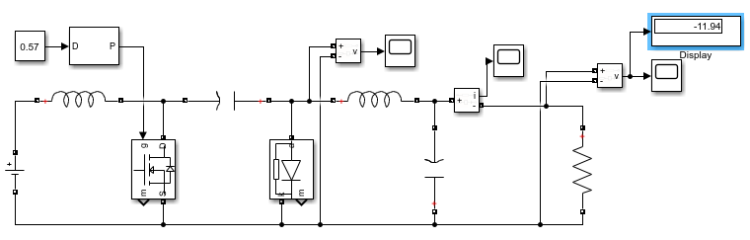

Figure : Cuk converter topology on the simulink

We can see the cuk converter topology in the figure XXXXX. We do not know any component in this topology. Only we have some specification. To design cuk converter with respect to given specification, we need some formulas. One is

$$\frac{V_{o}}{V_{d}}= \frac{D}{1-D}$$

Where Vo is the output voltage, Vd is the input voltage and D is the duty cycle ratio.

By using this formula, we can find the duty ratio which is %57.

Another unknown value is the resistor value and we can find it by using

$$R= \frac{V_{o}}{I_{o}}$$

In this equation, we know output voltage and current. Then, we can find the resistor value as 4 ohms.

As specification, maximum output voltage ripple is %2. To find output ripple, we assume that output current is constant and capacitor current is equal to output voltage. To calculate ripple, we can off state of switch.

$$\frac{{∆V}_{c}}{V_{c}}= \frac{I_{o}*\left(1-D\right)* T_{S}}{C}$$

By using that formula, we can find the capacitor value as 642 uF.

We have no idea about inductor current ripple and we cannot find exact numerical value to inductor. However, To constant output current, we can chose large value to inductor and we chose 5mH.

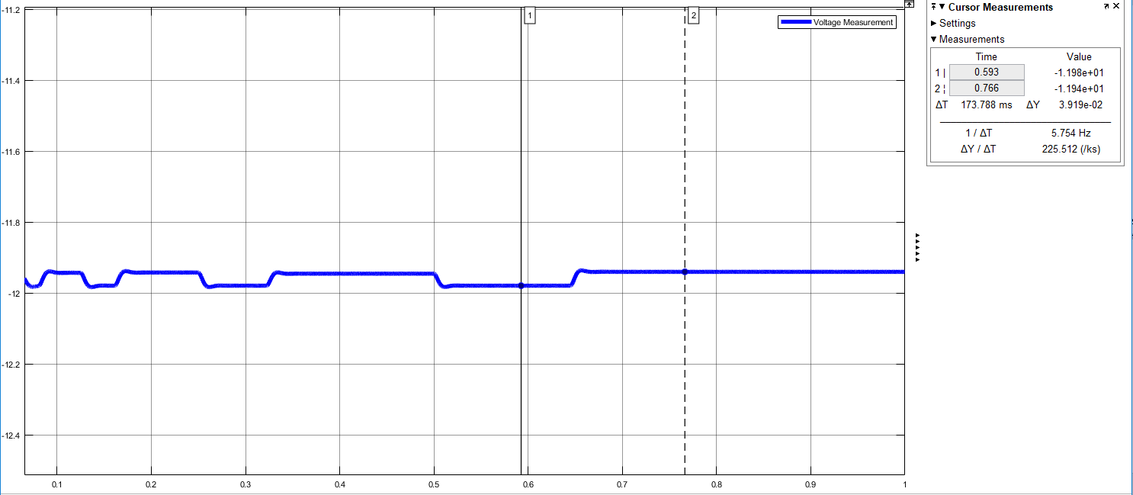

After simulating the circuit, we can see voltage ripple is smaller than %2 in the figure XXXXX.

**Part b-)**

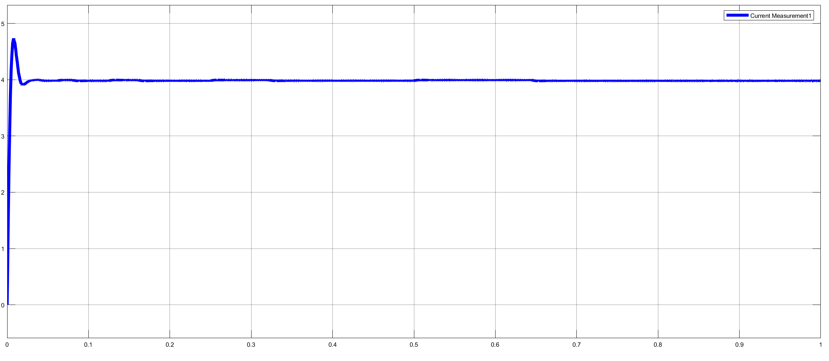

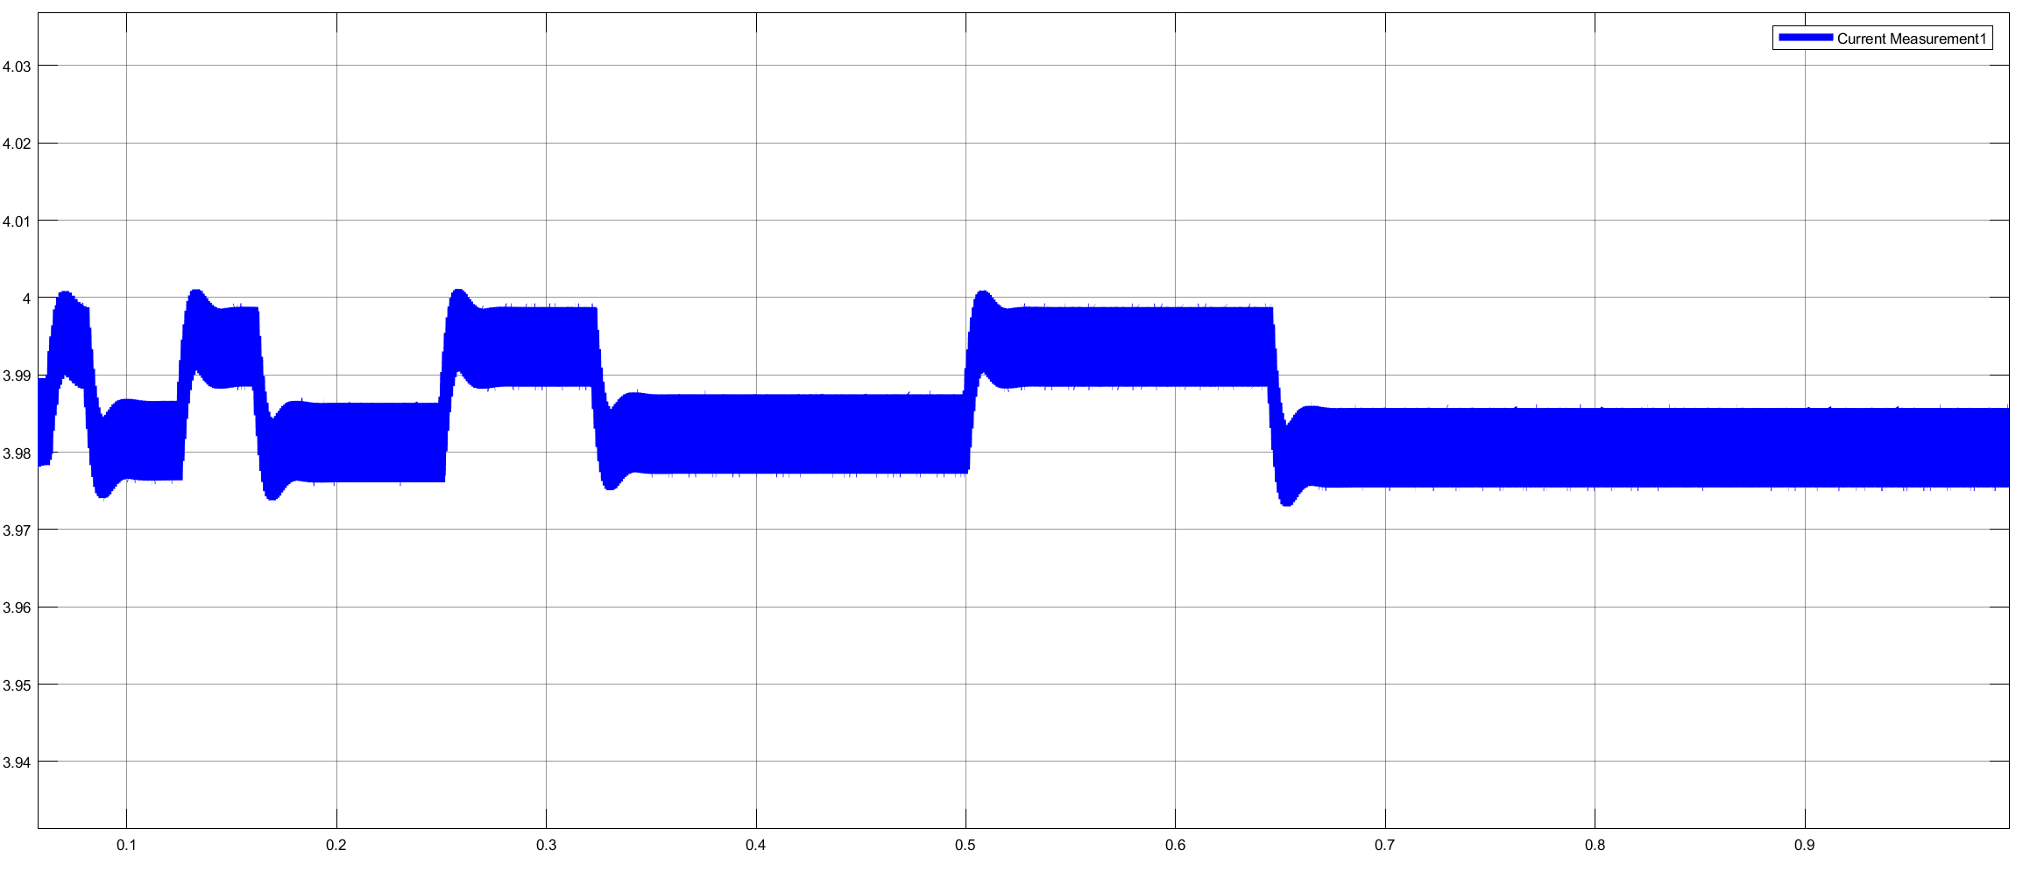

**Part c-)**

**Part d-)**

**Part e-)**