# OVERALL SYSTEM DESCRIPTION

In this project, the robot extracts the plan of the closed region autonomously. Also, it defines the objects in aspect of shape, size and centre coordinates.  There are some requirements and these requirements are provided by the subsystem levels. There are 6 subsystems which are Self-Localization Unit, Decision and Control Unit, Motion Unit, Sensing Unit, Power Unit and Data Transfer. Overall block diagram is shown at Figure X.

**Sensing Unit** is powered by 5 V DC from power unit. It takes the timing of measurement and sends the measurement data to decision unit.

**Self-Localization** unit takes the encoder data from motion unit and it has High Resolution Movement Tracking Unit which determines the device position. It sends the self-position and heading angles of the robot.

**Power unit** has three different DC voltage level. It takes the power by battery and distributes the power in kind of 3.3, 5 and 6 V DC voltages.

**Motion Unit** takes the destination points and give the PWM for motors.

**Data transfer** unit sends the MAP as images after the operation finished.

**Decision and Control** unit governs the other units and adjusts the timing of operation.

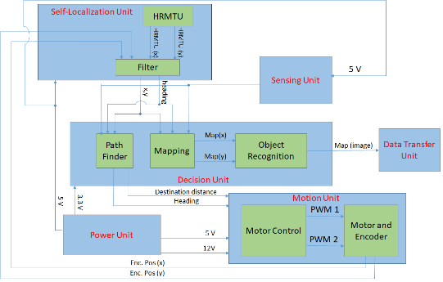

Figure X shows the overall flow chart. The devices start with start command. Then, it senses the environment and takes the data points (Objects and walls). A mapping matrices is created. If the area of map is not filled enough, the device creates a destination point and moves. Otherwise, the map is sent the object recognition algorithm. The map and results of the object algorithm are transferred.

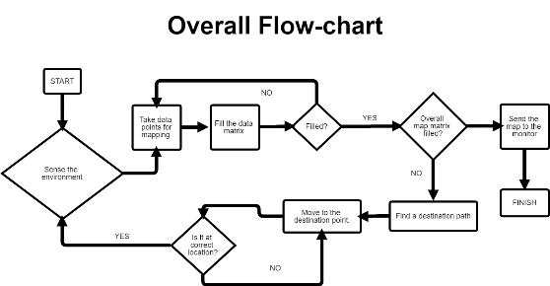

**SENSING UNIT**

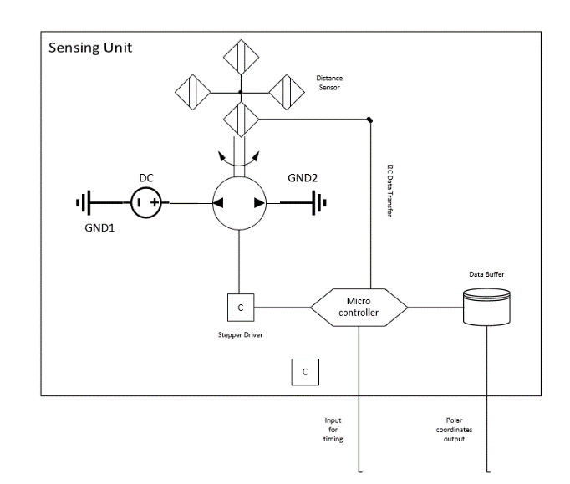

In this unit, we need to determine the objects that surround the device. To determine the positions and types of objects, we need to transfer the field into a binary understanding of the device. To accomplish this task, we need to understand whether there is an object or not.  Thus, we use the ‘distance sensor’ to detect the object.

Figure X   shows the block diagram of the sensing unit. There are 4 distance sensor which placed on 90 degree differences. The sensors communicate with microcontroller by using I^2C protocol. The sensors are used like LIDAR. Each sensor are rotated by stepper motor. Thus, Each measurement Four sensors rotates 360 degree totally. The stepper motor is controlled by using stepper driver.

Measurements occurs while device is stationary. It is sent by decision unit. After the four sensors rotated 360 degree. The outcome data are stored to convert serial data to distance matrices in the shape of polar coordinates. Also, the data are controlled by the sensing unit to avoid false data. The data are stored with consecutive angles. Difference of radius of each consecutive angle is controlled if the difference is much more than average distance, these data will be erased.

**Materials:**

**4 Distance Sensor :** Communicate with I2C protocol with microcontroller. The measurement time is taken from Microcontroller.

**Step Motor** : Driven by stepper motor, the position of measurements are logged.

**Microcontroller :** It provides the communication with Decision Unit. Also, It governs the timing and storing data.

**Input and Outputs:**

**Power Input:**  6 V DC for step motor and stepper driver. 5V for sensor and microcontroller.

**Measurement Time Input:** Time of taking data is adjusted by decision unit while the device is stationary.

**Measurement Coordinates :**  Measurement of the distance for 360 degrees are sent in the set of polar coordinates to decision and control unit after the measurement operation finished.

**SELF LOCALIZATION UNIT**

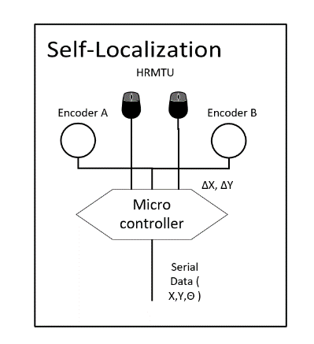

The device is not stationary. The position and heading angle changes with respect to movement. Because of all, it is required to obtain position and heading angle to create a overall map. We solve this problem with High Resolution Movement Tracking Sensor (or it is a basically a part of mouse). The HRMT creates a changes in x and y at each 100msec. The data are processed by the microcontroller and the position and heading changes are created. Self-Position is at origin and heading is 90 degree at first starting. Then the changes in heading angle and position are added.

**Materials:**

**HRMTU:** High Resolution Movement Tracking Sensor sends change in 2 dimension space at each 100 msec.

**Encoder:**  The motion of motor is measured by encoder to find change in 2 dimension space.

**Microcontroller**: It governs timing and reading of the HRMTU data and Encoder data.

INPUTS and OUTPUTS:

**Power Input:** 5 V for HRMTU, Encoders and microcontroller.

**Data Output:** Serial data of Self Position and heading angles of the devices for each 100 msec.

**MOTION UNIT**

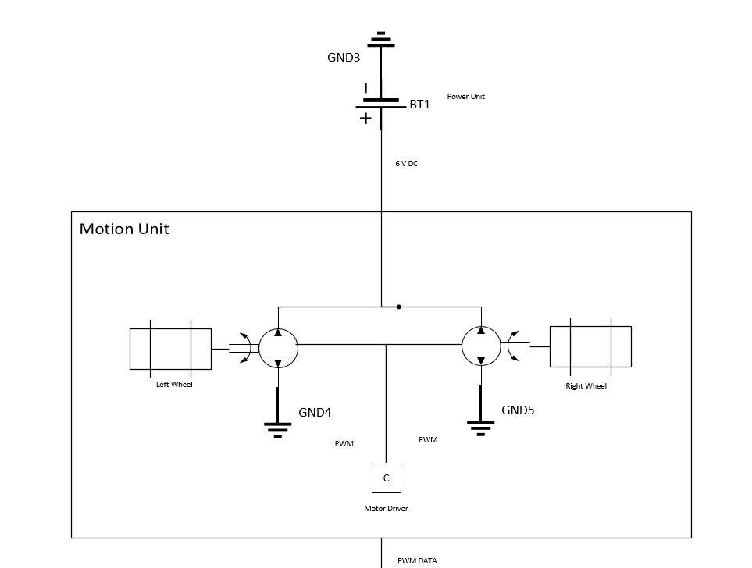

The motion unit is required for the movement of the devices. The movement of devices are provided by differential drive with two motor with encoder. The PWM data are created by decision unit and these motors are driven with PWM by using motor drivers.

**Materials:**

**DC MOTOR:** 2 DC motor to move 2Dimension

**MOTOR DRIVE:** It controls the speed of motor by PWM

**INPUT and OUTPUTS**

**Power Input:**

**PWM Input:** PWM inputs to adjusting motor speed and movement to destination point.

**DECISION AND CONTROL UNIT**

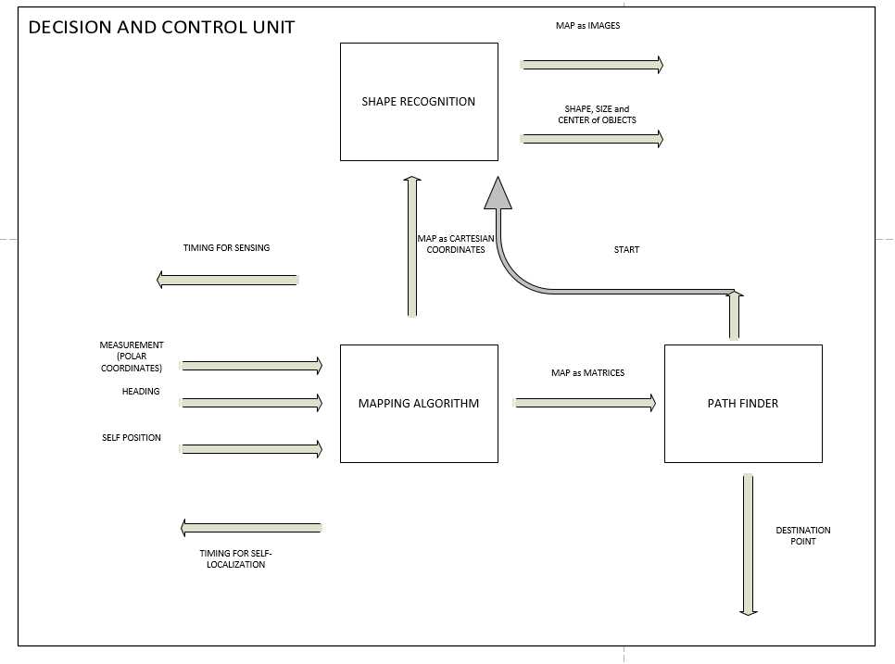

Decision and Control unit governs the other unit and process the data. Mapping algorithm adjusts the measurement of sensing unit by the self-localization and creates the real data. Also, path finder controls the map and find the unseen points of the map. After the path finder makes shape recognition starts, the devices stop and the taking data finishes. The Shape Recognition algorithm creates the shape, size and centre of the object and creates a map as images and sends these the data transfer unit. Block diagram of the unit is illustrated at figure X.

**Materials:**

**Microprocessor:** For operating the algorithms

**INPUT and OUTPUTS**

**Power Inputs:**

**Timing Outputs:** Adjusting the flow of operations

**Measurement Inputs:** Taking Objects and walls data with self-position

**Destination Outputs:** Sending movement data and PWM of motors

**Mapping Outputs:** Sending final Map and properties to data transfer unit

**POWER UNIT**

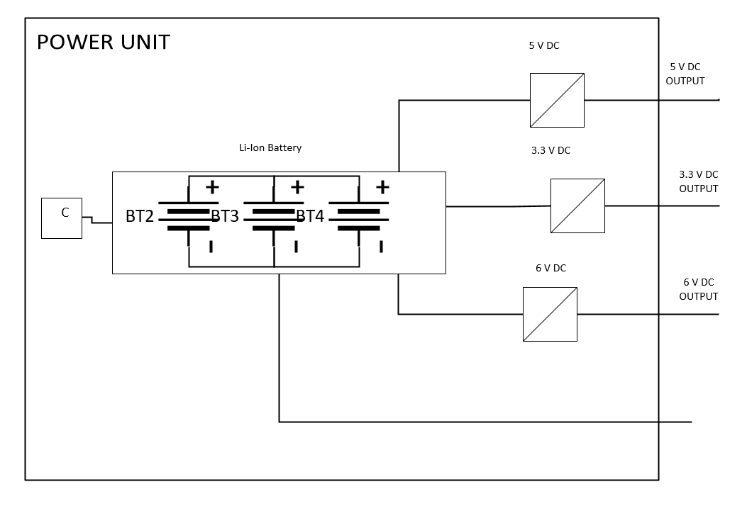

Power unit supply the all electrical components with DC voltages at required level. Our power unit includes Li-Ion Cells with parallel and series to adjust the voltage and current ratings. Our electrical components operate at different type DC level. There are 3 DC level. 3.3 V DC is used for main microprocessor, 5V is used slave microcontrollers and sensors. 6V DC is used for Motor drive.

**Materials:**

**Li-Ion Battery:** Supplying power

**Buck Converters:** It controls the voltage level for different subsystem.

**INPUT and OUTPUTS**

**OUTPUTs:** 3 different voltage level for subsytems.

**DATA TRANSFER**

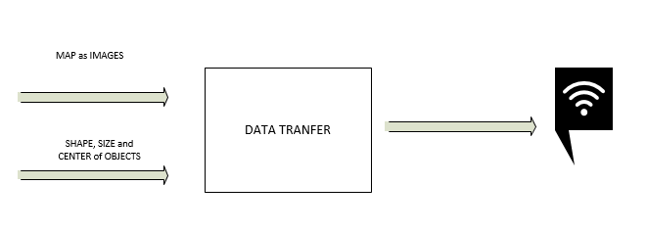

This is final step for project. The unit takes the map and properties and sends the data wireless to show the output.

**Materials:**

**Wi-fi Module:** Providing wireless communication

**INPUT and OUTPUTS**

**Power Input:**

**INPUTS and OUTPUTs:** Properties of Map and Map as Images for input and output, only transferring data.

**SUBSYSTEM REQUIREMENTS**

**Motion Unit**

* Motors should move with an average of 3.5 cm/sec velocity.
* Motion unit should get the destination data from decision and control unit and should convert this data to pwm signals to move motors
* The encoders should give position data to localization unit continuously.

**Sensing Unit**

* Sensors should be oriented to sense the environment with 360 degree range.
* The distances from 10 cm to 40cm should be sensed by the sensors to transfer the points to decision unit because the optimum measurement range of the sensors that we used is from 10 cm to 40 cm.
* Sensing unit should generate 80 data per second.
* Sensors should give data continuously to operate in a synchronized way.

**Decision and control Unit**

* The unit should combine data coming from localization unit and sensing unit to obtain destination path and map data.
* Path planning part should give destination distance and heading to motion unit.
* Mapping part should give x and y positions of data points coming from sensing unit to generate a map.
* Object recognition part should collect data point position information and generate contours.
* Object recognition part should decide the types, centers of the objects.

**Power Unit**

* Power unit should have the ability to supply 4 A current at 5 volts at the time such that robot dissipates maximum power.

**Localization Unit**

* High Resolution Tracking Module(HRTM) should give position data with less than 3% error.
* Kalman filter should model error and using the model, filter should compensate the error.
* Localization unit should send the current position of the robot to decision and control unit.

**Data Transfer Unit**

* Transferring Data properly from devices with wireless

**SYSTEM MODIFICATIONS**

* The number of sensors in sensing unit is increased to 4. With this modification, we are able to sense the environment in 360 degree range. With this ability, we can sense the environment at larger range with one round turn.
* Instead of servo motor, we used step motor to rotate sensing unit. Servo motor has some nonlinearities and because of the effect of nonlinearities, angle change in servo motor is not accurate.Step motor rotates with 1.8 degree per step and this can be decreased to 1/16 of 1.8 degree. This rotation is mostly linear and some distortions coming from the linearity of rotating device is eliminated with this change.
* We created a two dimensional interpolation algorithm in decision unit. This improvement gives us more data points to process in object recognition part. As the number of data is increased, distances between points which are sensed in sensing unit are closer to each other in image and shape finder algorithm can operate more efficiently. An illustration of two cases are shown below.