**EE463 PROJECT #1 REPORT**

**Question1-)** In this part, we try different step sizes for single phase rectifier and we observed that they different from each other since computer is working discrete domain. Due to that, computer take data with respect to step size. When step size is small like 1.5 msec, we did not observe waveform clearly since computer take less data and some point is missed. When we increase step size, computer take more data at unit time and missed point decrease. Because of that, we observe waveform clearly. For computer, step is very important to interpret waveforms correctly.

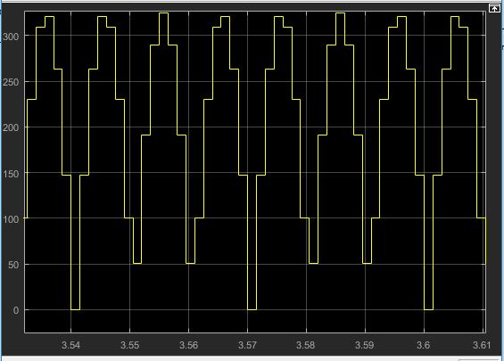

Figure : Output waveform at 1.5 msec

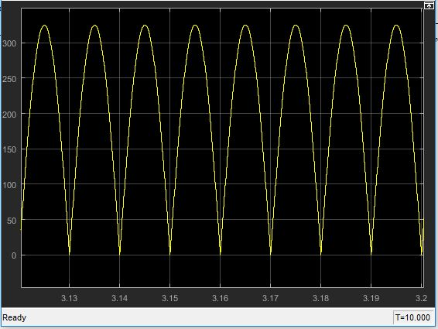

Figure : Output waveform at 10 usec

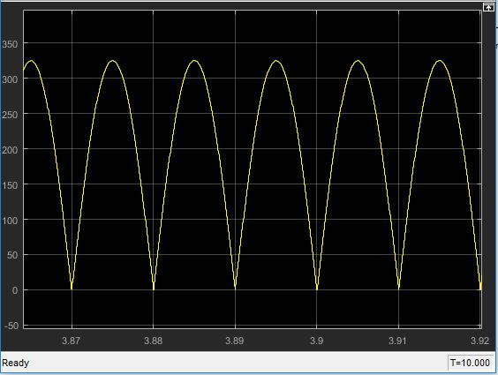

Figure : Output waveform at 1 usec

**Question2-)**