**MIDDLE EAST TECHNICAL UNIVERSITY**

**ELECTRICAL AND ELECTRONICS ENGINEERING DEPARTMENT**



**EE463 STATIC POWER CONVERSION-I**

**PROJECT #1 REPORT**

**Due Date: 25.11.2018**

**Team Members**

**Ali AYDIN 2093326**

**Metehan KARA 2093979**

**Question1-)** In this part, we try different step sizes for single phase rectifier and we observed that they different from each other. We performed our simulations with discrete time and constant step duration. Performing the simulation might be longer or shorter than the duration of time step since computer is also working discrete domain. Due to that, computer takes data with respect to step size. When step size is small like 1.5 msec, we did not observe waveform clearly since computer take less data and some point is missed in other words computer needed more time to perform the simulation than time step. When we increase step size, computer take more data at unit time and missed point decrease. Because of that, we observe waveform clearly. For computer, step duration is very important to interpret waveforms correctly. On the other in some cases decreasing the time step increases the simulation time. Hence it is important to perform the simulation in correct time step.

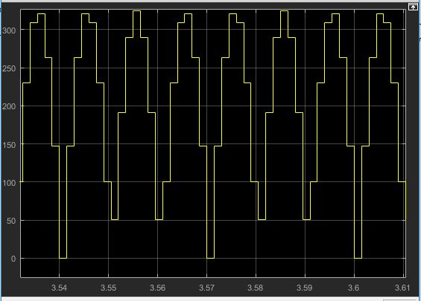

Figure 1: Output waveform at 1.5 msec

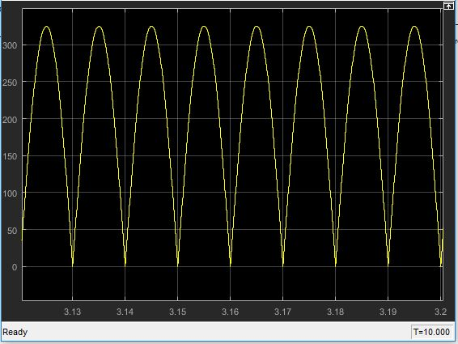

Figure 2: Output waveform at 10 usec

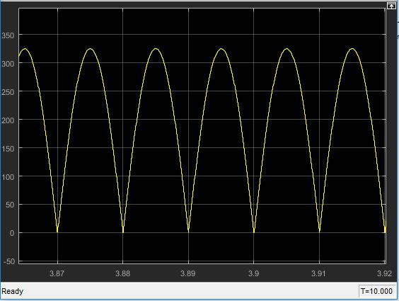

Figure 3: Output waveform at 1 usec

**Question2-)**

**Part 1-)**

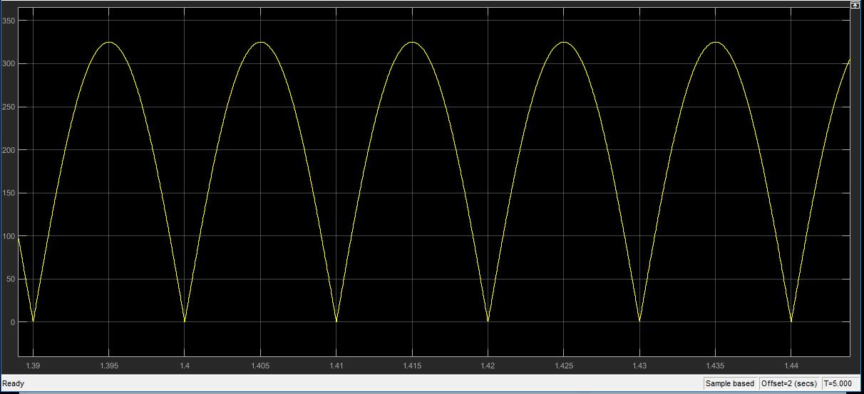

Figure 4: Output voltage waveform with resistive load of R = 25 ohm

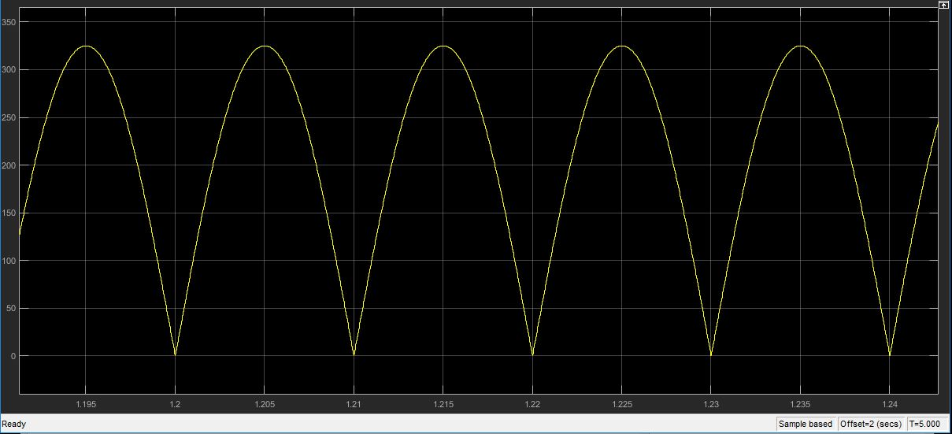

Figure 5: Output voltage waveform of RL load of R = 25 ohm, L = 10 mH

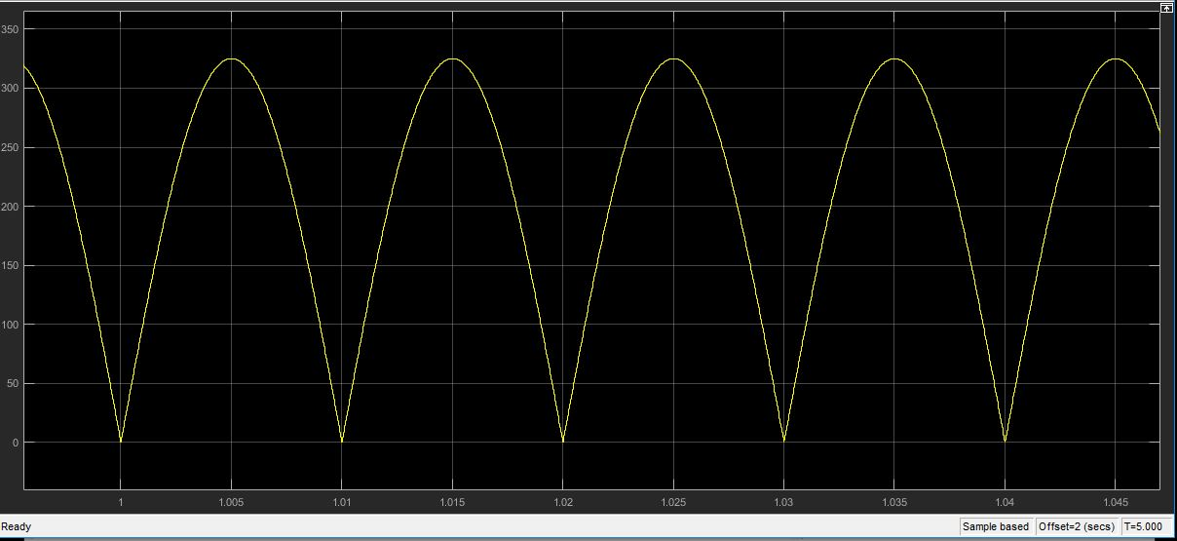

Figure 6: Output voltage waveform of RL load of R = 25 ohm, L = 1 H

Output waveforms of three simulation results are above picture. In those pictures, we see that output waveform does not change with adding inductor. Because of that, average voltage also does not change and average value is almost 207 V. However, THD of line current changes with inductor values. When there is only resistor and no inductive element, THD is zero since resistor does not any harmonic effect to circuit. When there is an inductive, THD increases with its value.

**Part 2-)**

**Part 3-)** We find capacitor value as 0.5uF. In this situation, average voltage is 301.7 and 20% of its is 60.34 V. Our ripple voltage is around 50 V. We can see output, average and input voltage waveform in the below figure.

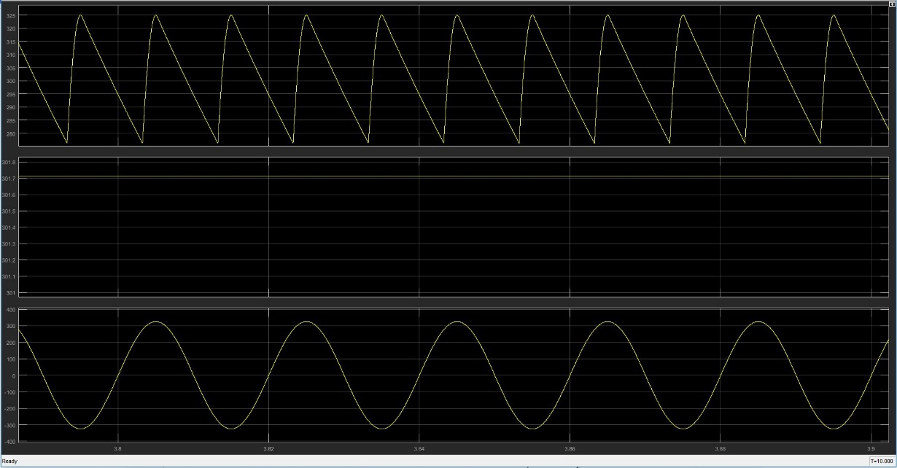

**Part 4-)**

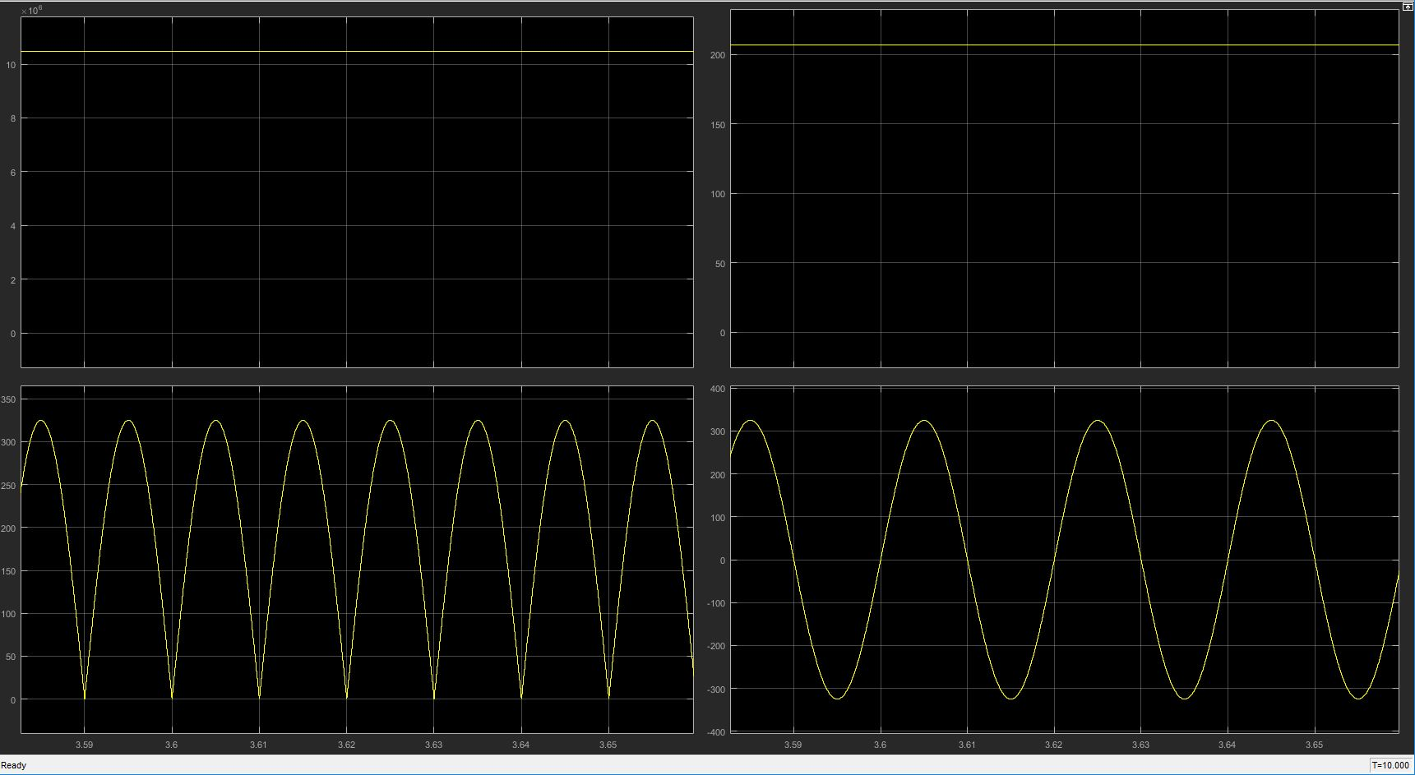

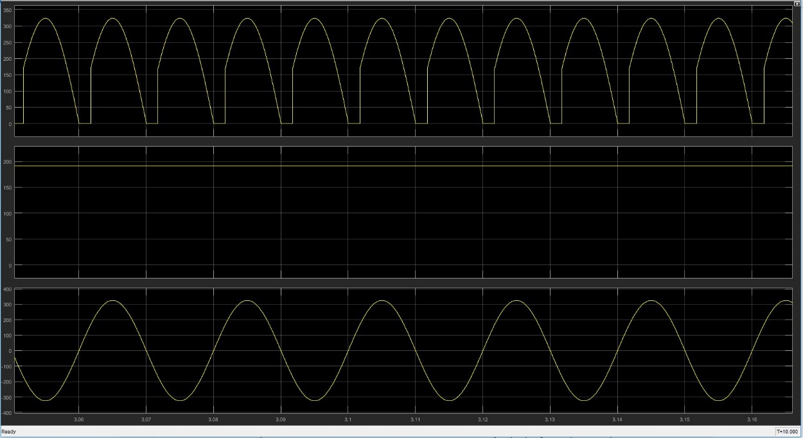

In this case, we observed commutation effect. When source has inductive effect, there is lost of voltage.

**Part 5-)**

**Question 3-)**

**Part 1-)**

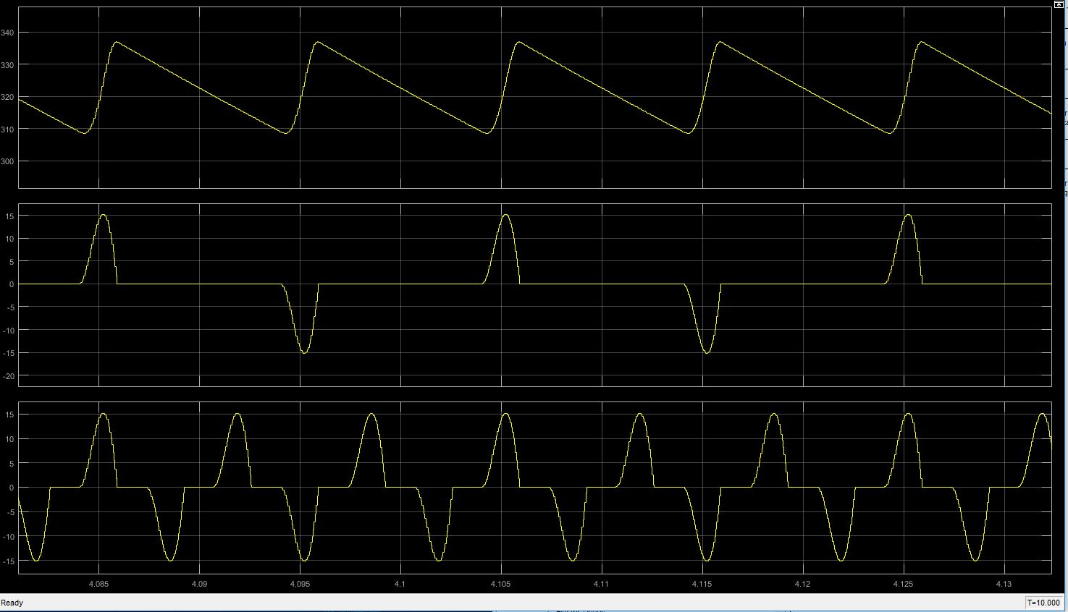

Figure 7: waveforms for output voltage, Phase A current and neutral wire current, respectively

As we can see figure x, output voltage has ripple because of capacitor. THD value of line current is %163,30. There is huge amount harmonics in it.

**Part 2-)**

RMS values of phase A, phase B, phase and neutral current are 4.346, 4.343, 4.343 and 7.523 Arms, respectively. RMS value of line current is the same we expect this solution since they provide the current to system. Also, Neutral current is greater since this current sum of line currents. As we can see figure X, frequency of this current and peak value is greater.

**Part 3-)**

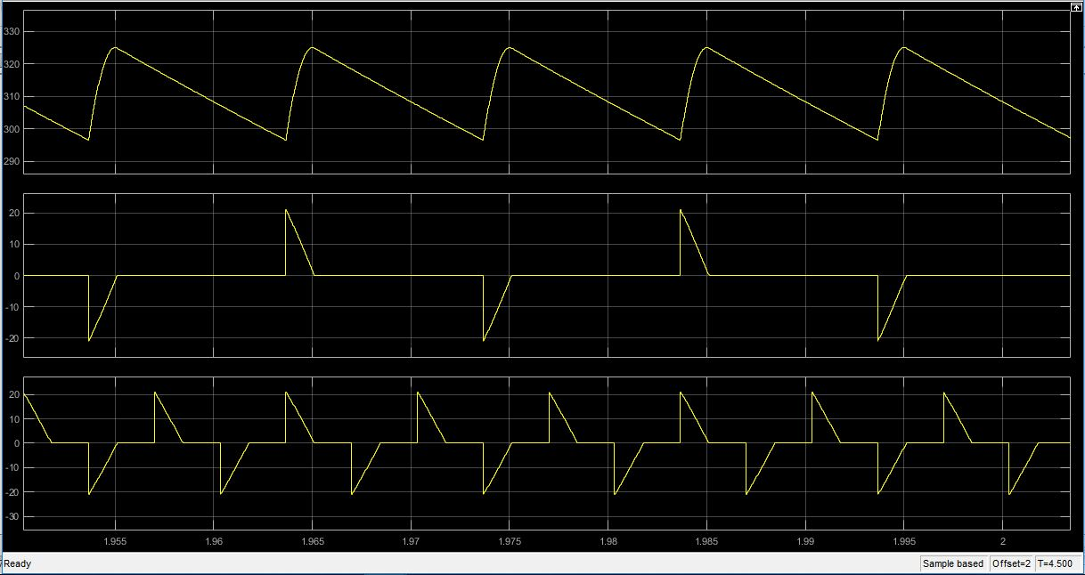

Figure 8: waveforms for output voltage, Phase A current and neutral wire current, respectively

THD value of line current is %246.35 and RMS values of phase A, phase B, phase and neutral current are 5.811, 5.854, 5.812 and 10.1 Arms, respectively.

As we expected RMS value of line currents is the same and neutral current greater. Also, without Ls, RMS values increased since due to commutation, we loss some voltage.