a)

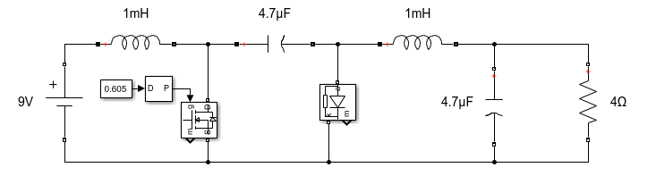

Figure 1: Designed converter

In the converter circuit given above, the values of the circuit’s elements are chosen so that they can be found easily in the market. Here the capacitor between the diode and the switch should withstand 21V. The voltage transfer characteristics of the converter is given in (1) below.

$$\begin{aligned}\frac{V_{out}}{V_{in}}=\frac{D}{D-1}\#\left(1\right)\end{aligned}$$

For the values of input voltage 9V and output voltage -12V the duty cycle can be found as following.

$$\frac{-12}{9}=\frac{D}{D-1}$$

$$-12D+12=9D$$

$$21D=12$$

$$\begin{aligned}D=57.14\%\#\left(2\right)\end{aligned}$$

However, the value found in (2) is less than what we had during the simulations. This is due to the losses. The output voltage characteristics are given in Figure 2. Using the simulated result, the percentage ripple can be calculated as 1.25% which is below than 2% in the following equation.

$$\begin{aligned}\frac{V_{pp}}{V_{mean}}×100=\frac{0.15}{12}×100=1.25\%\#\left(3\right)\end{aligned}$$

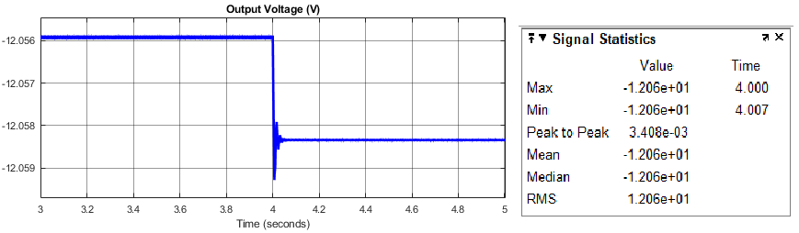

Figure 2: Output voltage and statistics of it in steady state

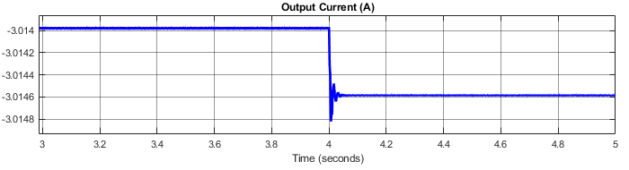

Figure 3: Output current in steady state

b)

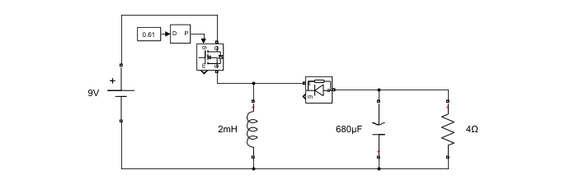

Figure 4: Designed buck-boost converter

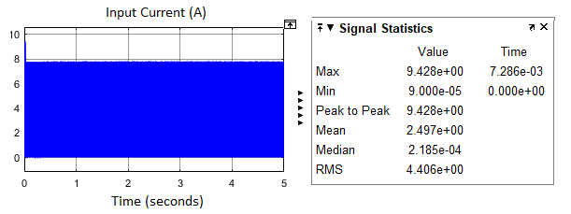

Figure 5: Input current of the buck-boost converter given in Figure 4

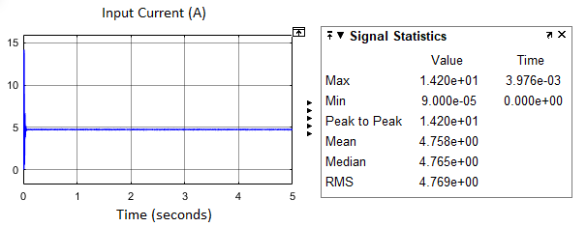

Figure 6: Input current of the Cuk converter given in Figure 1