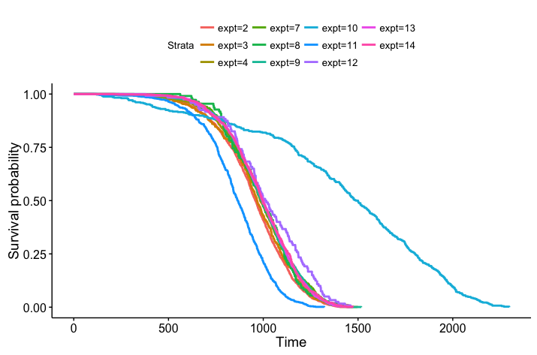

Figure 1 - all controls, only separated by experiment number.

* JM10 – peromyscus leucopus
* JM11 – not even listed??? Not listed as control, but under treatments tab, it shows the total dose is equal to 0Gy for gamma and neutrons, there aren’t any mice treated with a total dose over 0Gy. Ignore
* JM12 – 1 ctrl, 3 treatments of neutrons, all male, small sample size, 120 mice per group - exclude

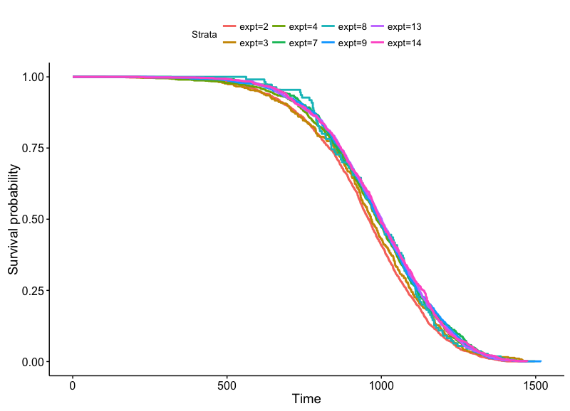

Figure 2 – all controls – exclude JM10, JM11, JM12 for reasons listed above

* expt 8 shows survival for a bit longer at the beginning… why?
  + Number of total controls = 110 (small n)
  + Average # of fractions = 125

(what about every other experiment that I’m not excluding?)

Learned dplyr!

controls %>%

group_by(expt) %>%

summarise(avg_fraction = mean(fractions),

tot_n = n())

Results:

expt avg_fraction tot_n

<int> <dbl> <int>

1 2 24.238824 1700

2 3 1.000000 385

3 4 88.536729 1021

4 7 0.000000 485

5 8 125.281818 110

6 9 4.437967 1338

7 13 60.000000 1176

8 14 1.000000 792

Clearly, expt 8 has way fewer animals and a much higher average number of fraction

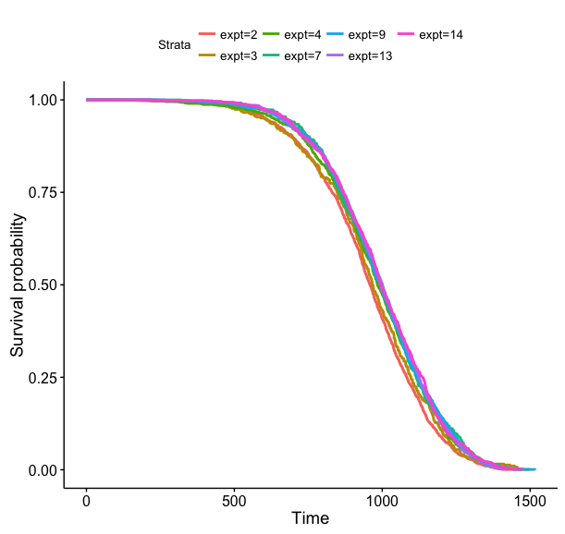

Figure 3 – all controls – excluding JM10/11/12 and now also excluding JM8

Very close together – check for significance. Also compare by fractions (all mice were sham treated?)

To check for significance, use survdiff(Surv(age) ~expt, data = controls)

* did this with above data (only exclude JM 8, 10, 11, 12), the p value showed significance

N Observed Expected (O-E)^2/E (O-E)^2/V

expt=2 1700 1700 1473 35.023 44.953

expt=3 385 385 369 0.661 0.705

expt=4 1021 1021 1051 0.880 1.045

expt=7 485 485 513 1.489 1.619

expt=9 1338 1338 1409 3.583 4.536

expt=13 1176 1176 1233 2.662 3.261

expt=14 792 792 848 3.744 4.297

Chisq= 48.5 on 6 degrees of freedom, p= 9.48e-09

* Tried again using only controls that looked very similar (9, 13, 14) and found a p value of .881… results below.

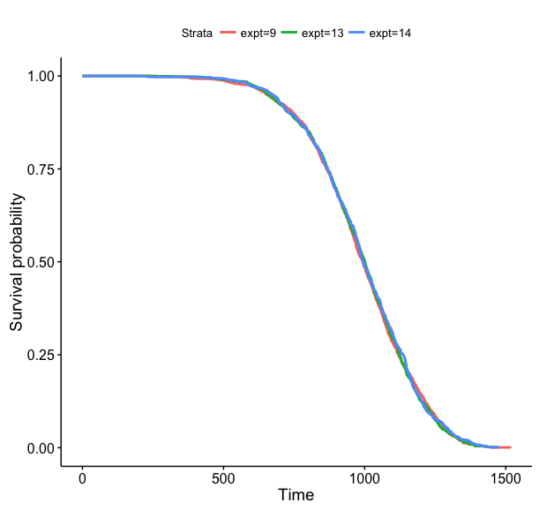

Figure 4 – JM9/13/14, VERY tight curves

Call:

survdiff(formula = Surv(age) ~ expt, data = controls)

N Observed Expected (O-E)^2/E (O-E)^2/V

expt=9 1338 1338 1334 0.00926 0.0156

expt=13 1176 1176 1167 0.06227 0.0969

expt=14 792 792 804 0.18033 0.2399

Chisq= 0.3 on 2 degrees of freedom, p= 0.881

Try including and comparing more controls…

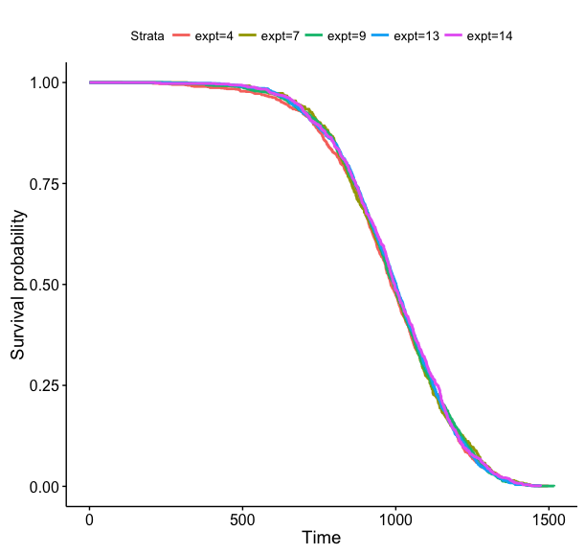

Figure 5 – JM4 and up, but also excluding JM8/10/11/12 as before, get the highest p-value yet meaning the curves are very similar! JM4 has a high n.

N Observed Expected (O-E)^2/E (O-E)^2/V

expt=4 1021 1021 1001 0.40336 0.51248

expt=7 485 485 488 0.02406 0.02695

expt=9 1338 1338 1342 0.00914 0.01276

expt=13 1176 1176 1173 0.00542 0.00721

expt=14 792 792 808 0.30460 0.36835

Chisq= 0.8 on 4 degrees of freedom, p= 0.945

Add in experiment 3…

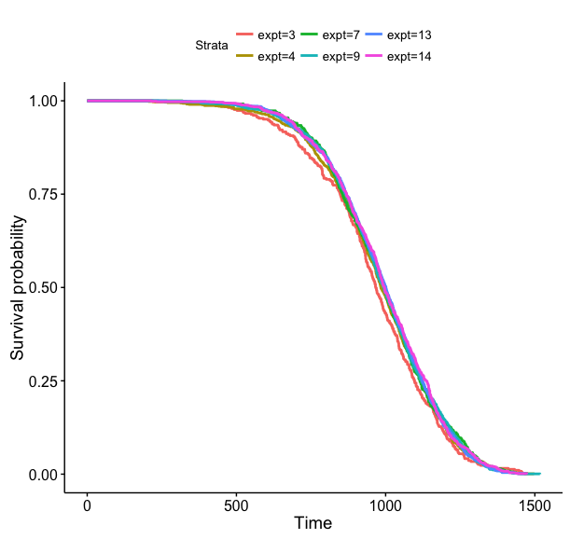

Figure 6 – include everything except JM 2 (and JM8/10/11/12 from before). P-value decreases a lot, but still not significant.

N Observed Expected (O-E)^2/E (O-E)^2/V

expt=3 385 385 354 2.7762 3.0069

expt=4 1021 1021 1007 0.1818 0.2268

expt=7 485 485 491 0.0795 0.0883

expt=9 1338 1338 1350 0.1129 0.1536

expt=13 1176 1176 1182 0.0257 0.0335

expt=14 792 792 813 0.5301 0.6324

Chisq= 3.7 on 5 degrees of freedom, p= 0.588

Still not significantly different! Only excluding JM2 and we can consider them all relatively similar. Issues with JM2 may be that this was the FIRST janus test and the JANUS facility could not be used… facility differences could explain life expectancy differences.

Another test – check between increased fractionations for sham treated mice. Do this with all experiments, within each experiment, and with only the experiments that have similar values as above (maybe if we take into account fractionation we will see that we can include more studies?)

Get an idea of how many fractions/experiments I'm dealing with…

controls %>%

group_by(fractions, expt) %>%

summarise(tot_n = n())

fractions expt tot_n

<int> <int> <int>

1 0 7 485

2 1 3 385

3 1 9 1138

4 1 14 792

5 24 4 659

6 24 9 200

7 60 13 1176

8 120 4 189

9 300 4 173

Not too many different groups! Plot all.

(tried with JM 8… waaaaay too many different fractions. Tried with 2,10,11,12, also ugly and I had good reasoning to leave them out, continue to leave them all out!)

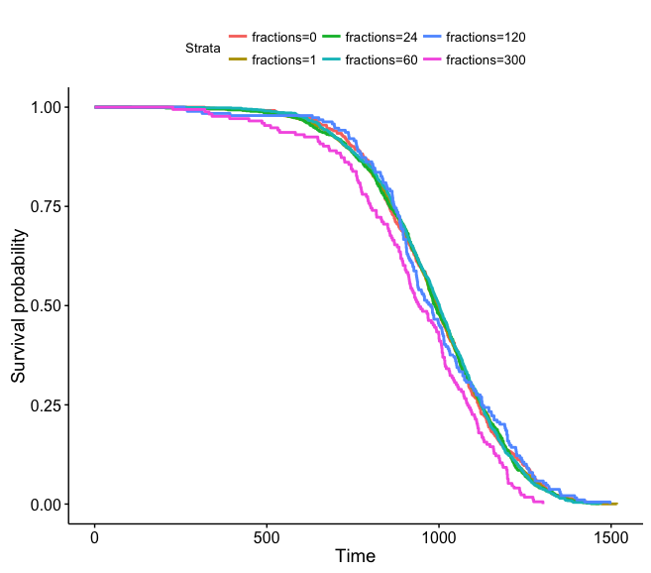

Figure 7 – Stratified by fractions… 300 and 120 both look the worst… both come from JM 4 and have the lowest n.

N Observed Expected (O-E)^2/E (O-E)^2/V

fractions=0 485 485 491 0.07950 0.08835

fractions=1 2315 2315 2336 0.19041 0.34815

fractions=24 859 859 857 0.00488 0.00588

fractions=60 1176 1176 1182 0.02571 0.03348

fractions=120 189 189 200 0.60961 0.64032

fractions=300 173 173 131 13.35337 13.78945

Chisq= 14.4 on 5 degrees of freedom, p= 0.0134

Remove JM4 and try again…

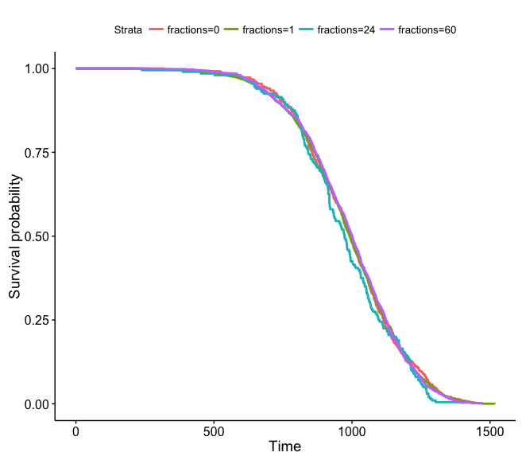

Figure 8 – Excludes JM2, 4, 8, 10, 11, 12 – much better now! The only issue looks like 24 fractions which could are from experiment 9. JM9 uses over 1100 mice for 1 fraction, but only 200 mice for 24 fractions. Even with this issue, there’s still no significant differences between groups.

N Observed Expected (O-E)^2/E (O-E)^2/V

fractions=0 485 485 490 0.04344 0.04953

fractions=1 2315 2315 2329 0.08150 0.18552

fractions=24 200 200 180 2.29698 2.41618

fractions=60 1176 1176 1178 0.00315 0.00442

Chisq= 2.4 on 3 degrees of freedom, p= 0.486

Do the curves stratified by experiment, but excluding experiment 4, still show good results/no significant differences?

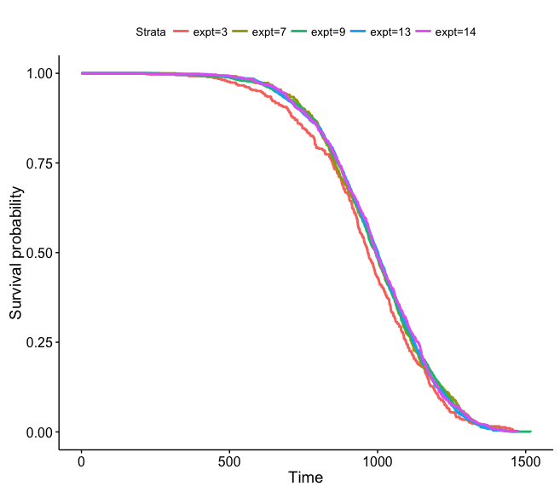

Figure 9 – stratify by experiment, exclude JM2, 4, 8, 10, 11, 12. JM 3 sticks out a bit, but it’s still not significant.

N Observed Expected (O-E)^2/E (O-E)^2/V

expt=3 385 385 353 2.96380 3.27241

expt=7 485 485 490 0.04344 0.04953

expt=9 1338 1338 1345 0.03929 0.05838

expt=13 1176 1176 1178 0.00315 0.00442

expt=14 792 792 811 0.42323 0.52869

Chisq= 3.5 on 4 degrees of freedom, p= 0.476

Now stratify by experiment and number of fractions…

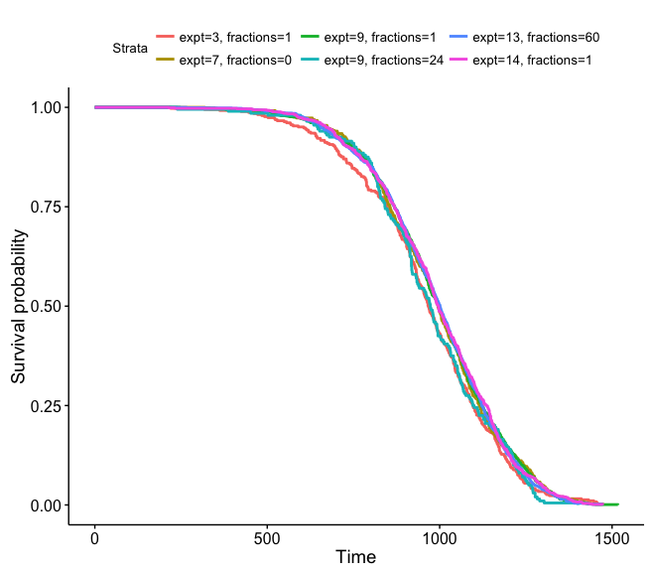

Figure 10 – exclude JM2, 4, 8, 10, 11, 12. The data looks good! I think I can justify using these conditions for everything. Reasons to exclude each of these and the data prove it best!

N Observed Expected (O-E)^2/E (O-E)^2/V

expt=3, fractions=1 385 385 353 2.96380 3.27241

expt=7, fractions=0 485 485 490 0.04344 0.04953

expt=9, fractions=1 1138 1138 1166 0.65288 0.91213

expt=9, fractions=24 200 200 180 2.29698 2.41618

expt=13, fractions=60 1176 1176 1178 0.00315 0.00442

expt=14, fractions=1 792 792 811 0.42323 0.52869

Chisq= 6.4 on 5 degrees of freedom, p= 0.266

Summary of final controls we will use:

fractions expt tot_n

<int> <int> <int>

1 0 7 485

2 1 3 385

3 1 9 1138

4 1 14 792

5 24 9 200

6 60 13 1176

* the worst looking curves (not fitting as tightly as others) are expt 3 with 1 fractions and expt 9 with 24 fractions – these are the two lowest n’s out of all other experiments.

More analysis:

Check for significant differences 1:1 between JM 13 and others

JM 13/JM 3 🡪 p=.104 graphs totally separate

JM 13/JM 7 🡪 p=.886 graphs on tops of each other

JM 13/JM 9 🡪 p=.927 graphs on top of each other

JM 13/JM 14 🡪 p= .607 graphs on top of each other

Check for significance between JM13 and all others combined

JM13/all others 🡪 p=.947 graphs on top of each other

(this was tricky for me to code at first, created final column called comparison that made JM13 = 13 and all others =0. Stratified by comparison)

Check for significance between 1 fraction and 0 fractions 🡪 p=.955

1 fraction and 60 fractions 🡪 p=.909

0 fractions and 60 fractions 🡪 p = .886

**all three graphs show curves on top of each other.

Conclusions: By checking the controls, I have an idea of which experiments are comparable to each other. Janus was designed to allow comparisons between different experiments, but occasionally the conditions changed (housing conditions, different species, etc.) and that prohibited this. Some data is more reliable than others (bigger sample size) and the analysis I just did should show that we now are working with comparable data sets that can be used for further analysis between experiments.

Next: Look into available data from JM3/7/9/13/14 for my analysis on fractions

Should I have considered gender yet? Should make sure all experiments have both… good variety… also need to check on age at exposure and strain

Strain: use ERA data set to get info:

JM3: B6CF1

JM7: B6CF1

JM9: B6CF1

JM13: B6CF1

JM14: B6CF1

(JM2, JM4, JM8, JM12 all B6CF1 mice, JM10 peromyscus, JM11 doesn’t exist, my data should work fine!)

What about sex? Gender breakdown for controls:

fractions expt sex tot_n

<int> <int> <fctr> <int>

1 0 7 F 175

2 0 7 M 310

3 1 3 F 185

4 1 3 M 200

5 1 9 F 938

6 1 9 M 200

7 1 14 F 399

8 1 14 M 393

9 24 9 F 200

10 60 13 F 584

11 60 13 M 592

Pretty even… now do graphs and statistical significance

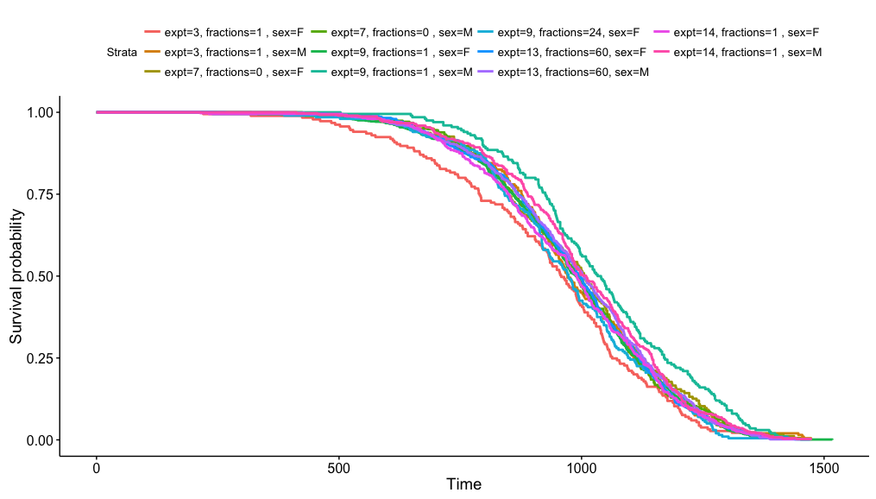

Figure 11 – stratify by sex, experiment and fractions. P = .00135… statistically significant.

Because male and female are statistically significant? Stratify by sex only.

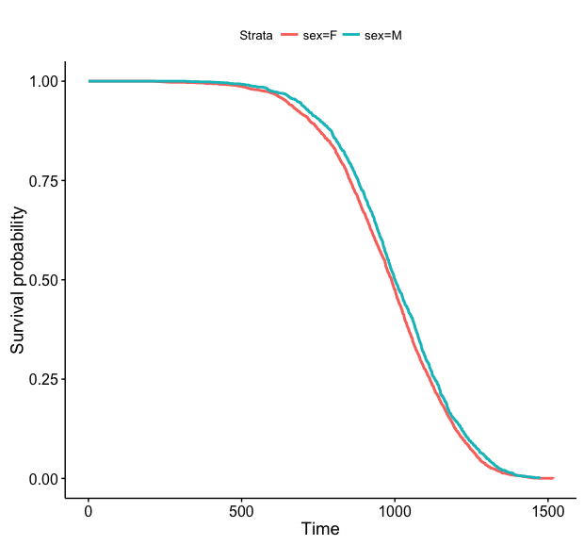

Figure 12: group all male and all female and compare. p=.00121, males and females are statistically significant.

What about within each sex?

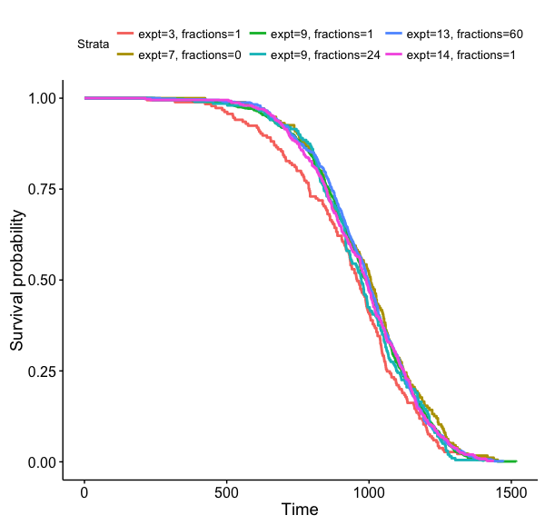

Figure 13: Females only, p=.197

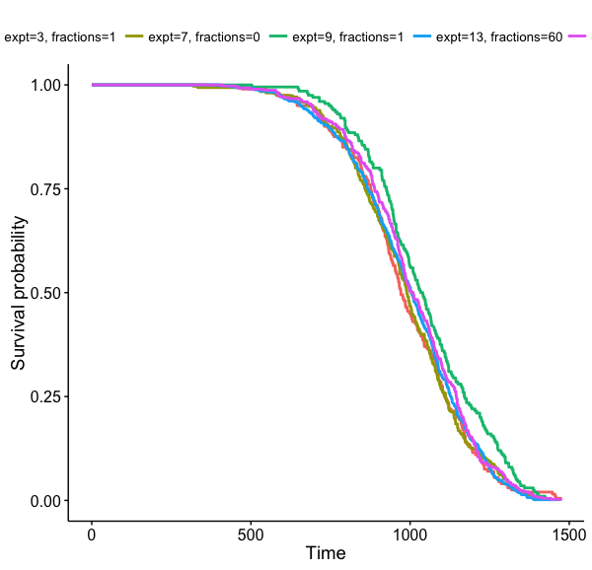

Figure 14: Males only, p=.0185. Looks like expt 9 is an issue… sample size much larger for F over M.

Maybe age at exposure can explain some variance?

fractions expt sex tot_n `mean(first_irrad)` `max(first_irrad)` `min(first_irrad)`

<int> <int> <fctr> <int> <dbl> <int> <int>

1 0 7 F 175 106.2000 120 99

2 0 7 M 310 108.4839 120 99

3 1 3 F 185 112.6757 123 109

4 1 3 M 200 112.9500 123 103

5 1 9 F 938 115.8454 123 101

6 1 9 M 200 108.0000 108 108

7 1 14 F 399 118.8070 128 114

8 1 14 M 393 119.8601 128 114

9 24 9 F 200 105.9000 115 101

10 60 13 F 584 113.3870 118 110

11 60 13 M 592 114.1132 118 110

Differences in age at exposure are small… make two groups of above average and below average? Stratify that way.

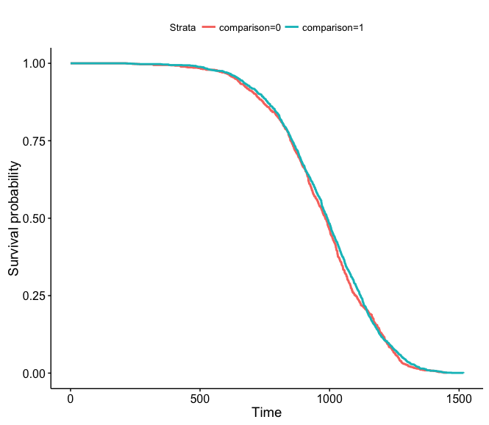

Figure 15 – Females only - stratify by first_irr (age at first exposure)… shouldn’t matter because there’s no radiation (duh). p=.218. Male looked similar, p=.611

Back to females only or males only… stratify by fractions only? Stratify by expt only?

Females only – fractions – graphs on to of each other, p=.415

Males only – fractions – graphs overlap, p=.0832

Males only – experiment – expt 9 separate, p=.0185

Females only – experiment – expt 3 separate, p=.167

What do I want to do with data? Why am I testing all of these things? BIG PICTURE…

Want to compare acute to fractionated – need to mix experiments

Want to compare different dose rates/fractionations – need to mix fractions

If controls are all similar within these areas, then it seems conditions are OK for mixing data between JM experiments… is it important to see individual differences between JM13 and others, or groups? Depends on exact analysis I’ll do… need to see what data I even want to use, I suppose. JM13 is the base… find things that match well with JM13 in terms of dose/dose rate/fractions. Only small issue right now is sex, but move on for now.

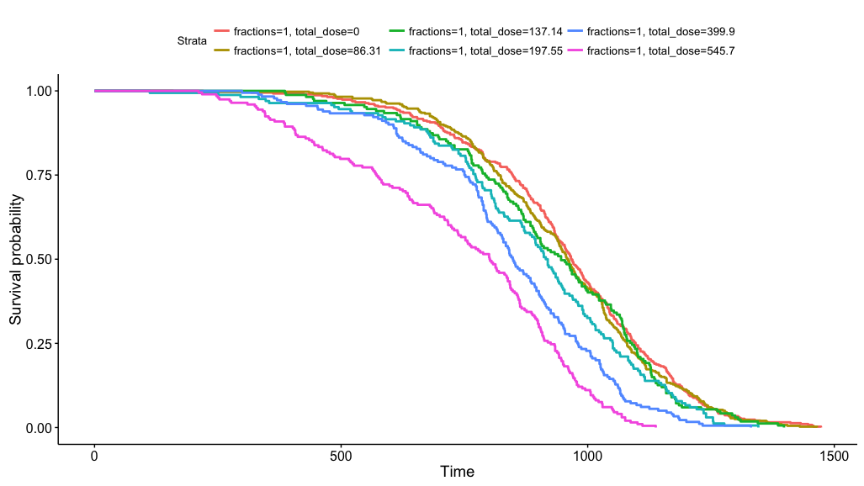

JM3 – stratified by fractions and total dose. Looks awesome!

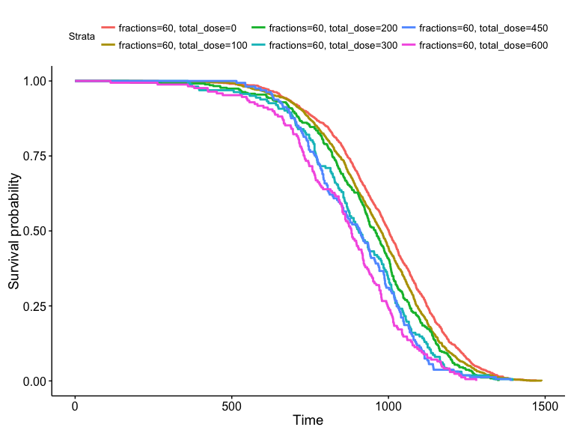

JM 13 – stratified by total dose, looks great

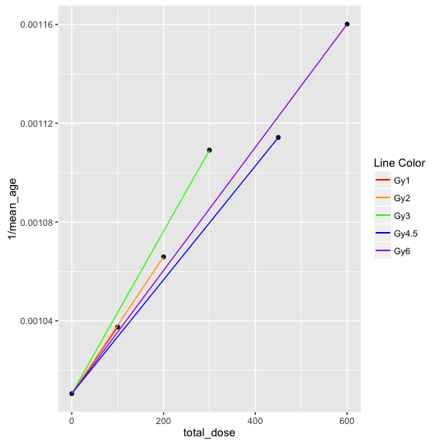

Linear regression of different total doses from JM13… falls apart after 3Gy, the slopes decreased for 4.5 and 6Gy. That’s why our cutoff is normally 2Gy.

This seems really not very sophisticated or complicated… am I doing something wrong? What can I tell from this? How would I calculate DREF? What information is in JM13?

fractions dose_rate total_dose total

<int> <dbl> <dbl> <int>

1 60 0.0000 0 1176

2 60 0.0830 100 1192

3 60 0.1665 200 352

4 60 0.2500 300 162

5 60 0.3750 450 161

6 60 0.5000 600 169

Add acute? Stratify by sex? I need to figure out how to make this graph less manual for coding… create a new dataframe that includes the 0Gy multiple times?

Start by adding acute – what acute data is available? (this is for 2Gy or less)

expt fractions dose_rate total_dose n ave_age

<int> <int> <dbl> <dbl> <int> <dbl>

1 3 1 0.0000 0.00 385 959.6779

2 3 1 4.3155 86.31 399 953.0852

3 3 1 6.8570 137.14 167 931.9521

4 3 1 9.8775 197.55 166 896.7590

5 7 0 0.0000 0.00 485 988.2928

6 7 1 9.8775 197.55 198 963.0101

7 9 1 0.0000 0.00 1138 990.3533

8 9 1 1.0785 21.57 497 962.9235

9 9 1 2.1575 43.15 346 967.9277

10 9 1 4.3155 86.31 194 934.8402

11 9 24 0.0000 0.00 200 970.7600

12 13 60 0.0000 0.00 1176 989.5672

13 13 60 0.0830 100.00 1192 963.8289

14 13 60 0.1665 200.00 352 938.1761

15 14 1 0.0000 0.00 792 991.7601

* JM3 shows nice trend, good acute data
* JM7 shows ok trend (only two values to use), but very different value for 2Gy treatment compared to JM3
* JM9 low doses, ok trend, doesn’t show big changes because small doses, doesn’t match JM13 doses
* JM14 – could only use controls (but can use them if necessary)

Right now, just check out JM3 with my JM13 and see what it looks like.

Figured out prettier code (could definitely still be less manual)…

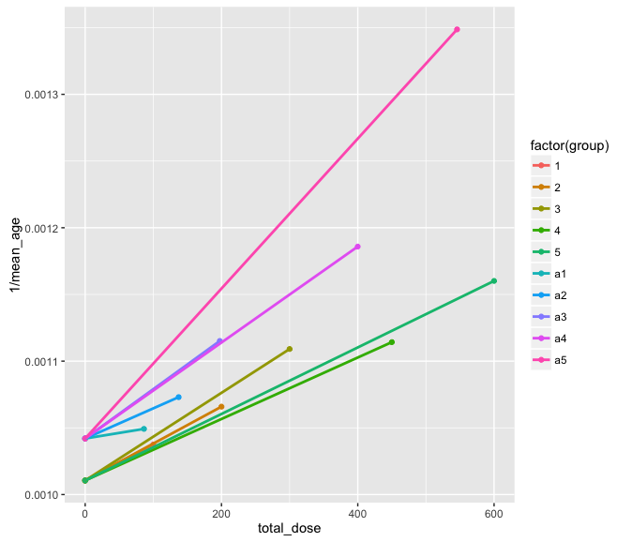

JM13 is grouped with numbers (60 fractions) and JM3 is grouped with “a”# to represent acute values. The total dose lines up for 200cGy, others are just close.

group Intercept Slope

<chr> <dbl> <dbl>

1 1 0.001010543 2.698578e-07

2 2 0.001010543 2.767756e-07

3 3 0.001010543 3.285588e-07

4 4 0.001010543 2.304400e-07

5 5 0.001010543 2.493164e-07

6 a1 0.001042016 8.351136e-08

7 a2 0.001042016 2.260483e-07

8 a3 0.001042016 3.700861e-07

9 a4 0.001042016 3.597105e-07

10 a5 0.001042016 5.619507e-07

Compare group 2 and group a3 🡪 slope = 2.767756e-07 and 3.700861e-07

DREF = 3.700861e-07/2.767756e-07 = 1.337

Is there a way to compare all values to each other and normalize by total dose or dose rate or something?

3/21

Discussed with Tanja…

* can we include JM 8?
* JM4 was cut out, can we include the 24 fractions still and just exclude 120 and 300?
* JM9 controls for males are bad, but there aren’t any gamma irradiated male mice that we can use so exclude the male controls
* Controls 1 vs all else – check JM9 with 24 fractions, didn’t originally do for some reason
* Don't limit total dose
* JM14 🡪 if it has WR it’s a drug and exclude it

1. Get max control population for cancer counting (they won’t have cancer very often, need bit population)
2. Send info to Japan on which data to use – dose, dose rate, expt and potentially some of my data to show that they can be compared between groups
3. In spare time – how else can we describe data? Cluster? PCA?

What should I do right now? Look into JM8… what are we dealing with? What do the controls look like stratified in different ways? What about JM4? What about JM9 females only?

JM8 – look into the controls – survival plots by fraction/total dose

Duh. They were given a set dose until the day they died, so the number of fractions and total dose corresponds to their age. If they lived longer, they had a higher dose. Now just check by dose rate, because that really is different.

Also, JM7 had the same dose rate (as JM8 high and low dose rates) for its 60 fractions and JM-4K had the same dose rate (as JM8 mid level dose rates) for its 24 fractions. In JM8, sample sizes for females were not adequate in most dose groups, but were sufficient for males (.37 and .68 only have 20 and 15 female mice… .15 has 174)

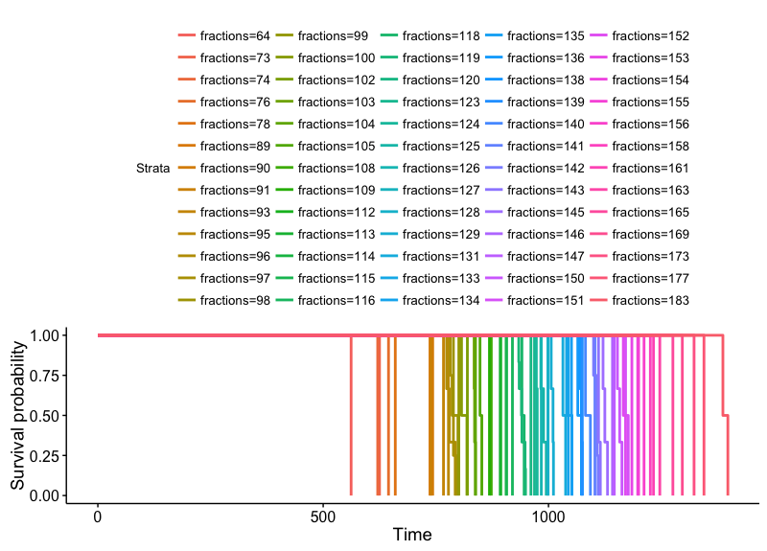

Controls for JM8 – stratified by fractions… they had a fraction every week until they died, so of course it shows that the more fractions received the longer they lived.

For JM8… only use males?

dose_rate sex total

<dbl> <fctr> <int>

1 0.000000 F 50

2 0.000000 M 60

3 0.148000 F 174

4 0.148000 M 181

5 0.370222 F 20

6 0.370222 M 120

7 0.679778 F 15

8 0.679778 M 86

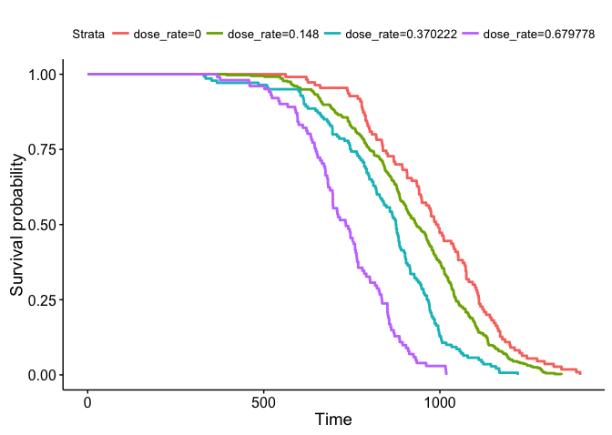

JM8 stratified by dose rate… this makes sense and looks correct.

Information we could get from JM8 – life span for dose rates, cancer death for dose rates… that’s it?

Check if JM8 controls match with the others (JM3/7/9/13/14)

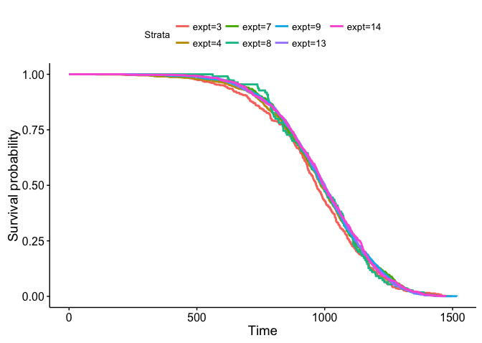

Survival curve excluding JM2/10/11/12 (including JM 4 and JM8). No significan difference.

survdiff(formula = Surv(age) ~ expt, data = controls)

N Observed Expected (O-E)^2/E (O-E)^2/V

expt=3 385 385 354 2.7159 2.9375

expt=4 1021 1021 1008 0.1613 0.2004

expt=7 485 485 492 0.0890 0.0988

expt=8 110 110 106 0.1542 0.1582

expt=9 1338 1338 1351 0.1347 0.1820

expt=13 1176 1176 1182 0.0343 0.0444

expt=14 792 792 813 0.5593 0.6647

Chisq= 3.9 on 6 degrees of freedom, p= 0.693

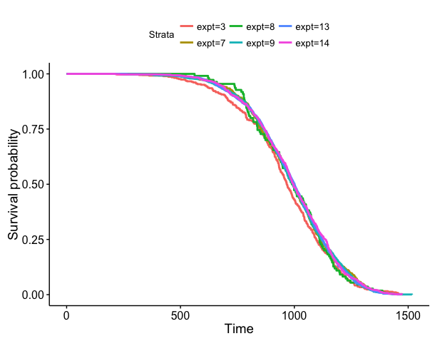

Include JM8, but not JM4, still ok.

Call:

survdiff(formula = Surv(age) ~ expt, data = controls)

N Observed Expected (O-E)^2/E (O-E)^2/V

expt=3 385 385 353 2.8807 3.1738

expt=7 485 485 490 0.0532 0.0605

expt=8 110 110 106 0.1802 0.1858

expt=9 1338 1338 1347 0.0574 0.0843

expt=13 1176 1176 1179 0.0080 0.0111

expt=14 792 792 811 0.4584 0.5692

Chisq= 3.7 on 5 degrees of freedom, p= 0.597

What if I just exclude JM4 120 and 300 fractions?

controls <- filter (controls,

!(expt ==4 & fractions == 120),

!(expt ==4 & fractions == 300))

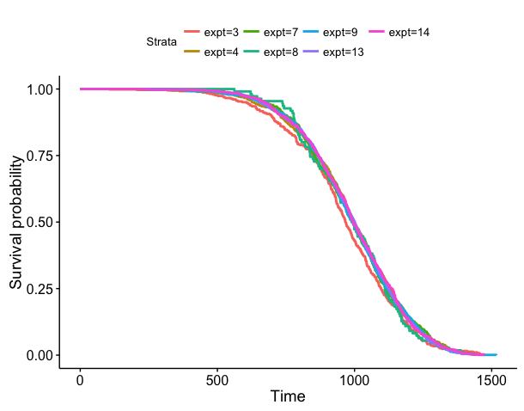

Exclude JM4 with 300 and 120 fractions because those stuck out when stratified by fraction.

survdiff(formula = Surv(age) ~ expt, data = controls)

N Observed Expected (O-E)^2/E (O-E)^2/V

expt=3 385 385 352 3.061729 3.331754

expt=4 659 659 673 0.279275 0.325288

expt=7 485 485 488 0.023847 0.026632

expt=8 110 110 105 0.209488 0.215319

expt=9 1338 1338 1343 0.015192 0.021006

expt=13 1176 1176 1175 0.000536 0.000707

expt=14 792 792 809 0.344490 0.414579

Chisq= 4 on 6 degrees of freedom, p= 0.68

Check stratifying by fractions (cannot include JM8 for previously stated reasons) this time including JM4 (not 120 and 300 fractions).

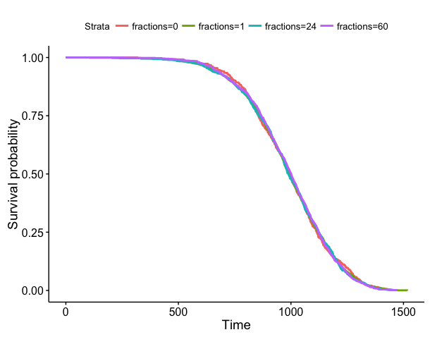

Stratify controls JM3/4 (not 120 and 300 fractions)/7/9/13/14 by fraction. Looks GREAT!

survdiff(formula = Surv(age) ~ fractions, data = controls)

N Observed Expected (O-E)^2/E (O-E)^2/V

fractions=0 485 485 488 0.01783 0.01996

fractions=1 2315 2315 2322 0.01825 0.03535

fractions=24 859 859 851 0.06756 0.08250

fractions=60 1176 1176 1174 0.00299 0.00398

Chisq= 0.1 on 3 degrees of freedom, p= 0.991

What about with JM4 (partial), but not JM8? JM8 doesn’t make that much sense for these purposes… only actually checking change in dose rate, not fractions. Already know it’s fine for fractions and it used to be fine for stratifying for experiments. Better check without the 120 and 300 fractions for good measure.

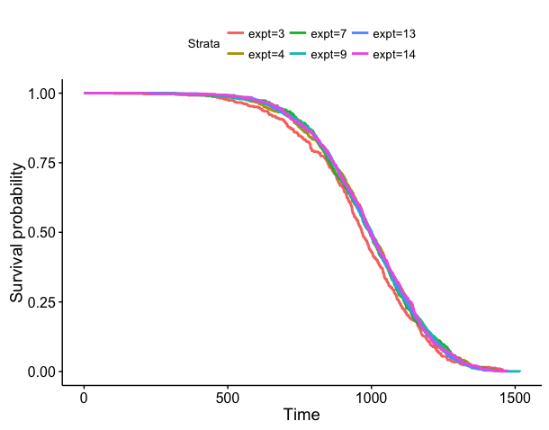

JM4(partial), but not JM8. Looks good.

survdiff(formula = Surv(age) ~ expt, data = controls)

N Observed Expected (O-E)^2/E (O-E)^2/V

expt=3 385 385 352 3.14065 3.42295

expt=4 659 659 672 0.25506 0.29810

expt=7 485 485 488 0.01783 0.01996

expt=9 1338 1338 1341 0.00716 0.00998

expt=13 1176 1176 1174 0.00299 0.00398

expt=14 792 792 808 0.31568 0.38153

Chisq= 3.8 on 5 degrees of freedom, p= 0.582

Now do comparisons…

JM13 vs. JM8 🡪 p=.678, graphs separate at top, then on top of each other

JM13 vs. JM4 (-120 and -300 fractions) 🡪p=.659, graphs on top of each other

JM13 vs. all else (now with partial JM4) 🡪 p=.95, graphs on top of each other

JM13 vs. all else (now with JM8 and partial JM4) 🡪 p=.979 graphs on top of each other

JM 13/JM 9 (exclude males from both)🡪 p=.556 graphs on top of each other

JM 13/JM 9 (exclude males from JM9)🡪 p=.229 graphs on top of each other

24 fractions and 60 fractions 🡪 p=.0541

If using only females for 24/60 🡪 p=.204

expt fractions sex tot_n

1 4 24 F 464

2 9 24 F 200

3 13 60 F 584

4 13 60 M 592

-24 fractions is all female, so the difference is partially due to gender

So both are viable options… definitely keep JM4. What would the benefit of JM8 be? Maybe not relevant for this study on fractionation because the fractions are basically equal to age… only helpful for dose rate.

Create nice summary for Japanese collaborators.