**Abstract:**

Understanding the risks of radiation exposure at different doses and dose rates is important for determining safe levels of exposure and the proper level of caution when considering general population exposures to ionizing radiation. Calculating this risk is typically done through statistical modeling with data from atomic bomb survivors and animal studies. Unfortunately, because the effect of low dose exposures is small, there is not enough statistical power in most epidemiologic studies to determine the precise risk associated with low dose/low dose rate exposure conditions. Instead, it is common practice to calculate the dose and dose rate effectiveness factor (DDREF) – the ratio that extrapolates the risk from high dose to low dose exposures and high dose rate to low dose rate. There has been a great deal of debate over which type of model best represents the physiological consequences of radiation exposure; the clinically used linear-quadratic model is often used as a basis for these statistical models designed for risk assessment. We recently showed that protracted exposure risk cannot be extrapolated directly from acute exposure data and that data for both conditions are necessary in order to arrive at the DDREF; moreover, we find that this factor can be modeled the best by using a linear-linear (rather than a linear-quadratic) model. We are now expanding this study to investigate the risk associated with specific cancers following radiation exposure in order to calculate a cancer associated DDREF value. In addition, we are investigating DDREF values associated with individual cancer types. **We hypothesize that human radiation risk estimates can be improved through rigorous statistical modeling with large, detailed mouse data sets that include protracted and acute dose data.** A more detailed knowledge of the risks posed by different types of radiation exposure may improve the safety of the general population and simultaneously reduce excess costs linked to superfluous safety regulations.

**Specific Aims:**

Aim 1: Calculate DDREF using lethal cancer endpoints from mice treated with varying radiation exposures.

Aim 2: Determine if harderian gland tumor (benign) formation in response to radiation exposure is a proper representative model for other cancer types.

**Significance:**

Humans are exposed to background levels of radiation every single day, mostly through radon, cosmic radiation, and medical devices used to treat and detect diseases such as cancer. All of these low level exposures, typically less than 20 millisieverts at a time, accumulate to a few hundred millisievers in a lifetime [2]. To study the affects of radiation on human health, experts turn to data from human subjects, typically atomic bomb survivors that suffered from large doses of acute radiation exposure and experienced increased cancer incidence and mortality. The latest report from the National Academy of Sciences (NAS) used a linear quadratic statistical model of atomic bomb survivor data and animal model data to estimate a 3-12% increase in lethal cancer cases per sievert of low dose rate or protracted ionizing radiation [1]. The large range of confidence from the NAS and the additional mixed reports from other research institutions concluding that the risk is either higher or lower than the NAS’s estimate clearly demonstrates the need for further studies. If current estimates for risk are too low, it puts everyone at danger. If risk estimates are too high, the government is wasting billions of dollars on waste disposal when that money could be better utilized in a myriad of ways. Increased certainty in the exact risks caused by radiation exposure will allow the proper level of caution to be taken for radiation exposure policies centered around waste disposal, decisions on medical treatment and detection, and thresholds for workers in the field in an effort to decrease cancer development.

In addition to atomic bomb survivor data, our lab utilizes publicly available radiation data archives with records on mice, dogs, and pigs irradiated under a large range of doses through acute and protracted conditions. With this data, we have already examined life span expectancy and our next aim is to investigate the risk associated with individual cancer types. We predict that by using data sources from multiple strains of mice in a controlled environment, we can better estimate risks associated with radiation exposure at all levels. By narrowing in on the greatest threats to human health due to radiation exposure in a cancer type specific manner, we can provide the appropriate protection to efficiently reduce cancer development and decrease mortality.

**Background:**

Aim 1 - The dose and dose rate effectiveness factor DDREF is used to quantify the fold change in risk between acute and protracted radiation exposures. To calculate overall risk, most often a linear-quadratic formula, as show below, is used.



When fitting this linear quadratic equation to data, the alpha coefficient represents the slope at low doses/dose rates, and the beta coefficient represents the slope at higher doses/dose rates. Their ratio is called theta, and if this ratio is known and the risk associated with high or acute doses is known, then the risk associated with low or protracted doses can be calculated. This is depicted in figure 1 along with the DDREF equation.

A

B

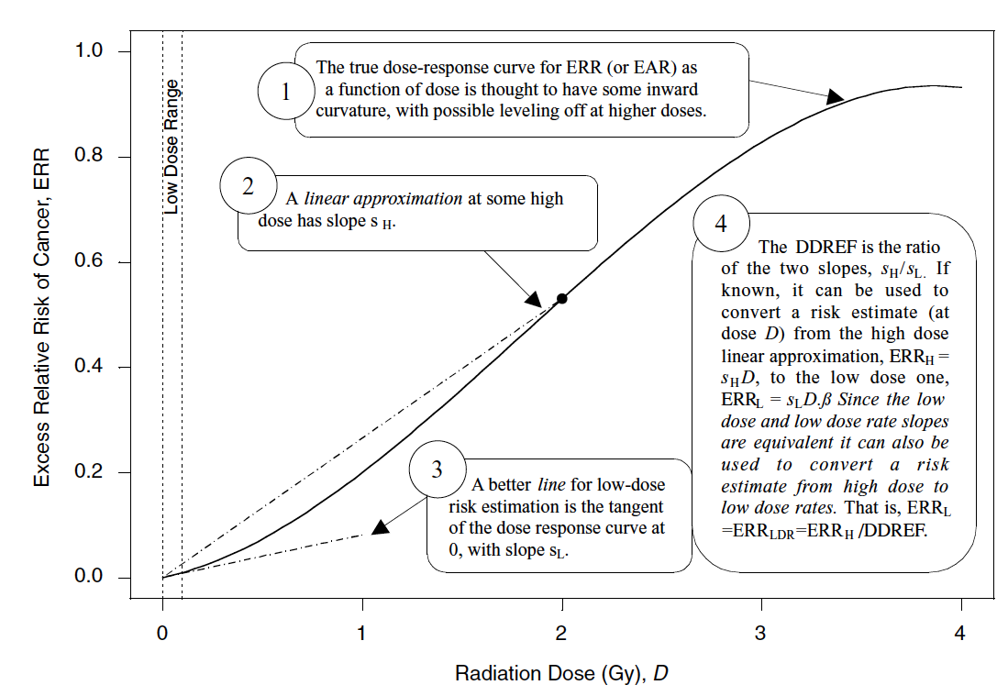

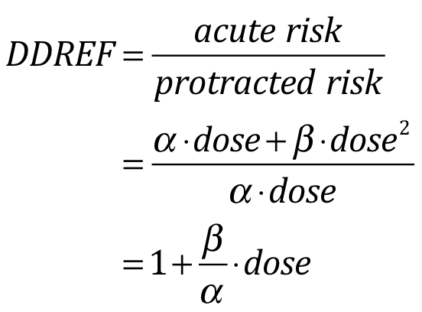

**Figure 1**: Linear-quadratic equation to calculate DDREF. **A.** Representative linear-quadratic dose response curve with separate slopes for high doses and low doses. Their ratio can be used to estimate risks a low doses given the risk at high doses. Figure 10-1 from BEIR VII report [1]. **B.** DDREF equation.

Our lab recently showed that the BEIR VII method for calculating DDREF values cannot be used for larger animal data sets, leading us to believe that there is still a lot of research needed to determine better risk estimates [3]. In addition to BEIR VII, DDREF is being studied across the world, and research institutions have been unable to converge on a single estimate (table 1). It is important to further study radiation risk and DDREF calculations to ensure proper caution is being taken.

|  |  |
| --- | --- |
| **Research Institution** | **DDREF Value** |
| United Nations Scientific Committee on the Effects of Atomic Radiation (UNSCEAR) [4, 5] | 1.2 – 2.85 (2006)  N/A (2012) |
| French Academy of Sciences [6] | Very high |
| National Academy of Sciences (NAS) - Biological Effects of Ionizing Radiation (BEIR VII) [1] | 1.5 |
| International Commission on Radiological Protection (ICRP) [7] | 2.0 |
| National Council on Radiation Protection (NCRP) [8] | 2.0 – 10.0 |

**Table 1**: DDREF values at different national and international research institutions and protection agencies.

Aim 2 – The harderian gland is present in animals with a third eyelid and positioned on the posterior side of the eyeball. The third eyelid is necessary for protection, vision purposes, and retaining moisture [9]. Harderian gland tumors are non-lethal, but induced by radiation. Because of their dose dependent sensitivity to radiation, they are commonly used to model risk associated with radiation exposure in humans. This is concerning because humans do not develop harderian glands, these tumors are benign, and the dose-response curves for harderian glands resemble myeloid leukemia more so than solid cancer types (figure 2).

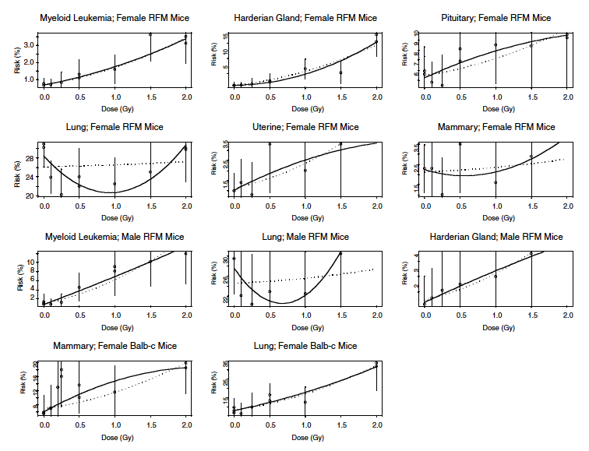

**Figure 2** – Cancer risk models from mouse experiments. SOURCE: Data from A.A. Edwards(1992). Reprinted from a subset of figure 10B-2 of “Health risks from exposure to low levels of ionizing radiation: BEIR VII phase 2” [1]. Vertical bars extend two standard errors above and below each estimate. Solid lines are linear-quadratic fits with individual estimates. Dashed lines are linear-quadratic fits with curvature constrained to be the same for all data sets. DDREF ~ 1.4 (1.1, 2.6) for 95% confidence interval.

**Preliminary Data:**

As a benchmark for DDREF calculations, we reproduced one key figure from BEIR VII and plan to reproduce two other important figures from their report (figure 3).

B

A

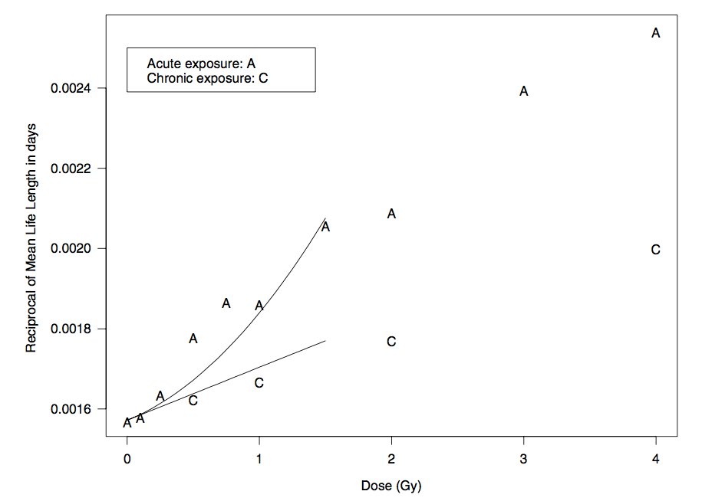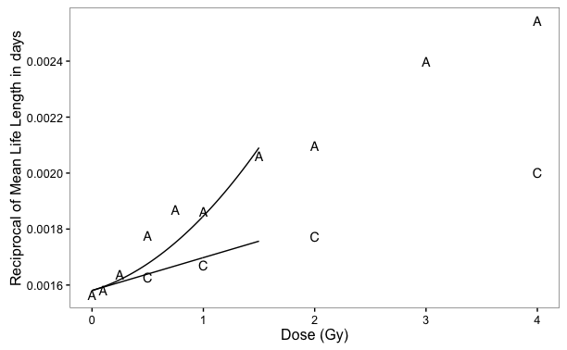

**Figure 3 -** Life span study data over varying doses administered acutely, or chronically and DDREF calculations. **A.** Reprinted from figure 10B-3 of “Health risks from exposure to low levels of ionizing radiation: BEIR VII phase 2” [1]. A graph of the reciprocal of the mean life lengths for RFM female mice versus the dose of exposure for chronically (C) and acutely (A) exposed groups. A linear-quadratic model was fit to data within the 0-1.5 Gy dose range. The data came from Tables 1, 2, and 3 of Storer and others. **B.** A reproduction of figure 10B-3 from BEIR VII produced from our lab. The data and code used for generating this figure can be found at <https://github.com/aliazander/Thesis/tree/master/BEIR-VII_10B3>. **C.** Calculations for DDREF used with linear-quadratic model of risk. DDREF is dependent on the ratio of coefficients and dose. The coefficients are estimated from the linear-quadratic model and the dose is set at 1Gy.

**Research Plan:**

Aim 1 - Calculate DDREF using lethal cancer endpoints from mice treated with varying radiation exposures.

Cancer is the number one risk associated with radiation and therefore, it’s important to understand how radiation plays a role specifically in cancer induction. To do so, we will reproduce key figures from BEIR VII and then improve their model by using more data (data from Janus Archives and European Radiobiological Archives) and improved statistical analysis methods. First, data will filtered according to the following inclusion criteria:

•Individual-level animal data available

•External radiation exposures

•Low – LET, whole body exposures

•Total dose equal to or below 2 Gy

•No other treatments (e.g. no chemical exposures)

•Digitized data on treatment and cancer incidences confirmed by primary literature

•Cancer associated cause of death

•At least three distinct treatment groups per stratum so that a linear-quadratic model can be fitted

For risk models, the data will also be stratified by gender, age, and strain, as all of these factors play an important role in cancer risk due to radiation exposure. We will then calculate DDREF and confidence intervals using BEIR VII methods. Finally, we will consider alternative models that account for heterogeneity and exclude data showing hormesis.

Aim 2 - Determine if harderian gland tumor (benign) formation in response to radiation exposure is a proper representative model for other cancer types.

Harderian gland tumors are commonly used to better understand the relationship between cancer incidence and high and low LET radiation. To test the suitability for harderian gland tumor models, we plan to carry out several comparisons between harderian gland tumors and other cancer types. The first test will be to check models for individual cancer types, similar to the method BEIR VII used in figure 2. Next, we will compare several different groupings of cancer types:

* Benign vs. lethal cancers
* Harderian gland tumors vs. myeloid leukemia
* Harderian gland tumors vs. solid tumors
* Harderian gland tumors vs. all other cancer types

To compare models, we will use likelihood ratio tests to measure goodness of fit. We will also calculate DDREF values and corresponding confidence intervals. To verify that our models are not over-fit to the data sets, we will perform cross validation.

**Publications, abstract presentations, and awards:**

Hanh Chi Do-Umehara, Cong Chen, Daniela Urich, Liang Zhou, Ju Qiu, Samuel Jang, **Alia Zander**, et al. (2013). Suppression of inflammation and acute lung injury by Miz1 via repression of C/EBP-[delta]. *Nature Immunology*. doi:10.1038/ni.2566

Radiation Research Society Conference, Poster presentation 2016

Pulmonary Symposium, Poster Presentation 2014 and 2015

Pulmonary and Critical Care Division Seminar, Research in Progress Presentation 2014

Reach for the Stars NSF GK-12 Fellowship (2013-2014)

Katten Muchin Rosenman Travel Scholarship

**References:**

1. Council, N.R., *Health Risks from Exposure to Low Levels of Ionizing Radiation: BEIR VII Phase 2*. 2006, Washington, DC: The National Academies Press. 422.

2. Fred A. Mettler, J., et al., *Effective Doses in Radiology and Diagnostic Nuclear Medicine: A Catalog.* Radiology, 2008. **248**(1): p. 254-263.

3. Haley, B.M., et al., *The Increase in Animal Mortality Risk following Exposure to Sparsely Ionizing Radiation Is Not Linear Quadratic with Dose.* PLOS ONE, 2015. **10**(12): p. e0140989.

4. Radiation, U.N.S.C.o.t.E.o.A., *Effects of ionizing radiation Annex A: Epidemiological studies of radiation and cancer*. 2006.

5. Radiation, U.N.S.C.o.t.E.o.A., *SOURSE, EFFECTS AND RISKS OF IONIZING RADIATION*. 2012: New York.

6. Tubiana, M., *Dose-effect relationship and estimation of the carcinogenic effects of low doses of ionizing radiation: the joint report of the Academie des Sciences (Paris) and of the Academie Nationale de Medecine.* Int J Radiat Oncol Biol Phys, 2005. **63**(2): p. 317-9.

7. ICRP, *Low-dose Extrapolation of Radiation-related Cancer Risk*. 2005.

8. Protection, N.C.o.R. and Measurements, *Influence of dose and its distribution in time on dose-response relationships for low-let radiations: recommendations of the National Council on Radiation Protection and Measurements ; issued April 1, 1980*. 1980: NCRP.

9. Di Majo, V., et al., *Dose-response relationship of radiation-induced harderian gland tumors and myeloid leukemia of the CBA/Cne mouse.* J Natl Cancer Inst, 1986. **76**(5): p. 955-66.