Now with set conditions… get summary that can be used for everything.

coxph(formula = Surv(age, status) ~ sex + expt, data = subset(all.info,

total_dose == 0))

n= 4460, number of events= 4062

coef exp(coef) se(coef) z Pr(>|z|)

sexM -0.126501 0.881173 0.033755 -3.748 0.000179 ***

expt7 0.025843 1.026180 0.058659 0.441 0.659527

expt8 0.026949 1.027315 0.107089 0.252 0.801314

expt9 -0.058997 0.942709 0.046584 -1.266 0.205345

expt13 0.020434 1.020644 0.046287 0.441 0.658873

expt14 -0.008696 0.991342 0.062396 -0.139 0.889158

---

Signif. codes: 0 '***' 0.001 '**' 0.01 '*' 0.05 '.' 0.1 ' ' 1

exp(coef) exp(-coef) lower .95 upper .95

sexM 0.8812 1.1349 0.8248 0.9414

expt7 1.0262 0.9745 0.9147 1.1512

expt8 1.0273 0.9734 0.8328 1.2672

expt9 0.9427 1.0608 0.8604 1.0328

expt13 1.0206 0.9798 0.9321 1.1176

expt14 0.9913 1.0087 0.8772 1.1203

Concordance= 0.518 (se = 0.005 )

Rsquare= 0.003 (max possible= 1 )

Likelihood ratio test= 15.14 on 6 df, p=0.01919

Wald test = 15.12 on 6 df, p=0.01936

Score (logrank) test = 15.13 on 6 df, p=0.01929

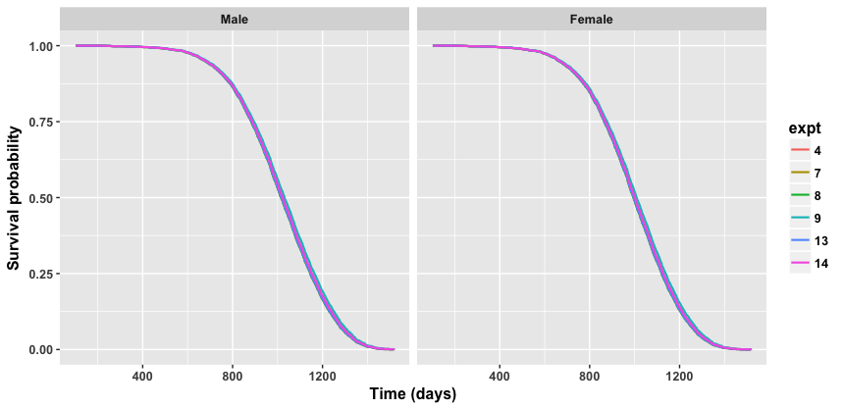

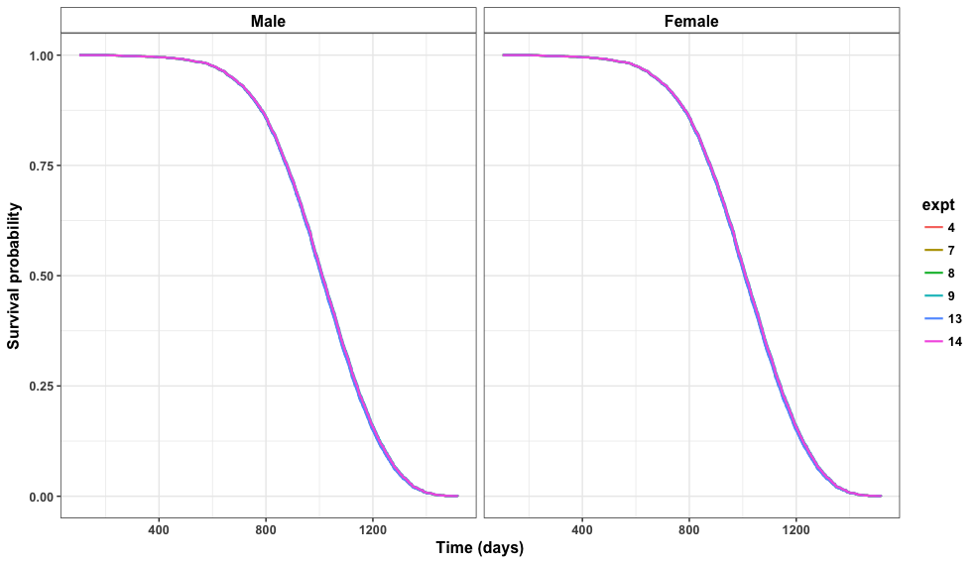

rho chisq p

sexM 0.00594 0.141 0.708

expt7 -0.00605 0.148 0.701

expt8 0.01194 0.579 0.447

expt9 0.00815 0.271 0.603

expt13 0.01192 0.578 0.447

expt14 0.01648 1.103 0.294

GLOBAL NA 2.659 0.850

|  |  |
| --- | --- |
| **Factor** | **P-value** |
| sexM | .708 |
| expt7 | .701 |
| expt8 | .447 |
| expt9 | .603 |
| expt13 | .447 |
| expt14 | .294 |
| GLOBAL | .850 |

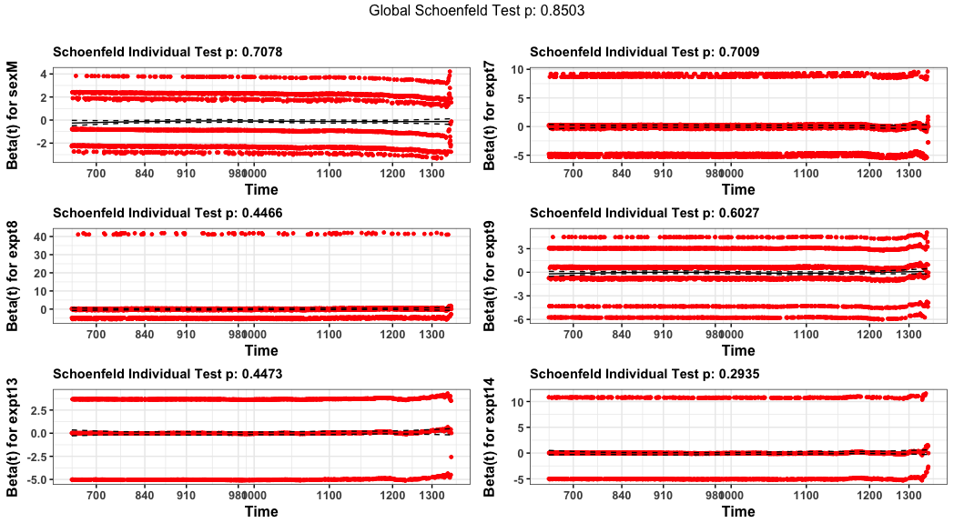

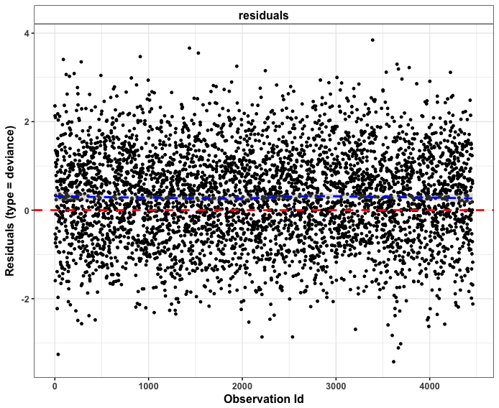

res.cox <- coxph(Surv(age, status) ~ sex + fractions,

+ data = subset(all.info.no8, total_dose == 0))

> summary(res.cox)

Call:

coxph(formula = Surv(age, status) ~ sex + fractions, data = subset(all.info.no8,

total_dose == 0))

n= 4350, number of events= 3964

coef exp(coef) se(coef) z Pr(>|z|)

sexM -0.114321 0.891972 0.034781 -3.287 0.00101 **

fractions1 -0.082537 0.920777 0.054988 -1.501 0.13336

fractions24 -0.014447 0.985657 0.059583 -0.242 0.80841

fractions60 -0.004104 0.995905 0.055778 -0.074 0.94135

fractions120 -0.005013 0.994999 0.089032 -0.056 0.95510

---

Signif. codes: 0 '***' 0.001 '**' 0.01 '*' 0.05 '.' 0.1 ' ' 1

exp(coef) exp(-coef) lower .95 upper .95

sexM 0.8920 1.121 0.8332 0.9549

fractions1 0.9208 1.086 0.8267 1.0256

fractions24 0.9857 1.015 0.8770 1.1078

fractions60 0.9959 1.004 0.8928 1.1110

fractions120 0.9950 1.005 0.8357 1.1847

Concordance= 0.518 (se = 0.005 )

Rsquare= 0.003 (max possible= 1 )

Likelihood ratio test= 14.33 on 5 df, p=0.01366

Wald test = 14.26 on 5 df, p=0.01402

Score (logrank) test = 14.27 on 5 df, p=0.01397

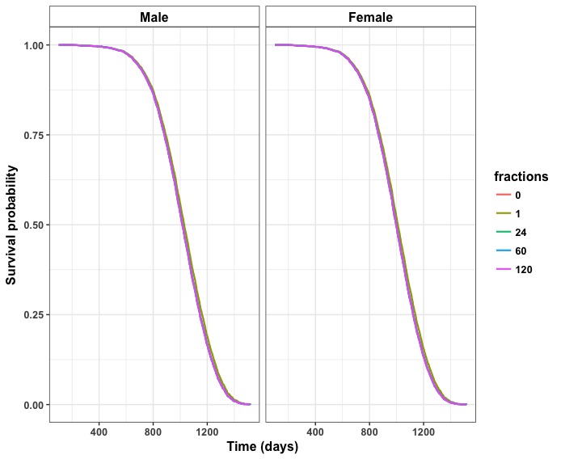

rho chisq p

sexM 0.0192 1.41 0.235

fractions1 0.0201 1.58 0.208

fractions24 0.0164 1.04 0.307

fractions60 0.0173 1.18 0.277

fractions120 -0.0202 1.63 0.202

GLOBAL NA 6.21 0.286

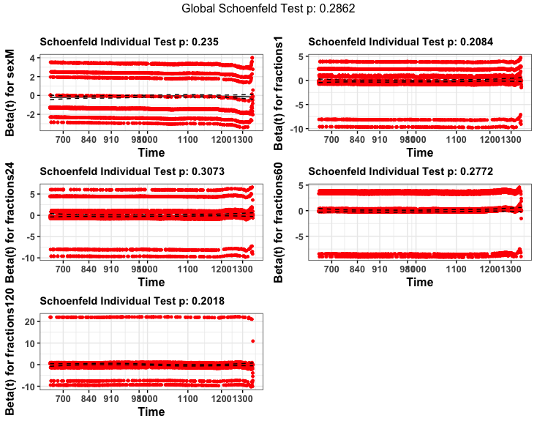

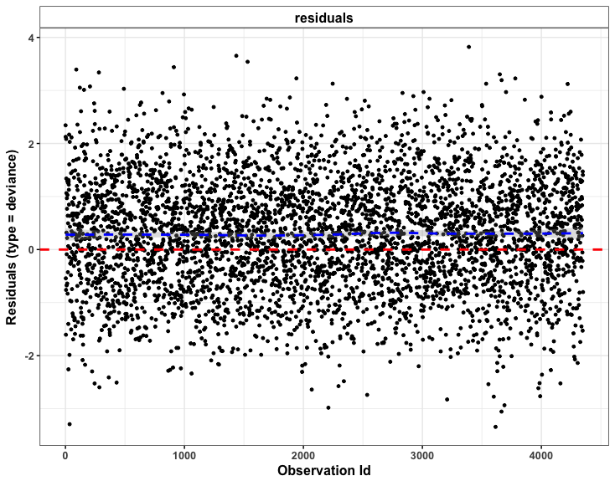

JM8 analysis

res.cox <- coxph(Surv(age, status) ~ sex + dose_rate,

+ data = jm8)

> summary(res.cox)

Call:

coxph(formula = Surv(age, status) ~ sex + dose_rate, data = jm8)

n= 720, number of events= 648

coef exp(coef) se(coef) z Pr(>|z|)

sexM -0.11428 0.89201 0.08948 -1.277 0.20154

dose_rate0.148 0.36670 1.44297 0.11762 3.118 0.00182 **

dose_rate0.370222 0.97166 2.64232 0.14174 6.855 7.13e-12 ***

dose_rate0.679778 1.90115 6.69356 0.15919 11.943 < 2e-16 ***

---

Signif. codes: 0 '***' 0.001 '**' 0.01 '*' 0.05 '.' 0.1 ' ' 1

exp(coef) exp(-coef) lower .95 upper .95

sexM 0.892 1.1211 0.7485 1.063

dose_rate0.148 1.443 0.6930 1.1459 1.817

dose_rate0.370222 2.642 0.3785 2.0014 3.488

dose_rate0.679778 6.694 0.1494 4.8996 9.144

Concordance= 0.631 (se = 0.013 )

Rsquare= 0.19 (max possible= 1 )

Likelihood ratio test= 151.7 on 4 df, p=0

Wald test = 175.5 on 4 df, p=0

Score (logrank) test = 202 on 4 df, p=0

> test.ph <- cox.zph(res.cox)

> print(test.ph)

rho chisq p

sexM -0.03513 0.8343 0.361

dose_rate0.148 -0.01627 0.1746 0.676

dose_rate0.370222 0.00643 0.0266 0.870

dose_rate0.679778 -0.00675 0.0290 0.865

GLOBAL NA 1.0743 0.898

