**Goal:** Determine which Janus experiments can be compared to each other so that we have a large pool. Controls will have fewer cases of cancer, so the larger the sample size, the better.

**Method:** Check survival curves in control mice to determine if there are significant changes in survival and, therefore, conditions in the experiment that indicate results cannot be grouped outside of individual experiments.

**Results:**

Initial examination of data with all experiments included -

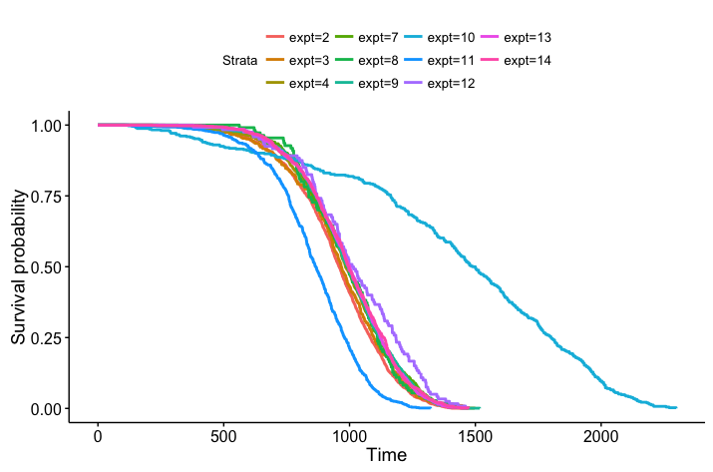

Figure 1 - all controls, stratified by experiment number.

* JM10 – peromyscus leucopus 🡪 exclude
* JM11 –Not listed as control, but under treatments tab, it shows the total dose is equal to 0Gy for gamma and neutrons, there aren’t any mice treated with a total dose over 0Gy 🡪 exclude
* JM12 – 1 ctrl, 3 treatments of neutrons, all male, small sample size, 120 mice per group 🡪 exclude

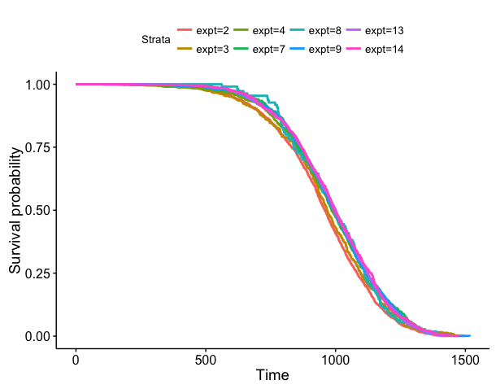

Figure 2 - all controls except for JM10, JM11, JM12, stratified by experiment number.

This looks much better, but when checking for significance, there is a significant difference in this group and it appears to mostly be due to JM2 based on the graph and the significance test:

survdiff(formula = Surv(age) ~ expt, data = controls)

N Observed Expected (O-E)^2/E (O-E)^2/V

expt=2 1700 1700 1472 35.15410 44.92227

expt=3 385 385 369 0.65912 0.70244

expt=4 1021 1021 1051 0.87657 1.03801

expt=7 485 485 513 1.48493 1.61271

expt=8 110 110 111 0.00417 0.00427

expt=9 1338 1338 1409 3.58432 4.51920

expt=13 1176 1176 1233 2.65033 3.23619

expt=14 792 792 848 3.73109 4.27327

Chisq= 48.6 on 7 degrees of freedom, p= 2.74e-08

* JM2 was the first study and was not performed in the JANUS facility, this must have caused significant differences in survival. It cannot be compared to other Janus experiments 🡪 exclude

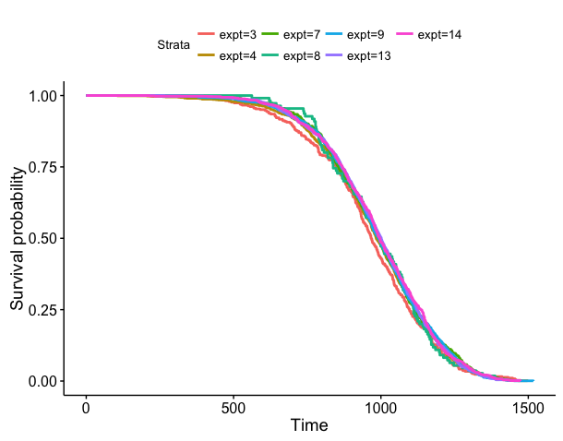

Figure 3 - all controls except for JM2, JM10, JM11, JM12, stratified by experiment number. P-value 🡪0.693

We will most likely stratify by fraction as well, check for significant differences when stratifying by fractions:

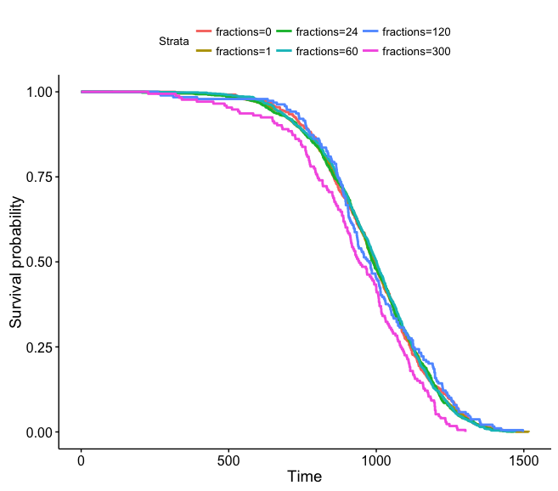

Figure 4 – JM8 was excluded from this analysis because there are too many different groups of fractions due to the nature of the study. Stratified by fractions with 300 and 120 both looking the worst (P-value = 0.0134). Both come from JM 4 and have the lowest n 🡪 exclude those fractions from JM4.

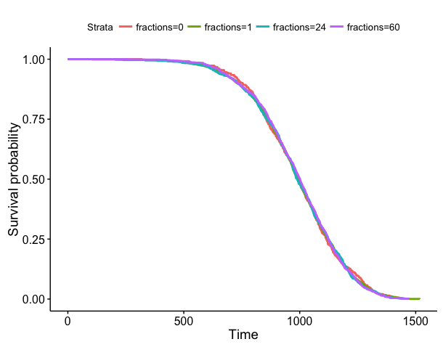

Figure 5 – now excluding JM4 with 120 and 300 fractions. P-value = 0.991.

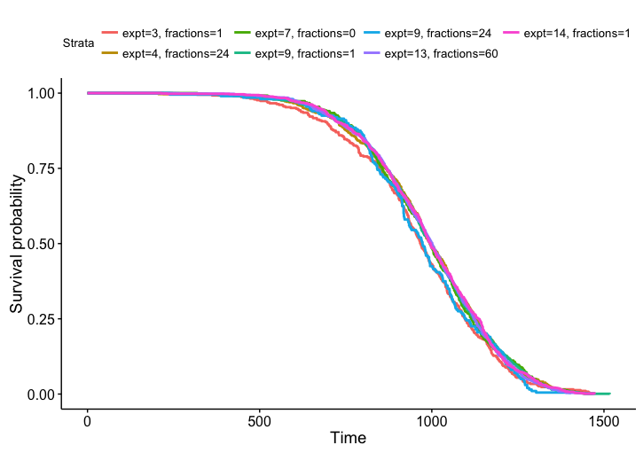

Figure 6 – using the same conditions as above, stratify by expt and fractions. P-value = .354.

Other ways we still stratify data – by sex and strain. All of these mice are B6CF1. When stratifying by expt, fractions, and sex, the p-value shows significant differences. When stratifying by sex alone, female mice die significantly earlier than male mice. When comparing within sexes, female mice could be stratified by expt and fractions without showing significant differences. Male mice showed a significant difference with the main issue being JM9. JM9 doesn’t gamma irradiate any male mice and there is only one small group of male control mice 🡪 exclude the male mice from JM9. With JM9 excluded, males still show a significant difference when stratified by expt and fractions, JM4 seems to be the cause. JM4 has less than half as many male control mice as female. Also exclude JM4 for males and p = 0.568.

These p-values above represent significant differences between all experiments in general… we are mostly interested in comparing JM13 to others so check those statistical tests:

Check for significant differences 1:1 between JM 13 and others

JM 13/JM 3 🡪 p=.104 graphs totally separate

JM13 vs. JM4 (-120 and -300 fractions) 🡪p=.659, graphs on top of each other

JM 13/JM 7 🡪 p=.886 graphs on tops of each other

JM13/JM8 🡪 p=.678, graphs separate at top, then on top of each other

JM 13/JM 9 (exclude males from both)🡪 p=.556 graphs on top of each other

JM 13/JM 9 (exclude males from JM9)🡪 p=.229 graphs on top of each other

JM 13/JM 14 🡪 p= .607 graphs on top of each other

Check for significance between JM13 and all others combined

JM13/all else 🡪 p=.979 graphs on top of each other

Check for significance between 1 fraction and 0 fractions 🡪 p=.955

1 fraction and 60 fractions 🡪 p=.909

0 fractions and 60 fractions 🡪 p = .886

24 fractions and 60 fractions 🡪 p=.0541

If using only females for 24/60 🡪 p=.204

expt fractions sex tot_n

1 4 24 F 464

2 9 24 F 200

3 13 60 F 584

4 13 60 M 592

-24 fractions is all female, so the difference is partially due to gender

**Conclusions:**

Include the following data-

JM3

JM4 (excluding 120 and 300 fractions, excluding males)

JM7

JM8* only helpful to compare dose rates

JM9 (excluding males)

JM13

JM14

*JM 8 - Mice were given a weekly exposure at a set dose rate until they died, so the number of fractions and total dose corresponds to their age. If they lived longer, they had a higher total dose and received more fractions. This information is only helpful for comparing dose rates, not total number of fractions.

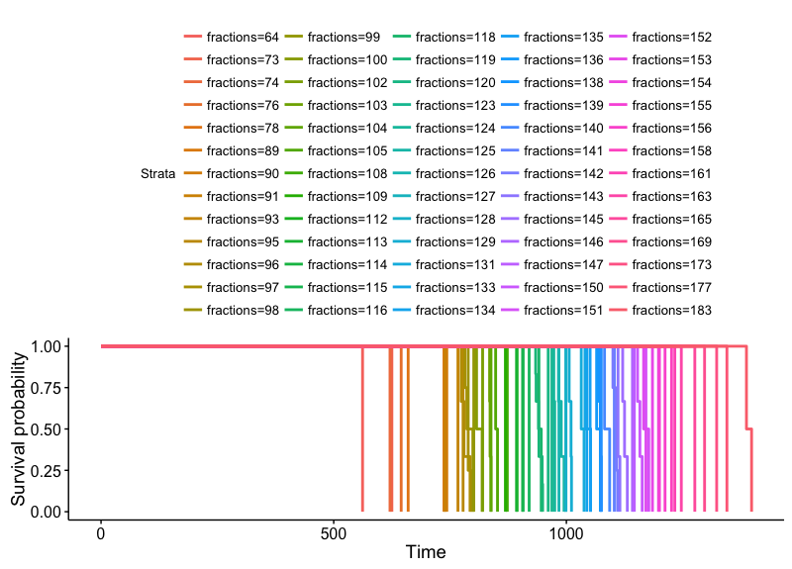

Figure 7 – survival “curves” stratified by fractions.

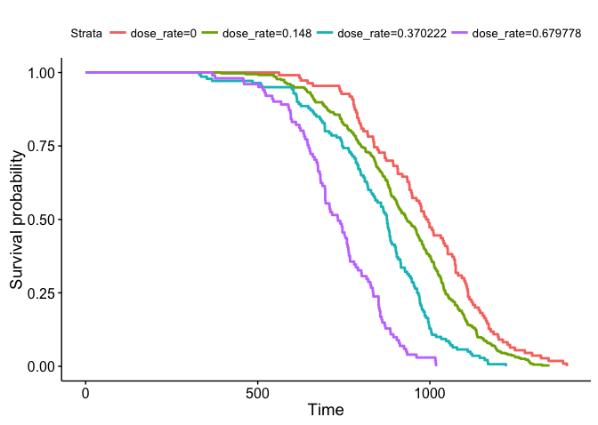

Figure 8 – survival curves stratified by dose rate.