Goal: Now that we filtered the data correctly, examine the data to get a feel for which causes of death are most prominent in these data sets.

Number of mice: 10788

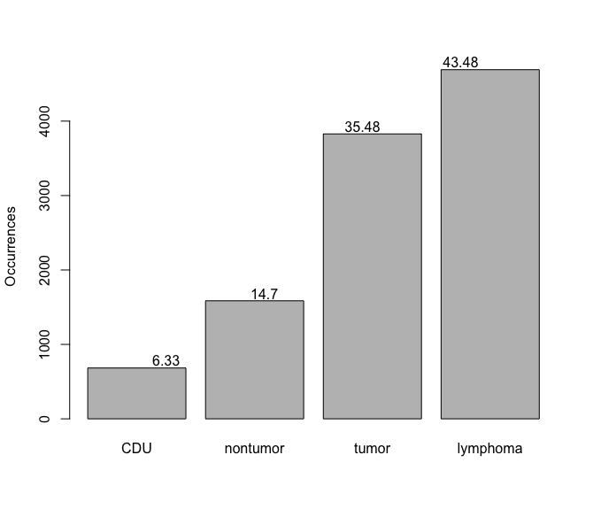

Figure 1: Number of deaths for each different cause of death. Percentages listed at the top of the bar.

Break down of deaths by category – raw numbers and then percentages.

CDU lymphoma nontumor tumor

683 4691 1586 3828

CDU lymphoma nontumor tumor

6.33 43.48 14.70 35.48

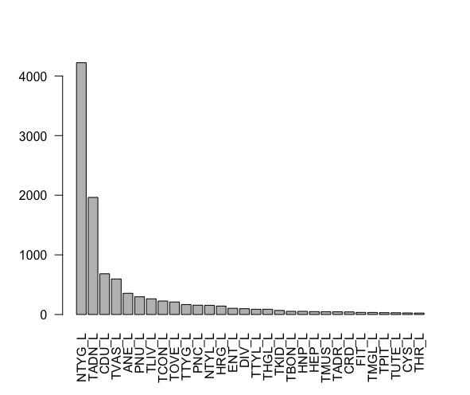

Figure 2: Top 30 causes of death.

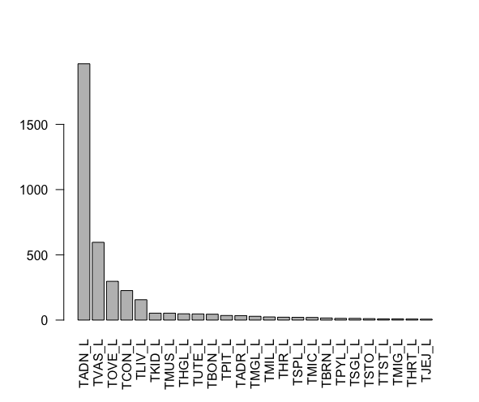

Figure 3: Top 25 most frequent tumors that caused death (out of 48 total tumors that caused death). TADN – lung, TVAS – vascular, TOVE – ovarian ,TCON – connective tissue tumors other than lymphoreticular and vascular tumors, TLIV – liver and gallbladder tumors

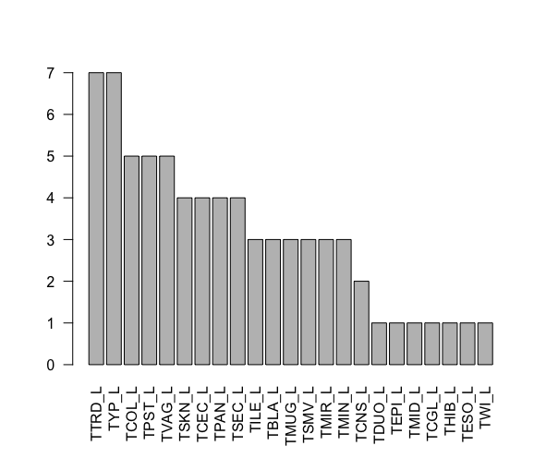

Figure 4: bottom 23 tumors that caused death

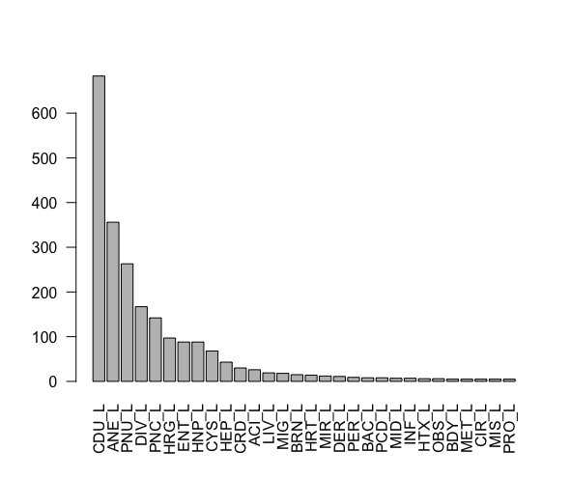

Figure 5: Top 30 non-tumor causes of death (58 total). CDU – Cause of death undetermined, ANE – anemia, PNU – pneumonia, DIV – diverticulum, PNC – pneumonitits, HRG – hemorrhage, ENT – enteritis, HNP – hydronephrosis, CYS – ovarian cyst

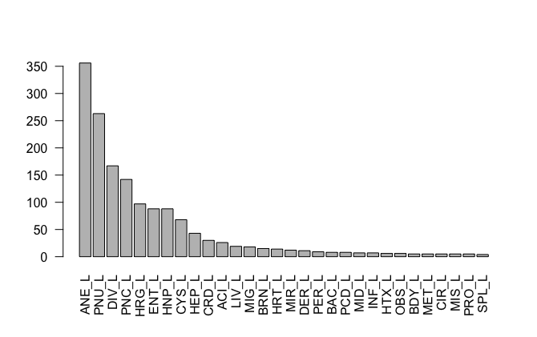

Figure 6: Top 30 non-tumor causes of death with CDU unknown (57 total).

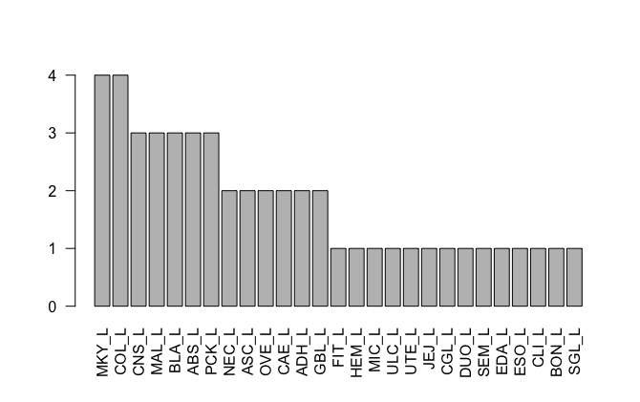

Figure 7: Bottom 27 non-tumor causes of death.

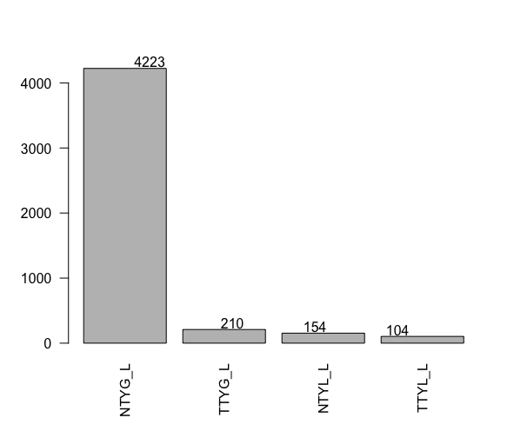

Figure 8: All 4 types of lymphoma (non-thymic/thymic and generalized/localized)

GOAL: Determine if certain causes of death result in changes in total lifespan.

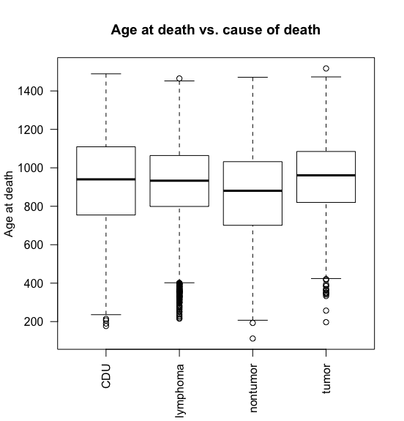

Figure 9: Age at death vs cause of death as a box plot. One-way anova to check for significant differences – nontumor and tumor are different from CDU, lymphoma is not different. One way anova shows class is a significant factor for determining age at death (p <2.2e-16).

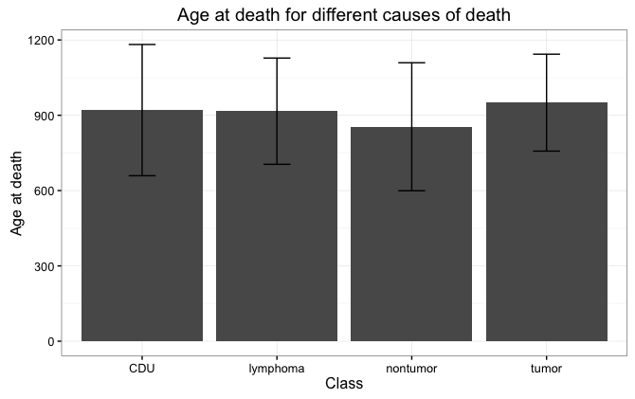

Figure 10: Age at death vs. cause of death as a bar graph with mean and standard deviation to see if it’s easier to notice significant differences. The differences still seem minor, but with a large n, they’re significant.

|  | **Class** | **Avg Age** | **Stdev** | **n** |
| --- | --- | --- | --- | --- |
| **1** | CDU | 920.5842 | 261.4220 | 683 |
| **2** | lymphoma | 916.3223 | 211.5785 | 4691 |
| **3** | nontumor | 854.3354 | 254.9648 | 1586 |
| **4** | tumor | 950.2578 | 193.0110 | 3828 |

Table 1: Raw data showing average age, standard deviation, and n for each type of death.

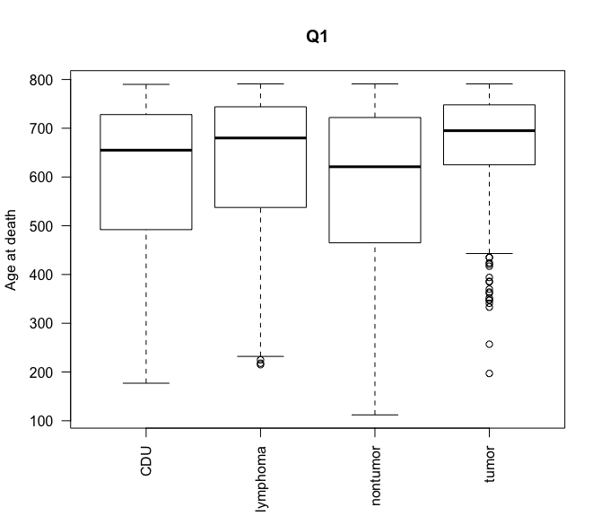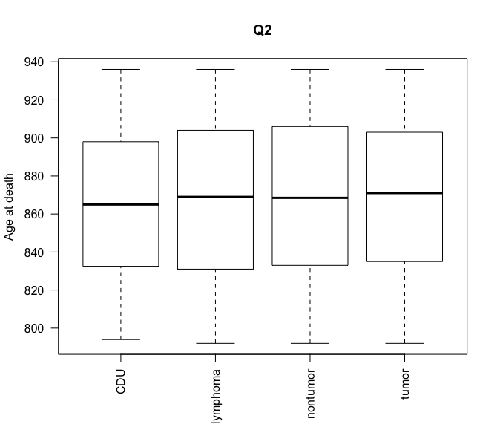

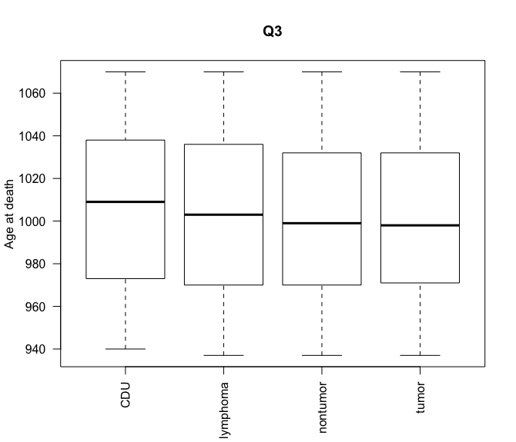 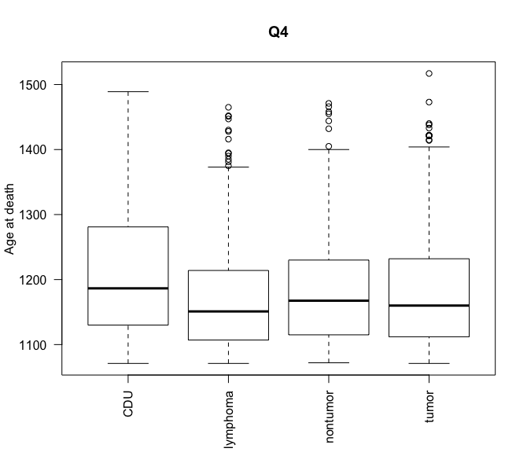

Figure 11: Box plots of age at death vs. cause of death broken down by quarter. There may be significance, but I don’t find this information very interesting. We mostly wanted to see if CDU was actually dying of old age, but figure 13 better shows that CDU is not just dying of old age.

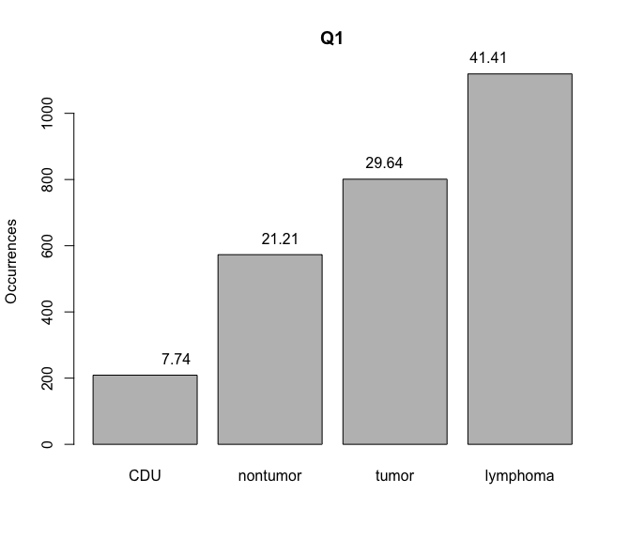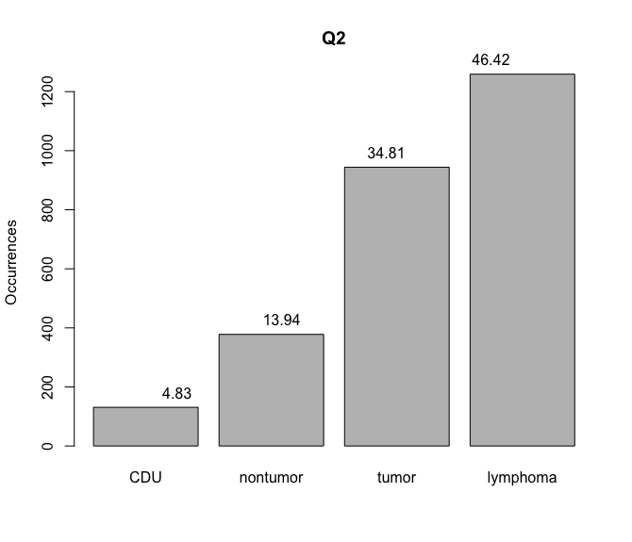

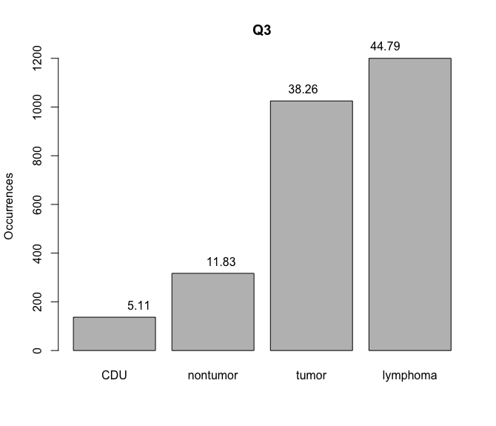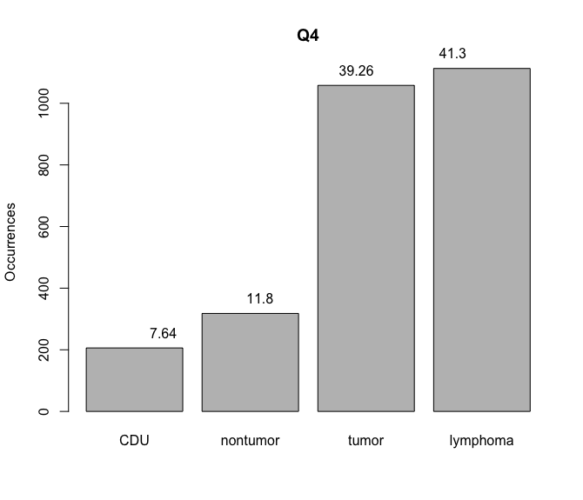

Figure 12: Number of occurrences for each cause of death by quarter. Exploring the data, most deaths are due to tumors and lymphoma during all stages of life. Tumors appear to become more relevant during the final quarter.

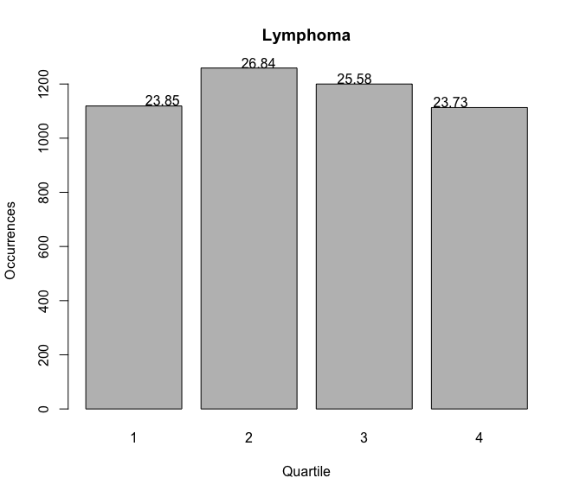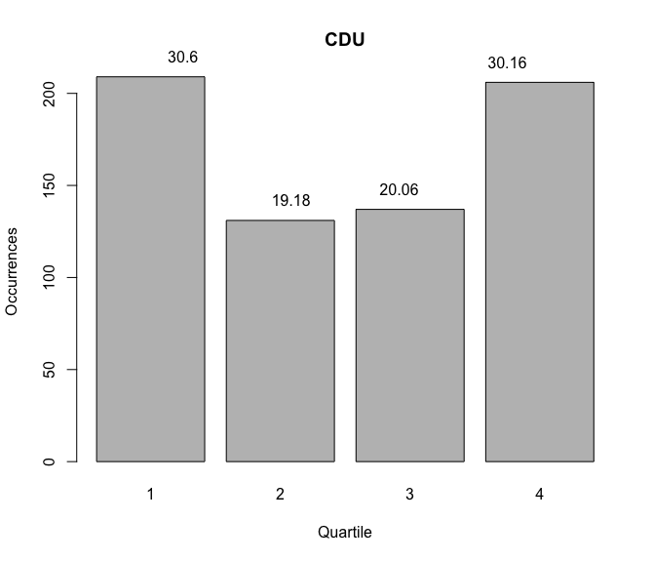

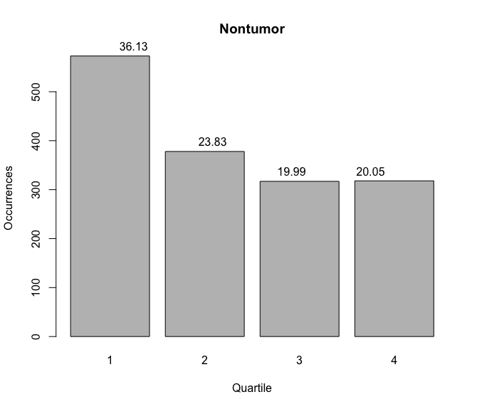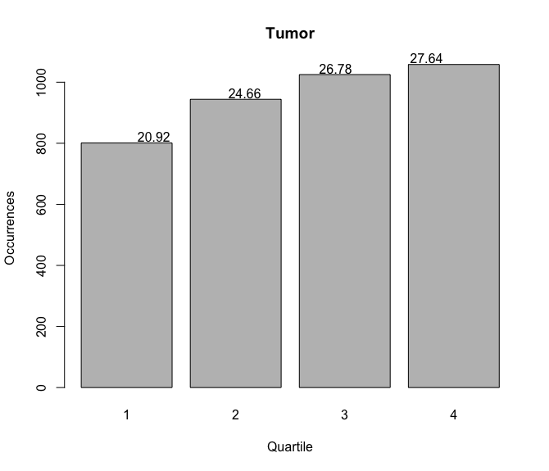

Figure 13: For each cause of death, a break down of how many deaths per quarter. Tumors and non-tumors seem to have opposite trends. Tumors take the longest to develop and/or become deadly?

GOAL: How do gamma irradiated vs. control mice compare to each other?

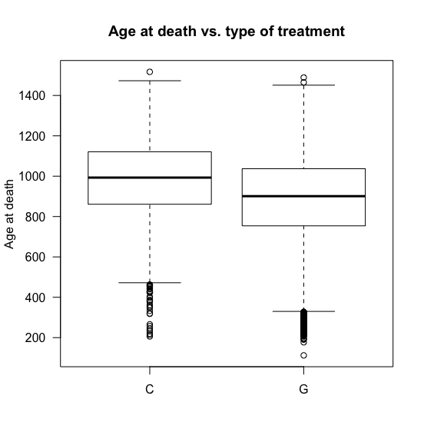

Figure 14: Age at death versus type of treatment. Is there a significant change in life span between control and gamma treated mice? Yes, p-value < 2.2e-16. Mean C = 984.8, mean G = 883.0.

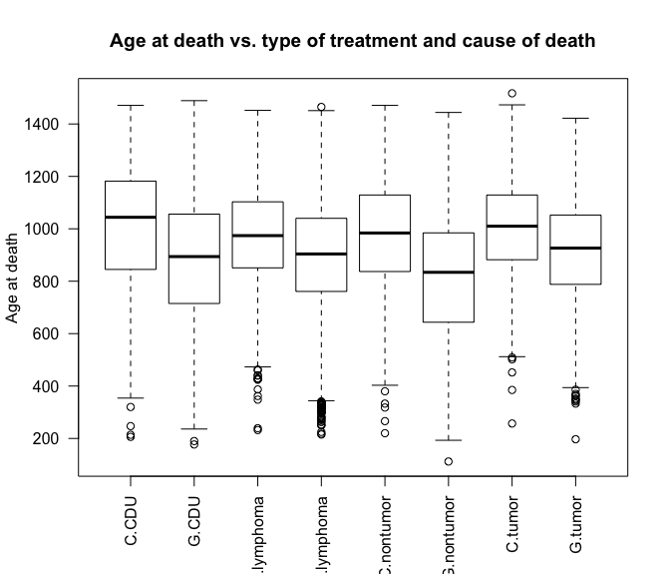

Figure 15: Age at death vs. type of treatment and cause of death. Anova shows treatment type and cause of death are both significant. Controls live longer. Tumors live longest, then CDU, lymphoma, non-tumor.

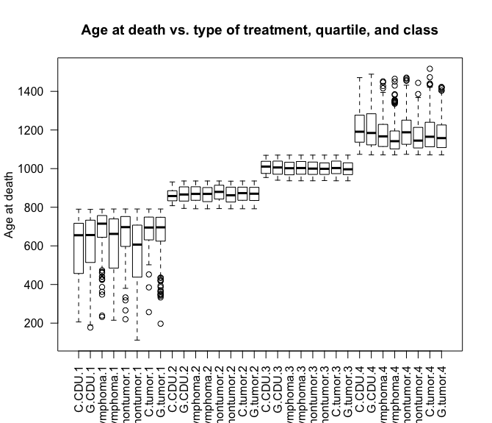

Figure 16: Does the quartile make a difference for the age at death differences between treatments and causes of death? It appears that the biggest differences in age at death for control vs. gamma treated mice are for lymphoma and nontumors. This is most obvious in the first and fourth quartile. The middle quartiles have less flexibility with ranges in age, which explains why the differences are much more difficult to see.

Goal: For **female** mice that died of **lung cancer**, determine if fractionation, dose, and dose rate impact age at death.

| **fractions** | **Dose group** | **N per group** |
| --- | --- | --- |
| 0 | 0 | 164 |
| 1 | 0 | 1199 |
| 1 | 2 | 239 |
| 1 | 4 | 54 |
| 24 | 0 | 629 |
| 24 | 2 | 7 |
| 24 | 4 | 378 |
| 60 | 0 | 541 |
| 60 | 2 | 167 |
| 60 | 4 | 25 |

Table 2: All animals with this set of fractions and dose group. Highlighted have small n and were removed.

| Fractions | Dose_group | N_group | percentage |  |
| --- | --- | --- | --- | --- |
| 0 | 0 | 17 | 0.10365854 |
| 1 | 0 | 147 | 0.12260217 |
| 1 | 2 | 27 | 0.11297071 |
| 1 | 4 | 9 | 0.16666667 |
| 24 | 0 | 94 | 0.14944356 |
| 24 | 2 | 1 | 0.14285714 |
| 24 | 4 | 38 | 0.10052910 |
| 60 | 0 | 54 | 0.09981516 |
| 60 | 2 | 20 | 0.11976048 |
| 60 | 4 | 6 | 0.24000000 |

Table 3: Animals with this set of fractions and dose group that died of lung cancer. Highlighted rows have small n and were removed from analysis.

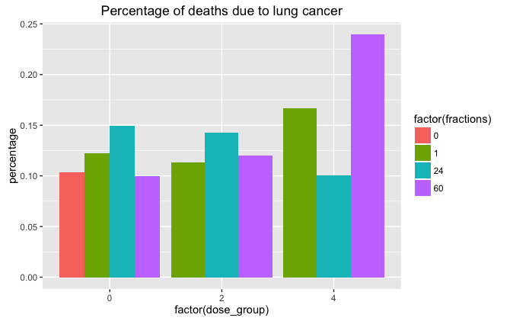

Figure 17: Percentage of deaths due to lung cancer.

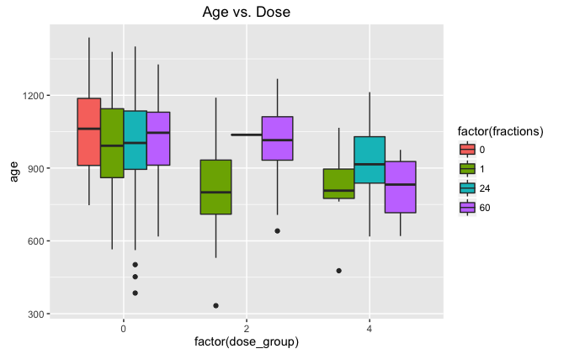

Figure 18: Age vs. dose for animals that died of lung cancer under these conditions. Fractions are shown by changes in fill. This is before any data was removed for having low sample sizes within a condition group.

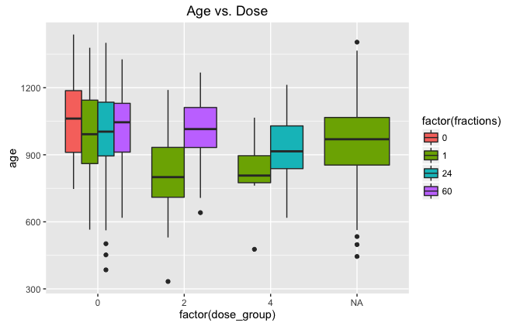

Figure 19: Age vs. dose for animals that died of lung cancer under these conditions. Fractions are shown by changes in fill. This is after data was removed for having low sample sizes within a condition group. Dose has a significant impact on age at death with p = 2.263e-05. Fractions are not significant, but most likely because fraction should not matter for the 0Gy condition.

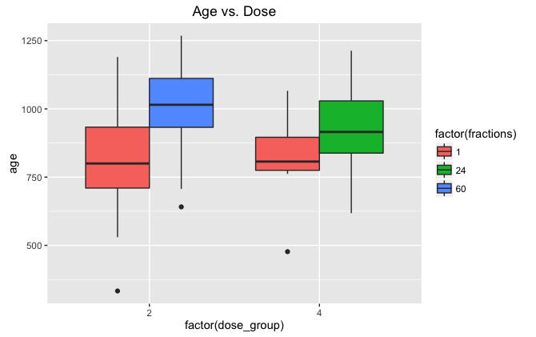

Figure 20: Age vs. dose for 2Gy and 4Gy treatment groups (exclude 0Gy) to see if fractionation has an impact on age at death. According to ANOVA, p = 0.0005984 meaning fractions are very significant.

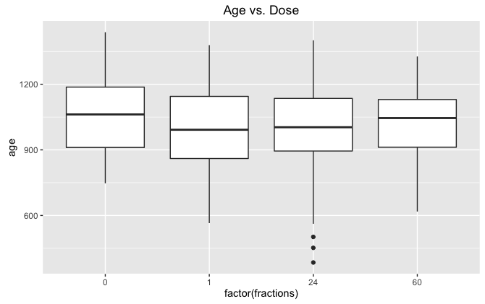

Figure 21: Age vs. fractions for 0 Gy. P = 0.5357, the controls are all comparable without significant differences between fractionation groups.

Conclusions – Fractions and dose are significant indicators of age at death and the number of fractions INCREASES age and the dose DECREASES age. This is based on linear models of the data used for ANOVA tests.

Goal: For **female** mice that died of **lymphoma**, determine if fractionation, dose, and dose rate impact age at death.

| **fractions** | | **dose_group** | | | **n_group** | | **percentage** | | |
| --- | --- | --- | --- | --- | --- | --- | --- | --- | --- |
|  |  |  | |  | | |  |
| 0 | 0 | | 88 | | 0.5365854 | | |
| 1 | 0 | | 537 | | 0.4478732 | | |
| 1 | 2 | | 101 | | 0.4225941 | | |
| 1 | 4 | | 12 | | 0.2222222 | | |
| 24 | 0 | | 287 | | 0.4562798 | | |
| 24 | 2 | | 3 | | 0.4285714 | | |
| 24 | 4 | | 131 | | 0.3465608 | | |
| 60 | 0 | | 308 | | 0.5693161 | | |
| 60 | 2 | | 88 | | 0.5269461 | | |
| 60 | 4 | | 6 | | 0.2400000 | | |

Table 4: Animals that died of thymic lymphoma (localized and general) with this set of conditions. Table 2 shows all mice with those conditions. Highlighted have small n and were removed later on.

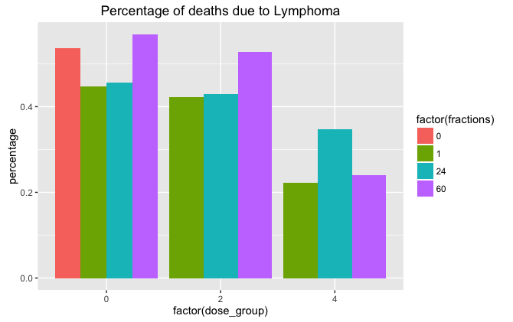

Figure 22: Percentage of deaths due to lymphoma under different conditions. It looks like the higher the dose, the less likely a mouse was to die of lymphoma. The 24 fractions at 2Gy has a very low sample size, remove later on.

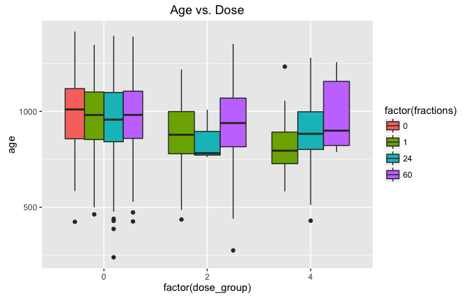

Figure 23: Age at death vs. dose in Gy. For controls, the age at death is pretty consistent regardless of number of fractions. At higher doses, fractionation helps increase the age at death, but there’s a clear drop in age at death for higher doses. Again, small sample size for 24 fractions at 2Gy that messes up expected trends.

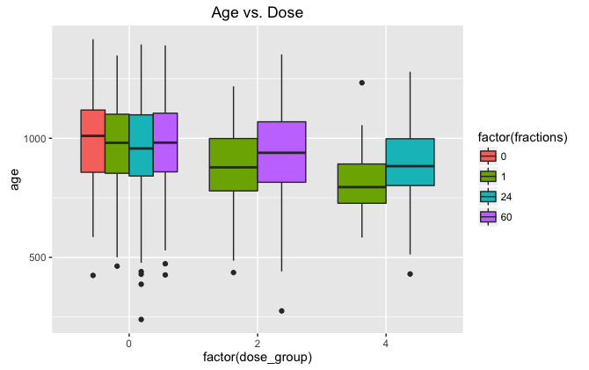

Figure 24: Same as figure 23, but now with low sample sizes removed from data set. The higher the dose, the lower the age at death. Dose has a significant impact on age with a p-value of 1.021e-09.

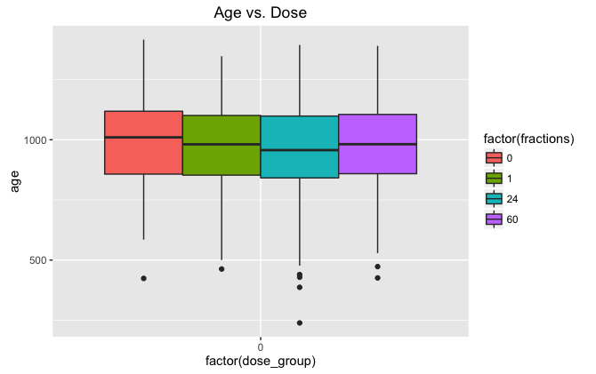

Figure 25: Age vs. fractions for 0 Gy. P = 0.3695, the controls are all comparable without significant differences between fractionation groups.

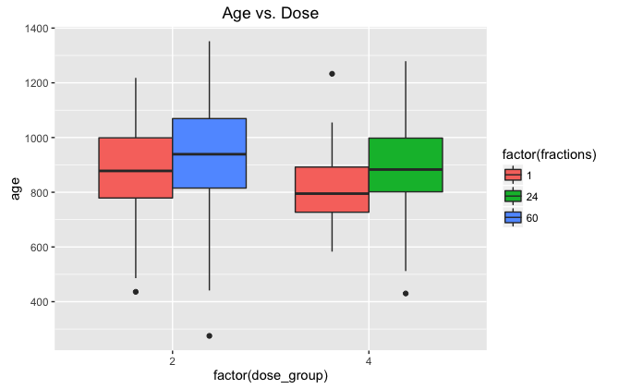

Figure 26: Age vs. dose for 2Gy and 4Gy. Fractions are not significantly impacting age at death, P = 0.06549.

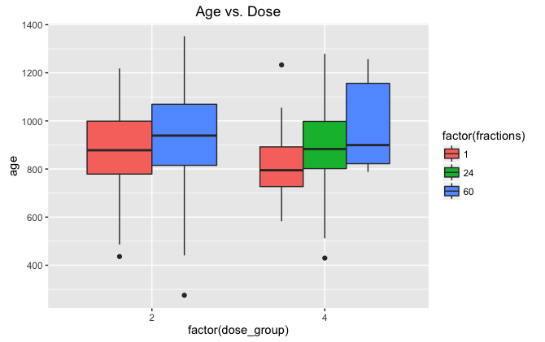

Figure 27: Same as 26, this time add in one more condition group because maybe the n is high enough? Talk with Dr. Malthouse about how to determine sample size cut off appropriately. Even with this change, p = 0.05634.

I tried separating out generalized and localized thymic lymphoma and it did not result in a significant impact of fractions on age. Should I try combining thymic and non-thymic lymphoma?

GOAL: Using all available data, determine if dose plays a major role in age at death due to **lymphoma** in **female** mice.

**Dose groups:**

0, 0 🡪 1.5, 1.5 🡪 4, 4 🡪 7.6, 7.6 🡪 16.4, 16.4 🡪 inf

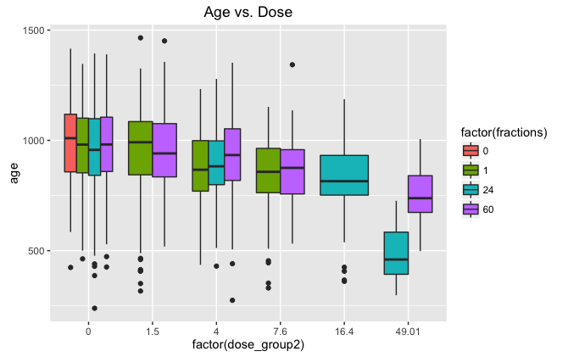

Figure 28: Age vs. dose group using all available data. As dose increases, it appears that age at death decreases. Outside of the controls, increasing fractions increases age at death.

|  |  |  |  |
| --- | --- | --- | --- |
| **0** | 0.00 | 88 | 1001.3409 |
| **2** | 1 | 0.00 | 537 | 974.7263 |
| **3** | 1 | 1.50 | 440 | 958.3932 |
| **4** | 1 | 4.00 | 113 | 880.5221 |
| **5** | 1 | 7.60 | 80 | 841.3500 |
| **6** | 24 | 0.00 | 287 | 964.0697 |
| **7** | 24 | 4.00 | 134 | 892.9478 |
| **8** | 24 | 16.40 | 93 | 826.2473 |
| **9** | 24 | 49.01 | 49 | 487.0204 |
| **10** | 60 | 0.00 | 308 | 977.9740 |
| **11** | 60 | 1.50 | 315 | 950.9556 |
| **12** | 60 | 4.00 | 136 | 930.2059 |
| **13** | 60 | 7.60 | 86 | 866.9535 |
| **14** | 60 | 49.01 | 55 | 749.1091 |

Table 5: Summary of the data from figure 28. Fractions, dose group, sample size, average age at death. For row 1, the row number didn’t copy over and everything is shifted to make it extra confusing for you, sorry. Looking within each fraction, as dose goes up, age at death goes down.

| **dose_group2** | | | **fractions** | | **n** | | **mean_age** | |
| --- | --- | --- | --- | --- | --- | --- | --- | --- |
|  |  | |  |  |  | |
| **1** | 0.00 | | 0 | 88 | 1001.3409 | |
| **2** | 0.00 | | 1 | 537 | 974.7263 | |
| **3** | 0.00 | | 24 | 287 | 964.0697 | |
| **4** | 0.00 | | 60 | 308 | 977.9740 | |
| **5** | 1.50 | | 1 | 440 | 958.3932 | |
| **6** | 1.50 | | 60 | 315 | 950.9556 | |
| **7** | 4.00 | | 1 | 113 | 880.5221 | |
| **8** | 4.00 | | 24 | 134 | 892.9478 | |
| **9** | 4.00 | | 60 | 136 | 930.2059 | |
| **10** | 7.60 | | 1 | 80 | 841.3500 | |
| **11** | 7.60 | | 60 | 86 | 866.9535 | |
| **12** | 16.40 | | 24 | 93 | 826.2473 | |
| **13** | 49.01 | | 24 | 49 | 487.0204 | |
| **14** | 49.01 | | 60 | 55 | 749.1091 | |

Table 6: Same data as table 5, but organized so it’s easy to look at each dose group. Within each dose group, as fractions increase, age at death also increases. This is not true for 1 Gy (everything is expected to be similar for controls), 1.5 Gy (small difference), or 16.4 Gy (nothing for comparison).

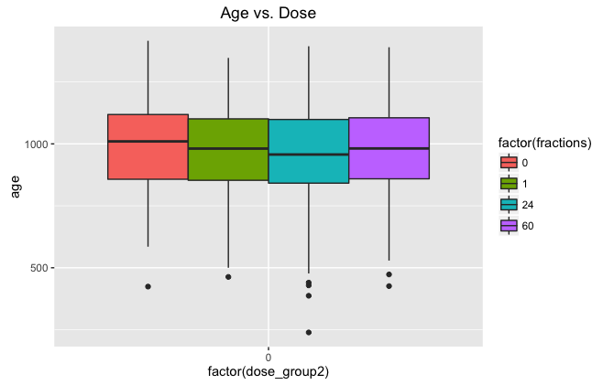

Figure 29: Age vs. dose for control mice treated with 0Gy. P-value for fractions = 0.3695. As expected, there is no significant differences between groups.

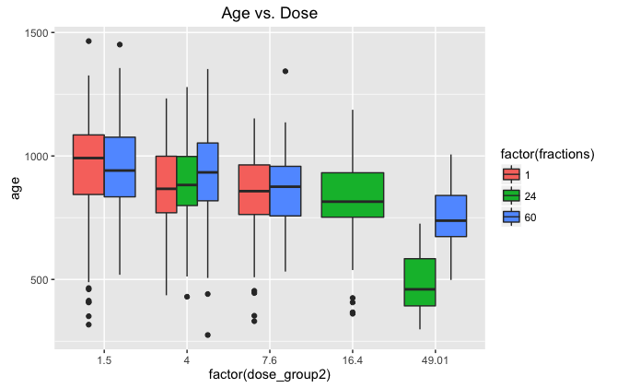

Figure 30: Age vs. dose for gamma treated mice. Dose group and fractions are both significant, but the 24 fractions shows a significant decrease in age compared to 1 fraction. This may be because the 24 fractions are rarely compared to 1 fraction and the statistical method I’m using is incorrect? Ask Dr. Malthouse about this issue.

GOAL: Using all available data, determine if dose plays a major role in age at death due to **lung cancer** in **female** mice.

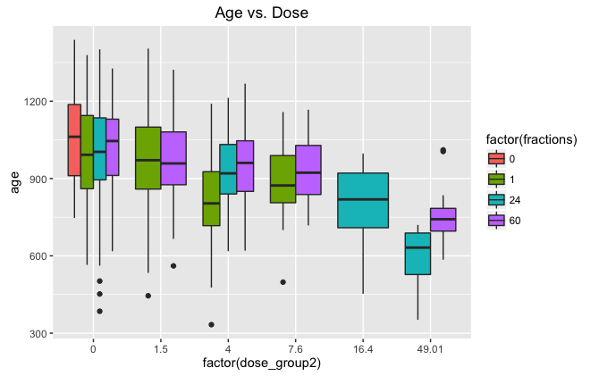

Figure 31: Female mice that died of lung cancer, age vs. dose. Dose is significant with p-value < 2e-16. Fractions are not significant, divide up data for analysis.

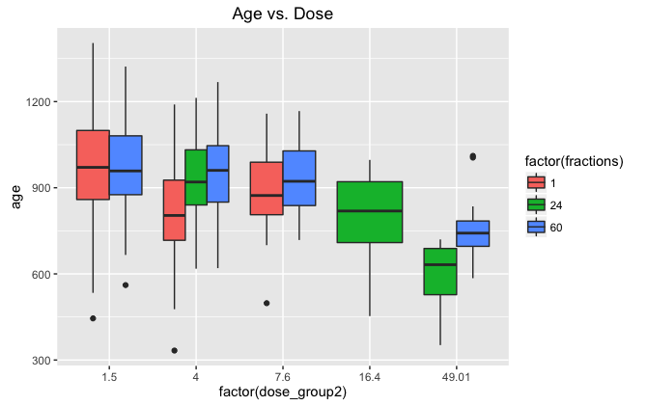

Figure 32: Female mice that died of lung cancer, age vs. dose, excluding control mice. Fractions are significant with p = 0.04828 and according to the model, increasing fractions increases age at death, as expected.

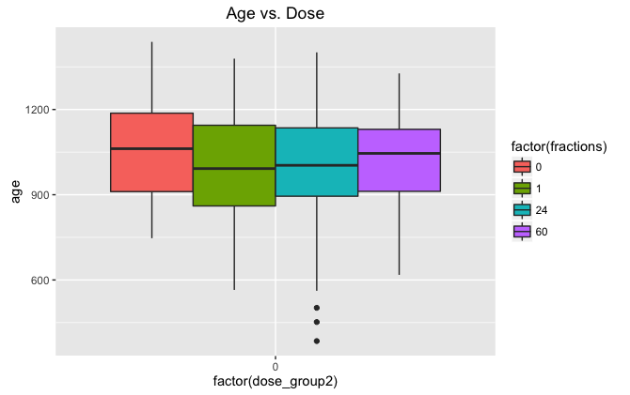

Figure 33: Female mice that died of lung cancer, age vs. dose, controls only. Fractions are not significant with p = 0.5357.

GOAL: Using all available data, determine if dose rate plays a major role in age at death due to **lymphoma**.

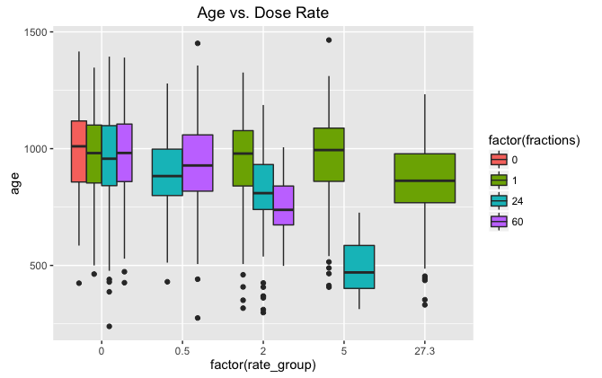

Figure 34: Age vs. dose rate. This data is not what we would expect, but that’s because the increased fractions are typically associated with increased total doses. Another issue is the large amounts of missing data, but that is because larger total doses cannot be used for acute exposures – animals would die very quickly.

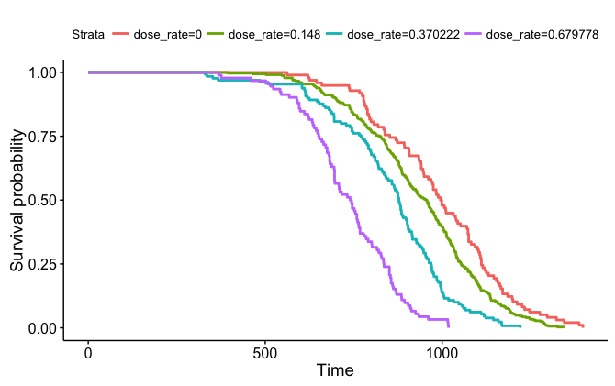

Figure 35: Using all JM8 data, plot survival curves for different dose rates. Dose rate has a significant impact on survival (p = 0… figure out why I cannot get a better number for this). Check total doses… Did experimental set up have the same dose/fractionation or are the doses causing this difference in lifespan?

Goal: Determine if there are major differences in cause of death between males and females.

Repeat a lot of analysis with just **females:**

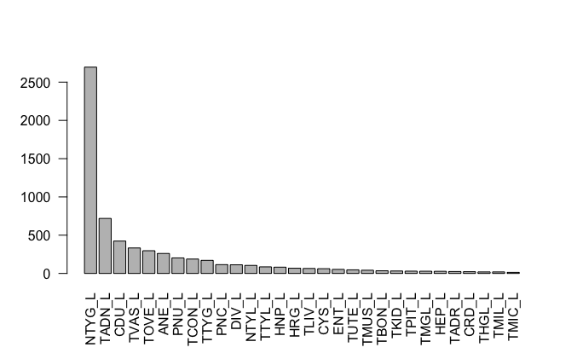

Figure 36: Top 30 causes of death for all female mice

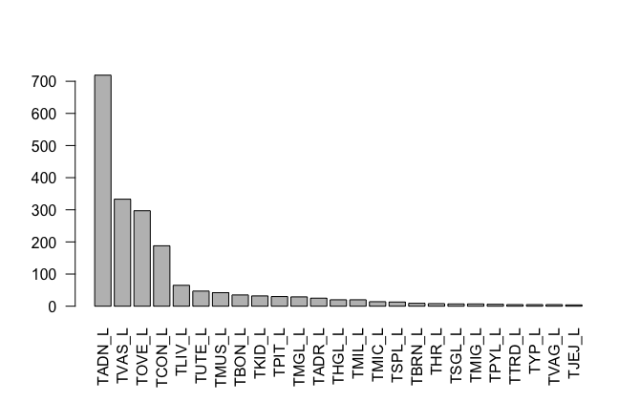

Figure 37: Top 25 tumor causes of deaths for females

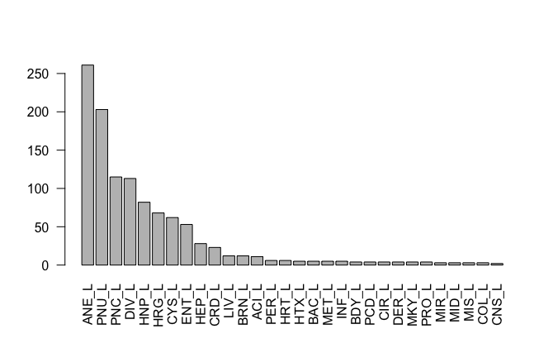

Figure 38: Top 30 non-tumor causes of death for females

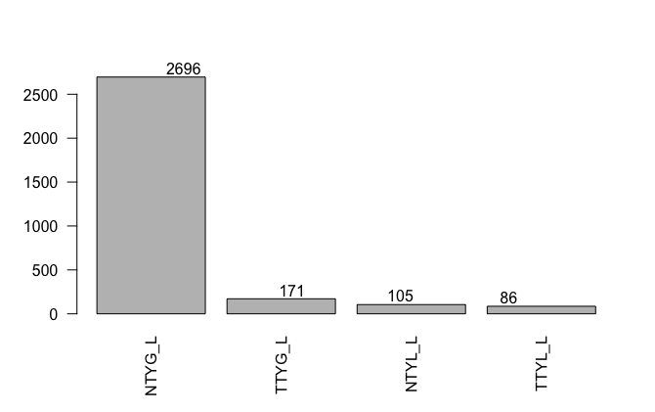

Figure 39: All four types of lymphoma that caused death in females.

Repeat a lot of analysis with just **males.**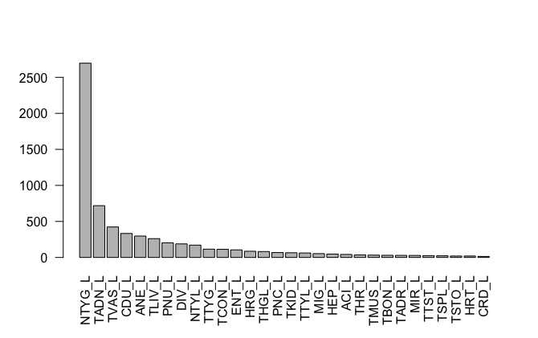

Figure 40: Top 30 causes of death for males.

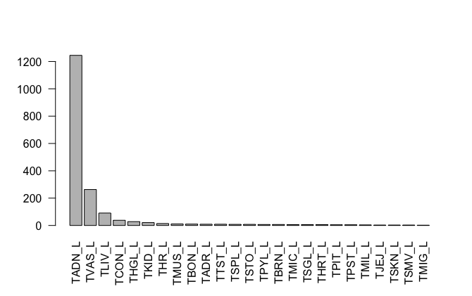

Figure 41: Top 25 tumor causes of death for males.

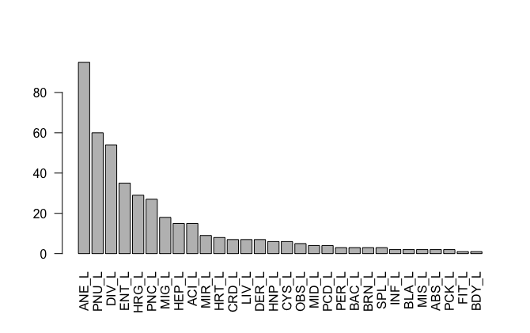

Figure 42: Top 30 non-tumor causes of death for males.

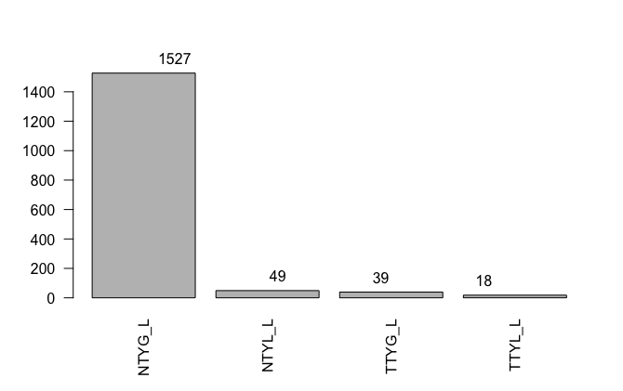

Figure 43: All four types of lymphoma that caused death in females.

Goal: Determine if there are major differences in cause of death between controls and gamma irradiated mice.

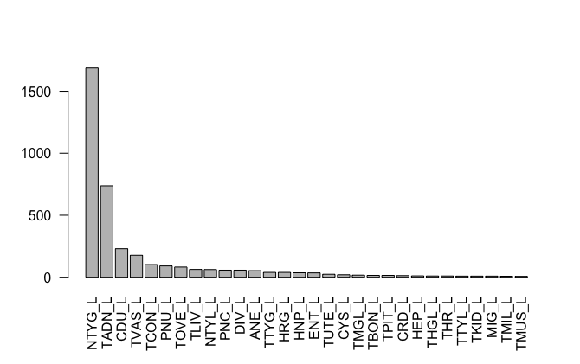

Figure 44: Top 30 causes of death for control mice.

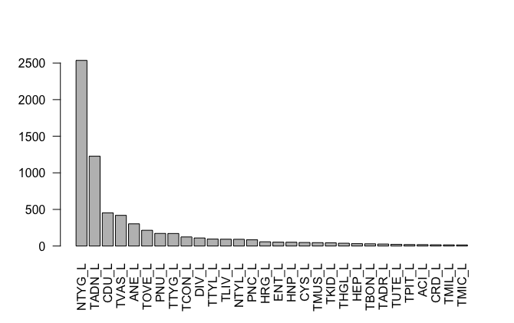

Figure 45: Top 30 causes of death for gamma irradiated mice. More common than in controls: ANE, TTYG, TTYL, . Less common than in controls: TCON, PNU,

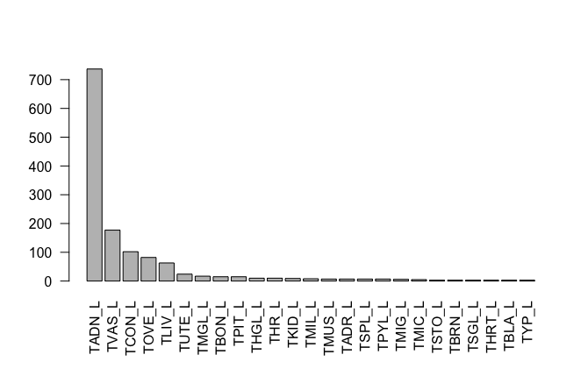

Figure 46: Top 25 tumor causes of death for control mice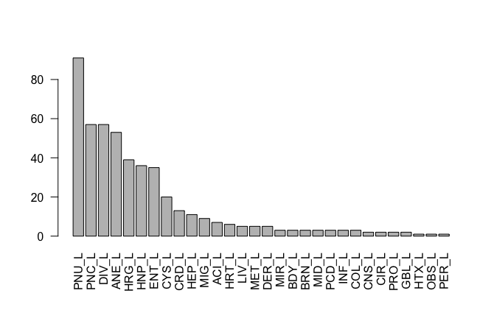

Figure 47: Top 30 non tumor causes of death for control mice.

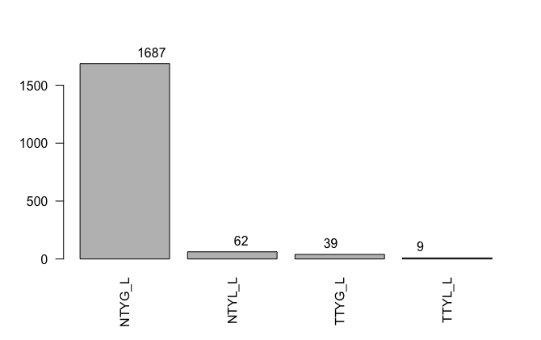

Figure 48: All four types of lymphoma that caused death in control mice.

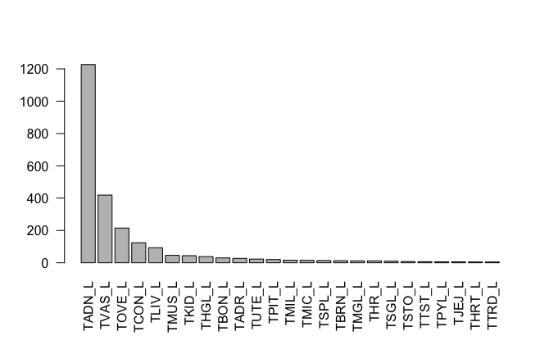

Figure 49: Top 25 tumor causes of death for gamma irradiated mice.

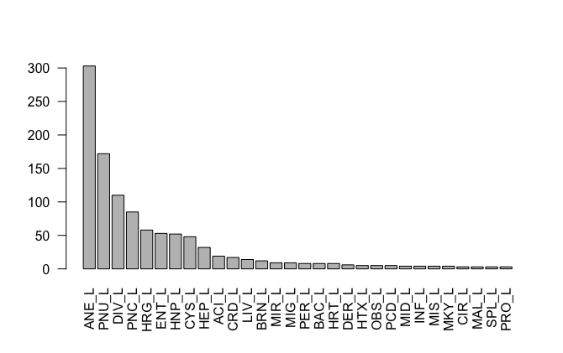

Figure 50: Top 30 non-tumor causes of death for gamma irradiated mice.

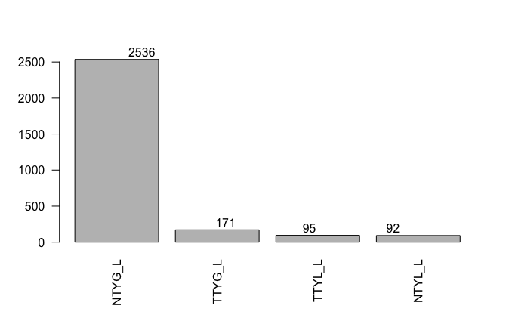

Figure 51: All four types of lymphoma that caused death in gamma irradiated mice.

Not sure if any of the differences could be considered significant… maybe hold this as a stats question for Dr. Malthouse? Should I plan to meet with him again soon?

See if top 5 cancers or causes of death have significant differences in age at death? Meaning some are more dangerous than others for life shortening.

Repeat some earlier analysis of fractions/doses/dose rates impacting age at death in male mice.

GOAL: Using all available data, determine if dose plays a major role in age at death due to **lung cancer** in **male** mice.

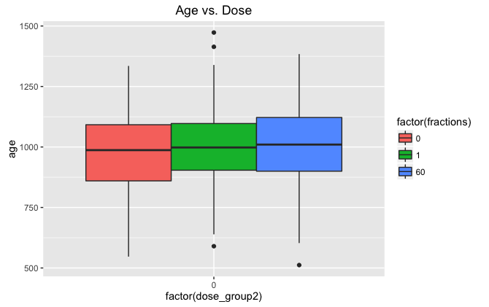

Figure 52: Lung cancer in male mice – 0Gy treatment. Anova shows no significance p=0.1964

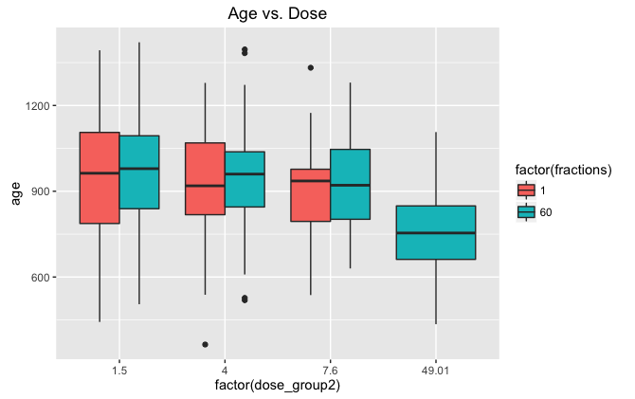

Figure 53: Lung cancer in gamma irradiated male mice. Anova shows dose bring significant p=5.929e-10 and fractions insignificant p=.1965.

Recall – remove JM4 and JM9 males. We should be able to see interesting trends with 60 fractions vs. 1 fraction, but we do not. Why? Check raw data.

|  | fractions | Dose_group2 | N_group | Avg Age | Avg dose | Avg rate |
| --- | --- | --- | --- | --- | --- | --- |
| 1 | 0 | 0.00 | 105 | 974.5619 | 0.0000 | 0.0000000 |
| 2 | 1 | 0.00 | 133 | 1003.1880 | 0.0000 | 0.0000000 |
| 3 | 1 | 1.50 | 122 | 947.6721 | 107.9752 | 5.3987623 |
| 4 | 1 | 4.00 | 169 | 931.1065 | 228.5861 | 11.4293047 |
| 5 | 1 | 7.60 | 75 | 899.3733 | 545.6772 | 27.2838600 |
| 6 | 60 | 0.00 | 165 | 1010.4424 | 0.0000 | 0.0000000 |
| 7 | 60 | 1.50 | 159 | 963.1509 | 100.0000 | 0.0830000 |
| 8 | 60 | 4.00 | 103 | 946.9806 | 298.9883 | 0.1735485 |
| 9 | 60 | 7.60 | 43 | 929.4419 | 530.2326 | 0.4418605 |
| 10 | 60 | 49.01 | 42 | 762.0238 | 1839.4000 | 0.6811110 |

Table 7: Breakdown of data on male mice that died of lung cancer. Dose rates are actually higher for 1 fraction (they should die younger) and total dose is pretty similar. Maybe there is just not enough data for significance? Much higher n’s for females.

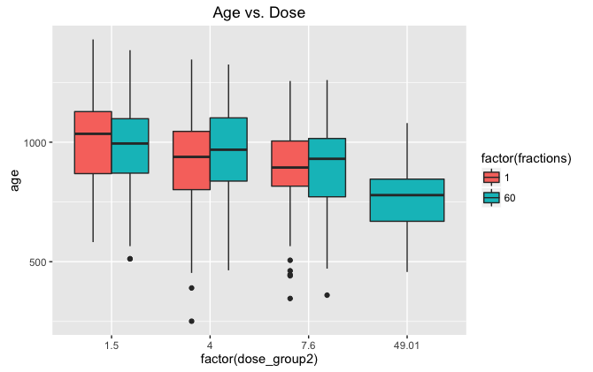

Figure 54: Age vs. dose for gamma irradiated male mice that died of lymphoma. Dose is significant with p <2e-16. Fractions are not significant p = .2746.