Machine-Learning Prediction of Double-Pipe Heat Exchanger Thermal Performance: A Focused Structured Literature Review
Second-stage, full-text-verified review - rewritten from scratch on the verified database
Prepared for: Ali Abdelwahab (Kuwait University) - MgO-TiO2 hybrid-nanofluid double-pipe heat exchanger project
5 October 2026
Companion files: DPHE_ML_Literature_Log_v2_Verified.xlsx (database, statistics dashboard, removed papers, PDF status, rename map); rename_pdfs.ps1 / rename_pdfs.sh. Scope: thermal-performance prediction only; hydraulic quantities are recorded for completeness but never steer conclusions.

1. Executive Summary
All 26 PDFs in the project 'Papers' folder were opened and matched to the first-pass database by title, authors and DOI read inside each PDF; none was mismatched and none was unmatched. Combined with the 37 first-pass records, the verified active database contains 24 papers (Tier 1: 8, Tier 2: 8, Tier 3: 8), of which 22 rest on full PDFs (Evidence A: 12, B: 10) and two (P01, P09) are retained abstract-only exceptions. Thirteen records were moved to a 'Removed Papers' sheet (nine without accessible evidence, three reviews and one meta-science reference).
The verified literature is weaker than the first-pass map suggested. The key findings are:
- Every double-pipe study with experimental data validated its model with a random row split or did not report a split. None withheld whole operating conditions, concentrations or flow levels, and none reported prediction intervals.
- High headline accuracies (R or R² ≥ 0.99 in 12 papers) mostly come from random splits of small factorial grids, often with networks whose parameters outnumber the data points (P10: about 9 runs and a 20-neuron network; P05: 111 weights for 72 points). In two papers the reported error is lower than the measurement uncertainty (P04, P16).
- The two strongest methodological papers come from outside heat exchangers. Withholding entire experimental campaigns raised a gradient-boosting model's error 2.5-fold, whereas a model anchored to a physical correlation barely degraded (P27). On unseen tube geometries a physics correlation beat the ML model (P29). A dimensionless, physics-structured network extrapolated far better than a dimensional one (P28).
- Studies that predict effectiveness, NTU and heat duty learn them as independent targets (P02, P07), so their predictions can violate the energy balance.
- Only one double-pipe hybrid-nanofluid ML study was identified (P01), and its full text could not be accessed.
Benchmarks after full-text review:
- Primary: P02 (Esfandyari et al., 2023), primary. It is the closest experimental analogue in fluid, inputs and thermal outputs.
- Secondary: P13 (Alsayah et al., 2025), secondary. It has the best-documented pipeline: cross-validation for model selection, an untouched test set, physical-unit errors and correlation baselines.
- Supporting: P37 (Hadj Salah et al., 2026), supporting. It has the best leakage controls and the only calibrated uncertainty, plus mono-to-hybrid transfer learning.
Recommendation in brief:
- Learn one thermal transport quantity: the overall coefficient U, or the tube-side Nu if wall temperatures are reliable. Preferably learn it as a log-ratio to a correlation baseline. Derive NTU, effectiveness, heat duty and outlet temperatures through ε-NTU and energy-balance relations.
- Use dimensionless inputs: Re and Pr of each stream, concentration and the heat-capacity-rate ratio. Average repeated readings so that each operating condition is one row.
- Compare the following models under nested grouped validation (leave-one-condition-out, leave-one-concentration-out, leave-one-flow-level-out): a refitted power-law baseline, regularised log-linear regression, GPR, SVR, random forest, shallow gradient boosting, and a small MLP ensemble.
- Report physical-unit errors against the measurement uncertainty of U. Give calibrated prediction intervals, and refuse queries outside the experimental envelope.
- Deep learning, ANFIS and metaheuristic-tuned networks are not justified by the evidence for a dataset of tens of operating conditions.

2. Introduction
Double-pipe (concentric-tube) heat exchangers are the standard laboratory platform for nanofluid heat-transfer studies because both streams are measurable and the geometry is simple. Each experimental operating point is costly - nanofluid preparation, stabilisation, steady-state attainment and cleaning - so a surrogate model that predicts the thermal performance at untested combinations of flow rates, inlet temperatures and concentrations is attractive. The project aims to train such a surrogate on the authors' own experimental MgO-TiO2 hybrid-nanofluid DPHE data and to package it as a user-facing application.
A surrogate is only useful if its accuracy on genuinely new operating conditions is known. This review therefore focuses on how published ML models for double-pipe and closely related exchangers were built and validated - data structure, inputs, thermal targets, model capacity, validation design, leakage, uncertainty and physics integration - rather than on the heat-transfer enhancements reported.

3. Review Methodology
The first-pass review (4 October 2026) screened peer-reviewed literature from 2022 onwards and logged 37 papers plus nine screening candidates, many assessed only from abstracts or index records. This second stage re-built the evidence base from full texts:
- Every PDF in the OneDrive folder 'Thesis/Machine learning project/ML_DPHE_Papers' was read through the Microsoft 365 connector; identity (title, authors, year, journal, DOI) was taken from the PDF itself, not from the filename.
- For each retained paper the full extraction template (bibliography, study design, ML methodology, performance, critical assessment) was filled from the PDF; values contradicting the first-pass log were overwritten; items absent from the paper are recorded as 'Not reported'; reviewer deductions are labelled as inferences.
- Evidence levels: A = full paper read directly; B = full PDF available, with data, ML set-up, validation, results tables and conclusions verified through targeted extraction; C = abstract only.
- Tiers were reassessed against the stated definitions (Tier 1: double-pipe/concentric + experimental + ML thermal prediction; Tier 2: strong transferable methodology; Tier 3: supporting). Relevance (1-5) and methodological quality (1-5) were scored independently.
- Validation was audited against the leakage taxonomy of Kapoor and Narayanan (2023): no test set, preprocessing or feature selection on the full data, duplicates, illegitimate (target-derived) features, and non-independence between training and test samples.
- Statistics and charts were generated programmatically from the database so that the report, the dashboard and the log cannot disagree.
Limitations of the process: journal quartiles could not be verified (SCImago and OpenAlex were blocked by the session's network policy) and are recorded as 'Not verified'; the OneDrive connector was read-only, so PDF renaming is delivered as a mapping and scripts rather than performed in place.

4. Screening and Verification Process
Step | Count | Notes
First-pass records (P01-P37) | 37 | Plus 9 screening candidates (X01-X09) never logged
PDFs in Papers folder | 26 | Plus one non-paper file (software installer)
PDFs matched to a Paper ID from PDF content | 26 | 0 mismatched, 0 unmatched
Records without PDF | 11 | P01, P08, P09, P11, P20, P23, P24, P25, P34, P35, P36
Retained abstract-only (exception) | 2 | P01 (only hybrid-NF DPHE ML study); P09 (operating-variable inputs + regression baseline)
Removed - no accessible evidence | 8 | P08, P11, P20, P23, P24, P34, P35, P36
Removed - insufficient methodological relevance | 1 | P25
Removed - review / supporting only | 4 | P30 (leakage reference - still cited), P31, P32, P33 (reviews)
Active (retained) database | 24 | Tier 1: 8 | Tier 2: 8 | Tier 3: 8; Evidence A 12, B 10, C 2

Corrections to the first-pass log included: P29's DOI (previously 'not retrieved') and P33's and P37's author lists were recovered from the PDFs; P03 was found to be an air/steam constant-wall-temperature exchanger rather than a liquid-liquid DPHE; P06's 'experimental' heat-transfer coefficient is partly computed from correlations; P18's network uses linear transfer functions; P12's data are analytical; and P05 reports no train/test split at all. Previous 'Q1 (recalled)' quartile labels were removed.

5. Literature Landscape
The 24 retained papers span 2022-2026. Fourteen concern double-pipe or concentric-tube exchangers (eight experimental Tier 1 papers, two air/steam DPHE papers, two CFD design studies, one CFD surrogate and one analytical design study); seven use single tubes or coils; three come from other thermal problems (critical heat flux, supercritical convection, condensation) and are retained for their validation methodology. Eighteen use experimental data, four CFD, one analytical design calculations and one a mixture. Twelve involve mono nanofluids and three hybrid nanofluids (only one of them in a DPHE, abstract-only).
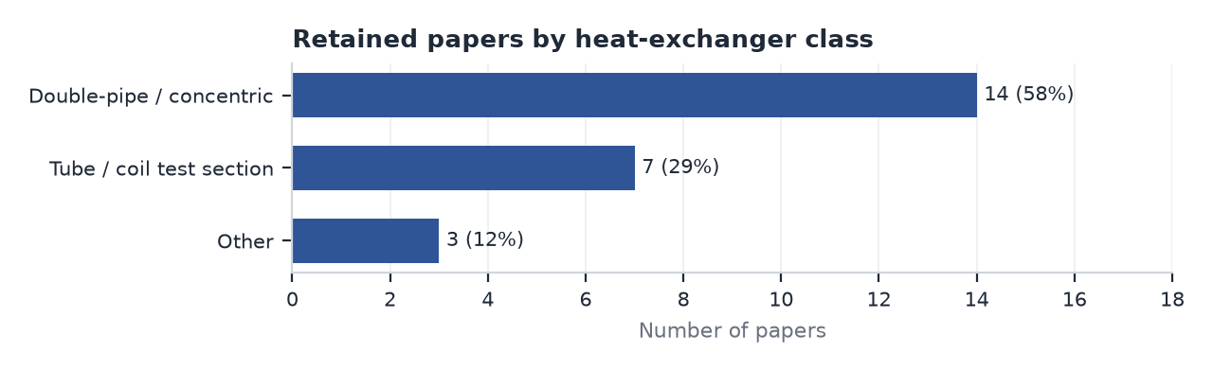
Figure 1. Heat-exchanger class (n = 24).
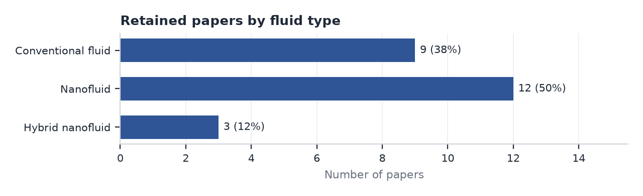
Figure 2. Fluid type.

6. Individual Paper Reviews
Papers are grouped by tier; benchmark papers are listed first. Each paragraph concentrates on ML methodology.

6.1 Benchmark papers
P02 - Esfandyari (2023), International Communications in Heat and Mass Transfer. Evidence A; Tier 1 [Primary benchmark]. Esfandyari et al. (2023) modelled an experimental counter-flow concentric double-pipe exchanger (1.2 m, steel) in which hot water or Al2O3/water nanofluid (0.4-0.8 vol%) flowed in the inner tube, optionally under ultrasonic excitation, while the cold annulus stream was fixed at 164 L/h and 20 C. Four dimensional inputs (ultrasound on/off, hot flow 113-257 L/h, hot inlet temperature 40-60 C and volume fraction) were mapped to five thermal outputs - hot-side heat duty, hot- and cold-side Nusselt numbers, NTU and effectiveness - using MLPs (one and two hidden layers, LM/SCG/BR training, three transfer functions), ANFIS (genfis1/genfis2) and PSO-tuned versions of both. The 84 data points were split randomly into 59 training and 25 test points; no validation set was used and the network architecture (best: two hidden layers of 10 LOGSIG neurons) was chosen from average R2, so the test data probably influenced selection. Test R2 of the ANN-PSO ranged from 0.948 (NTU) to 0.999 (cold-side Nu), but test MSE for NTU and effectiveness was 25-65 times the training MSE, the overall R2 for hot-side Nu was printed as 1.976, and effectiveness, NTU and duty were learned as independent targets even though they are linked by the energy balance and the eps-NTU relation. Scaling and the units of the MSE are not reported. Strength: it is the closest experimental analogue to our rig in inputs, fluid and outputs. Weakness: random splitting of a factorial grid measures interpolation only and the model is oversized for 59 training rows. Relevance: primary benchmark for problem formulation, not for validation.
P13 - Alsayah (2025), International Communications in Heat and Mass Transfer. Evidence A; Tier 2 [Secondary benchmark]. Alsayah et al. (2025) built an ANN surrogate for the overall heat-transfer coefficient U of a counter-flow concentric-tube exchanger from 2,700 axisymmetric CFD simulations (k-omega SST, GCI 0.375%) spanning Re 1,000-20,000 on each side, four air/water fluid pairings, three diameter ratios and lengths of 0.4-4 m; transitional cases were removed. Eleven inputs (both Reynolds and Prandtl numbers, geometry, and conductivities and viscosities of both streams) were standardised. The authors held out 20% as an untouched test set, selected among six MLP architectures with 5-fold CV on the remaining 80%, and retrained the best model (128-256-128 ReLU, L2 = 0.001, Adam lr 0.001, MAE loss, early stopping with patience 200, up to 2,000 epochs; Keras/TensorFlow). The test MAE was 5.5 W/m2K and the MAPE 3.08% (CV validation MAPE 4.96 +/- 0.67%), with regime-wise median absolute errors of 0.1-0.7% against 4.8-25.8% for six classical correlations; SHAP identified cold-side conductivity, hot-side Re, hot-side viscosity and inner diameter as most influential. Strength: the cleanest train/selection/test discipline and physical-unit reporting in the DPHE class. Weakness: noise-free CFD data, random (interpolative) splitting, correlations used without refitting, no nanofluid and no uncertainty. Relevance: secondary benchmark for the ML pipeline and for U as a single learned thermal target; its deep architecture must not be transferred to small experimental data.
P37 - HadjSalah (2026), Energy Science & Engineering. Evidence A; Tier 2 [Supporting benchmark]. Hadj Salah, Ochi and Bezi (2026) generated 200 Latin-hypercube OpenFOAM simulations of laminar Al2O3/water flow in a heated pipe (volume fraction 0.5-5%, Re 1,000-2,000, wall temperature 305-330 K) and 20 independent simulations of an Al2O3-TiO2 hybrid nanofluid represented by mixture-rule properties. An XGBoost model with three inputs predicted Nu; the data were split 80/20 before any preprocessing, hyperparameters were grid-searched by 5-fold CV on the training set only (100 trees, depth 5, learning rate 0.1, L1/L2 penalties), and a leakage-prevention table, fixed seeds and public code are provided. XGBoost reached test R2 0.996 (RMSE 0.045) against 0.989 for an ANN and 0.975 for SVR; fine-tuning the source model on 20 hybrid points gave R2 0.980 (bootstrap 95% CI 0.951-0.988) versus 0.761 from scratch. Uncertainty was quantified with quantile XGBoost (91% coverage of a 90% interval) and a 100-model bootstrap ensemble that was overconfident (72.5% coverage); a retrospective active-learning analysis suggested 40 instead of 200 simulations. Strength: best validation hygiene and the only calibrated uncertainty in the set. Weakness: the hybrid nanofluid exists only through assumed mixture properties, the split is random and several numbers are internally inconsistent. Relevance: supporting benchmark for leakage control, interval calibration and small-data transfer to hybrid nanofluids.

6.2 Tier 1 papers (non-benchmark)
P01 - Abdelghany (2026), Journal of Thermal Analysis and Calorimetry. Evidence C; Tier 1. Abdelghany and Sharafeldin (2026) report an experimental and feed-forward ANN study of a plain double-pipe heat exchanger operated with hybrid Al2O3-CuO/water nanofluid. Only the abstract was accessible; inputs, outputs, dataset size, split, architecture and metrics could not be verified. It is retained (Evidence C) as the single exception to the full-text rule because it is the only identified ML study on a hybrid nanofluid in a double-pipe exchanger, which is precisely our configuration. Its methodological value cannot be judged until the full text is obtained; it is therefore not used as a benchmark and is flagged as the highest-priority download.
P04 - Sammil (2024), Thermal Science and Engineering Progress. Evidence A; Tier 1. Sammil and Sridharan (2024) predicted Nu, friction factor, effectiveness and NTU of a copper water-water DPHE without inserts and with gear-disc turbulators (own experiments) and dolphin-ring turbulators (data taken from a previous publication). Three inputs (Re, number of turbulators and turbulator length) were used for 540 rows split 80/20 at random, and random forest, XGBoost and CatBoost were tuned by grid, random and Bayesian search within k-fold CV. CatBoost achieved test R2 0.9989 and AAPRE 0.33%, XGBoost 0.9881 and RF 0.9741. These errors are well below the stated uncertainty of the measured Nusselt number (+/-1.9%), which, together with 540 rows obtained from a handful of operating conditions, strongly suggests that near-duplicate readings appear in both training and test sets. Reporting errors (a learning rate and a fractional min_samples_leaf quoted for RF, inconsistent inlet temperatures and Re ranges, and RMSE values that only make sense on scaled targets) reduce confidence further, and the data are confidential. Strength: a systematic boosting comparison with feature importance. Weakness: implausible accuracy and high leakage risk. Relevance: moderate; it shows what must be avoided when many readings are logged per condition.
P05 - Karimpooremam (2025), Case Studies in Thermal Engineering. Evidence A; Tier 1. Karimpooremam et al. (2025) measured Nu in a horizontal mini double-pipe exchanger with wire-coil inserts (p/d 0-2.4) using Al2O3/water nanofluid (0.02-0.06 vol%, Re 4,000-14,000) as the hot inner-tube stream. Seventy-two Nu values were modelled with a 3-22-1 MLP (inputs Re, volume fraction and p/d; TANSIG/PURELIN; Levenberg-Marquardt) and with two quadratic surface fits. No training/validation/test partition is described; training stopped after 11 epochs with a training MSE of 3.8e-9, and the reported metrics (correlation coefficient 0.983, MSE 11.28, RMSE 3.36 in Nu units, MAE 0.76, deviation within +3.4/-3.2%) therefore appear to describe the fit to the training data. The quadratic fit in Re and p/d achieved RMSE 4.28 with six parameters, so the 111-weight network adds little, and both errors are of the order of the stated Nu uncertainty (+/-3.8%). Strength: physical-unit errors and a polynomial baseline in a nanofluid DPHE. Weakness: no held-out evaluation and an oversized network. Relevance: high for setup, low for method.
P06 - Zakeri (2023), International Communications in Heat and Mass Transfer. Evidence A; Tier 1. Zakeri and Sarmasti Emami (2023) studied a small counter-current DPHE (copper inner tube 8/10 mm, 0.5 m) with deionised water as the hot inner stream (66.7 mL/s) and graphene-oxide nanofluid (0.01-0.1%) in the annulus at 14.4-23.4 mL/s and hot inlet temperatures of 35-55 C. The heat-transfer coefficient was modelled from three dimensional inputs (hot inlet temperature, concentration and cold flow rate) with an MLP, an RBF network and an RSM quadratic model. The data reduction computes the convective coefficients from Sieder-Tate-type correlations with mixture-rule properties, so the learned target is partly a correlation output rather than an independent measurement. The number of runs is not stated; the ANOVA implies about 20. Data were min-max normalised (apparently before splitting) and divided 80/20 at random, leaving about four test points; network architectures are not reported. Test errors were RMSE 5.37 W/m2K (RBF; R2 0.969) and 8.15 W/m2K (MLP; R2 0.93) on an HTC of about 163 W/m2K, while the quadratic RSM reached R2 0.95 (predicted R2 0.91). Strength: inputs closest to our operating variables and physical-unit test errors. Weakness: correlation-derived target, tiny test set and undocumented models. Relevance: high for input design, a warning for target definition.
P07 - Sundar (2023), Case Studies in Thermal Engineering. Evidence A; Tier 1. Sundar, Deepanraj and Mewada (2023) measured h, Nu, effectiveness and NTU in a counter-flow U-bend tube-in-tube exchanger with MWCNT/water nanofluid (0-0.3 vol%) in the inner tube (3-8 L/min, 25 C inlet) and hot water (80 C, 3 L/min) in the annulus, Re 3,751-11,139. Separate Sugeno ANFIS models with fuzzy C-means membership functions used two dimensionless inputs (Re and volume fraction) and an 80/20 random split; the number of data points and the rule structure are not reported. Correlation coefficients of 0.987-0.998 and test RMSEs of 2.5 (Nu, range 20-120), 0.0028 (effectiveness, range 0.46-0.58) and 0.0021 (NTU, range 0.45-0.49) were reported; the abstract presents the correlation coefficients as R2, and both result blocks in the text are labelled 'test data'. Because NTU varies only between 0.45 and 0.49, high correlation is not informative, and effectiveness and NTU are learned independently although they are linked analytically. Multilinear regressions in Re and volume fraction (standard deviation 6.5% for Nu) provide a useful baseline. Strength: effectiveness/NTU targets with dimensionless inputs and physical errors. Weakness: unreported sample size and inconsistent reporting. Relevance: high for target choice.
P09 - MeghdadiIsfahani (2024), Journal of Thermal Analysis and Calorimetry. Evidence C; Tier 1. Meghdadi Isfahani, Hosseinian and Bagherzadeh (2024) predicted the heat-transfer coefficient of a vibrating counter-flow double-pipe exchanger with MWCNT/water nanofluid from flow rate, temperature, concentration and vibration amplitude, comparing a two-layer feed-forward network with a parametric regression fitted by robust least squares. Only the abstract was accessible (Evidence C); dataset size, split and metrics are unknown. It is retained because its operating-variable inputs and regression baseline mirror the structure proposed for our project; its conclusions cannot be weighed until the full text is read.
P10 - KrishnaVarma (2024), Journal of Thermal Engineering. Evidence A; Tier 1. Krishna Varma et al. (2024) tested a twin-pipe DPHE with cut twisted tapes and Fe3O4/water nanofluid (0.01-0.05 vol%) using a Taguchi L9 array in coolant flow rate, volume fraction and cut radius, and analysed h, Nu, friction factor and thermal performance factor with ANOVA and a feed-forward ANN (one hidden layer of 10, 20 or 30 tansig neurons, Levenberg-Marquardt, MATLAB). The ANN data appear to be the nine L9 runs; the split is not described and the 20-neuron network was chosen because it minimised MSE. Only correlation coefficients are reported (training 1, validation 0.9999, test 1, all 0.9992). A network with roughly one hundred parameters fitted to about nine points cannot provide evidence of predictive skill, and R = 1 on one or two test points is meaningless. Strength: careful experimental uncertainty analysis (Nu 1.64%). Weakness: extreme over-parameterisation and no meaningful validation. Relevance: a negative example despite the closely related set-up.

6.3 Tier 2 papers (non-benchmark)
P03 - Celik (2023), International Journal of Thermal Sciences. Evidence A; Tier 2. Celik et al. (2023) re-analysed 162 experiments on a concentric double-pipe exchanger in which air flowed through the inner tube and condensing steam kept the wall near 98 C, with coiled-wire inserts varied in thickness, pitch and length. Four dimensionless inputs (Re, e/d, p/d, l/d) were used to predict Nu, friction factor and thermal performance factor with MATLAB Regression Learner models: robust linear regression, an ensemble labelled 'random forest' whose settings are those of boosted trees, medium-Gaussian SVR, exponential-kernel GPR and a 10-10-10 ReLU MLP, all with presets and evaluated by random 10-fold CV. For Nu the MLP gave RMSE 3.72 (R2 1.00), GPR 8.25 (0.98), SVR 14.97, the ensemble 14.68 and linear regression 19.63; GPR had the lowest RMSE for the friction factor. One- and two-way partial dependence plots were reported, but GPR predictive variance was not used. Strength: the only DPHE-type study comparing five families including GPR and a linear baseline under CV with dimensionless inputs. Weakness: random folds across a 27-geometry x 6-Re grid test interpolation only, the boundary condition (constant wall temperature, air) differs from liquid-liquid nanofluid operation, and the algorithm labelling is inconsistent. Relevance: methodological model for comparing families, not for data.
P14 - Kanti (2025), Scientific Reports. Evidence B; Tier 2. Kanti et al. (2025) measured Nu, friction factor and entropy generation for water, Al2O3 and Al2O3-CuO (50:50) hybrid nanofluids (0-1 vol%) in a uniformly heated copper tube (Re 7,000-26,444) and modelled them with XGBoost tuned by Bayesian optimisation (for Nu: 456 trees, depth 12, learning rate 0.30). The inputs and the split are not stated; results are shown for six test samples. Training R2 was 1.000 for Nu and test R2 0.975 (MSE 29.5), while the friction-factor model showed a higher test than training R2 (0.916 vs 0.686), an anomaly not explained. A power-law correlation, Nu = 0.11 Re^0.741 Pr^-0.413 (T/60)^-0.56 (1 + phi/100)^51.8, achieved a mean deviation of 3.06% and R2 0.97, essentially matching the boosted model. Strength: experimental hybrid-nanofluid data and a physically structured correlation including a temperature term. Weakness: a very deep booster on a few dozen points, a six-sample test and missing input definitions. Relevance: supports a refitted power-law baseline for hybrid nanofluids.
P17 - Gupta (2026), Discover Nano. Evidence B; Tier 2. Gupta et al. (2026) measured Nu and friction factor for GO/water nanofluid (0.025-0.1 wt%) in a tube with wire-coil inserts (P/D 1-2, Re 5,000-18,000) and trained a single 3-12-8-2 feed-forward network (inputs Re, wt% and P/D; tansig/purelin; Levenberg-Marquardt) on 120 data sets after min-max scaling, split at random into 84 training, 18 validation and 18 test samples; the architecture was chosen on validation error. Test R2 for Nu was 0.9912 (validation 0.9869) and for friction factor 0.8728, but RMSE (0.0255) and MAE (0.0211) are only given on the normalised scale. Strength: transparent split counts and architecture selection on validation data. Weakness: no physical-unit error, a random split across a factorial grid, and a joint thermal-hydraulic output layer. Relevance: moderate, mainly as a reporting example.
P19 - Celik (2025), Thermal Science and Engineering Progress. Evidence B; Tier 2. Celik et al. (2025) analysed a concentric double-pipe exchanger with air in the inner tube, condensing steam outside and corrugated-tape inserts (t/d, w/d, p/d), and regressed second-law and performance quantities (entropy-generation number, exergy destruction, effectiveness and NTU) on Re and the three tape ratios with multiple linear regression, Lasso, Ridge and Elastic Net. Each configuration was run three times and averaged before modelling, which avoids treating repeated readings as independent samples. Lasso and Elastic Net gave R2 about 0.985 and MAPE about 4.1% for effectiveness (linear regression 5.5%) and about 4.9% for NTU, but no train/test partition is reported and adjusted R2 values indicate in-sample evaluation; the measurement uncertainty of the second-law quantities is about +/-11%. Strength: averaging of repeats and regularised linear models suited to small data. Weakness: no held-out validation and an air/steam configuration. Relevance: supports regularised (log-)linear baselines and repeat averaging.
P27 - Saraswat (2026), Energy and AI. Evidence B; Tier 2. Saraswat (2026) used 24,579 critical-heat-flux measurements from 60 experimental campaigns in heated vertical tubes to test whether ML accuracy survives campaign-disjoint validation. Fifteen pre-crisis inputs (ten dimensionless groups plus five raw variables, after a causal audit that excluded outcome-derived quantities) fed direct HistGradientBoosting and XGBoost regressors and hybrids that learn the multiplicative log-residual of the Bowring correlation; hyperparameters were fixed a priori. The direct learner's MAPE rose from 4.69% under random record splitting to 11.91% when whole campaigns were withheld (leakage amplification 2.54), whereas the correlation-anchored hybrids retained grouped errors of 3.94% and 4.96% (amplification 1.36 and 1.06), outperformed direct learners in 26-28 of 30 held-out partitions, and were insensitive to a 6% bias in the anchor. Queries outside the Mahalanobis-distance domain or the correlation envelope were flagged rather than predicted. Strength: rigorous grouped validation, anchoring and applicability domain. Weakness: boiling CHF physics and a database far larger than ours. Relevance: the methodological template for our validation, anchoring and domain checks.
P28 - Wang (2026), International Journal of Thermal Sciences. Evidence A; Tier 2. Wang et al. (2026) compared a dimensionless ANN (inputs: dimensionless groups with property-ratio corrections; output: Nu, from which wall temperature is recovered by Newton's law through a surface-intersection solver) with a parametric ANN mapping mass flow, pressure, heat flux and inlet temperature directly to wall temperature, for supercritical n-decane in a heated thin tube. Both were trained on 410 experimental points and tested on a separate set of 940 points obtained in new experiments extending flow, pressure, heat flux and inlet temperature beyond the training ranges; depth (3-5 hidden layers) and width (10-500 neurons) were explored with tanh activations. Within the training domain both networks performed similarly, but outside it the dimensionless network was more accurate, remained robust when trained on only 200 samples, and never produced non-physical predictions, whereas the parametric network predicted wall temperatures below the bulk temperature. Strength: a genuine out-of-domain experimental test. Weakness: different physics and broad architecture search. Relevance: direct evidence for learning a dimensionless thermal quantity and deriving dimensional outputs through physics.

6.4 Tier 3 papers (non-benchmark)
P12 - Colak (2022), Case Studies in Thermal Engineering. Evidence A; Tier 3. Colak et al. (2022) generated 438 parametric design cases for multi-hairpin double-pipe exchangers with pure fluids and nanofluids in the tube side, computing the overall heat-transfer coefficient, pressure drops and total cost from standard correlations, and trained two MLPs (one hidden layer of 15 neurons, Levenberg-Marquardt, 70/15/15 random split) with ten inputs (including Reynolds numbers, friction factors and pumping powers) or eight inputs. Deviations of 0.02-0.16% for U and R > 0.98 were reported. Because several inputs are intermediate quantities of the same correlations that generate the targets, the near-perfect accuracy is expected and does not show predictive skill on physical data (a form of illegitimate-feature leakage). Strength: illustrates input redundancy. Weakness: deterministic analytical data. Relevance: cautionary example only.
P15 - Sundar (2024), International Journal of Thermofluids. Evidence B; Tier 3. Sundar, Mewada and Sangaraju (2024) measured thermophysical properties and Nu, h, friction factor and thermal performance factor of rGO/water nanofluids (0.5-2.0 vol%) in a heated tube over Re 1,800-21,000 and modelled each quantity with boosted regression trees and XGBoost using 70 points per target (56 training, 14 test; inputs not listed explicitly). For Nu, BRT reached training/test R2 0.999/0.89 and XGBoost 0.999/0.991, with test RMSE 11.6 and 6.7 Nu units respectively; hyperparameters are not reported and several MAE values contain obvious typographical errors. The near-zero training error against much larger test error indicates overfitting, and laminar, transitional and turbulent data are pooled. Strength: experimental nanofluid data with train/test/all metrics in physical units. Weakness: overfitting and incomplete reporting. Relevance: low-moderate.
P16 - Akilu (2024), Scientific Reports. Evidence B; Tier 3. Akilu et al. (2024) measured Nu and friction factor of SiO2 nanofluids in glycerol and ethylene glycol (up to 1.0 vol%) in a small heated stainless tube and modelled Nu from Reynolds and Prandtl numbers with linear regression, decision tree, random forest, XGBoost and AdaBoost (Python; random 70/30 split; hyperparameters not reported). XGBoost had the lowest test error (R2 0.987, MAPE 0.59%), followed by random forest (0.98, 0.71%) and the decision tree (0.972, 0.91%, with zero training error), whereas untransformed linear regression gave R2 0.35. A test MAPE below the uncertainty of the measured properties (k 2.4%, viscosity 4.1%) is difficult to reconcile with genuine generalisation, and a log-linear Nu = c Re^m Pr^n model - which the authors present elsewhere in the paper - would have been the appropriate baseline instead of an untransformed linear model. Strength: dimensionless inputs and a five-model comparison. Weakness: doubtful test independence and a straw-man baseline. Relevance: low-moderate.
P18 - Alharthi (2024), Case Studies in Thermal Engineering. Evidence A; Tier 3. Alharthi et al. (2024) measured Nu and friction factor for Al2O3/water nanofluid (0.3-0.9 vol%) in electrically heated conically coiled tubes (coil torsion 0.02-0.052, Re 4,836-12,562) and trained feed-forward networks in MATLAB with mass flow rate, concentration and coil torsion as inputs, using a 70/15/15 random split. The network is described as having three hidden layers with PURELIN (linear) transfer functions, which makes it a linear model; neuron counts and the number of samples are not given. Nu was predicted with R 0.9952, MSE 9.62, RMSE 3.10 and MAPE 2.6% (the abstract interchanges MSE and RMSE). The paper then presents predictions at 0.5% and 0.8% concentration - never measured - as results. Strength: clearly stated inputs and physical errors. Weakness: contradictory network description, missing sample size and unvalidated interpolated predictions. Relevance: low-moderate; shares authors with P01.
P21 - Mousavi (2025), Applied Thermal Engineering. Evidence B; Tier 3. Mousavi et al. (2025) simulated a double-pipe exchanger with helical annulus fins (Fluent, k-omega SST) at 44 RSM-designed combinations of Re, fin number, fin height and twist pitch, and trained separate 4-7-1 networks for Nu and friction factor after min-max scaling, using a 39/5 split and 9-fold CV with a 'total goodness function' that combines training and test performance to select the number of neurons. R2 close to 1 was reported, sensitivity analysis ranked Re first for Nu, the network weights and biases were published, and the GA optimum was re-simulated. Strength: reproducible published weights and a confirmation run. Weakness: deterministic CFD data and test data used in model selection. Relevance: low for prediction, useful for reproducibility practice.
P22 - SheikhiAzizi (2024), International Journal of Thermal Sciences. Evidence B; Tier 3. Sheikhi Azizi et al. (2024) simulated a DPHE with twisted tri-lobe tubes at 41 RSM cases varying both Reynolds numbers (10,000-25,000), both twist ratios and twist direction, and trained four single-hidden-layer networks (Nu and f on each side) on 36 cases with five test cases and no validation set, tuning them with a goodness function that includes the test data; RSM quadratic models performed worse. A GA then searched an extended domain (Re 5,000-50,000, twist ratio 2.5-25); new CFD runs at the AI-guided points confirmed the trends but the authors acknowledge a discrepancy between predicted and simulated objective values attributed to extrapolation. Strength: one of the few studies that actually re-simulates extrapolated predictions. Weakness: deterministic data, five test points and test-informed tuning. Relevance: evidence that accuracy degrades outside the training domain.
P26 - Syed (2025), Energies. Evidence B; Tier 3. Syed (2025) studied water/graphene nanofluids (0.1-0.5 vol%) in a heated tube with convergent and convergent-divergent nozzle inserts, trained SVR and random forest on about 220 CFD samples (80/20 split) and checked the models against ten experimental samples; separate models were built per concentration, so concentration is not a learned input. Experimental validation gave Nu R2 0.97-0.99 for RF and 0.91-0.96 for SVR. The rig's water validation showed mean errors of +/-28.5% for Nu and +/-18.5% for friction factor against literature data, which weakens the experimental anchor, and hyperparameters are not reported. Strength: the idea of validating a simulation-trained surrogate on independent experiments. Weakness: weak rig validation and minimal ML reporting. Relevance: low.
P29 - LoyolaFuentes (2024), Applied Thermal Engineering. Evidence B; Tier 3. Loyola-Fuentes et al. (2024) proposed a six-step framework for ML regression of heat-transfer data (pre-treatment, feature selection, data-splitting philosophy, training/testing, grid-search tuning and performance assessment with MAE and the percentage of points outside +/-20%) and applied it to 4,333 condensation heat-transfer coefficients in microfin tubes with random forest and three deep networks (TensorFlow) against a semi-empirical correlation. With a random split the best ML model achieved MAE 535 W/m2K versus 1,061 for the correlation, but when 40 tube geometries were held out entirely the ML error rose to 1,819 W/m2K whereas the (un-refitted) correlation gave 1,111 W/m2K; expert-knowledge features improved accuracy. Strength: an explicit comparison of interpolation and unseen-geometry performance. Weakness: two-phase flow and a large literature database. Relevance: strong evidence that random splits overstate ML performance and that physics-based correlations extrapolate better.

7. Comparative Analysis of ML Methods
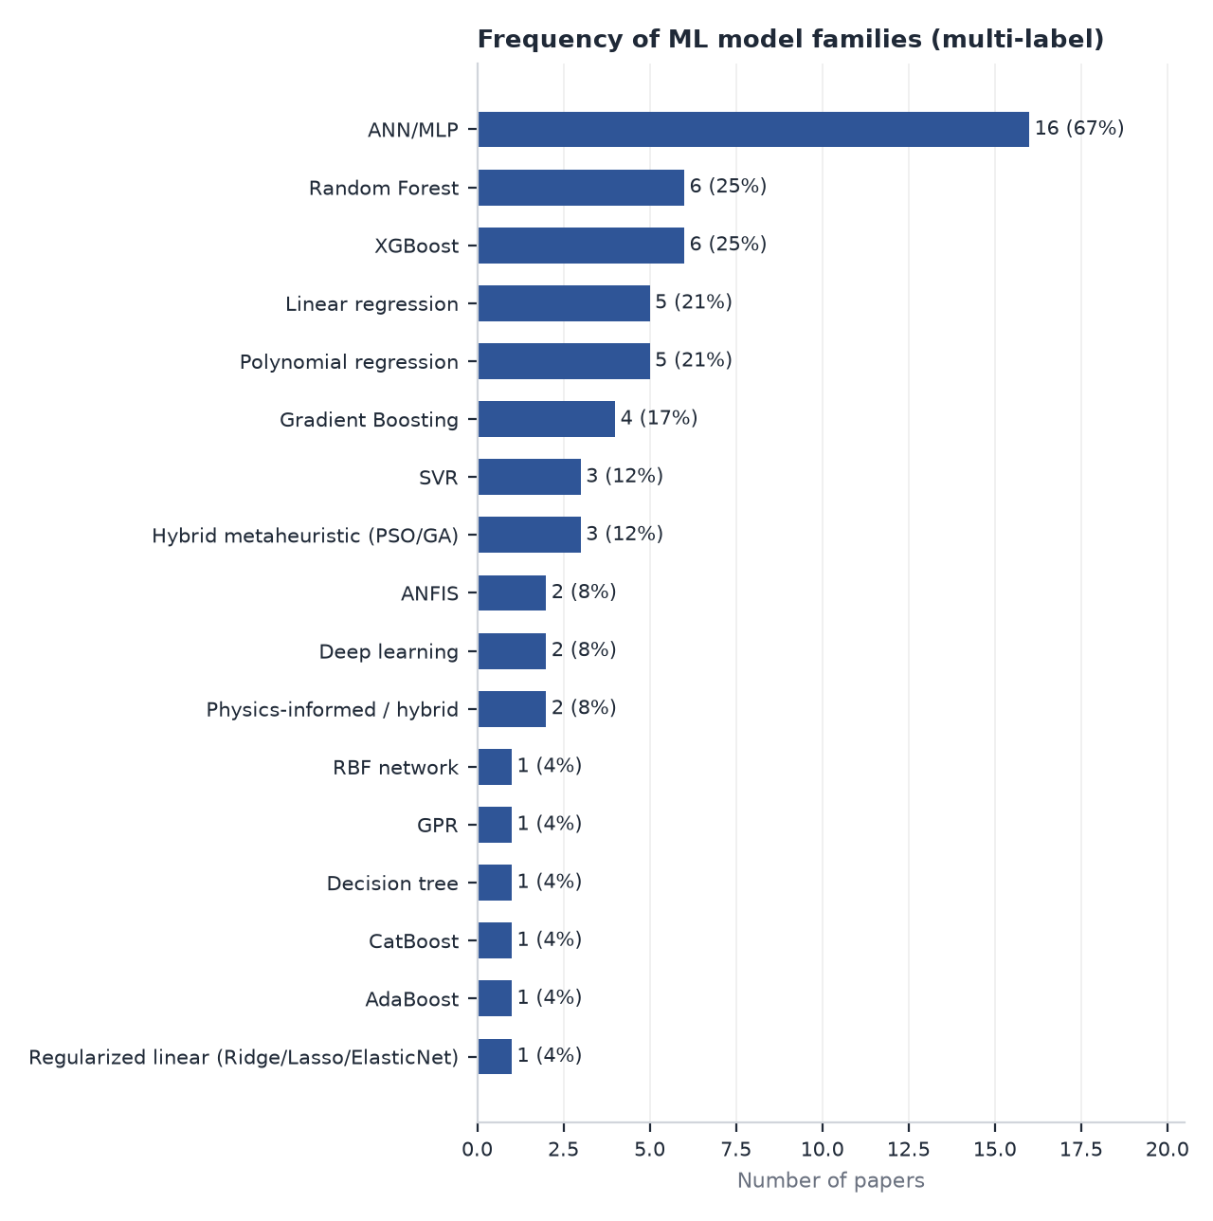
Figure 3. Model families used across retained papers.
Neural networks dominate (16 of 24 papers), usually Levenberg-Marquardt-trained MLPs sized by trial and error. Tree ensembles follow (random forest 6, XGBoost 6, other gradient boosting 4), while kernel methods are rare (SVR 3, GPR 1). Seventeen papers compare several models, but almost always under random splits, so the rankings mainly reflect interpolation smoothness. Where a properly structured simple model was included it was competitive: a six-parameter quadratic was within 1 Nu unit of a 111-weight MLP (P05); an RSM quadratic matched the MLP (P06); a power-law correlation matched XGBoost (P14). Conversely, untransformed linear regression used as a baseline (P16) is a straw man; a log-linear (power-law) form is the appropriate reference for convective heat transfer.
Model family | Small-data suitability | Extrapolation | Uncertainty | Relevance to our project
Correlation / power-law baseline | Excellent | Best of all families when refitted to own data | Via regression statistics | Mandatory baseline and anchor
Linear / polynomial regression | Excellent | Poor (polynomial) / fair (log-linear) | Analytical CIs/PIs | Required baseline (log-linear form)
Ridge / Lasso / Elastic Net | Excellent | Fair with log/dimensionless features | Bootstrap / Bayesian ridge | Recommended baseline (log-space power law with penalty)
ANN / MLP | Poor unless very small, regularised and ensembled | Poor (P28 parametric net produced non-physical values) | None unless ensembles/MC-dropout | Candidate only as a small regularised ensemble
RBF network / GRNN | Good | Poor | None | Not prioritised (GPR covers the same niche with UQ)
ANFIS | Fair for <=3 inputs | Poor | None | Not recommended
SVR | Good | Poor-fair | Conformal only | Candidate
GPR | Excellent | Poor-fair (but signals it through growing variance) | Native | Strong candidate (not presumed final)
Random Forest | Fair | None (flat beyond range) | Quantile forests / jackknife | Candidate (reference ensemble)
Gradient Boosting / XGBoost / CatBoost | Fair if shallow and regularised | None | Quantile loss / conformal | Candidate (shallow, regularised XGBoost or sklearn GBR); CatBoost unnecessary without categorical inputs
Deep learning | Poor | Poor | Ensembles | Not recommended
Physics-informed / anchored hybrids | Excellent | Best of ML options | Inherits learner's UQ | Recommended framing for all candidate learners

8. Dataset Size and Data Structure
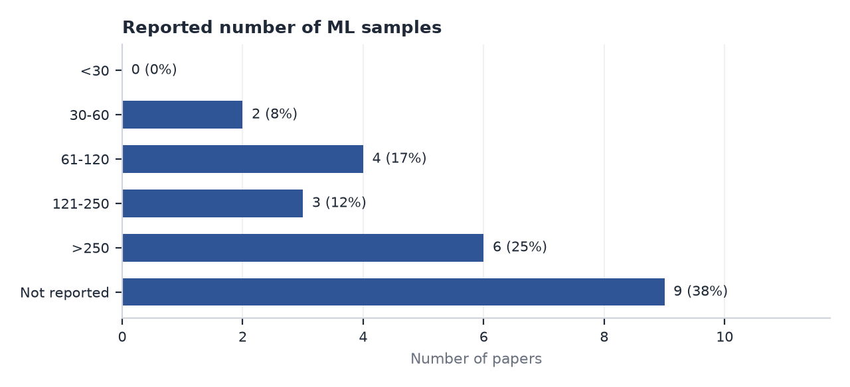
Figure 4. Dataset-size distribution (9 papers do not report n).
Experimental thermal datasets are small: 72 (P05), 84 (P02), 70 (P15), 120 (P17) and about 9-20 runs (P10, P06, inferred). Large datasets come only from CFD (P13: 2,700; P37: 200) or compiled public databases (P27: 24,579; P29: 4,333). More important than the row count is the number of independent operating conditions: P04's 540 rows originate from a few conditions, and no Tier 1 paper states whether repeated steady-state readings were averaged - only P19 explicitly averaged three repeats per configuration before modelling. Factorial or Taguchi designs (P02, P03, P05, P06, P10) mean that every condition has close neighbours differing in one factor level, which makes random splits easy and uninformative.
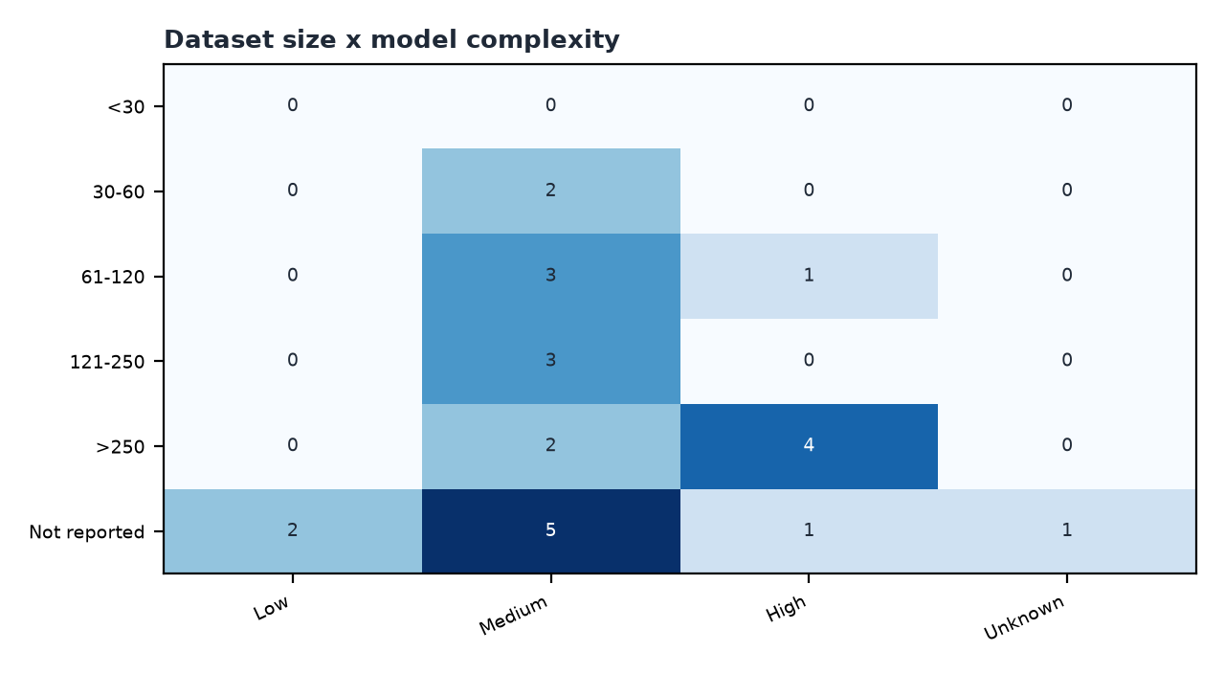
Figure 5. Model complexity is not matched to dataset size.

9. Input-Variable Analysis
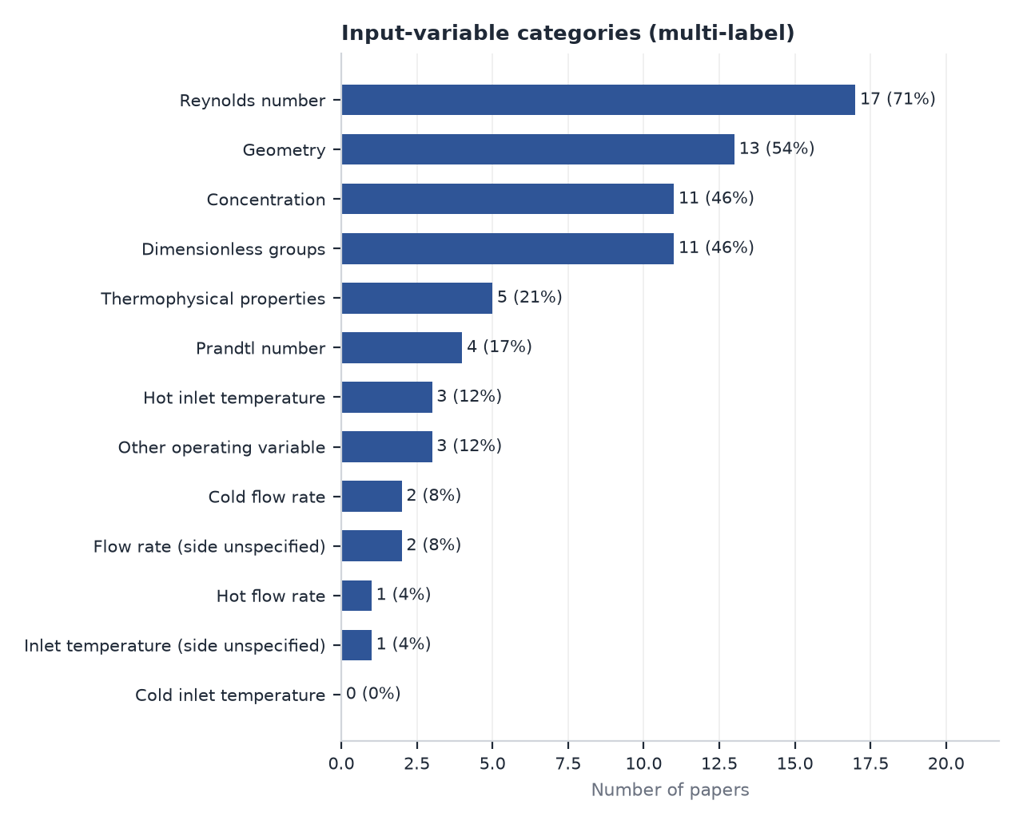
Figure 6. Input variables.
Reynolds number (17 papers), geometric ratios (13) and concentration (11) dominate; geometry is irrelevant to our fixed plain exchanger. Operating-temperature inputs are rare (hot inlet temperature in 3 papers) and no paper used the cold inlet temperature. No double-pipe paper varied both flow rates and both inlet temperatures together with concentration: P02 fixed the cold stream, P06 fixed the hot flow and P07 fixed the hot stream. Dimensional inputs (P02, P06, P10) are common in Tier 1, whereas the strongest extrapolation evidence favours dimensionless groups (P28) and physics-informed features (P29). Feeding correlation intermediates as inputs (friction factors and pumping powers in P12) or any quantity computed from the measured outlet temperatures constitutes target leakage.

10. Thermal Output Analysis
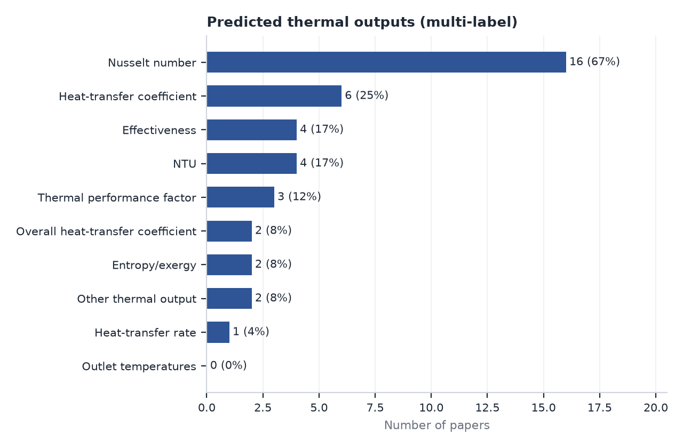
Figure 7. Thermal outputs (hydraulic outputs excluded by scope).
Nusselt number is the dominant target (16 papers), followed by heat-transfer coefficient (6), effectiveness and NTU (4 each), thermal performance factor (3), overall coefficient U (2) and heat duty (1); no paper learns outlet temperatures. Two observations decide our target choice:
- Linked outputs learned independently. P02 and P07 train separate models for Q, Nu, NTU and effectiveness. Because effectiveness is a deterministic function of NTU and the capacity-rate ratio, independent models can return mutually inconsistent values; P02's NTU and effectiveness models also generalised worst (train/test MSE ratios of 25-65).
- Learning one transport quantity and deriving the rest. P28 learned Nu from dimensionless groups and recovered the dimensional wall temperature through Newton's law; the directly learned dimensional network produced non-physical predictions out of range. P13 shows that U is learnable as a single transport quantity.
Conclusion: learn U (or tube-side Nu when wall temperatures are reliable), preferably as a ratio to a correlation, and derive NTU, effectiveness, Q and outlet temperatures physically. Learning outlet temperatures directly is not recommended: temperature differences are small relative to absolute temperatures, so small temperature errors become large errors in derived U or Q, and there is no literature support for it.

11. Validation Methodology
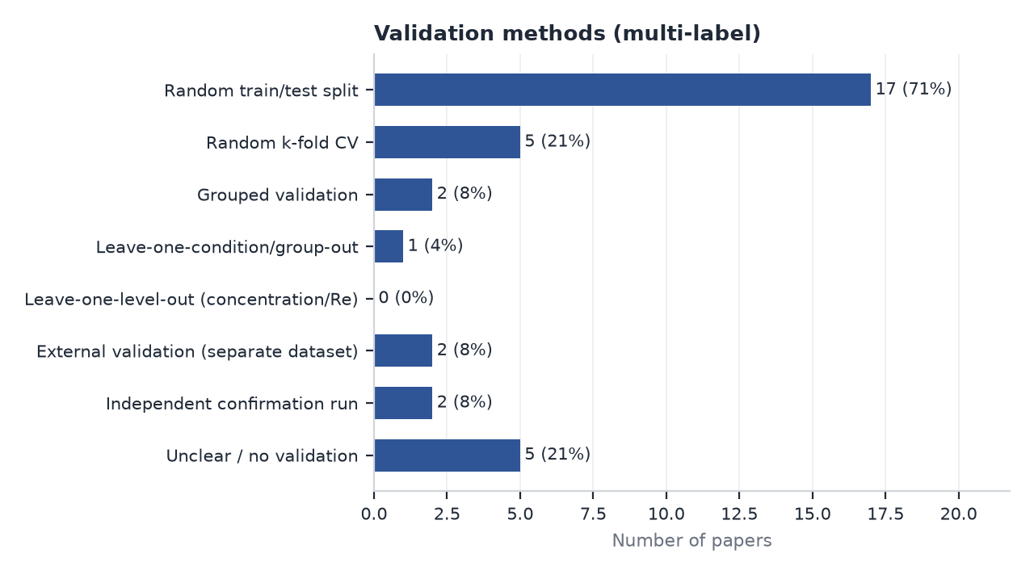
Figure 8. Validation methods.
Seventeen papers used a random train/test split and five random k-fold CV; five reported no clear validation (P01, P05, P09, P10, P19). Grouped validation appears only in P27 (campaign-disjoint, leave-campaign-out) and P29 (unseen tube geometries); separate external datasets appear in P28 (new experiments outside the training range) and P26 (ten experiments for a CFD-trained model); confirmation simulations in P21 and P22. No paper used leave-one-concentration-out or leave-one-Re-level-out validation, and no double-pipe paper performed independent confirmation experiments. Model selection is frequently contaminated by the test set: architecture chosen on pooled performance (P02), on minimum MSE including test points (P10), or with a goodness function that includes test metrics (P21, P22). P13 and P37 are the exceptions, selecting models by CV on training data and evaluating the test set once.
Three regimes must be distinguished in our project:
- Interpolation: predicting between tested points of the grid - what random splits measure;
- Extrapolation: predicting beyond the tested range of any input - not to be offered by the application;
- True held-out-condition prediction: predicting an operating condition, concentration or flow level withheld entirely (all repeats) from training - the quantity that justifies replacing experiments, and the only one that should be reported as the model's accuracy.

12. Data Leakage and Generalisation Concerns
Leakage / generalisation issue | Where observed | Remedy for our project
Rows from the same condition in train and test | P04 (540 rows from few conditions); possible in P02, P05, P07, P15, P16 (repeats not reported) | Average repeats; group by condition
Repeated time samples treated as independent | Not reported by any Tier 1 paper; averaged in P19 only | One row per steady state
Random split of factorial grid | P02, P03, P05?, P06, P07, P10, P17 | Leave-condition / level-out CV
Scaling before splitting | P06, P17 (min-max on full data); P13 scope not stated | Fit scaler inside each training fold
Feature selection / target-derived features | P12 (correlation intermediates as inputs); P06 target from correlations | Inputs only from controlled variables
Hyperparameters tuned on test data | P02, P10, P21, P22 (likely or explicit) | Nested CV
Only training/fit metrics reported | P05, P19 (no hold-out); P10 (R only) | Report held-out metrics
R/R2 without physical-unit error | P10, P02 (MSE units unclear), P17 (normalised only), P04 | RMSE/MAE/MAPE in physical units vs measurement uncertainty
Error below measurement uncertainty | P04 (0.33% vs 1.9%), P16 (0.6% vs 2.4-4.1%) | Sanity check against uncertainty

P27 quantifies the consequence: the same learner's error more than doubled (4.69% to 11.91%) when campaigns were withheld instead of random records, while correlation-anchored learners changed little. P29 shows the same pattern for unseen geometries. The reported accuracies in Tier 1 should therefore be read as interpolation fits, not as evidence that experiments can be replaced.

13. Uncertainty Quantification
Experimental measurement uncertainty is reported in most experimental papers (e.g., Nu +/-1.6-4.3%), but predictive uncertainty is almost absent: only P37 provides prediction intervals (quantile XGBoost with 91% coverage of a nominal 90% interval; a bootstrap ensemble that under-covered at 72.5%), and P27 provides one-sided tolerance divisors. P03 used GPR without reporting its predictive variance. No double-pipe study reports intervals or compares model error with measurement uncertainty. For our project, GPR offers native variance; for other learners, grouped conformal intervals give distribution-free coverage; in all cases empirical coverage must be checked on held-out conditions, because P37 shows that uncalibrated ensembles are overconfident.

14. Physics-Informed and Physics-Anchored Approaches
Only two retained papers embed physics in the learning problem, both outside heat exchangers. P27 learns the multiplicative log-residual of the Bowring correlation and achieves lower grouped error (3.94-4.96%) and far lower leakage amplification (1.06-1.36) than direct learners (2.54); it also tolerated a 6% bias in the anchor. P28 shows that a network with dimensionless inputs and a Nu output extrapolates better and remains physically consistent with only 200 samples. P29 adds that expert (physics-based) features improve ML accuracy and that a plain correlation beats ML on unseen geometries. In heat-exchanger ML, correlations appear only as competitors (P05, P13, P14, P15) or for rig validation (P02, P07, P17). Anchoring a DPHE model to a Gnielinski/Dittus-Boelter prediction (or to a power law refitted on the base fluid) is therefore well supported by cross-domain evidence but untested for nanofluid double-pipe exchangers.

15. Benchmark Papers
Three benchmarks were selected from Evidence A papers. The first-pass benchmarks P03 and P04 were dropped: P03 is an air/steam constant-wall-temperature configuration validated by random k-fold CV, and P04 reports accuracy below its measurement uncertainty with a high leakage risk.

P02 - Esfandyari (2023) - Primary benchmark
- Why selected: Closest experimental analogue: counter-flow DPHE, Al2O3 nanofluid, operating-variable inputs (hot flow, hot inlet temperature, concentration) and the full set of thermal outputs a user would want (Q, Nu, NTU, effectiveness); compares ANN and ANFIS; reports train and test separately.
- Adopt: Input variables; multi-output thermal reporting; separate train/test reporting; comparison of at least two model families.
- Do not copy: Random split of the factorial grid; architecture selection using pooled/test performance; PSO-tuned two-layer network for 59 rows; independent learning of NTU, effectiveness and Q; MSE without units.
- What we can improve: Grouped (leave-one-condition / concentration-out) validation; learn U or Nu only and derive NTU/eps/Q physically; add cold-side variables; add prediction intervals and an applicability-domain check; report physical-unit errors vs measurement uncertainty.

P13 - Alsayah (2025) - Secondary benchmark
- Why selected: Best-documented ML pipeline in the DPHE class: architecture chosen by 5-fold CV on the training portion, untouched test set, physical-unit MAE/MAPE, regularisation and early stopping, comparison against six correlations by flow regime, SHAP explanation; U is the learned thermal target.
- Adopt: Train / CV-selection / untouched-test discipline; correlation baselines by regime; SHAP; physical-unit metrics; U as a single learned transport quantity.
- Do not copy: Deep 128-256-128 network (justified only by 2,700 CFD samples); un-refitted correlations as the only baseline; random splitting.
- What we can improve: Use experimental data, small-capacity models, refitted correlation baselines and grouped validation.

P37 - HadjSalah (2026) - Supporting benchmark
- Why selected: Strongest validation hygiene and uncertainty treatment: split before preprocessing, tuning on training folds only, explicit leakage checklist, fixed seeds, public code, calibrated quantile prediction intervals with coverage, and mono-to-hybrid nanofluid transfer learning on 20 points.
- Adopt: Leakage checklist; train-only preprocessing/tuning; interval coverage checks; reproducibility package; shallow regularised boosting settings.
- Do not copy: CFD-only mixture-rule hybrid properties as a substitute for measurements; random splitting; uncalibrated bootstrap intervals (72.5% coverage).
- What we can improve: Apply the same hygiene with grouped validation on experimental hybrid-nanofluid DPHE data.

16. Statistical Literature Findings
Evidence base: the 'Statistical Analysis' sheet of the companion workbook (KPI blocks, 18 charts A-R, 14 cross-tabs). The key findings generated from the database are:
- F1. ANN/MLP is the dominant model family: 16 of 24 retained papers (67%) use it; GPR appears in only 1 paper (P03) despite most experimental datasets being small.
- F2. Validation is weak: 15 papers rely only on random splits and 5 report no clear validation; none of the 8 Tier 1 (double-pipe, experimental) papers used grouped, held-out-condition or external validation (count = 0).
- F3. Predictive uncertainty is reported by 2 of 24 papers (P37 - CFD; P27 - partial), and by none of the double-pipe papers.
- F4. Nusselt number is the most frequent thermal target (16 papers), followed by heat-transfer coefficient (6); effectiveness and NTU appear in 4 papers each, and no paper learns outlet temperatures.
- F5. Headline R/R2 >= 0.99 is reported by 12 papers; 11 of these rest on random splits or no clear validation, so high R2 is not evidence of generalisation.
- F6. Dataset size is not reported by 9 of 24 papers; among Tier 1 papers only P02 (84), P04 (540) and P05 (72) state n.
- F7. Physics enters the models rarely: 2 papers use physics-anchored or physics-structured learning (P27, P28 - both outside heat exchangers), while 9 use fully dimensionless inputs.
- F8. Hybrid nanofluids appear in 3 papers, and only one (P01, abstract only) concerns a double-pipe heat exchanger.
- F9. No retained study used cold-side inlet temperature as an input, and no double-pipe study varied both flow rates and both inlet temperatures together with concentration.
- F10. Multi-model comparisons are common (17 papers), but only P27 and P29 compare families under grouped validation; in P29 the correlation beat ML on unseen geometries (MAE 1,111 vs 1,819 W/m2K).
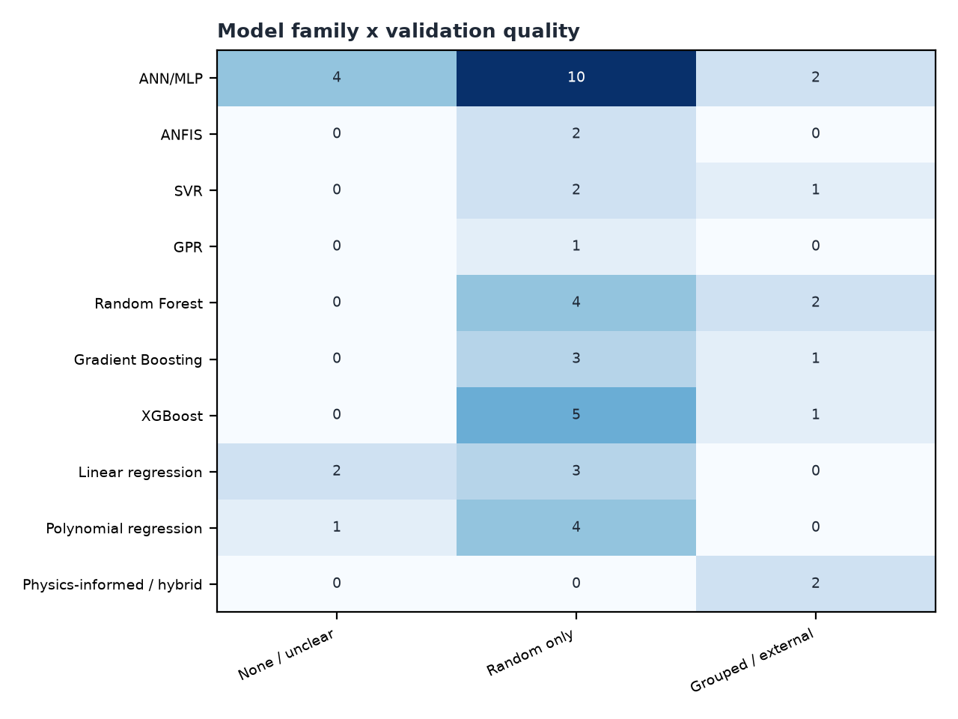
Figure 9. Model family against validation quality.
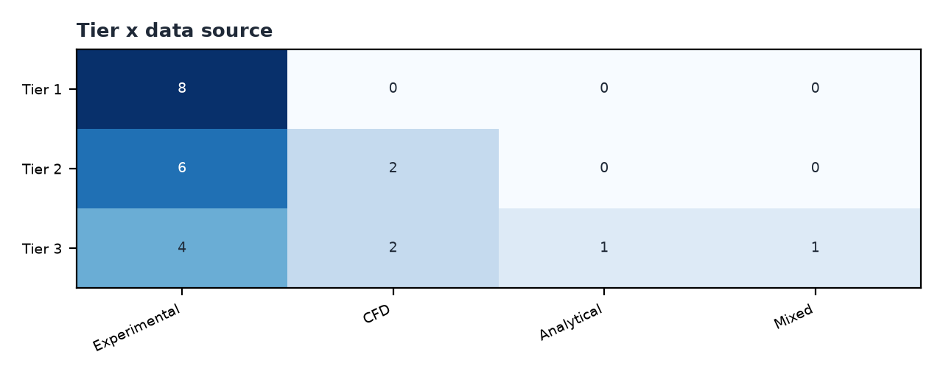
Figure 10. Tier against data source.
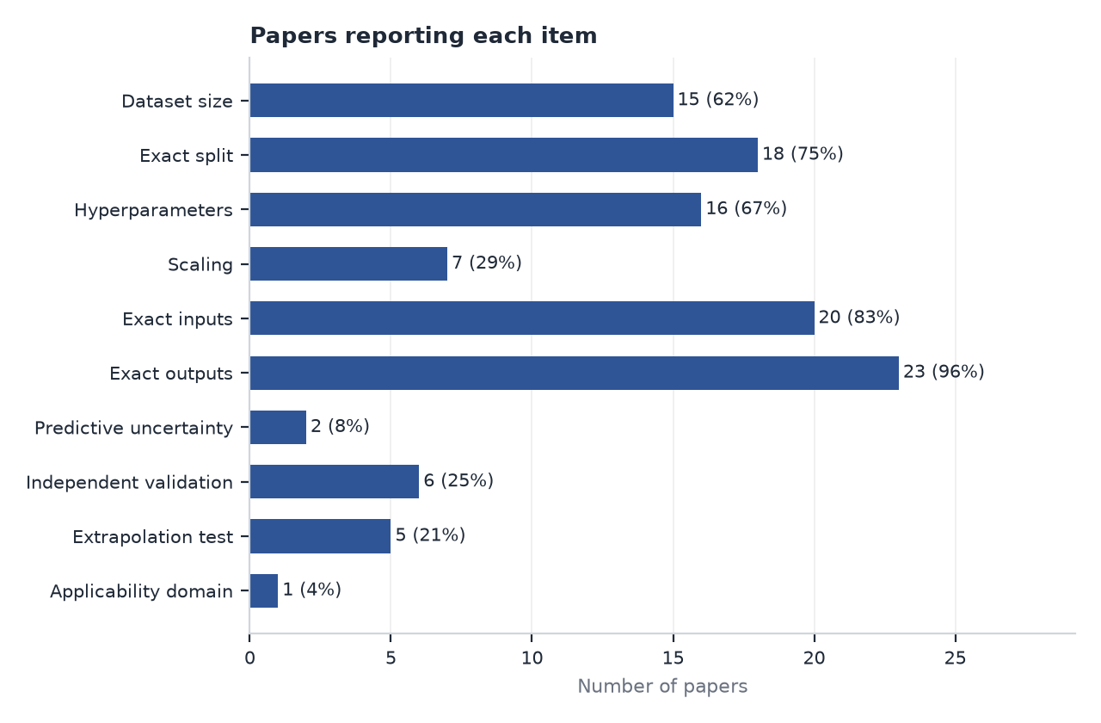
Figure 11. Reporting quality.

17. Research Gaps
Each gap is stated relative to the reviewed literature; absence from this database is not proof of absence elsewhere. Two first-pass gaps were withdrawn: the 'hydraulic penalty left out of models' gap (outside the thermal-only scope) and the claim that 'no ML study exists for MgO-TiO2 hybrid nanofluid in a DPHE' (not verifiable from this database; subsumed in Gap 1).
# | Gap (cautious wording) | Supporting papers | Priority | Strength
1 | No full-text-verified study was identified that applies ML to a hybrid nanofluid in a double-pipe heat exchanger. | P01 (abstract only); P14, P37 (hybrid NF, single tube); all verified DPHE nanofluid studies use mono nanofluids (P02, P05, P06, P07, P10) | High | Moderate (limited by P01 being unverifiable; must be re-checked once its full text is obtained)
2 | No reviewed DPHE study used grouped / held-out-condition validation; all used random row splits or did not report a split. | Random: P02, P04, P06, P07, P03 (k-fold), P13; none/unclear: P05, P10, P19; grouped only outside DPHE: P27, P29 | High | Strong
3 | Predictive uncertainty (prediction intervals) is absent from all double-pipe and all experimental nanofluid ML studies reviewed. | UQ only in P37 (CFD tube; quantile/bootstrap) and partially P27 (one-sided tolerance); none in the 14 DPHE-class papers | High | Strong
4 | No study was identified that anchors an ML model to a heat-transfer correlation for single-phase heat-exchanger data. | Anchoring only in P27 (boiling CHF, Bowring residual); correlations used only as competitors in P05, P13, P14, P15, P29 | High | Strong (cross-domain evidence)
5 | Thermodynamically linked outputs (Q, effectiveness, NTU, outlet temperatures) are learned as independent targets. | P02 (Q, Nu, NTU, eps separately), P07 (h, Nu, eps, NTU separately), P04, P19 | High | Strong
6 | Model capacity is routinely mismatched to dataset size, and reported accuracy often exceeds measurement uncertainty. | P10 (~9 runs, 20 neurons), P05 (111 weights / 72 points), P02 (2x10 MLP / 59 rows), P14/P15 (train R2 = 1), P04/P16 (test error below measurement uncertainty) | Medium-High | Strong
7 | No reviewed DPHE study varied both stream flow rates and both inlet temperatures together with nanoparticle concentration. | P02 varies hot flow and hot inlet T (cold fixed); P06 varies cold flow and hot inlet T (hot flow fixed); P07 varies cold flow only | High | Strong
8 | Applicability-domain checking is absent from all heat-exchanger ML studies reviewed. | Only P27 (Mahalanobis + correlation envelope, CHF) | High | Strong
9 | Few studies compare model families under the same protocol, and GPR is almost untested for DPHE data. | Multi-family: P03 (incl. GPR), P04, P16, P37; GPR only in P03 (air-side, variance unused) | Medium | Strong
10 | Extrapolation and interpolation to untested operating conditions are rarely tested; some studies present unvalidated predictions as results. | Unvalidated: P18 (phi 0.5%, 0.8%); tested: P28 (separate experiments), P22 (CFD re-runs), P29 (unseen tubes) | High | Strong
11 | No user-facing prediction software or decision-support tool was identified for DPHE ML models. | Weights published in P21, P22 (reproducibility only); code released in P37 | Medium | Moderate (absence of evidence within the reviewed set only)
12 | Reporting is incomplete: sample counts, split details, hyperparameters and physical-unit errors are often missing. | Dataset size missing in 9/24; hyperparameters missing in P06, P07, P15, P16; normalised-only errors in P17, P04 | Medium | Strong

Final research-gap statement:
No study was identified in the reviewed literature that (i) predicts the thermal performance of a double-pipe heat exchanger operating with a hybrid nanofluid using verified, fully reported methods; (ii) validates such a model on operating conditions, concentrations or flow levels withheld entirely from training; (iii) reports calibrated predictive uncertainty and applicability-domain warnings; or (iv) anchors the learner to a heat-transfer correlation and derives effectiveness, NTU, heat duty and outlet temperatures from a single learned transport quantity. A study combining these elements on MgO-TiO2 hybrid-nanofluid DPHE data would address several independently documented weaknesses at once.

18. Recommended Direction for Our Study
1. Prediction objective. Predict the steady-state thermal performance of the plain experimental DPHE with MgO-TiO2 hybrid nanofluid on the tube side (fluid as stated in the first-pass project report) for operating conditions inside the tested envelope, with calibrated uncertainty and an explicit out-of-domain warning; thermal outputs only.
2. User inputs. Hot inlet temperature; cold inlet temperature; hot-side flow rate; cold-side flow rate; nanoparticle concentration (and hybrid mixing ratio only if it is varied experimentally); which stream carries the nanofluid (tube side, fixed by design - not a model input).
3. Model-level features. Dimensionless: Re and Pr of each stream (properties from measured/validated nanofluid property correlations at bulk temperature), concentration, heat-capacity-rate ratio Cr; optionally log-transformed. Avoid any feature computed from measured outlet temperatures (target leakage, Kapoor L2).
4. Learned thermal output. One transport quantity: the overall heat-transfer coefficient U (or UA) from the measured LMTD and mean heat duty; if wall temperatures are reliably measured, the nanofluid-side Nu can be the learned target instead. Prefer learning ln(U_measured / U_baseline) where U_baseline comes from Gnielinski/Dittus-Boelter annulus and tube correlations (or a power law refitted to base-fluid data).
5. Physically derived outputs. NTU = UA/Cmin; effectiveness from the counter-flow eps-NTU relation; Q = eps*Cmin*(Th,in - Tc,in); outlet temperatures from energy balances; h_nf via resistance decomposition when the other side is known. This guarantees energy-balance consistency (unlike P02, P07).
6. Candidate ML models. Compare under identical grouped CV: (a) regularised log-linear (power-law) regression; (b) GPR with ARD Matern kernel; (c) SVR (RBF); (d) Random Forest; (e) shallow regularised gradient boosting (XGBoost/sklearn GBR, depth <= 3); (f) small MLP ensemble (1 hidden layer, <= 8 neurons, weight decay). Each as a direct model and as a residual on the baseline. No deep learning, ANFIS or PSO.
7. Baseline. Classical correlations evaluated with nanofluid properties (no fitting) AND a power-law correlation refitted to the project's training folds. ML must beat the refitted baseline on grouped validation to be adopted.
8. Preprocessing. Average repeated steady-state readings into one row per independent operating condition (P19 practice); propagate measurement uncertainty; energy-balance check (|Qh-Qc|/Qmean threshold) and steady-state criteria; scaling fitted inside each training fold only (P37).
9. Minimum dataset structure. Literature gives no validated minimum; reviewer recommendation: >= 40-60 independent conditions spanning >= 3 concentrations (plus base fluid), >= 4 levels of each flow rate and >= 3 inlet-temperature levels, with replicate runs at a subset of points to estimate pure error.
10. Validation. Nested grouped CV: outer leave-one-condition-out (or grouped K-fold by condition), leave-one-concentration-out and leave-one-flow-level-out; inner CV for hyperparameters; report random-split results only for comparison (leakage amplification factor, P27). Final untouched confirmation experiments.
11. Metrics. Physical-unit RMSE, MAE and MAPE of U (and derived Q, outlet temperatures), maximum error, % within +-5% and +-10%, bias, PI coverage and width; always compared with the experimental uncertainty of U.
12. Uncertainty method. GPR predictive variance; conformal (grouped CV+) intervals for non-probabilistic models; report empirical coverage on held-out conditions (target 90%/95%).
13. Extrapolation policy. No extrapolation outside the tested ranges of any input; the application reports 'outside validated domain' instead of a number (or a correlation-only estimate clearly labelled).
14. Applicability domain. Per-input range check plus Mahalanobis distance (or convex hull) in standardized dimensionless feature space (P27 practice); threshold set from training data.
15. Physics anchoring. Yes - learn the residual/ratio to a correlation (P27 evidence) and derive dependent outputs physically (P28 evidence).
16. Dimensionless features. Yes - Re, Pr per stream, concentration and Cr (P28, P29 evidence); keep a dimensional variant only as a comparison.
17. Software feasibility. Realistic: a frozen model (scikit-learn pipeline) wrapped in a small desktop/web app (e.g., Streamlit) with input validation, AD warning, prediction intervals and derived outputs; no evidence in the literature of an existing tool.
18. Future work. Fouling/time-dependent degradation, transient operation, other geometries/inserts, other nanofluids (transfer learning per P37), hydraulic quantities, active-learning experimental design.
Thermal input/output architecture:
Layer | Content
User inputs | Th,in; Tc,in; m_h; m_c; nanoparticle concentration (MgO-TiO2, tube side)
Property layer | Nanofluid rho, cp, k, mu at bulk temperature from measured property correlations (base fluid from IAPWS/standard tables)
Model features | Re_t, Pr_t (nanofluid, tube); Re_a, Pr_a (annulus); phi; Cr; optionally ln-transformed
Baseline | U_base from Gnielinski (tube) + annulus correlation + wall resistance; or power law refitted on training folds
Learned quantity | y = ln(U_meas / U_base) (or ln Nu_t ratio if wall temperatures are reliable)
Physics layer | U = U_base * exp(y); NTU = UA/Cmin; eps = f(NTU, Cr) counter-flow; Q = eps*Cmin*(Th,in - Tc,in); Th,out, Tc,out from energy balances
Trust layer | Prediction interval (GPR variance or grouped conformal) propagated to all outputs; applicability-domain flag (range + Mahalanobis)

19. Recommended Model Candidates
Candidate | Role | Settings to start from | Evidence
Classical correlations (no fit) | Reference | Gnielinski / Dittus-Boelter with nanofluid properties | P13, P29 (correlations), P27 (anchor)
Refitted power law (log-linear, ridge) | Baseline to beat | ln Nu or ln U on ln Re, ln Pr, phi, ln Cr | P14 (power law ~ XGBoost), P19, P16 (counter-example)
GPR (ARD Matern 5/2 + white noise) | Strong candidate | Direct and residual; standardised dimensionless inputs | P03 (2nd best, best for f), small-data theory
SVR (RBF) | Candidate | C, epsilon, gamma by inner CV | P03, P26, P37
Random forest | Reference ensemble | 500 trees, min_samples_leaf >= 3 | P04, P16, P37
Shallow gradient boosting | Candidate | depth 2-3, lr <= 0.1, strong L2, early stopping | P37 (good), P14/P15 (deep = overfit)
Small MLP ensemble | Candidate | 1 hidden layer, 4-8 tanh units, weight decay, 10-member ensemble | P02, P05, P13 (capacity lessons)
Not recommended | - | Deep nets, ANFIS, PSO/GA-trained networks, CatBoost (no categorical inputs) | P13 justification only with 2,700 CFD samples

No model is pre-selected: the final choice should be the simplest model whose grouped-CV error is not significantly worse than the best and whose intervals achieve nominal coverage. If GPR and the anchored power law perform equally, the simpler and more extrapolation-robust option should be preferred.

20. Recommended Validation Strategy
- Unit of independence = one steady-state operating condition (all repeats averaged; pure error estimated from replicates).
- Outer loop (reported accuracy): leave-one-condition-out (or grouped K-fold by condition); plus leave-one-concentration-out and leave-one-flow-level-out (hot and cold separately) to measure transfer to unseen levels.
- Inner loop: hyperparameters and scaler fitted on outer-training folds only (nested CV); no test information in model selection.
- Comparison run: random split reported only to compute a leakage-amplification factor (grouped error / random error) as in P27.
- Metrics: RMSE, MAE, MAPE and max error of U (and of derived Q and outlet temperatures) in physical units; % within +/-5% and +/-10%; bias; PI coverage and mean width; all compared with the propagated measurement uncertainty of U.
- Final test: 4-8 confirmation experiments chosen after the model is frozen - interior untested combinations and near-boundary points - never used for tuning.
- Documentation: model information sheet (data, splits, features, leakage checks), random seeds and code archived.

21. Recommended Software / Application Concept
- Inputs: hot and cold inlet temperatures, hot and cold flow rates, concentration; unit selection; validation of ranges.
- Engine: frozen scikit-learn pipeline (property layer -> features -> model -> physics layer) serialised with version metadata.
- Outputs: U, tube-side h/Nu (if modelled), NTU, effectiveness, heat duty and both outlet temperatures, each with a prediction interval.
- Trust features: applicability-domain indicator (green / amber / red), nearest tested condition, model card with validation results, refusal outside the validated envelope.
- Form: a small Streamlit (web) or desktop application; no literature evidence of an existing comparable tool was found (P21/P22 only publish network weights).

22. Immediate Action Plan (baby steps)
Step 1 - Data audit
- List every run: date, fluid batch, concentration, four temperatures, two flows, wall temperatures (if any), pressure data, duration.
- Flag runs with |Qh - Qc|/Qmean above a threshold (e.g., 10%) and non-steady segments.
- Record sensor uncertainties and compute propagated uncertainty of U.
Step 2 - Define independent conditions
- Group readings by set-point (Th,in, Tc,in, m_h, m_c, phi); one condition = one row.
- Count conditions per concentration and per flow level; identify gaps in the factorial coverage.
Step 3 - Data-cleaning rules
- Steady-state criterion (e.g., temperature drift < 0.1 C/min over 5 min).
- Average repeats; keep replicate spread as pure-error estimate.
- Write rules down before modelling; never remove points because the model fits them badly.
Step 4 - Thermal target definition
- Compute U from Qmean and LMTD with the same reference area for all runs.
- Decide whether wall temperatures are reliable enough for tube-side Nu.
- Compute baseline U_base (and Nu_base) with nanofluid properties.
Step 5 - Feature definition
- Implement nanofluid property models (from your measured k, mu if available).
- Compute Re, Pr of each stream, Cr, phi; log-transform where appropriate.
- Exclude any feature derived from outlet temperatures.
Step 6 - Baseline model
- Evaluate un-fitted correlations.
- Fit ridge-regularised power law in log space inside CV.
Step 7 - Validation code
- Implement grouped splitters (condition, concentration, hot-flow level, cold-flow level).
- Nested CV wrapper; scaler inside pipeline; fixed seeds; unit tests for leakage (no group overlap).
Step 8 - Candidate model training
- Train GPR, SVR, RF, shallow GBR, small MLP ensemble - each direct and residual-on-baseline.
- Keep hyperparameter grids small.
Step 9 - Model comparison
- Tabulate grouped metrics, leakage-amplification factor and paired differences across folds.
- Select the simplest adequate model.
Step 10 - Uncertainty analysis
- GPR intervals; grouped conformal intervals for others.
- Check coverage at 90%/95% on outer folds; recalibrate if needed.
Step 11 - Applicability domain
- Fit range + Mahalanobis gate on training features; set threshold (e.g., 95th percentile of training distances).
Step 12 - Confirmation experiments
- Freeze model; choose 4-8 new conditions (interior and edge); run them blind; compare with intervals.
Step 13 - Model freeze
- Version the pipeline, data snapshot and metrics; write the model card.
Step 14 - Application development
- Build the input form, prediction + intervals, derived outputs and AD indicator; add export of results.
Step 15 - Documentation & reproducibility
- Repository with code, environment file, data dictionary, model information sheet, and a script that reproduces every reported number.
Literature housekeeping (parallel): obtain full texts of P01 (highest priority), P35, P36 and P08 and re-assess them with the same template; verify quartiles on SCImago; rename the PDFs with the supplied scripts; screen X01 and X09 (hybrid-nanofluid ML).

23. Final Conclusion
After full-text verification, the published evidence on machine-learning prediction of double-pipe heat-exchanger thermal performance is narrower and less rigorous than its headline accuracies suggest. Experimental DPHE studies are small, mostly use oversized neural networks, validate with random splits of factorial grids, omit uncertainty, and learn physically linked outputs independently. The strongest methodological guidance comes from outside heat exchangers: group-disjoint validation exposes leakage, correlation-anchored and dimensionless models transfer better, and calibrated intervals make predictions usable. Our project should therefore be framed not as 'another ANN with R2 > 0.99' but as a small-data, physics-anchored, uncertainty-aware surrogate for an MgO-TiO2 hybrid-nanofluid DPHE, validated on withheld operating conditions and deployed with explicit domain limits. That framing is supported by the verified literature, addresses documented gaps, and is realistic for a dataset of tens of operating conditions.

Appendix A. Retained papers (24)
ID | Tier | Ev. | First author (year) | Journal | DOI
P02 | Tier 1 | A | Esfandyari (2023) | International Communications in Heat and Mass Transfer, 147, 106985 | 10.1016/j.icheatmasstransfer.2023.106985
P13 | Tier 2 | A | Alsayah (2025) | International Communications in Heat and Mass Transfer, 163, 108723 | 10.1016/j.icheatmasstransfer.2025.108723
P37 | Tier 2 | A | HadjSalah (2026) | Energy Science & Engineering, 14(9), 4316-4332 | 10.1002/ese3.70580
P01 | Tier 1 | C | Abdelghany (2026) | Journal of Thermal Analysis and Calorimetry, 151, 13425-13444 | 10.1007/s10973-026-15731-w
P04 | Tier 1 | A | Sammil (2024) | Thermal Science and Engineering Progress, 47, 102337 | 10.1016/j.tsep.2023.102337
P05 | Tier 1 | A | Karimpooremam (2025) | Case Studies in Thermal Engineering, 71, 106232 | 10.1016/j.csite.2025.106232
P06 | Tier 1 | A | Zakeri (2023) | International Communications in Heat and Mass Transfer, 148, 107002 | 10.1016/j.icheatmasstransfer.2023.107002
P07 | Tier 1 | A | Sundar (2023) | Case Studies in Thermal Engineering, 43, 102645 | 10.1016/j.csite.2022.102645
P09 | Tier 1 | C | MeghdadiIsfahani (2024) | Journal of Thermal Analysis and Calorimetry, 149, 1251-1266 | 10.1007/s10973-023-12780-3
P10 | Tier 1 | A | KrishnaVarma (2024) | Journal of Thermal Engineering, 10(5), 1184-1197 | 10.14744/thermal.0000860
P03 | Tier 2 | A | Celik (2023) | International Journal of Thermal Sciences, 192, 108439 | 10.1016/j.ijthermalsci.2023.108439
P14 | Tier 2 | B | Kanti (2025) | Scientific Reports, 15, 38717 | 10.1038/s41598-025-23785-3
P17 | Tier 2 | B | Gupta (2026) | Discover Nano, 21, 352 | 10.1186/s11671-026-04805-1
P19 | Tier 2 | B | Celik (2025) | Thermal Science and Engineering Progress, 66, 104033 | 10.1016/j.tsep.2025.104033
P27 | Tier 2 | B | Saraswat (2026) | Energy and AI, 26, 100889 | 10.1016/j.egyai.2026.100889
P28 | Tier 2 | A | Wang (2026) | International Journal of Thermal Sciences, 224, 110698 | 10.1016/j.ijthermalsci.2026.110698
P12 | Tier 3 | A | Colak (2022) | Case Studies in Thermal Engineering, 39, 102391 | 10.1016/j.csite.2022.102391
P15 | Tier 3 | B | Sundar (2024) | International Journal of Thermofluids, 21, 100557 | 10.1016/j.ijft.2023.100557
P16 | Tier 3 | B | Akilu (2024) | Scientific Reports, 14, 14829 | 10.1038/s41598-024-65411-8
P18 | Tier 3 | A | Alharthi (2024) | Case Studies in Thermal Engineering, 54, 104043 | 10.1016/j.csite.2024.104043
P21 | Tier 3 | B | Mousavi (2025) | Applied Thermal Engineering, 258, 124605 | 10.1016/j.applthermaleng.2024.124605
P22 | Tier 3 | B | SheikhiAzizi (2024) | International Journal of Thermal Sciences, 206, 109331 | 10.1016/j.ijthermalsci.2024.109331
P26 | Tier 3 | B | Syed (2025) | Energies, 18(1), 77 | 10.3390/en18010077
P29 | Tier 3 | B | LoyolaFuentes (2024) | Applied Thermal Engineering, 248, 123043 | 10.1016/j.applthermaleng.2024.123043

Appendix B. Supporting references cited but removed from the active database
ID | Reference | Reason
P08 | Khadang, A.; Nazari, M.; Maddah, H.; Ahmadi, M.H.; Sharifpur, M. (2024). Experimental study and neural network-based prediction of thermal performance of applying baffles and nanofluid in the double-pipe heat exchangers. Journal of Thermal Analysis and Calorimetry, 149, 4239-4259. DOI 10.1007/s10973-024-12969-0 | No accessible evidence
P11 | Prakash, B.; Sridharan, M. (2023). Predicting the thermal performance of double pipe heat exchanger using the generalized regression neural network model. International Journal of Ambient Energy, 44(1), 270-279. DOI 10.1080/01430750.2022.2127885 | No accessible evidence
P20 | Panda, J.P.; Kumar, B.; Patil, A.K.; Kumar, R. (2023). Machine learning assisted modeling of thermohydraulic correlations for heat exchangers with twisted tape inserts. Acta Mechanica Sinica, 39 (arXiv:2202.00927). DOI 10.1007/s10409-022-22036-x | No accessible evidence
P23 | Shin, Y.H.; Gwon, J.G.; Choi, H.K.; Park, Y.G. (2026). CFD simulation for thermal performance analysis of twisted oval double-pipe heat exchangers with ANN prediction. Journal of Mechanical Science and Technology, 40(5), 3935-3952. DOI 10.1007/s12206-026-0462-z | No accessible evidence
P24 | Heeraman, J.; Kumar, R.; Chaurasiya, P.K.; Verma, T.N.; Chauhan, D.K. (2025). Optimisation and comparison of performance parameters of a double pipe heat exchanger with dimpled twisted tapes using CFD and ANN. Proc. IMechE Part E, 239(6), 3251-3268. DOI 10.1177/09544089231223599 | No accessible evidence
P25 | Gomathi, B.; Ramanipriya, M.; Anitha, S. (2025). Machine learning approach to predict the thermal performance and friction factor of cylindrical heat exchangers with perforated conical ring turbulators. Journal of Thermal Analysis and Calorimetry, 150, 5841-5854. DOI 10.1007/s10973-025-14092-0 | Insufficient methodological relevance
P30 | Kapoor, S.; Narayanan, A. (2023). Leakage and the reproducibility crisis in machine-learning-based science. Patterns, 4(9), 100804. DOI 10.1016/j.patter.2023.100804 | Review only / supporting only
P31 | Zou, J.; Hirokawa, T.; An, J.; Huang, L.; Camm, J. (2023). Recent advances in the applications of machine learning methods for heat exchanger modeling - a review. Frontiers in Energy Research, 11, 1294531. DOI 10.3389/fenrg.2023.1294531 | Review only / supporting only
P32 | Togun, H.; Basem, A.; Kadhum, A.A.H.; Mohammed, H.I.; Abed, A.M.; Anqi, A.E.; Chattopadhyay, A.; Sharma, B.K.; Homod, R.Z.; Barmavatu, P. (2025). Machine learning in heat exchanger modeling: Recent trends and innovations. International Communications in Heat and Mass Transfer, 169, 109920. DOI 10.1016/j.icheatmasstransfer.2025.109920 | Review only / supporting only
P33 | Ayub, A.; Ahmad, I.; Qazi, A.; Sethi, H.; Zulkefal, M.; Zulfiqar, A.; Deebani, W. (2026). Machine Learning in Heat Exchangers: State-of-the-Art Review. ACS Engineering Au, 6(2), 231-248. DOI 10.1021/acsengineeringau.5c00073 | Review only / supporting only
P34 | Singh, S.K.; Kacker, R.; Gautam, S.S.; Tamang, S.K.; Arora, A. (2024). Application of ANN methodology to optimize the criteria of performance evaluation with multiple v-cut twisted tape inserts. Numerical Heat Transfer, Part B, 86(7). DOI 10.1080/10407790.2024.2333018 | No accessible evidence
P35 | Singh, S.K.; Anand, R.; Sikarwar, V.S.; Arora, A.; Kacker, R. (2025). Optimizing performance of DPHE using twisted tape with v-cuts and circular holes: An experimental and Gradient Boosting approach. Energy Sources, Part A. DOI 10.1080/15567036.2025.2552998 | No accessible evidence
P36 | Not retrieved (2023). Analysis of thermal performance and ultrasonic wave power variation on heat transfer of heat exchanger in the presence of nanofluid using the artificial neural network: experimental study and model fitting. Journal of Thermal Analysis and Calorimetry, 148, 8009-8023. DOI Not retrieved | No accessible evidence

