Algorithmic Optimization of Dense Sphere Packings in Non-Euclidean Spaces
Marian Ela J. Alibadbad
Region VIII
Mathematics and Computational Science – Individual Category (MCS-I)
December 3, 2026

Abstract
This study compares optimization algorithms for dense packings on the sphere, the Euclidean plane, and the hyperbolic plane under one protocol with an equal budget and paired seeds. In a preregistered confirmatory round (six methods, 33 conditions, three budgets; 11,880 runs), polished gradient descent had the best mean rank (1.70), and L-BFGS-B or basin hopping beat both gradient descent and simulated annealing in all 33 conditions; compression ranked last. The shortfall of a packing from the density bound rose with the share of the ball near its wall (Spearman r_{s} = .87, partly circular because both come from the radius found; .59 at a fixed radius). A final preregistered round of 144 equal-area conditions found no curvature effect larger than .02 of the bound (hyperbolic 0.010, cap −0.009), though both intervals excluded zero. A rule, the number of disks at the bound times (1 − 0.46 times the boundary share), predicted the number of disks that fit within one disk in all 20 new conditions. No method reached a .90 success share for 13 points (3 of 360 runs). Results concern the budgets and implementations tested and set no records.
Keywords: sphere packing, Tammes problem, hyperbolic plane, optimization algorithms, curvature

Table of Contents
Chapter Page
List of Figures . . . . . . . . . . . . . . . . . . . . . . . . . . . . . . . . . . . . . . . . . . . . . . . . . . . . . . . . . . 6
List of Tables . . . . . . . . . . . . . . . . . . . . . . . . . . . . . . . . . . . . . . . . . . . . . . . . . . . . . . . . . . . 7
Main Results at a Glance . . . . . . . . . . . . . . . . . . . . . . . . . . . . . . . . . . . . . . . . . . . . . . . . . 9
Introduction . . . . . . . . . . . . . . . . . . . . . . . . . . . . . . . . . . . . . . . . . . . . . . . . . . . . . . . . . . . 10
Background and Related Work . . . . . . . . . . . . . . . . . . . . . . . . . . . . . . . . . . . . . . . . . . 11
Research Gap and Contribution . . . . . . . . . . . . . . . . . . . . . . . . . . . . . . . . . . . . . . . . . . 11
Research Questions and Hypotheses . . . . . . . . . . . . . . . . . . . . . . . . . . . . . . . . . . . . . . 12
Framework . . . . . . . . . . . . . . . . . . . . . . . . . . . . . . . . . . . . . . . . . . . . . . . . . . . . . . . . . . . . 12
Geometry of the Spaces . . . . . . . . . . . . . . . . . . . . . . . . . . . . . . . . . . . . . . . . . . . . . . . . 13
Packing Problems and Comparability . . . . . . . . . . . . . . . . . . . . . . . . . . . . . . . . . . . . . 17
Experimental Design . . . . . . . . . . . . . . . . . . . . . . . . . . . . . . . . . . . . . . . . . . . . . . . . . . 18
Optimization Algorithms . . . . . . . . . . . . . . . . . . . . . . . . . . . . . . . . . . . . . . . . . . . . . . . 19
Gradient Descent on a Soft-Minimum Energy . . . . . . . . . . . . . . . . . . . . . . . . . . . 21
Simulated Annealing . . . . . . . . . . . . . . . . . . . . . . . . . . . . . . . . . . . . . . . . . . . . . . . 21
Compression Method . . . . . . . . . . . . . . . . . . . . . . . . . . . . . . . . . . . . . . . . . . . . . . . 21
Properties of the Algorithms: Proven and Observed . . . . . . . . . . . . . . . . . . . . . . . . . . 22
Validation Procedures . . . . . . . . . . . . . . . . . . . . . . . . . . . . . . . . . . . . . . . . . . . . . . . . . 23
Statistical Analysis . . . . . . . . . . . . . . . . . . . . . . . . . . . . . . . . . . . . . . . . . . . . . . . . . . . . 23
Reproducibility and Data Integrity . . . . . . . . . . . . . . . . . . . . . . . . . . . . . . . . . . . . . . . 25
Deviations From the Research Plan . . . . . . . . . . . . . . . . . . . . . . . . . . . . . . . . . . . . . . . 25
Disclosure of AI Assistance and Researcher’s Contribution . . . . . . . . . . . . . . . . . . . . 27
Findings . . . . . . . . . . . . . . . . . . . . . . . . . . . . . . . . . . . . . . . . . . . . . . . . . . . . . . . . . . . . . . . 27
Validation Results . . . . . . . . . . . . . . . . . . . . . . . . . . . . . . . . . . . . . . . . . . . . . . . . . . . . 27
Packing Performance on the Sphere . . . . . . . . . . . . . . . . . . . . . . . . . . . . . . . . . . . . . . 29
Packing Performance in Geodesic Balls . . . . . . . . . . . . . . . . . . . . . . . . . . . . . . . . . . . 32
Convergence, Scaling, and Cost . . . . . . . . . . . . . . . . . . . . . . . . . . . . . . . . . . . . . . . . . 32
Statistical Comparison of Algorithms . . . . . . . . . . . . . . . . . . . . . . . . . . . . . . . . . . . . . 37
Hypothesis Evaluation . . . . . . . . . . . . . . . . . . . . . . . . . . . . . . . . . . . . . . . . . . . . . . . . . 39
Supplementary Exploratory Analyses . . . . . . . . . . . . . . . . . . . . . . . . . . . . . . . . . . . . . 41
Numerical Accuracy and Independent Recomputation . . . . . . . . . . . . . . . . . . . . . 44
Gradient Descent With a Polishing Step, and Wall-Clock Time . . . . . . . . . . . . . . 45
Sensitivity to the Budget, the Parameters, and the Starting Configuration . . . . . . . . . 47
Equal-Area and Larger-Ball Comparison . . . . . . . . . . . . . . . . . . . . . . . . . . . . . . . 48
Robustness of the H1 Result . . . . . . . . . . . . . . . . . . . . . . . . . . . . . . . . . . . . . . . . . 48
Confirmatory Round With Equal-Area Balls and Stronger Baselines . . . . . . . . . . . . . 50
Prediction, Design, and Preregistration . . . . . . . . . . . . . . . . . . . . . . . . . . . . . . . . . 50
Results of the Preregistered Decisions . . . . . . . . . . . . . . . . . . . . . . . . . . . . . . . . . . 54
Budget Levels, Time, and the Count-Based Problem . . . . . . . . . . . . . . . . . . . . . . 56
Baselines Re-Tuned After the First Analysis . . . . . . . . . . . . . . . . . . . . . . . . . . . . . 58
Wall Contact in All Runs . . . . . . . . . . . . . . . . . . . . . . . . . . . . . . . . . . . . . . . . . . . . 59
Limits of the Confirmatory Round . . . . . . . . . . . . . . . . . . . . . . . . . . . . . . . . . . . . 60
Final Round: An Equal-Area Test of Curvature and a Rule for the Number of Disks . . . 63
Design and Preregistered Rules . . . . . . . . . . . . . . . . . . . . . . . . . . . . . . . . . . . . . . . 66
Result for Curvature . . . . . . . . . . . . . . . . . . . . . . . . . . . . . . . . . . . . . . . . . . . . . . . . 66
Result for the Rule for the Number of Disks . . . . . . . . . . . . . . . . . . . . . . . . . . . . . 68
Conclusions . . . . . . . . . . . . . . . . . . . . . . . . . . . . . . . . . . . . . . . . . . . . . . . . . . . . . . . . . . . . 70
Summary of Findings . . . . . . . . . . . . . . . . . . . . . . . . . . . . . . . . . . . . . . . . . . . . . . . . . . 70
Limitations on the Research Design and Material . . . . . . . . . . . . . . . . . . . . . . . . . . . . 73
Implications and Future Directions . . . . . . . . . . . . . . . . . . . . . . . . . . . . . . . . . . . . . . . 75
References . . . . . . . . . . . . . . . . . . . . . . . . . . . . . . . . . . . . . . . . . . . . . . . . . . . . . . . . . . . . . 76
Appendix A: Sensitivity of the Main Results to Budget, Parameters, and Starting Configuration . . . . . . . . . . . . . . . . . . . . . . . . . . . . . . . . . . . . . . . . . . . . . . . 79
Appendix B: Mini-Round, Follow-Up, and the Withdrawn Decision . . . . . . . . . . . . . 82
Additions After the First Analysis . . . . . . . . . . . . . . . . . . . . . . . . . . . . . . . . . . . . . . . . 82
Mini-Round With a Fixed Radius and a Matched Boundary Share . . . . . . . . . . . . . . . 82
Follow-Up With More Levels, a Third Radius, and a Second Method . . . . . . . . . . . . 86

List of Figures
Figure Page
Figure 1. Mean Rank of the Six Methods in the 33 Conditions of the Confirmatory Round . . . . . . . . . . . . . . . . . . . . . . . . . . . . . . . . . . . . . . . . . . . . . . . . . . . . . . . . . 10
Figure 2. Framework of the Study . . . . . . . . . . . . . . . . . . . . . . . . . . . . . . . . . . . . . . . . . . . 16
Figure 3. Best Configurations on the Sphere for Six Values of N . . . . . . . . . . . . . . . . . . . 30
Figure 4. Best Packings of 19 Disks in a Ball of Radius 3 in Three Spaces . . . . . . . . . . . 35
Figure 5. Convergence of the Best Score During the Budget . . . . . . . . . . . . . . . . . . . . . . 36
Figure 6. Final Relative Score by Condition . . . . . . . . . . . . . . . . . . . . . . . . . . . . . . . . . . . 38
Figure 7. Mean Run Time on the Sphere by Number of Points . . . . . . . . . . . . . . . . . . . . . 40
Figure 8. Distribution of Relative Scores Over Seeds . . . . . . . . . . . . . . . . . . . . . . . . . . . . 42
Figure 9. Density Deficit Against Boundary Share in the Confirmatory Round . . . . . . . . 64
Figure 10. Mean Relative Score of the Six Methods at Three Budget Levels . . . . . . . . . . 65
Figure 11. Density Deficit Against Boundary Share in the Final Round . . . . . . . . . . . . . . 70

List of Tables
Table Page
Table 1. Stages of the Study . . . . . . . . . . . . . . . . . . . . . . . . . . . . . . . . . . . . . . . . . . . . . . . . 14
Table 2. Area Within Distance 1 of the Boundary of a Ball of Radius R . . . . . . . . . . . . . 17
Table 3. Algorithm Parameters . . . . . . . . . . . . . . . . . . . . . . . . . . . . . . . . . . . . . . . . . . . . . . 20
Table 4. Validation Tests, Pass Criteria, and Results . . . . . . . . . . . . . . . . . . . . . . . . . . . . . 28
Table 5. Final Minimum Distance and Success Rate on the Sphere by Algorithm . . . . . . . . . 31
Table 6. Mean Disk Radius and Packing Density in a Ball by Algorithm . . . . . . . . . . . . . 33
Table 7. Largest Tested Number of Disks That Fit at a Target Radius . . . . . . . . . . . . . . . 34
Table 8. Mean Sweeps Needed to Reach 99% of the Final Score . . . . . . . . . . . . . . . . . . . 37
Table 9. Conditions in Which One Algorithm Was Significantly Higher . . . . . . . . . . . . . 43
Table 10. Hypotheses, Decision Rules, and Results . . . . . . . . . . . . . . . . . . . . . . . . . . . . . 44
Table 11. Mean Relative Score of Gradient Descent With and Without a Polishing Step . . . . 46
Table 12. Mean Wall-Clock Time per Run at Equal Budget . . . . . . . . . . . . . . . . . . . . . . . 46
Table 13. Balls of Equal Area in the Three Spaces, and Larger Balls . . . . . . . . . . . . . . . . 49
Table 14. Methods, Tuned Parameters, and Candidate Settings of the Confirmatory Round . . . . . . . . . . . . . . . . . . . . . . . . . . . . . . . . . . . . . . . . . . . . . . . . . . . . . . . . . 53
Table 15. Preregistered Decisions of the Confirmatory Round . . . . . . . . . . . . . . . . . . . . . 56
Table 16. Mean Relative Score of the Six Methods at 1,500 Sweeps . . . . . . . . . . . . . . . . 58
Table 17. Density Deficit and Boundary Share of the 26 Ball Conditions . . . . . . . . . . . . 61
Table 18. Mean Relative Score at Three Budget Levels, With Time and Budget Used . . . . . 63
Table 19. Count-Based Version of the Disk Problem: Largest Number of Disks of Radius 0.30 . . . . . . . . . . . . . . . . . . . . . . . . . . . . . . . . . . . . . . . . . . . . . . . . . . . . . . . . . . . 65
Table 20. Wall Contact of the Final Configurations of All Ball Runs at 1,500 Sweeps . . . . . 66
Table 21. Curvature Terms in the Final Round at Equal Area . . . . . . . . . . . . . . . . . . . . . . 67
Table 22. Predicted and Found Number of Disks in the Final Round . . . . . . . . . . . . . . . . 68
Table A1. Mean Relative Score at Three Budgets . . . . . . . . . . . . . . . . . . . . . . . . . . . . . . . 79
Table A2. Mean Relative Score With One Parameter Changed . . . . . . . . . . . . . . . . . . . . . 80
Table A3. Spread of the Relative Score Over 30 Starting Configurations . . . . . . . . . . . . . 81
Table 23. Mini-Round Conditions With a Fixed Disk Radius and a Matched Boundary Share . . . . . . . . . . . . . . . . . . . . . . . . . . . . . . . . . . . . . . . . . . . . . . . . . . . . . . . . . . 85
Table 24. Mini-Round Results as Preregistered and After Removing the Duplicated Euclidean Conditions . . . . . . . . . . . . . . . . . . . . . . . . . . . . . . . . . . . . . . . . . . . . . . . . . . . . . 86
Table 25. Follow-Up Conditions and the Number of Disks Found by Two Methods . . . . . . . 90

Algorithmic Optimization of Dense Sphere Packings in Non-Euclidean Spaces

Main Results at a Glance
Four results carry the paper, and the rest of the text supports them. First, the ranking of the methods: across the 33 conditions of the preregistered confirmatory round, polished gradient descent had the best mean rank (1.70), followed by L-BFGS-B (2.48), basin hopping (2.86), simulated annealing (3.72), gradient descent (4.24), and the simplified compression method (6.00); the better of L-BFGS-B and basin hopping beat both gradient descent and simulated annealing in all 33 conditions (Figure 1). Second, the boundary: the share by which a packing falls short of the upper bound on the density rises with the share of the ball’s area near its wall, in all three spaces (Spearman r_{s} = .87 in the confirmatory round, a test that is partly circular, and .59 at a fixed disk radius in a follow-up). Third, curvature: in a final preregistered round of 144 equal-area conditions, once the boundary share is in the model the hyperbolic disk differed from the Euclidean disk by 0.010 (95% interval 0.004 to 0.017) and the cap by −0.009, so no curvature effect larger than .02 of the upper bound was found, whereas three earlier rounds had been inconclusive. Fourth, a rule: the number of disks of a given radius that fit in a ball is predicted by the number at the upper bound times (1 − 0.46 times the boundary share), within one disk in 100% of 20 new conditions.
Two cautions apply to all four. The results hold for the budgets, implementations, and sizes tested (the rule for the number of disks was tested only for balls of at most 46 disks), and no packing found is claimed to be optimal. The first study, which preceded these rounds and is exploratory, is reported in the Findings; the mini-round, the follow-up, and a decision that was withdrawn are in Appendix B.
Figure 1
Mean Rank of the Six Methods in the 33 Conditions of the Confirmatory Round
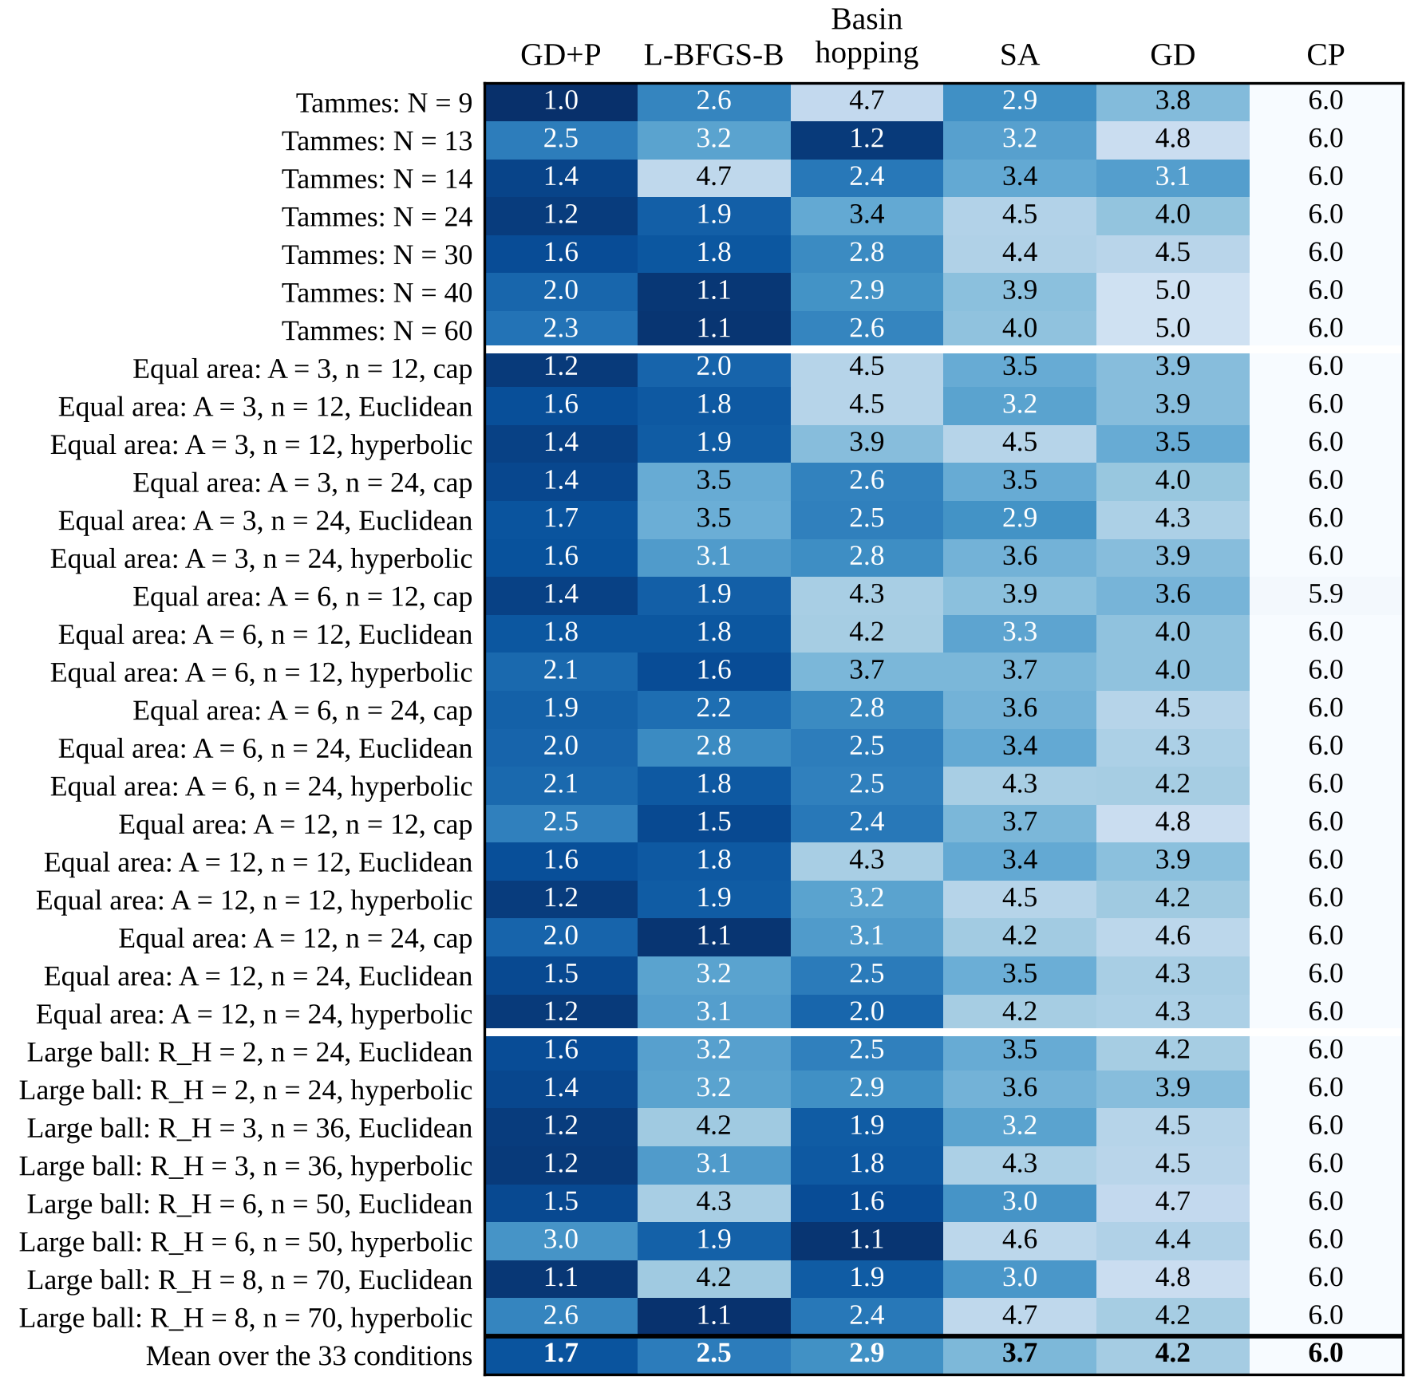
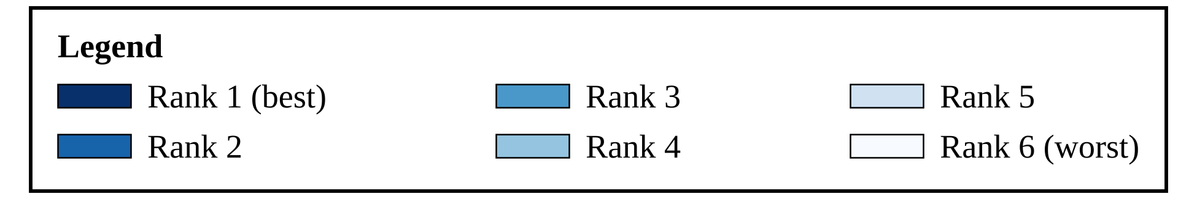
Note. Polished gradient descent has the best mean rank over the 33 conditions and the best or second-best rank in most of them; compression has the worst mean rank in almost every condition. Each cell is the mean rank (1 = best, 6 = worst) of the method within seeds at 1,500 sweeps, over 20 seeds; darker blue = better rank. Columns are ordered by mean rank over all conditions (bottom row, in bold). GD = gradient descent; GD+P = GD with a polishing step; SA = simulated annealing; CP = compression.

Introduction
This paper compares optimization methods for dense packings on the sphere, the Euclidean plane, and the hyperbolic plane: three methods in a first, exploratory study, and six in the preregistered rounds that followed. This section reviews what is known, states the gap, the questions, and the hypotheses, and distinguishes established knowledge from the contribution of this study.

Background and Related Work
On the unit sphere, the Tammes problem asks for N points whose smallest pairwise geodesic distance is as large as possible. The problem is named for Tammes (1930). Optimal configurations have been proved for N = 3, 4, 6, and 12 (Fejes Tóth, 1943), N = 5, 7, 8, and 9 (Schütte & van der Waerden, 1951), N = 24 (Robinson, 1961), N = 10 and 11 (Danzer, 1963), N = 13 (Musin & Tarasov, 2012), and N = 14 (Musin & Tarasov, 2015). For most other N, the best-known configurations come from computer search (Sloane et al., n.d.; Cohn, n.d.), and their optimality is unproven. Energy-minimization methods for spreading many points over a sphere are surveyed by Saff and Kuijlaars (1997).
Curvature changes the geometry of packing. In the Euclidean plane the area of a disk grows as the square of its radius; in the hyperbolic plane it grows exponentially (Cannon et al., 1997), so most of the area of a large hyperbolic disk lies near its boundary. Böröczky (1978) proved density bounds for packings in spaces of constant curvature, where the definition of density is itself delicate. Computational methods for packing include energy minimization, Monte Carlo and annealing methods (Kirkpatrick et al., 1983; Metropolis et al., 1953), and compression of growing disks (Lubachevsky & Stillinger, 1990).

Research Gap and Contribution
Established knowledge in this area includes the optimal Tammes configurations listed above, the area formulas of the three plane geometries, and the existence of the three families of methods. I did not find a study that runs several of these methods on the sphere, the Euclidean plane, and the hyperbolic plane under one shared protocol with an equal budget and paired seeds. The contribution of this project is that comparison: three simple optimizers, one bounded disk-packing problem posed identically in geodesic balls of curvature +1, 0, and −1, the Tammes problem on the whole sphere, validation against closed-form and published values, and a full report of failures. The study proves no theorem and sets no packing record.

Research Questions and Hypotheses
RQ1: under an equal budget, which algorithm reaches the best packings in each problem? RQ2: how does performance change with the number of points or disks? RQ3: for numbers of points with a proven optimum, how often does each algorithm recover it within a stated tolerance? RQ4 (exploratory): when the same bounded-disk problem is solved in spaces of curvature +1, 0, and −1, does the ranking of the algorithms change? Three hypotheses were stated in the Research Plan, and Table 10 gives each one with its measurable decision rule and its result. Because the plan was finalized after some results had been seen (see Deviations From the Research Plan), every hypothesis result is reported as exploratory. RQ4 and H1 are exploratory in a stronger sense: curvature and area are confounded, because a ball of the same radius has a different area in each space; only six settings per space were run; and the ball of radius 3 on the sphere covers nearly the whole sphere. H1 therefore refers to the space, not to curvature alone.
The study has six stages, which Table 1 lists in order so that the findings in the following pages can be placed. Only the stages with a hash were written before their runs, and all hashes were recorded by the author.

Framework
Figure 2 is a conceptual illustration of the study design and shows no data. The study moves from the research problem through the geometric spaces, the definitions of distance and score, the three algorithms, and their implementation, which is accepted only if the unit tests pass and is otherwise corrected and retested. Passing code is run in repeated seeded trials, summarized by performance measures and analyzed statistically to evaluate the hypotheses.

Geometry of the Spaces
The unit sphere S² has curvature +1. Its points are unit vectors x in R³, and the geodesic distance is given by Equation 1. The hyperbolic plane H² has curvature −1. Computations use the hyperboloid model, in which a point is x = (x₀, x₁, x₂) with x₀ > 0 and Lorentz product [x, y] = −x₀y₀ + x₁y₁ + x₂y₂ = −1 for y = x; figures use the Poincaré disk. The Euclidean plane R² has the usual distance.
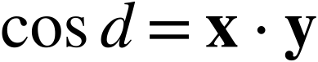 (1)
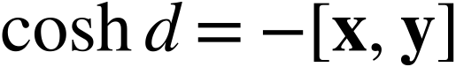 (2)
The Poincaré disk coordinate of a hyperboloid point is 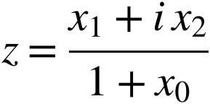, and the distance between disk points z and w is given by Equation 3. A hyperbolic ball of radius R centered at the origin is the Euclidean circle of radius 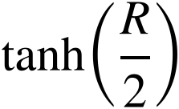.
Table 1
Stages of the Study
Stage | Purpose and data | Preregistered | Main result
First study | Three methods (gradient descent, simulated annealing, compression) in 33 conditions on the sphere, the Euclidean disk, the hyperbolic disk, and the spherical cap; seeds 1 to 30; 2,970 runs. | No. The plan was finalized after results had been seen, so every result is exploratory. | Simulated annealing had the best mean rank on the sphere, in the cap, and in the Euclidean disk, and gradient descent in the hyperbolic disk; compression was last; no dependence on the space after correction (Holm-adjusted p = .122).
Confirmatory round | Six methods, three budgets, 33 conditions including equal-area balls; seeds 101 to 120; 11,880 runs. | Yes; hash recorded 2026-10-28 21:35 UTC, before the pilot tuning and every evaluation run. | Polished gradient descent had the best mean rank (1.70); the added baselines beat gradient descent and annealing; the deficit followed the boundary share (Spearman r_{s} = .87); curvature was inconclusive; no method recovered every proven optimum.
Addendum | Changes decided after seeing the confirmatory results: Packomania references, wider tuning ranges for two methods and a rerun, saved configurations, wall analysis, wording of the reference density. | Written and hashed 2026-10-29 07:32 UTC before the runs it describes; it adds no hypothesis. | No decision changed; compression moved inside its tuning range, and L-BFGS-B stayed at the edge.
Mini-round (Appendix B) | Fixed disk radius and matched boundary share, 18 conditions (15 distinct), polished gradient descent; seeds 301 to 320. | Yes; hash recorded 2026-10-29 07:32 UTC, before its runs. | M1 inconclusive; M2 computed as “no detectable curvature effect”, a decision withdrawn because 3 of the 18 conditions duplicated others (inconclusive without them, post hoc); M3 describes the other spaces.
Follow-up (Appendix B) | Five boundary shares, three radii, 33 distinct conditions, two methods; seeds 401 to 420. | Yes; hash recorded 2026-10-29 23:33 UTC, before its runs. | F1 supported; F2 inconclusive; F3 describes the other spaces.
Final round | Equal-area balls (144 conditions, 48 area-by-count cells, seeds 501 to 520) and a count rule at fixed radius (20 conditions, seeds 601 to 620); two methods. | Yes; hash recorded 2026-10-30 03:43 UTC, before its runs (06:42 to 06:52 UTC on October 31). | No curvature effect larger than .02 (hyperbolic 0.010, cap −0.009); the rule for the number of disks supported.
Note. The confirmatory round and the final round have their own sections; the addendum, mini-round, and follow-up, and a decision that was withdrawn, are in Appendix B. Hashes are SHA-256 values recorded by the author (see the section on the Confirmatory Round for what they do and do not show). UTC = Coordinated Universal Time.
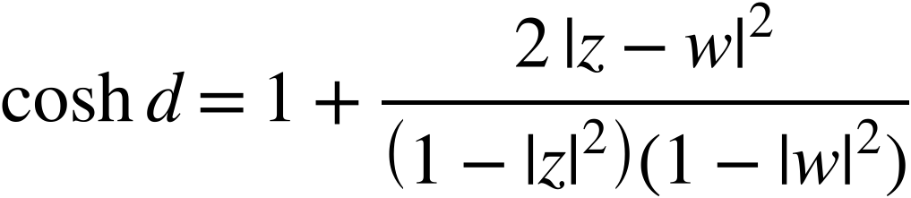 (3)
Proof sketch that Equations 2 and 3 agree. The inverse of the coordinate map is 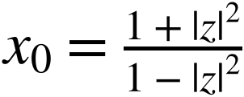 and 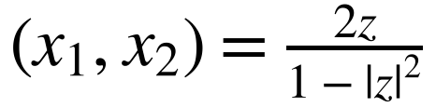. Substituting into −[x, y], where w* is the complex conjugate of w, gives 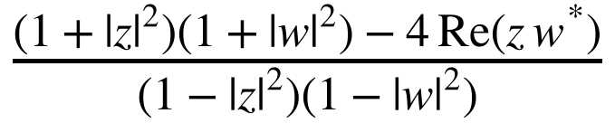. The right side of Equation 3 has the same value, because (1 − ⁠|⁠z⁠|⁠²)(1 − ⁠|⁠w⁠|⁠²) + 2⁠|⁠z − w⁠|⁠² = (1 + ⁠|⁠z⁠|⁠²)(1 + ⁠|⁠w⁠|⁠²) − 4 Re(z w*). The disk areas follow from the area elements sin ρ dρ dθ, ρ dρ dθ, and sinh ρ dρ dθ, and are given by Equation 4. Integrating each element over 0 ≤ θ ≤ 2π and 0 ≤ ρ ≤ r, where r is the disk radius, gives the area of the disk on each surface.
Figure 2
Framework of the Study
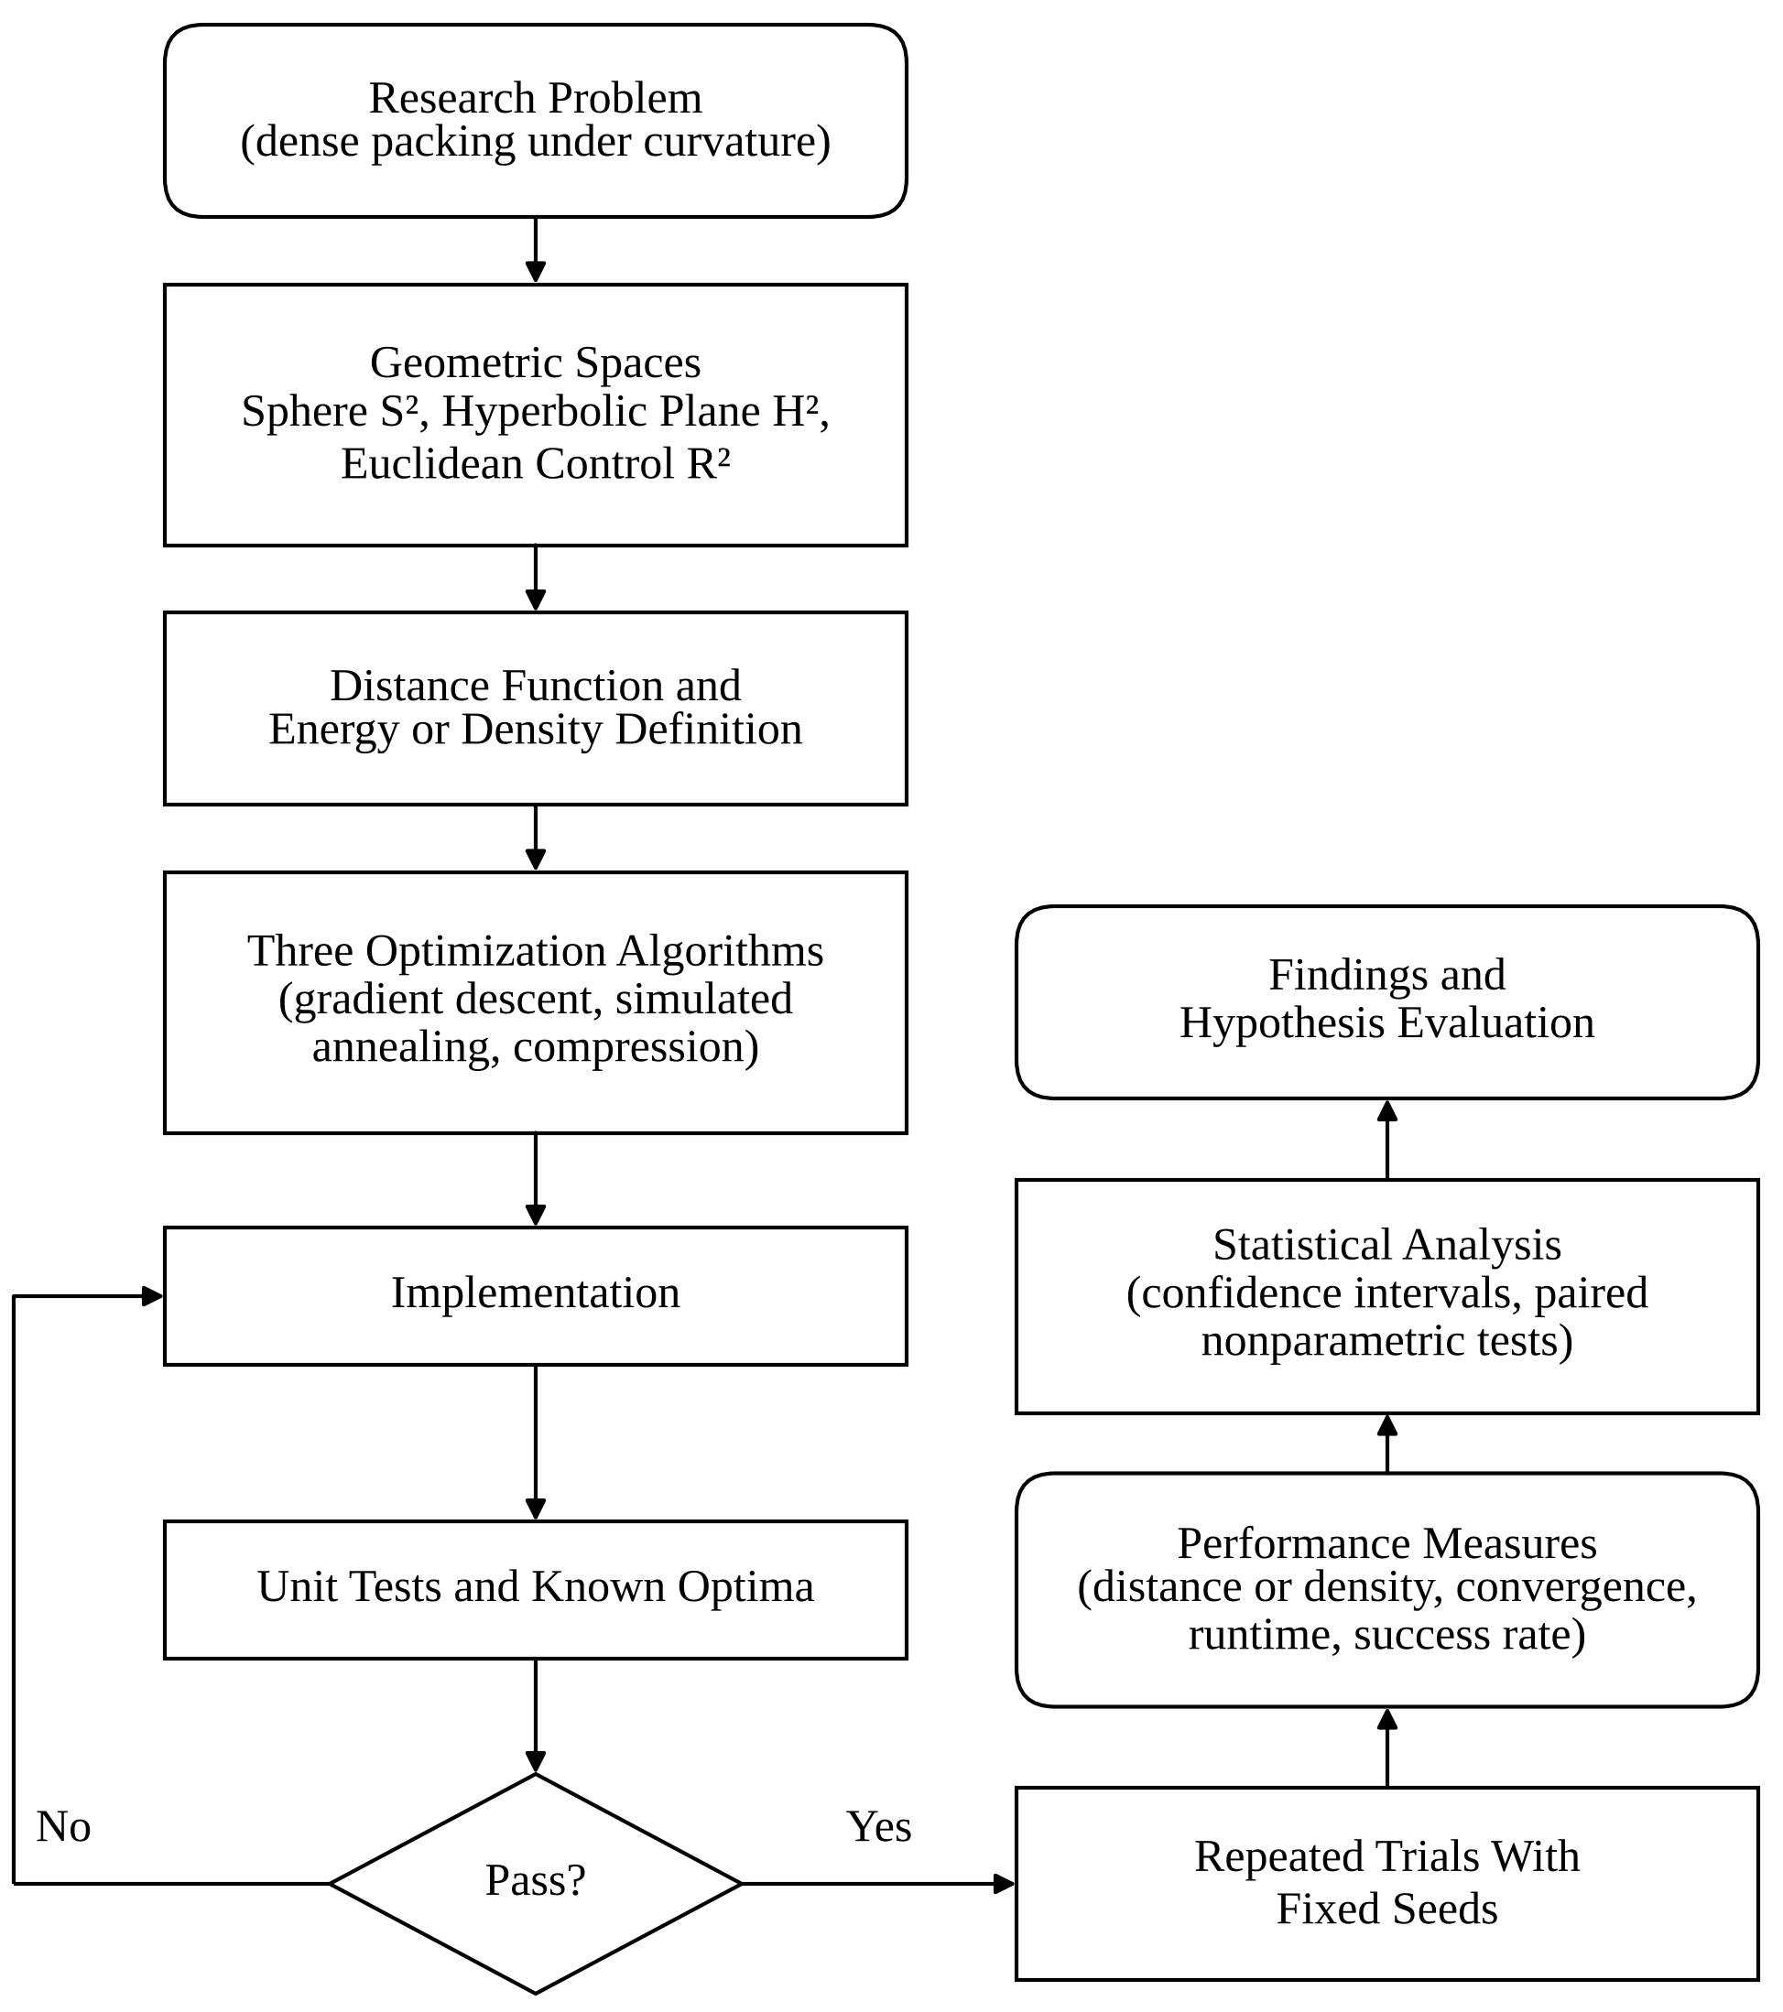
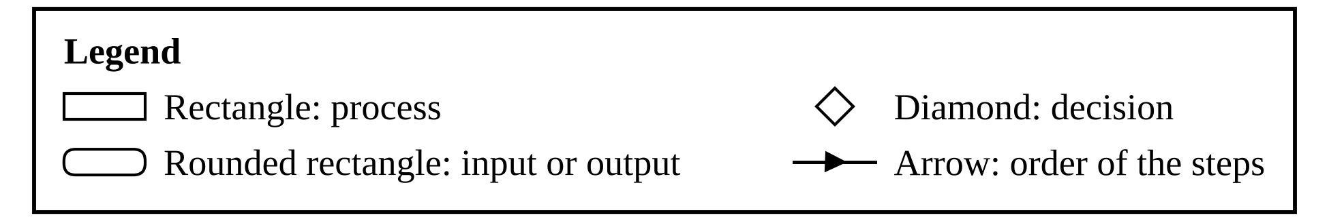
Note. Conceptual illustration of the study design (no experimental data). Rectangles are processes, rounded rectangles are inputs and outputs, and the diamond is a decision. If any unit test fails, the implementation is corrected and retested before trials begin.
(4)
Table 2 gives the area of a ball of radius R and the share of it that lies within distance 1 of its boundary, computed from Equation 4 and stored in area_fractions.csv. In the Euclidean plane this share shrinks toward zero as R grows, but in the hyperbolic plane it tends to 1 − e⁻¹, which is .632 to three decimals. On the sphere a ball can have radius at most π, so the table has no spherical entries for larger R. Density is therefore always reported relative to the area of the container.
Table 2
Area Within Distance 1 of the Boundary of a Ball of Radius R
R | S² area | S² share | R² area | R² share | H² area | H² share
2 | 8.90 | .675 | 12.57 | .750 | 17.36 | .803
3 | 12.50 | .288 | 28.27 | .556 | 56.97 | .695
6 | — | — | 113.10 | .306 | 1261.13 | .635

Packing Problems and Comparability
Problem A is the Tammes problem on S²: place N points to maximize the smallest pairwise distance. Problem B places n equal disks in a closed geodesic ball of radius R about a fixed center, in each of the three spaces (a spherical cap, a Euclidean disk, and a hyperbolic disk), and maximizes the common radius r. A disk of radius r whose center is at distance ρ_{i} from the center of the ball lies inside the ball when ρ_{i} ≤ R − r, and two disks do not overlap when d_{ij} ≥ 2r. Both problems maximize ℓ_{min} in Equation 5, where the second term is absent for Problem A; the score is ℓ_{min} for Problem A and 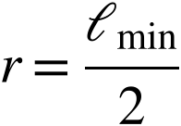 for Problem B. Packing density in Problem B is 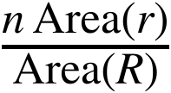 from Equation 4.
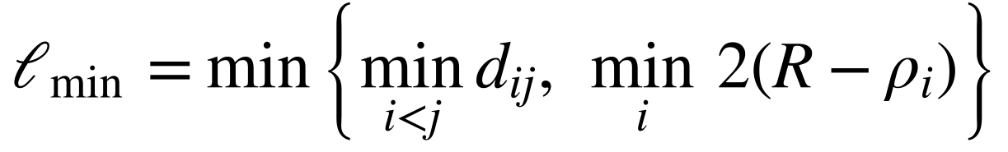 (5)
Problem B fixes n and R and maximizes r, which gives a continuous score that all three algorithms can improve smoothly; the number of disks of a fixed radius that fit is derived from it. The problems are comparable only to a limited extent, and these limits shape every conclusion. Problems A and B differ in objective (a minimum distance against a common radius), in constraints (no boundary against a boundary), and in scale, so no result of Problem A is compared with a result of Problem B. Statements about curvature rest on Problem B alone, which has the same formulation, the same R and n, and the same code in all three spaces. Even there, a ball of radius R has a different area in each space (Table 2), so a difference between spaces can come from curvature, from area, or from both, and this study does not separate them. A comparison at equal area is a different design; a supplementary comparison was run after the main study and is reported separately as exploratory (see Supplementary Exploratory Analyses). It is not part of the hypothesis tests.

Experimental Design
Problem A uses N = 4, 5, 6, 7, 8, 9, 10, 11, 12, 13, 14, 24, 30, 40, and 60. Problem B uses the six settings (R, n) = (2, 7), (2, 12), (2, 19), (3, 12), (3, 19), (3, 30) in each of the three spaces. The evaluation seeds are 1 to 30. The initial configuration depends only on the seed and the condition, so the three algorithms start from the same configuration, and initial points are uniform on S² for Problem A and uniform by area in the ball of radius R − 0.05 for Problem B. Pilot runs for parameter tuning used seeds 9001 to 9004 only, which never appear in the evaluation. The total is 2,970 runs.
The Tammes problem accounts for 1,350 runs (15 values of N × 30 seeds × 3 algorithms), and each of the three spaces accounts for 540 runs in Problem B (6 settings × 30 seeds × 3 algorithms).
Every run receives a budget of 1,500 sweeps, where one sweep is the 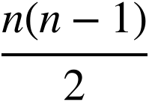 pair-distance evaluations needed to compute all distances once. A gradient step costs one sweep plus one sweep per line-search trial (in Problem B each evaluation also includes the n wall clearances), a simulated-annealing move costs n − 1 evaluations, and a compression step costs two sweeps. Counting evaluations keeps the comparison independent of implementation speed. Gradient descent and compression stop when their next step would exceed the budget. Simulated annealing fixes its number of moves from the budget in advance and does not charge proposals rejected for lying outside the ball, so in the ball problems it used slightly less than the budget (at least 1,476 of 1,500 sweeps in every run); this can only disadvantage annealing. Every run reports the best configuration it visited, scored exactly from its coordinates.
The reference value of a condition is the proven optimum for Problem A with N = 4 to 14 and 24 (credited to Fejes Tóth, 1943; Schütte & van der Waerden, 1951; Robinson, 1961; Danzer, 1963; and Musin & Tarasov, 2012, 2015; the values for N = 4, 6, and 12 were also derived in closed form); for the other values of N it is the published best-known value where one was entered (N = 30, 40 and 60; Sloane et al., n.d.; Cohn, n.d.) and otherwise the highest score found by any run in that condition. A best-known value is not proven optimal, and a best-found value is a computational result, so relative scores near 1 mean agreement with that reference, not optimality. After the main results were seen, the published best-known values for N = 30, 40, and 60 replaced the best values found (see Deviations From the Research Plan).
The relative score of a run is its score divided by the reference value. A run succeeds when its relative score is at least .999, and a 1% tolerance (at least .99) is a sensitivity check. Convergence is the number of sweeps after which the best score first reached 99% of the run’s own final score. Scaling is the per-seed slope of relative score on log₁₀ N for N ≥ 13 and the log–log slope of mean run time on N. Cost is the wall-clock time, reported descriptively because the budget is fixed in distance evaluations, so run time is an outcome of each method and not a controlled quantity.

Optimization Algorithms
All three algorithms move points along geodesics and stay on the manifold (Table 3).
Table 3
Algorithm Parameters
Algorithm and parameter | Value
GD: energy, exponent | E_{p} of Equation 6 over pair distances and, in Problem B, doubled wall clearances; p from 2 to 150, geometric in the share of budget used
GD: step, line search | 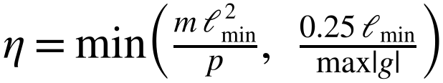; m starts at 0.5, × 1.3 after success (maximum 2), × 0.5 after failure (minimum 0.001); on failure multiply η by 0.4, at most 5 trials
SA: temperature | Geometric from 0.02 to 10⁻⁵ times the length scale 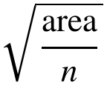
SA: move, adaptation | Random geodesic step of length δ(0.1 + 0.9u), u uniform on (0, 1); δ starts at 0.3 times the length scale; every 100 proposals δ × 1.15 if acceptance > .40, × 0.87 if < .25
SA: point choice | Probability 0.3: an endpoint of the limiting pair or the point nearest the wall; otherwise uniform
CP: time step, growth | Time step 0.02 times the length scale at unit root-mean-square speed; common radius grows by γ dt per step, γ falling linearly from 0.25 to 0.01, capped by half the smallest distance
CP: collisions | Velocity components along the line of centers exchanged if approaching; overlaps removed; wall reflection in Problem B; kinetic energy renormalized each step
Note. GD = gradient descent; SA = simulated annealing; CP = compression. The length scale is 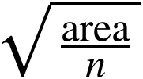. Defaults are read from algorithms.py.
The parameter values were chosen on pilot seeds 9001 to 9004 at the same budget in four pilot conditions (Tammes N = 13 and 30, hyperbolic disk (R, n) = (2, 12), Euclidean disk (3, 19)) from grids of 11 settings for gradient descent, 4 for annealing, and 10 for compression, ranked by mean score. The gradient-descent and annealing settings used are grid points; the compression setting lies between grid points and was set by inspection. The spherical-cap family was not used for tuning, and the parameters were not changed for it. All values were fixed before the evaluation.

Gradient Descent on a Soft-Minimum Energy
Let ℓ₁, …, ℓ_{m} be the pair distances and, in Problem B, the doubled wall clearances 2(R − ρ_{i}). The energy in Equation 6 is a smooth stand-in for −ln ℓ_{min}. It satisfies the bound in Equation 7, because the sum lies between its largest term and m times that term. The exponent p grows geometrically from 2 to 150 over the budget, and each step follows the negative Riemannian gradient with backtracking.
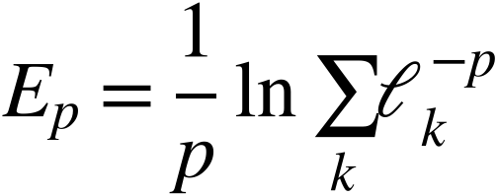 (6)
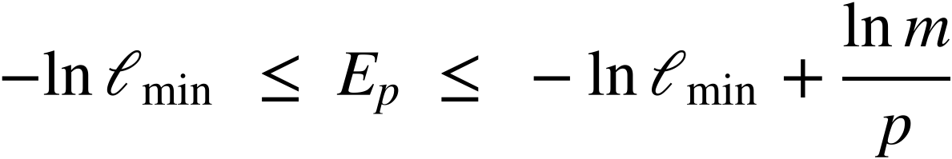 (7)

Simulated Annealing
Simulated annealing moves one point at a time by a random geodesic step and accepts the move by the Metropolis rule (Metropolis et al., 1953) applied to −ℓ_{min}, with a geometric cooling schedule (Kirkpatrick et al., 1983). With probability 0.3 the point chosen is one that currently limits ℓ_{min}. Because of this focused choice and the nonuniform step distribution, the method is an optimizer, not a sampler of the Boltzmann distribution.

Compression Method
The compression method follows the idea of Lubachevsky and Stillinger (1990) in a simplified, time-stepped form, not an event-driven one. Points move with random initial velocities; overlapping disks exchange the velocity components along the line of centers and are pushed apart; the common radius grows at a rate that falls linearly over the budget, limited by the room available. Because contacts are resolved only at the end of each time step, the scheme is approximate, which limits its final precision.

Properties of the Algorithms: Proven and Observed
This subsection separates what is mathematically established from what this study only observed. Nothing below is a guarantee that an algorithm finds a globally optimal packing, and the empirical statements are given in the Findings, not here.
Gradient descent. Proven here: Equation 7 holds because ℓ_{min}^{−p} ≤ Σ_{k} ℓ_{k}^{−p} ≤ m ℓ_{min}^{−p}, so the energy approaches −ln ℓ_{min} as p grows, with an error of at most 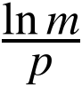. Not established: the energy is not convex, so a stationary point can be a local optimum or a saddle; the exponent p changes at every step, so the energy does not decrease monotonically over a run; and the standard convergence theory for Riemannian gradient methods with a backtracking line search (Absil et al., 2008) concerns a fixed smooth objective, so it does not cover this schedule. The true objective ℓ_{min} is not differentiable where distances tie, and its maxima are rigid configurations with many contacts. No theorem is claimed that gradient descent reaches a stationary point of ℓ_{min} or a global maximum.
Simulated annealing. Proven for finite-state Markov chains (Hajek, 1988): the probability of being at a global optimum tends to 1 under a logarithmic cooling schedule 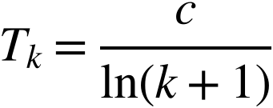 if and only if c is at least the depth of the deepest local minimum that is not global. Not applicable here: the state space is continuous, the cooling is geometric over a fixed number of moves, the step size adapts, and 30% of the moves target the limiting pair. The method is therefore a heuristic optimizer without a convergence guarantee in this study, and its final configuration is not a sample from a known distribution.
Compression. The method of Lubachevsky and Stillinger (1990) is an event-driven simulation of disks whose radii grow, and this study uses a simplified time-stepped version that resolves contacts only at the end of each step. No theorem guaranteeing convergence of either version to a densest packing is known to me, and none is claimed. Positions are therefore accurate only to about the distance a disk moves in one step, which is a plausible reason for the lower final precision of this implementation; this explanation was not tested separately.
Stopping and numerical precision. All three methods use the same stopping rule, a fixed budget of pair-distance evaluations with no early stopping, so differences in the final score are not caused by different stopping criteria; the exception, unused budget in simulated annealing near the wall, is described under Experimental Design. Because the budget is fixed, the results describe performance at that budget and not convergence to a limit (Figure 5 shows how the best score rose during the budget). Distances use arcsine and arcsinh forms that stay accurate for small distances; floating-point error is examined in the Findings.

Validation Procedures
Unit tests checked the geometry and the code before the experiments: the 23 tests of the sphere, hyperbolic, Euclidean, and optimizer code passed before the first 27 conditions were run, and the 6 spherical-cap tests passed before the cap conditions were run. The test log is the complete run of all 29 tests with the final code, and three of the first 27 conditions (Tammes N = 13, hyperbolic disk (2, 12), Euclidean disk (2, 7)) were rerun with it and reproduced every score exactly. Table 4 states how each group is tested and what counts as passing; a single failure would have blocked the experiments. Recovery of known optima uses the best of the three optimizers on five seeds (9101 to 9105), because recovery by each optimizer is hypothesis H3, not a validation criterion.

Statistical Analysis
For each condition the observations are the 30 final scores of each algorithm. Scores of the same seed come from the same starting configuration and form a block. The Friedman test compares the three algorithms across the 30 blocks, and the Wilcoxon signed-rank test (Wilcoxon, 1945) compares each pair on the 30 within-seed differences. Nonparametric paired tests are used because scores are bounded, are tied or clustered at local optima, and are not normally distributed. Effect sizes are Kendall’s W for the Friedman test and the matched-pairs rank-biserial correlation (r_{rb}) with the standardized mean difference (d_{z}) for pairs. Means carry 95% confidence intervals based on the t distribution, which are approximate for non-normal scores and used descriptively.
The tests assume independent blocks, which holds because each seed gives an independent random start. The Wilcoxon test also assumes that the paired differences are symmetric about their median. This was checked through the skewness of each set of differences (an absolute value above 1 is flagged) and the share of zero differences, which are stored in assumption_checks.csv. Tests were corrected with the Holm procedure (Holm, 1979), taking as one family all tests of the same kind within one space; hypothesis tests are corrected across their own pairs. A result is statistically significant when the Holm-adjusted p is below .05. Practical importance is judged separately: a difference is practically important when its mean is at least 0.5% of the reference value. This threshold and the assumption checks were formalized after the first 27 conditions had been run. The Friedman test also requires that the scores within a block can be ranked; ties are corrected by the implementation, and with three algorithms and 30 blocks the chi-square approximation is generally considered adequate. The Wilcoxon test discards zero differences and uses an exact p value only when there are no ties or zeros (otherwise the normal approximation of the implementation). The rank-biserial correlation and d_{z} describe the size of a paired difference, and the intervals are t intervals of the mean, checked against bootstrap intervals for two headline differences (see Supplementary Exploratory Analyses). Holm’s procedure controls the familywise error rate without assuming that the tests are independent (Holm, 1979), which matters because all tests in one space share the same 30 seeds.

Reproducibility and Data Integrity
All code is in Code_Listing.docx and, as source files, in the code folder of CSV_Data.zip. The reported runs used Python 3.12.3 with numpy 2.4.4, scipy 1.17.1, pandas 3.0.2, and matplotlib 3.10.8; an independent full rerun (python3 build_all.py --rerun) under Python 3.13.18 with numpy 2.5.3, scipy 1.18.1, pandas 3.0.5, and matplotlib 3.11.2 reproduced every score, test statistic, and p-value in the CSV files exactly; only the wall-clock times differ. The command python3 tests.py runs the validation tests, and python3 build_all.py runs the tests, all experiments, the statistics, the figures, and the building of every document; adding --rerun recomputes every run, which took 30 minutes of run time on one core in the run reported here. Seeds are fixed (evaluation seeds 1 to 30, pilot seeds 9001 to 9004, test seeds 9101 to 9105), so a rerun reproduces every value. CSV_Data.zip holds 35 CSV files (among them runs_raw.csv with all 2,970 runs, configurations.csv with every final configuration, and convergence_traces.csv), unit_test_output.txt, README.md, which defines every column of every file, and MANIFEST.sha256, whose SHA-256 hashes can be checked with sha256sum. Every table and figure note names the file from which its values were computed. No run was excluded: all 2,970 runs are in the data, including failures such as the 1 of 30 seeds in which gradient descent stalled for N = 4 (see Conclusions). The forms required by the competition are submitted separately and are not reproduced here.

Deviations From the Research Plan
The Research Plan was finalized after the results of all 33 conditions had been seen (see Appendix A of the Research Plan), so the hypotheses and decision rules are not strictly preregistered. Its Appendix A, History of Work Done, lists the changes, which are summarized here. First, the compression method was implemented as a time-stepped scheme, not an event-driven one. Second, the spherical-cap condition family was added after the results of the other 27 conditions had been seen, to obtain a common formulation across curvatures; its analysis was written into the code before the cap runs were executed, but the resulting evaluation of H1 is exploratory with respect to the earlier results. Third, the practical-importance threshold and the assumption checks were formalized after the first 27 conditions had been run. Fourth, the validation criterion for optimizer recovery was changed to the best of three optimizers after compression failed an earlier per-optimizer version. Pilot tuning and the validation tests preceded the main runs they support (see Validation Procedures); the data package contains no dated log of when each run was executed. After the main results had been seen, five further changes were made, all recorded in the plan: the references for N = 30, 40, and 60 were replaced by published best-known values (they had been the best values found, which changed the relative scores for those values of N and therefore the scaling slopes); the citations of the proven optima were corrected; the result of every hypothesis is labeled exploratory; the supplementary analyses and a polished gradient-descent variant were added; and a statement on AI assistance was added. None of them changes a run, a seed, a parameter, or a decision rule of the main study. The confirmatory round was added after all of these, with its own preregistration, which was hashed before its pilot tuning and before every evaluation run; it did not change any result of the first study. After the results of the confirmatory round had been seen, the following were added, each listed in a second preregistration file and in the section on the Confirmatory Round: Packomania reference values for the Euclidean conditions (entered after the first analysis of the round; the decisions were the same with both references), extended tuning ranges and a rerun of compression and L-BFGS-B, the saved final configurations with the wall analysis, a correction of the wording of the reference density, and a mini-round with a fixed radius and a matched boundary share, whose own preregistration was hashed before its runs. A withdrawn mini-round decision, a follow-up, and a final round followed. The final round was preregistered: its rules were written in the Research Plan before the paper, and its runs followed the adviser email that the author reports sending. The withdrawal is in Appendix B.

Disclosure of AI Assistance and Researcher’s Contribution
Claude, an AI assistant developed by Anthropic, was used to help write this document, including drafting, grammar checking, and editing. Other uses of AI assistance, including in programming and analysis, are described in the AI Disclosure Agreement submitted to the research adviser and the Science Research Committee. GitHub was used to support code management and access to programming resources.
The author’s original contributions include the selection of the research problem, the formulation of the research questions, and the decisions regarding the research design. The author personally ran and checked the code, verified the results, and can explain and defend the programming procedures, methods, and findings. The author accepts full responsibility for the accuracy and integrity of every statement, numerical result, citation, and conclusion presented in this research. The code and data are provided in the accompanying data package and code listing to support reproducibility and independent verification of the results.

Findings
This section reports the validation of the code, the results on the sphere and in geodesic balls, convergence, scaling and cost, the statistical comparison, and the resolution of the hypotheses. Every value comes from the files named in the table and figure notes.

Validation Results
All 29 of 29 unit tests passed (Table 4).
Table 4
Validation Tests, Pass Criteria, and Results
Test group | How it is performed | Pass criterion | Passed
Sphere distance | 300 random pairs against the arctangent form; closed forms | Error < 10⁻⁹; closed forms < 10⁻¹² (antipode < 10⁻⁷) | 2 of 2
Hyperbolic distance | Poincaré formula, radius 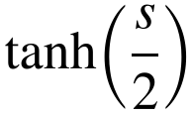, law of cosines, area integral | Relative error < 10⁻⁷; others < 10⁻⁹, 10⁻⁸, 10⁻⁶ | 4 of 4
Euclidean control | Distance of (0,0) and (3,4); 7-disk hexagon in a ball of radius 3 | Error < 10⁻¹² | 2 of 2
Spherical cap | Pole, equator, antipode, area, sampling, Euclidean limit, clipping | Area error < 10⁻⁶; sampling within 4 s.e.; limit within 0.2% | 5 of 5
Metric axioms | Symmetry and 4,000 random triples per space | Asymmetry < 10⁻¹²; triangle violation < 10⁻⁹ | 3 of 3
Exponential map | Step length equals vector length; point stays on the manifold | Error < 10⁻⁷; manifold error < 10⁻⁹ | 3 of 3
Gradients | Analytic Riemannian gradient against central finite differences | Difference < 10⁻⁵ max(1, ⁠|⁠gradient⁠|⁠) | 4 of 4
Known Tammes optima | Three polyhedra; optimizers on seeds 9101 to 9105 | Distance error < 10⁻¹²; best gap < 0.002 rad | 6 of 6
Total |  |  | 29 of 29
Note. Full output is in unit_test_output.txt. Passed = tests passed of tests run in the group.
Distances on S² matched the arctangent form to a maximum error of 1.3 × 10⁻¹⁵ rad, and distances on H² matched the Poincaré disk formula to a maximum relative error of 4.4 × 10⁻¹⁵. The analytic gradients matched finite differences, the closed-form tetrahedron, octahedron, and icosahedron gave the Tammes values 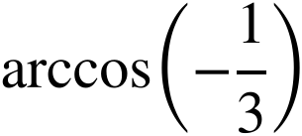, 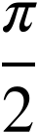, and arctan 2 for N = 4, 6, and 12, and the spherical-cap code reproduced the Euclidean limit. These tests show that the geometry code measures distances correctly and that the optimizers move points as the mathematics prescribes; they do not show that any optimizer finds optimal packings.

Packing Performance on the Sphere
The reference values are stored in benchmark_values.csv with the source of each (in degrees and radians; the radian values are in the Reference column of Table 5); the proofs are credited in the Introduction. Figure 3 shows the best configuration found for six values of N, and Table 5 gives the mean final minimum distance and the success rate for every N.
For N = 12, gradient descent and simulated annealing both reached the icosahedral value (M = 1.107 and 1.107 rad; the optimum is 1.107 rad), whereas compression stopped lower (M = 1.025, SD = 0.011). For N = 13, no algorithm reached the proven optimum of 0.997 rad on average (gradient descent M = 0.980, simulated annealing 0.985, compression 0.930). For N = 60, simulated annealing led with M = 0.461, ahead of gradient descent (0.438) and compression (0.322); there the reference is the best value found, not a proven optimum.
Figure 3
Best Configurations on the Sphere for Six Values of N
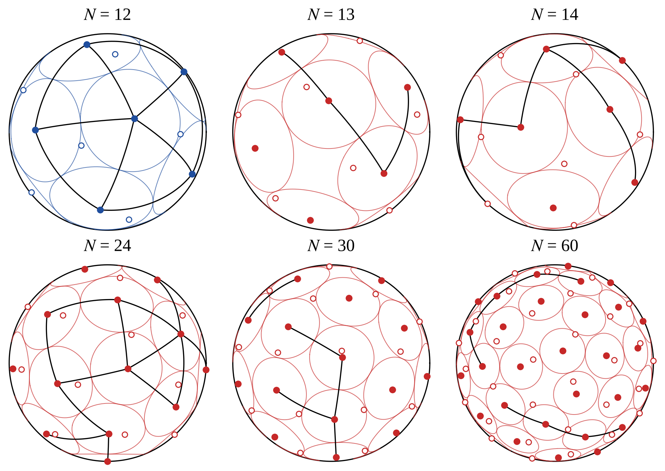
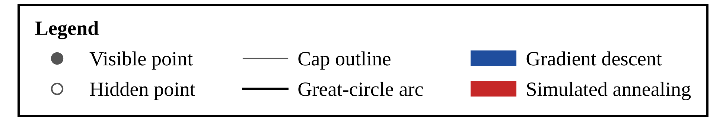
Note. Orthographic view of the best configuration over all algorithms and seeds for N = 12, 13, 14, 24, 30, and 60. Data: configurations.csv. Points: filled = on the visible hemisphere, open = on the hidden hemisphere. Circles: spherical caps whose angular radius is half the minimum distance. Black arcs: great-circle arcs joining points within 0.0001 rad of the minimum. Color: algorithm (blue = gradient descent, red = simulated annealing, green = compression).
Counting pairs whose distance is within 0.001 rad of the minimum shows how rigid each displayed configuration is (contacting pairs, points without contact): N = 12, 30 pairs and 0 free points; N = 13, 18 pairs and 0 free points; N = 14, 25 pairs and 0 free points; N = 24, 60 pairs and 0 free points; N = 30, 42 pairs and 4 free points; N = 60, 71 pairs and 6 free points. Free points can move without changing the minimum distance. Free points in the larger configurations (N = 30 and 60) suggest that the search has not reached a jammed packing within the budget; for a small N such as 13, a free point can also belong to an optimal packing.
At the 0.1% tolerance, simulated annealing succeeded in all 30 seeds for N = 4, 5, 6, 12, and gradient descent for N = 5, 6, 12. Gradient descent never met the tolerance for N = 7, 8, 10, 11 even though its mean relative scores there were at least .995, which suggests that its final precision, not its search, limits the success rate. Compression met the tolerance in at most 87% of seeds for N = 4 to 6 and never beyond. For N ≥ 24 no algorithm succeeded in more than 17% of seeds, so the large-N results are comparisons of average quality, not recoveries of optima.
Table 5
Final Minimum Distance and Success Rate on the Sphere by Algorithm
N | Reference (rad) | GD M (SD) | SA M (SD) | CP M (SD) | Success (%)  GD / SA / CP
4 | 1.911 | 1.899 (0.062) | 1.910 (0.000) | 1.909 (0.001) | 97 / 100 / 87
5 | 1.571 | 1.571 (0.000) | 1.571 (0.000) | 1.569 (0.001) | 100 / 100 / 60
6 | 1.571 | 1.571 (0.000) | 1.571 (0.000) | 1.556 (0.039) | 100 / 100 / 0
7 | 1.359 | 1.356 (0.001) | 1.358 (0.003) | 1.344 (0.007) | 0 / 80 / 0
8 | 1.307 | 1.305 (0.000) | 1.306 (0.003) | 1.271 (0.018) | 0 / 97 / 0
9 | 1.231 | 1.230 (0.001) | 1.229 (0.002) | 1.188 (0.012) | 97 / 73 / 0
10 | 1.154 | 1.149 (0.003) | 1.151 (0.002) | 1.110 (0.015) | 0 / 10 / 0
11 | 1.107 | 1.103 (0.000) | 1.106 (0.003) | 1.038 (0.014) | 0 / 93 / 0
12 | 1.107 | 1.107 (0.000) | 1.107 (0.000) | 1.025 (0.011) | 100 / 100 / 0
13 | 0.997 | 0.980 (0.001) | 0.985 (0.004) | 0.930 (0.010) | 0 / 0 / 0
14 | 0.972 | 0.964 (0.007) | 0.961 (0.006) | 0.891 (0.017) | 0 / 7 / 0
24 | 0.763 | 0.745 (0.015) | 0.746 (0.013) | 0.632 (0.009) | 0 / 17 / 0
30 | 0.674* | 0.655 (0.006) | 0.662 (0.006) | 0.540 (0.011) | 0 / 0 / 0
40 | 0.579* | 0.555 (0.005) | 0.567 (0.003) | 0.439 (0.012) | 0 / 0 / 0
60 | 0.475* | 0.438 (0.008) | 0.461 (0.003) | 0.322 (0.008) | 0 / 0 / 0
Note. Distances in radians over 30 seeds. Success = percentage of seeds with relative score ≥ .999. GD = gradient descent; SA = simulated annealing; CP = compression. An asterisk marks a reference that is not proven optimal: a published best-known value (N = 30, 40 and 60). Data: summary_by_condition.csv.

Packing Performance in Geodesic Balls
Figure 4 shows the best packing of 19 disks in a ball of radius 3 in each of the three spaces. Table 6 reports the mean radius and the packing density for all 18 conditions, and Table 7 turns the best radii into a statement about capacity: the largest tested number of disks that fit when the radius must reach a target value. These capacity entries are lower bounds from the tested values of n only.
The best radii were 0.4144 in the cap, 0.6166 in the Euclidean disk, and 0.7541 in the hyperbolic disk. These radii are not comparable as measures of packing quality, because the balls have different areas; the densities in Table 6 are the better guide. In the hyperbolic plane, gradient descent had the highest mean radius in 5 of 6 settings and simulated annealing in 1. In the Euclidean disk, simulated annealing had the highest mean radius in 6 of 6 and gradient descent in 0. In the cap, simulated annealing had the highest mean radius in 6 of 6 and gradient descent in 0. Compression never had the highest mean radius (0 of 18 conditions).

Convergence, Scaling, and Cost
Convergence effort is the number of sweeps a run needed to first reach 99% of its own final score (Table 8). For N = 60 the mean was 1,240 sweeps for gradient descent, 906 for simulated annealing, and 1,073 for compression, out of a budget of 1,500. A value near the budget means that the run was still improving when the budget ended, so its final score is a lower bound on what a longer run could reach. Figure 5 shows how the best score so far rose with the budget, Figure 6 shows the final relative score for every condition, Figure 7 shows run time, and Figure 8 shows the spread over seeds.
Table 6
Mean Disk Radius and Packing Density in a Ball by Algorithm
Space | R | n | GD r (SD) | SA r (SD) | CP r (SD) | Density (%)  GD / SA / CP
Cap | 2 | 7 | 0.530 (0.011) | 0.545 (0.002) | 0.527 (0.008) | 68 / 72 / 67
Cap | 2 | 12 | 0.423 (0.004) | 0.426 (0.005) | 0.393 (0.005) | 75 / 76 / 65
Cap | 2 | 19 | 0.340 (0.003) | 0.342 (0.003) | 0.299 (0.004) | 77 / 78 / 59
Cap | 3 | 12 | 0.540 (0.004) | 0.541 (0.005) | 0.501 (0.018) | 86 / 86 / 74
Cap | 3 | 19 | 0.410 (0.003) | 0.410 (0.002) | 0.363 (0.005) | 79 / 79 / 62
Cap | 3 | 30 | 0.325 (0.003) | 0.327 (0.003) | 0.268 (0.004) | 79 / 80 / 54
R² | 2 | 7 | 0.654 (0.025) | 0.667 (0.000) | 0.618 (0.052) | 75 / 78 / 67
R² | 2 | 12 | 0.492 (0.007) | 0.493 (0.005) | 0.443 (0.050) | 73 / 73 / 60
R² | 2 | 19 | 0.402 (0.011) | 0.402 (0.009) | 0.335 (0.025) | 77 / 77 / 54
R² | 3 | 12 | 0.738 (0.012) | 0.742 (0.003) | 0.665 (0.076) | 73 / 73 / 60
R² | 3 | 19 | 0.597 (0.020) | 0.600 (0.013) | 0.503 (0.016) | 75 / 76 / 53
R² | 3 | 30 | 0.459 (0.010) | 0.469 (0.005) | 0.365 (0.024) | 70 / 73 / 45
H² | 2 | 7 | 0.684 (0.010) | 0.672 (0.010) | 0.645 (0.010) | 62 / 59 / 55
H² | 2 | 12 | 0.526 (0.011) | 0.521 (0.009) | 0.483 (0.011) | 62 / 60 / 52
H² | 2 | 19 | 0.441 (0.009) | 0.431 (0.011) | 0.372 (0.007) | 68 / 65 / 48
H² | 3 | 12 | 0.913 (0.024) | 0.891 (0.041) | 0.844 (0.014) | 59 / 56 / 50
H² | 3 | 19 | 0.729 (0.023) | 0.713 (0.024) | 0.632 (0.014) | 58 / 56 / 43
H² | 3 | 30 | 0.588 (0.022) | 0.594 (0.011) | 0.459 (0.043) | 59 / 60 / 36
Note. Radius r over 30 seeds, in the units of the space. Density = percentage of the ball’s area covered by the disks, averaged over seeds. Cap = spherical cap. GD = gradient descent; SA = simulated annealing; CP = compression. Data: summary_by_condition.csv.
Table 7
Largest Tested Number of Disks That Fit at a Target Radius
Space | R | r ≥ 0.4 | r ≥ 0.5
Cap | 2 | 12 (0.432) | 7 (0.547)
Cap | 3 | 19 (0.414) | 12 (0.546)
R² | 2 | 19 (0.411) | 7 (0.667)
R² | 3 | 30 (0.480) | 19 (0.617)
H² | 2 | 19 (0.451) | 12 (0.543)
H² | 3 | 30 (0.619) | 30 (0.619)
Note. Largest tested n (best radius). Cap = spherical cap. Data: capacity_fixed_radius.csv.
On the sphere, gradient descent and simulated annealing had relative scores of at least .994 for N ≤ 12, whereas compression first fell below .990 at N = 7 and then declined steadily, reaching a mean of 0.68 of the reference at N = 60, against 0.92 for gradient descent and 0.97 for simulated annealing. Simulated annealing took the longest and its time grew almost linearly with N (log–log slope 1.02), because each of its moves costs one row of distances. Gradient descent and compression took much less time (slopes 0.44 and 0.25), because their vectorized steps are dominated by fixed overhead at these sizes; these slopes describe this implementation, not the algorithms in general.
Figure 4
Best Packings of 19 Disks in a Ball of Radius 3 in Three Spaces
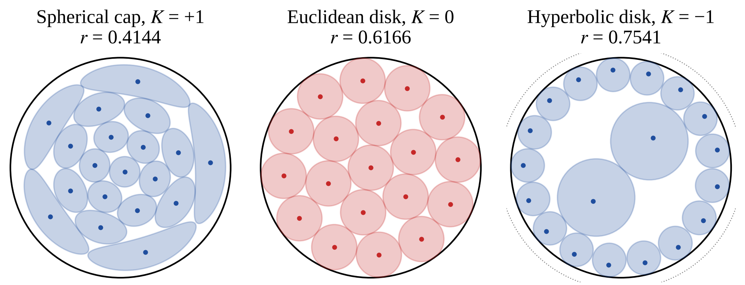
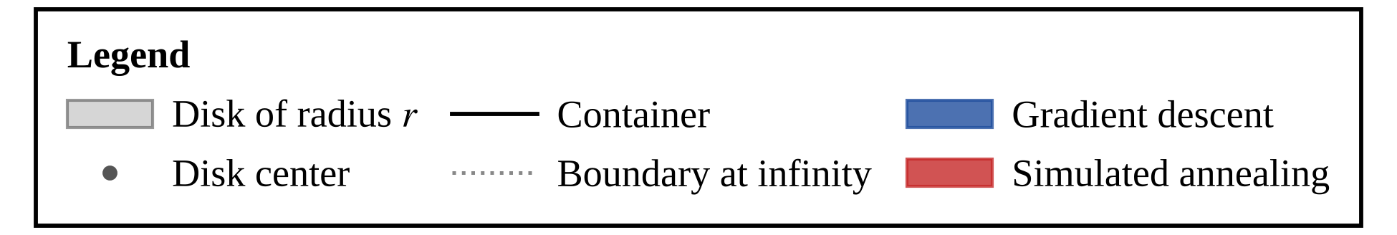
Note. Best packing found for R = 3 and n = 19 in each space (best run over all algorithms and seeds), with the resulting radius r in the panel title. The panels use different projections: the spherical cap is shown in azimuthal equidistant projection, where the distance from the center is preserved and shapes are distorted; the Euclidean disk is shown undistorted; the hyperbolic disk is shown in the Poincaré disk, where hyperbolic disks are exact Euclidean circles. Data: configurations.csv. Shaded regions: disks of radius r. Dots: disk centers. Solid circle: container, a ball of radius 3 (Euclidean radius 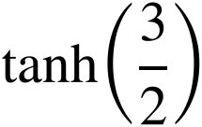 in the Poincaré disk). Dotted circle: boundary at infinity of the Poincaré disk. Color: algorithm that found the packing (blue = gradient descent, red = simulated annealing).
For N = 60 the interquartile ranges of the three algorithms do not overlap (Figure 8).
Figure 5
Convergence of the Best Score During the Budget
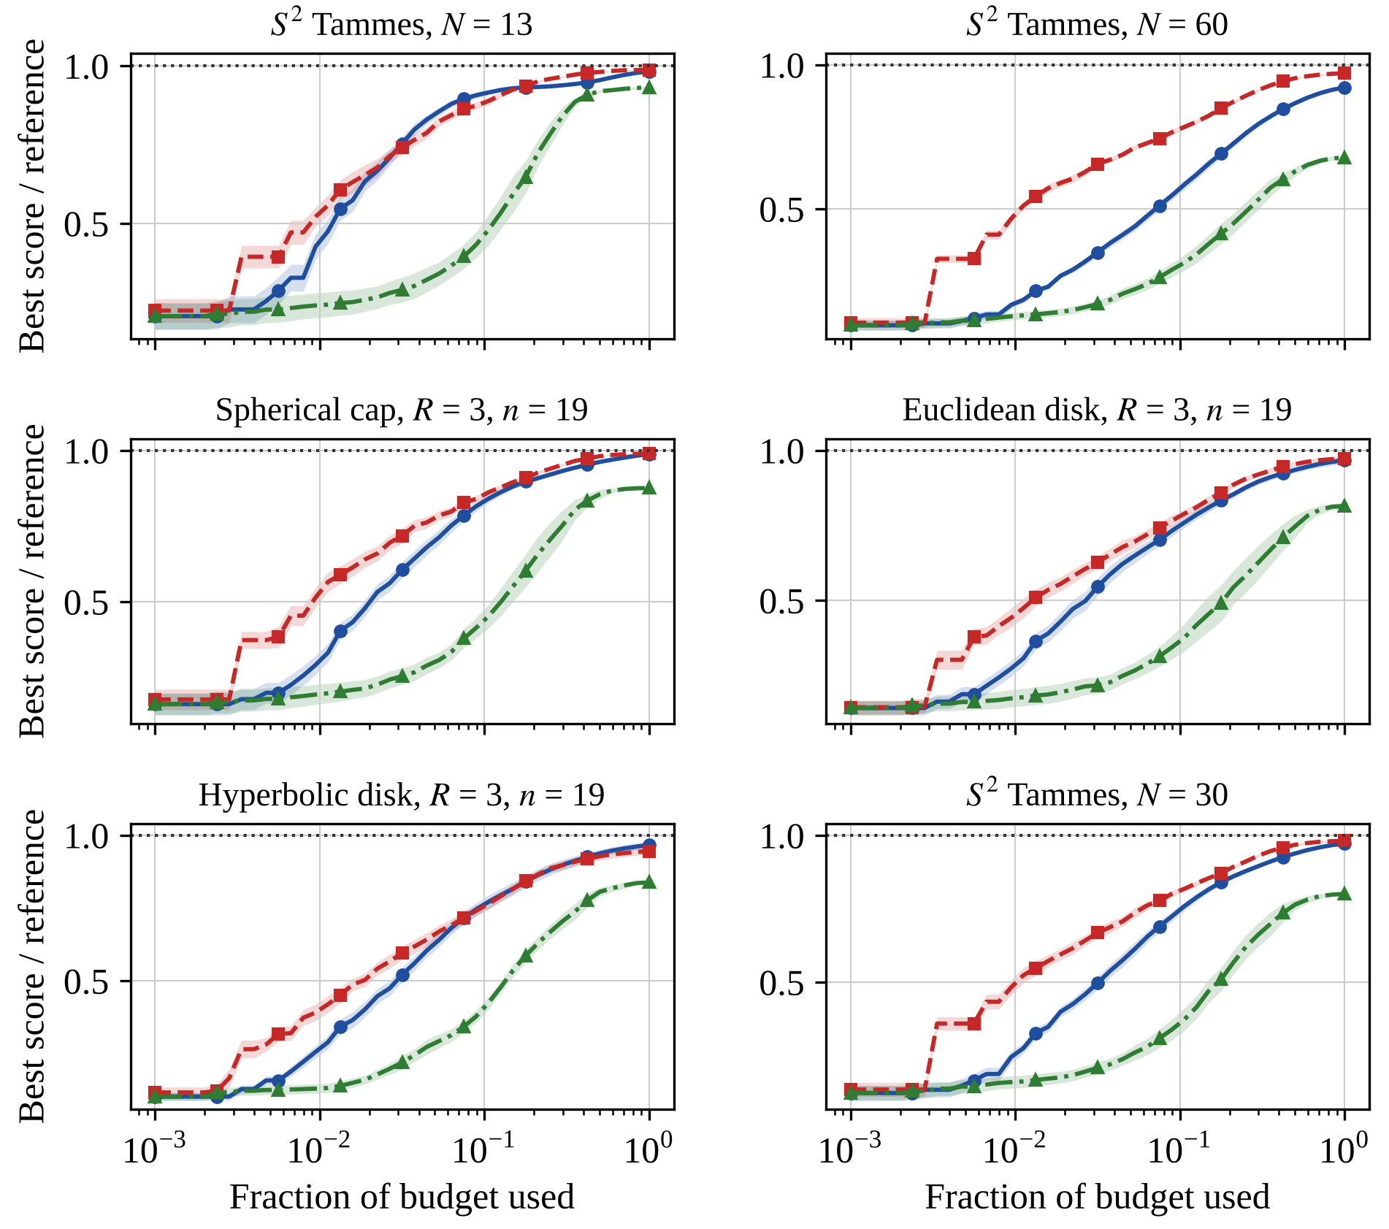
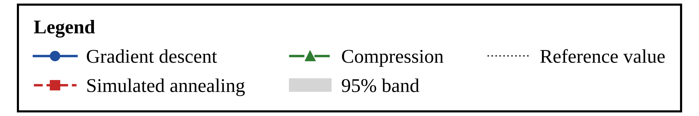
Note. Mean of the best score so far divided by the reference value, over 30 seeds, for six conditions. The horizontal axis is logarithmic and the vertical axes do not start at zero. Data: convergence_traces.csv. Lines: mean of the best score so far (blue solid with circles = gradient descent, red dashed with squares = simulated annealing, green dash-dot with triangles = compression). Shaded bands: 95% confidence intervals over seeds. Dotted line: reference value (1.0). Cap = spherical cap, R = ball radius, n = number of disks, N = number of points.
Table 8
Mean Sweeps Needed to Reach 99% of the Final Score
Condition | GD | SA | CP
S², N = 60 | 1,240 | 906 | 1,073
Cap, R = 3, n = 19 | 1,102 | 722 | 850
R², R = 3, n = 19 | 1,059 | 874 | 1,038
H², R = 3, n = 19 | 1,072 | 886 | 981
Note. Budget = 1,500 sweeps. Cap = spherical cap. Data: summary_by_condition.csv.

Statistical Comparison of Algorithms
The Friedman test found a significant difference among the three algorithms in 33 of 33 conditions (largest Holm-adjusted p < .001), with Kendall’s W between .57 and 1.00. Table 9 counts, for each space and pair, the conditions in which one algorithm was significantly higher after Holm correction and, in the last column, how many of those differences were also practically important (mean difference at least 0.5% of the reference). Compression was significantly lower than gradient descent in 31 of 33 conditions and lower than simulated annealing in 33 of 33.
Significance does not always mean a large difference. For N = 5, 6, and 12, gradient descent was significantly higher than simulated annealing with r_{rb} = 1.00, yet the mean differences were only 0.2, 0.2, and 0.1 milliradians, which is below the 0.5% threshold. Of the 84 significant pairwise results, 74 were also practically important. For N = 60 on the sphere, gradient descent minus simulated annealing was −0.023 rad, 95% CI [−0.027, −0.020], r_{rb} = −1.00, d_{z} = −2.70, p < .001. For 19 hyperbolic disks in a ball of radius 3 the same difference was 0.016, 95% CI [0.006, 0.025], r_{rb} = .67, d_{z} = 0.61, p = .004.
Figure 6
Final Relative Score by Condition
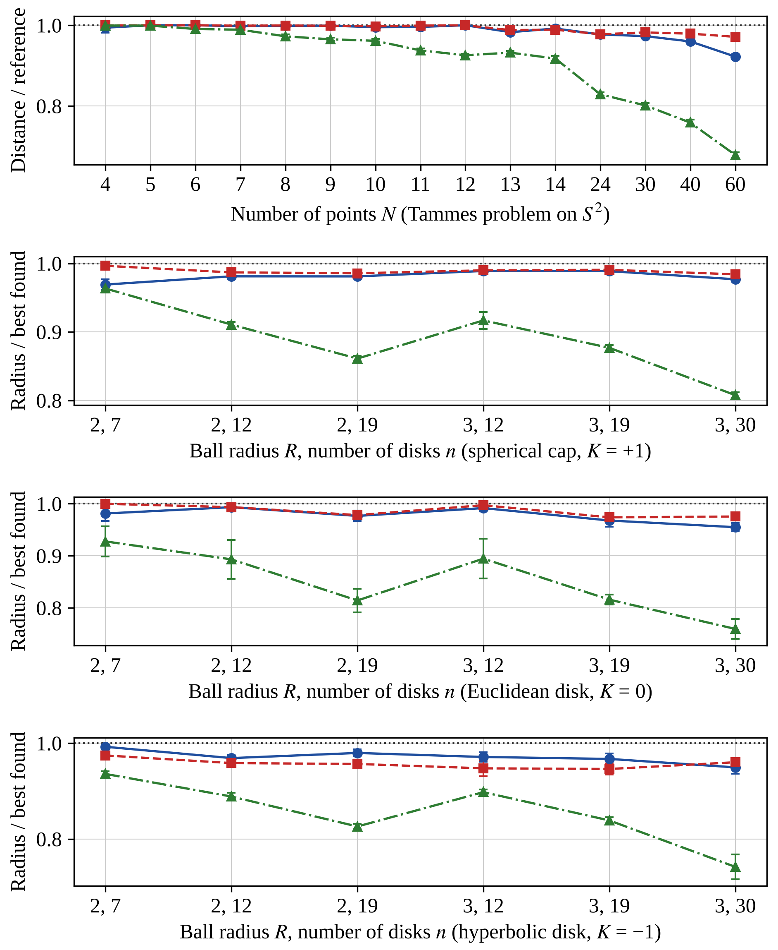
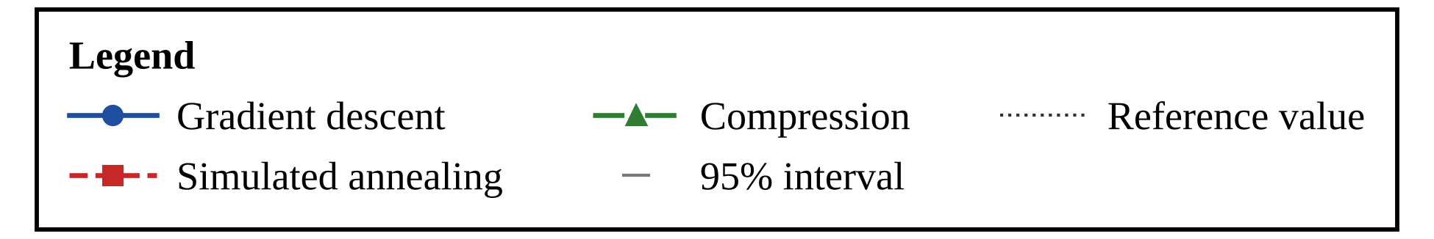
Note. Mean relative score over 30 seeds with 95% confidence intervals. The top panel is the Tammes problem and the other panels are disks in a ball; vertical axes do not start at zero. Data: summary_by_condition.csv. Markers and lines as in the previous figure (blue circles = gradient descent, red squares = simulated annealing, green triangles = compression). Error bars: 95% confidence intervals. Dotted line: reference value (1.0), which is a proven optimum for N ≤ 14 and N = 24, a published best-known value where stated in the text, and the best value found otherwise. Horizontal labels in the lower panels: ball radius R, number of disks n.
The assumption checks show where the Wilcoxon results need care. The absolute skewness of the paired differences exceeded 1 in 41 of 99 comparisons, so the symmetry assumption is doubtful there, and in no comparison were all paired differences zero. Of the flagged comparisons, 28 had an absolute rank-biserial correlation of at least .90, where the sign of the difference is nearly constant and the conclusion does not rest on symmetry; the remaining 13 should be read with caution (all values are in test_pairwise_wilcoxon.csv). Mean ranks (1 = best of three) were 1.43 for simulated annealing, 1.59 for gradient descent, and 2.99 for compression on the sphere; 1.28, 1.78, and 2.93 in the cap; 1.46, 1.57, and 2.97 in the Euclidean disk; and 1.36 for gradient descent, 1.67 for simulated annealing, and 2.98 for compression in the hyperbolic disk.

Hypothesis Evaluation
Table 10 states the decision rules and resolves the three hypotheses; the text after it gives the reasoning.
H1 is partly supported (exploratory). Criterion (b) holds: simulated annealing has the lowest mean rank in the cap and in the Euclidean disk, and gradient descent in the hyperbolic disk. Criterion (a) fails: the difference between gradient descent and simulated annealing does not vary significantly across the three spaces after Holm correction (raw p = .041, adjusted p = .122), and the other two pairs show no significant difference (adjusted p = 1.000 and 1.000). The median per-setting difference (gradient descent minus simulated annealing, in relative score) was −0.0051 in the cap, −0.0058 in the Euclidean disk, and 0.0195 in the hyperbolic disk, so the cap resembles the Euclidean disk, whereas the hyperbolic disk differs. A paired contrast of that difference against the Euclidean disk over the six settings gave raw p = .031 (adjusted p = .062) for the hyperbolic disk and raw p = 1.000 for the cap. With six settings per space the smallest possible two-sided p of this contrast is .031, so the study has little power here. For completeness, the contrast between the sphere (Tammes) and the hyperbolic disk that was specified first gave an adjusted p of .033 for the gradient descent–simulated annealing pair; it compares different problems and is not used to attribute the difference to curvature. In summary, the evidence is consistent with a difference in the hyperbolic disk, but it is not significant after correction, it cannot separate curvature from area, and it was explored after the first results were seen.
Figure 7
Mean Run Time on the Sphere by Number of Points
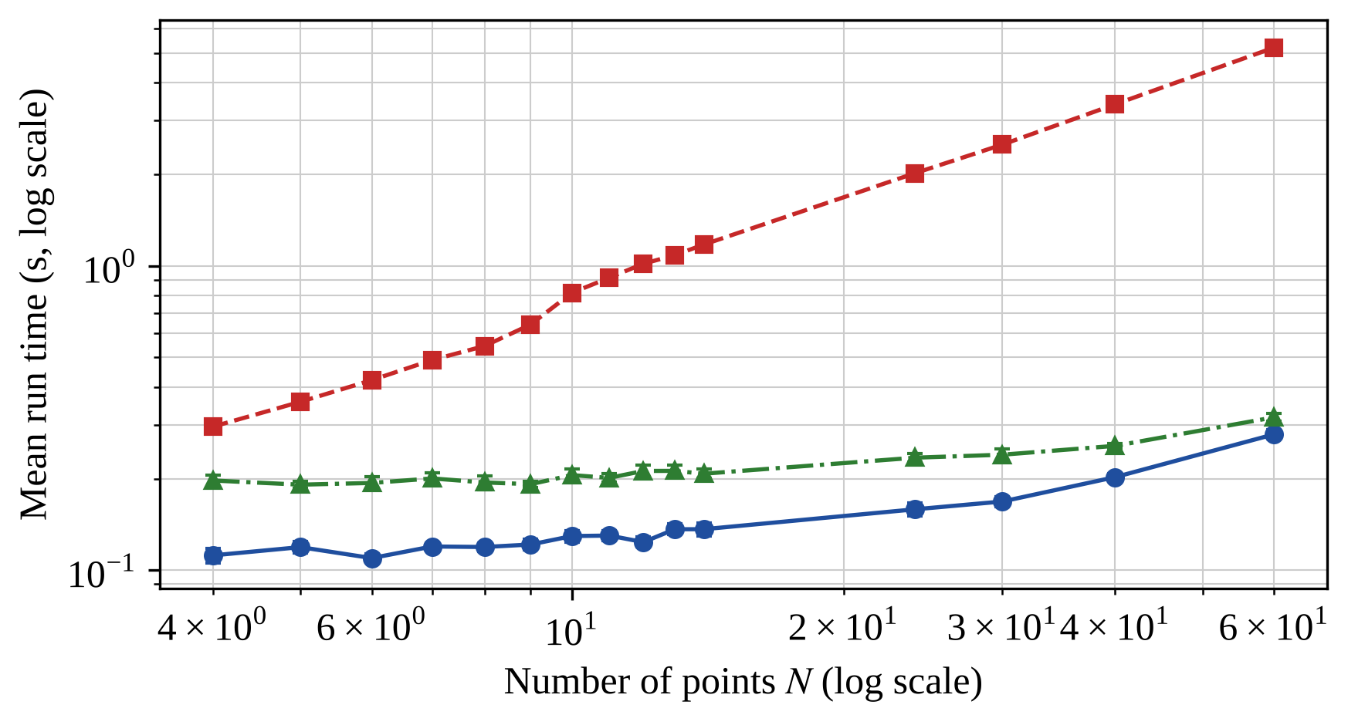
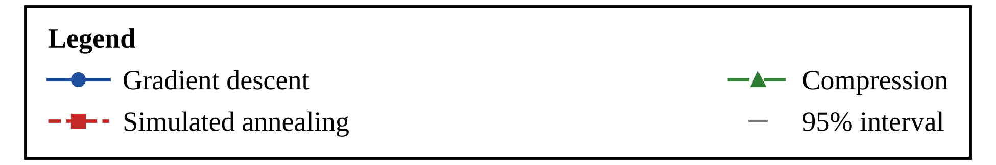
Note. Mean wall-clock time per run over 30 seeds at equal budget. Data: summary_by_condition.csv. Blue circles = gradient descent, red squares = simulated annealing, green triangles = compression. Error bars: 95% confidence intervals. Both axes logarithmic; time in seconds.
H2 is not supported (exploratory): compression scaled worse, not better. Its relative score fell by 0.371 per decade of N for N ≥ 13, much faster than that of gradient descent (0.087) or simulated annealing (0.024), with p < .001 against both. For N = 30, 40, and 60 the reference is not a proven optimum; a reference that is too low raises all relative scores in a condition by the same factor, so it cannot reverse the order of the three algorithms within a condition, but it can change slopes across N. The compression method is also a simplified version, so this result does not describe the event-driven original.
H3 is not supported (exploratory) at the 0.1% tolerance. Success rates reached .90 at 6 of 11 values of N for simulated annealing, 5 for gradient descent, and 0 for compression. As a sensitivity check, at the 1% tolerance gradient descent fell below .90 only at N = 13, 14, simulated annealing at N = 13, 14, and compression at 8 of 11 values. The bound in Equation 7 shows that the smoothing error of gradient descent can reach in the logarithm of the score, which at the final exponent is not small compared with a 0.1% tolerance; the shortfall of gradient descent is consistent with this bias, but the study did not test that explanation.

Supplementary Exploratory Analyses
The analyses in this section were added after the main results had been seen, in response to the limitations listed in the Conclusions. They use the same seeds, starting configurations, and budget unless stated otherwise, and none of them is used to decide H1, H2, or H3. Their code is in supplementary.py, and their data are the files whose names begin with supp_.
Figure 8
Distribution of Relative Scores Over Seeds
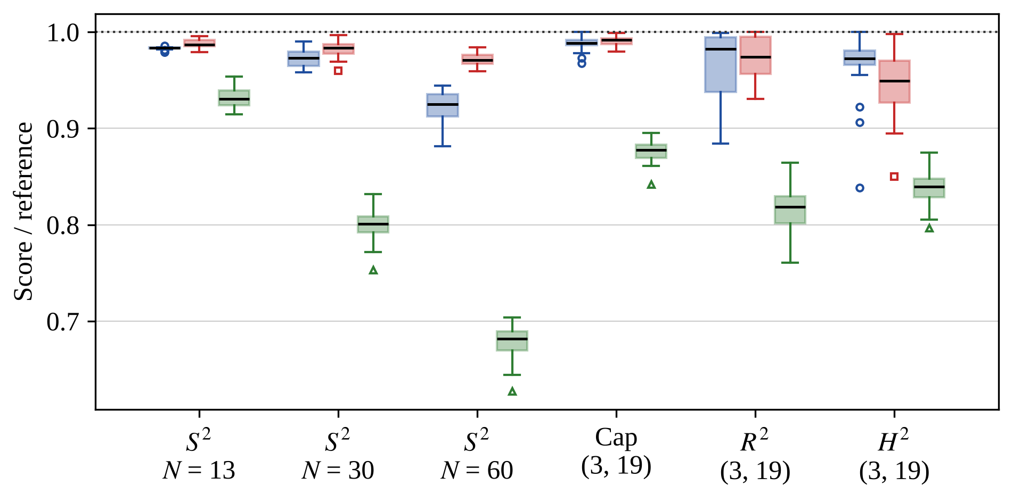
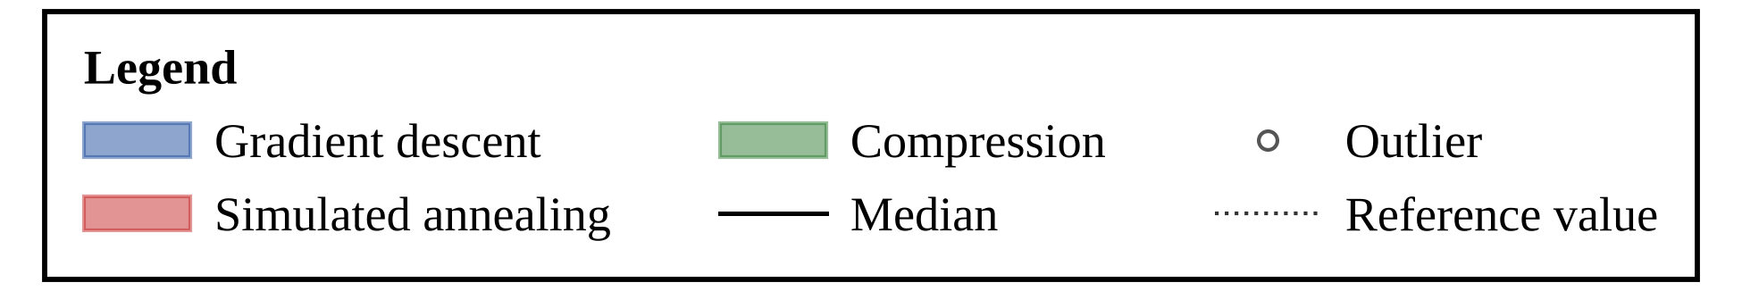
Note. Box plots over 30 seeds for six conditions; the pair in parentheses is (R, n). Data: runs_raw.csv. Box: interquartile range. Black line: median. Whiskers: 1.5 interquartile ranges. Markers: outliers. Dotted line: reference value. Blue = gradient descent, red = simulated annealing, green = compression. Cap = spherical cap.
Summary of the supplementary results. (1) Numerical accuracy: all 2,970 scores agreed with an independent recomputation to within 9e-15. (2) Polishing: gradient descent followed by a max-min polishing step raised the mean relative score on the sphere for N = 24 to 60 from .958 to .995 (simulated annealing: .978) and the number of N from 4 to 14 with a success share of at least .90 from 5 to 8 of 11 (simulated annealing: 6); the polishing step uses a linear program that the sweep count does not charge, which added 0.26 seconds per run on average. (3) Time: at equal sweeps, simulated annealing took 6.7 to 16.2 times as long as gradient descent. (4) Sensitivity: moving one parameter at a time changed gradient descent and simulated annealing very little and compression a great deal, and compression stayed last at every budget and parameter setting tried. (5) Equal area: the gradient-descent minus annealing difference did not vary detectably across the three spaces (Kruskal–Wallis p = .834), while larger balls reproduced the main-study sign pattern, so the apparent effect of the space is tied to ball size and is not shown to be caused by curvature. All of this is exploratory.
Table 9
Conditions in Which One Algorithm Was Significantly Higher
Space | Comparison | First higher | Second higher | No difference | Also practical
S² | GD vs. SA | 3 | 9 | 3 | 5
S² | GD vs. CP | 14 | 1 | 0 | 14
S² | SA vs. CP | 15 | 0 | 0 | 13
Cap | GD vs. SA | 0 | 2 | 4 | 2
Cap | GD vs. CP | 5 | 0 | 1 | 5
Cap | SA vs. CP | 6 | 0 | 0 | 6
R² | GD vs. SA | 0 | 1 | 5 | 1
R² | GD vs. CP | 6 | 0 | 0 | 6
R² | SA vs. CP | 6 | 0 | 0 | 6
H² | GD vs. SA | 4 | 0 | 2 | 4
H² | GD vs. CP | 6 | 0 | 0 | 6
H² | SA vs. CP | 6 | 0 | 0 | 6
Note. Counts of conditions (15 for S², 6 for each other space) from Wilcoxon signed-rank tests with Holm-adjusted p < .05. First = first-named algorithm. Also practical = significant differences of at least 0.5% of the reference. Cap = spherical cap. GD = gradient descent; SA = simulated annealing; CP = compression. Data: test_pairwise_wilcoxon.csv.
Table 10
Hypotheses, Decision Rules, and Results
Hypothesis | Decision rule | Result | Decision
H1: the ranking depends on the space | Disks in a geodesic ball: Kruskal–Wallis test across the three spaces of the per-setting mean paired difference in relative score, per algorithm pair, Holm-adjusted over three pairs; and the lowest-mean-rank algorithm in each space. Supported if some pair has adjusted p < .05 and the lowest-mean-rank algorithm is not the same in all spaces; partly if exactly one holds. | Kruskal–Wallis for GD–SA across spaces, χ²(2) = 6.40, Holm p = .122; lowest mean rank: cap SA, Euclidean SA, hyperbolic GD | Partly supported (exploratory)
H2: compression scales better | Tammes problem, N ≥ 13: Wilcoxon tests of the compression slope of relative score on log₁₀ N against each other slope, Holm-adjusted over two tests. Supported if higher than both (adjusted p < .05); partly if higher than one. | Slope per decade of N: CP −0.371, GD −0.087, SA −0.024; Holm p < .001 | Not supported (exploratory)
H3: all recover the proven optimum for small N | Tammes problem, N = 4 to 14: share of seeds with relative score ≥ .999. Supported if the share is ≥ .90 at every N for all three algorithms; partly if for one or two. | N with share ≥ .90: GD 5 of 11, SA 6 of 11, CP 0 of 11 | Not supported (exploratory)
Note. GD = gradient descent; SA = simulated annealing; CP = compression. A 1% tolerance (relative score ≥ .99) is a sensitivity check only. Data: hypothesis_tests.csv, scaling_slopes_per_seed.csv.

Numerical Accuracy and Independent Recomputation
Every one of the 2,970 final scores was recomputed from the saved coordinates with formulas that do not use the geometry code: the arctangent form of the sphere distance, the Poincaré-disk formula for the hyperbolic plane, and direct Euclidean distances. The largest difference from the stored score was 9.3e-15, the largest manifold error of any saved point was 1.3e-13, and no disk extended beyond the wall of its ball (largest excess 0.0). These errors are many orders of magnitude below the 0.1% success tolerance, so rounding does not affect any success rate. The distance code uses arcsine and arcsinh forms, which stay accurate for small distances where an arccosine would lose digits. These checks show that the stored scores are numerically sound; they do not show that any configuration is optimal.

Gradient Descent With a Polishing Step, and Wall-Clock Time
The main study suggested that the final precision of gradient descent, not its search, limits its success rate (the bound in Equation 7 allows for a smoothing bias). To test this, gradient descent was followed by a max-min polishing step: the first 85% of the budget was used by the unchanged gradient descent, and the remaining 15% by a sequential linear program that maximizes the smallest distance within a shrinking trust region, with every polishing iteration charged as one sweep. The step is a local refinement of the same kind as the L-BFGS refinement of a smoothed energy (Liu & Nocedal, 1989; Byrd et al., 1995), which was used as a baseline in the Confirmatory Round. With the same total budget, polishing changed the mean relative score on the sphere from .996 to .999 for N = 4 to 14 and from .958 to .995 for N = 24 to 60 (Table 11). The number of values of N from 4 to 14 at which at least 90% of seeds reached the proven optimum within 0.1% changed from 5 to 8 of 11 (simulated annealing: 6; compression: 0). This is exploratory evidence about the explanation, not a revision of H3, which was decided on the three algorithms of the main study.
Equal sweeps do not mean equal time (Table 12). Simulated annealing took 6.7 to 16.2 times as long as gradient descent per run in these five conditions, so the small advantage of simulated annealing in some conditions was obtained with a much longer wall-clock time; the polishing step added 0.26 seconds per run on average because each polishing iteration solves a linear program that the sweep count does not charge. The times are those of the machine and implementation used here, so they compare the methods only with each other.
Table 11
Mean Relative Score of Gradient Descent With and Without a Polishing Step
Problem group | GD | GD+P | SA | CP
Sphere, N = 4 to 14 | .996 | .999 | .997 | .963
Sphere, N = 24 to 60 | .958 | .995 | .978 | .767
Spherical cap | .981 | .995 | .989 | .889
Euclidean disk | .978 | .989 | .986 | .851
Hyperbolic disk | .971 | .994 | .957 | .855
N with success share ≥ .90 (of 11) | 5 | 8 | 6 | 0
Note. GD = gradient descent; GD+P = gradient descent on the first 85% of the budget followed by a max-min polishing step on the remaining 15%; SA = simulated annealing; CP = compression. Cells are the mean relative score over the conditions of the group (30 seeds each); the last row counts the values of N from 4 to 14 at which at least 90% of seeds reached a relative score of .999. GD, SA, and CP are the main-study runs. A value above 1.000 means the result exceeds the reference, which in the ball problems is the best score found in the main study, so values above 1.000 are possible there. Data: runs_raw.csv, supp_gd_polish_runs.csv.
Table 12
Mean Wall-Clock Time per Run at Equal Budget
Condition | GD | GD+P | SA | CP | 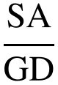
Tammes N = 13 | 0.07 | 0.25 | 0.61 | 0.11 | 9.0
Tammes N = 30 | 0.09 | 0.37 | 1.41 | 0.13 | 16.2
Cap, R = 3, n = 19 | 0.10 | 0.31 | 1.06 | 0.13 | 10.2
Euclidean, R = 3, n = 19 | 0.08 | 0.27 | 0.54 | 0.10 | 6.7
Hyperbolic, R = 3, n = 19 | 0.10 | 0.52 | 1.19 | 0.17 | 11.6
Note. Seconds per run at 1,500 sweeps, mean of 5 runs (seeds 1 to 5) per cell, measured in one process with nothing else running on the same computer. 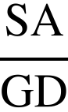 = ratio of simulated-annealing time to gradient-descent time. The sweep budget is equal, but the time per sweep differs between methods and between implementations; times describe this Python code only. The main-study times are in summary_by_condition.csv. Data: supp_timing.csv.

Sensitivity to the Budget, the Parameters, and the Starting Configuration
Tripling the budget from 500 to 1,500 sweeps and then doubling it to 3,000 raised the mean relative score for every algorithm; the doubling from 1,500 to 3,000 sweeps changed it by .009 for gradient descent, .010 for simulated annealing, and .025 for compression on average over the five conditions (Table A1). The algorithm with the highest mean was the same at all three budgets in 4 of 5 conditions. The budget therefore matters; the conclusion that compression is last holds at every budget tested; and the ordering of gradient descent and simulated annealing depends on the condition and the budget.
Changing one parameter at a time within the ranges in Table A2 moved the mean relative score by at most .001 for gradient descent, .003 for simulated annealing, and .087 for compression (differences between the best and worst setting, averaged over the five conditions). Only three of the nine settings were tuned on the pilot seeds, so this is a local sensitivity check, not a new tuning: it asks whether the main conclusions depend on the exact default values, and it does not search for better ones.
The spread over starting configurations (Table A3) shows local optima directly. For the Tammes problem with N = 13 the standard deviation of the relative score was .001 for gradient descent, .004 for simulated annealing, and .010 for compression, and no run reached the proven optimum, so different starts end in nearby but different local optima, and the best of 30 starts is a better estimate of what the method can reach than a single start. Whether a given local optimum is a strict local maximum was not tested.

Equal-Area and Larger-Ball Comparison
The main study could not separate curvature from area. To control for area, balls of the same area (3, 6, and 12) were packed in the three spaces with n = 12, 19, and 30 disks (Table 13). At equal area, the difference between gradient descent and simulated annealing did not vary detectably across the three spaces (median −0.0061 in the cap, −0.0058 in the Euclidean disk, and −0.0013 in the hyperbolic disk; Kruskal–Wallis χ²(2) = 0.36, p = .834, nine settings per space), and the algorithm with the lowest mean rank was simulated annealing in the cap, simulated annealing in the Euclidean disk, and simulated annealing in the hyperbolic disk (mean ranks in the hyperbolic disk: 1.51 for gradient descent and 1.49 for simulated annealing). In the two larger balls, which can exist only in the Euclidean and hyperbolic planes, the sign pattern of the main study was reproduced: gradient descent minus simulated annealing was −.077 to −.023 in the Euclidean disk and .011 to .016 in the hyperbolic disk (Holm-adjusted p = .304 at its smallest in the hyperbolic disk, two settings only). Together these results suggest that the apparent dependence of the ranking on the space in the main study is tied to the size of the ball and is not shown to be caused by curvature, but this design cannot establish that: equal area is possible only up to 4π on the sphere, where hyperbolic curvature has little room to act, and the larger balls differ in both area and curvature.

Robustness of the H1 Result
The H1 contrast (gradient descent minus simulated annealing across the cap, the Euclidean disk, and the hyperbolic disk) gave a Kruskal–Wallis statistic of 6.40 (p = .041 before Holm adjustment). Replacing the per-setting mean difference by the median gave 6.68 (p = .035); a permutation test of the same statistic over the 18 settings (20,000 random relabelings of the three spaces) gave p = .036; restricting to the three settings with R = 2 gave p = .051 and to the three with R = 3 gave p = .393. All of these unadjusted values are of the same magnitude as the original one, and multiplying any of them by 3 for the three algorithm pairs puts it above .05, so the conclusion is unchanged: the evidence is suggestive but not significant after correction. For two headline paired differences, bootstrap percentile intervals agreed with the t intervals reported in the Statistical Comparison: for N = 60 on the sphere (gradient descent minus simulated annealing, in relative score) the mean was −0.0491, 95% t interval [−0.0559, −0.0423] and bootstrap interval [−0.0556, −0.0429]; for the hyperbolic ball with R = 3 and n = 19 the mean was 0.0210, [0.0082, 0.0337] and [0.0092, 0.0335]. These robustness checks use the same 18 settings and the same seeds as the main analysis; they cannot add power, and they do not address the confounding of curvature with area.
Table 13
Balls of Equal Area in the Three Spaces, and Larger Balls
Area | Space | R | GD | SA | CP | GD − SA
3 | Cap | 1.02 | .983 | .987 | .848 | −.004
3 | Euclidean | 0.98 | .977 | .982 | .841 | −.004
3 | Hyperbolic | 0.94 | .982 | .986 | .838 | −.004
6 | Cap | 1.53 | .981 | .985 | .850 | −.004
6 | Euclidean | 1.38 | .975 | .980 | .830 | −.005
6 | Hyperbolic | 1.29 | .982 | .984 | .830 | −.002
12 | Cap | 2.71 | .982 | .986 | .863 | −.004
12 | Euclidean | 1.95 | .977 | .983 | .822 | −.006
12 | Hyperbolic | 1.73 | .976 | .978 | .841 | −.002
50 | Euclidean, n = 30 | 4.00 | .959 | .982 | .727 | −.023
79 | Euclidean, n = 60 | 5.00 | .909 | .986 | .618 | −.077
165 | Hyperbolic, n = 30 | 4.00 | .928 | .912 | .737 | .016
460 | Hyperbolic, n = 60 | 5.00 | .907 | .896 | .577 | .011
Note. The first nine rows are balls of equal area (3, 6, and 12) in the three spaces, averaged over n = 12, 19, and 30 (the radius R is the same for all n); the last four rows are single larger balls in the Euclidean and hyperbolic planes, which the sphere cannot contain. Cells are mean relative scores over 30 seeds, relative to the best score found in the same condition; GD − SA is the mean paired difference. Data: supp_equal_area_runs.csv, supp_equal_area_summary.csv.

Confirmatory Round With Equal-Area Balls and Stronger Baselines
The first study could not separate curvature from area, and its two best methods were not compared with stronger baselines. A second round was therefore designed to test a prediction; its hypotheses, thresholds, and decision rules were written and hashed before any of its evaluation seeds was run. This round is confirmatory only in that sense: it answers the questions written in its preregistration, with fresh seeds, and it is separate from the first study, whose results are unchanged. All analyses outside the six preregistered decisions are exploratory and are labeled so wherever they are reported here.

Prediction, Design, and Preregistration
The prediction is that the density deficit of a packing follows the share of the ball’s area near its boundary, so that most of the lower density of packings in hyperbolic balls is a boundary effect and not an effect of curvature. For n disks of radius r in a ball of radius R let the reference density ρ* be an upper bound on the density of any packing of disks of radius r in the whole space (Fejés Tóth, 1943; Böröczky, 1978), the density deficit be 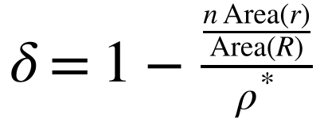, and the boundary share be 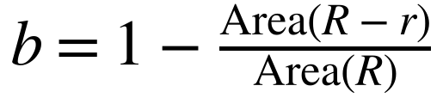, the share of the ball’s area within distance r of its boundary. The reference density is an upper bound for the whole space, not for a bounded ball, so δ includes the loss caused by the wall.
The preregistration (PREREGISTRATION.md in the data package) fixes the fresh evaluation seeds 101 to 120, three budget levels of 500, 1,500, and 3,000 sweeps in the main design, six methods, and 33 conditions: the Tammes problem for N = 9, 13, 14, 24, 30, 40, and 60; balls of equal area (3, 6, and 12) with 12 and 24 disks in the spherical cap, the Euclidean disk, and the hyperbolic disk; and large balls of hyperbolic radius 2, 3, 6, and 8 (areas 17.4, 57.0, 1,261.1, and 9,358.7) with 24, 36, 50, and 70 disks, paired with Euclidean disks of the same area. Equal area in all three spaces is possible only up to 4π, because the sphere has finite area, so the large balls compare only the hyperbolic and Euclidean planes.
The SHA-256 hash of the preregistration was computed on 2026-10-28 at 21:35:04 UTC, before the pilot tuning and before every evaluation run; it is 39bee69da1ffb2a23961dcbfeafafe9e63b421b5f88c9c79c27036cfadeaa7a0. The tuned parameters (hash da9e8ec3d5c348b2d0517f99d821cf892341fbc2a701298ed2f9fb18eef3c455) were fixed before the evaluation run as well. A hash recorded by the author is not an independent time stamp; the record kept by the research adviser is described in Appendix B. The hashes allow the files to be checked against these values.
Table 14 lists the six methods, their tuned parameters, and the selected values. The two added baselines minimize the same energy as gradient descent. Each method has one tuned parameter with six candidate settings, so every method received the same tuning effort, and the selected setting of each method was then used unchanged in every condition of the round (tuned_params.json; the tuning runs are in tuning_runs.csv).
L-BFGS-B (SciPy; Virtanen et al., 2020; Byrd et al., 1995) minimizes the soft-minimum energy with its exponent raised in ten stages and restarts from a new random configuration, with the same random stream, when it stops by its own convergence test before the budget is used; basin hopping (Wales & Doye, 1997; scipy.optimize.basinhopping) perturbs the points and minimizes locally with L-BFGS-B at p = 60. Because both baselines work on the same energy as gradient descent, a difference between them and gradient descent reflects the search rule and not a different objective.
Every energy-and-gradient evaluation is charged one sweep, as in gradient descent. Equal tuning means equal effort (one parameter, six settings, the same pilot runs for every method), not an equal chance of finding the best possible setting: the selected value lies at the edge of its candidate range for Compression, L-BFGS-B (SciPy), so those two methods may be tuned less well than the others. The reported runs were made on Intel(R) Xeon(R) Processor @ 2.10GHz with 2 logical processors and 7.8 GB of memory, using Linux-6.18.44-fc-v180-x86_64, Python 3.13.18, numpy 2.5.3, scipy 1.18.1, and pandas 3.0.5 (hardware.json), with two worker processes sharing the machine; wall-clock times are comparable only within this round. The hardware of the computer that produced the first study was not recorded in its data package, so its run times cannot be compared with these. The run times are therefore reported as a description of each method on this machine and are not used for any of the preregistered decisions.
Reference values: the proven optimum for N = 9, 13, 14, and 24 and the published best-known value (Sloane’s tables) for N = 30, 40, and 60, seven conditions in all. For the ten Euclidean conditions with 12, 24, 36, 50, or 70 disks the reference is the Packomania value (circles in a circle; Specht, n.d.), entered after the first analysis of this round, which had used the best score found (the decisions were the same with both references; decisions_best_found_references.json), and for the spherical cap and the hyperbolic disk, for which the author knows of no published table of best packings, the reference is the best score found by any method, budget, or seed of this round in the condition (16 conditions). Where a published table exists the reference is that published value, and a best-found reference is used only for the spherical cap and the hyperbolic disk.
A relative score for a best-found reference measures the distance from the best score this study found, not from the optimum, so for the spherical cap and the hyperbolic disk the relative scores compare the methods with each other more than with a known bound. No run was excluded; every run is in conf_runs.csv, and every score agreed with its recomputation from the final coordinates to within 7e-13.
Table 14
Methods, Tuned Parameters, and Candidate Settings of the Confirmatory Round
Method | Tuned parameter | Candidate settings | Selected
Gradient descent | p_{max} | 40, 80, 150, 250, 400, 700 | 150
GD with polishing | polishing share | 0.05, 0.1, 0.15, 0.25, 0.35, 0.5 | 0.25
Simulated annealing | initial temperature | 0.005, 0.01, 0.02, 0.04, 0.08, 0.16 | 0.04
Compression | initial growth rate | 0.1, 0.15, 0.25, 0.35, 0.5, 0.7 | 0.7
L-BFGS-B (SciPy) | p_{max} | 40, 80, 150, 250, 400, 700 | 700
Basin hopping (SciPy) | step size | 0.05, 0.1, 0.2, 0.4, 0.8, 1.5 | 0.1
Note. Each method had one tuned parameter and six candidate settings, run on the same four pilot conditions (Tammes N = 11 and 33; hyperbolic and Euclidean balls of area 8 with 16 disks) and the same four pilot seeds (9101 to 9104) at 1,500 sweeps; the setting with the highest mean score relative to the best score seen in the pilot condition was kept. GD = gradient descent; GD+P = GD followed by a max-min polishing step; the polishing share is the fraction of the budget given to the polishing step; the step size and the initial temperature are multiples of the length scale . Data: tuning_runs.csv, tuned_params.json.

Results of the Preregistered Decisions
Table 15 gives the decisions. For C1 the correlation between the boundary share and the density deficit over the 26 ball conditions was .87 (p < .001), so the prediction is supported (Figure 9; Table 17). The correlation was positive within each space (.64 in the Euclidean disk, .94 in the hyperbolic disk, and .66 in the cap; these within-space values were not part of the decision). The two hyperbolic balls of radii 6 and 8 have the largest boundary shares and deficits; without them the correlation was .83 for 24 conditions (exploratory). The final configuration of every run was saved in a rerun with identical seeds and settings (every score agreed with the original to within 1e-9), and the wall contact of all 9,360 ball runs is reported below (exploratory). The 26 conditions are not independent: the equal-area conditions come in triplets of one area and one number of disks in the three spaces, and each large hyperbolic ball is paired with a Euclidean ball of the same area, so the permutation test, which treats the conditions as exchangeable, assumes more independence than the design has, and its p value is optimistic. The boundary share is a function of the disk radius that the method finds, so it is not independent of the outcome, and the deficit moves with the boundary share without showing that the share causes it.
For C2, once the boundary share is in the model, the hyperbolic term was −0.010 (95% bootstrap interval −0.068 to 0.039) and the cap term was 0.023, so the decision is inconclusive: with 26 conditions in which the boundary share and the space are strongly related, a separate effect of curvature could be neither shown nor excluded. For C3, the median difference in relative score between gradient descent and simulated annealing was −0.0084 in the Euclidean disk, −0.0051 in the cap, and 0.0016 in the hyperbolic disk. The Kruskal–Wallis test found a difference between the spaces (p = .011), but it is less than .01 in relative score: simulated annealing was ahead of gradient descent in the Euclidean disk and the cap, and the two tied in the hyperbolic disk. This result differs from the exploratory equal-area comparison of the first study, which found no detectable dependence on the space with other areas, other numbers of disks, and other seeds; the difference is small in both studies, six conditions per space is a small sample, and the preregistered result is the confirmatory one. Both are reported.
For C4, a stronger baseline mattered in every condition: L-BFGS-B or basin hopping had a higher mean relative score than both gradient descent and simulated annealing in all 33 conditions, and the mean ranks over seeds and conditions were 1.70 for GD+P, 2.48 for L-BFGS-B, 2.86 for basin hopping, 3.72 for simulated annealing, 4.24 for gradient descent, and 6.00 for compression (Table 16). The comparison of gradient descent with simulated annealing in the first study is therefore a comparison of two methods that stronger methods beat at the same budget, and its conclusions about their order should be read with that in mind. For C5, the ordering of the six methods was stable across the three budget levels (median Kendall’s W .90), but the best method at 1,500 sweeps was also the best at 3,000 sweeps in only 70% of conditions (Table 18). For C6, no method recovered the proven optimum in at least 90% of seeds for every one of N = 9, 13, 14, and 24: the best share was 1.00 at N = 9, .00 at N = 13, .80 at N = 14, and 1.00 at N = 24, so no method reached the 0.1% tolerance at N = 13. Basin hopping came closest (mean relative score .997, against .988 for GD+P and .988 for L-BFGS-B); across all three budget levels, 3 of the 360 runs at N = 13 reached it (GD+P 2 at 500 sweeps, SA 1 at 3,000 sweeps).

Budget Levels, Time, and the Count-Based Problem
Raising the budget from 500 to 3,000 sweeps raised the mean relative score of every method (Table 18; Figure 10), most for compression (.691 to .846) and gradient descent (.885 to .969) and least for GD+P (.985 to .989), so the methods differ most at the smallest budget. Time per run at 1,500 sweeps was 10.4 times as long for simulated annealing as for gradient descent, and GD+P ran for 0.32 seconds against 0.18 for L-BFGS-B, because the linear programs of GD+P are not charged in sweeps. The sweep counts are equal by construction; the times are not.
Table 15
Preregistered Decisions of the Confirmatory Round
Question | Decision rule | Result | Decision
C1: the density deficit follows the boundary share (26 ball conditions) | Supported if Spearman r_{s} ≥ .70 and one-sided permutation p < .05; not supported if r_{s} < .30 | r_{s} = .87, permutation p < .001 | Supported
C2: curvature adds a deficit beyond the boundary share | The 95% bootstrap interval of the hyperbolic term excludes 0 and the term is ≥ .02; no effect if the interval lies within ±.02 | Hyperbolic term −0.010, 95% interval [−0.068, 0.039] | Inconclusive
C3: the GD versus SA ranking depends on the space (18 equal-area conditions) | Kruskal–Wallis p < .05; no dependence if every 90% interval of a difference of medians lies within ±.01 | χ²(2) = 9.09, p = .011 | Ranking depends on the space
C4: stronger baselines matter; GD+P is competitive (33 conditions) | L-BFGS-B or BH beats both GD and SA in at least half of the conditions; GD+P ranks first or second in at least half | Baselines beat GD and SA in 100% of conditions; GD+P in the top two in 91% | Both supported
C5: the ranking of the methods is stable across budgets | Median Kendall’s W over the three budget levels ≥ .80 | Median W = .90 (minimum .72) | Ranking stable across budgets
C6: some method recovers the proven optimum for N = 9, 13, 14, 24 | Best share of seeds with relative score ≥ .999 is ≥ .90 for all four | Best share: N = 9: 1.00, N = 13: .00, N = 14: .80, N = 24: 1.00 | Not supported
Note. Relative scores at 1,500 sweeps, 20 fresh seeds per condition. GD = gradient descent; GD+P = GD with a polishing step; SA = simulated annealing; BH = basin hopping. Data: conf_runs.csv, conf_deficit_boundary.csv, conf_gd_minus_sa_equal_area.csv, conf_mean_ranks.csv, conf_kendall_w.csv, decisions.json.
The count-based problem fixes the disk radius at 0.30 and asks how many disks fit (Table 19). This is an original use of the same optimizers: the answer is an integer that can be compared across spaces without choosing a value of n in advance. At area 6 the largest numbers found were 16 in the cap, 15 in the Euclidean disk, and 14 in the hyperbolic disk, and at area 12 they were 35, 32, and 30. These are lower bounds on the true maximum, because a failure to find a packing does not prove that none exists, and they depend on the method and the budget. Each count is the largest number of disks for which some run found a valid packing at radius 0.30, and the last column of the table gives the share of seeds that reached it.
Table 16
Mean Relative Score of the Six Methods at 1,500 Sweeps
Condition group (conditions) | GD | GD+P | SA | CP | L-BFGS-B | BH
Tammes problem (7) | .973 | .995 | .983 | .856 | .995 | .994
Equal area: cap (6) | .982 | .993 | .985 | .886 | .991 | .990
Equal area: Euclidean (6) | .981 | .992 | .989 | .883 | .991 | .991
Equal area: hyperbolic (6) | .978 | .995 | .977 | .877 | .992 | .991
Large ball: Euclidean (4) | .920 | .991 | .971 | .703 | .940 | .987
Large ball: hyperbolic (4) | .846 | .948 | .841 | .640 | .983 | .970
Mean rank over all conditions | 4.24 | 1.70 | 3.72 | 6.00 | 2.48 | 2.86
Note. Mean over conditions of the mean relative score over 20 fresh seeds; boldface marks the best method in each row. For the Tammes problem the reference is the proven or published best-known value; for the other groups it is the best score found in this round, so values are relative to that score. The last row is the mean rank of the methods within seeds (1 = best). GD = gradient descent; GD+P = GD with a polishing step; SA = simulated annealing; CP = compression; L-BFGS-B and BH (basin hopping) are SciPy methods. Data: conf_summary_by_condition.csv, conf_mean_ranks.csv.

Baselines Re-Tuned After the First Analysis
Compression and L-BFGS-B had been selected at the upper edge of their candidate ranges (0.70 and 700). Their ranges were extended (compression: 1.0, 1.4, and 2.0 added; L-BFGS-B: 1,000, 1,500, and 2,500 added), the same pilot protocol was applied to the new settings, and the selected values, hashed on 2026-10-29 at 22:34:59 UTC (SHA-256 4a8f8b799b5e641b591f7a8b9887ad260c1834d4ccc51b0a57a514de1a747b6b) before the evaluation, were 1.4 for compression, inside its extended range, and 2500 for L-BFGS-B, again the largest value tried. Both methods were then run again on all 33 conditions at three budgets with the same 20 seeds. At 1,500 sweeps the mean relative score changed by 0.007 for compression and 0.002 for L-BFGS-B (by 0.018 and 0.002 at 500 sweeps). The decisions C1 to C6 recomputed with the re-tuned methods were the same as the preregistered ones; the mean rank of compression stayed last (6.00), that of L-BFGS-B moved from 2.48 to 2.36, and GD+P kept the best mean rank (1.72). The tables above are the preregistered runs; the re-tuned runs are additional (conf_retuned_vs_original.csv, decisions_retuned.json).
The two methods received nine candidate settings and the other four methods six, so the effort is unequal, and a gain from still larger values of the L-BFGS-B exponent cannot be excluded, although the gain from the extension was small.

Wall Contact in All Runs
In the main round, one run in the hyperbolic ball of radius 6 had shown all 50 centers in a ring along the wall. With the configurations of all runs saved (Table 20), this ring is specific to the two largest hyperbolic balls (radii 6 and 8) and is not a general result: all 225 runs with every disk in the outer ring were in these two conditions (83 of 360 runs in the ball of radius 6 and 142 of 360 in the ball of radius 8, over all methods and budgets), and none of the other 8,640 ball runs, in 24 conditions, had one (0 runs). Contact with the wall is more common: over all 9,360 ball runs, 32% of the disks touched the wall, and the share differed widely by method (from .03 for CP to .65 for L-BFGS-B at 1,500 sweeps), because the methods that polish or run to convergence push disks against the wall. At 1,500 sweeps the share of runs with all disks in the outer ring reached 1.00 in the ball of radius 6 and 1.00 in the ball of radius 8 for the method with the most such runs (L-BFGS-B and L-BFGS-B). A disk that touches the wall is a disk of the boundary layer, so a high share indicates that the packing is dominated by the wall; it does not show that the interior is poorly packed.

Limits of the Confirmatory Round
Seven limits apply. First, the conditions are few (33, with six per space in the equal-area comparison) and the boundary share depends on the result, so C1 and C2 describe 26 points, not a large sample. Second, 16 of 33 references are best-found values from this round, so relative scores for those conditions cannot show how far the methods are from the optimum. Third, tuning used one parameter per method and six settings. Compression and L-BFGS-B were selected at the edge of their ranges; after their ranges were extended (post hoc), compression was selected inside its range and L-BFGS-B again at the edge. The effort is therefore unequal (nine settings for these two methods, six for the others), and L-BFGS-B may still be undertuned. Fourth, one round was run, on one machine, with two processes sharing it. Fifth, the preregistration is a self-recorded hash and is not independently time-stamped. Sixth, the large hyperbolic balls are dominated by the wall (see the wall contact analysis above), so they test the boundary effect and say little about packings in the interior of a hyperbolic ball. Seventh, the number of disks K in the mini-round and the follow-up is a lower bound from one or two optimizers at one budget, and as an integer it changes the deficit in steps. The boundary-loss model has one fitted parameter and no derivation, and the follow-up balls are small (at most 46 disks), so these analyses cannot settle a curvature effect smaller than about .05, which is why the final round was designed with many more equal-area conditions. Taken together, the limits mean that the confirmatory round supports the ranking of the methods and the link between the boundary share and the density deficit in these conditions, but it does not show whether curvature itself lowers the density. The exploratory results reported beside the six decisions describe these runs and are not tests. A different budget, a different set of optimizers, or a different choice of ball sizes could give different counts and densities, so the conclusions apply to these conditions and are not claims about every packing problem. The results compare these six methods at the three budgets used here and are not a ranking that is shown to hold at every budget.
Table 17
Density Deficit and Boundary Share of the 26 Ball Conditions
Condition | Best method | r | δ | b
A = 3, n = 12, cap | GD+P | 0.243 | .187 | .397
A = 3, n = 12, Euclidean | L-BFGS-B | 0.242 | .186 | .435
A = 3, n = 12, hyperbolic | L-BFGS-B | 0.236 | .227 | .456
A = 3, n = 24, cap | GD+P | 0.174 | .161 | .293
A = 3, n = 24, Euclidean | GD+P | 0.172 | .184 | .320
A = 3, n = 24, hyperbolic | GD+P | 0.170 | .199 | .344
A = 6, n = 12, cap | L-BFGS-B | 0.356 | .130 | .361
A = 6, n = 12, Euclidean | L-BFGS-B | 0.343 | .186 | .435
A = 6, n = 12, hyperbolic | L-BFGS-B | 0.330 | .241 | .479
A = 6, n = 24, cap | GD+P | 0.248 | .147 | .256
A = 6, n = 24, Euclidean | GD+P | 0.242 | .186 | .320
A = 6, n = 24, hyperbolic | GD+P | 0.241 | .195 | .368
A = 12, n = 12, cap | L-BFGS-B | 0.502 | .136 | .163
A = 12, n = 12, Euclidean | L-BFGS-B | 0.485 | .186 | .435
A = 12, n = 12, hyperbolic | GD+P | 0.452 | .284 | .511
A = 12, n = 24, cap | L-BFGS-B | 0.361 | .102 | .108
A = 12, n = 24, Euclidean | GD+P | 0.344 | .180 | .321
A = 12, n = 24, hyperbolic | GD+P | 0.341 | .190 | .408
R_{H} = 2, n = 24, Euclidean | GD+P | 0.413 | .182 | .321
R_{H} = 2, n = 24, hyperbolic | GD+P | 0.404 | .210 | .433
R_{H} = 3, n = 36, Euclidean | GD+P | 0.626 | .141 | .273
R_{H} = 3, n = 36, hyperbolic | GD+P | 0.587 | .232 | .489
R_{H} = 6, n = 50, Euclidean | GD+P | 2.492 | .147 | .233
R_{H} = 6, n = 50, hyperbolic | BH | 1.637 | .557 | .809
R_{H} = 8, n = 70, Euclidean | GD+P | 5.780 | .134 | .201
R_{H} = 8, n = 70, hyperbolic | L-BFGS-B | 2.452 | .760 | .914
Note. r = highest mean disk radius over the six methods at 1,500 sweeps (units of the space); δ = density deficit and b = boundary share, defined in the text; A = area of the ball; R_{H} = hyperbolic radius of the large ball, whose area the Euclidean ball matches. Data: conf_deficit_boundary.csv.
Table 18
Mean Relative Score at Three Budget Levels, With Time and Budget Used
Method | 500 | 1,500 | 3,000 | Median time (s) | Budget used
GD | .885 | .955 | .969 | 0.10 | 100%
GD+P | .985 | .988 | .989 | 0.32 | 81%
SA | .933 | .965 | .975 | 1.04 | 99%
CP | .691 | .825 | .846 | 0.14 | 100%
L-BFGS-B | .974 | .985 | .988 | 0.18 | 93%
BH | .969 | .989 | .992 | 0.21 | 100%
Note. Mean relative score over the 33 conditions and 20 seeds at 500, 1,500, and 3,000 sweeps. Time = median wall-clock seconds per run at 1,500 sweeps with two worker processes on the machine described in the text; Budget used = mean share of the 1,500 sweeps actually used (GD+P and L-BFGS-B stop when their own convergence tests are met; the linear programs of GD+P are not charged in sweeps). Data: conf_summary_by_condition.csv, conf_time_by_method.csv.

Final Round: An Equal-Area Test of Curvature and a Rule for the Number of Disks
Three earlier tests of curvature, the confirmatory round, the mini-round, and the follow-up (Appendix B), were inconclusive. The final round was designed to answer that one question with many more equal-area conditions, and to test one original rule for the number of disks. Its hypotheses, decision rules, seeds, and analysis code were written in a preregistration file (PREREGISTRATION_ROUND3.md) before any run was started. The Research Plan, which was finished before this paper, states the rules, and the analysis below follows them.
Figure 9
Density Deficit Against Boundary Share in the Confirmatory Round
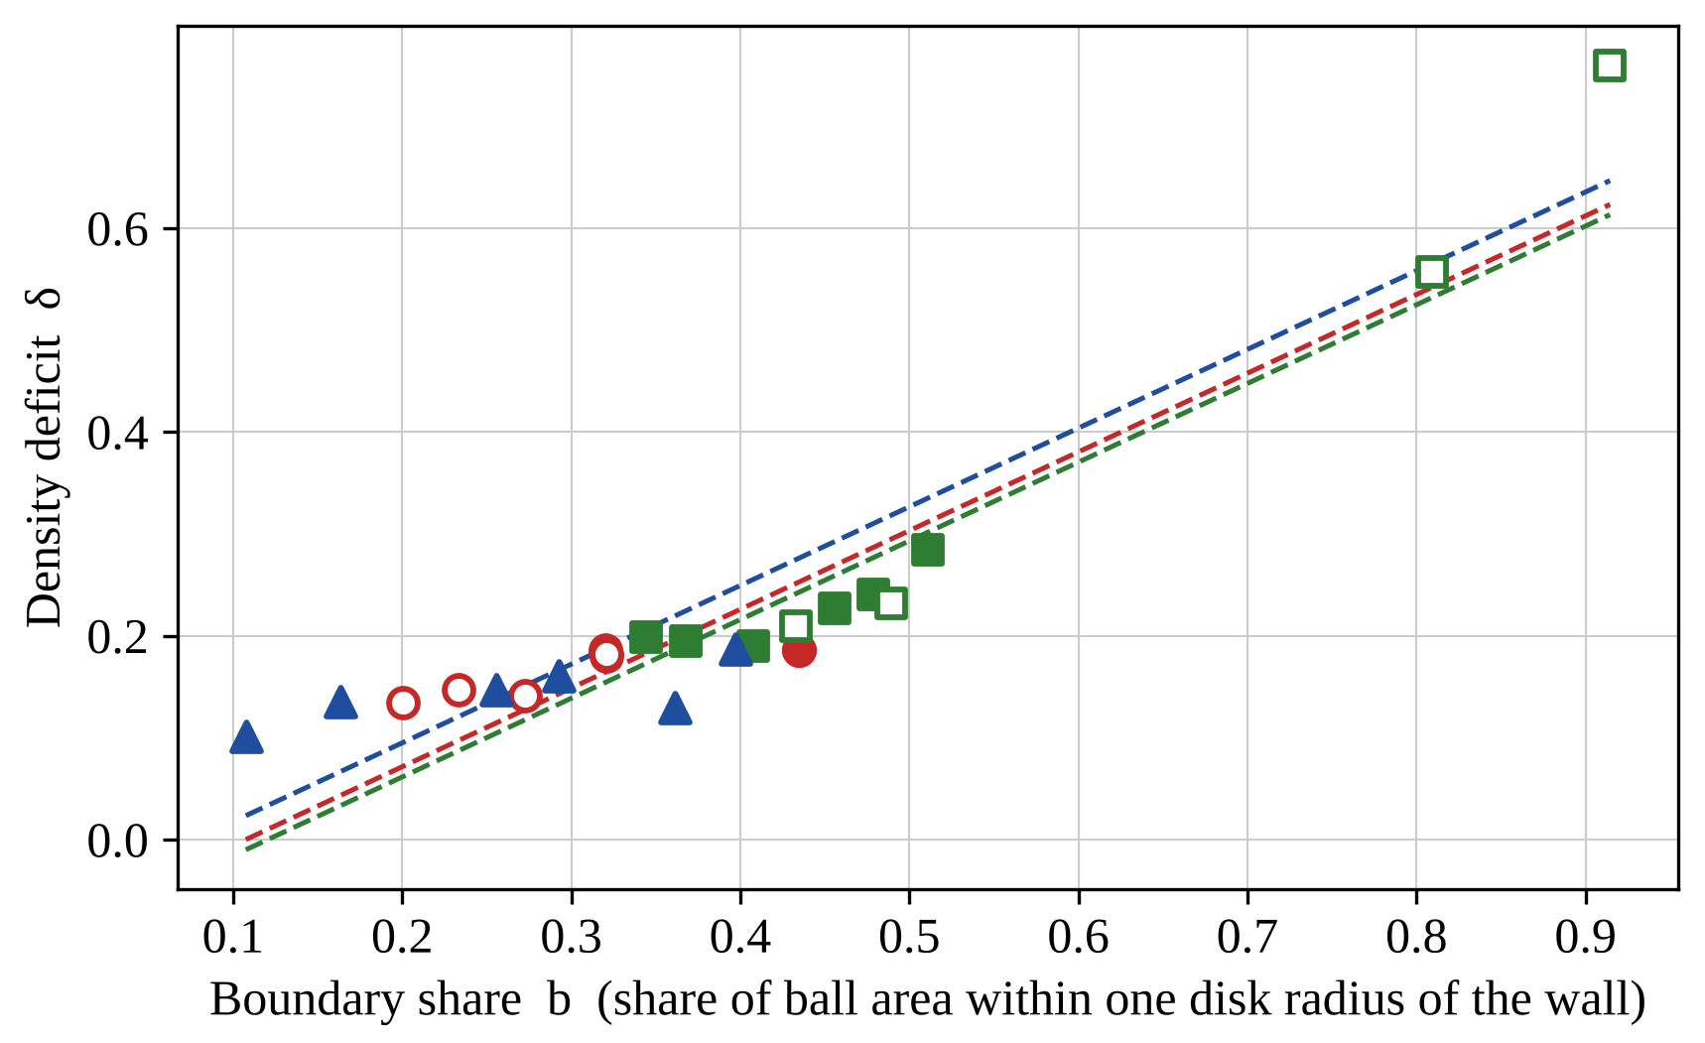
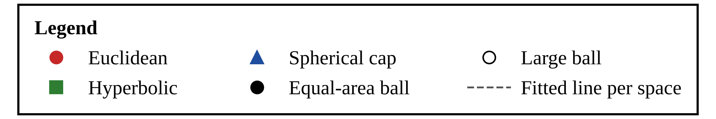
Note. Each point is one of the 26 ball conditions, using the best mean radius over the six methods at 1,500 sweeps. The deficit rises with the share of the ball’s area near its wall in all three spaces. Symbols: circles = Euclidean disk, squares = hyperbolic disk, triangles = spherical cap; filled = equal-area balls, open = large balls. Dashed lines = fitted lines with a common slope and a different intercept for each space (hyperbolic and cap terms from the regression described in the text). 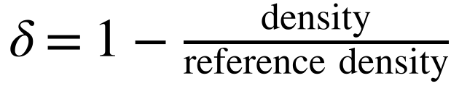; b = share of the ball’s area within one disk radius of the boundary. Both are dimensionless.
The author recorded the SHA-256 hash of that file on 2026-10-30 03:43 UTC; it is e9d6cf21391fbd2f262e192940c07482f82e43c08857c58f1624d405eb448424. The file, the Research Plan, and the earlier preregistration files were emailed to the research adviser before any run was started; the author reports this, and the adviser’s email is the independent record of the date. The runs began at 2026-10-31 06:42 UTC and ended at 2026-10-31 06:52 UTC (ROUND3_START.txt and ROUND3_END.txt).
Figure 10
Mean Relative Score of the Six Methods at Three Budget Levels
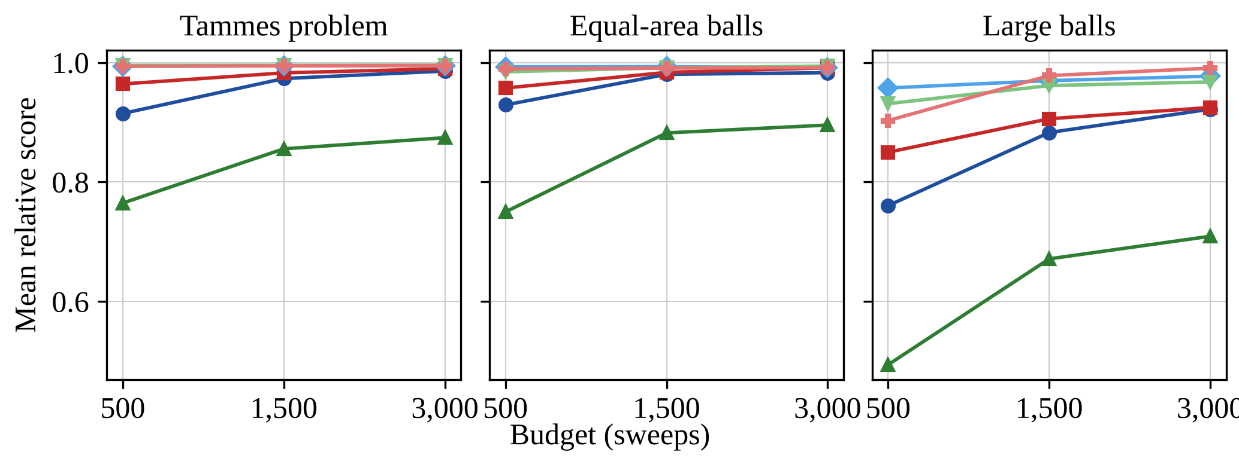
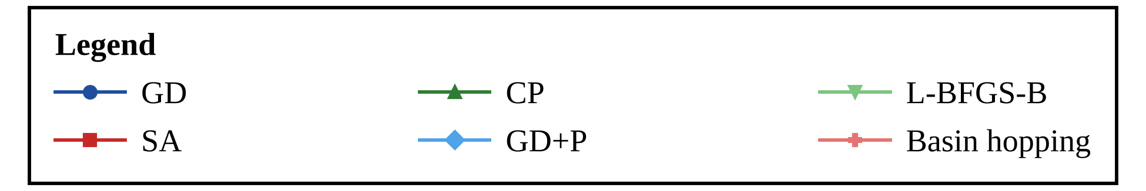
Note. The ordering of the methods is similar at the three budget levels; the gap between the methods is largest at 500 sweeps. Lines and markers: blue circles = GD, light blue diamonds = GD+P, red squares = SA, green triangles = compression, light green triangles = L-BFGS-B, light red crosses = basin hopping. Each point is the mean relative score over the conditions of the panel and 20 seeds; 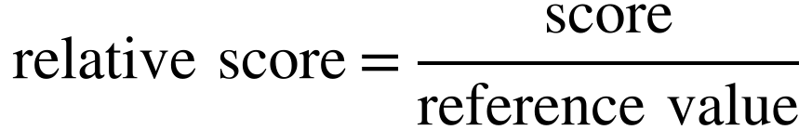 (dimensionless).
Table 19
Count-Based Version of the Disk Problem: Largest Number of Disks of Radius 0.30
Space | Area | Reference count | K | 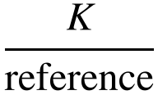 | Share at K
Cap | 6 | 19 | 16 | .84 | .75
Cap | 12 | 38 | 35 | .92 | .65
Euclidean | 6 | 19 | 15 | .79 | .95
Euclidean | 12 | 38 | 32 | .84 | .75
Hyperbolic | 6 | 19 | 14 | .74 | 1.00
Hyperbolic | 12 | 38 | 30 | .79 | .90
Note. K = largest number of disks of radius 0.30 for which GD+P at 1,500 sweeps reached a radius of at least 0.30 in at least half of 20 fresh seeds (201 to 220), scanned downward from the reference count; reference count = 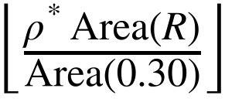, the number of disks that would fit if the ball were packed at the reference density of the whole space (a heuristic ceiling, not a theorem for a bounded ball). Share at K = share of seeds that reached the radius at K. Exploratory; no decision rule. Data: count_runs.csv, count_summary.csv.
Table 20
Wall Contact of the Final Configurations of All Ball Runs at 1,500 Sweeps
Method | Disks touching the wall | Runs with all disks in the outer ring | 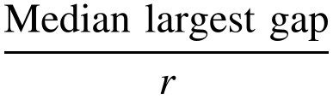
GD | .27 | .017 | 3.77
GD+P | .58 | .023 | 3.71
SA | .35 | .000 | 3.74
CP | .03 | .000 | 4.49
L-BFGS-B | .65 | .077 | 3.46
BH | .13 | .021 | 3.77
Note. Each row covers the 26 ball conditions and 20 seeds (520 runs). A disk touches the wall if its gap to the wall limit R − r is at most 1% of the disk radius r; a run has all disks in the outer ring if every disk lies within one disk radius of the wall limit; the 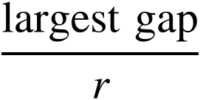 is the largest such gap in a run in units of r. Exploratory; no decision rule. Data: conf_walls_by_method.csv, conf_walls_by_condition.csv.

Design and Preregistered Rules
Part A used three spaces, eight ball areas (2, 3, 4, 5, 6, 8, 10, and 12), and six numbers of disks (8, 12, 16, 20, 24, and 32), 144 conditions in 48 cells of equal area and equal n. Each condition was run with polished gradient descent and L-BFGS-B at 1,500 sweeps and fresh seeds 501 to 520 (5,760 runs). For each condition the radius used is the larger of the two methods’ mean radii, the density deficit δ and the boundary share b are computed from it, and rule A1 fits δ = a + β b + g_{H} [hyperbolic] + g_{S} [cap]. The interval of each term comes from resampling the cells, not the conditions, because the three balls of a cell are paired. A curvature effect is detectable if the interval of g_{H} excludes 0 and g_{H} is at least .02, and absent if the interval lies within ±.02. Part B tested the rule on 20 new conditions with seeds 601 to 620. Here n_{ref} is the number of disks of radius r₀ that would fit in the ball at the upper bound on the density, b₀ is the boundary share at r₀, and 0.46 is the loss coefficient fitted in the follow-up and not refitted.

Result for Curvature
The preregistered answer is that there is no detectable curvature effect: the whole interval lies within ±.02, so any difference between the spaces at the same boundary share is smaller than .02 of the upper bound. The hyperbolic term was 0.010 (95% interval 0.004 to 0.017) and the cap term −0.009 (−0.018 to −0.001; no detectable curvature effect), with 144 conditions and a residual standard deviation of .022; the plan expected a half-width of about .03 for a residual of .058, and the half-width found for the hyperbolic term was .006 (Table 21; Figure 11). The decision means that no effect as large as .02 was found, not that the effect is zero: both intervals exclude 0, the hyperbolic term is positive and the cap term negative, and both are about 1% of the bound, so small effects of opposite sign remain possible and are not explained here. The slope on the boundary share was 0.22: in all three spaces the deficit rose with the boundary share. At equal area and equal number of disks the hyperbolic disk differed from the Euclidean disk by 0.021 and the cap by −0.029 in δ. These differences include the effect of the different boundary share and are descriptive. Because each condition used the larger mean radius of polished gradient descent and L-BFGS-B, the conclusion concerns what these two optimizers find at 1,500 sweeps, not every possible packing. The rule and the ±.02 margin were stated before the round, and the rule was applied once to all conditions, so the result does not depend on a choice made after the data were seen. The earlier tests of curvature were inconclusive; this one is not, because its interval is narrow enough to lie inside ±.02.
Table 21
Curvature Terms in the Final Round at Equal Area
Quantity | Estimate | 95% interval | Decision
Hyperbolic term, g_{H} (A1) | 0.010 | 0.004 to 0.017 | No detectable curvature effect
Cap term, g_{S} (A1, secondary) | −0.009 | −0.018 to −0.001 | No detectable curvature effect
Boundary-share slope, β | 0.218 | not part of the rule | —
Hyperbolic − Euclidean at equal area and n (A2) | 0.021 | 0.014 to 0.028 | Descriptive
Cap − Euclidean at equal area and n (A2) | −0.029 | −0.040 to −0.019 | Descriptive
Note. 144 conditions in 48 cells; intervals are percentile intervals of 10,000 resamples of the cells (seed 20261030). δ = density deficit; b = boundary share; the decision rule is in the text. Data: r3a_runs.csv, r3a_conditions.csv, round3_decisions.json.

Result for the Rule for the Number of Disks
The rule predicted the number of disks within one disk in 100% of the 20 new conditions and exactly in 75% (Table 22); the mean absolute error was 0.25 disks, the mean relative error .030, and the mean signed errors were −0.25 for the Euclidean disk, −0.12 for the hyperbolic disk, and 0.12 for the cap. The preregistered decision is that the rule is supported. The rule is a description of what these optimizers find at this budget. It gives the number of disks that fit as the number at the upper bound times (1 − 0.46 b₀), it does not explain why the loss is proportional to the boundary share, and its coefficient was fitted on one earlier round and then held fixed. It is original in the sense that it turns the count-based problem into a prediction that can be checked, but it is a rule for small balls (at most 46 disks here) and for the two methods used, and the number of disks found is a lower bound on the true maximum.
Table 22
Predicted and Found Number of Disks in the Final Round
Space | r₀ | b₀ | Reference count | K found | K predicted | Error
Euclidean | 0.30 | 0.375 | 20 | 16 | 17 | -1
Euclidean | 0.30 | 0.425 | 15 | 12 | 12 | 0
Euclidean | 0.30 | 0.475 | 11 | 9 | 9 | 0
Euclidean | 0.30 | 0.525 | 9 | 7 | 7 | 0
Hyperbolic | 0.25 | 0.375 | 28 | 23 | 23 | 0
Hyperbolic | 0.25 | 0.425 | 19 | 15 | 15 | 0
Hyperbolic | 0.25 | 0.475 | 14 | 10 | 11 | -1
Hyperbolic | 0.25 | 0.525 | 10 | 8 | 8 | 0
Hyperbolic | 0.35 | 0.375 | 46 | 38 | 38 | 0
Hyperbolic | 0.35 | 0.425 | 25 | 20 | 20 | 0
Hyperbolic | 0.35 | 0.475 | 16 | 13 | 13 | 0
Hyperbolic | 0.35 | 0.525 | 12 | 9 | 9 | 0
Cap | 0.25 | 0.375 | 16 | 13 | 13 | 0
Cap | 0.25 | 0.425 | 12 | 10 | 10 | 0
Cap | 0.25 | 0.475 | 10 | 8 | 8 | 0
Cap | 0.25 | 0.525 | 8 | 7 | 6 | +1
Cap | 0.35 | 0.375 | 13 | 11 | 11 | 0
Cap | 0.35 | 0.425 | 11 | 8 | 9 | -1
Cap | 0.35 | 0.475 | 9 | 7 | 7 | 0
Cap | 0.35 | 0.525 | 7 | 6 | 5 | +1
Note. K found = largest number of disks of radius r₀ reached by polished gradient descent in at least 10 of 20 fresh seeds (601 to 620); ; error = found − predicted. Data: r3b_design.csv, r3b_scan.csv, r3b_summary.csv.

Conclusions
This section answers the research questions, states the limits, and points to next steps.
Figure 11
Density Deficit Against Boundary Share in the Final Round
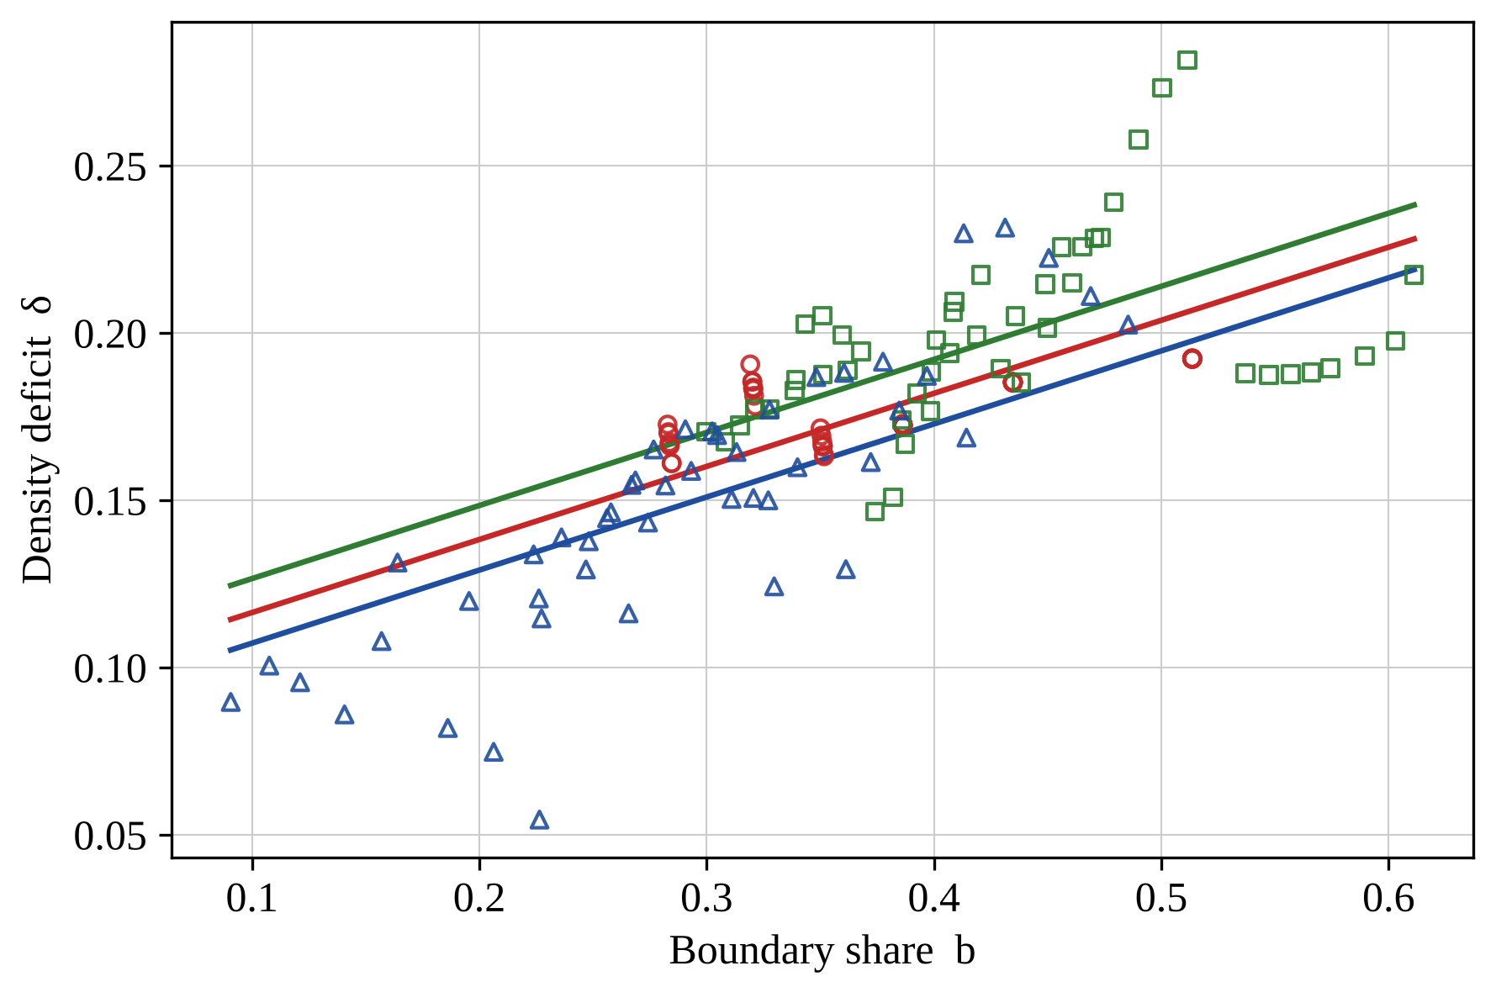
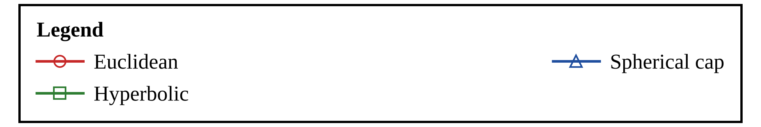
Note. Each point is one of the 144 equal-area conditions, using the larger mean radius of the two methods at 1,500 sweeps. The three fitted lines have a common slope and differ only in their intercepts. Symbols and lines: circles and red line = Euclidean disk, squares and green line = hyperbolic disk, triangles and blue line = spherical cap. ; b = share of the ball’s area within one disk radius of its wall (both dimensionless).

Summary of Findings
The findings rest first on the preregistered confirmatory round (fresh seeds, three budget levels, six methods, 33 conditions, 11,880 runs) and then on the first study, which is exploratory. Answering RQ1 on the confirmatory round, polished gradient descent had the best mean rank (1.70, against 2.48 for L-BFGS-B, 2.86 for basin hopping, 3.72 for simulated annealing, 4.24 for gradient descent, and 6.00 for compression), and the better of the added L-BFGS-B and basin-hopping baselines beat both gradient descent and simulated annealing in all 33 conditions, so the ranking of the first study, in which simulated annealing and gradient descent led, is a ranking among weaker methods. The best method at 1,500 sweeps was the best at 3,000 sweeps in only 70% of conditions, although the whole ordering was stable across budgets (median Kendall’s W .90). Answering RQ2, the relative score of compression fell from .977 at N = 9 to .679 at N = 60 and that of gradient descent from .999 to .922, while polished gradient descent, L-BFGS-B, and basin hopping stayed at or above .983 for N from 13 to 60, so the number of points hurts the weaker methods most. Answering RQ3, no method recovered the proven optimum within 0.1% in at least 90% of seeds for all of N = 9, 13, 14, and 24 (C6 not supported): the best shares were 1.00 at N = 9, .00 at N = 13, .80 at N = 14, and 1.00 at N = 24. Answering RQ4, the ranking of gradient descent and simulated annealing depended on the space (p = .011) but by less than .01 in relative score. The confirmatory round, the mini-round, and the follow-up could not settle whether curvature itself lowers the density; the final round of 144 equal-area conditions did so: with the boundary share in the model, the hyperbolic term was 0.010 (95% interval 0.004 to 0.017) and the cap term −0.009 (−0.018 to −0.001), so the preregistered decision is that no curvature effect as large as .02 of the density bound was detected. The intervals exclude zero, with opposite signs, so small effects of about 1% of the bound are not ruled out; the earlier withdrawn decision is in Appendix B. The boundary-share prediction is supported in the confirmatory round (Spearman r_{s} = .87), but that test is partly circular, because the deficit and the boundary share are both computed from the radius that the methods find, and its 26 conditions are paired. At a fixed radius, which removes the circularity, the mini-round was inconclusive (M1 .31) and the follow-up supported the correlation (.59, p < .001); the loss model is a description, not an explanation. Beyond benchmarking, the final round tested a rule for the number of disks that fit in a ball: it was within one disk in 100% of 20 new conditions (mean absolute error 0.25 disks), for balls of at most 46 disks.
The first study (exploratory; 30 paired seeds, 33 conditions, one budget, three methods) found that gradient descent and simulated annealing were close to each other and clearly ahead of the simplified compression method in all four settings (the sphere, the spherical cap, the Euclidean disk, and the hyperbolic disk; on the sphere, mean relative scores of .986 for gradient descent, .992 for simulated annealing, and .911 for compression). Simulated annealing had the best mean rank on the sphere, in the cap, and in the Euclidean disk, and gradient descent in the hyperbolic disk, and the difference between spaces was not significant after correction.
In exploratory follow-up runs (see Supplementary Exploratory Analyses), a max-min polishing step raised the mean relative score of gradient descent and the number of values of N with a success share of at least .90 (its linear programs are not charged in the sweep count; about 0.3 seconds per run); the confirmatory round then confirmed this for the ranking. At equal area, the ranking did not differ detectably across the three spaces; the preregistered comparison C3 did not reproduce this, though its difference is smaller than .01 in relative score. In the confirmatory round, for N = 13, no method reached a success share of .90, and 3 of 360 runs recovered the proven optimum to within 0.1%.
What can be concluded. Five conclusions are supported by the preregistered rounds and do not depend on exploratory labels. First, at an equal budget of distance evaluations, the better of the two stronger baselines (L-BFGS-B and basin hopping) beat plain gradient descent and simulated annealing in every one of 33 conditions, polished gradient descent had the best mean rank, and compression, as implemented here, is the weakest. Second, the order of the methods is stable across the three budgets, but the single best method changes with the budget. Third, packing density in a bounded ball falls short of the whole-space upper bound by an amount that grows with the share of the ball near its wall, in all three spaces. Fourth, recovery of the proven or best-known configuration within 0.1% depended on N: at 1,500 sweeps some method reached it in at least 80% of seeds for N = 9, 14, 24, and 30, but none did for N = 13, and the best shares were only .40 for N = 40 and .10 for N = 60. Fifth, in the final preregistered round no curvature effect larger than .02 of the density bound was found at equal area, and the number of disks that fit in a ball was predicted within one disk by a one-coefficient rule. Three things are not concluded: that curvature has exactly no effect (the final-round intervals exclude zero, with opposite signs, within about 1% of the bound), whether the boundary causes the loss (the boundary-loss model describes the data and does not explain them), and whether the configurations found are optimal. The practical recommendation rests on the first two conclusions: for a fixed budget, use polished gradient descent, L-BFGS-B, or basin hopping, not plain gradient descent, annealing, or this compression method; the polishing step helps in the confirmatory round and costs wall-clock time that the sweep count does not charge.
One failure is worth recording. In 1 of 30 seeds, gradient descent for N = 4 converged to four points on one great circle, with a minimum distance of instead of the tetrahedral value, which shows why repeated seeds matter even for four points.

Limitations on the Research Design and Material
The conclusions are limited as follows. (a) The first study used one budget level (1,500 sweeps); the confirmatory round used three levels (500, 1,500, and 3,000), and a larger budget could still change the ordering, especially for compression. (b) The compression method is a simplified, time-stepped version of the method of Lubachevsky and Stillinger (1990). (c) In the first study, algorithm parameters were tuned on four pilot seeds in four pilot conditions with grids of different sizes, and unequal tuning effort could favor one method; the confirmatory round used the same effort for all six methods (one parameter, six settings), but two methods were selected at the edge of their range, and after their ranges were extended (post hoc, nine settings for those two methods) L-BFGS-B was again selected at the edge. (d) Where no optimum is proven, the reference is a published best-known value (N = 30, 40 and 60; Sloane et al., n.d.; Cohn, n.d.) or else the best value found, so relative scores near 1 do not establish optimality; the polished variant exceeded the best value found in some ball conditions, which shows that a best-found reference can lie below what is reachable. (e) Problem B maximizes the radius for fixed n and R, and uses 6 settings with R = 2 or 3. The first study did not compare equal areas, so curvature and area are confounded in it; the confirmatory round compares equal areas, but only up to 4π for the sphere, and its boundary-share and curvature analyses rest on 26 conditions; and the cap with R = 3 covers almost the whole sphere. (f) The comparison of curvatures rests on six settings per space and an exploratory analysis, which is why RQ4 and H1 are exploratory. (g) The Wilcoxon symmetry assumption was doubtful in part of the comparisons, and the 0.1% success tolerance interacts with the exponent cap of gradient descent. (h) Run times describe this Python implementation on one machine. (i) No claim of global optimality is made for any configuration found. (j) Equal sweeps are not equal time: simulated annealing took several times longer per run than gradient descent (Table 12), and the linear programs of the polishing step are not charged in the sweep count. (k) The polishing step is one refinement (max-min by sequential linear programming). (l) The confirmatory round used one machine with two processes, 20 seeds, six methods with one tuned parameter each, a reference that is the best score found in 16 of 33 conditions, and a self-recorded preregistration hash. (m) The boundary-share test C1 is partly circular, because the density deficit and the boundary share are both computed from the radius that the methods find, and the 26 ball conditions are paired by area or by number of disks, so its permutation test assumes more independence than the design has. The mini-round designed to remove the circularity was inconclusive for M1 (Spearman r_{s} = .31), its decision M2 was withdrawn when three duplicated Euclidean conditions were removed, and the follow-up, with a second method, supported F1 (Appendix B); the boundary-loss model is a description, not an explanation. (n) The final round used two methods at one budget (1,500 sweeps), balls of at most 46 disks for the counting rule (a lower bound on the number that fit, from 20 seeds), and a loss coefficient (0.46) fitted in the follow-up; its curvature decision means that no effect above .02 was detected, not that the effect is zero, and its self-recorded hash is independent of the adviser’s email only by the author’s report. (o) The wall ring (every disk within one disk radius of the wall) occurred only in the two largest hyperbolic balls (radii 6 and 8) and is not a general result.

Implications and Future Directions
Well-spread point sets on spheres are used for sampling and for placing sensors or antennas, and packings in hyperbolic space relate to embeddings of tree-like networks. Within the limits above, the results suggest a practical rule that rests on the confirmatory round: at a fixed budget, use polished gradient descent, L-BFGS-B, or basin hopping, which beat gradient descent and annealing in all 33 conditions, and not the simplified compression method. The polishing step’s linear programs are not charged in the sweep count and cost extra wall-clock time, and the first study’s preference for gradient descent or annealing applies only among those weaker methods. Natural extensions are an event-driven compression method, larger budgets, more ball radii, equal-area and equal-density designs at areas beyond what the sphere can hold (in the Euclidean and hyperbolic planes only), a count-based version of Problem B for balls larger than the 46 disks tested here, and proofs or certified bounds for the best configurations found.

References
Absil, P.-A., Mahony, R., & Sepulchre, R. (2008). Optimization algorithms on matrix manifolds. Princeton University Press.
Böröczky, K. (1978). Packing of spheres in spaces of constant curvature. Acta Mathematica Academiae Scientiarum Hungaricae, 32, 243–261. https://doi.org/10.1007/BF01902361
Byrd, R. H., Lu, P., Nocedal, J., & Zhu, C. (1995). A limited memory algorithm for bound constrained optimization. SIAM Journal on Scientific Computing, 16(5), 1190–1208.
Cannon, J. W., Floyd, W. J., Kenyon, R., & Parry, W. R. (1997). Hyperbolic geometry. In S. Levy (Ed.), Flavors of geometry (pp. 59–115). Cambridge University Press.
Cohn, H. (n.d.). Spherical codes [Table of best known spherical codes]. Massachusetts Institute of Technology. https://cohn.mit.edu/spherical-codes/
Danzer, L. (1963). Endliche Punktmengen auf der 2-Sphäre mit möglichst grossem Minimalabstand [Habilitation thesis]. Universität Göttingen.
Fejes Tóth, L. (1943). Über eine Abschätzung des kürzesten Abstandes zweier Punkte eines auf einer Kugelfläche liegenden Punktsystems. Jahresbericht der Deutschen Mathematiker-Vereinigung, 53, 66–68.
Hajek, B. (1988). Cooling schedules for optimal annealing. Mathematics of Operations Research, 13(2), 311–329. https://doi.org/10.1287/moor.13.2.311
Holm, S. (1979). A simple sequentially rejective multiple test procedure. Scandinavian Journal of Statistics, 6(2), 65–70.
Kirkpatrick, S., Gelatt, C. D., Jr., & Vecchi, M. P. (1983). Optimization by simulated annealing. Science, 220(4598), 671–680. https://doi.org/10.1126/science.220.4598.671
Liu, D. C., & Nocedal, J. (1989). On the limited memory BFGS method for large scale optimization. Mathematical Programming, 45(1–3), 503–528.
Lubachevsky, B. D., & Stillinger, F. H. (1990). Geometric properties of random disk packings. Journal of Statistical Physics, 60, 561–583. https://doi.org/10.1007/BF01025983
Metropolis, N., Rosenbluth, A. W., Rosenbluth, M. N., Teller, A. H., & Teller, E. (1953). Equation of state calculations by fast computing machines. The Journal of Chemical Physics, 21(6), 1087–1092. https://doi.org/10.1063/1.1699114
Musin, O. R., & Tarasov, A. S. (2012). The strong thirteen spheres problem. Discrete & Computational Geometry, 48(1), 128–141. https://doi.org/10.1007/s00454-011-9392-2
Musin, O. R., & Tarasov, A. S. (2015). The Tammes problem for N = 14. Experimental Mathematics, 24(4), 460–468. https://doi.org/10.1080/10586458.2015.1022842
Robinson, R. M. (1961). Arrangement of 24 points on a sphere. Mathematische Annalen, 144, 17–48.
Saff, E. B., & Kuijlaars, A. B. J. (1997). Distributing many points on a sphere. The Mathematical Intelligencer, 19(1), 5–11.
Schütte, K., & van der Waerden, B. L. (1951). Auf welcher Kugel haben 5, 6, 7, 8 oder 9 Punkte mit Mindestabstand Eins Platz? Mathematische Annalen, 123, 96–124.
Sloane, N. J. A., Hardin, R. H., Smith, W. D., & others. (n.d.). Tables of spherical codes [Data set]. http://neilsloane.com/packings/
Specht, E. (n.d.). Packomania: Circles in a circle [Data set]. http://www.packomania.com/
Tammes, P. M. L. (1930). On the origin of number and arrangement of the places of exit on the surface of pollen-grains. Recueil des Travaux Botaniques Néerlandais, 27, 1–84.
Virtanen, P., Gommers, R., Oliphant, T. E., Haberland, M., Reddy, T., Cournapeau, D., Burovski, E., Peterson, P., Weckesser, W., Bright, J., van der Walt, S. J., Brett, M., Wilson, J., Millman, K. J., Mayorov, N., Nelson, A. R. J., Jones, E., Kern, R., Larson, E., ... SciPy 1.0 Contributors. (2020). SciPy 1.0: Fundamental algorithms for scientific computing in Python. Nature Methods, 17(3), 261–272. https://doi.org/10.1038/s41592-019-0686-2
Wales, D. J., & Doye, J. P. K. (1997). Global optimization by basin-hopping and the lowest energy structures of Lennard-Jones clusters containing up to 110 atoms. The Journal of Physical Chemistry A, 101(28), 5111–5116. https://doi.org/10.1021/jp970984n
Wilcoxon, F. (1945). Individual comparisons by ranking methods. Biometrics Bulletin, 1(6), 80–83. https://doi.org/10.2307/3001968

Appendix A: Sensitivity of the Main Results to Budget, Parameters, and Starting Configuration
This appendix holds the three sensitivity tables referred to in the Supplementary Exploratory Analyses: Table A1 gives the mean relative score at three budgets, Table A2 the effect of changing one parameter at a time, and Table A3 the spread over starting configurations.
Table A1
Mean Relative Score at Three Budgets
Condition | Algorithm | 500 sweeps | 1,500 sweeps | 3,000 sweeps
Tammes N = 13 | GD | .979 | .983 | .984
 | SA | .981 | .988 | .989
 | CP | .795 | .932 | .954
Tammes N = 30 | GD | .897 | .973 | .988
 | SA | .954 | .982 | .987
 | CP | .604 | .801 | .823
Cap, R = 3, n = 19 | GD | .961 | .989 | .993
 | SA | .978 | .991 | .996
 | CP | .710 | .877 | .894
Euclidean, R = 3, n = 19 | GD | .897 | .968 | .971
 | SA | .945 | .974 | .991
 | CP | .584 | .816 | .849
Hyperbolic, R = 3, n = 19 | GD | .896 | .967 | .987
 | SA | .892 | .946 | .969
 | CP | .664 | .839 | .871
Note. Mean over 30 seeds, relative to the reference value of the main study (a value above 1.000 would exceed it). The 1,500-sweep column is the main study; the other columns use the same starting configurations and random streams. GD = gradient descent; SA = simulated annealing; CP = compression. Data: runs_raw.csv, supp_sensitivity_runs.csv.
Table A2
Mean Relative Score With One Parameter Changed
Setting | N = 13 | N = 30 | Cap | Euclid. | Hyperb. | Mean
GD: p_{max} = 75 | .979 | .973 | .985 | .967 | .972 | .975
GD: p_{max} = 150 (default) | .983 | .973 | .989 | .968 | .967 | .976
GD: p_{max} = 300 | .985 | .972 | .990 | .965 | .963 | .975
SA: T₀ = 0.005 (default 0.02) | .989 | .976 | .989 | .976 | .944 | .975
SA: T₀ = 0.02 (default) | .988 | .982 | .991 | .974 | .946 | .976
SA: T₀ = 0.08 | .987 | .975 | .990 | .973 | .943 | .974
CP: γ₀ = 0.10 | .897 | .733 | .823 | .735 | .736 | .785
CP: γ₀ = 0.25 (default) | .932 | .801 | .877 | .816 | .839 | .853
CP: γ₀ = 0.50 | .942 | .820 | .893 | .841 | .866 | .872
Note. Mean relative score over 30 seeds at 1,500 sweeps; N = 13 and N = 30 are Tammes problems; “Cap”, “Euclid.”, and “Hyperb.” are the balls with R = 3 and n = 19. p_{max} = final exponent of gradient descent; T₀ = initial temperature of simulated annealing as a multiple of the length scale; γ₀ = initial growth rate of compression. One parameter was changed at a time. Data: runs_raw.csv, supp_sensitivity_runs.csv.

Table A3
Spread of the Relative Score Over 30 Starting Configurations
Condition | GD | SA | CP
Tammes N = 13 | .983 (.979–.985) | .987 (.979–.996) | .930 (.914–.954)
Tammes N = 30 | .973 (.958–.990) | .984 (.960–.997) | .801 (.753–.832)
Cap, R = 3, n = 19 | .988 (.968–1.000) | .992 (.980–.999) | .878 (.842–.895)
Euclidean, R = 3, n = 19 | .982 (.884–.999) | .974 (.931–1.000) | .818 (.761–.864)
Hyperbolic, R = 3, n = 19 | .972 (.839–1.000) | .949 (.850–.998) | .840 (.797–.875)
Note. Median relative score, with the minimum and maximum in parentheses, of single runs at 1,500 sweeps (seeds 1 to 30); each seed gives one starting configuration shared by the three algorithms. GD = gradient descent, SA = simulated annealing, CP = compression. Standard deviations are in supp_initialization_spread.csv. Data: runs_raw.csv.

Appendix B: Mini-Round, Follow-Up, and the Withdrawn Decision
This appendix keeps the history of the work between the confirmatory round and the final round, including a decision that was withdrawn. It is not needed to follow the main results. The Research Plan holds the dated version history in its Appendix A.

Additions After the First Analysis
Five additions were made after the results above were seen. They were written in a second preregistration file (PREREGISTRATION_ADDENDUM_1.md, SHA-256 abfc572a207fdb943b067ff54851cbabe5736039b0ed399c10144b4db87225dd), a mini-round file (PREREGISTRATION_MINIROUND.md, SHA-256 3b6702f683023611d6f4a7549317d3e11be674fff08a85ed451bf46969df5492), both hashed on 2026-10-29 at 07:32:46 UTC before any of the runs they describe, and a follow-up file (PREREGISTRATION_FOLLOWUP.md, SHA-256 d8a5f5101148869a4a39c91c4e1a64f938a41a2f96caa2224c0b49b281334a0b), hashed on 2026-10-29 at 23:33:06 UTC before its runs. The addendum lists what was decided after the first round had been seen: the Packomania references, the extended tuning ranges, the saved configurations and the wall analysis, and a correction of the wording of the reference density (an upper bound on the density, not the density of a densest packing). The first preregistration file was not edited. A hash recorded by the author is not an independent time stamp; the author reports having emailed the preregistration of the confirmatory round to the research adviser on October 28, 2026, before the runs of that round. The adviser’s email, not the author’s hash, is the independent record of the date of that file; the addendum, the mini-round file, and the follow-up file are preregistered by the author’s hash alone.

Mini-Round With a Fixed Radius and a Matched Boundary Share
In the main round the boundary share depends on the radius each method finds, and the spaces differ in boundary share, so C1 is partly circular and C2 could not separate curvature from the boundary. The mini-round fixes the disk radius r₀ (0.30 or 0.40) and the design boundary share b₀ (0.40, 0.45, or 0.50) in advance, and chooses the radius of each ball so that b₀ is the same in the Euclidean disk, the hyperbolic disk, and the spherical cap while the curvature differs (Table 23). The matched boundary share requires much larger hyperbolic balls than Euclidean ones for the same r₀. The Euclidean plane has no length scale, so a packing of disks of radius 0.40 in a disk of radius R is a scaled copy of a packing of disks of radius 0.30 in a disk of radius 0.75 R: with the same b₀ the Euclidean conditions at r₀ = 0.30 and 0.40 are the same problem and gave the same K (Table 23). The six Euclidean conditions are therefore three distinct ones, and the model fitted on them in M3 rests on three independent points. The hyperbolic disk and the cap have a length scale, so their conditions at different r₀ are different problems. For each ball the number of disks K is the largest n for which GD+P at 1,500 sweeps reaches radius r₀ in at least 10 of 20 fresh seeds (301 to 320), and the fixed-radius deficit is 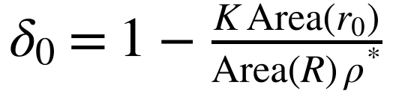. Because b₀ and r₀ are set by design, δ₀ is not circular in the sense of C1; it is still a lower bound on the true deficit, because a failure to find K + 1 disks does not prove that they do not fit.
For M1 the Spearman correlation between b₀ and δ₀ over the 18 conditions was r_{s} = .31 (one-sided permutation p = .103), which is inconclusive at the preregistered thresholds (supported at .50 or more with p < .05); the values of K are small integers, so δ₀ changes in coarse steps, and 18 conditions give little power. For M2, with the boundary share and the radius in the model, the hyperbolic term was 0.007 (95% interval −0.032 to 0.046) and the cap term 0.007 (−0.032 to 0.047), so the decision computed under the preregistered rule was “no detectable curvature effect”. That decision is withdrawn: it used 13 degrees of freedom, which counted the three duplicated Euclidean conditions as independent, and the sample was 15 conditions, not 18. The withdrawal was decided after the result was seen, so the analysis without the duplicates is post hoc; both analyses are given side by side in Table 24. A correction note (CORRECTION_NOTE_1.md, SHA-256 80df1f48699de18153ca678d31e4758acf98bc8233f502a51d178987f23fe1ff, hashed 2026-10-30 at 02:51:08 UTC) records the withdrawal. With the duplicates removed, M2 is inconclusive and M1 stays inconclusive, so the mini-round does not show that curvature has no effect at a matched boundary share; the follow-up below was designed to add power. For M3 the boundary-loss model δ₀ = λ b₀ with λ = .53 fitted on the six Euclidean conditions predicted the twelve other conditions with a mean absolute error of .028, so the model describes the other spaces at the preregistered thresholds (at most .05). Applied after the fact to the 26 ball conditions of the main round (exploratory; λ = .50 from the 10 Euclidean conditions), the mean absolute error for the other 16 conditions was .047 (.055 in the hyperbolic disk and .033 in the cap). The mini-round used one method at one budget, so it says what GD+P finds, not what is possible, and the three rules were not corrected for the six rules of the main round.
Table 23
Mini-Round Conditions With a Fixed Disk Radius and a Matched Boundary Share
r₀ | b₀ | Space | R | Reference count | K | δ₀
0.30 | 0.40 | Euclidean | 1.331 | 17 | 14 | .216
0.30 | 0.40 | Hyperbolic | 1.503 | 27 | 22 | .193
0.30 | 0.40 | Cap | 1.218 | 13 | 10 | .246
0.30 | 0.45 | Euclidean | 1.161 | 13 | 10 | .264
0.30 | 0.45 | Hyperbolic | 1.261 | 18 | 14 | .230
0.30 | 0.45 | Cap | 1.088 | 10 | 8 | .262
0.30 | 0.50 | Euclidean | 1.024 | 10 | 8 | .243
0.30 | 0.50 | Hyperbolic | 1.085 | 13 | 9 | .309
0.30 | 0.50 | Cap | 0.976 | 8 | 7 | .213
0.40 | 0.40 | Euclidean | 1.775 | 17 | 14 | .216
0.40 | 0.40 | Hyperbolic | 2.315 | 46 | 36 | .221
0.40 | 0.40 | Cap | 1.537 | 11 | 8 | .275
0.40 | 0.45 | Euclidean | 1.548 | 13 | 10 | .264
0.40 | 0.45 | Hyperbolic | 1.828 | 24 | 19 | .229
0.40 | 0.45 | Cap | 1.389 | 9 | 7 | .252
0.40 | 0.50 | Euclidean | 1.366 | 10 | 8 | .243
0.40 | 0.50 | Hyperbolic | 1.528 | 15 | 11 | .307
0.40 | 0.50 | Cap | 1.258 | 7 | 6 | .242
Note. r₀ = disk radius, b₀ = design boundary share, R = radius of the ball (units of the space), reference count = 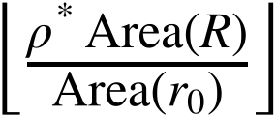, K = largest number of disks found at radius r₀ (GD+P, 1,500 sweeps, at least 10 of 20 seeds, seeds 301 to 320), δ₀ = fixed-radius density deficit. Data: mini_design.csv, mini_scan.csv, mini_summary.csv, mini_decisions.json.
Table 24
Mini-Round Results as Preregistered and After Removing the Duplicated Euclidean Conditions
Rule | As preregistered (18 conditions) | Duplicates removed (15 conditions; post hoc)
M1: Spearman correlation of b₀ and δ₀ (one-sided permutation p) | .31 (p = .103): inconclusive | .30 (p = .143): inconclusive
M2: hyperbolic term (95% interval) | 0.007 (−0.032 to 0.046), 13 df: no detectable curvature effect (withdrawn) | 0.001 (−0.058 to 0.060), 10 df: inconclusive
M2: cap term (95% interval) | 0.007 (−0.032 to 0.047): no detectable curvature effect (withdrawn) | 0.001 (−0.058 to 0.060): inconclusive
M3: mean absolute error of the boundary-loss model | .028 (λ from 6 Euclidean conditions, 3 distinct): describes the other spaces | .028 (λ from 3 Euclidean conditions): describes the other spaces
Note. The left column applies the preregistered rules to all 18 conditions; the right column drops the three Euclidean conditions at r₀ = 0.40, which duplicate those at 0.30, and was decided after the result was seen, so it is post hoc. The preregistered decision of M2 is withdrawn (see text). Data: mini_decisions.json, followup_decisions.json.

Follow-Up With More Levels, a Third Radius, and a Second Method
A follow-up with its own preregistration (SHA-256 d8a5f5101148869a4a39c91c4e1a64f938a41a2f96caa2224c0b49b281334a0b, hashed 2026-10-29 at 23:33:06 UTC, before its runs) removed the Euclidean duplicates and added power: five design boundary shares (0.35 to 0.55), three disk radii (0.20, 0.30, and 0.40) for the hyperbolic disk and the cap, one Euclidean condition for each boundary share because the Euclidean results do not depend on r₀, and fresh seeds 401 to 420, in 33 conditions (Table 25). The revised set of boundary shares (0.35 and 0.55 were added), the third radius, and the second method were all written in that file before any of its runs. The runs started at 23:34 UTC on October 29, 2026, about one minute after the hash was recorded, and the two-method runs ended at 23:43 UTC (file time stamps; FOLLOWUP_RUNTIMES.txt). F1 to F3 are therefore preregistered by the author’s hash alone; the time stamps of the runs come from the machine that ran them. The number of disks K of a condition was computed with two methods, GD+P and L-BFGS-B (re-tuned value 2,500), each scanned downward from the reference count, and the larger of the two is used, because a lower bound from one method is weak and a second method can only raise it. For F1, the Spearman correlation between b₀ and δ₀ over the 33 conditions was r_{s} = .59 (p < .001), so the prediction that the fixed-radius deficit follows the design boundary share is supported at the preregistered thresholds; unlike in the main round, this test does not use a radius found by a method, so it is not circular in the way C1 is. For F2, with b₀ and the radius in the model, the hyperbolic term was 0.025 (95% interval −0.021 to 0.070) and the cap term 0.040 (−0.005 to 0.086), so the decision is inconclusive: both terms are positive and small, neither interval excludes 0, and neither interval lies within ±.05, so a curvature effect could be neither shown nor excluded. For F3, the boundary-loss model δ₀ = λ b₀ with λ = .46 fitted on the 5 Euclidean conditions predicted the other 28 with a mean absolute error of .042 (.036 for the hyperbolic disk and .049 for the cap), so the model describes the other spaces at the thresholds, with the cap error close to the limit of .05. The second method added nothing to the first: L-BFGS-B found a larger K than GD+P in 0 of 33 conditions, the same in 28, and a smaller one in 5, and on the distinct conditions of the mini-round (exploratory) it found a larger K in none. The two methods agree, which supports the values of K as what these optimizers find at this budget; it does not show that more disks cannot fit.
The boundary-loss model is a description, not an explanation. It has one parameter fitted on the Euclidean disk, it is not derived from a theory of how a wall disturbs a packing. Agreement of its predictions with the other two spaces shows that the deficit is similar at the same boundary share, not that the boundary causes the loss or that curvature does not matter. A different one-parameter family could fit as well. In addition, because the number of disks is an integer that changes in steps, δ₀ changes in steps of about .05 to .10 for the smallest balls, which limits what can be seen at a boundary share near 0.55.
Table 25
Follow-Up Conditions and the Number of Disks Found by Two Methods
Space | r₀ | b₀ | R | Reference count | K GD+P | K L-BFGS-B | K | δ₀
Euclidean | 0.30 | 0.35 | 1.548 | 24 | 20 | 19 | 20 | .172
Euclidean | 0.30 | 0.40 | 1.331 | 17 | 14 | 14 | 14 | .216
Euclidean | 0.30 | 0.45 | 1.161 | 13 | 10 | 10 | 10 | .264
Euclidean | 0.30 | 0.50 | 1.024 | 10 | 8 | 8 | 8 | .243
Euclidean | 0.30 | 0.55 | 0.911 | 8 | 7 | 7 | 7 | .164
Hyperbolic | 0.20 | 0.35 | 1.109 | 30 | 25 | 25 | 25 | .188
Hyperbolic | 0.20 | 0.40 | 0.931 | 21 | 17 | 17 | 17 | .194
Hyperbolic | 0.20 | 0.45 | 0.801 | 15 | 12 | 12 | 12 | .216
Hyperbolic | 0.20 | 0.50 | 0.700 | 11 | 8 | 8 | 8 | .307
Hyperbolic | 0.20 | 0.55 | 0.618 | 8 | 7 | 7 | 7 | .216
Hyperbolic | 0.30 | 0.35 | 1.876 | 46 | 38 | 35 | 38 | .190
Hyperbolic | 0.30 | 0.40 | 1.503 | 27 | 22 | 21 | 22 | .193
Hyperbolic | 0.30 | 0.45 | 1.261 | 18 | 14 | 14 | 14 | .230
Hyperbolic | 0.30 | 0.50 | 1.085 | 13 | 9 | 9 | 9 | .309
Hyperbolic | 0.30 | 0.55 | 0.950 | 9 | 7 | 7 | 7 | .282
Hyperbolic | 0.40 | 0.40 | 2.315 | 46 | 36 | 35 | 36 | .221
Hyperbolic | 0.40 | 0.45 | 1.828 | 24 | 19 | 18 | 19 | .229
Hyperbolic | 0.40 | 0.50 | 1.528 | 15 | 11 | 11 | 11 | .307
Hyperbolic | 0.40 | 0.55 | 1.314 | 11 | 8 | 8 | 8 | .285
Cap | 0.20 | 0.35 | 0.973 | 19 | 16 | 16 | 16 | .194
Cap | 0.20 | 0.40 | 0.851 | 15 | 12 | 12 | 12 | .224
Cap | 0.20 | 0.45 | 0.751 | 12 | 9 | 9 | 9 | .263
Cap | 0.20 | 0.50 | 0.668 | 9 | 7 | 7 | 7 | .282
Cap | 0.20 | 0.55 | 0.597 | 7 | 5 | 5 | 5 | .365
Cap | 0.30 | 0.35 | 1.372 | 16 | 13 | 13 | 13 | .200
Cap | 0.30 | 0.40 | 1.218 | 13 | 10 | 10 | 10 | .246
Cap | 0.30 | 0.45 | 1.088 | 10 | 8 | 8 | 8 | .262
Cap | 0.30 | 0.50 | 0.976 | 8 | 7 | 7 | 7 | .213
Cap | 0.30 | 0.55 | 0.879 | 7 | 5 | 5 | 5 | .317
Cap | 0.40 | 0.40 | 1.537 | 11 | 8 | 8 | 8 | .275
Cap | 0.40 | 0.45 | 1.389 | 9 | 7 | 7 | 7 | .252
Cap | 0.40 | 0.50 | 1.258 | 7 | 6 | 6 | 6 | .242
Cap | 0.40 | 0.55 | 1.142 | 6 | 5 | 5 | 5 | .251
Note. K = larger of the two method values. Seeds 401 to 420, 1,500 sweeps, at least 10 of 20 seeds at radius r₀; other symbols as in the mini-round table. The Euclidean disk is run at r₀ = 0.30 only because its results do not depend on r₀. Data: followup_design.csv, followup_scan.csv, followup_summary.csv, followup_decisions.json.

