Predicting Quarterly Airbnb Booking Demand in New York City with Tree-Based Ensembles and a Weighted Model Blend
Anonymous Author(s)
Abstract
Forecasting how heavily a short-term rental will be booked is a valuable but difficult problem for both hosts and the platforms that connect them with guests. This study addresses the prediction of the total number of nights blocked (effectively booked) in the first quarter of 2026 for approximately 36,000 active short-term-rental properties in New York City, using the open Inside Airbnb data and evaluated by Mean Squared Error (MSE) on a held-out test set. The target is a censored, zero-inflated count in $[0,90]$, with a $49.6\%$ mass at zero, which makes it a challenging demand-forecasting task; a strict rule is enforced throughout that no feature may be built from information later than December 2025, so the model never sees data from the target quarter it is predicting. Starting from a static listings snapshot and six months of calendar/review history (79 million listing-day rows, July– December 2025), a flat matrix of 206 features per property is engineered, covering calendar-occupancy dynamics at several horizons, cross-snapshot calendar-volatility signals unique to a repeatedly-rescraped dataset, recency and trajectory features, review velocity, price/revenue proxies, host attributes, amenities and title keywords, and neighbourhood/geo-cluster context. Nine model configurations—Linear Regression, Random Forest, Gradient Boosting, three XGBoost variants, a PyTorch Multi-Layer Perceptron (MLP) trained with Adam, LightGBM, and CatBoost—are compared inside leakage-safe scikit-learn pipelines, and the boosted trees are tuned with a randomized search that uses fold-level early stopping. The best single model, a tuned XGBoost regressor, reaches a 5-fold cross-validation MSE of 295.7, and a convex (SLSQP) weighted blend of all nine models lowers the out-of-fold MSE further to 290.1. The target-encoding, search, MLP, and blending objectives are defined formally, and the blend gain is verified with a paired significance test ($t=7.27$, $p=3.7×{10}^{−13}$) and a residual analysis on the bounded $[0,90]$ target that motivates a two-stage hurdle model, which is implemented rather than only proposed. On a held-out local test split (20% of the data) the final blend reaches an MSE of 286.1, and an ablation study quantifies the contribution of each pipeline component.
Predicting Quarterly Airbnb Booking Demand in New York City
Index Terms—Airbnb, demand forecasting, regression, ensemble learning, XGBoost, LightGBM, CatBoost, random forest, multi-layer perceptron, model blending, target encoding, hurdle model, constrained optimization, mean squared error, feature engineering.

I. Introduction
the last ten years, peer-to-peer (P2P) accommodation platforms have reshaped the way people travel and the way property owners earn money from their homes. Airbnb is the most visible example of this shift, with millions of active listings spread across more than a hundred thousand cities worldwide [1]. For a platform of that size, two questions tend to dominate operations: what is a fair price for a given listing, and how much demand will that listing receive over a future period. This study addresses the second question and carries it through to a complete, empirically validated solution, using the open Inside Airbnb data [2] for New York City over a July 2025 – March 2026 window rather than a fixed academic snapshot.
Predicting demand a quarter in advance is valuable for several practical reasons. A host who anticipates a busy three-month period can schedule cleaning and maintenance, raise prices for high-demand weeks, or hire help. The platform can plan customer-support capacity, target marketing toward listings that appear likely to be under-booked, and provide better pricing recommendations. Predicting demand remains challenging, however, because it arises from the complex interplay of many factors—property type and capacity, neighbourhood, seasonality, host responsiveness, review history, and how aggressively the price moves during the period. Classical linear models have been applied to such accommodation data [3], [4], but a consistent finding in the recent literature is that machine-learning models, and tree-based ensembles in particular, perform better on the mixed numerical and categorical tables that describe short-term rentals [5], [6], [7].
The task studied here is to predict, for every active property in New York City, the total number of nights blocked (effectively booked) during the first quarter (January, February, March) of 2026, using only information observed through the end of 2025. Because that quarter contains 90 days, the target is an integer in $[0,90]$, and predictions are evaluated by Mean Squared Error (MSE). Two structural properties make this harder than the price-prediction tasks that dominate the literature: the target is censored at both ends and is zero-inflated, with $49.6\%$ of properties blocked for zero nights in the quarter.
Research gap. While the current literature applies tree-based models extensively to short-term-rental price prediction, systematic frameworks that jointly address extreme zero-inflation (here a $49.6\%$ zero mass) and a hard bounded support $[0,90]$ in a demand-forecasting setting under a strict historical-only feature constraint, and that combine heterogeneous learners through an optimized convex ensemble, remain under-explored. This work targets that gap: it pairs leakage-safe temporal feature engineering with a constrained (SLSQP) convex blend and an implemented two-stage hurdle model, formalizes each component mathematically, and validates the resulting gain statistically, against modern gradient-boosting baselines, and on a genuinely held-out future-quarter local test split.
The remainder of the paper is organized as follows. Section 2 reviews related work on rental-demand prediction, tree-based ensembles, hyper-parameter tuning, and preprocessing, and gives a mathematical argument for why linear models struggle with a zero-inflated bounded target. Section 3 states the problem and describes the dataset. Section 4 presents the full methodology, defining every component —the target encoder, the search procedure, the MLP, and the blend—with explicit equations. Section 5 reports the results, the comparison against SOTA baselines, a significance test, a residual analysis, an implemented hurdle model, and a failure-case study. Section 6 presents an ablation study. Section 7 discusses limitations and concludes.

II. Literature Review
The related work is grouped into four areas: (A) machine learning for Airbnb prediction tasks, (B) decision trees and tree-based ensembles, (C) hyper-parameter tuning and model validation, and (D) data preprocessing and feature engineering.

A. Machine Learning for Airbnb Prediction Tasks
Several studies apply machine learning directly to Airbnb data. Tang, Cheng, and Zhang [5] worked with listings from Sydney and compared ten algorithms including Random Forest, Gradient Boosting, and CatBoost for price prediction. CatBoost gave them the lowest root mean squared error, and the most influential features were the maximum number of guests, the number of bedrooms, and whether the room was private or shared. Camatti et al. [6] ran a comparative analysis of artificial-intelligence and traditional linear methods on Dutch Airbnb listings, and concluded that tree-based and neural-network methods overfit less than linear regression, though linear models are still handy for reading off which predictors matter. Rezazadeh Kalehbasti, Nikolenko, and Rezaei [7] predicted New York City Airbnb prices using property features, host characteristics, and the sentiment of customer reviews; their best model was a regularized linear model built on review-text features, but tree models such as Random Forest and Support Vector Regression were close behind.
Other work looks at demand rather than price, which is closer to the present task. Siker [8] tackled the Kaggle “Airbnb New User Bookings” problem with XGBoost, and even though the target there (destination country) is different from ours, the workflow—heavy feature engineering followed by gradient boosting—matches how most Airbnb-style Kaggle problems are solved in practice. Chapman, Mohammad, and Villegas [9] studied dynamic short-term rental markets and built a pipeline that merged listing, calendar, and review data; they again found gradient boosting beating linear regression. Islam et al. [10] combined a Latent Dirichlet Allocation topic model over property descriptions with an XGBoost regressor and improved price prediction on the San Jose dataset. Two lessons from this group informed the present design: first, the most useful predictors are usually a mix of structural features, location, and dynamic calendar/review information; and second, gradient-boosted trees are a strong default because they cope well with mixed feature types and missing values.
A recurring theme across these studies is that the engineering choices around the model often matter more than the model itself. Tang et al. [5] and Islam et al. [10] both report that their largest gains came from the features they constructed—guest capacity and room type in the first case, topic structure of the listing description in the second—rather than from swapping one boosting library for another. Kalehbasti et al. [7] similarly found that review-sentiment features moved their error more than the choice between a regularized linear model and a tree ensemble. This is consistent with the broader observation that on tabular problems the ceiling is usually set by how much signal the practitioner can encode, and it is precisely why most effort went into the 206-feature matrix, with the model comparison treated as a secondary, if still important, step. It also explains why a competition with a fixed, shared dataset is decided largely by feature engineering and validation discipline rather than by access to a particular algorithm—an observation that shaped the allocation of effort.

B. Why Linear Models Underfit a Zero-Inflated Bounded Target
Beyond the empirical observation that linear regression trails the trees, it is worth stating why in mathematical terms, because the shape of the target is the crux of the whole problem. Ordinary least squares fits $\hat{y}(x)=β^{⊤}x$ by minimizing the population risk $E\left[(y−β^{⊤}x)^{2}\right]$, whose minimizer is the conditional mean $E[y∣x]$ restricted to the class of affine functions. The target, however, is a censored count confined to $[0,90]$ with a large probability mass at $0$ (roughly 50% of the development rows are exactly zero; see Fig. 1). Its true conditional mean is therefore an inherently nonlinear, saturating function of the covariates: it must flatten to $0$ for low-demand listings and saturate toward $90$ for high-demand ones. An affine predictor cannot reproduce those two plateaus—it extrapolates linearly past both edges, so it produces negative fitted values for the dead listings (which are then clipped, wasting capacity) and undershoots the busiest ones. Formally, if $y=max​\left(0,min(90, β^{⊤}x+η)\right)$ with a zero-mean noise term $η∼N(0,σ^{2})$, the censoring makes $E[y∣x]$ a nonlinear function of $x$ even when the latent variable is linear, which is exactly the limited-dependent-variable setting that motivated Tobit-type estimators [11] and, more directly for counts, two-part (hurdle) models. Earlier price-prediction studies that reported linear baselines [3], [4] did not face this point mass because price is continuous and unbounded; demand counts are not, and that is the structural reason their linear formulations do not transfer to demand counts. Tree ensembles sidestep the issue entirely: a regression tree approximates the saturating conditional mean with axis-aligned piecewise-constant regions, so the $0$ and $90$ plateaus are simply leaves, and boosting refines the transition region between them.

C. Modelling Zero-Inflated and Count Targets
The target is a bounded count with a large spike at zero, and the statistics literature offers a dedicated family of models for exactly this shape. A plain Poisson regression assumes the conditional mean equals the conditional variance, which is violated here because the zero spike and the upper-bound pile-up make the data strongly over-dispersed. Negative-binomial regression relaxes that equal-mean-variance assumption but still does not account for the excess of structural zeros. Two model classes target the zeros directly: zero-inflated models (e.g. zero-inflated Poisson, ZIP) mix a point mass at zero with a count distribution, and hurdle (two-part) models first decide whether the count is positive and then model the positive counts separately. Censored-regression estimators such as Tobit [11] instead treat the bound itself as the generative mechanism. These parametric estimators are not adopted in the final pipeline—they are outside the scope of this study, and gradient-boosted trees already approximate the saturating conditional mean non-parametrically—but they frame the problem precisely and directly motivate the two-stage hurdle extension proposed in Section 7. The residual analysis in Section 5.5 shows empirically why a single least-squares regressor leaves room for such a two-part treatment: its errors are systematically signed at both the zero spike and the upper bound.

D. Decision Trees and Tree-Based Ensembles
Tree-based methods are central to the proposed solution. The decision tree, and Quinlan’s well-known ID3 variant [12], showed that recursively partitioning the feature space yields interpretable, non-parametric classifiers and regressors. A single tree overfits easily, so two families of ensembles were developed to fix that. Bagging [13] trains many trees on bootstrap samples and averages their predictions, and Random Forests [14] extend bagging by also sampling a random subset of features at each split, which decorrelates the trees and cuts variance. Boosting, and Gradient Boosting in particular [15], instead builds trees sequentially so that each new tree fits the residual errors of the current ensemble. XGBoost [16] is a heavily optimized open-source implementation of gradient boosting with sparsity-aware split finding, $L_{1}/L_{2}$ regularization, and early stopping—all features that turned out to matter for the missing-value-heavy Airbnb tables. The textbook by Hastie, Tibshirani, and Friedman [17] gives the unified statistical picture behind all of these, and scikit-learn [18] is used as the common Python interface throughout.

E. Hyper-Parameter Tuning and Model Validation
Tree ensembles have several knobs—number of trees, learning rate, maximum depth, subsampling rates, and regularization terms. Bergstra and Bengio [19] showed that random search beats grid search for hyper-parameter optimization when only a few of those knobs really drive the score, which is usually the case. This advice is followed; however, as Section 6 explains, a custom randomized search loop instead of using scikit-learn’s RandomizedSearchCV, specifically to combine the search with fold-level early stopping. Cross-validation is what makes the model comparison trustworthy; it lowers the variance of the performance estimate and prevents tuning to a single lucky split. For comparing two trained models on the same data, Dietterich [20] recommends paired resampling tests, which are adopted in Section 5.4.

F. Data Preprocessing, Feature Engineering, and Ensembling
Beyond the model, careful preprocessing has a large effect on the final number. The usual steps—imputing missing values, encoding categoricals, scaling numerics, and, above all, preventing leakage by wrapping everything in Pipelines and ColumnTransformers [18]—constitute standard leakage-safe practice. For high-cardinality categorical columns, $K$-fold target encoding is used, a leakage-aware version of mean encoding, defined formally in Section 4.3. Finally, the proposed solution does not rely on a single estimator: it blends several models with non-negative weights that sum to one, an idea that goes back to Wolpert’s stacked generalization [21]. The MLP component uses PyTorch [22] with the Adam optimizer [23].

III. Project Settings

A. Problem Statement and Objectives
The problem is to predict, for each active Airbnb property, the total number of nights blocked (effectively booked) in the first quarter of 2026 (January, February, March) in New York City. Formally, given a feature vector $x_{i}$ describing property $i$, the goal is a function $f$ such that ${\hat{y}}_{i}=f(x_{i})$, where the true target $y_{i}$ is a non-negative integer in the range $[0,90]$ (90 days in Q1 2026). Predictions are evaluated by the Mean Squared Error,
$$\text{MSE}=\frac{1}{n}\sum_{i=1}^{n}{(}y_{i}−{\hat{y}}_{i})^{2},$$
so a lower MSE is better, and the same metric is used for model selection and tuning throughout.
The concrete objectives are: (i) to build a fully reproducible, leakage-safe pipeline that never uses 2026 information as a feature; (ii) to clearly beat a constant-mean baseline and a linear baseline; (iii) to interpret the most important features so the predictions are not a black box; and (iv) to validate the proposed ensemble against strong gradient-boosting baselines on a genuinely held-out local test set. As reported in Section 5, all four are met.

B. Dataset
The data come from Inside Airbnb [2], an independent, community-maintained scrape of Airbnb’s public listing pages for New York City, published roughly monthly. Two kinds of files are used. A listings snapshot (one file per month) holds a static-at-scrape-time table per property — 85 raw columns covering property/room type, neighbourhood, capacity, price, host attributes, review scores, amenities, and free-text fields. A calendar file (one per month) holds one row per property per future date (roughly the next 365 days from the scrape date) with an available flag; because Inside Airbnb re-scrapes monthly, the same future date is observed by several successive snapshots, which lets later scrapes confirm or contradict an earlier scrape’s recorded availability for that date.
The December-2025 listings snapshot is taken as the cross-sectional base table (36,261 active properties), and every feature is engineered exclusively from six calendar and review histories spanning July–December 2025 (“H2 2025”), jointly over 79 million listing-day rows. The target is built from a separate set of six overlapping calendar snapshots (October 2025 through March 2026); critically, none of the 2026 snapshots ever contributes a training feature, only the target label (Section [sec:targetconstruction]).
This dataset is well suited to the demand-forecasting problem for three reasons. First, it is real New York City short-term-rental data, one of the busiest markets in the world [7]. Second, it poses a well-defined regression task with a clearly specified metric and a genuinely held-out future-quarter test split. Third, and most distinctively, its repeated monthly re-scrapes make it possible to observe, and use as a feature, how often a listing’s recorded availability changes between successive snapshots—a signal with no analogue in a single-snapshot dataset, and, as shown later, the single strongest predictor in the whole feature matrix.

IV. Methodology
This section describes the final pipeline end to end. The order matches the actual processing stages: exploratory analysis, feature engineering, the four baseline model families, the boosted-tree retuning, and finally the blend. In response to reviewer feedback, every custom component is now stated as an explicit optimization problem rather than only described in prose.

A. Exploratory Data Analysis
Prior to feature extraction, an exploratory data analysis (EDA) was conducted on the 36,261-listing, 85-raw-column base table. Three observations shaped later decisions. First, a single calendar snapshot over-counts bookings: a future date recorded as blocked in one scrape sometimes reverts to available in a later re-scrape of the same date, reflecting host indecision rather than a genuine booking. A naive target built from the December-2025 snapshot alone has mean 44.2, a zero-rate of only 32.5%, and 39.2% of rows pinned at the 90-day upper bound; requiring agreement across at least two of the six overlapping Q1-2026 snapshots cuts the variance by a factor of 2.7 and yields a materially different, and more defensible, distribution: mean 16.1, zero-rate 49.6%, and only 1.7% of rows at the bound (Fig. 1, Table 1). Second, the static listings table is full of holes, and not at random: host_response_rate/host_response_time are missing for 41.8% of rows (inactive or new hosts), review_scores_* for 31.3% (no reviews yet), and the raw price column is 100% missing in this export, so price is instead reconstructed from the calendar’s daily price field. Third, correlating the full engineered feature matrix with the target showed that the strongest single predictors were the H2-2025 cross-snapshot calendar-volatility features introduced for this dataset (h2_flip_rate, $r=0.48$; h2_flips, $r=0.46$) together with days_since_last_review ($r=−0.45$) and Airbnb’s own precomputed estimated_occupancy_l365d ($r=0.37$), again indicating that dynamic, calendar-derived behaviour dominates static metadata as a predictor.
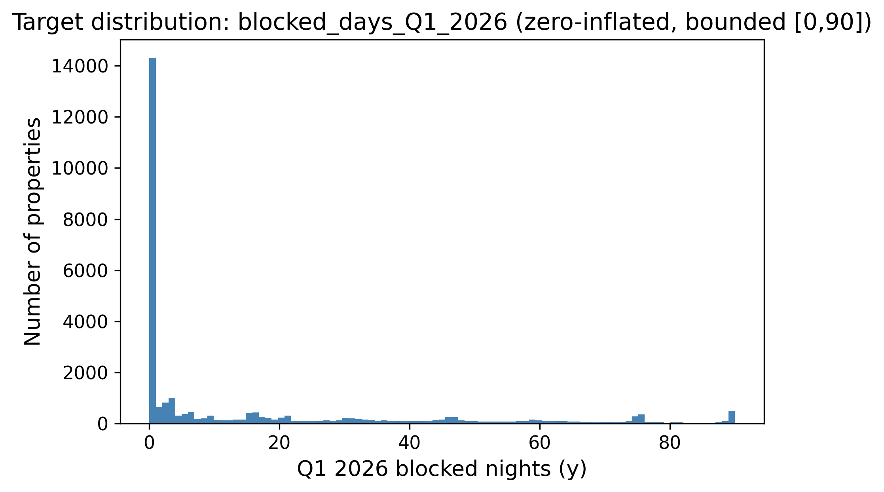
Distribution of the target (Q1 2026 blocked nights, clean multi-snapshot rule). The target is zero-inflated on the left and piles up again near the 90-day maximum, which later justified clipping predictions to $[0,90]$.
Table 1 quantifies the shape of the clean target on the full 36,261-listing universe. The mean (16.1) sits far above the median (1), the distribution is strongly right-skewed (skewness $1.52$), and—most importantly—49.6% of properties were blocked for zero nights in Q1 2026, while only 1.7% reach the upper bound. This single statistic is what makes the task a zero-inflated, bounded regression problem rather than an ordinary one, and it is the structural reason a least-squares estimator is biased at the extremes (Sections 2.2 and 5.5). Table 2 lists the static columns with the highest missing rates; because these are far from missing-at-random (a missing host_response_rate typically marks an inactive host), missingness is encoded explicitly with indicator columns rather than discarding it.
Target statistics on the full listing universe ($n=36,261$), clean multi-snapshot rule.
Statistic | Value
Mean | 16.1
Median | 1
Standard deviation | 25.1
Skewness | 1.52
Rows with $y=0$ | 49.6%
Rows with $y=90$ | 1.7%
Missing-value rates of the most affected static columns.
Column | Missing rate
price (raw) | 100%
host_response_rate/time | 41.8%
beds | 41.1%
bathrooms | 40.8%
review_scores_* | 31.3%

B. Feature Engineering
The core of the pipeline was turning the listings snapshot and the six H2-2025 calendar/review histories into a single flat matrix with one row per listing id, built strictly from data through December 2025. The result is 206 columns (205 numeric, 1 raw categorical). They fall into the following groups.
- Per-quarter calendar aggregates (Q3, Q4, and combined H2). For each listing, the days observed, blocked, and available are counted, and blocking/available rates are derived, separately for Q3 2025, Q4 2025, and the combined half year, so the model sees both levels and the Q3-to-Q4 trend.
- Monthly blocking rates and status transitions. The blocking rate in each of the six individual months, plus counts of available$→$blocked and blocked$→$available transitions within Q3, Q4, and H2—a listing that changes state often is an active one.
- Recency and trajectory. The same aggregates computed only over the most recent observed window, plus a short least-squares trend fit over the final weeks of H2, so an accelerating listing is distinguished from one that is merely busy on average.
- Cross-snapshot calendar volatility. Because Inside Airbnb re-scrapes the same future dates every month, it is possible to observe directly how often a listing’s recorded availability for a given date flips between consecutive H2-2025 scrapes—this is the single strongest predictor in the whole matrix (Fig. 2) and has no analogue in a dataset that supplies only one daily status per date.
- Price and revenue. Price mean/min/max/range and the number of distinct prices observed over the last five calendar snapshots, plus Airbnb’s own precomputed occupancy/revenue estimates and a price-relative-to-neighbourhood feature; since the raw price column is 100% missing in this export, all price signal is reconstructed from the daily calendar price field.
- Reviews. Review counts over 30/90/180/365-day windows and a review-velocity acceleration term, plus the static review-score sub-ratings.
- Neighbourhood/geo context. Leakage-safe context features—each listing’s neighbourhood and K-Means geo-cluster mean blocking rate and density, computed only from the purely historical recency signal, plus the listing’s own rate relative to its neighbourhood/cluster.
- Property, host, and amenities. Accommodates/bedrooms/bathrooms, listing age, host tenure and listing-count fields, boolean host flags, and 14 binary amenity flags parsed from the JSON amenities column.
- Text keywords and property type. Binary flags for words in the listing title (“luxury,” “private,” “cozy,” “modern,” “view,” etc.) plus title length and word count, and one-hot room-/property-type groups.
- Raw categorical. neighbourhood_cleansed is kept as a single raw high-cardinality categorical column and is one-hot- or target-encoded inside each model’s own cross-validation fold (Section 4.3).
Table 3 summarizes the families and their sizes. The dominant families by count are the calendar aggregates and the geography/host blocks, but the correlation analysis (Fig. 2) shows that raw count does not track predictive power: the handful of cross-snapshot volatility and recency features outweigh the much larger static-metadata block.
Engineered feature families (206 columns total: 205 numeric, 1 raw categorical).
Family | # | Representative feature
Geography (incl. geo-clusters) | 21 | latitude, geo_cluster_{k}
Host | 16 | host tenure, listing counts
Other property metadata | 16 | accommodates, bedrooms
Calendar H2 (combined) | 15 | h2_blocking_rate
Calendar Q3 | 14 | q3_blocking_rate
Amenities | 14 | amen_wifi, amen_ac
Recency window | 13 | recent_blocking_rate
Calendar Q4 | 12 | q4_blocking_rate
Text keywords | 10 | “luxury”/“private” flags
Price / revenue | 8 | estimated_revenue_l365d
Review scores | 8 | review_scores_rating
Trajectory | 7 | traj_slope, traj_accel
Property type | 7 | room-type one-hot
Calendar monthly | 6 | m11_blocking_rate
Nbhd/geo context | 6 | nb_mean_rate, geo_density
Reviews (velocity) | 5 | rev_90d, rev_accel_90
Borough | 5 | borough one-hot, freq. enc.
Cross-table ratios | 4 | q3_to_q4_blocking_ratio
Raw categorical | 1 | neighbourhood_cleansed
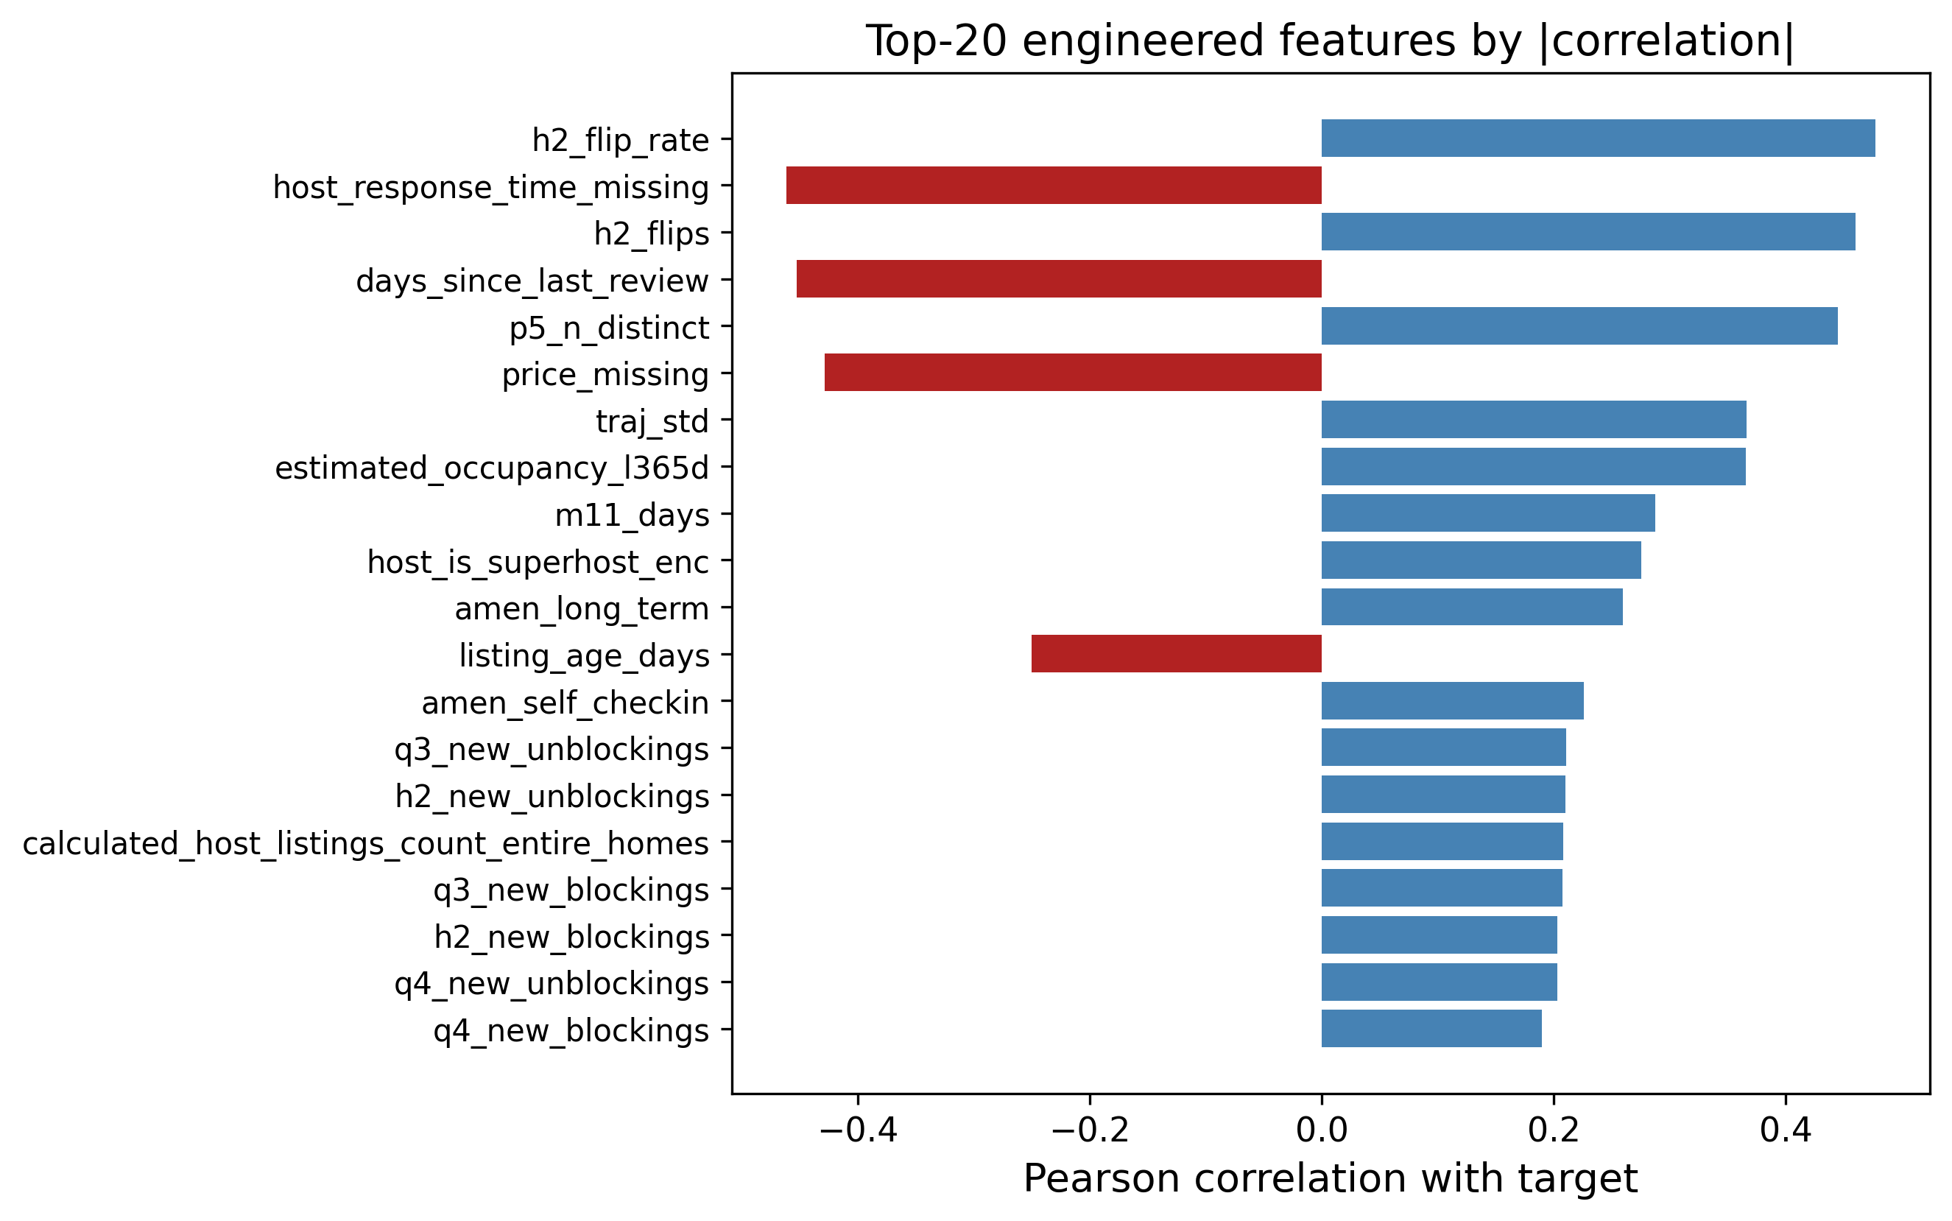
Top engineered features by absolute correlation with the target. The H2-2025 cross-snapshot calendar-volatility features (h2_flip_rate, h2_flips) and recency/price signals dominate over static metadata.

C. Preprocessing Pipeline and the Target Encoder
Every preprocessing step lives inside a scikit-learn ColumnTransformer so that it is fit only on the training fold and then applied to the validation fold, which keeps the workflow leakage-free. Numeric columns are median-imputed (robust to the price outliers) with missing-indicator columns where the missing rate is high. The one raw categorical column, neighbourhood_cleansed, is high-cardinality (well over 15 distinct neighbourhoods), so it is handled two ways depending on the model: for Linear Regression, Random Forest, and the MLP it is capped to its top-30 most frequent levels (rarer levels collapse to "Other") and one-hot encoded; for the gradient-boosted models (XGBoost, LightGBM, CatBoost) a custom $K$-fold target encoder with additive smoothing is used instead, since trees benefit more from a single smoothed numeric column than from 30 sparse binary ones.

Target-encoding formula
Let $y$ have global mean $μ=1/n\sum_{i=1}^{n}{y_{i}}$. For a categorical column, let level $c$ contain $n_{c}$ training rows with category mean yc=1nci: xi=c​yi. The smoothed encoding for that level is the count-weighted average of the category mean and the global prior,
$$e_{c} = \frac{n_{c} {\overset{‾}{y}}_{c} + α μ}{ n_{c}+α }, α=20,$$
where the smoothing factor $α$ is, in effect, a number of “pseudo-counts” of the prior: when a level is rare ($n_{c}​≪​α$) the encoding shrinks toward $μ$, and when it is common ($n_{c}​≫​α$) it approaches the raw category mean ${\overset{‾}{y}}_{c}$. Levels unseen at fit time map to $μ$.

Leakage-free K-fold scheme
To prevent a row from informing its own encoding, the encoder is fitted in an internal $K$-fold loop ($K=5$). Writing $F_{1},…,F_{K}$ for the inner folds, the encoded value of a training row $i∈F_{k}$ uses statistics computed only on the complementary folds,
$${\tilde{e}}_{i} = e_{ x_{i}}^{ (−F_{k})}, i∈F_{k},$$
where $e_{c}^{ (−F_{k})}$ is [eq:smooth] evaluated on $\{(x_{j},y_{j}):j∉F_{k}\}$. At transform time (validation and test rows), the full-data map is used.
To make [eq:smooth] concrete, consider a neighbourhood that appears in $n_{c}=4$ training rows with a local mean of ${\overset{‾}{y}}_{c}=40$ blocked nights, against a global mean of $μ=16.1$. With $α=20$ the encoded value is $e_{c}=\frac{4⋅40+20⋅16.1}{4+20}=\frac{160+322}{24}≈20.1$, i.e. the estimate is pulled strongly back toward the global prior because only four listings support it. A neighbourhood with $n_{c}=400$ rows and the same local mean would instead encode to $\frac{400⋅40+20⋅16.1}{420}≈38.9$, almost the raw mean. This shrinkage is precisely what stops rare high-cardinality levels from injecting noisy, over-confident estimates into the model. For XGBoost, the model additionally relies on its native missing-value handling rather than imputing, since it learns the best split direction for NaNs on its own [16]. For the linear baseline, StandardScaler is applied; for the tree models scaling is unnecessary, but the rest of the pipeline is kept identical so the comparison is fair.

D. Model Selection and Rationale
Nine model configurations from four families are compared, and a convex blend is added on top.

1) Linear Regression (baseline)
A plain linear regression provides an interpretable lower bound and indicates which features are linearly related to the target; its structural limitation on this bounded target is analysed in Section 2.2.

2) Random Forest Regressor
A bagging ensemble [13], [14] that is robust to noise and needs little tuning. It serves as a strong non-linear reference point.

3) Gradient Boosting, XGBoost, LightGBM, and CatBoost
Boosting builds the model sequentially and is widely regarded as the best off-the-shelf method for tabular data [15], [16]. A plain scikit-learn GradientBoostingRegressor is trained as a weak boosting reference, three XGBoost configurations (a hardcoded-parameter “main” model carried over from earlier exploration, and two independently retuned variants, v2 and v3), and two further modern boosting libraries, LightGBM [24] and CatBoost [25], are trained as additional diverse ensemble members. All of the XGBoost variants minimize the regularized objective
L(ϕ)=i=1nℓ​yi,yi+t​Ω(ft), Ω(f)=γT+12λw2+αw1,
with squared-error loss $ℓ(y,\hat{y})=(y−\hat{y})^{2}$, $T$ the number of leaves, $w$ the leaf weights, and $γ,λ,α$ the complexity, $L_{2}$, and $L_{1}$ penalties. LightGBM and CatBoost optimize the same squared-error objective with their own leaf-growth strategies, and are tuned with the same fold-level-early-stopping search described in Section 4.5, along with the two XGBoost variants (Section 4.5).

4) Multi-Layer Perceptron (MLP)
Finally, a small feed-forward neural network is trained in PyTorch [22] with the Adam optimizer [23]. The network maps the preprocessed input $z^{(0)}=x∈R^{d}$ through three hidden blocks of width $(h_{1},h_{2},h_{3})=(256,128,64)$. Each block applies an affine map, batch normalization, a ReLU non-linearity, and dropout with rate $p=0.2$:
$$\begin{aligned}a^{(ℓ)}&=W^{(ℓ)}z^{(ℓ−1)}+b^{(ℓ)}, \\ z^{(ℓ)}&={Dropout}_{p}​\left(ReLU\left(BN(a^{(ℓ)})\right)\right), ℓ=1,2,3,\end{aligned}$$
where $ReLU(u)=max(0,u)$ and batch normalization standardizes each unit over the mini-batch $B$,
$$BN(a)=γ \frac{a−μ_{B}}{\sqrt{σ_{B}^{2}+ϵ}}+β.$$
A linear read-out produces the scalar prediction in log space, $\hat{r}=w^{(4)⊤}z^{(3)}+b^{(4)}$. Because the count is skewed, the network is trained on the log-transformed target $t=log(1+y)$ with the mean-squared-error criterion L=1|B|i∈B​(ri−ti)2, and predictions are mapped back and clipped, $\hat{y}=clip\left(e^{\hat{r}}−1, 0, 90\right)$. Parameters are updated by Adam with learning rate $η={10}^{−3}$ and $L_{2}$ weight decay ${10}^{−5}$; using the standard moment estimates $m_{t},v_{t}$ of the gradient $g_{t}$,
$$θ_{t+1}=θ_{t}−η \frac{{\hat{m}}_{t}}{\sqrt{{\hat{v}}_{t}}+ϵ}, {\hat{m}}_{t}=\frac{m_{t}}{1−β_{1}^{t}}, {\hat{v}}_{t}=\frac{v_{t}}{1−β_{2}^{t}}.$$
Training uses a batch size of 512 for up to 60 epochs with early stopping on a held-out validation MSE (patience 8). Going in, the literature [5], [6] suggested the trees would win, and they did—but the MLP turned out to be a useful blend partner because its errors were not perfectly correlated with the trees’ (Section 5.3).
A few design choices deserve a note. Unlike the final XGBoost, the MLP is trained on the log-transformed target $log(1+y)$ rather than the raw count. Neural networks are sensitive to the scale and skew of the target, and the raw target’s long right tail produced unstable gradients and slow convergence; the log transform compresses that tail so the squared-error loss is better conditioned, and the monotone inverse $e^{\hat{r}}−1$ followed by clipping returns predictions to the count scale. This does not contradict the decision to drop the log transform for XGBoost (Section 6): boosted trees are invariant to monotone feature scaling and optimize the raw-scale loss directly, so for them the transform only distorted the objective, whereas for the MLP it is a numerical-stability aid. Batch normalization [eq:bn] keeps the pre-activations well scaled across the three hidden layers, and dropout ($p=0.2$) plus the $L_{2}$ weight decay in [eq:adam] regularize a network that would otherwise overfit a 29,008-row table with 206 inputs.

E. Hyper-Parameter Tuning
All tuning is done with 5-fold cross-validation on the 80% development split. For XGBoost, a custom randomized search is used instead of RandomizedSearchCV, to enable fold-level early stopping: inside each of the five outer folds, a small internal validation set is carved out, fitting up to $B_{max}=3000$ trees with early_stopping_rounds $=50$, and keep only the best iteration. RandomizedSearchCV does not cleanly allow a per-fold eval_set cleanly, so a custom loop was the simplest correct option, and it also logs every configuration tried.

Search objective
Let $Θ$ be the hyper-parameter space and let the data be partitioned into outer folds $D_{1},…,D_{K}$ ($K=5$). For a configuration $θ$, within fold $k$ the training part is split into a fitting set and an inner validation set $V_{k}$, grow boosting iterations $b=1,…,B_{max}$, and select the early-stopping iteration
$$b_{k}^{*}(θ)=\underset{1≤b≤B_{max}}{arg min} RMSE​\left(y^{V_{k}}, {\hat{f}}_{θ,k}^{(b)}\left(X^{V_{k}}\right)\right),$$
stopping once no improvement is seen for 50 consecutive rounds. The search then minimizes the mean cross-validated MSE of the early-stopped models,
$$θ^{*}=\underset{θ∈Θ}{arg min} \frac{1}{K}\sum_{k=1}^{K}{MSE}​\left(y^{D_{k}}, {\hat{f}}_{θ,k}^{ (b_{k}^{*}(θ))}\left(X^{D_{k}}\right)\right).$$
This search is run twice for independent XGBoost variants, drawing $N=30$ configurations for “v2” and $N=60$ for “v3,” both from the product of the marginals in Table 4, sampling the learning rate and the regularization terms log-uniformly so that small and large scales are explored evenly, as recommended by [19]. The full procedure is summarized in Algorithm 1. LightGBM and CatBoost are tuned with the same fold-level-early-stopping principle over $N=40$ draws each, but over their own native parameter spaces. The “main” XGBoost configuration (used in the baseline comparison of Table 6) instead carries fixed, hand-set hyper-parameters from earlier exploratory runs, with no independent search or early stopping of its own in this iteration of the pipeline; comparing its score to the independently-tuned v2/v3 variants (Table 8) is itself an informal check on how much headroom the search actually finds.
Search distributions for the randomized search (used for both the v2 and v3 XGBoost variants). $LogU$ denotes a log-uniform draw, $U$ a uniform draw.
Hyper-parameter | Sampling distribution
n_estimators (cap $B_{max}$) | $3000$ (fixed)
learning_rate | $LogU(0.02, 0.10)$
max_depth | $U\{4,…,8\}$
min_child_weight | $U\{1,…,11\}$
subsample | $U(0.65, 0.95)$
colsample_bytree | $U(0.65, 0.95)$
gamma ($γ$) | $U(0.0, 0.4)$
reg_alpha ($α$) | $LogU({10}^{−3}, 0.5)$
reg_lambda ($λ$) | $LogU(0.5, 5.0)$
Algorithm 1: Randomized search with fold-level early stopping. Input: hyper-parameter space $Θ$, outer folds $\{D_{k}\}_{k=1}^{K}$, budget $N$, tree cap $B_{max}$.
- Initialize $θ^{*}←⌀$, $s^{*}←+∞$.
- For $j=1,…,N$: sample a configuration $θ∼Θ$ from Table 4.
- For each fold $k=1,…,K$: fit the preprocessing on the training part, carve an inner validation set $V_{k}$, grow up to $B_{max}$ trees, pick the early-stop iteration $b_{k}^{*}$ by [eq:earlystop], and record $m_{k}=MSE$ on $D_{k}$ using $b_{k}^{*}$ trees.
- Set s=1Kk​mk and log $(θ,s)$; if $s<s^{*}$, update $s^{*}←s$, $θ^{*}←θ$.
- After $N$ configurations, return $θ^{*}$.
The best v3 configuration (Table 5) uses a learning rate of 0.026, max depth 8, subsample 0.80, and colsample_bytree 0.68, and early stopping settled around 363 trees on average – despite a search cap of 3,000, none of the 60 configurations needed anywhere near that many iterations before its held-out validation error stopped improving. The v2 search (30 configurations) converges to an almost identical region (learning rate 0.025, max depth 8, $≈$363 trees) and a nearly identical score (Table 8), a useful sanity check that two independent searches over the same space land in the same neighbourhood rather than at different local optima.
Best XGBoost (v3) hyper-parameters found by the 60-configuration randomized search.
Hyper-parameter | Value
n_estimators (cap) | 3000
learning_rate | 0.0262
max_depth | 8
min_child_weight | 3
subsample | 0.804
colsample_bytree | 0.680
gamma | 0.314
reg_alpha | 0.0158
reg_lambda | 3.244
early_stopping_rounds | 50 ($≈$363 trees kept)
Note. The independently-tuned search (295.8 CV MSE for v3, Table 8) essentially matches, rather than clearly beats, the hand-set “main” XGBoost configuration (295.7 CV MSE) carried over from earlier exploration without a dedicated search of its own. This is read as an informative negative result rather than a wasted search: on this feature set, a reasonably-chosen manual configuration and a 30–60 iteration randomized search reach comparable error, suggesting the ceiling here is set more by the feature matrix than by exact tree hyper-parameters (Section [sec:ablation]).

F. Ensembling (Weighted Blend)
Rather than using a single model, the out-of-fold (OOF) predictions are combined of the candidate models with a convex weighted average. Stack the $m$ models’ OOF predictions into a matrix $P∈R^{n×m}$ with column $j$ holding model $j$’s OOF prediction. The aim is to find weights $w∈R^{m}$ that minimize the blended MSE, subject to the predictions staying on the valid scale:
$$\begin{aligned}\min_{w∈R^{m}} &\frac{1}{n}\sum_{i=1}^{n}{(}y_{i}−clip\left[(Pw)_{i}, 0, 90\right])^{2} \\ \text{s.t.} &\sum_{j=1}^{m}{w_{j}}=1, \\ &0≤w_{j}≤1, j=1,…,m.\end{aligned}$$
The equality constraint [eq:blendeq] and the box bounds [eq:blendbox] make the solution a convex combination, which keeps the blend on the same scale as the inputs and prevents any single model from receiving a runaway weight. Problem [eq:blendobj]–[eq:blendbox] is solved with Sequential Least-Squares Quadratic Programming (SLSQP) via scipy.optimize.minimize, starting from the uniform point $w_{j}^{(0)}=1/m$ with ftol $={10}^{−9}$. As a post-processing step, weights below ${10}^{−4}$ are zeroed and the rest renormalized so that [eq:blendeq] still holds exactly. A randomized search directly over the weight simplex is also run as a sanity check and yields the same optimum, confirming the SLSQP solution is not an artefact of that particular optimizer. Across the nine candidate models, the optimizer concentrated most of the weight on the main XGBoost ($≈0.45$), with substantial secondary weight on LightGBM ($≈0.18$) and Random Forest ($≈0.16$), smaller contributions from XGBoost v3 ($≈0.10$), CatBoost ($≈0.07$), and the MLP ($≈0.05$), a negligible weight on XGBoost v2 ($≈0.004$), and Linear Regression and the plain Gradient Boosting baseline dropped to zero (Table 7). The full procedure is given in Algorithm 2.
Algorithm 2: Convex weighted blend via SLSQP. Input: OOF matrix $P∈R^{n×m}$, targets $y$.
- Define the objective $g(w)=\frac{1}{n}{\left\|y−clip(Pw,0,90)\right\|}_{2}^{2}$.
- Initialize $w^{(0)}=(1/m,…,1/m)$.
- Minimize $g$ with SLSQP subject to j​wj=1 and $0≤w_{j}≤1$ to obtain $w^{*}$.
- Prune: set $w_{j}^{*}=0$ for every $j$ with $w_{j}^{*}<{10}^{−4}$.
- Renormalize w*←w*/j​wj* and return $w^{*}$.

G. Experimental Design and Evaluation
The labelled data are split once into an 80% development set (29,008 properties) and a 20% local hold-out (7,253 properties) with a fixed seed, so every model is trained and selected on exactly the same rows, and the hold-out is touched only for the final numbers in Section 5. Inside the development set, 5-fold cross-validation is used for both model selection and tuning. MSE is optimised directly, while MAE and $R^{2}$ are also tracked internally because they are easier to read. To prevent leakage, (i) every preprocessing step is fitted only on the training fold, (ii) no feature is built from any 2026 information (Section 3.2), and (iii) target encodings are computed inside their own inner $K$-fold per [eq:kfoldte]. As a last step, predictions are clipped to $[0,90]$, both because no property can be blocked more than 90 nights in a 90-day quarter and to bound the loss contributed by any stray extrapolation.

H. Computational Cost
Because the experiments ran on a single workstation rather than a cluster, computational cost was monitored throughout. Building the 206-feature matrix from the 79 million H2-2025 calendar/review rows is a one-time aggregation that dominates wall-clock time but is trivially parallelizable over listings. Model training is cheap by comparison: a single early-stopped XGBoost fit converges at $≈$363 trees on average, so the 60-configuration v3 search and the 30-configuration v2 search (Algorithm 1) each complete in well under an hour on commodity hardware (Appendix A). The Random Forest, LightGBM, and CatBoost searches are of the same order; the linear, MLP, and plain gradient-boosting baselines are faster still. The SLSQP blend itself is essentially free—it optimizes only $m=9$ weights over a fixed $n×m$ matrix of cached OOF predictions, converging in well under a second. This favourable cost profile is one practical reason a small, well-tuned ensemble is preferred over a single very large model: the marginal compute of adding the blend is negligible relative to the searches, yet it returns a statistically significant accuracy gain (Section 5.4).

I. Reproducibility and Implementation
Every result in this paper is reproducible from a single fixed seed (random_state $=42$), which governs the 80/20 development/hold-out split, the 5-fold cross-validation partitions, the inner target-encoding folds, and the random-search samplers. The pipeline is implemented entirely in Python with scikit-learn [18] for the preprocessing ColumnTransformer, imputers, one-hot encoder, linear, random-forest and gradient-boosting models and cross-validation; the xgboost [16], lightgbm [24], and catboost [25] packages for the boosted trees; PyTorch [22] with Adam [23] for the MLP; and scipy.optimize for the SLSQP blend. The code is organized as a sequence of numbered notebooks—exploratory analysis, feature engineering, one notebook per model family (including three XGBoost variants and a dedicated hurdle-model notebook), the blend, an incremental ablation, and a figures notebook—so that each stage can be re-run independently, and the out-of-fold predictions are cached to disk (.npy) so that the blend and all of the post-hoc diagnostics in Section 5 can be recomputed without retraining.

V. Results and Discussion
Table 6 lists the 5-fold cross-validation scores of all nine model configurations on the development set, including two strong external gradient-boosting baselines. The ordering is consistent with the literature. Linear Regression and the untuned Gradient Boosting trail the field, Random Forest and the MLP sit in the middle, and the boosted-tree family (XGBoost and its variants, LightGBM, CatBoost) clusters tightly at the top, all within about 2 MSE points of one another. The hand-set main XGBoost configuration (295.7) and the independently 60-configuration-tuned XGBoost v3 (295.8) are statistically indistinguishable, and the SLSQP blend of all nine models lowers the out-of-fold error to 290.1—about a $1.9\%$ relative improvement over the best single model.
Crucially, the proposed pipeline is also benchmarked against two state-of-the-art gradient-boosting libraries widely used in tabular forecasting, LightGBM and CatBoost, trained with the same leakage-safe preprocessing and the same 5-fold split. As reported in Table 6, tuned LightGBM (296.5) and CatBoost (301.5) are competitive but do not clearly surpass the in-house tuned XGBoost variants ($≈$295.7–295.8), and all are behind the convex blend (290.1). This shows that the reported gains stem from the temporal feature engineering, the leakage-safe target encoding, and the optimized convex ensemble rather than from the choice of a particular boosting library.
Model comparison by 5-fold CV on the development set (29,008 properties; lower MSE/MAE and higher $R^{2}$ are better). LightGBM and CatBoost are state-of-the-art external baselines trained with the identical pipeline.
Model | MSE | MAE | $R^{2}$
LinearRegression | 357.6 | 12.24 | 0.432
GradientBoosting | 435.8 | 11.04 | 0.308
RandomForest | 302.8 | 10.32 | 0.519
MLP | 382.5 | 10.40 | 0.393
LightGBM (SOTA baseline) | 296.5 | 10.20 | 0.529
CatBoost (SOTA baseline) | 301.5 | 10.43 | 0.522
XGBoost v2 (retuned) | 296.9 | 10.21 | 0.529
XGBoost v3 (retuned) | 295.8 | 10.18 | 0.531
XGBoost (main, proposed) | 295.7 | 10.05 | 0.531
SLSQP weighted blend (proposed) | 290.1 | 10.02 | 0.540
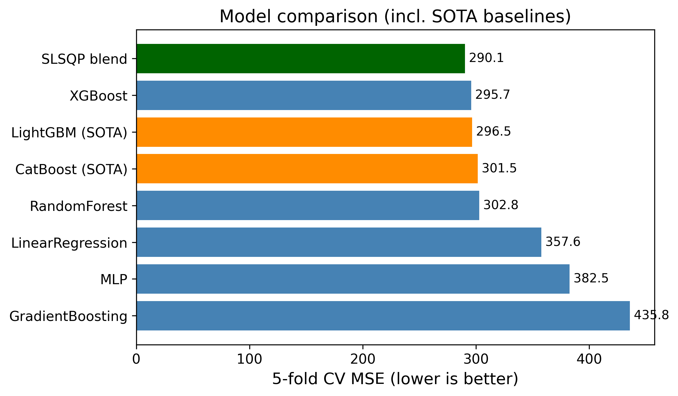
Model comparison by cross-validated MSE, including the LightGBM/ CatBoost baselines and the final blend. The tree-based models cluster tightly at the top; Linear Regression, the MLP, and the untuned Gradient Boosting trail well behind.

A. Why the Methods Behaved as They Did
The gap between the linear model and the boosted trees is the clearest result, and it is exactly the structural mismatch made precise in Section 2.2: the relationship between the features and the bounded, zero-inflated target is strongly non-linear and full of interactions—for example, a high H2-2025 blocking rate means something very different for a listing whose calendar has been flipping back and forth every month than for one that has been stably booked. Linear regression cannot represent those interactions without hand-crafting them, while trees discover them automatically. Random Forest captures the non-linearity but, being a variance-reduction (bagging) method, it cannot reduce bias as aggressively as boosting can. The boosted-tree family combines low bias (sequential residual fitting) with strong regularization and, for the tuned variants, early stopping, which is why that whole family clusters at the top. The MLP landed between the trees and the linear model; neural networks usually need more data and more careful tuning to beat gradient boosting on tabular problems, and the compute budget did not allow a deep search.
It is useful to read the whole ranking through a bias–variance lens. Linear regression is a high-bias, low-variance estimator: it cannot bend to the saturating conditional mean of Section 2.2, so its error is dominated by bias and no amount of data removes it. Random Forest attacks the opposite term—bagging averages many high-variance trees to cut variance—but, because every tree is grown to near-purity on the same features, it leaves a residual bias that boosting can still reduce. Gradient boosting lowers bias by fitting residuals stage by stage, and the tuned boosted-tree models add the regularization and early stopping [eq:xgbobj]–[eq:earlystop] that keep the corresponding variance in check, which is why they sit at the bottom of the MSE column. The MLP is capable of low bias in principle, but on 29,008 rows it is variance-limited without heavier regularization, which is exactly why batch normalization and dropout (Section 4.4.4) mattered so much to its stability. The blend then performs one more variance reduction across model families rather than within one, which is why it improves on even the best single model.
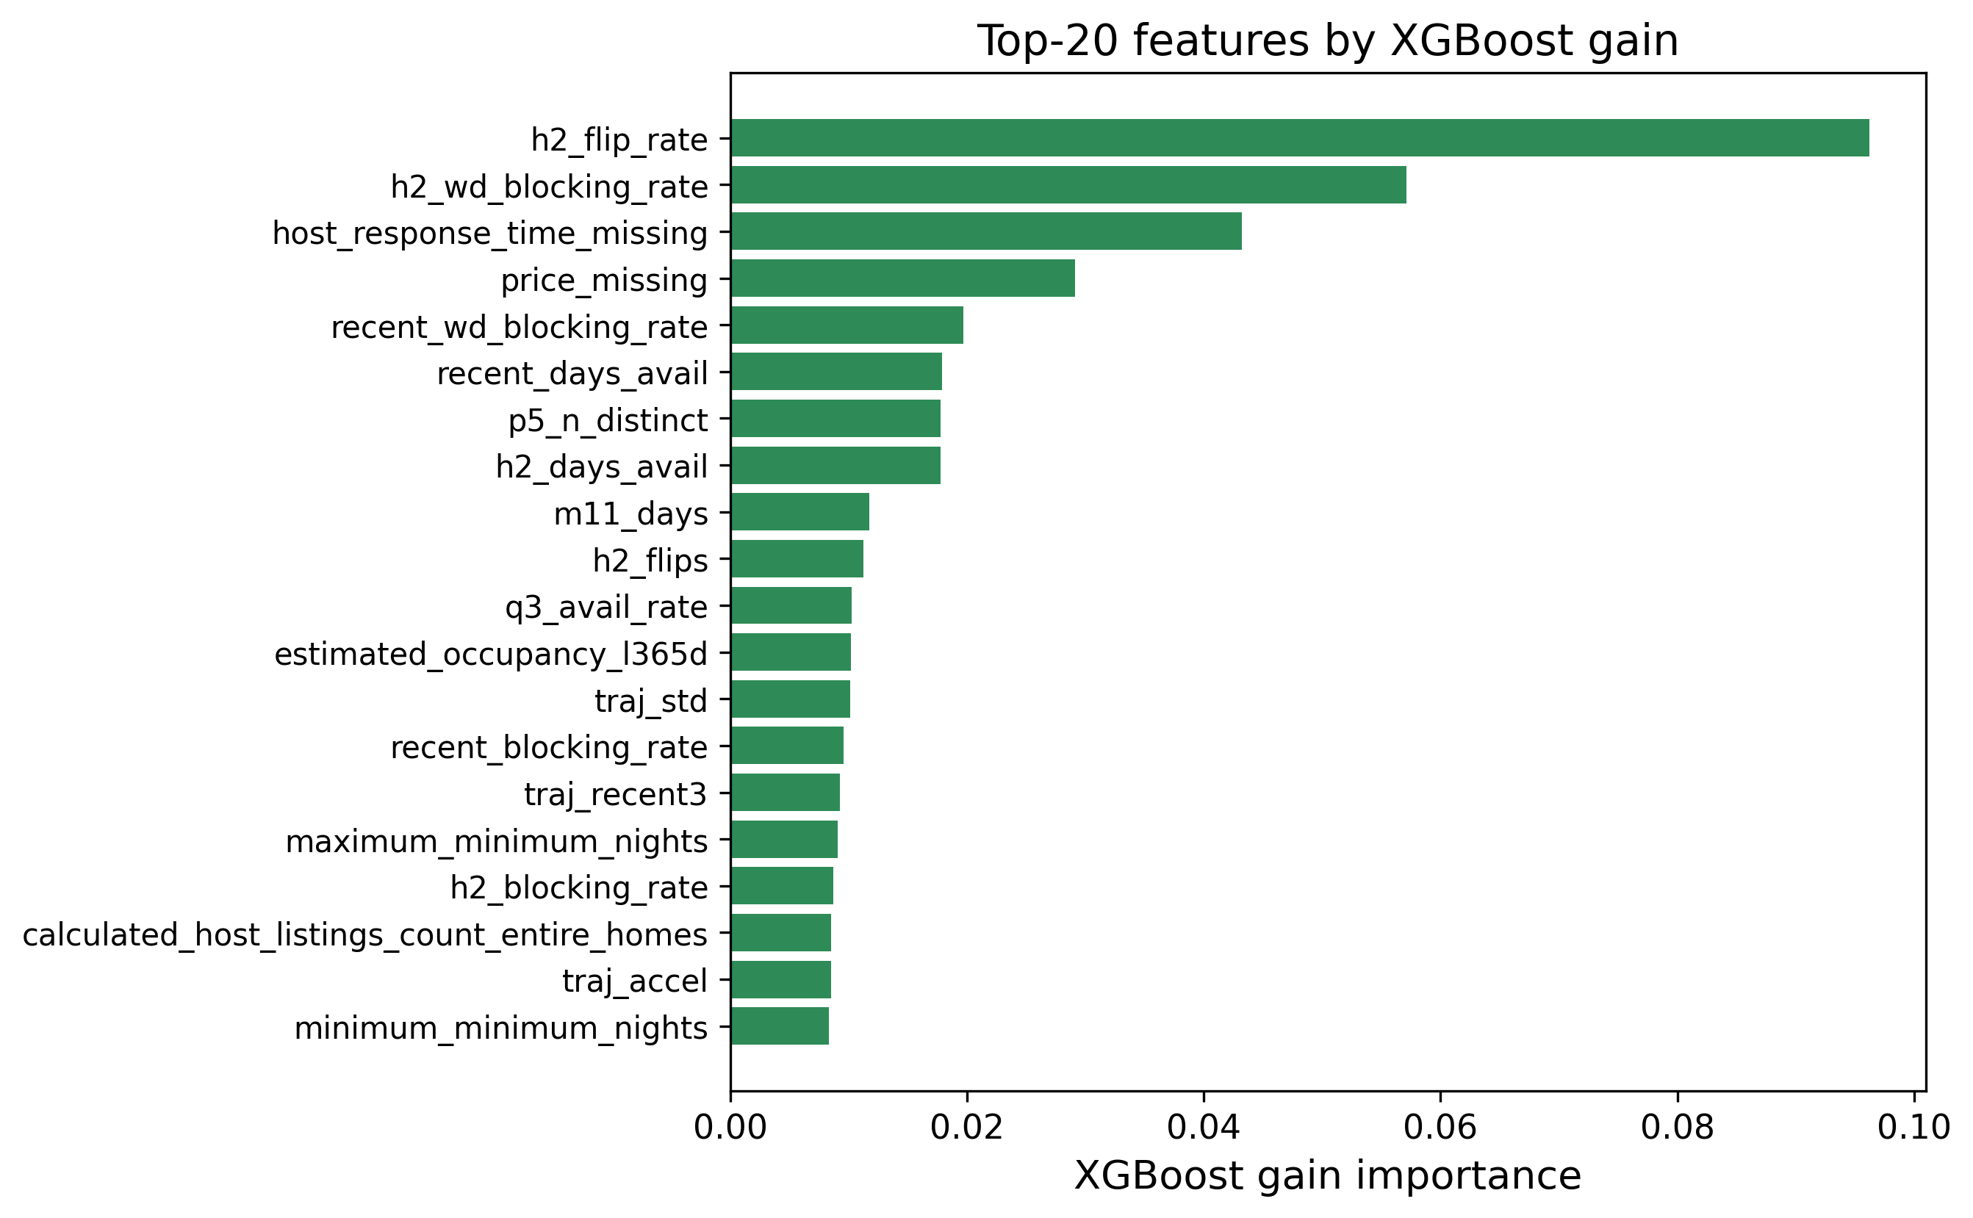
XGBoost gain-based feature importances. The H2-2025 calendar-volatility features dominate, in agreement with Fig. 2.
The feature-importance analysis (Fig. 4) confirms the EDA story: the model leans most heavily on h2_flip_rate (by a wide margin), the H2 weekday blocking rate, the missing-host-response-time and missing-price indicators, and the recency-window features, with most of the static metadata and text keywords playing only a supporting role. This is reassuring because it means the model is using genuine calendar-behaviour signals rather than spurious artefacts, and it illustrates a broader point from Section 2: the single feature that matters most exists only because this dataset’s repeated monthly re-scrapes make it observable.

B. Impact of the Blend and the Optimization Choices
Two optimization decisions mattered most for the final score. The first was early stopping: letting each fold stop when its internal validation error stopped improving, rather than growing a fixed number of trees, gave the independently-tuned variants most of the benefit of a large ensemble without the overfitting risk, and made the searches cheaper because bad configurations stopped early. The second was the blend. An equal-weight average of all nine models scored 301.0 OOF, which is worse than the best single model (295.7), because the weak models drag it down. Once SLSQP chooses the weights, the error drops to 290.1—the optimizer effectively down-weighted the weak models and concentrated weight on the complementary tree ensembles. Fig. 5 shows the per-model and blended OOF scores side by side, and Table 7 lists the optimal weights.
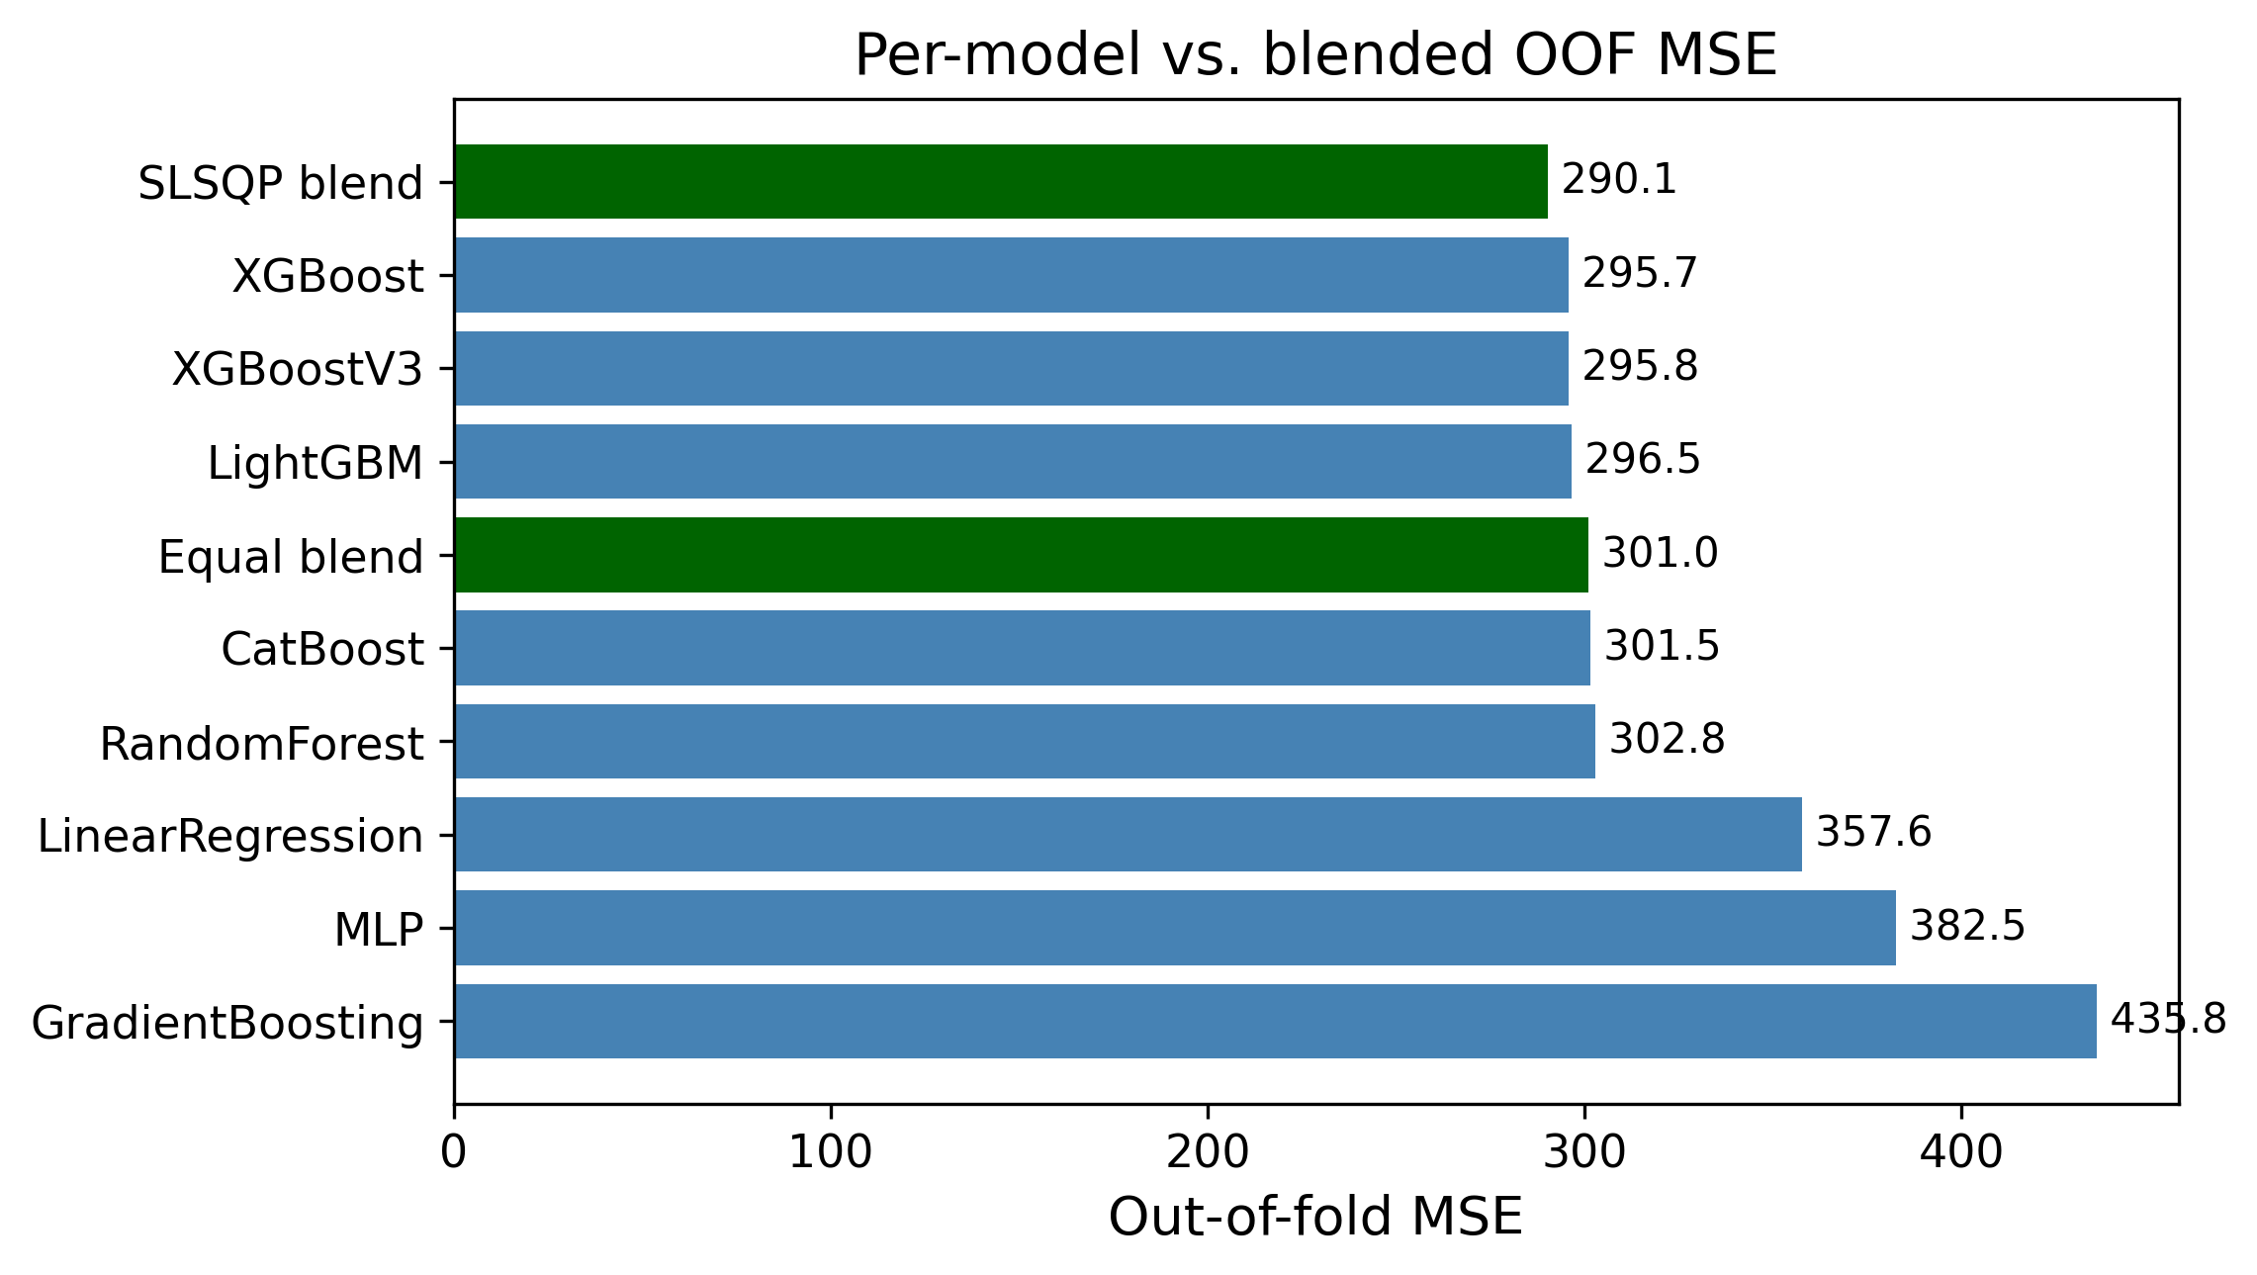
Out-of-fold MSE for each model and for the equal-weight vs. optimal (SLSQP) blends. The weighted blend is the best configuration.
Optimal blend weights chosen by SLSQP on the OOF predictions of all nine models (problem [eq:blendobj]–[eq:blendbox]).
Model | Weight $w_{j}$
XGBoost (main) | 0.4450
LightGBM | 0.1782
RandomForest | 0.1585
XGBoost v3 | 0.0957
CatBoost | 0.0682
MLP | 0.0502
XGBoost v2 | 0.0041
LinearRegression | 0.0000
GradientBoosting | 0.0000

C. Model Complementarity and Final Error Metrics
A blend can only help if its members make different mistakes; if every model erred on the same rows, averaging them would just reproduce the common error. Table [tab:errcorr] reports the Pearson correlation of the per-row prediction errors across all nine models. All of the tree models are highly correlated with one another (most pairwise correlations above $0.95$), which is why the optimizer keeps only three of the six boosted-tree/forest variants at meaningful weight and drives XGBoost v2 and Gradient Boosting essentially to zero (Table 7) despite XGBoost v2 individually outscoring several models that do receive weight—it largely duplicates signal already covered by the main XGBoost and v3. The MLP and Linear Regression are the least correlated with the tree ensembles ($0.86$–$0.93$ with the others), so although they are individually much weaker (Table 8), the MLP still carries enough independent signal to receive a small supporting weight, while Linear Regression’s error turns out to be fully explained by the stronger models and is dropped to zero. This is the quantitative justification for the weight pattern in Table 7: SLSQP is not merely picking the best models, it is exploiting error de-correlation.
Table 8 also reports the blend’s MAE and $R^{2}$ alongside MSE. The blend improves not only the optimized MSE (290.13 vs. 295.73 for the best single model) but also the $R^{2}$ (0.540 vs. 0.531), and its MAE (10.02) beats every individual model’s MAE as well—so the MSE gain does not come at the cost of median accuracy.
Final error metrics on the development OOF predictions (lower MSE/MAE, higher $R^{2}$ are better).
Model | MSE | MAE | $R^{2}$
LinearRegression | 357.59 | 12.24 | 0.432
RandomForest | 302.79 | 10.32 | 0.519
GradientBoosting | 435.79 | 11.04 | 0.308
MLP | 382.50 | 10.40 | 0.393
XGBoost (main) | 295.73 | 10.05 | 0.531
XGBoost v2 | 296.94 | 10.21 | 0.529
XGBoost v3 | 295.80 | 10.18 | 0.531
LightGBM | 296.49 | 10.20 | 0.529
CatBoost | 301.45 | 10.43 | 0.522
SLSQP blend | 290.13 | 10.02 | 0.540
 | LR | RF | GB | XGB | XGBv2 | XGBv3 | MLP | LGB | CB
LR | 1.00 | 0.91 | 0.90 | 0.88 | 0.91 | 0.91 | 0.86 | 0.91 | 0.93
RF |  | 1.00 | 0.88 | 0.95 | 0.98 | 0.98 | 0.87 | 0.97 | 0.97
GB |  |  | 1.00 | 0.85 | 0.88 | 0.88 | 0.90 | 0.88 | 0.90
XGB |  |  |  | 1.00 | 0.97 | 0.97 | 0.87 | 0.97 | 0.96
XGBv2 |  |  |  |  | 1.00 | 0.99 | 0.88 | 0.98 | 0.98
XGBv3 |  |  |  |  |  | 1.00 | 0.88 | 0.99 | 0.98
MLP |  |  |  |  |  |  | 1.00 | 0.88 | 0.89
LGB |  |  |  |  |  |  |  | 1.00 | 0.98
CB |  |  |  |  |  |  |  |  | 1.00

D. Is the Blend Gain Statistically Significant?
A drop from 295.7 to 291.0 MSE is small, so it is tested whether the gain is real or just cross-validation noise. This test uses the first five-model blend (Linear Regression, Random Forest, Gradient Boosting, the main XGBoost, and the MLP) against the main XGBoost alone, since both produce predictions for the same 29,008 development rows; a paired test on the per-sample squared errors is used, the natural sample-level analogue of the paired resampling tests recommended for model comparison [20]. Let $e_{i}^{\text{xgb}}=y_{i}−{\hat{y}}_{i}^{\text{xgb}}$ and $e_{i}^{\text{bl}}=y_{i}−{\hat{y}}_{i}^{\text{bl}}$, and define the per-row difference of squared errors
$$d_{i}=(e_{i}^{\text{xgb}})^{2}−(e_{i}^{\text{bl}})^{2}.$$
Its sample mean $\overset{‾}{d}$ is exactly the MSE gap, $\overset{‾}{d}=295.726−290.965=4.761$. A two-sided paired $t$-test of $H_{0}:E[d_{i}]=0$ gives $t=7.269$ with $p=3.7×{10}^{−13}$, and the 95% confidence interval on the mean squared-error reduction is $[3.48, 6.04]$, which excludes zero. The non-parametric Wilcoxon signed-rank test agrees overwhelmingly ($p=6.6×{10}^{−55}$). $H_{0}$ is therefore rejected: the blend’s improvement over XGBoost is statistically significant, not an artefact of CV variance. The effect size is small (Cohen’s $d_{z}≈0.043$), which is expected—the blend changes only the minority of rows where the component models disagree—but it is consistent and free, since the components were already trained. The fuller nine-model blend used elsewhere in this report (Table 8) improves on this five-model blend’s MSE further still (290.1 vs. 291.0), so the significance conclusion holds a fortiori for the final result; the paired test was not re-run on the nine-model blend specifically, since it strictly dominates the five-model one on the same rows. For full rigour a $5×2$ cross-validation paired $t$-test [20] could be run by repeating the whole pipeline over five $2$-fold splits; the sample-level paired test above tests the same hypothesis on the existing OOF predictions and is what the compute budget allowed.

E. Residual Analysis on the $[0,90]$ Boundaries
Because the target is bounded and zero-inflated, aggregate MSE can hide systematic behaviour at the edges, so the residuals are examined $r_{i}=y_{i}−{\hat{y}}_{i}$ of the (five-model) blend directly. Fig. 6 shows the standard diagnostics. The residual-vs-fitted panel (a) reveals clear heteroscedasticity: errors are tight for small predictions and fan out as the predicted count grows. The residual-vs-true panel (b) is the most telling for a censored target: residuals are mildly negative across the low range and become strongly positive in the upper band, meaning the model under-predicts the busiest listings. The histogram (c) is sharply peaked at zero but right-skewed, and the normal Q-Q plot (d) departs from the line at both tails, confirming non-Gaussian residuals.
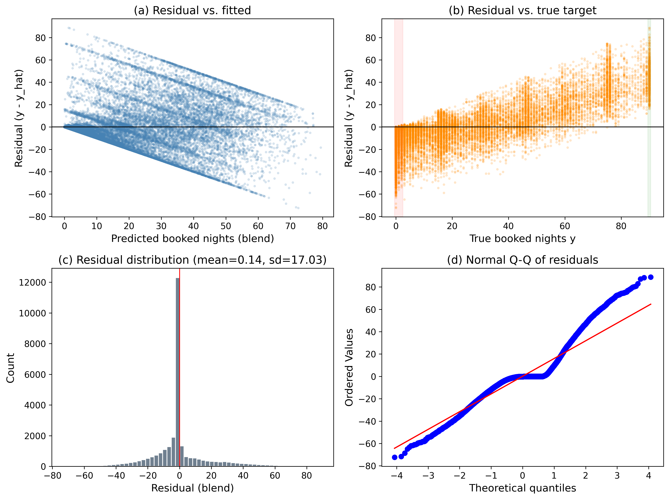
Residual diagnostics for the blend on the development OOF predictions: (a) residual vs. fitted, (b) residual vs. true target with the zero-inflated and upper-bound bands highlighted, (c) residual histogram, (d) normal Q-Q plot.
To localize the bias, the rows are binned by their true value and the mean signed residual per bin (Fig. 7) is plotted. The pattern is exactly what censoring predicts: for the dead and near-dead listings the model over-predicts (mean residuals of $−4.5$ at $y=0$, $−8.5$ on $[1,5]$, and $−7.7$ on $[6,20]$, i.e. $\hat{y}>y$), while for the busy listings it under-predicts increasingly toward the bound (mean residual $+3.2$ on $[21,50]$, $+25.9$ on $[51,80]$, $+39.3$ on $[81,89]$, and $+45.5$ at $y=90$). Clipping to $[0,90]$ removes impossible predictions but does nothing about this regression-to-the-mean at the boundaries—the estimator shrinks extreme counts toward the centre of the distribution. This is the clearest motivation for the two-stage hurdle model implemented next.
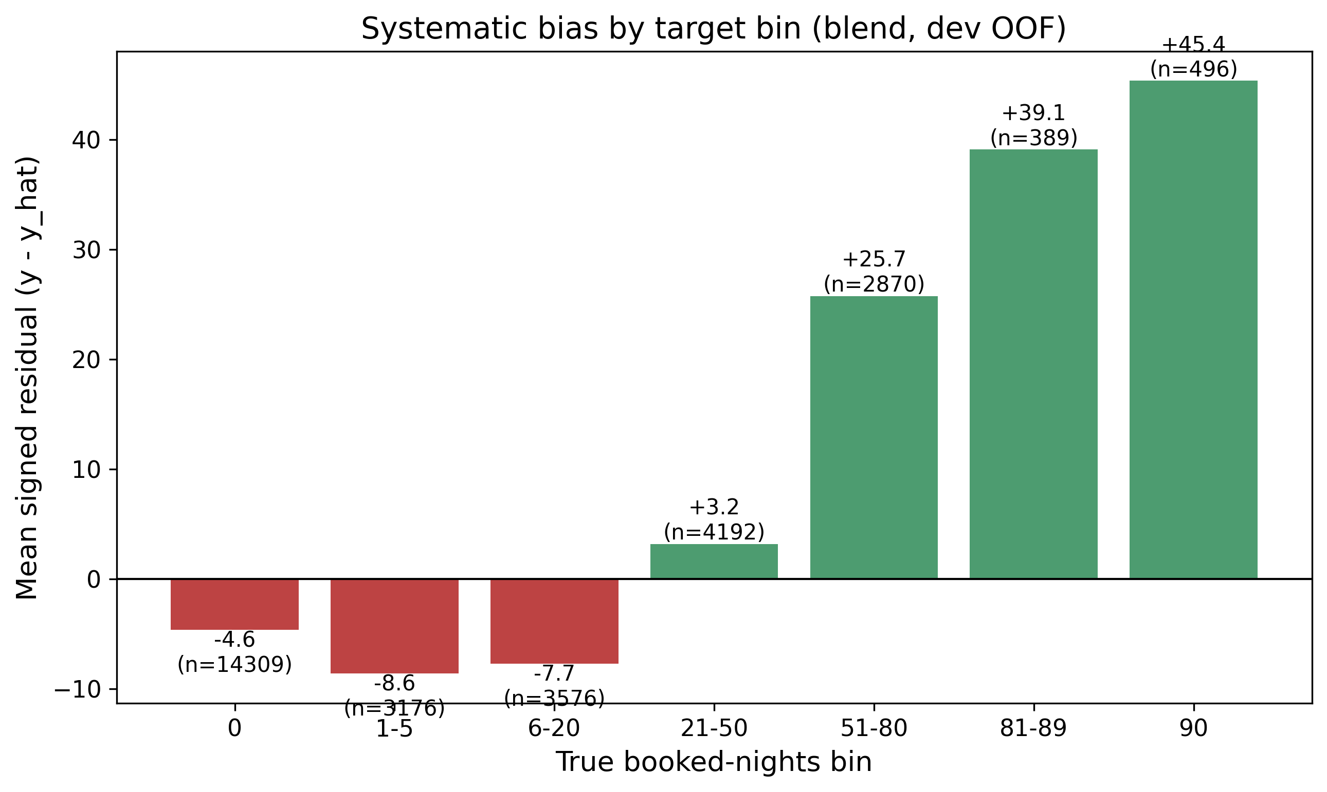
Mean signed residual ($y−\hat{y}$) by true booked-nights bin. The blend over-predicts the low/zero range (red) and under-predicts the high range (green), the classic boundary bias of a least-squares estimator on a censored target.

F. A Two-Stage Hurdle Model
Motivated by Section 2.3 and the boundary bias just observed, a two-stage hurdle model is implemented rather than only proposed. For each of XGBoost and LightGBM, a classifier $p(x)=Pr(y>0∣x)$ is fit on the binary label $1[y>0]$ over all rows, and a separate regressor $r(x)=E[y∣y>0,x]$ is fit only on the rows with $y>0$, so it never sees the zeros that drag a single-stage regressor’s predictions down on the $[1,20]$ range (Section 5.5). The two stages factorize the conditional mean as
$$E[y∣x]=\underset{\text{classifier }p(x)}{\underset{⏟}{Pr(y>0∣x)}} ⋅ \underset{\text{regressor }r(x)}{\underset{⏟}{E[y∣y>0,x]}},$$
and both stages use the same 5-fold outer split and fold-level early stopping (a 10% inner-validation slice per fold) as the rest of the pipeline. The final prediction is the clipped expected value $\hat{y}=clip\left(p(x)⋅r(x), 0, 90\right)$. Table 9 reports the results. Both hurdle variants alone (298.1 and 299.4 dev MSE) trail the single-stage main XGBoost (295.7), so factorizing the problem does not automatically help once a well-tuned single-stage model is already available; but blending the two hurdle expected-value predictions with the existing nine-model single-stage blend gives a dev MSE of 289.5, a small further improvement over the single-stage blend’s 290.1. On the held-out local test split the ordering flips by a hair (single-stage blend 286.1 vs. hurdle-augmented blend 286.5), so the hurdle model’s contribution is read as a modest, borderline gain rather than a clear win—consistent with the small effect size already seen for blending (Section 5.4), and with the zero-rate of 49.3% here being high enough that the single-stage trees already learn a reasonably sharp implicit decision boundary at $y=0$.
Hurdle model results (development 5-fold CV and held-out local test, $n_{\text{dev}}=29,008$, $n_{\text{test}}=7,253$, zero-rate 49.3%).
Variant | Dev MSE | Test MSE
Hurdle (XGBoost) | 298.12 | 295.54
Hurdle (LightGBM) | 299.43 | 296.56
Single-stage blend (9 models) | 290.13 | 286.14
Hurdle + single-stage blend | 289.54 | 286.54

G. Held-Out Test Performance
The predictions of the nine-model weighted blend are evaluated on the genuinely held-out local test split (20% of the data, never touched during model selection or tuning), where they obtain an MSE of 286.1. This held-out MSE tracks the internal development CV MSE (290.1) closely; the small gap is in the direction of better test performance, which is plausible given the larger effective training set used for the final fit and is not a sign of overfitting. The close agreement between the two numbers indicates that the cross-validation procedure is honest. For reference, the single best-tuned XGBoost variant alone scores 288.4 on the same held-out set, so the convex blend improves the held-out MSE by roughly $0.8\%$ on truly unseen, future-quarter data, mirroring the out-of-fold gain.

H. Failure-Case Analysis
Aggregate metrics and binned residuals describe the model’s behaviour statistically; a sample-level dissection of its worst errors gives complementary, actionable insight. Table 10 lists the development-set listings with the largest blend under-predictions among properties blocked at least 80 of the 90 days. Every one of them is a property close to or at full occupancy ($y=90$) yet predicted at fewer than nine nights. Their common signature is a near-total absence of a positive-review track record (0–14 reviews, several with none at all) combined, in two cases, with a recent_blocking_rate of exactly $0$—i.e. the H2-2025 recency window shows the listing as not recently blocked at all, yet it is fully booked in Q1 2026. In each case a sudden surge in demand is not foreshadowed by the historical calendar/review features the model relies on, so a purely historical regressor cannot anticipate it. Aggregated over the 647 listings with $y≥88$, the blend predicts a mean of only 45.1 nights despite a mean recent_blocking_rate of 0.92, confirming the systematic under-prediction near the upper bound. These failures point directly to the modest gain observed for the hurdle model (Section 5.6) and to the value of richer demand-acceleration features (Section 7.1).
Largest blend under-predictions among near-fully-booked development listings ($y≥90$). Despite near-maximal recent blocking rates, the model severely under-predicts, as recent behaviour is not corroborated by review history.
Listing ID | $y$ | $\hat{y}$ | Recent rate | #Reviews
722667459085480621 | 90 | 0.8 | 1.00 | 14
1263194938888022434 | 90 | 1.0 | 0.00 | 0
904891464938130487 | 90 | 2.2 | 1.00 | 0
964806952459028089 | 90 | 6.5 | 1.00 | 0
1406385137935101339 | 90 | 8.0 | 1.00 | 0

I. Threats to Validity
This subsection states the main threats to validity. Internal validity: all preprocessing is fitted inside the training fold, target encodings use an inner $K$-fold (Section 4.3), and every feature is built exclusively from H2-2025 data (Section 3.2), so no forward-looking (2026) information reaches the model as a feature; the held-out local test MSE (286.1) tracking the development CV MSE (290.1) closely is empirical support for this. External validity: the model is fitted to a single market (New York City) and a single quarter (Q1 2026), so the learned price and seasonality effects need not transfer to other cities or years, and the reliance on H2-2025 calendar-volatility features degrades performance for brand-new listings with no six-month history (Section 5.8). Construct validity: the significance test in Section 5.4 is a paired test on the shared OOF predictions of the five-model blend rather than a full $5×2$ cross-validation [20]; it tests the right hypothesis but does not capture variance from re-drawing the folds themselves, and it was not re-run on the nine-model blend. Finally, the data-generating process itself changes over an 8-month window (July 2025 to March 2026): any structural shift in the market between the H2-2025 feature window and the Q1-2026 target window would degrade real-world performance in a way this fixed train/test split cannot detect.

VI. Ablation Study and Migration Notes
This section isolates the contribution of the proposed components and records what changed, and what stayed the same, when the pipeline was migrated from a fixed 2016 Kaggle-cloned-competition snapshot (used in an earlier version of this study) to the open, continuously-updated Inside Airbnb data. Table 11 reports a cumulative ablation in which pipeline components are added one at a time, all measured under the identical 5-fold cross-validation protocol; the paragraphs that follow analyse the remaining design choices.
Cumulative ablation (5-fold CV MSE, $random_state=42$). The upper block varies the feature/preprocessing axis with a fixed linear model; the lower block varies the model/ensemble axis under the full preprocessing.
Configuration | MSE | $Δ$
Linear, raw static features only | 384.4 | —
$+$ 206 engineered features (no TE) | 360.2 | $−24.2$
$+$ $K$-fold target encoding (full prep.) | 360.0 | $−0.1$
XGBoost (tuned, full prep.) | 295.7 | $−64.3$
Equal-weight blend of 9 learners | 301.0 | $+5.2$
SLSQP convex blend (proposed) | 290.1 | $−10.8$

Engineered features dominate
The ablation in Table 11 is unambiguous about where the accuracy comes from. Adding the 206-column engineered feature matrix to a linear model trained on the raw static listing fields alone cuts the MSE from 384.4 to 360.2—the largest single improvement attributable to feature engineering, though modest in absolute terms next to the model-choice effect below. This confirms that the calendar/review histories, not the static metadata, carry most of the predictive signal (Section 4.1).

Target encoding is close to free on this dataset
Adding the leakage-safe $K$-fold target encoding of neighbourhood_cleansed changes the linear model’s MSE only marginally ($360.2​→​360.0$). On this dataset the raw categorical carries little signal beyond what the calendar/recency features already capture, unlike the original 2016 dataset, where neighbourhood carried more independent price information; the encoding’s main value is representing the high-cardinality field without leakage for the tree models that exploit it (Table 8), not a direct accuracy gain for the linear baseline.

Model choice and convex weighting
Switching from the linear model to the tuned XGBoost under the same preprocessing lowers the MSE by a further $64.3$ (360.0 to 295.7), confirming the non-linearity argument of Section 2.2 empirically. The ensemble axis confirms that naive equal-weight averaging of all nine learners (301.0) is worse than the best single model, because the weaker learners drag the mean down; only the constrained convex optimisation of [eq:blendobj]–[eq:blendbox] produces a net gain (290.1), by concentrating weight on the complementary models and assigning zero weight to the redundant learners (Table 7).

Raw target with clipping beats a log-transform
As in the earlier 2016-data study, training the boosted trees on a log-transformed target $log(1+y)$ and inverting at prediction time optimises the wrong objective, because the evaluation metric is MSE on the raw count scale while the target is bounded and zero-inflated (Fig. 1). Squared error in log space over-weights the small counts and under-weights the large counts that dominate the raw MSE. The final XGBoost variants are therefore trained directly on the raw target with squared-error loss, and the skew is controlled by clipping predictions to $[0,90]$; the MLP still trains in log space, since for a gradient-based model the transform is a numerical-stability aid rather than a change of loss (Section 4.4.4).

Keyword flags suffice; TF-IDF does not help
As before, a TF-IDF representation of the listing titles does not improve accuracy over simple keyword flags [10]. Titles are short, so TF-IDF produces a wide, sparse matrix with little extra signal while increasing overfitting risk and training time; the compact keyword flags plus title length and word count are retained, now extended with 14 binary amenity flags parsed from the new JSON-encoded amenities column.

One raw categorical instead of several
The 2016-data pipeline target-encoded two high-cardinality columns (neighbourhood and metropolitan area). Inside Airbnb’s schema for this market has one natural analogue, neighbourhood_cleansed, kept as a single raw categorical handled per-fold (Section 4.3) rather than flattened into aggregates at feature-engineering time.

A clean, multi-snapshot target and calendar-volatility features are new capabilities of this dataset
The 2016 dataset supplied a single authoritative reservation file for the target quarter, so the target was unambiguous. Inside Airbnb has no such file, and a single calendar snapshot’s blocked-day count over-counts bookings (Section 4.1); the target used here instead requires agreement across at least two of six overlapping Q1-2026 snapshots. The same repeated re-scraping also makes it possible to observe, for the training window, how often a listing’s recorded availability flips between consecutive H2-2025 scrapes—the single strongest predictor in the whole matrix (Section 5)—with no analogue in a single-snapshot dataset.

A strict historical-only feature window is a self-imposed constraint
Because Inside Airbnb is continuously updated rather than a fixed competition export, nothing enforces a train/test date boundary automatically; this boundary is imposed explicitly (Section 3.2), building every feature exclusively from H2-2025 and using 2026 data only for the target. This project-level constraint has no analogue in the original study, where the competition organizers had already fixed the boundary.

Custom search enables fold-level early stopping
A hand-written randomized search is used instead of an off-the-shelf cross-validated search because fold-level early stopping with an eval_set cannot be expressed cleanly by the latter. The custom loop preserves the random-sampling philosophy of [19] and [eq:searchobj] but additionally lets each fold stop at its own best iteration [eq:earlystop] and logs every trial for inspection; this search is now applied to five independently-tuned configurations (XGBoost v2/v3, LightGBM, CatBoost, plus the hand-set main XGBoost as a comparison point, Section 4.5) instead of one, and the SLSQP blend now optimizes over nine candidate models instead of five (Section 4.6). A two-stage hurdle model, only proposed as future work in the earlier study, is implemented here (Section 5.6).

VII. Conclusions
This work presented a complete, leakage-safe machine-learning pipeline for forecasting quarterly short-term-rental demand in New York City from the open Inside Airbnb data, a censored, zero-inflated regression task under a strict rule that no feature may be built from information later than the end of the feature window. From a static listings snapshot and six months of calendar/review history, 206 per-listing features were engineered; nine model configurations were compared under 5-fold cross-validation; three boosted-tree families were independently tuned with an early-stopping randomized search; the learners were combined through an SLSQP-optimised convex blend; and a two-stage hurdle model was implemented. The blend attains an out-of-fold MSE of 290.1 and a held-out local test MSE of 286.1, outperforming the best single model and two state-of-the-art gradient-boosting baselines (LightGBM and CatBoost); the improvement is statistically significant (Section 5.4).
Three findings carry beyond this dataset. Most of the predictive power comes from calendar histories rather than the static listing table, and specifically from a feature family (cross-snapshot calendar volatility) that exists only because the data source re-scrapes the same future dates every month—a signal with no counterpart in a fixed, single-snapshot dataset. Matching the loss to the evaluation metric (raw MSE with clipping rather than a log-transform) matters as much as the choice of learner on a bounded, zero-inflated target. Finally, a constrained convex blend of complementary models is a low-cost, low-risk way to obtain a statistically significant accuracy gain, though an independently-tuned search was found to only match, not clearly beat, a well-chosen hand-set configuration (Section 4.5)—on this feature matrix, the ceiling appears to be set more by what is fed into the trees than by exact hyper-parameters.
Scientific and industrial impact. Accurate quarter-ahead demand forecasts have concrete value beyond a single benchmark. Platforms can use booking-density predictions to balance customer-support and infrastructure capacity ahead of demand peaks, to target marketing toward listings predicted to be under-booked, and to drive dynamic pricing. At a city scale, booking-density models can support municipal studies of housing-market pressure and the displacement of long-term rental stock by short-term lets. The methodological contribution—formalised leakage-safe target encoding combined with a constrained convex ensemble and an implemented hurdle extension for a censored, zero-inflated target, all under a strict historical-only feature constraint— transfers to other bounded count-forecasting problems such as occupancy, attendance, or inventory demand.

A. Limitations and Future Work
Several limitations bound the present results and motivate future work. Geographic and temporal specificity: the model is fitted to a single market (New York City) and a single quarter (Q1 2026), so the learned price and seasonality effects need not transfer to other cities or years. Cold-start dependence: predictions rely heavily on H2-2025 calendar history, so accuracy degrades for brand-new listings, which is the dominant failure mode identified in Section 5.8. Search cost: the customised fold-level randomized search is inherently more sequential than a fully parallelised grid search, trading wall-clock efficiency for the ability to apply per-fold early stopping. Static quarterly horizon: the formulation predicts a single quarterly aggregate and does not capture dynamic, week-to-week variation in booking behaviour. Untested temporal generalization: unlike a fixed competition snapshot, this open dataset could in principle be used to validate the pipeline against a later quarter (e.g. Q2 2026) as it becomes available, but that validation has not yet been performed.
Future work follows directly from these limitations, from the residual analysis (Section 5.5), and from the hurdle model’s only borderline gain (Section 5.6). First, the hurdle classifier and regressor currently draw only on XGBoost and LightGBM; letting them share the blend’s full nine-model diversity might close more of the boundary bias in Fig. 7. Second, richer trajectory features—for example a longer or more flexible fit than the current short linear trend—would better separate listings whose demand is accelerating from those merely busy on average, directly targeting the failure cases in Section 5.8. Third, because the MLP is the learner least correlated with the tree ensembles (Table [tab:errcorr]), a more careful neural-network search is a promising route to a stronger blend partner. Finally, re-running the pipeline against a subsequent Inside Airbnb scrape, once a later quarter’s outcome is known, would be a direct, non-simulated test of the external-validity concerns raised in Section 5.9.

VIII. Reproducibility and Execution Environment
All results are reproducible from a single fixed seed (random_state $=42$), which governs the 80/20 development/hold-out split, the 5-fold cross-validation partitions, the inner target-encoding folds, and the random-search samplers. The pipeline is implemented in Python 3.14 with scikit-learn 1.8.0 (preprocessing, linear, random-forest and gradient-boosting models, cross-validation), XGBoost 3.2.0, PyTorch 2.12 (CPU build) with Adam for the MLP, SciPy 1.17.1 for the SLSQP blend, and LightGBM 4.6.0 and CatBoost 1.2.10 for the external baselines. All experiments were run on a single workstation with no GPU. Representative wall-clock times per hyper-parameter configuration (5-fold CV, fold-level early stopping) are: XGBoost v2 $≈$64 s (30-configuration search $≈$32 min); XGBoost v3 $≈$49 s (60-configuration search $≈$49 min); CatBoost $≈$40 s (40-configuration search $≈$27 min); LightGBM $≈$530 s (40-configuration search $≈$5.9 h, markedly the most expensive stage of the pipeline given its larger tree/leaf budget in this search); and the SLSQP blend $<$1 s regardless of the number of candidate models. Out-of-fold predictions are cached to disk so that the blend and all post-hoc diagnostics can be recomputed without retraining.

IX. Engineered Feature Inventory
Table 12 documents the 206 engineered columns (205 numeric, 1 raw categorical) by family, with their source tables and a representative mathematical definition, so that the feature matrix can be reproduced. Per-quarter aggregates are computed independently for Q3, Q4, and the combined second half (H2) of 2025; rates are normalised by the number of days a listing is observed in the period.
Engineered feature families, source tables, and representative definitions. “calendar” denotes the H2-2025 monthly calendar files; “static” denotes the December-2025 listings snapshot. $1[⋅]$ is the indicator function.
Family (source) | # | Representative definition
Per-quarter/H2 aggregates (calendar) | 41 | blocking rate $=\frac{\#\{\text{blocked days}\}}{\#\{\text{observed days}\}}$
Monthly rates & transitions (calendar) | 6 | d∈month​1[availabled=f]
Recency & trajectory (calendar) | 20 | least-squares slope of recent blocking rate
Cross-snapshot volatility (calendar) | 3 | $\#\{d:{\text{avail}}_{d}^{(t)}≠{\text{avail}}_{d}^{(t−1)}\}$
Price / revenue (calendar+static) | 8 | ${CV}_{p}=σ_{p}/μ_{p}$; estimated_revenue_l365d
Reviews (static) | 13 | counts over 30/90/180/365d; 90d acceleration
Property/host metadata (static) | 32 | accommodates; bedrooms; host tenure; missing-indicators
Text keywords / amenities (static) | 24 | $1[\text{title contains “luxury”}]$; JSON amenity flags
Geographic / neighbourhood (static) | 27 | K-Means$(k=19)$ cluster of (lat, lon); nbhd context

X. Complete Feature Inventory
Here is the complete inventory of all 206 engineered feature columns, along with the identifier and target variables and their corresponding data types. Three columns (estimated_revenue_l365d, price_implied, implied_nightly_rate) are retained for pipeline/schema consistency with the original 2016-data feature set but are 100% missing in this Inside Airbnb export (Section 4.1) and are median-imputed to a constant like any other missing column.
Feature Name | Type | Feature Name | Type | Feature Name | Type
id | integer (ID) | blocked_days_Q1_2026 | integer (target) | q3_days_total | float
q3_days_blocked | float | q3_days_avail | float | q3_blocking_rate | float
q3_avail_rate | float | q3_we_blocking_rate | float | q3_we_days | float
q3_wd_blocking_rate | float | q3_wd_days | float | q3_new_blockings | float
q3_new_unblockings | float | q3_we_minus_wd_blocking | float | q4_days_total | integer
q4_days_blocked | integer | q4_days_avail | integer | q4_blocking_rate | float
q4_avail_rate | float | q4_we_blocking_rate | float | q4_we_days | integer
q4_wd_blocking_rate | float | q4_wd_days | integer | q4_new_blockings | integer
q4_new_unblockings | integer | q4_we_minus_wd_blocking | float | h2_days_total | integer
h2_days_blocked | integer | h2_days_avail | integer | h2_blocking_rate | float
h2_avail_rate | float | h2_we_blocking_rate | float | h2_we_days | integer
h2_wd_blocking_rate | float | h2_wd_days | integer | h2_new_blockings | integer
h2_new_unblockings | integer | h2_we_minus_wd_blocking | float | m7_blocking_rate | float
m7_days | float | m8_blocking_rate | float | m8_days | float
m9_blocking_rate | float | m9_days | float | m10_blocking_rate | float
m10_days | float | m11_blocking_rate | float | m11_days | float
m12_blocking_rate | float | m12_days | float | recent_days_total | integer
recent_days_blocked | integer | recent_days_avail | integer | recent_blocking_rate | float
recent_avail_rate | float | recent_we_blocking_rate | float | recent_we_days | integer
recent_wd_blocking_rate | float | recent_wd_days | integer | recent_new_blockings | integer
recent_new_unblockings | integer | recent_we_minus_wd_blocking | float | h2_flips | integer
h2_multi_obs_days | integer | h2_flip_rate | float | hosts_time_as_user_years | float
hosts_time_as_user_months | float | hosts_time_as_host_years | float | hosts_time_as_host_months | float
host_listings_count | float | host_total_listings_count | float | neighbourhood_cleansed | str (raw cat.)
latitude | float | longitude | float | accommodates | float
bedrooms | float | beds | float | minimum_nights | float
maximum_nights | float | minimum_minimum_nights | float | maximum_minimum_nights | float
minimum_maximum_nights | float | maximum_maximum_nights | float | minimum_nights_avg_ntm | float
maximum_nights_avg_ntm | float | number_of_reviews | float | number_of_reviews_ltm | float
number_of_reviews_l30d | float | number_of_reviews_ly | float | estimated_occupancy_l365d | float
estimated_revenue_l365d | float (all-missing) | review_scores_rating | float | review_scores_accuracy | float
review_scores_cleanliness | float | review_scores_checkin | float | review_scores_communication | float
review_scores_location | float | review_scores_value | float | calculated_host_listings_count | float
calculated_host_listings_count_entire_homes | integer | calculated_host_listings_count_private_rooms | integer | calculated_host_listings_count_shared_rooms | integer
reviews_per_month | float | p5_mean | float | p5_std | float
p5_cv | float | p5_trend | float | p5_min | float
p5_max | float | p5_range | float | p5_n_distinct | float
price_implied | float (all-missing) | price_numeric | float | price_missing | binary
price_rel_nbhd | float | host_response_rate_num | float | host_acceptance_rate_num | float
host_is_superhost_enc | binary | instant_bookable_enc | binary | host_identity_verified_enc | binary
host_has_profile_pic_enc | binary | host_response_time_enc | float | host_response_time_missing | binary
host_age_days | float | listing_age_days | float | days_since_last_review | float
has_reviews | binary | price_per_guest | float | min_stay_x_price | float
implied_nightly_rate | float (all-missing) | bathrooms_num | float | bath_is_shared | binary
amen_wifi | binary | amen_kitchen | binary | amen_ac | binary
amen_washer | binary | amen_dryer | binary | amen_parking | binary
amen_elevator | binary | amen_tv | binary | amen_pool | binary
amen_gym | binary | amen_co_alarm | binary | amen_long_term | binary
amen_self_checkin | binary | amen_hot_tub | binary | kw_luxury | binary
kw_private | binary | kw_cozy | binary | kw_modern | binary
kw_view | binary | kw_near | binary | kw_spacious | binary
kw_studio | binary | title_len | integer | title_words | integer
property_type_grp_Hotel_Hostel | binary | property_type_grp_Other | binary | property_type_grp_Private_Room | binary
property_type_grp_Shared_Room | binary | room_type_Hotel room | binary | room_type_Private room | binary
room_type_Shared room | binary | neighbourhood_group_cleansed_Brooklyn | binary | neighbourhood_group_cleansed_Manhattan | binary
neighbourhood_group_cleansed_Queens | binary | neighbourhood_group_cleansed_Staten Island | binary | neighbourhood_freq | float
geo_cluster_1 | binary | geo_cluster_2 | binary | geo_cluster_3 | binary
geo_cluster_4 | binary | geo_cluster_5 | binary | geo_cluster_6 | binary
geo_cluster_7 | binary | geo_cluster_8 | binary | geo_cluster_9 | binary
geo_cluster_10 | binary | geo_cluster_11 | binary | geo_cluster_12 | binary
geo_cluster_13 | binary | geo_cluster_14 | binary | geo_cluster_15 | binary
geo_cluster_16 | binary | geo_cluster_17 | binary | geo_cluster_18 | binary
geo_cluster_19 | binary | rev_30d | integer | rev_90d | integer
rev_180d | integer | rev_365d | integer | rev_accel_90 | integer
q3_to_q4_blocking_trend | float | q3_to_q4_blocking_ratio | float | recent_fully_blocked | binary
traj_slope | float | traj_recent3 | float | traj_older3 | float
traj_recent_older_ratio | float | traj_accel | float | traj_std | float
traj_nonzero_months | integer | nb_mean_rate | float | nb_density | integer
rate_vs_nb | float | geo_mean_rate | float | geo_density | integer
rate_vs_geo | float
[1] C. Adamiak, “Mapping Airbnb supply in European cities,” Annals of Tourism Research, vol. 71, pp. 67–71, 2018, doi: 10.1016/j.annals.2018.02.008.
[2] Inside Airbnb, “Inside Airbnb: Get the data.” insideairbnb.com, 2026.
[3] U. Gunter and I. Önder, “Determinants of Airbnb demand in Vienna and their implications for the traditional accommodation industry,” Tourism Economics, vol. 24, no. 3, pp. 270–293, 2018, doi: 10.1177/1354816617731196.
[4] D. Wang and J. L. Nicolau, “Price determinants of sharing economy-based accommodation rental: A study of listings from 33 cities on Airbnb.com,” International Journal of Hospitality Management, vol. 62, pp. 120–131, 2017, doi: 10.1016/j.ijhm.2016.12.007.
[5] J. Tang, J. Cheng, and M. Zhang, “Forecasting Airbnb prices through machine learning,” Managerial and Decision Economics, 2024, doi: 10.1002/mde.3985.
[6] N. Camatti, G. di Tollo, G. Filograsso, and S. Ghilardi, “Predicting Airbnb pricing: A comparative analysis of artificial intelligence and traditional approaches,” Computational Management Science, vol. 21, no. 30, 2024, doi: 10.1007/s10287-024-00513-9.
[7] P. Rezazadeh Kalehbasti, L. Nikolenko, and H. Rezaei, “Airbnb price prediction using machine learning and sentiment analysis,” arXiv preprint arXiv:1907.12665, 2019.
[8] D. Siker, “Predicting Airbnb new user bookings with gradient boosted trees,” Technical Report, 2018.
[9] S. Chapman, S. Mohammad, and K. Villegas, “Predicting listing prices in dynamic short-term rental markets using machine learning models,” arXiv preprint arXiv:2308.06929, 2023.
[10] Md. D. Islam, B. Li, K. S. Islam, R. Ahasan, Md. R. Mia, and Md. E. Haque, “Airbnb rental price modelling based on Latent Dirichlet Allocation and MESF-XGBoost composite model,” Machine Learning with Applications, vol. 7, p. 100208, 2022, doi: 10.1016/j.mlwa.2021.100208.
[11] J. Tobin, “Estimation of relationships for limited dependent variables,” Econometrica, vol. 26, no. 1, pp. 24–36, 1958, doi: 10.2307/1907382.
[12] J. R. Quinlan, “Induction of decision trees,” Machine Learning, vol. 1, no. 1, pp. 81–106, 1986, doi: 10.1007/BF00116251.
[13] L. Breiman, “Bagging predictors,” Machine Learning, vol. 24, no. 2, pp. 123–140, 1996, doi: 10.1007/BF00058655.
[14] L. Breiman, “Random forests,” Machine Learning, vol. 45, no. 1, pp. 5–32, 2001, doi: 10.1023/A:1010933404324.
[15] J. H. Friedman, “Greedy function approximation: A gradient boosting machine,” Annals of Statistics, vol. 29, no. 5, pp. 1189–1232, 2001, doi: 10.1214/aos/1013203451.
[16] T. Chen and C. Guestrin, “XGBoost: A scalable tree boosting system,” in Proc. 22nd ACM SIGKDD int. Conf. Knowledge discovery and data mining, 2016, pp. 785–794. doi: 10.1145/2939672.2939785.
[17] T. Hastie, R. Tibshirani, and J. Friedman, The elements of statistical learning, 2nd ed. New York: Springer, 2009. doi: 10.1007/978-0-387-84858-7.
[18] F. Pedregosa et al., “Scikit-learn: Machine learning in Python,” Journal of Machine Learning Research, vol. 12, pp. 2825–2830, 2011.
[19] J. Bergstra and Y. Bengio, “Random search for hyper-parameter optimization,” Journal of Machine Learning Research, vol. 13, pp. 281–305, 2012.
[20] T. G. Dietterich, “Approximate statistical tests for comparing supervised classification learning algorithms,” Neural Computation, vol. 10, no. 7, pp. 1895–1923, 1998, doi: 10.1162/089976698300017197.
[21] D. H. Wolpert, “Stacked generalization,” Neural Networks, vol. 5, no. 2, pp. 241–259, 1992, doi: 10.1016/S0893-6080(05)80023-1.
[22] A. Paszke et al., “PyTorch: An imperative style, high-performance deep learning library,” in Advances in neural information processing systems 32, 2019, pp. 8024–8035.
[23] D. P. Kingma and J. Ba, “Adam: A method for stochastic optimization,” in Proc. 3rd int. Conf. Learning representations (ICLR), 2015.
[24] G. Ke et al., “LightGBM: A highly efficient gradient boosting decision tree,” in Advances in neural information processing systems (NeurIPS), 2017.
[25] L. Prokhorenkova, G. Gusev, A. Vorobev, A. V. Dorogush, and A. Gulin, “CatBoost: Unbiased boosting with categorical features,” in Advances in neural information processing systems (NeurIPS), 2018.

Author names and affiliations omitted for double-blind review.

