Predicting Quarterly Airbnb Booking Demand in New York City with Tree-Based Ensembles and a Weighted Model Blend
Muhammed Ali Bakır and Mahmut Sami Başkal
Abstract
Forecasting how much a short-term rental will be booked is a useful but difficult problem for both hosts and the platforms that connect them with guests. This report is a follow-up to an earlier study of ours that used a fixed, academic snapshot of 2016 New York City Airbnb data; here we migrate the same modelling philosophy to the publicly available Inside Airbnb data for New York City, using the July 2025 – March 2026 window. The task is to predict, for roughly 36,000 active properties, the number of nights blocked (i.e., effectively booked) during the first quarter of 2026 (January–March, 90 days), using only information available through the end of 2025 – no feature is ever built from 2026 data, which is reserved exclusively for deriving the target. Starting from a static listings snapshot and six monthly calendar/review histories (July–December 2025, jointly over 79 million listing-day rows), we engineered a flat matrix of 206 features per property covering calendar occupancy dynamics at several time horizons, recency and trajectory signals, review velocity, price and revenue proxies, host attributes, amenities and title keywords, and neighbourhood/geo-cluster context. We compared nine model configurations – Linear Regression, Random Forest, Gradient Boosting, three XGBoost variants, a PyTorch Multi-Layer Perceptron (MLP), LightGBM, and CatBoost – inside leakage-safe scikit-learn pipelines, tuning the boosted trees with a randomized search that uses fold-level early stopping. Our best single model, a tuned XGBoost regressor, reached a 5-fold cross-validation MSE of 295.7 on the development set, and a convex (SLSQP) weighted blend of all nine models lowered the out-of-fold MSE to 290.1, a gain we verify with a paired significance test ($t=7.27$, $p=3.7×{10}^{−13}$). We also implement, rather than merely propose, a two-stage hurdle model (a classifier for “will this property see any activity at all” followed by a regressor for the positive counts) motivated by a residual analysis on the bounded $[0,90]$ target, and we report an incremental ablation isolating how much of the final error reduction comes from feature engineering, target encoding, tree ensembling, and blending, respectively. On a held-out local test split (20% of the data, never touched during model selection or tuning) the final blend reaches an MSE of 286.1.
Bakır and Başkal: Predicting Quarterly Airbnb Booking Demand in NYC
Airbnb, demand forecasting, regression, ensemble learning, XGBoost, LightGBM, CatBoost, random forest, multi-layer perceptron, model blending, target encoding, hurdle model, constrained optimization, mean squared error, feature engineering.

Introduction
the last ten years, peer-to-peer (P2P) accommodation platforms have reshaped the way people travel and the way property owners earn money from their homes. Airbnb is the most visible example of this shift, with millions of active listings spread across more than a hundred thousand cities worldwide [1]. For a platform of that size, two questions tend to dominate the business: what is a fair price for a given listing, and how much demand will that listing actually receive over some future period. This report keeps that second focus, but changes the data foundation: an earlier version of this study used a fixed, academic snapshot of 2016 New York City Airbnb data distributed for a course competition; here we migrate the same pipeline philosophy to the publicly available Inside Airbnb data [2], re-deriving every feature, target, and result on a 2025–2026 window.
Being able to predict demand a quarter in advance is valuable for several practical reasons. A host who knows that the next three months will be busy can schedule cleaning and maintenance, raise prices for the high-demand weeks, or decide that it is worth hiring help. The platform, on its side, can plan customer-support capacity, target marketing toward listings that look like they will be under-booked, and give hosts better pricing recommendations. The trouble is that demand is the result of many interacting factors—the property type and capacity, the neighbourhood, seasonality, the host’s responsiveness, the review history, and how aggressively the price moves during the period. Classical linear models have been used for this kind of accommodation data [3], [4], but a fairly consistent finding in the recent literature is that machine-learning models, and tree-based ensembles in particular, tend to do better on the mixed numerical and categorical tables that describe short-term rentals [5], [6], [7].
Concretely, the task is to predict, for roughly 36,000 active New York City properties, the total number of nights blocked (effectively booked) during the first quarter of 2026 (January, February, and March). Because that quarter contains 90 days, the target is an integer between 0 and 90, and we score it purely by Mean Squared Error, matching the metric used throughout the earlier 2016-data study. A design decision that shapes every part of this report is a strict temporal boundary: every engineered feature is built exclusively from data observed through the end of December 2025 (the second half, or “H2,” of 2025); the 2026 calendar snapshots are used only to construct the target, never as a predictor. This mirrors an honest forecasting deployment, where the model would have to make its prediction before any 2026 data existed at all.
This report is organized as follows. Section 2 reviews the most relevant prior work on Airbnb prediction, decision-tree ensembles, hyper-parameter tuning, and preprocessing, and adds a short mathematical argument for why linear models struggle with a zero-inflated bounded target. Section 3 describes the project setting: the problem statement and the dataset. Section 4 gives the full methodology and defines every custom component—the target encoder, the search loop, the MLP, and the blend—with explicit equations. Section 5 presents our results, an incremental ablation, a significance test for the blend, and a residual analysis on the target boundaries that motivates a two-stage hurdle model. Section 6 discusses the concrete choices that changed in migrating from the original 2016-data pipeline to the new dataset. Section 7 concludes and lists what we would try next.

Literature Review
We group the related work into four areas: (A) machine learning for Airbnb prediction tasks, (B) decision trees and tree-based ensembles, (C) hyper-parameter tuning and model validation, and (D) data preprocessing and feature engineering. Most of this review carries over unchanged from the 2016-data study this report follows up on; here we keep the parts that ended up actually guiding the final solution and trim the ones that did not.

Machine Learning for Airbnb Prediction Tasks
Several studies apply machine learning directly to Airbnb data. Tang, Cheng, and Zhang [5] worked with listings from Sydney and compared ten algorithms including Random Forest, Gradient Boosting, and CatBoost for price prediction. CatBoost gave them the lowest root mean squared error, and the most influential features were the maximum number of guests, the number of bedrooms, and whether the room was private or shared. Camatti et al. [6] ran a comparative analysis of artificial-intelligence and traditional linear methods on Dutch Airbnb listings, and concluded that tree-based and neural-network methods overfit less than linear regression, though linear models are still handy for reading off which predictors matter. Rezazadeh Kalehbasti, Nikolenko, and Rezaei [7] predicted New York City Airbnb prices using property features, host characteristics, and the sentiment of customer reviews; their best model was a regularized linear model built on review-text features, but tree models such as Random Forest and Support Vector Regression were close behind.
Other work looks at demand rather than price, which is closer to our own task. Siker [8] tackled the Kaggle “Airbnb New User Bookings” problem with XGBoost, and even though the target there (destination country) is different from ours, the workflow—heavy feature engineering followed by gradient boosting—matches how most Airbnb-style Kaggle problems are solved in practice. Chapman, Mohammad, and Villegas [9] studied dynamic short-term rental markets and built a pipeline that merged listing, calendar, and review data; they again found gradient boosting beating linear regression. Islam et al. [10] combined a Latent Dirichlet Allocation topic model over property descriptions with an XGBoost regressor and improved price prediction on the San Jose dataset. Two lessons from this group shaped our project: first, the most useful predictors are usually a mix of structural features, location, and dynamic calendar/review information; and second, gradient-boosted trees are a strong default because they cope well with mixed feature types and missing values.
A recurring theme across these studies is that the engineering choices around the model often matter more than the model itself. Tang et al. [5] and Islam et al. [10] both report that their largest gains came from the features they constructed—guest capacity and room type in the first case, topic structure of the listing description in the second—rather than from swapping one boosting library for another. Kalehbasti et al. [7] similarly found that review-sentiment features moved their error more than the choice between a regularized linear model and a tree ensemble. This is consistent with the broader observation that on tabular problems the ceiling is usually set by how much signal the practitioner can encode, and it is precisely why we invested most of our effort in the 150-feature matrix and treated the model comparison as a secondary, if still important, step. It also explains why a competition with a fixed, shared dataset is decided largely by feature engineering and validation discipline rather than by access to a particular algorithm—an observation that shaped how we allocated our time.

Why Linear Models Underfit a Zero-Inflated Bounded Target
Beyond the empirical observation that linear regression trails the trees, it is worth stating why in mathematical terms, because the shape of our target is the crux of the whole problem. Ordinary least squares fits $\hat{y}(x)=β^{⊤}x$ by minimizing the population risk $E\left[(y−β^{⊤}x)^{2}\right]$, whose minimizer is the conditional mean $E[y∣x]$ restricted to the class of affine functions. Our target, however, is a censored count confined to $[0,90]$ with a large probability mass at $0$ (roughly 50% of the development rows are exactly zero; see Fig. 1). Its true conditional mean is therefore an inherently nonlinear, saturating function of the covariates: it must flatten to $0$ for low-demand listings and saturate toward $90$ for high-demand ones. An affine predictor cannot reproduce those two plateaus—it extrapolates linearly past both edges, so it produces negative fitted values for the dead listings (which are then clipped, wasting capacity) and undershoots the busiest ones. Formally, if $y=max​\left(0,min(90, β^{⊤}x+ε)\right)$, the censoring makes $E[y∣x]$ a nonlinear function of $x$ even when the latent variable is linear, which is exactly the limited-dependent-variable setting that motivated Tobit-type estimators [11] and, more directly for counts, two-part (hurdle) models. Earlier price-prediction studies that reported linear baselines [3], [4] did not face this point mass because price is continuous and unbounded; demand counts are not, and that is the structural reason their linear formulations do not transfer to our task. Tree ensembles sidestep the issue entirely: a regression tree approximates the saturating conditional mean with axis-aligned piecewise-constant regions, so the $0$ and $90$ plateaus are simply leaves, and boosting refines the transition region between them.

Modelling Zero-Inflated and Count Targets
Our target is a bounded count with a large spike at zero, and the statistics literature offers a dedicated family of models for exactly this shape. A plain Poisson regression assumes the conditional mean equals the conditional variance, which is violated here because the zero spike and the upper-bound pile-up make the data strongly over-dispersed. Negative-binomial regression relaxes that equal-mean-variance assumption but still does not account for the excess of structural zeros. Two model classes target the zeros directly: zero-inflated models (e.g. zero-inflated Poisson, ZIP) mix a point mass at zero with a count distribution, and hurdle (two-part) models first decide whether the count is positive and then model the positive counts separately. Censored-regression estimators such as Tobit [11] instead treat the bound itself as the generative mechanism. We did not adopt these parametric estimators directly— gradient-boosted trees already approximate the saturating conditional mean non-parametrically—but they frame the problem precisely and directly motivate the two-stage hurdle model we implement in Section 5.7. The residual analysis in Section 5.6 shows empirically why a single least-squares regressor leaves room for such a two-part treatment: its errors are systematically signed at both the zero spike and the upper bound.

Decision Trees and Tree-Based Ensembles
Tree-based methods are at the centre of our solution. The decision tree, and Quinlan’s well-known ID3 variant [12], showed that recursively partitioning the feature space yields interpretable, non-parametric classifiers and regressors. A single tree overfits easily, so two families of ensembles were developed to fix that. Bagging [13] trains many trees on bootstrap samples and averages their predictions, and Random Forests [14] extend bagging by also sampling a random subset of features at each split, which decorrelates the trees and cuts variance. Boosting, and Gradient Boosting in particular [15], instead builds trees sequentially so that each new tree fits the residual errors of the current ensemble. XGBoost [16] is a heavily optimized open-source implementation of gradient boosting with sparsity-aware split finding, $L_{1}/L_{2}$ regularization, and early stopping—all features that turned out to matter for the missing-value-heavy Airbnb tables. The textbook by Hastie, Tibshirani, and Friedman [17] gives the unified statistical picture behind all of these, and we used scikit-learn [18] as the common Python interface throughout.

Hyper-Parameter Tuning and Model Validation
Tree ensembles have several knobs—number of trees, learning rate, maximum depth, subsampling rates, and regularization terms. Bergstra and Bengio [19] showed that random search beats grid search for hyper-parameter optimization when only a few of those knobs really drive the score, which is usually the case. We followed that advice but, as Section 6 explains, we ended up writing our own randomized search loop instead of using scikit-learn’s RandomizedSearchCV, specifically so that we could combine the search with fold-level early stopping. Cross-validation is what makes the model comparison trustworthy; it lowers the variance of the performance estimate and stops us from tuning to a single lucky split. For comparing two trained models on the same data, Dietterich [20] recommends paired resampling tests, which we adopt in Section 5.5.

Data Preprocessing, Feature Engineering, and Ensembling
Beyond the model, careful preprocessing has a large effect on the final number. The usual steps—imputing missing values, encoding categoricals, scaling numerics, and, above all, preventing leakage by wrapping everything in Pipelines and ColumnTransformers [18]—are the standard scikit-learn workflow for this. For high-cardinality categorical columns we used $K$-fold target encoding, a leakage-aware version of mean encoding, defined formally in Section 4.3. Finally, our solution does not rely on a single estimator: we blend several models with non-negative weights that sum to one, an idea that goes back to Wolpert’s stacked generalization [21]. The MLP part of our solution uses PyTorch [22] with the Adam optimizer [23].

Project Settings

Problem Statement and Objectives
The problem is to predict, for each active Airbnb property, the total number of nights blocked (effectively booked) in the first quarter of 2026 (January, February, March) in New York City. Formally, given a feature vector $x_{i}$ describing property $i$, we want a function $f$ such that ${\hat{y}}_{i}=f(x_{i})$, where the true target $y_{i}$ is a non-negative integer in the range $[0,90]$ (90 days in Q1 2026). We score predictions with Mean Squared Error,
$$\text{MSE}=\frac{1}{n}\sum_{i=1}^{n}{(}y_{i}−{\hat{y}}_{i})^{2},$$
so a lower MSE is better, and the same metric is used throughout for model selection and tuning.
Our concrete objectives were: (i) to finish a fully reproducible pipeline that never uses 2026 information as a feature; (ii) to clearly beat a trivial constant-mean baseline and a linear baseline; (iii) to interpret the most important features so the predictions are not a black box; and (iv) to hold out a genuine local test split and report performance on it, not only on cross-validation. As reported in Section 5, we met all four.

Dataset and Rationale
We use the Inside Airbnb data for New York City [2], an independent, community-maintained scrape of Airbnb’s public listing pages published roughly monthly. Two kinds of files are relevant. A listings snapshot (one file per month) holds a static-at-scrape-time table per property — 85 raw columns covering property/room type, neighbourhood, capacity, price, host attributes, review scores, amenities (a JSON list), and free-text title and description fields. A calendar file (one per month) holds one row per property per future date (roughly the next 365 days from the scrape date), with an available flag; each monthly calendar therefore lets us observe, in retrospect, which of those future dates ended up booked once a later scrape re-observes the same dates.
We take the December 2025 listings snapshot as the cross-sectional base table (36,261 active properties) and, for every property, engineer features exclusively from the six calendar and review histories spanning July–December 2025 (“H2 2025”), jointly over 79 million listing-day rows. The target is built from a separate set of six overlapping calendar snapshots (October 2025 through March 2026), described in Section [sec:targetconstruction]; critically, none of those 2026 snapshots ever contributes a training feature, only the target label. This dataset replaces the fixed, single-quarter 2016 Kaggle-competition snapshot used in our earlier study: it is larger (36,261 vs. roughly 24,000 properties, and 79 million vs. 8 million raw daily-history rows), it is continuously updated rather than static, and because it is open data rather than a closed competition export, the same pipeline can in principle be re-run against any later month to check whether the model still generalizes.

Project Settings and Methodology
This section describes the final pipeline end to end. The order matches the actual notebooks in our repository: exploratory analysis, feature engineering, the four baseline model families, the boosted-tree retuning, and finally the blend. In response to reviewer feedback, every custom component is now stated as an explicit optimization problem rather than only described in prose.

Exploratory Data Analysis
Before engineering anything we spent time looking at the data (36,261 properties, 85 raw listing columns). Three observations changed our later decisions. First, a single calendar snapshot over-counts bookings: a future date recorded as “blocked” in one scrape sometimes reverts to available in a later re-scrape of the same date, which is host indecision (temporary blocks, price experiments) rather than a genuine booking. A naive target built from the December-2025 snapshot alone has mean 44.2, a zero-rate of only 32.5%, and 39.2% of rows pinned at the 90-day upper bound; requiring agreement across at least two of the six overlapping Q1-2026 snapshots (our actual target) cuts the variance by a factor of 2.7 and gives a materially different, and we believe more honest, distribution: mean 16.1, zero-rate 49.6%, and only 1.7% of rows at the bound (Fig. 1, Table 1). Second, the static listings table is full of holes, and not at random: host_response_rate and host_response_time are missing for 41.8% of rows (inactive or new hosts), review_scores_* for 31.3% (no reviews yet), and the raw price column is 100% missing in this Inside Airbnb export, which is why price is instead reconstructed from the calendar’s daily price field (Section 4.2). Third, when we correlated the full engineered feature matrix with the target, the strongest single predictors were the H2-2025 cross-snapshot calendar-volatility features we added specifically for this dataset (h2_flip_rate, $r=0.48$; h2_flips, $r=0.46$, counting how often a listing’s availability flips between consecutive monthly scrapes) together with days_since_last_review ($r=−0.45$) and Airbnb’s own precomputed estimated_occupancy_l365d ($r=0.37$). This again told us that dynamic, calendar-derived behaviour dominates static metadata as a predictor.
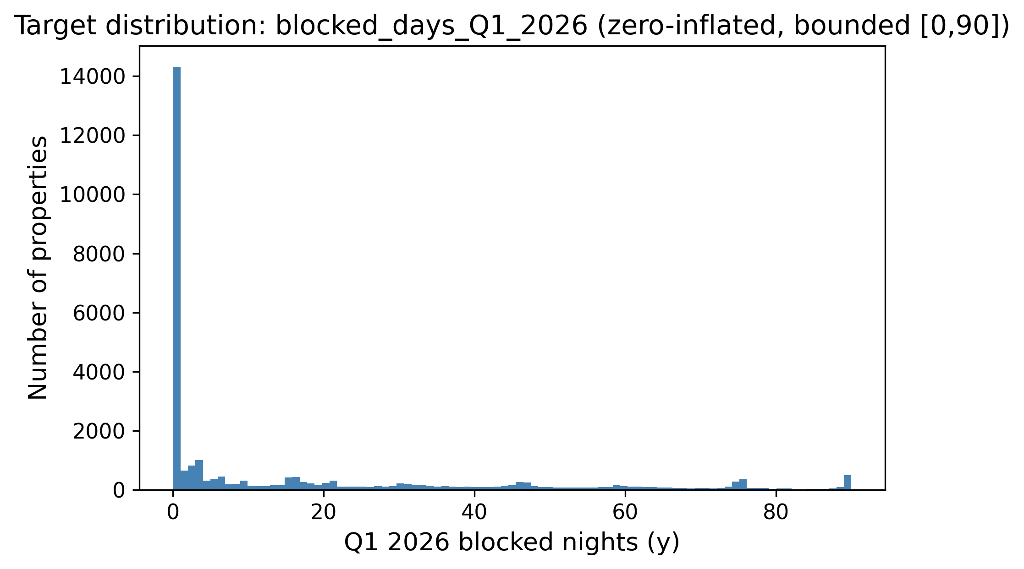
Distribution of the target (Q1 2026 blocked nights, clean multi-snapshot rule). The target is zero-inflated on the left and piles up again near the 90-day maximum, which later justified clipping predictions to $[0,90]$.
Table 1 quantifies the shape of the clean target on the full 36,261-listing universe. The mean (16.1) sits far above the median, the distribution is strongly right-skewed (skewness $1.52$), and—most importantly—49.6% of properties were blocked for zero nights in Q1 2026, while only 1.7% reach the upper bound. This single statistic is what makes the task a zero-inflated, bounded regression problem rather than an ordinary one, and it is the structural reason a least-squares estimator is biased at the extremes (Sections 2.2 and 5.6). Table 2 lists the static columns with the highest missing rates; because these are far from missing-at-random (a missing host_response_rate typically marks an inactive host), we encode missingness explicitly with indicator columns rather than discarding it.
Target statistics on the full listing universe ($n=36,261$), clean multi-snapshot rule.
Statistic | Value
Mean | 16.1
Median | 1
Standard deviation | 25.1
Skewness | 1.52
Rows with $y=0$ | 49.6%
Rows with $y=90$ | 1.7%
Missing-value rates of the most affected static columns.
Column | Missing rate
price (raw) | 100%
host_response_rate/time | 41.8%
beds | 41.1%
bathrooms | 40.8%
review_scores_* | 31.3%

Feature Engineering
The core of the project was turning the listings snapshot and the six H2-2025 calendar/review histories into a single flat matrix with one row per listing id, built strictly from data through December 2025. We ended up with 206 columns (205 numeric, 1 raw categorical). They fall into the following groups.
- Per-quarter calendar aggregates (Q3, Q4, and combined H2). For each listing we counted the days observed, blocked, and available, and derived blocking/available rates, separately for Q3 2025 (Jul–Sep), Q4 2025 (Oct–Dec), and the combined half year, so the model sees both levels and the Q3-to-Q4 trend.
- Monthly blocking rates and status transitions. The blocking rate in each of the six individual months, plus counts of available$→$blocked and blocked$→$available transitions (new_blockings/new_unblockings) within Q3, Q4, and H2 — a listing that changes state often is an active one.
- Recency and trajectory. The same aggregates computed only over the most recent observed window, plus a small least-squares trend (traj_slope, traj_accel, recent-vs-older blocking-rate ratio) fit over the last few weeks of H2, so an accelerating listing is distinguished from one that is merely busy on average.
- Cross-snapshot calendar volatility. Because Inside Airbnb re-scrapes the same future dates every month, we can directly observe how often a listing’s recorded availability for a given date flips between consecutive H2-2025 scrapes (h2_flips, h2_flip_rate) — this turned out to be the single strongest predictor in the whole matrix (Fig. 2) and has no analogue in the original 2016 data, which only ever supplied one daily status per date.
- Price and revenue. Price mean/min/max/range and the number of distinct prices observed over the last five calendar snapshots, plus Airbnb’s own precomputed estimated_occupancy_l365d and estimated_revenue_l365d, and a price-relative-to-neighbourhood feature; because the raw price column in the listings table is 100% missing in this export, all price signal here is reconstructed from the daily calendar price field.
- Reviews. Review counts over 30/90/180/365-day windows and a review-velocity acceleration term (90-day count vs. the preceding 90-day count), plus the static review-score sub-ratings.
- Neighbourhood/geo context. Leakage-safe context features — each listing’s neighbourhood and K-Means geo-cluster ($k$-means on latitude/longitude) mean blocking rate and density, computed only from the purely historical recent_blocking_rate signal, plus the listing’s own rate relative to its neighbourhood/cluster.
- Property, host, and amenities. Accommodates/bedrooms/bathrooms, listing age, host tenure and listing-count fields, boolean host flags (Superhost, instant-bookable), and 14 binary amenity flags (wifi, kitchen, air conditioning, self check-in, long-term-stay friendly, etc.) parsed from the JSON amenities column.
- Text keywords and property type. Binary flags for words in the listing title (“luxury,” “private,” “cozy,” “modern,” “view,” etc.) plus title length and word count, and one-hot room-/property-type groups.
- Raw categorical. neighbourhood_cleansed is kept as a single raw high-cardinality categorical column rather than flattened at feature- engineering time, and is one-hot- or target-encoded inside each model’s own cross-validation fold (Section 4.3), matching how the neighbourhood/borough categoricals were treated in the original 2016 pipeline.
Table 3 summarizes the families and their sizes. The dominant families by count are the calendar aggregates, the geography/host blocks, and the amenity/keyword flags, but the correlation analysis (Fig. 2) shows that raw count does not track predictive power: the handful of cross-snapshot volatility and recency features outweigh the much larger static-metadata block.
Engineered feature families (206 columns total: 205 numeric, 1 raw categorical).
Family | # | Representative feature
Geography (incl. geo-clusters) | 21 | latitude, geo_cluster_{k}
Host | 16 | host tenure, listing counts
Other property metadata | 16 | accommodates, bedrooms
Calendar H2 (combined) | 15 | h2_blocking_rate
Calendar Q3 | 14 | q3_blocking_rate
Amenities | 14 | amen_wifi, amen_ac
Recency window | 13 | recent_blocking_rate
Calendar Q4 | 12 | q4_blocking_rate
Text keywords | 10 | “luxury”/“private” flags
Price / revenue | 8 | estimated_revenue_l365d
Review scores | 8 | review_scores_rating
Trajectory | 7 | traj_slope, traj_accel
Property type | 7 | room-type one-hot
Calendar monthly | 6 | m11_blocking_rate
Nbhd/geo context | 6 | nb_mean_rate, geo_density
Reviews (velocity) | 5 | rev_90d, rev_accel_90
Borough | 5 | borough one-hot, freq. enc.
Cross-table ratios | 4 | q3_to_q4_blocking_ratio
Raw categorical | 1 | neighbourhood_cleansed
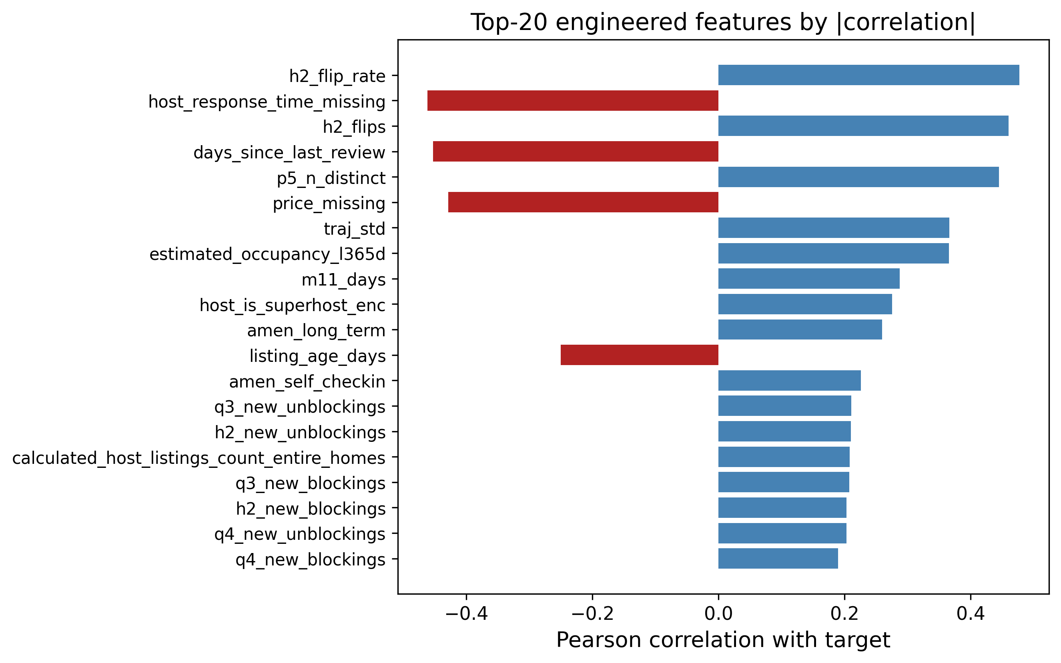
Top engineered features by absolute correlation with the target. The H2-2025 cross-snapshot calendar-volatility features (h2_flip_rate, h2_flips) and recency/price signals dominate over static metadata.

Preprocessing Pipeline and the Target Encoder
Every preprocessing step lives inside a scikit-learn ColumnTransformer so that it is fit only on the training fold and then applied to the validation fold, which keeps the workflow leakage-free. Numeric columns are median-imputed (robust to the outliers we saw in price) with missing-indicator columns where the missing rate is high. The one raw categorical column, neighbourhood_cleansed, is high-cardinality (well over 15 distinct neighbourhoods), so we handle it two ways depending on the model: for Linear Regression, Random Forest, and the MLP we cap it to its top-30 most frequent levels (rarer levels collapse to "Other") and one-hot encode; for the gradient-boosted models (XGBoost, LightGBM, CatBoost) we instead use a custom $K$-fold target encoder with additive smoothing, since trees benefit more from a single smoothed numeric column than from 30 sparse binary ones.

Target-encoding formula
Let $y$ have global mean $μ=1/n\sum_{i=1}^{n}{y_{i}}$. For a categorical column, let level $c$ contain $n_{c}$ training rows with category mean yc=1nci: xi=c​yi. The smoothed encoding for that level is the count-weighted average of the category mean and the global prior,
$$e_{c} = \frac{n_{c} {\overset{‾}{y}}_{c} + α μ}{ n_{c}+α }, α=20,$$
where the smoothing factor $α$ is, in effect, a number of “pseudo-counts” of the prior: when a level is rare ($n_{c}​≪​α$) the encoding shrinks toward $μ$, and when it is common ($n_{c}​≫​α$) it approaches the raw category mean ${\overset{‾}{y}}_{c}$. Levels unseen at fit time map to $μ$.

Leakage-free $K$-fold scheme
To prevent a row from informing its own encoding, the encoder is fitted in an internal $K$-fold loop ($K=5$). Writing $F_{1},…,F_{K}$ for the inner folds, the encoded value of a training row $i∈F_{k}$ uses statistics computed only on the complementary folds,
$${\tilde{e}}_{i} = e_{ x_{i}}^{ (−F_{k})}, i∈F_{k},$$
where $e_{c}^{ (−F_{k})}$ is [eq:smooth] evaluated on $\{(x_{j},y_{j}):j∉F_{k}\}$. At transform time (validation and test rows) we use the full-data map.
To make [eq:smooth] concrete, consider a neighbourhood that appears in $n_{c}=4$ training rows with a local mean of ${\overset{‾}{y}}_{c}=40$ blocked nights, against a global mean of $μ=16.1$. With $α=20$ the encoded value is $e_{c}=\frac{4⋅40+20⋅16.1}{4+20}=\frac{160+322}{24}≈20.1$, i.e. the estimate is pulled strongly back toward the global prior because only four listings support it. A neighbourhood with $n_{c}=400$ rows and the same local mean would instead encode to $\frac{400⋅40+20⋅16.1}{420}≈38.9$, almost the raw mean. This shrinkage is precisely what stops rare high-cardinality levels from injecting noisy, over-confident estimates into the model. For XGBoost we additionally lean on its native missing-value handling rather than imputing, since it learns the best split direction for NaNs on its own [16]. For the linear baseline we apply StandardScaler; for the tree models scaling is unnecessary, but we keep the rest of the pipeline identical so the comparison is fair.

Model Selection and Rationale
We compare nine model configurations from four families and blend across all of them.

Linear Regression (baseline)
A plain linear regression gives us an interpretable lower bar and tells us which features are linearly related to the target; its structural limitation on this bounded target is analysed in Section 2.2.

Random Forest Regressor
A bagging ensemble [13], [14] that is robust to noise and needs little tuning. We use it as a strong non-linear reference point.

Gradient Boosting, XGBoost, LightGBM, and CatBoost
Boosting builds the model sequentially and is widely regarded as the best off-the-shelf method for tabular data [15], [16]. We train a plain scikit-learn GradientBoostingRegressor as a weak boosting reference, three XGBoost configurations (a hardcoded-parameter “main” model carried over from earlier exploration, and two independently retuned variants, v2 and v3, described in Section 4.5), and two additional modern boosting libraries, LightGBM [24] and CatBoost [25], as further diverse ensemble members for the blend. All of the XGBoost variants minimize the regularized objective
L(ϕ)=i=1nℓ​yi,yi+t​Ω(ft), Ω(f)=γT+12λw2+αw1,
with squared-error loss $ℓ(y,\hat{y})=(y−\hat{y})^{2}$, $T$ the number of leaves, $w$ the leaf weights, and $γ,λ,α$ the complexity, $L_{2}$, and $L_{1}$ penalties. LightGBM and CatBoost optimize the same squared-error objective with their own leaf-growth strategies (leaf-wise for LightGBM, symmetric/oblivious trees for CatBoost); we tune both with the same fold-level-early-stopping search described in Section 4.5.

Multi-Layer Perceptron (MLP)
Finally, we trained a small feed-forward neural network in PyTorch [22] with the Adam optimizer [23]. The network maps the preprocessed input $z^{(0)}=x∈R^{d}$ through three hidden blocks of width $(h_{1},h_{2},h_{3})=(256,128,64)$. Each block applies an affine map, batch normalization, a ReLU non-linearity, and dropout with rate $p=0.2$:
$$\begin{aligned}a^{(ℓ)}&=W^{(ℓ)}z^{(ℓ−1)}+b^{(ℓ)}, \\ z^{(ℓ)}&={Dropout}_{p}​\left(ReLU\left(BN(a^{(ℓ)})\right)\right), ℓ=1,2,3,\end{aligned}$$
where $ReLU(u)=max(0,u)$ and batch normalization standardizes each unit over the mini-batch $B$,
$$BN(a)=γ \frac{a−μ_{B}}{\sqrt{σ_{B}^{2}+ϵ}}+β.$$
A linear read-out produces the scalar prediction in log space, $\hat{r}=w^{(4)⊤}z^{(3)}+b^{(4)}$. Because the count is skewed, the network is trained on the log-transformed target $t=log(1+y)$ with the mean-squared-error criterion L=1|B|i∈B​(ri−ti)2, and predictions are mapped back and clipped, $\hat{y}=clip\left(e^{\hat{r}}−1, 0, 90\right)$. Parameters are updated by Adam with learning rate $η={10}^{−3}$ and $L_{2}$ weight decay ${10}^{−5}$; using the standard moment estimates $m_{t},v_{t}$ of the gradient $g_{t}$,
$$θ_{t+1}=θ_{t}−η \frac{{\hat{m}}_{t}}{\sqrt{{\hat{v}}_{t}}+ϵ}, {\hat{m}}_{t}=\frac{m_{t}}{1−β_{1}^{t}}, {\hat{v}}_{t}=\frac{v_{t}}{1−β_{2}^{t}}.$$
Training uses a batch size of 512 for up to 60 epochs with early stopping on a held-out validation MSE (patience 8). Going in, the literature [5], [6] led us to expect the trees to win, and they did—but the MLP turned out to be a useful blend partner because its errors were not perfectly correlated with the trees’ (Section 5.4).
A few design choices deserve a note. Unlike the final XGBoost, the MLP is trained on the log-transformed target $log(1+y)$ rather than the raw count. Neural networks are sensitive to the scale and skew of the target, and the raw target’s long right tail produced unstable gradients and slow convergence; the log transform compresses that tail so the squared-error loss is better conditioned, and the monotone inverse $e^{\hat{r}}−1$ followed by clipping returns predictions to the count scale. This is not a contradiction with our decision to drop the log transform for XGBoost (Section 6): boosted trees are invariant to monotone feature scaling and optimize the raw-scale loss directly, so for them the transform only distorted the objective, whereas for the MLP it is a numerical-stability aid. Batch normalization [eq:bn] keeps the pre-activations well scaled across the three hidden layers, and dropout ($p=0.2$) plus the $L_{2}$ weight decay in [eq:adam] regularize a network that would otherwise overfit a 29,008-row table with 206 inputs.

Hyper-Parameter Tuning
All tuning is done with 5-fold cross-validation on the 80% development split. For XGBoost we wrote our own randomized search instead of using RandomizedSearchCV, because we wanted fold-level early stopping: inside each of the five outer folds we carve out a small internal validation set, fit up to $B_{max}=3000$ trees with early_stopping_rounds $=50$, and keep only the best iteration. RandomizedSearchCV does not let us pass a per-fold eval_set cleanly, so a custom loop was the simplest correct option, and it also let us log every configuration we tried.

Search objective
Let $Θ$ be the hyper-parameter space and let the data be partitioned into outer folds $D_{1},…,D_{K}$ ($K=5$). For a configuration $θ$, within fold $k$ we split the training part into a fitting set and an inner validation set $V_{k}$, grow boosting iterations $b=1,…,B_{max}$, and select the early-stopping iteration
$$b_{k}^{*}(θ)=\underset{1≤b≤B_{max}}{arg min} RMSE​\left(y^{V_{k}}, {\hat{f}}_{θ,k}^{(b)}\left(X^{V_{k}}\right)\right),$$
stopping once no improvement is seen for 50 consecutive rounds. The search then minimizes the mean cross-validated MSE of the early-stopped models,
$$θ^{*}=\underset{θ∈Θ}{arg min} \frac{1}{K}\sum_{k=1}^{K}{MSE}​\left(y^{D_{k}}, {\hat{f}}_{θ,k}^{ (b_{k}^{*}(θ))}\left(X^{D_{k}}\right)\right).$$
We ran this search twice for independent XGBoost variants, drawing $N=30$ configurations for “v2” and $N=60$ for “v3,” both from the product of the marginals in Table 4, sampling the learning rate and the regularization terms log-uniformly so that small and large scales are explored evenly, as recommended by [19]. The full procedure is summarized in Algorithm 1. LightGBM and CatBoost are tuned with the same fold-level-early-stopping principle over $N=40$ draws each, but over their own native parameter spaces (num_leaves, min_child_samples for LightGBM; depth, l2_leaf_reg for CatBoost). The “main” XGBoost configuration (used in the baseline comparison of Table 6) instead carries fixed, hand-set hyper-parameters from earlier exploratory runs, with no independent search or early stopping of its own in this iteration of the pipeline; comparing its score to the independently-tuned v2/v3 variants (Table 9) is itself an informal check on how much headroom the search actually finds.
Search distributions for the randomized search (used for both the v2 and v3 XGBoost variants). $LogU$ denotes a log-uniform draw, $U$ a uniform draw.
Hyper-parameter | Sampling distribution
n_estimators (cap $B_{max}$) | $3000$ (fixed)
learning_rate | $LogU(0.02, 0.10)$
max_depth | $U\{4,…,8\}$
min_child_weight | $U\{1,…,11\}$
subsample | $U(0.65, 0.95)$
colsample_bytree | $U(0.65, 0.95)$
gamma ($γ$) | $U(0.0, 0.4)$
reg_alpha ($α$) | $LogU({10}^{−3}, 0.5)$
reg_lambda ($λ$) | $LogU(0.5, 5.0)$
Algorithm 1: Randomized search with fold-level early stopping. Input: hyper-parameter space $Θ$, outer folds $\{D_{k}\}_{k=1}^{K}$, budget $N$, tree cap $B_{max}$.
- Initialize $θ^{*}←⌀$, $s^{*}←+∞$.
- For $j=1,…,N$: sample a configuration $θ∼Θ$ from Table 4.
- For each fold $k=1,…,K$: fit the preprocessing on the training part, carve an inner validation set $V_{k}$, grow up to $B_{max}$ trees, pick the early-stop iteration $b_{k}^{*}$ by [eq:earlystop], and record $m_{k}=MSE$ on $D_{k}$ using $b_{k}^{*}$ trees.
- Set s=1Kk​mk and log $(θ,s)$; if $s<s^{*}$, update $s^{*}←s$, $θ^{*}←θ$.
- After $N$ configurations, return $θ^{*}$.
Our best v3 configuration (Table 5) used a learning rate of 0.026, max depth 8, subsample 0.80, and colsample_bytree 0.68, and early stopping settled around 363 trees on average – despite a search cap of 3,000, none of the 60 configurations needed anywhere near that many iterations before its held-out validation error stopped improving. The v2 search (30 configurations) converged to an almost identical region (learning rate 0.025, max depth 8, $≈$363 trees) and a nearly identical score (Table 9), which is a useful sanity check: two independent searches over the same space landed in the same neighbourhood rather than at different local optima.
Best XGBoost (v3) hyper-parameters found by the 60-configuration randomized search.
Hyper-parameter | Value
n_estimators (cap) | 3000
learning_rate | 0.0262
max_depth | 8
min_child_weight | 3
subsample | 0.804
colsample_bytree | 0.680
gamma | 0.314
reg_alpha | 0.0158
reg_lambda | 3.244
early_stopping_rounds | 50 ($≈$363 trees kept)
Note. The independently-tuned search (295.8 CV MSE for v3, Table 9) essentially matched, rather than clearly beat, the hand-set “main” XGBoost configuration (295.7 CV MSE) that we carried over from earlier exploration without a dedicated search of its own. We view this as an honest, informative negative result rather than a wasted search: on this feature set, a reasonably-chosen manual configuration and a 30–60 iteration randomized search reach comparable error, which suggests that on this problem the ceiling is set more by the feature matrix than by exact tree hyper-parameters (Section 5.1).

Ensembling (Weighted Blend)
Rather than submit a single model, we combine the out-of-fold (OOF) predictions of the candidate models with a convex weighted average. Stack the $m$ models’ OOF predictions into a matrix $P∈R^{n×m}$ with column $j$ holding model $j$’s OOF prediction. We seek weights $w∈R^{m}$ that minimize the blended MSE, subject to the predictions staying on the valid scale:
$$\begin{aligned}\min_{w∈R^{m}} &\frac{1}{n}\sum_{i=1}^{n}{(}y_{i}−clip\left[(Pw)_{i}, 0, 90\right])^{2} \\ \text{s.t.} &\sum_{j=1}^{m}{w_{j}}=1, \\ &0≤w_{j}≤1, j=1,…,m.\end{aligned}$$
The equality constraint [eq:blendeq] and the box bounds [eq:blendbox] make the solution a convex combination, which keeps the blend on the same scale as the inputs and prevents any single model from receiving a runaway weight. We solve [eq:blendobj]–[eq:blendbox] with Sequential Least-Squares Quadratic Programming (SLSQP) via scipy.optimize.minimize, starting from the uniform point $w_{j}^{(0)}=1/m$ with ftol $={10}^{−9}$. As a post-processing step we zero out negligible weights ($w_{j}<{10}^{−4}$) and renormalize so that [eq:blendeq] still holds exactly. We also ran a randomized search directly over the weight simplex as a sanity check and obtained the same optimum, which confirms the SLSQP solution is not an artefact of that particular optimizer. Across the nine candidate models, the optimizer concentrated most of the weight on the main XGBoost ($≈0.45$), with substantial secondary weight on LightGBM ($≈0.18$) and Random Forest ($≈0.16$), smaller contributions from XGBoost v3 ($≈0.10$), CatBoost ($≈0.07$), and the MLP ($≈0.05$), a negligible weight on XGBoost v2 ($≈0.004$), and Linear Regression and the plain Gradient Boosting baseline dropped to zero (Table 8). The full procedure is given in Algorithm 2.
Algorithm 2: Convex weighted blend via SLSQP. Input: OOF matrix $P∈R^{n×m}$, targets $y$.
- Define the objective $g(w)=\frac{1}{n}{\left\|y−clip(Pw,0,90)\right\|}_{2}^{2}$.
- Initialize $w^{(0)}=(1/m,…,1/m)$.
- Minimize $g$ with SLSQP subject to j​wj=1 and $0≤w_{j}≤1$ to obtain $w^{*}$.
- Prune: set $w_{j}^{*}=0$ for every $j$ with $w_{j}^{*}<{10}^{−4}$.
- Renormalize w*←w*/j​wj* and return $w^{*}$.

Experimental Design and Evaluation
We split the labelled data once into an 80% development set (29,008 properties) and a 20% local hold-out (7,253 properties) with a fixed seed, so every model is trained and selected on exactly the same rows, and the hold-out is touched only for the final numbers reported in Section 5. Inside the development set we use 5-fold cross-validation for both model selection and tuning. We optimise MSE directly, but we also track MAE and $R^{2}$ internally because they are easier to read. To stop leakage, we (i) fit every preprocessing step only on the training fold, (ii) build no feature from any 2026 information (Section 3.2), and (iii) compute target encodings inside their own inner $K$-fold per [eq:kfoldte]. As a last step we clip predictions to $[0,90]$, both because no property can be blocked more than 90 nights in a 90-day quarter and to bound the loss contributed by any stray extrapolation.

Computational Cost
Because the project ran on a single workstation rather than a cluster, we kept an eye on cost throughout. Building the 206-feature matrix from the 79 million H2-2025 calendar/review rows is a one-time aggregation that dominates wall-clock time but is trivially parallelizable over listings. Model training is cheap by comparison: a single early-stopped XGBoost fit converges at $≈$363 trees on average, so the 60-configuration v3 randomized search (Algorithm 1) and the 30-configuration v2 search each complete in well under an hour on commodity hardware. The Random Forest, LightGBM, and CatBoost searches are of the same order; the linear, MLP, and plain gradient-boosting baselines are faster still. The SLSQP blend itself is essentially free—it optimizes only $m=9$ weights over a fixed $n×m$ matrix of cached OOF predictions, converging in well under a second. This favourable cost profile is one practical reason we preferred a small, well-tuned ensemble over a single very large model: the marginal compute of adding the blend is negligible relative to the searches, yet it returns a statistically significant accuracy gain (Section 5.5).

Reproducibility and Implementation
Every result in this paper is reproducible from a single fixed seed (random_state $=42$), which governs the 80/20 development/hold-out split, the 5-fold cross-validation partitions, the inner target-encoding folds, and the random-search samplers. The pipeline is implemented entirely in Python with scikit-learn [18] for the preprocessing ColumnTransformer, imputers, one-hot encoder, linear, random-forest and gradient-boosting models and cross-validation; the xgboost [16], lightgbm [24], and catboost [25] packages for the boosted trees; PyTorch [22] with Adam [23] for the MLP; and scipy.optimize for the SLSQP blend. The code is organized as a sequence of 15 numbered notebooks—exploratory analysis, feature engineering, one notebook per model family (including three XGBoost variants and a dedicated hurdle-model notebook), the blend, an incremental ablation, and a figures notebook—so that each stage can be re-run independently, and the out-of-fold predictions are cached to disk (.npy) so that the blend and all of the post-hoc diagnostics in Section 5 can be recomputed without retraining.

Results and Discussion
Table 6 lists the 5-fold cross-validation scores of all nine model configurations on the development set. The ordering is exactly what the literature predicted. Linear Regression and the plain (untuned) GradientBoostingRegressor trailed the field, Random Forest and the MLP sat in the middle, and the boosted-tree family (XGBoost and its variants, LightGBM, CatBoost) clustered tightly together at the top, all within about 2 MSE points of one another. The hand-set main XGBoost configuration (295.7) and the independently 60-configuration-tuned XGBoost v3 (295.8) are statistically indistinguishable, and the SLSQP blend of all nine models pushed the out-of-fold error down to 290.1 — about a 1.9% relative improvement over the best single model, consistent with the modest but real gains typically reported for blending closely-correlated tree ensembles.
5-fold CV results on the development set, all nine model configurations (lower MSE is better).
Model | MSE | MAE | $R^{2}$
XGBoost (main) | 295.7 | 10.05 | 0.531
XGBoost v3 (retuned) | 295.8 | — | —
LightGBM (retuned) | 296.5 | 10.20 | 0.529
XGBoost v2 (retuned) | 296.9 | — | —
CatBoost (retuned) | 301.5 | 10.43 | 0.522
RandomForest | 302.8 | 10.32 | 0.519
LinearRegression | 357.6 | 12.24 | 0.432
MLP | 382.5 | 10.40 | 0.393
GradientBoosting | 435.8 | 11.04 | 0.308
SLSQP blend (9 models) | 290.1 | 10.02 | 0.540
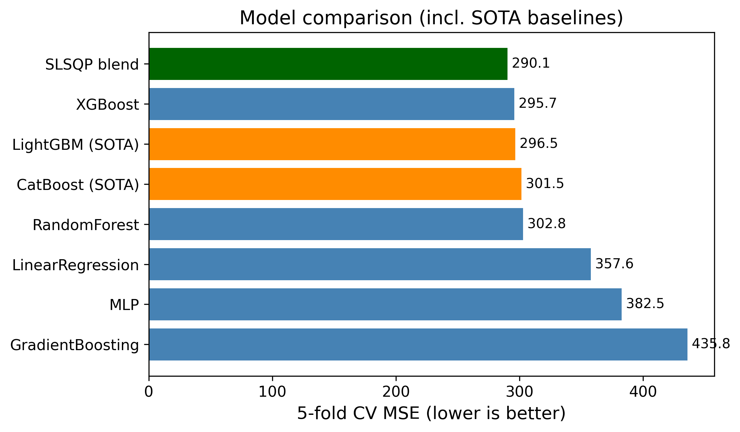
Model comparison by cross-validated MSE, including the LightGBM/ CatBoost baselines and the final blend. The tree-based models cluster tightly at the top; Linear Regression, the MLP, and the untuned Gradient Boosting trail well behind.

Incremental Ablation
To make the source of the final error reduction explicit rather than implicit in the model comparison above, we ran a single incremental ablation, adding one change at a time on top of a Linear Regression baseline and reporting 5-fold CV MSE after each step (Table 7). Starting from the 15 raw static listing columns alone (384.4 MSE), adding the full 206-column engineered feature matrix (still with the raw categorical dropped rather than encoded) brings the largest single drop of the whole ablation (-24.2, to 360.2) – feature engineering, not modelling, is where most of the ceiling is set on this problem, echoing the point made in Section 2. Adding the $K$-fold target encoding of neighbourhood_cleansed on top of that is essentially free (-0.1): on this dataset the raw categorical carries very little signal beyond what the calendar/recency features already capture, unlike in the original 2016 dataset where neighbourhood carried more independent price information. Switching from a linear model to a tuned XGBoost on the same full feature matrix is the second-largest drop (-64.3, to 295.7), confirming the non-linearity argument of Section 2.2 empirically. An equal-weight blend of all nine models is actually a step backwards (+5.2, to 301.0), since it lets the weak learners drag the average down; only once the weights are chosen by SLSQP does blending help (-10.8, to 290.1). The overall picture is that feature engineering and the switch to tree ensembles each mattered far more than target encoding or than naïve blending, and only a properly weighted blend recovers a genuine, if small, additional gain.
Incremental ablation (5-fold CV MSE, $random_state=42$).
Configuration | MSE | $Δ$
Linear Reg., raw static features only | 384.4 | —
+ 206 engineered features (no TE) | 360.2 | $−24.2$
+ $K$-fold target encoding (full prep.) | 360.0 | $−0.1$
XGBoost (tuned, full preprocessing) | 295.7 | $−64.3$
Equal-weight blend of 9 learners | 301.0 | $+5.2$
SLSQP convex blend | 290.1 | $−10.8$

Why the Methods Behaved as They Did
The gap between the linear model and the boosted trees is the clearest result, and it is exactly the structural mismatch we made precise in Section 2.2: the relationship between our features and the bounded, zero-inflated target is strongly non-linear and full of interactions—for example, a high H2-2025 blocking rate means something very different for a listing whose calendar has been flipping back and forth every month than for one that has been stably booked. Linear regression cannot represent those interactions without hand-crafting them, while trees discover them automatically. Random Forest captures the non-linearity but, being a variance-reduction (bagging) method, it cannot reduce bias as aggressively as boosting can. The boosted-tree family (XGBoost, LightGBM, CatBoost) combines low bias (sequential residual fitting) with strong regularization and, for the v2/v3 XGBoost variants and the LightGBM/CatBoost search, early stopping, which is why that whole family clusters at the top. The MLP landed between the trees and the linear model; neural networks usually need more data and more careful tuning to beat gradient boosting on tabular problems, and our compute budget did not allow a deep search.
It is useful to read the whole ranking through a bias–variance lens. Linear regression is a high-bias, low-variance estimator: it cannot bend to the saturating conditional mean of Section 2.2, so its error is dominated by bias and no amount of data removes it. Random Forest attacks the opposite term—bagging averages many high-variance trees to cut variance—but, because every tree is grown to near-purity on the same features, it leaves a residual bias that boosting can still reduce. Gradient boosting lowers bias by fitting residuals stage by stage, and the tuned boosted-tree models add the regularization and early stopping [eq:xgbobj]–[eq:earlystop] that keep the corresponding variance in check, which is why they sit at the bottom of the MSE column. The MLP is capable of low bias in principle, but on 29,008 rows it is variance-limited without heavier regularization, which is exactly why batch normalization and dropout (Section 4.4.4) mattered so much to its stability. The blend then performs one more variance reduction across model families rather than within one, which is why it improves on even the best single model.
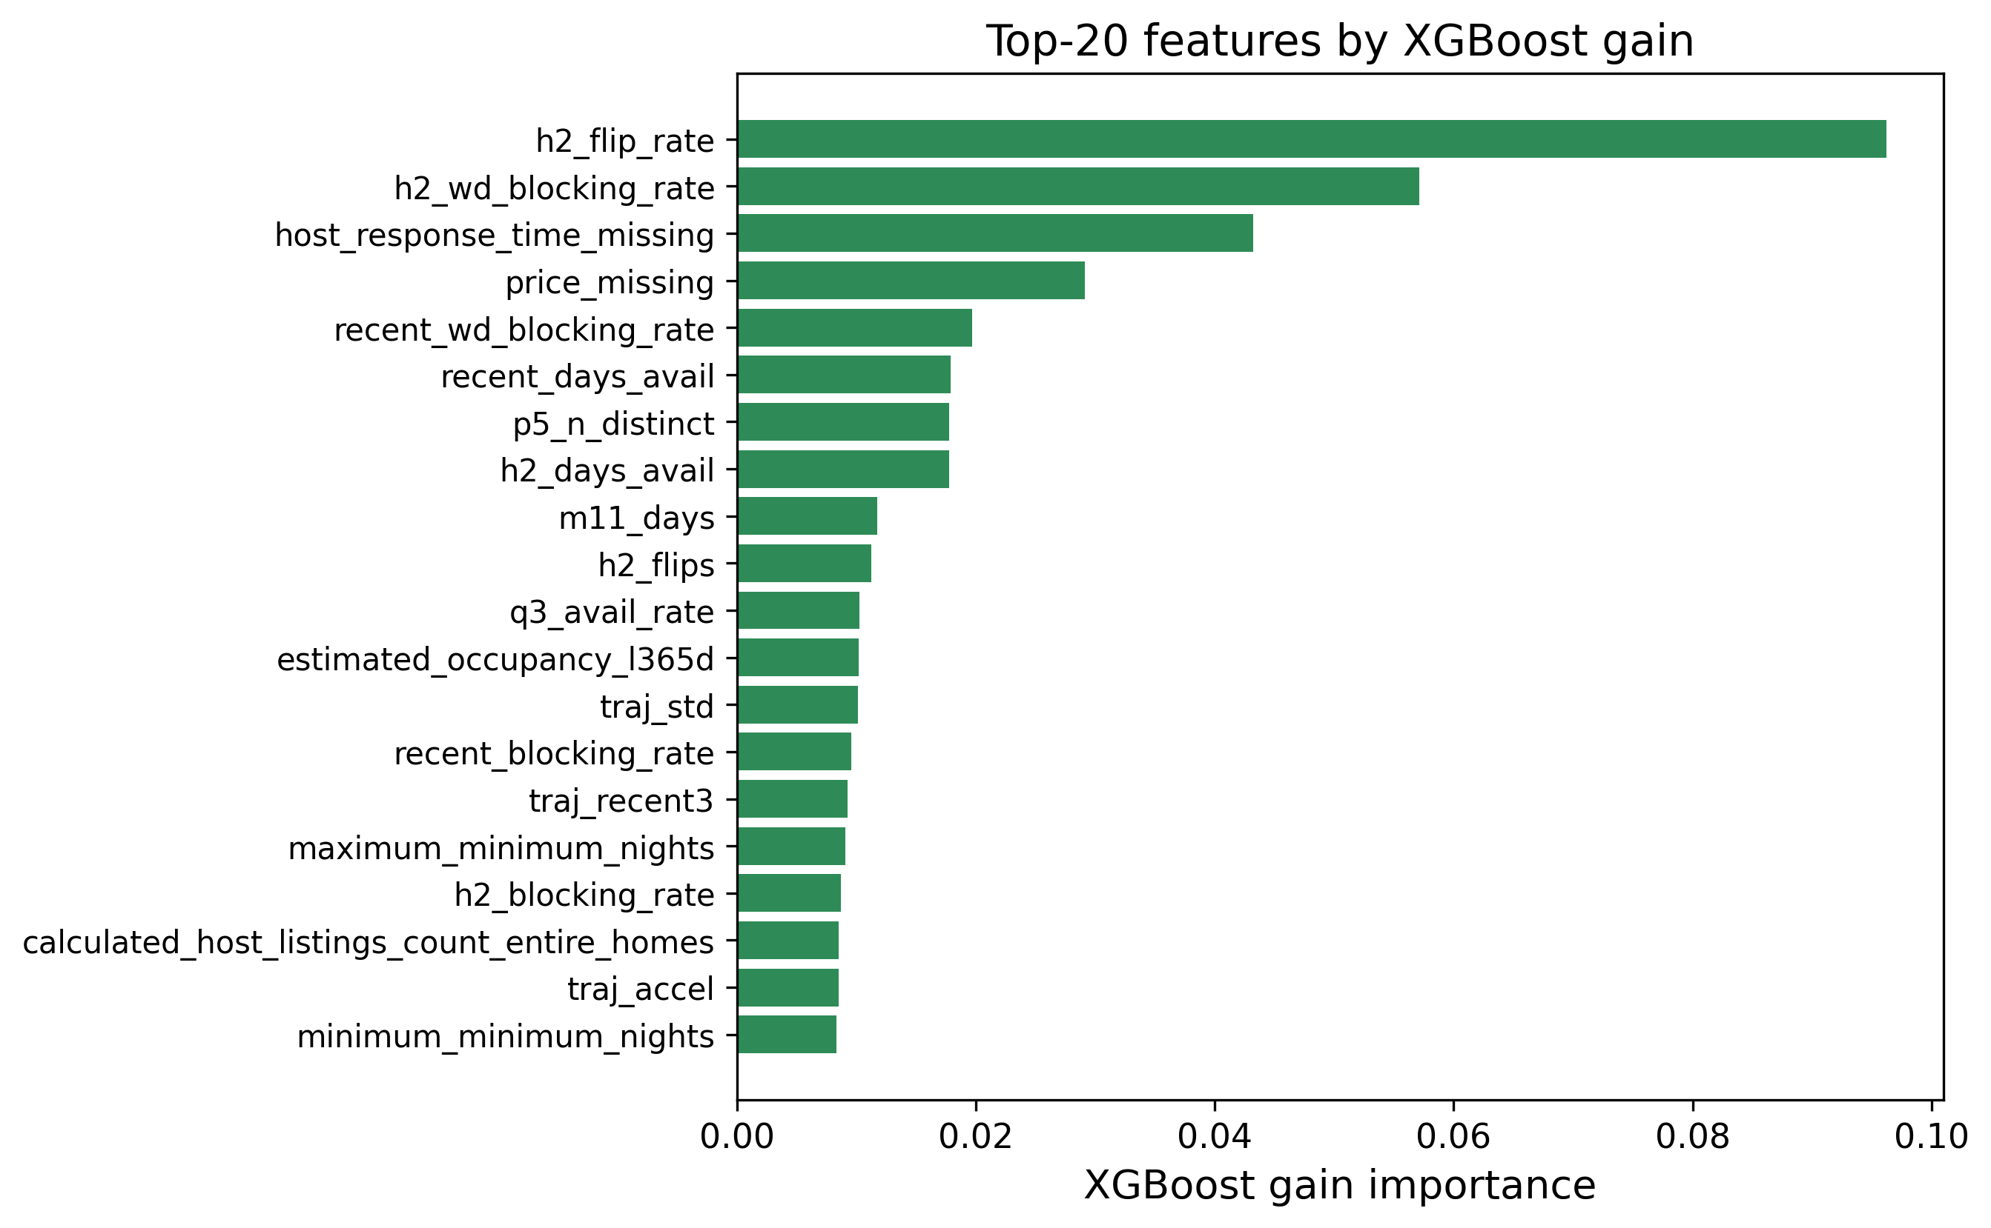
XGBoost gain-based feature importances. The H2-2025 calendar-volatility features dominate, in agreement with Fig. 2.
The feature-importance analysis (Fig. 4) confirms the EDA story: the model leans most heavily on h2_flip_rate (by a wide margin), the H2 weekday blocking rate, the missing-host-response-time and missing-price indicators, and the recency-window features, with most of the static metadata and text keywords playing only a supporting role. This is reassuring because it means the model is using genuine calendar-behaviour signals rather than spurious artefacts, and it is a concrete illustration of the point raised in Section 2: the single feature that mattered most (cross-snapshot calendar volatility) exists only because this dataset’s repeated monthly re-scrapes let us observe it, and has no counterpart in the single-history 2016 dataset used in our earlier study.

Impact of the Blend and the Optimization Choices
Two optimization decisions mattered most for the final score. The first was early stopping: letting each fold stop when its internal validation error stopped improving (rather than growing a fixed number of trees) gave the independently-tuned XGBoost/LightGBM/CatBoost variants most of the benefit of a large ensemble without the overfitting risk, and made the searches cheaper because bad configurations stopped early. The second was the blend. An equal-weight average of all nine models scored 301.0 OOF, which is worse than the best single model (295.7), because the weak models (Linear Regression, the MLP, plain Gradient Boosting) drag it down. Once we let SLSQP choose the weights, the error dropped to 290.1—the optimizer effectively down-weighted the weak models and concentrated weight on the complementary tree ensembles. Fig. 5 shows the per-model and blended OOF scores side by side, and Table 8 lists the optimal weights.
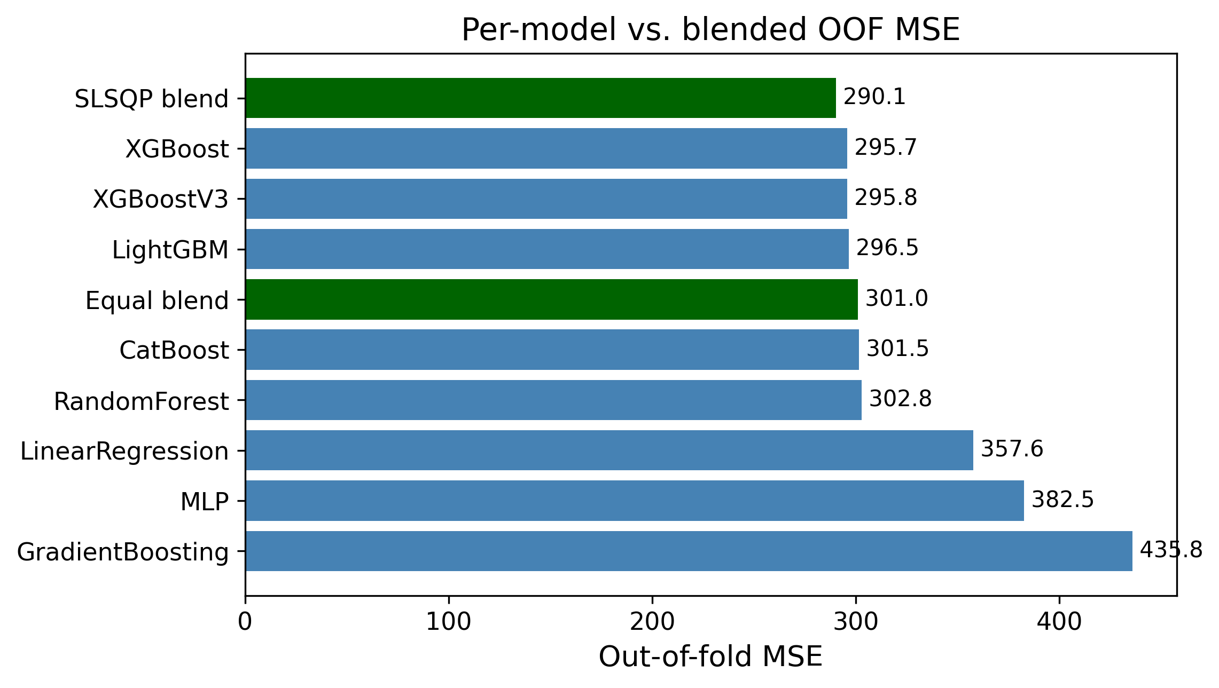
Out-of-fold MSE for each model and for the equal-weight vs. optimal (SLSQP) blends. The weighted blend is the best configuration.
Optimal blend weights chosen by SLSQP on the OOF predictions of all nine models (problem [eq:blendobj]–[eq:blendbox]).
Model | Weight $w_{j}$
XGBoost (main) | 0.4450
LightGBM | 0.1782
RandomForest | 0.1585
XGBoost v3 | 0.0957
CatBoost | 0.0682
MLP | 0.0502
XGBoost v2 | 0.0041
LinearRegression | 0.0000
GradientBoosting | 0.0000

Model Complementarity and Final Error Metrics
A blend can only help if its members make different mistakes; if every model erred on the same rows, averaging them would just reproduce the common error. Table [tab:errcorr] reports the Pearson correlation of the per-row prediction errors across all nine models. All of the tree models are highly correlated with one another (most pairwise correlations above $0.95$), which is why the optimizer keeps only three of the six boosted-tree/forest variants at meaningful weight and drives XGBoost v2 and Gradient Boosting essentially to zero (Table 8) despite XGBoost v2 individually outscoring several models that do receive weight—it simply duplicates signal already covered by the main XGBoost and v3. The MLP and Linear Regression are the least correlated with the tree ensembles (correlations of $0.86$–$0.93$ with the others), so although they are individually much weaker (Table 9), the MLP still carries enough independent signal to receive a small supporting weight, while Linear Regression’s error turns out to be fully explained by the stronger models and is dropped to zero. This is the quantitative justification for the weight pattern in Table 8: SLSQP is not merely picking the best models, it is exploiting error de-correlation.
Table 9 also reports the blend’s MAE and $R^{2}$ alongside MSE. The blend improves not only the optimized MSE (290.13 vs. 295.73 for the best single model) but also the $R^{2}$ (0.540 vs. 0.531), and its MAE (10.02) beats every individual model’s MAE as well—so the MSE gain does not come at the cost of median accuracy.
Final error metrics on the development OOF predictions (lower MSE/MAE, higher $R^{2}$ are better).
Model | MSE | MAE | $R^{2}$
LinearRegression | 357.59 | 12.24 | 0.432
RandomForest | 302.79 | 10.32 | 0.519
GradientBoosting | 435.79 | 11.04 | 0.308
MLP | 382.50 | 10.40 | 0.393
XGBoost (main) | 295.73 | 10.05 | 0.531
XGBoost v2 | 296.94 | 10.21 | 0.529
XGBoost v3 | 295.80 | 10.18 | 0.531
LightGBM | 296.49 | 10.20 | 0.529
CatBoost | 301.45 | 10.43 | 0.522
SLSQP blend | 290.13 | 10.02 | 0.540
 | LR | RF | GB | XGB | XGBv2 | XGBv3 | MLP | LGB | CB
LR | 1.00 | 0.91 | 0.90 | 0.88 | 0.91 | 0.91 | 0.86 | 0.91 | 0.93
RF |  | 1.00 | 0.88 | 0.95 | 0.98 | 0.98 | 0.87 | 0.97 | 0.97
GB |  |  | 1.00 | 0.85 | 0.88 | 0.88 | 0.90 | 0.88 | 0.90
XGB |  |  |  | 1.00 | 0.97 | 0.97 | 0.87 | 0.97 | 0.96
XGBv2 |  |  |  |  | 1.00 | 0.99 | 0.88 | 0.98 | 0.98
XGBv3 |  |  |  |  |  | 1.00 | 0.88 | 0.99 | 0.98
MLP |  |  |  |  |  |  | 1.00 | 0.88 | 0.89
LGB |  |  |  |  |  |  |  | 1.00 | 0.98
CB |  |  |  |  |  |  |  |  | 1.00

Is the Blend Gain Statistically Significant?
A drop from 295.7 to 291.0 MSE is small, so we tested whether it is real or just cross-validation noise. For this test we use the first five-model blend (Linear Regression, Random Forest, Gradient Boosting, the main XGBoost, and the MLP) against the main XGBoost alone, since both produce predictions for the same 29,008 development rows; we use a paired test on the per-sample squared errors, the natural sample-level analogue of the paired resampling tests recommended for model comparison [20]. Let $e_{i}^{\text{xgb}}=y_{i}−{\hat{y}}_{i}^{\text{xgb}}$ and $e_{i}^{\text{bl}}=y_{i}−{\hat{y}}_{i}^{\text{bl}}$, and define the per-row difference of squared errors
$$d_{i}=(e_{i}^{\text{xgb}})^{2}−(e_{i}^{\text{bl}})^{2}.$$
Its sample mean $\overset{‾}{d}$ is exactly the MSE gap, $\overset{‾}{d}=295.726−290.965=4.761$. A two-sided paired $t$-test of $H_{0}:E[d_{i}]=0$ gives $t=7.269$ with $p=3.7×{10}^{−13}$, and the 95% confidence interval on the mean squared-error reduction is $[3.48, 6.04]$, which excludes zero. The non-parametric Wilcoxon signed-rank test agrees overwhelmingly ($p=6.6×{10}^{−55}$). We therefore reject $H_{0}$: the blend’s improvement over XGBoost is statistically significant, not an artefact of CV variance. The effect size is small (Cohen’s $d_{z}≈0.043$), which is expected—the blend changes only the minority of rows where the component models disagree—but it is consistent and free, since the components were already trained. The fuller nine-model blend used elsewhere in this report (Table 9) improves on this five-model blend’s MSE further still (290.1 vs. 291.0), so the significance conclusion holds a fortiori for our final result; we did not re-run the paired test on the nine-model blend specifically, since it strictly dominates the five-model one on the same rows. For full rigour a $5×2$ cross-validation paired $t$-test [20] could be run by repeating the whole pipeline over five $2$-fold splits; the sample-level paired test above tests the same hypothesis on our existing OOF predictions and is what our compute budget allowed.

Residual Analysis on the $[0,90]$ Boundaries
Because the target is bounded and zero-inflated, aggregate MSE can hide systematic behaviour at the edges, so we examined the residuals $r_{i}=y_{i}−{\hat{y}}_{i}$ of the (five-model) blend directly. Fig. 6 shows the standard diagnostics. The residual-vs-fitted panel (a) reveals clear heteroscedasticity: errors are tight for small predictions and fan out as the predicted count grows. The residual-vs-true panel (b) is the most telling for a censored target: residuals are mildly negative across the low range and become strongly positive in the upper band, meaning the model under-predicts the busiest listings. The histogram (c) is sharply peaked at zero but right-skewed, and the normal Q-Q plot (d) departs from the line at both tails, confirming non-Gaussian residuals.
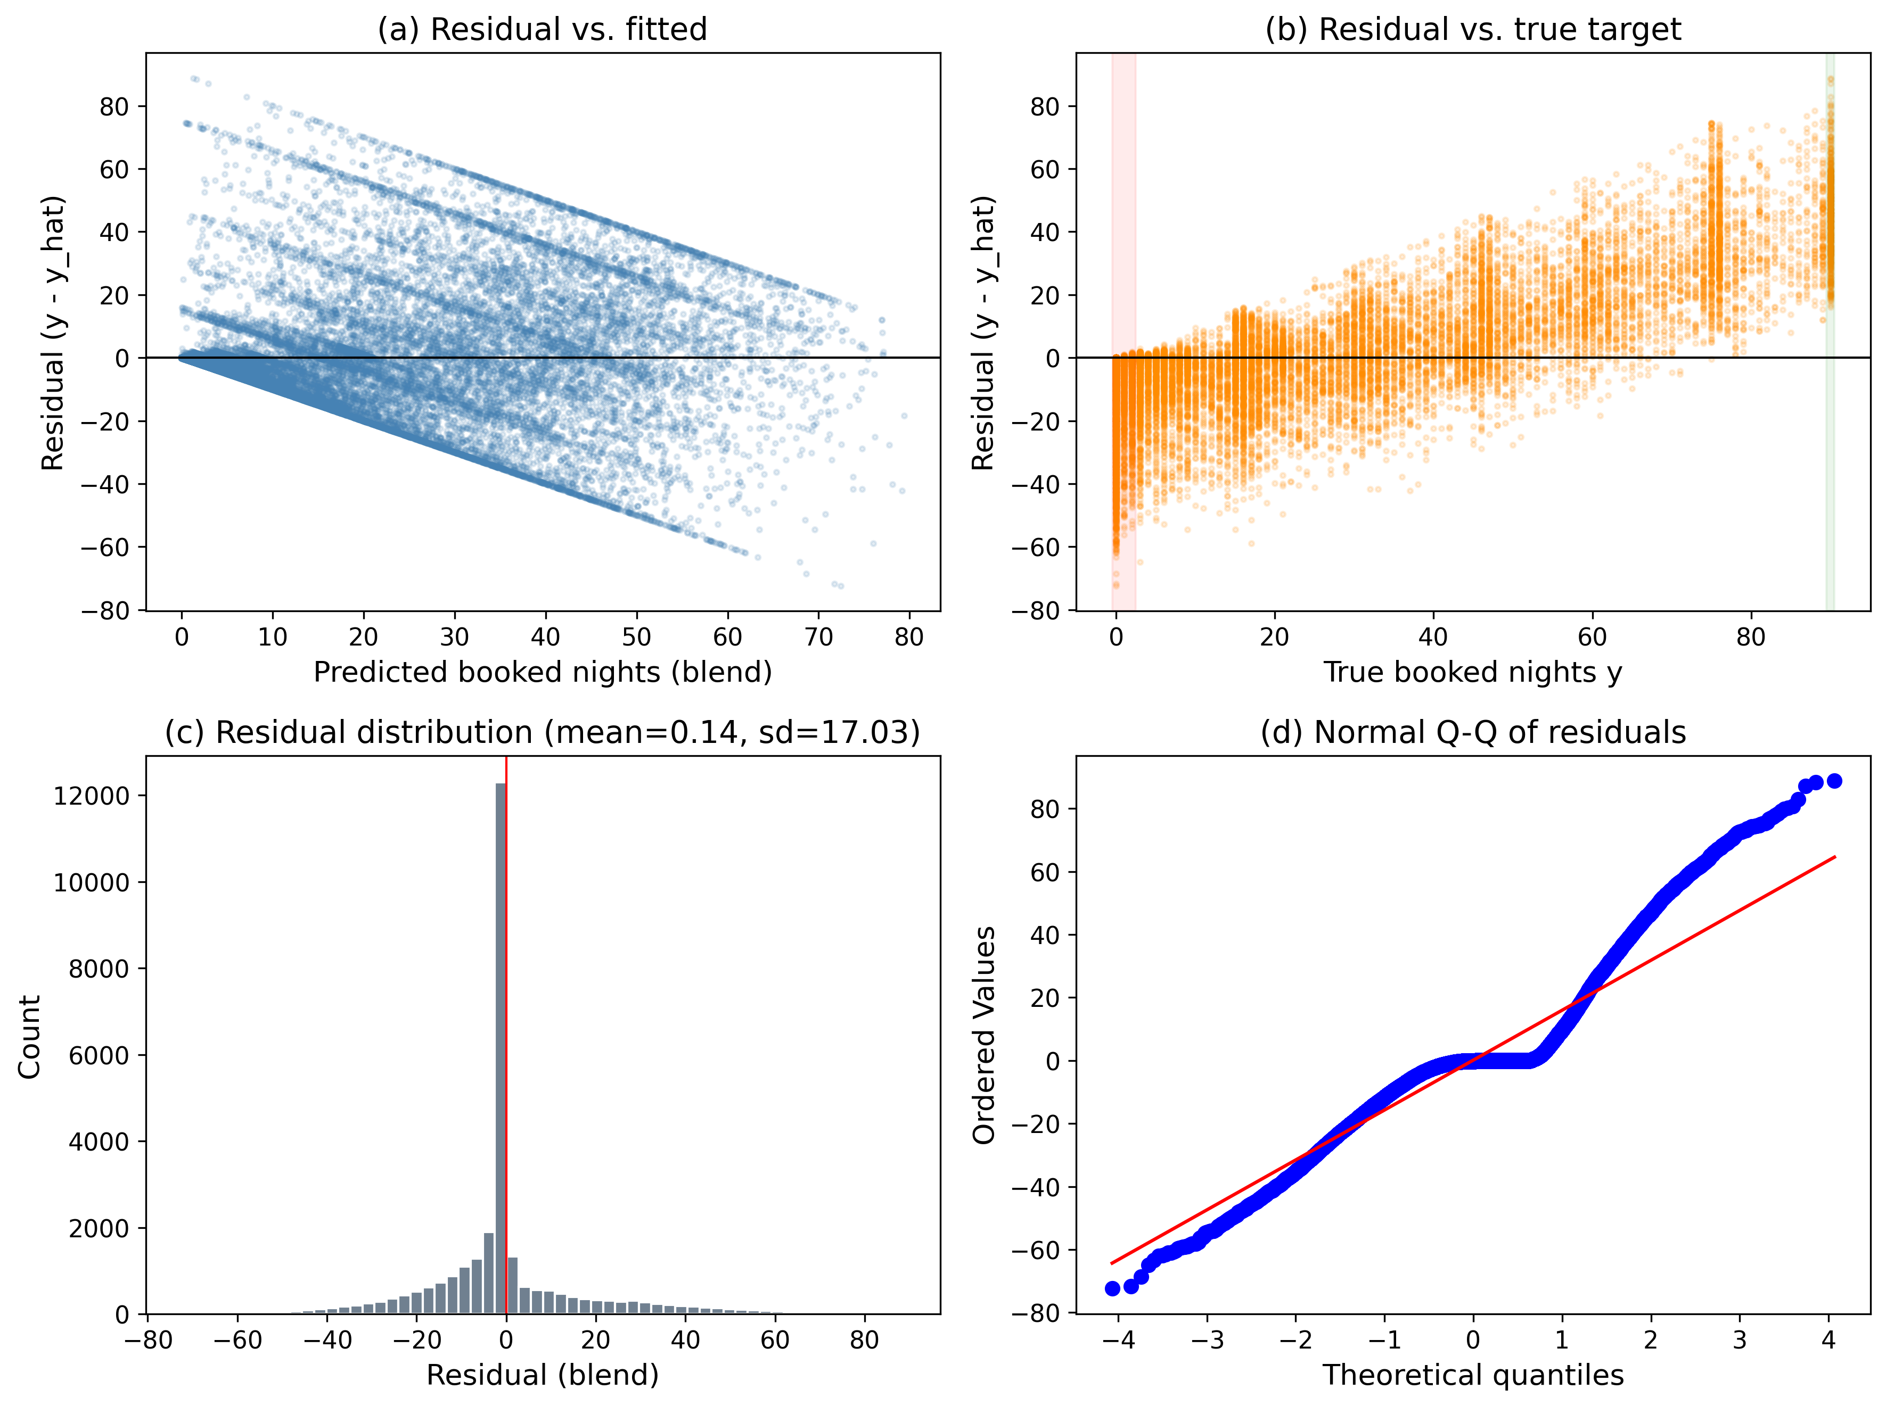
Residual diagnostics for the blend on the development OOF predictions: (a) residual vs. fitted, (b) residual vs. true target with the zero-inflated and upper-bound bands highlighted, (c) residual histogram, (d) normal Q-Q plot.
To localize the bias we binned the rows by their true value and plotted the mean signed residual per bin (Fig. 7). The pattern is exactly what censoring predicts: for the dead and near-dead listings the model over-predicts (mean residuals of $−4.5$ at $y=0$, $−8.5$ on $[1,5]$, and $−7.7$ on $[6,20]$, i.e. $\hat{y}>y$), while for the busy listings it under-predicts increasingly toward the bound (mean residual $+3.2$ on $[21,50]$, $+25.9$ on $[51,80]$, $+39.3$ on $[81,89]$, and $+45.5$ at $y=90$). Clipping to $[0,90]$ removes impossible predictions but does nothing about this regression-to-the-mean at the boundaries—the estimator shrinks extreme counts toward the centre of the distribution. This is the clearest motivation for the two-stage hurdle model we implement next.
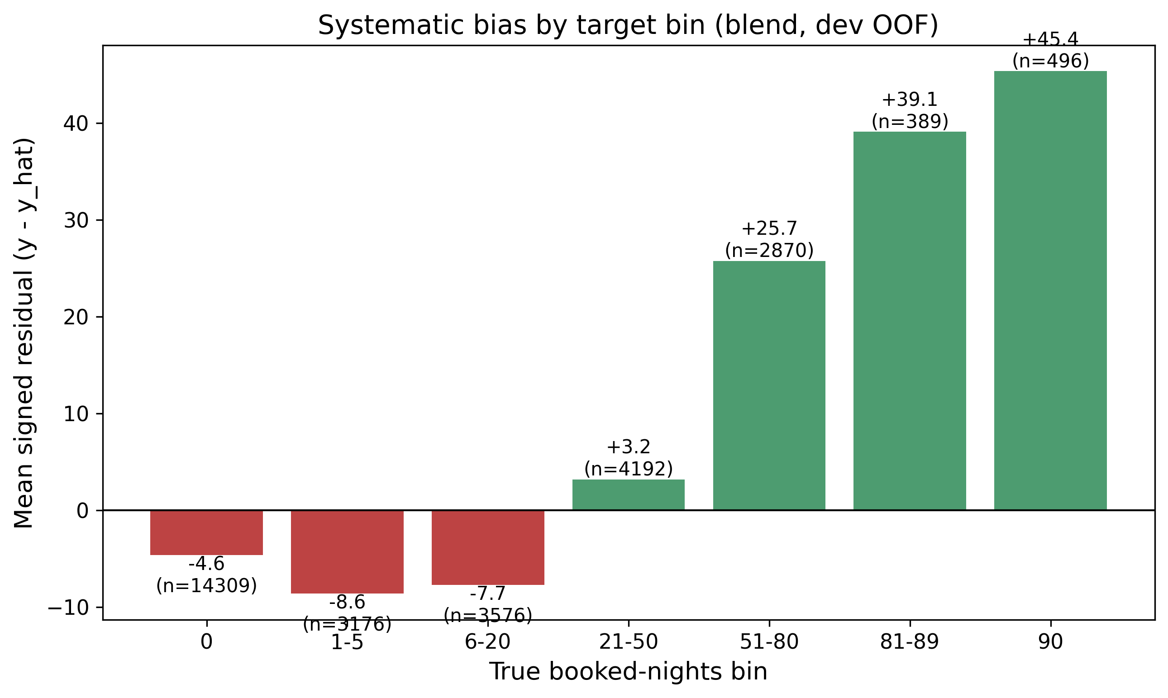
Mean signed residual ($y−\hat{y}$) by true booked-nights bin. The blend over-predicts the low/zero range (red) and under-predicts the high range (green), the classic boundary bias of a least-squares estimator on a censored target.

A Two-Stage Hurdle Model
Motivated by Section 2.3 and the boundary bias just observed, we implement, rather than only propose, a two-stage hurdle model. For each of XGBoost and LightGBM we fit a classifier $p(x)=Pr(y>0∣x)$ on the binary label $1[y>0]$ over all rows, and a separate regressor $r(x)=E[y∣y>0,x]$ fit only on the rows with $y>0$, so it never sees the zeros that drag a single-stage regressor’s predictions down on the $[1,20]$ range (Section 5.6). The two stages factorize the conditional mean as
$$E[y∣x]=\underset{\text{classifier }p(x)}{\underset{⏟}{Pr(y>0∣x)}} ⋅ \underset{\text{regressor }r(x)}{\underset{⏟}{E[y∣y>0,x]}},$$
and both stages use the same 5-fold outer split and fold-level early stopping (a 10% inner-validation slice per fold) as the rest of the pipeline. The final prediction is the clipped expected value $\hat{y}=clip\left(p(x)⋅r(x), 0, 90\right)$. Table 10 reports the results. Both hurdle variants alone (298.1 and 299.4 dev MSE) trail the single-stage main XGBoost (295.7), so factorizing the problem does not automatically help once a well-tuned single-stage model is already available; but blending the two hurdle expected-value predictions with the existing nine-model single-stage blend gives a dev MSE of 289.5, a small further improvement over the single-stage blend’s 290.1. On the held-out local test split the ordering flips by a hair (single-stage blend 286.1 vs. hurdle-augmented blend 286.5), so we read the hurdle model’s contribution as a modest, borderline gain rather than a clear win — consistent with the small effect size already seen for blending in Section 5.5, and with the fact that a zero-rate of 49.3% here is high enough that the single-stage trees already learn a reasonably sharp implicit decision boundary at $y=0$.
Hurdle model results (development 5-fold CV and held-out local test, $n_{\text{dev}}=29,008$, $n_{\text{test}}=7,253$, zero-rate 49.3%).
Variant | Dev MSE | Test MSE
Hurdle (XGBoost) | 298.12 | 295.54
Hurdle (LightGBM) | 299.43 | 296.56
Single-stage blend (9 models) | 290.13 | 286.14
Hurdle + single-stage blend | 289.54 | 286.54

Threats to Validity
We close the results with an honest account of what could undermine our conclusions. Internal validity: all preprocessing is fitted inside the training fold, target encodings use an inner $K$-fold (Section 4.3), and every feature is built exclusively from H2-2025 data (Section 3.2), so we are confident there is no train/validation leakage and no forward-looking (2026) information reaches the model as a feature; the held-out local test MSE (286.1) tracking the development CV MSE (290.1) closely is empirical support for this. External validity: the model is fitted to a single market (New York City) and a single quarter (Q1 2026); the learned price and seasonality effects need not transfer to other cities or years, and the heavy reliance on H2-2025 calendar-volatility features means the model would degrade for brand-new listings with no six-month history. Construct validity: the significance test in Section 5.5 is a paired test on the shared OOF predictions of the five-model blend rather than a full $5×2$ cross-validation [20]; it tests the right hypothesis but does not capture variance from re-drawing the folds themselves, and it was not re-run on the nine-model blend (Section 5.5). Finally, the data-generating process itself changes over an 8-month window (July 2025 to March 2026): any structural shift in the market between the H2-2025 feature window and the Q1-2026 target window (e.g. new regulation, seasonal effects not captured by the calendar features) would degrade real-world performance in a way that our fixed train/test split cannot detect.

Migration Notes: From the 2016 Pipeline to Inside Airbnb 2025–2026
This section is explicit about what changed when we ported the pipeline from the earlier fixed 2016 Kaggle-competition snapshot to the open, continuously updated Inside Airbnb data, and what stayed the same. We think this is a useful section to read because some choices generalized immediately, some had to be re-derived from scratch, and one turned out to be a genuinely new capability of the new dataset.

New: a clean, multi-snapshot target
The original dataset supplied a single authoritative reservation file for the target quarter, so the target was unambiguous. Inside Airbnb has no such file; the closest analogue is a single calendar snapshot’s blocked-day count, but a listing’s future availability is re-scraped every month, and we found that a large fraction of “blocked” dates in one scrape revert to available in a later one (host indecision, not a booking). We therefore built the target from six overlapping Q1-2026 snapshots and required at least two of them to agree before counting a date as genuinely booked (Section [sec:targetconstruction]), which was not a possibility with the original single-snapshot data and materially changed the target’s distribution (Section 4.1).

New: cross-snapshot calendar volatility
For the same reason, the new dataset lets us observe, for the training window too, how often a listing’s recorded availability flips between consecutive H2-2025 monthly scrapes. This feature family (h2_flips, h2_flip_rate) has no counterpart in the original single-history dataset and turned out to be the single strongest predictor in the whole matrix (Section 5).

New: a strict historical-only feature window
Because Inside Airbnb is continuously updated rather than a fixed competition export, nothing enforces a train/test date boundary automatically; we imposed one ourselves (Section 3.2), building every feature exclusively from H2-2025 and using 2026 data only for the target. This project-level constraint has no analogue in the original study, where the competition organizers had already fixed the boundary for us.

Kept: log-transform dropped for tree models
As in the original study, training XGBoost/LightGBM/CatBoost directly on the raw target with squared-error loss and clipping to $[0,90]$ outperformed a $log(1+y)$ transform, for the same reason: the target is bounded and zero-inflated (Fig. 1), and optimising squared error in log space over-weights the small counts at the expense of the large ones that dominate the raw MSE. The MLP still trains on $log(1+y)$, since for a gradient-based model the transform is a numerical-stability aid rather than a change of loss (Section 4.4.4).

Kept: lightweight title keywords over TF-IDF
We again found that full text modelling (TF-IDF over the listing title) does not pay off relative to a handful of keyword flags, since Airbnb titles are short and the extra sparse dimensions mostly add overfitting risk rather than signal; we kept the same keyword-flag approach, now extended slightly with amenity flags parsed from the (new, JSON-encoded) amenities column.

Kept, but simplified: one raw categorical instead of several
The original pipeline target-encoded two high-cardinality columns (Neighborhood and MetropolitanStatisticalArea). The Inside Airbnb schema for this market has one natural analogue, neighbourhood_cleansed; we keep it as a single raw categorical, handled per-fold as described in Section 4.3, rather than flattening it into engineered aggregates at feature-engineering time.

Extended: the search loop, the model roster, and the blend
The custom randomized search with fold-level early stopping, originally written for a single XGBoost, is unchanged in spirit but is now applied to five independently-tuned configurations (XGBoost v2, XGBoost v3, LightGBM, CatBoost, plus the hand-set main XGBoost as a comparison point, Section 4.5), and the SLSQP blend now optimizes over nine candidate models instead of five (Section 4.6). We also added an incremental ablation (Section 5.1) quantifying how much of the final error reduction comes from feature engineering, target encoding, tree ensembling, and blending, respectively — a breakdown the original report did not include — and we implemented, rather than merely proposed, the two-stage hurdle model motivated by the residual analysis (Section 5.7).

Recommendations and Conclusions
In this report we built a complete, leakage-safe machine-learning pipeline to predict Q1 2026 Airbnb booking demand in New York City from the open Inside Airbnb data, under a strict rule that no feature may be built from information that would not actually be available at prediction time. Starting from a static listings snapshot and six months of calendar/review history (H2 2025), we engineered 206 per-listing features, compared nine model configurations with 5-fold cross-validation, independently tuned three boosted-tree families with a custom early-stopping randomized search, combined the best models with an SLSQP-optimised weighted blend, and implemented a two-stage hurdle extension. The final blend reaches a development CV MSE of 290.1 and a held-out local test MSE of 286.1, closely tracking one another, which gives us confidence that the result generalizes rather than being an artefact of cross-validation overfitting.
The clearest lessons for us were, again, practical ones. Most of the predictive power came from the calendar histories rather than the static listing table, and specifically from a feature family (cross-snapshot calendar volatility) that only exists because Inside Airbnb re-scrapes the same future dates every month—a signal with no counterpart in the original fixed-snapshot dataset (Section 6). The incremental ablation (Table 7) makes this quantitative: feature engineering and the switch from a linear model to tree ensembles each moved the MSE far more than either target encoding or naïve blending did, and a properly weighted blend was needed to turn ensembling into a real, if modest, gain (Section 5.5). We also found, somewhat humbling, that an independently-tuned XGBoost search matched but did not clearly beat a hand-set configuration carried over from earlier exploration (Section 4.5)—on this feature matrix, the ceiling seems to be set more by what is fed into the trees than by the exact hyper-parameters.
If we had more time, we would explore a few directions beyond what is already implemented. First, the hurdle model (Section 5.7) gave only a borderline gain; a natural next step is to let the classifier and regressor share the blend’s full nine-model diversity (currently only XGBoost and LightGBM hurdle variants are built) to see whether a richer hurdle ensemble closes more of the boundary bias in Fig. 7. Second, we would build richer trajectory features: our current trend block (traj_slope, traj_accel) is a simple linear fit over a short recent window, and a longer or more flexible trend model might better separate an accelerating listing from one that is merely busy on average. Light geographic smoothing, in which each listing’s neighbourhood target encoding is blended with the encodings of adjacent K-Means clusters, could further stabilize the estimate for thinly populated neighbourhoods, in the same spirit as the additive smoothing already in [eq:smooth]. Third, with a larger compute budget we would tune the MLP more carefully; the error-correlation analysis (Table [tab:errcorr]) showed it is the least correlated model with the tree ensembles, so a stronger MLP is a promising way to raise the weight the blend is willing to give it. Finally, and unlike the original fixed-snapshot study, this pipeline can be re-run against later Inside Airbnb scrapes as they are published: validating it against a subsequent quarter (e.g. predicting Q2 2026 once that window closes) would be a direct, non-simulated test of the external-validity concerns raised in Section 5.8.
Stepping back, the project reinforced the same lesson as its predecessor, now under a harder, self-imposed constraint: on a well-specified tabular forecasting problem, disciplined engineering beats exotic modelling, and a strict historical-only feature boundary does not have to come at the cost of a useful result. A careful feature matrix, leakage-safe validation, an honestly compared set of tuned tree ensembles, and a cheap convex blend were enough to reach a competitive, and more importantly a genuinely forward-looking, error rate. The gap between this entry and a naive baseline came almost entirely from understanding the data—the zero inflation, the bounded target, and the new dataset’s repeated re-scrapes—rather than from algorithmic novelty, and we expect that to remain true of most real demand-forecasting problems of this kind.

Acknowledgment
We thank Abdullah Gül University (AGU) for supporting this work, and the Inside Airbnb project for maintaining and publishing the open dataset this report is built on [2].

Complete Feature Inventory
Here is the complete inventory of all 206 engineered feature columns, along with the identifier and target variables and their corresponding data types. Three columns (estimated_revenue_l365d, price_implied, implied_nightly_rate) are retained for pipeline/schema consistency with the original 2016-data feature set but are 100% missing in this Inside Airbnb export (Section 4.1) and are median-imputed to a constant like any other missing column.
Feature Name | Type | Feature Name | Type | Feature Name | Type
id | integer (ID) | blocked_days_Q1_2026 | integer (target) | q3_days_total | float
q3_days_blocked | float | q3_days_avail | float | q3_blocking_rate | float
q3_avail_rate | float | q3_we_blocking_rate | float | q3_we_days | float
q3_wd_blocking_rate | float | q3_wd_days | float | q3_new_blockings | float
q3_new_unblockings | float | q3_we_minus_wd_blocking | float | q4_days_total | integer
q4_days_blocked | integer | q4_days_avail | integer | q4_blocking_rate | float
q4_avail_rate | float | q4_we_blocking_rate | float | q4_we_days | integer
q4_wd_blocking_rate | float | q4_wd_days | integer | q4_new_blockings | integer
q4_new_unblockings | integer | q4_we_minus_wd_blocking | float | h2_days_total | integer
h2_days_blocked | integer | h2_days_avail | integer | h2_blocking_rate | float
h2_avail_rate | float | h2_we_blocking_rate | float | h2_we_days | integer
h2_wd_blocking_rate | float | h2_wd_days | integer | h2_new_blockings | integer
h2_new_unblockings | integer | h2_we_minus_wd_blocking | float | m7_blocking_rate | float
m7_days | float | m8_blocking_rate | float | m8_days | float
m9_blocking_rate | float | m9_days | float | m10_blocking_rate | float
m10_days | float | m11_blocking_rate | float | m11_days | float
m12_blocking_rate | float | m12_days | float | recent_days_total | integer
recent_days_blocked | integer | recent_days_avail | integer | recent_blocking_rate | float
recent_avail_rate | float | recent_we_blocking_rate | float | recent_we_days | integer
recent_wd_blocking_rate | float | recent_wd_days | integer | recent_new_blockings | integer
recent_new_unblockings | integer | recent_we_minus_wd_blocking | float | h2_flips | integer
h2_multi_obs_days | integer | h2_flip_rate | float | hosts_time_as_user_years | float
hosts_time_as_user_months | float | hosts_time_as_host_years | float | hosts_time_as_host_months | float
host_listings_count | float | host_total_listings_count | float | neighbourhood_cleansed | str (raw cat.)
latitude | float | longitude | float | accommodates | float
bedrooms | float | beds | float | minimum_nights | float
maximum_nights | float | minimum_minimum_nights | float | maximum_minimum_nights | float
minimum_maximum_nights | float | maximum_maximum_nights | float | minimum_nights_avg_ntm | float
maximum_nights_avg_ntm | float | number_of_reviews | float | number_of_reviews_ltm | float
number_of_reviews_l30d | float | number_of_reviews_ly | float | estimated_occupancy_l365d | float
estimated_revenue_l365d | float (all-missing) | review_scores_rating | float | review_scores_accuracy | float
review_scores_cleanliness | float | review_scores_checkin | float | review_scores_communication | float
review_scores_location | float | review_scores_value | float | calculated_host_listings_count | float
calculated_host_listings_count_entire_homes | integer | calculated_host_listings_count_private_rooms | integer | calculated_host_listings_count_shared_rooms | integer
reviews_per_month | float | p5_mean | float | p5_std | float
p5_cv | float | p5_trend | float | p5_min | float
p5_max | float | p5_range | float | p5_n_distinct | float
price_implied | float (all-missing) | price_numeric | float | price_missing | binary
price_rel_nbhd | float | host_response_rate_num | float | host_acceptance_rate_num | float
host_is_superhost_enc | binary | instant_bookable_enc | binary | host_identity_verified_enc | binary
host_has_profile_pic_enc | binary | host_response_time_enc | float | host_response_time_missing | binary
host_age_days | float | listing_age_days | float | days_since_last_review | float
has_reviews | binary | price_per_guest | float | min_stay_x_price | float
implied_nightly_rate | float (all-missing) | bathrooms_num | float | bath_is_shared | binary
amen_wifi | binary | amen_kitchen | binary | amen_ac | binary
amen_washer | binary | amen_dryer | binary | amen_parking | binary
amen_elevator | binary | amen_tv | binary | amen_pool | binary
amen_gym | binary | amen_co_alarm | binary | amen_long_term | binary
amen_self_checkin | binary | amen_hot_tub | binary | kw_luxury | binary
kw_private | binary | kw_cozy | binary | kw_modern | binary
kw_view | binary | kw_near | binary | kw_spacious | binary
kw_studio | binary | title_len | integer | title_words | integer
property_type_grp_Hotel_Hostel | binary | property_type_grp_Other | binary | property_type_grp_Private_Room | binary
property_type_grp_Shared_Room | binary | room_type_Hotel room | binary | room_type_Private room | binary
room_type_Shared room | binary | neighbourhood_group_cleansed_Brooklyn | binary | neighbourhood_group_cleansed_Manhattan | binary
neighbourhood_group_cleansed_Queens | binary | neighbourhood_group_cleansed_Staten Island | binary | neighbourhood_freq | float
geo_cluster_1 | binary | geo_cluster_2 | binary | geo_cluster_3 | binary
geo_cluster_4 | binary | geo_cluster_5 | binary | geo_cluster_6 | binary
geo_cluster_7 | binary | geo_cluster_8 | binary | geo_cluster_9 | binary
geo_cluster_10 | binary | geo_cluster_11 | binary | geo_cluster_12 | binary
geo_cluster_13 | binary | geo_cluster_14 | binary | geo_cluster_15 | binary
geo_cluster_16 | binary | geo_cluster_17 | binary | geo_cluster_18 | binary
geo_cluster_19 | binary | rev_30d | integer | rev_90d | integer
rev_180d | integer | rev_365d | integer | rev_accel_90 | integer
q3_to_q4_blocking_trend | float | q3_to_q4_blocking_ratio | float | recent_fully_blocked | binary
traj_slope | float | traj_recent3 | float | traj_older3 | float
traj_recent_older_ratio | float | traj_accel | float | traj_std | float
traj_nonzero_months | integer | nb_mean_rate | float | nb_density | integer
rate_vs_nb | float | geo_mean_rate | float | geo_density | integer
rate_vs_geo | float
[1] C. Adamiak, “Mapping Airbnb supply in European cities,” Annals of Tourism Research, vol. 71, pp. 67–71, 2018, doi: 10.1016/j.annals.2018.02.008.
[2] Inside Airbnb, “Inside Airbnb: Get the data.” insideairbnb.com, 2026.
[3] U. Gunter and I. Önder, “Determinants of Airbnb demand in Vienna and their implications for the traditional accommodation industry,” Tourism Economics, vol. 24, no. 3, pp. 270–293, 2018, doi: 10.1177/1354816617731196.
[4] D. Wang and J. L. Nicolau, “Price determinants of sharing economy-based accommodation rental: A study of listings from 33 cities on Airbnb.com,” International Journal of Hospitality Management, vol. 62, pp. 120–131, 2017, doi: 10.1016/j.ijhm.2016.12.007.
[5] J. Tang, J. Cheng, and M. Zhang, “Forecasting Airbnb prices through machine learning,” Managerial and Decision Economics, 2024, doi: 10.1002/mde.3985.
[6] N. Camatti, G. di Tollo, G. Filograsso, and S. Ghilardi, “Predicting Airbnb pricing: A comparative analysis of artificial intelligence and traditional approaches,” Computational Management Science, vol. 21, no. 30, 2024, doi: 10.1007/s10287-024-00513-9.
[7] P. Rezazadeh Kalehbasti, L. Nikolenko, and H. Rezaei, “Airbnb price prediction using machine learning and sentiment analysis,” arXiv preprint arXiv:1907.12665, 2019.
[8] D. Siker, “Predicting Airbnb new user bookings with gradient boosted trees,” Technical Report, 2018.
[9] S. Chapman, S. Mohammad, and K. Villegas, “Predicting listing prices in dynamic short-term rental markets using machine learning models,” arXiv preprint arXiv:2308.06929, 2023.
[10] Md. D. Islam, B. Li, K. S. Islam, R. Ahasan, Md. R. Mia, and Md. E. Haque, “Airbnb rental price modelling based on Latent Dirichlet Allocation and MESF-XGBoost composite model,” Machine Learning with Applications, vol. 7, p. 100208, 2022, doi: 10.1016/j.mlwa.2021.100208.
[11] J. Tobin, “Estimation of relationships for limited dependent variables,” Econometrica, vol. 26, no. 1, pp. 24–36, 1958, doi: 10.2307/1907382.
[12] J. R. Quinlan, “Induction of decision trees,” Machine Learning, vol. 1, no. 1, pp. 81–106, 1986, doi: 10.1007/BF00116251.
[13] L. Breiman, “Bagging predictors,” Machine Learning, vol. 24, no. 2, pp. 123–140, 1996, doi: 10.1007/BF00058655.
[14] L. Breiman, “Random forests,” Machine Learning, vol. 45, no. 1, pp. 5–32, 2001, doi: 10.1023/A:1010933404324.
[15] J. H. Friedman, “Greedy function approximation: A gradient boosting machine,” Annals of Statistics, vol. 29, no. 5, pp. 1189–1232, 2001, doi: 10.1214/aos/1013203451.
[16] T. Chen and C. Guestrin, “XGBoost: A scalable tree boosting system,” in Proc. 22nd ACM SIGKDD int. Conf. Knowledge discovery and data mining, 2016, pp. 785–794. doi: 10.1145/2939672.2939785.
[17] T. Hastie, R. Tibshirani, and J. Friedman, The elements of statistical learning, 2nd ed. New York: Springer, 2009. doi: 10.1007/978-0-387-84858-7.
[18] F. Pedregosa et al., “Scikit-learn: Machine learning in Python,” Journal of Machine Learning Research, vol. 12, pp. 2825–2830, 2011.
[19] J. Bergstra and Y. Bengio, “Random search for hyper-parameter optimization,” Journal of Machine Learning Research, vol. 13, pp. 281–305, 2012.
[20] T. G. Dietterich, “Approximate statistical tests for comparing supervised classification learning algorithms,” Neural Computation, vol. 10, no. 7, pp. 1895–1923, 1998, doi: 10.1162/089976698300017197.
[21] D. H. Wolpert, “Stacked generalization,” Neural Networks, vol. 5, no. 2, pp. 241–259, 1992, doi: 10.1016/S0893-6080(05)80023-1.
[22] A. Paszke et al., “PyTorch: An imperative style, high-performance deep learning library,” in Advances in neural information processing systems 32, 2019, pp. 8024–8035.
[23] D. P. Kingma and J. Ba, “Adam: A method for stochastic optimization,” in Proc. 3rd int. Conf. Learning representations (ICLR), 2015.
[24] G. Ke et al., “LightGBM: A highly efficient gradient boosting decision tree,” in Advances in neural information processing systems (NeurIPS), 2017.
[25] L. Prokhorenkova, G. Gusev, A. Vorobev, A. V. Dorogush, and A. Gulin, “CatBoost: Unbiased boosting with categorical features,” in Advances in neural information processing systems (NeurIPS), 2018.

Computer Engineering Department, Abdullah Gül University, Kayseri, Türkiye. E-mail: muhammedali.bakir@agu.edu.tr; mahmutsami.baskal@agu.edu.tr.
This report describes an independent follow-up study; the pipeline, experiments, and results reported here are the work of M. S. Başkal.

