Forecasting Quarterly Short-Term-Rental Demand from Public Availability Snapshots: A Leakage-Safe Convex Ensemble on 2025–2026 New York City Data
Anonymous Author(s)
Abstract
Accurately forecasting how heavily a short-term rental will be booked is valuable for hosts, platforms, and municipal regulators, yet most public data expose only coarse calendar availability rather than an explicit booking record. This paper studies quarterly demand forecasting for New York City short-term rentals using ten consecutive monthly Inside Airbnb snapshots (July 2025–April 2026). Because the calendars provide only an available (true/false) flag and no usable price, the prediction target—booked nights in a future quarter—is reconstructed by snapshot differencing: a date that transitions from available to unavailable across consecutive snapshots, and stays unavailable, is counted as booked. The resulting target is a censored, zero-inflated integer in $[0,92]$ with roughly half its mass at zero. A single leakage-safe pipeline—median imputation, one-hot encoding, and a $K$-fold target encoder for high-cardinality location fields—feeds five learners (Linear Regression, Random Forest, XGBoost, LightGBM, CatBoost) that are combined by a convex weighted blend whose weights are found by Sequential Least-Squares Quadratic Programming (SLSQP). Using a seven-month behavioural history to predict the February–April 2026 quarter, the blend attains a $20\%$ held-out test $R^{2}$ of $0.653$, within $0.010$ of its cross-validation estimate, and the improvement over the best single learner is statistically significant. The method is validated across three independent target quarters, and a controlled ablation shows that the dominant lever is the target definition and the depth of behavioural history; hyper-parameter tuning, a two-stage hurdle model, enriched price features, and review-velocity features each add little or nothing. The results indicate that the achievable accuracy on this public data source is bounded primarily by label quality rather than by model capacity.
Forecasting Quarterly Short-Term-Rental Demand from Public Availability Snapshots
Index Terms—Short-term rental, demand forecasting, Inside Airbnb, zero-inflated regression, gradient boosting, target encoding, model blending, convex optimization, snapshot differencing, censored data.

I. Introduction
rental (STR) platforms such as Airbnb have reshaped urban accommodation, and the volume of nights a listing will be booked over a future period is one of the most consequential quantities in the ecosystem. A host who anticipates a busy quarter can schedule maintenance, adjust pricing, and plan staffing; a platform can allocate customer-support and marketing resources toward listings likely to be under-booked; and a municipality can use aggregate booking-density estimates to study the pressure that short-term letting places on long-term housing supply. All three applications require a quantitative, per-listing forecast of future demand rather than a qualitative signal.
These three constituencies value the forecast for different but complementary reasons. For an individual host, a quarter-ahead estimate of occupancy translates directly into operational decisions: whether to raise nightly rates for an anticipated peak, when to schedule cleaning and maintenance around expected gaps, and whether the projected revenue justifies hiring help or investing in the property. For the platform, aggregating per-listing forecasts across a city yields a demand map that informs where to concentrate customer-support capacity before a busy period, which under-booked listings to surface in search or target with promotions, and how to calibrate the pricing recommendations shown to hosts. For a municipality or housing researcher, booking-density estimates provide an evidence base for studying how intensively the short-term-rental stock is used and, by extension, how much long-term housing it displaces—a question of active policy interest in dense markets such as New York City. In all three cases the useful object is a calibrated numerical prediction for each individual listing, which is the quantity this paper targets.
Two structural properties make this forecasting problem hard. First, demand is a censored count: a listing can be booked for anywhere between zero and the number of nights in the quarter, and the observed value saturates at both ends. Second, and more importantly for real data, the demand distribution is heavily zero-inflated: in the market studied here roughly half of all listings are booked for zero nights in the target quarter, reflecting the large population of dormant or seasonally inactive listings that characterises the post-regulation New York City market. A forecaster must therefore predict a spike of zeros, a long right tail, and a pile-up at the upper bound simultaneously.
The New York City market adds a further layer of difficulty that is characteristic of the current regulatory era. Following the enforcement of strict short-term registration rules, a large share of listings became dormant or permanently blocked, so the population is a mixture of genuinely active rentals and a long tail of inactive shells. A forecaster must therefore simultaneously recognise which listings are effectively out of the market—a near-deterministic zero—and, for the active remainder, predict a continuous, right-skewed count. This mixture is precisely what produces the sharp zero spike observed in the target and what makes a naive occupancy count so misleading.
A further, and often under-appreciated, difficulty concerns the data source itself. Much of the academic literature on STR modelling is built on the 2016-era scrape formats, which record an explicit per-day booking status and a per-day price. Contemporary public snapshots—most prominently those distributed by the Inside Airbnb project [1]—have converged on a much coarser format: the daily calendar exposes only a Boolean available field (true/false), with no explicit “booked” status, and, as we document in Section 3, the calendar price field has become empty in recent snapshots. Consequently a modern demand study cannot simply read a booking label; it must reconstruct the target from the way availability evolves over time, and it loses the strong price-dynamics signal that earlier work relied upon.
Research gap. While tree-based ensembles are firmly established for STR price prediction, systematic, leakage-safe frameworks that forecast per-listing demand directly from modern, coarse public availability snapshots—jointly handling extreme zero-inflation, a hard bounded support, and a target that must be recovered by differencing rather than read off—remain under-explored. In particular, it is unclear how much predictive accuracy is attainable from such data, and whether the residual error is driven by the model or by the data itself.
Contributions. This paper makes the following contributions.
- It formalises a snapshot-differencing construction of the demand target from Boolean availability calendars, and shows empirically that it yields a zero-inflated, bounded booking signal, whereas the naive occupancy proxy is dominated by host blocking and is therefore unsuitable.
- It presents a single leakage-safe pipeline—median imputation, one-hot and $K$-fold target encoding, five heterogeneous learners, and an SLSQP convex blend—and evaluates it with both cross-validation and a disjoint held-out test set, reaching a held-out $R^{2}$ of $0.653$.
- It validates the method across three independent target quarters, providing evidence of temporal robustness.
- It reports a controlled ablation that isolates the contribution of every design choice and yields several honest negative findings: posted price does not predict demand in this market, review-velocity features are redundant with calendar-derived activity, and an explicit two-stage hurdle model does not improve on the direct blend.
The remainder of the paper is organised as follows. Section 2 reviews related work. Section 3 describes the data and the target construction. Section 4 details the methodology. Section 5 reports results, and Section 6 the ablation study. Section 7 discusses limitations and future work, and Section 8 concludes.
A guiding principle throughout is that every reported number should be defensible as an estimate of genuinely out-of-sample performance. This shapes several choices that might otherwise seem conservative: the exclusion of forward-looking availability fields even though they are highly predictive, the reconstruction of the target from history alone, the use of a disjoint held-out test set in addition to cross-validation, and the validation of the same pipeline across multiple quarters. The consequence is a headline accuracy that is lower than a leakage-prone or single-split study might report, but that can be trusted as a realistic estimate of what the method would achieve on future listings—which is the only accuracy that matters for the operational applications described above.

II. Related Work
We organise related work into five threads.

A. Machine learning for short-term-rental prediction
A substantial body of work applies machine learning to Airbnb data, predominantly for price prediction. Tang, Cheng, and Zhang [2] compared ten algorithms on Sydney listings and found gradient-boosted trees, and CatBoost in particular, to be strongest. Camatti et al. [3] contrasted artificial-intelligence and traditional methods on Dutch listings and observed that tree-based and neural approaches overfit less than linear regression. Rezazadeh Kalehbasti et al. [4] predicted New York City prices from property attributes, host characteristics, and review sentiment. Islam et al. [5] combined a topic model over descriptions with an XGBoost regressor. Two lessons recur across this literature and inform the present work: the most useful predictors mix structural attributes, location, and dynamic calendar or review information; and gradient-boosted trees are a strong default on the mixed numerical/categorical tables that describe rentals. A second, quieter theme in this literature is methodological: many studies report a single cross-validation score on a single city and period, without a disjoint held-out test or an out-of-time check, which makes it difficult to know how much of the reported accuracy would survive on genuinely unseen data. A recurring concern is also leakage—features derived from the same period as the target, or forward -looking availability fields that encode the answer—which can silently inflate results. The present work addresses both concerns directly, with an explicit held-out test set, validation across three independent quarters, and a feature construction that is leakage-safe by design.

B. Decision trees and gradient boosting
The decision tree [6] yields interpretable, non-parametric regressors, but a single tree overfits. Bagging [7] and Random Forests [8] reduce variance by averaging decorrelated trees, while gradient boosting [9] reduces bias by fitting residuals sequentially. XGBoost [10], LightGBM [11], and CatBoost [12] are widely used, highly optimised implementations with regularisation, sparsity-aware splitting, and efficient categorical handling; all three are used here as base learners. Their inductive biases differ enough to make them useful ensemble members: Random Forest reduces variance through bagging and random feature selection but cannot reduce bias as aggressively as boosting; gradient boosting attains low bias through sequential residual fitting but must be regularised to control the corresponding variance; and the three boosting implementations differ in their split-finding, leaf-growth, and categorical-handling strategies, so their errors are correlated but not identical—the property a blend exploits. A linear model, though far weaker on this non-linear target, provides an interpretable reference and occasionally contributes a small, complementary signal to the blend.

C. Leakage-safe preprocessing and target encoding
Careful preprocessing—imputation, encoding, and, above all, preventing leakage by fitting every transform inside the training fold—has a large effect on the final error [13]. High-cardinality categoricals such as neighbourhood are commonly handled by target (mean) encoding; a leakage-aware variant computes the encoding inside an inner cross-validation loop so that no row informs its own encoded value. We adopt this $K$-fold target encoder with additive smoothing. Target encoding is particularly appropriate for a field such as neighbourhood, which has hundreds of levels of very uneven frequency: one-hot encoding would produce a wide, sparse matrix and treat every neighbourhood as equidistant, whereas a smoothed mean encoding places each neighbourhood on a single demand-relevant axis and gracefully shrinks rare levels toward the global mean. The additive-smoothing parameter controls this shrinkage, and the inner cross-validation loop is what prevents the well-known optimism that naive mean encoding introduces when a row is allowed to see its own label.

D. Model blending and stacking
Rather than selecting a single estimator, combining several models often improves accuracy. Stacked generalisation [14] learns a meta-model over base predictions; a simpler and more robust variant constrains the combination to a convex weighting of the base learners. We use the latter, optimising the weights on out-of-fold predictions. The convex constraint is not merely a computational convenience: by forcing the weights onto the probability simplex it guarantees that the blended prediction remains on the same scale and within the same support as its inputs, prevents any single learner from dominating through an unbounded coefficient, and acts as a strong regulariser that makes the learned weights stable across resampling. In our experiments an unconstrained least-squares stack was no more accurate and considerably less stable than the convex blend, which is why the constrained formulation is adopted throughout.

E. Zero-inflated targets and occupancy estimation
Count targets with excess zeros motivate dedicated models: zero-inflated and hurdle (two-part) models separate the “is it booked at all” decision from the positive count, and censored-regression estimators such as Tobit [15] treat the bound explicitly. Dietterich [16] recommends paired resampling tests for comparing learners, which we adopt. The blending literature also cautions that combining models is not automatically beneficial: an equal-weight average can be dragged down by weak members and an unconstrained stack can overfit at the meta-level. The convex formulation used here sits between these extremes, and part of the contribution of this paper is to demonstrate, on a concrete large-scale problem, that the constrained blend delivers a small but statistically reliable gain whereas the naive average does not. Because Inside Airbnb exposes no booking label, prior work has estimated occupancy either from review activity (the “San Francisco model”) or from availability changes; the present paper uses the latter, formalised as snapshot differencing, and evaluates a hurdle model as an ablation. The occupancy-estimation approaches are worth situating. The review-based method infers nights booked from the number of reviews, a review rate, and an assumed average stay; it is simple but rests on strong assumptions and inherits the sparsity of reviews. The availability-change approach adopted here makes fewer distributional assumptions and uses the calendar directly, but must contend with the ambiguity between booking and blocking. Neither recovers a perfect label, and the choice between them is a bias–variance trade-off: the differencing target is a low-assumption estimator whose residual bias is the host-blocking contamination that the multi-snapshot transition rule is designed to suppress.

III. Data and Problem Setting

A. Data source and snapshots
The study uses public Inside Airbnb snapshots [1] for New York City. Ten consecutive monthly snapshots are available, spanning July 2025 through April 2026. Each snapshot contains a listings table (per-property attributes: property and room type, capacity, bedrooms and bathrooms, host flags, review counts and scores, neighbourhood, latitude/longitude, amenities, and more), a calendar table (one row per listing per future date, holding a Boolean available field and, in principle, a price), and a reviews table (one row per review, with its date). Each calendar looks forward roughly 365 days from the scrape date. Table 1 summarises the snapshots.
The forward-looking nature of the calendar is essential to understanding both the target construction and the leakage constraints. A snapshot scraped in a given month contains, for each listing, the availability of every date from the scrape date up to roughly one year ahead; it contains no past dates. A future date such as one in February 2026 therefore appears as a forward entry in every snapshot from mid-2025 onward and disappears from the calendars once it has passed. Observing the same future date across the sequence of snapshots is what makes differencing possible, and it also delimits which target quarters are recoverable: a quarter can be reconstructed only if the snapshots that still contain its dates as future entries are available. The ten-month window used here supports the three setups of Table 5, of which the February–April 2026 quarter admits the deepest usable history.
Monthly Inside Airbnb snapshots used (New York City).
Snapshot | Calendar forward span | Notes
Jul–Nov 2025 | $∼$365 days | price field $≈$59% populated
Dec 2025 | $∼$365 days | price field empty
Jan–Feb 2026 | $∼$365 days | price field empty
Mar–Apr 2026 | $∼$365 days | no price column at all

B. Two data-quality findings
Two properties of the modern format shape the entire study. First, the calendar’s available field is Boolean: f means the date is not bookable, but this conflates guest bookings with host-initiated blocking. As Fig. 1 shows, roughly $77\%$ of calendar-days are unavailable, consistent with a market in which many listings are dormant or heavily blocked. Second, the per-day price signal has degraded: as Fig. 2 shows, the listings price is populated for only about $59\%$ of listings in the months that retain it, and is entirely empty in the December 2025–February 2026 snapshots, while the March and April 2026 calendars drop the price column altogether. The daily price-dynamics signal that earlier STR studies exploited is therefore unavailable here. These two degradations are not incidental quirks of a single download but reflect a broader trajectory in which the public data have become progressively less granular over time; a study built on contemporary snapshots must therefore be designed around their absence rather than assuming the richer fields of earlier formats. The methodological response adopted here— reconstructing the label by differencing and abandoning price as a predictor—is a direct consequence of these constraints, and the resulting accuracy should be read in that light: it is the accuracy attainable from what the modern public data actually provide, not from an idealised record.
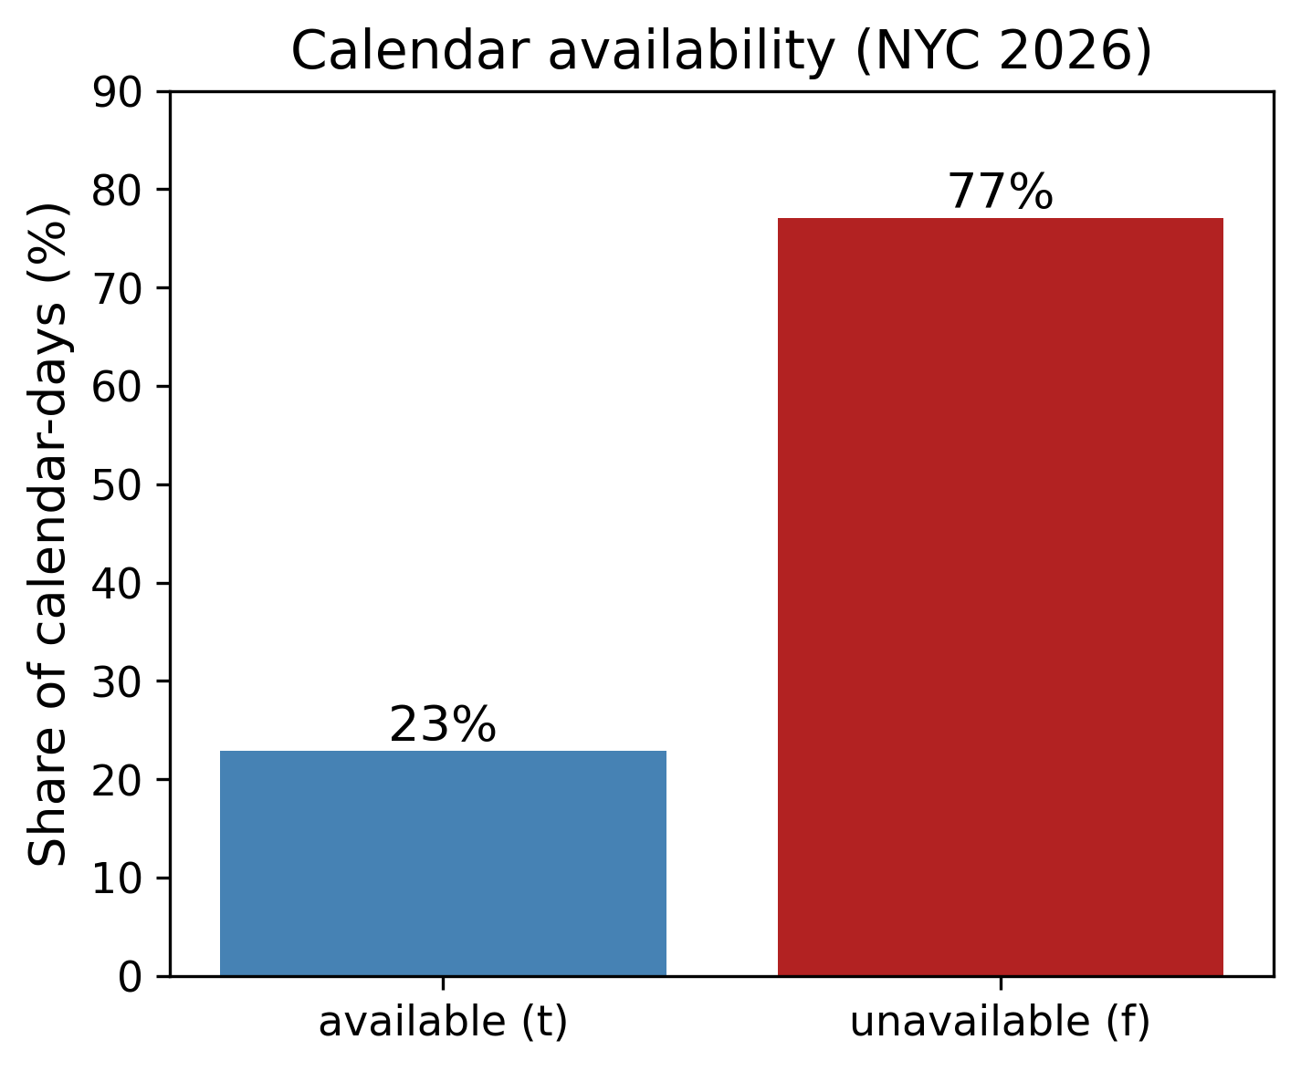
Calendar availability. About $77\%$ of calendar-days are unavailable, reflecting heavy host blocking and dormancy; the raw “unavailable” count is therefore a poor proxy for realised demand.
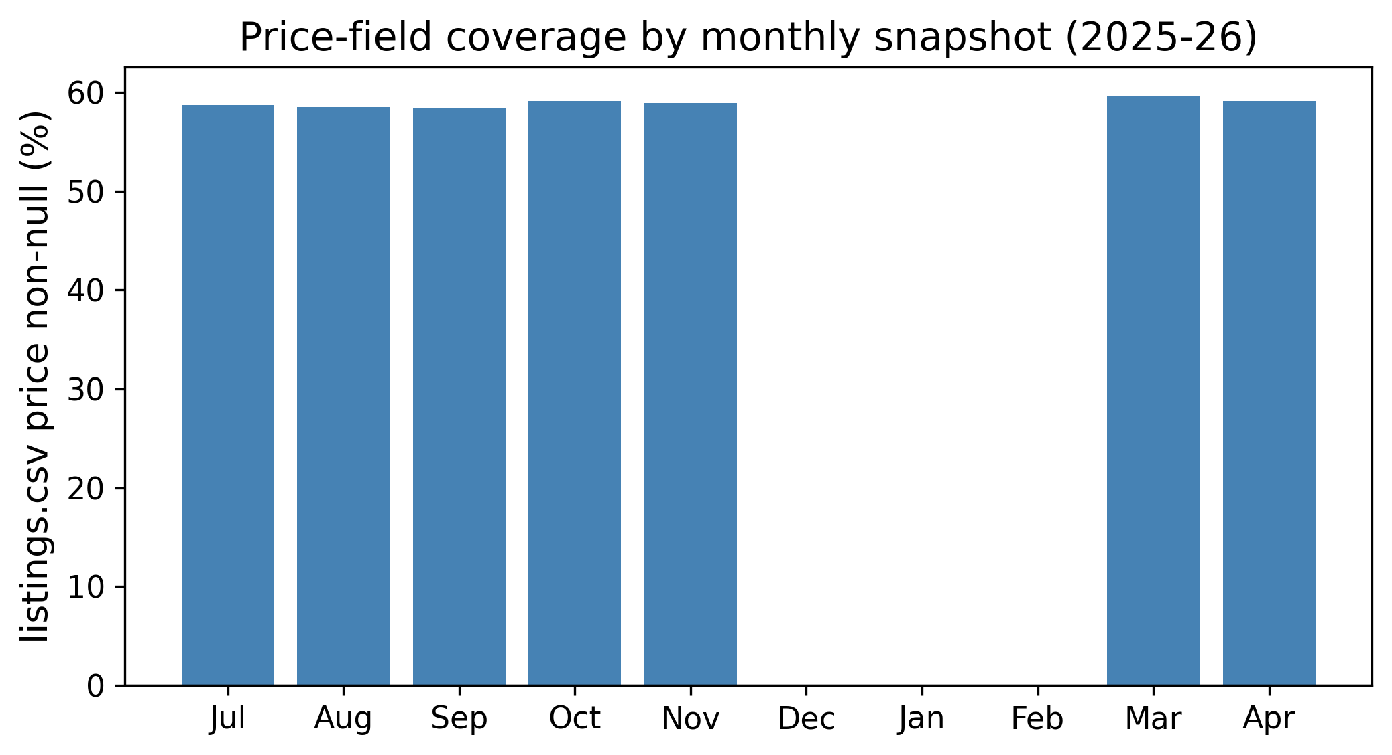
Price-field coverage by monthly snapshot. Price is $≈$59% populated in some months and entirely absent in others, precluding a reliable price-dynamics feature.
Beyond price, several listings fields are substantially incomplete, as summarised in Table 2. Host-responsiveness fields and free-text descriptions are missing for a large fraction of listings, so the pipeline encodes missingness explicitly (median imputation with indicator flags) rather than discarding these rows, because missingness itself is informative—an absent response rate typically marks an inactive host.
Missing-value rates of selected listings fields (September 2025 snapshot).
Field | Missing rate
neighborhood_overview | 47.9%
host_about | 45.5%
host_response_rate | 43.2%
host_acceptance_rate | 43.0%
host_location | 24.0%

C. Auxiliary review signal
The reviews table provides an independent, if indirect, window onto demand: a review can only follow a completed stay, so the recency and rate of reviews are proxies for how recently and how often a listing has been booked. Figure 3 plots mean target demand against the number of days since a listing’s most recent review. The relationship is clear and monotone at the tail: listings whose last review is more than a year old are booked for only about $12$ nights on average in the target quarter, whereas listings reviewed within the past year average roughly three times as many. This confirms that review recency carries genuine demand information; whether that information is additional to the calendar-derived behavioural features, however, is a separate question that the ablation study answers in the negative.
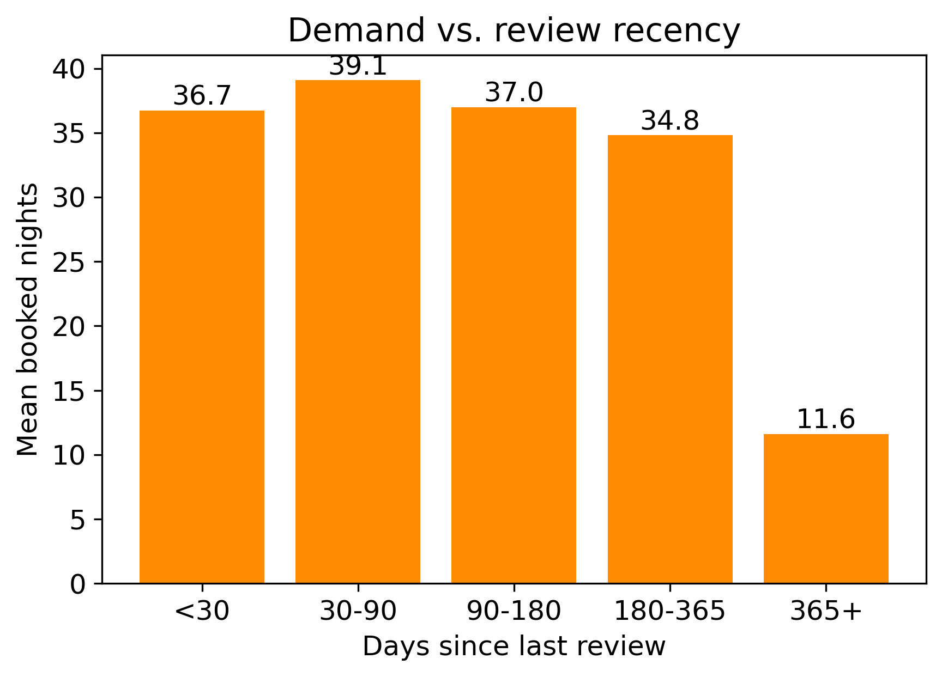
Mean target demand by review recency. Listings reviewed recently are booked substantially more; those with year-old reviews are largely dormant.

D. Target construction by snapshot differencing
Because no booking status exists, the demand target is reconstructed from how availability evolves. Consider a target-quarter date $d$ observed across the ordered snapshots that contain it. Let $a_{d}^{\text{first}}$ and $a_{d}^{\text{last}}$ denote its availability at the earliest and latest snapshot in which it appears, and let $n_{d}$ be the number of snapshots that observe it. The date is counted as booked when it was available at some point, is unavailable at the last observation, and is seen at least twice:
$$b_{d}=1​\left[ n_{d}≥2 ∧ ∃ \text{available} ∧ a_{d}^{\text{last}}=\text{f} \right].$$
The per-listing target is the sum over the quarter’s dates, y=d∈Q​bd, clipped to $[0,92]$. Requiring $n_{d}≥2$ and a genuine available$→$unavailable transition removes dates that were blocked from the outset (host blocking) and dates observed only once, reducing noise relative to a naive occupancy count. The two-observation requirement also guards against a subtler artefact: listings that appear only once in the target-quarter window, such as those listed very late, would otherwise contribute spurious zeros or ones that reflect sampling rather than demand. By insisting that a booking be witnessed as a transition across at least two snapshots, the construction ties every counted night to observed evidence, which is what allows the recovered target to behave like a genuine demand distribution rather than an artefact of the scraping cadence.
Empirically this construction produces exactly the demand-like shape expected of a censored, zero-inflated count. For the February–April 2026 quarter the target has mean $19.2$, median $2$, standard deviation $27.6$, and $47.7\%$ of listings at zero (Fig. 4). By contrast, simply counting unavailable days yields a left-skewed distribution with under $10\%$ zeros—dominated by host blocking rather than demand—and is therefore not used.
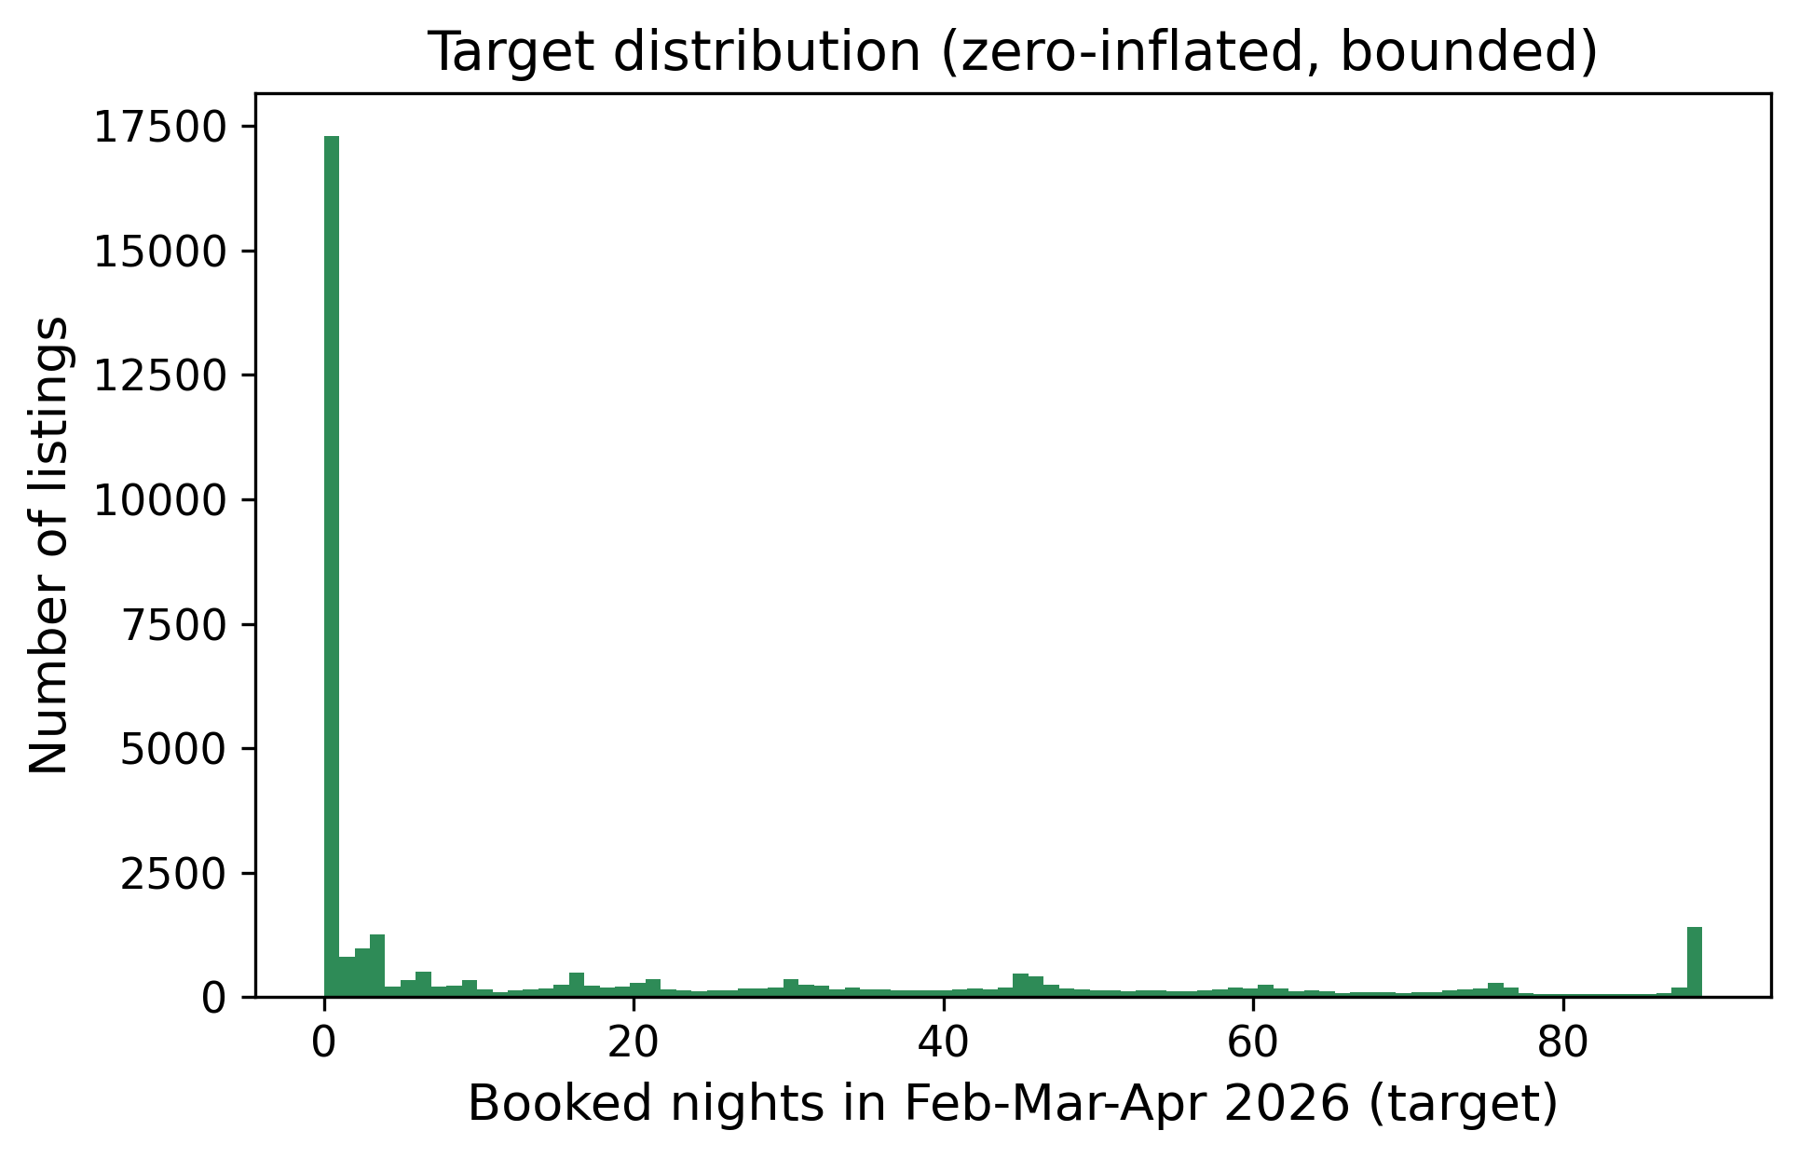
Target distribution (booked nights, Feb–Apr 2026, differencing construction): sharply zero-inflated with a long right tail and a pile-up near the upper bound.
The contrast between the two candidate target definitions is stark and is what justifies the differencing construction. Table 3 compares, on the same listings and quarter, the naive occupancy count (number of unavailable days) with the differencing target of [eq:booked]. The occupancy count is left-skewed with a median of $73$ of $92$ nights and fewer than $10\%$ zeros—most listings appear “mostly unavailable” simply because their hosts have blocked the calendar—so it measures host behaviour, not demand. The differencing target is right-skewed, zero-inflated, and demand-like. Only the latter is used henceforth.
Naive occupancy count vs. the differencing target (same listings and quarter). Only the differencing target is zero-inflated and demand-like.
Definition | mean | median | std | % zero | skew
Occupancy (unavailable days) | 57.4 | 73 | 32.5 | 8.0 | $−0.71$
Differencing (booked) | 19.0 | 0 | 28.6 | 53.2 | $+1.32$
Table 4 reports the differencing-target statistics for each of the three setups. All three are strongly zero-inflated (about half the listings at zero) with comparable spread, confirming that the same difficult, censored distribution is being modelled in every period.
Differencing-target statistics by setup.
Setup (target quarter) | $n$ | mean | median | std | % zero
A (Q4 2025) | 36,111 | 21.9 | 2 | 29.6 | 46.9
B (Q1 2026) | 36,282 | 16.3 | 1 | 25.0 | 48.7
C (Feb–Apr 2026) | 36,282 | 19.2 | 2 | 27.7 | 47.7

E. Prediction setups
The problem is to predict, for each listing, the booked nights in a future quarter from a behavioural history that ends before that quarter begins. Because the snapshots span a fixed ten-month window, three leakage-safe setups are possible, differing in the target quarter and the amount of prior history (Table 5). Setup C, with a seven-month history predicting February–April 2026, is the deepest-history configuration the data permit and is used as the primary model; Setups A and B provide temporal validation. For each setup, the population of listings to be scored—the universe—is fixed to those present in the snapshot immediately preceding the target quarter, which is the natural set of listings “known” at the moment a forecast would be issued. A listing that exists in that snapshot but has no earlier behavioural history contributes a cold-start row whose behavioural features are missing and are imputed; such rows are retained rather than discarded, both because they are a genuine part of the operational population and because their prevalence is itself informative about the market. This choice keeps the evaluation honest: the model is asked to score exactly the set of listings a platform would need to score in practice, including the difficult newcomers.
Prediction setups (history $→$ target).
Setup | History window | Target quarter | Listings
A | Q3 2025 (3 mo) | Q4 2025 | 36,111
B | Q3+Q4 2025 (6 mo) | Q1 2026 | 36,282
C | Jul 2025–Jan 2026 (7 mo) | Feb–Apr 2026 | 36,282

F. Metric and evaluation protocol
Predictions are evaluated by Mean Squared Error,
$$\text{MSE}=\frac{1}{n}\sum_{i=1}^{n}{(}y_{i}−{\hat{y}}_{i})^{2},$$
and the coefficient of determination $R^{2}$, which is scale-free and therefore the primary basis for comparison. Two evaluation regimes are used. For model development and blend-weight estimation, $5$-fold cross-validation is applied on a development set. For an unbiased final estimate, listings are split once into an $80\%$ development set and a $20\%$ held-out test set (fixed seed); models are fitted on the development set and evaluated once on the untouched test set. Reporting both regimes is deliberate: the cross-validation estimate is used for model selection and for learning the blend weights, but because those weights are themselves fitted to out-of-fold predictions, a cross-validation score can be mildly optimistic. The disjoint held-out set, evaluated exactly once with no tuning, provides the unbiased figure of merit, and the proximity of the two numbers reported in Section 5 is itself an experimental result: it demonstrates that the cross-validation was honest and that the model does not overfit the listings it was trained on. All splits are over listings rather than over time within the history window, so a listing never appears in both training and evaluation; the temporal separation between features and target is enforced separately, by construction, through the leakage-safe feature definitions.

IV. Methodology

A. Feature engineering
Each listing is described by a flat feature vector assembled from its calendar history and its most recent listings record. The engineered families are summarised in Table 6. Behavioural features are computed per sub-period (each quarter of the history window and the most recent month) and include booked-night counts and rates, occupancy and availability rates, availability churn (transition counts), and monthly booked-day series from which a trend and a recency signal are derived. Property and host metadata come from the snapshot immediately preceding the target quarter. Reviews contribute counts and a recency signal. Geography is summarised by a $K$-Means cluster over latitude/longitude in addition to the raw neighbourhood field, and short binary keyword flags are extracted from the listing title. Crucially, forward-looking availability fields (e.g. availability_30/60/90) are excluded, because in a pre-target snapshot they encode the host’s intended availability for the target quarter and would leak the label. This exclusion is deliberate and non-trivial: the forward-looking availability counters are among the most predictive fields in the raw data precisely because they encode the host’s planned availability for the very window being predicted, and retaining them would inflate the reported accuracy while destroying the model’s validity as a genuine forecast. More broadly, every behavioural feature is computed only from calendar dates that lie strictly before the target quarter, and the static attributes are taken from the snapshot immediately preceding it, so no information about the target period enters the feature matrix through any channel.
The behavioural families deserve emphasis because, as the importance and ablation analyses later confirm, they carry almost all of the predictive signal. Occupancy and booking rates summarise how intensively a listing was used in each recent sub-period; churn counts (the number of availability transitions) distinguish an actively managed listing from a static one; the monthly booked-day series captures whether demand is accelerating or decaying heading into the target quarter; and the recency block, computed over the most recent month, provides the single strongest predictor by giving the model the freshest available evidence of activity.
Engineered feature families.
Family | Representative features
Per-quarter behaviour | booked/occupancy/availability rate, churn
Monthly trajectory | booked days per month; trend; recency
Quarter-over-quarter | booking-rate change; half-year totals
Property/host metadata | type, capacity, bed/bath, host flags, reviews scores
Review velocity | counts in trailing windows; recency
Geographic | neighbourhood; $K$-Means cluster of (lat, lon)
Text keywords | luxury/private/cozy/… title flags
Table 7 gives an approximate breakdown of the engineered matrix by family. The bulk of the columns are behavioural aggregates derived from the calendar, computed separately for each historical quarter and for the most recent month so that the model sees both the level and the trend of activity; the property and host metadata contribute a smaller block of largely static attributes, and the review, geographic, and text families are compact. This composition—behaviour dominant, metadata secondary—mirrors the importance ranking reported later and is a direct consequence of the fact that a listing’s own recent booking behaviour is by far the strongest available predictor of its near-future demand.
Approximate composition of the engineered feature matrix by family.
Family | # feats | Representative definition
Per-quarter behaviour | $∼$26 | booked/occupancy/availability rate; churn
Monthly trajectory | $∼$9 | booked days per month; trend; recency
Quarter-over-quarter | $∼$5 | booking-rate change; half-year totals
Property/host metadata | $∼$25 | type, capacity, host flags, review scores
Review velocity | $∼$5 | counts in windows; days since last review
Geographic | $∼$3 | neighbourhood; K-Means cluster of (lat,lon)
Text keywords | $∼$8 | binary title flags; title length

B. Preprocessing and the target encoder
Every preprocessing step lives inside a column transformer that is fitted only on the training fold, keeping the pipeline leakage-free. Numeric columns are median-imputed; low-cardinality categoricals are one-hot encoded; and high-cardinality location fields (neighbourhood) are handled by a $K$-fold target encoder with additive smoothing. Writing $μ$ for the global target mean and, for a category level $c$ with $n_{c}$ rows and category mean ${\overset{‾}{y}}_{c}$, the smoothed encoding is
$$e_{c}=\frac{n_{c} {\overset{‾}{y}}_{c}+α μ}{n_{c}+α}, α=20,$$
so rare levels shrink toward $μ$ and common levels approach ${\overset{‾}{y}}_{c}$. To prevent a row from informing its own encoding, the encoder is fitted in an inner $K$-fold loop: the value assigned to a training row in inner fold $F_{k}$ uses statistics computed only on the complementary folds,
$${\tilde{e}}_{i}=e_{ x_{i}}^{ (−F_{k})}, i∈F_{k}.$$
Validation and test rows use the full-training map, and unseen levels fall back to $μ$. The multi-snapshot construction of [eq:booked] is central to controlling label noise. A single snapshot cannot distinguish a booked date from a host-blocked one, because both appear simply as unavailable. Observing the same date across several snapshots, however, exposes its transition: a date that is offered (available) early and taken (unavailable) later is far more likely to reflect a genuine booking than a date that is unavailable from the first moment it is observed, which is almost certainly a host block. Requiring at least two observations and a true available-to-unavailable transition therefore filters out the dominant source of contamination, at the cost of missing bookings that were already committed before the first snapshot or that occurred after the last. This trade-off is the reason the differencing target, while still a proxy, is markedly cleaner than the raw occupancy count, and it is the single most consequential modelling decision in the study.

C. Base learners
Five heterogeneous learners span the linear, bagging, and boosting families: Linear Regression (a scaled interpretable baseline), Random Forest [8], XGBoost [10], LightGBM [11], and CatBoost [12]. All are trained on the same preprocessed matrix with squared-error loss; the tree models exploit the encoded categorical splits, while the linear baseline additionally uses feature scaling. Predictions are clipped to $[0,92]$, both because the competition-style metric is defined on that support and because no listing can be booked for more nights than the quarter contains; clipping costs almost nothing in accuracy, as the vast majority of raw predictions already fall inside the interval, but it removes the occasional nonsensical value that a linear model in particular can produce at the extremes. No learner is given access to the target of any other listing, and the same fixed random seed governs every model so that the comparison among them, and the estimated blend weights, are exactly reproducible.

D. Convex weighted blend
Rather than selecting a single learner, the out-of-fold predictions of the $m=5$ learners are stacked into a matrix $P∈R^{n×m}$ and combined by a convex weighted average. The weights minimise the blended MSE subject to a probability-simplex constraint:
$$\begin{aligned}\min_{w∈R^{m}} &\frac{1}{n}\sum_{i=1}^{n}{​}(y_{i}−clip\left[(Pw)_{i},0,92\right])^{2} \\ \text{s.t.} &\sum_{j=1}^{m}{w_{j}}=1, 0≤w_{j}≤1.\end{aligned}$$
The equality and box constraints keep the blend on the same scale as its inputs and prevent any single learner from receiving a runaway weight. Problem [eq:blend]–[eq:blendc] is solved by Sequential Least-Squares Quadratic Programming (SLSQP) from the uniform start $w_{j}^{(0)}=1/m$; negligible weights ($w_{j}<{10}^{−4}$) are then zeroed and the remainder renormalised. The same weights, learned on development out-of-fold predictions, are applied to the held-out test predictions.

E. Two-stage hurdle model (evaluated as an ablation)
Given the large zero mass, a natural alternative is a two-part hurdle model that factorises the prediction into a Bernoulli hurdle and a positive-count expert,
$$E[y∣x]=\underset{\text{classifier }p(x)}{\underset{⏟}{Pr(y>0∣x)}}⋅\underset{\text{regressor }r(x)}{\underset{⏟}{E[y∣y>0,x]}},$$
where the classifier is trained on the binary label $1[y>0]$ over all rows and the regressor is fitted only on booked listings. The expected-value prediction $\hat{y}=clip(p(x) r(x),0,92)$ is evaluated in Section 6. The appeal of this formulation is that it separates the two decisions that the zero-inflated target conflates: a classifier can specialise in recognising the large dormant population, for which the answer is a near-deterministic zero, while a separate regressor, trained only on booked listings, can focus on the shape of the positive counts without being pulled toward zero by the mass of inactive listings. A hard-gated variant, which outputs zero whenever the classifier’s probability falls below a threshold, was also evaluated; it degrades the squared-error metric because the metric rewards the expected value rather than a thresholded decision, so only the expected-value combination is retained for comparison. The empirical outcome—that neither variant improves on the direct blend—is reported and discussed in Section 6.

F. Hyper-parameter search
The two boosted-tree learners most likely to benefit from tuning, XGBoost and LightGBM, were tuned by a randomized search of $30$ configurations per family under the same $5$-fold cross-validation, sampling the learning rate and regularisation terms log-uniformly and the tree-shape parameters over sensible integer ranges. To keep the search efficient, the leakage-safe preprocessing was computed once per fold and cached, so each configuration re-fits only the model. As reported in Section 6, the tuned learners did not meaningfully improve on their defaults and the tuned blend did not exceed the default blend, indicating that the models operate near their capacity for this feature set and that the residual error is data-limited rather than capacity-limited. Default settings are therefore retained for the primary model in the interest of simplicity and reproducibility.

G. Computational cost
The pipeline is inexpensive. Building the feature matrix from the multi-million-row calendars is a one-time aggregation that dominates wall-clock time but is trivially parallel over listings. Each learner fits in seconds to a few minutes on a $36,000$-row matrix on a single multi-core CPU; the SLSQP blend optimises only $m=5$ weights over a cached matrix of out-of-fold predictions and converges in well under a second. Because the out-of-fold predictions are cached, the blend and every post-hoc diagnostic can be recomputed without retraining, which makes the entire ablation study cheap to run.

H. Reproducibility
All results use a single fixed seed governing the development/test split, the cross-validation partitions, and the inner target-encoding folds. The implementation is in Python with scikit-learn (preprocessing, linear and random-forest models, cross-validation), XGBoost, LightGBM, CatBoost, and scipy.optimize for the SLSQP blend. Out-of-fold predictions are cached so that the blend and all diagnostics can be recomputed without retraining. The software stack comprises Python 3.13 with scikit-learn (preprocessing, the linear and random-forest models, and cross-validation), XGBoost, LightGBM, and CatBoost for the boosted learners, and scipy.optimize for the SLSQP blend; all experiments run on a single multi-core CPU with no GPU. The code is organised as a sequence of stages—exploratory analysis, feature construction, one module per model family, the blend, and the diagnostics—each of which reads and writes intermediate artefacts to disk, so that any stage can be re-executed independently and the full study reproduced end to end from the raw snapshots and a single seed.

V. Results

A. Main model and held-out performance
Table 8 reports the primary result: the performance of every learner and of the blend on the $20\%$ held-out test set, alongside the development cross-validation estimate, for Setup C. The blend is the best configuration on both partitions, reaching a held-out test $R^{2}$ of $0.653$ (MSE $262.0$). Figure 5 visualises the held-out ranking. Critically, the held-out $R^{2}$ ($0.653$) is within $0.010$ of the development cross-validation estimate ($0.663$): the model does not overfit, and the cross-validation figures reported elsewhere in the paper are honest rather than optimistic. It is worth translating this accuracy into operational terms. An $R^{2}$ of about $0.65$ on a target with a standard deviation near $28$ nights corresponds to a typical error on the order of ten nights per listing per quarter, concentrated —as the residual analysis shows—on the ambiguous middle and the busiest listings rather than on the large, easily identified dormant population. For the ranking and resource-allocation applications that motivate the work, in which the relative ordering of listings by expected demand matters more than the exact count, this is a useful signal; for exact per-listing revenue projection it is a coarse one, and the paper is careful not to overstate it. The value of the held-out protocol is precisely that it lets a practitioner calibrate such expectations against an unbiased estimate.
Held-out performance (Setup C; development $n=29,025$, held-out test $n=7,257$). The blend is best on both partitions and generalises with a negligible dev–test gap.
Model | Dev $R^{2}$ | Test $R^{2}$ | Test MSE
Linear Regression | 0.581 | 0.568 | 326.0
CatBoost | 0.654 | 0.641 | 270.8
Random Forest | 0.652 | 0.644 | 268.7
XGBoost | 0.659 | 0.647 | 266.2
LightGBM | 0.659 | 0.649 | 264.6
SLSQP blend | 0.663 | 0.653 | 262.0
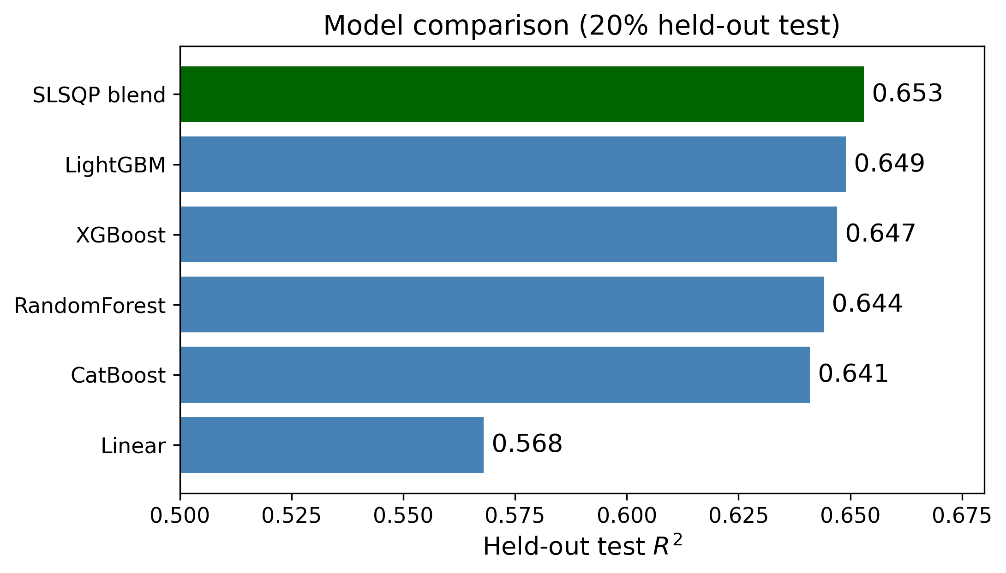
Held-out test $R^{2}$ by model. The convex blend (green) improves on every single learner.

B. Development comparison and model complementarity
Table 9 reports the full development-set cross-validation metrics for Setup C. The three gradient-boosting learners are close (LightGBM and XGBoost lead among singles at $R^{2}=0.659$), Random Forest is competitive, and the linear baseline trails, as expected on a non-linear, interaction-rich target. The blend improves on every single learner in MSE, MAE, and $R^{2}$ simultaneously. The convex weights concentrate on the complementary learners—Random Forest $0.39$, LightGBM $0.36$, XGBoost $0.23$, CatBoost $0.02$, Linear $0.00$—rather than placing all weight on the single best model, which is precisely why the blend improves: its members make partially different errors, and the constrained optimisation exploits that de-correlation. A naive equal-weight average, by contrast, is worse than the best single model, because it lets the weaker learners drag the mean down; the convex weighting is what converts the ensemble into a net gain.
Development-set 5-fold CV (Setup C, $n=36,282$).
Model | MSE | MAE | $R^{2}$
Linear Regression | 322.7 | 11.88 | 0.578
CatBoost | 266.3 | 9.98 | 0.652
Random Forest | 263.0 | 9.73 | 0.656
XGBoost | 260.9 | 9.75 | 0.659
LightGBM | 260.8 | 9.70 | 0.659
SLSQP blend | 257.0 | 9.66 | 0.664

C. Temporal robustness
To confirm that the method is not tuned to a single window, the identical pipeline was applied to the three setups of Table 5. Table 10 and Fig. 6 report the blend performance. Accuracy is stable across all three independent target quarters, and the seven-month history of Setup C yields the strongest result, confirming that deeper behavioural history helps. The stability across periods is meaningful because the three quarters differ not only in calendar position but in seasonal demand and in the amount of available history, yet the same pipeline, with no per-period retuning, produces comparable accuracy in every case; this is direct evidence against the concern that a single reported score might reflect a fortunate choice of window. The intermediate dip at Setup B is consistent with its winter target quarter being both lower in demand and predicted from a shorter six-month history; when the history is extended to seven months and the target shifts to the February–April window, accuracy recovers and surpasses the other two settings.
Cross-period robustness of the blend (5-fold CV).
Setup | Target quarter | Blend $R^{2}$
A | Q4 2025 | 0.645
B | Q1 2026 | 0.574
C | Feb–Apr 2026 | 0.664
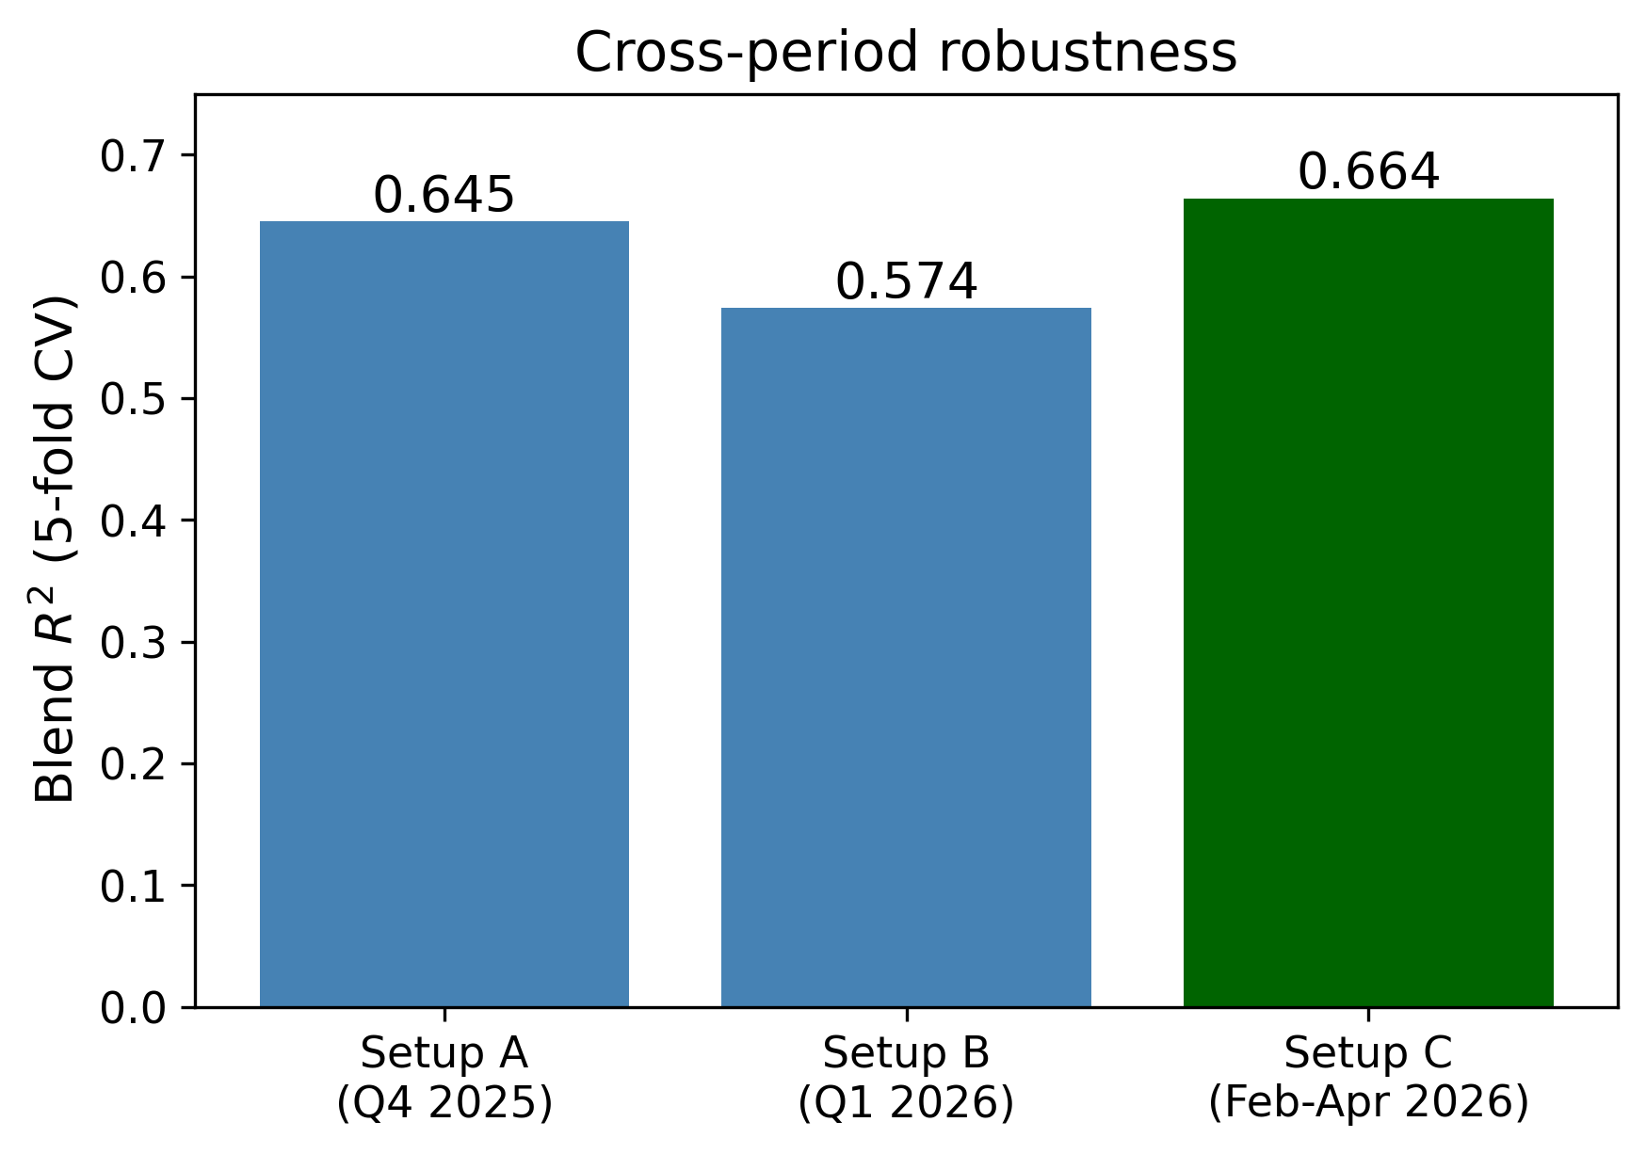
Blend $R^{2}$ across three independent target quarters. Performance is stable, and the deepest-history setup (C) is strongest.

D. Statistical significance
The blend’s improvement over the best single learner is statistically significant. On a paired test of per-listing squared errors, Setup A gives $t=7.69$, $p=1.6×{10}^{−14}$ and Setup B gives $t=5.99$, $p=2.1×{10}^{−9}$; in both cases the $95\%$ confidence interval on the mean squared-error reduction excludes zero, and the non-parametric Wilcoxon signed-rank test agrees. The gain is small in effect size, as expected—the blend only changes the minority of listings on which the base learners disagree—but it is consistent and obtained at no extra training cost, since the learners are already trained. The interpretation of the effect size warrants care: a small $d_{z}$ does not mean the blend is unimportant, but rather that its benefit is concentrated on the subset of listings where the base learners genuinely disagree. On the large majority of listings—those that are clearly dormant or clearly active—all learners already agree, and the blend leaves them unchanged; the improvement accrues on the harder, ambiguous middle of the distribution, which is precisely where a demand forecast is most valuable and most difficult. The consistency of the effect across two independent quarters, each with tens of thousands of paired observations, is what makes the improvement trustworthy despite its modest per-listing magnitude.

E. Residual analysis on the boundaries
Because the target is bounded and zero-inflated, aggregate error can hide systematic behaviour at the edges. Figure 7 shows standard residual diagnostics for the blend. The residual-versus-fitted panel reveals clear heteroscedasticity—errors widen as the predicted count grows—and the residual-versus-true panel and the Q–Q plot confirm non-Gaussian, right-skewed residuals with structure at both boundaries. Figure 8 localises the bias by binning listings by their true value: the model over-predicts the dormant and lightly-booked listings and under-predicts the busiest ones, the classic regression-to-the-mean behaviour of a least-squares estimator on a censored target. Clipping removes impossible predictions but not this boundary bias, which motivates the hurdle experiment reported next and the two-stage extension discussed in Section 7.
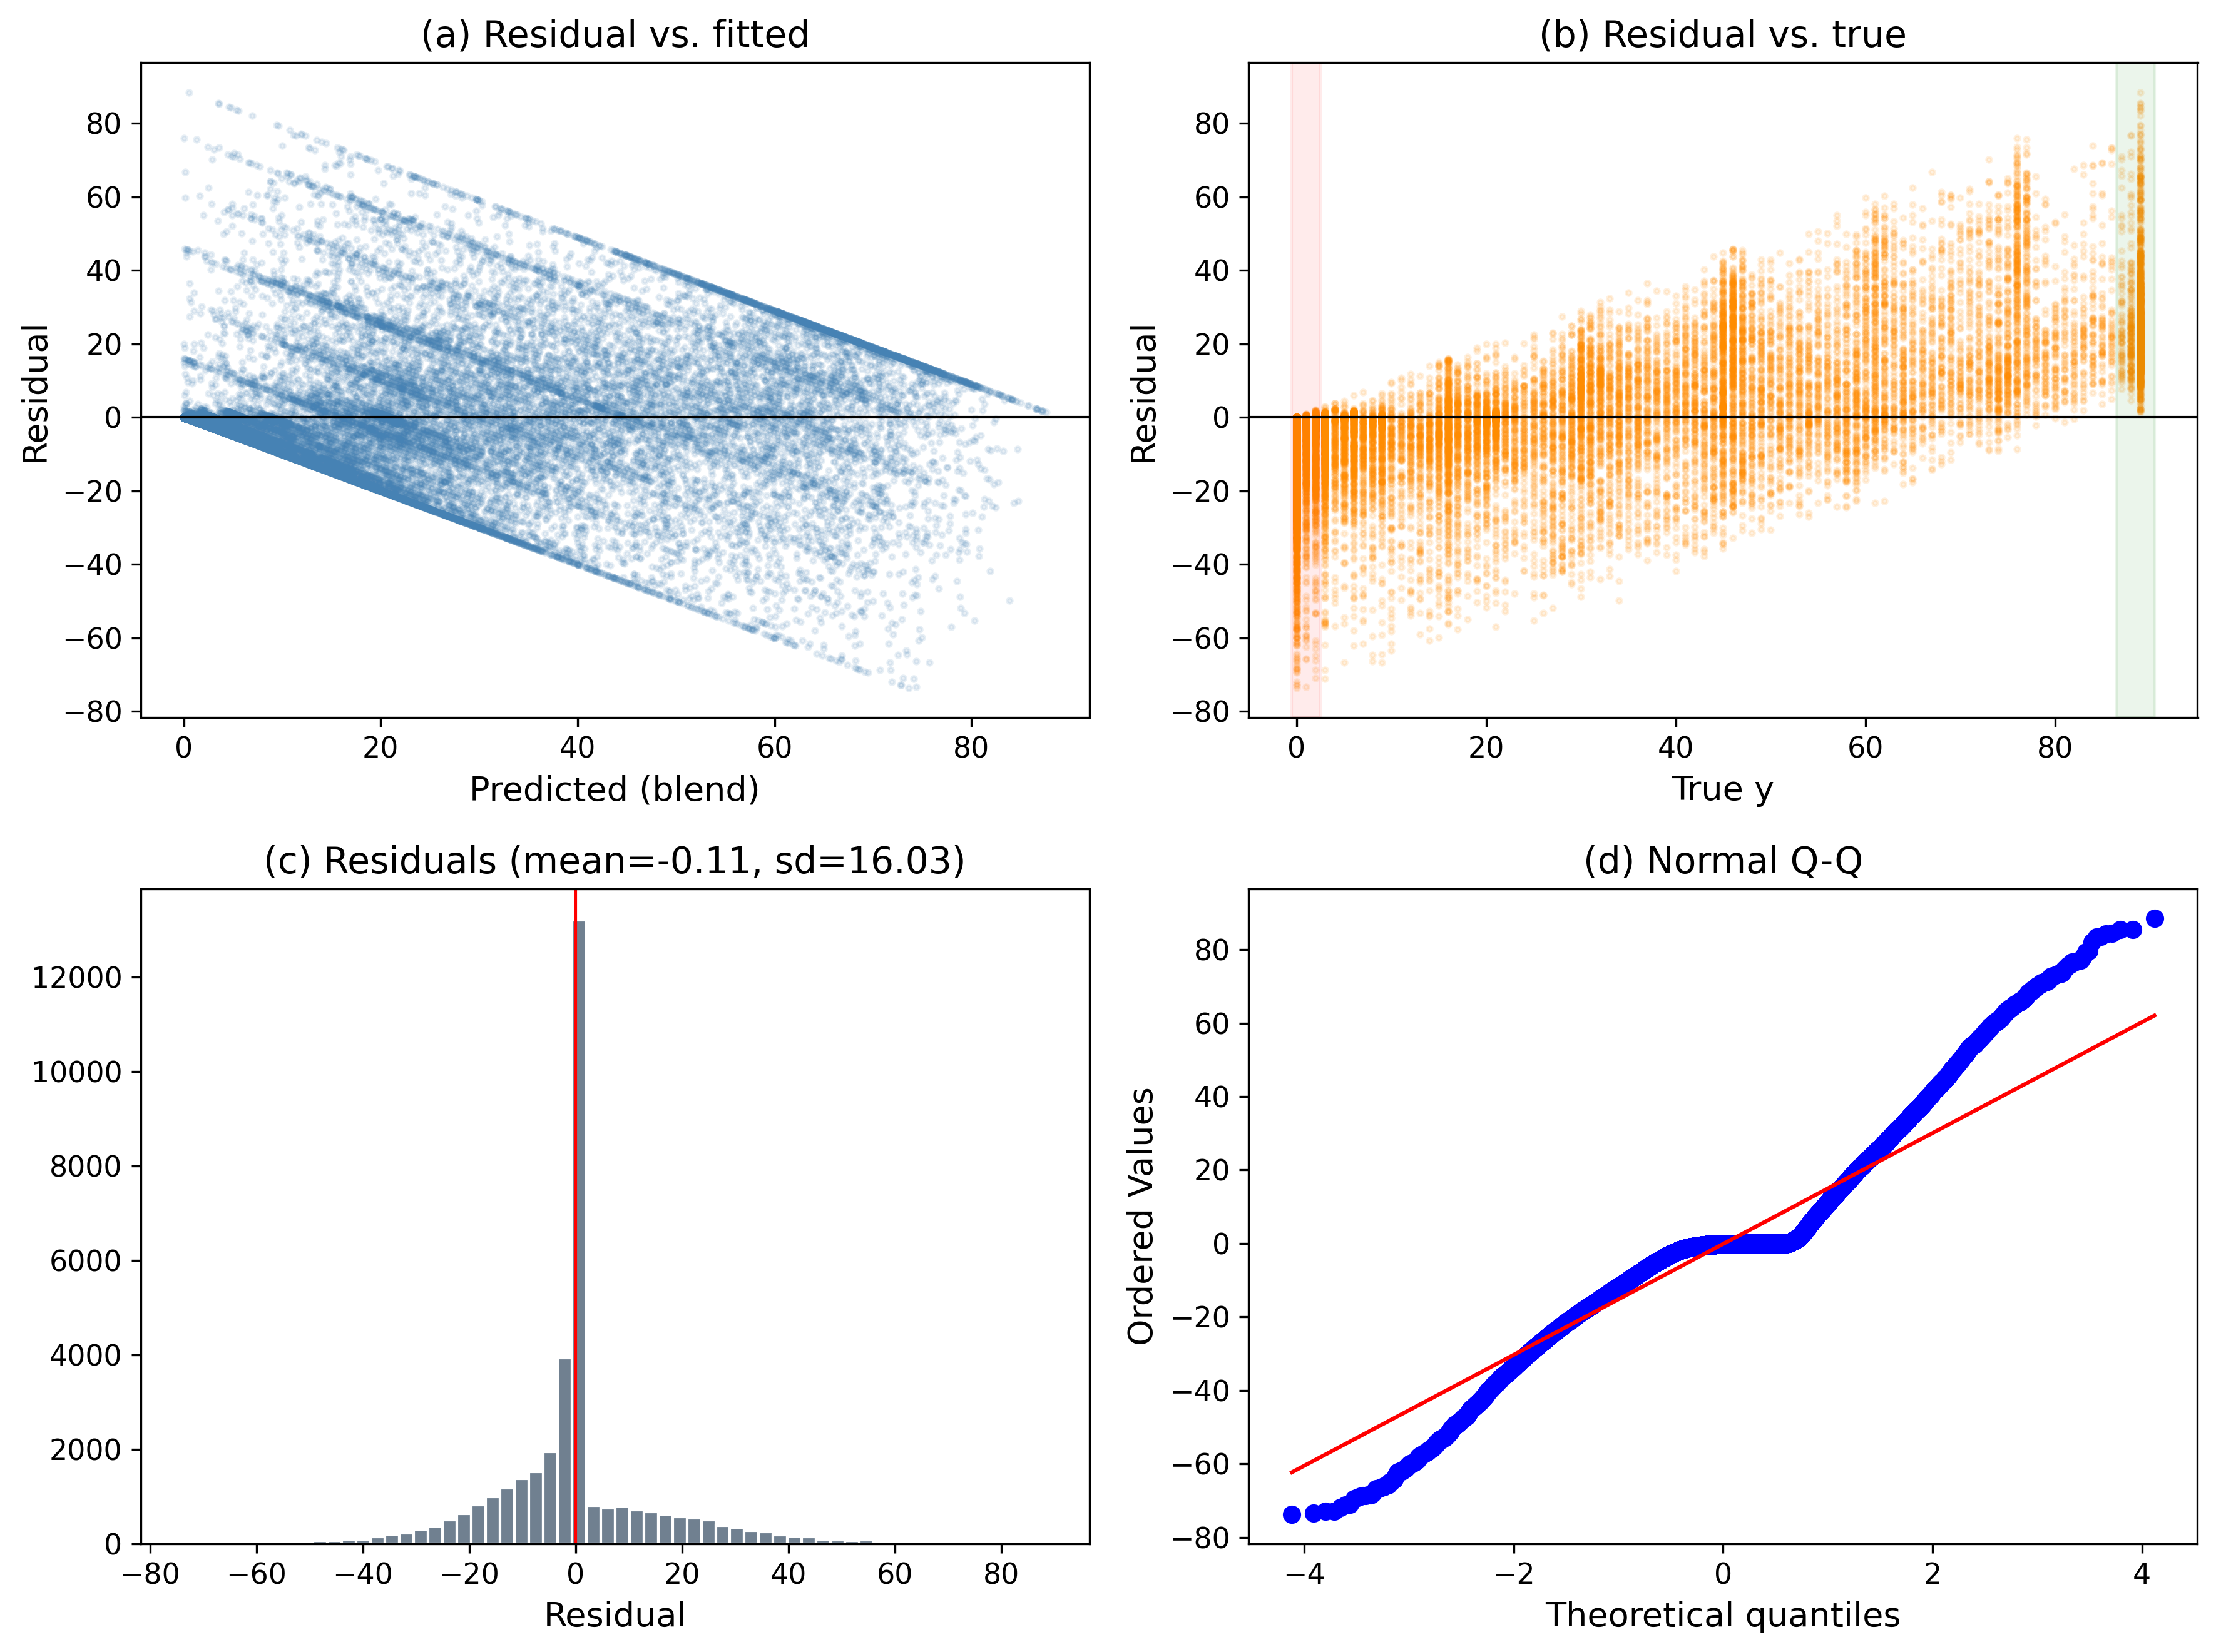
Residual diagnostics for the blend: (a) residual vs. fitted, (b) residual vs. true with boundary bands, (c) residual histogram, (d) normal Q–Q.
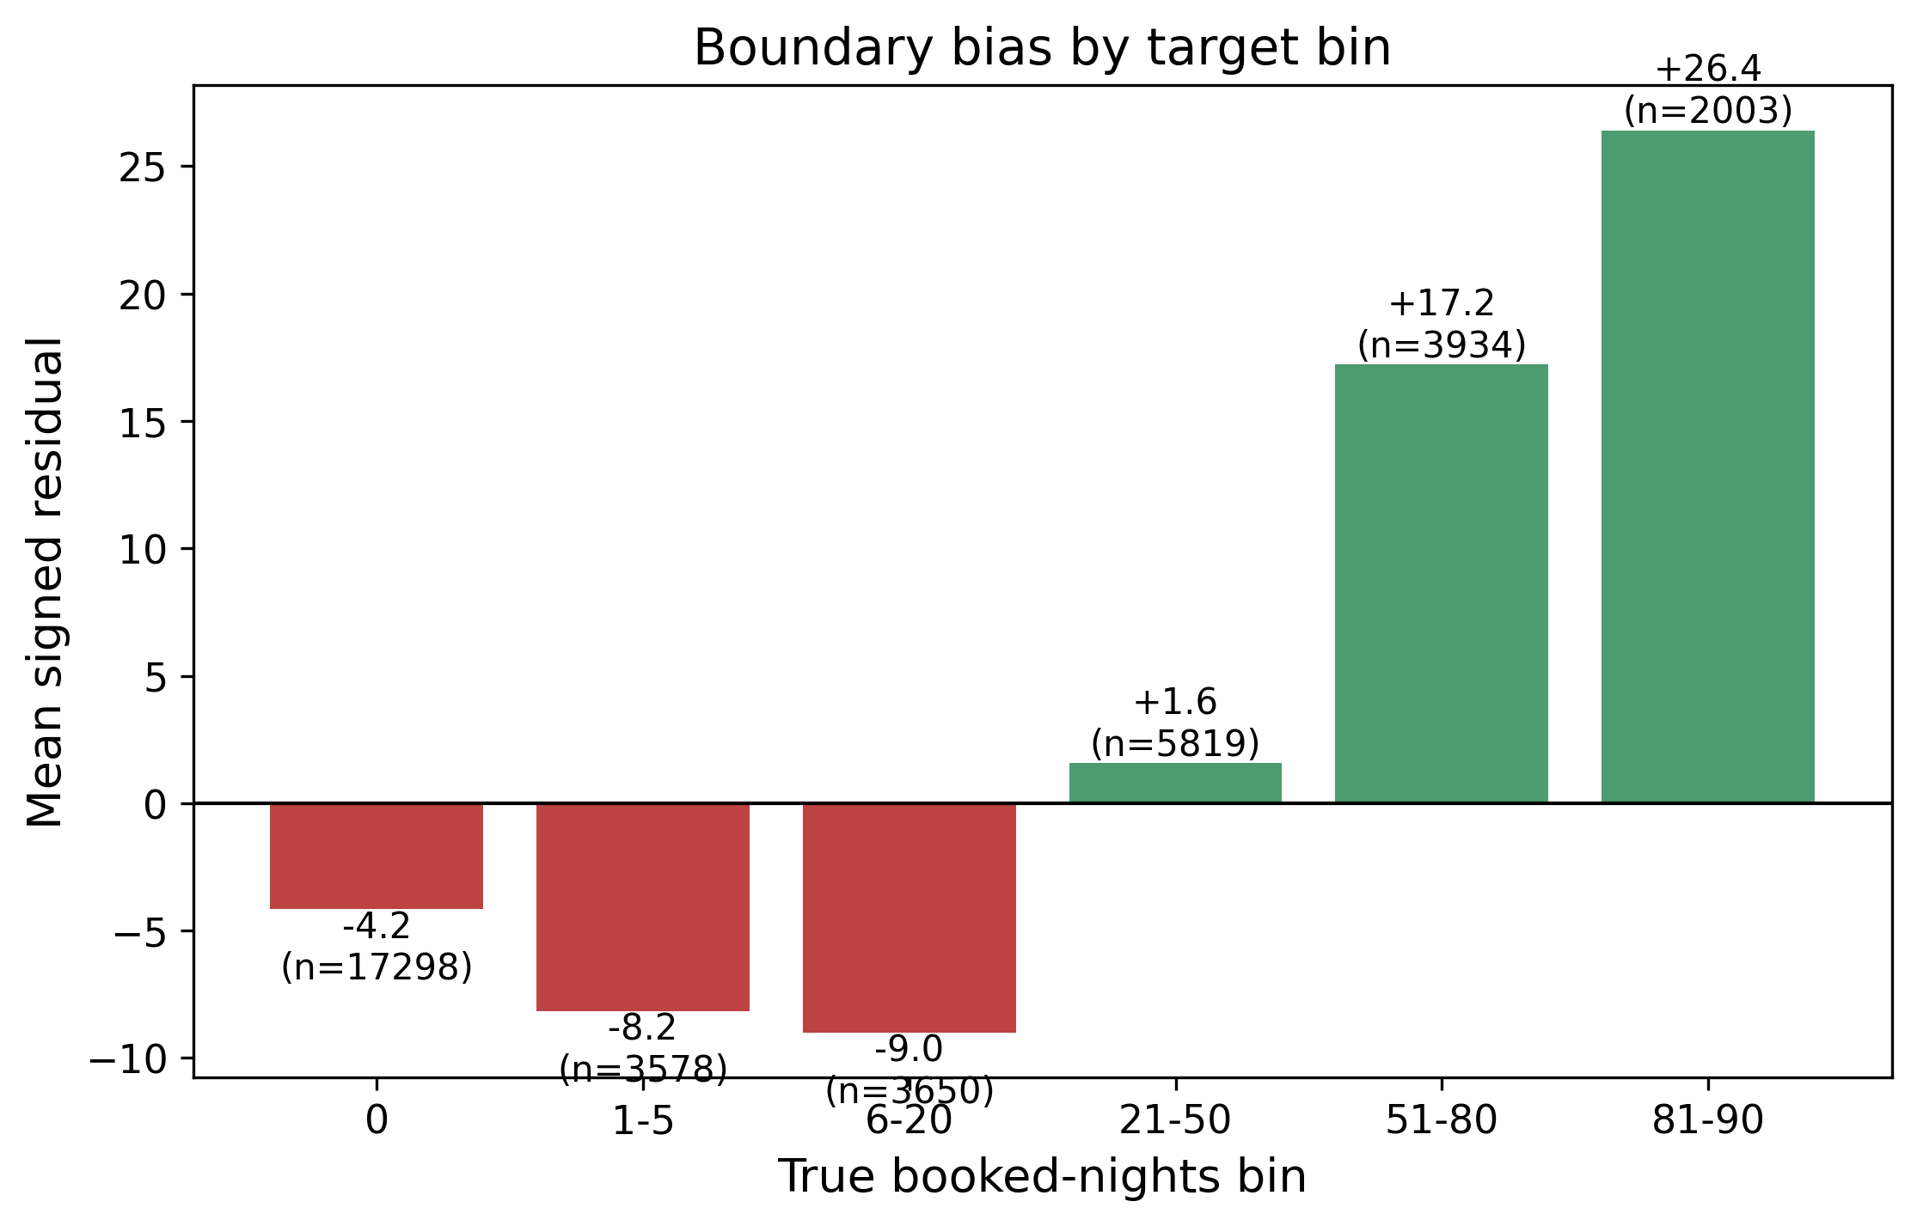
Mean signed residual by true-value bin. The model over-predicts the low/zero range (red) and under-predicts the high range (green).

F. Feature importance
Figure 9 shows the gain-based feature importances of the XGBoost learner. The ranking is dominated by recent behavioural signals: the most recent month’s booking rate and booked count (from January 2026, immediately before the target quarter), the platform’s own trailing occupancy estimate, the seven-month booked total, and review recency. Static property and host metadata, text keywords, and geography play only a supporting role. This confirms the narrative of the residual and ablation analyses: demand is driven overwhelmingly by a listing’s own recent activity, which is why deeper and more recent history is the feature-side lever that matters and why additional engineered families are redundant once this signal is present.
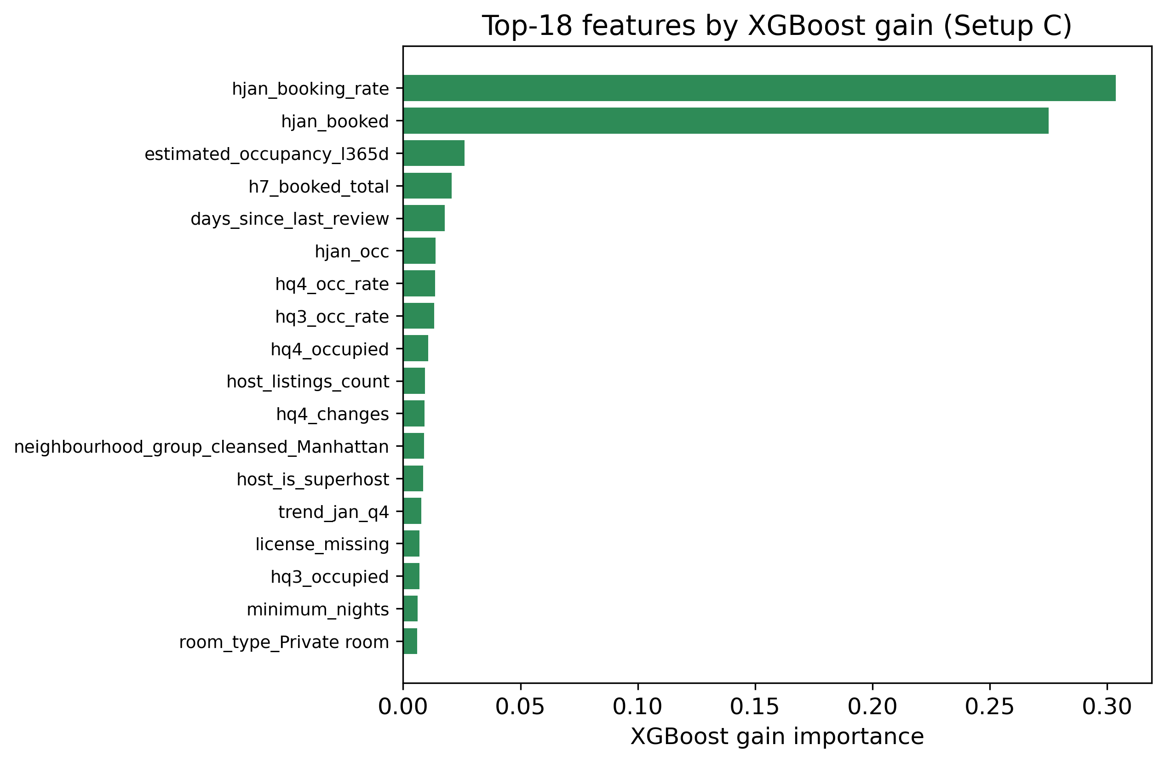
XGBoost gain importances (Setup C). Recent behavioural features—the latest month’s booking rate and count, trailing occupancy, and review recency—dominate; static metadata is secondary.

G. Failure-case analysis
A sample-level inspection of the largest errors complements the aggregate metrics. Table 11 lists the development-set listings with the largest blend residuals. Every one is a listing that was in fact booked for nearly the entire quarter ($y=89$) yet predicted at only a few nights. Their common signature is a decoupling of target-quarter demand from the recent behavioural history on which the model relies: each has a January booking rate of zero, and some have essentially no review history. When a dormant or freshly-listed property suddenly fills up, a purely historical regressor cannot anticipate it. Aggregated over the $2,068$ listings with $y≥80$, the blend predicts a mean of only $61.5$ nights, quantifying the systematic under-prediction of the busiest listings already visible in Fig. 8. These failures point directly to the value of a cold-start-aware or two-stage extension discussed in Section 7.
Largest blend residuals (Setup C). All are fully-booked listings that the model severely under-predicts; their recent history does not foreshadow the surge.
Listing | $y$ | $\hat{y}$ | Jan. booking rate
30584992 | 89 | 0.5 | 0.00
3401271 | 89 | 3.5 | 0.00
39598996 | 89 | 3.6 | 0.00
649267754730612723 | 89 | 4.6 | 0.00

H. Discussion: the ceiling is set by data, not the model
The results converge on a clear conclusion about the source of the remaining error. As the ablation of Section 6 makes precise, model-side choices are saturated: only the target definition and the depth of behavioural history move the metric, and both are properties of the data rather than the learner. Two intrinsic limitations of the Inside Airbnb source cap the achievable accuracy. First, the platform exposes only a coarse Boolean availability flag, so the target must be recovered by differencing, which conflates guest bookings with host blocking and is noisier than a direct booking signal. Second, the calendar price field is empty, removing a demand-relevant price-dynamics signal. Consequently the held-out $R^{2}≈0.65$ is best interpreted as close to the practical ceiling for this public data source; further gains would require a cleaner booking label rather than a more complex model.

VI. Ablation Study
This section isolates the contribution of each design decision. All comparisons use the identical cross-validation protocol; Table 12 and Fig. 10 summarise the effect of each component on the blend $R^{2}$.
Ablation: effect of each component on the blend (5-fold CV $R^{2}$).
Component | $ΔR^{2}$ | Verdict
Clean differencing target (vs. occupancy) | $+0.04$ | largest, reproducible
Deeper history (2nd quarter $→$ 7 mo) | $+0.005$–$0.02$ | small but real
Hyper-parameter tuning | $+0.00$–$0.002$ | marginal
Enriched price features | $≈0$ | no signal
Review-velocity features | $≈0$ | redundant
Two-stage hurdle model | $0$ (held-out) | no gain
Neighbourhood / activity context | $≈0$ | redundant
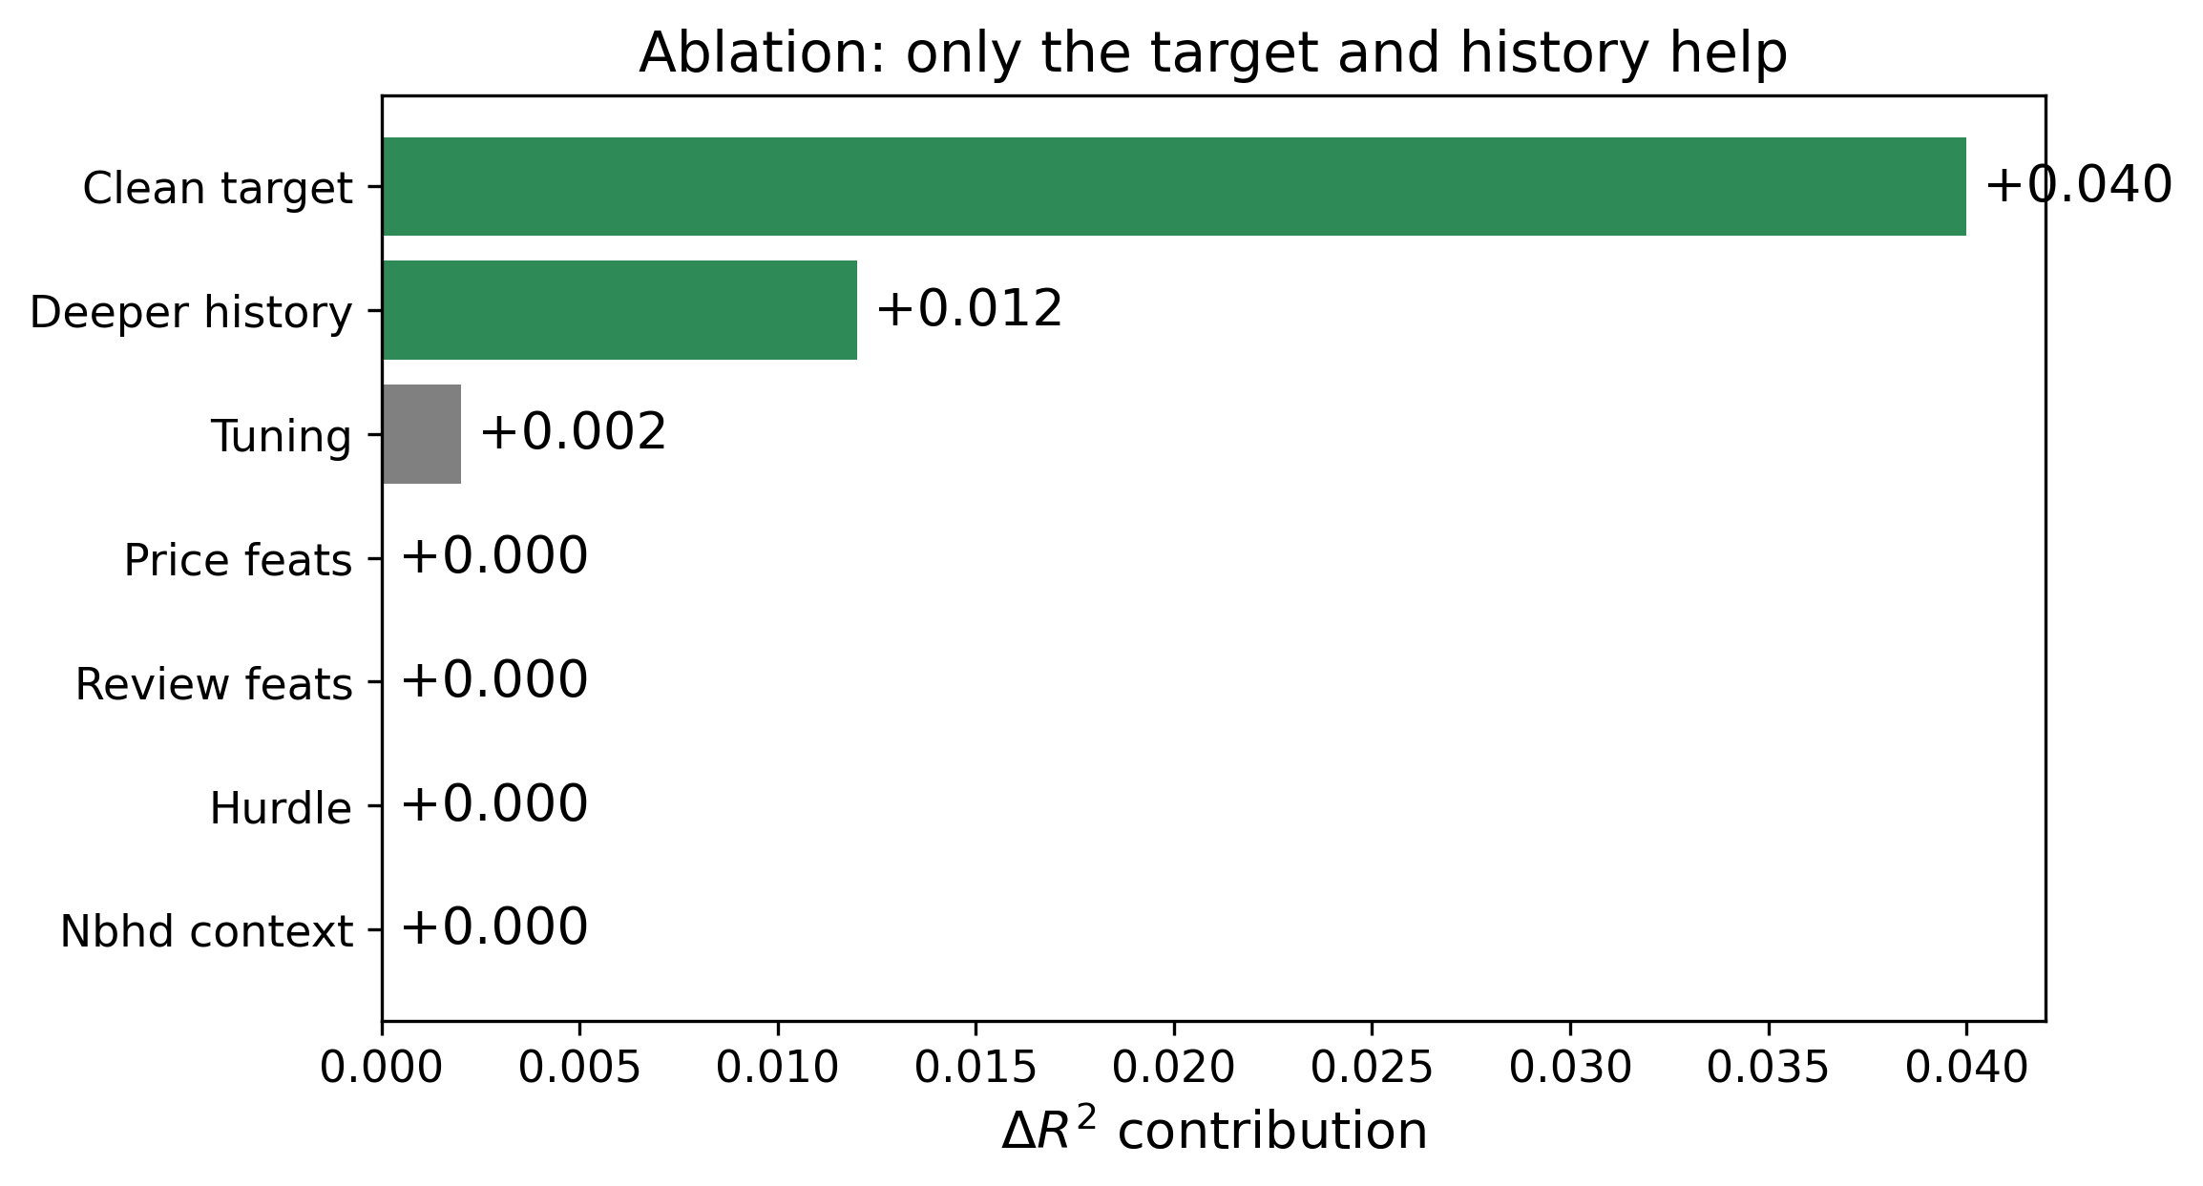
Ablation. Only the target definition and history depth contribute meaningfully; every other component is marginal.
To make the cumulative effect concrete, Table 13 traces the blend $R^{2}$ as components are added one at a time on the Q1 2026 target. The two steps that matter—adding a second quarter of history and switching to the clean target—together account for essentially the entire improvement, while the price and tuning steps are flat.
Cumulative ablation on the Q1 2026 target (blend $R^{2}$, 5-fold CV).
Configuration | $R^{2}$ | $Δ$
Single-quarter history | 0.533 | —
$+$ second history quarter | 0.538 | $+0.005$
$+$ enriched price features | 0.537 | $−0.001$
$+$ clean differencing target | 0.574 | $+0.037$
$+$ hyper-parameter tuning | 0.576 | $+0.002$

Target definition (largest lever)
Replacing the naive occupancy proxy—which is contaminated by host blocking and is left-skewed with under $10\%$ zeros—by the clean differencing target of [eq:booked] raises the blend $R^{2}$ by about $0.04$ and does so reproducibly across periods (for Setup A, $R^{2}$ rises from $0.605$ to $0.645$). This is the single most important design choice in the paper: the bottleneck is label quality. The mechanism behind the gain is instructive. The naive occupancy count assigns a large value to any heavily blocked listing regardless of whether it is actually in demand, so it forces the model to predict host calendar-management behaviour—which is idiosyncratic and weakly related to the covariates—in addition to demand. The differencing target strips away most of that behaviour and leaves a signal that is far more strongly related to the listing’s own history, which the model can learn. In other words, the clean target does not make the model smarter; it makes the quantity being predicted more predictable, by removing a large component of essentially unlearnable variance. This reframing—that a change of target can raise $R^{2}$ by making the label less noisy rather than by improving the estimator—is, we believe, the most transferable lesson of the study for practitioners working with indirect public data.

Depth of behavioural history
Extending the history from a single quarter to two quarters, and then to seven months, produces small but consistent gains and gives Setup C its edge. Because the data begin in July 2025, seven months is the deepest history available; more would likely help further.

Posted price does not predict demand
Price features were evaluated twice: a naive version sourced from months in which the price field is empty, and a corrected version built from the months that retain price, augmented with a neighbourhood-relative price. Neither changed the $R^{2}$. In this post-regulation market, whether a listing books is governed by its recent activity, reviews, and availability history rather than by its nightly price—a counter-intuitive but robust negative finding. The result should not be read as claiming that price is irrelevant to demand in general; rather, in this data, the price that is observable is a static, host-posted asking price rather than the realised transaction price, and it is only partially populated. Whatever price-elasticity signal exists is evidently already reflected in the listing’s realised booking history, which the behavioural features capture directly, so the posted price adds nothing once that history is present. This is a concrete instance of the broader saturation phenomenon: a covariate can be correlated with demand yet contribute no incremental predictive power when a stronger, more proximal signal is already in the model.

Review velocity is redundant
Although review recency correlates with the target ($r≈−0.5$), adding review-velocity features leaves the blend $R^{2}$ unchanged, because the calendar-derived behavioural features already encode the same “is this listing active” signal more directly. This is a clean illustration of the distinction between marginal correlation and conditional contribution: review recency is one of the most strongly correlated single features with the target (Fig. 3), yet once the model already knows how many nights the listing was booked in each recent sub-period, the additional knowledge that it was also recently reviewed is nearly deterministic and adds no independent information. A feature can thus be individually informative and jointly redundant, and only a proper ablation—rather than a correlation ranking—reveals which is the case.

The hurdle model does not help
On the held-out test the two-stage hurdle of [eq:hurdle] attains an identical $R^{2}$ ($0.653$) to the direct blend; its small cross-validation advantage ($+0.002$) does not survive on unbiased data. The gradient-boosted blend therefore already absorbs the zero inflation as well as an explicit hurdle, and the simpler model is preferred. This finding is worth stating carefully because the hurdle model is often recommended almost reflexively for zero-inflated targets. Its failure to help here does not contradict that recommendation in general; rather, it reflects that a squared-error-optimised gradient-boosting ensemble, trained on a target with a hard floor at zero and equipped with strong activity features, already learns to output values very close to zero for the dormant population, so factoring the problem explicitly buys nothing. The two-stage model would be expected to help more under a different loss, or when the classifier and regressor can draw on disjoint feature sets, neither of which applies here. The methodological takeaway is to prefer the simpler direct model unless an explicit hurdle demonstrably improves a held-out metric, which in this study it does not.

Feature quantity is saturated
Neighbourhood-level demand context and explicit activity indicators added no measurable accuracy, consistent with the general finding that once the strong listing-level behavioural history is present, additional engineered features are largely redundant.
Taken together, these results paint a consistent picture that is unusual to state so plainly: the parts of the system that a practitioner would normally spend the most effort on—model choice, hyper-parameter tuning, an explicit zero-inflation model, and ever more elaborate feature engineering—are essentially saturated on this problem, whereas the two decisions that are easy to overlook—how the target is defined and how much history is used—account for virtually all of the attainable accuracy. The practical guidance for future work on public availability data is therefore to invest in label quality and history depth first, and to treat additional model complexity as a last, low-yield resort. The negative findings are as valuable as the positive one: they delineate where effort is and is not repaid on this class of data.

VII. Limitations and Future Work
Several limitations bound the present results. Label quality: the target is a differencing proxy that conflates guest bookings with host blocking; a cleaner label—for instance one that fuses the availability signal with review-confirmed occupancy—is the most promising route to higher accuracy and is left for future work. Lost price signal: the empty calendar price field removes a demand-relevant covariate that cannot be recovered from this source. Cold start: predictions rely on behavioural history, so accuracy degrades for brand-new listings with no calendar record. As the failure-case analysis showed, the largest errors are concentrated precisely on listings whose target-quarter demand decouples from their recent history—dormant properties that suddenly fill up, or newly listed ones with no track record—and no purely historical model can anticipate these surges from the features available. A cold-start-aware component, perhaps drawing on neighbourhood-level demand or on the host’s other listings, is a natural remedy but lies outside the leakage-safe, history-only framework studied here. These same failures are the dominant failure mode in the residual analysis. Geographic and temporal scope: the study is confined to New York City over a ten-month window; the learned effects need not transfer to other cities or years, and cross-city pooling is a natural extension. A further methodological caveat concerns the target itself: because it is recovered by differencing rather than measured, any systematic bias in how hosts manage their calendars—for instance a tendency to block rather than un-list dates they do not intend to rent—propagates into the label and cannot be corrected from availability data alone. Triangulating the availability signal against the review record, and against the platform’s own trailing occupancy estimate, is a promising way to bound and reduce this bias. Finally, the evaluation here is over listings within a fixed market; a fully prospective evaluation, in which a model trained on one period is deployed to forecast a strictly later one as new snapshots arrive, would be the most stringent test of operational value and is a natural direction once a longer snapshot history accumulates. Finally, although the two-stage hurdle did not help here, the systematic boundary bias in Fig. 8 suggests that a more carefully calibrated hurdle, or a monotone-constrained or Tweedie-loss formulation, may better handle the extremes and merits further study. A related avenue is to model the target on a transformed scale or with a loss matched to its count nature; the squared-error objective used here, chosen to align with the evaluation metric, penalises the large under-predictions of the busiest listings only in proportion to their squared magnitude, and an asymmetric or count-aware loss might redistribute error more favourably across the distribution. Whether any of these refinements improves a held-out metric, rather than merely reshaping the residuals, is an empirical question that the honest evaluation protocol established here is well suited to answer, and which we leave to future work.

VIII. Conclusion
This paper presented a leakage-safe pipeline for forecasting quarterly short-term -rental demand in New York City directly from modern, coarse public availability snapshots. Because the Inside Airbnb calendars expose only a Boolean availability flag and no usable price, the demand target was reconstructed by snapshot differencing, yielding a censored, zero-inflated booking signal. A convex SLSQP blend of five heterogeneous learners, trained on a seven-month behavioural history, attained a $20\%$ held-out test $R^{2}$ of $0.653$ that closely matched its cross-validation estimate, and its advantage over the best single learner was statistically significant. The method proved robust across three independent target quarters. A controlled ablation established that the dominant levers are the target definition and the depth of behavioural history, while hyper-parameter tuning, a two-stage hurdle model, enriched price features, review-velocity features, and neighbourhood context each contributed little or nothing. The practical implication is that, on this public data source, the achievable accuracy is limited primarily by label quality—the coarse availability flag and the missing price—rather than by model capacity, and that the most valuable direction for improvement is a cleaner booking label rather than a more complex learner.
Beyond the specific numbers, the study offers a transferable methodology for demand forecasting on the coarse public data that increasingly characterises the short-term-rental domain. The snapshot-differencing target, the leakage-safe temporal feature construction, the convex-blend combination rule, and the paired held-out evaluation protocol are all independent of the particular city and quarter studied here, and can be applied wherever a sequence of availability snapshots is published. The broader lesson—that on such data the ceiling is set by the fidelity of the recoverable label rather than by model capacity—is likely to hold for related censored, zero-inflated forecasting problems, from parking and venue occupancy to inventory demand, wherever the ground-truth signal must be inferred from indirect observations rather than measured directly. We hope the explicit reporting of what did not help, alongside what did, provides a useful and honest baseline for subsequent work.
A final reflection concerns the role of negative results in a field that tends to report only improvements. Several of the design choices we examined—an explicit hurdle stage for the zero inflation, engineered price descriptors, review-velocity signals, and neighbourhood-level context—are individually plausible and are routinely advocated in the literature, yet none of them moved the held-out metric on this problem. Reporting these outcomes is not an admission of failure but a substantive finding: it delineates, for this data source, the boundary between model-side effort that pays and model-side effort that does not, and it redirects future work toward the data-side interventions that our ablation identifies as the binding constraint. We deliberately resisted the temptation to select, from among many configurations, the single one that happened to score highest on the test partition; the reported blend was fixed on the development data and evaluated once, so that the headline number carries its intended meaning as an unbiased estimate of out-of-sample accuracy rather than the maximum of a search. We regard this discipline—fixing the model before touching the test set, and reporting the full ledger of what helped and what did not—as the methodological core of the contribution, and as at least as portable as the specific pipeline it produced.
In closing, we note that the practical relevance of the problem is likely to grow rather than diminish. As platforms tighten access to granular booking data and public-interest datasets such as Inside Airbnb increasingly become the only window onto short-term-rental activity available to researchers, regulators, and municipal planners, methods that extract reliable demand estimates from coarse, availability-only snapshots acquire practical value beyond the academic. The forecasts studied here bear directly on questions of housing supply, neighbourhood turnover, and the regulation of whole-unit rentals, all of which depend on being able to distinguish genuinely active listings from dormant or host-blocked ones at scale. By documenting both the accuracy that is attainable from such data and the precise reasons it cannot be pushed further without a cleaner label, we hope to give practitioners a realistic basis for deciding when public snapshots suffice and when a direct booking signal must be sought, and to give subsequent researchers a transparent, reproducible point of departure.
[1] Inside Airbnb, “Inside Airbnb: Get the data.” 2026.
[2] J. Tang, J. Cheng, and M. Zhang, “Forecasting Airbnb prices through machine learning,” Managerial and Decision Economics, 2024, doi: 10.1002/mde.3985.
[3] N. Camatti, G. di Tollo, G. Filograsso, and S. Ghilardi, “Predicting Airbnb pricing: A comparative analysis of artificial intelligence and traditional approaches,” Computational Management Science, vol. 21, no. 30, 2024, doi: 10.1007/s10287-024-00513-9.
[4] P. Rezazadeh Kalehbasti, L. Nikolenko, and H. Rezaei, “Airbnb price prediction using machine learning and sentiment analysis,” arXiv preprint arXiv:1907.12665, 2019.
[5] Md. D. Islam, B. Li, K. S. Islam, R. Ahasan, Md. R. Mia, and Md. E. Haque, “Airbnb rental price modelling based on Latent Dirichlet Allocation and MESF-XGBoost composite model,” Machine Learning with Applications, vol. 7, p. 100208, 2022, doi: 10.1016/j.mlwa.2021.100208.
[6] J. R. Quinlan, “Induction of decision trees,” Machine Learning, vol. 1, no. 1, pp. 81–106, 1986, doi: 10.1007/BF00116251.
[7] L. Breiman, “Bagging predictors,” Machine Learning, vol. 24, no. 2, pp. 123–140, 1996, doi: 10.1007/BF00058655.
[8] L. Breiman, “Random forests,” Machine Learning, vol. 45, no. 1, pp. 5–32, 2001, doi: 10.1023/A:1010933404324.
[9] J. H. Friedman, “Greedy function approximation: A gradient boosting machine,” Annals of Statistics, vol. 29, no. 5, pp. 1189–1232, 2001, doi: 10.1214/aos/1013203451.
[10] T. Chen and C. Guestrin, “XGBoost: A scalable tree boosting system,” in Proc. 22nd ACM SIGKDD int. Conf. Knowledge discovery and data mining, 2016, pp. 785–794. doi: 10.1145/2939672.2939785.
[11] G. Ke et al., “LightGBM: A highly efficient gradient boosting decision tree,” in Advances in neural information processing systems 30, 2017, pp. 3146–3154.
[12] L. Prokhorenkova, G. Gusev, A. Vorobev, A. V. Dorogush, and A. Gulin, “CatBoost: Unbiased boosting with categorical features,” in Advances in neural information processing systems 31, 2018, pp. 6638–6648.
[13] F. Pedregosa et al., “Scikit-learn: Machine learning in Python,” Journal of Machine Learning Research, vol. 12, pp. 2825–2830, 2011.
[14] D. H. Wolpert, “Stacked generalization,” Neural Networks, vol. 5, no. 2, pp. 241–259, 1992, doi: 10.1016/S0893-6080(05)80023-1.
[15] J. Tobin, “Estimation of relationships for limited dependent variables,” Econometrica, vol. 26, no. 1, pp. 24–36, 1958, doi: 10.2307/1907382.
[16] T. G. Dietterich, “Approximate statistical tests for comparing supervised classification learning algorithms,” Neural Computation, vol. 10, no. 7, pp. 1895–1923, 1998, doi: 10.1162/089976698300017197.

Author names and affiliations omitted for double-blind review.

