4. What is the output of the following code?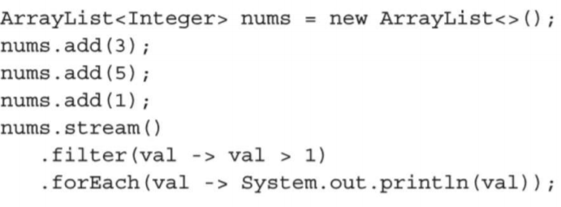output :

3

5