**Instruction**

**Step in-using the application:**

* **Sign In and User Privileges**
* Sign in Username and Password (each account have their own position which correspond to three different job position: Area Manager, Branch Manager, and Cashier).

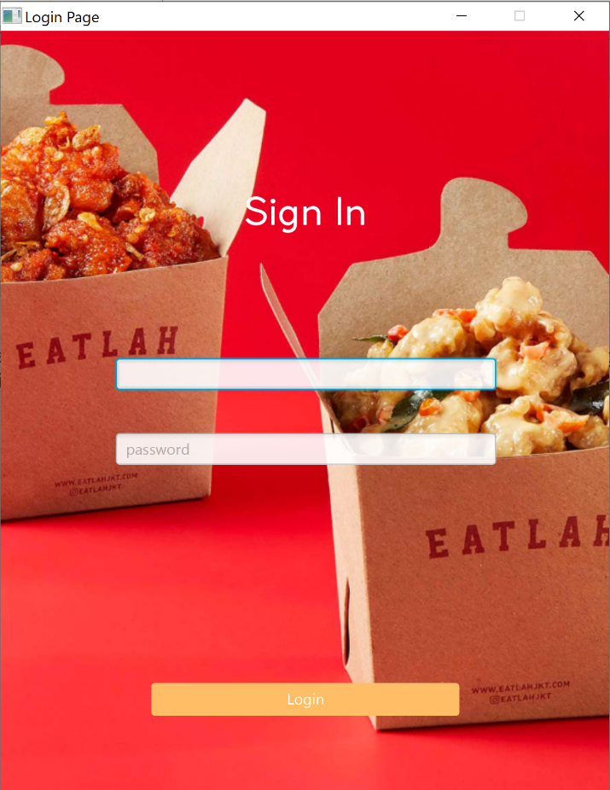

*Login Page*

* Each Position have different privileges in which Area Manager have the high privileges.
* Branch Manager can use all privileges except manipulate branch data, and Area Manager data.
* Cashier account only can add new order, edit order and edit their data (e.g. username and password).
* **Program Manual**
* If you want to add new order, click “*New Order*” text on the upper right corner on the Main Screen, then the “*New Order Form*” will appear. (Details on picture below).
* If you want to delete or edit, click “*Edit Order*” and *“Delete Order*” text on the lower right and left corner on the Main Screen. But you must select the data first in the table view otherwise the function will not be executed. (Details on picture below).
* We also provide sorting on the *Order* page, such as filter between start and end date, or filter by *Branch.*
* If you want to change the others page such as *Product, Employee,* or *Branch*. Click the specific page name on the side bar which located under the Eatlah logo.
* Each page has similar function like the *Order* page, in which the user can manipulate each page data, and each page has sorting combo box.

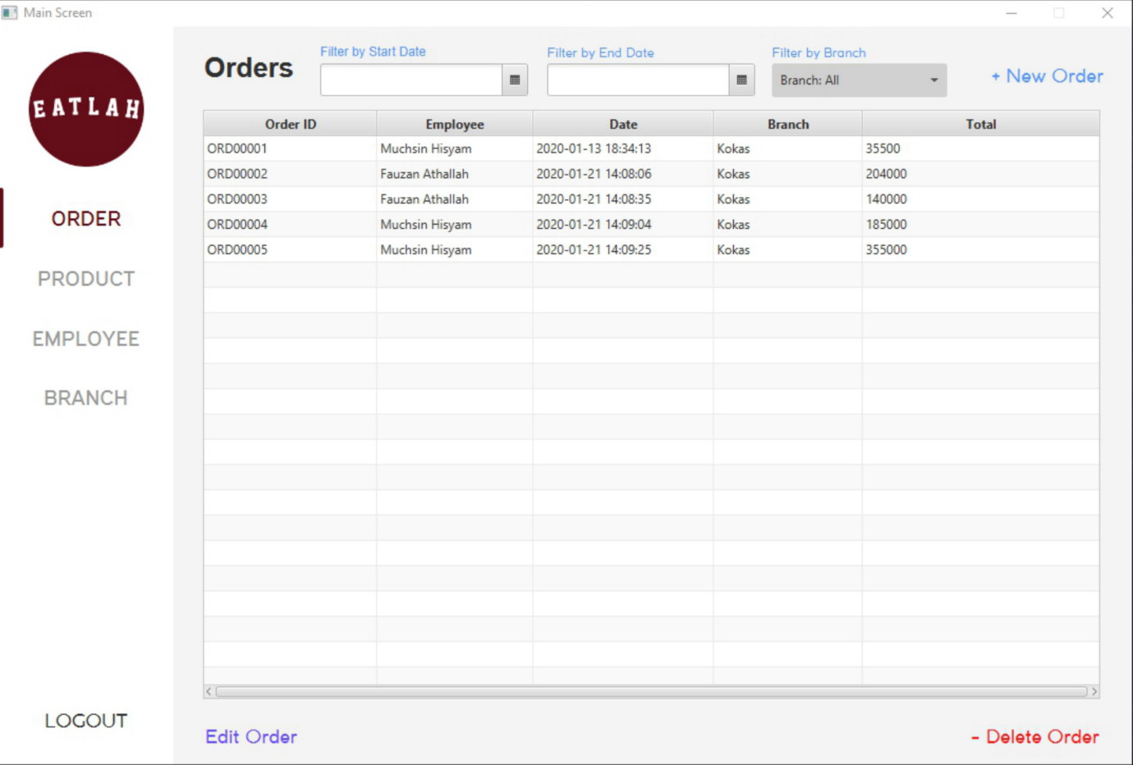

*Main Screen (Order)*

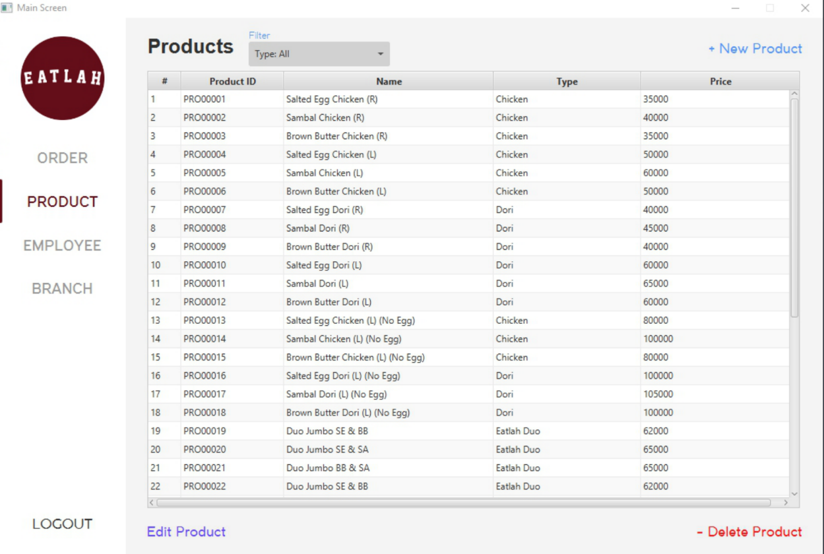

*Main Screen (Product)*

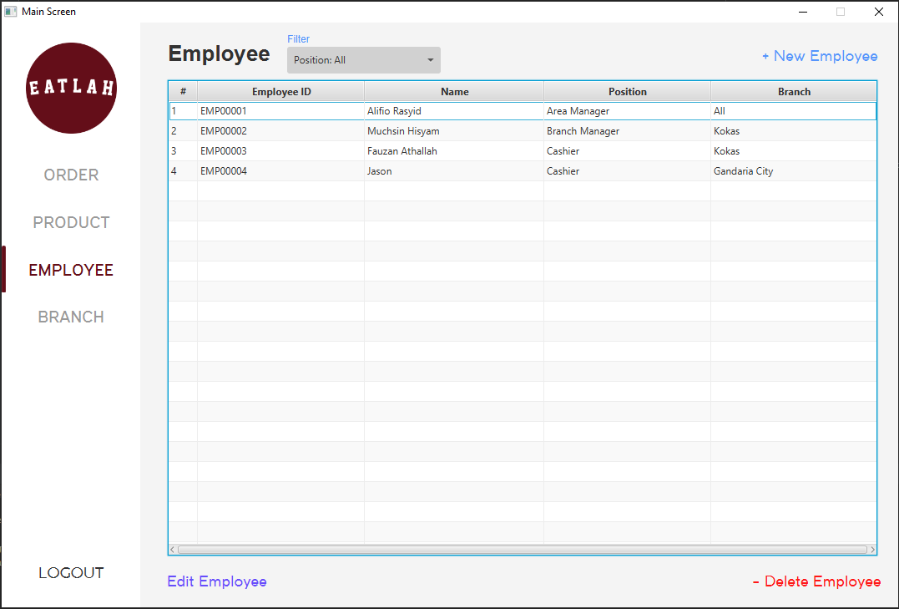

*Main Screen (Employee)*

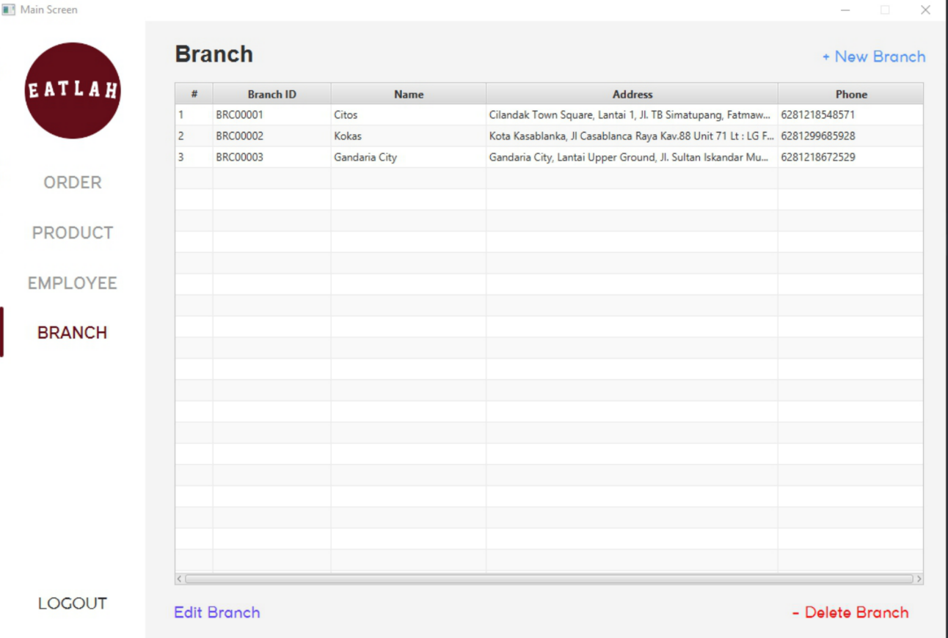

*Main Screen (Branch)*

* **Order Form**
* If you want to add item into the sub-order list, you can type the starting alphabet of the product name in the “*Product Name*” text field, so it will automaticly show the dropdown list of the product name that you want to type. After it shows, you must enter it once to select some specific items that you want to add to the list, and twice to make the price come out, otherwise it will come alert box because the price is null.
* The description text is not a mandatory, so you can let it null.
* You can also delete some data from the sub-order list by click the table row and click the “*Delete Item*” button that we already provided.
* After done adding some items to sub-order list you can click “*Next*” button, and the cash textfield can’t be null since it will be stored in the database.

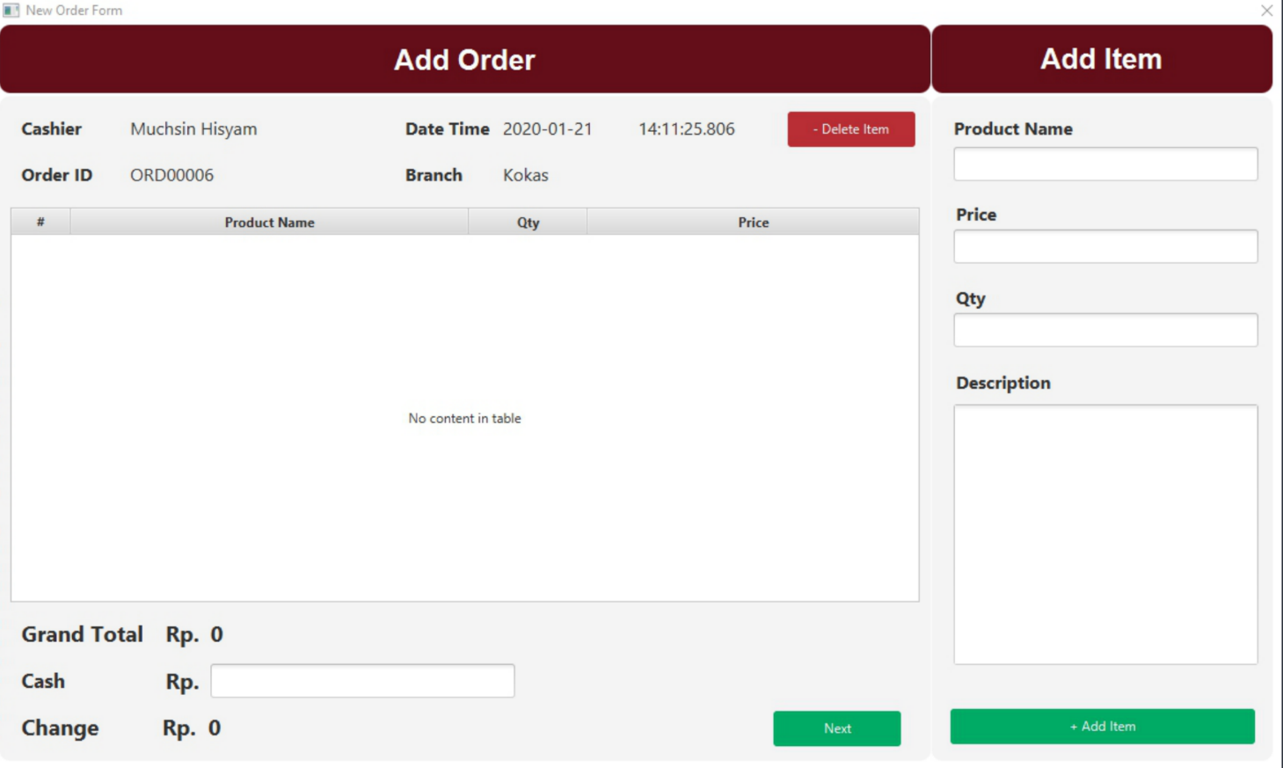

*New Order Form*

* **Others Form**
* Each form from other pages has same interface, in which the user just manipulates some specific data for each page.
* We also provide error validation through alert box for each page.