

|  |
| --- |
| Logical Data Model  **Social Media** |
| **By Zhasmina Alibayeva** |

Contents

1 Business Description 3

1.1 Business background 3

1.2 Problems. Current Situation 3

1.3 The benefits of implementing a database. Project Vision 3

2 Model description 3

2.1 Definitions & Acronyms 3

2.2 Logical Scheme 3

2.3 Objects 3

# 

# Business Description

## Business background

Nowadays social media has become an integral and important part of the people’s lives. Social media help users communicate, share content, participate in discussions, and etc. However, for the stable and efficient operation of the social media platform, we need a reliable database that can support a high load, store a large amount of information, and ensure user safety.

## Problems. Current Situation

The current problems that many social media may include is low performance, security concerns (data leaks) and data redundancy.

## the Benefits of implementing a database. Project Vision

The creation of this database will provide a stable, secure and scalable social platform.

# Model description

## Definitions & Acronyms

PK – Primary key

FK – Foreign key

1:M – One-to-Many relationship

M:N - Many-to-Many relationship

3NF - Third Normal Form

## Logical Scheme

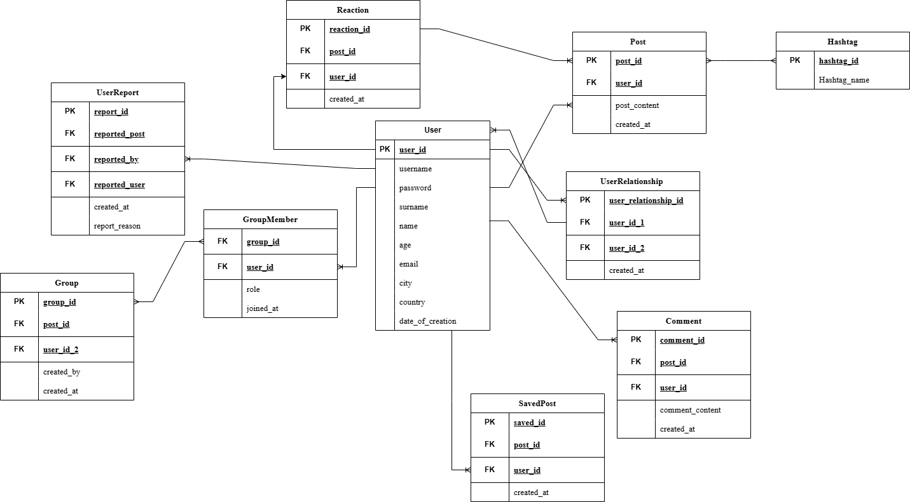

## Objects

**Table 1: User**

User table contains data about users including their user name, password, name, surname, age, email, city and country that they live in. For social media it is important to understand brief information about social media users. All the data can be used to provide more precise analytics about users.

|  |  |  |  |
| --- | --- | --- | --- |
| Column | Data Type | Constraints | Brief description |
| user_id | INT | Primary key, AUTO_INCREMENT | Unique identifier for each social media user |
| username | VARCHAR(75) | UNIQUE, NOT NULL | The Username of each social media user |
| password | VARCHAR(300) | NOT NULL | The Password of each social media user |
| name | VARCHAR(75) | NOT NULL | The First name of each social media user |
| surname | VARCHAR(75) | NOT NULL | The Last name of each social media user |
| age | INT | CHECK (age >= 0) | The Age of each social media user |
| email | VARCHAR(150) | NOT NULL, UNIQUE | The email address of each social media user |
| city | VARCHAR(170) | NULL | The city where the user lives |
| country | VARCHAR(50) | NULL | The country where the user lives |
| date_of_creation | TIMESTAMP | DEFAULT CURRENT_TIMESTAMP | Date and time the user record was created |

**Table 2: User Relationship**

User Relationship table contains data about the relationship between users.

|  |  |  |  |
| --- | --- | --- | --- |
| Column | Data Type | Constraints | Brief description |
| user_relationship_id | INT | Primary key, AUTO_INCREMENT | Unique identifier for relationship |
| user_id_1 | INT | Foreign key: User(user_id) | The User ID of the first user |
| user_id_2 | INT | Foreign key: User(user_id) | The User ID of the second user |
| created_at | TIMESTAMP | DEFAULT CURRENT_TIMESTAMP | Date and time the user relationship record was created |

**Table 3: Post**

Post table contains data about the created posts in social media.

|  |  |  |  |
| --- | --- | --- | --- |
| Column | Data Type | Constraints | Brief description |
| post_id | INT | Primary key, AUTO_INCREMENT | Unique identifier for the post |
| user_id | INT | Foreign key: User(user_id) | The User ID who created the post |
| post_content | TEXT | NOT NULL | Text content of the post |
| created_at | TIMESTAMP | DEFAULT CURRENT_TIMESTAMP | Date and time the post was created |

**Table 4: Comment**

Comment table contains data about the comments in social media.

|  |  |  |  |
| --- | --- | --- | --- |
| Column | Data Type | Constraints | Brief description |
| comment_id | INT | Primary key, AUTO_INCREMENT | Unique identifier for the comment |
| post_id | INT | Foreign key: Post(post_id) | Unique identifier for the post |
| user_id | INT | Foreign key: User(user_id) | The User ID who created the comment |
| comment_content | TEXT | NOT NULL | Text content of the comment |
| created_at | TIMESTAMP | DEFAULT CURRENT_TIMESTAMP | Date and time the comment was created |

**Table 5: Reaction**

Reaction table contains data about the user reaction to the post (likes, dislikes and etc.) in social media.

|  |  |  |  |
| --- | --- | --- | --- |
| Column | Data Type | Constraints | Brief description |
| reaction_id | INT | Primary key, AUTO_INCREMENT | Unique identifier for the comment |
| post_id | INT | Foreign key: Post(post_id) | Unique identifier for the post |
| user_id | INT | Foreign key: User(user_id) | The User ID who reacted to the post |
| created_at | TIMESTAMP | DEFAULT CURRENT_TIMESTAMP | Date and time the reaction to the post was created |

**Table 6: Hashtag**

Hashtag table contains data about the hashtag used in the post in social media.

|  |  |  |  |
| --- | --- | --- | --- |
| Column | Data Type | Constraints | Brief description |
| hashtag_id | INT | Primary key, AUTO_INCREMENT | Unique identifier for the hashtag |
| Hashtag_name | VARCHAR(300) | NOT NULL, UNIQUE | Text of the hashtag |

**Table 7: Group**

Group table contains data about the groups in social media.

|  |  |  |  |
| --- | --- | --- | --- |
| Column | Data Type | Constraints | Brief description |
| group_id | INT | Primary key, AUTO_INCREMENT | Unique identifier for the comment |
| name | VARCHAR(300) | NOT NULL, UNIQUE | Name of the group |
| created_by | INT | Foreign key: User(user_id) | The User ID who created the group |
| created_at | TIMESTAMP | DEFAULT CURRENT_TIMESTAMP | Date and time the reaction to the group was created |

**Table 8: Group Member**

Group member contains data about which groups users joined in social media.

|  |  |  |  |
| --- | --- | --- | --- |
| Column | Data Type | Constraints | Brief description |
| group_id | INT | Foreign key: Group(group_id) | Group ID |
| user_id | INT | Foreign key: User(user_id) | The User ID |
| role | VARCHAR(50) | DEFAULT 'member' | The role of the user |
| joined_at | TIMESTAMP | DEFAULT CURRENT_TIMESTAMP | When the user joined the group |

**Table 9: Saved Post**

Saved Post table contains data about user’s saved posts in social media.

|  |  |  |  |
| --- | --- | --- | --- |
| Column | Data Type | Constraints | Brief description |
| saved_id | INT | Primary key, AUTO_INCREMENT | Unique identifier for the saved post |
| post_id | INT | Foreign key: Post(post_id) | Unique identifier for the saved post |
| user_id | INT | Foreign key: User(user_id) | The User ID who saved the post |
| created_at | TIMESTAMP | DEFAULT CURRENT_TIMESTAMP | Date and time the reaction to the post was created |

**Table 10: User Report**

User report table contains data about the user reports in social media.

|  |  |  |  |
| --- | --- | --- | --- |
| Column | Data Type | Constraints | Brief description |
| report_id | INT | Primary key, AUTO_INCREMENT | Unique identifier for the report |
| reported_post | INT | Foreign key: Post(post_id) | Unique identifier for the post |
| reported_by | INT | Foreign key: User(user_id) | The User ID who reported to the post |
| reported_user | INT | Foreign key: User(user_id), NULL | The User ID to whom reported to the post |
| report_reason | TEXT | NOT NULL | The reason of the report |
| created_at | TIMESTAMP | DEFAULT CURRENT_TIMESTAMP | Date and time the report to the post was created |