

|  |
| --- |
| Logical Data Model  **Museum** |
| **By Zhasmina Alibayeva** |

Contents

1 Business Description 3

1.1 Business background 3

1.2 Problems. Current Situation 3

1.3 The benefits of implementing a database. Project Vision 3

2 Model description 3

2.1 Definitions & Acronyms 3

2.2 Logical Scheme 3

2.3 Objects 3

# 

# Business Description

## Business background

Museums need to store data about items, visitors, employees and exhibitions. It is very important to create a convenient database to store all the data.

## Problems. Current Situation

The current problems that many museums have may include is low performance, security concerns (data leaks) and data redundancy.

## the Benefits of implementing a database. Project Vision

The creation of this database will provide a stable, secure and scalable museum database.

# Model description

## Definitions & Acronyms

PK – Primary key

FK – Foreign key

1:M – One-to-Many relationship

M:N - Many-to-Many relationship

3NF - Third Normal Form

## Logical Scheme

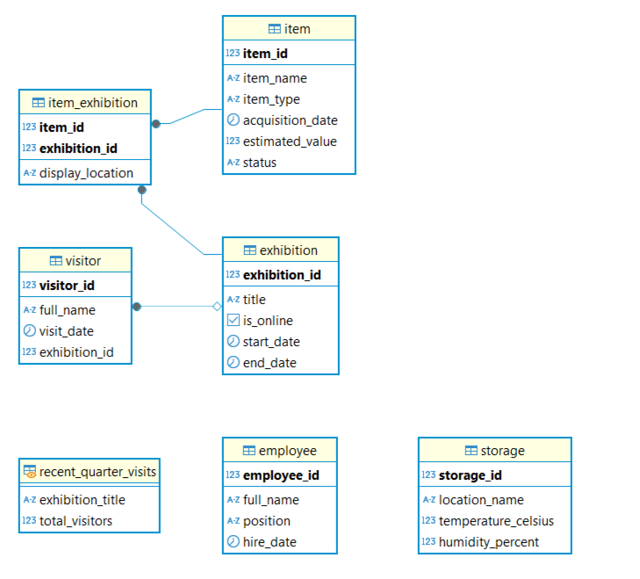

## Objects

**Table 1: Item**

Table contains data about item that museum holds.

|  |  |  |  |
| --- | --- | --- | --- |
| **Column** | **Data Type** | **Constraints** | **Brief description** |
| Item_name | VARCHAR(255) | NOT NULL | The name of the item |
| Item_id | SERIAL | PK | The ID of each item |
| item_type | VARCHAR(100) | CHECK (item_type IN ('artwork', 'artifact', 'specimen', 'historical_object')) | Type of the item |
| acquisition_date | DATE | NOT NULL, CHECK (acquisition_date >= '2024-01-01') | Date when the item was acquired |
| estimated_value | NUMERIC(12,2) | DEFAULT 0, CHECK (estimated_value >= 0) | Estimated value of the item |
| status | VARCHAR(50) | DEFAULT 'in_storage', CHECK (status IN ('in_storage', 'on_display', 'under_maintenance')) | Current status of the item |

**Table 2:** exhibition

Table contains data about the exhibition.

|  |  |  |  |
| --- | --- | --- | --- |
| **Column** | **Data Type** | **Constraints** | **Brief description** |
| exhibition_id | SERIAL | PRIMARY KEY | Unique identifier for each exhibition |
| title | VARCHAR(255) | NOT NULL | Title of the exhibition |
| is_online | BOOLEAN | DEFAULT FALSE | Whether the exhibition is online |
| start_date | DATE |  | Start date of the exhibition |
| end_date | DATE | CHECK (start_date <= end_date) | End date of the exhibition |

**Table 3:** storage

Table contains data about the storage.

|  |  |  |  |
| --- | --- | --- | --- |
| **Column** | **Data Type** | **Constraints** | **Brief description** |
| storage_id | SERIAL | PRIMARY KEY | Unique identifier for each storage location |
| location_name | VARCHAR(255) | NOT NULL | Name of the storage location |
| temperature_celsius | NUMERIC(5,2) | CHECK (temperature_celsius BETWEEN 5 AND 25) | Temperature in the storage |
| humidity_percent | NUMERIC(5,2) | CHECK (humidity_percent BETWEEN 30 AND 70) | Humidity level in the storage |

**Table 4:** employee

Table contains data about the employee.

|  |  |  |  |
| --- | --- | --- | --- |
| **Column** | **Data Type** | **Constraints** | **Brief description** |
| employee_id | SERIAL | PRIMARY KEY | Unique identifier for each employee |
| full_name | VARCHAR(255) | NOT NULL, CHECK (LENGTH(full_name) > 0) | Full name of the employee |
| position | VARCHAR(100) |  | Employee's position |
| hire_date | DATE | NOT NULL, DEFAULT CURRENT_DATE | Date of hire |

**Table 5:** visitor

Table contains data about the visitor.

|  |  |  |  |
| --- | --- | --- | --- |
| **Column** | **Data Type** | **Constraints** | **Brief description** |
| visitor_id | SERIAL | PRIMARY KEY | Unique identifier for each visitor |
| full_name | VARCHAR(255) | CHECK (LENGTH(full_name) > 0) | Full name of the visitor |
| visit_date | DATE | DEFAULT CURRENT_DATE, CHECK (visit_date >= '2024-01-01') | Date of the visit |
| exhibition_id | INT | REFERENCES exhibition(exhibition_id) | Linked exhibition for the visit |

**Table 6:** item_exhibition

Table contains data about the item in exhibition.

|  |  |  |  |
| --- | --- | --- | --- |
| **Column** | **Data Type** | **Constraints** | **Brief description** |
| item_id | INT | REFERENCES item(item_id) | ID of the item |
| exhibition_id | INT | REFERENCES exhibition(exhibition_id) | ID of the exhibition |
| display_location | VARCHAR(255) |  | Display location in the exhibition |
| Primary Key |  | PRIMARY KEY (item_id, exhibition_id) | Composite key to prevent duplicates |