Logical Data Model

Social Media
By Zhasmina Alibayeva

Contents
1 Business Description 3
1.1 Business background 3
1.2 Problems. Current Situation 3
1.3 The benefits of implementing a database. Project Vision 3
2 Model description 3
2.1 Definitions & Acronyms 3
2.2 Logical Scheme 3
2.3 Objects 3

Business Description

Business background
Nowadays social media has become an integral and important part of the people’s lives. Social media help users communicate, share content, participate in discussions, and etc. However, for the stable and efficient operation of the social media platform, we need a reliable database that can support a high load, store a large amount of information, and ensure user safety.

Problems. Current Situation
The current problems that many social media may include is low performance, security concerns (data leaks) and data redundancy.

the Benefits of implementing a database. Project Vision
The creation of this database will provide a stable, secure and scalable social platform.

Model description

Definitions & Acronyms
PK – Primary key
FK – Foreign key
1:M – One-to-Many relationship
M:N - Many-to-Many relationship
3NF - Third Normal Form

Logical Scheme
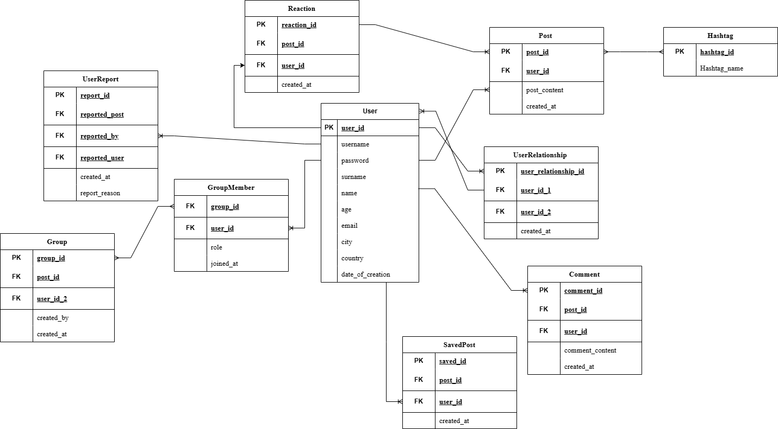

Objects

Table 1: User
User table contains data about users including their user name, password, name, surname, age, email, city and country that they live in. For social media it is important to understand brief information about social media users. All the data can be used to provide more precise analytics about users.

Column | Data Type | Constraints | Brief description
user_id | INT | Primary key, AUTO_INCREMENT | Unique identifier for each social media user
username | VARCHAR(75) | UNIQUE, NOT NULL | The Username of each social media user
password | VARCHAR(300) | NOT NULL | The Password of each social media user
name | VARCHAR(75) | NOT NULL | The First name of each social media user
surname | VARCHAR(75) | NOT NULL | The Last name of each social media user
age | INT | CHECK (age >= 0) | The Age of each social media user
email | VARCHAR(150) | NOT NULL, UNIQUE | The email address of each social media user
city | VARCHAR(170) | NULL | The city where the user lives
country | VARCHAR(50) | NULL | The country where the user lives
date_of_creation | TIMESTAMP | DEFAULT CURRENT_TIMESTAMP | Date and time the user record was created

Table 2: User Relationship
User Relationship table contains data about the relationship between users.

Column | Data Type | Constraints | Brief description
user_relationship_id | INT | Primary key, AUTO_INCREMENT | Unique identifier for relationship
user_id_1 | INT | Foreign key: User(user_id) | The User ID of the first user
user_id_2 | INT | Foreign key: User(user_id) | The User ID of the second user
created_at | TIMESTAMP | DEFAULT CURRENT_TIMESTAMP | Date and time the user relationship record was created

Table 3: Post
Post table contains data about the created posts in social media.

Column | Data Type | Constraints | Brief description
post_id | INT | Primary key, AUTO_INCREMENT | Unique identifier for the post
user_id | INT | Foreign key: User(user_id) | The User ID who created the post
post_content | TEXT | NOT NULL | Text content of the post
created_at | TIMESTAMP | DEFAULT CURRENT_TIMESTAMP | Date and time the post was created

Table 4: Comment
Comment table contains data about the comments in social media.

Column | Data Type | Constraints | Brief description
comment_id | INT | Primary key, AUTO_INCREMENT | Unique identifier for the comment
post_id | INT | Foreign key: Post(post_id) | Unique identifier for the post
user_id | INT | Foreign key: User(user_id) | The User ID who created the comment
comment_content | TEXT | NOT NULL | Text content of the comment
created_at | TIMESTAMP | DEFAULT CURRENT_TIMESTAMP | Date and time the comment was created
Table 5: Reaction
Reaction table contains data about the user reaction to the post (likes, dislikes and etc.) in social media.

Column | Data Type | Constraints | Brief description
reaction_id | INT | Primary key, AUTO_INCREMENT | Unique identifier for the comment
post_id | INT | Foreign key: Post(post_id) | Unique identifier for the post
user_id | INT | Foreign key: User(user_id) | The User ID who reacted to the post
created_at | TIMESTAMP | DEFAULT CURRENT_TIMESTAMP | Date and time the reaction to the post was created
Table 6: Hashtag
Hashtag table contains data about the hashtag used in the post in social media.

Column | Data Type | Constraints | Brief description
hashtag_id | INT | Primary key, AUTO_INCREMENT | Unique identifier for the hashtag
Hashtag_name | VARCHAR(300) | NOT NULL, UNIQUE | Text of the hashtag
Table 7: Group
Group table contains data about the groups in social media.

Column | Data Type | Constraints | Brief description
group_id | INT | Primary key, AUTO_INCREMENT | Unique identifier for the comment
name | VARCHAR(300) | NOT NULL, UNIQUE | Name of the group
created_by | INT | Foreign key: User(user_id) | The User ID who created the group
created_at | TIMESTAMP | DEFAULT CURRENT_TIMESTAMP | Date and time the reaction to the group was created
Table 8: Group Member
Group member contains data about which groups users joined in social media.

Column | Data Type | Constraints | Brief description
group_id | INT | Foreign key: Group(group_id) | Group ID
user_id | INT | Foreign key: User(user_id) | The User ID
role | VARCHAR(50) | DEFAULT 'member' | The role of the user
joined_at | TIMESTAMP | DEFAULT CURRENT_TIMESTAMP | When the user joined the group

Table 9: Saved Post
Saved Post table contains data about user’s saved posts in social media.

Column | Data Type | Constraints | Brief description
saved_id | INT | Primary key, AUTO_INCREMENT | Unique identifier for the saved post
post_id | INT | Foreign key: Post(post_id) | Unique identifier for the saved post
user_id | INT | Foreign key: User(user_id) | The User ID who saved the post
created_at | TIMESTAMP | DEFAULT CURRENT_TIMESTAMP | Date and time the reaction to the post was created
Table 10: User Report
User report table contains data about the user reports in social media.

Column | Data Type | Constraints | Brief description
report_id | INT | Primary key, AUTO_INCREMENT | Unique identifier for the report
reported_post | INT | Foreign key: Post(post_id) | Unique identifier for the post
reported_by | INT | Foreign key: User(user_id) | The User ID who reported to the post
reported_user | INT | Foreign key: User(user_id), NULL | The User ID to whom reported to the post
report_reason | TEXT | NOT NULL | The reason of the report
created_at | TIMESTAMP | DEFAULT CURRENT_TIMESTAMP | Date and time the report to the post was created

