Output over current protection:

Over current at the output can occur due to many reasons like inrush current or short circuit. To protect both the load and the converter we need to shut down the converter in such cases. Most common way to protect from over current is to use a slow burn fuse. However, fuses require replacement if they burn. Therefore, we designed a circuit so that no replacement is necessary.

First, we measure the load current with an IC and compared with the limit current (15A) that we specified using a zener voltage reference. Then, we added an analog delay (2ms) circuit so that converter is not turned of during transients or small inrush current event. Resulting overcurrent signal drives MOSFETs that turns down the converter using it’s “Enable” pin. Between the MOSFETs and the converter an optocoupler is used to maintain the isolation. Op-amp and reference voltage generator is supplied with a small 5V switching regulator.

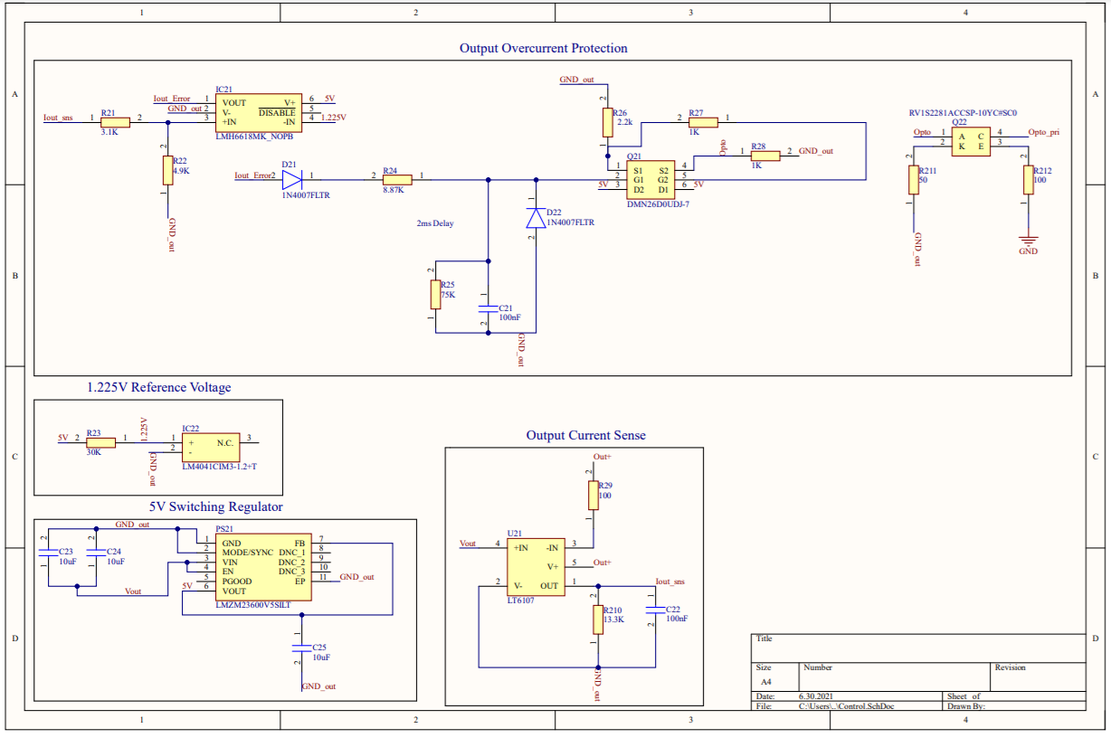

Input reverse polarity protection:

Reverse voltage is destructive to the circuit due to unipolar components. To avoid this, we implemented PMOS reverse polarity protection between the input and the converter. PMOS protection is selected due to it’s simplicity. Since our input current is quite low, loss of the PMOS is also very small (~0.8W). Zener diode is used so that VSG voltage of the MOSFET stays in the limit. Simulation and the schematic are given below.

