## 4.2. Winding Selection

Winding selection is another important topic while designing a transformer. Both the wire itself and the wiring type effects the performance of the transformer. Choosing thicker wire may seem to reduce the resistance and losses however due to skin and proximity effects, diameter of the wire does not affect losses after a point. Moreover, thicker wires results in bulkier windings which increases leakage inductances. However, choosing wires too thin may result in excessive heat generation and meltdown in critical points of the winding. Therefore, we tried to make a balanced selection.

First, we assumed that output current flows through the windings without alternating and find a wire so that current density of the wire is around 5 A/mm2

Even though, due to skin and proximity effects, current will flow nonhomogeneous and most of the copper will not carry any current, high heat capacitance of thicker wire will prevent burnouts in the winding.

We have total of 31 turns of winding which consists of 25 primary, 3 secondary and 3 feedback turns. The selected core can accommodate around 12-13 turns per layer. Since we only needed three layers of windings, we did not see necessary to make interleaved winding and make two layers of primary winding and one layer of combined secondary and feedback winding.

## 4.3. Finite Element Analysis

After deciding the core material, shape, airgap and the windings, we started to draw the transformer in Maxwell 3D. For faster analysis, continuous surfaces were drawn with edges as shown in **FİG XX.** Main reason of Finite Element Analysis is to check our design parameters and calculate transformer parameters which can not be calculated analytically. First, we draw only the primary winding to check our model’s validity. After finding that analysis results were almost same with datasheet values of the core we continued with secondary and feedback windings. However, if we make 25 turn primary and 3 turn secondary, secondary inductance becomes larger than the calculations. This is most probably due to reduction of magnetic path (therefore reduction in reluctance) while increasing layer number (winding radius). This kind of secondary effects was the first reason why we did finite element analysis. To overcome this effect, we reduced the secondary turn number to 2.5 and the results were satisfactory.

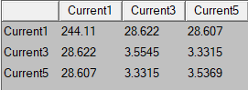

Self and mutual inductances of the windings. (uH)

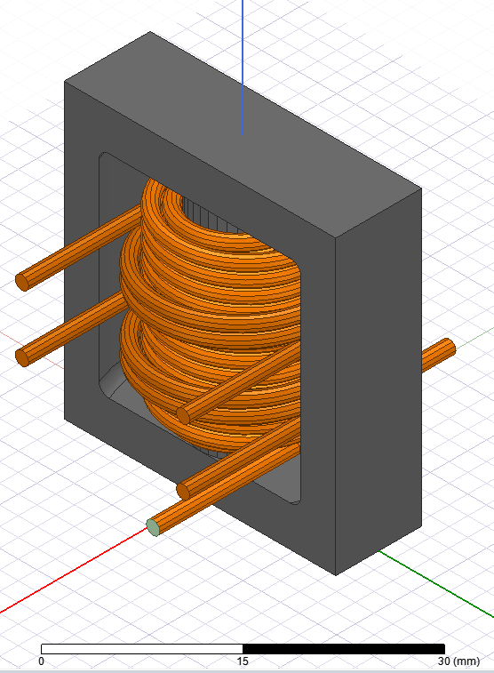 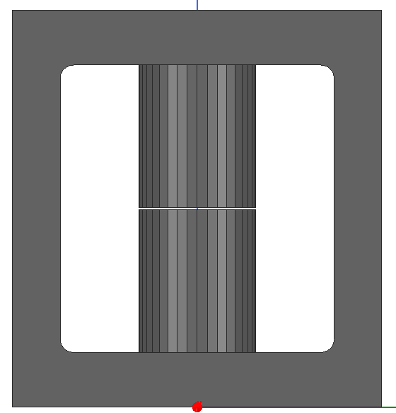

Maxwell 3D model.

After satisfying inductance and turn ratio parameters we moved on to saturation control. To observe the magnetic flux density in most extreme case, we supplied primary winding with 3A current. This 3A comes from the calculations of the controller and it is also observed in LTspice. To ease the work of the computer, meshing was concentrated in the inner corner and near the airgap. Both magnetic flux density and vectors can be seen in **FİG XX.**

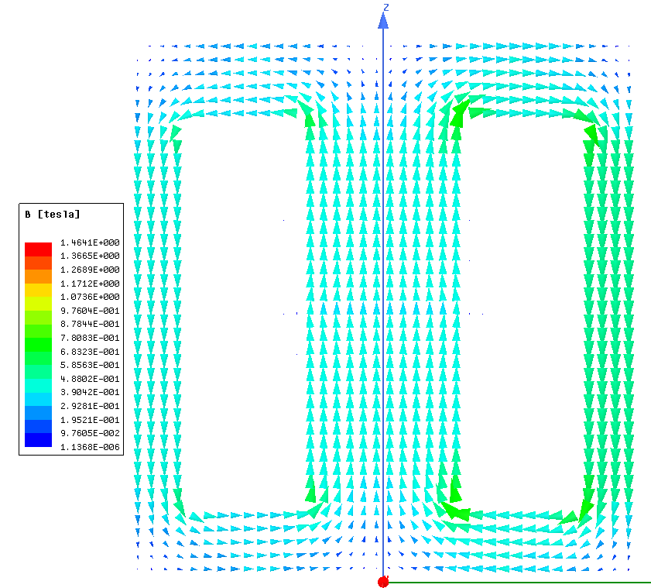

Magnetic flux vectors

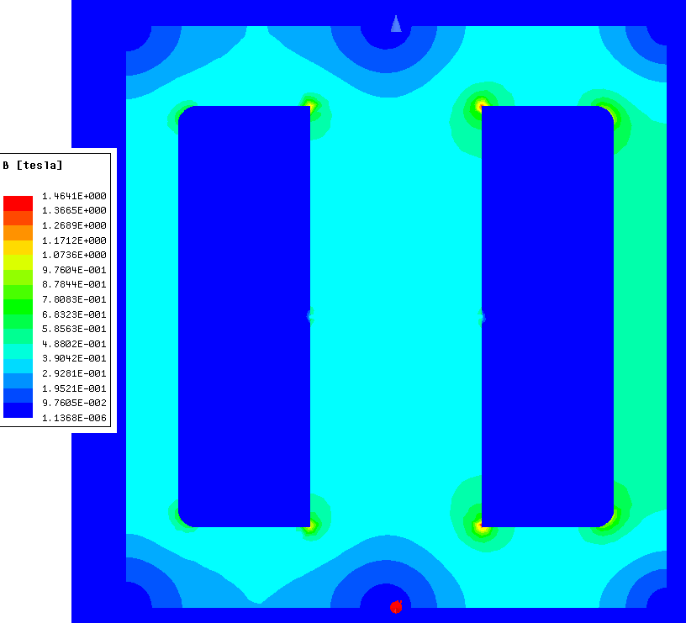

Magnetic flux density

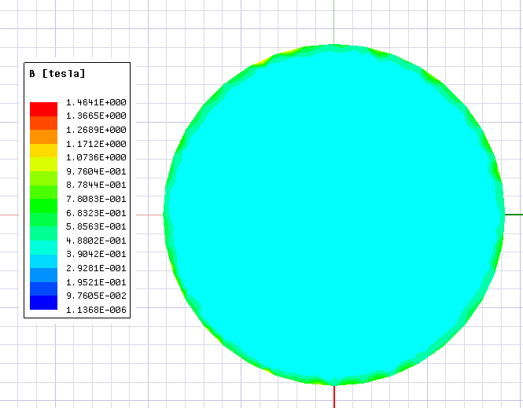

Magnetic flux density of the core center.

At maximum magnetic flux density that the core can see, most of the core remans unsaturated. However, some corners of the core are saturated. This may be acceptable since transformer will work in this condition on extreme cases and for transient times. Transformer current will reduce after reaching steady state.

Final analysis that we made is eddy current analysis. We made this analysis to estimate the AC resistance of the windings and to observe the current density in those windings.

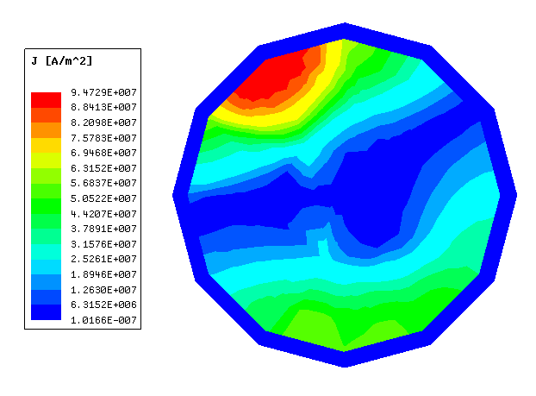

Current density of a single wire in primary winding.

As expected, we see nonhomogeneous current distribution in the conductor due to skin and proximity effects. More important than to see the current distribution is to get the AC resistance to accurately calculate copper losses in the transformer.

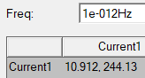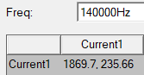

DC and AC resistances of primary winding (m Ω).

As we can see in **FİG XX.** Frequency has a significant effect on the resistance. Even though we expected such increase, numerical value of the resistance is found by FEA. Therefore, we used this result (1.869Ω) in Ltspice simulations.

$$L_{leak}=2\frac{L_{pri}(1-k)}{k}$$

$$R_{Snubber}=\sqrt{\frac{L_{leak}}{C_{in}}}$$