1. Open file form.php, write your message and click submit :

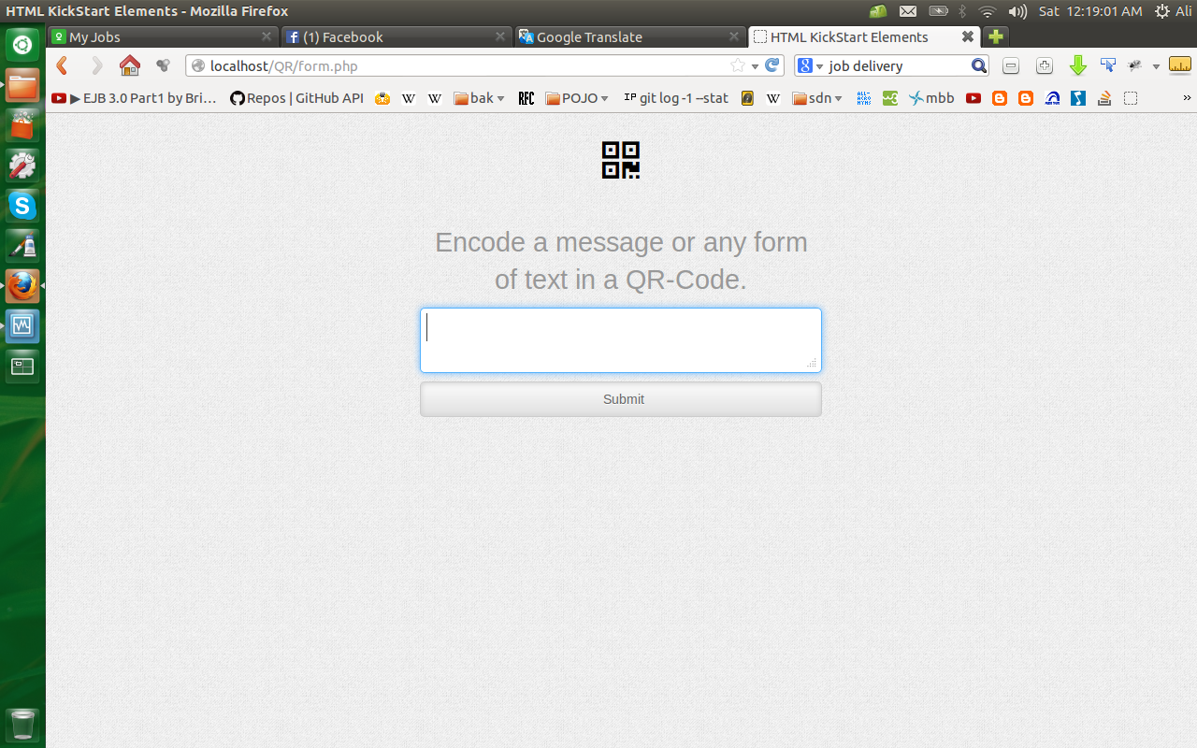

2. If you submit an empty message you got an error like this :

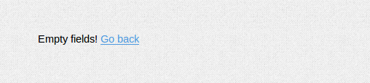

3. Write your message for example “SCAN” and click submit buuton :

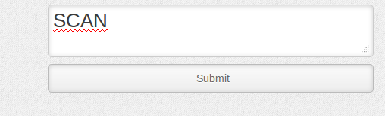

4. And you will got a result like this :
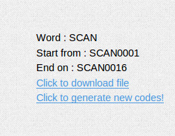

5. Click on the first link to download the final generated document.

