Q3.

Entropy criterion:

Suppose class1=A, class0=B

The training examples have labels: 4A & 2B

X1:

Yes: 3A

No: 1A & 2B

X2:

Yes: 2A & 2B

No: 2A

X3:

Yes: 3A & 1B

No: 1A & 1B

X4:

Yes: 2A & 2B

No: 2A

$$H\left(S_{l}\right)=-\frac{1}{2}\log{\frac{1}{2}}- \frac{1}{2}\log{\frac{1}{2}}=1$$

$$H\left(S_{r}\right)=-1log1=0$$

$$H\left(after\right)=\frac{\left|S_{l}\right|H\left(S_{l}\right)+\left|S_{r}\right|H\left(S_{r}\right)}{\left|S_{l}\right|+\left|S_{r}\right|}=\frac{4×1+2×0}{4+2}=\frac{2}{3}=0.667$$

Because we want to minimize Hafter to find the best split, X1 will be chosen for the root.

Gini criterion:

X1:

Yes: 3A

No: 1A & 2B

X2:

Yes: 2A & 2B

No: 2A

X3:

Yes: 3A & 1B

No: 1A & 1B

X4:

Yes: 2A & 2B

No: 2A

$$G\left(S_{l}\right)=1-{\frac{1}{2}}^{2}-{\frac{1}{2}}^{2}=\frac{1}{2}$$

$$G\left(S_{r}\right)=1-1^{2}=0$$

$$G\left(S\right)=\frac{2}{3}×\frac{1}{2}+\frac{1}{3}×0=\frac{1}{3}=0.333$$

Because Gini index is to calculate how frequently a randomly chosen element will be wrongly identified and so that we want to minimize Gini indexto find the best split, X1 will be chosen for the root.

Misclassification criterion:

X1:

Yes: 3A

No: 1A & 2B

X2:

Yes: 2A & 2B

No: 2A

X3:

Yes: 3A & 1B

No: 1A & 1B

X4:

Yes: 2A & 2B

No: 2A

$$J\left(S_{l}\right)=2$$

$$J\left(S_{r}\right)=0$$

$$J\left(S\right)=2+0=2$$

Because we want to minimize number of points that are incorrectly classified, X1 will be chosen so that we minimize J(S).

4.

$g_{1}\left(x_{1},x_{2}\right)$ =5 $x_{2}+3x_{1}-4$

$g_{2}\left(x_{1},x_{2}\right)$ =-3 $x_{2}+2x_{1}-6$

If g1 is greater than g2, then we assign it to C1.

5 $x_{2}+3x_{1}-4$ > -3 $x_{2}+2x_{1}-6$

8 $x_{2}+x_{1}+2$ > 0

We can replace these two functions by a single discriminant function:

8

7.

a.

S1=

S2=

S3=

B=

b.

S1,3 =

c.

12.9788

d.

$$\left[\begin{matrix}0.26018674 & -1.41900435 \\ \begin{matrix}-0.87353472 \\ -4.04749635 \\ 4.66084433\end{matrix} & \begin{matrix}4.03721245 \\ -1.8486773 \\ -0.7695308\end{matrix}\end{matrix}\right]$$

5.

a.

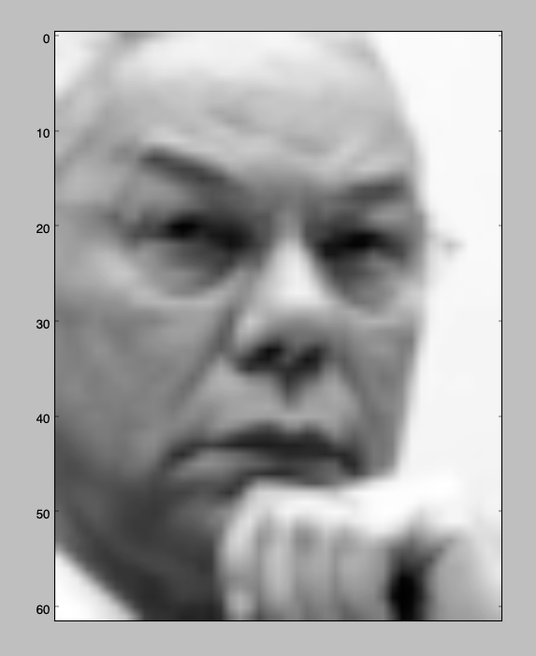

plt_face(fea[3])

b.

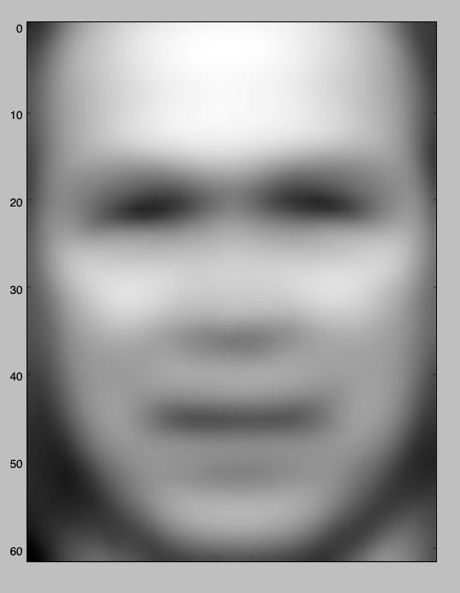

plt_face(np.mean(fea,axis=0))

c.

pca = skd.PCA(n_components = 5)

skd.PCA.fit(pca,fea)

W1 = pca.components_

W = W1.transpose()

Z = pca.transform(fea)

print Z[3]

$$\left[\begin{matrix}-574.02077112 & -1405.52609978 & \begin{matrix}-1423.46980598 & \begin{matrix}-822.73949443 & 535.51024051\end{matrix}\end{matrix}\end{matrix}\right]$$

d.

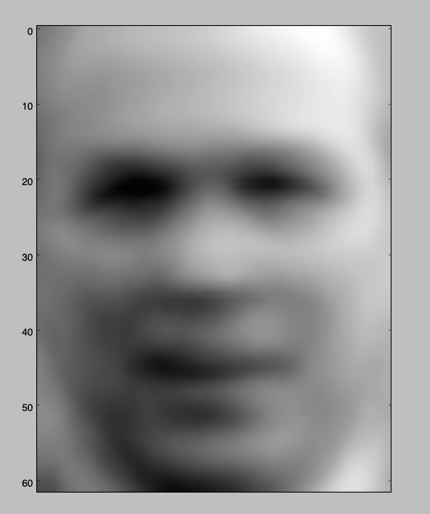

pca = skd.PCA(n_components = 5)

skd.PCA.fit(pca,fea)

W1 = pca.components_

W = W1.transpose()

Z = pca.transform(fea)

A=np.dot(W, Z[3])+np.mean(fea,axis=0)

plt_face(A)

plt.show()

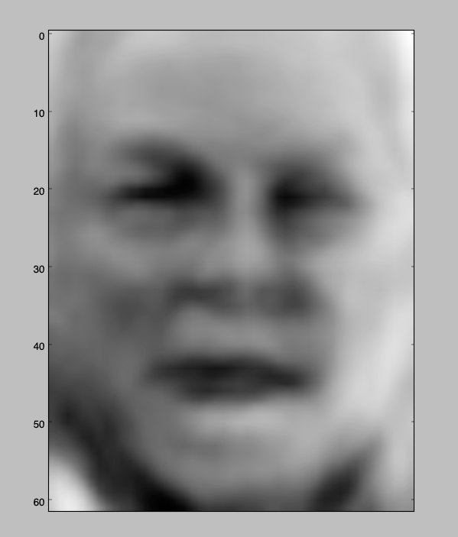

pca = skd.PCA(n_components = 50)

skd.PCA.fit(pca,fea)

W1 = pca.components_

W = W1.transpose()

Z = pca.transform(fea)

B=np.dot(W, Z[3])+np.mean(fea,axis=0)

plt_face(B)

plt.show()