SECENTIC
AI Agent Security Control Plane
Final Year Project Proposal (FYP-I)
Session Fall 2026



Supervisor: Sandesh Kumar
Group Members:
21K-4767 Syed Bakhtiar Ahmed
22K-4042 Syed Areeb Hussain
22K-4002 Ali Hyder Bhellar

Department of Cyber Security (CY) & Artificial Intelligence (AI)
Fast School of Computing
Fast National University, Karachi Campus
14th September 2026

Project Registration
Project ID (for office use)
Type of project | [X] Traditional [ ] Industrial [ ] Continuing
Nature of project | [ ] Development [ ] Research & Development [ ] Research
Sustainable Development Goals (SDGs) | [ ] Good Health and Well-Being [ ] Quality Education  [X] Industry, Innovation, and Infrastructure [ ] Gender Equality  [ ] Decent Work and Economic Growth [ ] Climate Action
Area of specialization | [X] Artificial Intelligence (AI) [ ] Data Science and Analytics  [ ] Internet of Things (IoT) [ ] Blockchain  [ ] Mobile App Development [ ] Web Development [X] Cybersecurity  [ ] Game Development [ ] Natural Language Processing (NLP)  [ ] Other

Project Group Members
Sr.# | Reg. # | Student Name | CGPA | Email ID | Phone # | Signature
(i) | 21K-4767 | Syed Bakhtiar Ahmed (Group Leader)
(ii) | 22K-4042 | Syed Areeb Hussain
(iii) | 22K-4002 | Ali Hyder Bhellar
Declaration: FYP group members have cleared all prerequisite courses for FYP-I as per their degree requirements.

1. Project Abstract
Secentic is a security control plane we are proposing for AI agents, meant to control what autonomous agents are actually allowed to do once they are deployed inside an organization. Companies are now connecting AI agents to enterprise tools, cloud systems, and external services like Model Context Protocol (MCP) servers, and this has created a gap in how these agents are governed. In most cases there is no proper inventory of which agents are running, no clear record of what authority each one has, no visibility into which tools they can reach, and no step that checks an agent's action against policy before it happens. The security controls that already exist were built for human users and fixed service accounts, so they don't really work for agents that read untrusted content and can take actions on their own with very little human checking in between.
What we are proposing with Secentic is a system that constrains what an agent can do, instead of trying to make the agent's own reasoning perfectly safe (which is very hard to guarantee). This is done through a verifiable identity for each agent, authority that is delegated and time-bound rather than inherited, a policy engine that gives deterministic and explainable results, a risk-scoring engine, and a runtime gateway that checks every important action before it is allowed to go through. The system has a control plane, a data-plane runtime gateway, and a storage/audit layer, and is broken down into twelve modules that can each be built and tested on their own, split across two semesters. Six of these — agent discovery and inventory, agent identity, delegated authority, the agent/tool registry, the policy engine, and the runtime gateway — are the modules we are targeting for FYP-I.
We plan to test the system against simulated agent behaviour and attack scenarios based on recent research in this area, including indirect prompt injection and tool misuse. By the end of this project, we expect to have a working prototype, a documented policy and risk model with decisions that can be explained rather than being a black box, and some evidence that an agent's actions can still be kept under control even if its reasoning gets manipulated or simply makes a mistake.

2. Introduction
AI agents have moved past being simple chatbots. They now read data on their own, call external tools, modify records, send messages, run code, and make multi-step decisions on behalf of a user or an organization. This creates a security problem that is quite different from regular application security. In a normal system, what you're securing is a user, an application, or a service account, and its permissions don't change much. With an agent, what you're securing is something that acts under context that keeps changing, works on authority that was delegated to it, often reads content it shouldn't fully trust, and can take real actions with barely any human in the loop.
As more organizations start using autonomous and semi-autonomous agents connected to enterprise tools, cloud infrastructure, and external services like MCP servers, a governance gap shows up. Most of the time there's no reliable list of which agents exist, what authority each one has, what tools they can reach, or whether an action was ever checked against a policy before it happened. Because of this, agent security has become a fast-growing and genuinely important area within applied AI and cybersecurity, not just a theoretical concern.
Recent work on tool-using LLM agents backs this up. Research has shown that indirect prompt injection, where malicious instructions are hidden inside content the agent reads, is a real and measurable attack surface [1], [2], and that teams of LLM agents can even find and exploit software vulnerabilities on their own once they are given enough tool access [9]. This kind of evidence is why we think purpose-built, system-level defenses matter more than just relying on the model itself to behave safely [7]. It also shapes the problem this proposal is built around: since we can't assume an agent's reasoning will always be safe, its actions need to be checked and constrained independently, at the point where they are actually executed.

3. Problem Statement
Organizations that are deploying AI agents today are running into a number of security problems that are still unresolved:
- Agent sprawl and shadow agents: security and engineering teams often don't have a reliable inventory of the autonomous agents running in their environment.
- Unclear ownership and accountability: there's usually no clear record of who owns a given agent, or whose authority it was acting on when it did something.
- Overprivileged agents: agents often end up inheriting broad service-account or human permissions that go well beyond what the task actually needs.
- Uncontrolled tool and MCP access: agents can reach external tools and MCP servers without anyone verifying their trust level, capabilities, or where they actually came from.
- Context-blind authorization: static, role-based permissions don't take into account the task, session history, how sensitive the data is, where it's going, or the risk at that moment.
- Limited runtime visibility: most existing controls only see isolated events instead of the full chain from agent, to tool, to resource.
- Manual or absent approval mechanisms: teams end up having to choose between manually watching every single agent action or just giving the agent more autonomy than they're comfortable with.
- Prompt-injection-to-action risk: content an agent reads that it shouldn't fully trust can manipulate its reasoning, and that manipulation can turn directly into an unauthorized action in the real world [1], [2].
- Weak audit and accountability trails: organizations don't have a defensible, tamper-evident record connecting an agent's identity, its delegated authority, the policy check, the decision, and what actually happened as a result.
As far as we can tell, there isn't a widely adopted, purpose-built control plane that brings agent identity, delegated authority, contextual policy enforcement, explainable risk scoring, human approval, and tamper-evident audit together into one enforcement layer for agentic AI systems [7]. This is the gap this project is trying to address.

4. Motivation
What motivates this project is the growing, practical need for a dedicated security and governance layer for AI agents, separate from general LLM safety work. We're not trying to make a language model's reasoning perfectly safe, since that's not really something we can guarantee. The idea instead is architectural: even if an agent's reasoning is manipulated or just wrong, the actions it takes should still be limited by its identity, its delegated authority, a deterministic policy, and enforcement at runtime. This project is our attempt to design and build a system, Secentic, that works as this control plane.

a. Aims and Objectives
The aim of this project is to design and develop Secentic, a security control plane for AI agents that decides what autonomous agents are allowed to do by checking every important action against identity, delegated authority, and policy before it is executed.
The specific objectives of the project are to:
- Design and build a way to discover and keep an inventory of the AI agents operating across an organization's environment.
- Give every registered agent a unique, cryptographically verifiable identity that is kept separate from human identity.
- Implement a delegated authority model where an agent's permissions are scoped to a specific task, resource, and time window, instead of the agent just inheriting a full human or service-account permission set.
- Build a registry of which tools each agent can access, including an inventory of MCP servers and a trust state for each tool.
- Develop a runtime security gateway that can intercept an agent's important actions and authorize them before they execute.
- Design a policy engine that is deterministic and explainable, and that evaluates actions using identity, delegation, tool, resource, context, and risk signals.
- Build a risk-scoring engine that classifies agent actions by severity in a way that can be explained rather than just being a number.
- Build a human-in-the-loop approval workflow for actions that are high-impact or not clearly safe.
- Provide runtime activity monitoring, some investigation tooling, and an append-only, tamper-evident audit trail.
- Evaluate the system against realistic agent security scenarios, including indirect prompt injection and tool-misuse benchmarks based on current research [1], [2], [5], [8].

b. Scope of the Project
The project is scoped as an MVP-level security control plane for AI agents, to be delivered across two semesters (FYP-I and FYP-II). The system has three main layers. The control plane handles inventory, identity, delegation, policy, risk scoring, and the human approval workflow. The data-plane runtime gateway sits between an agent's reasoning and its actions, intercepting every tool or API call the agent attempts and authorizing it in real time based on policy and risk. The storage and audit layer keeps agent activity, decisions, and approvals in a log that can't easily be tampered with, which is also what supports investigation and compliance reporting later on.
Out of the overall product design, we picked twelve core modules as the FYP deliverable set, mainly because each one can be built, demonstrated, and graded as its own unit of work. These are split six per semester. FYP-I covers the foundational identity and control layer: agent discovery and inventory, agent identity, delegation and context tracking, the tool/agent registry, the policy engine, and the runtime security gateway. FYP-II then builds the decision, response, and visibility layer on top of that: the risk-scoring engine, the allow/deny/require-approval decision flow, human approval workflows, activity logging and investigation, alerting and incident handling, and the audit/compliance dashboard for a CISO/SOC type of user. A full breakdown of each module is given in Section 6.3.
Each module is meant to end up as a working, testable piece of the system rather than just a design on paper. For example, the policy engine has to actually enforce a defined rule set against simulated agent actions, and the risk engine has to produce risk scores that can be checked against a labeled set of benign and malicious agent behaviors. We also plan to demonstrate the modules working together through at least one end-to-end scenario, where a simulated AI agent tries a sequence of actions and the system identifies it, checks it against policy, scores its risk, and either allows it, denies it, or sends it for human approval, with the whole decision trail visible afterward in the audit log.
A few things are explicitly out of scope for the two-semester FYP timeline, and are only mentioned here as possible future or enterprise-level extensions: multi-cloud and Kubernetes-native discovery, SIEM integrations (e.g., Splunk, Sentinel), full SSO/OIDC enterprise administration, advanced behavioral analytics, and multi-region high-availability deployment. We're listing these as a rough future roadmap rather than something we're committing to, since they would need infrastructure and integration partnerships that aren't realistic to set up and properly test within an academic FYP timeline. In line with this scope, this project should be read as an engineering system that is informed by current security research, not as proof that the whole architecture is secure in production or at enterprise scale. We are not claiming that prompt-injection detection or risk scoring will catch everything. The claim we can actually stand behind, and one that lines up with the literature we reviewed, is architectural: even if an agent's reasoning gets manipulated, its actions still stay constrained by identity, delegated authority, deterministic policy, and runtime enforcement.

5. Proposed Methodology

5.1 Development Approach
We're following an iterative, module-by-module approach for this project, where each module is designed, built, tested, and documented on its own before it gets integrated with the rest. This fits the two-semester FYP structure well, since FYP-I can deliver a working foundation and FYP-II can build on top of it instead of starting from scratch.

5.2 Research Foundation
The problem we're working on isn't something we came up with in isolation — it's grounded in recent security and ML research on autonomous, tool-using LLM agents. We reviewed ten studies (found through Google Scholar and arXiv) to build the research foundation behind the system's design; the full citations are in Section 11. Table 1 shows how this literature connects to specific modules of the proposed system, basically to show that each module is there because of an identified problem in the research, not just something we decided to add.
Table 1. Research-to-Module Traceability
Research Theme | Key Studies | Related Module(s)
Indirect prompt injection | InjecAgent [1]; AgentDojo [2] | Runtime Gateway, Policy Engine, Risk Engine, Human Approval
Tool / agent risk evaluation | ToolEmu [5]; Penetration Testing of Agentic AI [8] | Tool Registry, Risk Engine, Security Testing
Agent permissions & access control | Automating Data Access Permissions [3]; RBAC for AI Agents [4] | Delegated Authority, Policy Engine, Permission Analytics
System-level defense architecture | Architecting Secure AI Agents [7] | Control Plane, Runtime Gateway, Human Approval
Autonomous offensive capability | Teams of LLM Agents can Exploit Zero-Day [9] | Least Privilege, Quarantine & Response
Trusted / untrusted instruction hierarchy | The Instruction Hierarchy [10] | Context Engine, Risk Escalation, Deterministic Policy

5.3 Functional and Non-Functional Requirements
Based on our aims, objectives, and the literature we reviewed, the system needs to meet the following functional and non-functional requirements.

Functional Requirements
- The system shall discover, register, and maintain an inventory of AI agents, including first-seen, last-seen, owner, environment, and status.
- The system shall issue a unique, cryptographically verifiable identity to every registered agent, separate from human identity.
- The system shall allow a human to delegate scoped, time-bound authority to an agent for a specific task and resource set.
- The system shall maintain a registry of agent-to-tool and agent-to-MCP-server relationships, including a trust state for each tool.
- The system shall intercept every consequential agent action at runtime and evaluate it before allowing execution.
- The system shall evaluate intercepted actions against a deterministic, rule-based policy engine.
- The system shall produce an explainable risk score for each evaluated action and classify it by severity.
- The system shall route high-impact or ambiguous actions to a human-in-the-loop approval workflow.
- The system shall record every authorization decision, along with its inputs and outcome, into an audit trail.

Non-Functional Requirements
- Security: the system must fail closed for security-sensitive operations if the policy or risk engine is unavailable.
- Auditability: audit records must be tamper-evident and support search and export for investigation and compliance.
- Explainability: policy and risk decisions must be traceable to specific rules and signals, not opaque model output.
- Performance: the runtime gateway must authorize actions with latency low enough not to materially disrupt agent workflows.
- Separation of authority: enforcement decisions must remain deterministic and auditable; any ML/LLM-assisted classification is advisory only and never the final authority.
- Extensibility: the module boundaries must allow FYP-II components (risk engine, approval workflow, dashboard) to build on the FYP-I foundation without redesign.

6. System Architecture

6.1 High-Level Architecture
We're going with a layered control-plane / data-plane architecture instead of a single-tier design, mainly because governance decisions (like setting policy) and real-time enforcement (like checking an action against that policy) need to be kept separate. The main layers/components are:
- Control plane: agent inventory, identity, policy management, risk configuration, approvals, analytics, and administration.
- Data plane: the runtime gateway that intercepts and authorizes agent actions in real time.
- Event plane: normalized discovery, activity, decision, and security events, processed asynchronously.
- Security engine: deterministic policy evaluation combined with explainable risk scoring; any ML/LLM-assisted classification remains advisory and is never the final enforcement authority.
- Storage plane: a relational database for transactional and security metadata, an in-memory store for caching and queues, and an append-oriented store for tamper-evident audit records.
The overall workflow goes: User / AI Agent → Secentic Gateway → Policy & Risk Evaluation → Decision (Allow / Deny / Require Approval) → Target Tool or System, and every step along the way gets recorded to the audit layer.

6.2 Core Authorization Decision Flow
Everything in the system is built around one central authorization flow. When an AI agent makes a request, it passes through the Secentic gateway first. The gateway resolves the agent's identity, pulls together delegation and session context, checks the request against the policy engine and the risk engine, and then returns a decision — ALLOW, DENY, or REQUIRE APPROVAL — before the action is allowed anywhere near the target enterprise tool or system. Every one of these steps gets logged for telemetry and audit, as shown in Fig. 1.
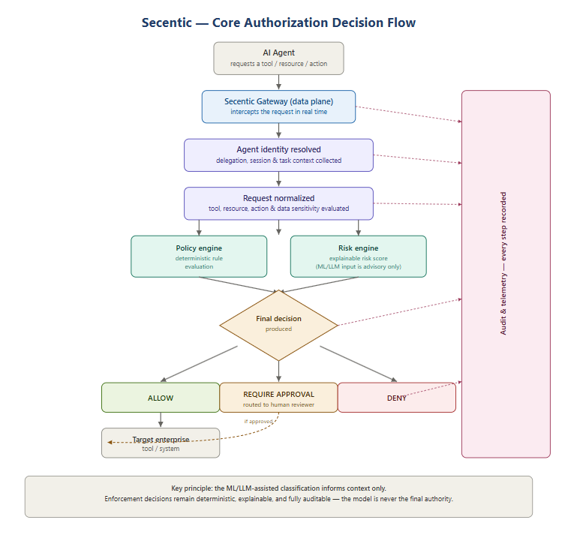
Fig. 1. Secentic core authorization decision flow.
(1) The agent authenticates to the gateway. (2) Secentic resolves the agent's identity. (3) User, delegation, session, and task context are collected. (4) The requested tool, resource, and action are normalized. (5) Data sensitivity and destination are evaluated. (6) Deterministic policies are evaluated. (7) An explainable risk score is calculated. (8) A final decision — ALLOW, DENY, or REQUIRE APPROVAL — is produced. (9) If allowed, the action proceeds. (10) The request, decision, and outcome are recorded to the audit trail at every step.
One principle we're sticking to throughout this design is that the language model can inform context or make a suggestion, but it doesn't get the final say on security enforcement. That decision has to stay deterministic and something we can actually audit.

6.3 System Modules (FYP-I / FYP-II Breakdown)
The system is broken down into twelve modules, ordered so that each semester's work builds on top of components that are already working from the stage before. FYP-I covers the identity, inventory, delegation, tool-registry, and core-enforcement foundation shown in Table 2, and FYP-II adds the intelligence, response, and assurance layer on top of that, shown in Table 3.
Table 2. FYP-I Modules — Foundation & Core Enforcement
Module | Description
M1 — Agent Discovery & Asset Inventory | A mechanism to register and discover AI agents (via API/SDK registration and manual onboarding), deduplicate observations into a single asset record, and track key metadata such as first-seen, last-seen, owner, environment, and status.
M2 — Agent Identity & Non-Human Identity | A unique cryptographic identity for every registered agent, using asymmetric key pairs for request authentication, with support for key rotation, revocation, and replay protection, kept fully separate from human user identity.
M3 — Delegated Authority | An explicit human-to-agent delegation model that scopes an agent's permissions to a specific task, resource, and action set, with expiration and revocation, preventing automatic inheritance of a full human or service-account permission set.
M4 — Agent & Tool Registry | A registry mapping agents to the tools and MCP servers they can access, recording tool capability, provider, endpoint, version, and a trust state (trusted / unknown / suspicious / blocked).
M5 — Runtime Security Gateway (Core) | The interception point for consequential agent actions: authenticates the agent, resolves context, normalizes the requested action, and produces an ALLOW/DENY/REQUIRE-APPROVAL decision, failing closed for security-sensitive operations if the engine is unavailable.
M6 — Contextual Policy Engine (Core) | A deterministic policy evaluation engine that authorizes actions based on agent, delegation, tool, resource, action, and environment, with basic policy versioning and decision explanations.

Table 3. FYP-II Modules — Intelligence, Enforcement Depth & Assurance (for context)
Module | Description
M7 — Risk Engine | An explainable 0–100 risk-scoring model driven by signals such as sensitive-data access, privileged actions, new/unknown tools, external destinations, and abnormal request volume, mapped to LOW/MEDIUM/HIGH/CRITICAL levels.
M8 — Human Approval Workflow | An approval workflow for high-impact or ambiguous actions, binding each approval exactly to the agent, task, tool, resource, and context it was granted for, with expiration and replay prevention.
M9 — Runtime Activity & Investigation | Recording of agent sessions, tool calls, resource access, and decisions into a real-time activity stream, searchable by agent, tool, action, risk, and time, with a basic agent activity graph (user → agent → session → tool → resource).
M10 — Security Alerts, Incidents & Quarantine | Automated alerting for policy violations, repeated denials, and unknown tool activity, combined with an agent quarantine/response capability (suspend agent, revoke identity, block tool, require approval for all actions).
M11 — Audit & Compliance | An append-oriented audit log with cryptographic hash chaining for tamper evidence, capturing actor, agent, delegation, policy, decision, and timestamp for every authorization event, with search and export.
M12 — CISO / SOC Dashboard & Permission Analytics | A consolidated dashboard summarizing agent inventory, risk posture, blocked actions, approval backlog, and policy violations, together with basic granted-vs-used permission analytics to surface least-privilege recommendations.

7. Individual Tasks
Below is the individual task breakdown, showing what each member is contributing and how the work is split across the three of us over the year. The tentative dates line up with the FYP-I Gantt chart in Section 8.
Team Member | Activity | Tentative Date
All members | Proposal finalization, literature review consolidation, requirements gathering (coordination) | Week 1 – 2
Ali Bhellar | M1 — Agent Discovery & Asset Inventory: design and implementation | Week 5 – 6
Ali and Areeb | M2 — Agent Identity & Non-Human Identity: design and implementation | Week 6 – 7
All members | System architecture design, data model design, technology finalization | Week 3 – 4
Bakhtiar and Areeb | M3 — Delegated Authority: design and implementation | Week 8 – 9
Areeb | M4 — Agent & Tool Registry: design and implementation | Week 9 – 10
Bakhtiar | M5 — Runtime Security Gateway (Core): design and implementation | Week 11 – 12
Bakhtiar and Areeb | M6 — Contextual Policy Engine (Core): design and implementation | Week 13 – 14
All members | Integration testing, FYP-I report writing, and demo preparation | Week 15 – 16

8. Gantt Chart
Based on the individual tasks from Section 7, the Gantt chart below shows when each task will happen over the 16-week FYP-I semester, and which of them overlap versus run one after another.
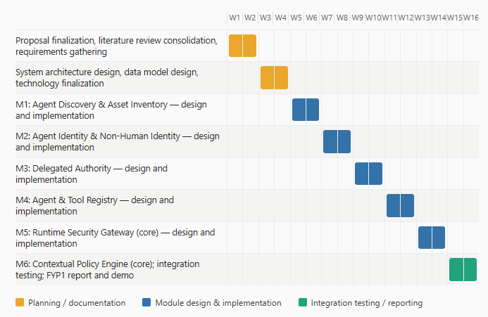
Fig. 2. FYP-I tentative Gantt chart.

9. Tools and Technologies
Here are the tools and technologies we're planning to use to build and test Secentic:
- Backend: Python and/or Node.js/TypeScript for the gateway and SDKs.
- Database: PostgreSQL for transactional and security metadata.
- Frontend: a web-based dashboard for inventory, policy management, and the CISO/SOC view.
- Cryptography: asymmetric key-based request signing for agent identity.
- Deployment: Docker-based containerization for reproducible evaluation.

10. Expected Deliverables
- A working prototype implementing the six FYP-I modules described in Section 6.3, deployed in a containerized environment for demonstration.
- A documented deterministic policy model with explainable decision output for the runtime gateway.
- A preliminary security evaluation of the system against realistic agent attack scenarios (e.g., indirect prompt injection, tool misuse) drawn from the reviewed literature and public benchmarks.
- An SDK (Python and/or Node.js) allowing an external AI agent to register, authenticate, and request authorization from the system.
- Complete FYP-I documentation, including design specifications and test reports.

10.1 Success Metrics
- Percentage of registered agents with a verified owner and cryptographic identity.
- Percentage of simulated sensitive actions correctly covered by policy.
- Correct block/approval rate on injected benchmark attack scenarios.
- Gateway authorization latency under test load.
- Reduction in unused/excessive permissions identified through early permission analytics.

11. References
[1] Zhan, Z. Liang, Z. Ying, and D. Kang, “InjecAgent: Benchmarking Indirect Prompt Injections in Tool-Integrated Large Language Model Agents,” arXiv:2403.02691, 2024.
[2] Debenedetti et al., “AgentDojo: A Dynamic Environment to Evaluate Prompt Injection Attacks and Defenses for LLM Agents,” Proc. NeurIPS, arXiv:2406.13352, 2024.
[3] Wu, Z. Yang, F. Roesner, T. Kohno, R. Zhang, and U. Iqbal, “Towards Automating Data Access Permissions in AI Agents,” arXiv:2511.17959, 2025.
[4] Ganie, “Securing AI Agents: Implementing Role-Based Access Control for Industrial Applications,” arXiv:2509.11431, 2025.
[5] Ruan et al., “Identifying the Risks of LM Agents with an LM-Emulated Sandbox,” Proc. ICLR, arXiv:2309.15817, 2024.
[6] Ramakrishnan and B. Balaji, “Securing AI Agents Against Prompt Injection Attacks,” arXiv:2511.15759, 2025.
[7] Xiang et al., “Architecting Secure AI Agents: Perspectives on System-Level Defenses Against Indirect Prompt Injection Attacks,” arXiv:2603.30016, 2026.
[8] Nguyen and A. Husain, “Penetration Testing of Agentic AI: A Comparative Security Analysis Across Models and Frameworks,” arXiv:2512.14860, 2025.
[9] Fang et al., “Teams of LLM Agents can Exploit Zero-Day Vulnerabilities,” arXiv:2406.01637, 2024.
[10] Wallace et al., “The Instruction Hierarchy: Training LLMs to Prioritize Privileged Instructions,” arXiv:2404.13208, 2024.

