<Survey Horse>

Requirements Specification and Analysis

<1.0>

<14.11.2016>

Osman Çiçek

Emre Şaşmaz

Ali Buğra Kanburoğlu

Burak Sağlam

Prepared for

SE301 Software Engineering



Table of Contents

1. Introduction 1

1.1. Purpose of the System 1

1.2. Scope of the System 1

1.3. Objectives and Success Criteria of the Project 1

1.4. Definitions, Acronyms, and Abbreviations 2

1.5. Overview 2

2. Proposed System 3

2.1. Overview 3

2.2. Functional Requirements 4

2.3. Nonfunctional Requirements 5

Usability 5

Reliability 5

Performance 5

Supportability 5

Implementation 5

Interface 6

Packaging 6

Legal 6

3.4. System Models 6

Scenarios 6

Use case model 11

Object model 16

Dynamic model 17

User interface—navigational paths and screen mock-ups 22

4. Glossary 24

5. References 25

REQUIREMENTS ANALYSIS DOCUMENT

# Introduction [1][2][3][4]

## Purpose of the System

In this system, we designed a survey system to provide everyone to make survey and with the powerful, conscious tools that we use, they will get extraordinary statistical analyze with well-designed graphs. Our priority is to appeal to every age of people so our design based on simplicity, abstraction and effectivity. In addition to this, we have designed a model that also aimed to please both researchers and analysts to provide fast, reliable, lossless and meaningful data. By developing this system we tried to serve any type of survey, any topic to make our system preferable by anyone. We provide real-time result panel to protect time loosing specifically for the researchers and analysts. So they can watch the results like president Election Day!

## Scope of the System

Our system is web based so it can be used everywhere, every device that have Internet access. It is so simple to use; define a questions, create a survey, share it and wait your survey to be filled by people. Our system consists of mainly three parts. First of them for the researchers, second one for the users with registration and last one for the users who only fills the survey without registration. Survey Horse wants no payment. It is completely free and user-friendly. Our domain includes https and security certificate which are provide secure and reliable information. We have also SSL (Secure Sockets Layer) and some other security and back-up services to protect your data.

## Objectives and Success Criteria of the Project

The success of the system depends on providing the given main set of arguments:

* To provide reliable, efficient, lossless data.
* Well association between platform and database design.
* The general design of system in order to have fast, efficient system.
* The demo of system should ensure good success rate.
* The system has implementations understandable, clear and efficient.
* The system should be used by the people who has huge scope of age.
* The system should keep protected and guarantee every user’s information and their data.

## Definitions, Acronyms, and Abbreviations

Important terms and concepts are listed here.

*Model* A schematic description of a system that accounts for its known or inferred properties

*View*  A visual representation of a model which might

*Domain* Name and address ofwebsite.

*HTTP*  is a protocol for secure communication over a computer network which is widely used on the Internet.

*GUI* Graphical User Interface

*Surveyor*  Any user can interact with the system

*Survey*  has questions about title that decided by survey manager.

*Researcher*  if user can be survey manager, they can create survey in the system

*System* Any interactions performed by the application are considered to be performed by

The system.

*Distribution* There are answers to survey`s questions so options has some rate to use during

Decision making

*Undo*  If the user fill in the blank or answer the questions wrongly, they can reverse that action.

## Overview

### The rest of RAD includes and explains clearly the core features of system such as; Functional and Nonfunctional requirements of the system. These features will answer your general questions about our system. Furthermore, it continues with scenarios that will provide you to examine possible usage of whole system and inputs and outputs of the system’s components. Then by checking the use case diagram and definitions, you will get a general idea. You can examine our object diagram to get idea how we designed the system. You will also see the sequence diagrams so as to see all the actors that has interaction with the system. Also we have put some mock-ups for the system to get any feedback. Glossary can be examined to learn jargon.

# Proposed System

In this project, we have tried to come up with different structure of survey system. We have mostly focused the efficiency, abstraction. We designed the system not only appealing only the specific users such as companies or academy but also every user who wants to create a survey or want to learn how survey system works. We claim that our system is usable for everyone including the children.

## Overview

Survey Horse is a survey system which appeals to everybody to get statistical analysis and information about any subject. They are able to do anything only with a computer connected the network.

The system serves for the use of system admin, survey manager, registered surveyor, unregistered surveyor with respectively changing boundaries for each user. Every user without unregistered surveyor in the system has some common prerogatives such as being register, login and also, they have some specific prerogatives too. The system allows all users change their name, username, password, birthdate and email whenever they need.

The system also allows system admin and Survey Manager to show results of survey. System Admin can see all surveys and can manage them. Actually, system admin has a little bit the more prerogatives than system survey manager because, he or she can also manage the all users. Another kind of user in the system is unregistered surveyor has one role which can fill out questionnaire.

## Functional Requirements

In the system, all actors have some privileges that as it appears below.

* Registered Surveyor must be able to register.
* Registered Surveyor must be able to login.
* Registered Surveyor must be able to fill survey after registered.
* Registered Surveyor must be able to change password when forgot it.
* Registered Surveyor must be able to renew password.
* Registered Surveyor must be able to edit profile like that username, mail, and password.
* Unregistered Surveyor must be able to fill survey without being register.
* System Admin must be able to register.
* System Admin must be able to login.
* System Admin must be able to change password when forgot it.
* System Admin must be able to renew password.
* System Admin must be able to edit profile like that username, mail, and password.
* System Admin must be able to search for desired survey at show result.
* System Admin must be able to show result of survey.
* System Admin must be able to manage user.
* System Admin must be able to manage survey.
* System Admin must be able to create survey.
* System Admin must be able to destroy survey.
* Survey Manager must be able to edit surveys` questions and answers.
* We can accept registered surveyor and unregistered surveyor do not have search show result, manage user, and manage survey feature.
* Survey Manager must be able to register.
* Survey Manager must be able to login.
* Survey Manager must be able to register.
* Survey Manager must be able to change password when forgot it.
* Survey Manager must be able to renew password.
* Survey Manager must be able to show result of survey.
* Survey Manager must be able to search for desired survey at show result
* Survey Manager must be able to manage survey.
* Survey Manager must be able to create survey.
* Survey Manager must be able to create survey.
* Survey Manager must be able to edit surveys` questions and answers.
* Survey Manager must be able to destroy survey.

## Nonfunctional Requirements [1]

### Usability

The user which level of expertise is newbie and has some ease to let the system enter correctly. Because user interface is easy to use and familiar with the other survey sites. For the usability side of the project, there is no documentation provided to the user. The system is available to use of user without any prior knowledge because the system does not have any useless components which might cause conflicts. The system makes everything easier for the user.

### Reliability

The system has reliability requirements. The system must be available for the access of the users. Restarting the system is not acceptable in the event of a failure. The system can handle exceptions by mail with the system admin. The system also has security requirements. For example; each actor has to login with password that gains credibility. The system must be able to running almost 100% of the time.

### Performance

The performance is very important and system should be responsive to users. For example; we sent a lot of people to fill out the prepared questionnaire, the system must provide access for infinite numbers of people at therewithal. System will support infinite concurrent users. Everyone has to fill out the questionnaire at the concurrent time. Also, a single user must be able to do more than one thing at the same time. The worst latency that is acceptable to users refreshed the page in 5 second.

### Supportability

The system must be able to be manage by system admin. The system must be available for any web browser. The web site must not be platform dependent. It must be accessible from any browser under any circumstances.

### Implementation

There are no constraints on the hardware platform. There are no constraints imposed by the maintenance team. There are no constraints imposed by the testing team. Ruby language is used in this system. Also, Rails is used to develop web application with using its standard framework.

### Interface

The system shouldn't interact with any existing system. The system must be able to use by a user. The user must be connected to the network to use the features of the system.

### Packaging

System admin installs the system. Also, the system is a web site so the site is installed on the server. There are no time constraints on the installation.

### Legal

The system should be licensed https domain. There are liability issues associated with system failures like depends of order cost giving a free or discount on order. Licensing fees incurred by using specific algorithms or components is free.

## System Models [1]

### Scenarios

Scenario Name: Register

Participating actor Instances: Ali Buğra: System Admin

Osman: Survey Manager

Emre: Registered Surveyor

Flow of events

1. Ali Buğra is a default user who defined by the system at the beginning of the project. So, he goes to register process automatically. Now, he can login to system as an admin.
2. The all actors above except Ali Buğra enters to SurveyHorse main page. Then, Osman or Emre clicks to register button in order to register to the system.
3. After their entering to the register page, there will be a form on this page. This form includes some fields in order to get the information of the users. Fields are name, surname, birthdate, username, password, re-password, email address.
4. Then, they will fill this form, after that there will be an option below of form to choose the user type of them. User type can be Registered Surveyor or Survey Manager.
5. After filling all information and chosen of user type, they click register button.
6. Then, if the username, email are available and password is same with re-password, and user type is chosen then they will be redirected to a new page which says to actors “Welcome to the Survey Horse”.

Scenario Name: Login

Participating actor Instances: Ali Buğra: System Admin

Osman: Survey Manager

Emre: Registered Surveyor

Flow of events

1. After the given actors who are Ali Buğra, Osman and Emre registered to the system, these actors open the website and go to login area.
2. In the login area, users type their login information which are username and password into the login fields.
3. Then, they click to the login button, if the username and password are valid, then page redirects them to the main page with green label says successfully signed in.
4. If the username and password are not valid or empty, page says “Username and/or Password Invalid”.
5. If the actors click the “Forgot Password” which is under Login area then, they are redirected to the renew password page by the system. In that page, actors enter their e-mail so that a renew password link is sent to them.

Scenario Name: EditProfile

Participating actor Instances: Ali Buğra: System Admin

Osman: Survey Manager

Emre: Registered Surveyor

Flow of events

1. When the given actors who are Ali Buğra, Osman and Emre signed in to the system, they all can edit/update their profiles.
2. In order to edit profile, actors go to profile page via clicking Profile label.
3. There will be a form which includes all information which are name, surname, birthdate, username, password, and email of actors. In this form, actors must choose valid username, password, and email.
4. Then, actors click the save button.
5. If actors didn’t write valid information to the fields, there will be some warnings on screen for actors. Otherwise, system says “Successfully updated”.

Scenario Name: ManageSurvey

Participating actor Instances: Ali Buğra: System Admin

Osman: Survey Manager

Flow of events

1. When the given actors who are Ali Buğra and Osman signed in to the system, in order to manage survey, they go to survey page via clicking Manage Survey label.
2. Firstly, before editing and destroying survey, there must be a survey in system. So, actors must create a survey.
3. Under survey management page, actors click Create Survey label and go to a form which is about creating a new survey.
4. In create survey page, form includes title, number of questions and answers which is n length and the n fields for them. Creating survey form will have a template which is user friendly in order to add new fields for titles and questions, answers for survey.
5. Now, it is time to publish this form to actors, so they click Create button and it is done.
6. However, if the actors would like to edit/update the survey, they click Edit Survey label near each created surveys in the manage survey page. In edit survey page, there will be a form which includes title, questions and answers of survey. After changing they can click Edit button.
7. If the actors want to destroy the created surveys, using the Destroy Survey button near the each surveys could destroy them. There will be a message box which includes a message like “Are you sure you want to destroy?” If they choose yes it will be destroyed, otherwise it will not.

Scenario Name: RegisteredFillSurvey

Participating actor Instances: Emre: Registered Surveyor

Flow of events

1. When Emre signed in to the system and he would like to fill any form, he will click to a link which generated by the survey manager.
2. After entering to link, there will be a form which includes survey title, questions and answers to select the answers of questions.
3. Emre will fill the survey, then at the bottom of the form there is a button which labeled as “Send”.
4. Finally, he will click “Send” button and send survey to the system with his profile information.

Scenario Name: UnregisteredFillSurvey

Participating actor Instances: Burak: Unregistered Surveyor

Flow of events

1. Burak will enter to a link which generated by the survey manager in order to fill any form without any registration and login process.
2. After entering to link, there will be a form which includes survey title, questions and answers to select the answers of questions.
3. He will fill the survey, then at the bottom of the form there is a button which labeled as “Send”.
4. Finally, he will click “Send” button and send survey to the system as an anonymous user that we called unregistered user who has no any information.

Scenario Name: ShowResults

Participating actor Instances: Ali Buğra: System Admin

Osman: Survey Manager

Flow of events

1. When the given actors who are Ali Buğra and Osman signed in to the system, they will click to Show Results label from any page.
2. On this screen, there is a search box. If they search about title or content of surveys, there will be some results below this page.
3. They can filter the results according to the questions or answers.
4. In order to filter the results, there will be a choice near the search box. They could choose any filter type. Then, click to the Search button.
5. If there exists any datas, these actors have been seen the results. Otherwise, there will be some information error.

Scenario Name: ManageUser

Participating actor Instances: Ali Buğra: System Admin

Flow of events

1. Firstly Ali Buğra signed in (logins) successfully to the system, the panel will be shown to Ali Buğra in the middle of the page.
2. In this panel, he is able to manage the registered user like edit user, block user and destroy user.
3. If he wants to block a user, he will just click the Block button or he can destroy user.
4. By clicking the edit user button, the user list comes to screen so as to he chooses a user. Then he clicks to details button and changes users’ username, password, email.
5. Finally, he clicks the save button in order to complete the changes.

### Use case model [1]

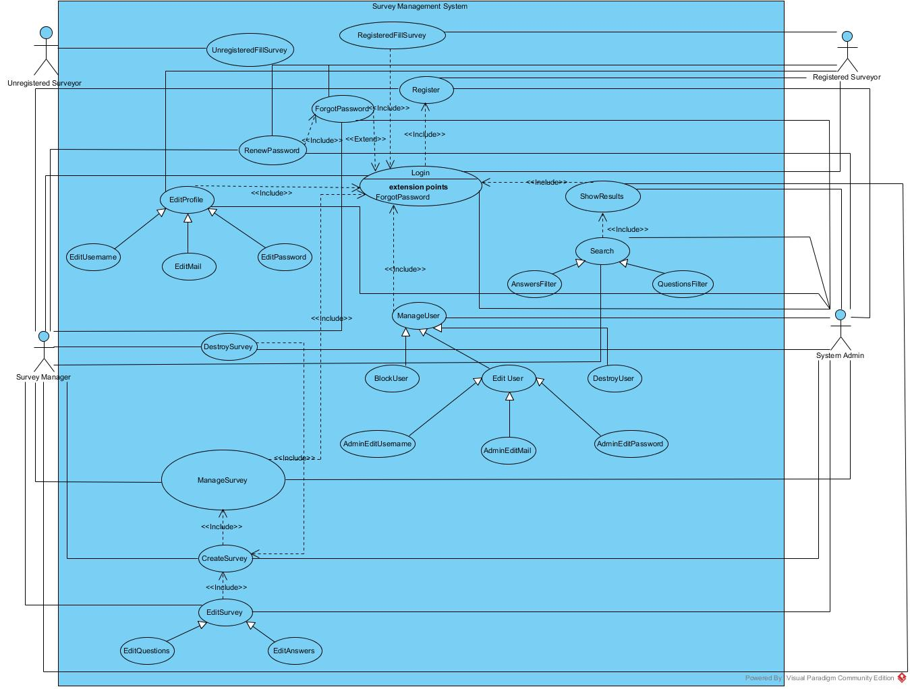

**Use Case Name:** Register (High Priority)

**Participating Actors**: Registered Surveyor, Survey Manager, System Admin

**Flow of events:**

1. System Admin registers automatically by default at the beginning of the project.
2. The other actors; Registered Surveyor and Survey Manager, (except System Admin) enter main page then they click register button.
3. A new register page will appear which has some fields to be filled by the actors these are; username, password, re-password, email address.
4. They will choose their registering option at the bottom of register field. These options are: Registered Surveyor and Survey Manager.
5. As a final step, they will click save button to be able to register the system.
6. If the username, email are available and password is same with re-password, and if user type is chosen, then they will be redirected to main page as a registered user.

**Entry Condition:** This use case starts when mentioned actors wishes to register to the Survey Management System.

**Exit Conditions:** If in the flow of events,the actor enters invalid values to fields, the system displays error message/messages. If they give up when they are at the register page, it is also terminate the use case. The actor can choose either return to the beginning of the *Flow of events*or cancel the register, at which point the use case ends.

**Quality Requirements:** Verification mail will be sent by the system in 30 seconds.

**Use Case Name:** Login (High Priority)

**Participating Actors**: Registered Surveyor, Survey Manager, System Admin

**Flow of events:**

1. The system requests that the actor enter his/her name and password.
2. The actor enters his/her name and password.
3. The system validates the entered name and password and logs the actor into the system.
4. If these actors forgot their password, they can click forgot password option to renew their passwords with their emails.

**Entry Condition:** This use case starts when mentioned actors wishes to log into the Survey Management System.

**Exit Conditions:** If in the flow of events,the actor enters an invalid name and/or password, the system displays an error message. The actor can choose either return to the beginning of the *Flow of events*or cancel the login, at which point the use case ends.

**Quality Requirements:** For forgot password, E-mails are sent in max 30 sec.

**Use Case Name:** EditProfile (Medium Priority)

**Participating Actors**: Registered Surveyor, Survey Manager, System Admin

**Flow of events:**

1. Mentioned actors login successfully to the system.
2. By clicking to Edit Profile tag, they can change their names, surnames, usernames, passwords and emails.
3. Then they click to save button so that the changes are saved to the system.
4. If information are validated by the system, then actor will get a message says “Successfully Updated” otherwise fail warning will be shown to actor.

**Entry Condition:** All mentioned actor login successfully to the system.

**Exit Conditions:** After the changes made, the actors click the save button or cancel button.

**Quality Requirements:** None

**Use case name:** ManageSurvey (High Priority)

**Participating actors:** Survey Manager, System Admin, Registered Surveyor

**Flow of events:**

1. Survey Manager, Registered Surveyor and System Admin login the system successfully.
2. They click to manage survey label to create survey.
3. Under survey management page, actors click Create Survey label and they will be redirected to create survey page.
4. After filling the necessary areas, such as title, questions, and answers these actors can compose the survey clicking to create button.
5. They are also able to edit their surveys by clicking to edit survey page after they compose their survey.
6. To destroy created survey, it is enough to click destroy survey button that stays near of each created survey.
7. Admin has authority to see and examine all the created surveys.

**Entry Condition:** Survey Manager, Registered Surveyor or System Admin create survey.

**Exit Condition:** Actorsdestroy, create or edit survey.

**Quality Requirements:** None.

**Use case name:** RegisteredFillSurvey (High Priority)

**Participating actors:** Registered Surveyor

**Flow of events:**

1. Registered Surveyor logins successfully to the system.
2. After that, this actor will click a link to fill survey which is created survey manager.
3. Then actor clicks send button to submit his/her survey.
4. By doing this, his/her survey result would be saved with his/her profile information.

**Entry Condition:** Survey Manager or Registered Surveyor create survey.

**Exit Condition:** Survey Manager or Registered SurveyorcanDestroy Survey

**Quality Requirements:** None

**Use case name:** UnregisteredFillSurvey (High Priority)

**Participating actors:** Unregistered Surveyor

**Flow of events:**

1. After Unregistered Surveyor logins to the system, he/she can click a survey’s link address to fill the survey that created by survey manager or admin.
2. The actor will click the “send” button after he/she fills the survey.
3. System will keep the actor anonymously user who has no information in the system.

**Entry Condition:** Unregistered Surveyor enters the survey without login.

**Exit Condition:** Unregistered Surveyor gives up filling survey.

**Quality Requirements:** None

**Use Case Name:** Show Results (High Priority)

**Participating Actors**: System Admin, Survey Manager

**Flow of events:**

1. System Admin and Survey Manager log in to system, then they will click Show Results label from any page.
2. In this page, they can use search box to make search by title or content of surveys.
3. After they choose the type of filter, they should click search button.
4. The filtered results will be on the page if that results are exist, otherwise, they will get a message (“There is no results what you are searching”).

**Entry Condition:** Admin and Survey Manager logins successfully to the system then they click to “Show Results” label.

**Exit Conditions**

System Admin or Survey Manager click the show results label.

System Admin or Survey Manager give up searching or close the session.

**Quality Requirements:** None.

**Use Case Name:** ManageUser (Low Priority)

**Participating Actors**: System Admin

**Flow of events:**

1. System Admin logs in to system, he/she will be shown a panel to manage User information.
2. With this panel, System Admin capable to Edit User (Username, Mail, Password), Block User and Destroy User.
3. Admin can also reach “user edit page” and in this page he/she can change any user information (names, surnames, usernames, passwords and emails.) who registered to the system.
4. After the changes are made, System Admin clicks the save button to save the changes.

**Entry Condition:** Admin logins successfully to the system.

**Exit Conditions**

Admin logs out.

**Quality Requirements:** None.

### Object model [1]

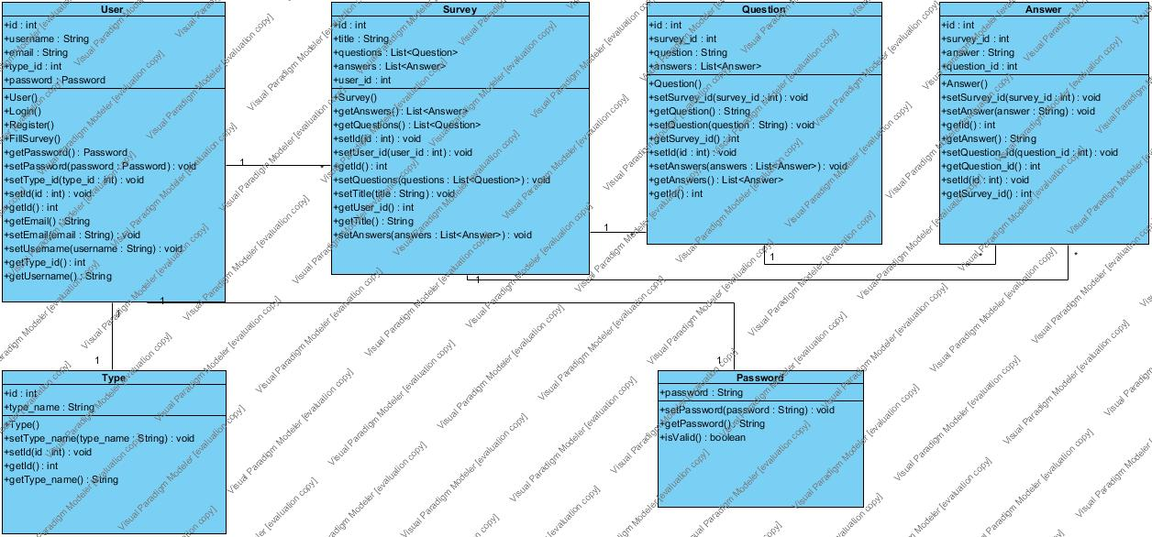

### Dynamic model [1][3][4]

Register

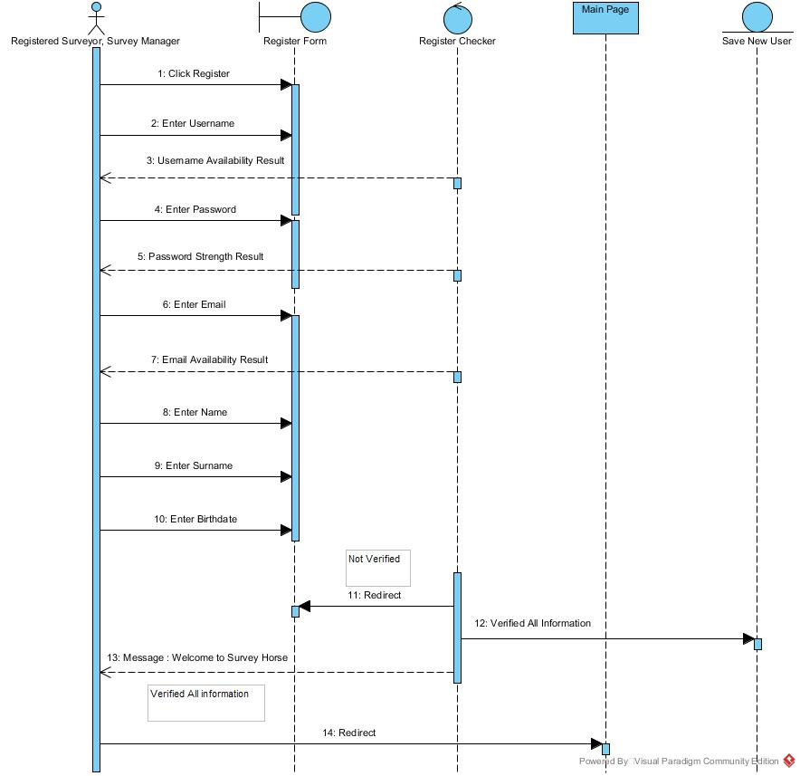

Edit Profile

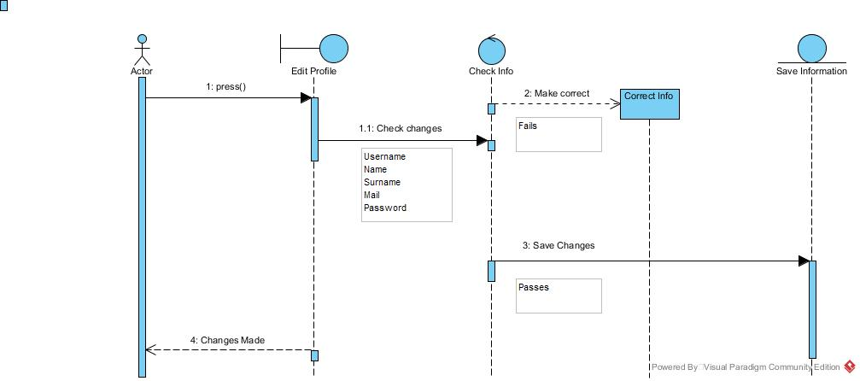

Create Survey

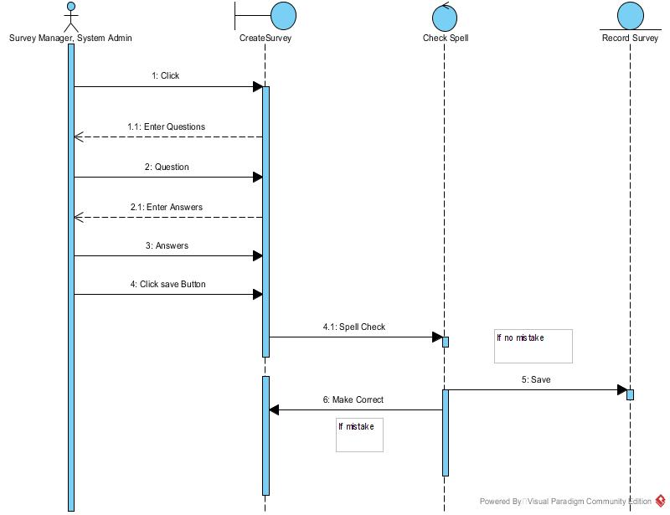

Fill Survey (Unregistered)

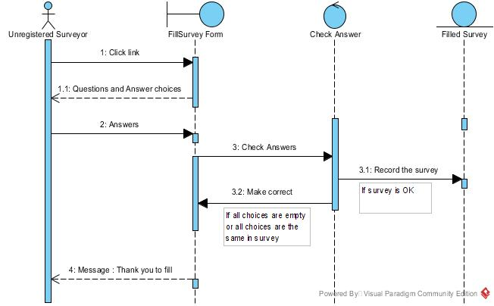

Fill Survey (Registered)

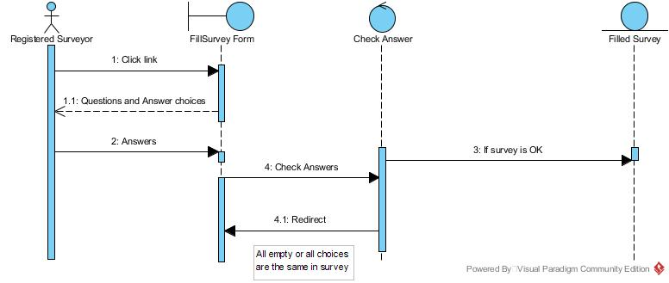

Show Results

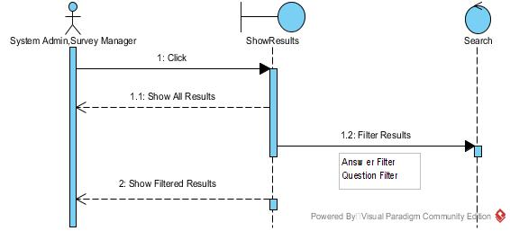

Edit Username

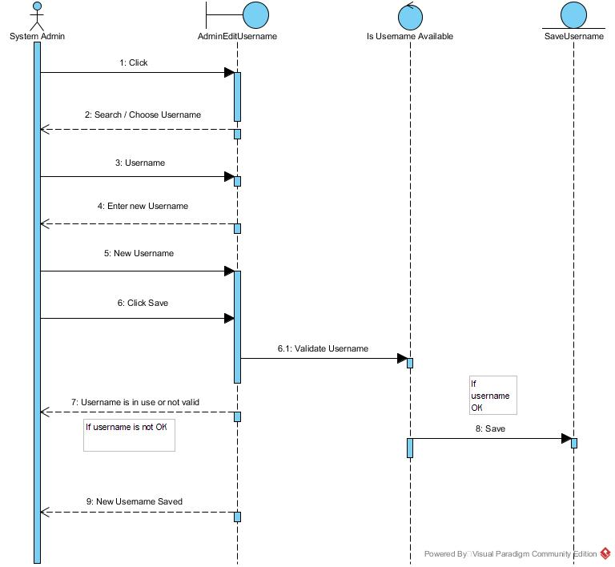

Destroy User

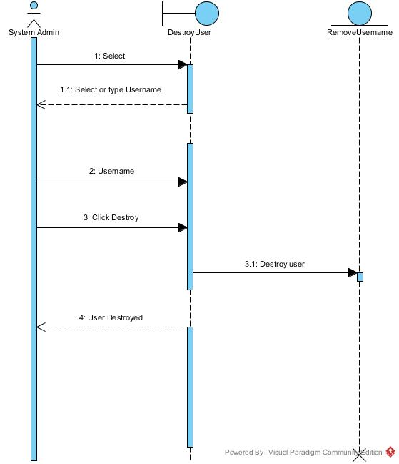

### User interface—navigational paths and screen mock-ups [3]



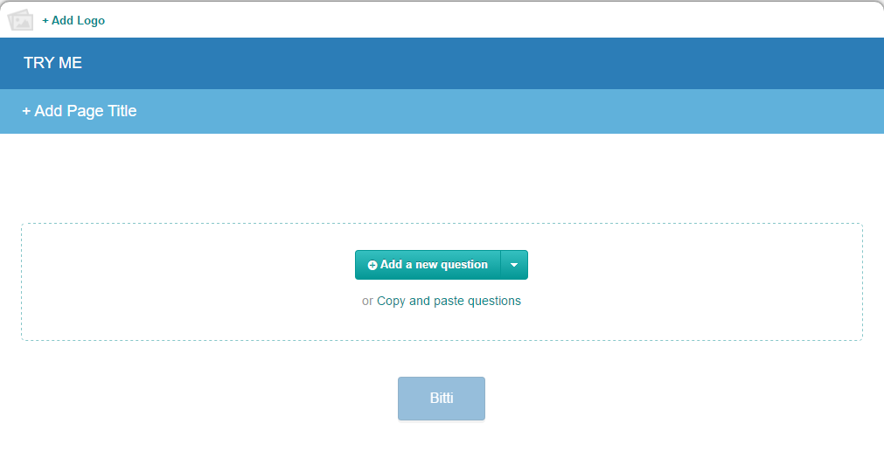

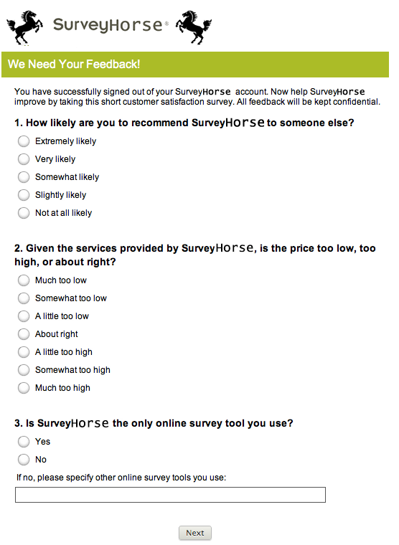

(Example Survey)

# Glossary [1]

**Admin Edit Username:** system admin can manage to edit users` username.

**Admin Edit Mail:** system admin can manage to edit users` mail.

**Admin Edit Password:** system admin can manage to edit users` password.

**Answers Filter:** is used to filter answers any survey in the system.

**Answer:** the database table that contains information about survey answers.

**Create Survey:** have questions about title.

**Destroy survey:** is used to delete survey.

**Destroy user:** is used to delete any user that register in the system.

**Edit Answers:** system admin and survey manager can edit surveys` answers.

**Edit Mail:** is used to change mail addresses by system admin and registered surveyor.

**Edit Password:** is used to change password by system admin and registered surveyor.

**Edit Profile:** is used by user that register in the system.

**Edit Survey:** is used by survey manager to change something or fix in survey.

**Edit Questions:** is used to edit questions in the survey.

**Edit Username:** is used to change username by system admin and registered surveyor.

**Forgot Password:** is used to bad situation that if user that register in the system forget password they use this.

**Login:** is the form which shows sign in status for all actors without unregistered surveyor.

**Password:** is the database table that keeps users` password information.

**Register:** is the form which shows sign up status for all actors without unregistered surveyor.

**Registered Surveyor:** is a user to fill in the blank and they must create a profile.

**Renew Password:** is used by user that register which if they forget password, can change to take new password.

**Show Result:** is the form whichinclude surveys results.

**Survey:** has some questions that selected title by the Survey Manager.

**Survey Manager:** is a user to create a survey and manage.

**Search:** is used by all of user`s type to looking for anything.

**System Admin:** is a manager all system.

**Type:** is the database table that contains information about users like user can be system admin, survey manager, registered surveyor, unregistered surveyor.

**Unregister Surveyor:** is a user to fill in the blank, answer the questions also he does not need to login.

**User:** is the database table that contains information about users.

**Question:** is the database table that includes information about survey questions.

**Questions filter:** is used to control questions.

# References

1. Bruegge B. & Dutoit A.H.. (2010). *Object-Oriented Software Engineering Using UML, Patterns, and Java*, Prentice Hall, 3rd ed.
2. Handbook of Survey Research, Second Edition 2nd Edition by [Peter V. Marsden](https://www.amazon.com/s/ref=dp_byline_sr_book_1?ie=UTF8&text=Peter+V.+Marsden&search-alias=books&field-author=Peter+V.+Marsden&sort=relevancerank) (Author, Editor), [James D. Wright](https://www.amazon.com/s/ref=dp_byline_sr_book_2?ie=UTF8&text=James+D.+Wright&search-alias=books&field-author=James+D.+Wright&sort=relevancerank) (Editor)
3. <https://tr.surveymonkey.com/>
4. https://surveyplanet.com/