Unit 20 — Design and Programming Report
Fantasy Bazaar (FBZ) Comics Unmasked Dataset Processing Application
Submission document aligned to the supplied Unit 20 assignment brief. It combines the OOP/SOLID analysis, application design, implementation evidence, dataset validation and higher-grade evaluation.

1. Assignment and Scenario
The brief asks for a large dataset-processing application for Fantasy Bazaar using the British Library Comics Unmasked data. Required behaviour includes loading the data into memory, filtering by Fantasy/Horror/Science Fiction, grouping by author or publication year, sorting titles, title search, robust handling of special characters and multiple values, an in-memory search list, advanced search, and reporting of popular searches/results. The design also needs OOP/SOLID, clean coding, design patterns and an appropriate test regime.
The brief states that the dataset has five CSV views and that BL record IDs begin with leading zeroes; it also explains that repeated values may be separated by semicolons and that multi-facet values can contain “--”. The implementation preserves these characteristics instead of coercing identifiers to numbers.

2. Real Dataset Acquisition and Validation
The exact 2022 Researcher Format package referenced by the assignment was recovered from an Internet Archive snapshot of the original British Library download URL after the old direct URL returned 404. The project stores the downloaded archive and all extracted files under data/raw/extracted/. The current British Library metadata service now states that Researcher Format CSV datasets are available from the British Library Research Repository.
CSV view | Rows | Columns | Missing titles | Leading-zero IDs
records.csv | 57746 | 27 | 0 | 57746
names.csv | 117873 | 27 | 0 | 117873
titles.csv | 77280 | 27 | 0 | 77280
topics.csv | 77919 | 28 | 0 | 77919
classification.csv | 57844 | 27 | 0 | 57844
names.csv contains 117,873 rows and 54,147 unique BL record IDs. That duplicate-row structure is important: the application aggregates rows by BL record ID so a resource with multiple name/title/facet rows is presented as one record, with variant metadata retained as list-like semicolon-separated values.
After exact genre filtering, the aggregated names view contains 4,793 Fantasy records, 1,929 Horror records and 9,356 Science Fiction records. The project also keeps the full unfiltered views for Phase 2 field searches.
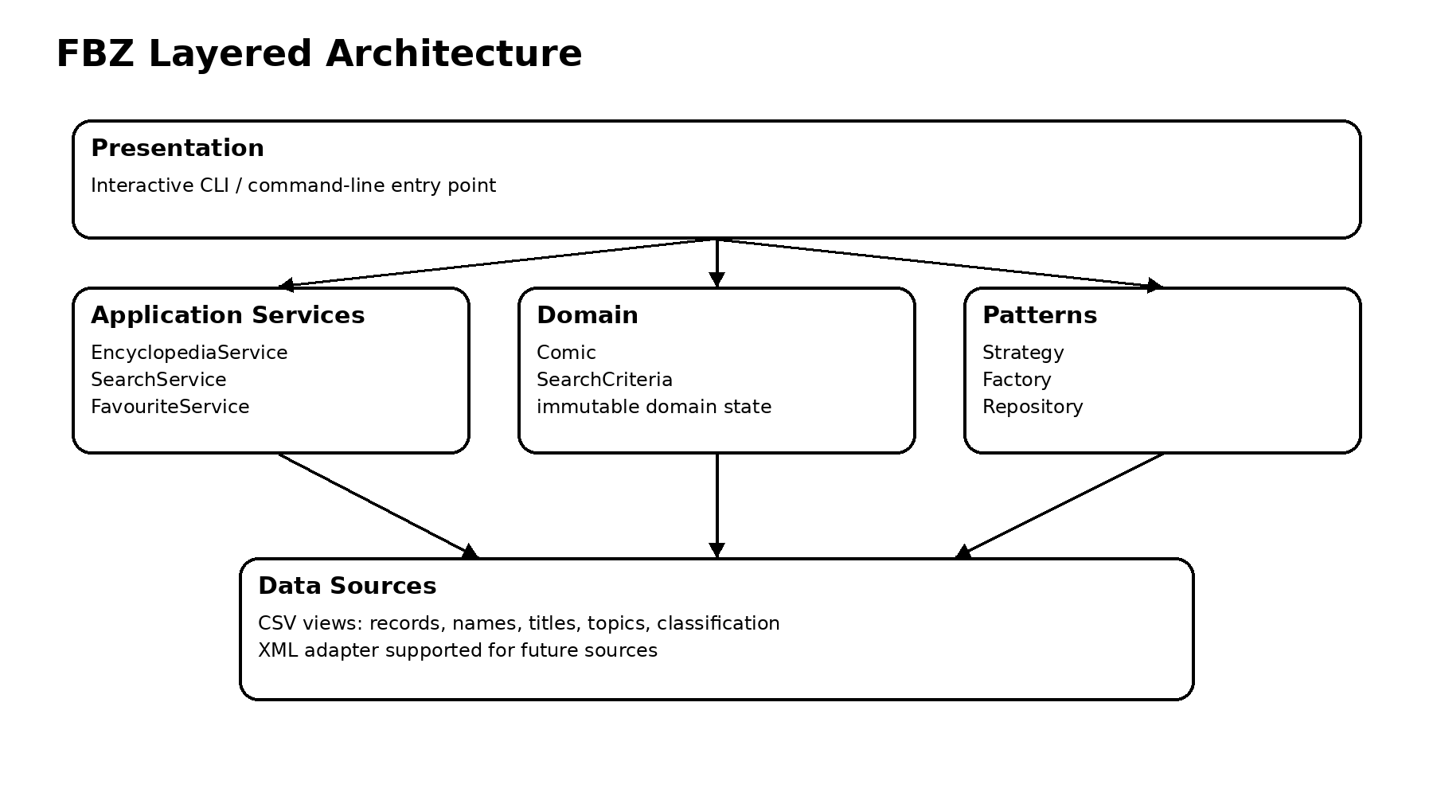
Figure 1. Layered architecture.

3. Functional Design
Requirement | Implemented design | Evidence
Load dataset into memory | CSV repository using csv.DictReader; aggregated names view for one-record presentation | src/fbz/repositories/
Allowed genres | Exact Fantasy/Horror/Science Fiction matching | EncyclopediaService.filter_genre
Group by author/year | Grouping over tokenised aggregated fields | EncyclopediaService.group_by_*
A–Z / Z–A titles | Stable sort by case-folded title | sorted_titles
Manual title search | Case-insensitive title substring search | search_title + CLI
Special characters | Unicode preserved; strings are not narrowed to ASCII | CSV UTF-8 handling + tests
Repeated values | Semicolon-separated values tokenised and displayed individually | Comic.tokens + format_record
Missing ISBN | Missing ISBN rendered as “missing” | format_record
Multiple titles | Rows aggregated by BL record ID and variants retained | AggregatingComicRepository
Search list | In-memory tuple; no account/persistent account state | save_to_search_list/reset
Advanced search | Author/year/genre/edition/languages/name type/title | advanced_search
Phase 2 views | Classification/names/titles/topics search + generic CSV repository | search_field
Future XML | XML repository adapter | XmlComicRepository
Popular reporting | Search query/result telemetry and >100 threshold reporting | top_search_queries/top_search_results/comics_over_threshold

4. OOP and SOLID Design
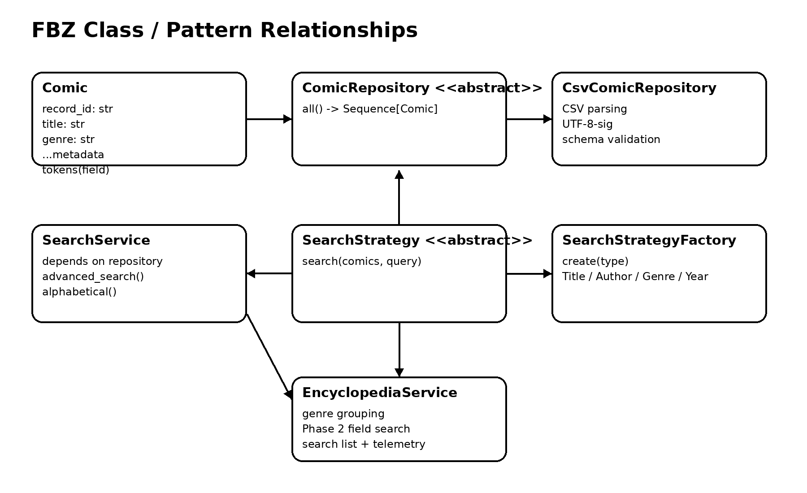
Figure 2. Main class/pattern relationships.

Encapsulation
Comic owns the representation and tokenisation behaviour of a catalogue record; callers do not manipulate raw CSV rows.

Abstraction
ComicRepository and SearchStrategy define focused contracts; services use the contracts rather than concrete storage/search classes.

Polymorphism
Title, Author, Genre and Year strategies implement the same SearchStrategy contract and are interchangeable.

Inheritance
Abstract repository/strategy contracts provide purposeful inheritance for interchangeable behaviours rather than using inheritance only for code reuse.

Single Responsibility
CSV parsing, domain modelling, business search, favourites, telemetry and presentation are separate responsibilities.

Open/Closed
New search algorithms can be added as strategies without changing SearchService.

Liskov Substitution
Any SearchStrategy or ComicRepository implementation can fulfil the contract expected by consumers.

Interface Segregation
Interfaces are small: repository access and search strategy are not combined into one large interface.

Dependency Inversion
SearchService and EncyclopediaService depend on ComicRepository, which enables in-memory repositories for tests and alternative data sources.

5. Clean Coding and Algorithms
The application uses explicit names, type hints, immutable dataclasses, small focused methods, validation near input boundaries, and dependency injection. Search is O(n) over the in-memory sequence. Alphabetical sorting is O(n log n). Token-frequency aggregation uses Counter-style counting. The chosen algorithms are intentionally simple and deterministic for an in-memory educational dataset processor; indexed/database search would be a sensible future optimisation for much larger or frequently updated data.

6. Design Patterns
Pattern family | Pattern/technique | Why used
Behavioural | Strategy | Title/author/genre/year searches are interchangeable algorithms.
Creational | Simple Factory | Centralises construction of the concrete strategy selected by the search type.
Structural / architectural | Repository | Separates CSV/XML persistence from application logic and enables test doubles.
The project intentionally describes SearchStrategyFactory as a simple factory rather than incorrectly labelling it the formal GoF Factory Method pattern. This distinction improves technical accuracy while still demonstrating the creational design objective. Strategy is classified as a behavioural pattern in the standard design-pattern catalogue.

7. Implementation
The implementation is under src/fbz/. The command-line entry point supports both direct command usage and an interactive nine-option encyclopedia menu. The default path points to the supplied names.csv view and aggregates repeated rows by BL record ID, while any of the five CSV views can be passed explicitly for Phase 2 searching.

8. Verification Results
The final automated suite includes unit, integration and CLI/end-to-end tests. The real dataset acceptance tests load all five official CSV views and verify their observed row counts and leading-zero IDs.
Verification | Result
Automated tests | 26 passed
Real five-view load test | Passed
Real names.csv scale | 117,873 raw rows
Aggregated unique records | 54,147
Coverage before final added acceptance-only paths | 93% reported on the earlier application suite; final coverage should be read from the latest run in reports/

9. References
British Library. Collection Metadata Services. https://www.bl.uk/services/collection-metadata-services
British Library. Sharing British Library Open Metadata with Our Communities. https://www.bl.uk/about/governance/policies/sharing-british-library-open-metadata-with-our-communities
Python Software Foundation. csv — CSV File Reading and Writing. https://docs.python.org/3/library/csv.html
pytest Documentation. API Reference / Fixtures. https://docs.pytest.org/en/latest/reference/reference.html
Refactoring.Guru. Strategy. https://refactoring.guru/design-patterns/strategy
Refactoring.Guru. Design Patterns Catalogue. https://refactoring.guru/design-patterns/catalog
British Library. Researcher Format package used by the supplied brief; exact 2022 ZIP recovered from the Internet Archive snapshot cited in project evidence.

