Ai ccp
A* Pathfinding Game - AI Assignment

About the Project
This project implements the A* (A-star) search algorithm as an interactive terminal-based pathfinding game. The AI agent navigates from a start position (S) to a goal position (G) through a grid filled with obstacles, using the A* heuristic search algorithm to find the shortest path.
A* is one of the most widely used pathfinding and graph traversal algorithms in artificial intelligence. It combines the strengths of Dijkstra's algorithm (which guarantees the shortest path) with greedy best-first search (which uses heuristics to guide the search efficiently).

How A* Works
f(n) = g(n) + h(n)
g(n) — actual cost from start to node n
h(n) — heuristic estimate from node n to goal (Manhattan distance)
f(n) — total estimated cost through node n

Features
• Configurable grid size (--size)
• Adjustable obstacle density (--density)
• Auto mode: full run with statistics
• Step mode: advance through each iteration with Enter
• Seed support for reproducible runs (--seed)
• Visual grid showing open set (?), closed set (.), current node (@), and final path (*)

Screenshot
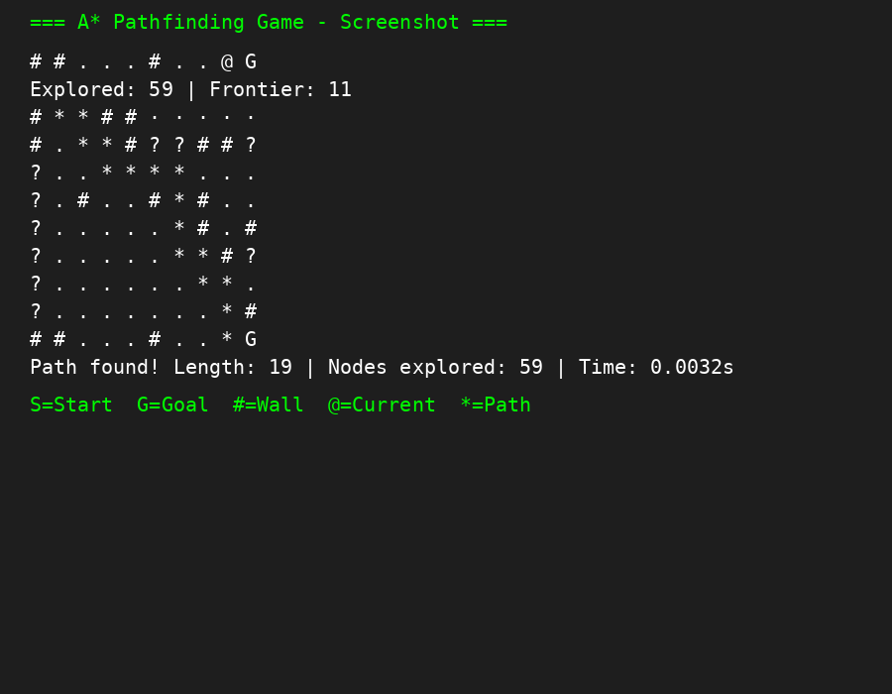

Usage
python main.py --size 10 --density 0.2 --mode auto

Code Listing

main.py
import argparse
from grid import Grid
from game import play

def main():
parser = argparse.ArgumentParser(description="A* Pathfinding Game")
parser.add_argument("--size", type=int, default=20,
help="Grid size (NxN, default: 20)")
parser.add_argument("--density", type=float, default=0.25,
help="Wall density 0.0-1.0 (default: 0.25)")
parser.add_argument("--mode", choices=["auto", "step"], default="auto",
help="Run mode (default: auto)")
parser.add_argument("--seed", type=int, default=None,
help="Random seed for reproducibility")
args = parser.parse_args()

if args.seed is not None:
import random
random.seed(args.seed)

grid = Grid(size=args.size, density=args.density)
play(grid, mode=args.mode)

if __name__ == "__main__":
main()

grid.py
import random

class Grid:
def __init__(self, size: int = 20, density: float = 0.25):
self.size = size
self.density = density
self.walls = set()
self.start = (0, 0)
self.goal = (size - 1, size - 1)
self._generate_walls()

def _generate_walls(self):
for r in range(self.size):
for c in range(self.size):
if (r, c) in (self.start, self.goal):
continue
if random.random() < self.density:
self.walls.add((r, c))

def in_bounds(self, pos: tuple[int, int]) -> bool:
r, c = pos
return 0 <= r < self.size and 0 <= c < self.size

def is_wall(self, pos: tuple[int, int]) -> bool:
return pos in self.walls

def is_passable(self, pos: tuple[int, int]) -> bool:
return self.in_bounds(pos) and not self.is_wall(pos)

def get_neighbors(self, pos: tuple[int, int]) -> list[tuple[int, int]]:
r, c = pos
candidates = [(r - 1, c), (r + 1, c), (r, c - 1), (r, c + 1)]
return [nb for nb in candidates if self.is_passable(nb)]

def render(self, path: set = set(), open_set: set = set(),
closed_set: set = set(), current: tuple[int, int] | None = None) -> str:
lines = []
for r in range(self.size):
row = []
for c in range(self.size):
pos = (r, c)
if pos == self.start:
row.append("S")
elif pos == self.goal:
row.append("G")
elif pos in self.walls:
row.append("#")
elif pos == current:
row.append("@")
elif pos in path:
row.append("*")
elif pos in closed_set:
row.append(".")
elif pos in open_set:
row.append("?")
else:
row.append("\u00b7")
lines.append(" ".join(row))
return "\n".join(lines)

astar.py
import heapq

def heuristic(a: tuple[int, int], b: tuple[int, int]) -> int:
return abs(a[0] - b[0]) + abs(a[1] - b[1])

def reconstruct_path(came_from: dict, current: tuple[int, int]) -> list[tuple[int, int]]:
path = [current]
while current in came_from:
current = came_from[current]
path.append(current)
path.reverse()
return path

def astar_step(grid):
start = grid.start
goal = grid.goal

open_set = [(0, start)]
came_from = {}
g_score = {start: 0}
f_score = {start: heuristic(start, goal)}

open_lookup = {start}
closed_lookup = set()

while open_set:
_, current = heapq.heappop(open_set)
open_lookup.discard(current)

if current == goal:
path = reconstruct_path(came_from, current)
yield open_lookup, closed_lookup, current, path
return

closed_lookup.add(current)

for neighbor in grid.get_neighbors(current):
if neighbor in closed_lookup:
continue
tentative_g = g_score[current] + 1

if neighbor not in g_score or tentative_g < g_score[neighbor]:
came_from[neighbor] = current
g_score[neighbor] = tentative_g
f = tentative_g + heuristic(neighbor, goal)
f_score[neighbor] = f
if neighbor not in open_lookup:
heapq.heappush(open_set, (f, neighbor))
open_lookup.add(neighbor)

yield open_lookup, closed_lookup, current, None

yield open_lookup, closed_lookup, None, None

game.py
import time
from grid import Grid
from astar import astar_step

def clear_screen():
print("\033[2J\033[H", end="")

def play(grid: Grid, mode: str = "auto"):
generator = astar_step(grid)
path = None
final_stats = {}

start_time = time.perf_counter()

for open_set, closed_set, current, result in generator:
if result is not None:
path = result
final_stats["path_length"] = len(path)
final_stats["nodes_explored"] = len(closed_set)
final_stats["time"] = time.perf_counter() - start_time
clear_screen()
print(grid.render(path=set(path), open_set=open_set,
closed_set=closed_set, current=current))
break

clear_screen()
print(grid.render(open_set=open_set, closed_set=closed_set,
current=current))
print(f"\nExplored: {len(closed_set)} | Frontier: {len(open_set)}")

if mode == "step":
input("Press Enter to advance...")
else:
clear_screen()
print(grid.render(closed_set=closed_set, open_set=set()))
final_stats["path_length"] = 0
final_stats["nodes_explored"] = len(closed_set)
final_stats["time"] = time.perf_counter() - start_time
print("\nNo path found!")

if final_stats.get("path_length", 0) > 0:
print(f"\nPath found! Length: {final_stats['path_length']}"
f" | Nodes explored: {final_stats['nodes_explored']}"
f" | Time: {final_stats['time']:.4f}s")
elif final_stats:
print(f"\nNo path found. Nodes explored: {final_stats['nodes_explored']}"
f" | Time: {final_stats['time']:.4f}s")

