LLM Powered Movie Suggestions for Aggregate Streaming Services
Ali Burkemper  The University of Alabama  Tuscaloosa, AL  aeburkemper@crimson.ua.edu | Zimuzo Ernest-Eze  The University of Alabama  Tuscaloosa, AL  ccernesteze@crimson.ua.edu | Thomas Waelde  The University of Alabama  Tuscaloosa, AL  tpwaelde@crimson.ua.edu

ABSTRACT
Aggregate streaming services provide a searchable database of movies and what streaming platforms show them. These sites profit when users find a movie they wish to watch and visit the appropriate affiliate-linked streaming service.
Our project is designed to fill the niche of user-responsive movie recommendations on such platforms. While much research and effort has gone into recommending movies based on watch history and user demographics, our focus is on intelligent responses to specific user queries. There is an opportunity in the middle ground between directly searching (which requires the user to have a concrete idea of what to watch) and purely algorithmically generated suggestions in the style of Netflix recommendations (which often miss the mark due to transient preferences or moods).
We developed an LLM-driven search system that can provide recommendations based on complex user queries such as “movies like Jaws, but with robots” By diversifying into providing recommendations beyond simple user searches, streaming aggregators can encourage users to use them as intermediaries, increasing revenue and traction.
Our system is able to take text input from the user and generate relevant movie recommendations with an overall relevancy metric of 87% between genres, plot, and cast.
Author Keywords
Movies, Recommendations, Text Classification

INTRODUCTION
Choosing something to watch has become increasingly difficult as movies and television shows are distributed across many streaming services. Aggregated streaming platforms aim to simplify this process by showing users where content is available, but discovery on these platforms still relies heavily on keyword search and basic filters such as genre, release year, or popularity. These tools work best when users already know the exact title they want or can describe their preferences using predefined categories. When users have only a descriptive idea of what they want to watch, such as “a feel-good sports movie with a dog,” traditional search methods often fail to return useful results.
Recommendation systems used by major streaming platforms attempt to solve this problem through personalization. These systems rely on historical viewing behavior and engagement metrics to generate suggestions. While effective in many cases, they often fail to capture a user’s current intent. A user’s mood or interest can change from one session to the next, and recommendations based solely on past behavior may not reflect what the user wants to watch at that moment. This creates a gap between direct search, which requires prior knowledge of titles or keywords, and automated recommendations, which prioritize historical data over real time intent.
Our project addresses this gap by introducing an LLM assisted natural language search system designed for aggregated streaming platforms. The system allows users to describe the type of movie they want to watch using free form text. A prompt engineered large language model (Gemma 2 2B) extracts relevant signals from the query, including genre, themes, keywords, and references to similar movies. The system uses Python and scikit-learn to embed this information in the same vector space as movie data collected from TMDb and IMDb. It then retrieves relevant titles using a nearest-neighbor search over the database, thus yielding a set of movies close to what the user requested.
This approach provides clear value to multiple stakeholders. Users gain a faster and more intuitive way to discover content that matches their current preferences. Aggregated streaming platforms benefit from increased engagement, as improved discovery encourages users to rely on them as intermediaries between viewers and streaming services. This increased reliance directly supports the aggregator’s business model by driving affiliate traffic and retention.
The rest of this paper is organized as follows. Section 2 reviews related work in recommender systems and natural language search. Section 3 describes the system architecture and data processing pipeline. Section 4 focuses on our design vision. Section 5 presents the evaluation methodology and results. Finally, section 6 discusses prototypes and references.

RELATED WORK
In [1], the authors use collaborative filtering algorithms with the Apache framework to provide movie recommendations. The authors similarly identified the issue with current recommendation systems but use collaborative filtering instead of content-based filtering.
In [2], the authors use AI to perform sentiment analysis with their content-based recommendation system. The sentiment analysis analyzes users' past interactions to aid in further recommendations. Our system will differ by focusing on just real-time recommendations, eliminating the possibility of poor feedback due to a user's changing preferences.
In [3], the authors compare KNN and HNPCC algorithms on a movie recommendation system. They find HNPCC to outperform KNN in recommendations. However, their system takes into account user profiles and helps make recommendations by finding similarities across user profiles. Our system will use KNN possibly at the expense of accuracy when compared to other algorithms, but we must keep in mind we do not need to tie together a user profile in our iteration.
In [4], the authors used KNN to build a movie recommender and evaluate the system using cosine similarity. In their findings they state that the virtue of this system could be made better by using the principle of sentiment analysis – Which we employ in our system and found that the sentiment analysis allowed the model to fit many additional scenarios rather than the singular ‘Movie like _’ that the authors used in their system.
In [5], the authors use the Naive Bayes Classifier with KNN and Cosine Similarity to provide users with movie recommendations. The Naive Bayes Classifier analyzes the sentiment of movie reviews to aid in recommendations. This addition is something our system lacks that could improve it in the future.
In [6], the authors use a Euclidean distance algorithm to compute the distance between user ratings for different genres and the normalized ratings of films in each genre. The author differs from our recommender by using user history to generate movies rather than a movie with raw similarity to another based on several features.
In [7], the authors take a similar approach to our system by using TF-idf and cosine similarity to recommend movies. The authors also use the same features as our system with one addition: production companies. The addition of production companies in the vectors might improve some searches but was deemed not relevant enough due to the low likelihood of the user specifying a particular company in their description.
In [8], the authors use content-based filtering with cosine similarity to weigh movies by assuming users will score movies with comparable characteristics the same. They use latent semantic indexing to parse users' tags, posts, and comments. This method creates highly individualistic recommendations but still fails to capture a user's current desires for a film.
In [9], the authors use semantic role labelling to determine sentiment of user reviews which they then use to create a knowledge graph. This graph is then used in conjunction with an LLM to provide recommendations. This system is opposite our pipeline which employs the LLM at the front to parse user queries and then used to create our model.
In [10], the authors use Tf-idf and cosine similarity, but their initial system used only plots as a feature. After they evaluated their system, they created a refined system with the incorporation of average votes, mean rating, total votes, and a limiting vote threshold. Our system similarly produced worse results when we did not limit our movies by their votes. Once we eliminated movies with low votes, our system was able to improve our average cosine score.
Our system aims to address the issue of analyzing what a user wants at a given point in time by eliminating the need to do vast research and analysis on a user's past movie ratings, historical leanings, etc. by using a simple text input. Our text input is able to gather desired genres, similar movies, and cast by using a LLM to parse through the response. This key change is what many other systems have missed out on. This addition simplifies our pipeline immensely while providing accurate results.

SYSTEM ARCHITECTURE
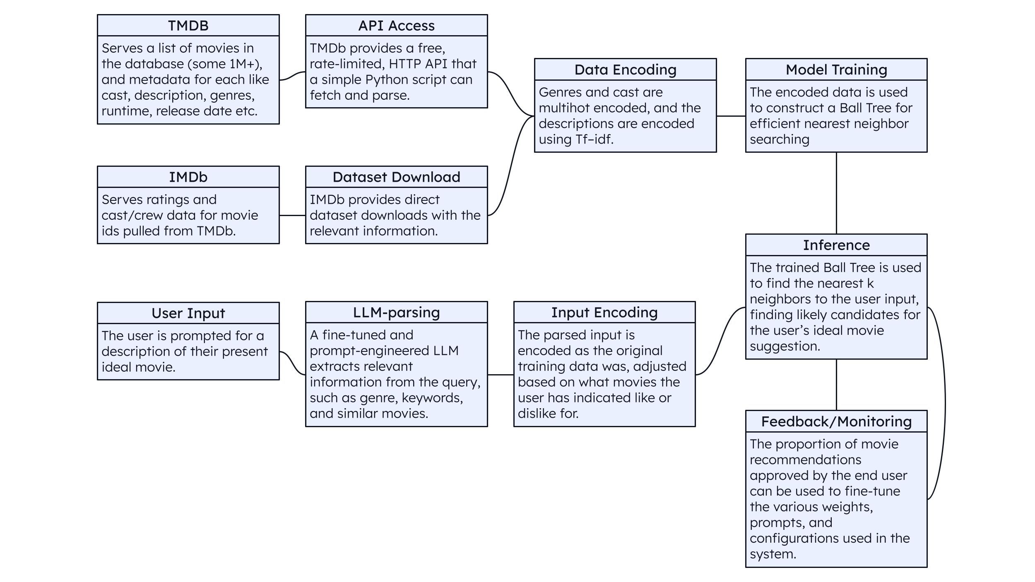
Figure 1. TMDb and IMDb movie information is used to train a nearest neighbor model. An LLM extracts the meaning from user input to compare it to the trained movie data, allowing the classifier to find the closest matches from the database.

Design Vision
Aggregated streaming platforms help locate when a movie is available but still struggle with delivery. Most aggregators, such as justwatch.com, depend on keyword searches and simple filters such as genre and release year. That workflow breaks down when a user fails to name a specific title and instead describes preference in natural language. Other platforms (Amazon Video, Netflix, YouTube) provide personalized recommendations based on past watch history. Those recommendations often miss what the user wants right now because mood and intent change quickly. Our system targets the gap between rigid search and history-based recommendations by supporting free-form, text-based queries and returning relevant movies from a large catalog.
We implement a content-based retrieval system that represents each movie using both structured metadata and text. Content-based recommendation is a standard approach when the system can describe items with features such as genre, cast, and plot summaries [10]. Prior work shows that content-based methods perform well when user preferences align with item attributes and when the system can build strong feature representation of content [8]. We also ground our design in established recommender-system principles, including ranking-based outputs and the need to evaluate relevance using user-centered metrics. For textual representation, we rely on TFIDF style term weighting as a strong baseline for text retrieval and similarity [7]. We also treat modern embedding-based semantic search as a reference point for further improvement, since sentence embedding methods often improve retrieval quality for natural language queries.

Datasets
The first data source we made use of was movie metadata from The Movie Database (TMDb, themoviedb.org) using the official API. This source provides structured fields such as title, genres, runtime, release date, and overview text, and it supports large scale programmatic access through a free API key.
Furthermore, we supplemented the TMDb data with IMDb’s (imdb.com) official noncommercial dataset downloads, which provide cast/crew data and rating-related fields in bulk TSV files. IMDb hosts these datasets publicly and refreshes them regularly.
We joined these sources using stable identifiers, especially the IMDb ID that TMDb includes for many titles. IMDb IDs are unique across all movies, so a reliable match between the two datasets is ensured.

Candidate Feature Sets and Prediction Targets
We perform data cleaning to ensure consistency across movie records and to support reliable feature encoding. We remove duplicate entries and retain only movies with sufficient metadata for retrieval, such as titles, genres, and descriptive text. We handle missing values by omitting fields that are unavailable rather than attempting to impute them, since our system relies on similarity rather than supervised prediction. Additionally, it is generally safe to drop records with missing values because incomplete profiles on TMDb are highly correlated with obscure or low-rated movies users are not likely to want.
To reduce noise introduced by non-feature content such as behind-the-scenes clips, short films and talk show specials, we apply filtering based on runtime and popularity. We remove all movies with runtime shorter than 30 minutes and discard entries with very low vote counts. This filtering step reduces obscure or non-standard titles that might dominate similarity results due to sparse or misleading metadata and sheer quantity.
For textual fields such as movie overviews, we rely on the default preprocessing behavior of the scikit-learn (scikit-learn.org) TFIDF vectorizer. This preprocessing includes lowercasing, token normalization, and accent removal, which ensures that semantically identical words with different formatting are treated consistently. We do not apply custom stemming or lemmatization as our goal is to preserve interpretability while maintaining strong baseline retrieval performance.
Movie genres and cast/crew (identified by IMDb person IDs) are normalized to a consistent list-based format for human readable display. A secondary helper table relates IMDB person IDs to their full names.
During model training, each movie is represented using a hybrid feature vector that combines textual and structured metadata. This representation allows the system to balance semantic similarity with categorical constraints.
We encode movie overviews using TFIDF, producing sparse vectors that capture term importance across the dataset. These vectors enable the system to compare descriptive similarity between movies and user queries expressed in natural language.
Genres are encoded using multi-hot representation (sklearn.preprocessing.MultiLabelBinarizer) where each genre corresponds to a feature dimension. This encoding allows the similarity model to regard partial overlap between movies with related genres rather than requiring exact matches.
Cast/crew members are also encoded as multi-hot features. These features are intentionally treated as soft signals rather than hard filters. Actor names are often ambiguous, sparsely distributed, and inconsistently referenced across metadata fields. Treating actors as weighted similarity features rather than strict constraints improve our system’s robustness and prevents failing when exact matches are unavailable.
The final movie representation concatenates these feature groups into a single, weighted sparse vector. The system does not perform supervised classification. Instead, the prediction target is a ranked list of movies that are most similar to the user query in this feature space.
Movies known to be similar to what the user is looking for are treated differently to the other features, in that they affect the entire vector space; they are encoded as fractions of their associated movie vectors that can be taken with the user query vector as a weighted average.

Learning Algorithms
We use a content-based nearest-neighbor retrieval approach rather than a supervised learning model. This choice prioritizes interpretability, efficiency, and alignment with the main goal of improving discovery for descriptive queries.
We construct a sparse nearest-neighbor index (sklearn.neighbors.NearestNeighbors) over the movie feature vectors using scikit-learn. During inference, the system embeds the user query into the same feature space as the movie dataset. It then computes distances between the query vector and indexed movie vectors to retrieve the top K most similar movies.
Similarity is computed using cosine distance over the combined feature representation. We apply feature weighting to balance the influence of different components. Textual similarity derived from movie overviews carries the highest weight for descriptive queries, while genre and cast features contribute additional context. Actor features are weighted carefully to avoid dominating results due to sparsity or name ambiguity.
User input is processed using Gemma 2 and lightweight parsing techniques including fuzzy string matching using fuzzywuzzy. These methods transform free-form text into a structured representation suitable for similarity-based retrieval.

User Interface
We implement a lightweight user-facing interface using Gradio. The interface allows users to submit free-form, text-based queries describing the type of movie they want to watch.
The frontend queries the model for a scored list of recommended movies along with relevant metadata, including title, release year, and brief descriptions and displays it formatted in a table. The interface supports rapid iteration by allowing users to refine their input and immediately view update recommendations. Using Gradio enables quick deployment and testing before being adapted to the relevant aggregate streaming platform’s styles and requirements. In production, however, the system would likely take the form of a widget or web page on the aggregate streaming site. In that case, most of the user interface code (namely the HTML table showing and sorting the movie recommendations) would be much the same, possibly adapted for the particular web framework used.

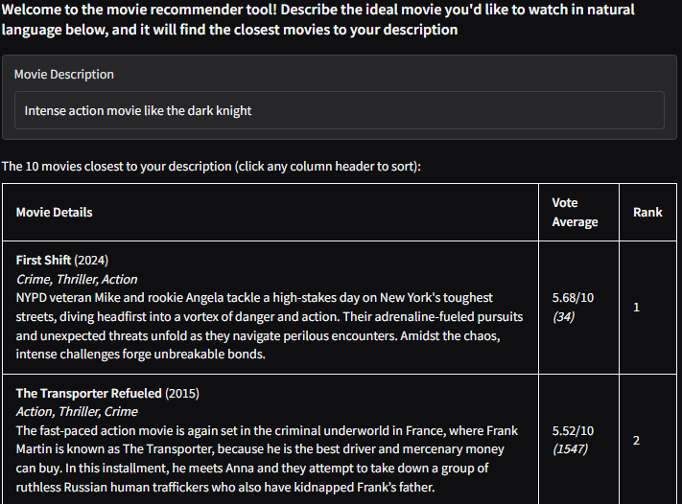
Figure 2. A simple text field for the user’s description, and the first two subsequent movie recommendations.

SYSTEM EVALUATION
Metric/System | Genre Jaccard Top 1 | Genre Jaccard Top 5 | Genre Jaccard Top 10 | Cosine Score Top 1 | Cosine Score Top 5 | Cosine Score Top 10 | Unique Genres in top 10
Full System | 0.866 | 0.897 | 0.901 | 0.181 | 0.164 | 0.157 | 3.55
Genre+ Overview | 0.704 | 0.709 | 0.727 | 0.342 | 0.295 | 0.273 | 5.44
Only Overview | 0.313 | 0.281 | 0.269 | 0.262 | 0.208 | 0.181 | 10.04
Only Genre | 0.992 | 0.982 | 0.970 | 0.996 | 0.990 | 0.984 | 2.95
Only Actors | 0.173 | 0.131 | 0.133 | 0.00 | 0.00 | 0.00 | 11.0

Table 1. Evaluation outcomes. Only-actors and only-overview models provide the most genre diversity. The full system sacrifices little in genre Jaccard scores compared to the only-genre model.
To evaluate our system, we created 5 different models. Each model represents a different combination of features. The first is our full system, the second is trained only on the text overviews, the third uses only genres, the fourth uses overview and genres, and the final uses cast/crew only. This shows the effects of the various fields and explains much of the overall model's behavior. Then, we created a test dataset of 300 randomly selected movies. For each movie, we parsed the movie description and created a simulated user query that was then passed to each model. We tracked the mean genre Jaccard index (the proportion of genres shared between recommendations and described movie), the mean cosine similarity, and the mean number of unique genres across all 10 recommendations. Each of these metrics allowed us to see if our model was giving users diverse enough recommendations while still being relevant.
The outcome of our evaluation shows that our full system has a genre similarity score of 0.86 for the top recommendation, a cosine score of 0.18 for the top recommendation, and a genre diversity score of 3.55 for the top 10 recommendations. In comparison with the other test systems, the full system is neither the best nor the worst for every category. For example, the highest scoring genre similarity system was genre-only. This can be expected because if the user only inputs a genre, the search weighs the genre as 100% as opposed to the blend of features when a more robust entry is used. The highest scoring cosine-similarity system is genres-only as well, which also makes sense given genres has a very small feature set (19 total). Therefore, the feature set between a recommendation for a genre-only entry is going to be very similar. The genre diversity metric is the highest for the actors only system – this follows from the fact that an actor typically has movies spanning across many different genres.
During real use our system returns a top recommendation within the range of 0.15-0.25 for a good recommendation, subjectively. This number seems so low because of our large feature set however when normalized this is a good number. Our initial project proposal highlighted that we may use the LLM to provide an accuracy score by feeding the results of the query. However, this proved to not be needed because our results were meeting our relevancy threshold on their own. Along with this, we tested our system with 300 queries derived from real movies within our system instead of the proposed “thousands of LLM generated queries” that would have taken a massive amount of time and resources to complete.
One way we could improve our system is by having a user feedback system. The feedback system would allow a user to select which recommendations they felt were relevant. We could then use that data to determine what factors the user-specified relevant movies have in common. With our current evaluation data, we try to increase our cosine-similarity score by weighing some features more or less. For example, our overview-genre only system outperformed our full system by 0.16 in cosine similarity. This nearly double increase could be reason enough to re-evaluate how we handle cast input, i.e. using a hard filter instead of just weighing it more in our model.

PROTOTYPE
Our project may be viewed and tested at:
https://colab.research.google.com/drive/1ARtxlpBuvwnAVgU4P5VMAnUt0B0LJ_ba?usp=sharing

REFERENCES
- C. -S. M. Wu, D. Garg and U. Bhandary, "Movie Recommendation System Using Collaborative Filtering," 2018 IEEE 9th International Conference on Software Engineering and Service Science (ICSESS), Beijing, China, 2018, pp. 11-15, doi: 10.1109/ICSESS.2018.8663822.
- S. Ravisankar, A. Marimuthu and K. Praveen, "Elevating Movie Reviews with Intelligent Recommendation Systems," 2023 International Conference on Data Science, Agents & Artificial Intelligence (ICDSAAI), Chennai, India, 2023, pp. 1-6, doi: 10.1109/ICDSAAI59313.2023.10452615.
- S. M. Shoaib and J. K, "Comparison of Hybrid Novel Pearson Correlation Coefficient (HNPCC) with K-Nearest Neighbor (KNN) Model to Improve Accuracy for Movie Recommendation System," 2023 International Conference on Advances in Computing, Communication and Applied Informatics (ACCAI), Chennai, India, 2023, pp. 1-6, doi: 10.1109/ACCAI58221.2023.10200272.
- M. Singh, P. Mishra, N. Aggarwal, V. Kumar, P. K. Sharma and R. Yadav, "CosineRecom: A KNN-Based Movie Recommendation System Using Cosine Similarity," 2024 4th International Conference on Advancement in Electronics & Communication Engineering (AECE), GHAZIABAD, India, 2024, pp. 190-194, doi: 10.1109/AECE62803.2024.10911391.
- S. Katkam, A. Atikam, P. Mahesh, M. Chatre, S. S. Kumar and S. G. R, "Content-based Movie Recommendation System and Sentimental analysis using ML," 2023 7th International Conference on Intelligent Computing and Control Systems (ICICCS), Madurai, India, 2023, pp. 198-201, doi: 10.1109/ICICCS56967.2023.10142424.
- M. S. Khan et al., "Movie Recommendation System Using Euclidean Distance," 2024 OPJU International Technology Conference (OTCON) on Smart Computing for Innovation and Advancement in Industry 4.0, Raigarh, India, 2024, pp. 1-7, doi: 10.1109/OTCON60325.2024.10688032.
- M. Chibb, P. Vashisht, A. Katti and A. Nrang, "Enhancing Movie Recommendations: A Content Based Approach Using TF-IDF Weighted Word2Vec and Cosine Similarity," 2024 4th International Conference on Technological Advancements in Computational Sciences (ICTACS), Tashkent, Uzbekistan, 2024, pp. 1449-1454, doi: 10.1109/ICTACS62700.2024.10841087.
- M. K. Delimayanti et al., "Web-Based Movie Recommendation System using Content-Based Filtering and KNN Algorithm," 2022 9th International Conference on Information Technology, Computer, and Electrical Engineering (ICITACEE), Semarang, Indonesia, 2022, pp. 314-318, doi: 10.1109/ICITACEE55701.2022.9923974.
- J. K. S and N. K, "Advancements in Context-Aware Recommender Systems: An Exhaustive Exploration of Ontology and LLM in improving ranking accuracy," 2025 2nd International Conference on Research Methodologies in Knowledge Management, Artificial Intelligence and Telecommunication Engineering (RMKMATE), Chennai, India, 2025, pp. 1-7, doi: 10.1109/RMKMATE64874.2025.11042856.
- S. Shaikh and D. Dani, "Enhancing Movie Recommendation Systems through Demographic and Content-Based Filtering Using TF-IDF and Cosine Similarity," 2024 International Conference on Artificial Intelligence and Quantum Computation-Based Sensor Application (ICAIQSA), Nagpur, India, 2024, pp. 1-5, doi: 10.1109/ICAIQSA64000.2024.10882441.

