**General**

> Open up the script in Matlab (through server MELGS1, which has the correct version R2019b)

> Run the script

> Select the pre or post data for that subject (make sure it’s for the correct protocol)

> Will open up EEGlab

> Settings > Time Range to Display > Type in “1” > OK

> Click through each trial

> To reject trials, just click anywhere on the window (will highlight it yellow)

> Once you finish clicking through all the trials, click REJECT in the bottom right

> Are you sure you want to reject the labeled trials? > YES

> Another window will pop up (Dataset info) > don’t need to change anything > OK

> Close the EEGlab window:

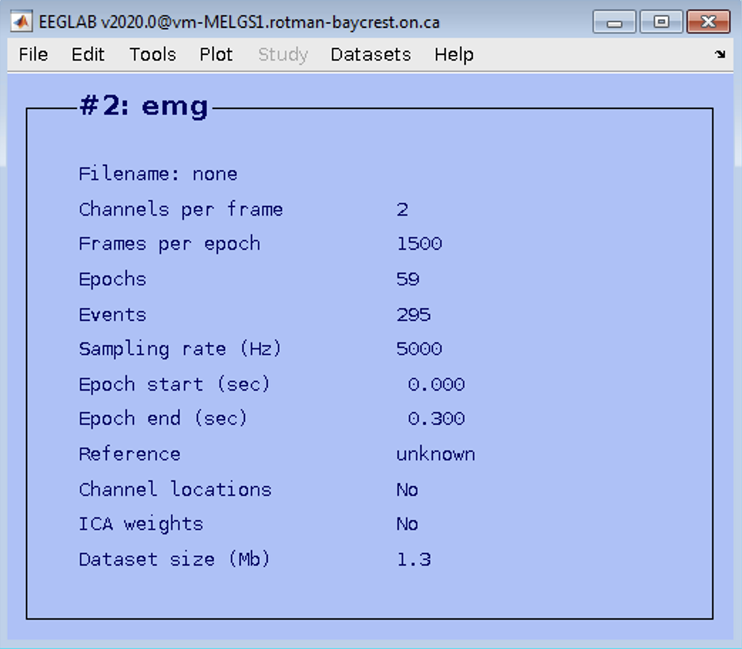

> Can now click OK on this window (do NOT close this until you’re done everything)

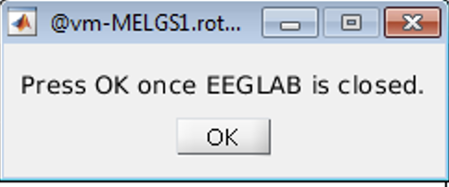

> Outputs will include a trial-by-trial .csv file and an averaged trial data .csv file

> Proceed to next subject

**Recruitment curve (RC):**

Using a single TMS coil, a single pulse was used to stimulate M1 at a range of increasing intensities in 11 states. There were a total of 110 pulses delivered, i.e. 10 pulses for the 11 different stimulator intensities. State 1 was set as the intensity of the RMT rounded down to the nearest 5% (e.g., if RMT was 53%, the first intensity used was 50%) and each state thereafter increased by 5% in raw TMS output. The RC is used to measure the increase in excitability of the cortex at a number of increasing stimulator outputs.

**Preprocessing script: RC_20230515.m** (as well as pre and post versions that create output files with pre and post in the filename)

* Finds the minimum and maximum MEP values after the pulse, and then measures MEP amplitude as the peak-to-peak (min-to-max) difference
* Outputs both a trial-by-trial file, as well as an average file (gives mean MEP amplitude for each state).

**Short-interval intracortical inhibition (SICI):**

Using a single TMS coil, a subthreshold conditioning stimulus (CS) pulse was delivered in advance of a suprathreshold test stimulus (TS) pulse, with an interstimulus interval of 1-6 ms. This typically results in a reduction of the MEP elicited by the TS compared to that elicited by the TS delivered alone. This reduction in the MEP is related to GABA-A signaling.

**Preprocessing script: SICI_20230515.m** (as well as pre and post versions that create output files with pre and post in the filename)

* Finds the minimum and maximum MEP values after the pulse, and then measures MEP amplitude as the peak-to-peak (min-to-max) difference
* Measures MEP latency, defined as the latency of the first maximum/minimum peak
* Outputs both a trial-by-trial file, as well as an average file

**Long-interval intracortical inhibition (LICI):**

Using a single TMS coil, a suprathreshold CS pulse was followed by a suprathreshold TS pulse, with an interstimulus interval of 50-100ms. This typically results in a reduction of the MEP compared to a TS alone. This reduction in the MEP is attributable to GABA-B signaling.

**Preprocessing script: LICI_20230515.m** (as well as pre and post versions that create output files with pre and post in the filename)

* Finds the minimum and maximum MEP values after the pulse, and then measures MEP amplitude as the peak-to-peak (min-to-max) difference
* Measures MEP latency, defined as the latency of the first maximum/minimum peak
* Outputs both a trial-by-trial file, as well as an average file

**Contralateral (cortical) silent period (cSP):**

Participants were asked to hold a sustained muscle contraction at 10% maximum effort, resulting in ongoing EMG activity. Using a single TMS coil, a pulse was delivered to the M1 contralateral to the hand sustaining a muscle contraction. This typically elicits an MEP followed by a flattening of the EMG signal (known as the contralateral, or cortical, silent period), reflecting GABA-B mediated local inhibition.

**Preprocessing:** Currently being revamped. Briefly, it should work as follows:

The cSP script utilizes a combination of methods for identifying cSP events, drawing insights from various research papers ([Conforto et al., 2014](https://doi.org/10.1177/0333102413515340); [Garvey et al., 2001](https://doi.org/10.1016/S1388-2457(01)00581-8); [Kuo, Y.L. et al., 2014](https://pubmed.ncbi.nlm.nih.gov/28119588/); [Giovannelli, F. et al., 2009](https://pubmed.ncbi.nlm.nih.gov/19770195/)). It’s important to note that all calculations below are NOT done on a single trial basis - we ended up averaging the rectified-and-filtered trials together first and then computed the silent period based on that average. The single trials were too noisy to quantify the silent periods on a single-trial level. This is pretty standard in the field - in contrast to MEPs and paired pulse signals, which can be quantified more easily on a single-trial level.

**1. cSP Confirmation Criteria:**

The initial phase involves determining the cSP start look, marking the confirmed occurrence of a cSP. Three conditions, adapted from Conforto et al. (2014), contribute to this determination:

- A 2.5 ms drop in the rectified EMG signal below a lower threshold (mean EMGbaseline - 2 σbaseline).

- A 5 ms drop below the mean EMGbaseline - σbaseline.

- A 10 ms drop below the mean EMGbaseline.

If any of these conditions are met within a specified time window (30-60 ms post-pulse), the cSP start look is set to the point at which the condition was satisfied.

- The script evaluates each condition within the cSP look window in decreasing order (1-3), commencing with the 2.5 ms drop below EMG - 2SD.

- The window size was determined based on the general occurrence of cSPs within 30-45 ms post-pulse, with allowances for outliers (Kuo, Y.L. et al., 2014; Giovannelli, F. et al., 2009).

**2. cSP Start and End Times:**

Once the cSP start look is established, the script employs a method from Garvey et al. (2001) to determine the cSP start and end times:

- The script traces backward from the cSP start look along the rectified EMG signal. The cSP start is identified as the point where 50% of the preceding data points in a 5 ms window are above Garvey’s variation limit.

- Similarly, the cSP end is determined by looking forward from the cSP start look until 50% of the succeeding data within a 5 ms window are above Garvey’s variation limit.

- The variation limit is defined as the mean EMGbaseline - 1.77 * MCD, where MCD (Mean Consecutive Difference) represents the mean of the baseline EMG’s first derivative.

**Ipsilateral silent period (iSP):**

Participants were asked to hold a sustained muscle contraction at 10% maximum effort, resulting in ongoing EMG activity. Using a single TMS coil, a pulse was delivered to the M1 ipsilateral to the hand sustaining a muscle contraction. This typically results in a flattening of the background EMG signal in the ipsilateral muscle (known as ipsilateral silent period), reflecting transcallosal inhibition.

**Preprocessing:** Currently being revamped. Will work essentially the same as when looking for the cSP outcomes.

**Long interhemispheric inhibition (LIHI):**

Using two TMS coils simultaneously, a subthreshold CS was delivered to M1 on one side, which typically causes a reduction in MEP amplitude elicited by a TS delivered to M1 on the other side. Similarly to iSP, these LIHI effects are due to transcallosal inhibition.

**Preprocessing:** Have not run this preprocessing as there were only 3 subjects that had MEPs in both hemispheres.