# CS3570 Introduction to Multimedia Homework #1

## 1.

(a)

I write a function called psnr to compute the value by the given PSNR Formula.

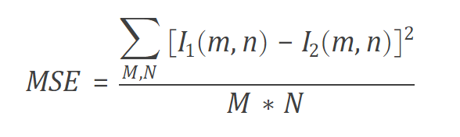

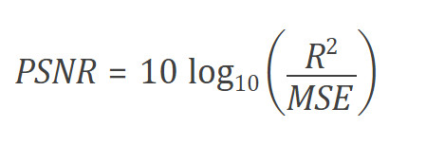

This is not finished.

I did the steps below:

* Cut the img into 8x8 by mat2cell()
* Use the DCT formula to do transformation

## 2.Convolution

By the given formula from class.

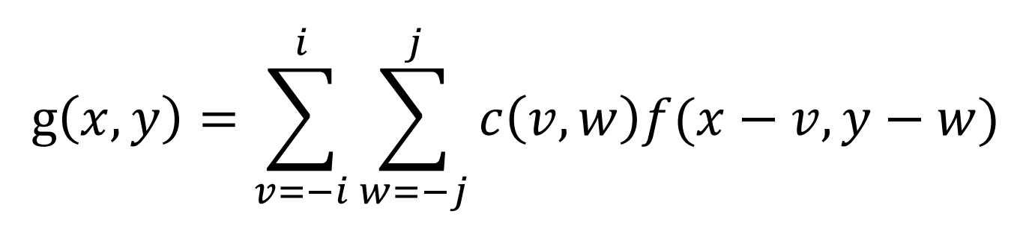

**(a) Gaussian blur filter**

mask sizes 3×3 with sigma 0.3 ; mask sizes 9×9 with sigma 1.0

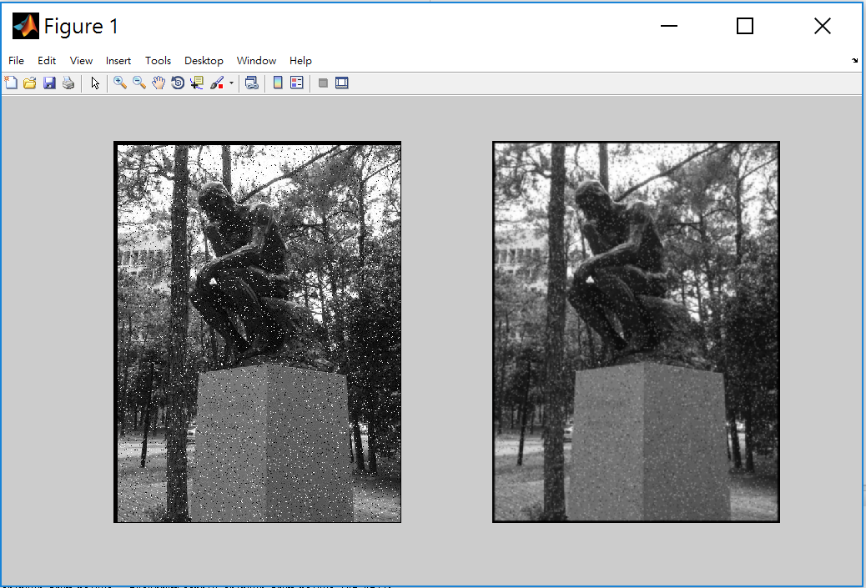

The left one has more noises dots than the right side.

**(b) median filter**

I haven’t finished this part, but I did the following steps:

* Use two for loop to iterate the elements of output
* Use two inner for loop to handle the mask
* Sort the neighbors to find the median
* Take the median as our output value

**(c) Differences**

We make a Gaussian mask and calculate the weighted value for blurring. Unlike Gaussian blurring, median filtering uses the original median value of the image, not computed value. So, it can be used on noise reduction.

## 3. interpolation

(a) (b)

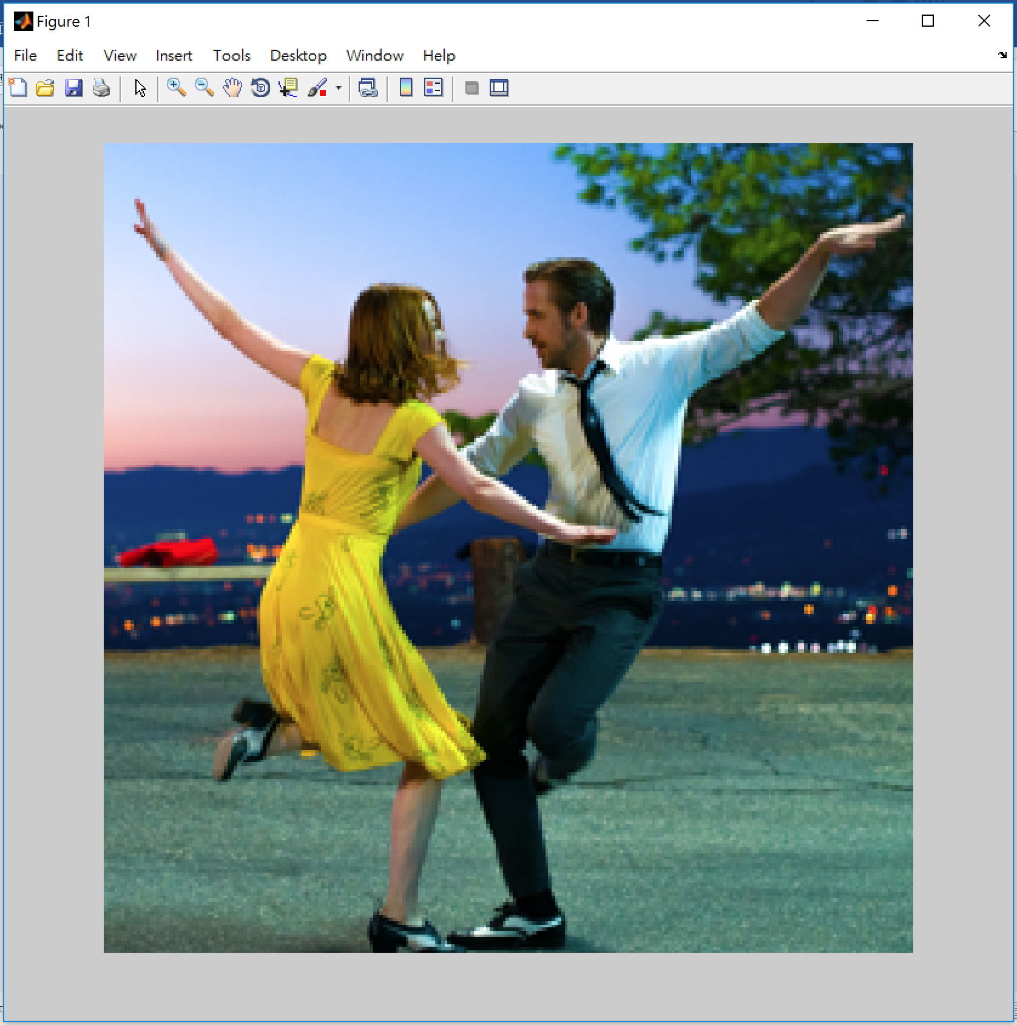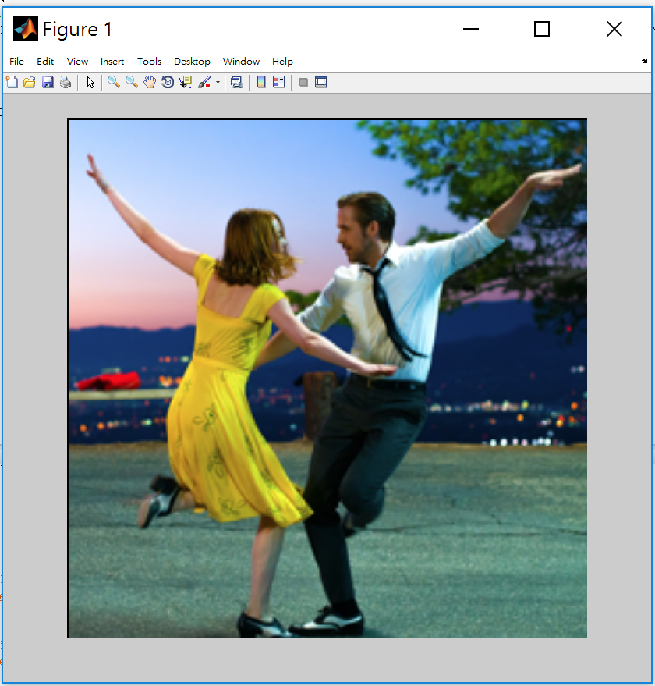

**(a) nearest-neighbor interpolation**

* Read the image file by Double type.
* Create an empty 4x array.
* Map the 4x image array index to the original image and get the corresponding value by round().
* If the index=0, it means the first element.
* Print the 4x image by unit8 type.

PSNR=5.9202

**(b) bilinear interpolation**

The steps are similar to (a).

The difference of the two methods is that bilinear not only map to the original image, but also weighted by 4 neighbors to get the value of new image.

PSNR=5.8960

**(c) Compare (a) & (b)**

The PSNR by bilinear is smaller.

## References

<http://angeljohnsy.blogspot.com/2014/04/gaussian-filter-without-using-matlab.html>

<http://www.cnblogs.com/lzhen/p/3947600.html>

<https://wuyuans.com/2012/11/dct2>

<https://www.mathworks.com/help/images/ref/dct2.html>

<https://www.mathworks.com/help/vision/ref/psnr.html>