CS 3570 Introduction to Multimedia Technology
Midterm Examination (5/5/2014)
(Totally 8 questions and 112 points on 2 pages)

- (16 pt) Consider compressing a 64X64 color image, which is composed of 6 colors, represented by A, B, C, D, E, F. The color histogram for the image is given as follows.
color | A | B | C | D | E | F
frequency | 256 | 512 | 128 | 1024 | 2048 | 128

(a) Calculate the probabilities associated with the six colors in this case.
(b) Based on the Shannon’s theory, what is the average bits per pixel required for the color information based on the associated entropy computation? Show the details of your calculation.
(c) Show how to construct the Shannon-Fano coding tree to encode the six colors in this image and the resulting binary code for each color.
(d) Show how to use the arithmetic coding to encode a sequence of three colors: B D E.
(c) 把ABCDEF分成頻率總和差不多的兩堆，依序將頻率最高的抽出來放最左邊，剩下低頻的放右邊，直到不能再分為止。
(d) 部分的部分，最後的中點，再用(中點-前一個的低點)/區間

- (16 pts)
(a) What is aliasing?
(b) What is image dithering?
(c) Assume 64 indexed colors are given and denoted by {(r₁, g₁, b₁), …, (r₆₄, g_{64,} b₆₄)}. To reduce the bit-depth for a color image f(x,y) from 24-bit RGB color to 6-bit index color with the above set of index colors, how do you determine the corresponding indexed color for each pixel f(x,y)?
(d) For the following mask commonly used in the error diffusion dithering technique, briefly describe how to apply this error diffusion technique to decide the indexed color for each pixel.

 | p | 7/16
3/16 | 5/16 | 1/16

  - Aliasing：由像素的離散特性所造成的失真現象(sample error)。
  - Dithering：用模擬的方式騙過人眼，可顯示接近於電腦調色盤調不出的顏色
  - 計算原本的顏色數量為2^24個，選出當中2^6個實際出現的顏色，建立有2^6個項目的表格，1~6變成表格的索引，每項裡有24個bits。
如果用Popularity algorithm的話，會選2^6個出現頻率最高的顏色，但出現少的顏色會直接消失在壓縮好的圖中。
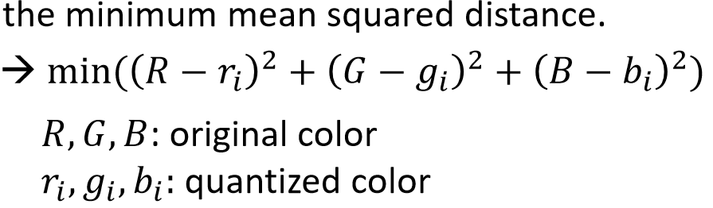
  - 令每個pixel = p, if(p<128) e=p; else e=p-255，將周圍的鄰居用原本的值加上自己的權重*e
接著往下一個pixel移動(會用到上一個p改變的鄰居)，直到整張圖都做完相同步驟為止。然後，開始做第二次，這次令 if (p<128) e=0; else e=1，一樣重複步驟，直到整張圖的像素做完為止。

- (12 pts) Consider the following color spaces: (a) RGB, (b) YC_{b}C_{r}, (c) CMYK. Please give the main application and/or advantage for each of these color spaces.
  - RGB三個8位元無符號整數（0到255）表示紅色、綠色和藍色的強度。人眼可感知，電腦也可顯示，是當前主流的標準表示方法，用於電腦螢幕呈現、真彩色和JPEG或者TIFF等圖檔格式裡的通用顏色交換。
  - YCbCr的Y與YUV中的Y含義一致(YELLOW)，Cb和Cr與UV同樣都指色彩，Cb指藍色色度，Cr指紅色色度，在應用上很廣泛，JPEG、MPEG、DVD、攝影機、數字電視等皆採此一格式。
  - 用於印刷，能比RGB印出更精確無誤差的顏色

- (10 pts) To scale a grayscale image I(x,y) of size 100X100 with 3 times horizontally and vertically, i.e. to size 300X300, by using bilinear interpolation. Give the pseudo code for this image scaling process.

- (18 pts) JPEG compresses an image by using several compression techniques, including DCT, predictive coding, chroma subsampling, quantization, entropy coding, run-length coding.
(a) The 1D DCT formula is given below. Write the matrix-vector form for the DCT transform equation. Define the matrix and vectors in the equation.
(b) Based on this formula, give the 2D DCT formula for an 8X8 2D image block.
(c) What is the 2D DCT basis corresponding to F(u,v)?
(d) Describe how the DCT is used in the JPEG compression. Give the details of the implementation.
(e) When the 4:2:0 chrominance subsampling in is used for a 16X16 macroblock in JPEG, how many 8X8 DCT’s are needed in the encoding for this 16X16 macroblock? Give the number of 8X8 DCT’s for each color channel.
(f) How is the compression ratio and image quality adjusted in JPEG?
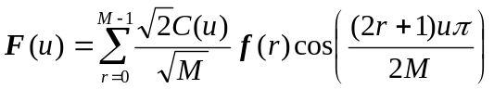 for 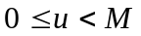
where 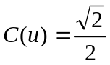 if 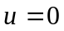 otherwise 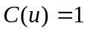
(a)

- (12pt) Consider an audio signal f(t) given as follows: . The time t is represented in seconds.
  - What is the highest frequency in this signal f(t)?
  - What is the minimal sampling frequency that can avoid aliasing when digitizing this signal? Give the reason for your answer.
  - Assume the signal is sampled at the Nyquist rate and a period of the discrete signal is taken for discrete Fourier transform. Plot the associated Fourier spectrum. (1D DFT formula is given below.)
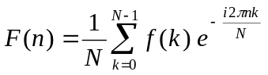, n=0, 1, …, N-1
(a) fsin=1000 fcos=1500
fmax=1500
(b) fs= 3000
(c)

- (12 pts) (a) Give a brief one-sentence definition for each of the following filters: low-pass, band-pass, and band-reject filters.
(b) Also plot the transfer function, or the frequency response graph, for each type of these filters. In the graph, the x-axis is the frequency, and the y-axis is the fraction of frequency component retained in filtered signal.
(c) Given a sampled audio signal f(k), k=1, .., 1000, in temporal domain, how do you apply any one of the above filter with its transfer function represented by H(k) to filter the audio signal f(k)? Give the filter result in temporal domain.

- (16 pts) Consider video compression in the MPEG standard. Assume a video is compressed with the GOP sequence: IBBPBBPBB.
(a) What are the I, B, P frames in the above GOP sequence?
(b) Why is motion estimation needed for MPEG video compression?
(c) When the size of a macroblock is 8X8, write down the pseudo code for finding the block motion vector for a target image block T(x,y), 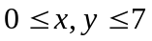, (P frame) from the reference frame R(i,j) with the search range within [-15, 15] along x and y directions. Use the SAD for the block matching criterion here.
(d) Plot the flow chart for compressing a P frame with motion estimation, entropy coding, DCT, and quantization.

