ISA542300 Software Quality Assurance

Homework 3 – Group Exercises **Deadline : 6/8**

In this exercise, you are going to develop a small program and go through the process of software testing. The subject program could be designed in any language, for any platform. Refer to Appendix for the basic requirements.

1. What are the control flow graph and the cyclomatic complexity of the subject program? Briefly explain the calculation process and feel free to use a development / testing tool. **(20%)**
2. Develop the following test specifications: **(50%)**
   1. Test plan,
   2. Test procedure specification,
   3. Test cases specification,
   4. Test log, and
   5. Test summary report (including the statement and branch coverage values).

You may refer to the following documents for the descriptions of these testing documents:

• IEEE Standard for Software Test Documentation, and

• 經濟部工業局軟體整合與測試作業規範.

• IEEE Test Case Specification Template

Note that both black box testing (including boundary value testing, equivalence testing, and decision table) and white box testing techniques should be incorporated and explained in the testing procedure, and test cases should reach nearly 100% branch coverages. You may also tailor the documents fields or formats according to your practical testing activities.

1. Upload the subject program (including the source codes and the binaries) and the documents.**(30%)**

**Appendix: Baseline Requirements for the Subject Program**

There are five inputs, ***a***, ***b***, ***c***, ***d*** and ***p*** depicted in Figure 1. The length of ***a*** to ***d*** is bounded by 1 to 200. ***p*** is an included angle by two diagonal lines. The range of ***p*** is bounded by (0**∘**, 90**∘**]. The output can show which shapes will be created. Please show the highest priority shape, and the priority order from high to low is <square, rhombus, rectangle, harrier-shaped, parallelogram, trapezium, quadrilateral>.

**String shape (int a, int b, int c, int d, int p);**

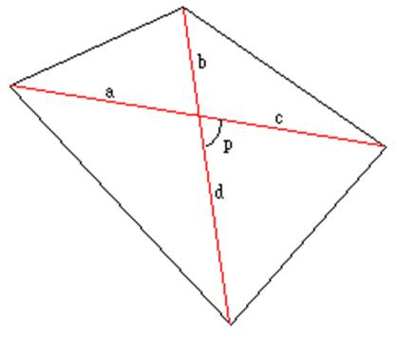

**Notice**

**Grading will depend on the following factors:**

* **Completeness of the documents,**
* **Readability of the documents,**
* **Design of the test cases, and**
* **Coverage of the test cases.**

**If you have any questions, please feel free to contact TA ☺**