**Main Manuscript for**

DNA methylation provides a molecular basis for disease tolerance and intergenerational paternal effects

Alice Balard1*, Kostas Sagonas2, Joshka Kaufmann3,4, Melanie J. Heckwolf5,6, Christophe Eizaguirre1

1 School of Biological and Behavioural Sciences, Queen Mary University of London, London E1 4NS, United Kingdom; 2 School of Biology, Aristotle University of Thessaloniki, 541 24 Thessaloniki, Greece; 3 School of Biological, Earth and Environmental Sciences, University College Cork, T23 N73K, Cork, Ireland; 4 Marine Institute, Foras na Mara, F28 PF65, Newport, Ireland; 5 Smithsonian Tropical Research Institute, 0843 Ancón, Panamá, Panama; 6 Leibniz Centre for Tropical Marine Research, D-28359 Bremen, Germany

*corresponding author: Alice Balard.

**Email:** alice.cam.balard[@gmail.com](mailto:xxxxx@xxxx.xxx)

**Author Contributions:** A.B and C.E led this study. C.E. and J.K. designed the breeding experiments at the max planck institute for evolutionary biology. J.K. carried out the breeding experiment as well as the infection experiment with C.E. K.S and C.E conceived the sequencing strategy. A.B. analysed the data for which M.J.H. provided supporting scripts. C.E. advised the analyses. A.B. drafted the manuscript with support of C.E. All co-authors contributed to the final version of the manuscript.

**Competing Interest Statement:** All the authors state that there is no conflict of interest.

**Classification:** BIOLOGICAL SCIENCES – Evolution

**Keywords:** DNA methylation, epigenetics, host–parasite interactions, trans-generational immune priming, three-spined stickleback

**This PDF file includes:**

Main Text

Figures 1 to 4

**Abstract**

Parasites play a significant role in species’ evolution, and one aspect is the evolution of disease tolerance. Tolerance is the capacity of hosts to withstand infection without suffering its costs on key fitness-related traits. Yet, the heritability and molecular mechanisms of tolerance remain elusive. In model fish species, paternal infection correlates with increased disease tolerance in the offspring and infection also correlates with DNA methylation. However, whether DNA methylation correlates with the transmission of tolerance is unknown. In this study, we experimentally investigated the role of DNA methylation in the evolution of tolerance via the paternal line across generations of three-spined stickleback fish (*Gasterosteus aculeatus*). Using a new analytical framework applied to reduced representation bisulfite sequencing, we asked (1) whether offspring DNA methylation profile varies with paternal infection, and (2) whether DNA methylation correlates with tolerance in offspring. We found a strong correlation between the infectious status of fathers and changes in the methylome of their offspring. This effect was so strong that the offspring's infection status hardly predicted their methylation patterns compared to that of their father. Ultimately, we identified DNA methylation marks associated with tolerance that could be used as potential biomarkers. Our results provide new insights into the molecular mechanisms underlying tolerance as well and trans-generational immune priming via the paternal line.

**Significance Statement**

The impact of parasite-mediated selection extends beyond the evolution of disease resistance. Indeed tolerance is defined as the capacity to withstand infection without suffering its costs. This work fills a knowledge gap investigating the molecular basis of tolerance and its transmission across generations. We identified DNA methylation as candidate biomarkers of tolerance transmitted through the father’s line. This work provides now the tools and a conceptual framework to understand the evolution of tolerance and its molecular basis.

**Main Text**

**Introduction**

Parasites and pathogens are ubiquitous in nature [(1)](https://www.zotero.org/google-docs/?buESLJ). They are arguably one of the strongest natural selection pressures, as they reduce their hosts’ fitness [(2)](https://www.zotero.org/google-docs/?r1GX1C), alter their gene expression profiles [(3)](https://www.zotero.org/google-docs/?SMaX2g) and populations’ genetic makeup [(4)](https://www.zotero.org/google-docs/?qf7syw), modify species composition of ecosystems [(5)](https://www.zotero.org/google-docs/?Vq5aDC), and even change the selection environment of successive host generations [(6)](https://www.zotero.org/google-docs/?2JAdgR). In response to this multifaceted selection pressure, hosts can either evolve resistance, i.e. the ability to reduce parasite burden [(2)](https://www.zotero.org/google-docs/?nTeXdM), or tolerance [(7)](https://www.zotero.org/google-docs/?Wc4w0K). Tolerance is the capacity of hosts to withstand the infection without suffering its costs on their Darwinian fitness [(7, 8)](https://www.zotero.org/google-docs/?t0o1YO). By definition, tolerance is therefore a form of phenotypic plasticity [(9, 10)](https://www.zotero.org/google-docs/?76skMI) and is predicted to evolve under predictable environments, when offspring share the parasitic environment of their parents [(11–13)](https://www.zotero.org/google-docs/?qFAxPF). When the parasite exposure of parents shapes the immune response of their offspring, this phenomenon is referred to as “trans-generational immune priming” (TGIP; [14, 15)](https://www.zotero.org/google-docs/?bOIRNc).

While the genomics of disease resistance is increasingly well understood [(16–19)](https://www.zotero.org/google-docs/?ThRRGi), the molecular mechanisms underlying the phenotypic plastic nature of tolerance are more complex to unravel [(20)](https://www.zotero.org/google-docs/?OfVyio). Potential mechanisms consist in the regulation of gene expression [(10)](https://www.zotero.org/google-docs/?cANnGv) via histone modification, small RNA, and DNA methylation [(21)](https://www.zotero.org/google-docs/?tup4Ki). Specifically, the DNA methylation in the 5’ position of the cytosine of CG dinucleotide (CpG) can alter gene expression by decreasing the accessibility of transcription factor binding sites to their corresponding transcription factors [(22–24)](https://www.zotero.org/google-docs/?h5P2JD). DNA methylation is a key epigenetic mark that correlates with health risks associated with age [(25)](https://www.zotero.org/google-docs/?wtVWZS) or cancer types [(26)](https://www.zotero.org/google-docs/?KOb7GK) in human. Likewise, in various vertebrate species, genome-wide DNA methylation patterns differ between infected and control individuals, demonstrating the link between infection and DNA methylation [(27–29)](https://www.zotero.org/google-docs/?Dr0Sdf).

Here, we used the three-spined stickleback fish (*Gasterosteus aculeatus*, hereafter “stickleback”) as an experimental model system. This small teleost fish is exposed to a wide variety of parasites, and resistance strongly correlates with polymorphism at the antigen-presenting molecules of the Major Histocompatibility Complex (MHC; [4, 30)](https://www.zotero.org/google-docs/?Y8DH5z). For instance, an adaptive frequency-shift of MHC alleles has been detected in response to infection by the nematode *Camallanus lacustris* [(4)](https://www.zotero.org/google-docs/?jv4DbT). That common parasite reduces fish growth [(4)](https://www.zotero.org/google-docs/?j6XBLl) and triggers an innate immune response [(31)](https://www.zotero.org/google-docs/?MNco8N). In an inter-generational experiment spanning two generations, Kaufmann et al. [(32)](https://www.zotero.org/google-docs/?8pNo0u) showed that paternal infection with this parasite is associated with increased fitness in the next generation, hence revealing TGIP of tolerance and its evolutionary significance.

We used the liver of the fish from this exact experiment to measure genome-wide DNA methylation using reduced representation bisulfite sequencing (RRBS) across eight fish families. In this inter-generational experiment, some males were exposed to the trophically transmitted nematode *C. lacustris* [(4)](https://www.zotero.org/google-docs/?FtvKlZ). Their brothers were treated identically but were not exposed to the parasite and hence served as controls. Each of eight brother pairs (G1) fertilised eggs of an unrelated female. Offspring (G2) were then split into two groups: exposed to the parasites or unexposed control. All exposed fish were infected, which resulted in a full factorial two by two matrix with paternal treatment (exposed infected, unexposed) and offspring treatment (exposed infected, unexposed) as well as their interaction [(29, 32)](https://www.zotero.org/google-docs/?s1rw74) (**Figure 1A**). While still debated, some teleost species seem to experience a weaker epigenetic reprogramming than mammals [(33)](https://www.zotero.org/google-docs/?dT4uVt). Furthermore, early work on epigenetic inheritance in zebrafish indicates that the embryo adopts a paternal-like methylome before the onset of zygotic genome activation [(34, 35)](https://www.zotero.org/google-docs/?fUL78X). Combined, these two facts make paternal effects likely candidates for mediating TGIP of tolerance in fish. Studying paternal effects also allows control for physiological maternal transmission routes, e.g. via antibodies through the egg yolk [(36)](https://www.zotero.org/google-docs/?NEAIDq). In our experiment, fecundation was performed *in vitro*, which excluded confounding maternal factors and paternal care.

To analyse our data, we established a new analytical framework whereby the effect of offspring infection on DNA methylation was detected by comparing fish from the unexposed group with their infected siblings from the same father. The effect of paternal infection on offspring’s DNA methylation was detected by comparing offspring receiving the same treatment (control or infected) from infected and non-infected related fathers (**Figure 1B**). Our framework (**Figure 1C**) enabled us to detect differentially methylated CpG sites (DMS) which can be classified in four categories based on the change of their methylation level between: (i) offspring infection (hereafter “infection-induced”); (ii) paternal infection but without change upon direct offspring infection (hereafter “intergenerational”); (iii) both direct offspring and paternal infection in the same direction (hereafter “additive”); (iv) both direct offspring infection and paternal infection in opposite direction (hereafter “interaction”). After characterising these four categories of DMS and annotating them to find the associated genes, we statistically tested the correlation between their methylation value and disease tolerance.

**Results**

1. **Effect of genetic background and paternal infection on the methylome**

Using reduced representation bisulfite sequencing (RRBS), we recovered 1,002,565 CpG sites present in at least 50% of the fish per each of the four treatment groups for 111 offspring, and the two treatment groups of their 16 fathers. Within these CpG sites, 78,384 were present in all 111 G2 fish. We estimated the methylation value (number of methylated cytosines over the number of cytosines sequenced) at each of these 78,384 CpG sites and performed a hierarchical clustering analysis to test for differences among treatment groups. We observed a strong clustering by father’s family (G1), representing the individual genetic background (**Figure 2A**). Father’s family explained 14.8% of the variation in offspring methylation pattern (PERMANOVA, R2=0.148, F=2.63, P=0.001). Another 7.6% of the observed variation was explained by the interaction of father’s infection treatment and family (R2=0.076, F=1.35, P=0.001), 1.5% by father’s infection treatment (R2=0.015, F=1.83, P=0.001), 1.3% by offspring’s sex (R2=0.013, F=1.59, P=0.003), and 1% by offspring’s infection treatment (R2=0.01, F=1.25, P=0.034; NMDS: **Figure 2B**). To account for the genetic variation that stems from the family effect, we re-performed this analysis within the fathers' family background (i.e. using N = 8 families in the permutation structure). The results remain similar, with 1.5% of the variation in offspring methylation value explained by the paternal infection treatment (R2=0.015, F=1.63, P<0.001), 1.3% by offspring’s sex (R2=0.013, F=1.42, P=0.006), and 1% by offspring’s infection treatment (R2=0.01, F=1.12, P=0.039). Overall, our results confirm the important role of the father’s family background in methylation pattern. More surprisingly, our results indicate that the methylome of offspring seems to be better predicted by the paternal infection treatment than by the offspring infection itself.

1. **Characterisation of differentially methylated sites by category**

Accounting for the genetic structure linked to family-breeding using PQLSeq, we calculated site-specific differential methylation between offspring groups across the 1,002,565 CpGs. We identified 707 (0.07%) significant DMS associated with the four different categories defined in our framework (**Figure 1C**): 393 (55.59%) infection-induced, 307 (43.42%) intergenerational, 1 (0.14%) additive, and 6 (0.85%) interaction. The highest number of differentially methylated CpG sites (DMS) was found in between offspring from control fathers, between control and infection (32%, N=226). This was followed by control offspring whose fathers were infected or not (29.8%, N=211), then offspring from infected fathers, between control and infection (23.6%, N=167). The least amount of difference in methylation was found between infected offspring from either control or infected fathers (N=96, 13.6%). The DMS were predominately found in intergenic regions (47.10%), followed by introns (27.86%), exons (17.40%), and promoters (7.64%). These percentages were different from those of the overall sequenced CpG positions (40.37% intergenic regions, 25.80% intron, 18.19% promoters and 15.64% exons; *χ2*[3, *Ngroups* = 4] = 53.7, P<0.001, **Supplementary Figure S1A**). Moreover, the distribution of intergenerational and infection-induced DMS on chromosomes compared to the overall sequenced CpG positions was not random (*χ2*[38, *N* = 40] = 74.8, P<0.001), ranging from 0.05% of the CpG sequenced on chromosome XIV to 0.11% on chromosome V. In particular, we found a significantly higher number of infection-induced DMS at chromosome XVIII (*χ2* post hoc test, P=0.018), and significantly higher number of intergenerational DMS on chromosome XX (*χ2* post hoc test, P<0.001; **Supplementary Figure S1B**).

1. **Genes annotation by DMS category**

We annotated the 707 DMS and found 608 genes containing at least one DMS, amongst which 548 known genes coding for 556 known proteins. The majority of genes contained infection-induced DMS (52%, N=316), followed by 44% (N=265) genes containing intergenerational DMS. 3% of the genes (N=20) contained DMS associated with both intergenerational and infection-induced categories, 1% (N=6) carried interaction DMS, and less than 1% (N=1) had additive DMS (**Figure 3, Supplementary Table S1**).

We searched for the term "immun*" in the function associated with the DMS associated genes, and found the majority belonged to the infection-induced category (N=20; N=16 in intergenerational category; N=1 in interaction). The genes with the most DMS (>2) and the most DMS per kilobase (>0.1) with infection-induced DMS encode proteins involved in: protein modification and trafficking (NDFIP2 (negative regulation of gene expression), ST6GALNAC3 (protein glycosylation), Rab11fip5 (protein trafficking)); protein regulation and stress response (TRIM16); cell adhesion and signalling (PCDH7, MAGI3, LRFN2); transcription factor (Gzf1), and growth (bmp2)).

Genes with intergenerational DMS containing the most DMS (>2) and the most DMS per kilobase (>0.1) encode for proteins involved in intracellular signalling and cell migration (Stk24), glycosylation (B3GAT1), cell signalling and development (Mosmo), chromatin remodelling and gene regulation (CHD5), and immunity (CD4). We specifically searched for genes that could link generations and be related to heritability in genes with intergenerational DMS. We found four genes with the keyword "sperm" associated with these DMS, and five genes with the keyword "segregation". In comparison, there was respectively one gene with the keyword “sperm” and one with “segregation” in genes infection-induced DMS

Among the genes with DMS associated with both intergenerational and infection-induced categories, Stk24 on chromosome I is involved in immune regulation (one intergenerational DMS 55k upstream of TSS, two infection-induced DMS 40k upstream of TSS), AHR on chromosome I is a transcription factor known to play important roles in immunity (one intergenerational DMS inside the promoter, one infection-induced intronic DMS), and cdk12 on chromosome XI is a key regulator of transcription elongation (one infection-induced DMS 34k downstream, one intronic intergenerational DMS).

The six genes with interaction DMS were SPATA20 (associated with spermatogenesis, DMS 2.7kb upstream of TSS), ANTXR1 (cell attachment and migration, one DMS 13k upstream of TSS), PER2 (transcriptional receptor, exonic DMS), Rprd1a (cell-cycle and transcription regulation, 1 DMS 2k upstream of TSS), FBP1 (enzyme involved in gluconeogenesis, one DMS 1.2k upstream of TSS) and Alpha-1-antitrypsin homolog (protease inhibitor that protects tissues from enzymes of inflammatory cells, one DMS 72k upstream of TSS). Finally, the only gene with an additive effect was PPFIBP1, which may regulate the disassembly of focal adhesions that connect cells to the extracellular matrix, thereby influencing cell movement, signaling, and adhesion dynamics (one DMS 9.9k upstream of TSS).

1. **Gene ontology enrichment analysis**

Gene ontology (GO) enrichment analysis (**Figure 3C; Supplementary Figure S2**) showed that the genes with intergenerational DMS and those with infection-induced DMS are enriched with both different and shared functions. The genes with infection-induced DMS were enriched for terms including protein metabolism and immune system biological processes, the molecular functions catalytic activity and signaling receptor activity, and the cellular component protein-containing complex.

GO analysis for genes with intergenerational DMS showed enrichment among other terms in biological processes linked to cell differentiation, cellular component organization and developmental process, in the molecular functions catalytic activity and transporter activity, and in multiple cellular component terms including protein-containing complex. Genes with both infection-induced and intergenerational DMS were enriched in RNA and DNA metabolic processes.

1. **Do the detected DMS predict offspring tolerance?**

Central to our work, we speculated that there are DMS for which the methylation values correlate with a change in the phenotype of disease tolerance. We measured this phenotype as the slope of the regression between the body condition index and parasite count [(7)](https://www.zotero.org/google-docs/?PhMyhP), which was higher in offspring from infected fathers compared to offspring from control father (LMER, Interaction of number of worms by paternal treatment: df=1, F=6.13, P=0.015; **Supplementary Figure S3**).

To summarise the correlation between DMS and disease tolerance, we performed a series of principal component analyses (PCA) with the methylation values at the 707 DMS (**Figure 4A**), with the methylation values at the 393 infection-induced DMS (**Figure 4C**) and at the 307 intergenerational DMS (**Figure 4D**). Those were split because we expect a strong correlation at those DMS given their functions. We then correlated the body condition index with the two first axes of the DNA methylation PCA (hereafter “PCA1” and “PCA2”), the number of worms, the paternal treatments, and their interactions in a mixed effect model where father’s family and sex were set as random factors. Considering all DMS, we found a significant correlation between fish body condition and the interaction between PCA1 and paternal treatment (LMER: F=7.31, P=0.008; **Figure 4D**), showing that offspring body condition is negatively correlated with DMS methylation when the father is not infected. 16.8% of the variance in body condition was associated with the paternal infection and 15.36% with PCA1. We then performed the test for infection-induced and intergenerational DMS separately to disentangle these effects.

Running the PCA and the model on infection-induced DMS only, we found significant correlations on the body condition of PCA1 (LMER: F=17.47, P<0.001) and of paternal treatment (LMER: F=12.66, P<0.001), but no significant interaction (**Figure 4E**). The body condition is better overall for offspring from infected father than from offspring from control father, and body condition positively correlates with these DMS methylation. 8.95% of the variance is associated with the paternal infection, 12.4% with PCA1. Interestingly, offspring from infected fathers do not vary much in body condition or value along the methylation PCA1 axis upon infection (dark blue and dark red points in the center of the figure); but offspring from control fathers see a decrease in both body condition and value on the methylation PCA1 axis upon infection.

In the case of intergenerational DMS, we found a significant effect on the body condition of the interaction between PCA2 and paternal treatment (LMER: F=9.52, P=0.003; **Figure 4F**). Fish body condition negatively correlates with these DMS methylation when the father fish is not infected. 6.01% of the variance in body condition is associated with the paternal infection, and 18.22% with the second PCA axis

Our pipeline detected the DMS based on comparisons between treatment groups. To exclude that the correlation we observe between body condition and methylation is driven uniquely by the strong difference between treatment groups, we ran the previous model within the treatment group for which body condition is affected by parasite infection, namely infected offspring fish from control fathers. We did not find significant terms considering infection-induced DMS, but at intergenerational DMS we found a significant effect on body condition of the interaction of PCA1 and PCA2 (LMER: F=10.66, P=0.006) and more importantly of number of worms and PCA1 (LMER: F=7.5, P=0.017; **Supplementary Figure S4**). This indicates that these CpG sites and their associated genes are good candidates for DNA methylation biomarkers of tolerance.

**Discussion**

Parasites and infectious diseases exert selection pressures on their hosts, which in turn evolve different responses [(37)](https://www.zotero.org/google-docs/?krxolW). Host tolerance is one of them, but it remains poorly understood from a molecular and trans-generational perspective. Here, we questioned whether DNA methylation can predict the phenotype of tolerance and its heritability in the form of transgenerational immune priming (TGIP). We found that, when controlling for the genetic background, paternal infection better predicted variation at DNA methylation in offspring than the offspring infection itself. Most importantly, we identified a set of CpG sites and genes linked to TGIP, which could act as biomarkers of tolerance in our system. With this study, we reveal a molecular basis of tolerance and offer new potential monitoring tools to understand the effects of infection on species’ evolution.

We found that variation in offspring methylomes was better predicted by their father’s infection than by their own infection status. Moreover, despite controlling for the genetic effect, almost half (44%) of the identified differentially methylated CpG sites among offspring groups were categorised as intergenerational, compared to the 52% that were infection-induced. Although previous work has shown that stickleback fish infected with *C. lacustris* have different methylation patterns than those uninfected [(29)](https://www.zotero.org/google-docs/?f9MEDp), we did not expect such a strong effect, which demonstrates elements of paternal trans-generational contribution of DNA methylation. Studies on zebrafish suggest that the sperm methylome is retained in offspring, while the maternal methylome is reset [(34, 35)](https://www.zotero.org/google-docs/?NQ1LM0). We speculate that similar mechanisms could be at play in stickleback in relation to parasite infection. Noteworthy, the relative importance of parental and offspring environment on offspring DNA methylation appears context-dependent. For example, in brook charr (*Salvelinus fontinalis*), the temperature experienced by parents during maturation affects the DNA methylation of offspring, while the effect of their own rearing temperature on their DNA methylation profiles is negligible [(38)](https://www.zotero.org/google-docs/?d4WaKC). Conversely, in a study on mangrove killifish (*Kryptolebias marmoratus*), only a small proportion (5.28%) of differentially methylated sites between enriched and poor environments retained the parental methylation pattern regardless of the offspring environment [(39)](https://www.zotero.org/google-docs/?lhMv6T). In our present work, we found that genes containing intergenerational DMS are associated among others with developmental processes, with chromatin remodeling, crucial for regulating gene expression and maintaining genomic integrity across generations, as well as with sperm-related functions. We hypothesize that the processes associated with intergenerational DMS may not be erased in the next generation.

In this study, we developed a framework which enabled us to categorise a DMS not only as intergenerational, but also as infection-induced, or as linked to an additive or interaction effect between paternal and offspring infections. This framework extends on the described channels of DNA methylation origin as inducible or selection-based [(40)](https://www.zotero.org/google-docs/?a9Wdde). In the case of infection-induced DMS, the associated genes were enriched for encoding protein modification and trafficking, protein regulation and immune response. We found only one DMS categorised as additive (PPFIBP1, known to regulate the disassembly of focal adhesions), which suggests that both father and offspring parasitic environments triggering a change in DNA methylation in the same direction is not common. We identified six genes carrying DMS associated with an interaction of paternal and offspring infection, including SPATA20 (associated with spermatogenesis [(41)](https://www.zotero.org/google-docs/?8LBTeh)). We speculate they may stem from DNA methylation conflicts between generations: a response in the father in one DMS could be in conflict with the same position in its offspring because this methylated site belongs to the same pathways as the intergenerational one. In this scenario, following evolutionary theory, the intergenerational pathway could be selected for if it is slightly more advantageous than the rarer infection-induced DMS. Overall, in the future, our framework that classifies DMS should be combined with the assessment of fitness effects of the methylation of specific positions to confirm the evolutionary costs / benefits of the diverse pathways [(41)](https://www.zotero.org/google-docs/?R6rgX2), hence formally testing the molecular significance of phenotypic plasticity.

Epigenetic marks are not all inducible by the environment but can also result from previous random epimutations shaped by selection. In a recent two-generation experiment on salinity acclimation and adaptation in three-spined stickleback, Heckwolf et al. [(40)](https://www.zotero.org/google-docs/?qkfL27) detected as much as 62% selection-based DNA methylation sites. In *Arabidopsis thaliana*, *trans*-acting loci previously shaped by local adaptation influence the gene body methylation at certain other sites [(43)](https://www.zotero.org/google-docs/?FkUMEG). In humans, about 20% of individual differences in DNA methylation can be explained by DNA sequence variation outside of the CpG positions [(44)](https://www.zotero.org/google-docs/?vMH0zS). In the present work, we found that the father's family explained the main variation in methylation pattern. This may reflect the large contribution of sequence variation to DNA methylation [(29, 45)](https://www.zotero.org/google-docs/?wUIFPK). Here, we accounted for the link with the underlying genomic sequence by using a relatedness matrix in our differential methylation analysis, taking advantage of the eight independent breeding lines. Our results emphasize the need to consider the genetic background before attributing the variation in epigenetic states to a given environmental factor.

A practical goal of this study was to test whether DNA methylation marks can act as biomarkers of disease tolerance. We found 316 genes containing CpGs for which methylation correlates with body condition. The slope of this correlation does not depend on the father’s infection status, but the range of methylation change upon infection was stronger when the father was not infected. We also found 265 other genes for which CpG methylation varies upon infection, but this variation correlates with a decrease in body condition only when the father was not infected. Moreover, infected offspring from control fathers, the only group whose body condition was affected by parasite infection, have a different tolerance slope depending on CpG methylation at these positions. This result brings evidence these genes are linked with the phenotype of tolerance. While TGIP has been shown in reptiles [(46)](https://www.zotero.org/google-docs/?bCZjLc), amphibians [(47)](https://www.zotero.org/google-docs/?OUmru7), birds [(48, 49)](https://www.zotero.org/google-docs/?9PGW7c), mammals [(50)](https://www.zotero.org/google-docs/?z70X7K) and fish [(51)](https://www.zotero.org/google-docs/?SpzOSM), there are to date only few studies linking TGIP with a molecular basis in vertebrates (reviewed in [15](https://www.zotero.org/google-docs/?6uMZdL)). For instance, in pipefish, paternal and grand-paternal infection affects immune and DNA methylation-mediated gene expression in offspring [(52)](https://www.zotero.org/google-docs/?rv0QYc). Here, we provide direct experimental evidence of a correlation between paternal transmission of disease tolerance and DNA methylation in vertebrates. This is important because predicting whether organisms can cope with diseases without human intervention has enormous financial consequences, for instance in aquaculture where the annual global cost of parasites has been roughly approximated at 1.05 to 9.58 billion US dollars [(53, 54)](https://www.zotero.org/google-docs/?rG8Zej).

Overall, our experimental and theoretical framework enabled us to identify DNA methylated sites and their associated genes which could be used as biomarkers of disease tolerance, within and between generations. This work fills a knowledge gap in evolutionary biology by better grasping the molecular mechanisms underlying paternal transmission of tolerance. It revealed that sperm could mediate fast phenotypic change in response to parasites and pathogens, which may be crucial in a changing environment.

**Materials and Methods**

**Experimental design**

The experimental fish are exactly those from Kaufmann et al. [(32)](https://www.zotero.org/google-docs/?ef47F1). In brief, three-spined sticklebacks (*Gasterosteus aculeatus*) that formed the stock population, i.e. G0 generation, were caught in a lake (Grosser Plöner See, 54°9’21.16’’ N, 10°25’50.14’’ E, Germany). In the lab, at the Max Planck Institute for Evolutionary Biology, a G1 generation of full-sib fish families was obtained by random pairing of males and females. Within each G1 family, males were randomly assigned to either the “treatment” (exposure to *Camallanus lacustris* nematode) or the “control” (no parasite exposure, but similar handling) group. Each G1 fish from the “treatment” group was exposed twice to exactly six larvae (12 in total) of *C. lacustris* previously counted in copepods, while fish from the “control” group received uninfected copepods.

The second generation (G2) was produced by *in vitro* mating of G1 males and a G1 unexposed gravid female from another family serving as egg donor. This mating was repeated for brother pairs within eight male families. Clutches were split into two halves, to be fertilised by each of the brothers. After six months, half of each G2 maternal half-sib family was randomly assigned to either “treatment” or “control” groups. Fish from the “treatment” group were exposed with seven *C. lacustris* larvae through copepod ingestion, while fish from the “control” group were given uninfected copepods. With this design, differential levels of infections are the results of individual response and not of differential exposure.

Before exposure of G1 and G2 generations, fish were laboratory bred and thus parasite free. Fish were sacrificed, dissected and measured as described in [(32)](https://www.zotero.org/google-docs/?FADN8O). Number of parasites was counted in each fish, and body condition index (BCI) was calculated using the residuals from the linear regression of body mass on body length, with sex set as a fixed factor and family as a random factor. At this stage, 16 G1 fish (one infected, one control per family) and 116 G2 fish belonging to the four “paternal treatment”-by-”offspring treatment” groups were randomly selected for reduced representation bisulfite sequencing (RRBS, [29](https://www.zotero.org/google-docs/?NlepUt)).

**Reference genome**

The use of a local reference genome significantly increases the number of methylated sites and differentially methylated sites detected due to improved mapping efficiency [(55)](https://www.zotero.org/google-docs/?PYwK5J). We used a European *Gasterosteus aculeatus* gynogen genome as our reference and completed the structural genome annotation of the assembly generated by Thorburn et al. [(55)](https://www.zotero.org/google-docs/?f3Ryz9) by performing a functional annotation. The AGAT [(56)](https://www.zotero.org/google-docs/?VWnlkL) function “agat_sp_keep_longest_isoform.pl” was used to extract the longest isoform of each gene from the annotation file. A total of 20,228 isoforms were detected, for which we extracted the coding sequences with “agat_sp_extract_sequences.pl”. We searched for homology against the uniprot database (http://www.uniprot.org, uniprot_sprot.fasta.gz retrieved on the 02-Mar-2022) with BLASTp v2.11.0 [(57)](https://www.zotero.org/google-docs/?kJ0AJe), and used InterProScan v.5.56-89.0 [(58)](https://www.zotero.org/google-docs/?ZGCBR7) to combine different protein signature recognition methods, namely Gene3D v4.3.0 [(59)](https://www.zotero.org/google-docs/?ykL93s), PANTHER v15.0 [(60)](https://www.zotero.org/google-docs/?adzJXO), Pfam v34.0 [(61)](https://www.zotero.org/google-docs/?ToLUst), SFLD v4 [(62)](https://www.zotero.org/google-docs/?grxkcS), SUPERFAMILY v1.75 [(63)](https://www.zotero.org/google-docs/?tEZCvz) and TIGRFAM v15.0 [(64)](https://www.zotero.org/google-docs/?B8qd3e). We then integrated functional annotations into structural annotations using MAKER accessory scripts [(65)](https://www.zotero.org/google-docs/?9gwPRG).

**Data processing and methylation calling**

Single-end reads of 100bp were obtained for the 132 paternal and offspring samples using Illumina HiSeq 2500 (Average: 11.02 +/- 0.38 million reads). Cutadapt v2.10 (64), was used to remove adaptor sequences (AGATCGGAAGAGCACAC, ATCGGAAGAGCACAC and NNAGATCGGAAGAGCACAC) with a minimum overlap of 1 bp between adapter and read as well as low-quality reads (q<20, length<20bp after trimming). Quality control of raw and filtered reads was done by FastQC v0.11.9 [(66)](https://www.zotero.org/google-docs/?md6DyJ) and reports checked via MultiQC v1.10.1 [(67)](https://www.zotero.org/google-docs/?5yrSth).

We then used BSBolt [(68)](https://www.zotero.org/google-docs/?Bgc7g9) to (i) index our European three-spined stickleback reference genome, (ii) align the trimmed reads of each sample to this genome and (iii) call the methylation states. Average mapping efficiency was 85.6% ± 0.51%. Five samples with less than six million reads after trimming were removed. We excluded CpG sites located on the sex chromosome (chromosome XIX; [69](https://www.zotero.org/google-docs/?urRUXj)), as well as those unmapped to a chromosome. Samples were filtered based on coverage to remove potential PCR bias: bases with a particularly low coverage (below 10X) or high coverage (more than 99.9th percentile of coverage in each sample) were removed using the function “filterByCoverage” from the R package methylKit v.1.24.0 [(70)](https://www.zotero.org/google-docs/?w4Qrdh). The additional function “normalizeCoverage” was used to normalise read coverage among samples using a scaling factor derived from differences between the median of the coverage distribution. We kept for downstream analyses all CpG sites present in at least 50% individuals per generation/treatment group. We additionally kept only the sites which were matching between father and offspring generation, to remove possible bias due to maternal inherited positions. Our final high-quality data set consisted of 1,002,565 CpG sites covered in 111 offspring (**Supplementary Table S2**) and their 16 fathers.

**Analyses of methylation patterns**

To quantify the father’s family effect, as well as paternal and offspring treatment effects on offspring methylation profile, we performed a hierarchical clustering of methylation values (number of methylated cytosines over the number of cytosines per site) using the function “clusterSamples” of the R package methylKit [(70)](https://www.zotero.org/google-docs/?71y58f). We calculated a Bray–Curtis dissimilarity matrix and used it as input for (i) graphing a non-metric multidimensional scaling analysis (NMDS) and (ii) hypothesis testing by non-parametric permutational multivariate analysis of variance (PERMANOVA). We performed a PERMANOVA using methylation value as a response and father’s treatment, offspring treatment, sex, father’s family, and all interactions as predictors, then ran the same model without father’s family as a predictor, but defining the permutation structure within father’s family (N = 8). NMDS and PERMANOVA were conducted using the functions “metaMDS” and “adonis2” from the R package vegan v.2.6-8 [(71)](https://www.zotero.org/google-docs/?66jrMx) respectively.

**Identification and categorisation of Differentially Methylated Sites**

The analysis of differential methylation was performed using the function “getDiffMeth” from the R package PQLseq [(72)](https://www.zotero.org/google-docs/?TXxAvA), with sex set as covariate and relationship between fish accounted to control for individual relatedness and limit type I error. PQLseq fits a generalised linear mixed model with a random intercept proportional to a genetic relatedness matrix. We created this matrix assuming a relatedness coefficient of 0.5 between siblings and siblings/fathers, 0.25 between uncle/niece/nephew, and 0.125 between cousins. The p-values for the fixed effect, based on the Wald test performed at each CpG site, were corrected for multiple testing using the Benjamini-Hochberg method of False Discovery Rate (FDR), implemented using the package q-value v2.30.0 [(73)](https://www.zotero.org/google-docs/?NRaI7S).

We selected DMS for which the model converged, and which presented a q-value < 0.05 and > 5% methylation difference between the two groups considered. We considered the four offspring comparisons presented in **Figure 1B**:

1. control offspring from control father ***vs*** infected offspring from control father
2. control offspring from infected father ***vs*** infected offspring from infected father
3. control offspring from control father ***vs*** control offspring from infected father
4. infected offspring from control father ***vs*** infected offspring from infected father

The comparisons 1) and 2) identified DMS linked to **offspring** infection, while 3) and 4) identified DMS associated with **paternal** infection. Then, as presented in **Figure 1C,** DMS that were only linked with offspring infection were classified as **infection-induced**, and DMS only linked with paternal infection were named **intergenerational**. DMS that were found associated simultaneously to offspring and paternal infection were further classified as linked with interactive or additive effect of the two: a DMS that was found in comparison 1) and showed a mean differential methylation in the opposite direction in comparison 2), or inversely, was considered associated with **interaction** of offspring and paternal infection. The remaining DMS associated with both offspring and paternal infection were classified as **additive**.

We compared the distribution of DMS on the chromosomes using a chi-square test with number of infection-induced DMS, number of intergenerational DMS (the two more prevalent DMS) and total number of CpG sequenced as columns and chromosome as rows, followed by a post hoc test with Bonferroni correction using the R package “chisq.posthoc.test” [(74)](https://www.zotero.org/google-docs/?ZmoM1p).

**Gene annotation**

Using methylKit [(70)](https://www.zotero.org/google-docs/?LLz6OF), we associated each DMS with its genomic feature, giving precedence to the following order: promoters, exons, introns, and intergenic regions when features overlapped. We define the promoter region as 1,500-bp upstream and 500-bp downstream from the transcription starting site [(29, 40)](https://www.zotero.org/google-docs/?Dyvfno). We used a custom R script (<https://github.com/alicebalard/StickParaOffsBroject/blob/main/code/R/homebrewDMSannotation.R>) to retrieve the complete gene annotation of the DMS of interest. To be associated with a gene, a DMS had to be either 1) inside the gene or, 2) if intergenic, not further than 10 kb away from the transcription starting site (TSS; [38](https://www.zotero.org/google-docs/?sRCZ2x)). In the first case, we obtained the annotation by intersection with the bed12 annotation file of our European stickleback reference genome. In the second case, we obtained the annotation by proximity to nearest TSS using the R packages genomation v1.30.0 [(75)](https://www.zotero.org/google-docs/?UjT2ib) and methylKit [(70)](https://www.zotero.org/google-docs/?X6xNpa).

**Gene ontology enrichment (GO) analyses**

We tested DMS against a universe of 9,234 annotated genes corresponding to our final 1,002,565 CpG sites to assess the potential over representation of gene ontology terms categorised as biological processes, molecular functions, and cellular components. Significant overrepresented GO terms were obtained by performing a conditional hypergeometric test with a false discovery rate correction, using the R packages GOstats version 2.64.0 [(76)](https://www.zotero.org/google-docs/?LH5Ke5) and GSEABase version 1.60.0 [(77)](https://www.zotero.org/google-docs/?LmyqUj). Additional correction for multiple testing was performed with the R package goEnrichment version 1.0 [(78)](https://www.zotero.org/google-docs/?AWUDe5). To help interpretation, we used GO slim terms, i.e. condensed versions of the GO containing a subset of the terms, with GSEABase.

**Correlation between DMS and the phenotype of tolerance**

Disease tolerance, the host capacity to limit the impact of parasite infection on its fitness, can be defined as a proxy of reaction norm, i.e. the slope of the correlation between host fitness trait and parasite load [(7, 8, 79)](https://www.zotero.org/google-docs/?8GIGCZ). Body condition index, a proxy for health, was calculated as the residuals of the linear mixed effect regression of body weight on body length, sex and their interaction, with fathers’ family set as random effect to account for genetic background.

To test if disease tolerance, measured as the slope of BCI on parasite count, correlated with paternal treatment, we performed a linear mixed effect model with BCI as response variable, using number of worms, paternal treatment and their interactions as fixed factors. Father’s family and sex were set as random factors. Then, to test if disease tolerance correlated with methylation at identified DMS, we performed a linear mixed effect model with BCI as response variable, using this time number of worms, paternal treatment, the two first PCA axes from the PCA obtained using the methylation values at identified DMS, and all interactions as fixed factors. Here as well, father’s family and sex were set as random factors. For the PCA, we used the function “estim_ncpPCA” and “imputePCA” from the R package missMDA v1.19 [(80)](https://www.zotero.org/google-docs/?oMHMC6) to impute missing data, and “PCA” from the R package FactoMineR v2.11 [(81)](https://www.zotero.org/google-docs/?aNgBGl) to perform the PCA. The function “dimdesc” from FactoMineR was used to identify the most correlated variables with each principal component using Pearson’s correlation.

The significance of factors was obtained using the “step” function from the R package lmerTest v3.1-3 [(82)](https://www.zotero.org/google-docs/?HKWXXC). The p-values for the fixed effects are calculated from the F test based on Satterthwaite’s approximation, while p-values for the random effects are based on likelihood ratio test. To decipher how much of the BCI variance was explained by each variable, we used the function “r.squaredGLMM” from the R package MuMIn v1.48.4 [(83)](https://www.zotero.org/google-docs/?hpZvLg).

Figures were produced using ggplot2 version 3.5.1 [(84)](https://www.zotero.org/google-docs/?g2Mbfn) and formatted with Inkscape v1.1 [(85)](https://www.zotero.org/google-docs/?EMcnkA). All scripts used for this publication can be found on GitHub using the following link: <https://github.com/alicebalard/StickParaOffsBroject>.

**Acknowledgments and funding sources**

The experimental part of this project was funded by the Max Planck Evolutionary Biology as part of JK’s PhD research, while the sequencing part was funded by the European Union’s Horizon 2020 research and innovation programme under the Marie Skłodowska-Curie grant agreements No 704673 to KS and No. 101026703 to AB under the mentoring of CE. This research used Queen Mary's Apocrita HPC facility, supported by QMUL Research-IT [(86)](https://www.zotero.org/google-docs/?p4vbah).

**References**

[1. A. M. Kuris, *et al.*, Ecosystem energetic implications of parasite and free-living biomass in three estuaries. *Nature* **454**, 515–518 (2008).](https://www.zotero.org/google-docs/?yAOUMN)

[2. P. Schmid-Hempel, *Evolutionary Parasitology: The Integrated Study of Infections, Immunology, Ecology, and Genetics* (Oxford University Press, 2021).](https://www.zotero.org/google-docs/?yAOUMN)

[3. D. Haase, *et al.*, Specific gene expression responses to parasite genotypes reveal redundancy of innate immunity in vertebrates. *PLOS ONE* **9**, e108001 (2014).](https://www.zotero.org/google-docs/?yAOUMN)

[4. C. Eizaguirre, T. L. Lenz, M. Kalbe, M. Milinski, Rapid and adaptive evolution of MHC genes under parasite selection in experimental vertebrate populations. *Nat. Commun.* **3**, 1–6 (2012).](https://www.zotero.org/google-docs/?yAOUMN)

[5. R. M. Anderson, R. M. May, *Infectious diseases of humans: dynamics and control* (Oxford university press, 1992).](https://www.zotero.org/google-docs/?yAOUMN)

[6. F. S. Brunner, J. M. Anaya-Rojas, B. Matthews, C. Eizaguirre, Experimental evidence that parasites drive eco-evolutionary feedbacks. *Proc. Natl. Acad. Sci.* **114**, 3678–3683 (2017).](https://www.zotero.org/google-docs/?yAOUMN)

[7. L. Råberg, A. L. Graham, A. F. Read, Decomposing health: tolerance and resistance to parasites in animals. *Philos. Trans. R. Soc. Lond. B. Biol. Sci.* **364**, 37–49 (2009).](https://www.zotero.org/google-docs/?yAOUMN)

[8. M. A. Kutzer, S. A. Armitage, Maximising fitness in the face of parasites: a review of host tolerance. *Zoology* **119**, 281–289 (2016).](https://www.zotero.org/google-docs/?yAOUMN)

[9. S. M. Scheiner, Genetics and evolution of phenotypic plasticity. *Annu. Rev. Ecol. Syst.* 35–68 (1993).](https://www.zotero.org/google-docs/?yAOUMN)

[10. M. J. West-Eberhard, *Developmental plasticity and evolution* (Oxford University Press, 2003).](https://www.zotero.org/google-docs/?yAOUMN)

[11. S. C. Burgess, D. J. Marshall, Adaptive parental effects: the importance of estimating environmental predictability and offspring fitness appropriately. *Oikos* **123**, 769–776 (2014).](https://www.zotero.org/google-docs/?yAOUMN)

[12. S. Gavrilets, S. M. Scheiner, The genetics of phenotypic plasticity. V. Evolution of reaction norm shape. *J. Evol. Biol.* **6**, 31–48 (1993).](https://www.zotero.org/google-docs/?yAOUMN)

[13. C. Leung, M. Rescan, D. Grulois, L.-M. Chevin, Reduced phenotypic plasticity evolves in less predictable environments. *Ecol. Lett.* **23**, 1664–1672 (2020).](https://www.zotero.org/google-docs/?yAOUMN)

[14. Y. Moret, ‘Trans-generational immune priming’: specific enhancement of the antimicrobial immune response in the mealworm beetle, *Tenebrio molitor*. *Proc. R. Soc. B Biol. Sci.* **273**, 1399–1405 (2006).](https://www.zotero.org/google-docs/?yAOUMN)

[15. O. Roth, A. Beemelmanns, S. M. Barribeau, B. M. Sadd, Recent advances in vertebrate and invertebrate transgenerational immunity in the light of ecology and evolution. *Heredity* **121**, 225–238 (2018).](https://www.zotero.org/google-docs/?yAOUMN)

[16. D. P. Kwiatkowski, How malaria has affected the human genome and what human genetics can teach us about malaria. *Am. J. Hum. Genet.* **77**, 171–192 (2005).](https://www.zotero.org/google-docs/?yAOUMN)

[17. B. K. Lohman, N. C. Steinel, J. N. Weber, D. I. Bolnick, Gene expression contributes to the recent evolution of host resistance in a model host parasite system. *Front. Immunol.* **8** (2017).](https://www.zotero.org/google-docs/?yAOUMN)

[18. P. Luijckx, H. Fienberg, D. Duneau, D. Ebert, A matching-allele model explains host resistance to parasites. *Curr. Biol.* **23**, 1085–1088 (2013).](https://www.zotero.org/google-docs/?yAOUMN)

[19. N. E. Martins, *et al.*, Host adaptation to viruses relies on few genes with different cross-resistance properties. *Proc. Natl. Acad. Sci.* **111**, 5938–5943 (2014).](https://www.zotero.org/google-docs/?yAOUMN)

[20. R. J. Sommer, Phenotypic plasticity: from theory and genetics to current and future challenges. *Genetics* **215**, 1–13 (2020).](https://www.zotero.org/google-docs/?yAOUMN)

[21. O. Bossdorf, C. L. Richards, M. Pigliucci, Epigenetics for ecologists. *Ecol. Lett.* **11**, 106–115 (2008).](https://www.zotero.org/google-docs/?yAOUMN)

[22. R. Holliday, J. E. Pugh, DNA modification mechanisms and gene activity during development. *Science* **187**, 226–232 (1975).](https://www.zotero.org/google-docs/?yAOUMN)

[23. P. A. Jones, Functions of DNA methylation: islands, start sites, gene bodies and beyond. *Nat. Rev. Genet.* **13**, 484–492 (2012).](https://www.zotero.org/google-docs/?yAOUMN)

[24. S. Kaluscha, *et al.*, Evidence that direct inhibition of transcription factor binding is the prevailing mode of gene and repeat repression by DNA methylation. *Nat. Genet.* **54**, 1895–1906 (2022).](https://www.zotero.org/google-docs/?yAOUMN)

[25. C. Wang, *et al.*, DNA methylation-based biomarkers of age acceleration and all-cause death, myocardial infarction, stroke, and cancer in two cohorts: The NAS, and KORA F4. *eBioMedicine* **63** (2021).](https://www.zotero.org/google-docs/?yAOUMN)

[26. D. Capper, *et al.*, DNA methylation-based classification of central nervous system tumours. *Nature* **555**, 469–474 (2018).](https://www.zotero.org/google-docs/?yAOUMN)

[27. J. Hu, F. Pérez-Jvostov, L. Blondel, R. D. H. Barrett, Genome-wide DNA methylation signatures of infection status in Trinidadian guppies (*Poecilia reticulata*). *Mol. Ecol.* **27**, 3087–3102 (2018).](https://www.zotero.org/google-docs/?yAOUMN)

[28. S. L. Lundregan, *et al.*, Infection by a helminth parasite is associated with changes in DNA methylation in the house sparrow. *Ecol. Evol.* **12**, e9539 (2022).](https://www.zotero.org/google-docs/?yAOUMN)

[29. K. Sagonas, *et al.*, Experimental parasite infection causes genome-wide changes in DNA methylation. *Mol. Biol. Evol.* (2020).](https://www.zotero.org/google-docs/?yAOUMN)

[30. J. Kurtz, *et al.*, Major histocompatibility complex diversity influences parasite resistance and innate immunity in sticklebacks. *Proc. R. Soc. B Biol. Sci.* **271**, 197–204 (2004).](https://www.zotero.org/google-docs/?yAOUMN)

[31. C. Krobbach, M. Kalbe, J. Kurtz, J. Scharsack, Infectivity of two nematode parasites, *Camallanus lacustris* and  *Anguillicola crassus*  , in a paratenic host, the three-spined stickleback Gasterosteus aculeatus. *Dis. Aquat. Organ.* **74**, 119–26 (2007).](https://www.zotero.org/google-docs/?yAOUMN)

[32. J. Kaufmann, T. L. Lenz, M. Milinski, C. Eizaguirre, Experimental parasite infection reveals costs and benefits of paternal effects. *Ecol. Lett.* **17**, 1409–1417 (2014).](https://www.zotero.org/google-docs/?yAOUMN)

[33. S. Matlosz, S. R. Franzdóttir, A. Pálsson, Z. O. Jónsson, DNA methylation reprogramming in teleosts. *Evol. Dev.* **26**, e12486 (2024).](https://www.zotero.org/google-docs/?yAOUMN)

[34. M. E. Potok, D. A. Nix, T. J. Parnell, B. R. Cairns, Reprogramming the maternal zebrafish genome after fertilization to match the paternal methylation pattern. *Cell* **153**, 759–772 (2013).](https://www.zotero.org/google-docs/?yAOUMN)

[35. L. Jiang, *et al.*, Sperm, but not oocyte, DNA methylome is inherited by zebrafish early embryos. *Cell* **153**, 773–784 (2013).](https://www.zotero.org/google-docs/?yAOUMN)

[36. J. P. Curley, R. Mashoodh, F. A. Champagne, Epigenetics and the origins of paternal effects. *Horm. Behav.* **59**, 306–314 (2011).](https://www.zotero.org/google-docs/?yAOUMN)

[37. M. E. J. Woolhouse, J. P. Webster, E. Domingo, B. Charlesworth, B. R. Levin, Biological and biomedical implications of the co-evolution of pathogens and their hosts. *Nat. Genet.* **32**, 569–577 (2002).](https://www.zotero.org/google-docs/?yAOUMN)

[38. C. J. Venney, *et al.*, Thermal regime during parental sexual maturation, but not during offspring rearing, modulates DNA methylation in brook charr (Salvelinus fontinalis). *Proc. R. Soc. B Biol. Sci.* **289**, 20220670 (2022).](https://www.zotero.org/google-docs/?yAOUMN)

[39. W. M. Berbel-Filho, *et al.*, Environmental enrichment induces intergenerational behavioural and epigenetic effects on fish. *Mol. Ecol.* **29**, 2288–2299 (2020).](https://www.zotero.org/google-docs/?yAOUMN)

[40. M. J. Heckwolf, *et al.*, Two different epigenetic information channels in wild three-spined sticklebacks are involved in salinity adaptation. *Sci. Adv.* **6**, eaaz1138 (2020).](https://www.zotero.org/google-docs/?yAOUMN)

[41. M. Arora, *et al.*, Genetic etiological spectrum of sperm morphological abnormalities. *J. Assist. Reprod. Genet.* (2024). https://doi.org/10.1007/s10815-024-03274-8.](https://www.zotero.org/google-docs/?yAOUMN)

[42. R. E. O’Dea, D. W. A. Noble, S. L. Johnson, D. Hesselson, S. Nakagawa, The role of non-genetic inheritance in evolutionary rescue: epigenetic buffering, heritable bet hedging and epigenetic traps. *Environ. Epigenetics* **2**, dvv014 (2016).](https://www.zotero.org/google-docs/?yAOUMN)

[43. M. J. Dubin, *et al.*, DNA methylation in Arabidopsis has a genetic basis and shows evidence of local adaptation. *eLife* **4**, e05255 (2015).](https://www.zotero.org/google-docs/?yAOUMN)

[44. A. F. McRae, *et al.*, Contribution of genetic variation to transgenerational inheritance of DNA methylation. *Genome Biol.* **15**, R73 (2014).](https://www.zotero.org/google-docs/?yAOUMN)

[45. S. Villicaña, J. T. Bell, Genetic impacts on DNA methylation: research findings and future perspectives. *Genome Biol.* **22**, 127 (2021).](https://www.zotero.org/google-docs/?yAOUMN)

[46. T. J. Poorten, R. E. Kuhn, Maternal transfer of antibodies to eggs in *Xenopus laevis*. *Dev. Comp. Immunol.* **33**, 171–175 (2009).](https://www.zotero.org/google-docs/?yAOUMN)

[47. J. B. Walke, R. N. Harris, L. K. Reinert, L. A. Rollins-Smith, D. C. Woodhams, Social immunity in amphibians: Evidence for vertical transmission of innate defenses. *Biotropica* **43**, 396–400 (2011).](https://www.zotero.org/google-docs/?yAOUMN)

[48. J. Gasparini, K. D. McCoy, T. Tveraa, T. Boulinier, Related concentrations of specific immunoglobulins against the Lyme disease agent *Borrelia burgdorferi* sensu lato in eggs, young and adults of the kittiwake (*Rissa tridactyla*). *Ecol. Lett.* **5**, 519–524 (2002).](https://www.zotero.org/google-docs/?yAOUMN)

[49. S. F. Rehmani, S. Firdous, Passive immunity in chicks from a laying flock vaccinated with the Mukteswar strain of Newcastle disease virus. *Prev. Vet. Med.* **23**, 111–118 (1995).](https://www.zotero.org/google-docs/?yAOUMN)

[50. A. L. Graham, *et al.*, Fitness correlates of heritable variation in antibody responsiveness in a wild mammal. *Science* **330**, 662–665 (2010).](https://www.zotero.org/google-docs/?yAOUMN)

[51. A. Beemelmanns, O. Roth, Biparental immune priming in the pipefish *Syngnathus typhle*. *Zoology* **119**, 262–272 (2016).](https://www.zotero.org/google-docs/?yAOUMN)

[52. A. Beemelmanns, O. Roth, Grandparental immune priming in the pipefish *Syngnathus typhle*. *BMC Evol. Biol.* **17**, 44 (2017).](https://www.zotero.org/google-docs/?yAOUMN)

[53. A. P. Shinn, *et al.*, Economic impacts of aquatic parasites on global finfish production. *Glob. Seaf. Alliance* (2015).](https://www.zotero.org/google-docs/?yAOUMN)

[54. A. P. Shinn, *et al.*, Economic costs of protistan and metazoan parasites to global mariculture. *Parasitology* **142**, 196–270 (2015).](https://www.zotero.org/google-docs/?yAOUMN)

[55. D.-M. J. Thorburn, *et al.*, Origin matters: Using a local reference genome improves measures in population genomics. *Mol. Ecol. Resour.* **23**, 1706–1723 (2023).](https://www.zotero.org/google-docs/?yAOUMN)

[56. J. Dainat, D. Hereñú, LucileSol, pascal-git, NBISweden/AGAT: AGAT-v0.8.1. (2022). https://doi.org/10.5281/zenodo.5834795. Deposited January 2022.](https://www.zotero.org/google-docs/?yAOUMN)

[57. S. F. Altschul, W. Gish, W. Miller, E. W. Myers, D. J. Lipman, Basic local alignment search tool. *J. Mol. Biol.* **215**, 403–410 (1990).](https://www.zotero.org/google-docs/?yAOUMN)

[58. P. Jones, *et al.*, InterProScan 5: genome-scale protein function classification. *Bioinformatics* **30**, 1236–1240 (2014).](https://www.zotero.org/google-docs/?yAOUMN)

[59. T. E. Lewis, *et al.*, Gene3D: Extensive prediction of globular domains in proteins. *Nucleic Acids Res.* **46**, D435–D439 (2018).](https://www.zotero.org/google-docs/?yAOUMN)

[60. P. D. Thomas, *et al.*, PANTHER: Making genome-scale phylogenetics accessible to all. *Protein Sci.* **31**, 8–22 (2022).](https://www.zotero.org/google-docs/?yAOUMN)

[61. J. Mistry, *et al.*, Pfam: The protein families database in 2021. *Nucleic Acids Res.* **49**, D412–D419 (2021).](https://www.zotero.org/google-docs/?yAOUMN)

[62. E. Akiva, *et al.*, The Structure–Function Linkage Database. *Nucleic Acids Res.* **42**, D521–D530 (2014).](https://www.zotero.org/google-docs/?yAOUMN)

[63. J. Gough, K. Karplus, R. Hughey, C. Chothia, Assignment of homology to genome sequences using a library of hidden Markov models that represent all proteins of known structure. *J. Mol. Biol.* **313**, 903–919 (2001).](https://www.zotero.org/google-docs/?yAOUMN)

[64. D. H. Haft, *et al.*, TIGRFAMs: a protein family resource for the functional identification of proteins. *Nucleic Acids Res.* **29**, 41–43 (2001).](https://www.zotero.org/google-docs/?yAOUMN)

[65. C. Holt, M. Yandell, MAKER2: an annotation pipeline and genome-database management tool for second-generation genome projects. *BMC Bioinformatics* **12**, 491 (2011).](https://www.zotero.org/google-docs/?yAOUMN)

[66. S. Andrews, FASTQC. A quality control tool for high throughput sequence data. (2010). Deposited 2010.](https://www.zotero.org/google-docs/?yAOUMN)

[67. P. Ewels, M. Magnusson, S. Lundin, M. Käller, MultiQC: summarize analysis results for multiple tools and samples in a single report. *Bioinformatics* **32**, 3047–3048 (2016).](https://www.zotero.org/google-docs/?yAOUMN)

[68. C. Farrell, M. Thompson, A. Tosevska, A. Oyetunde, M. Pellegrini, BiSulfite Bolt: A bisulfite sequencing analysis platform. *GigaScience* **10** (2021).](https://www.zotero.org/google-docs/?yAOUMN)

[69. D. C. H. Metzger, P. M. Schulte, The DNA methylation landscape of stickleback reveals patterns of sex chromosome evolution and effects of environmental salinity. *Genome Biol. Evol.* **10**, 775–785 (2018).](https://www.zotero.org/google-docs/?yAOUMN)

[70. A. Akalin, *et al.*, methylKit: a comprehensive R package for the analysis of genome-wide DNA methylation profiles. *Genome Biol.* **13**, R87 (2012).](https://www.zotero.org/google-docs/?yAOUMN)

[71. J. Oksanen, *et al.*, vegan: Community Ecology Package. (2019). Deposited 2019.](https://www.zotero.org/google-docs/?yAOUMN)

[72. S. Sun, *et al.*, Heritability estimation and differential analysis of count data with generalized linear mixed models in genomic sequencing studies. *Bioinformatics* **35**, 487–496 (2019).](https://www.zotero.org/google-docs/?yAOUMN)

[73. StoreyLab/qvalue. (2024). Deposited 7 August 2024.](https://www.zotero.org/google-docs/?yAOUMN)

[74. T. M. Beasley, R. E. Schumacker, Multiple Regression Approach to Analyzing Contingency Tables: Post Hoc and Planned Comparison Procedures. *J. Exp. Educ.* **64**, 79–93 (1995).](https://www.zotero.org/google-docs/?yAOUMN)

[75. A. Akalin, V. Franke, K. Vlahovicek, C. Mason, D. Schubeler, genomation: a toolkit to summarize, annotate and visualize genomic intervals. *Bioinformatics* (2014). https://doi.org/10.1093/bioinformatics/btu775.](https://www.zotero.org/google-docs/?yAOUMN)

[76. S. Falcon, R. Gentleman, Using GOstats to test gene lists for GO term association. *Bioinformatics* **23**, 257–258 (2007).](https://www.zotero.org/google-docs/?yAOUMN)

[77. M. Morgan, S. Falcon, R. Gentleman, GSEABase: Gene set enrichment data structures and methods. (2022). Deposited 2022.](https://www.zotero.org/google-docs/?yAOUMN)

[78. A. Hallab, goEnrichment: Helper functions to compute GO enrichment tests using GOstats and GSEABase. (2015). Deposited 2015.](https://www.zotero.org/google-docs/?yAOUMN)

[79. E. L. Simms, Defining tolerance as a norm of reaction. *Evol. Ecol.* **14**, 563–570 (2000).](https://www.zotero.org/google-docs/?yAOUMN)

[80. J. Josse, F. Husson, missMDA: A Package for Handling Missing Values in Multivariate Data Analysis. *J. Stat. Softw.* **70**, 1–31 (2016).](https://www.zotero.org/google-docs/?yAOUMN)

[81. S. Lê, J. Josse, F. Husson, FactoMineR: A package for multivariate analysis. *J. Stat. Softw.* **25**, 1–18 (2008).](https://www.zotero.org/google-docs/?yAOUMN)

[82. A. Kuznetsova, P. B. Brockhoff, R. H. B. Christensen, lmerTest package: Tests in linear mixed effects models. *J. Stat. Softw.* **82**, 1–26 (2017).](https://www.zotero.org/google-docs/?yAOUMN)

[83. K. Bartoń, MuMIn: Multi-Model Inference. (2022). Deposited 2022.](https://www.zotero.org/google-docs/?yAOUMN)

[84. H. Wickham, *ggplot2: Elegant Graphics for Data Analysis* (Springer-Verlag, 2009).](https://www.zotero.org/google-docs/?yAOUMN)

[85. Inkscape Project, Inkscape. (2020). Deposited 16 April 2020.](https://www.zotero.org/google-docs/?yAOUMN)

[86. T. King, S. Butcher, L. Zalewski, Apocrita - High performance computing cluster for Queen Mary University Of London. (2017). https://doi.org/10.5281/ZENODO.438045.](https://www.zotero.org/google-docs/?yAOUMN)

**Figures**

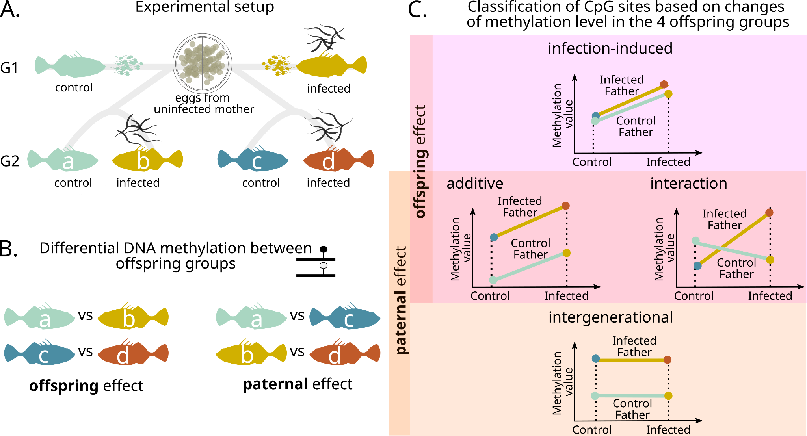

**Figure 1. Theoretical framework and experimental design. (A)** Three-spined stickleback fish were infected by the trophically-transmitted parasite, *Camallanus lacustris* in a two-by-two intergenerational infection experiment. Specifically, brothers (G1) were either infected by the parasite or served as controlled. Their sperm was used to fertilise eggs from an unrelated female. Offspring (G2) were then split into two groups to be infected by the parasites of not. **(B)** The effect of the direct treatment of offspring on their DNA methylation is detected by comparing control with infected offspring from one or the other father, while the effect of paternal infection on offspring’s DNA methylation is detected by comparing offspring receiving a similar treatment (control or infected) from their father. **(C)** Based on the comparison of regression slopes between paternal treatments, each DMS can be linked with a category: (1) infection-induced, (2) intergenerational, (3) additive or (4) interaction of both paternal and direct offspring infection.

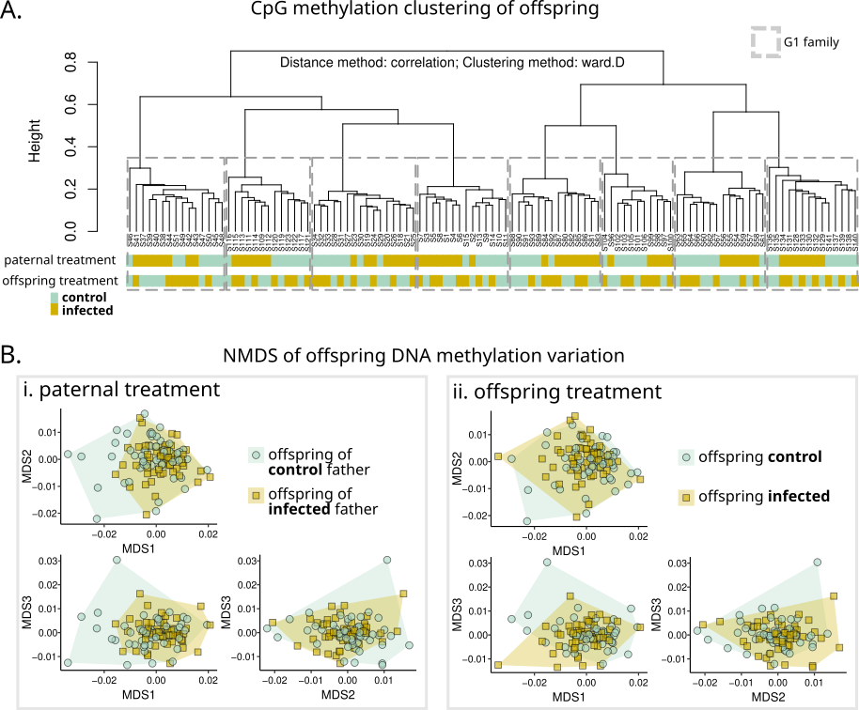

**Figure 2. Genetic background and paternal infection treatment correlate with DNA methylation variation of offspring**. (A) Hierarchical clustering of all CpG sites covered in all offspring. Father’s family, representing genetic background, is the main driver of clustering, followed by paternal infection treatment. Offspring do not cluster by their infection treatment. (B) Offspring DNA methylation variation represented on the three first axes of NMDS analysis based on Bray-Curtis dissimilarity distances. Goodness of fit for NMDS suggested the presence of six dimensions with a stress value > 0.1.

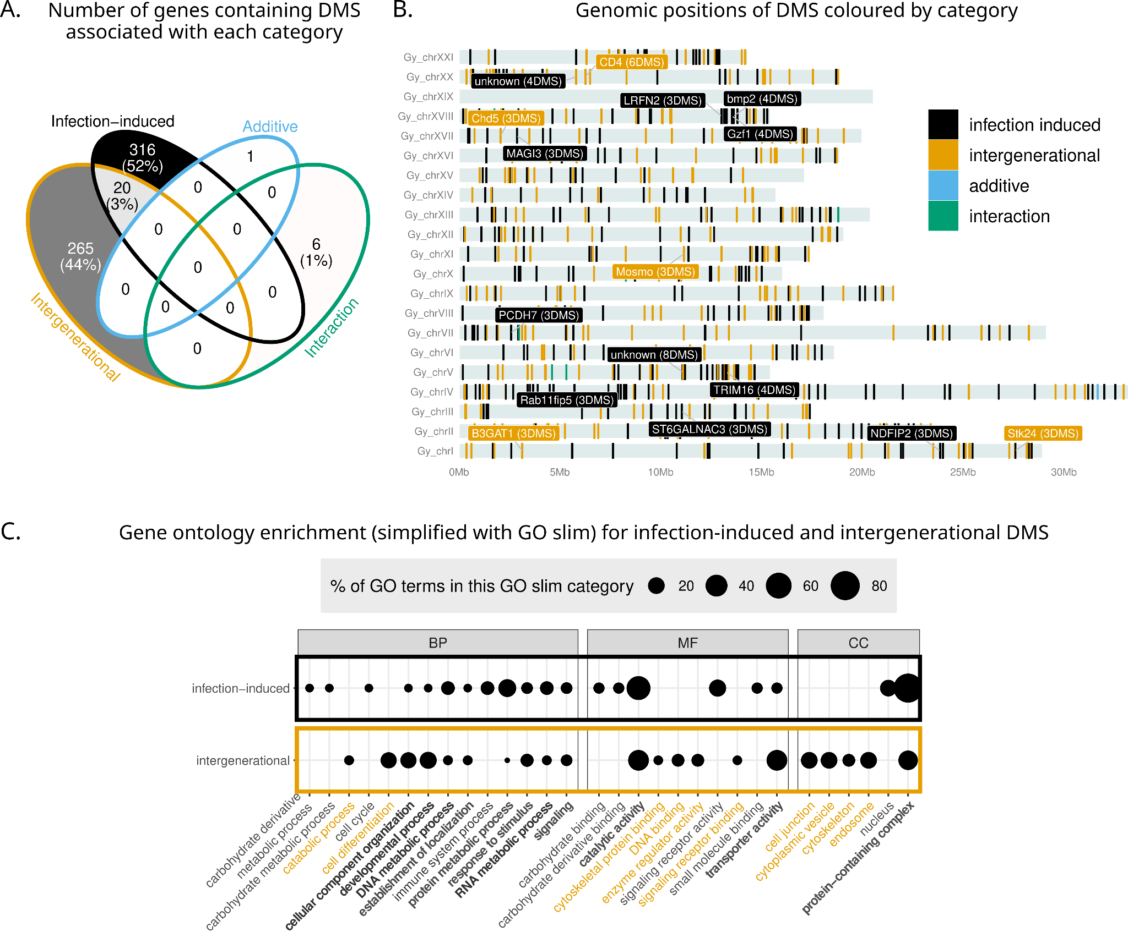**Figure 3. Differentially methylated sites (DMS) annotation. (A)** Number of genes containing DMS associated with each of the four categories (presented in **Figure 1**). 20 genes contained DMS associated with intergenerational and infection-induced categories. **(B)** Genomic positions of the DMS coloured by category. Gene names are indicated for those with 3 DMS or more, and more than 0.1 DMS per gene kilobase. **(C)** Gene ontology for the categories with most of the DMS (infection-induced and intergenerational), simplified using GOslim terms. BP: Biological processes; MF: Molecular functions; CC: Cellular components. GO slim terms in black were found only for infection-induced DMS, in orange only for intergenerational, in bold for both.

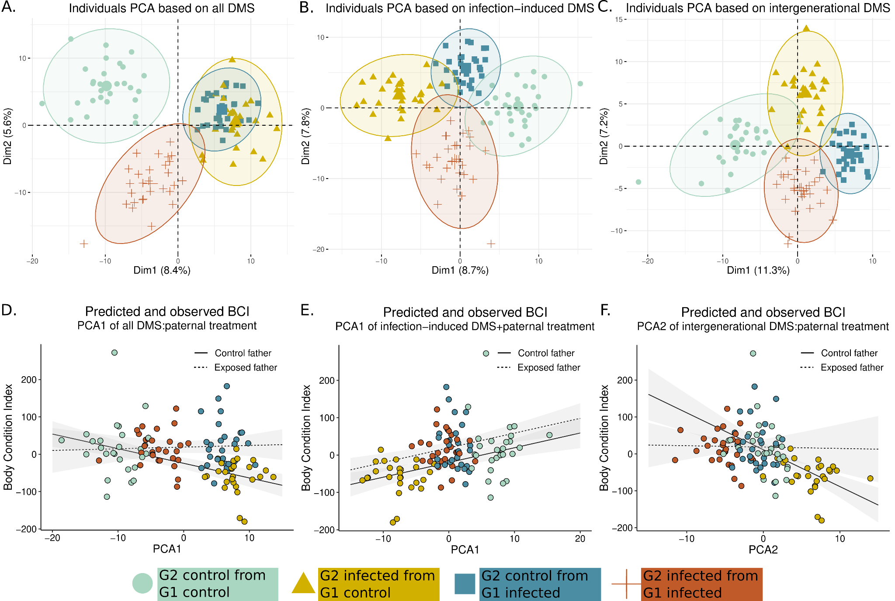

**Figure 4. Link between tolerance, paternal effects and DNA methylation at the identified DMS.** PCA of offspring methylation at all DMS (A), infection-induced DMS (B) and intergenerational DMS (C) show distinct methylation patterns for each treatment group. Body condition explained by father treatment and methylation at DMS for all DMS (D), infection-induced DMS (E) and intergenerational DMS (F).