# **Resistance and tolerance to *Eimeria* in the European house mouse hybrid zone**

Genetic diversity in animal hybrids can affect each physiological system differently. If reproduction usually suffers from breakdown of coadapted complexes, resistance to parasite could benefit from the novelty brought by recombination. The question of hybrid relative resistance or susceptibility to parasites in the European house mouse hybrid zone has been discussed for the past thirty years, leading to contradictory conclusions on relative hybrid fitness. But drawing conclusions on hybrid host fitness in relation to parasites requires first to investigate the link between resistance and host health. Resistance (the host’s capacity to reduce parasite burden) and tolerance (the host’s capacity to reduce impact on host health of a given parasite burden) manifest two different lines of immune defences. Trade-offs arise, as resistance limits infection load and thereby the scope of possible tolerance, and both resistance and tolerance can be costly in terms of resource allocation. During this PhD project, we assessed infections by intracellular protozoans, *Eimeria* spp., using field sampling and laboratory infection of wild and wild-derived mice from a hybrid zone between *Mus musculus domesticus* and *Mus musculus musculus*. We asked (1) whether hybrid mice are more or less resistant than their parents and (2) how resistance and tolerance are correlated, this correlation potentially differing between *Eimeria* species. We found lower intensities in hybrid hosts than in parental mice and no evidence of lowered probability of infection or increased mortality in the centre of the hybrid zone. This challenges the longstanding impression that hybrid mice are more highly parasitised than parentals. Upon experimental infection, we found a trade-off between resistance and tolerance in *E. falciformis*, but not in *E. ferrisi*. Building on previous research showing that resistance and tolerance should be studied jointly, our results show that assumptions on coupling of the two can not be transferred across even closely related parasite taxa. We showed that the impact of parasitism on hybrid fitness is a complex matter that needs to be investigated for each parasite beyond the measurement of hybrid vigour on resistance, taking into account possible trade-offs between resistance and tolerance.

# Are parasites a selective force in the European house mouse hybrid zone?

## Hybrids are not an average of their parents

Species can be defined as "*groups of actually or potentially interbreeding natural populations which are reproductively isolated from other such groups*" (“biological species concept” proposed by Mayr (1942)). Hybrids appear when two species, or more largely two genetically distinct populations, meet and reproduce (Barton and Hewitt 1985). Artificial animal hybridization may be almost as old as selective animal breeding itself. A common, old and well known example is the mule, hybrid of a female horse and a male donkey, especially enduring, able to transport heavy burden, but sterile (Leighton 1967).

Hybrids can be superior than both parental populations for specific traits such as size, strength and growth. This phenomenon, called **heterosis** or **hybrid vigour**, is especially pronounced when parents come from two inbred populations (Crow 2001a). Hybrid vigour is maximum in the first generation of crossing, F1, where heterozygosity is at its highest. The **dominance hypothesis** states that the increase of heterozygosity in hybrids leads to the purge of deleterious recessive mutations in homozygous. According to the **overdominance hypothesis**, heterozygosity at one locus can even improve some traits compared to parents (Crow 2001b). Overdominance is for example one of the possible explanations for the maintenance of high levels of genetic diversity of Major Histocompatibility Complex (MHC, set of genes coding for proteins involved in vertebrate immunity) (Read and Smith 2001; Sommer 2005). Finally, interaction between genes could participate in hybrid vigour (Schnell and Cockerham 1992)(positive epistasis), as was shown for the growth of the well-studied plant model, *Arabidopsis thaliana* (Vanhaeren et al. 2014).

However, hybridization does not necessarily result in hybrid superiority for all phenotypic traits. The heterozygous advantage can be counteracted by **genetic incompatibilities** arising from the second generation of hybrids, when recombination breaks down coadapted complexes. Firstly described by Bateson in the early 20th century (Bateson 1909), these incompatibilities arise from the admixture of (at least) two alleles that have never before coexisted, and therefore create deleterious effects when brought together from distinct populations (Dobzhansky 1936; Muller 1942; Orr 1995). Later work on *Drosophila* hybrids showed that these incompatibilities commonly involve three genes or more (Cabot et al. 1994; Palopoli and Wu 1994), and interactions between genes (Larson et al. 2018)(negative epistasis). Hybrid incompatibilities can affect hybrid relative **fitness**, i.e. its reproductive success compared to other genotypes of the same population, in this case the parental genotypes (Krimbas 2001). Total or partial **hybrid inviability** or **hybrid sterility** can act as reproductive barrier between two genetically distinct populations (Coyne 2001). In case of fertility decrease, Haldane first described that the heterogametic sex is the one more likely to be affected (Haldane 1922). Moreover, some **speciation genes** (genes underlying reproductive isolation; Wu and Ting 2004) have been identified, mainly in the genus *Drosophila* (Oliver et al. 2009). The *prdm9* gene identified in mice is so far the only vertebrate gene known to participate in hybrid male sterility (Mihola et al. 2009).

Traditionally, hybrids were thought of as a rarity, but it seems now that a large proportion of plants (10%) and animals (25%) can produce hybrids in nature (Mallet 2005). Not only studying hybrids allows us to understand the mechanisms of speciation, but hybridization with introduced species can threaten autochthonous endangered animals, making studies of hybridization relevant for conservation biology (Simberloff 1996). Stronen and Paquet (2013) also argue that the specific ecological role of hybrids could justify their protection by conservation policies. Moreover, hybrid zones represent melting pots of genotypes that allow to explore the impact of genetic diversity on several physiological systems (e.g. reproduction, immunity).

In this thesis, we focus on a well studied system, the European house mouse hybrid zone (HMHZ).

## The European house mouse hybrid zone, a tension zone

The house mouse (*Mus musculus*) is the most widely used animal model in biomedicine. However, the vast majority of inbred lines used nowadays are not “natural” animals: they originate from pet mice from the late 19th and beginning of 20th century, and are mixtures of four different subspecies (Davisson and Linder 2004). The common ancestor to all *Mus musculus* subspecies originates from the Indo-Pakistani cradle. Several subspecies emerged after expansion from this cradle, commensal mice following human migrations (Boursot et al. 1993). At least five subspecies have been described based on phylogenetic analysis: *M. m. musculus*, *M. m. domesticus*, *M. m. castaneus*, *M. m. molossinus*, and *M. m. gentilulus*. There is a wide range of evidence that these subspecies are not in complete reproductive isolation, and that gene flow can occur between them in zones of secondary contact (Auffray and Britton-Davidian 2012). In Europe, *M. m. domesticus* (hereafter Mmd) and *M. m. musculus* (hereafter Mmm) entered into secondary contact around the Bronze Age after having taken different colonisation routes, respectively south and north of the Black Sea, and, thus, diverging (mostly) in allopatry for about half a million years (Duvaux et al. 2011; Geraldes et al. 2008, 2011). This secondary contact formed a belt of about 20 km wide and more than 2500 km long, running from Denmark to the Black Sea: the European house mouse hybrid zone (hereafter HMHZ) (Baird and Macholán 2012; Boursot et al. 1993)(**Figure 1**). Despite the fact that they can form hybrids, these two subspecies differ in several traits including pelage color, tail/body length ratio (shorter for Mmm than for Mmd) (Boursot et al. 1993), boldness and activity (Frynta et al. 2018), and male aggressiveness (Ďureje, Bímová, and Piálek 2010).

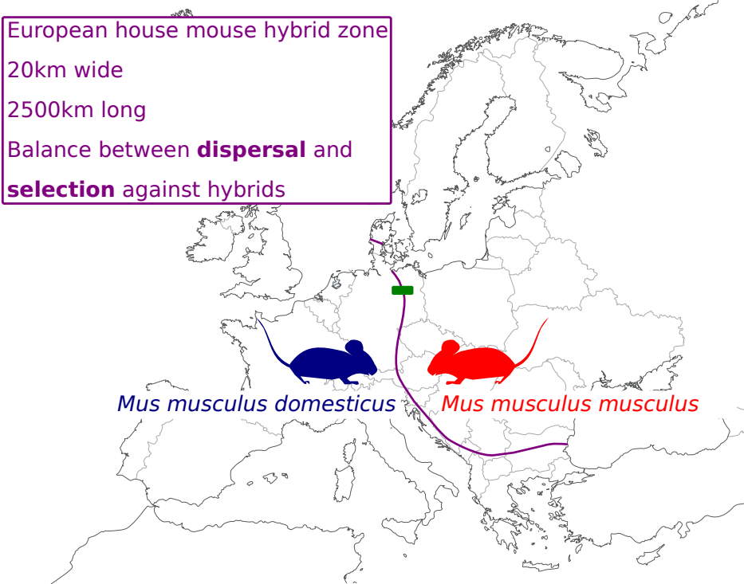**Figure 1. Approximate course of the European house mouse hybrid zone (purple line) between *Mus musculus domesticus* (blue) and *Mus musculus musculus* (red) areas** (adapted from Baird et al. (2012). Green square: Heitlinger group transect.

Through the HMHZ, the gene flow between both subspecies is not completely interrupted, and introgression of genes from one side to the other happens (Macholán et al. 2007, 2011; Macholán et al. 2019; Raufaste et al. 2005). Hybrids between Mmd and Mmm are highly recombinant, presenting a range of genotypes, and no F1 or early-generation hybrids have been found (Macholán et al. 2007). Numerous genetic studies performed over geographically independent transects of the HMHZ (e.g. Macholán et al. 2007; Payseur, Krenz, and Nachman 2004; Raufaste et al. 2005) give strong support to the **tension zone** model in this system: the immigration of less hybridized mice to the centre of the zone, increasing the hybrid population size, is balanced by endogenous selection against hybrids (Baird and Macholán 2012; Barton and Hewitt 1985; Boursot et al. 1993). This negative selection of hybrids seem to be linked with sterility or fertility (Baird and Macholán 2012) and disruption of their spermatogenesis has been shown (Albrechtová et al. 2012; Martincová et al. 2019; Turner, Schwahn, and Harr 2012; Turner and Harr 2014).

Additionally, interaction with parasites (in this thesis, we will use the term “parasite” in the restricted eukaryotic sense, unless stated otherwise) has long been suggested to participate in the maintenance of the HMHZ. The next section will describe the long-lasting controversy around this issue.

## Parasites as hosts’ selective factor

Parasites are ubiquitous in natural systems and affect human and animal health alike (Schurer et al. 2016). Their close interaction with their hosts over several generations and incentive to develop tactics to escape the host immune system led to consider parasites as plausible selective force for their hosts (Schmid-Hempel 2009). There is evidence that parasites can manipulate vertebrate hosts behaviour, including the part related with reproduction (Klein 2003). They can also affect their host community structure as was shown empirically in macroinvertebrates of New Zealand, where nematode density on cockles affect the full intertidal community (Mouritsen and Poulin 2005). It stands to reason that parasitic infections have been hypothesised to be a potential driving factor of maintenance or break-up of species barriers in hybrid zones (Sage et al. 1986) (**Figure 2**).

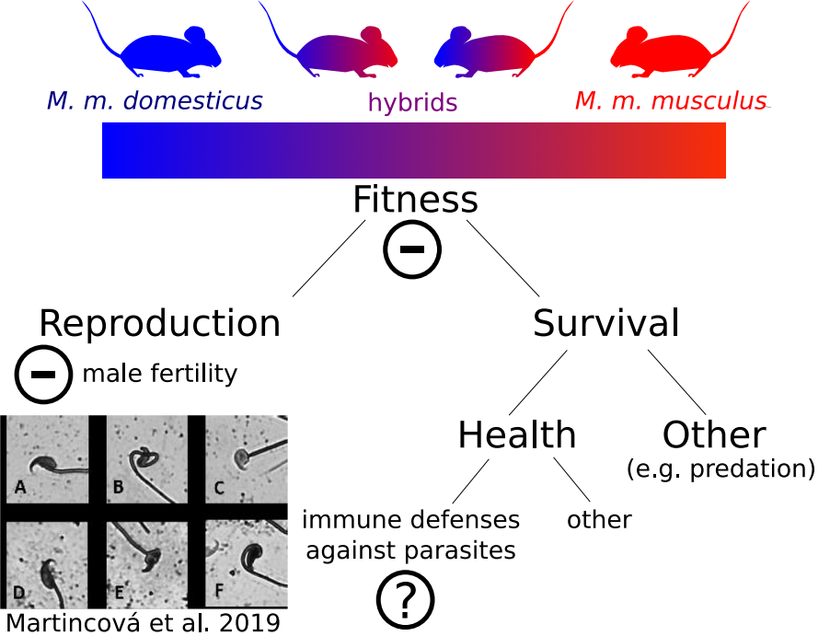**Figure 2. Hybrid fitness is reduced in the HMHZ (Baird & Macholán 2012).** Reproduction is negatively affected in hybrids, mainly via disruption of spermatogenesis (photography: various sperm heads from F1 experimentally produced hybrids. Figures A & D: normal sperm heads; Figures B, C and E, F: abnormal sperm heads (source: Martincova et al. 2019). How hybrid health is affected by parasites is a long lasting debate.

The HMHZ is the first animal hybrid zone studied for differences in parasite loads (Sage et al. 1986). Original results seemed to indicate elevated worm load in hybrids. This was interpreted as hybrid incompatibilities: after having evolved separately within each subspecies, coadapted gene complexes in the immune system would be broken down in hybrids, which would lead to fitness reduction (Moulia et al. 1991, 1993; Sage et al. 1986). However, further infection studies showed inconsistencies. Hybrids showed higher parasite loads compared to parents with the protozoan *Sarcocystis muris* (Derothe et al. 2001), but reduced parasite loads (i.e. hybrid vigour on resistance) not only in F1 (Moulia et al. 1995) but also in later recombinant crossings F3 and F4 (Derothe et al. 2004) following laboratory infection with helminths. More recently, a field study confirmed that hybrids had reduced helminth loads compared to parentals (Baird et al. 2012).

All these different studies disagree on two major points: (1) the direction of hybrid effect of parasitism (are hybrids more resistant or more susceptible to parasites?) and (2) the role of parasites as selective factor. Indeed, to fully understand the possible impact of parasites on animals in the HMHZ, one must answer this question: does a change in parasite load necessarily imply a change in fitness? Before making assumptions on the impact of parasites on host fitness, there is a need to explore more thoroughly the different defense mechanisms of mice against parasites.

# Host immune defenses against parasites

## Resistance and tolerance

Parasites are by definition harmful to their hosts, and therefore imply costs (“Parasitism” 2019). These can be direct, including tissue damages and drain of host nutrients, or indirect, for instance, the decline of body condition that can lead to higher susceptibility to further infections (Beldomenico et al. 2008), or by increasing susceptibility to predation (Bakker, Mazzi, and Zala 1997; Östlund-Nilsson et al. 2005). Hosts can defend themselves against parasitic infections in numerous ways. The first line of protection is provided by avoidance of parasites. If this strategy fails and the host gets infected, then the host immune system steps in (Schmid-Hempel 2013). **Resistance** is the ability of a host to reduce its pathogen burden. It results from host defense against infection or proliferation (Råberg, Graham, and Read 2009). Resistance reduces parasite fitness by definition. However, when the immune response targeted at the parasite causes disease to the host (**immunopathology**), resistance can reduce host fitness too (Graham, Allen, and Read 2005).

To deal with both the direct damages created by parasite infection and immunopathology, a second line of defense comes into play. **Disease tolerance** (not to be confused with immune tolerance which is the unresponsiveness of an immune system to a pathogen) is the ability of a host to reduce the damage induced by a certain parasite burden (Råberg, Graham, and Read 2009), on health (**mortality tolerance**) or more indirectly on fecundity (**sterility tolerance**) (Best, White, and Boots 2008). It is usually measured as the slope of a fitness trait, often a health measurement supposed to alter fitness eventually (e.g. body weight), on parasite load. It can be calculated in two ways: **range tolerance** measures a reaction norm, i.e. a change of phenotypic expression of the fitness trait in one genotype across a range of environments (in this case, several parasite loads). **Point tolerance** instead measures health at one single parasite load. These two measures can possibly give different results when different hosts present different health conditions when not infected with parasites, or when the relationship between health and parasite load is not linear (Little et al. 2010). This can be problematic for field studies, where host health for a null parasite load and health-parasite load relationship are usually unknown, as confounding factors (e.g. coinfections, age, lactation status) come into play. Tolerance by definition increases the overall host fitness for a particular parasite load. Contrary to resistance, tolerance also increases parasite fitness, e.g. by providing parasite with a longer living niche, the host (Kutzer and Armitage 2016; Miller, White, and Boots 2006; Roy and Kirchner 2000).

Resistance and tolerance are costly: in order to defend themselves against parasites, hosts consume resources that could have otherwise been used for other physiological functions (Sheldon and Verhulst 1996). In the next section, we will examine the nature of the costs of defense mechanisms for the hosts. For the sake of conciseness, unless otherwise stated, we will focus on vertebrate hosts.

## Immune defenses are costly

Resistance can result from a large range of mechanisms, from simple presence of unspecific biological barriers, to limitation of specific parasite growth. For the latter, the activation of innate and adaptive immune arms of the immune system comes with an energetic cost to the host (Schmid-Hempel 2013). This cost is typically measured by associating individual parasite load with fitness-associated functions. For example, resistance to parasites measured as (inverse of) fecal egg counts is reduced in lactating females in several animals including bighorn ewes (Festa-Bianchet 1989) and spotted hyena (East et al. 2015). Lactation is a critical life-history stage for the survival of offspring and resource-demanding to the mother, hence it is hypothesised to be prioritised over maximum resistance to parasites.

After establishment of infection, several mechanisms act to increase tolerance, without targeting parasite growth, but rather the consequences of infection on host fitness. These mechanisms, much less studied than resistance mechanisms, mainly consist in protection from tissue damage or from alteration of host physiology, caused by pathogens or by the immune response (Medzhitov, Schneider, and Soares 2012). For example, (Reece, Siracusa, and Scott 2006) have shown that inflammation in the lungs of mice induced by infection with the hookworm *Nippostrongylus brasiliensis* is reduced by the induction of alternatively activated alveolar macrophages. In another rodent, field voles, (Jackson et al. 2014) identified a mediator of T helper type 2 (Th2) immunity (the transcription factor Gata3) as tolerance marker, improving body condition and survival upon infection with macroparasites in mature animals. In this system, Gata3 was also negatively correlated with testis weight, suggesting a cost of tolerance in terms of reproductive effort.

The optimal level of both defense mechanisms is determined by the balance between costs associated with parasitism, with resistance and with tolerance (Sheldon and Verhulst 1996). Theory predicts that resistance alleles should present polymorphisms maintained by balancing selection, while tolerance alleles should evolve to fixation (Roy and Kirchner 2000; Miller, White, and Boots 2006). Nevertheless, empirical studies do not all detect such pattern. Laboratory mouse strains infected with *Plasmodium chabaudi* (Råberg, Sim, and Read 2007) present a negative correlation between resistance and tolerance (a given strain presenting intermediate levels of resistance and tolerance, high resistance and low tolerance, or vice versa). Similar results were found in infection of sea trout (*Salmo trutta trutta*) and Atlantic salmon (*Salmo salar*) with the trematode *Diplostomum pseudospathaceum* (Klemme and Karvonen 2016). This could be due to the redundancy of resistance and tolerance, resulting in trade-offs (Restif and Koella 2004; Fornoni et al. 2004).

Kutzer and Armitage (2016) noted that if studies addressing resistance are common, those addressing tolerance are more scarce. They suggest increasing the number of longitudinal studies and note that a host-centric view of tolerance is unsatisfactory, as host fitness also depends on the parasite **virulence**. In its strict sense, virulence means host mortality rate caused by parasite infection (Anderson and May 1982); in a more general sense evolutionary biologists sometimes use it as reduction of host fitness (health or fecundity) upon infection (Little et al. 2010). For the reasons above developed, studying jointly resistance and tolerance is necessary to correctly assess the impact of parasites on their hosts. Importantly, this requires suitable host-parasite models, possibly with various levels of virulence in the same host.

# Our parasite model: *Eimeria* spp.

## *Eimeria* spp. trigger a Th1 immune response

We have seen earlier (1.1.3.) that the majority of studies (and all of the field studies) investigating the role of parasitism in the maintenance or break-down of species barrier in the European house mouse hybrid zone focused on helminths. As extracellular macroparasite, they trigger mainly a Th2 immune response (Sher and Coffman 1992). The effect of hybridization in terms of immune defenses of hybrid mice against parasites relatively to parental mice (higher, lower, or average) could depend on the type of immune response triggered. For this reason, we chose to focus our work on an intracellular microparasite genus, triggering a T helper type 1 (Th1)-mediated response (Sher and Coffman 1992), *Eimeria*. In our second Chapter, we considered also helminths (more precisely pinworms) for comparison.

The genus *Eimeria* belongs to the phylum of Apicomplexan, which contains only parasites. Their host range is extremely wide and includes birds, mammals, reptiles, amphibians and fish (Chapman et al. 2013). They are described particularly well in domestic animals due to their economical importance, especially in poultry (Blake and Tomley 2014), but can also be found in wild animals, where they are potentially problematic for conservation (Jeanes et al. 2013; Knowles et al. 2013; Matsubayashi et al. 2018). Each of the >1800 described *Eimeria* species is generally considered strictly host specific (Duszynski 2011), but the recent use of multilocus genetic markers method in rodents showed that this host specificity could be less strict than previously thought (Jarquín-Díaz et al. 2020). *Eimeria* oocysts, the infectious stage, are released in the environment via the feces and infect the next host by oral-fecal contamination. The parasites infect epithelial digestive cells of their hosts, which leads to malabsorption of nutrients and weight loss. The *Eimeria* life cycle presents both asexual (schizogony) and sexual (gametogony) phases, and takes place in a single host (Burrell et al. 2019).

*E. falciformis* is the gold standard for murine *Eimeria* research. Host defense mechanisms against this parasite are well studied (see for example) (Mesfin, Bellamy, and Stockdale 1978; Pogonka et al. 2010; Schmid et al. 2012) and its whole genome is sequenced and annotated (Heitlinger et al. 2014). T-cells have been shown to play a major role in the defense against *E. falciformis* infection (Mesfin and Bellamy 1979; Stiff and Vasilakos 1990). Following infection, interferon γ (IFNγ) is upregulated (Schmid et al. 2014), and experimental infections showed higher weight loss and pathology but lower oocysts shedding in IFNγ-deficient mice than in wild type (Stange et al. 2012). IFNγ could in this respect be seen as a tolerance factor. (Ehret et al. 2017) compared host and *E. falciformis* transcriptomes (dual transcriptomes) in immunocompetent and immunodeficient laboratory mice, and in naïve and challenged laboratory mice. They did not find differences in the gene expression profile of this parasite between hosts, and concluded that *E. falciformis* does not respond plastically to the host environment but rather present a genetically canalised (“hard wired”) program of infection.

By considering *Eimeria* spp. and helminths jointly, triggering Th1 and Th2 immune responses, we attempted to assess the generality of hybrid response in nature (**Chapter 2**). On a note of caution, in the field, one can only assess the impact of parasite species that are prevalent enough to allow robustness of statistical tests. Using a complementary laboratory approach can solve this issue (**Chapter 3**).

## Focus on two *Eimeria* species: *E. falciformis* and *E. ferrisi*

In a recent study performed by our group in the HMHZ, three *Eimeria* species have been identified: *E. ferrisi*, *E. falciformis*, and *E. vermiformis* with prevalences of 16.7%, 4.2% and 1.9%, respectively (Jarquín-Díaz et al. 2019). Current markers were not able to detect a population structure for *Eimeria* spp. in the HMHZ (Jarquín-Díaz et al. 2020). The two most prevalent *Eimeria* species, *E. ferrisi* and *E. falciformis*, present close ecological niches (*E. ferrisi* infects the cecum villar epithelial cells and *E. falciformis* the cecum crypt cells)(Schito, Barta, and Chobotar 1996), but different virulence in laboratory mice. More precisely, the life cycle of *E. ferrisi* is shorter than that of *E. falciformis* (Al-khlifeh et al. 2019; Schito, Barta, and Chobotar 1996). They both provoke similar symptoms in laboratory mice, mainly diarrhea, lesion of the enteric epithelium, and weight loss (Ankrom, Chobotar, and Ernst 1975; Ehret et al. 2017; Schito, Barta, and Chobotar 1996). In a study using the laboratory Swiss mouse strain, (Tilahun and Stockdale 1981) found a higher mortality rate for *E. ferrisi* (2 out of 5 mice died when infected with 10 ${}^{5}$ oocysts) than for *E. falciformis* (no death observed for the same inoculum). Though, they note that a former study described another isolate of *E. falciformis* far more lethal, killing mice from an inoculum of 2000 oocysts (Mesfin, Bellamy, and Stockdale 1978). More recently, using a lower infective dose (200 oocysts) on the laboratory NMRI mouse strain, we observed a stronger virulence of two different isolates of *E. falciformis* compared with one of *E. ferrisi*, both in terms of weight loss and mortality, correlated with a stronger immunopathology (Al-khlifeh et al. 2019). The observed discrepancies in these in vivo experiments can be due to potential attenuation of virulence in case oocysts are collected early in the infection cycle (McDonald and Shirley 1987), to modified virulence of specific parasite isolate over time in the lab, or to different immune systems of each mouse strain. *E. ferrisi* has been less intensively studied than *E. falciformis*; nevertheless, mortality after infection and oocysts output were found to differ between eight tested laboratory mouse strains, and T-cells also play a role in resistance to this parasite (Klesius and Hinds 1979).

## Proxies for resistance and tolerance to *Eimeria* spp.

Resistance against murine *Eimeria* species can be estimated by the inverse of parasite load. In our field study (**Chapter 2**), *Eimeria* load was measured by the quantity of parasite DNA in the infected tissues (ileum and caecum) per mouse DNA. More specifically, we used the quantitative Polymerase Chain Reaction (qPCR) technique to estimate the quantity of a parasite mitochondrial gene relatively to a mouse housekeeping gene used as reference (Al-khlifeh et al. 2019; Jarquín-Díaz et al. 2019). This technique which allows to quantify the internal stages of the parasite requires to sacrifice the animal, and is therefore an "endpoint" technique, not usable for time series analyses. We also assessed the impact of infection on host health: body condition was calculated as individual residuals from ordinary least-squares regression of body weight by body length (separately for males and females). Of note, this is not an estimation of tolerance, as individual weight before infection cannot be known in the field (apart from capture-marked-recapture, an approach that we excluded as it would have significantly reduced the number of mice and locations visited).

Our complementary laboratory experiment allowed us to measure the parasite load in the same individual along the course of infection, estimating this time parasite reproductive output (oocysts count per gram of feces, or OPG). We found it correlated with parasite load at the peak of infection, and used this second measurement as a proxy for (inverse of) resistance. More importantly, tolerance could be estimated for each mouse genotype, as a reaction norm, i.e. a relative weight loss across a range of parasite load, for a given host group. This is developped in **Chapter 3**.

# Aims of this thesis

**Aim 1. Solving conflicting findings regarding the effect of host hybridization on resistance to parasites in the HMHZ**. We addressed the generality of hybrid response by considering simultaneously our protozoan model (*Eimeria* spp.) and helminths (pinworms), in a new transect of the HMHZ, including four years of mice sampling. To distinguish between interpretations of parasitemia we asked if (i) parasite loads are higher or lower in hybrids compared to parentals, and (ii) if these loads are consistent, or differ, between prevalent representative helminth and protozoan species. This topic is covered in **Chapter 2**.

**Aim 2. Testing the coupling of resistance and tolerance against two murine *Eimeria* species**. In a laboratory infection, we asked if *E. ferrisi* and *E. falciformis* showed the same resistance and tolerance coupling patterns in eight different mouse groups. This will inform on the importance of measuring tolerance, or if it can be predicted from resistance, as the latter is easier to measure (e.g. in field sampling). An understanding of this potential coupling will allow to gain insight on impact of parasites on hybrid fitness. This topic is covered in **Chapter 3**.

# Summary of the studies

Using field sampling and laboratory infection of wild and wild-derived mice from the European house mouse hybrid zone (HMHZ) between *M. m. domesticus* and *M. m. musculus*, we asked (1) whether hybrid mice are more or less resistant than their parents to *Eimeria* spp., and (2) whether resistance and tolerance are decoupled in two *Eimeria* species.

In **Chapter 2**, we found that for both intracellular *Eimeria* spp. and extracellular pinworms, parasite intensities are significantly lower in hybrid mice than in parental genotypes. We tested potential over or under-mortality of hybrids, as well as difference of prevalence in the centre of the zone, and could not detect either of these effects. We concluded that hybrid mice are more resistant to parasites than their parents in this system (**Figure 3**).

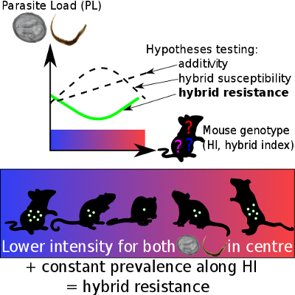**Figure 3. Lower intensity of infection with intracellular *Eimeria* spp. and extracellular pinworms in the centre than in the edges of the HMHZ without evidence of decreased parasite prevalence towards the centre: hybrid resistance hypothesis is favoured.** The hybrid index is represented as a gradient ranging from 0 (pure Mmd, in blue) to 1 (pure Mmm, in red)

These findings alone do not allow to draw conclusions on hybrid host fitness in relation to parasites. In order to do so, there is a need to investigate the link between resistance and host health, or more precisely to test the coupling between resistance and tolerance, which was the second aim of this thesis. In **Chapter 3**, we infected four wild-derived inbred strains, two Mmd and two Mmm, with three isolates from two *Eimeria* species, namely *E. falciformis* and *E. ferrisi*. We found a trade-off between resistance and tolerance for *E. falciformis*, and that these defense mechanisms were decoupled for *E. ferrisi*. We demonstrated the necessity of studying not only resistance but also tolerance in order to assess the impact of parasite on health, and to do so at the parasite species level (**Figure 4**).

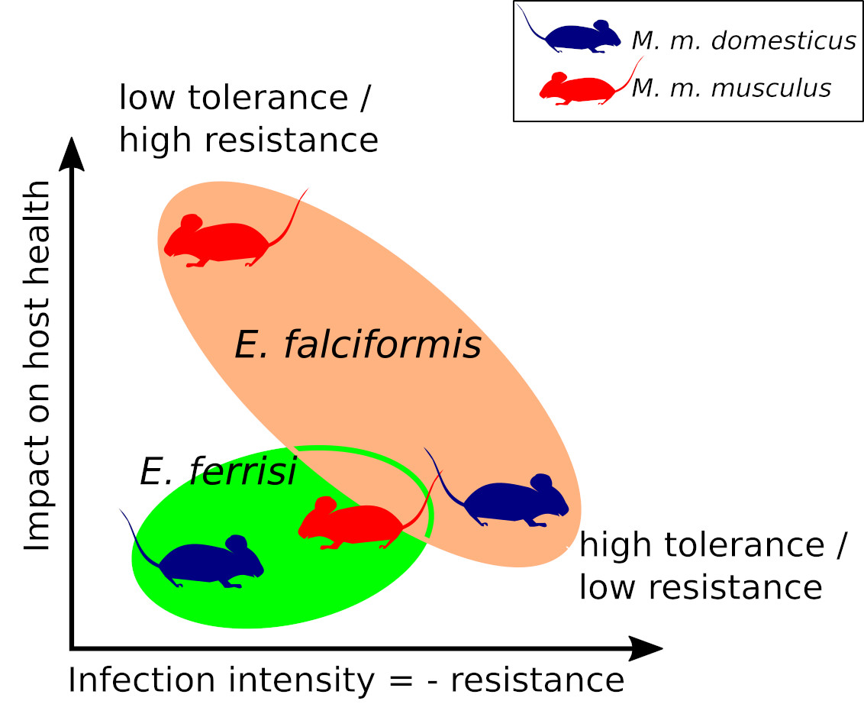**Figure 4. Coupling between resistance and tolerance for two different *Eimeria* species.** Upper left corner: low tolerance area (strong impact on health despite low parasite load). Lower right corner: high tolerance area. We found a resistance/tolerance trade-off upon infection with *E. falciformis*, absent in the case of *E. ferrisi*

The results of our first study (**Chapter 2**) indicate that hybrid mice resist parasites better than parental subspecies. If there are incompatibilities in the hybrid genomes associated with resistance, they are likely compensated by the advantage of recombinations. As presented in the introduction of this thesis, previous field studies and laboratory experiments failed to reach a consensus. We believe it is necessary to review previous studies on hybrid resistance in this system in an attempt to settle the debate.

# Discrepancies between studies on hybrid resistance or susceptibility to parasites in the HMHZ are likely explained by methodological issues

At the light of our new results, and in order to understand the discrepancies between studies, we summarise in **Table 1** the key characteristics of each study explicitly addressing differences between hybrid and parental subspecies parasite load in the HMHZ.

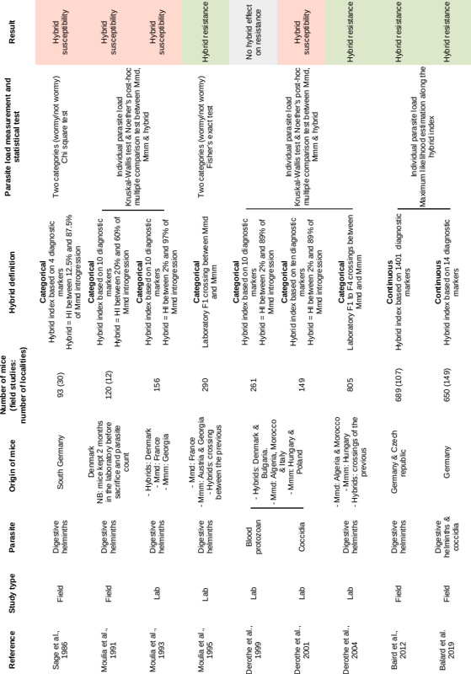**Table 1. List of studies addressing relative parasite load of hybrids compared to parental subspecies in the HMHZ.** The last column shows the main result of each study, either “hybrid susceptibilities” if hybrids were found to harbour significantly more parasites than parental subspecies, “hybrid resistance” in the opposite case, and in one case “no hybrid effect on resistance” if no significant difference between parasite load in hybrids and parental subspecies could be detected.

Reviewing the main differences between all studies, we see first that there seems to be a change over time, from hybrid susceptibility to hybrid resistance. In particular, the two field studies concluding on hybrid susceptibility (Sage et al. 1986; Moulia et al. 1991) rely on data collected about twenty years earlier than the two field studies concluding on hybrid resistance (Baird et al. 2012; Balard et al. 2020). One could suspect a change of hybrid response to parasite in terms of resistance of susceptibility over time. Indeed, (Wolinska, Lively, and Spaak 2008) proposed that parasites could represent a dynamic selective force in hybrid zones. Frequency-dependent selection could explain oscillations between hybrid resistance and hybrid susceptibility scenarios. According to this model, parasites adapt alternatively to the most common host taxon, represented either by parents or by hybrids. If parasites decrease host fitness, the relatively more infected host taxon decreases in prevalence. Eventually the other taxon becomes the most common one, targeted by parasites, and the cycle goes on. Nevertheless, as noted by (Baird et al. 2012), the HMHZ system lacks F1 and early generations hybrids: late generation, highly recombinant hybrids represent a highly diverse genetic pool of individuals rather than one homogeneous taxon. Thus, this frequency-dependent selection dynamic is unlikely to apply in our system. Then, the question of hybrid resistance/susceptibility has been asked in a full range of geographical locations (column “Origin of mice” of **Table 1**). Hybrids could be either more susceptible or resistant to parasites in different part of the zone. This is nevertheless contradicted by the fact that several studies performed in Germany on the same parasites, intestinal helminths, showed opposite results (hybrid susceptibility: (Sage et al. 1986);(hybrid resistance:(Baird et al. 2012; Balard et al. 2020).

Technical and statistical differences between the studies seem more likely to explain the observed discrepancies. One major difference between studies is the characterisation of hybrids (see **Table 1**). The two more recent studies (including ours), besides examining the highest number of mice, considered these mice on a continuum of hybridization rather than as in arbitrary categories. Moreover, each study using the categorical approach used a different threshold, the more stringent (Moulia et al. 1991) considering that a mouse presenting between 20 to 60% of Mmd alleles constitutes a hybrid, the more relaxed ((Moulia et al. 1993)) 2 to 97%. Dichotomization of continuous variables, the practice of converting data sampled along a continuum into categories, is harmful to data analysis (MacCallum et al. 2002). In our system, if there is an effect of hybridization on immune genes, hybrid resistance or susceptibility must be higher in the most introgressed mice (Baird et al. 2012). Dichotomization of hybrid index ignores this relationship, and can mislead the results.

To conclude on this section, we can say that the pioneer study (Sage et al. 1986) raised a fascinating question regarding the possible role of parasites in the hybridization process. About this first work, (Klein 1988) wrote that “the data are too preliminary to qualify for inclusion in a textbook”. He qualifies the conclusion of this study “a finding that still awaits confirmation on a truly representative sample”. It seem likely that original limitations of statistical methods are the main reason for the observed discrepancies in the follow up works. At the light of our summarized review, we can be confident that hybrids in the HMHZ are more resistant to parasites than parental subspecies.

As described in the introduction of this thesis, there has been a long lasting controversy on (1) the relative load of parasites in hybrids vs. parentals, and (2) the effect of parasitism as selective factor against hybrid mice in the HMHZ. Once agreed on the direction of hybrid effect on resistance to parasite, one needs to question the actual effect of an increased resistance on the overall fitness of hybrids.

# Studies of parasite selective pressure on their hosts require a switch of focus from resistance to tolerance

Since the end of 1990s, numerous studies have discussed the role of parasites in hybridizing animal systems (see reviews by (Fritz, Moulia, and Newcombe 1999), (Karvonen and Seehausen 2012) and (Theodosopoulos, Hund, and Taylor 2019)). Of note, (Baird and Goüy de Bellocq 2019) argue that directly linking differential resistance to differential fitness in hybrids compared to parents is a dangerous shortcut, because tolerance could distort the link between parasite load and fitness. Unfortunately, only a few studies focusing on parasite as selective factors in hybridizing systems measure jointly resistance and tolerance in hybrids compared to parents. For example, in the freshwater snails genus *Melanopsis*, resistance against trematodes was found higher in hybrids than in parental taxa, and damaging parasite-induced gigantism (a measure of tolerance) was absent in hybrids and present in all parental taxa (Guttel and Ben-Ami 2014). Such approach truly allows to conclude on an impact of parasitism on the maintenance of species barrier in this system.

In our system, the field study alone allowed to test relative hybrid resistance, but testing relative hybrid tolerance was particularly challenging (**Chapter 2**). Moreover it would not have been possible to test the difference between *Eimeria* species in the field due to the low prevalence of *E. falciformis* leading to a lack of statistical power. We chose to use a complementary laboratory approach to address resistance and tolerance altogether. Although laboratory inbred mice represent only a small proportion of the diversity observed in the wild, we were able to gain insight on the coupling of resistance and tolerance in both parental subspecies (**Chapter 3**). More specifically, Eastern mice (Mmm) strains resist the parasite *E. falciformis* similarly or even more than Western (Mmd) mouse strains, but do not tolerate it as well. We can argue that the tolerance mechanisms involved in response to infection by this parasite differ in each host subspecies. During hybridization, the increased resistance of hybrids against *Eimeria* likely comes from recombinations in parts of the immune system responsible of resistance (**Chapter 2**). There is no evidence that tolerance, especially if implying different mechanisms in each parental subspecies, would be affected the same way upon hybridization. Preliminary experimental infection of four F1 crossings (two outbred pure subspecies (Mmd or Mmm), and two Mmd-Mmm hybrids) did not allow to detect effect of hybridization on tolerance (unpublished data), though this experiment contained a low number of mice and has to be repeated to gain sufficient statistical power. At this stage, we might still assume that parasites could play a role as selective factor advantaging (or penalising) hybrids in the HMHZ, even if our sample does not show such a role, which is an incentive for further experimental testing.

# Conclusion and perspective

During this PhD project, we argue that we settled the debate on hybrid resistance or susceptibility to parasites in the European house mouse hybrid zone: hybrid mice are more resistant to parasites than parental host subspecies, and contradicting results of part of the previous studies likely find their origin in technical and statistical limitations. Moreover, we found differences in coupling of resistance and tolerance between two closely related parasites in laboratory infection, showing the necessity of measuring jointly resistance and tolerance before drawing conclusions on the impact of parasitism on species barriers.

In future, relative tolerance in hybrids compared to parental mice could be assessed in a control setting. To control for the deleterious effects of inbreeding, one should compare tolerance to both *Eimeria* species between intra- and inter-subspecies mouse groups, using for example the maximum likelihood optimization approach developped in **Chapter 2**. This would allow to finally tackle the issue of impact of parasite on species barrier in this system.

# References

Albrechtová, Jana, Tomáš Albrecht, Stuart J. E. Baird, Miloš Macholán, Geir Rudolfsen, Pavel Munclinger, Priscilla K. Tucker, and Jaroslav Piálek. 2012. “Sperm-Related Phenotypes Implicated in Both Maintenance and Breakdown of a Natural Species Barrier in the House Mouse.” *Proceedings of the Royal Society B: Biological Sciences* 279 (1748): 4803–10. <https://doi.org/10.1098/rspb.2012.1802>.

Al-khlifeh, E., A. Balard, V. H. Jarquín-Díaz, A. Weyrich, G. Wibbelt, and E. Heitlinger. 2019. “*Eimeria Falciformis* BayerHaberkorn1970 and Novel Wild Derived Isolates from House Mice: Differences in Parasite Lifecycle, Pathogenicity and Host Immune Reactions.” *bioRxiv*, May, 611277. <https://doi.org/10.1101/611277>.

Anderson, R. M., and R. M. May. 1982. “Coevolution of Hosts and Parasites.” *Parasitology* 85 (2): 411–26. <https://doi.org/10.1017/S0031182000055360>.

Ankrom, Susan L., Bill Chobotar, and John V. Ernst. 1975. “Life Cycle of *Eimeria Ferrisi* Levine & Ivens, 1965 in the mouse, *Mus Musculus*.” *The Journal of Protozoology* 22 (3): 317–23. <https://doi.org/10.1111/j.1550-7408.1975.tb05177.x>.

Auffray, Jean-Christophe, and Janice Britton-Davidian. 2012. “The House Mouse and Its Relatives.” In *Evolution of the House Mouse*, edited by Jaroslav Pialek, Milos Macholan, Stuart J. E. Baird, and Pavel Munclinger, 1–34. Cambridge University Press. <https://doi.org/10.1017/cbo9781139044547.003>.

Baird, Stuart J. E., and Joëlle Goüy de Bellocq. 2019. “Shifting Paradigms for Studying Parasitism in Hybridising Hosts: Response to Theodosopoulos, Hund, and Taylor.” *Trends in Ecology & Evolution* 34 (5): 387–89. <https://doi.org/doi.org/10.1016/j.tree.2019.01.011>.

Baird, Stuart J. E., and Miloš Macholán. 2012. “What Can the Mus Musculus Musculus/M. M. Domesticus Hybrid Zone Tell Us About Speciation?” In *Evolution of the House Mouse*, edited by Miloš Macholán, Stuart J. E. Baird, Pavel Munclinger, and Jaroslav Piálek, 334–72. Cambridge, Uk: Cambridge University Press. Cambridge University Press. <https://doi.org/10.1017/CBO9781139044547.016>.

Baird, Stuart J. E., Alexis Ribas, Miloš Macholán, Tomáš Albrecht, Jaroslav Piálek, and Joëlle Goüy de Bellocq. 2012. “Where Are the Wormy Mice? A Reexamination of Hybrid Parasitism in the European House Mouse Hybrid Zone.” *Evolution* 66 (9): 2757–72. <https://doi.org/10.1111/j.1558-5646.2012.01633.x>.

Bakker, Theo CM, Dominique Mazzi, and Sarah Zala. 1997. “Parasite-Induced Changes in Behavior and Color Make *Gammarus Pulex* More Prone to Fish Predation.” *Ecology* 78 (4): 1098–1104. [https://doi.org/10.1890/0012-9658(1997)078[1098:PICIBA]2.0.CO;2](https://doi.org/10.1890/0012-9658(1997)078%5B1098:PICIBA%5D2.0.CO;2).

Balard, Alice, Víctor Hugo Jarquín-Díaz, Jenny Jost, Iva Martincová, Ľudovít Ďureje, Jaroslav Piálek, Miloš Macholán, Joëlle Goüy de Bellocq, Stuart J. E. Baird, and Emanuel Heitlinger. 2020. “Intensity of Infection with Intracellular *Eimeria* Spp. And Pinworms Is Reduced in Hybrid Mice Compared to Parental Subspecies.” *Journal of Evolutionary Biology* 33 (4). Wiley: 435–48. <https://doi.org/10.1111/jeb.13578>.

Barton, Nicholas Hamilton, and Godfrey Matthew Hewitt. 1985. “Analysis of Hybrid Zones.” *Annual Review of Ecology and Systematics* 16 (1): 113–48. <https://doi.org/10.1146/annurev.es.16.110185.000553>.

Bateson, W. 1909. “Heredity and Variation in Modern Lights.” In *Darwin and Modern Science*, edited by A. C. Seward, 85–101. Cambridge University Press. <https://doi.org/10.1017/cbo9780511693953.007>.

Beldomenico, Pablo M, Sandra Telfer, Stephanie Gebert, Lukasz Lukomski, Malcolm Bennett, and Michael Begon. 2008. “Poor Condition and Infection: A Vicious Circle in Natural Populations.” *Proceedings of the Royal Society B: Biological Sciences* 275 (1644): 1753–9. <https://doi.org/10.1098/rspb.2008.0147>.

Best, A., A. White, and M. Boots. 2008. “Maintenance of Host Variation in Tolerance to Pathogens and Parasites.” *Proceedings of the National Academy of Sciences* 105 (52): 20786–91. <https://doi.org/10.1073/pnas.0809558105>.

Blake, Damer P., and Fiona M. Tomley. 2014. “Securing Poultry Production from the Ever-Present *Eimeria* Challenge.” *Trends in Parasitology* 30 (1): 12–19. <https://doi.org/10.1016/j.pt.2013.10.003>.

Boursot, P., J.-C. Auffray, J. Britton-Davidian, and F. Bonhomme. 1993. “The Evolution of House Mice.” *Annual Review of Ecology and Systematics* 24 (1): 119–52. <https://doi.org/10.1146/annurev.es.24.110193.001003>.

Burrell, Alana, Fiona M. Tomley, Sue Vaughan, and Virginia Marugan-Hernandez. 2019. “Life Cycle Stages, Specific Organelles and Invasion Mechanisms of *Eimeria* Species.” *Parasitology*, 1–16. <https://doi.org/10.1017/S0031182019001562>.

Cabot, E. L., A. W. Davis, N. A. Johnson, and C. I. Wu. 1994. “Genetics of Reproductive Isolation in the *Drosophila Simulans* Clade: Complex Epistasis Underlying Hybrid Male Sterility.” *Genetics* 137 (1): 175–89.

Chapman, H. David, John R. Barta, Damer Blake, Arthur Gruber, Mark Jenkins, Nicholas C. Smith, Xun Suo, and Fiona M. Tomley. 2013. “Chapter Two - a Selective Review of Advances in Coccidiosis Research.” Edited by D. Rollinson 83 (January). Academic Press: 93–171. <https://doi.org/10.1016/B978-0-12-407705-8.00002-1>.

Coyne, J. 2001. “Reproductive Isolation.” In *Encyclopedia of Genetics*, 1679–86. Elsevier. <https://doi.org/10.1006/rwgn.2001.1442>.

Crow, J. F. 2001a. “Heterosis.” In *Encyclopedia of Genetics*, edited by Sydney Brenner and Jefferey H. Miller, 933. New York: Academic Press. <https://doi.org/10.1006/rwgn.2001.0611>.

———. 2001b. “Overdominance.” In *Encyclopedia of Genetics*, 1400–1401. Elsevier. <https://doi.org/10.1006/rwgn.2001.0943>.

Davisson, Muriel T, and Carol C Linder. 2004. “CHAPTER 2 - Historical Foundations.” In *The Laboratory Mouse*, edited by Hans J Hedrich and Gillian Bullock, 15–24. London: Academic Press. <https://doi.org/10.1016/B978-012336425-8/50055-8>.

Derothe, Jean-Marc, Adeline Porcherie, Marco Perriat-Sanguinet, Claude Loubès, and Catherine Moulia. 2004. “Recombination Does Not Generate Pinworm Susceptibility During Experimental Crosses Between Two Mouse Subspecies.” *Parasitology Research* 93 (5): 356–63. <https://doi.org/10.1007/s00436-004-1145-1>.

Derothe, J.-M., N. Le Brun, C. Loubes, M. Perriat-Sanguinet, and C. Moulia. 2001. “Susceptibility of Natural Hybrids Between House Mouse Subspecies to Sarcocystis Muris.” *International Journal for Parasitology* 31 (1): 15–19.

Dobzhansky, Th. 1936. “Studies on Hybrid Sterility. II. Localization of sterility factors in *Drosophila Pseudoobscura* hybrids.” *Genetics* 21 (2): 113–35. <https://www.ncbi.nlm.nih.gov/pmc/articles/PMC1208664/>.

Ďureje, Ľudovít, Barbora Vošlajerová Bímová, and Jaroslav Piálek. 2010. “No Postnatal Maternal Effect on Male Aggressiveness in Wild-Derived Strains of House Mice.” *Aggressive Behavior* 37 (1): 48–55. <https://doi.org/10.1002/ab.20371>.

Duszynski, Donald W. 2011. “Eimeria.” In *eLS*. American Cancer Society. <https://doi.org/10.1002/9780470015902.a0001962.pub2>.

Duvaux, Ludovic, Khalid Belkhir, Matthieu Boulesteix, and Pierre Boursot. 2011. “Isolation and Gene Flow: Inferring the Speciation History of European House Mice.” *Molecular Ecology* 20 (24): 5248–64. <https://doi.org/10.1111/j.1365-294X.2011.05343.x>.

East, Marion L., Ellen Otto, Janine Helms, Dagmar Thierer, Joanne Cable, and Heribert Hofer. 2015. “Does Lactation Lead to Resource Allocation Trade-Offs in the Spotted Hyaena?” *Behavioral Ecology and Sociobiology* 69 (5): 805–14. <https://doi.org/10.1007/s00265-015-1897-x>.

Ehret, Totta, Simone Spork, Christoph Dieterich, Richard Lucius, and Emanuel Heitlinger. 2017. “Dual RNA-Seq Reveals No Plastic Transcriptional Response of the Coccidian Parasite *Eimeria Falciformis* to Host Immune Defenses.” *BMC Genomics* 18 (1): 686. <https://doi.org/10.1186/s12864-017-4095-6>.

Festa-Bianchet, Marco. 1989. “Individual Differences, Parasites, and the Costs of Reproduction for Bighorn Ewes (Ovis Canadensis).” *Journal of Animal Ecology* 58 (3): 785–95. <https://doi.org/10.2307/5124>.

Fornoni, Juan, Juan Núñez-Farfán, Pedro Luis Valverde, and Mark D. Rausher. 2004. “Evolution of Mixed Strategies of Plant Defense Allocation Against Natural Enemies.” *Evolution* 58 (8): 1685–95. <https://doi.org/10.1554/03-510>.

Fritz, Robert S., Catherine Moulia, and George Newcombe. 1999. “Resistance of Hybrid Plants and Animals to Herbivores, Pathogens, and Parasites.” *Annual Review of Ecology and Systematics* 30 (1): 565–91. <https://doi.org/10.1146/annurev.ecolsys.30.1.565>.

Frynta, Daniel, Barbora Kaftanová-Eliášová, Barbora Žampachová, Petra Voráčková, Jovana Sádlová, and Eva Landová. 2018. “Behavioural Strategies of Three Wild-Derived Populations of the House Mouse (*Mus M. musculus* and *M. m. domesticus* in Five Standard Tests of Exploration and Boldness: Searching for Differences Attributable to Subspecies and Commensalism.” *Behavioural Processes* 157 (December): 133–41. <https://doi.org/10.1016/j.beproc.2018.09.008>.

Geraldes, A., P. Basset, K. L. Smith, and M. W. Nachman. 2011. “Higher Differentiation Among Subspecies of the House Mouse (*Mus Musculus*) in Genomic Regions with Low Recombination.” *Molecular Ecology* 20 (22): 4722–36. <https://doi.org/10.1111/j.1365-294X.2011.05285.x>.

Geraldes, Armando, Patrick Basset, Barbara Gibson, Kimberly L. Smith, Bettina Harr, Hon-Tsen Yu, Nina Bulatova, Yaron Ziv, and Michael W. Nachman. 2008. “Inferring the History of Speciation in House Mice from Autosomal, X-Linked, Y-Linked and Mitochondrial Genes.” *Molecular Ecology* 17 (24): 5349–63. <https://doi.org/10.1111/j.1365-294X.2008.04005.x>.

Graham, Andrea L., Judith E. Allen, and Andrew F. Read. 2005. “Evolutionary Causes and Consequences of Immunopathology.” *Annual Review of Ecology, Evolution, and Systematics* 36 (1). Annual Reviews: 373–97. <https://doi.org/10.1146/annurev.ecolsys.36.102003.152622>.

Guttel, Yonathan, and Frida Ben-Ami. 2014. “The Maintenance of Hybrids by Parasitism in a Freshwater Snail.” *International Journal for Parasitology* 44 (13): 1001–8. <https://doi.org/10.1016/j.ijpara.2014.06.011>.

Haldane, J. B. S. 1922. “Sex Ratio and Unisexual Sterility in Hybrid Animals.” *Journal of Genetics* 12 (2): 101–9. <https://doi.org/10.1007/bf02983075>.

Heitlinger, Emanuel, Simone Spork, Richard Lucius, and Christoph Dieterich. 2014. “The Genome of *Eimeria Falciformis* - Reduction and Specialization in a Single Host Apicomplexan Parasite.” *BMC Genomics* 15 (1): 696. <https://doi.org/10.1186/1471-2164-15-696>.

Jackson, Joseph A., Amy J. Hall, Ida M. Friberg, Catriona Ralli, Ann Lowe, Malgorzata Zawadzka, Andrew K. Turner, et al. 2014. “An immunological marker of tolerance to infection in wild rodents.” Edited by David S. Schneider. *PLoS Biology* 12 (7): e1001901. <https://doi.org/10.1371/journal.pbio.1001901>.

Jarquín-Díaz, Víctor Hugo, Alice Balard, Jenny Jost, Julia Kraft, Mert Naci Dikmen, Jana Kvičerová, and Emanuel Heitlinger. 2019. “Detection and Quantification of House Mouse *Eimeria* at the Species Level – Challenges and Solutions for the Assessment of Coccidia in Wildlife.” *International Journal for Parasitology: Parasites and Wildlife* 10 (December): 29–40. <https://doi.org/10.1016/j.ijppaw.2019.07.004>.

Jarquín-Díaz, Víctor Hugo, Alice Balard, Anna Mácová, Jenny Jost, Tabea Roth von Szepesbéla, Karin Berktold, Steffen Tank, Jana Kvičerová, and Emanuel Heitlinger. 2020. “Generalist Eimeria Species in Rodents: Multilocus Analyses Indicate Inadequate Resolution of Established Markers.” *Ecology and Evolution* 10 (January): 1378–89. <https://doi.org/10.1002/ece3.5992>.

Jeanes, C., R. Vaughan-Higgins, R. E. Green, A. W. Sainsbury, R. N. Marshall, and D. P. Blake. 2013. “Two New *Eimeria* Species Parasitic in Corncrakes (*Crex Crex*) (Gruiformes: Rallidae) in the United Kingdom.” *The Journal of Parasitology* 99 (4): 634–38. <https://doi.org/10.1645/12-52.1>.

Karvonen, Anssi, and Ole Seehausen. 2012. “The role of parasitism in adaptive radiations—When might parasites promote and when might they constrain ecological speciation?” Review Article. *International Journal of Ecology* 2012: 1–20. <https://doi.org/10.1155/2012/280169>.

Klein, Jan. 1988. “Book Review.” *Immunogenetics* 28 (1): 67–69. <https://doi.org/10.1007/bf00372534>.

Klein, Sabra L. 2003. “Parasite Manipulation of the Proximate Mechanisms That Mediate Social Behavior in Vertebrates.” *Physiology & Behavior* 79 (3): 441–49. <https://doi.org/10.1016/S0031-9384(03)00163-X>.

Klemme, Ines, and Anssi Karvonen. 2016. “Vertebrate Defense Against Parasites: Interactions Between Avoidance, Resistance, and Tolerance.” *Ecology and Evolution* 7 (2): 561–71. <https://doi.org/10.1002/ece3.2645>.

Klesius, P. H., and S. E. Hinds. 1979. “Strain-Dependent Differences in Murine Susceptibility to Coccidia.” *Infection and Immunity* 26 (3): 1111–5.

Knowles, Sarah C. L., Andy Fenton, Owen L. Petchey, Trevor R. Jones, Rebecca Barber, and Amy B. Pedersen. 2013. “Stability of Within-Host–Parasite Communities in a Wild Mammal System.” *Proceedings of the Royal Society B: Biological Sciences* 280 (1762): 20130598. <https://doi.org/10.1098/rspb.2013.0598>.

Krimbas, C. B. 2001. “Fitness.” In *Encyclopedia of Genetics*, 702–6. Elsevier. <https://doi.org/10.1006/rwgn.2001.0460>.

Kutzer, Megan A. M., and Sophie A. O. Armitage. 2016. “Maximising Fitness in the Face of Parasites: A Review of Host Tolerance.” *Zoology* 119 (4): 281–89. <https://doi.org/10.1016/j.zool.2016.05.011>.

Larson, Erica L., Dan Vanderpool, Brice A. J. Sarver, Colin Callahan, Sara Keeble, Lorraine L. Provencio, Michael D. Kessler, et al. 2018. “The evolution of polymorphic hybrid incompatibilities in house mice.” *Genetics* 209 (3): 845–59. <https://doi.org/10.1534/genetics.118.300840>.

Leighton, Albert C. 1967. “The mule as a cultural invention.” *Technology and Culture* 8 (1): 45–52. <https://doi.org/10.2307/3101524>.

Little, Tom J., David M. Shuker, Nick Colegrave, Troy Day, and Andrea L. Graham. 2010. “The Coevolution of Virulence: Tolerance in Perspective.” *PLoS Pathogens* 6 (9). <https://doi.org/10.1371/journal.ppat.1001006>.

MacCallum, Robert C., Shaobo Zhang, Kristopher J. Preacher, and Derek D. Rucker. 2002. “On the Practice of Dichotomization of Quantitative Variables.” *Psychological Methods* 7 (1): 19–40. <https://doi.org/10.1037/1082-989X.7.1.19>.

Macholán, Miloš, Stuart J. E. Baird, Petra Dufková, Pavel Munclinger, Barbora Vošlajerová Bímová, and Jaroslav Piálek. 2011. “Assessing Multilocus Introgression Patterns: A Case Study on the Mouse X Chromosome in Central Europe.” *Evolution* 65 (5): 1428–46. <https://doi.org/10.1111/j.1558-5646.2011.01228.x>.

Macholán, Miloš, Stuart J. E. Baird, Alena Fornsková, Iva Martincová, Pavel Rubík, Ľudovít Ďureje, Emanuel Heitlinger, and Jaroslav Piálek. 2019. “Widespread Introgression of the *Mus Musculus Musculus* Y Chromosome in Central Europe.” *bioRxiv*, December. Cold Spring Harbor Laboratory. <https://doi.org/10.1101/2019.12.23.887471>.

Macholán, Miloš, Pavel Munclinger, Monika Šugerková, Petra Dufková, Barbora Bímová, Eva Božíková, Jan Zima, and Jaroslav Piálek. 2007. “Genetic Analysis of Autosomal and X-Linked Markers Across a Mouse Hybrid Zone.” *Evolution: International Journal of Organic Evolution* 61 (4): 746–71. <https://doi.org/10.1111/j.1558-5646.2007.00065.x>.

Mallet, James. 2005. “Hybridization as an Invasion of the Genome.” *Trends in Ecology & Evolution* 20 (5): 229–37. <https://doi.org/10.1016/j.tree.2005.02.010>.

Martincová, Iva, Ľudovít Ďureje, Stuart J. E. Baird, and Jaroslav Piálek. 2019. “Sperm Quality Parameters Are Increased and Asymmetric in House Mouse Hybrids.” *bioRxiv*, June, 666511. <https://doi.org/10.1101/666511>.

Matsubayashi, Makoto, Sayaka Tsuchida, Atsushi Kobayashi, Tomoyuki Shibahara, Hiroshi Nakamura, Koichi Murata, and Kazunari Ushida. 2018. “Molecular Identification of Two *Eimeria* Species, *E. uekii* and *E. raichoi* as Type B, in Wild Japanese Rock Ptarmigans, *Lagopus Muta Japonica*.” *International Journal for Parasitology: Parasites and Wildlife* 7 (3): 243–50. <https://doi.org/10.1016/j.ijppaw.2018.06.005>.

Mayr, Ernst. 1942. *Systematics and the Origin of Species*. Columbia University Press, New York.

McDonald, V., and M. W. Shirley. 1987. “The Endogenous Development of Virulent Strains and Attenuated Precocious Lines of *Eimeria Tenella* and *E. necatrix*.” *The Journal of Parasitology* 73 (5): 993–97.

Medzhitov, Ruslan, David S. Schneider, and Miguel P. Soares. 2012. “Disease Tolerance as a Defense Strategy.” *Science* 335 (6071): 936–41. <https://doi.org/10.1126/science.1214935>.

Mesfin, G. M., and J. E. Bellamy. 1979. “Thymic Dependence of Immunity to Eimeria Falciformis Var. Pragensis in Mice.” *Infection and Immunity* 23 (2): 460–64.

Mesfin, G. M., J. E. Bellamy, and P. H. Stockdale. 1978. “The Pathological Changes Caused by *Eimeria Falciformis* Var Pragensis in Mice.” *Canadian Journal of Comparative Medicine: Revue Canadienne de Medecine Comparee* 42 (4): 496–510.

Mihola, Ondrej, Zdenek Trachtulec, Cestmir Vlcek, John C. Schimenti, and Jiri Forejt. 2009. “A mouse speciation gene encodes a meiotic histone H3 methyltransferase.” *Science* 323 (5912): 373–75. <https://doi.org/10.1126/science.1163601>.

Miller, Martin R., Andrew White, and Michael Boots. 2006. “The Evolution of Parasites in Response to Tolerance in Their Hosts: The Good, the Bad, and Apparent Commensalism.” *Evolution* 60 (5): 945–56. <https://doi.org/10.1111/j.0014-3820.2006.tb01173.x>.

Moulia, Catherine, Nathalie Le Brun, Claude Loubes, Rolland Marin, and François Renaud. 1995. “Hybrid Vigour Against Parasites in Interspecific Crosses Between Two Mice Species.” *Heredity* 74 (1): 48–52. <https://doi.org/10.1017/S0031182000067135>.

Moulia, C., J. P. Aussel, F. Bonhomme, P. Boursot, J. T. Nielsen, and F. Renaud. 1991. “Wormy Mice in a Hybrid Zone: A Genetic Control of Susceptibility to Parasite Infection.” *Journal of Evolutionary Biology* 4 (4): 679–87. <https://doi.org/10.1046/j.1420-9101.1991.4040679.x>.

Moulia, C., N. Le Brun, J. Dallas, A. Orth, and F. Renaud. 1993. “Experimental Evidence of Genetic Determinism in High Susceptibility to Intestinal Pinworm Infection in Mice: A Hybrid Zone Model.” *Parasitology* 106 (4): 387–93.

Mouritsen, Kim N., and Robert Poulin. 2005. “Parasites Boosts Biodiversity and Changes Animal Community Structure by Trait-Mediated Indirect Effects.” *Oikos* 108 (2): 344–50. <https://doi.org/10.1111/j.0030-1299.2005.13507.x>.

Muller, H. J. 1942. “Isolating Mechanisms, Evolution, and Temperature.” *Biol. Symp.* 6: 71–125.

Oliver, Peter L., Leo Goodstadt, Joshua J. Bayes, Zoë Birtle, Kevin C. Roach, Nitin Phadnis, Scott A. Beatson, Gerton Lunter, Harmit S. Malik, and Chris P. Ponting. 2009. “Accelerated evolution of the *Prdm9* speciation gene Across diverse metazoan taxa.” *PLOS Genetics* 5 (12): e1000753. <https://doi.org/10.1371/journal.pgen.1000753>.

Orr, H. A. 1995. “The Population Genetics of Speciation: The Evolution of Hybrid Incompatibilities.” *Genetics* 139 (4): 1805–13.

Östlund-Nilsson, Sara, Lynda Curtis, Göran E. Nilsson, and Alexandra S. Grutter. 2005. “Parasitic Isopod Anilocra Apogonae, a Drag for the Cardinal Fish Cheilodipterus Quinquelineatus.” *Marine Ecology Progress Series* 287: 209–16. <https://doi.org/10.3354/meps287209>.

Palopoli, M. F., and C. I. Wu. 1994. “Genetics of hybrid male sterility Between *Drosophila* sibling species: A complex web of epistasis is revealed in interspecific studies.” *Genetics* 138 (2): 329–41. <https://www.ncbi.nlm.nih.gov/pmc/articles/PMC1206152/>.

“Parasitism.” 2019.

Payseur, Bret A., James G. Krenz, and Michael W. Nachman. 2004. “Differential patterns of introgression across the X chromosome in a hybrid zone between two species of house mice.” *Evolution* 58 (9): 2064–78. <https://doi.org/10.1111/j.0014-3820.2004.tb00490.x>.

Pogonka, Thomas, Katja Schelzke, Jörg Stange, Konstantin Papadakis, Svenja Steinfelder, Oliver Liesenfeld, and Richard Lucius. 2010. “CD8+ Cells Protect Mice Against Reinfection with the Intestinal Parasite Eimeria Falciformis.” *Microbes and Infection* 12 (3): 218–26. <https://doi.org/10.1016/j.micinf.2009.12.005>.

Råberg, Lars, Andrea L. Graham, and Andrew F. Read. 2009. “Decomposing Health: Tolerance and Resistance to Parasites in Animals.” *Philosophical Transactions of the Royal Society B: Biological Sciences* 364 (1513): 37–49. <https://doi.org/10.1098/rstb.2008.0184>.

Råberg, Lars, Derek Sim, and Andrew F. Read. 2007. “Disentangling Genetic Variation for Resistance and Tolerance to Infectious Diseases in Animals.” *Science* 318 (5851): 812–14. <https://doi.org/10.1126/science.1148526>.

Raufaste, Nathalie, Annie Orth, Khalid Belkhir, David Senet, Carole Smadja, Stuart J. E. Baird, François Bonhomme, Barbara Dod, and Pierre Boursot. 2005. “Inferences of Selection and Migration in the Danish House Mouse Hybrid Zone.” *Biological Journal of the Linnean Society* 84 (3): 593–616. <https://doi.org/10.1111/j.1095-8312.2005.00457.x>.

Read, J., and B. J. Smith. 2001. “Major Histocompatibility Complex (MHC).” In *Encyclopedia of Genetics*, 1136. Elsevier. <https://doi.org/10.1006/rwgn.2001.0784>.

Reece, Joshua J., Mark C. Siracusa, and Alan L. Scott. 2006. “Innate Immune Responses to Lung-Stage Helminth Infection Induce Alternatively Activated Alveolar Macrophages.” *Infection and Immunity* 74 (9): 4970–81. <https://doi.org/10.1128/IAI.00687-06>.

Restif, Olivier, and Jacob C. Koella. 2004. “Concurrent evolution of resistance and tolerance to pathogens.” *The American Naturalist* 164 (4): E90–E102. <https://doi.org/10.1086/423713>.

Roy, B. A., and J. W. Kirchner. 2000. “Evolutionary Dynamics of Pathogen Resistance and Tolerance.” *Evolution* 54 (1): 51–63. <https://doi.org/10.1111/j.0014-3820.2000.tb00007.x>.

Sage, Richard D., Donald Heyneman, Kee-Chong Lim, and Allan C. Wilson. 1986. “Wormy Mice in a Hybrid Zone.” *Nature* 324 (6092): 60–63. <https://doi.org/10.1038/324060a0>.

Schito, M. L., J. R. Barta, and B. Chobotar. 1996. “Comparison of Four Murine *Eimeria* Species in Immunocompetent and Immunodeficient Mice.” *The Journal of Parasitology* 82 (2): 255–62. <https://doi.org/10.2307/3284157>.

Schmid, Manuela, Emanuel Heitlinger, Simone Spork, Hans-Joachim Mollenkopf, Richard Lucius, and Nishith Gupta. 2014. “*Eimeria Falciformis* Infection of the Mouse Caecum Identifies Opposing Roles of IFNγ-Regulated Host Pathways for the Parasite Development.” *Mucosal Immunology* 7 (4): 969–82. <https://doi.org/10.1038/mi.2013.115>.

Schmid, Manuela, Maik J. Lehmann, Richard Lucius, and Nishith Gupta. 2012. “Apicomplexan parasite, *Eimeria Falciformis*, Co-Opts host tryptophan catabolism for life cycle progression in mouse.” *Journal of Biological Chemistry* 287 (24): 20197–20207. <https://doi.org/10.1074/jbc.M112.351999>.

Schmid-Hempel, Paul. 2009. “Parasites—the New Frontier: Celebrating Darwin 200.” *Biology Letters* 5 (5): 625–27. <https://doi.org/10.1098/rsbl.2009.0589>.

———. 2013. *Evolutionary Parasitology: The Integrated Study of Infections, Immunology, Ecology, and Genetics*. Oxford University Press. <https://doi.org/10.1093/acprof:oso/9780199229482.001.0001>.

Schnell, F. W., and C. C. Cockerham. 1992. “Multiplicative Vs. Arbitrary Gene Action in Heterosis.” *Genetics* 131 (2): 461–69. <https://www.genetics.org/content/131/2/461?ijkey=a497a86d6426c30b9b204de3ec005149c00aefb9\&keytype2=tf_ipsecsha>.

Schurer, J. M., E. Mosites, C. Li, S. Meschke, and P. Rabinowitz. 2016. “Community-Based Surveillance of Zoonotic Parasites in a ’One Health’ World: A Systematic Review.” *One Health* 2 (December): 166–74. <https://doi.org/10.1016/j.onehlt.2016.11.002>.

Sheldon, Ben C., and Simon Verhulst. 1996. “Ecological Immunology: Costly Parasite Defences and Trade-Offs in Evolutionary Ecology.” *Trends in Ecology & Evolution* 11 (8): 317–21.

Sher, A, and R L Coffman. 1992. “Regulation of immunity to parasites by T cells and T cell-derived cytokines.” *Annual Review of Immunology* 10 (1): 385–409. <https://doi.org/10.1146/annurev.iy.10.040192.002125>.

Simberloff, Daniel. 1996. “Hybridization Between Native and Introduced Wildlife Species: Importance for Conservation.” *Wildlife Biology* 2 (3): 143–51. <https://doi.org/10.2981/wlb.1996.012>.

Sommer, Simone. 2005. “The Importance of Immune Gene Variability (MHC) in Evolutionary Ecology and Conservation.” *Frontiers in Zoology* 2 (1): 16. <https://doi.org/10.1186/1742-9994-2-16>.

Stange, Jörg, Matthew R. Hepworth, Sebastian Rausch, Lara Zajic, Anja A. Kühl, Catherine Uyttenhove, Jean-Christophe Renauld, Susanne Hartmann, and Richard Lucius. 2012. “IL-22 Mediates Host Defense Against an Intestinal Intracellular Parasite in the Absence of IFN-γ at the Cost of Th17-Driven Immunopathology.” *Journal of Immunology* 188 (5): 2410–8. <https://doi.org/10.4049/jimmunol.1102062>.

Stiff, M. I., and J. P. Vasilakos. 1990. “Effect of in Vivo T-Cell Depletion on the Effector T-Cell Function of Immunity to *Eimeria Falciformis*.” *Infection and Immunity* 58 (6): 1496–9.

Stronen, Astrid V., and Paul C. Paquet. 2013. “Perspectives on the Conservation of Wild Hybrids.” *Biological Conservation* 167: 390–95. <https://doi.org/10.1016/j.biocon.2013.09.004>.

Theodosopoulos, Angela N., Amanda K. Hund, and Scott A. Taylor. 2019. “Parasites and host species barriers in animal hybrid zones.” *Trends in Ecology & Evolution* 34 (1): 19–30. <https://doi.org/10.1016/j.tree.2018.09.011>.

Tilahun, G., and P. H. G. Stockdale. 1981. “Oocyst Production of Four Species of Murine Coccidia.” *Canadian Journal of Zoology* 59 (9): 1796–1800. <https://doi.org/10.1139/z81-246>.

Turner, Leslie M., and Bettina Harr. 2014. “Genome-Wide Mapping in a House Mouse Hybrid Zone Reveals Hybrid Sterility Loci and Dobzhansky-Muller Interactions.” *Elife* 3: e02504. <https://doi.org/10.7554/eLife.02504>.

Turner, Leslie M., Denise J. Schwahn, and Bettina Harr. 2012. “Reduced Male Fertility Is Common but Highly Variable in Form and Severity in a Natural House Mouse Hybrid Zone.” *Evolution: International Journal of Organic Evolution* 66 (2): 443–58.

Vanhaeren, Hannes, Nathalie Gonzalez, Frederik Coppens, Liesbeth De Milde, Twiggy Van Daele, Mattias Vermeersch, Nubia B. Eloy, Veronique Storme, and Dirk Inzé. 2014. “Combining Growth-Promoting Genes Leads to Positive Epistasis in Arabidopsis Thaliana.” *Elife* 3: e02252. <https://doi.org/10.7554/eLife.02252>.

Wolinska, Justyna, Curtis M. Lively, and Piet Spaak. 2008. “Parasites in Hybridizing Communities: The Red Queen Again?” *Trends in Parasitology* 24 (3): 121–26. <https://doi.org/10.1016/j.pt.2007.11.010>.

Wu, Chung-I., and Chau-Ti Ting. 2004. “Genes and Speciation.” *Nature Reviews Genetics* 5 (2): 114–22. <https://doi.org/10.1038/nrg1269>.