# Resistance/tolerance trade-off against only one of two related parasites in mice

# Alice Balard1,2, Víctor Hugo Jarquín-Díaz1,2, Jenny Jost1, Vivian Mittné1, Francisca Böhning1, Iva Martincová3, Ľudovít Ďureje3, Miloš Macholán4, Joëlle Goüy de Bellocq3, Stuart J. E. Baird3, Jaroslav Piálek3, Emanuel Heitlinger1,2

*1 Institute for Biology. Department of Molecular Parasitology. Humboldt University Berlin (HU). Philippstr. 13, Haus 14, 10115, Berlin, Germany*

*2 Leibniz-Institut für Zoo- und Wildtierforschung (IZW) im Forschungsverbund Berlin e.V.. Alfred-Kowalke-Straße 17, 10315, Berlin, Germany*

*3 Research Facility Studenec, Institute of Vertebrate Biology, Czech Academy of Sciences, Květná 8, 603 65 Brno, Czech Republic*

*4 Laboratory of Mammalian Evolutionary Genetics, Institute of Animal Physiology and Genetics, Czech Academy of Sciences, Veveri 97, 60200 Brno, Czech Republic*

# Abstract

Resistance (the host’s capacity to reduce parasite burden) and tolerance (the host’s capacity to reduce impact on host health of a given parasite burden) manifest two different lines of immune defenses. Trade-offs arise, as resistance limits infection load and thereby the scope of possible tolerance, and both resistance and tolerance can be costly in terms of resource allocation. Additionally, resistance is assumed to be limited by immunopathogenicity, tolerance by carrying capacity of the host or energy drained by the parasite.

Here, we used two closely related parasite species of genus *Eimeria* and measured resistance and tolerance of four wild-derived strains of inbred mice from two subspecies during controlled infection. One parasite species, *E. falciformis*, has a longer life cycle and higher pathogenicity than the other, *E. ferrisi*. We found a stronger trade-off between resistance and tolerance against the former parasite than against the latter. Resistance and tolerance against E*. ferrisi* seemed uncorrelated.

*E. falciformis* shows a lower prevalence than *E. ferrisi* in the field. Not only mechanisms behind resistance and tolerance, but also virulence realized in the evolution of different closely related parasites can be studied in this system.

# **Introduction**

Hosts defense mechanisms evolve in response to feedback between hosts and parasites (Little, Shuker, Colegrave, Day, & Graham, 2010). Resistance (the ability of a host to reduce its parasite burden) results from host defense against parasite infection or proliferation early after infection (Råberg, Graham, & Read, 2009). Resistance can be energetically costly and therefore limited by resource allocation: costs can be measured as a decrease of other fitness component (e.g. delayed maturity, lower fecundity) in the absence of infection (Langand, Jourdane, Coustau, Delay, & Morand, 1998; Sheldon & Verhulst, 1996; Vijendravarma, Kraaijeveld, & Godfray, 2009). Additionally, a strong immune response against parasites leading to resistance can impact health negatively, a process named immunopathology (Graham, Allen, & Read, 2005).

Tolerance balances damage induced by parasites and resulting from immunopathology (Medzhitov, Schneider, & Soares, 2012) through control mechanisms like stress response, damage repair and cellular regeneration (Soares, Teixeira, & Moita, 2017). This is why, just like resistance, tolerance can involve energetic costs (Simms & Triplett, 1994). While resistance lowers the parasite fitness and prevalence in natural populations, tolerance generally does not impact parasite fitness and either increases or does not affect prevalence (Miller, White, & Boots, 2005; Roy & Kirchner, 2000). For all those reasons, host defenses (tolerance, resistance, and their immunological mechanisms), parasite virulence (capacity to reduce host fitness, in terms of health or fecundity), and their interactions should be assessed jointly (Little et al., 2010; Restif & Koella, 2003).

Parasites of genus *Eimeria* present valuable characteristics to investigate the interplay of host defenses and parasite virulence. The species *E. ferrisi* is the most prevalent (17%) in a recently investigated study area, followed by *E. falciformis* (4%) (Jarquín-Díaz et al., 2019). Both house mouse subspecies *Mus musculus domesticus* and *Mus musculus musculus* (hereafter Mmd and Mmm) show the same resistance against *E. ferrisi* in the field (Balard et al., 2019). *Eimeria* spp. are monoxenous parasites that expand asexually and reproduce sexually in intestinal epithelial cells, leading to malabsorption of nutrients, tissue damage and weight loss (Chapman et al., 2013). They are generally considered to be host specific, and different species infect a wide range of animals including birds, mammals, reptiles, amphibia and fish (Chapman et al., 2013; Jarquín-Díaz et al., 2019). *E. ferrisi* and *E. falciformis* live in the cecum villar epithelial cells and cecum crypt cells, respectively (Schito, Barta, & Chobotar, 1996). Pre-patency (the time to shedding of infectious stages, so called oocysts) is longer (7 days) for *E. falciformis* than for *E. ferrisi* (5 days) (Al-khlifeh et al., 2019). While both species provoke inflammation, cellular infiltration, enteric lesions, diarrhea, and ultimately weight loss (Ankrom, Chobotar, & Ernst, 1975; Ehret, Spork, Dieterich, Lucius, & Heitlinger, 2017; Schito et al., 1996), symptoms are stronger for *E. falciformis* than for *E. ferrisi* infections (Al-khlifeh et al., 2019).

We experimentally tested whether *E. falciformis* and *E. ferrisi* are resisted and tolerated differently in controlled infections of Mmd and Mmm. We used four wild-derived inbred mouse strains representing Mmm and Mmd, to test these defenses at the level of host subspecies and strains. We question whether two closely related parasites in their natural house mouse host differ in virulence, resistance and tolerance.

# Material and methods

## Mouse strains

We used four wild-derived mouse strains: two Mmd strains **SCHUNT** (Locality: Schweben 2, Hessen, Germany [N: 50° 26’, E: 9° 35’] (Martincová, Ďureje, Kreisinger, Macholán, & Piálek, 2019)) and **STRA** (Locality: Straas 16, Bavaria, Germany [N: 50° 11’, E: 11° 46’] (Piálek et al., 2008), and two Mmm strains **BUSNA** (Locality: Buškovice 215, Bohemia, Czech Republic. [N: 50° 14’, E: 13° 22’] (Piálek et al., 2008)) and **PWD** (Locality: . [N: 50° 0’, E: 14° 29’]. Provided by Jiří Forejt, Institute of Molecular Genetics AS CR in Prague (Gregorová & Forejt, 2000)). Both SCHUNT and PWD strains had their original mice collected respectively about 250 and 150 km from the hybrid zone center (**Figure 1**) Age of the mice at the moment of infection ranged between 7.5 and 21.5 weeks. All mouse strains were maintained before infection in the Institute of Vertebrate Biology in Studenec (Piálek et al., 2008)(licence number 61,974/2017‐MZE‐17214).

## Parasite strains

The three parasite isolates used in this study were isolated from feces of mice captured in Brandenburg, Germany, in 2016 (capture permit No. 2347/35/2014). They belong to the most prevalent *Eimeria* species in the wild (Jarquín-Díaz et al., 2019), namely *E. ferrisi* (isolates Brandenburg64 and Brandenburg139) and *E. falciformis* (isolate Brandenburg88). Pre-patency and peak day of oocyst shedding for this isolates was estimated during infection in NMRI laboratory mice (Al-khlifeh et al., 2019). All isolates were maintained by serial passaging in NMRI mice. Parasite oocysts were floated from feces with NaCl (Al-khlifeh et al., 2019) and stored at room temperature in 1mL of 2% potassium dichromate for a maximum of 2 months before infection of wild-derived mouse strains. Oocysts were allowed to sporulate 10 days before infection in a 30°C water bath.

## Experimental infection

Mice were kept in individual cages during infection. Water and food (SNIFF, Rat/Mouse maintenance feed 10 mm) were provided *ad libitum*, in addition to 1 g of sunflower and barley seeds per day. Mice were orally infected with 150 sporulated oocysts of one *Eimeria* isolate suspended in 100 µl phosphate-buffer saline (PBS) and monitored daily until their sacrifice by cervical dislocation at 11 days post infection (dpi)(experiment license Reg. 0431/17). Individuals presenting severe health deficiency or a weight loss approaching 18% relative to their starting weight were sacrificed before. Weight was recorded and feces collected on a daily basis. Fecal pellets were collected every day from each individual cage and suspended in potassium dichromate 2%. Parasite oocysts were recovered by NaCl flotation. Potential cross-contamination between infections was monitored.

In total, 108 mice were infected as shown in **Table 1**. Mice were randomly allocated to experimental groups ensuring homogeneous distribution of ages and sexes between groups. Our experiments were conducted in infection batches. Nematode infection being common in breeding facilities (Baker, 1998), feces of a subset of each mouse strain were tested for presence of nematode eggs by microscopic analysis of feces prior to any infection. We could detect *Syphacia* and *Aspiculuris* eggs. Despite treatment with anthelminthics (Profender®, Bayer AG, Levekusen, Germany (Mehlhorn et al., 2005)) of the first infection batch of mice (22 mice), worms were still detected by PCR (Floyd, Rogers, Lambshead, & Smith, 2005) in randomly sampled fecal samples a week later. We therefore decided to not treat mice from the following infection batches. To verify the absence of impact of this treatment on our results, we performed the statistical analyses on a dataset excluding the 22 treated individuals (see **Supplementary Material S1**).

## Choice of measurements for resistance and tolerance

Resistance is the capacity of a host to reduce its parasite burden, therefore it is usually estimated by the inverse of infection intensity (Råberg et al., 2009). We used as proxy the number of parasite per host, calculated as the number of oocysts in feces at the day of maximal shedding, divided by the mouse weight at this day (in gram). This measurement allows to account for the host volume, assuming a lower capacity to carry parasites in lighter mice. A higher number of oocysts per mouse weight corresponds to a lower resistance. This measure of resistance at the day of peak intensity was tightly correlated (0.92; pearson correlation coefficient) with the sum of oocysts shed throughout the experiment. For further statistical analysis we modeled the raw value of “maximum number of oocysts per mouse gram”; For plotting and comparison with tolerance we used a resistance index ranging between 0 and 1 (see **Supplementary Figure S2.A**) calculated as:

*Resistance index = (- maximum number of oocysts per mouse gram + 300000) / 300000*

Tolerance is usually defined as the slope of a regression of impact on host fitness, approximated by impact on health against infection intensity (Råberg, 2014). The major measurable symptom in murine *Eimeria* infections is weight loss. Therefore, the impact of parasites on host health was measured as the maximum relative weight loss compared to day 0 (mouse starting weight).

We defined a tolerance index for each individual, describing how its health varied with infection intensity, between day 0 of infection (weight = 100%, parasite intensity = 0 oocyst per mouse gram) and highest impact (weight = minimum weight relative to day 0, parasite intensity = maximum parasite number per mouse gram). We normalised this index by log transformation (adding 1e-8 to avoid infinite values) and divided by -8 to obtained an increasing index for more tolerant individuals (see **Supplementary Figure S2.A**) :

*Tolerance index = (log10(maximum relative weight loss / maximum number of oocysts per mouse gram + 1e-8) / -8*

## Statistical analyses

Adequate distributions for both resistance, impact on host health and tolerance were selected based on (log) likelihood and by comparing goodness-of-fits plots (density, CDF, Q-Q, P-P plots) between usual distributions. Negative binomial, Weibull, and normal distribution were the most adequate to describe peak of oocysts per mouse gram, impact on host health and tolerance index, respectively (see **Supplementary Figure S3**). For modelling impact on host health, we added 0.01 to the raw value as the Weibull distribution regression requires positive values.

We tested the effects of mouse subspecies (Mmd or Mmm), *Eimeria* species (*E. ferrisi* or *E. falciformis*) and their interaction separately using (generalized) linear models. To assess the stability of our results across mice strains and *Eimeria* isolates, we also tested the effects of mouse strain (N=4), parasite isolate (N=3) and their interaction separately using the same (generalized) linear models. We used likelihood ratio tests (LRT) with and without the focal term to test for its significance in the model.

We then compared the trade-off between resistance and tolerance between *E. ferrisi* and *E. falciformis*. Using resistance index and tolerance index as defined previously, we fitted a linear model to explain the variations of tolerance index by the interaction between resistance index and *Eimeria* species.

All analyses were performed using the R software version 3.5.2 (R Development Core Team, 2018). Graphics were produced using the R package ggplot2 (Wickham, 2016) and compiled using the free software inkscape (https://inkscape.org). Model summary statistics were calculated and displayed using the R package stargazer (Hlavac, 2018).

All code and data used for this article can be found at: https://github.com/alicebalard/Article_RelatedParasitesResTol

# Results

## General parasitology

To test for differences in resistance and tolerance, we analysed parasite infections with isolates of the species *E. ferrisi* (two isolates; Brandenburg64 and Brandenburg139) and *E. falciformis* (one isolate; Brandenburg88). The life cycle of all isolates was successfully completed in all wild derived mouse strains (**Figure 2**). For *E. ferrisi* (both isolates) prepatent period (period between infection and detection of oocysts in feces) was 5 dpi and the median day of maximal oocyst shedding was 6 dpi (sd=0.71 and 0.65, respectively). The median day of maximum weight loss was 5 dpi for both isolates (sd=2.2 and 1.9 respectively). For *E. falciformis* (isolate Brandenburg88) pre-patency was 7 dpi, median day of maximal shedding was 8 dpi (sd=1.2) and median day of maximal weight loss 9 dpi (sd=1.5). All tested *Eimeria* isolates infect all individuals of the tested mouse strains.

A very low level of *Eimeria* oocysts were found at the day of initial infection in the feces of 9 mice belonging to the two final experimental batches (6 infected with Brandenburg64 and 3 with Brandenburg88). This result is likely due to cross-contamination through cages. To test the consistency of our results, we performed the different analyses (modeling of resistance, impact on health, tolerance, as well as linear regression of tolerance index by resistance index) on a dataset excluding the 22 mice treated by anthelminthics and the 9 mice showing contaminant infections. The results obtained on this conservative dataset are congruent with the results obtained on all mice, thus we consider the influence of both factors negligible (see **Supplementary Material S3**).

A significant number of Mmm mice (8/14; 5 BUSNA strain and 3 PWD strain) infected with *E. falciformis* (isolate Brandenburg88) died (or had to be sacrificed at humane end points specified in animal experimental procedures) before the peak of oocyst shedding. Moreover, one Mmd mouse (strain SCHUNT) infected by *E. ferrisi* isolate Brandenburg139 had liquid diarrhea on the peak shedding day, making its feces not collectable. These mice were assessed as missing data for resistance and for the following tolerance measurement.

## *M. m. musculus* are more resistant to *E. falciformis* than to *E. ferrisi*

To establish differences between the two house mouse subspecies and between the parasite species we analysed the extent of oocyst shedding as a measure of resistance after infection with both *Eimeria* species. We found statistically significant differences in resistance between parasite species (glm/LRT: df = 96, P = 0.022, *n* = 99) as well as an interaction between parasite species and mouse subspecies (glm/LRT: df = 95, P = 6e-07, *n* = 99). Mmm mice resist *E. falciformis* better than *E. ferrisi*, while the difference in resistance is in the other direction in Mmd(**Figure 3A**; summary statistics in **Table 2**).

We then tested the influence of geographical origin of mouse and parasite in a model separating *Eimeria* by isolates and mouse by strains. We also found statistically significant differences in resistance between parasite isolate (glm/LRT: df = 96, P = 0.019, *n* = 99) as well as an interaction between parasite isolate and mouse strain (glm/LRT: df = 87, P < 0.001, *n* = 99; summary statistics in **Supplementary Table S4**). Post-hoc multiple comparison tests showed statistically significantly higher resistance of PWD (an Mmm mouse strain) infected with Brandenburg88 (our *E. falciformis* isolate) than of the same mouse strain infected by the two *E. ferrisi* isolates, Brandenburg64 (Tukey Multiple Comparisons of Means: z = -5.45, P < 0.001) and Brandenburg139 (Tukey Multiple Comparisons of Means: z = -3.83, P < 0.01). Similarly, BUSNA, the second Mmm strain, resisted more Brandenburg88 than Brandenburg64 (Tukey Multiple Comparisons of Means: z = -3.54, P = 0.02). We find the two Mmm strains to show a higher resistance against *E. falciformis* than against *E. ferrisi*, and overall, we did not find any significant difference between in resistance mice strains belonging to the same subspecies within a given parasite species infection, or between parasite isolates belonging to the same species within a given mouse strain (**Table 3**; **Figure 4A**).

## *M. m. musculus* are more impacted by *E. falciformis* than by *E. ferrisi*

We assessed difference in the impact of different *Eimeria* species on health of mice of different strains *Eimeria* using weight loss after infection. We found statistically significant differences in impact on host health between mouse subspecies (glm/LRT: df = 104, P < 0.01, *n* = 108) and between parasite species (glm/LRT: df = 105, P < 0.001, *n* = 108). Mmd lost less weight than Mmm when infected by both *E. falciformis* (9.3% vs 18.7%) and *E. ferrisi* (6.1% vs 8.3%), and *E. falciformis* impacts the health of both mouse subspecies more than *E. ferrisi* (**Figure 3B**;summary statistics in **Table 2**)*.*

Testing the influence of geographical origin of mouse and parasite in a model separating *Eimeria* by isolates and mice by strains (instead of subspecies), we found impact on health to differ significantly for parasite isolates (glm/LRT: df = 104, P < 0.001, *n* = 108) and mouse strains (glm/LRT: df = 101 P < 0.01, *n* = 108; summary statistics in **Supplementary Table S4**). Notably, PWD mice (Mmm) infected with Brandenburg64 (*E. ferrisi*) lost significantly more weight than STRA mice (Mmd) infected with the same parasite strain (Tukey Multiple Comparisons of Means: z = 3.5, P = 0.02), following the pattern described at the mouse subspecies-parasite species level (Mmd losing less weight than Mmm when infected by *E. ferrisi*). Overall, we did not find any significant difference between mice strains belonging to the same subspecies within a given parasite species infection, or between parasite isolates belonging to the same species within a given mouse strain (**Table 4**; **Figure 4B**).

## *M. m. musculus* are less tolerant to *E. falciformis* than to *E. ferrisi*

Combining resistance and impact on health, we assessed the tolerance of our mouse subspecies to both *Eimeria* species. Tolerance was found to differ significantly between mouse subspecies (lm, F1 = 10.4, P < 0.01, *n* = 99), between parasite species (lm, F1 = 5.3, P = 0.023, *n* = 99) and we found interactions between mouse subspecies and parasite species (lm, F1 = 10.2, P < 0.01, *n* = 99). Mice are overall more tolerant to *E. ferrisi* than to *E. falciformis*. While the difference in tolerance is negligible in Mmd infected by any of the parasite species (tolerance index = 0.78 for *E. ferrisi* and 0.77 for *E. falciformis*), Mmm are far less tolerant to *E. falciformis* (tolerance index = 0.55) than to *E. ferrisi* (tolerance index = 0.74) (**Figure 3C**; summary statistics in **Table 2**).

We confirmed this pattern testing the influence of geographical origin of mouse and parasite in a model separating *Eimeria* by isolates and mouse by strains. We found tolerance to differ significantly between mouse strains (lm, F3 = 4.7, P < 0.01, n = 99) as well as interactions between mouse subspecies and parasite isolate (lm, F6 = 2.2, P = 0.046, n = 99; summary statistics in **Supplementary Table S4**). Post-hoc multiple comparison tests showed statistically significant differences between PWD infected with Brandenburg88 against both Mmd strains infected with the same parasite isolated (Tukey Multiple Comparisons of Means, STRA: z = -3.68, P = 0.02, n = 99; SCHUNT: z = -3.45, P = 0.04, n= 99), and against animals of the same strain infected with Brandenburg64 (Tukey Multiple Comparisons of Means: z = -3.56, P = 0.03, n = 99). Overall, we did not find any significant difference in tolerance between mice strains belonging to the same subspecies within a given parasite species infection, or between parasite isolates belonging to the same species within a given mouse strain (**Table 5**; **Figure 4C**). These results indicate that the lower tolerance of Mmm to *E. falciformis* compared to Mmd is consistent at the mice strain level.

## Comparison of resistance/tolerance trade-off between *Eimeria* species

To test for a trade-off between resistance and tolerance between mice strains for each parasite species, we fitted a linear model of tolerance by resistance allowing for differences in intercept and slope for *Eimeria* species. We found this interaction term to be significant (t-statistic, p-value = 1.39e-05), indicating that the regression slopes between both *Eimeria* species are significantly different. More precisely, every increase of 1 unit of Resistance Index corresponds to a decrease of 0.06 unit of tolerance for *E. ferrisi* (95%CI: [-0.21 , 0.09]) and to a decrease of 1.2 unit of tolerance for *E. falciformis* (95%CI: [-1.73 , -0.75]). As the confidence interval for *E. ferrisi* contains 0, there is no statistically significant decrease or tolerance in correlation to resistance for this parasite species, meaning that we do not observe a trade-off between resistance and tolerance within the four mouse strains / two mouse subspecies tested. Contrary to this, we observe a strong trade-off for *E. falciformis* (**Figure 5**). Both Mmd strains are far more tolerant and far less resistant to this parasite species than both Mmm strains.

# Discussion

We here used a controlled infection experiment to test whether two closely related parasites are differently resisted or tolerated by house mice. We measured proxies of resistance, impact on health and tolerance in four different strains belonging to two subspecies of the house mouse. The host subspecies differed in resistance and tolerance depended on the infecting species of the unicellular parasite *Eimeria*. While Mmd, the Western mouse, did not show strong differences in infections with both parasite species, Mmm, the Eastern mouse, is more resistant but less tolerant to *E. falciformis* than to *E. ferrisi*. This also suggests that host response against *E. falciformis* is confined by a trade-off between resistance and tolerance, while resistance against *E. ferrisi* is independent of tolerance.

Resistance and tolerance are directly relevant in the house mouse system. Selection caused by parasites has been suggested as an extrinsic mechanism stabilizing the European house mouse hybrid zone (HMHZ) (Sage et al., 1986). The HMHZ is tension zone between *Mus musculus domesticus* and *Mus musculus musculus*  (Barton & Hewitt, 1985; Macholán et al., 2007). It has recently been shown that hybrid mice are more resistant to parasites (*Eimeria* and pinworms) than parental mice, while no impact on tolerance could be measured under natural conditions (Baird et al., 2012; Balard et al., 2019). Selection pressure caused by parasites is not sufficiently known in this system, but understanding the role of parasites in the evolution of species barriers would need an understanding of the parasite’s effect on host fitness and hence, at least, measurements of both resistance and tolerance (Baird & Goüy de Bellocq, 2019; Kutzer & Armitage, 2016). The work presented here is a foundation for such measurement in infection experiments with hybrid mice.

Trade-off between resistance and tolerance can emerge or resistance and tolerance can be uncorrelated. Both patterns have been reported from many different natural systems (Råberg, Sim, & Read, 2007; Vincent & Sharp, 2014; vs Hayward et al., 2014; Mazé-Guilmo, Loot, Páez, Lefèvre, & Blanchet, 2014). To our knowledge our present study is the first to find a case of each presence and absence of trade-offs between resistance and tolerance in two closely related parasites in the same host species.

*E. ferrisi* commits to sexual reproduction after a relatively short time with few cycles of asexual expansion (Al-khlifeh et al., 2019; Ankrom et al., 1975). As *E. ferrisi* infections don’t reach extremely high intensities with this infection strategy, high tolerance might be the optimal strategy for hosts of both house mouse subspecies. Resistance could then evolve relatively freely without major impact of the parasite on host health. Enhanced virulence (reduction of host fitness upon infection e.g. due to prolonged asexual replication before commitment to sexual replication and transmission) might not evolve because the low resistance of the host already allows a optimal transmission rate, especially considering the fast production of transmission stages (Anderson & May, 1982).

*E. falciformis* has a relatively long life cycle (Al-khlifeh et al., 2019; Haberkorn, 1970). This means that parasites multiply asexually for a relative long time leading to potentially higher tissue loads and – once it commits to sexual reproduction – extremely high reproductive output in extremely impacted hosts. Therefore, tolerance of this parasite might, on one hand, lead to prohibitively high intensities if the parasite is allowed to expand asexually and damage the tissue (Ehret et al., 2017) without enough resistance. Immunopathology, on the other hand, has been observed in advanced *E. falciformis* infections. For example, proinflammatory T cell mediators have been shown to decrease parasite load but increase body weight loss upon infection (Stange et al., 2012). This might lead to multiple different optima for resistance and tolerance (Råberg et al., 2007).In this context two alternative response strategies against *E. falciformis* might have evolved and stabilized in the house mouse subspecies: While Mmm rather resists *E. falciformis,* Mmd tolerates it more.

Whether these states are more or less stable optima and how establishment of the different states in the different mouse subspecies was achieved can only be speculated. *E. falciformis* e.g. could be a Mmd parasite that dissipates into Mmm territory and is not optimally virulent.

The contrast between two different *Eimeria* spp. invites future research on the relationship between infection intensity, parasite reproductive output, host health and immune response. This might allow to better understand both mechanisms and evolution of tolerance and resistance.

# Tables

|  |  |  |  |  |
| --- | --- | --- | --- | --- |
| **Mouse** | | **Eimeria species / isolate** | | |
| **strains** | **subspecies** | ***E. ferrisi***  **Brandenburg139** | ***E. ferrisi***  **Brandenburg64** | ***E. falciformis***  **Brandenburg88** |
| SCHUNT | *M.m.domesticus* | 7 (5M / 2F) | 14 (6M / 8F) | 6 (3M / 3F) |
| STRA | *M.m.domesticus* | 6 (2M / 4F) | 15 (8M / 7F) | 7 (4M /3F) |
| BUSNA | *M.m.musculus* | 6 (2M / 4F) | 14 (8M / 6F) | 7 (3M /4F) |
| PWD | *M.m.musculus* | 6 (3M / 3F) | 13 (10M / 3F) | 7 (1M / 6F) |

**Table 1. Infection experiment design.**

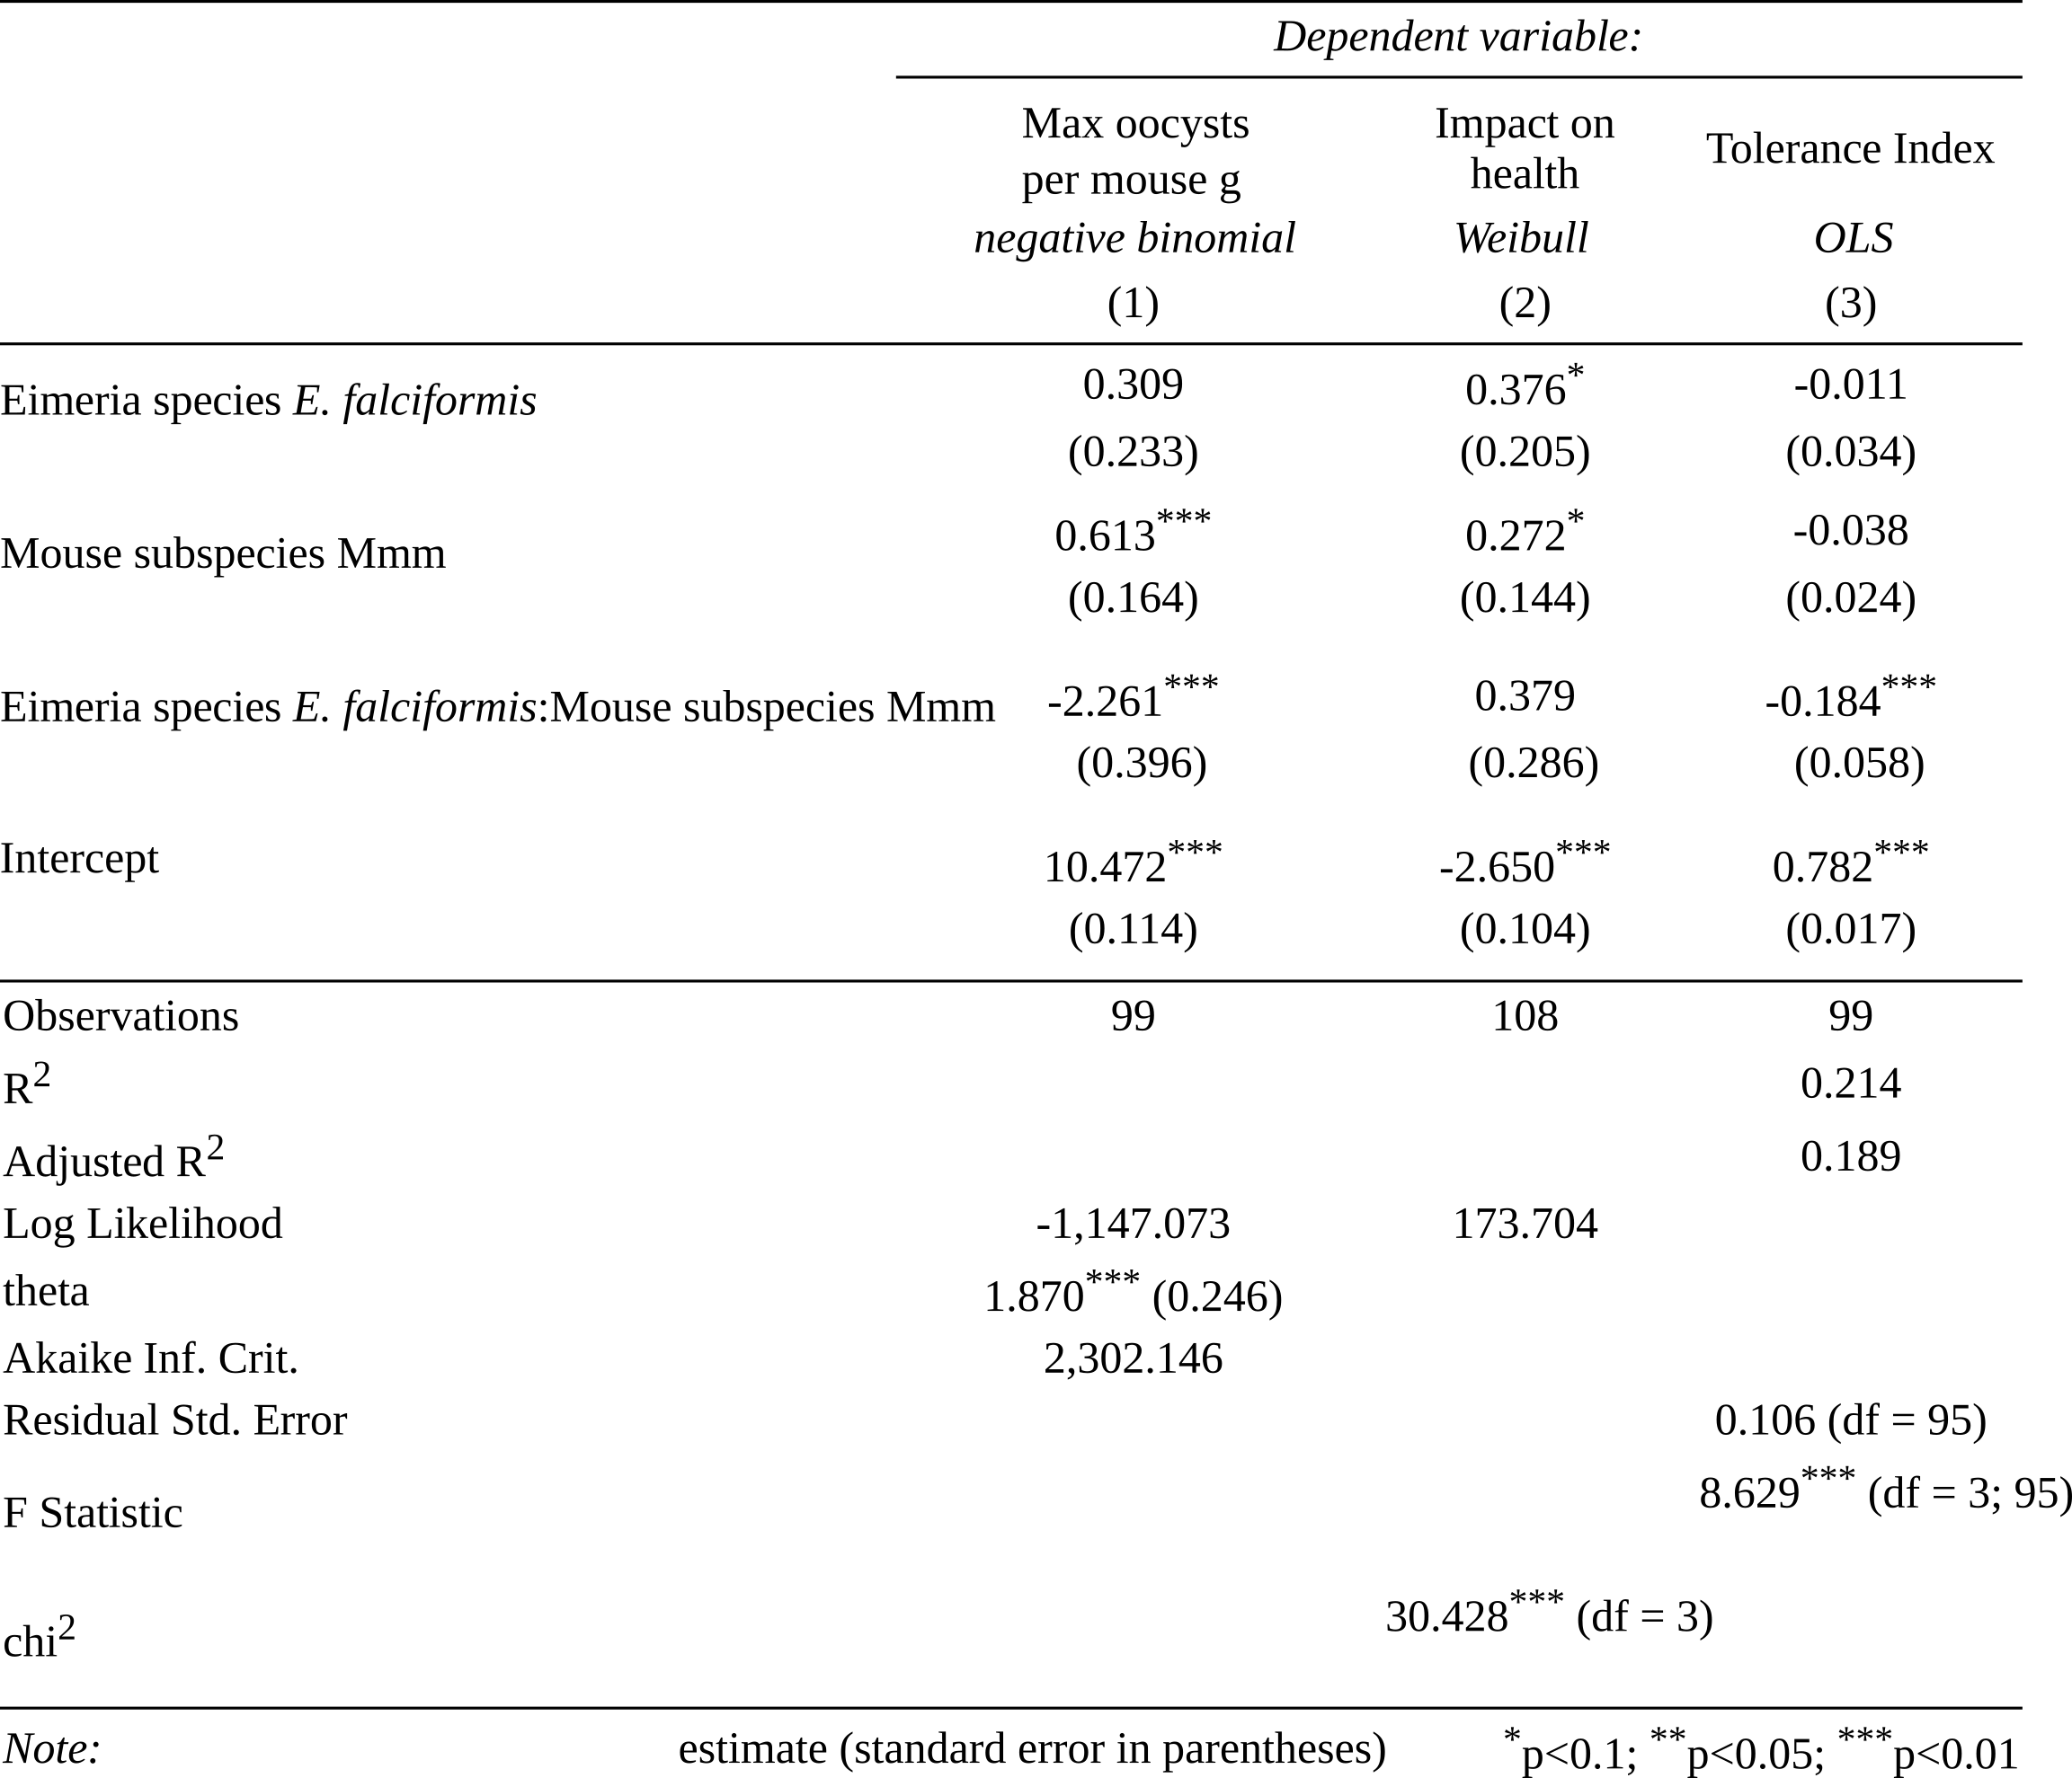

**Table 2. Regression analyses results at the host subspecies / parasite species level.**

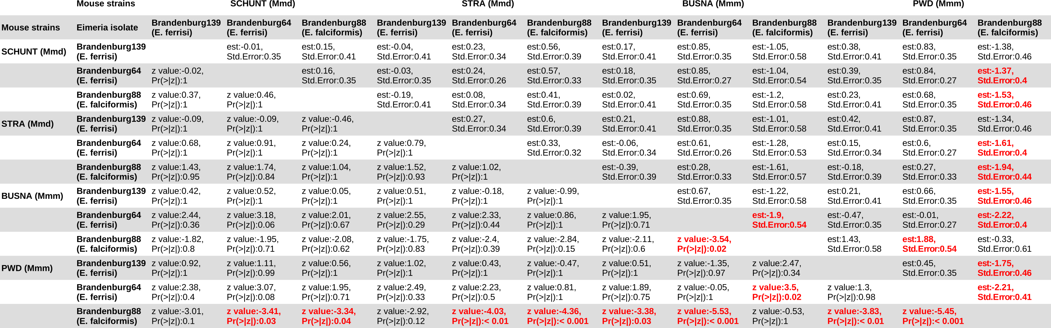

**Table 3. Post-hoc statistical test for resistance (Tukey Multiple Comparisons of Means). See Figure 4A.**

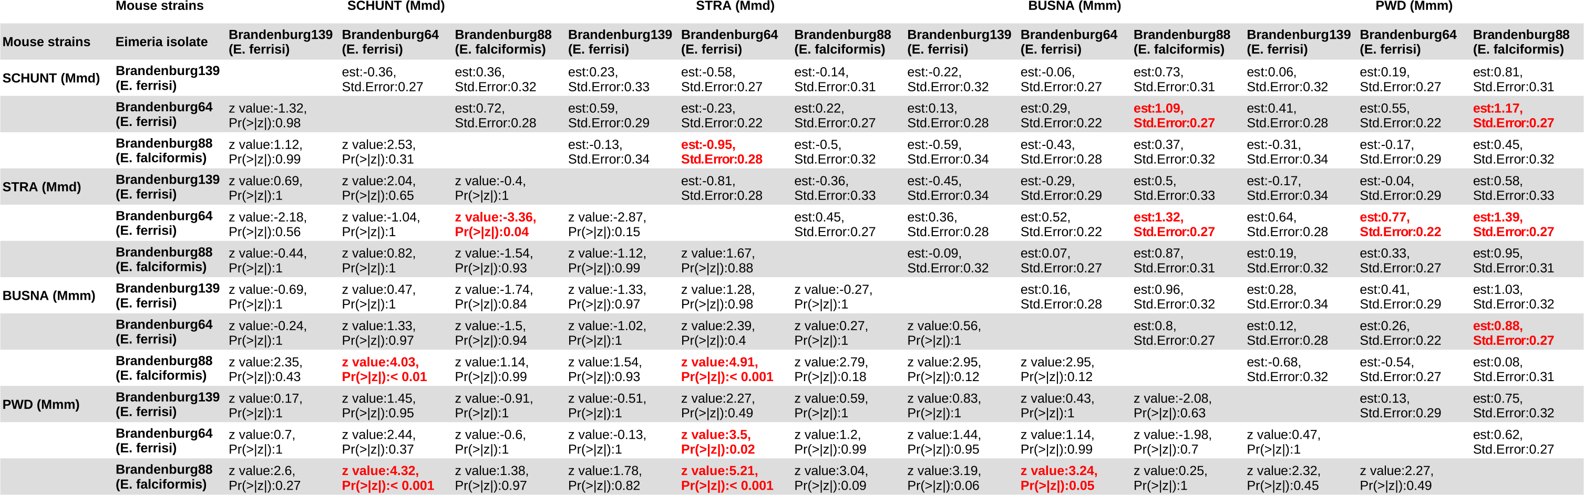

**Table 4. Post-hoc statistical test for impact on health (Tukey Multiple Comparisons of Means). See Figure 4B.**

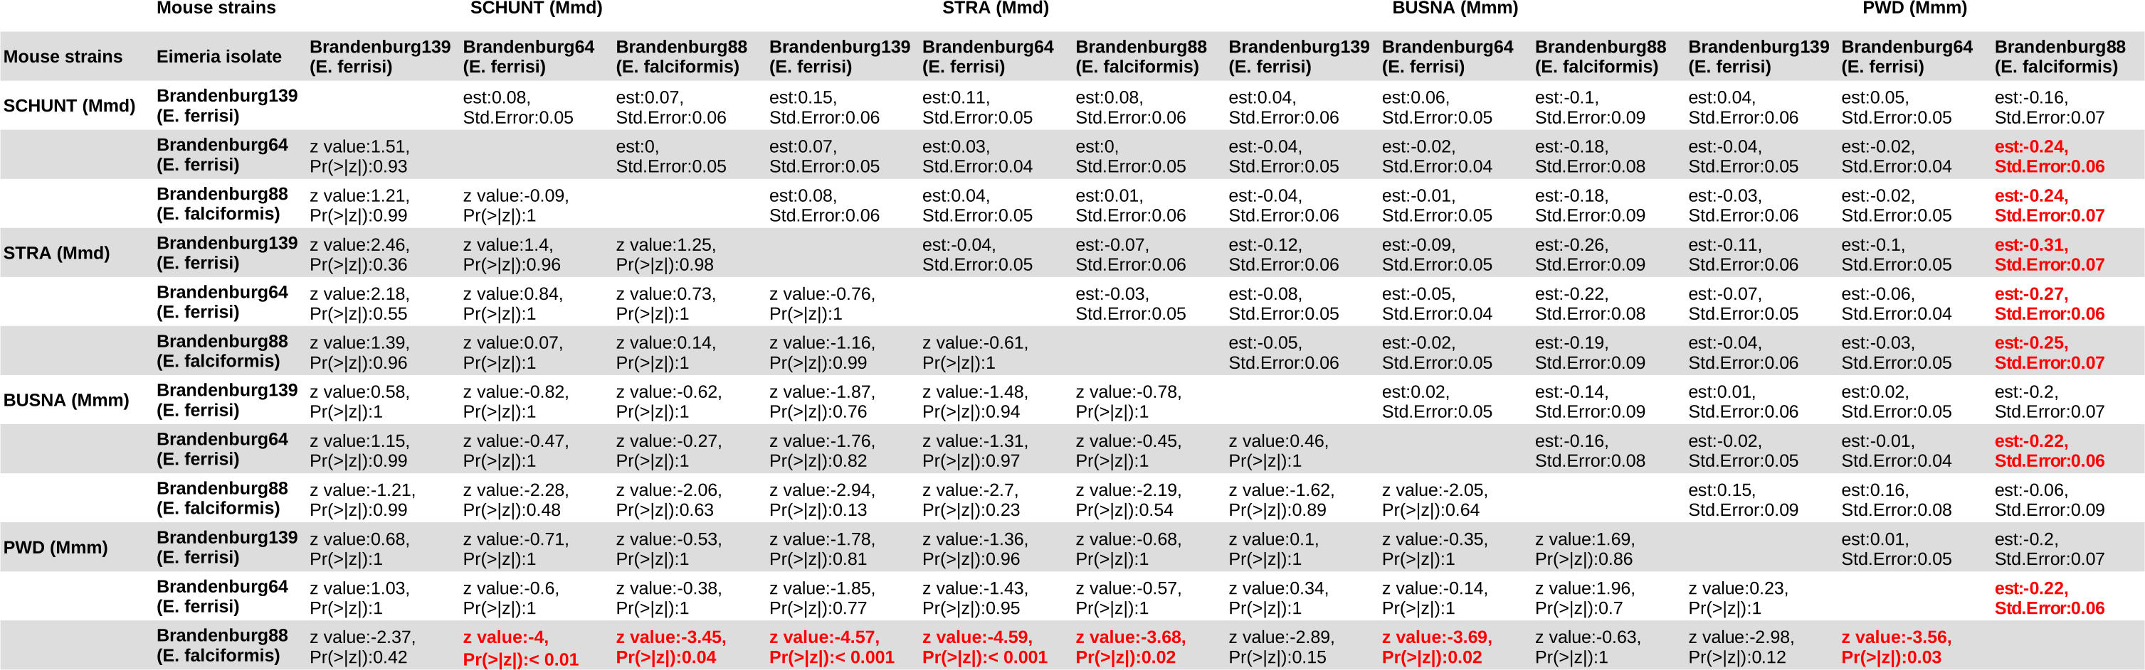

**Table 5. Post-hoc statistical test for tolerance (Tukey Multiple Comparisons of Means). See Figure 4C.**

# Figures

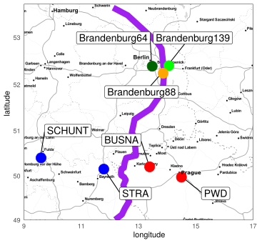

**Figure 1. Parasite isolates and mouse strains.** The map shows locations at which mice were collected for breeding of mouse strains and isolation of parasites. The purple line is an estimation of the center of the house mouse hybrid zone between Mmd and Mmm based on sampling and genotyping of mice in this area (Balard et al., 2019; Ďureje, Macholán, Baird, & Piálek, 2012). *M. m. domesticus* are colored in blue, *M. m. musculus* in red, parasite isolates in green and orange.

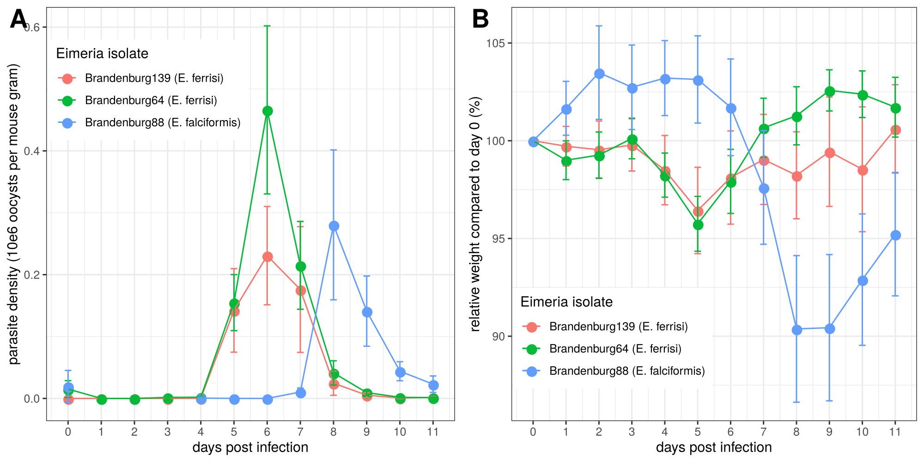

**Figure 2. Parasite density (A) and relative weight loss (B) during *Eimeria* infection.** Parasite density is calculated as number of oocysts detected (10e6) in feces per mouse gram, relative weight loss is calculated compared to day 0.Mean and 95% CI are plotted for each parasite isolate. All hosts strains are regrouped.

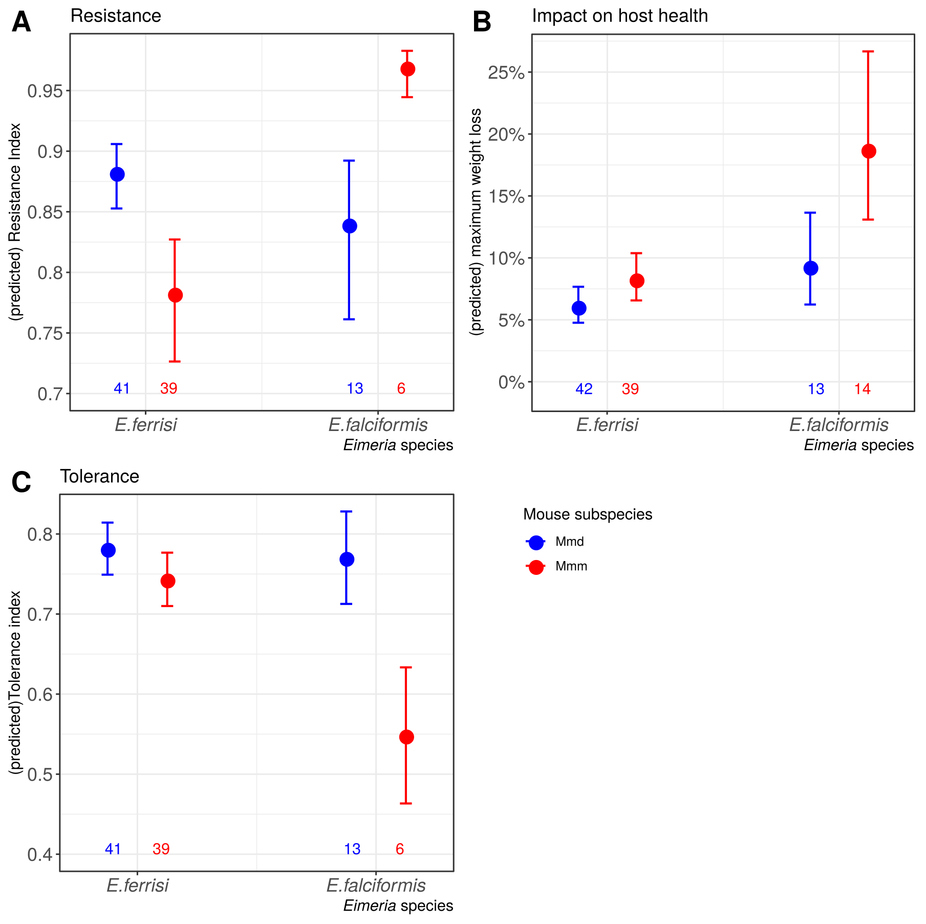

**Figure 3. Resistance, impact on host health and tolerance marginal effects for the two mice subspecies and two *Eimeria* species.** Predicted mean and standard deviation for each group. Values under bars represent the number of animals for each group. See Table 2 for summary statistics. (A) Resistance index measured as *(- maximum number of oocysts per mouse gram + 300000) / 300000* ; (B) Impact on host health measured as the maximum weight loss during patent period relative to starting weight (%); (C) Tolerance Index measured as *(log10(maximum relative weight loss / maximum number of oocysts per mouse gram + 1e-8) / -8*

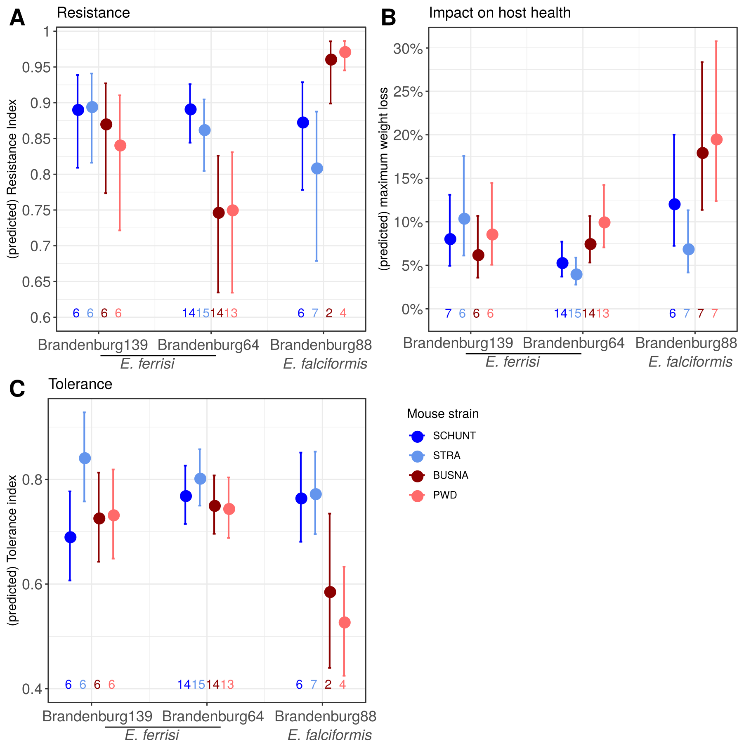

**Figure 4. Resistance, impact on host health and tolerance marginal effects for four inbred mouse strains infected with three *Eimeria* isolates each.** Predicted mean and standard deviation for each group. Values under bars represent the number of animals for each group. (A) Resistance Index measured as *(- maximum number of oocysts per mouse gram + 300000) / 300000* (see Table 3 for post-hoc tests); (B) Impact on host health measured as the maximum weight loss during patent period relative to starting weight (%)(see Table 4 for post-hoc tests); (C) Tolerance Index measured as *(log10(maximum relative weight loss / maximum number of oocysts per mouse gram + 1e-8) / -8* (see Table 5 for post-hoc tests).

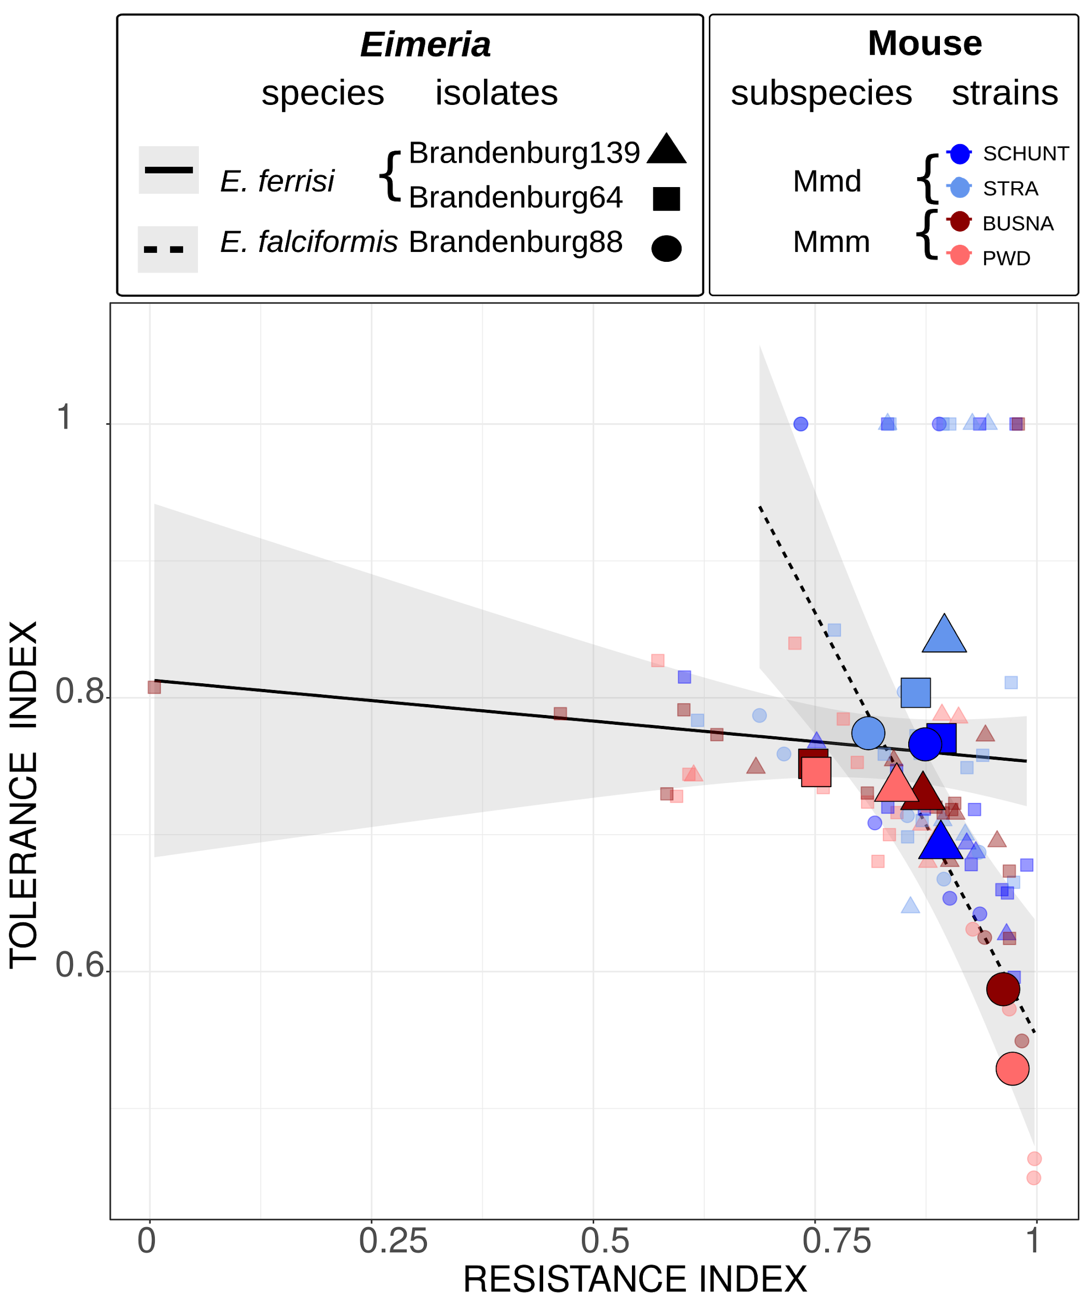

**Figure 5. Comparison of trade-off between resistance and tolerance between both *Eimeria* species.** Smaller points represent individual mice, while larger points figure the mean for a given (host strain-parasite isolate) group. Linear regression of tolerance by resistance are shown for both parasite species. Resistance Index measured as *(- maximum number of oocysts per mouse gram + 300000) / 300000*, Tolerance Index measured as *(log10(maximum relative weight loss / maximum number of oocysts per mouse gram + 1e-8) / -8*

# Funding

This work was funded by the German Research Foundation (DFG) Grant [HE 7320/1-1] to EH. VHJ is an associated student of GRK 2046 funded by the DFG. [XXX]

# References

Al-khlifeh, E., Balard, A., Jarquín-Díaz, V. H., Weyrich, A., Wibbelt, G., & Heitlinger, E. (2019). *Eimeria falciformis* BayerHaberkorn1970 and novel wild derived isolates from house mice: Differences in parasite lifecycle, pathogenicity and host immune reactions. *BioRxiv*, *611277*. http://dx.doi.org/10.1101/611277

Ankrom, S. L., Chobotar, B., & Ernst, J. V. (1975). Life cycle of *Eimeria ferrisi* Levine & Ivens, 1965 in the Mouse, *Mus musculus*. *The Journal of Protozoology*, *22*(3), 317–323. https://doi.org/10.1111/j.1550-7408.1975.tb05177.x

Baird, S. J. E., & Goüy de Bellocq, J. (2019). Shifting paradigms for studying parasitism in hybridising hosts: Response to Theodosopoulos, Hund, and Taylor. *Trends in Ecology & Evolution*, *34*, 387–389. https://doi.org/10.1016/j.tree.2019.01.011

Baird, S. J. E., Ribas, A., Macholán, M., Albrecht, T., Piálek, J., & Goüy de Bellocq, J. (2012). Where are the wormy mice? A reexamination of hybrid parasitism in the European house mouse hybrid zone. *Evolution*, *66*(9), 2757–2772. https://doi.org/10.1111/j.1558-5646.2012.01633.x

Baker, D. G. (1998). Natural pathogens of laboratory mice, rats, and rabbits and their effects on research. *Clinical Microbiology Reviews*, *11*(2), 231–266.

Balard, A., Jarquín-Díaz, V. H., Jost, J., Martincová, I., Ďureje, Ľ., Piálek, J., … Heitlinger, E. (2019). Intensity of infection with intracellular *Eimeria* spp. And pinworms is reduced in hybrid mice compared to parental subspecies. *BioRxiv*, *683698*. https://doi.org/10.1101/683698

Barton, N. H., & Hewitt, G. M. (1985). Analysis of hybrid zones. *Annual Review of Ecology and Systematics*, *16*(1), 113–148. https://doi.org/10.1146/annurev.es.16.110185.000553

Chapman, H. D., Barta, J. R., Blake, D., Gruber, A., Jenkins, M., Smith, N. C., … Tomley, F. M. (2013). A selective review of advances in coccidiosis research. *Advances in Parasitology*, *83*, 93–171. https://doi.org/10.1016/B978-0-12-407705-8.00002-1

Ďureje, Ľ., Macholán, M., Baird, S. J., & Piálek, J. (2012). The mouse hybrid zone in Central Europe: From morphology to molecules. *Folia Zoologica*, *61*(3–4), 308–318.

Ehret, T., Spork, S., Dieterich, C., Lucius, R., & Heitlinger, E. (2017). Dual RNA-seq reveals no plastic transcriptional response of the coccidian parasite Eimeria falciformis to host immune defenses. *BMC Genomics*, *18*(1), 686. https://doi.org/10.1186/s12864-017-4095-6

Graham, A. L., Allen, Judith. E., & Read, A. F. (2005). Evolutionary causes and consequences of immunopathology. *Annual Review of Ecology, Evolution, and Systematics*, 373–397. https://doi.org/10.1146/annurev.ecolsys.36.102003.152622

Gregorová, S., & Forejt, J. (2000). PWD/Ph and PWK/Ph inbred mouse strains of *Mus m. Musculus* subspecies—A valuable resource of phenotypic variations and genomic polymorphisms. *Folia Biologica*, *46*(1), 31–41.

Haberkorn, A. (1970). Die Entwicklung von *Eimeria falciformis*  (Eimer 1870) in der weißen Maus (*Mus musculus*). *Zeitschrift für Parasitenkunde*, *34*(1), 49–67. https://doi.org/10.1007/BF00629179

Hayward, A. D., Nussey, D. H., Wilson, A. J., Berenos, C., Pilkington, J. G., Watt, K. A., … Graham, A. L. (2014). Natural Selection on Individual Variation in Tolerance of Gastrointestinal Nematode Infection. *PLOS Biology*, *12*(7), e1001917. https://doi.org/10.1371/journal.pbio.1001917

Hlavac, M. (2018). *stargazer: Well-Formatted Regression and Summary Statistics Tables*. Retrieved from https://CRAN.R-project.org/package=stargazer

Jarquín-Díaz, V. H., Balard, A., Jost, J., Kraft, J., Dikmen, M. N., Kvičerová, J., & Heitlinger, E. (2019). Detection and quantification of house mouse *Eimeria* at the species level – Challenges and solutions for the assessment of coccidia in wildlife. *International Journal for Parasitology: Parasites and Wildlife*, *10*, 29–40. https://doi.org/10.1016/j.ijppaw.2019.07.004

Kutzer, M. A. M., & Armitage, S. A. O. (2016). Maximising fitness in the face of parasites: A review of host tolerance. *Zoology*, *119*(4), 281–289. https://doi.org/10.1016/j.zool.2016.05.011

Langand, J., Jourdane, J., Coustau, C., Delay, B., & Morand, S. (1998). Cost of resistance, expressed as a delayed maturity, detected in the host–parasite system Biomphalaria glabrata/Echinostoma caproni. *Heredity*, *80*(3), 320–325. https://doi.org/10.1046/j.1365-2540.1998.00291.x

Little, T. J., Shuker, D. M., Colegrave, N., Day, T., & Graham, A. L. (2010). The Coevolution of Virulence: Tolerance in Perspective. *PLOS Pathogens*, *6*(9), e1001006. https://doi.org/10.1371/journal.ppat.1001006

Macholán, M., Munclinger, P., Sugerková, M., Dufková, P., Bímová, B., Bozíková, E., … Piálek, J. (2007). Genetic analysis of autosomal and X-linked markers across a mouse hybrid zone. *Evolution*, *61*(4), 746–771. https://doi.org/10.1111/j.1558-5646.2007.00065.x

Martincová, I., Ďureje, Ľ., Kreisinger, J., Macholán, M., & Piálek, J. (2019). Phenotypic effects of the Y chromosome are variable and structured in hybrids among house mouse recombinant lines. *Ecology and Evolution*, *9*(10), 6124–6137. https://doi.org/10.1002/ece3.5196

Mazé-Guilmo, E., Loot, G., Páez, D. J., Lefèvre, T., & Blanchet, S. (2014). Heritable variation in host tolerance and resistance inferred from a wild host–parasite system. *Proceedings of the Royal Society B: Biological Sciences*, *281*(1779). https://doi.org/10.1098/rspb.2013.2567

Medzhitov, R., Schneider, D. S., & Soares, M. P. (2012). Disease tolerance as a defense strategy. *Science*, *335*(6071), 936–941. https://doi.org/10.1126/science.1214935

Miller, M. R., White, A., & Boots, M. (2005). The evolution of host resistance: Tolerance and control as distinct strategies. *Journal of Theoretical Biology*, *236*(2), 198–207. https://doi.org/10.1016/j.jtbi.2005.03.005

Piálek, J., Vyskocilová, M., Bímová, B., Havelková, D., Piálková, J., Dufková, P., … Forejt, J. (2008). Development of unique house mouse resources suitable for evolutionary studies of speciation. *The Journal of Heredity*, *99*(1), 34–44. https://doi.org/10.1093/jhered/esm083

R Development Core Team. (2018). *R: A language and environment for statistical computing. R Foundation for Statistical Computing, Vienna, Austria*. Retrieved from http://www.R-project.org

Råberg, L. (2014). How to live with the enemy: Understanding tolerance to parasites. *PLoS Biology*, *12*(11), e1001989. https://doi.org/10.1371/journal.pbio.1001989

Råberg, L., Graham, A. L., & Read, A. F. (2009). Decomposing health: Tolerance and resistance to parasites in animals. *Philosophical Transactions of the Royal Society B: Biological Sciences*, *364*(1513), 37–49. https://doi.org/10.1098/rstb.2008.0184

Råberg, L., Sim, D., & Read, A. F. (2007). Disentangling genetic variation for resistance and tolerance to infectious diseases in animals. *Science (New York, N.Y.)*, *318*(5851), 812–814. https://doi.org/10.1126/science.1148526

Restif, O., & Koella, J. C. (2003). Shared Control of Epidemiological Traits in a Coevolutionary Model of Host‐Parasite Interactions. *The American Naturalist*, *161*(6), 827–836. https://doi.org/10.1086/375171

Roy, B. A., & Kirchner, J. W. (2000). Evolutionary Dynamics of Pathogen Resistance and Tolerance. *Evolution*, *54*(1), 51–63. https://doi.org/10.1111/j.0014-3820.2000.tb00007.x

Schito, M. L., Barta, J. R., & Chobotar, B. (1996). Comparison of four murine *Eimeria* species in immunocompetent and immunodeficient mice. *The Journal of Parasitology*, *82*(2), 255–262. https://doi.org/10.2307/3284157

Sheldon, B. C., & Verhulst, S. (1996). Ecological immunology: Costly parasite defences and trade-offs in evolutionary ecology. *Trends in Ecology & Evolution*, *11*(8), 317–321. https://doi.org/10.1016/0169-5347(96)10039-2

Simms, E. L., & Triplett, J. (1994). Costs and benefits of plant response to disease: Resistance and tolerance. *Evolution*, *48*(6), 1973–1985. https://doi.org/10.1111/j.1558-5646.1994.tb02227.x

Soares, M. P., Teixeira, L., & Moita, L. F. (2017). Disease tolerance and immunity in host protection against infection. *Nature Reviews Immunology*, *17*(2), 83–96. https://doi.org/10.1038/nri.2016.136

Stange, J., Hepworth, M. R., Rausch, S., Zajic, L., Kühl, A. A., Uyttenhove, C., … Lucius, R. (2012). IL-22 Mediates Host Defense against an Intestinal Intracellular Parasite in the Absence of IFN-γ at the Cost of Th17-Driven Immunopathology. *The Journal of Immunology*, *188*(5), 2410–2418. https://doi.org/10.4049/jimmunol.1102062

Vijendravarma, R. K., Kraaijeveld, A. R., & Godfray, H. C. J. (2009). Experimental Evolution Shows Drosophila Melanogaster Resistance to a Microsporidian Pathogen Has Fitness Costs. *Evolution*, *63*(1), 104–114. https://doi.org/10.1111/j.1558-5646.2008.00516.x

Vincent, C. M., & Sharp, N. P. (2014). Sexual antagonism for resistance and tolerance to infection in Drosophila melanogaster. *Proceedings of the Royal Society B: Biological Sciences*, *281*(1788), 20140987. https://doi.org/10.1098/rspb.2014.0987

Wickham, H. (2016). *ggplot2: Elegant Graphics for Data Analysis*. Springer-Verlag, New York.