# The resistance/tolerance trade-off against only one of two related parasites in mice

# Alice Balard1,2, Víctor Hugo Jarquín-Díaz1,2, Jenny Jost1, Vivian Mittné1, Francisca Böhning1, Ľudovít Ďureje3, Jaroslav Piálek3, Emanuel Heitlinger1,2

*1 Institute for Biology. Department of Molecular Parasitology. Humboldt University Berlin (HU). Philippstr. 13, Haus 14, 10115, Berlin, Germany*

*2 Leibniz-Institut für Zoo- und Wildtierforschung (IZW) im Forschungsverbund Berlin e.V.. Alfred-Kowalke-Straße 17, 10315, Berlin, Germany*

*3 Research Facility Studenec, Institute of Vertebrate Biology, Czech Academy of Sciences, Květná 8, 603 65 Brno, Czech Republic*

# Abstract

Resistance (the host’s capacity to reduce parasite burden) and tolerance (the host’s capacity to reduce impact on host health of a given parasite burden) manifest two different lines of immune defenses. Trade-offs arise, as resistance limits infection load and thereby the scope of possible tolerance, and both resistance and tolerance can be costly in terms of resource allocation. Additionally, resistance is assumed to be limited by immunopathogenicity, tolerance by carrying capacity of the host or energy drained by the parasite.

Here, we used two closely related parasite species of genus *Eimeria* and measured resistance and tolerance of four wild-derived strains of inbred mice from two subspecies during controlled infection. One parasite species, *E. falciformis*, has a longer life cycle and higher pathogenicity than the other, *E. ferrisi*. We found a stronger trade-off between resistance and tolerance against the former parasite than against the latter. Resistance and tolerance against E*. ferrisi* seemed uncorrelated.

*E. falciformis* shows a lower prevalence than *E. ferrisi* in the field. Not only mechanisms behind resistance and tolerance, but also virulence realized in the evolution of different closely related parasites can be studied in this system.

# Introduction

Host defense mechanisms evolve in response to feedback between hosts and parasites (Little, Shuker, Colegrave, Day, & Graham, 2010). Resistance (the ability of a host to reduce its parasite burden) results from defense against parasite infection or proliferation early after infection (Råberg, Graham, & Read, 2009). It can be energetically costly and therefore limited by resource allocation: cost can be measured as a decrease of other fitness components (e.g. delayed maturity, lower fecundity) in the absence of infection (Langand, Jourdane, Coustau, Delay, & Morand, 1998; Sheldon & Verhulst, 1996; Vijendravarma, Kraaijeveld, & Godfray, 2009). Additionally, too strong immune response to pathogens can lead to a negative impact on health or immunopathology (Graham, Allen, & Read, 2005).

Tolerance balances damage caused by parasites themselves and immunopathology (Medzhitov, Schneider, & Soares, 2012) through control mechanisms like stress response, damage repair and cellular regeneration (Soares, Teixeira, & Moita, 2017). This is why, just like resistance, tolerance can involve energetic costs (Simms & Triplett, 1994). While resistance decreases parasite fitness and prevalence in natural populations, tolerance generally has no impact on parasite fitness and either increases or does not affect prevalence (Miller, White, & Boots, 2005; Roy & Kirchner, 2000). For all those reasons, host defenses (tolerance, resistance, and their immunological mechanisms), parasite virulence (capacity to reduce host fitness in terms of health or fecundity), and their interactions should be assessed jointly (Little et al., 2010; Restif & Koella, 2003).

Coccidia of the genus *Eimeria* are an excellent target for investigating the interplay of host defense and parasite virulence. *Eimeria ferrisi* has been found to be the most prevalent (17%) species of this genus in house mice recently studied in Brandenburg, Germany, followed by *E. falciformis* (4%) (Jarquín-Díaz et al., 2019). The two mouse subspecies, *Mus musculus musculus* and *M. m. domesticus* (hereafter Mmm and Mmd, respectively), hybridizing in this area, show the same resistance to *E. ferrisi* in the field (Balard et al., 2019). *Eimeria* spp. are monoxenous parasites that expand asexually and reproduce sexually in intestinal epithelial cells, leading to malabsorption of nutrients, tissue damage and weight loss (Chapman et al., 2013). They are generally considered to be host specific, and different species infect a wide range of animals including birds, mammals, reptiles, amphibians, and fish (Chapman et al., 2013; Jarquín-Díaz et al., 2019). *Eimeria ferrisi* and *E. falciformis* live in the cecum villar epithelial cells and cecum crypt cells, respectively (Schito, Barta, & Chobotar, 1996). Pre-patency (the time to shedding of infectious stages, so called oocysts) is longer for *E. falciformis* (7 days) than for *E. ferrisi* (5 days) (Al-khlifeh et al., 2019). While both species provoke inflammation, cellular infiltration, enteric lesions, diarrhea, and ultimately weight loss (Ankrom, Chobotar, & Ernst, 1975; Ehret, Spork, Dieterich, Lucius, & Heitlinger, 2017; Schito et al., 1996), the symptoms are stronger for *E. falciformis* than for *E. ferrisi* infections (Al-khlifeh et al., 2019).

In this study, we experimentally tested whether Mmm and Mmd differ in virulence, resistance, and tolerance to controlled infections of *E. falciformis* and *E. ferrisi*. For this purpose we employed four wild-derived inbred strains representing the two mouse taxa, to assess the parameters both at the level of host subspecies and strains.

# Material and methods

## Mouse strains

We used four wild-derived inbred strains, two representing Mmd: **SCHUNT** (Locality: Schweben 2, Hessen, Germany [N: 50° 26’, E: 9° 35’]; Martincová, Ďureje, Kreisinger, Macholán, & Piálek, 2019) and **STRA** (Locality: Straas 16, Bavaria, Germany [N: 50° 11’, E: 11° 46’]; Piálek et al., 2008), and two drived from Mmm: **BUSNA** (Locality: Buškovice 215, Bohemia, Czech Republic. [N: 50° 14’, E: 13° 22’] (Piálek et al., 2008)) and **PWD** (Locality: . [N: 50° 0’, E: 14° 29’], provided by Jiří Forejt, Institute of Molecular Genetics, CAS, Prague; Gregorová & Forejt, 2000). Founders of SCHUNT and PWD strains had been collected about 250 and 150 km from the estimated hybrid zone center, respectively (**Figure 1**). Age of the mice at the moment of infection ranged between 7.5 and 21.5 weeks. All mouse strains were maintained before infection in the Institute of Vertebrate Biology in Studenec (Piálek et al., 2008)(licence number 61,974/2017‐MZE‐17214).

## Parasite strains

The three parasite isolates used in this study were isolated from feces of mice captured in Brandenburg, Germany, in 2016 (capture permit No. 2347/35/2014). They belong to both the most prevalent *Eimeria* species in the wild (Jarquín-Díaz et al., 2019), namely *E. ferrisi* (isolates Brandenburg64 and Brandenburg139) and *E. falciformis* (isolate Brandenburg88). Pre-patency and the peak day of oocyst shedding for these isolates were estimated during infection in NMRI laboratory mice (Al-khlifeh et al., 2019) which were also used for serial passaging of all the isolates. Parasite oocysts were floated from feces with NaCl (Al-khlifeh et al., 2019) and stored at room temperature in 1mL of 2% potassium dichromate for a maximum of 2 months before infection of the wild-derived mouse strains. Oocysts were allowed to sporulate 10 days before infection in a water bath at 30°C.

## Experimental infection

Mice were kept in individual cages during infection. Water and food (SNIFF, Rat/Mouse maintenance feed 10 mm) were provided *ad libitum* supplemented with 1 g of sunflower and barley seeds per day. Mice were orally infected with 150 sporulated oocysts of one *Eimeria* isolate suspended in 100 µl phosphate-buffer saline (PBS) and monitored daily until their sacrifice by cervical dislocation at 11 days after infection (dpi) (experiment license Reg. 0431/17). Individuals presenting severe health deficiency and/or a weight loss approaching 18% relative to their starting weight were sacrificed earlier. Weight was recorded and feces collected on a daily basis. Fecal pellets were collected every day from each individual cage and suspended in 2% potassium dichromate. Parasite oocysts were recovered using NaCl flotation. Potential cross-contamination between infections was monitored.

In total, 108 mice were infected (**Table 1**). Mice were randomly allocated to experimental groups ensuring homogeneous distribution of ages and sexes between groups. Our experiments were conducted in infection batches. Since nematode infection is common in breeding facilities (Baker, 1998), feces of a subset of each mouse strain were tested for presence of nematode eggs under light microscope prior to infection. We could detect *Syphacia* and *Aspiculuris* eggs. Despite treatment of the first in fection batch of mice (22 mice) with anthelminthics (Profender®, Bayer AG, Levekusen, Germany (Mehlhorn et al., 2005)), worms were still detected with PCR (following the protocole of Floyd, Rogers, Lambshead, & Smith, 2005) in randomly sampled fecal samples a week later. We therefore decided not to treat mice of the following infection batches. To verify the absence of impact of this treatment on our results, we performed the statistical analyses on a dataset excluding the 22 treated individuals (see **Supplementary Material S1**).

## Choice of measurements for resistance and tolerance

Resistance is the capacity of a host to reduce its parasite burden, therefore it is usually estimated by the inverse of infection intensity (Råberg et al., 2009). As a proxy we used the number of parasites per host, calculated as the number of oocysts in feces at the day of maximal shedding, divided by the mouse weight at this day (in grams). This measurement allowed us to take into account the host’s volume, assuming a lower capacity to carry parasites in smaller mice: a higher number of oocysts per mouse weight corresponds to lower resistance. At the day of peak intensity, this measure was tightly correlated with the sum of oocysts shed throughout the experiment (Pearson correlation coefficient 0.92). For further statistical analyses we modeled the raw value of “maximum number of oocysts per mouse gram”; For plotting and comparison with tolerance we used a resistance index ranging between 0 and 1 (see **Supplementary Figure S2.A**) calculated as:

*Resistance index = (- maximum number of oocysts per mouse gram + 300000) / 300000*

Tolerance is usually defined as the slope of the regression of host fitness, approximated by health condition, on infection intensity (Råberg, 2014). The major measurable symptom in murine *Eimeria* infections is weight loss. Therefore, the impact of parasites on host health was measured as the maximum relative weight loss compared to day 0 (mouse starting weight).

We defined a tolerance index for each individual, describing how its health varied with infection intensity, between day 0 of infection (weight = 100%, parasite intensity = 0 oocyst per mouse gram) and highest impact (weight = minimum weight relative to day 0, parasite intensity = maximum parasite number per mouse gram). We normalized this index by log transformation (adding 1e-8 to avoid infinite values) and divided by -8 to obtained an increasing index for more tolerant individuals (see **Supplementary Figure S2.A**) :

*Tolerance index = (log10(maximum relative weight loss / maximum number of oocysts per mouse gram + 1e-8) / -8*

## Statistical analyses

Appropriate distribution for resistance, impact on host health, and tolerance were selected based on (log) likelihood and by comparing goodness-of-fits plots (density, CDF, Q-Q, P-P plots) between usual distributions. The negative binomial, Weibull, and normal distribution were the most adequate to describe the peak of oocysts per mouse gram, impact on host health, and tolerance index, respectively (see **Supplementary Figure S3**). For modelling the impact on host health, we added 0.01 to the raw value as the Weibull distribution regression requires positive values.

We tested the effects of mouse subspecies (Mmd or Mmm), *Eimeria* species (*E. ferrisi* or *E. falciformis*) and their interaction separately using (generalized) linear models. To assess the stability of our results across mouse strains and *Eimeria* isolates, we also tested the effects of mouse strain (N=4), parasite isolate (N=3) and their interaction separately using the same models. We used likelihood ratio tests (LRT) with and without the focal term to test for its significance in the model.

We then compared the trade-off between resistance and tolerance between *E. ferrisi* and *E. falciformis*. Using the resistance index and tolerance index defined above, we fitted a linear model to explain the variation of the tolerance index with the interaction between resistance and *Eimeria* species.

All analyses were performed using the R software version 3.5.2 (R Development Core Team, 2018). Graphics were produced using the R package ggplot2 (Wickham, 2016) and compiled using the free software inkscape (https://inkscape.org). Model summary statistics were calculated and displayed using the R package stargazer (Hlavac, 2018).

All code and data used for this article can be found at: https://github.com/alicebalard/Article_RelatedParasitesResTol

# Results

## General parasitology

To test for differences in resistance and tolerance, we analysed parasite infections with isolates of the species *E. ferrisi* (two isolates; Brandenburg64 and Brandenburg139) and *E. falciformis* (one isolate; Brandenburg88). The life cycle of all isolates was successfully completed in all mouse strains (**Figure 2**). For *E. ferrisi* (both isolates), the pre-patent period (period between infection and detection of oocysts in feces) was 5 dpi and the median day of maximal oocyst shedding was 6 dpi (standard deviation sd=0.71 and 0.65, respectively). The median day of maximum weight loss was 5 dpi for both isolates (sd=2.2 and 1.9 respectively). For *E. falciformis* (isolate Brandenburg88) pre-patency was 7 dpi, median day of maximal shedding was 8 dpi (sd=1.2) and median day of maximal weight loss 9 dpi (sd=1.5). All tested *Eimeria* isolates infected all individuals of the tested mouse strains.

A very low number of *Eimeria* oocysts were found at the day of initial infection in the feces of 9 mice belonging to the two final experimental batches (6 infected with Brandenburg64 and 3 with Brandenburg88). This result is likely due to cross-contamination through cages. To test the consistency of our results, we performed the different analyses (modeling of resistance, impact on health, tolerance, as well as linear regression of the tolerance index by the resistance index) on a dataset excluding the 22 mice treated by anthelminthics and the 9 mice showing contaminant infections. The results obtained in this conservative dataset are congruent with the results revealed in all mice, thus we consider the influence of both factors negligible (see **Supplementary Material S3**).

A considerable number of Mmm mice (8/14; 5 of BUSNA and 3 of PWD) infected with *E. falciformis* (isolate Brandenburg88) died (or had to be sacrificed at humane end points specified in animal experimental procedures) before the peak of oocyst shedding. Moreover, one Mmd mouse (strain SCHUNT) infected by *E. ferrisi* isolate Brandenburg139 had liquid diarrhea in the peak shedding day, making its feces not collectable. These mice were assessed as missing data for both resistance and following tolerance measurements.

## *M. m. musculus* is more resistant to *E. falciformis* than to *E. ferrisi*

To establish differences between the two house mouse subspecies and between the parasite species, we analyzed the extent of oocyst shedding as a measure of resistance after infection with both *Eimeria* species. We found statistically significant differences effect of parasite species (glm/LRT: df = 96, P = 0.022, *n* = 99) as well as the parasite species * mouse subspecies interaction (glm/LRT: df = 95, P = 6e-07, *n* = 99). Mmm mice resist *E. falciformis* better than *E. ferrisi*, while the opposite trend was found in Mmd(**Figure 3A**; summary statistics in **Table 2**).

We then tested the influence of geographical origin of host strains and *Eimeria* isolates. We found statistically significant differences in resistance between parasite isolates (glm/LRT: df = 96, P = 0.019, *n* = 99) as well as the significant effect of the isolate * strain interaction (glm/LRT: df = 87, P < 0.001, *n* = 99; summary statistics in **Supplementary Table S4**). Post-hoc multiple comparison tests showed significantly higher resistance of PWD (Mmm strain) infected with Brandenburg88 (*E. falciformis* isolate) than with the two *E. ferrisi* isolates, Brandenburg64 (Tukey Multiple Comparisons of Means: z = -5.45, P < 0.001) and Brandenburg139 (Tukey Multiple Comparisons of Means: z = -3.83, P < 0.01). Similarly, BUSNA (Mmm), was significantly more resistant to Brandenburg88 than to Brandenburg64 (Tukey Multiple Comparisons of Means: z = -3.54, P = 0.02). We found the two Mmm strains to show higher resistance to *E. falciformis* than to *E. ferrisi*. Overall, we found no significant difference between the strains of the same subspecies within a given parasite species infection, nor between the isolates of the same species within a given mouse strain (**Table 3**; **Figure 4A**).

## Health of *M. m. musculus* is more impacted by *E. falciformis* than by *E. ferrisi*

We found statistically significant differences in impact on host health both between the mouse subspecies (glm/LRT: df = 104, P < 0.01, *n* = 108) and between the parasite species (glm/LRT: df = 105, P < 0.001, *n* = 108). Mmd lost less weight than Mmm when infected by both *E. falciformis* (9.3% vs 18.7%) and *E. ferrisi* (6.1% vs 8.3%), and *E. falciformis* impacted the health of both mouse subspecies more than *E. ferrisi* (**Figure 3B**;summary statistics in **Table 2**)*.*

Testing the influence of geographical origin of mouse and parasite in a model separating *Eimeria* by isolates (instead of species) and mice by strains (instead of subspecies), we found the impact on health to differ significantly for both, i.e. isolates (glm/LRT: df = 104, P < 0.001, *n* = 108) and strains (glm/LRT: df = 101 P < 0.01, *n* = 108; for summary statistics see **Supplementary Table S4**). Notably, PWD (Mmm) mice infected with Brandenburg64 (*E. ferrisi*) lost significantly more weight than STRA mice (Mmd) infected with the same isolate (Tukey Multiple Comparisons of Means: z = 3.5, P = 0.02), following the pattern described at the mouse subspecies-parasite species level (Mmd losing less weight than Mmm when infected by *E. ferrisi*). Overall, we did not find any significant difference between mouse strains of the same subspecies within a given parasite species infection or between parasite isolates of the same species within a given mouse strain (**Table 4**; **Figure 4B**).

## *M. m. musculus* is less tolerant to *E. falciformis* than to *E. ferrisi*

Combining resistance and the impact on health, we assessed tolerance of the mouse subspecies to both *Eimeria* species. Tolerance was found to differ significantly between the mouse subspecies (lm, F1 = 10.4, P < 0.01, *n* = 99), between the two parasite species (lm, F1 = 5.3, P = 0.023, *n* = 99). Significant were also interactions between mouse subspecies and parasite species (lm, F1 = 10.2, P < 0.01, *n* = 99). Overall, the mice were more tolerant to *E. ferrisi* than to *E. falciformis*. While the difference in tolerance to any of the parasite species was negligible in Mmd (tolerance index = 0.78 for *E. ferrisi* and 0.77 for *E. falciformis*, respectively), Mmm was far less tolerant to *E. falciformis* (tolerance index = 0.55) than to *E. ferrisi* (tolerance index = 0.74) (**Figure 3C**; summary statistics in **Table 2**).

This pattern was confirmed by testing the *Eimeria* isolates and mouse strains separately: both the between-strain difference (lm, F3 = 4.7, P < 0.01, n = 99) and the interaction between subspecies and isolate (lm, F6 = 2.2, P = 0.046, n = 99) were significant (for summary statistics see **Supplementary Table S4**). Post-hoc multiple comparison tests showed statistically significant differences between PWD infected with Brandenburg88 against both Mmd strains infected with the same parasite isolate (Tukey Multiple Comparisons of Means, STRA: z = -3.68, P = 0.02, n = 99; SCHUNT: z = -3.45, P = 0.04, n= 99), and against animals of the same strain infected with Brandenburg64 (Tukey Multiple Comparisons of Means: z = -3.56, P = 0.03, n = 99). Overall, we did not find any significant difference in tolerance between mouse strains of the same subspecies within a given parasite species infection, or between parasite isolates of the same species within a given mouse strain (**Table 5**; **Figure 4C**). These results indicate that the lower tolerance of Mmm to *E. falciformis* compared to Mmd is consistent at the strain level.

## Comparison of the resistance/tolerance trade-off between *Eimeria* species

To test for a trade-off between resistance and tolerance of the mouse strains to each of the parasite species, we fitted a linear model of tolerance by resistance allowing for differences in intercept and slope for *Eimeria* species. We found their interaction to be significant (t=..., P = 1.39e-05), indicating that the regression slopes between both *Eimeria* species are significantly different. More precisely, every increase of 1 unit of Resistance Index corresponds to a decrease of 0.06 unit of tolerance for *E. ferrisi* (95%CI: [-0.21 , 0.09]) and to a decrease of 1.2 unit of tolerance for *E. falciformis* (95%CI: [-1.73 , -0.75]). As the confidence interval for *E. ferrisi* involves 0, there is no statistically significant decrease or tolerance in correlation to resistance for this parasite species, meaning that there is no trade-off between resistance and tolerance to this parasite species in the mouse strains/ subspecies under study. By contrast, we observe a strong trade-off for *E. falciformis* (**Figure 5**). The Mmd strains are far more tolerant and far less resistant to this species than both Mmm strains.

# Discussion

In this study, we used a controlled infection experiment to test whether two closely related parasites differ in their impact on their hosts – house mice. For this purpose, we assessed resistance and tolerance to *E. ferrisi* and *E. falciformis* and the effect their presence can have on health in four different wild-derived strains representing two mouse subspecies hybridizing in Europe. While the Western mouse (*M. m. domesticus*, Mmd) did not show strong differences in infections between the parasite species, the Eastern mouse (*M. m. musculus*, Mmm), was was found to be more resistant but less tolerant to *E. falciformis* than to *E. ferrisi*. This also suggests that the response of this taxon to *E. falciformis* is confined by a trade-off between resistance and tolerance, while its resistance against *E. ferrisi* is independent of tolerance.

Resistance and tolerance to parasites are highly relevant to the house mouse hybrid zone. This a so-called tension zone, i.e. the zone maintained by a balance between dispersal and endogenous selection against hybrids (Barton and Hewitt 1985; Payseur et al., 2004; Raufaste et al., 2005; Macholán et al., 2007). According to Sage et al. (1986), ... and ... () the hybrids are selected against due to disruption of co-adapted immune systems diverged in allopatry, resulting in their higher pinworm parasite load relative to parental populations. However, it has recently been shown that hybrid mice are in fact more resistant not only to pinworms but also to other parasites including *Eimeria*, whereas no impact on tolerance could be measured under natural conditions (Baird et al., 2012; Balard et al., 2019). The effect of parasites on hosts’ fitness in particular and the role they can play in the evolution of species barriers is thus still rather ambiguous. In this context, measuring both resistance and tolerance to pathogens is therefore indispensable (Baird & Goüy de Bellocq, 2019; Kutzer & Armitage, 2016).

Both presence of the trade-off between resistance and tolerance and its absence, have been reported from many different natural systems (Råberg, Sim, & Read, 2007; Vincent & Sharp, 2014; vs Hayward et al., 2014; Mazé-Guilmo, Loot, Páez, Lefèvre, & Blanchet, 2014). To our knowledge this study is the first to find a case of both phenomena in two closely related parasites in the same host species.

*E. ferrisi* commits to sexual reproduction after a relatively short time with few cycles of asexual expansion (Al-khlifeh et al., 2019; Ankrom et al., 1975). As *E. ferrisi* infections do not reach extremely high intensities with this infection strategy, high tolerance might be the optimal strategy for both house mouse subspecies. Resistance could then evolve relatively freely without any major impact of the parasite on the hosts’ health. Enhanced virulence (reduction of host fitness upon infection e.g. due to prolonged asexual replication before commitment to sexual replication and transmission) might not evolve because the low resistance of the host already allows an optimal transmission rate, especially considering the fast production of transmission stages (Anderson & May, 1982).

*E. falciformis* has a relatively long life cycle (Al-khlifeh et al., 2019; Haberkorn, 1970). This means that parasites multiply asexually for a relative long time leading to potentially higher tissue loads and – once it starts to reproduce sexually – extremely high reproductive output in extremely impacted hosts. Therefore, tolerance of this parasite might, on the one hand, lead to prohibitively high intensities if the parasite is allowed to expand asexually and damage the tissue (Ehret et al., 2017) without enough resistance.On the other hand, immunopathology has been observed in advanced *E. falciformis* infections. For example, proinflammatory T cell mediators have been shown to decrease parasite load but increase body weight loss upon infection (Stange et al., 2012). This might lead to multiple different optima for resistance and tolerance (Råberg et al., 2007).In this context, two alternative response strategies against *E. falciformis* might have evolved and stabilized in the house mouse subspecies: while Mmm rather resists *E. falciformis,* Mmd tends to tolerate it.

Whether these states are more or less stable optima and how establishment of the different states in the different mouse subspecies was achieved can only be speculated. *E. falciformis* e.g. could be a Mmd parasite that dissipates into Mmm territory and is not optimally virulent.

The contrast between two different *Eimeria* spp. invites future research on the relationship between infection intensity, parasite reproductive output, host health and immune response. This might allow us to better understand both the process and mechanisms of the evolution of tolerance and resistance.

# Tables

|  |  |  |  |  |
| --- | --- | --- | --- | --- |
| **Mouse** | | **Eimeria species / isolate** | | |
| **strains** | **subspecies** | ***E. ferrisi***  **Brandenburg139** | ***E. ferrisi***  **Brandenburg64** | ***E. falciformis***  **Brandenburg88** |
| SCHUNT | *M.m.domesticus* | 7 (5M / 2F) | 14 (6M / 8F) | 6 (3M / 3F) |
| STRA | *M.m.domesticus* | 6 (2M / 4F) | 15 (8M / 7F) | 7 (4M /3F) |
| BUSNA | *M.m.musculus* | 6 (2M / 4F) | 14 (8M / 6F) | 7 (3M /4F) |
| PWD | *M.m.musculus* | 6 (3M / 3F) | 13 (10M / 3F) | 7 (1M / 6F) |

**Table 1. Infection experiment design.**

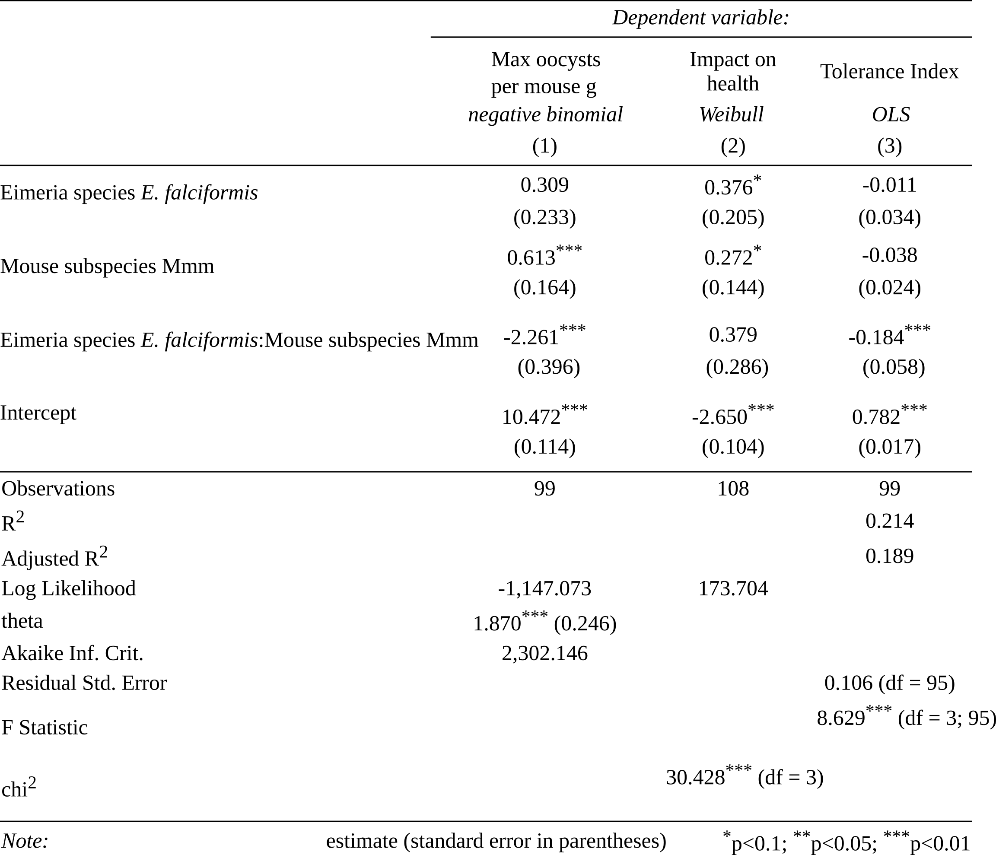

**Table 2. Regression analyses results at the host subspecies / parasite species level.**

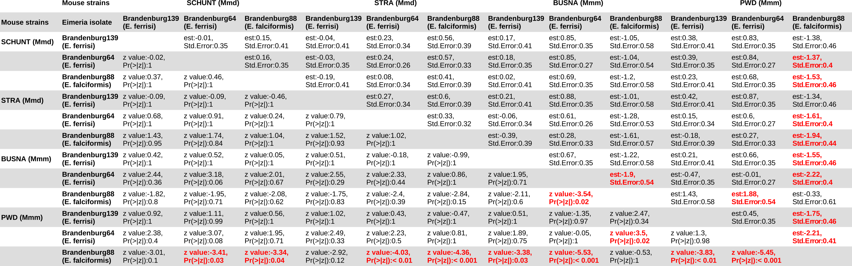

**Table 3. Post-hoc statistical test for resistance (Tukey Multiple Comparisons of Means). See Figure 4A.**

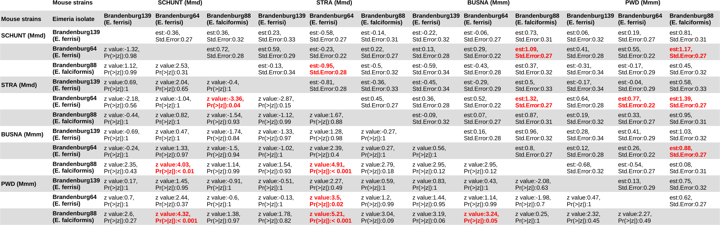

**Table 4. Post-hoc statistical test for impact on health (Tukey Multiple Comparisons of Means). See Figure 4B.**

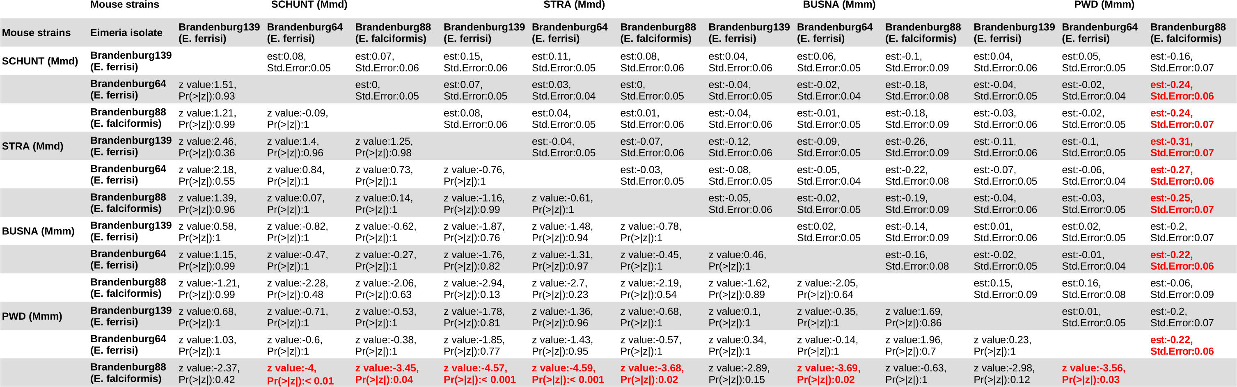

**Table 5. Post-hoc statistical test for tolerance (Tukey Multiple Comparisons of Means). See Figure 4C.**

# Figures

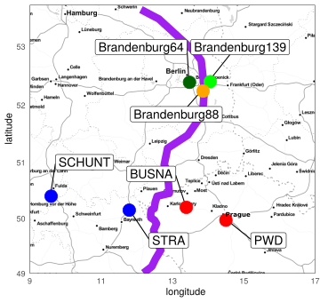

**Figure 1. Parasite isolates and mouse strains.** The map shows locations at which mice were collected for breeding of mouse strains and isolation of parasites. The purple line is an estimation of the center of the house mouse hybrid zone between Mmd and Mmm based on sampling and genotyping of mice in this area (Balard et al., 2019; Ďureje, Macholán, Baird, & Piálek, 2012). *M. m. domesticus* are colored in blue, *M. m. musculus* in red, parasite isolates in green and orange.

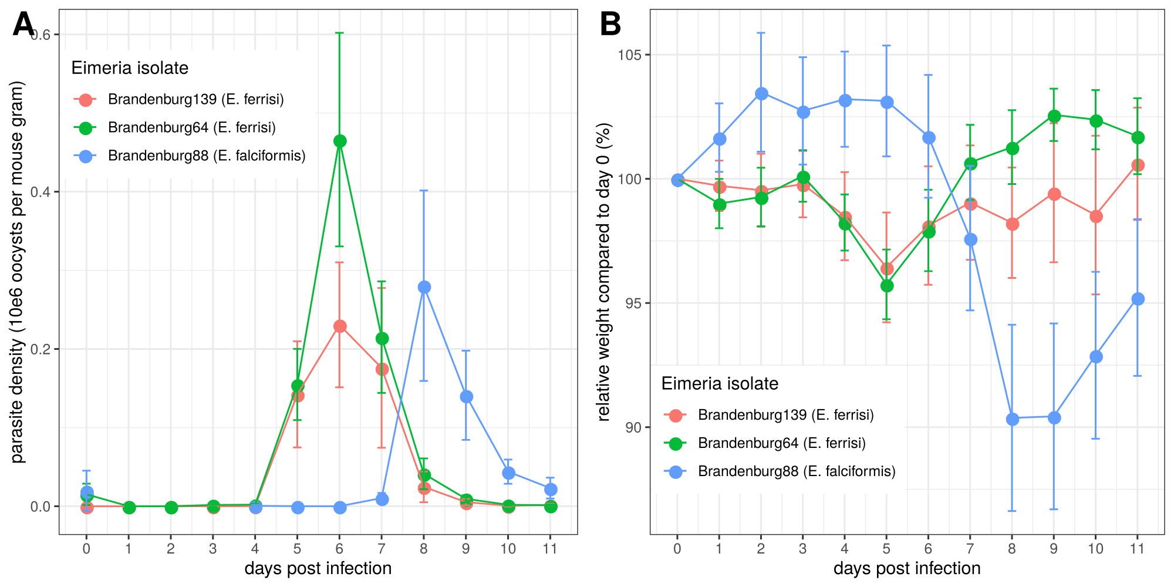

**Figure 2. Parasite density (A) and relative weight loss (B) during *Eimeria* infection.** Parasite density is calculated as number of oocysts detected (10e6) in feces per mouse gram, relative weight loss is calculated compared to day 0.Mean and 95% CI are plotted for each parasite isolate. All hosts strains are regrouped.

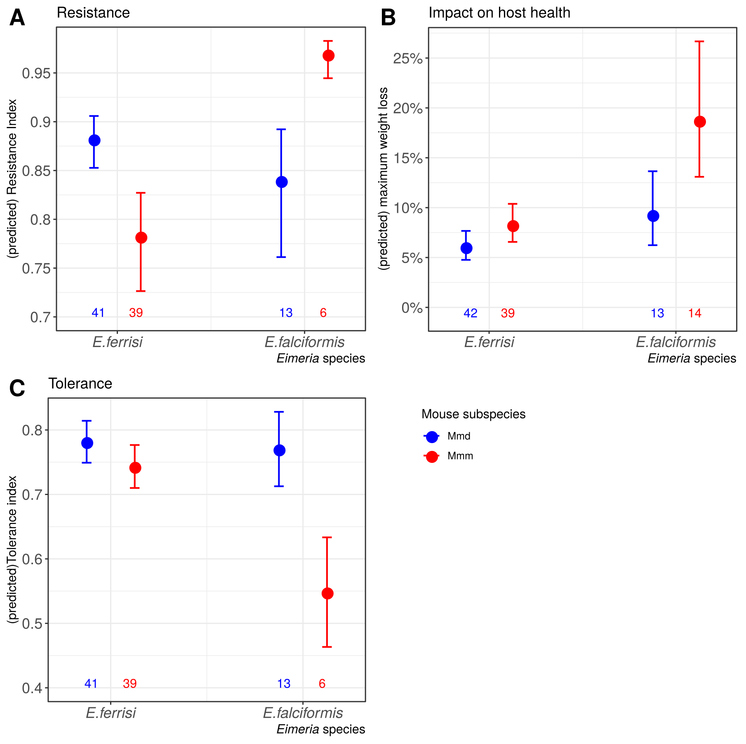

**Figure 3. Resistance, impact on host health and tolerance marginal effects for the two mice subspecies and two *Eimeria* species.** Predicted mean and standard deviation for each group. Values under bars represent the number of animals for each group. See Table 2 for summary statistics. (A) Resistance index measured as *(- maximum number of oocysts per mouse gram + 300000) / 300000* ; (B) Impact on host health measured as the maximum weight loss during patent period relative to starting weight (%); (C) Tolerance Index measured as *(log10(maximum relative weight loss / maximum number of oocysts per mouse gram + 1e-8) / -8*

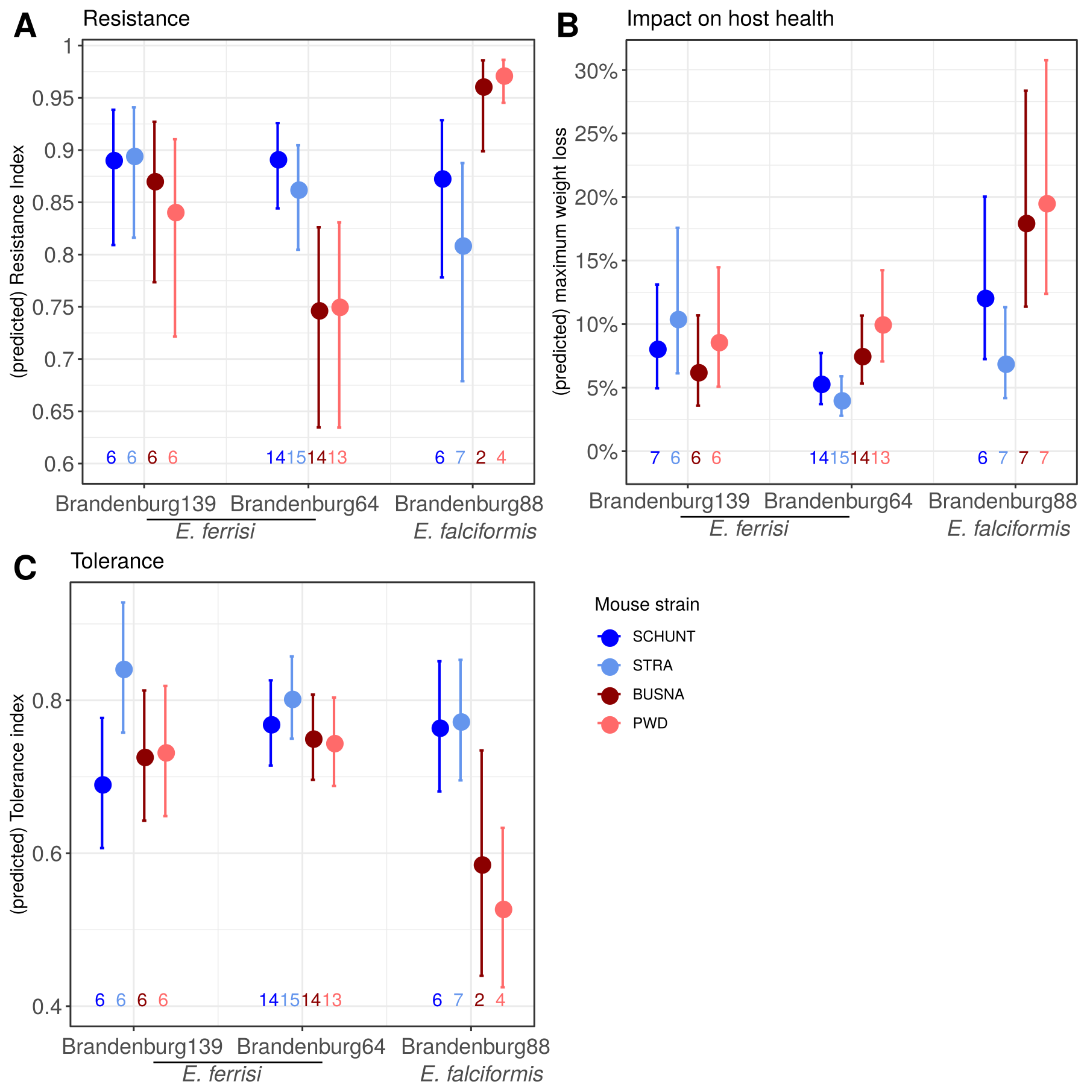

**Figure 4. Resistance, impact on host health and tolerance marginal effects for four inbred mouse strains infected with three *Eimeria* isolates each.** Predicted mean and standard deviation for each group. Values under bars represent the number of animals for each group. (A) Resistance Index measured as *(- maximum number of oocysts per mouse gram + 300000) / 300000* (see Table 3 for post-hoc tests); (B) Impact on host health measured as the maximum weight loss during patent period relative to starting weight (%)(see Table 4 for post-hoc tests); (C) Tolerance Index measured as *(log10(maximum relative weight loss / maximum number of oocysts per mouse gram + 1e-8) / -8* (see Table 5 for post-hoc tests).

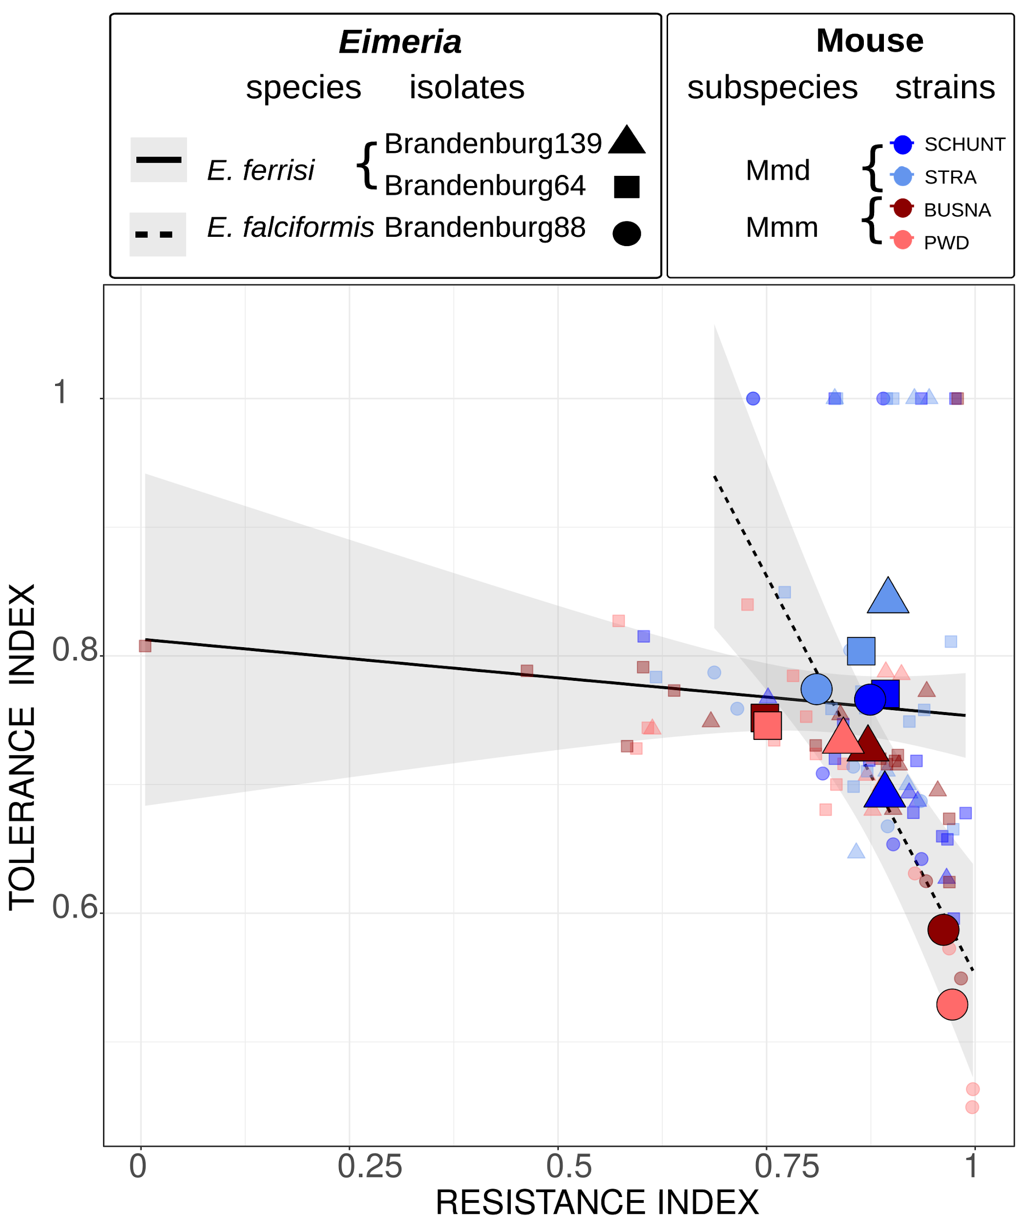

**Figure 5. Comparison of trade-off between resistance and tolerance between both *Eimeria* species.** Smaller points represent individual mice, while larger points figure the mean for a given (host strain-parasite isolate) group. Linear regression of tolerance by resistance are shown for both parasite species. Resistance Index measured as *(- maximum number of oocysts per mouse gram + 300000) / 300000*, Tolerance Index measured as *(log10(maximum relative weight loss / maximum number of oocysts per mouse gram + 1e-8) / -8*

# Funding

This work was funded by the German Research Foundation (DFG) Grant [HE 7320/1-1] to EH. VHJ is an associated student of GRK 2046 funded by the DFG. [XXX]

# References

Al-khlifeh, E., Balard, A., Jarquín-Díaz, V. H., Weyrich, A., Wibbelt, G., & Heitlinger, E. (2019). *Eimeria falciformis* BayerHaberkorn1970 and novel wild derived isolates from house mice: Differences in parasite lifecycle, pathogenicity and host immune reactions. *BioRxiv*, *611277*. http://dx.doi.org/10.1101/611277

Ankrom, S. L., Chobotar, B., & Ernst, J. V. (1975). Life cycle of *Eimeria ferrisi* Levine & Ivens, 1965 in the Mouse, *Mus musculus*. *The Journal of Protozoology*, *22*(3), 317–323. https://doi.org/10.1111/j.1550-7408.1975.tb05177.x

Baird, S. J. E., & Goüy de Bellocq, J. (2019). Shifting paradigms for studying parasitism in hybridising hosts: Response to Theodosopoulos, Hund, and Taylor. *Trends in Ecology & Evolution*, *34*, 387–389. https://doi.org/10.1016/j.tree.2019.01.011

Baird, S. J. E., Ribas, A., Macholán, M., Albrecht, T., Piálek, J., & Goüy de Bellocq, J. (2012). Where are the wormy mice? A reexamination of hybrid parasitism in the European house mouse hybrid zone. *Evolution*, *66*(9), 2757–2772. https://doi.org/10.1111/j.1558-5646.2012.01633.x

Baker, D. G. (1998). Natural pathogens of laboratory mice, rats, and rabbits and their effects on research. *Clinical Microbiology Reviews*, *11*(2), 231–266.

Balard, A., Jarquín-Díaz, V. H., Jost, J., Martincová, I., Ďureje, Ľ., Piálek, J., … Heitlinger, E. (2019). Intensity of infection with intracellular *Eimeria* spp. And pinworms is reduced in hybrid mice compared to parental subspecies. *BioRxiv*, *683698*. https://doi.org/10.1101/683698

Barton, N. H., & Hewitt, G. M. (1985). Analysis of hybrid zones. *Annual Review of Ecology and Systematics*, *16*(1), 113–148. https://doi.org/10.1146/annurev.es.16.110185.000553

Chapman, H. D., Barta, J. R., Blake, D., Gruber, A., Jenkins, M., Smith, N. C., … Tomley, F. M. (2013). A selective review of advances in coccidiosis research. *Advances in Parasitology*, *83*, 93–171. https://doi.org/10.1016/B978-0-12-407705-8.00002-1

Ďureje, Ľ., Macholán, M., Baird, S. J., & Piálek, J. (2012). The mouse hybrid zone in Central Europe: From morphology to molecules. *Folia Zoologica*, *61*(3–4), 308–318.

Ehret, T., Spork, S., Dieterich, C., Lucius, R., & Heitlinger, E. (2017). Dual RNA-seq reveals no plastic transcriptional response of the coccidian parasite Eimeria falciformis to host immune defenses. *BMC Genomics*, *18*(1), 686. https://doi.org/10.1186/s12864-017-4095-6

Graham, A. L., Allen, Judith. E., & Read, A. F. (2005). Evolutionary causes and consequences of immunopathology. *Annual Review of Ecology, Evolution, and Systematics*, 373–397. https://doi.org/10.1146/annurev.ecolsys.36.102003.152622

Gregorová, S., & Forejt, J. (2000). PWD/Ph and PWK/Ph inbred mouse strains of *Mus m. Musculus* subspecies—A valuable resource of phenotypic variations and genomic polymorphisms. *Folia Biologica*, *46*(1), 31–41.

Haberkorn, A. (1970). Die Entwicklung von *Eimeria falciformis*  (Eimer 1870) in der weißen Maus (*Mus musculus*). *Zeitschrift für Parasitenkunde*, *34*(1), 49–67. https://doi.org/10.1007/BF00629179

Hayward, A. D., Nussey, D. H., Wilson, A. J., Berenos, C., Pilkington, J. G., Watt, K. A., … Graham, A. L. (2014). Natural Selection on Individual Variation in Tolerance of Gastrointestinal Nematode Infection. *PLOS Biology*, *12*(7), e1001917. https://doi.org/10.1371/journal.pbio.1001917

Hlavac, M. (2018). *stargazer: Well-Formatted Regression and Summary Statistics Tables*. Retrieved from https://CRAN.R-project.org/package=stargazer

Jarquín-Díaz, V. H., Balard, A., Jost, J., Kraft, J., Dikmen, M. N., Kvičerová, J., & Heitlinger, E. (2019). Detection and quantification of house mouse *Eimeria* at the species level – Challenges and solutions for the assessment of coccidia in wildlife. *International Journal for Parasitology: Parasites and Wildlife*, *10*, 29–40. https://doi.org/10.1016/j.ijppaw.2019.07.004

Kutzer, M. A. M., & Armitage, S. A. O. (2016). Maximising fitness in the face of parasites: A review of host tolerance. *Zoology*, *119*(4), 281–289. https://doi.org/10.1016/j.zool.2016.05.011

Langand, J., Jourdane, J., Coustau, C., Delay, B., & Morand, S. (1998). Cost of resistance, expressed as a delayed maturity, detected in the host–parasite system Biomphalaria glabrata/Echinostoma caproni. *Heredity*, *80*(3), 320–325. https://doi.org/10.1046/j.1365-2540.1998.00291.x

Little, T. J., Shuker, D. M., Colegrave, N., Day, T., & Graham, A. L. (2010). The Coevolution of Virulence: Tolerance in Perspective. *PLOS Pathogens*, *6*(9), e1001006. https://doi.org/10.1371/journal.ppat.1001006

Macholán, M., Munclinger, P., Sugerková, M., Dufková, P., Bímová, B., Bozíková, E., … Piálek, J. (2007). Genetic analysis of autosomal and X-linked markers across a mouse hybrid zone. *Evolution*, *61*(4), 746–771. https://doi.org/10.1111/j.1558-5646.2007.00065.x

Martincová, I., Ďureje, Ľ., Kreisinger, J., Macholán, M., & Piálek, J. (2019). Phenotypic effects of the Y chromosome are variable and structured in hybrids among house mouse recombinant lines. *Ecology and Evolution*, *9*(10), 6124–6137. https://doi.org/10.1002/ece3.5196

Mazé-Guilmo, E., Loot, G., Páez, D. J., Lefèvre, T., & Blanchet, S. (2014). Heritable variation in host tolerance and resistance inferred from a wild host–parasite system. *Proceedings of the Royal Society B: Biological Sciences*, *281*(1779). https://doi.org/10.1098/rspb.2013.2567

Medzhitov, R., Schneider, D. S., & Soares, M. P. (2012). Disease tolerance as a defense strategy. *Science*, *335*(6071), 936–941. https://doi.org/10.1126/science.1214935

Miller, M. R., White, A., & Boots, M. (2005). The evolution of host resistance: Tolerance and control as distinct strategies. *Journal of Theoretical Biology*, *236*(2), 198–207. https://doi.org/10.1016/j.jtbi.2005.03.005

Piálek, J., Vyskocilová, M., Bímová, B., Havelková, D., Piálková, J., Dufková, P., … Forejt, J. (2008). Development of unique house mouse resources suitable for evolutionary studies of speciation. *The Journal of Heredity*, *99*(1), 34–44. https://doi.org/10.1093/jhered/esm083

R Development Core Team. (2018). *R: A language and environment for statistical computing. R Foundation for Statistical Computing, Vienna, Austria*. Retrieved from http://www.R-project.org

Råberg, L. (2014). How to live with the enemy: Understanding tolerance to parasites. *PLoS Biology*, *12*(11), e1001989. https://doi.org/10.1371/journal.pbio.1001989

Råberg, L., Graham, A. L., & Read, A. F. (2009). Decomposing health: Tolerance and resistance to parasites in animals. *Philosophical Transactions of the Royal Society B: Biological Sciences*, *364*(1513), 37–49. https://doi.org/10.1098/rstb.2008.0184

Råberg, L., Sim, D., & Read, A. F. (2007). Disentangling genetic variation for resistance and tolerance to infectious diseases in animals. *Science (New York, N.Y.)*, *318*(5851), 812–814. https://doi.org/10.1126/science.1148526

Restif, O., & Koella, J. C. (2003). Shared Control of Epidemiological Traits in a Coevolutionary Model of Host‐Parasite Interactions. *The American Naturalist*, *161*(6), 827–836. https://doi.org/10.1086/375171

Roy, B. A., & Kirchner, J. W. (2000). Evolutionary Dynamics of Pathogen Resistance and Tolerance. *Evolution*, *54*(1), 51–63. https://doi.org/10.1111/j.0014-3820.2000.tb00007.x

Schito, M. L., Barta, J. R., & Chobotar, B. (1996). Comparison of four murine *Eimeria* species in immunocompetent and immunodeficient mice. *The Journal of Parasitology*, *82*(2), 255–262. https://doi.org/10.2307/3284157

Sheldon, B. C., & Verhulst, S. (1996). Ecological immunology: Costly parasite defences and trade-offs in evolutionary ecology. *Trends in Ecology & Evolution*, *11*(8), 317–321. https://doi.org/10.1016/0169-5347(96)10039-2

Simms, E. L., & Triplett, J. (1994). Costs and benefits of plant response to disease: Resistance and tolerance. *Evolution*, *48*(6), 1973–1985. https://doi.org/10.1111/j.1558-5646.1994.tb02227.x

Soares, M. P., Teixeira, L., & Moita, L. F. (2017). Disease tolerance and immunity in host protection against infection. *Nature Reviews Immunology*, *17*(2), 83–96. https://doi.org/10.1038/nri.2016.136

Stange, J., Hepworth, M. R., Rausch, S., Zajic, L., Kühl, A. A., Uyttenhove, C., … Lucius, R. (2012). IL-22 Mediates Host Defense against an Intestinal Intracellular Parasite in the Absence of IFN-γ at the Cost of Th17-Driven Immunopathology. *The Journal of Immunology*, *188*(5), 2410–2418. https://doi.org/10.4049/jimmunol.1102062

Vijendravarma, R. K., Kraaijeveld, A. R., & Godfray, H. C. J. (2009). Experimental Evolution Shows Drosophila Melanogaster Resistance to a Microsporidian Pathogen Has Fitness Costs. *Evolution*, *63*(1), 104–114. https://doi.org/10.1111/j.1558-5646.2008.00516.x

Vincent, C. M., & Sharp, N. P. (2014). Sexual antagonism for resistance and tolerance to infection in Drosophila melanogaster. *Proceedings of the Royal Society B: Biological Sciences*, *281*(1788), 20140987. https://doi.org/10.1098/rspb.2014.0987

Wickham, H. (2016). *ggplot2: Elegant Graphics for Data Analysis*. Springer-Verlag, New York.