# Decoupling of resistance and tolerance in two related parasites (*Eimeria*) in mice

# Alice Balard1,2, Víctor Hugo Jarquín-Díaz1,2, Jenny Jost1, Vivian Mittné1, Francisca Böhning1, Ľudovít Ďureje3, Jaroslav Piálek3, Emanuel Heitlinger1,2

*1 Institute for Biology. Department of Molecular Parasitology. Humboldt University Berlin (HU). Philippstr. 13, Haus 14, 10115, Berlin, Germany*

*2 Leibniz-Institut für Zoo- und Wildtierforschung (IZW) im Forschungsverbund Berlin e.V.. Alfred-Kowalke-Straße 17, 10315, Berlin, Germany*

*3 Research Facility Studenec, Institute of Vertebrate Biology, Czech Academy of Sciences, Květná 8, 603 65 Brno, Czech Republic*

# Abstract

Resistance (the host’s capacity to reduce parasite burden) and tolerance (the host’s capacity to reduce impact on host health of a given parasite burden) manifest two different lines of immune defenses. In some host-parasite systems these two defenses are balanced against each other, while in others they are uncoupled. Here, we used two closely related parasite species of genus *Eimeria* and measured proxies for resistance and tolerance in four wild-derived strains of inbred mice from two subspecies during controlled infection.

We found a negative correlation between resistance and tolerance against *E. falciformis*, while the two are uncoupled against *E. ferrisi*. This might be explained by trade-offs, as resistance limits infection load and thereby the scope of possible tolerance, and both resistance and tolerance can be costly in terms of resource allocation. Resistance can be assumed to be limited by immunopathogenicity, tolerance by carrying capacity of the host or energy drained by the parasite.

Findings of resistance in natural populations of hybrid mice have to be interpreted carefully in this context. Not only mechanisms behind resistance and tolerance but also virulence realised in the evolution of different closely related parasites can be studied in laboratory infections in this system.

# Introduction

Host defense mechanisms evolving in response to feedback between hosts and parasites can be categorised into two components: resistance and tolerance (Little et al., 2010). Resistance (the ability of a host to reduce its parasite burden) results from defense against parasite infection or proliferation early after infection (Råberg et al., 2009). Resistance can be energetically costly and therefore limited by resource allocation as measured by a decrease of other fitness components (e.g. delayed maturity, lower fecundity) in the absence of infection (Langand et al., 1998; Sheldon & Verhulst, 1996; Vijendravarma et al., 2009). Additionally, too strong immune response against pathogens can lead to a negative impact on health or immunopathology (Graham et al., 2005). Tolerance balances damage caused by parasites themselves and immunopathology (Medzhitov et al., 2012) through control mechanisms like stress response, damage repair and cellular regeneration (Soares et al., 2017). This is why, just like resistance, tolerance can involve energetic costs (Simms & Triplett, 1994).

Both resistance and tolerance might be shaped by co-evolutionary host-parasite history. When in isolation coevolving systems meet, the newly generated variation can result in novel interplay in immunological responses. For example, two European house mouse subspecies, whose genomes diverged some 0.5 mil ago, are known to harbor different lineages of *Cryptosporidium tyzzeri* (Kváč et al. 2013). Hybrids between two mouse subspecies *Mus musculus musculus* and *M. m. domesticus* (hereafter Mmm and Mmd, respectively) show elevated resistance to parasites compared to both parental subspecies (Baird et al., 2012; Balard et al., 2019). Interpretations of these results in terms of health or even fitness effects have been attempted (Sage et al., 1986) and criticised (Baird & Goüy de Bellocq, 2019). In natural populations, costs of the two lines of defense against parasites predict that resistance and tolerance are negatively correlated (Råberg, 2014; Råberg et al., 2007). They can also be found uncoupled if they are at intermediate levels (Athanasiadou et al., 2015). As resistance alone is not an estimator of parasite impact on health, understanding how resistance and tolerance are coupled is necessary to conclude on health effects of parasitism.

*Eimeria ferrisi* has been found to be the most prevalent (17%) protozoan parasite in the house mouse hybrid zone in Brandenburg (Germany), followed by *E. falciformis (4%)* (Jarquín-Díaz, Balard, Jost, et al., 2019)*. Eimeria*spp. are monoxenous parasites that expand asexually and reproduce sexually in intestinal epithelial cells, leading to malabsorption of nutrients, tissue damage and weight loss (Chapman et al., 2013). They are generally considered to be host specific, and different species infect a wide range of animals including birds, mammals, reptiles, amphibians, and fish (Chapman et al., 2013; Jarquín-Díaz, Balard, Mácová, et al., 2019). *Eimeria ferrisi* and *E. falciformis* live in the cecum villar epithelial cells and cecum crypt cells, respectively (Schito et al., 1996). Pre-patency (the time to shedding of infectious stages, so called oocysts) is longer for *E. falciformis* (7 days) than for *E. ferrisi* (5 days) (Al-khlifeh et al., 2019). While both species provoke inflammation, cellular infiltration, enteric lesions, diarrhea, and ultimately weight loss (Ankrom et al., 1975; Ehret et al., 2017; Schito et al., 1996), the symptoms are stronger for *E. falciformis* than for *E. ferrisi* infections (Al-khlifeh et al., 2019).

Given differences in pathogenicity and prevalence between the two *Eimeria* species we suspected that coupling between resistance and tolerance might differ. We assessed this experimentally in controlled infections of Mmm and Mmd. We employed four wild-derived inbred strains representing the two mouse subspecies and assessed the symptoms both at the level of host subspecies and inbred strains.

# Material and methods

## Parasite strains

The three parasite isolates used in this study were isolated from feces of mice captured in a house mouse hybrid zone (HMHZ) running through Brandenburg, Germany (Macholán et al. 2019), in 2016 (capture permit No. 2347/35/2014). They belong to both the most prevalent *Eimeria* species in the wild (Jarquín-Díaz, Balard, Mácová, et al., 2019), namely *E. ferrisi* (isolates Brandenburg64 and Brandenburg139) and *E. falciformis* (isolate Brandenburg88). Hybrid index (HI) of each individual wild-caught mouse was calculated to account for the admixture of mouse genomes across the HMHZ as a proportion of Mmm alleles in a set of 14 diagnostic markers (Balard et al., 2019). Isolate Brandenburg64 was isolated in a 92% Mmd individual (HI = 0.08), isolate Brandenburg139 in a 85% Mmm (HI = 0.85) and isolate Brandenburg88 in a 80% Mmd (HI = 0.2). Pre-patency and the peak day of oocyst shedding for these isolates were estimated during infection in NMRI laboratory mice (Al-khlifeh et al., 2019) which were also used for serial passaging of all the isolates. Parasite infective forms (oocysts) were recovered by flotation in saturated NaCl solution followed by washing and observation under light microscope (following the protocole described in Clerc, Fenton, Babayan, & Pedersen, 2019) and stored at room temperature in 1mL of 2% potassium dichromate for a maximum of 2 months before infection of the wild-derived mouse strains. Oocysts were allowed to sporulate 10 days before infection in a water bath at 30°C.

## Mouse strains

We used four wild-derived fully-inbred mouse strains: two representing Mmd: **SCHUNT** (Locality: Schweben, Hessen, Germany [N: 50° 26’, E: 9° 36’] (Martincová et al., 2019)) and **STRA** (Locality: Straas, Bavaria, Germany [N: 50° 11’, E: 11° 46’] (Piálek et al., 2008), and two derived from Mmm: **BUSNA** (Locality: Buškovice, Bohemia, Czech Republic [N: 50° 14’, E: 13° 22’] (Piálek et al., 2008)) and **PWD** (Locality: Kunratice, Bohemia, Czech Republic [N: 50° 01’, E: 14° 29’] (Gregorová & Forejt, 2000))(**Figure 1**). Age of the mice at the time of infection ranged between 7.5 and 21.5 weeks. All mouse strains were maintained before infection in the Institute of Vertebrate Biology in Studenec (licence number 61974/2017‐MZE‐17214; for further details on strains see <https://housemice.cz/en>).

Parasites of the *Eimeria* genus are known to induce host immune protection against reinfection (Rose et al., 1992; Smith & Hayday, 2000). To ensure that our mice were *Eimeria*-naive, mice fecal samples were tested before infection for the presence of *Eimeria* spp. oocysts, by flotation in saturated NaCl solution followed by washing and observation under light microscope. All individuals were negative for *Eimeria* at the beginning of our experiment.

## Experimental infection

Mice were kept in individual cages during infection. Water and food (SNIFF, Rat/Mouse maintenance feed 10 mm) were provided *ad libitum* supplemented with 1 g of sunflower and barley seeds per day. Mice were orally infected with 150 sporulated oocysts of one *Eimeria* isolate suspended in 100 µl phosphate-buffer saline (PBS) and monitored daily until their sacrifice by cervical dislocation at 11 days after infection (dpi) (experiment license Reg. 0431/17). Individuals presenting severe health deficiency and/or a weight loss approaching 18% relative to their starting weight were sacrificed earlier. Weight was recorded and feces collected on a daily basis. Fecal pellets were collected every day from each individual cage and suspended in 2% potassium dichromate. Parasite oocysts were recovered using NaCl flotation (see above). In total, 108 mice were infected. Mice were randomly allocated to experimental groups ensuring homogeneous distribution of ages and sexes between groups. Our experiments were conducted in four consecutive batches for easy handling. The first two groups were infected by the two *E. ferrisi* isolates (Brandenburg64 and Brandenburg139), the two second by one *E. ferrisi* isolate (Brandenburg64) and one *E. falciformis* isolate (Brandenburg88). Summarised experiment design is shown in **Table 1**.

We observed *Eimeria* oocysts in the feces of 9 mice belonging to the last experimental batch at the day of infection, likely due to cross-contamination between batches. Moreover, before arrival to the infection facility, nematode eggs were observed in flotated feces of mice belonging to all genotypes. Nematode infection is common in breeding facilities (Baker, 1998). Despite treatment of the first infection batch of mice (22 mice) with anthelminthics (Profender®, Bayer AG, Levekusen, Germany) following the protocole of Mehlhorn et al. (2005), nematodes were still detected with PCR (following the protocole of Floyd, Rogers, Lambshead, & Smith, 2005) in randomly sampled fecal samples a week later. We therefore decided not to treat mice of the following infection batches. For following statistical tests, we considered the full dataset and a conservative dataset in which cross-contaminated animals and animals treated by anthelminthic are removed (see below).

## Choice of measurements for resistance and tolerance

Resistance is the capacity of a host to reduce its parasite burden, therefore it is usually estimated by the inverse of infection intensity (Råberg et al., 2009). As a proxy we used the number of parasites per host, calculated as the number of oocysts in feces at the day of maximal shedding, divided by the mouse weight at this day (in grams). This measurement allowed us to take into account the host’s body size, assuming a lower capacity to carry parasites in smaller mice: a higher number of oocysts per mouse weight corresponds to lower resistance. At the day of peak intensity, this measure was tightly correlated with the sum of oocysts shed throughout the experiment (Pearson correlation coefficient 0.92). For further statistical analyses we modelled the raw value of “maximum number of oocysts per mouse gram”; For plotting and comparison with tolerance index, we used a resistance index ranging between 0 and 1 (see **Supplementary Figure S1.A**). As the highest individual value was 298496 maximum number of oocysts per mouse gram, this index was obtained as follows:

*Resistance index = (- maximum number of oocysts per mouse gram + 300000) / 300000*

Tolerance is usually defined as the slope of the regression of host fitness, approximated by health condition, on infection intensity (Råberg, 2014). The major measurable symptom in murine *Eimeria* infections is weight loss. Therefore, the impact of parasites on host health was measured as the maximum relative weight loss compared to day 0 (body weight taken at the start of the experimental infection).

We defined a tolerance index for each individual, describing how its health varied with infection intensity, between day 0 of infection (weight = 100%, parasite intensity = 0 oocyst per mouse gram) and highest impact (weight = maximum weight loss relative to day 0, parasite intensity = maximum parasite number per mouse gram). This index was then normalised by log10 transformation, after addition of 1e-8 to the ratio ”maximum relative weight loss / maximum number of oocysts per mouse gram“ to avoid infinite values. The obtained log10 transformed ratio that ranged between -8 (high tolerant) and -3.6 (low tolerant) was divided by the negative constant -8 to obtained a final index positively correlated with tolerance, and ranging between 0 and 1 (see **Supplementary Figure S1.B**):

*Tolerance index = (log10(maximum relative weight loss / maximum number of oocysts per mouse gram + 1e-8) / -8*

## Statistical analyses

Appropriate distribution for maximum number of oocysts per mouse gram, maximum weight loss relative to day 0, and tolerance index were selected based on log likelihood and AIC criteria and by comparing goodness-of-fits plots (density, CDF, Q-Q, P-P plots) between usual distributions (R packages MASS (Venables & Ripley, 2002) and fitdistrplus (Delignette-Muller & Dutang, 2015)). The negative binomial, Weibull, and normal distribution were the most adequate to describe the peak of oocysts per mouse gram, impact on host health, and tolerance index, respectively (see **Supplementary Figure S2**). For modelling the impact on host health, we added 0.01 to the raw value as the Weibull distribution regression requires positive values.

We tested the effects of mouse subspecies (Mmd or Mmm), *Eimeria* species (*E. ferrisi* or *E. falciformis*) and their interaction on our three response variables using (generalised) linear models. To assess the stability of our results across mouse strains and *Eimeria* isolates, we also tested the effects of mouse strain (N=4), parasite isolate (N=3) and their interaction separately using the same models. To test the significance of the marginal contribution to each parameter to the full model, each parameter (mouse subspecies, *Eimeria* species, and their interaction in the first case; mouse strain, *Eimeria* isolate, and their interaction in the second case) was removed from the full model, and the difference between full model and sub-model was assessed using likelihood ratio tests (G). Post-hoc multiple comparison tests (Tukey Multiple Comparisons of Means) were then performed to test the significant difference of each host-parasite combination against all others in the most detailed model with the mouse strains and the parasite isolates as predictors.

We then compared the coupling between proxies of resistance and tolerance between mouse subspecies. Using the resistance index and tolerance index defined above, we fitted a linear model to explain the variation of tolerance with resistance, *Eimeria* species and their interaction.

To verify the absence of impact of both previous contamination by *Eimeria* and anthelminthic treatment on our results, we performed different analyses (modeling of resistance, impact on health, tolerance at the host subspecies/parasite species level, as well as linear regression of the tolerance index with the resistance index, see below) on a dataset excluding the 22 mice treated by anthelminthics and the 9 mice showing contaminant infections. The results obtained in this conservative dataset are congruent with the results revealed in all mice, thus we consider the influence of both factors negligible (see **Supplementary Material S3**).

All analyses were performed using the R software version 3.5.2 (R Development Core Team, 2018). Graphics were produced using the R package ggplot2 (Wickham, 2016) and compiled using the free software inkscape (https://inkscape.org).

All codes and data used for this article can be found at: https://github.com/alicebalard/Article_RelatedParasitesResTol

# Results

## General parasitology

The life cycle of all isolates was successfully completed in all mouse strains (**Figure 2**). For *E. ferrisi* (both isolates), the pre-patent period was 5 dpi and the median day of maximal oocyst shedding was 6 dpi (standard deviation sd=0.71 and 0.65, respectively). The median day of maximum weight loss was 5 dpi for both isolates (sd=2.2 and 1.9 respectively). For *E. falciformis* (isolate Brandenburg88) pre-patency was 7 dpi, median day of maximal shedding was 8 dpi (sd=1.2) and median day of maximal weight loss 9 dpi (sd=1.5). All tested *Eimeria* isolates infected all individuals of the tested mouse strains.

A considerable number of Mmm mice (8/14; 5 of BUSNA and 3 of PWD) infected with *E. falciformis* (isolate Brandenburg88) died (or had to be sacrificed at humane end points specified in animal experimental procedures) before the peak of oocyst shedding. Moreover, one Mmd mouse (strain SCHUNT) infected by *E. ferrisi* isolate Brandenburg139 had liquid diarrhea in the peak shedding day, making its feces not collectable. These mice were assessed as missing data for both resistance and following tolerance measurements.

## *M. m. musculus* is more resistant to *E. falciformis* than to *E. ferrisi*

To establish differences between the two house mouse subspecies and between the parasite species, we analysed the maximum number of oocysts per mouse gram as a measure of resistance after infection with both *Eimeria* species on the 99 mice alive by the time of median peak shedding. We found statistically significant effects of parasite species (LRT: G = 22.8, df = 2, P < 0.001), mouse subspecies (LRT: G = 26.7, df = 2, P < 0.001) as well as an interaction between parasite species and mouse subspecies (LRT: G = 22.4, df = 2, P < 0.001). Post-hoc multiple comparison tests showed than the subspecies Mmm shed less oocysts per mouse gram at the peak of shedding when infected with *E. falciformis* than with *E. ferrisi*. Moreover, the Mmm subspecies shed less oocysts per mouse gram at the peak of shedding than the Mmd subspecies when infected *E. falciformis*, and more than the Mmd subspecies when infected with *E. ferrisi* (**Table 2**; **Figure 3A**).

We then tested the influence of mouse strain and parasite isolate on maximum number of oocysts per mouse gram. We found statistically significant effects of parasite isolate (LRT: G = 28.8, df = 8, P < 0.001), mouse strain (LRT: G = 30.3, df = 9, P < 0.001) as well as an interaction between parasite isolate and mouse strain (LRT: G = 25.3, df = 6, P < 0.001). Post-hoc multiple comparison tests showed that PWD (Mmm strain) shed less oocysts per mouse gram at the peak of shedding when infected with Brandenburg88 (*E. falciformis* isolate) than with the two *E. ferrisi* isolates, Brandenburg64 and Brandenburg139. Mice belonging to the second Mmm strain, BUSNA, shed less oocysts per mouse gram at the peak of shedding when infected with Brandenburg88 than with Brandenburg64. Overall, we found no significant difference between the strains of the same subspecies within a given parasite species infection, nor between the isolates of the same species within a given mouse strain (**Supplementary Table S4**; **Figure 4A**).

## Health of *M. m. musculus* is more impacted by *E. falciformis* than by *E. ferrisi*

Analysing the weight loss upon infection as a proxy for impact on host health of the full dataset (N = 108), we found statistically significant differences both between the mouse subspecies (LRT: G = 10, df = 2, P < 0.01) and between the parasite species (LRT: G = 18.6, df = 2, P < 0.001). Post-hoc multiple comparison tests showed that Mmd lost less weight than Mmm when infected by *E. falciformis* (9.3% vs 18.7%), and Mmm lost more weight when infected by *E. falciformis* than by *E. ferrisi* (**Table 3**, **Figure 3B**).

Then we modelled maximum weight loss separating *Eimeria*by isolates (instead of species) and mice by strains (instead of subspecies). We found differences between parasite isolates (LRT: G = 30.7, df = 8, P < 0.001) and mouse strains (LRT: G = 23, df = 9, P < 0.01). Notably, PWD (Mmm) mice infected with Brandenburg64 (*E. ferrisi*) lost significantly more weight than STRA mice (Mmd) infected with the same isolate , following the pattern described at the mouse subspecies-parasite species level (Mmd losing less weight than Mmm when infected by *E. ferrisi*). Overall, we did not find any significant difference between mouse strains of the same subspecies within a given parasite species infection or between parasite isolates of the same species within a given mouse strain (**Supplementary Table S5**; **Figure 4B**).

## *M. m. musculus* is less tolerant to *E. falciformis* than to *E. ferrisi*

Combining resistance and the impact on health, we assessed tolerance of the mouse subspecies to both *Eimeria*species on the 99 mice for which this index could be calculated. Tolerance index was found to differ significantly between the mouse subspecies (LRT: G = 19.4, df = 2, P < 0.001), between the two parasite species (LRT: G = 16.8, df = 2, P < 0.001). Significant were also interactions between mouse subspecies and parasite species (LRT: G = 10.1, df = 1, P < 0.01). Post-hoc multiple comparison tests showed that tolerance index upon infection with *E. falciformis* was higher for Mmd than for Mmm. Within Mmm subspecies, animals had a lower tolerance index to *E. falciformis* than to *E. ferrisi* (**Table 4**; **Figure 3C**).

Testing at the level of *Eimeria*isolates and mouse strains, we found between-parasite isolates differences (LRT: G = 21.7, df = 8, P < 0.01), between-mouse strains differences (LRT: G = 27.3, df = 9, P < 0.01), and interaction between the two factors (LRT: G = 14.2, df = 6, P = 0.027). Post-hoc multiple comparison tests showed statistically significant differences between PWD infected with Brandenburg88 against both Mmd strains infected with the same parasite isolate (Tukey Multiple Comparisons of Means, STRA: z = -3.68, P = 0.02; SCHUNT: z = -3.45, P = 0.04), and against animals of the same strain infected with Brandenburg64 (Tukey Multiple Comparisons of Means: z = -3.56, P = 0.03). Overall, we did not find any significant difference in tolerance between mouse strains of the same subspecies within a given parasite species infection, or between parasite isolates of the same species within a given mouse strain (**Supplementary Table S6**; **Figure 4C**). These results indicate that the lower tolerance of Mmm to *E. falciformis* compared to Mmd is consistent at the strain level.

## Coupling of resistance and tolerance differs between *Eimeria* species

To test coupling between resistance and tolerance of the mouse strains within each of the parasite species, we fitted a linear model of tolerance index by resistance index allowing for differences in intercept and slope for *Eimeria* species. We found that tolerance index was negatively correlated with resistance index (LRT: G = 24.1, df = 2, p < 0.001), was different for both *Eimeria* species (LRT: G = 23.3, df = 2, p < 0.001), and, notably, interaction between these two factors were significant (LRT: G = 19.8, df = 1, p < 0.001). Every increase of 1 unit of resistance index corresponds to a decrease of 0.06 unit of tolerance index for *E. ferrisi* (95%CI: [-0.21 , 0.09]) and to a decrease of 1.2 unit of tolerance index for *E. falciformis* (95%CI: [-1.73 , -0.75]). As the confidence interval for *E. ferrisi* involves 0, tolerance and resistance indexes are not correlated for this parasite species, meaning that there is no coupling between resistance and tolerance in the mouse strains/subspecies studied. By contrast, we observe a strong negative correlation of resistance and tolerance for *E. falciformis* (**Figure 5**). One mouse (point [0,0.81]) seem to be an outlier; consequently, we tested how this point was affecting the linear fit by excluding it from our model. We found the trends remained stable after the outlier removal: tolerance index was negatively correlated with resistance index (LRT: G = 23.7, df = 2, p < 0.001), was different for both *Eimeria*species (LRT: G = 21.9, df = 2, p < 0.001), and interaction between these two factors were significant (LRT: G = 18.5, df = 1, p < 0.001). Every increase of 1 unit of resistance index corresponds to a decrease of 0.06 unit of tolerance index for *E. ferrisi* (95%CI: [-0.26 , 0.14]) and to a decrease of 1.2 unit of tolerance index for *E. falciformis* (95%CI: [-1.73 , -0.75]).

# Discussion

In this study, we used a controlled infection experiment to test whether two closely related parasites differ in their impact on their hosts – house mice. For this purpose, we assessed resistance and tolerance to *E. ferrisi* and *E. falciformis* and their effect on health in four different wild-derived strains from two mouse subspecies hybridising in Europe. While the Western mouse (*M. m. domesticus*, Mmd) did not show strong differences between the parasite species, the Eastern mouse (*M. m. musculus*, Mmm), was found to be more resistant but less tolerant to *E. falciformis* than to *E. ferrisi*. We found tolerance to be decoupled from resistance against *E. ferrisi.* The two types of responses against *E. falciformis* were negatively correlated, suggesting a trade-off between resistance and tolerance for this parasite. While resistance decreases parasite fitness and prevalence in natural populations, tolerance generally has no impact on parasite fitness and either increases or does not affect prevalence (Miller et al., 2005; Roy & Kirchner, 2000). This allows speculation on host-parasite co-evolution for both *Eimeria* species.

*E. ferrisi* commits to sexual reproduction after a relatively short time with few cycles of asexual expansion (Al-khlifeh et al., 2019; Ankrom et al., 1975). As *E. ferrisi* infections do not reach extremely high intensities with this infection strategy, high tolerance might be the optimal strategy for both house mouse subspecies. Resistance could then evolve relatively freely without any major impact of the parasite on the hosts’ health. Enhanced virulence (reduction of host fitness upon infection e.g. due to prolonged asexual replication before commitment to sexual replication and transmission) might not evolve because the low resistance of the host already allows an optimal transmission rate, especially considering the fast production of transmission stages (Anderson & May, 1982). A global optimum of high tolerance might also be the reason why no subspecies-specific adaptation of Mmd or Mmm infecting strains, i.e. increased tolerance of matching host-parasite pairs, could be detected in this parasite species.

*E. falciformis* has a relatively long life cycle (Al-khlifeh et al., 2019; Haberkorn, 1970). This means that parasites multiply asexually for a relative long time leading to potentially higher tissue loads and – once it starts to reproduce sexually – extremely high reproductive output in strongly impacted hosts. Therefore, tolerance of this parasite might, on the one hand, lead to prohibitively high intensities if the parasite is allowed to expand asexually and damage the tissue (Ehret et al., 2017) without enough resistance. On the other hand, immunopathology has been observed in advanced *E. falciformis* infections. For example, proinflammatory T cell mediators have been shown to decrease parasite load but increase body weight loss upon infection (Stange et al., 2012). This might lead to multiple different optima for resistance and tolerance (Råberg et al., 2007).In this context, two alternative response strategies against *E. falciformis* might have evolved and stabilised in the house mouse subspecies: while Mmm rather resists *E. falciformis,* Mmd tends to tolerate it.

Instead of such more or less stable optima in the two mouse subspecies we could speculate two related alternative explanations. Firstly, *E. falciformis* could originally be a Mmd parasite dissipated into Mmm territory by a spillover through the hybrid zone. As an argument against this explanation, no significant difference in *E. falciformis* prevalence at each side of the hybrid zone have be observed (unpublished data). Secondly, the *E. falciformis* isolate Brandenburg88 employed here was taken close to the hybrid zone center but from a predominantly Mmd mouse (hybrid index 0.2). The isolate could hence be adapted to Mmd. Experiments with an additional *E. falciformis* isolate from Mmm are needed to answer the question whether host subspecies adaptation can lead to tolerance in matching pairs of *E. falciformis* and mouse subspecies.

Resistance and tolerance to parasites are highly relevant to the house mouse hybrid zone. As a so-called tension zone, this zone is maintained by a balance between dispersal and endogenous selection against hybrids (Barton & Hewitt, 1985; Macholán et al., 2007; Payseur et al., 2004; Raufaste et al., 2005). It has been shown that hybrid mice are more resistant not only to *Eimeria* but also to other parasites including pinworms (Baird et al., 2012; Balard et al., 2019). Impact on tolerance could not be measured under natural conditions (Balard et al., 2019). The effect of parasites on hosts’ fitness in particular and the role they can play in the evolution of species barriers is thus still rather ambiguous. We here show that it is indispensable to measure both resistance and tolerance in *Eimeria* infections of house mice. Such measurements can be made in future laboratory experiments involving hybrid mice.

The contrast between two different *Eimeria* spp. invites future research on the relationship between infection intensity, parasite reproductive output, host health and immune response. This might allow us to better understand both the process and mechanisms of the evolution of tolerance and resistance in the context of hybrid hosts and beyond.

# Tables

|  |  |  |  |  |
| --- | --- | --- | --- | --- |
| **Mouse** | | **Eimeria species / isolate** | | |
| **strains** | **subspecies** | ***E. ferrisi***  **Brandenburg139** | ***E. ferrisi***  **Brandenburg64** | ***E. falciformis***  **Brandenburg88** |
| SCHUNT | *M.m.domesticus* | 7 (5M / 2F) | 14 (6M / 8F) | 6 (3M / 3F) |
| STRA | *M.m.domesticus* | 6 (2M / 4F) | 15 (8M / 7F) | 7 (4M /3F) |
| BUSNA | *M.m.musculus* | 6 (2M / 4F) | 14 (8M / 6F) | 7 (3M /4F) |
| PWD | *M.m.musculus* | 6 (3M / 3F) | 13 (10M / 3F) | 7 (1M / 6F) |

**Table 1. Infection experiment design.**

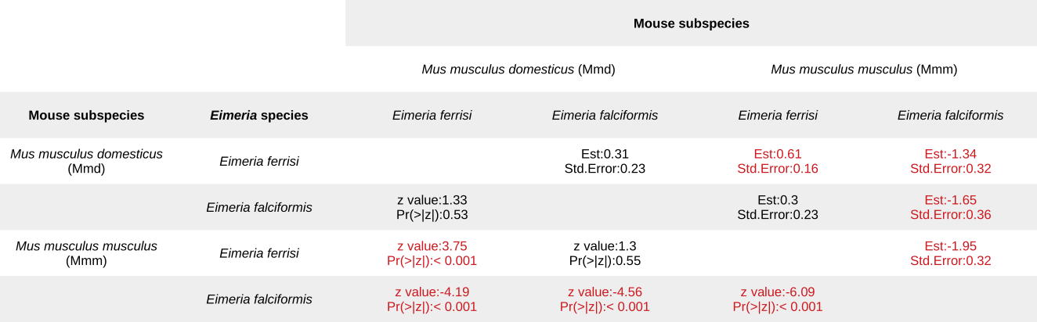**Table 2. Post-hoc statistical test for maximum oocyts density (Tukey Multiple Comparisons of Means). See Figure 3A.**

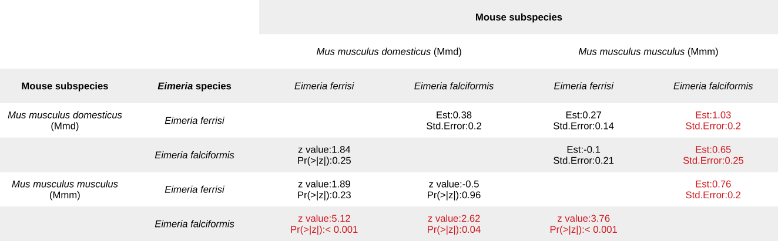

**Table 3. Post-hoc statistical test for maximum weight loss (Tukey Multiple Comparisons of Means). See Figure 3B.**

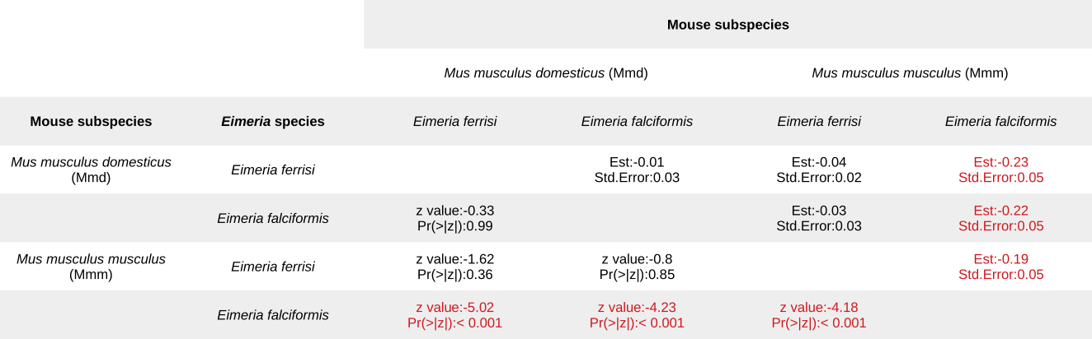**Table 4. Post-hoc statistical test for tolerance index (Tukey Multiple Comparisons of Means). See Figure 3C.**

# Figures

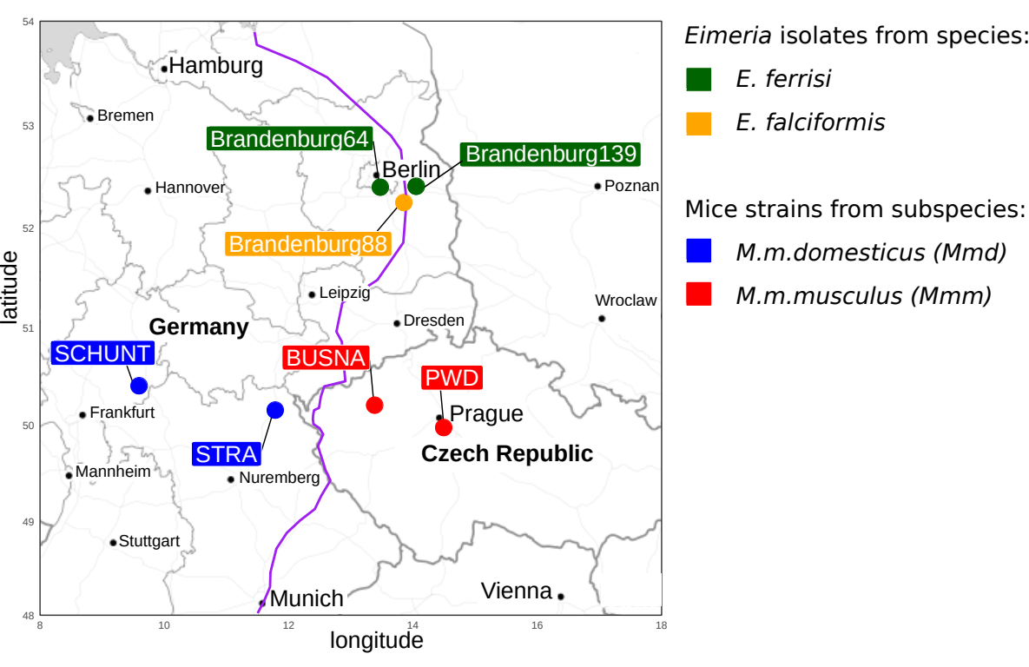**Figure 1. Parasite isolates and mouse strains.** The map shows locations at which mice were collected for breeding of mouse strains and isolation of parasites. The purple line is an estimation of the center of the house mouse hybrid zone between Mmd and Mmm based on sampling and genotyping of mice in this area (Balard et al., 2019; Ďureje et al., 2012, Macholán et al. 2019).

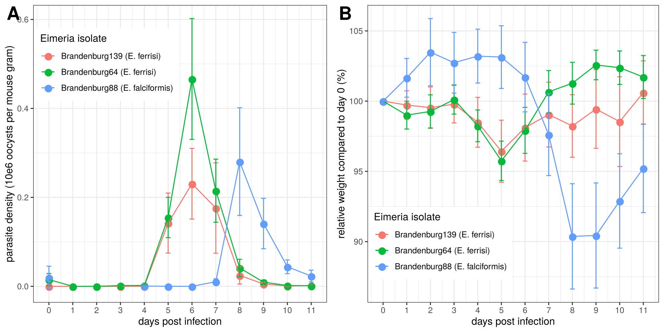

**Figure 2. Parasite density (A) and relative weight loss (B) during *Eimeria* infection.** Parasite density is calculated as number of oocysts detected (10e6) in feces per mouse gram, relative weight loss is calculated compared to day 0.Mean and 95% CI are plotted for each parasite isolate. All hosts strains are pooled together.

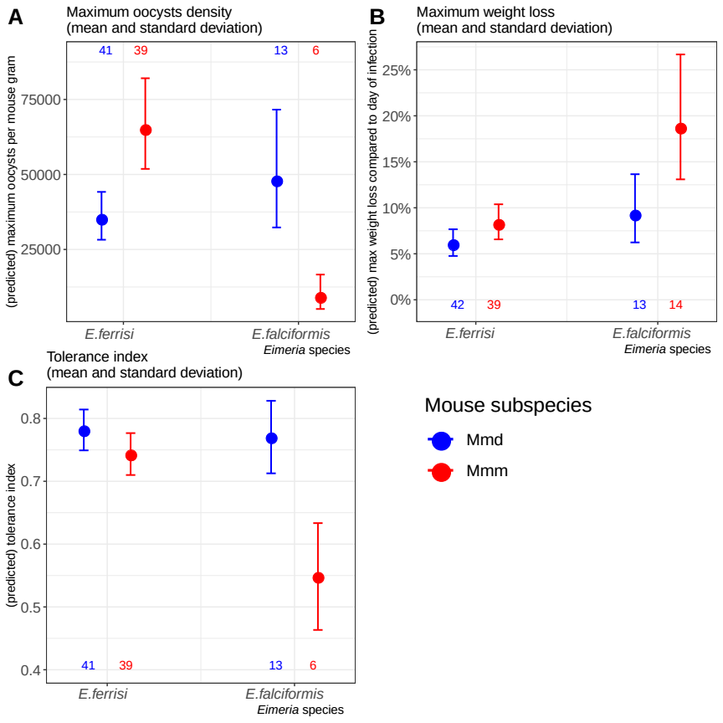

**Figure 3. Resistance, impact on host health and tolerance marginal effects for the two mice subspecies and two *Eimeria* species.** Values under bars represent the number of animals for each group. (A) Maximum oocysts density used as a proxy for (inverse of) resistance(see Table 2); (B) Impact on host health measured as the maximum weight loss during patent period relative to starting weight (%) (see Table 3); (C) Tolerance index measured as *(log10(maximum relative weight loss / maximum number of oocysts per mouse gram + 1e-8) / -8* (see Table 4)

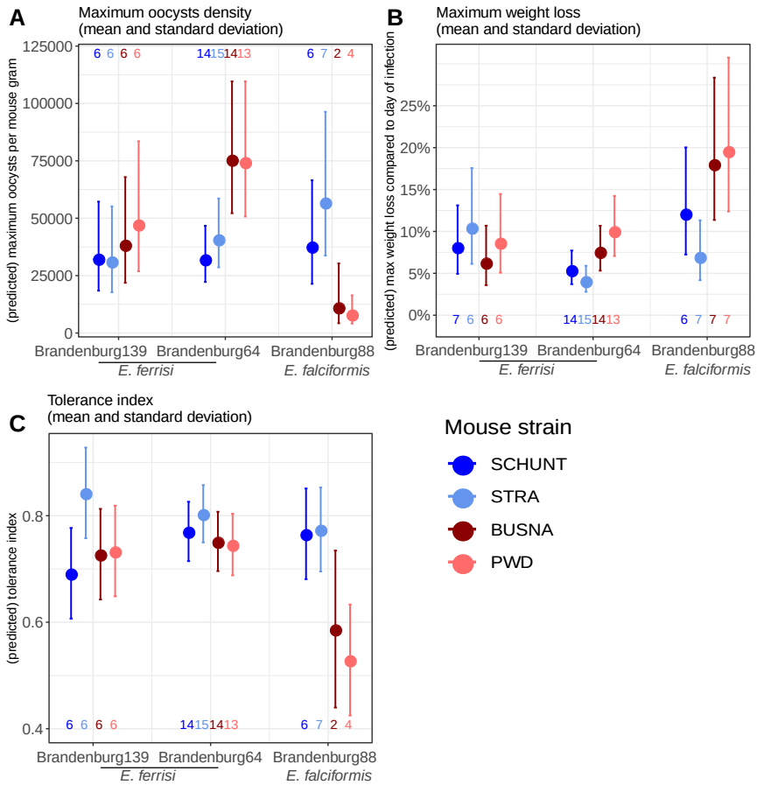

**Figure 4. Resistance, impact on host health and tolerance marginal effects for four inbred mouse strains infected with three *Eimeria* isolates each.** Values under bars represent the number of animals for each group. (A) Maximum oocysts density used as a proxy for (inverse of) resistance(see Table S4); (B) Impact on host health measured as the maximum weight loss during patent period relative to starting weight (%) (see Table S5); (C) Tolerance index measured as *(log10(maximum relative weight loss / maximum number of oocysts per mouse gram + 1e-8) / -8* (see Table S6)

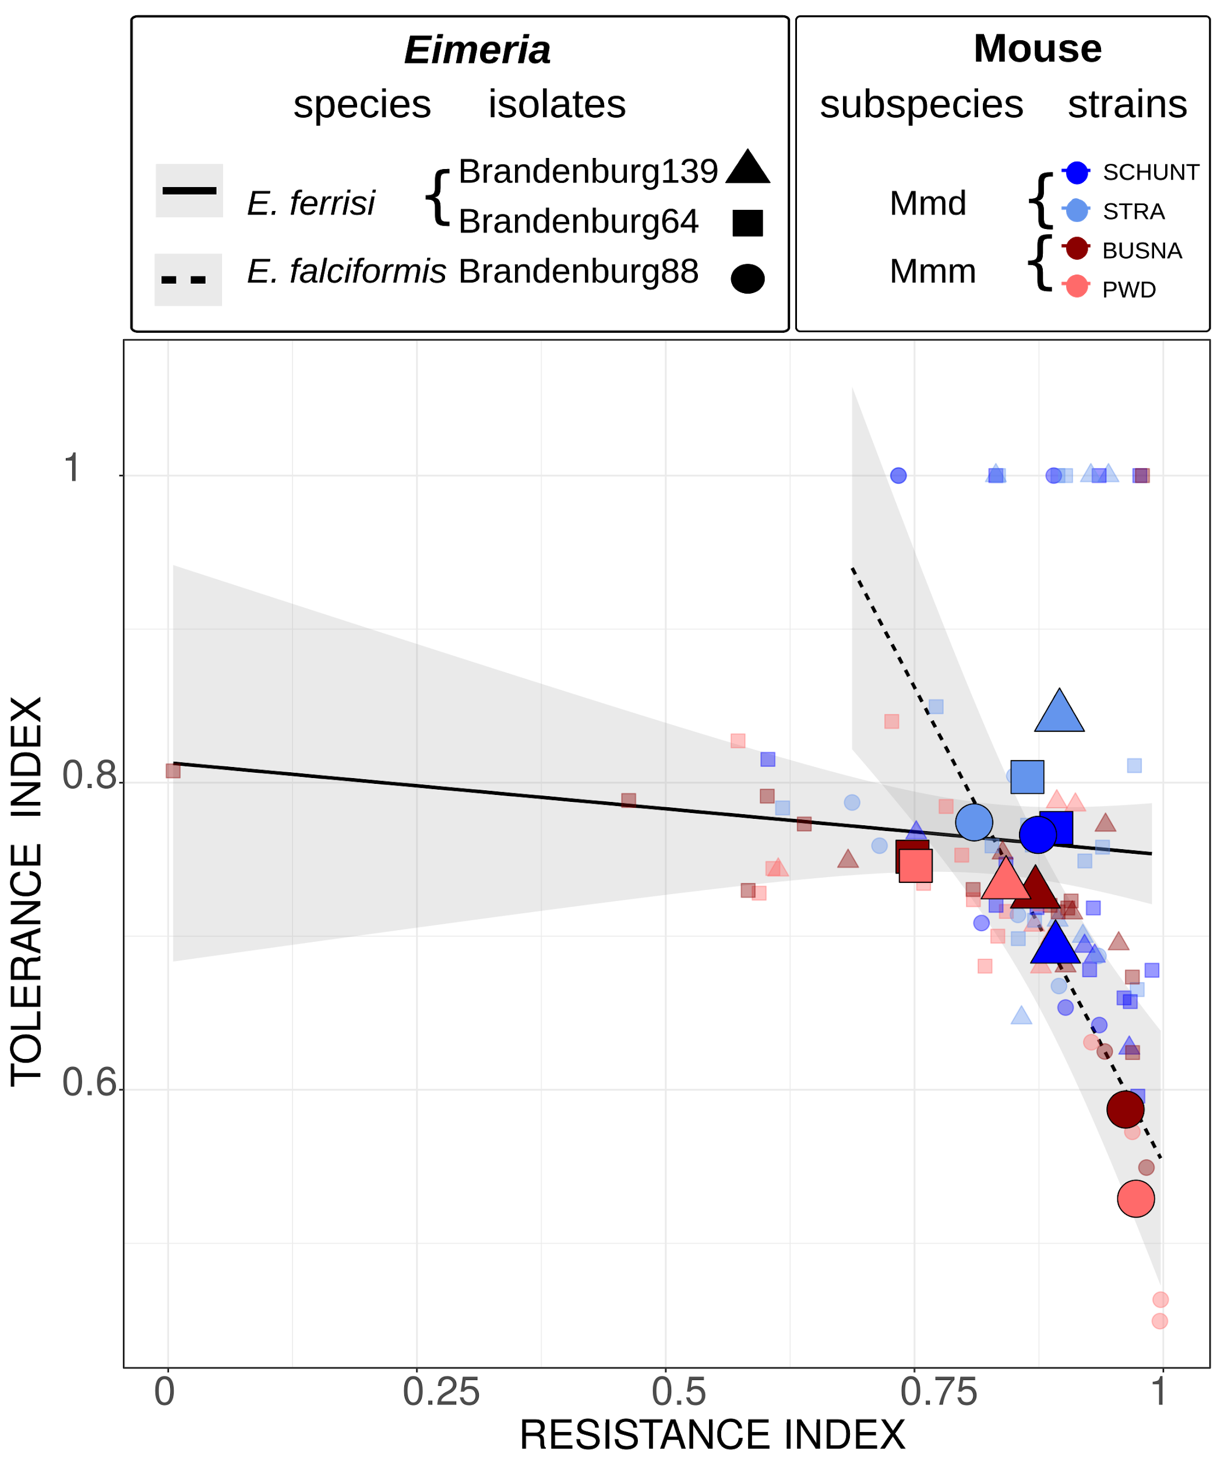

**Figure 5. Coupling between resistance and tolerance indexes for two different *Eimeria*species.** Smaller points represent individual mice, while larger points figure the mean for a given (host strain-parasite isolate) group. Linear regression of tolerance by resistance are shown for both parasite species. Resistance index measured as *(- maximum number of oocysts per mouse gram + 300000) / 300000*, Tolerance index measured as *(log10(maximum relative weight loss / maximum number of oocysts per mouse gram + 1e-8) / -8*

# Funding

This work was funded by the German Research Foundation (DFG) Grant [HE 7320/1-1] to EH. VHJ is an associated student of GRK 2046 funded by the DFG. The maintenance of wild-derived strains was supported by the ROSE program from Czech Academy of Sciences and the Czech Science Foundation (project 16-23773S) to JP.

# References

Al-khlifeh, E., Balard, A., Jarquín-Díaz, V. H., Weyrich, A., Wibbelt, G., & Heitlinger, E. (2019). *Eimeria* *falciformis* BayerHaberkorn1970 and novel wild derived isolates from house mice: Differences in parasite lifecycle, pathogenicity and host immune reactions. *BioRxiv*. http://dx.doi.org/10.1101/611277

Anderson, R. M., & May, R. M. (1982). Coevolution of hosts and parasites. *Parasitology*, *85 (Pt 2)*, 411–426. https://doi.org/10.1017/s0031182000055360

Ankrom, S. L., Chobotar, B., & Ernst, J. V. (1975). Life cycle of *Eimeria ferrisi* Levine & Ivens, 1965 in the Mouse, *Mus musculus*. *The Journal of Protozoology*, *22*(3), 317–323. https://doi.org/10.1111/j.1550-7408.1975.tb05177.x

Athanasiadou, S., Tolossa, K., Debela, E., Tolera, A., & Houdijk, J. G. M. (2015). Tolerance and resistance to a nematode challenge are not always mutually exclusive. *International Journal for Parasitology*, *45*(4), 277–282. https://doi.org/10.1016/j.ijpara.2014.12.005

Baird, S. J. E., & Goüy de Bellocq, J. (2019). Shifting paradigms for studying parasitism in hybridising hosts: Response to Theodosopoulos, Hund, and Taylor. *Trends in Ecology & Evolution*, *34*, 387–389. https://doi.org/10.1016/j.tree.2019.01.011

Baird, S. J. E., Ribas, A., Macholán, M., Albrecht, T., Piálek, J., & Goüy de Bellocq, J. (2012). Where are the wormy mice? A reexamination of hybrid parasitism in the European house mouse hybrid zone. *Evolution*, *66*(9), 2757–2772. https://doi.org/10.1111/j.1558-5646.2012.01633.x

Balard, A., Jarquín-Díaz, V. H., Jost, J., Martincová, I., Ďureje, Ľ., Piálek, J., Macholán, M., Goüy de Bellocq, J., Baird, S. J. E., & Heitlinger, E. (2019). Intensity of infection with intracellular *Eimeria* spp. and pinworms is reduced in hybrid mice compared to parental subspecies. *BioRxiv*, *683698*. https://doi.org/10.1101/683698

Barton, N. H., & Hewitt, G. M. (1985). Analysis of hybrid zones. *Annual Review of Ecology and Systematics*, *16*(1), 113–148. https://doi.org/10.1146/annurev.es.16.110185.000553

Chapman, H. D., Barta, J. R., Blake, D., Gruber, A., Jenkins, M., Smith, N. C., Suo, X., & Tomley, F. M. (2013). Chapter two—A selective review of advances in coccidiosis research. In D. Rollinson (Ed.), *Advances in Parasitology* (Vol. 83, pp. 93–171). Academic Press. https://doi.org/10.1016/B978-0-12-407705-8.00002-1

Clerc, M., Fenton, A., Babayan, S. A., & Pedersen, A. B. (2019). Parasitic nematodes simultaneously suppress and benefit from coccidian coinfection in their natural mouse host. *Parasitology*, *146*(8), 1096–1106. https://doi.org/10.1017/S0031182019000192

Delignette-Muller, M. L., & Dutang, C. (2015). fitdistrplus: An R Package for Fitting Distributions. *Journal of Statistical Software*, *64*(4), 1–34.

Ďureje, Ľ., Macholán, M., Baird, S. J., & Piálek, J. (2012). The mouse hybrid zone in Central Europe: From morphology to molecules. *Folia Zoologica*, *61*(3–4), 308–318.

Ehret, T., Spork, S., Dieterich, C., Lucius, R., & Heitlinger, E. (2017). Dual RNA-seq reveals no plastic transcriptional response of the coccidian parasite *Eimeria falciformis* to host immune defenses. *BMC Genomics*, *18*(1), 686. https://doi.org/10.1186/s12864-017-4095-6

Graham, A. L., Allen, Judith. E., & Read, A. F. (2005). Evolutionary causes and consequences of immunopathology. *Annual Review of Ecology, Evolution, and Systematics*, 373–397. https://doi.org/10.1146/annurev.ecolsys.36.102003.152622

Gregorová, S., & Forejt, J. (2000). PWD/Ph and PWK/Ph inbred mouse strains of *Mus m. Musculus* subspecies-a valuable resource of phenotypic variations and genomic polymorphisms. *Folia Biologica*, *46*(1), 31–41.

Haberkorn, A. (1970). Die Entwicklung von *Eimeria falciformis*  (Eimer 1870) in der weißen Maus (*Mus musculus*). *Zeitschrift für Parasitenkunde*, *34*(1), 49–67. https://doi.org/10.1007/BF00629179

Jarquín-Díaz, V. H., Balard, A., Jost, J., Kraft, J., Dikmen, M. N., Kvičerová, J., & Heitlinger, E. (2019). Detection and quantification of house mouse *Eimeria* at the species level – Challenges and solutions for the assessment of coccidia in wildlife. *International Journal for Parasitology: Parasites and Wildlife*, *10*, 29–40. https://doi.org/10.1016/j.ijppaw.2019.07.004

Jarquín-Díaz, V. H., Balard, A., Mácová, A., Jost, J., Szepesbéla, T. R. von, Berktold, K., Tank, S., Kvičerová, J., & Heitlinger, E. (2019). Generalist Eimeria species in rodents: Multilocus analyses indicate inadequate resolution of established markers. *BioRxiv*, 690487. <https://doi.org/10.1101/690487>

Kváč M., McEvoy J., Loudová M., Stenger B., Sak B., Květoňová D., Ditrich O., Rašková V., Moriarty E., Rost M., Macholán M., Piálek J. 2013. Coevolution of *Cryptosporidium tyzzeri* and the house mouse (*Mus musculus*). *International Journal for Parasitology* 43(10): 805–817. <http://dx.doi.org/10.1016/j.ijpara.2013.04.007>

Langand, J., Jourdane, J., Coustau, C., Delay, B., & Morand, S. (1998). Cost of resistance, expressed as a delayed maturity, detected in the host–parasite system *Biomphalaria glabrata*/*Echinostoma caproni*. *Heredity*, *80*(3), 320–325. https://doi.org/10.1046/j.1365-2540.1998.00291.x

Little, T. J., Shuker, D. M., Colegrave, N., Day, T., & Graham, A. L. (2010). The coevolution of virulence: Tolerance in perspective. *PLOS Pathogens*, *6*(9), e1001006. https://doi.org/10.1371/journal.ppat.1001006

Macholán, M., Munclinger, P., Sugerková, M., Dufková, P., Bímová, B., Bozíková, E., Zima, J., & Piálek, J. (2007). Genetic analysis of autosomal and X-linked markers across a mouse hybrid zone. *Evolution*, *61*(4), 746–771. https://doi.org/10.1111/j.1558-5646.2007.00065.x

Macholán M., Baird S.J.E., Fornuskova A., Martincová I., Rubík, P., Ďureje Ľ., Heitlinger E., Piálek J. 2019. Widespread introgression of the *Mus musculus musculus* Y chromosome in Central Europe. *BioRxiv*. http://dx.doi.org/10.1101/2019.12.23.887471

Martincová, I., Ďureje, Ľ., Kreisinger, J., Macholán, M., & Piálek, J. (2019). Phenotypic effects of the Y chromosome are variable and structured in hybrids among house mouse recombinant lines. *Ecology and Evolution*, *9*(10), 6124–6137. https://doi.org/10.1002/ece3.5196

Medzhitov, R., Schneider, D. S., & Soares, M. P. (2012). Disease tolerance as a defense strategy. *Science*, *335*(6071), 936–941. https://doi.org/10.1126/science.1214935

Miller, M. R., White, A., & Boots, M. (2005). The evolution of host resistance: Tolerance and control as distinct strategies. *Journal of Theoretical Biology*, *236*(2), 198–207. https://doi.org/10.1016/j.jtbi.2005.03.005

Payseur, B. A., Krenz, J. G., & Nachman, M. W. (2004). Differential patterns of introgression across the X chromosome in a hybrid zone between two species of house mice. *Evolution*, *58*(9), 2064–2078. https://doi.org/10.1111/j.0014-3820.2004.tb00490.x

Piálek, J., Vyskocilová, M., Bímová, B., Havelková, D., Piálková, J., Dufková, P., Bencová, V., Dureje, L., Albrecht, T., Hauffe, H. C., Macholán, M., Munclinger, P., Storchová, R., Zajícová, A., Holán, V., Gregorová, S., & Forejt, J. (2008). Development of unique house mouse resources suitable for evolutionary studies of speciation. *The Journal of Heredity*, *99*(1), 34–44. https://doi.org/10.1093/jhered/esm083

R Development Core Team. (2018). *R: A language and environment for statistical computing. R Foundation for Statistical Computing, Vienna, Austria*. http://www.R-project.org

Råberg, L. (2014). How to live with the enemy: Understanding tolerance to parasites. *PLoS Biology*, *12*(11), e1001989. https://doi.org/10.1371/journal.pbio.1001989

Råberg, L., Graham, A. L., & Read, A. F. (2009). Decomposing health: Tolerance and resistance to parasites in animals. *Philosophical Transactions of the Royal Society B: Biological Sciences*, *364*(1513), 37–49. https://doi.org/10.1098/rstb.2008.0184

Råberg, L., Sim, D., & Read, A. F. (2007). Disentangling genetic variation for resistance and tolerance to infectious diseases in animals. *Science*, *318*(5851), 812–814. https://doi.org/10.1126/science.1148526

Raufaste, N., Orth, A., Belkhir, K., Senet, D., Smadja, C., Baird, S. J. E., Bonhomme, F., Dod, B., & Boursot, P. (2005). Inferences of selection and migration in the Danish house mouse hybrid zone: Selection in the house mouse hybrid zone. *Biological Journal of the Linnean Society*, *84*(3), 593–616. https://doi.org/10.1111/j.1095-8312.2005.00457.x

Rose, M. E., Hesketh, P., & Wakelin, D. (1992). Immune control of murine coccidiosis: CD4+ and CD8+ T lymphocytes contribute differentially in resistance to primary and secondary infections. *Parasitology*, *105*, 349–354. https://doi.org/10.1017/s0031182000074515

Roy, B. A., & Kirchner, J. W. (2000). Evolutionary dynamics of pathogen resistance and tolerance. *Evolution*, *54*(1), 51–63. https://doi.org/10.1111/j.0014-3820.2000.tb00007.x

Sage, R. D., Heyneman, D., Lim, K.-C., & Wilson, A. C. (1986). Wormy mice in a hybrid zone. *Nature*, *324*(6092), 60–63. https://doi.org/10.1038/324060a0

Schito, M. L., Barta, J. R., & Chobotar, B. (1996). Comparison of four murine *Eimeria* species in immunocompetent and immunodeficient mice. *The Journal of Parasitology*, *82*(2), 255–262. https://doi.org/10.2307/3284157

Sheldon, B. C., & Verhulst, S. (1996). Ecological immunology: Costly parasite defences and trade-offs in evolutionary ecology. *Trends in Ecology & Evolution*, *11*(8), 317–321. https://doi.org/10.1016/0169-5347(96)10039-2

Simms, E. L., & Triplett, J. (1994). Costs and benefits of plant response to disease: Resistance and tolerance. *Evolution*, *48*(6), 1973–1985. https://doi.org/10.1111/j.1558-5646.1994.tb02227.x

Smith, A. L., & Hayday, A. C. (2000). Genetic dissection of primary and secondary responses to a widespread natural pathogen of the gut, *Eimeria vermiformis*. *Infection and Immunity*, *68*(11), 6273–6280. https://doi.org/10.1128/iai.68.11.6273-6280.2000

Soares, M. P., Teixeira, L., & Moita, L. F. (2017). Disease tolerance and immunity in host protection against infection. *Nature Reviews Immunology*, *17*(2), 83–96. https://doi.org/10.1038/nri.2016.136

Stange, J., Hepworth, M. R., Rausch, S., Zajic, L., Kühl, A. A., Uyttenhove, C., Renauld, J.-C., Hartmann, S., & Lucius, R. (2012). IL-22 mediates host defense against an intestinal intracellular parasite in the absence of IFN-γ at the cost of Th17-driven immunopathology. *Journal of Immunology*, *188*(5), 2410–8. https://doi.org/10.4049/jimmunol.1102062

Venables, W. N., & Ripley, B. D. (2002). *Modern Applied Statistics with S* (Fourth). Springer. http://www.stats.ox.ac.uk/pub/MASS4

Vijendravarma, R. K., Kraaijeveld, A. R., & Godfray, H. C. J. (2009). Experimental evolution shows *Drosophila melanogaster* resistance to a microsporidian pathogen has fitness costs. *Evolution*, *63*(1), 104–114. https://doi.org/10.1111/j.1558-5646.2008.00516.x

Wickham, H. (2016). *ggplot2: Elegant Graphics for Data Analysis*. Springer-Verlag, New York.