# Related Eimeria species parasites show different resistance and tolerance in two subspecies of Mus Musculus

Alice Balard1,2, Víctor Hugo Jarquín-Díaz1,2, Jenny Jost1, Vivian Mittné1, Francisca Böhning1, Iva Martincová3, Ľudovít Ďureje3, Miloš Macholán4, Joëlle Goüy de Bellocq3, Stuart J. E. Baird3, Jaroslav Piálek3, Emanuel Heitlinger1,2

*1 Institute for Biology. Department of Molecular Parasitology. Humboldt University Berlin (HU). Philippstr. 13, Haus 14, 10115, Berlin, Germany*

*2 Leibniz-Institut für Zoo- und Wildtierforschung (IZW) im Forschungsverbund Berlin e.V.. Alfred-Kowalke-Straße 17, 10315, Berlin, Germany*

*3 Research Facility Studenec, Institute of Vertebrate Biology, Czech Academy of Sciences, Květná 8, 603 65 Brno, Czech Republic*

*4 Laboratory of Mammalian Evolutionary Genetics, Institute of Animal Physiology and Genetics, Czech Academy of Sciences, Veveri 97, 60200 Brno, Czech Republic*

# Abstract

Resistance (host capacity to reduce parasite burden) or tolerance (reduced impact of a given parasite burden on host health) to parasites are two independent immune mechanisms that are quite challenging to study jointly in natural environments. The two closely related intracellular apicomplexans species *Eimeria ferrisi* and *Eimeria falciformis* can be found in mice of both sides of the European House Mouse Hybrid Zone (HMHZ) between *Mus musculus musculus* and *Mus musculus domesticus*. Using four wild derived inbred mouse strains as representative for these two host species, we measured resistance to parasite, impact on host health and tolerance during controlled infection. We found that resistance and tolerance differ between mice subspecies and parasite species. Specifically, *M. m. musculus*, the Eastern mouse, is far more resistant but far less tolerant to *E. falciformis* than *M. m. domesticus*, the Western mouse. Such difference between host subspecies was not observed in *E. ferrisi* infection. Studying together resistance and tolerance in this closely-related-double-parasites closely-related-double-hosts system presents a unique opportunity to understand the fine-tuning of immune mechanisms in *Eimeria* infection.

# Introduction

Resistance is the ability of a host to reduce pathogen burden. It results from host defense against infection or proliferation. Tolerance is the ability of a host to reduce impact on its health given a certain parasite load [(Råberg, Sim, & Read, 2007)](https://www.zotero.org/google-docs/?PTOrHh). Resistance can be seen as a reflection of early defense against pathogens after infection. It reduces parasite fitness and is costly for the host, due to immunopathology [(Graham, Allen, & Read, 2005)](https://www.zotero.org/google-docs/?Ztg1Bu). Tolerance, later in infection, balances damage induced directly by pathogens, and those linked to immunopathology. It reduces the impact of infection on host health [(Medzhitov, Schneider, & Soares, 2012)](https://www.zotero.org/google-docs/?hhWHS5). The idea that a lower resistance is necessarily correlated with higher fitness of the host was challenged in the mid-90s, in the field of plant biology [(Simms & Triplett, 1994)](https://www.zotero.org/google-docs/?H71cFX). In animal biology and biomedical research, resistance was long studied but tolerance often overlooked [(Medzhitov et al., 2012; Schneider & Ayres, 2008)](https://www.zotero.org/google-docs/?yerZZV). In 2007, Råberg and colleagues showed a trade-off between resistance and tolerance in experimental murine malaria infections. They used a similar framework than Simms & Triplett in which resistance is measured by the inverse of parasite burden and tolerance by the regression slope of host fitness against infection intensity [(Råberg et al., 2007)](https://www.zotero.org/google-docs/?SD6Vlq).

In biomedical research, studying solely resistance mechanisms can have serious implications for disease treatments, as tolerance is more meaningful in terms of health outcome for the patients (Schneider & Ayres, 2008). In the case of evolutionary biology, considering only the parasite load, and therefore only resistance, can lead to serious over-interpretation in terms of fitness effect [(Baird & Goüy de Bellocq, 2019)](https://www.zotero.org/google-docs/?NS3cjd). Fortunately, joint studies of resistance and tolerance are becoming the gold standard. For example, the resistance to highly prevalent and zoonotic parasite *Toxoplasma gondii* has been well described, bringing to the fore the importance of IFN-γ-regulated GTPase as major determinants of parasite invasion; but a number of studies have also been devoted to understand the mechanisms involved in the mitigation of Th1-mediated immunopathology (see review by Melchor & Ewald, 2019).

*Eimeria* species belong to apicomplexan protozoan parasites. They are monoxenous (their full life cycle happens in a single host), which make them particularly convenient models to study under laboratory conditions. They are particularly well described in domestic animals due to their economical importance, especially in poultry [(Blake & Tomley, 2014)](https://www.zotero.org/google-docs/?d3VcPP). Species specific parasites of this genus can infect an extremely wide range of animals including birds, mammals, reptiles, amphibia and fish [(Chapman et al., 2013)](https://www.zotero.org/google-docs/?pXvNEi). They are generally considered be strictly host specific, but the recent use of multilocus genetic markers method in rodents showed that this host specificity could be less strict than previously thought [(Jarquín-Díaz, Balard, Mácová, et al., 2019)](https://www.zotero.org/google-docs/?0vXaOe). They can also be found in wild animals, and be potentially problematic for conservation [(Jeanes et al., 2013; Knowles et al., 2013; Matsubayashi et al., 2018)](https://www.zotero.org/google-docs/?L9PR1D).

*Eimeria* parasites infect epithelial digestive cells of their hosts, which leads to malabsorption of nutrients and weight loss [(Chapman et al., 2013)](https://www.zotero.org/google-docs/?GxCw7i). Historically in *Eimeria* research, resistance and tolerance were not strictly defined, confusing distinct aspects of the biological underlying mechanisms. For example the combination of mortality, weight gain and parasite production have been used to define resistant vs. susceptible lines of chicken (Bumstead & Millard, 1987). We see in poultry industry a growing use of joint measure of parasite load and impact of health [(Boulton et al., 2018; Sakkas et al., 2018)](https://www.zotero.org/google-docs/?m9INl1). These intensive systems offer a very large and controlled setup, large number of animal and low variability. Nevertheless, the problematic is quite different for wild animals.

The house mouse (*Mus musculus*) offers a perfect model for comparative studies in the wild and under laboratory conditions. One if not the most studied hybrid zone in animals is the European house mouse hybrid zone (HMHZ), a tension zone between the Western house mouse *Mus musculus domesticus* and the Eastern one *Mus musculus musculus* (hereafter Mmd and Mmm) in which endogenous selection against house mouse hybrids is balanced by immigration of less admixed mice into the center [(Barton & Hewitt, 1985; Macholán et al., 2007)](https://www.zotero.org/google-docs/?fGpMeO). It has been shown that recombinant hybrid mice in this zone present a higher resistance to *Eimeria* spp. than parental mice, while no increase or decrease of tolerance compared to parents could be measured in natural conditions [(Balard et al., 2019)](https://www.zotero.org/google-docs/?gnc2hj). In the HMHZ, three species of these intracellular parasites have been identified. *E. ferrisi* the most prevalent (17%) and widely found all across the hybrid zone. *E. falciformis*, despite being the most common laboratory model, was only found at a prevalence of 4%, followed by *E. vermiformis* (2%) [(Jarquín-Díaz, Balard, Jost, et al., 2019)](https://www.zotero.org/google-docs/?EiQWuN). Infection experiment using *Eimeria* strains collected from wild mice showed weight loss up to 20% in laboratory NMRI mice [(Al-khlifeh et al., 2019)](https://www.zotero.org/google-docs/?virXvQ).

We asked if two naturally occurring parasites present in both West (Mmd) and East (Mmm) side of the HMHZ show the same resistance and tolerance patterns in both hosts. More precisely, we tested if we could observe an effect of host (one host more resistant/tolerant to both *Eimeria* spp. than the other), effect of parasite (one parasite species less resisted/tolerated by both hosts than the other), or interactions between host and parasite (the effect on resistance/tolerance of one parasite in one host is different than in the other). In order to deal with the constraints of studying parasite resistance and tolerance simultaneously in wild animals, we designed a laboratory infection experiment using four wild-derived inbred mouse strains, two Mmd and two Mmm, to account for possible geographical variations within subspecies. Moreover, we tested three *Eimeria* isolates: one for *E. falciformis*, and two for *E. ferrisi*, the more prevalent *Eimeria*. We found interactions between parasite and host rather than a unique effect of one or the other actor.

# Material and methods

Mouse strains

We used four wild-derived mouse strains: two Mmd strains **SCHUNT** (Locality: Schweben 2, Hessen, Germany [N: 50° 26’, E: 9° 35’] [(Martincová, Ďureje, Kreisinger, Macholán, & Piálek, 2019)](https://www.zotero.org/google-docs/?Qiv9CC)) and **STRA** (Locality: Straas 16, Bavaria, Germany [N: 50° 11’, E: 11° 46’] [(Piálek et al., 2008)](https://www.zotero.org/google-docs/?nbLt2q), and two Mmm strains **BUSNA** (Locality: Buškovice 215, Bohemia, Czech Republic. [N: 50° 14’, E: 13° 22’] [(Piálek et al., 2008)](https://www.zotero.org/google-docs/?3JHbX0)) and **PWD** (Locality: . [N: 50° 0’, E: 14° 29’]. Provided by Jiří Forejt, Institute of Molecular Genetics AS CR in Prague [(Gregorová & Forejt, 2000)](https://www.zotero.org/google-docs/?6AMAG3)). The original mice for these four lines were respectively isolated Both SCHUNT and PWD strains had their original mice collected respectively about 250 and 150 km from the hybrid zone center (**Figure 1**) Age of the mice at the moment of infection ranged between 7.5 and 21.5 weeks. All mouse strains were maintained before infection in the Institute of Vertebrate Biology in Studenec [(Piálek et al., 2008)](https://www.zotero.org/google-docs/?3javrp) (licence number 61,974/2017‐MZE‐17214).

Parasite strains

The three parasite isolates used in this study were isolated from feces of mice captured in Brandenburg, Germany, in 2016 (capture permit No. 2347/35/2014). They belong to the most prevalent *Eimeria* species in the wild [(Jarquín-Díaz, Balard, Jost, et al., 2019)](https://www.zotero.org/google-docs/?xt73nn), namely *E. ferrisi* (isolates Brandenburg64 and Brandenburg139) and *E. falciformis* (isolate Brandenburg88). Pre-patency and peak day of oocyst shedding for this isolates was estimated during infection in NMRI laboratory mice [(Al-khlifeh et al., 2019)](https://www.zotero.org/google-docs/?AAonUF). All isolates were maintained by cyclic passaging in NMRI mice. Parasite oocysts were floated from feces with NaCl [(Al-khlifeh et al., 2019)](https://www.zotero.org/google-docs/?QuDRcD) and stored at room temperature in 1mL of 2% potassium dichromate for a maximum of 2 months before infection of wild-derived mouse strains. Oocysts were allowed to sporulate 10 days before infection in a 30°C water bath.

Experimental infection

Mice were kept in individual cages during infection. Water and food (SNIFF, Rat/Mouse maintenance feed 10 mm) were provided ad libitum, in addition to 1 g of sunflower and barley seeds per day. Mice were orally infected with 150 sporulated oocysts of one *Eimeria* isolate suspended in 100 µl phosphate-buffer saline (PBS) and monitored daily until their sacrifice by cervical dislocation at 11 days post infection (dpi)(experiment license xxx). Individuals presenting severe health deficiency or a weight loss higher than 18% relative to their starting weight were sacrificed before the end of infection experiment. Weight was recorded and feces collected on a daily basis. Fecal pellets were collected every day from each individual cage and suspended in potassium dichromate 2%. Parasite oocysts were recovered by NaCl flotation. Potential cross-contamination between infections was monitored.

In total, 108 mice were infected as shown in **Table 1.** Mice were randomly allocated to experimental groups ensuring homogeneous distribution of ages and sexes between groups. Our experiments were conducted in infection batches. Nematode infection being common in breeding facilities [(Baker, 1998)](https://www.zotero.org/google-docs/?ToRzi4), feces of a subset of each parental genotype were tested for presence of nematode eggs by microscopic analysis of feces prior to any infection. We could detect *Syphacia* and *Aspiculuris* eggs. Despite treatment with anthelminthics (Profender®, Bayer AG, Levekusen, Germany [(Mehlhorn et al., 2005)](https://www.zotero.org/google-docs/?B03ypQ)) of the first infection batch of mice (22 mice), worms were still detected by PCR [(Floyd, Rogers, Lambshead, & Smith, 2005)](https://www.zotero.org/google-docs/?T2STp7) in randomly sampled fecal samples a week later. We therefore decided to not treat mice from the following infection batches, and performed a sanity check of the absence of impact of this treatment on our three measures of interest.

Measures of resistance and tolerance in our murine *Eimeria* system

Resistance is usually measured as the inverse of infection intensity [(Råberg, Graham, & Read, 2009)](https://www.zotero.org/google-docs/?SwISpy). As our proxy we used the highest intensity of oocysts shed during one day of the parasite’s patent period per weight of the mouse (in gram). This measurement allows to account for the host volume, assuming a lower parasite oocysts number in lighter mice. A higher number of oocysts per mouse weight corresponds to a lower resistance. This measure of resistance at the day of peak intensity was tightly correlated (0.92; pearson correlation coefficient) with the sum of oocysts shed throughout the experiment.

The major measurable symptom in murine *Eimeria* infections is weight loss. Therefore, impact on host health was measured as the maximum weight loss during the full *Eimeria* sp. patent period relative to the mouse starting weight. This measure is likely to reflect the most critical impact on host health as weight loss is unimodal and the length of the period a mouse is affected is constant (3–4 days for *E. falciformis* [(Ehret, Spork, Dieterich, Lucius, & Heitlinger, 2017; Schmid et al., 2014)](https://www.zotero.org/google-docs/?r6vpY2) and *E. ferrisi* [(Al-khlifeh et al., 2019; Ankrom, Chobotar, & Ernst, 1975)](https://www.zotero.org/google-docs/?0ZLXpX)).

Tolerance is usually defined as the slope of a regression of impact on host health against infection intensity [(Råberg et al., 2009)](https://www.zotero.org/google-docs/?aQvDk0). We calculated individual slopes between the day of infection (100% of host’s weight and a null intensity of parasite shedding) and the maximum impact on health/maximum infection intensity. As this results in a complex mix of distribution, we log transformed the data and added 1e-8 to avoid infinite values:

*Tolerance=log10((maximum weight loss relative to weight at infection / maximum oocysts yield per mouse gram) + 1e-8)*

Statistical analyses

Adequate distributions for both resistance, impact on host health and tolerance were selected using log likelihood and by comparing goodness-of-fits plots between usual distributions. Using log likelihood and goodness-of-fits (density, CDF, Q-Q, P-P plots) comparison, negative binomial, Weibull, and normal distribution were the most adequate to describe resistance, impact on host health and tolerance, respectively (see **supplementary Figure S1**).

We tested the effects of mouse subspecies (Mmd or Mmm), *Eimeria* species (*E. ferrisi* or *E. falciformis*) and their interaction separately using (generalized) linear models. To assess the stability of our results across mice strains and *Eimeria* isolates, we also tested the effects of mouse strain (N=4), parasite isolate (N=3) and their interaction separately using the same (generalized) linear models. We used likelihood ratio tests (LRT) with and without the focal term to test for its significance in the model.

All analyses were performed using the R software version 3.5.2 [(R Development Core Team, 2008)](https://www.zotero.org/google-docs/?MReqrt). Graphics were produced using the R package ggplot2 [(Wickham, 2016)](https://www.zotero.org/google-docs/?dzCoyO) and compiled using the free software inkscape (https://inkscape.org). All code and data used for this article can be found at: https://github.com/alicebalard/Article_RelatedParasitesResTol

# Results

General parasitology

To test for differences in resistance and tolerance, we analysed parasite infections with isolates of the species *E. ferrisi* (two isolates; Brandenburg64 and Brandenburg139) and *E. falciformis* (one isolate; Brandenburg88).

The life cycle of all isolates was successfully completed in all wild derived mouse strains (**Figure 2**). For *E. ferrisi* (both isolates) prepatent period (period between infection recovery of oocysts in feces) was 5 dpi and the median day of maximal oocyst shedding was 6 dpi (sd=0.71 and 0.65, respectively). The median day of maximum weight loss was 5 dpi for both isolates (sd=2.2 and 1.9 respectively).

For *E. falciformis* (isolate Brandenburg88) pre-patency was 7 dpi, median day of maximal shedding was 8 dpi (sd=1.2) and median day of maximal weight loss 9 dpi (sd=1.5). Infectivity with all tested *Eimeria* isolates can be considered 100% and infection dynamics are indistinguishably similar in different mouse strains. Besides, *E. ferrisi* isolate Brandenburg139 shed less oocysts at peak day than *E. ferrisi* isolate Brandenburg64.

Finally, a very low level of *Eimeria* oocysts were found at the day of initial infection in the feces of 9 mice belonging to the two final experimental batches (6 infected with Brandenburg64 and 3 with Brandenburg88). This result is likely due to cross-contamination through cages.

Parental *M. m. musculus* are more resistant to *E. falciformis* than to *E. ferrisi*

To establish differences between the two house mouse subspecies we analysed the extent of oocyst shedding as a measure of resistance after infection with both *Eimeria* species. We found statistically significant differences in resistance between parasite species (glm/LRT, p-value=0.022, *n*=99) as well as an interaction between parasite species and mouse subspecies (glm/LRT; p-value=6e-07, *n*=99; **Table 2**). These differences mean that Mmm strains resist *E. falciformis* better than *E. ferrisi*, while we could not detect difference between both parasite in Mmd(**Figure 3A**).

We then tested the influence of geographical origin of mouse and parasite in a model separating *Eimeria* by isolates and mouse by strains. We also found statistically significant differences in resistance between parasite isolate (glm/LRT, p-value=0.019, *n*=99) as well as an interaction between parasite isolate and mouse strain (glm/LRT, p-value=8e-05, *n*=99; **Table 2**). The pattern previously found of Mmm resisting *E. falciformis* better than *E. ferrisi* does not differ when host strains are added. Of note, Mmm are slightly less resistant to *E. ferrisi* isolate Brandeburg64 than to *E. ferrisi* isolate Brandeburg139. Again, we could not detect difference between parasite isolates in Mmd(**Figure 4A**).

A significant number of Mmm mice infected with *E. falciformis* (isolate Brandenburg88) died before the oocysts shedding peak (8 out of 14; 5 BUSNA strain and 3 PWD strain). Moreover, one Mmd mouse (strain SCHUNT) infected by *E. ferrisi* isolate Brandenburg139 had liquid diarrhea on the shedding peak day, making its feces not collectable. These mice were assessed as missing data for resistance and for the following tolerance measurement.

Parental *M. m. musculus* are more impacted by *E. falciformis* than by *E. ferrisi*

To assess difference of impact on host health by *Eimeria* between mouse strains we assessed weight loss after infection with the both *Eimeria* species. We found statistically significant differences in impact on host health between mouse subspecies (glm/LRT, p-value=0.016, *n*=108) and between parasite species (glm/LRT, p-value=6.3e-06, *n*=108; **Table 2**). This means that Mmd lost less weight when infected by both *E. falciformis* and *E. ferrisi* than Mmm, and that *E. falciformis* impacts more the health of both mouse subspecies than *E. ferrisi*. In the case of Mmm, the different impacts of both parasite species is particularly marked: Mmm infected with *E. falciformis* lost on average 10% more weight than those infected with *E. ferrisi* (**Figure 3B**)*.*

When we tested the influence of geographical origin of mouse and parasite in a model separating *Eimeria* by isolates and mouse by strains, we found impact on health to differ significantly for parasite isolates (glm/LRT, p-value=1.9e-5, *n*=108; **Table 2**). This confirms that mice are overall more impacted by *E. falciformis* than by *E. ferrisi* (**Figure 4B**).

Parental *M. m. musculus* are less tolerant to *E. falciformis* than to *E. ferrisi*

Combining resistance and impact on health as shown in **Figure 3C** and **Figure 4C**, we assessed the tolerance of our mouse subspecies to both *Eimeria* species. Tolerance was found to differ significantly between mouse subspecies (lm/LRT, p-value=0.002, *n*=99), between parasite species (lm/LRT, p-value=0.023, *n*=99) and we found interactions between mouse subspecies and parasite species (lm/LRT, p-value=0.002, *n*=99; **Table 2**).

Mice are overall more tolerant to *E. ferrisi* than to *E. falciformis*. While the difference in tolerance is negligible in *M. m. domesticus* infected by any of the parasite species, *M. m. musculus* are far less tolerant to *E. falciformis* than to *E. ferrisi* (**Figure 3D**). We confirm this pattern when we tested the influence of geographical origin of mouse and parasite in a model separating *Eimeria* by isolates and mouse by strains. We found tolerance to differ significantly between mouse subspecies (lm/LRT, p-value=0.004, *n*=99) as well as interactions between mouse subspecies and parasite species (lm/LRT, p-value=0.046, *n*=99; **Table 2**).Again, *M. m. musculus* strains are far less tolerant to *E. falciformis* than to *E. ferrisi* (**Figure 4D**).

Sanity check

Finally, we performed a sanity check of the effect of anthelmintic treatment on our 3 variables of interest. We run the exact same three (generalised) linear models for resistance, impact on host health, and tolerance, adding an additional factor “presence of anthelmintic”. This factor never showed significance. As we could detect helminth presence after treatment in feces of treated animals, we conclude that the treatment simply failed, and had no influence on the study results.

# Discussion

Measuring tolerance to parasites in natural population is challenging, and was done in only a small number of studies (Burgan, Gervasi, Johnson, & Martin, 2018). We here created a controlled setup to detect variations in resistance, impact of health and tolerance of different groups of mice when infected by a similar inoculum of two unicellular parasite (*Eimeria*) species of the European house mouse hybrid zone. While Mmd, the Western mice, did not show a strong variation between both parasite species, we found evidence that Mmm, the Eastern mice, are more resistant but less tolerant to *E. falciformis* than to *E. ferrisi*.

Previous infection experiments in NMRI mice have shown that *E. ferrisi* (Brandenburg64 isolate) pathogenicity is likely due to parasite proliferation and cell exhaustion, while *E. falciformis* (Brandenburg88 isolate) infection is characterized by an influx of immune cells, probably the major cause of pathogenicity [(Al-khlifeh et al., 2019)](https://www.zotero.org/google-docs/?uNMNVH). Moreover, the life cycle of *E. ferrisi* is shorter than of *E. falciformis* in all host strains of this study as well as in NMRI, BALB/c and SCID (immunodeficient) laboratory strains [(Al-khlifeh et al., 2019; Schito, Barta, & Chobotar, 1996)](https://www.zotero.org/google-docs/?iB18nI). All these characteristics lead to think that *E. ferrisi* fitness can be higher than the one of *E. falciformis* without affecting significantly the host’s fitness, which could explain the higher overall prevalence of *E. ferrisi* in the HMHZ compared to *E. falciformis* [(Jarquín-Díaz, Balard, Jost, et al., 2019)](https://www.zotero.org/google-docs/?MjNgbo).

Moreover, considering disease dynamics, *E. falciformis* shows a strong mortality rate (almost 60% (8/14)) in Mmm, coupled with a high resistance in this host subspecies. As the transmission of parasite infective forms happens by oral-fecal route, dead animals can’t spread the disease, and we can hypothesize in the natural system a lower capacity to spread of *E. falciformis* in Mmm than in Mmd [(Burgan, Gervasi, Johnson, & Martin, 2018)](https://www.zotero.org/google-docs/?fh3tlh). The optimum virulence of a parasite (high rate of host mortality) should allows both a sufficient host fitness and parasite fitness to be evolutively selected. According to the trade-off hypothesis [(Anderson & May, 1982)](https://www.zotero.org/google-docs/?mKkSXW) the high virulence of *E. falciformis* in Eastern mice could be explained if its transmission rate would be high. In the case of an oral-fecal transmission, the host’s death is detrimental for the parasite transmission. This aparent maladaptation could mean that *E. falciformis* has reached Mmm mice only after secondary contact with Mmd, the Western mice, potential original hosts. Ongoing work in our group that aim at describing the *Eimeria* population structure with a large multi-marker approach will provide precious information about the host-parasite structure in this zone.

With more than 1200 species infecting an impressive range of hosts [(Chapman et al., 2013)](https://www.zotero.org/google-docs/?h1GH3L), the diversity of *Eimeria* makes it a fascinating parasite to study parasite-host interactions. While domestic animals can be infected with numerous species (seven in domestic chickens [(Reid et al., 2014)](https://www.zotero.org/google-docs/?xjfEHc), more than twenty in cattle [(Daugschies & Najdrowski, 2005)](https://www.zotero.org/google-docs/?4QPayM)), wild animals are not spared: in a recent study, 46% of wood mice were found infected with *Eimeria*, with at least three species identified [(Knowles et al., 2013)](https://www.zotero.org/google-docs/?RvkFVJ). In the HMHZ, three species infecting *Mus* were detected [(Jarquín-Díaz, Balard, Jost, et al., 2019)](https://www.zotero.org/google-docs/?8awPnt). Host specificity in rodent *Eimeria* is suggested to be adaptive rather than conserved [(Kvičerová & Hypša, 2013)](https://www.zotero.org/google-docs/?AXCQFp). The results of the current study showed a quite constant resistance and tolerance to *E. ferrisi* across a host hybrid zone, while they greatly differ between both sides for *E. falciformis*. This could indicates a tighter adaptation to the latter to each specific host subspecies.

So far, *E. falciformis* is the more common murine *Eimeria* model [(Haberkorn, 1970; Huang et al., 2018; Schmid et al., 2014; Schmid, Lehmann, Lucius, & Gupta, 2012)](https://www.zotero.org/google-docs/?dHeObc). Its genome is published and annotated [(Heitlinger, Spork, Lucius, & Dieterich, 2014)](https://www.zotero.org/google-docs/?nuRemJ). Our results suggest that *E. ferrisi* may have been overlooked as a murine *Eimeria* model, and that its short life cycle and high tolerance in NMRI mice should be added to laboratory protocols as their comparison within the same host is promising when studying host-parasite immune mechanisms.

# Tables

|  |  |  |  |  |
| --- | --- | --- | --- | --- |
| **Mouse** | | **Eimeria species / isolate** | | |
| **strains** | **subspecies** | ***E. ferrisi***  **Brandenburg139** | ***E. ferrisi***  **Brandenburg64** | ***E. falciformis***  **Brandenburg88** |
| SCHUNT | *M.m.domesticus* | 7 (5M / 2F) | 14 (6M / 8F) | 6 (3M / 3F) |
| STRA | *M.m.domesticus* | 6 (2M / 4F) | 15 (8M / 7F) | 7 (4M /3F) |
| BUSNA | *M.m.musculus* | 6 (2M / 4F) | 14 (8M / 6F) | 7 (3M /4F) |
| PWD | *M.m.musculus* | 6 (3M / 3F) | 13 (10M / 3F) | 7 (1M / 6F) |

**Table 1. Infection experiment design.** Mouse type and strains as represented in figure 1. Parasite isolates belong to *Eimeria ferrisi* (Brandenburg139 and Brandenburg64) and *Eimeria falciformis* (Brandenburg88). Number of mice infected by each isolate is shown, as well as male/female number in parentheses.

|  |  |  |  |
| --- | --- | --- | --- |
| **(g)lm:** | **Resistance** | **Impact on health** | **Tolerance** |
| Factors tested | LRT significance | LRT significance | LRT significance |
| Parasite species (N=2) | 0.087 | 6.3e-06 *** | 0.023 * |
| Mouse subspecies (Mmd, Mmm) | 0.022 * | 0.016 * | 0.002 ** |
| interaction | 6.5e-07 *** | 0.42 | 0.002 ** |
| Parasite isolate (N=3) | 0.019 * | 1.9e-05 *** | 0.057 |
| Mouse strain (2xMmd, 2xMmm) | 0.092 | 0.077 | 0.004 ** |
| interaction | 8.4e-05 *** | 0.74 | 0.046 * |

**Table 2. Statistical significance of likelihood ratio tests (LRT) for our different models.** p-values of the (g)lm testing the influence of parasite, mouse, and their interactions on resistance (glm, negative binomial distribution), impact on health (glm, Weibull distribution) and tolerance (lm).

# Figures

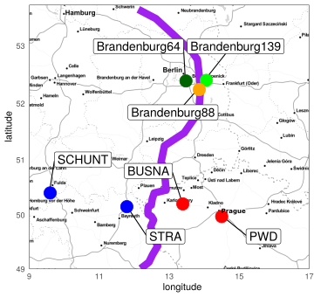

**Figure 1. Parasite isolates and mouse strains.** Map of the original locations at which mice were collected for breeding of mouse strains and isolation of parasites. The purple line is an estimation of the center of the hybrid zone between Mmd and Mmm based on sampling and genotyping of mice in this area [(Balard et al., 2019)](https://www.zotero.org/google-docs/?oh6mwe). *M. m. domesticus* are colored in blue, *M. m. musculus* in red.

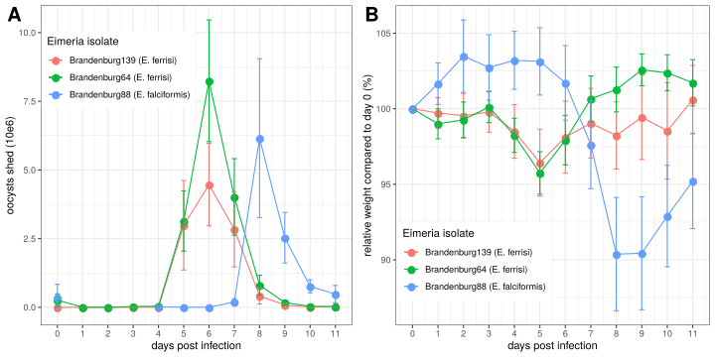

**Figure 2. Parasite shedding in feces (A) and relative weight loss (B) during *Eimeria* infection.** Mean and 95% CI are plotted for each parasite isolate. All hosts strains are regrouped.

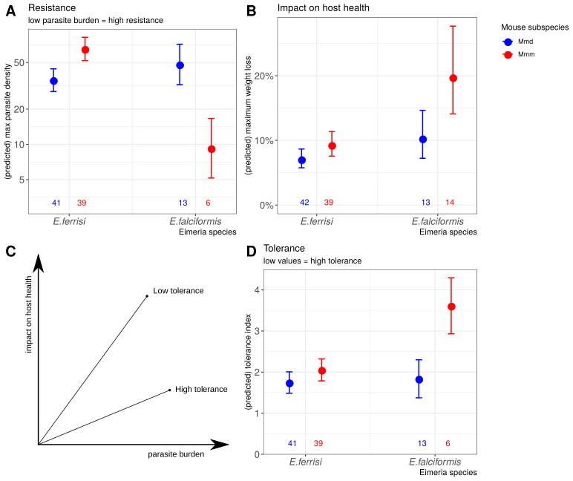

**Figure 3. Resistance, impact on host health and tolerance marginal effects for the two mice subspecies and two *Eimeria* species.** Predicted mean and standard deviation for each group. Values under bars represent the number of animals for each group. (A) Resistance measured as the inverse of maximum parasite burden (max parasite density: parasite oocysts (103) per gram of mouse at infection peak) ; (B) Impact on host health measured as the maximum weight loss during patent period relative to starting weight (%); (C) We measure individual tolerance as the slope between parasite burden and impact on host health, a lower ratio indicating a higher tolerance; (D) Tolerance measured as a (log) ratio of impact on host health by parasite burden (tolerance index: log10((relative weight loss / peak oocysts)+1e-8)+8).

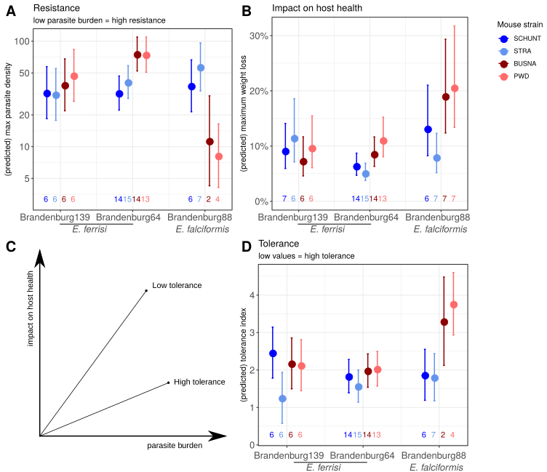

**Figure 4. Resistance, impact on host health and tolerance marginal effects for the four inbred mouse genotypes and three *Eimeria* isolates.** Predicted mean and standard deviation for each group. Values under bars represent the number of animals for each group. (A) Resistance measured as the inverse of maximum parasite burden (max parasite density: parasite oocysts (103) per gram of mouse at infection peak) ; (B) Impact on host health measured as the maximum weight loss during patent period relative to starting weight (%); (C) We measure individual tolerance as the slope between parasite burden and impact on host health, a lower ratio indicating a higher tolerance; (D) Tolerance measured as a (log) ratio of impact on host health by parasite burden (tolerance index: log10((relative weight loss / peak oocysts)+1e-8)+8).

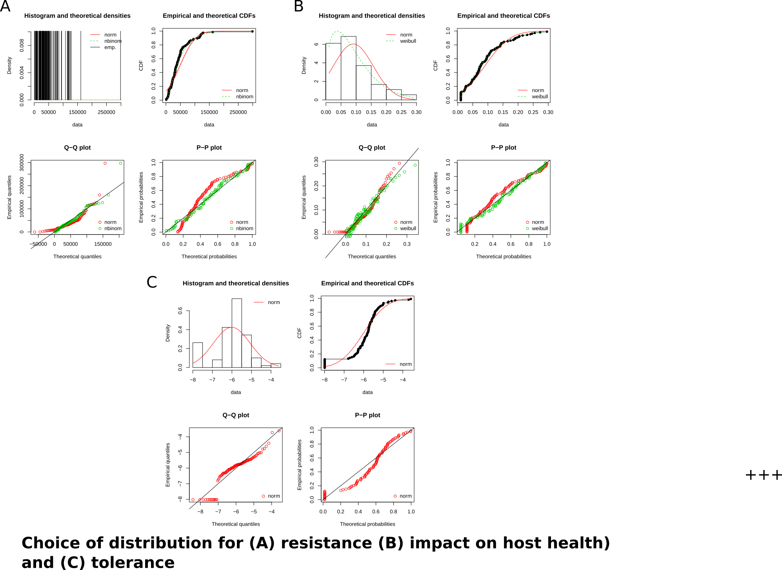**Supplementary Figure S1.** Goodness-of-fits comparison (density, CDF, Q-Q, P-P plots) for resistance (A), impact on host health (B) and tolerance (C). Negative binomial distribution, Weibull distribution, and normal distribution were respectively chosen as adequate distributions for our three measures.

# 

# Funding

This work was funded by the German Research Foundation (DFG) Grant [HE 7320/1-1] to EH. VHJ is an associated student of GRK 2046 funded by the DFG. [XXX]

# References

[Al-khlifeh, E., Balard, A., Jarquín-Díaz, V. H., Weyrich, A., Wibbelt, G., & Heitlinger, E. (2019). Eimeria falciformis BayerHaberkorn1970 and novel wild derived isolates from house mice: Differences in parasite lifecycle, pathogenicity and host immune reactions. *BioRxiv*, *611277*. http://dx.doi.org/10.1101/611277](https://www.zotero.org/google-docs/?gN5MKG)

[Anderson, R. M., & May, R. M. (1982). Coevolution of hosts and parasites. *Parasitology*, *85 (Pt 2)*, 411–426. https://doi.org/10.1017/s0031182000055360](https://www.zotero.org/google-docs/?gN5MKG)

[Ankrom, S. L., Chobotar, B., & Ernst, J. V. (1975). Life Cycle of *Eimeria ferrisi* Levine & Ivens, 1965 in the Mouse, *Mus musculus*. *The Journal of Protozoology*, *22*(3), 317–323. https://doi.org/10.1111/j.1550-7408.1975.tb05177.x](https://www.zotero.org/google-docs/?gN5MKG)

[Baird, S. J. E., & Goüy de Bellocq, J. (2019). Shifting paradigms for studying parasitism in hybridising hosts: Response to Theodosopoulos, Hund, and Taylor. *Trends in Ecology & Evolution*, *34*, 387–389. https://doi.org/10.1016/j.tree.2019.01.011](https://www.zotero.org/google-docs/?gN5MKG)

[Baird, S. J. E., Ribas, A., Macholán, M., Albrecht, T., Piálek, J., & Goüy de Bellocq, J. (2012). Where are the wormy mice? A reexamination of hybrid parasitism in the European house mouse hybrid zone. *Evolution*, *66*(9), 2757–2772. https://doi.org/10.1111/j.1558-5646.2012.01633.x](https://www.zotero.org/google-docs/?gN5MKG)

[Baker, D. G. (1998). Natural pathogens of laboratory mice, rats, and rabbits and their effects on research. *Clinical Microbiology Reviews*, *11*(2), 231–266.](https://www.zotero.org/google-docs/?gN5MKG)

[Balard, A., Jarquín-Díaz, V. H., Jost, J., Martincová, I., Ďureje, Ľ., Piálek, J., … Heitlinger, E. (2019). Intensity of infection with intracellular *Eimeria* spp. And pinworms is reduced in hybrid mice compared to parental subspecies. *BioRxiv*, *683698*. https://doi.org/10.1101/683698](https://www.zotero.org/google-docs/?gN5MKG)

[Barton, N. H., & Hewitt, G. M. (1985). Analysis of hybrid zones. *Annual Review of Ecology and Systematics*, *16*(1), 113–148. https://doi.org/10.1146/annurev.es.16.110185.000553](https://www.zotero.org/google-docs/?gN5MKG)

[Blake, D. P., & Tomley, F. M. (2014). Securing poultry production from the ever-present *Eimeria* challenge. *Trends in Parasitology*, *30*(1), 12–19. https://doi.org/10.1016/j.pt.2013.10.003](https://www.zotero.org/google-docs/?gN5MKG)

[Boulton, K., Nolan, M. J., Wu, Z., Riggio, V., Matika, O., Harman, K., … Psifidi, A. (2018). Dissecting the genomic architecture of resistance to *Eimeria maxima* parasitism in the chicken. *Frontiers in Genetics*, *9*. https://doi.org/10.3389/fgene.2018.00528](https://www.zotero.org/google-docs/?gN5MKG)

[Burgan, S. C., Gervasi, S. S., Johnson, L. R., & Martin, L. B. (2018). How individual variation in host tolerance affects competence to transmit parasites. *Physiological and Biochemical Zoology*, *92*(1), 49–57. https://doi.org/10.1086/701169](https://www.zotero.org/google-docs/?gN5MKG)

[Chapman, H. D., Barta, J. R., Blake, D., Gruber, A., Jenkins, M., Smith, N. C., … Tomley, F. M. (2013). A selective review of advances in coccidiosis research. *Advances in Parasitology*, *83*, 93–171. https://doi.org/10.1016/B978-0-12-407705-8.00002-1](https://www.zotero.org/google-docs/?gN5MKG)

[Daugschies, A., & Najdrowski, M. (2005). Eimeriosis in cattle: Current understanding. *Journal of Veterinary Medicine, Series B*, *52*(10), 417–427. https://doi.org/10.1111/j.1439-0450.2005.00894.x](https://www.zotero.org/google-docs/?gN5MKG)

[Ehret, T., Spork, S., Dieterich, C., Lucius, R., & Heitlinger, E. (2017). Dual RNA-seq reveals no plastic transcriptional response of the coccidian parasite Eimeria falciformis to host immune defenses. *BMC Genomics*, *18*(1), 686. https://doi.org/10.1186/s12864-017-4095-6](https://www.zotero.org/google-docs/?gN5MKG)

[Floyd, R. M., Rogers, A. D., Lambshead, P. J. D., & Smith, C. R. (2005). Nematode-specific PCR primers for the 18S small subunit rRNA gene. *Molecular Ecology Notes*, *5*(3), 611–612. https://doi.org/10.1111/j.1471-8286.2005.01009.x](https://www.zotero.org/google-docs/?gN5MKG)

[Graham, A. L., Allen, J. E., & Read, A. F. (2005). Evolutionary Causes and Consequences of Immunopathology. *Annual Review of Ecology, Evolution, and Systematics*, *36*(1), 373–397. https://doi.org/10.1146/annurev.ecolsys.36.102003.152622](https://www.zotero.org/google-docs/?gN5MKG)

[Gregorová, S., & Forejt, J. (2000). PWD/Ph and PWK/Ph inbred mouse strains of Mus m. Musculus subspecies—A valuable resource of phenotypic variations and genomic polymorphisms. *Folia Biologica*, *46*(1), 31–41.](https://www.zotero.org/google-docs/?gN5MKG)

[Haberkorn, A. (1970). Die Entwicklung von *Eimeria falciformis*  (Eimer 1870) in der weißen Maus (*Mus musculus*). *Zeitschrift für Parasitenkunde*, *34*(1), 49–67. https://doi.org/10.1007/BF00629179](https://www.zotero.org/google-docs/?gN5MKG)

[Heitlinger, E., Spork, S., Lucius, R., & Dieterich, C. (2014). The genome of *Eimeria falciformis*—Reduction and specialization in a single host apicomplexan parasite. *BMC Genomics*, *15*(1), 696. https://doi.org/10.1186/1471-2164-15-696](https://www.zotero.org/google-docs/?gN5MKG)

[Huang, G., Zhang, S., Zhou, C., Tang, X., Li, C., Wang, C., … Liu, X. (2018). Influence of Eimeria falciformis Infection on Gut Microbiota and Metabolic Pathways in Mice. *Infection and Immunity*, *86*(5), e00073-18. https://doi.org/10.1128/IAI.00073-18](https://www.zotero.org/google-docs/?gN5MKG)

[Jarquín-Díaz, V. H., Balard, A., Jost, J., Kraft, J., Dikmen, M. N., Kvičerová, J., & Heitlinger, E. (2019). Detection and quantification of house mouse Eimeria at the species level – Challenges and solutions for the assessment of coccidia in wildlife. *International Journal for Parasitology: Parasites and Wildlife*, *10*, 29–40. https://doi.org/10.1016/j.ijppaw.2019.07.004](https://www.zotero.org/google-docs/?gN5MKG)

[Jarquín-Díaz, V. H., Balard, A., Mácová, A., Jost, J., Szepesbéla, T. R. von, Berktold, K., … Heitlinger, E. (2019). Generalist Eimeria species in rodents: Multilocus analyses indicate inadequate resolution of established markers. *BioRxiv*, 690487. https://doi.org/10.1101/690487](https://www.zotero.org/google-docs/?gN5MKG)

[Jeanes, C., Vaughan-Higgins, R., Green, R. E., Sainsbury, A. W., Marshall, R. N., & Blake, D. P. (2013). Two new Eimeria species parasitic in corncrakes (Crex crex) (Gruiformes: Rallidae) in the United Kingdom. *The Journal of Parasitology*, *99*(4), 634–638. https://doi.org/10.1645/12-52.1](https://www.zotero.org/google-docs/?gN5MKG)

[Knowles, S. C. L., Fenton, A., Petchey, O. L., Jones, T. R., Barber, R., & Pedersen, A. B. (2013). Stability of within-host-parasite communities in a wild mammal system. *Proceedings. Biological Sciences*, *280*(1762), 20130598. https://doi.org/10.1098/rspb.2013.0598](https://www.zotero.org/google-docs/?gN5MKG)

[Kvičerová, J., & Hypša, V. (2013). Host-Parasite Incongruences in Rodent Eimeria Suggest Significant Role of Adaptation Rather than Cophylogeny in Maintenance of Host Specificity. *PLoS ONE*, *8*(7), e63601. https://doi.org/10.1371/journal.pone.0063601](https://www.zotero.org/google-docs/?gN5MKG)

[Macholán, M., Munclinger, P., Sugerková, M., Dufková, P., Bímová, B., Bozíková, E., … Piálek, J. (2007). Genetic analysis of autosomal and X-linked markers across a mouse hybrid zone. *Evolution; International Journal of Organic Evolution*, *61*(4), 746–771. https://doi.org/10.1111/j.1558-5646.2007.00065.x](https://www.zotero.org/google-docs/?gN5MKG)

[Martincová, I., Ďureje, Ľ., Kreisinger, J., Macholán, M., & Piálek, J. (2019). Phenotypic effects of the Y chromosome are variable and structured in hybrids among house mouse recombinant lines. *Ecology and Evolution*, *9*(10), 6124–6137. https://doi.org/10.1002/ece3.5196](https://www.zotero.org/google-docs/?gN5MKG)

[Matsubayashi, M., Tsuchida, S., Kobayashi, A., Shibahara, T., Nakamura, H., Murata, K., & Ushida, K. (2018). Molecular identification of two Eimeria species, E. uekii and E. raichoi as type B, in wild Japanese rock ptarmigans, Lagopus muta japonica. *International Journal for Parasitology: Parasites and Wildlife*, *7*(3), 243–250. https://doi.org/10.1016/j.ijppaw.2018.06.005](https://www.zotero.org/google-docs/?gN5MKG)

[Medzhitov, R., Schneider, D. S., & Soares, M. P. (2012). Disease Tolerance as a Defense Strategy. *Science*, *335*(6071), 936–941. https://doi.org/10.1126/science.1214935](https://www.zotero.org/google-docs/?gN5MKG)

[Mehlhorn, H., Schmahl, G., Frese, M., Mevissen, I., Harder, A., & Krieger, K. (2005). Effects of a combinations of emodepside and praziquantel on parasites of reptiles and rodents. *Parasitology Research*, *97*(1), S65–S69. https://doi.org/10.1007/s00436-005-1446-z](https://www.zotero.org/google-docs/?gN5MKG)

[Piálek, J., Vyskocilová, M., Bímová, B., Havelková, D., Piálková, J., Dufková, P., … Forejt, J. (2008). Development of unique house mouse resources suitable for evolutionary studies of speciation. *The Journal of Heredity*, *99*(1), 34–44. https://doi.org/10.1093/jhered/esm083](https://www.zotero.org/google-docs/?gN5MKG)

[R Development Core Team. (2008). *R: A Language and Environment for Statistical Computing*. Retrieved from http://www.R-project.org](https://www.zotero.org/google-docs/?gN5MKG)

[Råberg, L., Graham, A. L., & Read, A. F. (2009). Decomposing health: Tolerance and resistance to parasites in animals. *Philosophical Transactions of the Royal Society B: Biological Sciences*, *364*(1513), 37–49. https://doi.org/10.1098/rstb.2008.0184](https://www.zotero.org/google-docs/?gN5MKG)

[Råberg, L., Sim, D., & Read, A. F. (2007). Disentangling genetic variation for resistance and tolerance to infectious diseases in animals. *Science*, *318*(5851), 812–814. https://doi.org/10.1126/science.1148526](https://www.zotero.org/google-docs/?gN5MKG)

[Reid, A. J., Blake, D. P., Ansari, H. R., Billington, K., Browne, H. P., Bryant, J. M., … Pain, A. (2014). Genomic analysis of the causative agents of coccidiosis in domestic chickens. *Genome Research*, gr.168955.113–. https://doi.org/10.1101/gr.168955.113](https://www.zotero.org/google-docs/?gN5MKG)

[Sakkas, P., Oikeh, I., Blake, D. P., Nolan, M. J., Bailey, R. A., Oxley, A., … Kyriazakis, I. (2018). Does selection for growth rate in broilers affect their resistance and tolerance to Eimeria maxima? *Veterinary Parasitology*, *258*, 88–98. https://doi.org/10.1016/j.vetpar.2018.06.014](https://www.zotero.org/google-docs/?gN5MKG)

[Schito, M. L., Barta, J. R., & Chobotar, B. (1996). Comparison of Four Murine Eimeria Species in Immunocompetent and Immunodeficient Mice. *The Journal of Parasitology*, *82*(2), 255–262. https://doi.org/10.2307/3284157](https://www.zotero.org/google-docs/?gN5MKG)

[Schmid, M., Heitlinger, E., Spork, S., Mollenkopf, H.-J., Lucius, R., & Gupta, N. (2014). Eimeria falciformis infection of the mouse caecum identifies opposing roles of IFNγ-regulated host pathways for the parasite development. *Mucosal Immunology*, *7*(4), 969–982. https://doi.org/10.1038/mi.2013.115](https://www.zotero.org/google-docs/?gN5MKG)

[Schmid, M., Lehmann, M. J., Lucius, R., & Gupta, N. (2012). Apicomplexan parasite, Eimeria falciformis, co-opts host tryptophan catabolism for life cycle progression in mouse. *Journal of Biological Chemistry*, *287*(24), 20197–20207. https://doi.org/10.1074/jbc.M112.351999](https://www.zotero.org/google-docs/?gN5MKG)

[Schneider, D. S., & Ayres, J. S. (2008). Two ways to survive infection: What resistance and tolerance can teach us about treating infectious diseases. *Nature Reviews. Immunology*, *8*(11), 889–895. https://doi.org/10.1038/nri2432](https://www.zotero.org/google-docs/?gN5MKG)

[Simms, E. L., & Triplett, J. (1994). COSTS AND BENEFITS OF PLANT RESPONSES TO DISEASE: RESISTANCE AND TOLERANCE. *Evolution; International Journal of Organic Evolution*, *48*(6), 1973–1985. https://doi.org/10.1111/j.1558-5646.1994.tb02227.x](https://www.zotero.org/google-docs/?gN5MKG)

[Wickham, H. (2016). *ggplot2: Elegant Graphics for Data Analysis*. Springer.](https://www.zotero.org/google-docs/?gN5MKG)