Supplementary material S2. Conservative dataset (N=118)

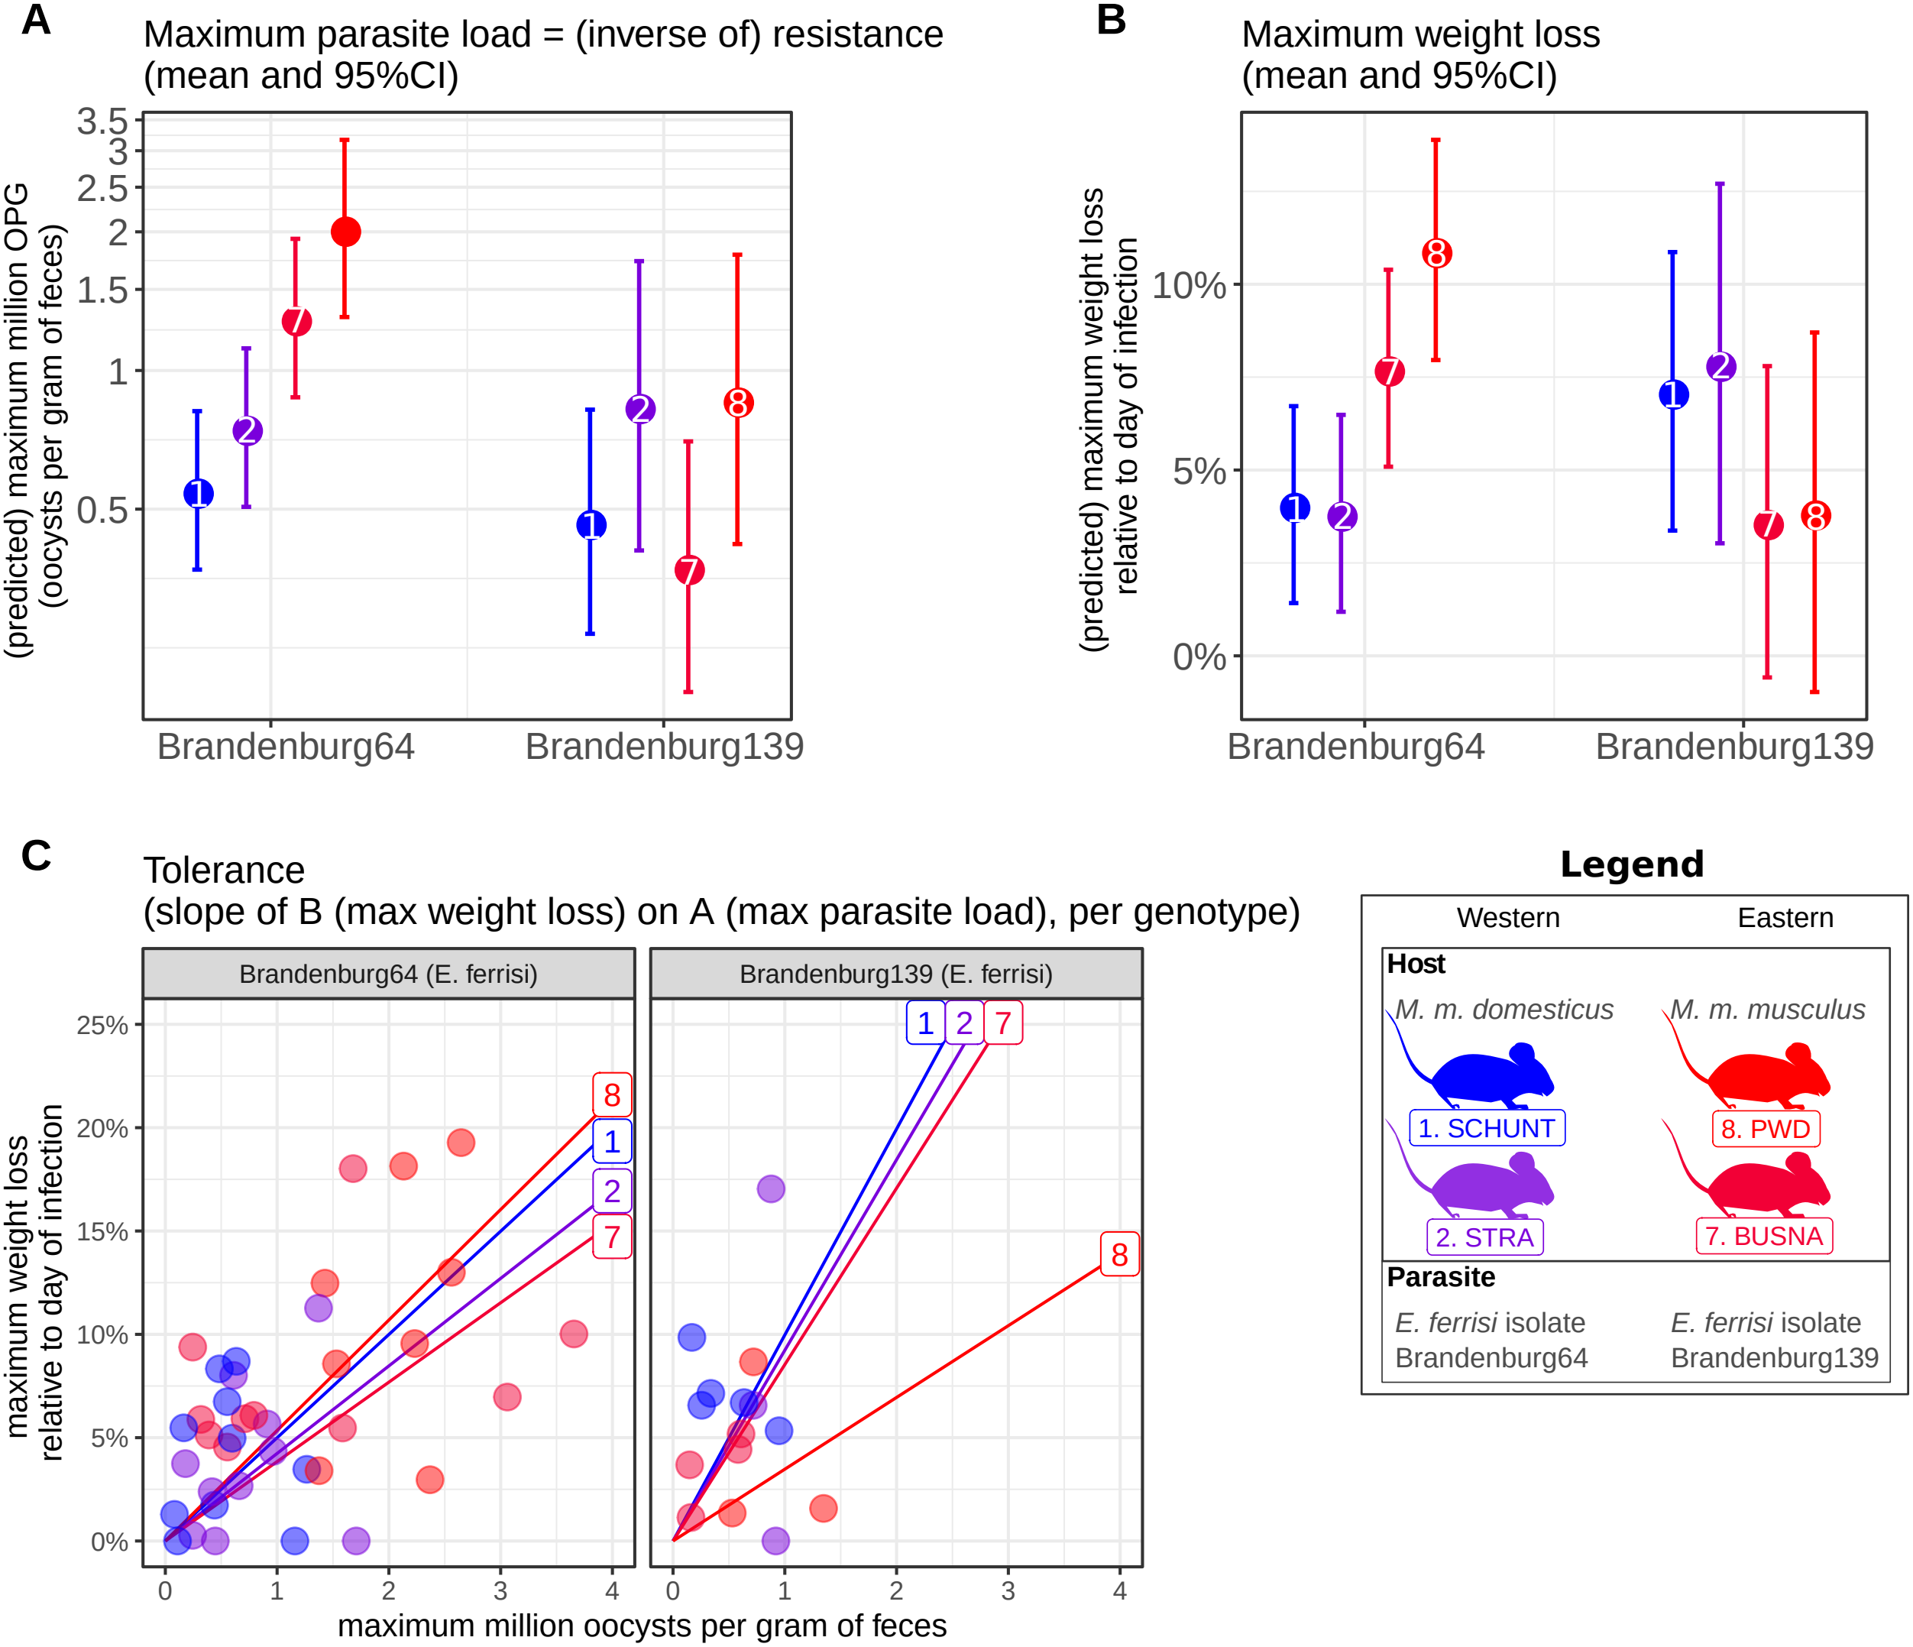
Figure S2.1. Comparison of resistance, impact on weight and tolerance between mouse strain for both Eimeria ferrisi isolates. (A) Maximum oocysts per gram of feces used as a proxy for (inverse of) resistance; (B) Impact on host health measured as the maximum weight loss during patent period relative to starting weight (%); (C) Tolerance estimated by the slope of the linear regression with null intercept modelling maximum relative weight loss as a response of maximum oocysts per gram of feces. A steep slope corresponds to a low tolerance. We did not detect (A) either higher parasite shedding of the Eastern parasite isolate in Eastern mouse strains and vice versa or (C) higher tolerance of Eastern hosts infected by Eastern parasite isolate and vice versa, thus our results do not support the hypothesis of local adaptation between E. ferrisi and its host.
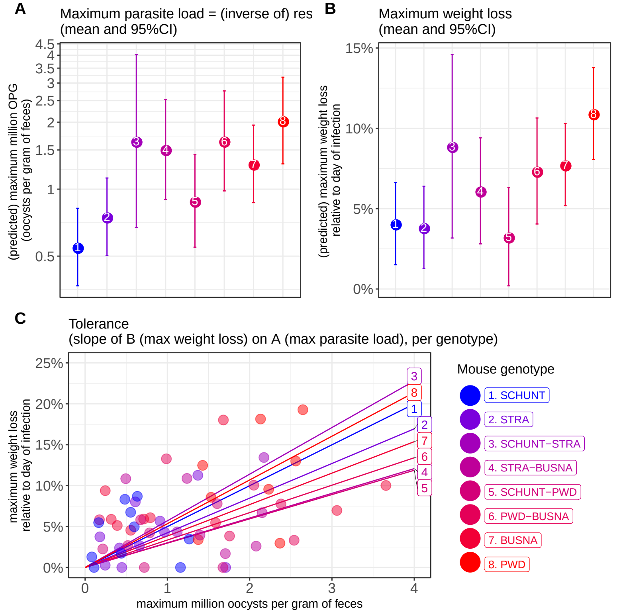
Figure 4. Comparison of resistance, impact on weight and tolerance between mouse strain for E. ferrisi isolate Brandenburg64. (A) Maximum oocysts per gram of feces used as a proxy for (inverse of) resistance; (B) Impact on host health measured as the maximum weight loss during patent period relative to starting weight (%); (C) Tolerance estimated by the slope of the linear regression with null intercept modelling maximum relative weight loss as a response of maximum oocysts per gram of feces. A steep slope corresponds to a low tolerance. CCL HERE
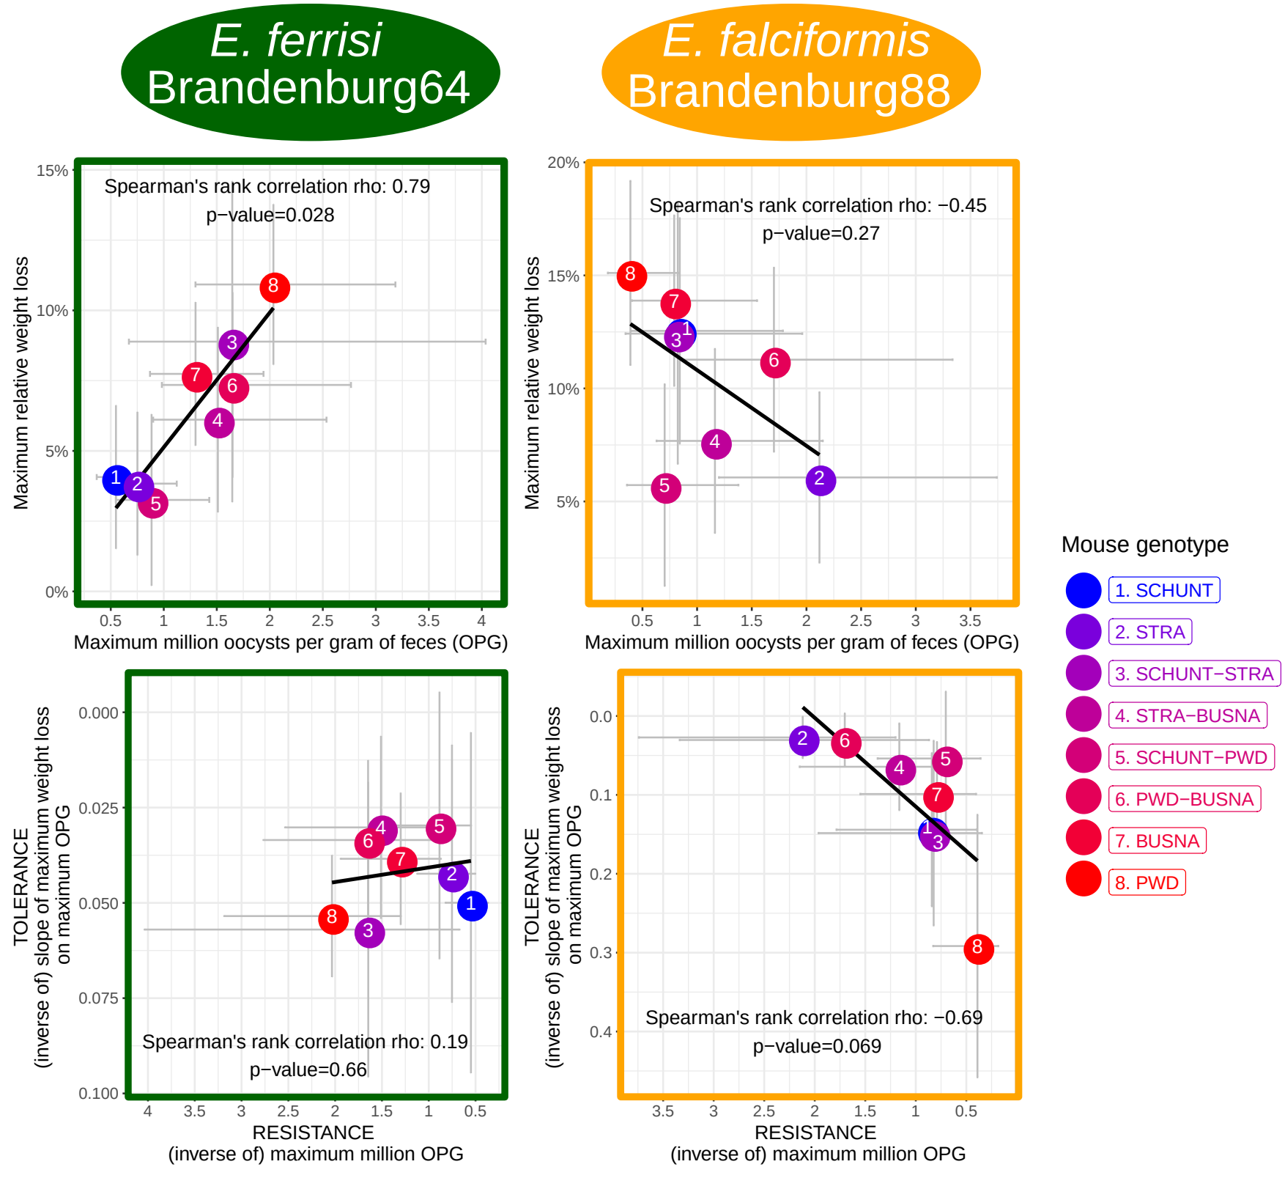
Figure 5. Coupling/not coupling No indication of resistance-tolerance coupling for both each E. ferrisi isolates. X-axis represents resistance (maximum oocysts per gram of feces used as a proxy, a high value corresponding to a low resistance); Y-axis represent tolerance (slope of the linear regression with null intercept modelling relative weight loss as a response of maximum oocysts per gram of feces, a high value corresponding to a low tolerance). Grey error bars represent 95% confidence intervals. Negative correlation between resistance and tolerance for E. falciformis isolate Brandenburg88. X-axis represents resistance (maximum oocysts per gram of feces used as a proxy, a high value corresponding to a low resistance); Y-axis represent tolerance (slope of the linear regression with null intercept modelling relative weight loss as a response of maximum oocysts per gram of feces, a high value corresponding to a low tolerance). (rho = -1, p=XXX, , Spearman's rank correlation). Grey error bars represent 95% confidence intervals.

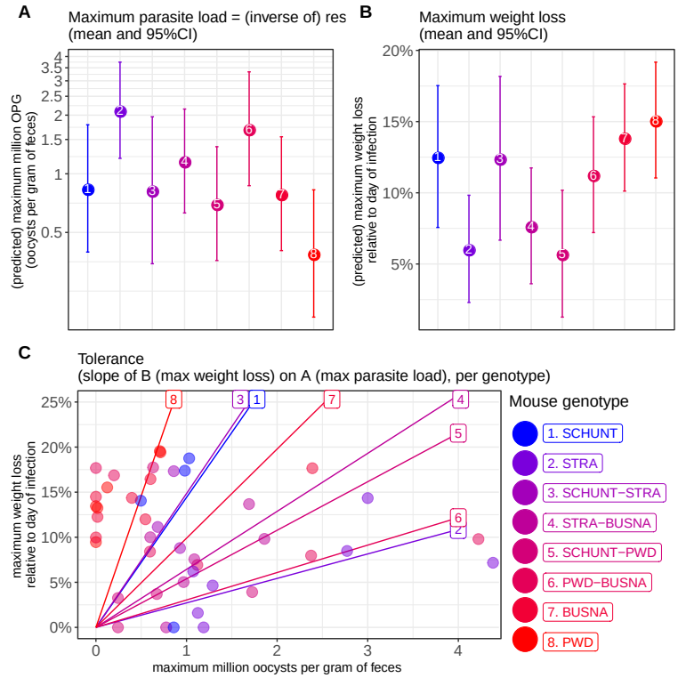
Figure 6. Comparison of resistance, impact on weight and tolerance between mouse strain for E. ferrisi isolate Brandenburg88. (A) Maximum oocysts per gram of feces used as a proxy for (inverse of) resistance; (B) Impact on host health measured as the maximum weight loss during patent period relative to starting weight (%); (C) Tolerance estimated by the slope of the linear regression with null intercept modelling maximum relative weight loss as a response of maximum oocysts per gram of feces. A steep slope corresponds to a low tolerance. CCL HERE

