Resistance/tolerance trade-off in closely related parasites

Alice Balard^{1,2}, Víctor Hugo Jarquín-Díaz^{1,2}, Jenny Jost¹, Vivian Mittné¹, Francisca Böhning¹, Iva Martincová³, Ľudovít Ďureje³, Miloš Macholán⁴, Joëlle Goüy de Bellocq³, Stuart J. E. Baird³, Jaroslav Piálek³, Emanuel Heitlinger^{1,2}
¹ Institute for Biology. Department of Molecular Parasitology. Humboldt University Berlin (HU). Philippstr. 13, Haus 14, 10115, Berlin, Germany
² Leibniz-Institut für Zoo- und Wildtierforschung (IZW) im Forschungsverbund Berlin e.V.. Alfred-Kowalke-Straße 17, 10315, Berlin, Germany
³ Research Facility Studenec, Institute of Vertebrate Biology, Czech Academy of Sciences, Květná 8, 603 65 Brno, Czech Republic
⁴ Laboratory of Mammalian Evolutionary Genetics, Institute of Animal Physiology and Genetics, Czech Academy of Sciences, Veveri 97, 60200 Brno, Czech Republic

Abstract
Resistance (host capacity to reduce parasite burden) or tolerance (reduced impact of a given parasite burden on host health) are two independent immune mechanisms challenging to study jointly in natural environments. Closely related intracellular apicomplexan parasites Eimeria ferrisi and Eimeria falciformis can be found in mice of both host subspecies of the European House Mouse Hybrid Zone (HMHZ) between Mus musculus musculus and Mus musculus domesticus. The first parasite species presents a higher prevalence in the field than the second one, and a lower pathogenicity in laboratory mice strains. We hypothesise [... more general, includes mecha]. We predict a stronger trade-off between resistance and tolerance for the more pathogenic parasite. Hence, E. falciformis is predicted to present a strong negative correlation between resistance and tolerance in different mice strains, while this correlation is expected to be mild or even absent in the case of E. ferrisi. Using four wild derived inbred mouse strains as representative for the two host subspecies, we measured resistance to parasite, impact on host health and tolerance during controlled infection.
Studying resistance and tolerance jointly in this system of closely related parasites infecting closely related hosts allowed us to INSERT HERE RESULTS… The system presents a unique opportunity to understand the fine-tuning of immune mechanisms in Eimeria infection.

Introduction
Health impact of parasitic infections has for long be assumed to immovably correlate with parasite burden. However, this assumption can lead to misleading results in biomedical studies (Schneider & Ayres, 2008) as well as when studying the ecology and evolution of host–parasite interactions (Baird & Goüy de Bellocq, 2019). Indeed, an accurate evaluation of the effect of a parasitic infection on its host requires measurements of two distinct aspects of host defense, namely resistance and tolerance (Kutzer & Armitage, 2016). Resistance is the ability of a host to reduce pathogen burden. It results from host defense against infection or proliferation, and can be seen as a reflection of early defense against pathogens after infection (Råberg, Sim, & Read, 2007). Besides reducing parasite fitness, the resultant immune response can cause immunopathology, costly for the host (Graham, Allen, & Read, 2005). Tolerance is the ability of a host to reduce the impact on its health given a certain parasite load (Råberg et al., 2007). This second line of host defense balances both damages directly induced by pathogens and those linked to immunopathology, and reduces the impact of infection on host health (Medzhitov, Schneider, & Soares, 2012).

The idea that the host resistance and tolerance had to be studied jointly to understand the impact of parasitic infections on host fitness was first suggested in the mid-90s, in the field of plant biology (Simms & Triplett, 1994). In animal biology and biomedical research, resistance was long studied but tolerance often overlooked (Medzhitov et al., 2012; Schneider & Ayres, 2008). In 2007, Råberg and colleagues showed a trade-off between resistance and tolerance in experimental murine malaria infections. They used a framework similar to that of Simms & Triplett, in which resistance is measured by the inverse of parasite burden and tolerance by the regression slope of host fitness against infection intensity (Råberg et al., 2007). Since then, an increasing body of studies have been jointly investigating resistance and tolerance. Notably, analyses of natural populations have allowed some crucial conclusions. For example, a study in wild voles showed that resistance to parasite and impact on health are not necessarily directly negatively correlated. Mature voles present in the opposite an increased body condition when parasite burden increases. Nevertheless, longitudinal data allowed to detect a reduced fecundity, showing in fine a negative correlation between host fitness and parasite burden (Jackson et al., 2014). When a negative correlation between host health and parasite burden is established, the slope of this correlation, i.e. the tolerance, can vary between individuals of the same population. A longitudinal study of a wild population of sheep has shown that parasite burden increases with weight loss, and that the strength of this correlation was positively selected: more tolerant individuals presented a higher breeding success through life (Hayward et al., 2014).
[Coccidian parasites are well studied due to their prevalence and health issue (REF). Nevertheless, much of the research is done on resistance. For example, the resistance to highly prevalent and zoonotic parasite Toxoplasma gondii has been well described, leading to the identification of IFN-γ-regulated GTPase as major determinants of parasite virulence (Lilue, Müller, Steinfeldt, & Howard, 2013). A number of separate studies have also been devoted to understand the mechanisms involved in the mitigation of Th1-mediated immunopathology (see review by Melchor & Ewald, 2019).]

But can related parasites, infecting the same host, the same organs even, present differences in there defense strategies? And what can these differences teach us in regards to the ecology and evolution of a given host-parasite system? The coccidian parasites of genus Eimeria present valuable characteristics to answer these questions. They infect intestinal epithelial cells of their hosts, which leads to malabsorption of nutrients and weight loss (Chapman et al., 2013). They are monoxenous (their full life cycle happens in a single host), which make them particularly convenient models to study under laboratory conditions. They are generally considered to be host specific, and can infect an extremely wide range of animals including birds, mammals, reptiles, amphibia and fish (Chapman et al., 2013). However, the recent use of multilocus genetic markers method in rodents showed that this host specificity could be less strict than previously thought (Jarquín-Díaz et al., 2019). They are particularly well studied in domestic animals, especially in poultry (Blake & Tomley, 2014), due to their economical importance; but can also be found in wild animals, where they can be potentially problematic for conservation (Jeanes et al., 2013; Knowles et al., 2013; Matsubayashi et al., 2018).

In the house mouse, Eimeria spp. are studied both in the laboratory and in the field. A recent study of resistance and tolerance to these parasites has been conducted in the well studied European house mouse hybrid zone (HMHZ) (Balard et al., 2019). This area is a tension zone between the Western house mouse Mus musculus domesticus and the Eastern one Mus musculus musculus (hereafter Mmd and Mmm) in which endogenous selection against house mouse hybrids is balanced by immigration of less admixed mice into the center (Barton & Hewitt, 1985; Macholán et al., 2007). It has been shown that recombinant hybrid mice in this zone present a higher resistance to Eimeria spp. than parental mice, while no increase or decrease of tolerance compared to parents could be measured in natural conditions (Balard et al., 2019). Three Eimeria species have been identified in the HMHZ: E. ferrisi is the most prevalent (17%) and widely found all across the hybrid zone. E. falciformis, despite being the most common laboratory model, was only found at a prevalence of 4%, followed by E. vermiformis (2%). The first two share very close ecological niches, namely cecum villar epithelial cells for E. ferrisi and cecum crypt cells for E. falciformis (Al-khlifeh et al., 2019; Jarquín-Díaz et al., 2019; Schito, Barta, & Chobotar, 1996). Infection experiments on laboratory mice strain have shown that the life cycle of E. falciformis was longer than those of E. ferrisi. The parasite reproductive forms (oocysts) are detectable in the host’s feces at 4 days post infection (dpi) for E. ferrisi, with a shedding peak at 5 dpi; for E. falciformis these values are 6-7 dpi and 8-9 dpi depending on the isolate. They both provoke enteric lesions, responsible of weight loss and diarrheas. These symptoms are stronger for E. falciformis infections, as well as the following inflammation and cellular infiltration (Al-khlifeh et al., 2019; Ankrom, Chobotar, & Ernst, 1975; Ehret, Spork, Dieterich, Lucius, & Heitlinger, 2017; Schito et al., 1996).
We hypothesise that the more pathogenic, more immunopathologic parasite, exerting a stronger selective pressure on the evolution of its host’s defenses, should lead to the evolution of a stronger trade-off between resistance and tolerance in different hosts. Accordingly, E. falciformis is predicted to present a strong negative correlation between resistance and tolerance in different mice strains, while this correlation is expected to be milder in the case of E. ferrisi. To test this hypothesis, we studied jointly resistance and tolerance in response to three Eimeria isolates (one for E. falciformis, and two for E. ferrisi) for two natural host subspecies (Mmd and Mmm) represented by four wild-derived inbred mouse strains.

Material and methods

Mouse strains
We used four wild-derived mouse strains: two Mmd strains SCHUNT (Locality: Schweben 2, Hessen, Germany [N: 50° 26’, E: 9° 35’] (Martincová, Ďureje, Kreisinger, Macholán, & Piálek, 2019)) and STRA (Locality: Straas 16, Bavaria, Germany [N: 50° 11’, E: 11° 46’] (Piálek et al., 2008), and two Mmm strains BUSNA (Locality: Buškovice 215, Bohemia, Czech Republic. [N: 50° 14’, E: 13° 22’] (Piálek et al., 2008)) and PWD (Locality: . [N: 50° 0’, E: 14° 29’]. Provided by Jiří Forejt, Institute of Molecular Genetics AS CR in Prague (Gregorová & Forejt, 2000)). The original mice for these four lines were respectively isolated Both SCHUNT and PWD strains had their original mice collected respectively about 250 and 150 km from the hybrid zone center (Figure 1) Age of the mice at the moment of infection ranged between 7.5 and 21.5 weeks. All mouse strains were maintained before infection in the Institute of Vertebrate Biology in Studenec (Piálek et al., 2008)(licence number 61,974/2017‐MZE‐17214).

Parasite strains
The three parasite isolates used in this study were isolated from feces of mice captured in Brandenburg, Germany, in 2016 (capture permit No. 2347/35/2014). They belong to the most prevalent Eimeria species in the wild (Jarquín-Díaz et al., 2019), namely E. ferrisi (isolates Brandenburg64 and Brandenburg139) and E. falciformis (isolate Brandenburg88). Pre-patency and peak day of oocyst shedding for this isolates was estimated during infection in NMRI laboratory mice (Al-khlifeh et al., 2019). All isolates were maintained by cyclic passaging in NMRI mice. Parasite oocysts were floated from feces with NaCl (Al-khlifeh et al., 2019) and stored at room temperature in 1mL of 2% potassium dichromate for a maximum of 2 months before infection of wild-derived mouse strains. Oocysts were allowed to sporulate 10 days before infection in a 30°C water bath.

Experimental infection
Mice were kept in individual cages during infection. Water and food (SNIFF, Rat/Mouse maintenance feed 10 mm) were provided ad libitum, in addition to 1 g of sunflower and barley seeds per day. Mice were orally infected with 150 sporulated oocysts of one Eimeria isolate suspended in 100 µl phosphate-buffer saline (PBS) and monitored daily until their sacrifice by cervical dislocation at 11 days post infection (dpi)(experiment license xxx). Individuals presenting severe health deficiency or a weight loss higher than 18% relative to their starting weight were sacrificed before the end of infection experiment. Weight was recorded and feces collected on a daily basis. Fecal pellets were collected every day from each individual cage and suspended in potassium dichromate 2%. Parasite oocysts were recovered by NaCl flotation. Potential cross-contamination between infections was monitored.
In total, 108 mice were infected as shown in Table 1. Mice were randomly allocated to experimental groups ensuring homogeneous distribution of ages and sexes between groups. Our experiments were conducted in infection batches. Nematode infection being common in breeding facilities (Baker, 1998), feces of a subset of each parental genotype were tested for presence of nematode eggs by microscopic analysis of feces prior to any infection. We could detect Syphacia and Aspiculuris eggs. Despite treatment with anthelminthics (Profender®, Bayer AG, Levekusen, Germany (Mehlhorn et al., 2005)) of the first infection batch of mice (22 mice), worms were still detected by PCR (Floyd, Rogers, Lambshead, & Smith, 2005) in randomly sampled fecal samples a week later. We therefore decided to not treat mice from the following infection batches. To verify the absence of impact of this treatment on our results, we performed the statistical analyses on a dataset excluding the 22 treated individuals (see Supplementary Material S3).

Choice of measurements for resistance and tolerance
Resistance being the capacity of a host to reduce its parasite burden, this defense line is usually estimated by the inverse of infection intensity (Råberg, Graham, & Read, 2009). We used as proxy the number of parasite par host, calculated as the number of oocysts in feces at the day of maximal shedding, divided by the mouse weight at this day (in gram). This measurement allows to account for the host volume, assuming a lower parasite oocyst number in lighter mice. A higher number of oocysts per mouse weight corresponds to a lower resistance. This measure of resistance at the day of peak intensity was tightly correlated (0.92; pearson correlation coefficient) with the sum of oocysts shed throughout the experiment. For further statistical analysis we modeled the raw value of “maximum number of oocysts per mouse gram”; For plotting and comparison with tolerance we used a Resistance Index ranging between 0 and 1 (see Supplementary Figure S2.A) calculated as:
Resistance Index = (- maximum number of oocysts per mouse gram + 300000) / 300000
Tolerance is usually defined as the slope of a regression of impact on host fitness, approximated by impact on health against infection intensity (Råberg, 2014). The major measurable symptom in murine Eimeria infections is weight loss. Therefore, the impact of parasites on host health was measured as the maximum relative weight loss compared to day 0 (mouse starting weight).
We defined a Tolerance Index for each individual, describing how its health varied with infection intensity, between day 0 of infection (weight = 100%, parasite intensity = 0 oocyst per mouse gram) and highest impact (weight = minimum weight relative to day 0, parasite intensity = maximum parasite number per mouse gram). We normalised this index by log transformation (adding 1e-8 to avoid infinite values) and divided by -8 to obtained a higher index for highly tolerant individuals (see Supplementary Figure S2.A) :
Tolerance Index = (log10(maximum relative weight loss / maximum number of oocysts per mouse gram + 1e-8) / -8

Statistical analyses
Adequate distributions for both resistance, impact on host health and tolerance were selected based on (log) likelihood and by comparing goodness-of-fits plots (density, CDF, Q-Q, P-P plots) between usual distributions. Negative binomial, Weibull, and normal distribution were the most adequate to describe peak of oocysts per mouse gram, impact on host health and tolerance index, respectively (see Supplementary Figure S1).
We tested the effects of mouse subspecies (Mmd or Mmm), Eimeria species (E. ferrisi or E. falciformis) and their interaction separately using (generalized) linear models. To assess the stability of our results across mice strains and Eimeria isolates, we also tested the effects of mouse strain (N=4), parasite isolate (N=3) and their interaction separately using the same (generalized) linear models. We used likelihood ratio tests (LRT) with and without the focal term to test for its significance in the model.
We then compared the trade-off between resistance and tolerance between E. ferrisi and E. falciformis. Using Resistance Index and Tolerance Index as defined previously, we fitted a linear model to explain the variations of Tolerance Index by the interaction between Resistance Index and Eimeria species.
All analyses were performed using the R software version 3.5.2 (R Development Core Team, 2008). Graphics were produced using the R package ggplot2 (Wickham, 2016) and compiled using the free software inkscape (https://inkscape.org). Full summary statistics were calculated and displayed using the R package stargazer (Hlavac, 2018).
All code and data used for this article can be found at: https://github.com/alicebalard/Article_RelatedParasitesResTol

Results

General parasitology
To test for differences in resistance and tolerance, we analysed parasite infections with isolates of the species E. ferrisi (two isolates; Brandenburg64 and Brandenburg139) and E. falciformis (one isolate; Brandenburg88). The life cycle of all isolates was successfully completed in all wild derived mouse strains (Figure 2). For E. ferrisi (both isolates) prepatent period (period between infection recovery of oocysts in feces) was 5 dpi and the median day of maximal oocyst shedding was 6 dpi (sd=0.71 and 0.65, respectively). The median day of maximum weight loss was 5 dpi for both isolates (sd=2.2 and 1.9 respectively). For E. falciformis (isolate Brandenburg88) pre-patency was 7 dpi, median day of maximal shedding was 8 dpi (sd=1.2) and median day of maximal weight loss 9 dpi (sd=1.5). Infectivity with all tested Eimeria isolates can be considered 100%.
A very low level of Eimeria oocysts were found at the day of initial infection in the feces of 9 mice belonging to the two final experimental batches (6 infected with Brandenburg64 and 3 with Brandenburg88). This result is likely due to cross-contamination through cages. To verify the consistency of our results, we performed the different analyses (modellisation of resistance, impact on health, tolerance, as well as linear regression of Tolerance Index by Resistance Index) on a dataset excluding the 22 mice treated by anthelminthics and the 9 coinfected mice. The results obtained on this conservative dataset is congruent with the results obtained on all mice, we considered the influence of both factors negligible (see Supplementary Material S3).
A significant number of Mmm mice infected with E. falciformis (isolate Brandenburg88) died before the oocysts shedding peak (8 out of 14; 5 BUSNA strain and 3 PWD strain). Moreover, one Mmd mouse (strain SCHUNT) infected by E. ferrisi isolate Brandenburg139 had liquid diarrhea on the shedding peak day, making its feces not collectable. These mice were assessed as missing data for resistance and for the following tolerance measurement.

Parental M. m. musculus are more resistant to E. falciformis than to E. ferrisi
To establish differences between the two house mouse subspecies we analysed the extent of oocyst shedding as a measure of resistance after infection with both Eimeria species. We found statistically significant differences in resistance between parasite species (glm/LRT, p-value=0.022, n=99) as well as an interaction between parasite species and mouse subspecies (glm/LRT; p-value=6e-07, n=99; summary statistics in Table 2). These differences mean that Mmm resist E. falciformis better than E. ferrisi, while the difference in resistance is in the other direction in Mmd (Figure 3A).
We then excluded the influence of geographical origin of mouse and parasite in a model separating Eimeria by isolates and mouse by strains. We also found statistically significant differences in resistance between parasite isolate (glm/LRT, p-value=0.019, n=99) as well as an interaction between parasite isolate and mouse strain (glm/LRT, p-value=8e-05, n=99; summary statistics in Table 3; Figure 4A).

Parental M. m. musculus are more impacted by E. falciformis than by E. ferrisi
To assess difference of impact on host health by Eimeria between mouse strains we assessed weight loss after infection with the both Eimeria species. We found statistically significant differences in impact on host health between mouse subspecies (glm/LRT, p-value=0.016, n=108) and between parasite species (glm/LRT, p-value=6.3e-06, n=108; summary statistics in Table 2). This means that Mmd lost less weight when infected by both E. falciformis and E. ferrisi than Mmm, and that E. falciformis impacts more the health of both mouse subspecies than E. ferrisi. In the case of Mmm, the different impacts of both parasite species is particularly marked: Mmm infected with E. falciformis lost on average 10% more weight than those infected with E. ferrisi (Figure 3B).
When excluding the influence of geographical origin of mouse and parasite in a model separating Eimeria by isolates and mice by strains (instead of subspecies), we also found impact on health to differ significantly for parasite isolates (glm/LRT, p-value=1.9e-5, n=108; summary statistics in Table 3; Figure 4B).

Parental M. m. musculus are less tolerant to E. falciformis than to E. ferrisi
Combining resistance and impact on health, we assessed the tolerance of our mouse subspecies to both Eimeria species. Tolerance was found to differ significantly between mouse subspecies (lm/LRT, p-value=0.002, n=99), between parasite species (lm/LRT, p-value=0.023, n=99) and we found interactions between mouse subspecies and parasite species (lm/LRT, p-value=0.002, n=99; Table 2).
Mice are overall more tolerant to E. ferrisi than to E. falciformis. While the difference in tolerance is negligible in M. m. domesticus infected by any of the parasite species, M. m. musculus are far less tolerant to E. falciformis than to E. ferrisi (Figure 3C). We confirm this pattern when we tested the influence of geographical origin of mouse and parasite in a model separating Eimeria by isolates and mouse by strains. We found tolerance to differ significantly between mouse subspecies (lm/LRT, p-value=0.004, n=99) as well as interactions between mouse subspecies and parasite species (lm/LRT, p-value=0.046, n=99; Table 2, Figure 4D).

Comparison of resistance/tolerance trade-off between Eimeria species
We fit a linear model with Tolerance Index as response variable, explained by the interaction between Resistance Index and Eimeria species. The interaction term being statistically significant (t-statistic, p-value = 1.39e-05), we hereby conclude that the slopes of regression between both Eimeria species are significantly different. More precisely, every increase of 1 unit of Resistance Index corresponds to a decrease of 0.06 unit of Tolerance Index for E. ferrisi (95%CI: [-0.21 , 0.09]) and to a decrease of 1.2 unit of Tolerance Index for E. falciformis (95%CI: [-1.73 , -0.75]). As the confidence interval for E. ferrisi contains 0, there is no statistically significant decrease or Tolerance Index in correlation to Resistance Index for this parasite species, meaning that we do not observe a trade-off between resistance and tolerance within the four mouse strains / two mouse subspecies tested. In the opposite, we observe a strong trade-off for E. falciformis. As we can see Figure 5, Mmd strains are far more tolerant and far less resistant to this parasite species than Mmm.

Discussion

Summary
We here used a controlled experimental setup to detect variations in resistance, impact on health and tolerance between different strains and subspecies of mice when infected by a the unicellular parasite Eimeria. While Mmd, the Western mice, did not show a strong variation between both parasite species, we found evidence that Mmm, the Eastern mice, are more resistant but less tolerant to E. falciformis than to E. ferrisi. Moreover XXX HYP FRAMEWORK.
TOLERANCE has been shown to evolve against
- pathogenic parasites more than less pathogenic ref ref ref
- prevalent parasites more than less prevalent ref ref ref

Testing in 2 parasites,we found that. Even more than hypothesise: TRES deco Res/TOl, malgrès impact! Comptes que sur Tol? tolerate nimp quel niveau?
E. ferrisi
Lab NMRI: shorter cycle, - immunopathology, + direct impact of infection
Field: high prevalence
This study: resistance totally uncorrelated from tolerance. Depending on the host genetic background (subspecies) [& parasite isolate (visual + check), less important]
Link with paper 1: no link between parasite load and fitness

E. falciformis
Lab NMRI: Longer cycle, + immunopathology, - direct impact of infection
Field: Low prevalence
This study: trade-off, either high resistance/low tolerance (Mmm) OR high tolerance/low resistance (Mmd).

Different trade-off

Muller White Boots 2007
B et al 2009
B donelly white 2013
Different investment in R or T dvp +++
DVP +++ on the idea of evolution of trade-off between res and tol. Chosen strategy. What does that imply.

Previous infection experiments in NMRI mice have shown that E. ferrisi (Brandenburg64 isolate) pathogenicity is likely due to parasite proliferation and cell exhaustion, while E. falciformis (Brandenburg88 isolate) infection is characterized by an influx of immune cells, probably the major cause of pathogenicity (Al-khlifeh et al., 2019). Moreover, the life cycle of E. ferrisi is shorter than of E. falciformis in all host strains of this study as well as in NMRI, BALB/c and SCID (immunodeficient) laboratory strains (Al-khlifeh et al., 2019; Schito, Barta, & Chobotar, 1996). All these characteristics lead to think that E. ferrisi fitness can be higher than the one of E. falciformis without affecting significantly the host’s fitness, which could explain the higher overall prevalence of E. ferrisi in the HMHZ compared to E. falciformis (Jarquín-Díaz, Balard, Jost, et al., 2019).

EFAL VIENT DE MMD
Ccl. Roy and Kirchner 2007. Increase resistance -> lower prevalence of parasie. Genes are more polymorphic (MHC etc. lier avec ce qu’on sait souris). Tolernace gense tend to be fixed!! Donc idee. Efal vient de Mmd.
Moreover, considering disease dynamics, E. falciformis induced mortality (almost 60% (8/14)) in Mmm, coupled with a high resistance in this host subspecies. As the transmission of parasite infective forms happens by oral-fecal route, dead animals can’t spread the disease, and we can hypothesize in the natural system a lower capacity to spread of E. falciformis in Mmm than in Mmd (Burgan, Gervasi, Johnson, & Martin, 2018). The optimum virulence of a parasite (high rate of host mortality) should allows both a sufficient host fitness and parasite fitness to be evolutively selected. According to the trade-off hypothesis (Anderson & May, 1982) the high virulence of E. falciformis in Eastern mice could be explained if its transmission rate would be high. In the case of an oral-fecal transmission, the host’s death is detrimental for the parasite transmission. This aparent maladaptation could mean that E. falciformis has reached Mmm mice only after secondary contact with Mmd, the Western mice, potential original hosts. Ongoing work in our group that aim at describing the Eimeria population structure with a large multi-marker approach will provide precious information about the host-parasite structure in this zone.

With more than 1200 species infecting an impressive range of hosts (Chapman et al., 2013), the diversity of Eimeria makes it a fascinating parasite to study parasite-host interactions. While domestic animals can be infected with numerous species (seven in domestic chickens (Reid et al., 2014), more than twenty in cattle (Daugschies & Najdrowski, 2005)), wild animals are not spared: in a recent study, 46% of wood mice were found infected with Eimeria, with at least three species identified (Knowles et al., 2013). In the HMHZ, three species infecting Mus were detected (Jarquín-Díaz, Balard, Jost, et al., 2019). Host specificity in rodent Eimeria is suggested to be adaptive rather than conserved (Kvičerová & Hypša, 2013). The results of the current study showed a quite constant resistance and tolerance to E. ferrisi across a host hybrid zone, while they greatly differ between both sides for E. falciformis. This could indicates a tighter adaptation to the latter to each specific host subspecies.

Ccl
So far, E. falciformis is the more common murine Eimeria model (Haberkorn, 1970; Huang et al., 2018; Schmid et al., 2014; Schmid, Lehmann, Lucius, & Gupta, 2012). We argue that E. ferrisi has probably been overlooked as model species. Moreover, comparing close species is cool, evolution of resistance / tolerance trade-off. Enlarge the system. Yepa!

Tables
Mouse |  | Eimeria species / isolate
strains | subspecies | E. ferrisi  Brandenburg139 | E. ferrisi  Brandenburg64 | E. falciformis  Brandenburg88
SCHUNT | M.m.domesticus | 7 (5M / 2F) | 14 (6M / 8F) | 6 (3M / 3F)
STRA | M.m.domesticus | 6 (2M / 4F) | 15 (8M / 7F) | 7 (4M /3F)
BUSNA | M.m.musculus | 6 (2M / 4F) | 14 (8M / 6F) | 7 (3M /4F)
PWD | M.m.musculus | 6 (3M / 3F) | 13 (10M / 3F) | 7 (1M / 6F)

Table 1. Infection experiment design.
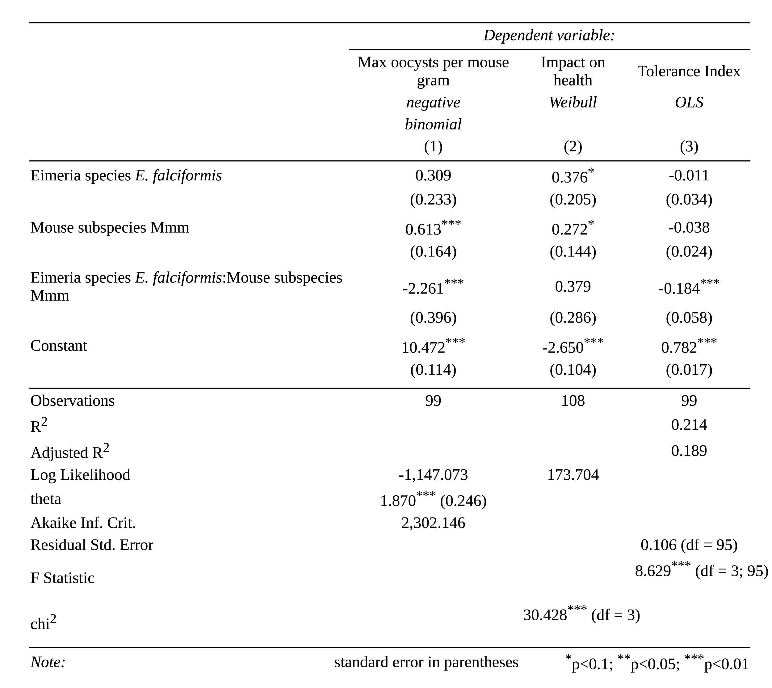
Table 2. Regression analyses results at the host subspecies / parasite species level.
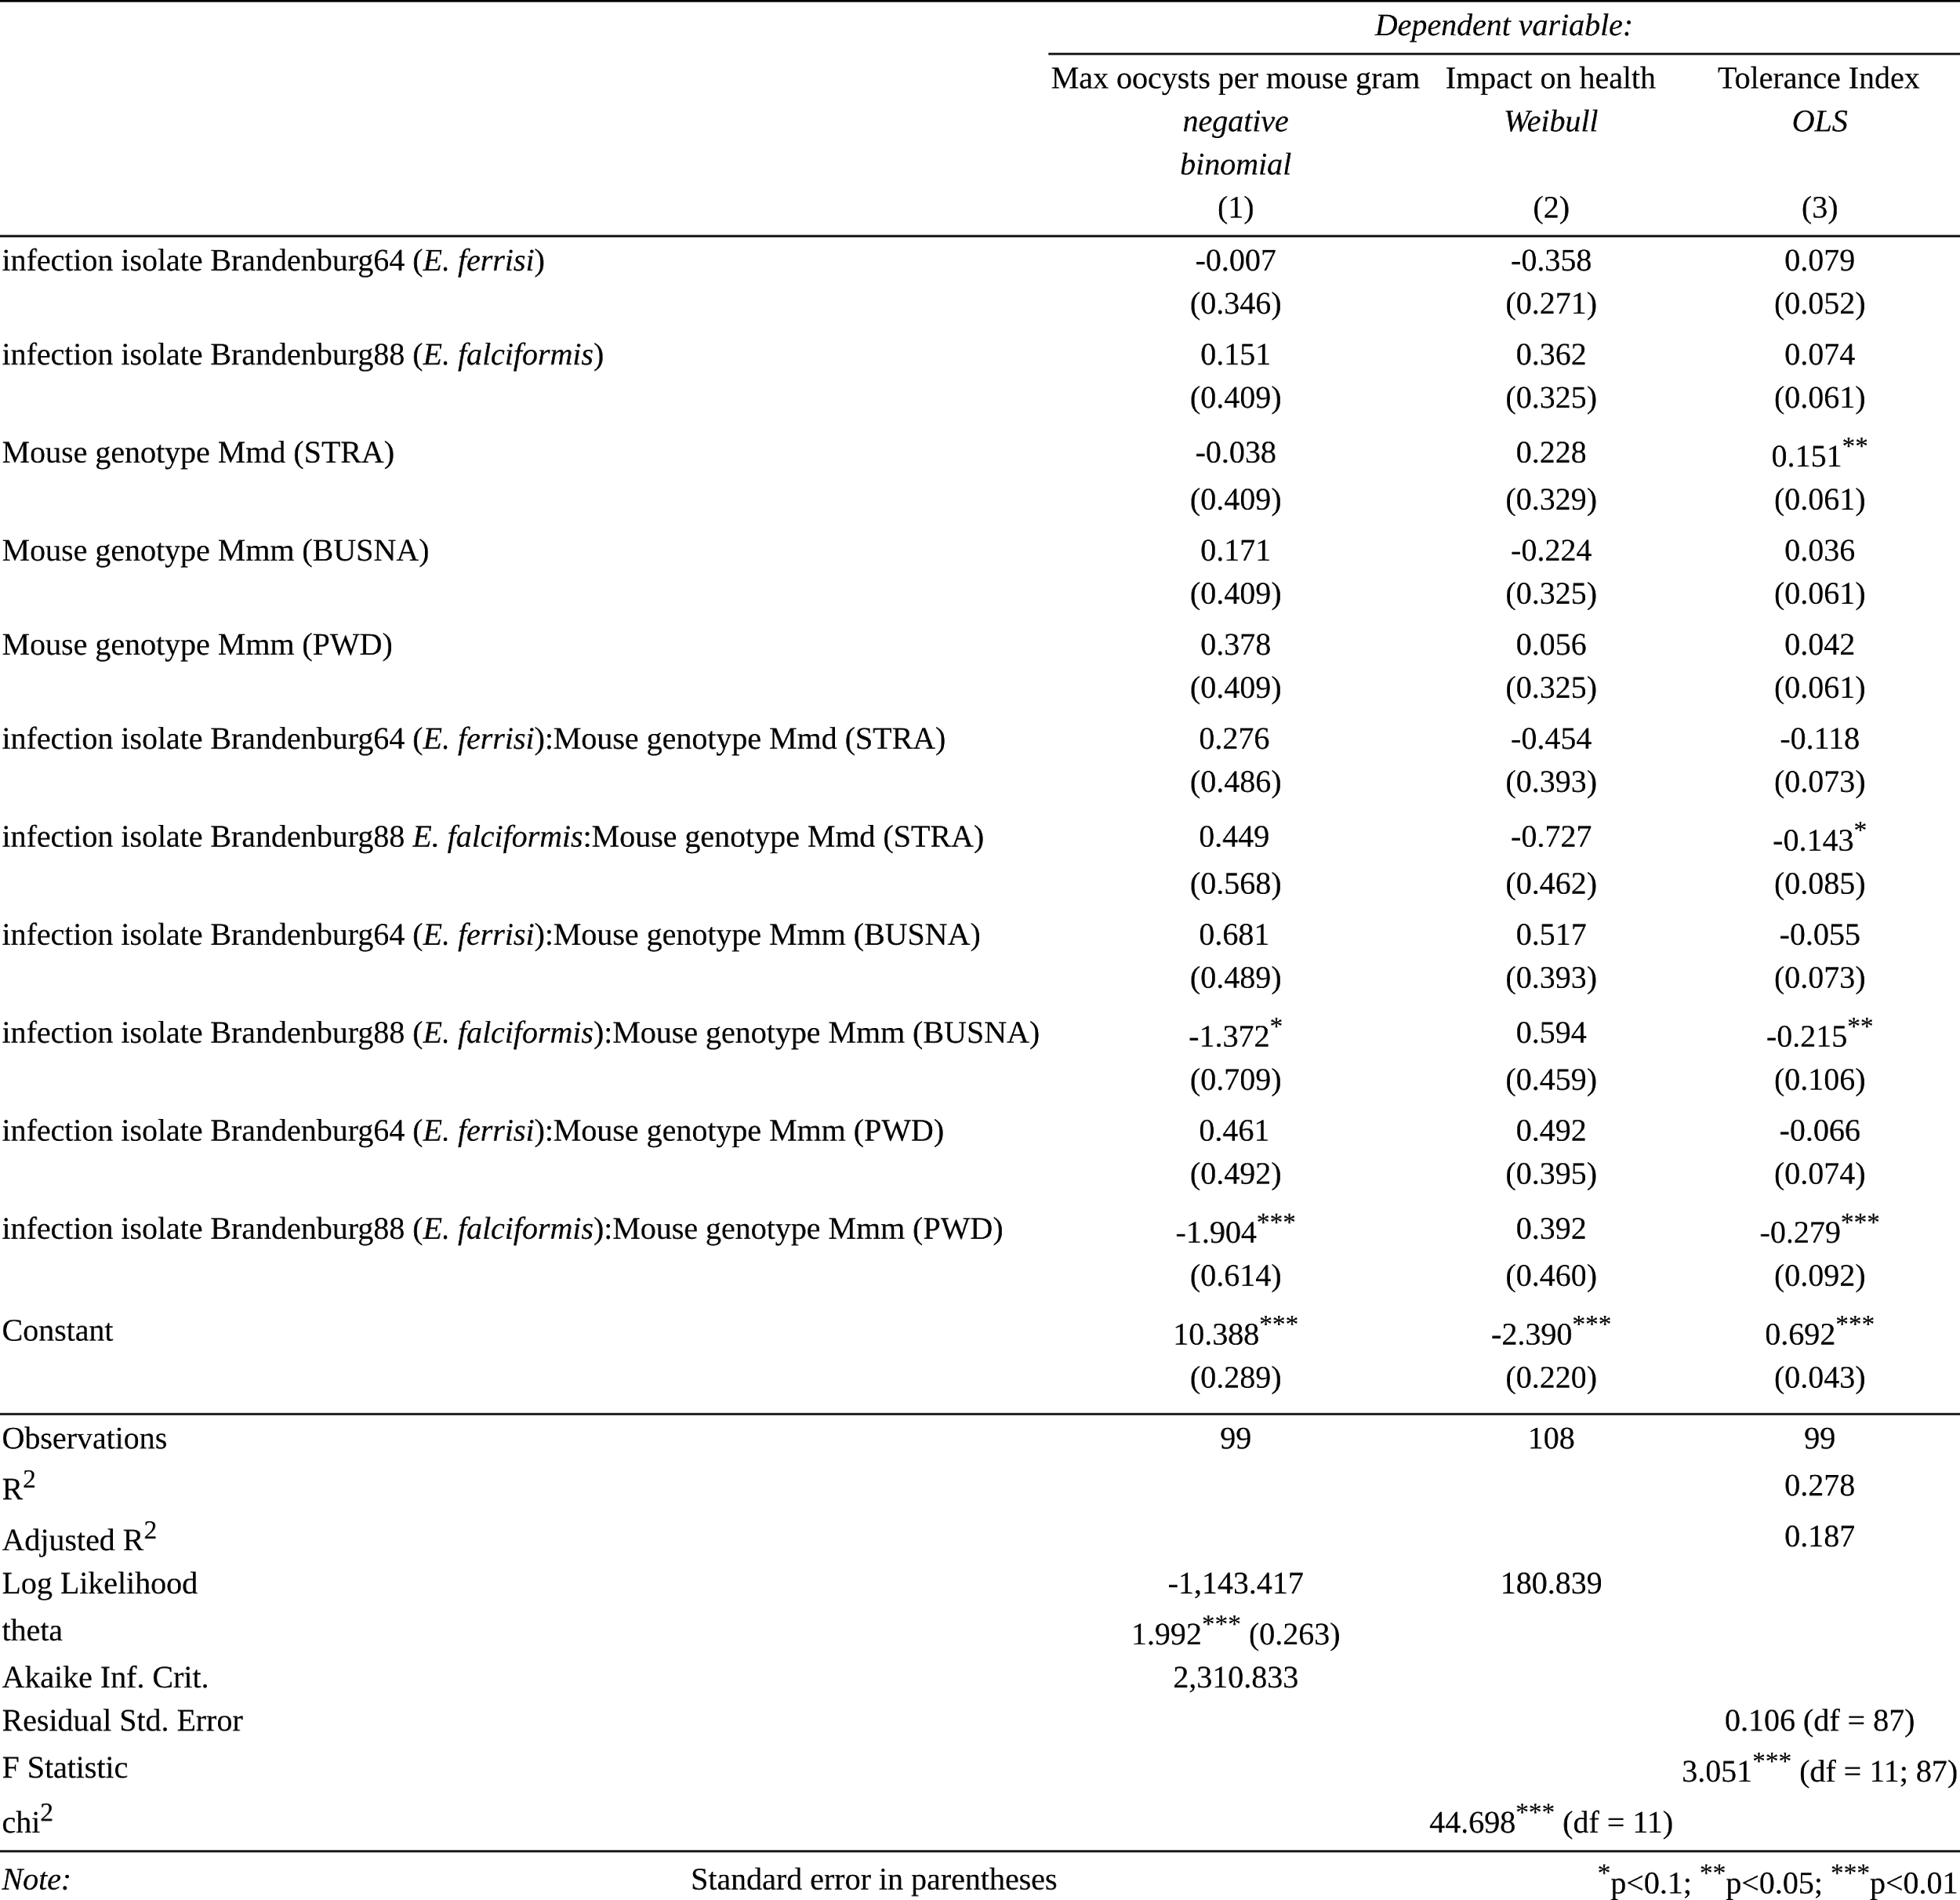
Table 3. Regression analyses results at the host strain / parasite isolate level.

Figures
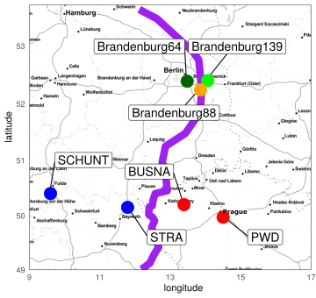
Figure 1. Parasite isolates and mouse strains. The map shows locations at which mice were collected for breeding of mouse strains and isolation of parasites. The purple line is an estimation of the center of the house mouse hybrid zone between Mmd and Mmm based on sampling and genotyping of mice in this area (Balard et al., 2019, Ďureje et al. 2012). M. m. domesticus are colored in blue, M. m. musculus in red, parasite isolates in green and orange.

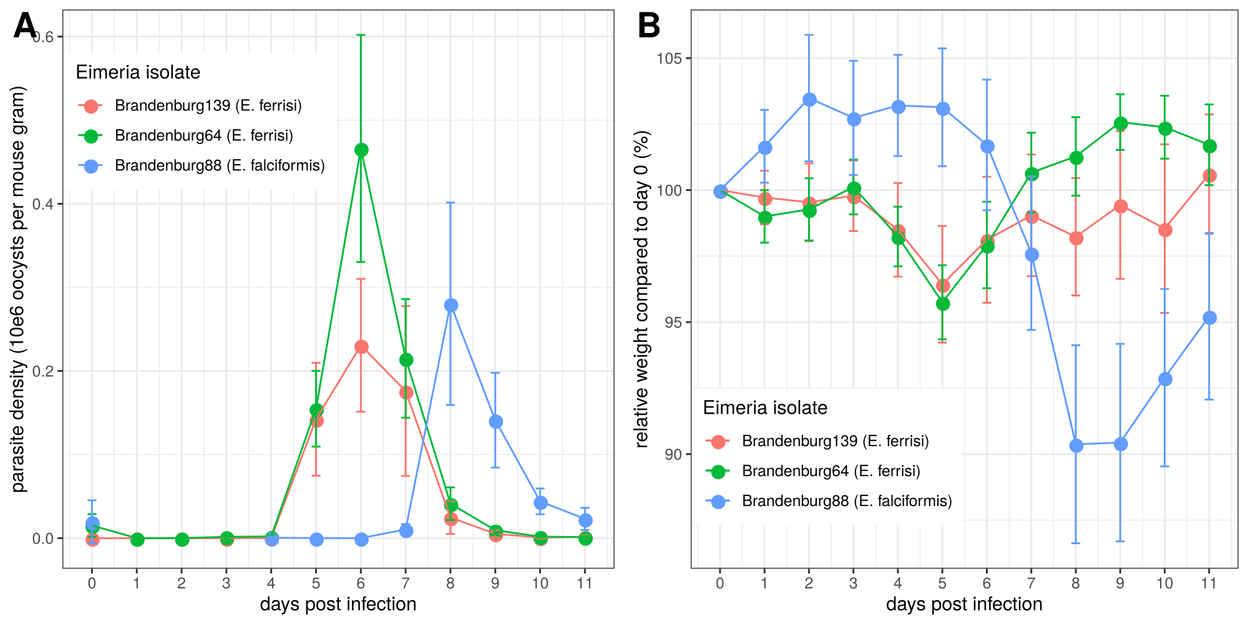
Figure 2. Parasite density (A) and relative weight loss (B) during Eimeria infection. Parasite density is calculated as number of oocysts detected (10e6) in feces per mouse gram, relative weight loss is calculated compared to day 0. Mean and 95% CI are plotted for each parasite isolate. All hosts strains are regrouped.
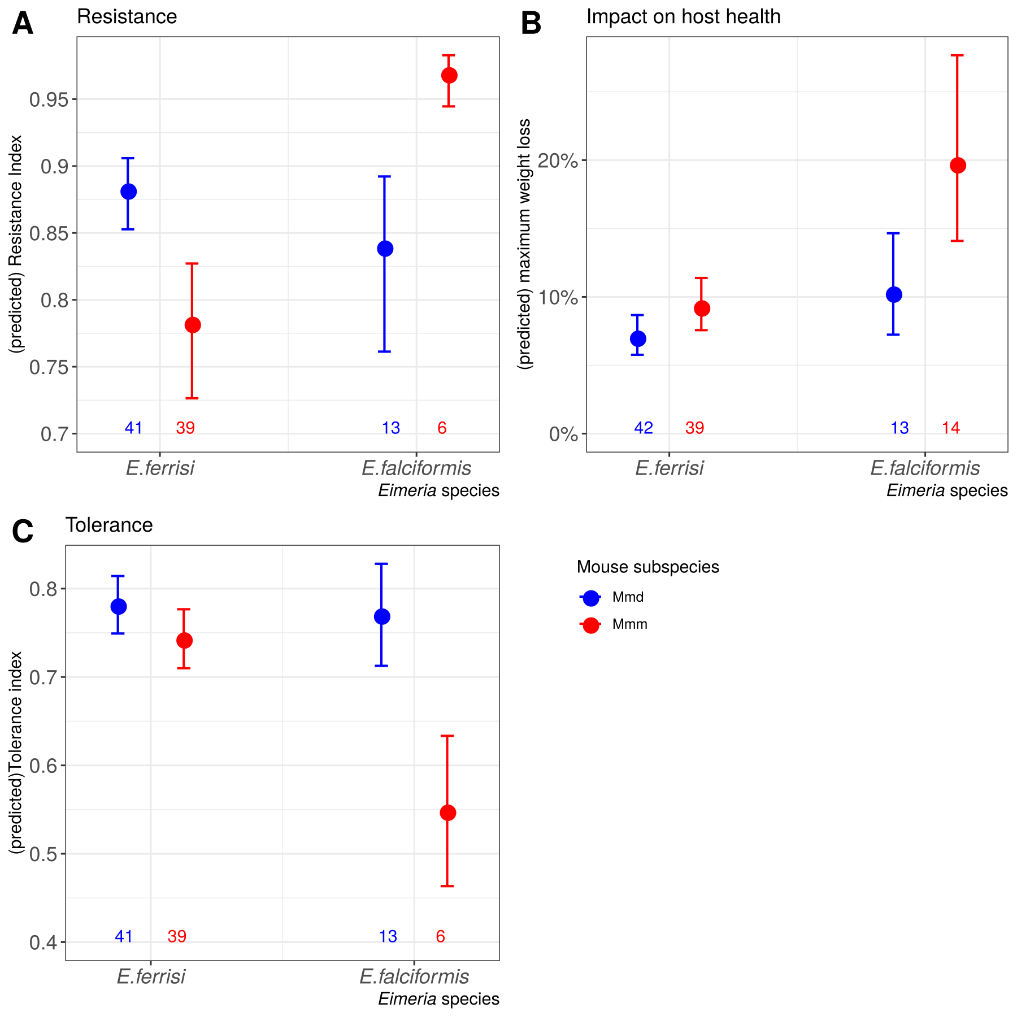
Figure 3. Resistance, impact on host health and tolerance marginal effects for the two mice subspecies and two Eimeria species. Predicted mean and standard deviation for each group. Values under bars represent the number of animals for each group. (A) Resistance Index measured as (- maximum number of oocysts per mouse gram + 300000) / 300000 ; (B) Impact on host health measured as the maximum weight loss during patent period relative to starting weight (%); (C) Tolerance Index measured as (log10(maximum relative weight loss / maximum number of oocysts per mouse gram + 1e-8) / -8
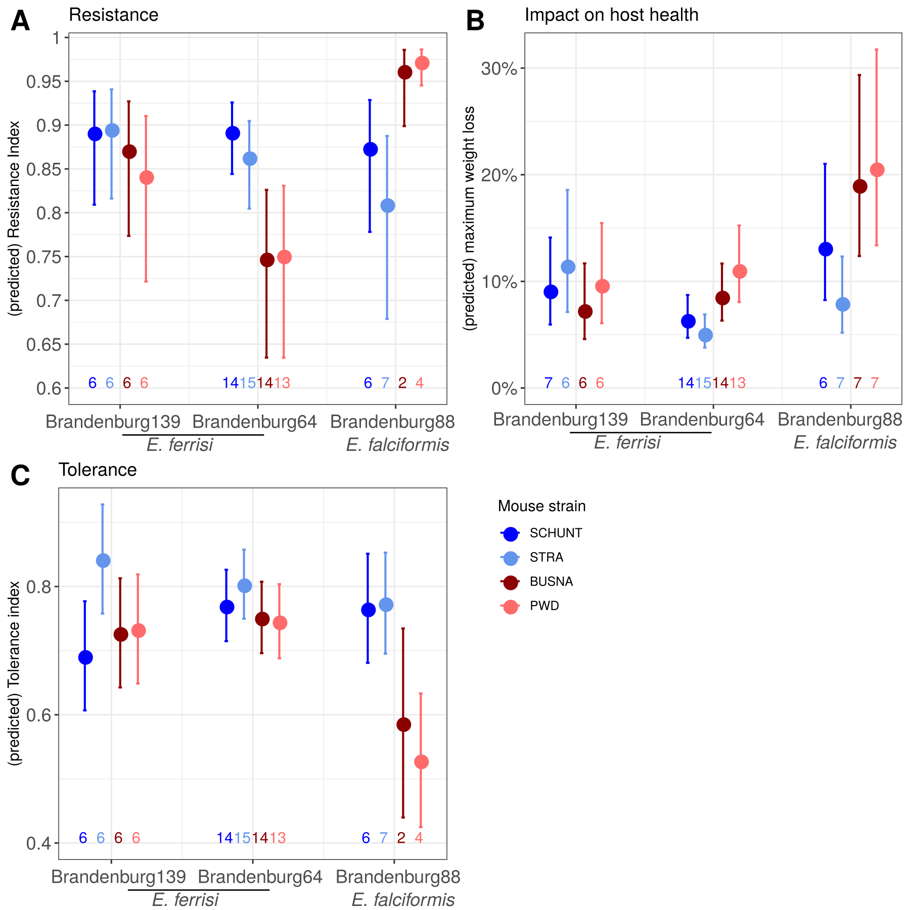

Figure 4. Resistance, impact on host health and tolerance marginal effects for four inbred mouse strains infected with three Eimeria isolates each. Predicted mean and standard deviation for each group. Values under bars represent the number of animals for each group. (A) Resistance Index measured as (- maximum number of oocysts per mouse gram + 300000) / 300000 ; (B) Impact on host health measured as the maximum weight loss during patent period relative to starting weight (%); (C) Tolerance Index measured as (log10(maximum relative weight loss / maximum number of oocysts per mouse gram + 1e-8) / -8

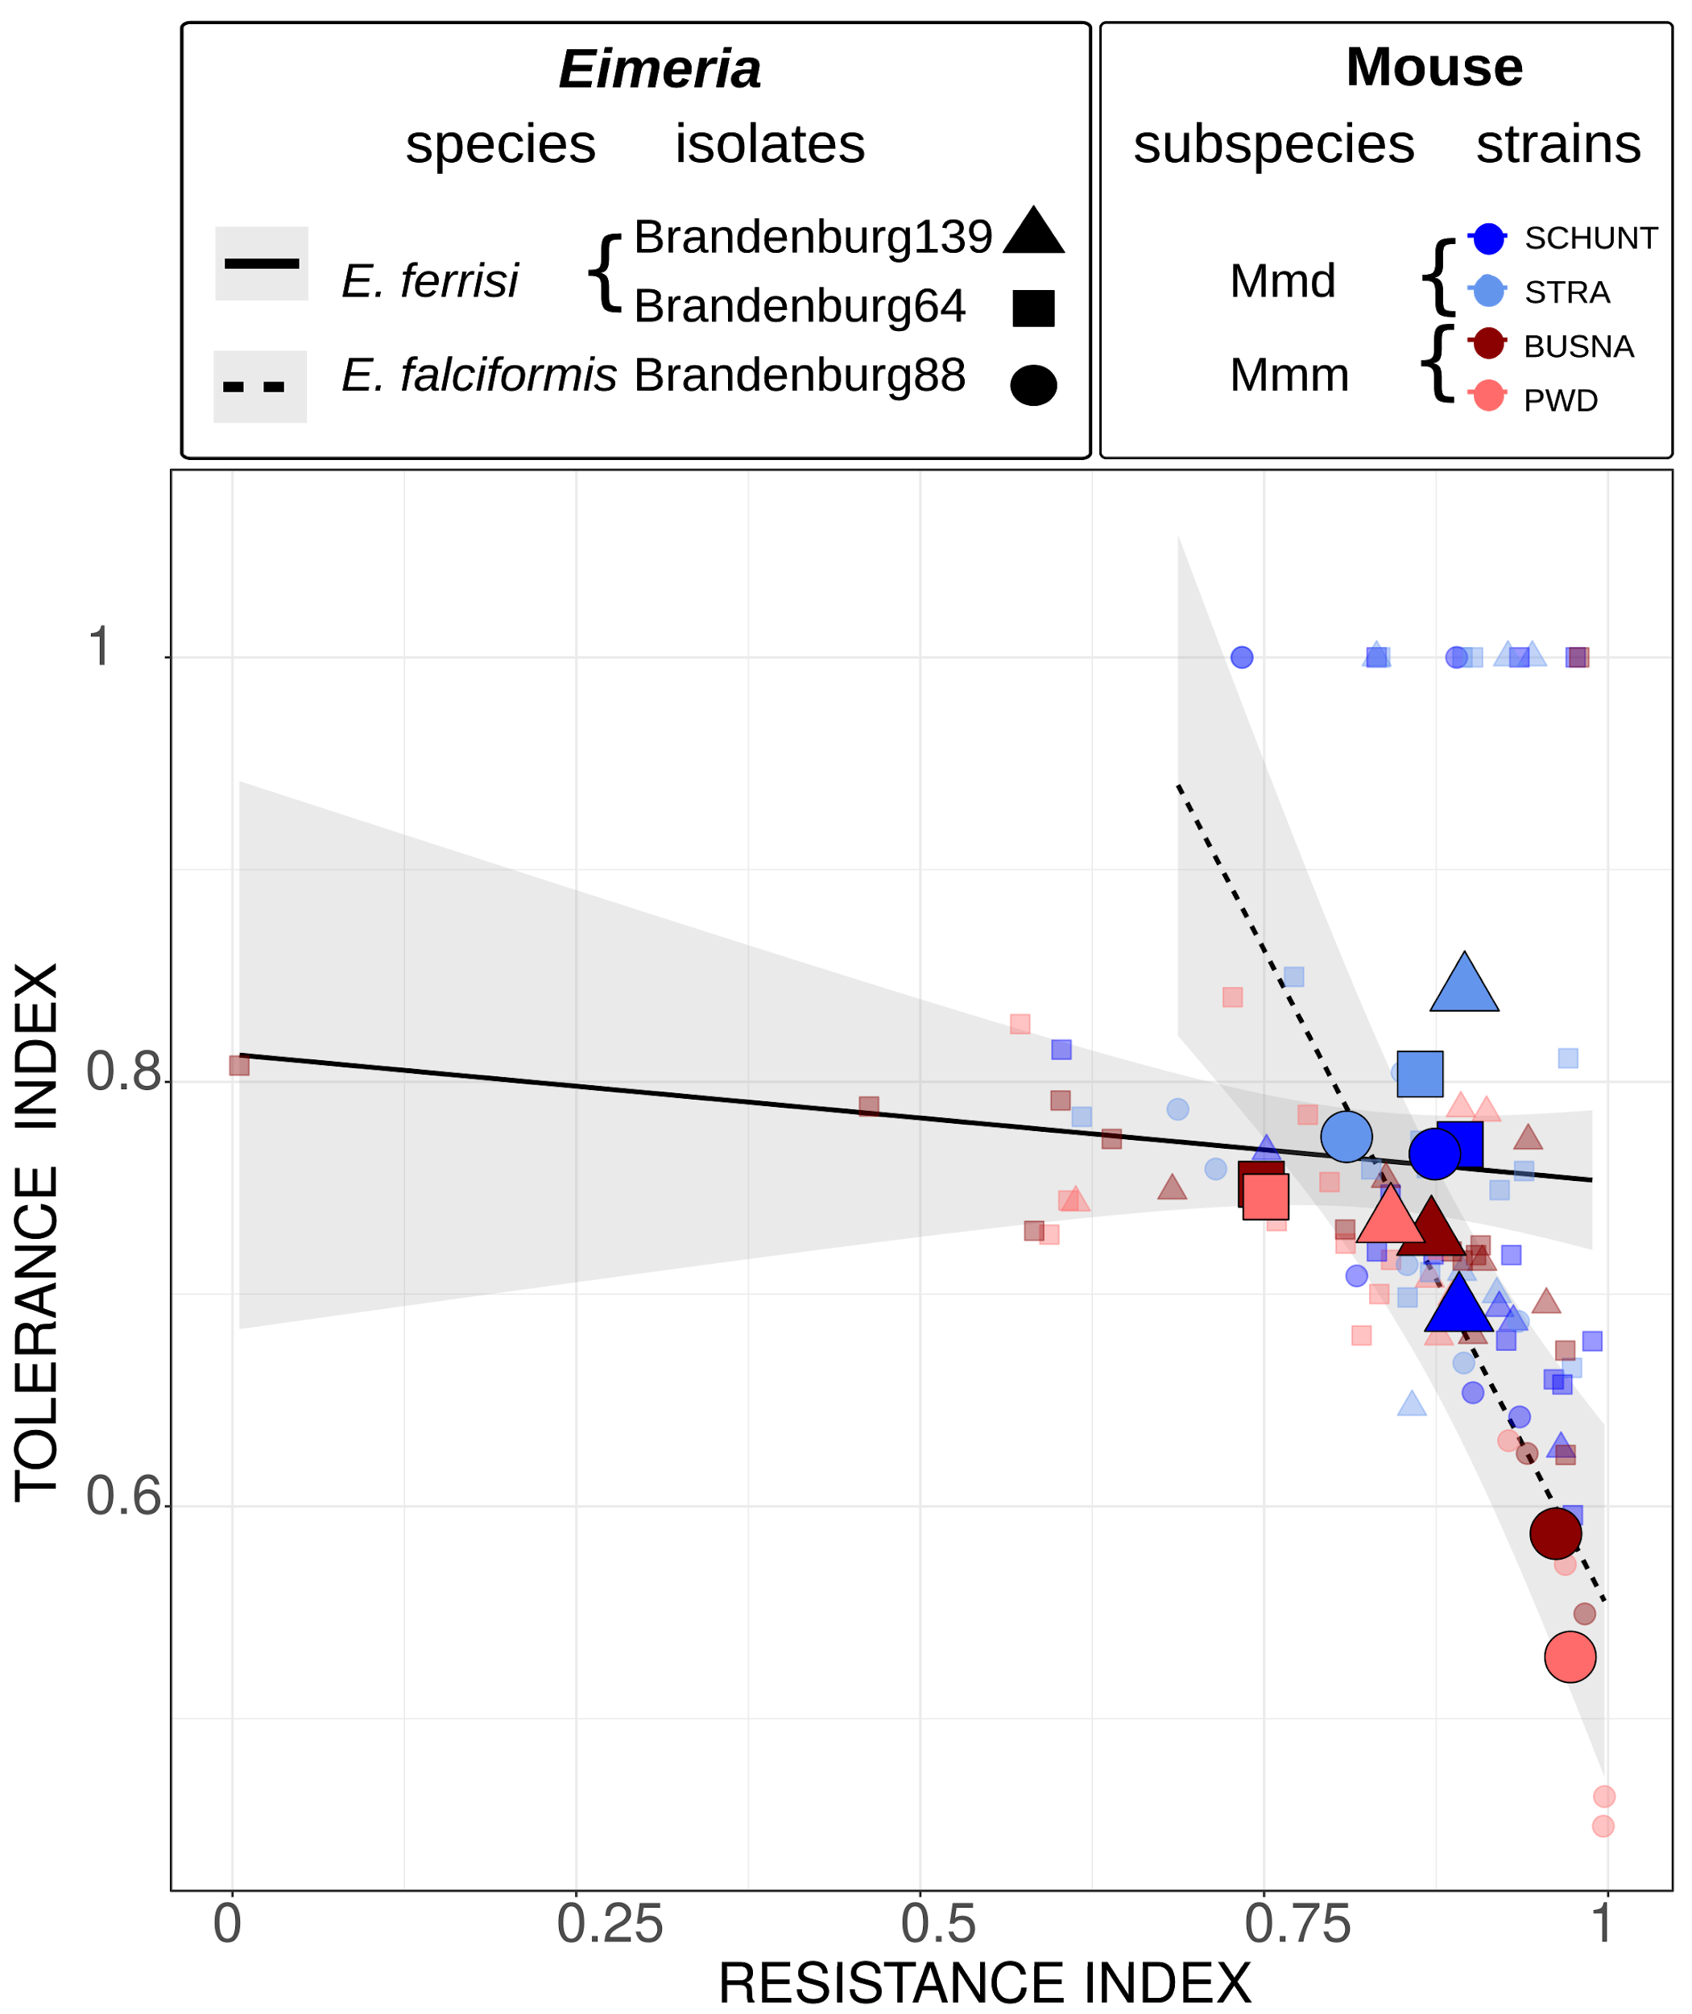
Figure 5. Comparison of trade-off between resistance and tolerance between both Eimeria species. Smaller points represent individual mice, while larger points figure the mean for a given (host strain-parasite isolate) group. Linear regression of tolerance by resistance are shown for both parasite species. Resistance Index measured as (- maximum number of oocysts per mouse gram + 300000) / 300000, Tolerance Index measured as (log10(maximum relative weight loss / maximum number of oocysts per mouse gram + 1e-8) / -8

Supplementary material

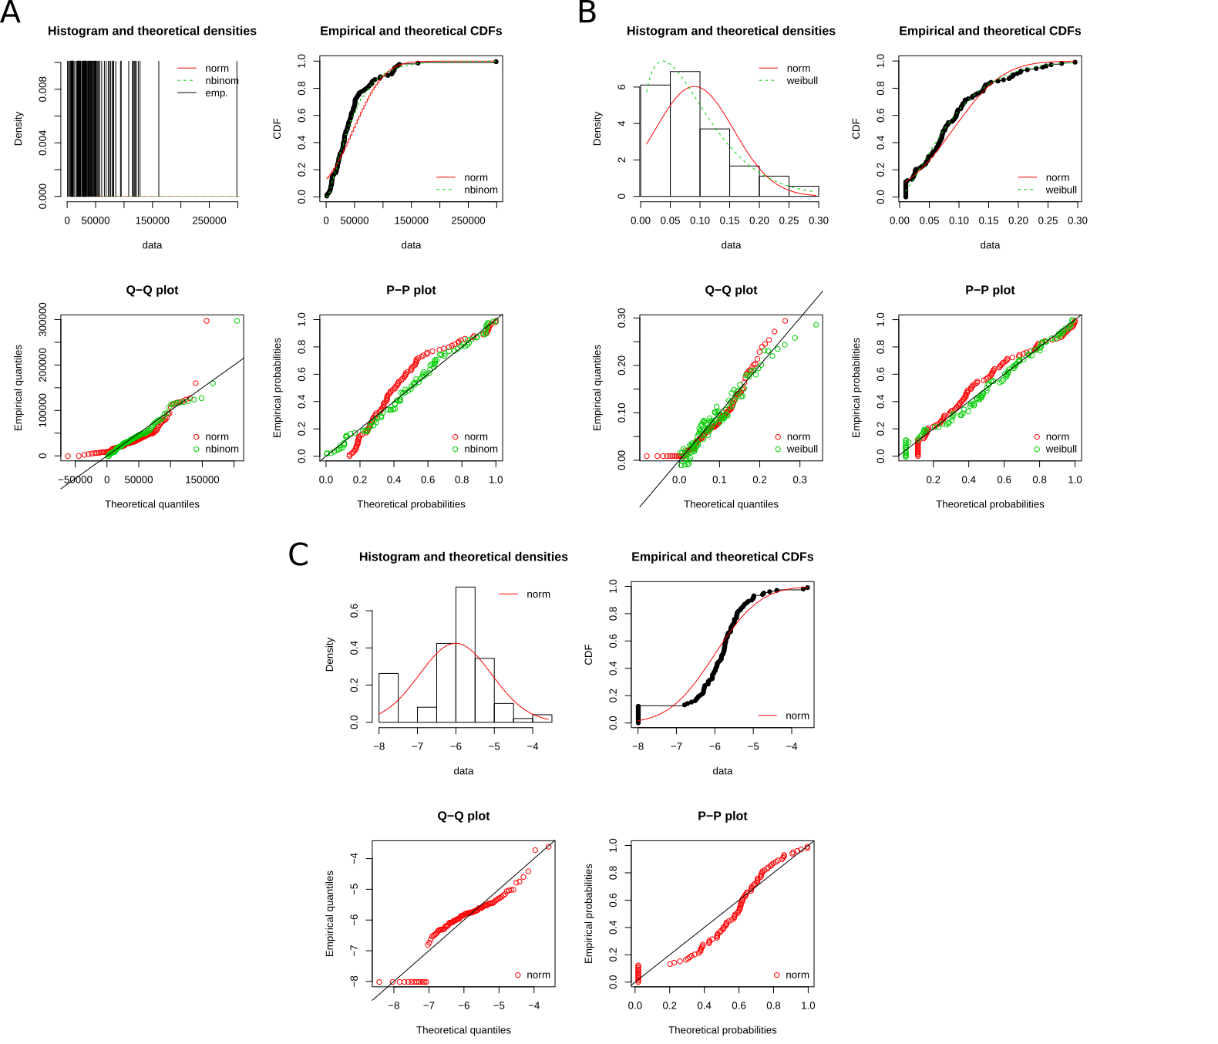
Supplementary Figure S1. Goodness-of-fits comparison (density, CDF, Q-Q, P-P plots) for resistance (A), impact on host health (B) and tolerance (C). Negative binomial distribution, Weibull distribution, and normal distribution were respectively chosen as adequate distributions for our three measures.

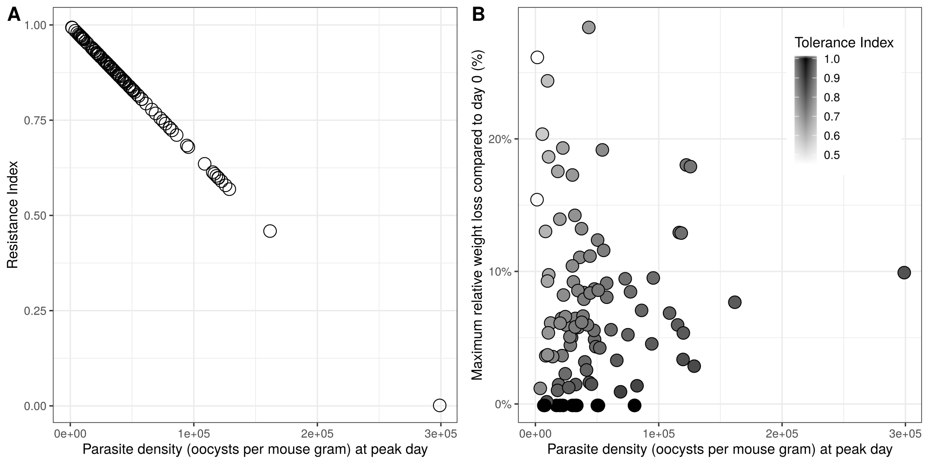
Supplementary Figure S2. Choice of measures for resistance and tolerance. (A) resistance is negatively correlated to peak parasite density; (B) tolerance index is higher when the slope of impact on health by parasite density decreases, i.e. when host is less impacted by a given load of parasite.

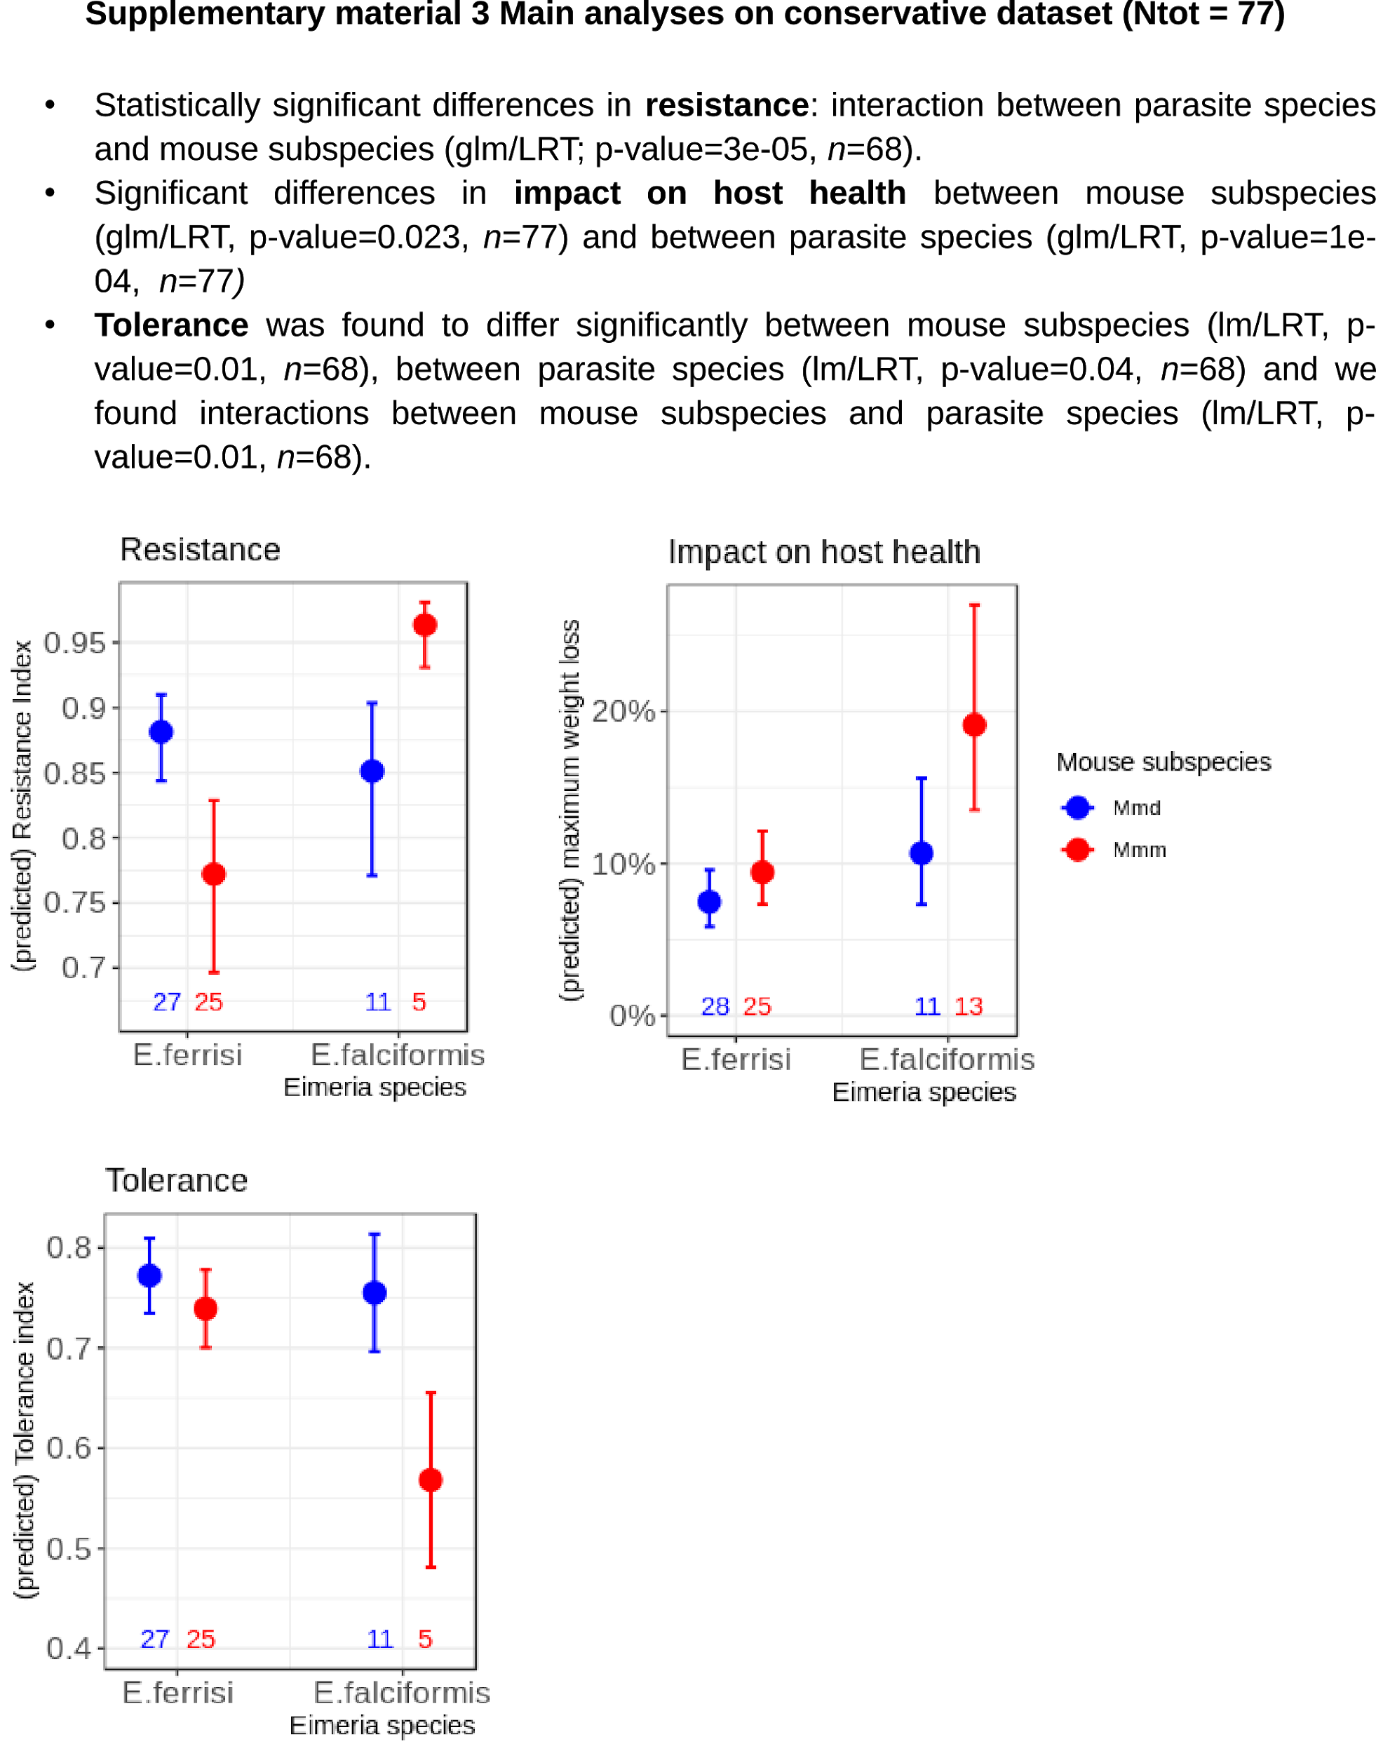

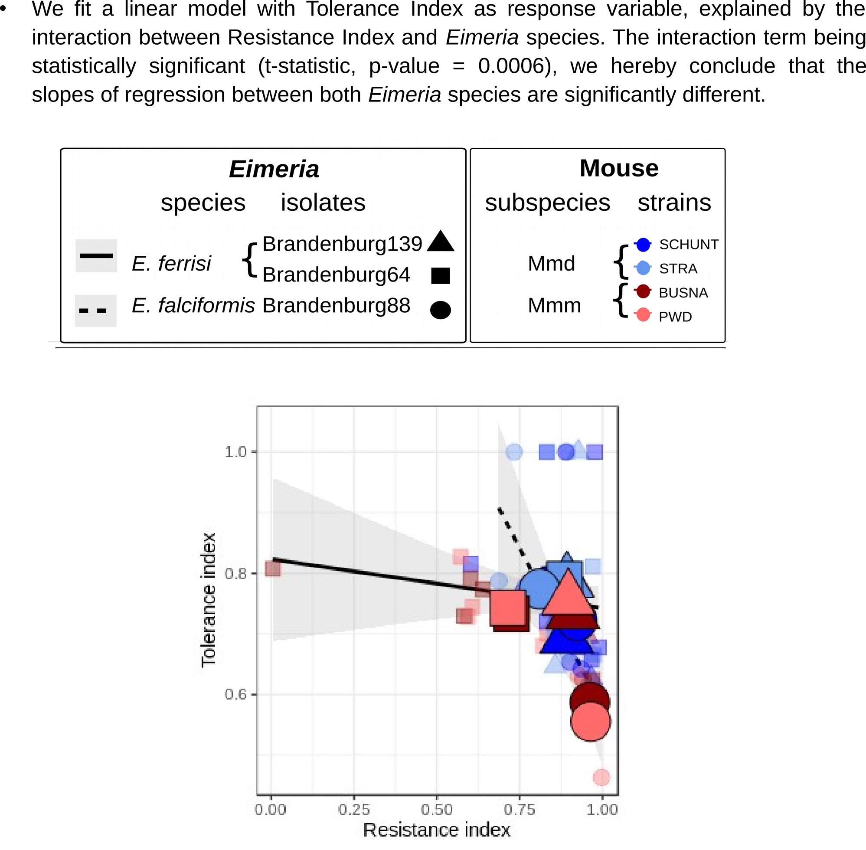

Funding
This work was funded by the German Research Foundation (DFG) Grant [HE 7320/1-1] to EH. VHJ is an associated student of GRK 2046 funded by the DFG. [XXX]

References

Al-khlifeh, E., Balard, A., Jarquín-Díaz, V. H., Weyrich, A., Wibbelt, G., & Heitlinger, E. (2019). Eimeria falciformis BayerHaberkorn1970 and novel wild derived isolates from house mice: Differences in parasite lifecycle, pathogenicity and host immune reactions. BioRxiv, 611277. http://dx.doi.org/10.1101/611277
Ankrom, S. L., Chobotar, B., & Ernst, J. V. (1975). Life cycle of Eimeria ferrisi Levine & Ivens, 1965 in the Mouse, Mus musculus. The Journal of Protozoology, 22(3), 317–323. https://doi.org/10.1111/j.1550-7408.1975.tb05177.x
Baird, S. J. E., & Goüy de Bellocq, J. (2019). Shifting paradigms for studying parasitism in hybridising hosts: Response to Theodosopoulos, Hund, and Taylor. Trends in Ecology & Evolution, 34, 387–389. https://doi.org/10.1016/j.tree.2019.01.011
Balard, A., Jarquín-Díaz, V. H., Jost, J., Martincová, I., Ďureje, Ľ., Piálek, J., … Heitlinger, E. (2019). Intensity of infection with intracellular Eimeria spp. And pinworms is reduced in hybrid mice compared to parental subspecies. BioRxiv, 683698. https://doi.org/10.1101/683698
Barton, N. H., & Hewitt, G. M. (1985). Analysis of hybrid zones. Annual Review of Ecology and Systematics, 16(1), 113–148. https://doi.org/10.1146/annurev.es.16.110185.000553
Blake, D. P., & Tomley, F. M. (2014). Securing poultry production from the ever-present Eimeria challenge. Trends in Parasitology, 30(1), 12–19. https://doi.org/10.1016/j.pt.2013.10.003
Chapman, H. D., Barta, J. R., Blake, D., Gruber, A., Jenkins, M., Smith, N. C., … Tomley, F. M. (2013). A selective review of advances in coccidiosis research. Advances in Parasitology, 83, 93–171. https://doi.org/10.1016/B978-0-12-407705-8.00002-1
Ehret, T., Spork, S., Dieterich, C., Lucius, R., & Heitlinger, E. (2017). Dual RNA-seq reveals no plastic transcriptional response of the coccidian parasite Eimeria falciformis to host immune defenses. BMC Genomics, 18(1), 686. https://doi.org/10.1186/s12864-017-4095-6
Graham, A. L., Allen, Judith. E., & Read, A. F. (2005). Evolutionary causes and consequences of immunopathology. Annual Review of Ecology, Evolution, and Systematics, 373–397. https://doi.org/10.1146/annurev.ecolsys.36.102003.152622
Gregorová, S., & Forejt, J. (2000). PWD/Ph and PWK/Ph inbred mouse strains of Mus m. Musculus subspecies—A valuable resource of phenotypic variations and genomic polymorphisms. Folia Biologica, 46(1), 31–41.
Hayward, A. D., Nussey, D. H., Wilson, A. J., Berenos, C., Pilkington, J. G., Watt, K. A., … Graham, A. L. (2014). Natural Selection on Individual Variation in Tolerance of Gastrointestinal Nematode Infection. PLOS Biology, 12(7), e1001917. https://doi.org/10.1371/journal.pbio.1001917
Hlavac, M. (2018). stargazer: Well-Formatted Regression and Summary Statistics Tables. Retrieved from https://CRAN.R-project.org/package=stargazer
Jackson, J. A., Hall, A. J., Friberg, I. M., Ralli, C., Lowe, A., Zawadzka, M., … Begon, M. (2014). An Immunological Marker of Tolerance to Infection in Wild Rodents. PLOS Biology, 12(7), e1001901. https://doi.org/10.1371/journal.pbio.1001901
Jarquín-Díaz, V. H., Balard, A., Jost, J., Kraft, J., Dikmen, M. N., Kvičerová, J., & Heitlinger, E. (2019). Detection and quantification of house mouse Eimeria at the species level – Challenges and solutions for the assessment of coccidia in wildlife. International Journal for Parasitology: Parasites and Wildlife, 10, 29–40. https://doi.org/10.1016/j.ijppaw.2019.07.004
Jeanes, C., Vaughan-Higgins, R., Green, R. E., Sainsbury, A. W., Marshall, R. N., & Blake, D. P. (2013). Two new Eimeria species parasitic in corncrakes (Crex crex) (Gruiformes: Rallidae) in the United Kingdom. The Journal of Parasitology, 99(4), 634–638. https://doi.org/10.1645/12-52.1
Knowles, S. C. L., Fenton, A., Petchey, O. L., Jones, T. R., Barber, R., & Pedersen, A. B. (2013). Stability of within-host-parasite communities in a wild mammal system. Proceedings. Biological Sciences, 280(1762), 20130598. https://doi.org/10.1098/rspb.2013.0598
Kutzer, M. A. M., & Armitage, S. A. O. (2016). Maximising fitness in the face of parasites: A review of host tolerance. Zoology, 119(4), 281–289. https://doi.org/10.1016/j.zool.2016.05.011
Macholán, M., Munclinger, P., Sugerková, M., Dufková, P., Bímová, B., Bozíková, E., … Piálek, J. (2007). Genetic analysis of autosomal and X-linked markers across a mouse hybrid zone. Evolution, 61(4), 746–771. https://doi.org/10.1111/j.1558-5646.2007.00065.x
Martincová, I., Ďureje, Ľ., Kreisinger, J., Macholán, M., & Piálek, J. (2019). Phenotypic effects of the Y chromosome are variable and structured in hybrids among house mouse recombinant lines. Ecology and Evolution, 9(10), 6124–6137. https://doi.org/10.1002/ece3.5196
Matsubayashi, M., Tsuchida, S., Kobayashi, A., Shibahara, T., Nakamura, H., Murata, K., & Ushida, K. (2018). Molecular identification of two Eimeria species, E. uekii and E. raichoi as type B, in wild Japanese rock ptarmigans, Lagopus muta japonica. International Journal for Parasitology: Parasites and Wildlife, 7(3), 243–250. https://doi.org/10.1016/j.ijppaw.2018.06.005
Medzhitov, R., Schneider, D. S., & Soares, M. P. (2012). Disease tolerance as a defense strategy. Science, 335(6071), 936–941. https://doi.org/10.1126/science.1214935
Piálek, J., Vyskocilová, M., Bímová, B., Havelková, D., Piálková, J., Dufková, P., … Forejt, J. (2008). Development of unique house mouse resources suitable for evolutionary studies of speciation. The Journal of Heredity, 99(1), 34–44. https://doi.org/10.1093/jhered/esm083
R Development Core Team. (2008). R: A language and environment for statistical computing. R Foundation for Statistical Computing, Vienna, Austria. Retrieved from http://www.R-project.org
Råberg, L. (2014). How to live with the enemy: Understanding tolerance to parasites. PLoS Biology, 12(11), e1001989. https://doi.org/10.1371/journal.pbio.1001989
Råberg, L., Graham, A. L., & Read, A. F. (2009). Decomposing health: Tolerance and resistance to parasites in animals. Philosophical Transactions of the Royal Society B: Biological Sciences, 364(1513), 37–49. https://doi.org/10.1098/rstb.2008.0184
Råberg, L., Sim, D., & Read, A. F. (2007). Disentangling genetic variation for resistance and tolerance to infectious diseases in animals. Science (New York, N.Y.), 318(5851), 812–814. https://doi.org/10.1126/science.1148526
Schito, M. L., Barta, J. R., & Chobotar, B. (1996). Comparison of four murine Eimeria species in immunocompetent and immunodeficient mice. The Journal of Parasitology, 82(2), 255–262. https://doi.org/10.2307/3284157
Schneider, D. S., & Ayres, J. S. (2008). Two ways to survive infection: What resistance and tolerance can teach us about treating infectious diseases. Nature Reviews. Immunology, 8(11), 889–895. https://doi.org/10.1038/nri2432
Simms, E. L., & Triplett, J. (1994). Costs and benefits of plant response to disease: Resistance and tolerance. Evolution, 48(6), 1973–1985. https://doi.org/10.1111/j.1558-5646.1994.tb02227.x
Wickham, H. (2016). ggplot2: Elegant Graphics for Data Analysis. Springer-Verlag, New York.

