The resistance/tolerance trade-off against only one of two related parasites in mice

Alice Balard^{1,2}, Víctor Hugo Jarquín-Díaz^{1,2}, Jenny Jost¹, Vivian Mittné¹, Francisca Böhning¹, Ľudovít Ďureje³, Jaroslav Piálek³, Emanuel Heitlinger^{1,2}
¹ Institute for Biology. Department of Molecular Parasitology. Humboldt University Berlin (HU). Philippstr. 13, Haus 14, 10115, Berlin, Germany
² Leibniz-Institut für Zoo- und Wildtierforschung (IZW) im Forschungsverbund Berlin e.V.. Alfred-Kowalke-Straße 17, 10315, Berlin, Germany
³ Research Facility Studenec, Institute of Vertebrate Biology, Czech Academy of Sciences, Květná 8, 603 65 Brno, Czech Republic

Abstract
Resistance (the host’s capacity to reduce parasite burden) and tolerance (the host’s capacity to reduce impact on host health of a given parasite burden) manifest two different lines of immune defenses. Trade-offs arise, as resistance limits infection load and thereby the scope of possible tolerance, and both resistance and tolerance can be costly in terms of resource allocation. Additionally, resistance is assumed to be limited by immunopathogenicity, tolerance by carrying capacity of the host or energy drained by the parasite.
Here, we used two closely related parasite species of genus Eimeria and measured resistance and tolerance of four wild-derived strains of inbred mice from two subspecies during controlled infection. One parasite species, E. falciformis, has a longer life cycle and higher pathogenicity than the other, E. ferrisi. We found a stronger trade-off between resistance and tolerance against the former parasite than against the latter. Resistance and tolerance against E. ferrisi seemed uncorrelated.
E. falciformis shows a lower prevalence than E. ferrisi in the field. Not only mechanisms behind resistance and tolerance, but also virulence realized in the evolution of different closely related parasites can be studied in this system.

Introduction
Host defense mechanisms evolve in response to feedback between hosts and parasites (Little, Shuker, Colegrave, Day, & Graham, 2010). There mechanisms consist of two components. Resistance (the ability of a host to reduce its parasite burden) results from defense against parasite infection or proliferation early after infection (Råberg, Graham, & Read, 2009). It can be energetically costly and therefore limited by resource allocation: cost can be measured as a decrease of other fitness components (e.g. delayed maturity, lower fecundity) in the absence of infection (Langand, Jourdane, Coustau, Delay, & Morand, 1998; Sheldon & Verhulst, 1996; Vijendravarma, Kraaijeveld, & Godfray, 2009). Additionally, too strong immune response to pathogens can lead to a negative impact on health or immunopathology (Graham, Allen, & Read, 2005).
Tolerance balances damage caused by parasites themselves and immunopathology (Medzhitov, Schneider, & Soares, 2012) through control mechanisms like stress response, damage repair and cellular regeneration (Soares, Teixeira, & Moita, 2017). This is why, just like resistance, tolerance can involve energetic costs (Simms & Triplett, 1994). While resistance decreases parasite fitness and prevalence in natural populations, tolerance generally has no impact on parasite fitness and either increases or does not affect prevalence (Miller, White, & Boots, 2005; Roy & Kirchner, 2000). For all those reasons, host defenses (tolerance, resistance, and their immunological mechanisms), parasite virulence (capacity to reduce host fitness in terms of health or fecundity), and their interactions should be assessed jointly (Little et al., 2010; Restif & Koella, 2003).
Coccidia of the genus Eimeria are excellent models for investigating the interplay of host defense and parasite virulence. Eimeria ferrisi has been found to be the most prevalent (17%) species of this genus in a recently investigated area of secondary contact between the house mouse subspecies in Brandenburg, Germany, followed by E. falciformis (4%) (Jarquín-Díaz, Balard, Jost, et al., 2019). The two mouse subspecies, Mus musculus musculus and M. m. domesticus (hereafter Mmm and Mmd, respectively), hybridizing in this area, show the same resistance to E. ferrisi in the field (Balard et al., 2019). Eimeria spp. are monoxenous parasites that expand asexually and reproduce sexually in intestinal epithelial cells, leading to malabsorption of nutrients, tissue damage and weight loss (Chapman et al., 2013). They are generally considered to be host specific, and different species infect a wide range of animals including birds, mammals, reptiles, amphibians, and fish (Chapman et al., 2013; Jarquín-Díaz, Balard, Mácová, et al., 2019). Eimeria ferrisi and E. falciformis live in the cecum villar epithelial cells and cecum crypt cells, respectively (Schito, Barta, & Chobotar, 1996). Pre-patency (the time to shedding of infectious stages, so called oocysts) is longer for E. falciformis (7 days) than for E. ferrisi (5 days) (Al-khlifeh et al., 2019). While both species provoke inflammation, cellular infiltration, enteric lesions, diarrhea, and ultimately weight loss (Ankrom, Chobotar, & Ernst, 1975; Ehret, Spork, Dieterich, Lucius, & Heitlinger, 2017; Schito et al., 1996), the symptoms are stronger for E. falciformis than for E. ferrisi infections (Al-khlifeh et al., 2019).
Given different pathogenicity and prevalence between the two Eimeria species we assumed different outcomes of host-parasite interplay. Resistance/tolerance can be strongly dependent of the history of the host-parasite interaction. Host with coevoving parasite might tend to be less impacted, while hosts that encounter unknown parasite might suffer higher pathogenicity. Both parasites species were found on both sides of the hybrid zone (Jarquín-Díaz, Balard, Jost, et al., 2019); Nevertheless this does not exclude the possibility of recent passage through this permeable barrier of one parasite species from its original host to the other, less optimal. Here we experimentally tested whether Mmm and Mmd differ in virulence, resistance, and tolerance to controlled infections of E. falciformis and E. ferrisi. For this purpose we employed four wild-derived inbred strains representing the two mouse taxa, to assess the parameters both at the level of host subspecies and strains. We tested for both parasite species the hypotheses of long-term host-parasite history (1) in both Mus musculus subspecies or (2) in each subspecies separately, and of (3) a more recent spillover from one subspecies to the other. In the first case, we predict a similar resistance and tolerance of both host subspecies; In the second case we could expect different defense strategies to have emerged in each host subspecies; Eventually, in the case of recent spillover, we expect also evidence of suboptimal adaptation in one of the two subspecies, e.g. with a higher mortality than in the other host.

Material and methods

Parasite strains
The three parasite isolates used in this study were isolated from feces of mice captured in Brandenburg, Germany, in 2016 (capture permit No. 2347/35/2014). They belong to both the most prevalent Eimeria species in the wild (Jarquín-Díaz, Balard, Mácová, et al., 2019), namely E. ferrisi (isolates Brandenburg64 and Brandenburg139) and E. falciformis (isolate Brandenburg88). Hybrid index (HI) of each individual wild-caught mouse was calculated to account for the admixture of mouse genomes across the HMHZ as a proportion of Mmm alleles in a set of 14 diagnostic markers (Balard et al., 2019). Isolate Brandenburg64 was isolated in a 92% Mmd individual (HI = 0.08), isolate Brandenburg139 in a 85% Mmm (HI = 0.85) and isolate Brandenburg88 in a 80% Mmd (HI = 0.2). Pre-patency and the peak day of oocyst shedding for these isolates were estimated during infection in NMRI laboratory mice (Al-khlifeh et al., 2019) which were also used for serial passaging of all the isolates. Parasite infective forms (oocysts) were recovered by flotation in saturated NaCl solution followed by washing and observation under light microscope following the protocole described in Clerc, Fenton, Babayan, & Pedersen (2019) and stored at room temperature in 1mL of 2% potassium dichromate for a maximum of 2 months before infection of the wild-derived mouse strains. Oocysts were allowed to sporulate 10 days before infection in a water bath at 30°C.

Mouse strains
We used four wild-derived fully-inbred mouse strains: two Mmd strains SCHUNT (Locality: Schweben 2, Hessen, Germany [N: 50° 26’, E: 9° 36’] (Martincová, Ďureje, Kreisinger, Macholán, & Piálek, 2019)) and STRA (Locality: Straas, Bavaria, Germany [N: 50° 11’, E: 11° 46’] (Piálek et al., 2008), and two Mmm strains BUSNA (Locality: Buškovice, Bohemia, Czech Republic [N: 50° 14’, E: 13° 22’] (Piálek et al., 2008)) and PWD (Locality: Kunratice, Bohemia, Czech Republic [N: 50° 01’, E: 14° 29’] (Gregorová & Forejt, 2000))(Figure 1). Age of the mice at the time of infection ranged between 7.5 and 21.5 weeks. All mouse strains were maintained before infection in the Institute of Vertebrate Biology in Studenec (licence number 61974/2017‐MZE‐17214; for further details on strains see https://housemice.cz/en).
Parasites of the Eimeria genus are known to induce host immune protection against reinfection (Rose, Hesketh, & Wakelin, 1992; Smith & Hayday, 2000). To ensure that our mice were Eimeria-naive, mice fecal samples were tested before infection for the presence of Eimeria spp. oocysts, by flotation in saturated NaCl solution followed by washing and observation under light microscope. All individuals were negative for Eimeria at the beginning of our experiment.

Experimental infection
Mice were kept in individual cages during infection. Water and food (SNIFF, Rat/Mouse maintenance feed 10 mm) were provided ad libitum supplemented with 1 g of sunflower and barley seeds per day. Mice were orally infected with 150 sporulated oocysts of one Eimeria isolate suspended in 100 µl phosphate-buffer saline (PBS) and monitored daily until their sacrifice by cervical dislocation at 11 days after infection (dpi) (experiment license Reg. 0431/17). Individuals presenting severe health deficiency and/or a weight loss approaching 18% relative to their starting weight were sacrificed earlier. Weight was recorded and feces collected on a daily basis. Fecal pellets were collected every day from each individual cage and suspended in 2% potassium dichromate. Parasite oocysts were recovered using NaCl flotation (see above). In total, 108 mice were infected. Mice were randomly allocated to experimental groups ensuring homogeneous distribution of ages and sexes between groups. Our experiments were conducted in four consecutive batches for easy handling. The first two groups were infected by the two E. ferrisi isolates (Brandenburg64 and Brandenburg139), the two second by one E. ferrisi isolate (Brandenburg64) and one E. falciformis isolate (Brandenburg88). Summarized experiment design is shown in Table 1.
We observed Eimeria oocysts in the feces of 9 mice belonging to the last experimental batch at the day of infection, likely due to cross-contamination between batches. Moreover, before arrival to the infection facility, nematode eggs were observed in flotated feces of mice belonging to all genotypes. Nematode infection is common in breeding facilities (Baker, 1998). Despite treatment of the first infection batch of mice (22 mice) with anthelminthics (Profender®, Bayer AG, Levekusen, Germany) following the protocole of Mehlhorn et al. (2005), nematodes were still detected with PCR (following the protocole of Floyd, Rogers, Lambshead, & Smith, 2005) in randomly sampled fecal samples a week later. We therefore decided not to treat mice of the following infection batches. For following statistical tests, we considered the full dataset and a conservative dataset in which cross-contaminated animals and animals treated by anthelminthic are removed (see below).

Choice of measurements for resistance and tolerance
Resistance is the capacity of a host to reduce its parasite burden, therefore it is usually estimated by the inverse of infection intensity (Råberg et al., 2009). As a proxy we used the number of parasites per host, calculated as the number of oocysts in feces at the day of maximal shedding, divided by the mouse weight at this day (in grams). This measurement allowed us to take into account the host’s body size, assuming a lower capacity to carry parasites in smaller mice: a higher number of oocysts per mouse weight corresponds to lower resistance. At the day of peak intensity, this measure was tightly correlated with the sum of oocysts shed throughout the experiment (Pearson correlation coefficient 0.92). For further statistical analyses we modelled the raw value of “maximum number of oocysts per mouse gram”; For plotting and comparison with tolerance index, we used a resistance index ranging between 0 and 1 (see Supplementary Figure S2.A). As the highest individual value was 298496 maximum number of oocysts per mouse gram, this index was obtained as follows:
Resistance index = (- maximum number of oocysts per mouse gram + 300000) / 300000
Tolerance is usually defined as the slope of the regression of host fitness, approximated by health condition, on infection intensity (Råberg, 2014). The major measurable symptom in murine Eimeria infections is weight loss. Therefore, the impact of parasites on host health was measured as the maximum relative weight loss compared to day 0 (body weight taken at the start of the experimental infection).
We defined a tolerance index for each individual, describing how its health varied with infection intensity, between day 0 of infection (weight = 100%, parasite intensity = 0 oocyst per mouse gram) and highest impact (weight = maximum weight loss relative to day 0, parasite intensity = maximum parasite number per mouse gram). This index was then normalized by log10 transformation, after addition of 1e-8 to the ratio ”maximum relative weight loss / maximum number of oocysts per mouse gram“ to avoid infinite values. The obtained log10 transformed ratio that ranged between -8 (high tolerant) and -3.6 (low tolerant) was divided by the negative constant -8 to obtained a final index positively correlated with tolerance, and ranging between 0 and 1 (see Supplementary Figure S2.A):
Tolerance index = (log10(maximum relative weight loss / maximum number of oocysts per mouse gram + 1e-8) / -8

Statistical analyses
Appropriate distribution for maximum number of oocysts per mouse gram, maximum weight loss relative to day 0, and T-index were selected based on log likelihood and AIC criteria and by comparing goodness-of-fits plots (density, CDF, Q-Q, P-P plots) between usual distributions (R packages MASS (Venables & Ripley, 2002) and fitdistrplus (Delignette-Muller & Dutang, 2015)). The negative binomial, Weibull, and normal distribution were the most adequate to describe the peak of oocysts per mouse gram, impact on host health, and tolerance index, respectively (see Supplementary Figure S3). For modelling the impact on host health, we added 0.01 to the raw value as the Weibull distribution regression requires positive values.
We tested the effects of mouse subspecies (Mmd or Mmm), Eimeria species (E. ferrisi or E. falciformis) and their interaction on our three response variables using (generalized) linear models. To assess the stability of our results across mouse strains and Eimeria isolates, we also tested the effects of mouse strain (N=4), parasite isolate (N=3) and their interaction separately using the same models. To test the significance of the marginal contribution to each parameter to the full model, each parameter (mouse subspecies, Eimeria species, and their interaction in the first case; mouse strain, Eimeria isolate, and their interaction in the second case) was removed from the full model, and the difference between full model and sub-model was assessed using likelihood ratio tests (G). Post-hoc multiple comparison tests (Tukey Multiple Comparisons of Means) were then performed to test the significant difference of each host-parasite combination against all others in the full model.
We then compared the trade-off between resistance and tolerance between mouse subspecies. Using the resistance index and tolerance index defined above, we fitted a linear model to explain the variation of tolerance with resistance, Eimeria species and their interaction.
To verify the absence of impact of both previous contamination by Eimeria and anthelminthic treatment on our results, we performed the different analyses (modeling of resistance, impact on health, tolerance, as well as linear regression of the tolerance index with the resistance index, see below) on a dataset excluding the 22 mice treated by anthelminthics and the 9 mice showing contaminant infections. The results obtained in this conservative dataset are congruent with the results revealed in all mice, thus we consider the influence of both factors negligible (see Supplementary Material S3).
All analyses were performed using the R software version 3.5.2 (R Development Core Team, 2018). Graphics were produced using the R package ggplot2 (Wickham, 2016) and compiled using the free software inkscape (https://inkscape.org).
All codes and data used for this article can be found at: https://github.com/alicebalard/Article_RelatedParasitesResTol

Results

General parasitology
The life cycle of all isolates was successfully completed in all mouse strains (Figure 2). For E. ferrisi (both isolates), the pre-patent period was 5 dpi and the median day of maximal oocyst shedding was 6 dpi (standard deviation sd=0.71 and 0.65, respectively). The median day of maximum weight loss was 5 dpi for both isolates (sd=2.2 and 1.9 respectively). For E. falciformis (isolate Brandenburg88) pre-patency was 7 dpi, median day of maximal shedding was 8 dpi (sd=1.2) and median day of maximal weight loss 9 dpi (sd=1.5). All tested Eimeria isolates infected all individuals of the tested mouse strains.
A considerable number of Mmm mice (8/14; 5 of BUSNA and 3 of PWD) infected with E. falciformis (isolate Brandenburg88) died (or had to be sacrificed at humane end points specified in animal experimental procedures) before the peak of oocyst shedding. Moreover, one Mmd mouse (strain SCHUNT) infected by E. ferrisi isolate Brandenburg139 had liquid diarrhea in the peak shedding day, making its feces not collectable. These mice were assessed as missing data for both resistance and following tolerance measurements.

M. m. musculus is more resistant to E. falciformis than to E. ferrisi
To establish differences between the two house mouse subspecies and between the parasite species, we analysed the maximum number of oocysts per mouse gram as a measure of resistance after infection with both Eimeria species on the 99 mice alive by the time of median peak shedding. We found statistically significant effects of parasite species (LRT: G = 22.8, df = 2, P < 0.001), mouse subspecies (LRT: G = 26.7, df = 2, P < 0.001) as well as an interaction between parasite species and mouse subspecies (LRT: G = 22.4, df = 2, P < 0.001). Post-hoc multiple comparison tests showed than the subspecies Mmm shed less oocysts per mouse gram at the peak of shedding when infected with E. falciformis than with E. ferrisi. Moreover, the Mmm subspecies shed less oocysts per mouse gram at the peak of shedding than the Mmd subspecies when infected E. falciformis, and more than the Mmd subspecies when infected with E. ferrisi (Table 2; Figure 3A).
We then tested the influence of mouse strain and parasite isolate on maximum number of oocysts per mouse gram. We found statistically significant effects of parasite isolate (LRT: G = 28.8, df =8, P < 0.001), mouse strain (LRT: G = 30.3, df = 9, P < 0.001) as well as an interaction between parasite isolate and mouse strain (LRT: G = 25.3, df = 6, P < 0.001). Post-hoc multiple comparison tests showed that PWD (Mmm strain) shed less oocysts per mouse gram at the peak of shedding when infected with Brandenburg88 (E. falciformis isolate) than with the two E. ferrisi isolates, Brandenburg64 and Brandenburg139. Mice belonging to the second Mmm strain, BUSNA, shed less oocysts per mouse gram at the peak of shedding when infected with Brandenburg88 than with Brandenburg64. Overall, we found no significant difference between the strains of the same subspecies within a given parasite species infection, nor between the isolates of the same species within a given mouse strain (Supplementary Table SX; Figure 4A).

Health of M. m. musculus is more impacted by E. falciformis than by E. ferrisi
Analysing the weight loss upon infection as a proxy for impact on host health of the full dataset (N = 108), we found statistically significant differences both between the mouse subspecies (LRT: G = 10, df = 2, P < 0.01) and between the parasite species (LRT: G = 18.6, df = 2, P < 0.001). Post-hoc multiple comparison tests showed that Mmd lost less weight than Mmm when infected by E. falciformis (9.3% vs 18.7%), and Mmm lost more weight when infected by E. falciformis than by E. ferrisi (Table 3, Figure 3B).
Then we modelled maximum weight loss separating Eimeria by isolates (instead of species) and mice by strains (instead of subspecies). We found differences between parasite isolates (LRT: G = 30.7, df = 8, P < 0.001) and mouse strains (LRT: G = 23, df = 9, P < 0.01). Notably, PWD (Mmm) mice infected with Brandenburg64 (E. ferrisi) lost significantly more weight than STRA mice (Mmd) infected with the same isolate , following the pattern described at the mouse subspecies-parasite species level (Mmd losing less weight than Mmm when infected by E. ferrisi). Overall, we did not find any significant difference between mouse strains of the same subspecies within a given parasite species infection or between parasite isolates of the same species within a given mouse strain (Supplementary Table SX; Figure 4B).

M. m. musculus is less tolerant to E. falciformis than to E. ferrisi
Combining resistance and the impact on health, we assessed tolerance of the mouse subspecies to both Eimeria species on the 99 mice for which this index could be calculated. Our proxy for tolerance, T-index, was found to differ significantly between the mouse subspecies (LRT: G = 19.4, df = 2, P < 0.001), between the two parasite species (LRT: G = 16.8, df = 2, P < 0.001). Significant were also interactions between mouse subspecies and parasite species (LRT: G = 10.1, df = 1, P < 0.01). Post-hoc multiple comparison tests showed that tolerance index upon infection with E. falciformis with higher for Mmd than for Mmm. Within Mmm subspecies, animals had a lower tolerance index to E. falciformis than to E. ferrisi (Table 4; Figure 3C).
Testing at the level of Eimeria isolates and mouse strains, we found between-parasite isolates differences (LRT: G = 21.7, df = 8, P < 0.01), between-mouse strains differences (LRT: G = 27.3, df = 9, P < 0.01), and interaction between the two factors (LRT: G = 14.2, df = 6, P = 0.027). Post-hoc multiple comparison tests showed statistically significant differences between PWD infected with Brandenburg88 against both Mmd strains infected with the same parasite isolate (Tukey Multiple Comparisons of Means, STRA: z = -3.68, P = 0.02; SCHUNT: z = -3.45, P = 0.04), and against animals of the same strain infected with Brandenburg64 (Tukey Multiple Comparisons of Means: z = -3.56, P = 0.03). Overall, we did not find any significant difference in tolerance between mouse strains of the same subspecies within a given parasite species infection, or between parasite isolates of the same species within a given mouse strain (Supplementary Table SX; Figure 4C). These results indicate that the lower tolerance of Mmm to E. falciformis compared to Mmd is consistent at the strain level.

Comparison of the resistance/tolerance trade-off between Eimeria species
To test for a trade-off between resistance and tolerance of the mouse strains to each of the parasite species, we fitted a linear model of tolerance index by resistance index allowing for differences in intercept and slope for Eimeria species. We found that tolerance index was negatively correlated with resistance index (LRT: G = 24.1, df = 2, p < 0.001), was different for both Eimeria species (LRT: G = 23.3, df = 2, p < 0.001), and, notably, interaction between these two factors were significant (LRT: G = 19.8, df = 1, p < 0.001). Every increase of 1 unit of Resistance Index corresponds to a decrease of 0.06 unit of tolerance for E. ferrisi (95%CI: [-0.21 , 0.09]) and to a decrease of 1.2 unit of tolerance for E. falciformis (95%CI: [-1.73 , -0.75]). As the confidence interval for E. ferrisi involves 0, tolerance and resistance indexes are not correlated for this parasite species, meaning that there is no trade-off between resistance and tolerance in the mouse strains/ subspecies under study. By contrast, we observe a strong trade-off for E. falciformis (Figure 5). The Mmd strains are more tolerant and less resistant to this species than both Mmm strains.

Discussion
In this study, we used a controlled infection experiment to test whether two closely related parasites differ in their impact on their hosts – house mice. For this purpose, we assessed resistance and tolerance to E. ferrisi and E. falciformis and the effect their presence can have on health in four different wild-derived strains representing two mouse subspecies hybridizing in Europe. While the Western mouse (M. m. domesticus, Mmd) did not show strong differences between the parasite species, the Eastern mouse (M. m. musculus, Mmm), was was found to be more resistant but less tolerant to E. falciformis than to E. ferrisi. This also suggests that the response of this taxon to E. falciformis is confined by a trade-off between resistance and tolerance, while its resistance against E. ferrisi is independent of tolerance.
Resistance and tolerance to parasites are highly relevant to the house mouse hybrid zone. This a so-called tension zone, i.e. the zone maintained by a balance between dispersal and endogenous selection against hybrids (Barton and Hewitt 1985; Payseur et al., 2004; Raufaste et al., 2005; Macholán et al., 2007). It has been shown that hybrid mice are more resistant not only to pinworms but also to other parasites including Eimeria, whereas no impact on tolerance could be measured under natural conditions (Baird et al., 2012; Balard et al., 2019). The effect of parasites on hosts’ fitness in particular and the role they can play in the evolution of species barriers is thus still rather ambiguous. In this context, measuring both resistance and tolerance to pathogens is therefore indispensable (Baird & Goüy de Bellocq, 2019; Kutzer & Armitage, 2016).
E. ferrisi commits to sexual reproduction after a relatively short time with few cycles of asexual expansion (Al-khlifeh et al., 2019; Ankrom et al., 1975). As E. ferrisi infections do not reach extremely high intensities with this infection strategy, high tolerance might be the optimal strategy for both house mouse subspecies. Resistance could then evolve relatively freely without any major impact of the parasite on the hosts’ health. Enhanced virulence (reduction of host fitness upon infection e.g. due to prolonged asexual replication before commitment to sexual replication and transmission) might not evolve because the low resistance of the host already allows an optimal transmission rate, especially considering the fast production of transmission stages (Anderson & May, 1982).
E. falciformis has a relatively long life cycle (Al-khlifeh et al., 2019; Haberkorn, 1970). This means that parasites multiply asexually for a relative long time leading to potentially higher tissue loads and – once it starts to reproduce sexually – extremely high reproductive output in extremely impacted hosts. Therefore, tolerance of this parasite might, on the one hand, lead to prohibitively high intensities if the parasite is allowed to expand asexually and damage the tissue (Ehret et al., 2017) without enough resistance. On the other hand, immunopathology has been observed in advanced E. falciformis infections. For example, proinflammatory T cell mediators have been shown to decrease parasite load but increase body weight loss upon infection (Stange et al., 2012). This might lead to multiple different optima for resistance and tolerance (Råberg et al., 2007). In this context, two alternative response strategies against E. falciformis might have evolved and stabilised in the house mouse subspecies: while Mmm rather resists E. falciformis, Mmd tends to tolerate it.
Whether these states are more or less stable optima and how establishment of the different states in the different mouse subspecies was achieved can be speculated. The similar resistance and tolerance in Mmd and Mmm for E. ferrisi, and even more so for both tested isolates independantly of their original host genetic background, indicates long-term host-parasite history in both Mus musculus subspecies. On the other hand, the two alternative resistance/tolerance strategies in each Mus musculus subspecies for E. falciformis indicates that this parasite species could be a Mmd parasite that dissipates into Mmm territory and is not optimally virulent. The isolates used in the present work was collected from the feces of a 80% Mmd host, it is then possible that a parasite isolated in a mostly Mmm host would present the opposite strategy in each host subspecies.
The contrast between two different Eimeria spp. invites future research on the relationship between infection intensity, parasite reproductive output, host health and immune response. This might allow us to better understand both the process and mechanisms of the evolution of tolerance and resistance.

Tables
Mouse |  | Eimeria species / isolate
strains | subspecies | E. ferrisi  Brandenburg139 | E. ferrisi  Brandenburg64 | E. falciformis  Brandenburg88
SCHUNT | M.m.domesticus | 7 (5M / 2F) | 14 (6M / 8F) | 6 (3M / 3F)
STRA | M.m.domesticus | 6 (2M / 4F) | 15 (8M / 7F) | 7 (4M /3F)
BUSNA | M.m.musculus | 6 (2M / 4F) | 14 (8M / 6F) | 7 (3M /4F)
PWD | M.m.musculus | 6 (3M / 3F) | 13 (10M / 3F) | 7 (1M / 6F)

Table 1. Infection experiment design.

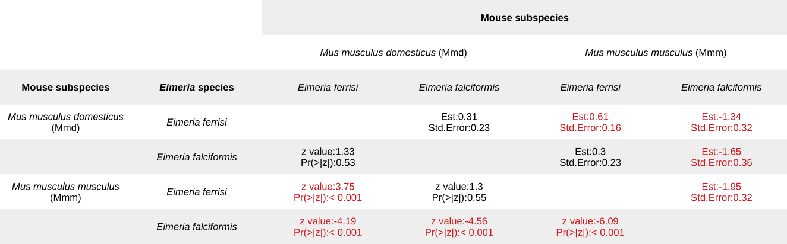
Table 2. Post-hoc statistical test for maximum oocyts shed (Tukey Multiple Comparisons of Means). See Figure 4A.
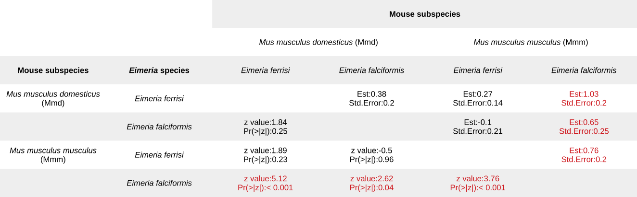

Table 3. Post-hoc statistical test for maximum weight loss (Tukey Multiple Comparisons of Means). See Figure 4B.

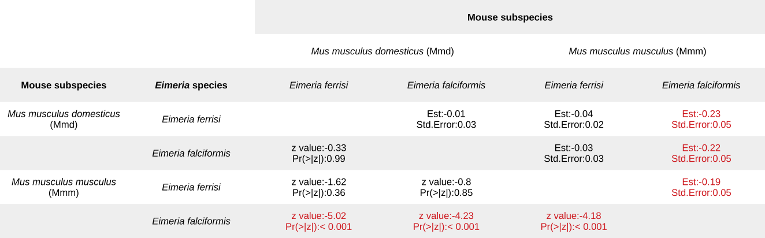
Table 4. Post-hoc statistical test for tolerance index (Tukey Multiple Comparisons of Means). See Figure 4C.

Figures
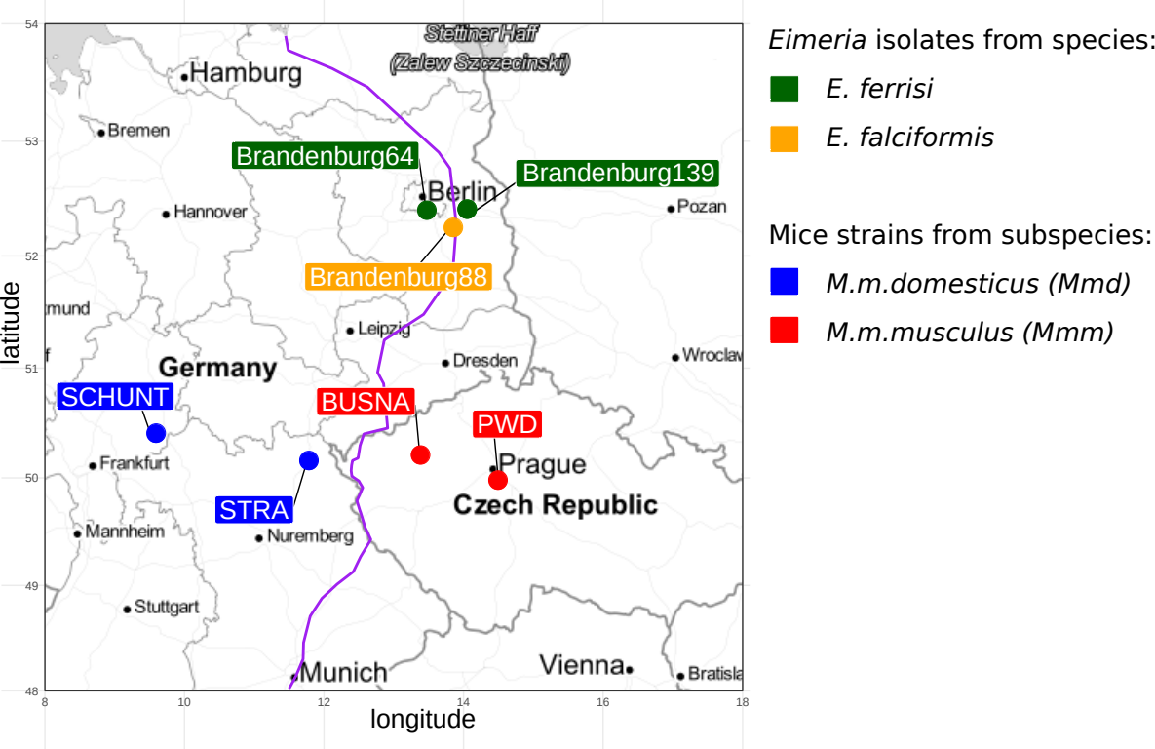
Figure 1. Parasite isolates and mouse strains. The map shows locations at which mice were collected for breeding of mouse strains and isolation of parasites. The purple line is an estimation of the center of the house mouse hybrid zone between Mmd and Mmm based on sampling and genotyping of mice in this area (Balard et al., 2019; Ďureje, Macholán, Baird, & Piálek, 2012).

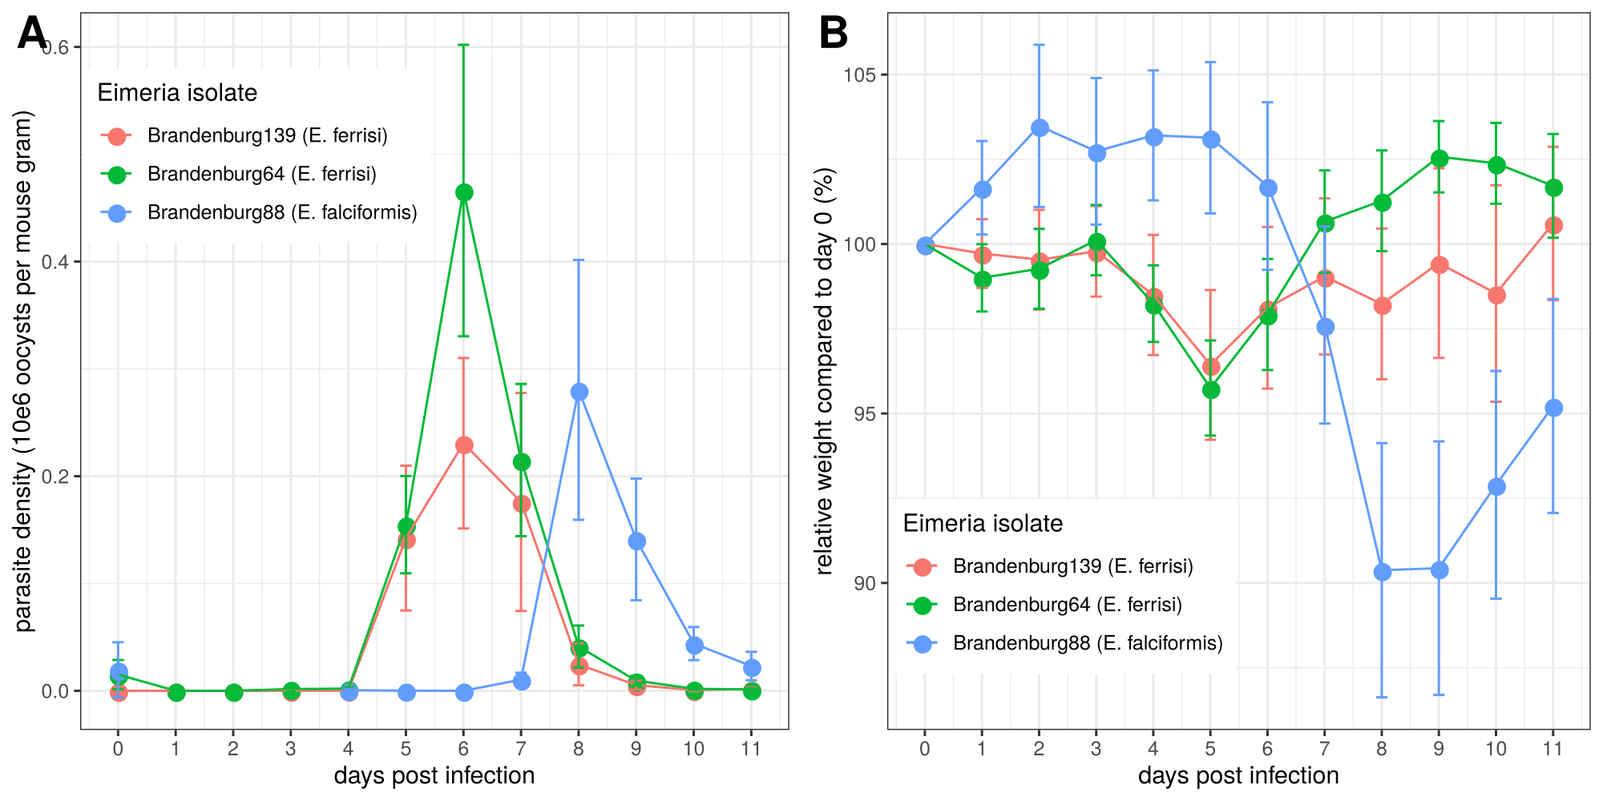
Figure 2. Parasite density (A) and relative weight loss (B) during Eimeria infection. Parasite density is calculated as number of oocysts detected (10e6) in feces per mouse gram, relative weight loss is calculated compared to day 0. Mean and 95% CI are plotted for each parasite isolate. All hosts strains are pooled together.
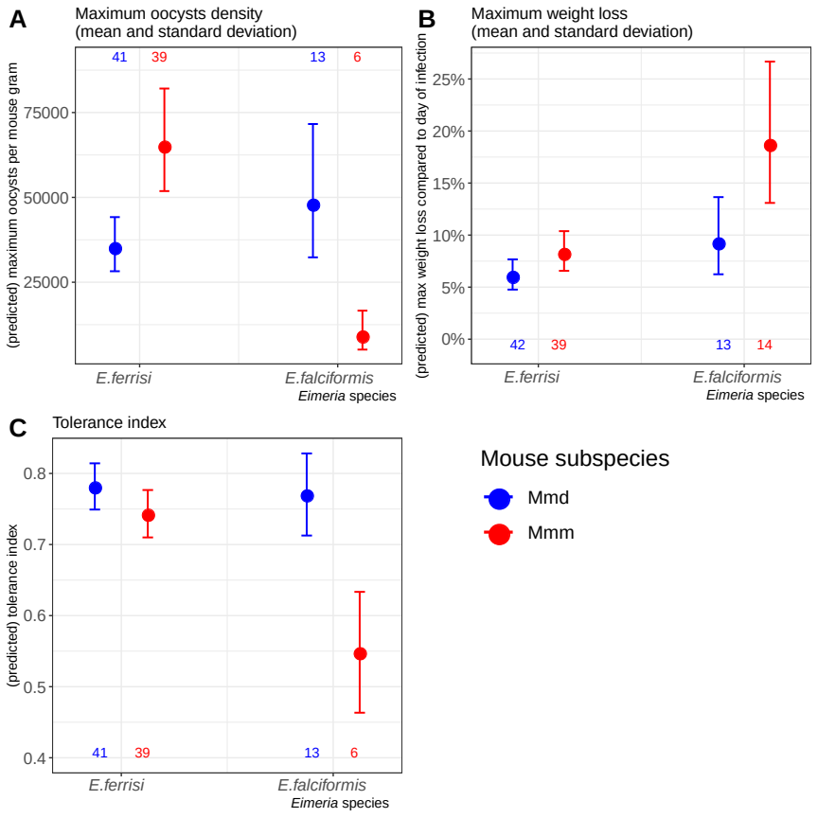

Figure 3. Resistance, impact on host health and tolerance marginal effects for the two mice subspecies and two Eimeria species. Predicted mean and standard deviation for each group. Values under bars represent the number of animals for each group. See Table 2 for summary statistics. (A) Resistance index measured as (- maximum number of oocysts per mouse gram + 300000) / 300000 ; (B) Impact on host health measured as the maximum weight loss during patent period relative to starting weight (%); (C) Tolerance Index measured as (log10(maximum relative weight loss / maximum number of oocysts per mouse gram + 1e-8) / -8
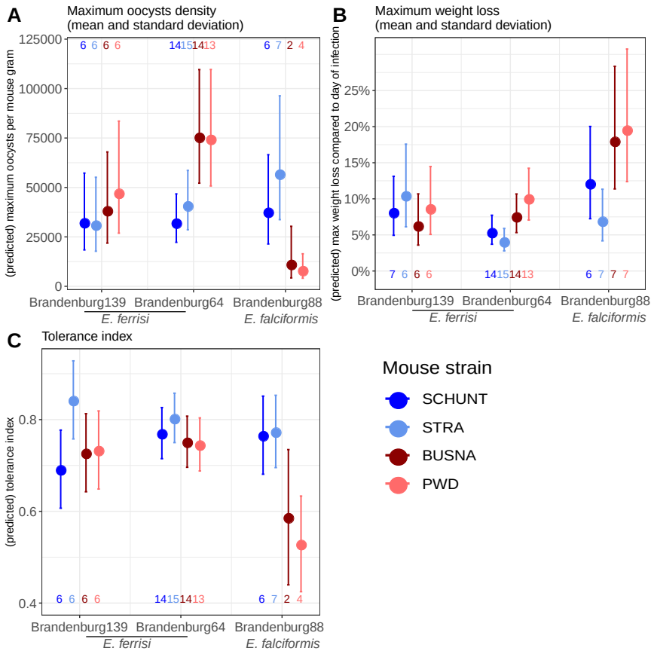

Figure 4. Resistance, impact on host health and tolerance marginal effects for four inbred mouse strains infected with three Eimeria isolates each. Predicted mean and standard deviation for each group. Values under bars represent the number of animals for each group. (A) Resistance Index measured as (- maximum number of oocysts per mouse gram + 300000) / 300000 (see Table 3 for post-hoc tests); (B) Impact on host health measured as the maximum weight loss during patent period relative to starting weight (%)(see Table 4 for post-hoc tests); (C) Tolerance Index measured as (log10(maximum relative weight loss / maximum number of oocysts per mouse gram + 1e-8) / -8 (see Table 5 for post-hoc tests).

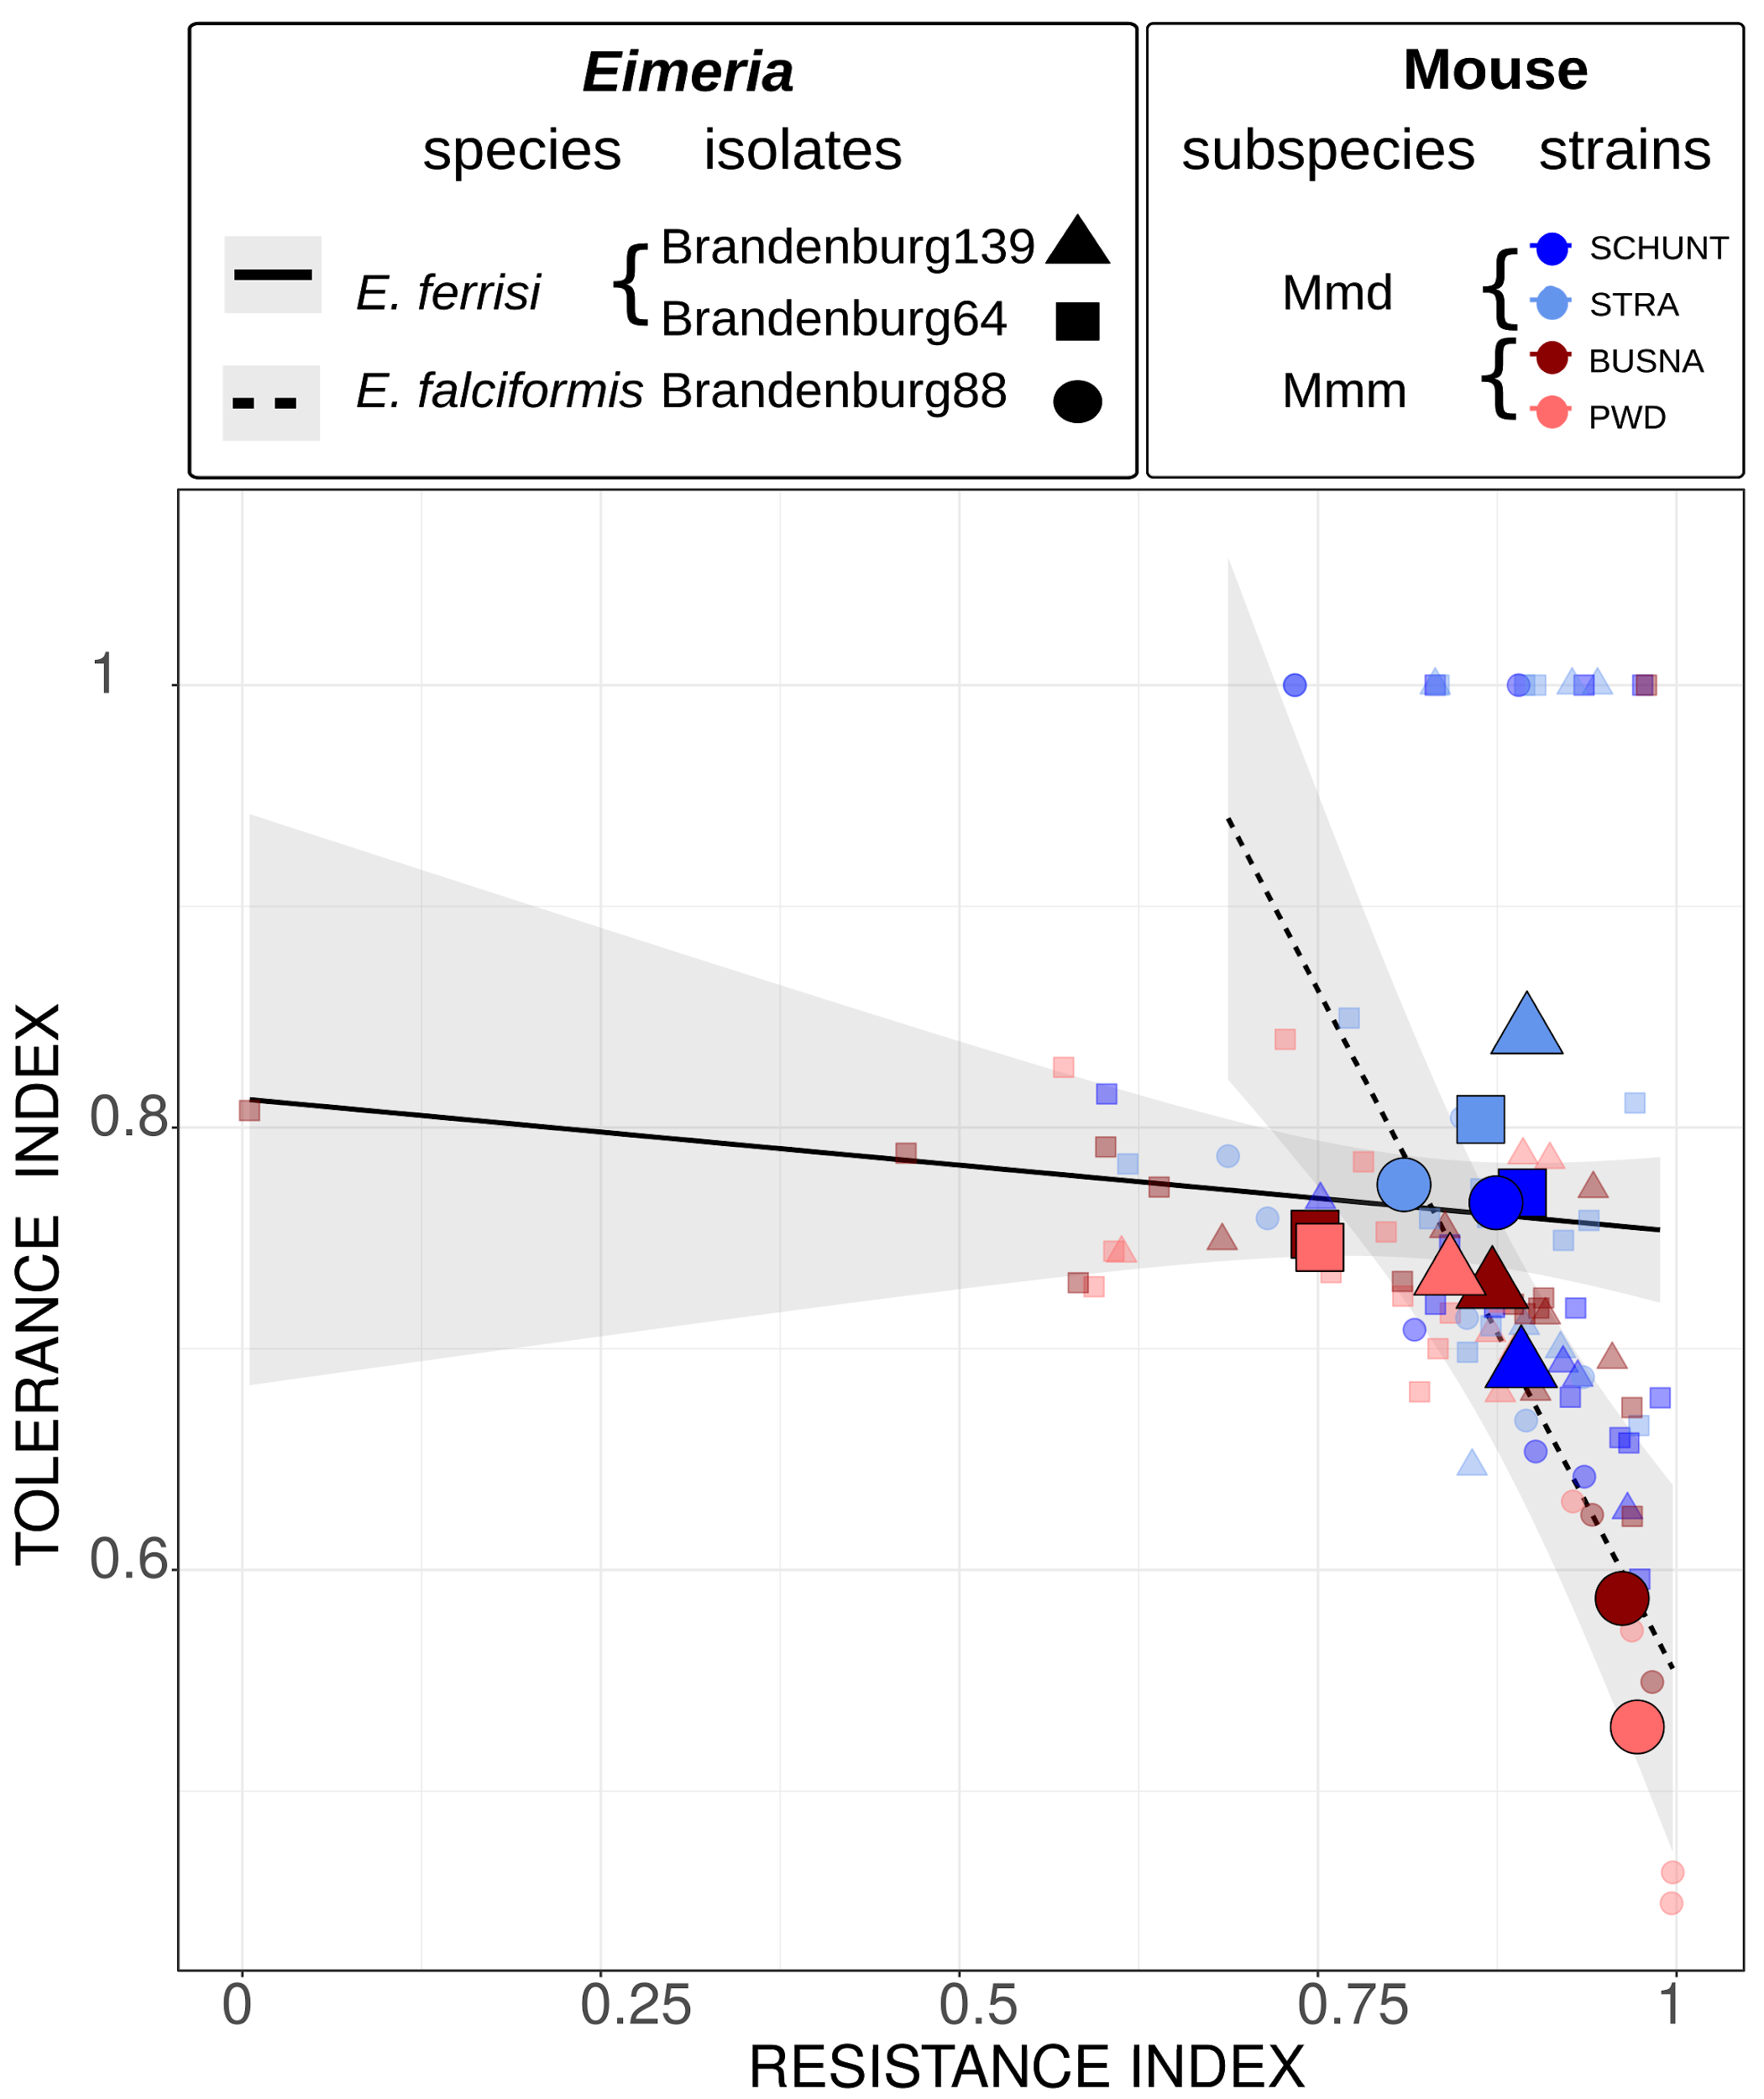
Figure 5. Comparison of trade-off between resistance and tolerance between both Eimeria species. Smaller points represent individual mice, while larger points figure the mean for a given (host strain-parasite isolate) group. Linear regression of tolerance by resistance are shown for both parasite species. Resistance Index measured as (- maximum number of oocysts per mouse gram + 300000) / 300000, Tolerance Index measured as (log10(maximum relative weight loss / maximum number of oocysts per mouse gram + 1e-8) / -8

Funding
This work was funded by the German Research Foundation (DFG) Grant [HE 7320/1-1] to EH. VHJ is an associated student of GRK 2046 funded by the DFG. The maintenance of wild-derived strains was supported by the ROSE program from Czech Academy of Sciences and the Czech Science Foundation (project 16-23773S) to JP.

References

Al-khlifeh, E., Balard, A., Jarquín-Díaz, V. H., Weyrich, A., Wibbelt, G., & Heitlinger, E. (2019). Eimeria falciformis BayerHaberkorn1970 and novel wild derived isolates from house mice: Differences in parasite lifecycle, pathogenicity and host immune reactions. BioRxiv, 611277. http://dx.doi.org/10.1101/611277
Ankrom, S. L., Chobotar, B., & Ernst, J. V. (1975). Life cycle of Eimeria ferrisi Levine & Ivens, 1965 in the Mouse, Mus musculus. The Journal of Protozoology, 22(3), 317–323. https://doi.org/10.1111/j.1550-7408.1975.tb05177.x
Baird, S. J. E., & Goüy de Bellocq, J. (2019). Shifting paradigms for studying parasitism in hybridising hosts: Response to Theodosopoulos, Hund, and Taylor. Trends in Ecology & Evolution, 34, 387–389. https://doi.org/10.1016/j.tree.2019.01.011
Baird, S. J. E., Ribas, A., Macholán, M., Albrecht, T., Piálek, J., & Goüy de Bellocq, J. (2012). Where are the wormy mice? A reexamination of hybrid parasitism in the European house mouse hybrid zone. Evolution, 66(9), 2757–2772. https://doi.org/10.1111/j.1558-5646.2012.01633.x
Baker, D. G. (1998). Natural pathogens of laboratory mice, rats, and rabbits and their effects on research. Clinical Microbiology Reviews, 11(2), 231–266.
Balard, A., Jarquín-Díaz, V. H., Jost, J., Martincová, I., Ďureje, Ľ., Piálek, J., … Heitlinger, E. (2019). Intensity of infection with intracellular Eimeria spp. And pinworms is reduced in hybrid mice compared to parental subspecies. BioRxiv, 683698. https://doi.org/10.1101/683698
Barton, N. H., & Hewitt, G. M. (1985). Analysis of hybrid zones. Annual Review of Ecology and Systematics, 16(1), 113–148. https://doi.org/10.1146/annurev.es.16.110185.000553
Chapman, H. D., Barta, J. R., Blake, D., Gruber, A., Jenkins, M., Smith, N. C., … Tomley, F. M. (2013). A selective review of advances in coccidiosis research. Advances in Parasitology, 83, 93–171. https://doi.org/10.1016/B978-0-12-407705-8.00002-1
Ďureje, Ľ., Macholán, M., Baird, S. J., & Piálek, J. (2012). The mouse hybrid zone in Central Europe: From morphology to molecules. Folia Zoologica, 61(3–4), 308–318.
Ehret, T., Spork, S., Dieterich, C., Lucius, R., & Heitlinger, E. (2017). Dual RNA-seq reveals no plastic transcriptional response of the coccidian parasite Eimeria falciformis to host immune defenses. BMC Genomics, 18(1), 686. https://doi.org/10.1186/s12864-017-4095-6
Graham, A. L., Allen, Judith. E., & Read, A. F. (2005). Evolutionary causes and consequences of immunopathology. Annual Review of Ecology, Evolution, and Systematics, 373–397. https://doi.org/10.1146/annurev.ecolsys.36.102003.152622
Gregorová, S., & Forejt, J. (2000). PWD/Ph and PWK/Ph inbred mouse strains of Mus m. Musculus subspecies—A valuable resource of phenotypic variations and genomic polymorphisms. Folia Biologica, 46(1), 31–41.
Haberkorn, A. (1970). Die Entwicklung von Eimeria falciformis (Eimer 1870) in der weißen Maus (Mus musculus). Zeitschrift für Parasitenkunde, 34(1), 49–67. https://doi.org/10.1007/BF00629179
Hayward, A. D., Nussey, D. H., Wilson, A. J., Berenos, C., Pilkington, J. G., Watt, K. A., … Graham, A. L. (2014). Natural Selection on Individual Variation in Tolerance of Gastrointestinal Nematode Infection. PLOS Biology, 12(7), e1001917. https://doi.org/10.1371/journal.pbio.1001917
Hlavac, M. (2018). stargazer: Well-Formatted Regression and Summary Statistics Tables. Retrieved from https://CRAN.R-project.org/package=stargazer
Jarquín-Díaz, V. H., Balard, A., Jost, J., Kraft, J., Dikmen, M. N., Kvičerová, J., & Heitlinger, E. (2019). Detection and quantification of house mouse Eimeria at the species level – Challenges and solutions for the assessment of coccidia in wildlife. International Journal for Parasitology: Parasites and Wildlife, 10, 29–40. https://doi.org/10.1016/j.ijppaw.2019.07.004
Kutzer, M. A. M., & Armitage, S. A. O. (2016). Maximising fitness in the face of parasites: A review of host tolerance. Zoology, 119(4), 281–289. https://doi.org/10.1016/j.zool.2016.05.011
Langand, J., Jourdane, J., Coustau, C., Delay, B., & Morand, S. (1998). Cost of resistance, expressed as a delayed maturity, detected in the host–parasite system Biomphalaria glabrata/Echinostoma caproni. Heredity, 80(3), 320–325. https://doi.org/10.1046/j.1365-2540.1998.00291.x
Little, T. J., Shuker, D. M., Colegrave, N., Day, T., & Graham, A. L. (2010). The Coevolution of Virulence: Tolerance in Perspective. PLOS Pathogens, 6(9), e1001006. https://doi.org/10.1371/journal.ppat.1001006
Macholán, M., Munclinger, P., Sugerková, M., Dufková, P., Bímová, B., Bozíková, E., … Piálek, J. (2007). Genetic analysis of autosomal and X-linked markers across a mouse hybrid zone. Evolution, 61(4), 746–771. https://doi.org/10.1111/j.1558-5646.2007.00065.x
Martincová, I., Ďureje, Ľ., Kreisinger, J., Macholán, M., & Piálek, J. (2019). Phenotypic effects of the Y chromosome are variable and structured in hybrids among house mouse recombinant lines. Ecology and Evolution, 9(10), 6124–6137. https://doi.org/10.1002/ece3.5196
Mazé-Guilmo, E., Loot, G., Páez, D. J., Lefèvre, T., & Blanchet, S. (2014). Heritable variation in host tolerance and resistance inferred from a wild host–parasite system. Proceedings of the Royal Society B: Biological Sciences, 281(1779). https://doi.org/10.1098/rspb.2013.2567
Medzhitov, R., Schneider, D. S., & Soares, M. P. (2012). Disease tolerance as a defense strategy. Science, 335(6071), 936–941. https://doi.org/10.1126/science.1214935
Miller, M. R., White, A., & Boots, M. (2005). The evolution of host resistance: Tolerance and control as distinct strategies. Journal of Theoretical Biology, 236(2), 198–207. https://doi.org/10.1016/j.jtbi.2005.03.005
Piálek, J., Vyskocilová, M., Bímová, B., Havelková, D., Piálková, J., Dufková, P., … Forejt, J. (2008). Development of unique house mouse resources suitable for evolutionary studies of speciation. The Journal of Heredity, 99(1), 34–44. https://doi.org/10.1093/jhered/esm083
R Development Core Team. (2018). R: A language and environment for statistical computing. R Foundation for Statistical Computing, Vienna, Austria. Retrieved from http://www.R-project.org
Råberg, L. (2014). How to live with the enemy: Understanding tolerance to parasites. PLoS Biology, 12(11), e1001989. https://doi.org/10.1371/journal.pbio.1001989
Råberg, L., Graham, A. L., & Read, A. F. (2009). Decomposing health: Tolerance and resistance to parasites in animals. Philosophical Transactions of the Royal Society B: Biological Sciences, 364(1513), 37–49. https://doi.org/10.1098/rstb.2008.0184
Råberg, L., Sim, D., & Read, A. F. (2007). Disentangling genetic variation for resistance and tolerance to infectious diseases in animals. Science (New York, N.Y.), 318(5851), 812–814. https://doi.org/10.1126/science.1148526
Restif, O., & Koella, J. C. (2003). Shared Control of Epidemiological Traits in a Coevolutionary Model of Host‐Parasite Interactions. The American Naturalist, 161(6), 827–836. https://doi.org/10.1086/375171
Roy, B. A., & Kirchner, J. W. (2000). Evolutionary Dynamics of Pathogen Resistance and Tolerance. Evolution, 54(1), 51–63. https://doi.org/10.1111/j.0014-3820.2000.tb00007.x
Schito, M. L., Barta, J. R., & Chobotar, B. (1996). Comparison of four murine Eimeria species in immunocompetent and immunodeficient mice. The Journal of Parasitology, 82(2), 255–262. https://doi.org/10.2307/3284157
Sheldon, B. C., & Verhulst, S. (1996). Ecological immunology: Costly parasite defences and trade-offs in evolutionary ecology. Trends in Ecology & Evolution, 11(8), 317–321. https://doi.org/10.1016/0169-5347(96)10039-2
Simms, E. L., & Triplett, J. (1994). Costs and benefits of plant response to disease: Resistance and tolerance. Evolution, 48(6), 1973–1985. https://doi.org/10.1111/j.1558-5646.1994.tb02227.x
Soares, M. P., Teixeira, L., & Moita, L. F. (2017). Disease tolerance and immunity in host protection against infection. Nature Reviews Immunology, 17(2), 83–96. https://doi.org/10.1038/nri.2016.136
Stange, J., Hepworth, M. R., Rausch, S., Zajic, L., Kühl, A. A., Uyttenhove, C., … Lucius, R. (2012). IL-22 Mediates Host Defense against an Intestinal Intracellular Parasite in the Absence of IFN-γ at the Cost of Th17-Driven Immunopathology. The Journal of Immunology, 188(5), 2410–2418. https://doi.org/10.4049/jimmunol.1102062
Vijendravarma, R. K., Kraaijeveld, A. R., & Godfray, H. C. J. (2009). Experimental Evolution Shows Drosophila Melanogaster Resistance to a Microsporidian Pathogen Has Fitness Costs. Evolution, 63(1), 104–114. https://doi.org/10.1111/j.1558-5646.2008.00516.x
Vincent, C. M., & Sharp, N. P. (2014). Sexual antagonism for resistance and tolerance to infection in Drosophila melanogaster. Proceedings of the Royal Society B: Biological Sciences, 281(1788), 20140987. https://doi.org/10.1098/rspb.2014.0987
Wickham, H. (2016). ggplot2: Elegant Graphics for Data Analysis. Springer-Verlag, New York.

