Supplementary Material. Main analyses on conservative dataset (N = 77)
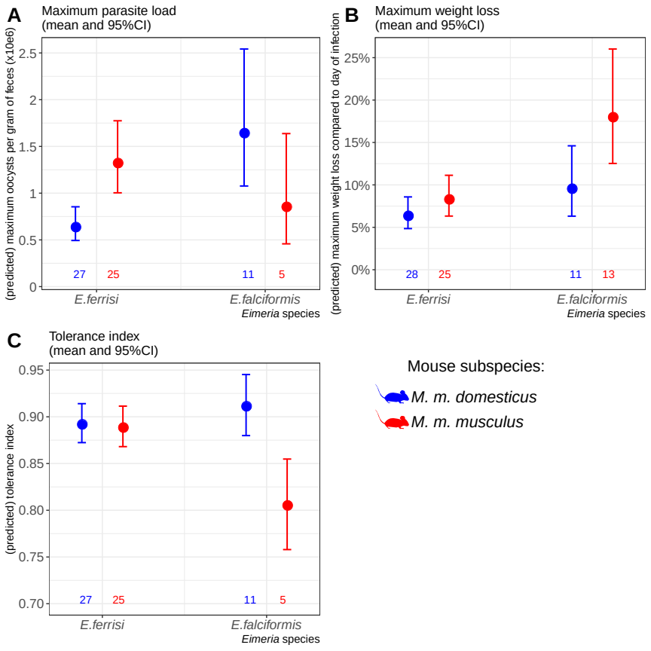
Resistance, impact on host health and tolerance marginal effects for the two mice subspecies and two Eimeria species. Values under bars represent the number of animals for each group. (A) Maximum oocysts per gram of feces used as a proxy for (inverse of) resistance; (B) Impact on host health measured as the maximum weight loss during patent period relative to starting weight (%); (C) Tolerance index measured as (log10(maximum relative weight loss / maximum number of oocysts per gram of feces + 1e-8) / -8
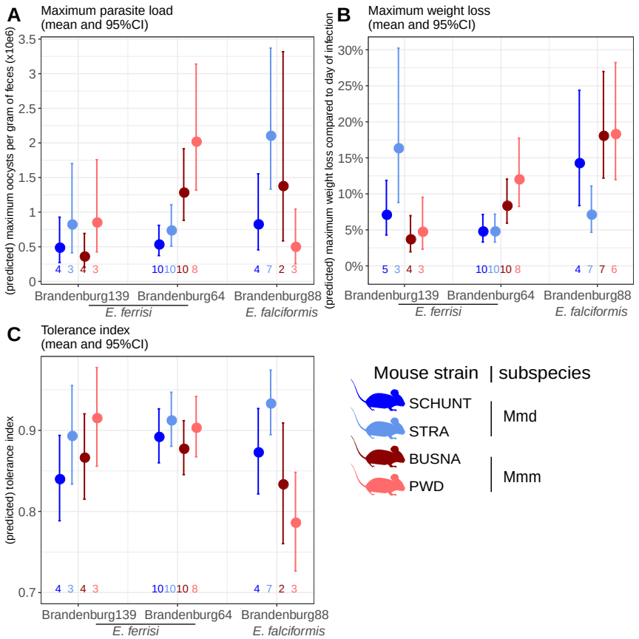
Resistance, impact on host health and tolerance marginal effects for four inbred mouse strains infected with three Eimeria isolates each. Values under bars represent the number of animals for each group. (A) Maximum oocysts per gram of feces used as a proxy for (inverse of) resistance; (B) Impact on host health measured as the maximum weight loss during patent period relative to starting weight (%); (C) Tolerance index measured as (log10(maximum relative weight loss / maximum number of oocysts per gram of feces + 1e-8) / -8
Post-hoc tests:
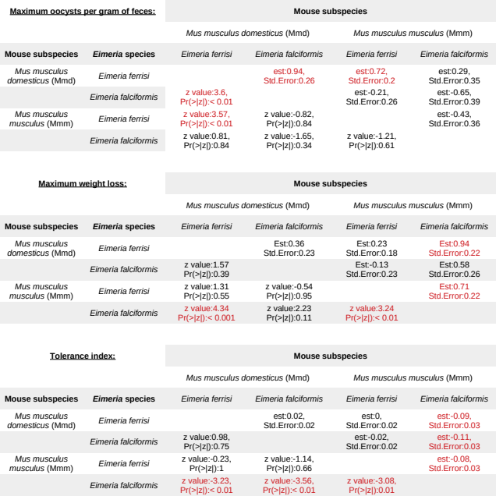
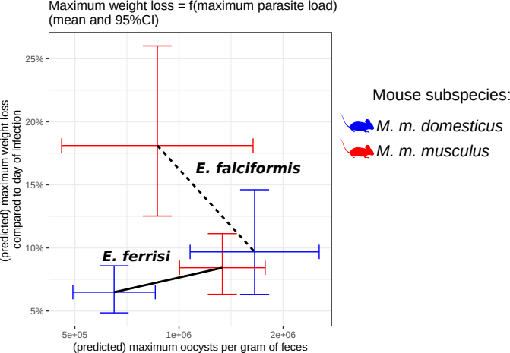
Coupling between resistance and tolerance for two different Eimeria species. Resistance is approximated as the inverse of maximum oocysts per gram of feces, impact on host health as maximum relative weight loss. The upper left corner represents the low tolerance area (strong impact on health despite low parasite load), the lower right the high tolerance area. There is a trade-off between resistance and tolerance between each mouse subspecies upon infection with E. falciformis, absent in the case of E. ferrisi.

